recrupatio TARGETING THE RIGHT EMPLOYABILITY SKILLS FOR ENTRY-LEVEL JOBS

KEY FINDINGS
- Most employers place considerable importance on employability skills and in many instances, more so than they do technical skills.
- The employability skills employers are looking for vary considerably across skill levels.
- For entry-level occupations they are more likely to relate to an individual’s ability to take responsibility for their actions, than those for higher skilled occupations.
- The employability skills sought for different entry-level occupations also vary in terms of their importance to the role.
- Job seekers applying for entry-level jobs need to demonstrate the employability skills most valued in the position for which they are applying.

INTRODUCTION
Figure 1
The term employability skills, or soft skills, covers a broad range of personal attributes and transferable skills that contribute significantly to an individual’s prospects of gaining employment. Research conducted by the Department of Employment, as part of the Surveys of Employers’ Recruitment Experiences, shows that around two-thirds of employers place at least as much emphasis, if not more, on employability skills than they do on technical skills. As part of the surveys, employers were asked to specify the personal attributes or employability skills they considered essential to the occupation for which they had most recently recruited.

This paper provides an overview of the most common responses received and explores the relationship between particular employability skills, skill level and occupation types, with focus given to entry-level occupations.

EMPLOYABILITY SKILLS BY SKILL LEVEL
The survey results were analysed to determine whether particular employability skills were valued more highly by employers with vacancies at specific skill levels, with emphasis on the lower skill levels. Figure 1 illustrates the key differences between the skill levels. Interestingly, employers view people skills as being important across all skill levels.

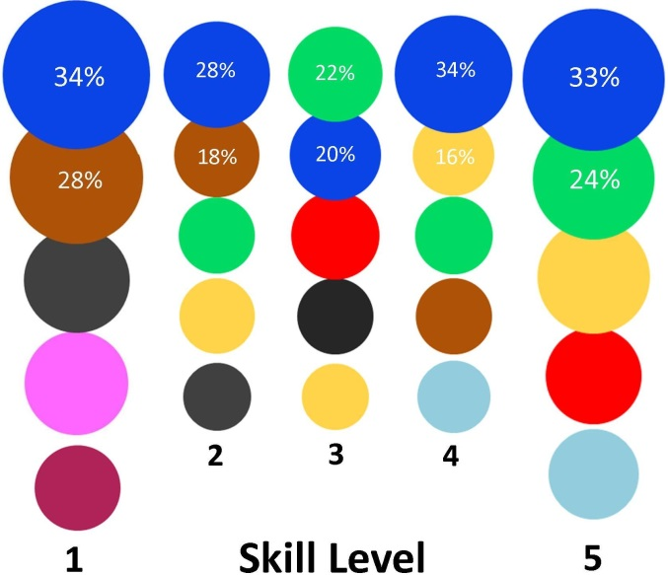

The importance of recruiting staff who are reliable, motivated/hardworking, and have good personal presentation is more likely to be mentioned as essential by employers when referring to lower skilled occupations (skill level 5). These employability skills demonstrate to an employer that a job seeker can take responsibility for their behaviour and actions, so it is important that they demonstrate their capacity in this regard.

By comparison, employers with vacancies for higher skilled occupations place greater emphasis on recruiting staff who have good communication and teamwork skills, are caring and empathetic and organised. Other highly developed employability skills, such as problem solving and leadership, are also important for higher skilled occupations.

EMPLOYABILITY SKILL REQUIREMENTS FOR SPECIFIC ENTRY-LEVEL POSITIONS
Employability skill development is crucial for all job seekers. It is vital that young, inexperienced job seekers who have yet to attain technical skills and qualifications are able to demonstrate their employability skills to employers. However, research by the Department shows that employers consider that young applicants often lack these valuable employability skills. Accordingly, it is essential that young job seekers are able to demonstrate the employability skills most crucial to the job for which they are applying.

Five entry-level occupations were assessed to determine which employability skills are most valued by employers. Figures 2 and 3 show these occupations with the seven most commonly reported employability skills regarded as essential and the proportion of employers who mentioned each skill. Figure 2 shows the employability skills that relate to how we engage, interact and provide service to others, and includes people skills, customer service skills and communication skills. Figure 3 shows those that relate to how we manage our actions, and includes reliability, presentation, motivation/hardworking and responsibility.

People skills are most commonly valued for all five entry-level occupations, with the exception of labourers, for whom reliability is the most important requirement, followed by being motivated/hardworking. Customer service skills and personal presentation are particularly important across the other occupations. For receptionists and sales assistants, there is a greater emphasis on customer service skills than for the other occupations. Communication skills are more commonly valued by employers recruiting receptionists. For all of these occupations employers valued staff who are reliable.

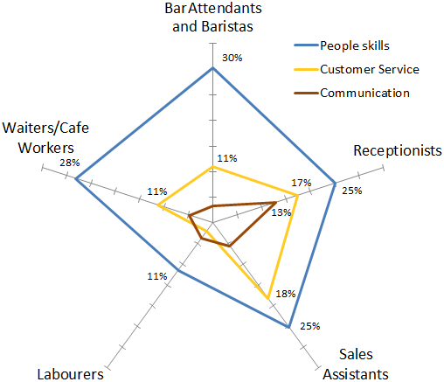
Figure 2

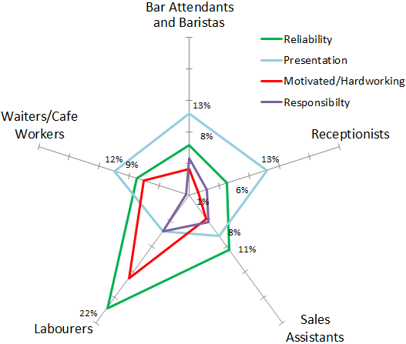
Figure 3

Employability skills are vital for all entry-level jobs. Furthermore, previous research by the Department shows that in addition to these employability skills employers are seeking other attributes, particularly from young job seekers, such as a positive attitude and realistic expectations about work. Applicants who have strong job search and interview skills, and are able to demonstrate their employability skills are more likely to make an impression when applying for jobs.

Department of Employment, Survey of Employers’ Recruitment Experiences, 2010.
Responses were made by 3,900 employers across 30 regions in 2014 and 2015. Employers could give multiple responses.
Skill levels as classified in ANZSCO (ABS). Skill level 1 - bachelor degree or higher qualification; Skill level 2 - associate degree, advanced diploma/diploma; Skill level 3 - certificate IV; Skill level 4 - certificate II or III; Skill level 5 - certificate I or compulsory secondary education.
The order/size of the circles reflects the proportion of employers who responded.
Department of Employment, Improving the employment prospects of young Australians, 2014.
ANZSCO classes Waiters, Bar Attendants and Baristas, and Receptionists as skill level 4; Cafe Workers and Sales Assistants as skill level 5; and Labourers are classed as either skill level 4 or 5.
Department of Employment, Looking for a job – Employers advice for young people, 2014.

