


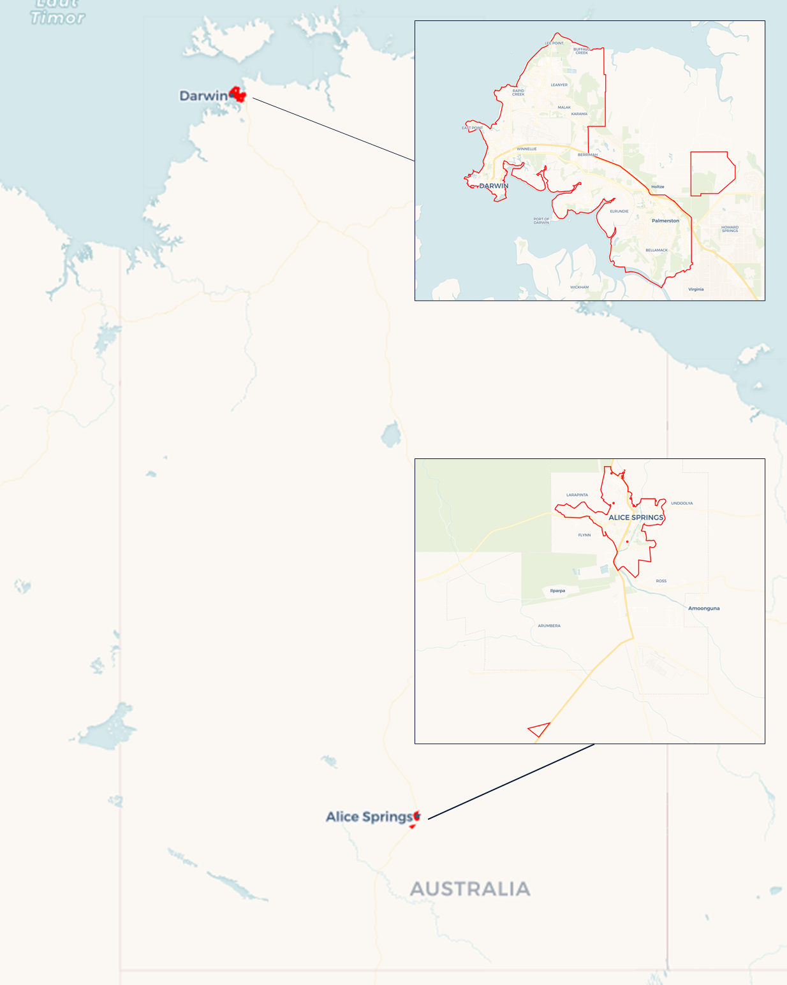
Local Jobs Plan
  - Darwin (including Alice Springs) Employment Region | NT | February 2026
Workforce Australia Local Jobs (Local Jobs) is a program that creates partnerships between business
and communities to meet local workforce needs, thereby improving employment outcomes.
Local Jobs operates in all 51 Employment Regions in Australia.

Local Jobs Overview

Local Jobs Plan
Each Employment Region has a Local Jobs Plan which outlines the labour market challenges in the region and the strategies to address these challenges.

Job Coordinators
Each Employment Region has a dedicated Job Coordinator who leverages existing resources, supports local labour markets through structural adjustments and retrenchments, and creates opportunities for collaboration between business and communities.

Local Jobs and Skills Taskforce
Each Employment Region has its own taskforce that meets regularly with the Job Coordinator to develop an understanding of challenges in the region and implement solutions. The taskforce is comprised of representatives from the region.

Local Jobs, Local People Grant
The Local Jobs, Local People grant funds activities that help people into ongoing employment or training. Activities must support local labour market needs.
Explore labour market insights for
Darwin (Including Alice Springs) Employment Region

Local labour market challenges

- The Northern Territory (NT) faces workforce shortages across most skill levels and sectors, particularly healthcare and social assistance, construction, mining, retail, public administration, and hospitality.
- The region faces high levels of socioeconomic disadvantage, intergenerational unemployment, and a high proportion of jobless families. Long-term unemployment remains high, especially among First Nations and young people.
- People seeking employment often face a range of challenges including low literacy, reading, and writing comprehension, language, digital literacy, criminal history, a lack of formal education, minimal or no work experience, and family or cultural obligations.
- Limited public transport service makes it difficult for people without private vehicles to access employment, education, healthcare, and other essential services. This can be burdensome for individuals and families facing socioeconomic disadvantages and for those living away from key industrial growth centres.
- Housing insecurity and homelessness remain critical challenges in the Northern Territory. High levels of mobility between remote communities and regional centres, combined with high living costs, lower incomes, and a persistent shortage of housing, contribute to overcrowding and housing instability. Homelessness is prevalent across both urban and remote areas, disproportionately affecting First Nations people and young people, and directly impacting individuals’ ability to engage in employment, training, and education.
- These challenges place sustained pressure on housing, employment, and support services and require coordinated, place-based responses.

Local priorities

Priority 1 – Collaborate with the business community to identify and broker solutions to current and emerging workforce and skills needs

What are our challenges?
Workforce shortages across multiple skill levels and sectors are impacting access to a job-ready, skilled workforce capable of meeting both current industry demands and the needs of emerging sectors—including defence support, information technology, renewables, manufacturing, and their related supply chains. There is an opportunity to address these challenges by prioritising targeted skill-building initiatives that strengthen cross-sector collaboration between industry and employment service providers. This approach can help bridge workforce gaps and deliver meaningful outcomes for both job seekers and the business community.

How are we responding?
- By convening place-based workforce development working groups in Darwin and Alice Springs that are focused on responding to identified workforce attraction, recruitment and retention challenges and support the co-design and delivery of local, employer-led solutions that addresses the challenges
- Through the participation in advisory and steering committees work with Australian and NT Government, businesses and peak bodies to create opportunities for locals, enabling them to transition into sustainable employment.
- Promoting employment opportunities available, and the skills needed with employment services providers and other stakeholders.
- Strengthening connections between businesses, employment services providers, training organisations and other industry stakeholders by collaborating on major projects, employment and workforce forums, information sessions and expos.
- Providing labour market intelligence to stakeholders to support employment pathway initiatives to meet labour market demand.

Priority 2 – Collaborate with the business community to build employer capacity to recruit, retain, and develop a skilled workforce

What are our challenges?

The workforce shortage in the NT presents an opportunity to implement localised attraction campaigns and skilling programs to tackle recruitment challenges and enhance workforce capabilities. Successful workforce attraction campaigns need to include development and retention strategies which requires planning, collaboration, and knowledge sharing among all stakeholders and must include cultural understanding, professional mentorship, to ensure ongoing retention.

How are we responding?
- Supporting employers streamline recruitment processes, identify gaps and opportunities for enhancement, and facilitate initiatives such as cultural awareness, mentoring and employment placement support, for the employer and individual.
- Providing information that increases the awareness of local businesses to available grants/programs and place-based initiatives provided by the Australian and NT Government to address workforce shortages, attraction, recruitment, and retention needs, such as the Local Jobs Local People grants, Remote Jobs Economic Development grants and or Skills NT grants etc
- Encouraging employers to consider internships, work experience, job sharing, and casual to part-time or full-time employment to enable individuals to build capability and capacity over time.
- Promoting cultural and inclusive mentorship to the business community and collaborating with key members of the community to provide informed advice to their organisation.

Priority 3 – Enhance efforts to increase the Vocational Education and Training (VET) sector capabilities to respond to current and emerging employment, skills and workforce needs of the region

What are our challenges?

VET organisations across the NT are experiencing critical shortages of trainers. These shortages pose significant challenges to delivering quality training and education to individuals to meet the workforce demand and job seeking skilling initiatives.

How are we responding?
- Conducting workshops to explore innovative solutions to address the demands in the VET industry and ensure training remains accessible.
- Working with the VET sector to identify innovative strategies and best practices for recruiting and retaining trainers in region.
- Collaborating with industry peaks and Jobs and Skills Councils in supporting Registered Training Organisations to understand the demand, and access government programs, services, and funding to deliver on the demand.
- Actively promoting employment pathways and opportunities in the sector.

Priority 4 – Enhance efforts to identify, facilitate, and support skills development and employment opportunities for the local job-seeking community

What are our challenges?

Those seeking employment lack skills to successfully transition into the workforce. The implementation of upskilling or reskilling initiatives, tailored to meet current labour market demands, will assist local job seekers in this process. The review of the employment landscape, including available opportunities, prerequisites, and potential challenges would benefit job seekers in enhancing their readiness for obtaining employment opportunities.

How are we responding?
- Connecting Workforce Australia Services, Community Development Program, and Inclusive Employment Australia providers with businesses and training organisations to facilitate the development of place-based initiatives that address skills in demand and provide individuals with pathways to employment.
- Encouraging employers to review expectations, job fit and employment options, work with people to build capacity, and ensure two-way communication.
- Facilitating collaboration between governments, peak bodies, and community to drive skills and employment initiatives that attract, train and prepare the labour force and employers to meet local employment requirements.
- Promoting the benefits of investment in language, literacy, numeracy, and digital skills of workers, with local employers and industry groups.
- Promoting the benefits of Australian Apprenticeships to meet local employment requirements.
- Promoting initiatives delivered by governments, peak bodies, training organisations and local employment providers that address labour market demands.
- Coordinating place-based workshops, job fairs, skilling initiatives and forums that bring local businesses and communities together to improve awareness of employment opportunities and strengthen local workforce participation.

Priority 5 – Facilitate and support participation in training and employment opportunities, with a particular focus on First Nations, young people, women and people with disability

What are our challenges?

Many people within the Employment Region encounter significant challenges to effective participation in training and employment. There is opportunity to ensure connection and advocacy of holistic support that addresses education, skills development, health, access to transport, accommodation, and other social needs.

How are we responding?
- Collaborating with local stakeholders to support the delivery of targeted place-based employment pathway programs through the utilisation of grants, where appropriate.
- Conducting workshops and information session on employment pathways, opportunities and supports available, aiming to increase workforce participation of cohorts facing complex challenges.
- Encouraging collaboration in the delivery of wrap-around supports and services, positioning individuals to successfully transition into sustainable employment.
- Maximising linkages between training and local employment opportunities to fill entry-level positions, including promotion of traineeships and apprenticeships.
- Working with local stakeholders to promote inclusive and culturally safe workplaces and collaborating with key members of the community on delivery of appropriate training to individuals and the business sector.
- Collaborating with all levels of government, health, transport, and accommodation support services to identify and address the needs of the local community.
- Collaborating with leaders from various sectors to support and improve the employment participation of people facing complex challenges.

Want to know more?
- Contact: Michelle Burgess, Employment Region Job Coordinator: mburgess@localjobsnt.com.au
- Website: Local Jobs or Workforce Australia
- Facebook: Workforce Australia Local Jobs - Darwin and Alice Springs

