


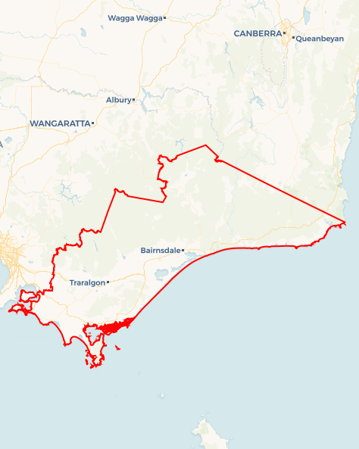
Local Jobs Plan
  - Gippsland Employment Region | Vic | March 2026
Workforce Australia Local Jobs (Local Jobs) is a program that creates partnerships between business
and communities to meet local workforce needs, thereby improving employment outcomes.
Local Jobs operates in all 51 Employment Regions in Australia.

Local Jobs Overview

Local Jobs Plan
Each Employment Region has a Local Jobs Plan which outlines the labour market challenges in the region and the strategies to address these challenges.

Job Coordinators
Each Employment Region has a dedicated Job Coordinator who leverages existing resources, supports local labour markets through structural adjustments and retrenchments, and creates opportunities for collaboration between business and communities.

Local Jobs and Skills Taskforce
Each Employment Region has its own taskforce that meets regularly with the Job Coordinator to develop an understanding of challenges in the region and implement solutions. The taskforce is comprised of representatives from the region.

Local Jobs, Local People Grant
The Local Jobs, Local People grant funds activities that help people into ongoing employment or training. Activities must support local labour market needs.
Explore labour market insights for
Gippsland Employment Region

Local labour market challenges

- Workforce participation of 78.5% is below the national average of 80.5%
- First Nations peoples experience higher rates of unemployment.
- High level of early school leavers and low completion rate of higher education.
- One third of our population is over 65 affecting demands in the health care and social assistance industries.
- Shortage of skilled and professional workers to meet the demand of local workforce requirements.
- Industry is transitioning from traditional sectors such as mining, coal fired energy and forestry, impacting local communities and existing workforces.
- Insufficient transport options and accommodation availability are restricting access to training and employment.

Local priorities

Priority 1 – Strengthen pathways into local employment

What are our challenges and opportunities?
Healthcare, social assistance, energy, construction, food, tourism and agriculture are key local industries. There is an opportunity to build awareness and establish clear pathways into programs, training and employment within these sectors.

How are we responding?
- Working with local stakeholders and industries to create, design, enhance and promote pre-employment and training programs. Tailoring to each person’s needs at various stages of their job search.
- Strengthening connections between employers, employment services and training providers to improve industry awareness, work readiness, and direct pathways into local jobs.
- Promoting available programs, training opportunities and entry level pathways, including through the Gippsland Jobs Hub to increase visibility and engagement among job seekers and employers.

Priority 2 – Skills shortages

What are our challenges and opportunities
Gippsland faces significant skill shortages in its workforce. The demand for skilled and professional labour is increasing. Opportunities exist for tailored training programs to support the demands of local businesses and emerging industries, for example, transitioning to net zero.

How are we responding?
- Partnering with Workforce Australia Employment Service Providers (providers) to ensure people are connected to appropriate programs and assisting providers to engage with and develop pre-employment activities both for pre-accredited and accredited training.
- Collaborating with industries to understand their future workforce needs.
- Partnering with training and education providers TAFE Gippsland, BBLLEN, GELLEN & SGLLEN & CCG to enhance training options to align with demand.
- Working with providers and training institutions to connect people to available courses and pre-employment programs for skill development.

Priority 3 – Promotion of existing training and employment opportunities

What are our challenges and opportunities?
Limited awareness exists on current training and job opportunities in Gippsland. There is opportunity to raise awareness about employment pathway training to support connection with ongoing employment opportunities within local industries.

How are we responding?
- Working with businesses to promote opportunities and attract individuals through local job expos, networking events, information sessions and connections with other local stakeholders.
- Engaging with local businesses to facilitate referrals from providers and community groups.
- Developing and managing online promotional resources for training programs and businesses such as the Gippsland Local Jobs Program social media platforms.

Priority 4 – Youth skill development and employment

What are our challenges and opportunities?
Youth are leaving school in Gippsland at a higher rate than the state and national rate. Young people, and their guardians are unaware of training and employment pathways. There is opportunity to work with local youth organisations to build awareness and support referrals and engagement into employment or training.

How are we responding?
- Working with schools, youth services and mental health providers to support early intervention, build employability skills and strengthen young people’s readiness for training and employment.
- Working with employment services and training providers to identify suitable entry level and vocational pathways for young people.
- Increasing awareness of apprenticeship and traineeship providers and linking them with local businesses.
- Supporting targeted pre-employment initiatives, including industry taster programs, mentoring, and practical work readiness activities for disengaged or at-risk young people.

Priority 5 –Supporting priority cohorts

What are our challenges and opportunities?
First Nations peoples, people with disability, mature age workers, women, culturally and linguistically diverse communities and intergenerationally unemployed individuals experience a range of barriers to employment. There is an opportunity to strengthen partnerships with community organisations and leaders, increase culturally safe and inclusive practices, and support these priority cohorts to access suitable training and employment pathways.

How are we responding?
- Supporting First Nations organisations and other community partners to strengthen networks and improve access to employment and training programs.
- Developing partnerships with First Nations organisations and Traditional Owners to co-design strategies that increase engagement in training and employment opportunities.
- Working with service providers to increase engagement with priority cohorts through inclusive, culturally safe and community appropriate settings.
- Attending community specific events to build relationships, understand local priorities and support pathways into training and employment.
- Promoting career counselling services, support programs and resources that assist priority cohorts to explore and navigate training and employment opportunities.

Priority 6 – Supporting individuals, workers and their families impacted by transitioning industries

What are our challenges and opportunities?
Gippsland is experiencing significant economic transition as major industries such as native timber, brown coal-fired power generation, and oil and gas move toward closure or transition to renewable energy.

How are we responding?
- Working closely with employers, industry, employment services providers to connect transitioning workers to services and vocational pathways.
- Promoting local health organisations that can support with counselling services and support programs.
- Coordinating local events and activities in impacted areas to promote and connect local opportunities and services.

Want to know more?
- Contact Darren Beggs, Gippsland Job Coordinator at darren.beggs@ljpgippsland.com.au
- Visit Local Jobs or Workforce Australia

