


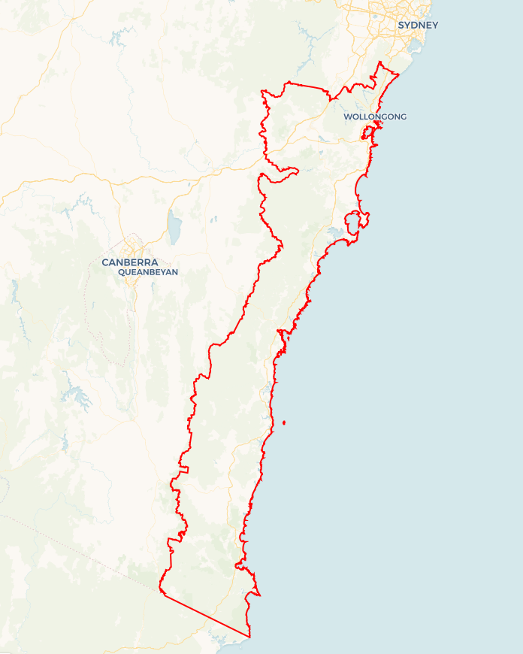
Local Jobs Plan
  - Illawarra South Coast Employment Region | NSW | May 2026
Workforce Australia Local Jobs (Local Jobs) is a program that creates partnerships between business
and communities to meet local workforce needs, thereby improving employment outcomes.
Local Jobs operates in all 51 Employment Regions in Australia.

Local Jobs Overview

Local Jobs Plan
Each Employment Region has a Local Jobs Plan which outlines the labour market challenges in the region and the strategies to address these challenges.

Job Coordinators
Each Employment Region has a dedicated Job Coordinator who leverages existing resources, supports local labour markets through structural adjustments and retrenchments, and creates opportunities for collaboration between business and communities.

Local Jobs and Skills Taskforce
Each Employment Region has its own taskforce that meets regularly with the Job Coordinator to develop an understanding of challenges in the region and implement solutions. The taskforce is comprised of representatives from the region.

Local Jobs, Local People Grant
The Local Jobs, Local People grant funds activities that help people into ongoing employment or training. Activities must support local labour market needs.
Explore labour market insights for
Illawarra South Coast Employment Region

Local labour market challenges
The Illawarra South Coast labour market continues to evolve, with several structural and emerging challenges impacting workforce participation and business growth.

- Youth unemployment and disengagement remain a concern across parts of the region. While there are strong employment opportunities, many young people require additional support to transition effectively into work, particularly those facing transport, confidence, or pathway barriers.
- Transport remains one of the most significant structural barriers to employment. Limited public transport coverage - particularly in the Shoalhaven and Far South Coast - and ongoing challenges in obtaining a driver licence continue to restrict access to jobs, training, and apprenticeships. This is now recognised as a system-wide issue requiring coordinated, cross-sector solutions (reflected in the Work Transit Alliance).
- Persistent disadvantage across key cohorts (First Nations people, long-term unemployed, migrants and refugees, mature aged jobseekers) requires more tailored, place-based responses rather than one-size-fits-all programs.
- Care sector workforce demand remains high but is shifting.
- Demand in childcare and early education remains critical and urgent.
- Disability and home care services continue to require workforce growth.
- Aged care demand has stabilised slightly in the short term but remains a medium-term workforce pressure.
This requires more targeted workforce strategies rather than broad ‘care sector shortages’ messaging.
- Hospitality, tourism and small business are stabilising but fragile. Many businesses continue to face:
- cost-of-living pressures,
- reduced margins,
- cautious hiring behaviour.
Workforce shortages persist in key roles (e.g. chefs) but are more targeted rather than widespread.
- Major project pipeline and industrial transition is accelerating. Growth in:
- manufacturing and defence,
- renewable energy and net zero industries,
- infrastructure and health (e.g. hospitals)
is creating future workforce demand that is not yet fully aligned with current worker pipelines.
- Training system complexity and accessibility remains a barrier. Ongoing changes to Smart and Skilled, funding caps, and course costs are:
- reducing accessibility for some cohorts,
- creating uncertainty for providers and employers.
- Housing availability is constraining workforce attraction and retention, particularly for essential workers and major project delivery.
- Employer engagement remains inconsistent. Many employers:
  - are time-poor,
  - are disengaged from traditional forums,
  - require more direct, targeted engagement approaches.

Local priorities

Priority 1 – Transport and driver licences

What are our challenges?
Transport disadvantage continues to limit access to employment, particularly for young people and disadvantaged cohorts. Existing programs (e.g. Driver Licensing Access Program) are valuable but fragmented and inconsistent across the region. There is a significant opportunity to move from isolated programs to a coordinated, system-level response to transport-to-employment barriers.

How are we responding?
- Leading the implementation of the Work Transit Alliance to coordinate transport solutions across regions, stakeholders, and programs.
- Supporting and strengthening driver mentoring and licensing programs, while improving consistency of access across the region.
- Working with employers and stakeholders to trial practical transport solutions (e.g. employer-led transport, shuttle models, coordinated access).
- Advocating for improved alignment between transport services and employment/training locations.
- Using data and stakeholder insights to identify priority transport gaps and pilot targeted responses.

Priority 2 – First Nations employment and economic participation

What are our challenges?

While strong partnerships exist, outcomes for First Nations employment remain uneven. Greater emphasis is needed on community-led solutions, culturally appropriate pathways, and economic participation through business and procurement.

How are we responding?
- Working in partnership with First Nations organisations and communities to co-design culturally appropriate employment pathways.
- Supporting pre-employment, traineeship and mentoring programs tailored to First Nations participants.
- Strengthening connections between employers and First Nations jobseekers through targeted engagement.
- Supporting the growth of First Nations businesses and procurement opportunities.
- Embedding First Nations participation across all priority areas rather than treating it as a standalone issue.

Priority 3 – Manufacturing, defence, energy, and major projects

What are our challenges?
The region is entering a period of significant industrial and infrastructure growth, but workforce pipelines are not yet aligned to future demand. There is a critical opportunity to better connect employers, training providers, and jobseekers before workforce shortages become acute.

How are we responding?
- Working with key stakeholders (industry, Regional Development Australia, Business Illawarra, University of Wollongong, TAFE, state and local governments, and Jobs and Skills Councils) to align workforce planning with major projects.
- Implementing a Local Jobs First approach to ensure major projects engage early and maximise local employment outcomes.
- Increasing employer engagement through targeted roundtables and direct outreach.
- Supporting initiatives that improve awareness of career pathways in these industries.
- Facilitating collaboration across stakeholders to reduce duplication and improve system coordination.

Priority 4 – Care sector workforce

What are our challenges?
Workforce demand in the care sector remains strong but is increasingly uneven across sub-sectors, with critical shortages in childcare and ongoing demand in aged care and disability services. There is an opportunity to move from broad promotion to targeted workforce strategies aligned to specific areas of need.

How are we responding?
- Working with care sector stakeholders to focus on priority workforce gaps, particularly childcare.
- Supporting targeted recruitment and training initiatives rather than broad sector campaigns.
- Trialling new pathways for career changers and non-traditional entrants.
- Strengthening collaboration between employers and providers to improve job-readiness and retention outcomes.
- Promoting clearer career pathways to improve perception and attractiveness of the sector.

Priority 5 – Hospitality, tourism and small business

What are our challenges?
While workforce shortages have eased in some areas, businesses remain under pressure and are more cautious in hiring and engagement. There is an opportunity to engage employers in more targeted, practical ways aligned to real hiring needs.

How are we responding?
- Partnering with Business Illawarra and others to deliver small, targeted employer roundtables to better understand workforce needs.
- Supporting employers with direct connections to jobseekers and programs.
- Focusing on specific high-need roles (e.g. chefs) rather than broad workforce messaging.
- Working with industry groups to improve the visibility of career pathways and opportunities.
- Supporting initiatives that help businesses engage with workforce solutions with minimal burden.

Priority 6 – Regional collaboration and system alignment

What are our challenges?
The region has a strong network of stakeholders, but coordination can be inconsistent, leading to duplication and missed opportunities. There is an opportunity to strengthen the Local Jobs Program’s role as a connector and coordinator across the employment and skills system.

How are we responding?
- Strengthening collaboration through working groups and taskforce structures aligned to priority areas.
- Improving information sharing between stakeholders, particularly around major projects and workforce needs.
- Aligning training and employment initiatives with real-time labour market intelligence.
- Supporting more joined-up approaches across government, industry and training providers.
- Continuing to refine engagement models to ensure employers are at the centre of discussions.

Want to know more?
- Contact Andrew Wales, Illawarra South Coast Job Coordinator at andrew.wales@illawarrascjobs.com.au
- Visit Local Jobs or Workforce Australia

