


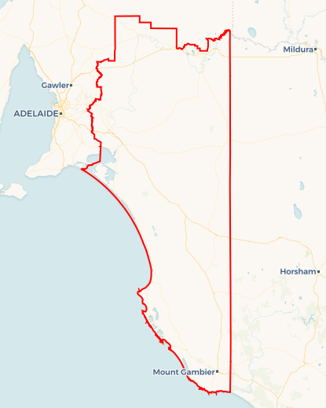
Local Jobs Plan
  - Murray and South East Employment Region | SA | July 2026
Workforce Australia Local Jobs (Local Jobs) is a program that creates partnerships between business
and communities to meet local workforce needs, thereby improving employment outcomes.
Local Jobs operates in all 51 Employment Regions in Australia.

Local Jobs Overview

Local Jobs Plan
Each Employment Region has a Local Jobs Plan which outlines the labour market challenges in the region and the strategies to address these challenges.

Job Coordinators
Each Employment Region has a dedicated Job Coordinator who leverages existing resources, supports local labour markets through structural adjustments and retrenchments, and creates opportunities for collaboration between business and communities.

Local Jobs and Skills Taskforce
Each Employment Region has its own taskforce that meets regularly with the Job Coordinator to develop an understanding of challenges in the region and implement solutions. The taskforce is comprised of representatives from the region.

Local Jobs, Local People Grant
The Local Jobs, Local People grant funds activities that help people into ongoing employment or training. Activities must support local labour market needs.
Explore labour market insights for
Murray and South East Employment Region
Explore labour market insights for
Murray and South East Employment Region

Local labour market challenges

- The Murray and South East Employment Region faces a range of labour market challenges that impact workforce participation and business growth.
- Persistent workforce shortages across key industries are compounded by barriers to attracting and retaining workers, including limited affordable housing and regional workforce mobility constraints.
- Some cohorts, including people experiencing long-term unemployment, First Nations peoples, mature aged job seekers and culturally and linguistically diverse communities, continue to experience higher levels of disadvantage in the labour market.
- Additional barriers such as limited transport options, difficulties obtaining a driver’s licence, and access to locally relevant training can further restrict participation.
- An ongoing need to strengthen employability, digital capability and foundational skills to support individuals to secure, retain and progress in employment opportunities across the region.

Local priorities

Priority 1 – Local people for local jobs

What are our challenges?

Employers in the region continue to experience difficulty filling vacancies with local candidates. At the same time, some job seekers need support to become job ready to secure employment opportunities. Limited capacity to attract workers from outside the region increases the need to improve local workforce participation.

How are we responding?
Activities will focus on improving connections between employers, job seekers and services, and strengthening local pathways into employment.
Key actions include:
- delivering coordinated jobs, skills and careers events to connect employers, job seekers and service providers
- promoting awareness of local job opportunities and career pathways, including in priority industries
- supporting direct recruitment through structured and coordinated employer engagement
- improving job readiness to better align with employer expectations
- strengthening coordination across employment, training and community services to support clearer pathways into work.

Priority 2 – Workforce pathways for priority cohorts

What are our challenges?
Young people, First Nations peoples, mature aged job seekers and people experiencing long-term unemployment often face barriers to securing and maintaining employment, including limited work experience, lower confidence, and other personal or systemic challenges. There is an opportunity to strengthen workforce participation by supporting employers to recruit and retain people from these cohorts, while creating targeted pathways into sustainable employment.

How are we responding?
Activities will support improved access to employment for priority cohorts and promote inclusive recruitment practices.
Key actions include:
- delivering targeted employment and careers activities, including youth-focused initiatives
- supporting culturally appropriate and safe employment pathways for First Nations peoples
- promoting flexible and inclusive employment opportunities
- supporting employers to adopt inclusive recruitment practices and build capability in workforce diversity
- working with employers and community partners to address cohort-specific barriers, including age-related perceptions and culturally safe engagement.

Priority 3 – Skills development aligned to local industry needs

What are our challenges?

There is a need to ensure that training and skills development align with current and emerging industry requirements. Limited access to locally delivered training can restrict workforce supply and impact productivity.

How are we responding?
Activities will strengthen alignment between training, employment services and industry demand to support job outcomes.
Key actions include:
- supporting industry-led training initiatives that respond to identified workforce needs
- embedding training within employment opportunities including workplace-based training for new employees and to upskill existing employees
- improving coordination between employers, training providers and employment services to ensure job seekers have the required vocational and non-vocational training to meet the needs of local employment opportunities
- increasing access to locally delivered training aligned to priority skills needs
- supporting upskilling and reskilling of both job seekers and existing workers
- encouraging flexible and responsive training approaches to meet changing labour market conditions.

Priority 4 – Reducing barriers to workforce participation

What are our challenges?

Vocational, non-vocational and personal barriers continue to limit participation in employment and training. These include transport and licensing issues, health and wellbeing challenges, and gaps in employability and digital literacy. Without addressing these barriers, employment outcomes are less likely to be sustained.

How are we responding?
Activities will focus on reducing barriers and supporting long-term participation in employment.
Key actions include:
- improving access to driver’s licences and transport solutions
- building employability, work readiness and digital literacy skills
- connecting individuals to coordinated support services, including mental health and alcohol and other drug supports
- supporting flexible job design and local placement solutions
- improving health and community service integration to deliver more coordinated and effective support.

Priority 5 – Strengthening workforce coordination and employer capability

What are our challenges?

Employers may require additional support to access workforce, training and support services. This can limit the effectiveness of workforce initiatives and labour market outcomes.

How are we responding?
Activities will strengthen coordination across the local employment and skills system and build employer capability.
Key actions include:
- facilitating collaboration between employers, service providers and stakeholders through forums and events
- supporting employers to navigate workforce, training and support systems
- using local workforce intelligence to inform planning, priorities and investment
- supporting employers to strengthen workforce planning, recruitment and retention practices
- coordinating timely responses to workforce disruption, including business closures
- leveraging the Local Jobs and Skills Taskforce to provide regional leadership, oversight and shared accountability.

Want to know more?
- Contact: Christine Willersdorf, Murray and South East Job Coordinator: Christine.willersdorf@mylocaljobsprogram.com.au
- Visit: Local Jobs or Workforce Australia

