


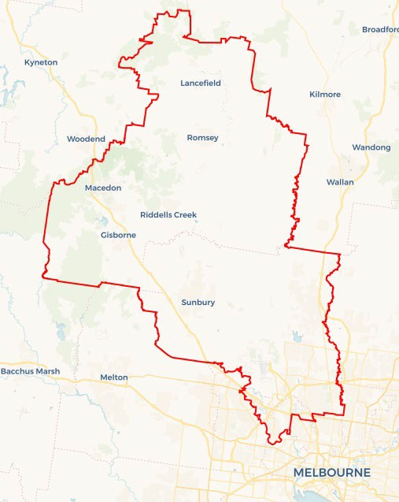
Local Jobs Plan
Explore labour market insights for the North Western Melbourne Employment Region
  - North Western Melbourne Employment Region | VIC | June 2026
Workforce Australia Local Jobs (Local Jobs) is a program that creates partnerships between business
and communities to meet local workforce needs, thereby improving employment outcomes.
Local Jobs operates in all 51 Employment Regions in Australia.

Local Jobs Overview

Local Jobs Plan
Each Employment Region has a Local Jobs Plan which outlines local labour market trends in the region and strategies to address these challenges.

Job Coordinators
Each Employment Region has a dedicated Job Coordinator who leverages existing resources, supports local labour markets through structural adjustments and retrenchments, and creates opportunities for collaboration between business and communities.

Local Jobs and Skills Taskforce
Each Employment Region has its own taskforce that meets regularly with the Job Coordinator to develop an understanding of challenges in the region and implement solutions. The taskforce is comprised of representatives from the region.

Local Jobs, Local People Grant
The Local Jobs, Local People grant funds activities that help people into ongoing employment or training. Activities must support local labour market needs.

Local labour market challenges

- Persistent shortages in major employing sectors including health care and social assistance, construction, education and training, manufacturing, transport, postal and warehousing.
- High demand for skilled workers which is misaligned with the current labour market supply.
- Significant proportion of multicultural communities with valuable skills and experience, yet often encounter challenges such as transport, language, and cultural differences limiting full participation in the labour market.
- Transport limitations and insufficient public transport options, particularly for shift work, reducing accessibility to employment.
- Youth unemployment rate is one of the highest in the country.

Local priorities

Priority 1 – Employment pathways into emerging industries

What are our challenges?

Our focus is on connecting people to opportunities in emerging industries in the region. Healthcare and social assistance remains a key sector with projected growth in industries such as education and training, tourism and information technology resulting in increased local employment opportunities. Reskilling and upskilling clients with relevant industry training is necessary to meet current and future demand. Achieving this requires ongoing understanding of regional economic development and targeted reskilling and upskilling to meet future workforce and industry needs.

How are we responding?
- Collaborating with local government, State Economic Development and Skills Authorities representatives across the region to identify emerging employment opportunities related to investment and infrastructure projects in growth industries.
- Actively participating in committees and working groups across the North Western Melbourne education and employment ecosystem, bringing together stakeholders from all levels of government, community organisations, social enterprises, employers and providers to identify emerging employment opportunities linked to investment and infrastructure in growth industries.
- Engaging and collaborating with employers and industry to support skill development to understand current and future workforce requirements.
- Aligning our schools and education networks such as local councils, Hume Employment Learning Committee, Registered Training Organisations (RTOs), TAFEs, Local Learning and Employment Networks (LLEN) and Apprentice Connect Australia Providers to offer opportunities that are currently available in emerging industries in the region.

Priority 2 – Young people (youth)

What are our challenges?

Youth unemployment remains a priority area, due to the high rate in the region compared to the national average. A key focus will be engaging young people who are currently disconnected from support services. This will have a focus on people from intersecting marginalised communities, including those from multicultural communities and First Nations young people.

How are we responding?
- Supporting the development of targeted industry programs that encourage the employment of young people for the apprenticeship/traineeship sector.
- Collaborating with LLENs, local government youth services, the Hume Community Investment Committee, local schools in the region and Workforce Australia Providers to increase the uptake and completion of work preparation programs.
- Facilitating the creation of targeted industry programs that motivate young people to explore and pursue apprenticeships and traineeships in these sectors. Identifying these early and working with local high schools to increase uptake.

Priority 3 – Overcoming challenges to employment for multicultural communities

What are our challenges?

We will address challenges to employment for multicultural people by providing pathways and training that align to local job opportunities. Commonly reported challenges to employment include limited language, literacy and numeracy skills, lack of recognition of overseas qualifications, no prior Australian work experience, minimal access to transport and affordable housing close to employment and lack of experience in Australian workplace culture and systems.

How are we responding?
- Working with industry employers to build awareness of the challenges relating to transport and building capacity to change working hours to align with public transport options.
- Encouraging industry and employers to introduce revised policies in multiple languages, mitigating the need for new employees to be immediately fluent in English.
- Working with and promoting the Self Employment Assistance program for individuals interested in self-employment.
- Collaborating with and promoting the Overseas Qualification Assessment service to support overseas qualified migrants in continue in career pathways aligned to their qualifications.
- Collaborating with Community Settlement and Engagement Transition Support program provider, Migrant Resource Centre to educate and inform multicultural communities of the Australian workplace culture and systems.

Priority 4 – Education, training and skills development

What are our challenges?

Leveraging the region’s diverse labour market while developing the skills of local people to support employment growth and meet ongoing workforce demand is an ongoing challenge. A strong focus will be placed on developing these local skills to improve access to employment opportunities. This approach will also ensure alignment between workforce capability and employer needs.

How are we responding?
- Engaging with industry and employers to identify and develop local programs that support opportunities for skills development and pathways to employment.
- Generating opportunities for skills development aligned with the needs of the local labour market, including apprenticeships and traineeships.
- Leveraging pre-employment programs such as Skills for Education and Employment, the Adult Migrant Education Program and Skills and Jobs Centres to assist individuals with low English and digital literacy skills and limited labour market experience in Australia.
- Partnering with local employers and industry representatives to promote inclusive recruitment practices that recognise overseas qualifications, international work experience and lived experience.
- Engaging with TAFE, education providers and RTOs to understand new and revised qualification opportunities.

Priority 5 – Increasing inclusive participation into employment

What are our challenges?

There is a strong opportunity to promote more inclusive employment practices among employers across the region. This includes increasing awareness and creating opportunities for under-represented groups, such as women in male-dominated industries. Strengthening inclusive recruitment and workplace practices will support more equitable employment outcomes.

How are we responding?
- Collaborating with the Brotherhood of St Laurence’s Hume Community Investment Committee and Workforce Australia’s Parent Pathways program, which includes members with lived experience, to gain a comprehensive understanding of the factors driving and supporting female participation.
- Identifying gaps in existing and planned employment and skills initiatives to developing inclusive, place-based approaches, including pre-employment, education and training programs aimed at achieving greater employment outcomes.
- Engaging with employers and industries affected by skills shortages to co-develop targeted industry led training and employment opportunities.

Priority 6 – Supporting business and industry through technological and automation transitions

What are our challenges?

We will respond to rapid technological change and automation, which are reshaping workforce needs across industries such as manufacturing, transport, logistics, and construction. The evolving impact of artificial intelligence is changing entry-level roles and increasing demand for new and specialist skills. Targeted support will prioritise minority groups who traditionally have high participation in these roles, including culturally and linguistically diverse communities, women, and youth. This is to ensure they are equipped to access emerging opportunities.

How are we responding?
- Using employment region data and insights to identify skills and training gaps for future in-demand opportunities.
- Connecting industry and educational institutions to develop training for future skills needs.
- Supporting businesses and supply chains in assisting to identify opportunities within industries impacted by technological and automation advancements.
- Working in partnership with Industry Adjustments team to guide employers through best practice retrenchment processes and provide advice on additional support through local providers.
- Building stronger pathways for AI-related technical skills, including micro-credentials, apprenticeships in robotics/automation and applied learning projects.

Want to know more?
- Contact Lee Matthews, North Western Melbourne Job Coordinator at lee.matthews@mylocaljobsprogram.com.au
- Visit Local Jobs or Workforce Australia

