Job Seeker Activities

What are they

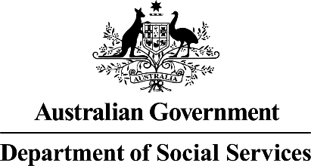  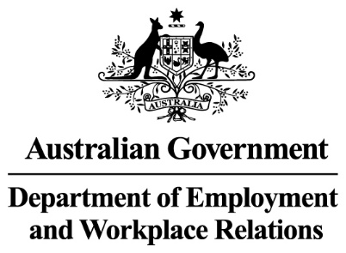 | The Australian Government  - Department of Social Services wrote this.  We say DSS for short.  - Department of Employment and Workplace Relations  We say DEWR for short.  When you see the word we it means DSS and DEWR.
 | We wrote this in an easy to read way.  We use pictures to explain some ideas.
 | We have some words in bold.  This means the letters are thicker and darker.  These are important words.
 | This is an Easy Read summary of another document.  This means it has the most important ideas.
 | You can ask for help to read this document.  You can ask  - A friend  - Family members  - A support person.

What are mutual obligation activities

 | We have laws for  - People who get Centrelink money for not having a job  We call this job seeker.
 | - The things they need to do to get their Centrelink money.  We call these activities.  Laws are rules for how we live.
 | The activities could be  - Making a job plan
 | - Get a set number of points  You get points for doing things like putting in a job application.
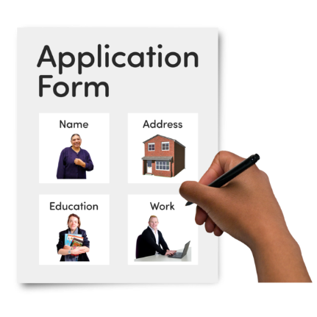 | Applications are forms you fill out to say you want to work at a job.
 | - Turn up to appointments about getting a job  - At all  - On time
 | - Take part in activities that we say you have to  These are called compulsory activities.
 | - Look for a job
 | - Do what is in your job plan
 | - Act in a safe way in your  - Appointments  - Activities
 | - Go to job interviews  - Act in a safe way in the job interviews
 | - Try and get a job if someone helps you.
 | All the activities are called mutual obligations.
 | It is called mutual obligation failure if you do not do them.
 | If you do not do them we can  - Make changes to  - Stop  Your Centrelink money.

What you need to do

 | You do not need to do anything at the moment.
 | You need to keep doing your activities.
 | Talk to  - Your employment provider
 | - The Digital Services Contact Centre  1800 314 677  To make sure your activities are right for you.

Support

 | You might  - Have questions
 | - Be worried
 | - Want to make a complaint.  Complaints are when you tell someone they have not done a good job.  Everyone has the right to make a complaint.
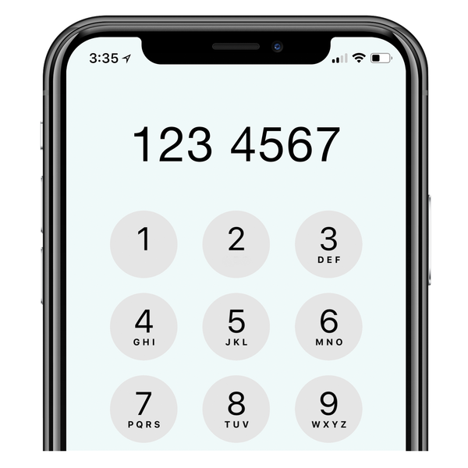 | You can call the DEWR National Customer Service Line  1800 805 260
Images in this Easy Read must not be used or copied without permission

