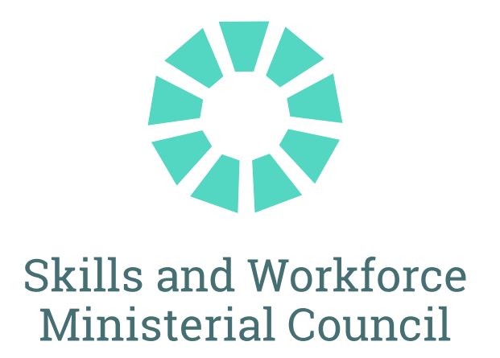

**The Hon Andrew Giles MP**

Minister for Skills and Training 

**The Hon Rosslyn Bates MP**

**Queensland**

Minister for Finance, Trade, Employment and Training

**The Hon Blair Boyer MP**

**South Australia**Minister for Education, Training and Skills

**Mr Michael Pettersson MLA   
Australian Capital Territory**Minister for Skills, Training and Industrial Relations

**The Hon Amber-Jade Sanderson MLA    
Western Australia**

Minister for Skills and TAFE 

**The Hon Gayle Tierney MLC**

**Victoria**

Minister for Training and Skills

Senior officials observed the meeting for New South Wales, Northern Territory and Tasmanian Governments

**JOINT COMMUNIQUÉ**

13 June 2025

COMMUNIQUE

**MEETING OF FEDERAL, STATE AND TERRITORY SKILLS MINISTERS**

Federal, state and territory Skills Ministers met today in Brisbane to collaborate on improvements to the vocational education and training system that will lift productivity and act as a critical enabler of inclusion and economic equality for individuals.

Skills Ministers discussed the central role that the skills and TAFE system must play to support the Australian Government’s economic and productivity growth agenda. Skills Ministers recognised that building the skilled and adaptable workforce required for the future economy requires a more cohesive and harmonised tertiary education sector.

## Delivering Housing Supply

Governments share an ambitious agenda to increase the supply of housing in Australia. Skills and workforce shortages remain one of the most significant challenges to improving housing supply. Skills Ministers discussed approaches to strengthen the pipeline of skilled residential construction workers to meet this national priority.

Skills Ministers discussed actions underway in each jurisdiction and the ongoing importance of national investment in programs that build capacity in the construction workforce, such as Fee-Free TAFE Construction, initiatives to grow female participation in the construction workforce, including the Construction Industry Culture Standard, the Advanced Entry Trades Training Program to support 6,000 tradies to gain formal qualifications and the Key Apprenticeship Program – Housing and Construction Stream.

## Future Apprenticeships and Traineeships

Skills Ministers agreed the critical importance of apprentices and trainees to meeting Australia’s skills needs, both in housing supply and more broadly. Ministers committed to prioritising increasing commencements and completions in priority areas. In 2025, the Skills and Workforce Ministerial Council will explore, collaborate and address issues of national importance through a standing agenda item on apprenticeships and traineeships, including consideration of the longer-term opportunities identified in the Strategic Review of Australian Apprenticeship Incentive System.

Ministers agreed to the development of a Future Apprenticeships Workplan to deliver immediate and long-term actions to support the ambitions for growth in priority areas, which will be approved by Skills Ministers in quarter 3.

## Integrity in training

The integrity of the vocational education and training system is central to delivering an appropriately skilled workforce. Ms Saxon Rice, Chief Executive Officer of the Australian Skills Quality Authority (ASQA) briefed Ministers on how recent work to revise outcome-focused standards for Registered Training Organisations will drive quality improvements in the sector. Skills Ministers noted ASQA’s ongoing program of work to build provider capacity and ensure integrity in the training system.

## National TAFE Network

Skills Ministers noted progress to establish a National TAFE Network, with five jurisdictions signing on to the policy initiative. The National TAFE Network is an essential piece of architecture that complements and maximises the benefits of initiatives under the National Skills Agreement, including TAFE Centres of Excellence. Skills Ministers noted that a National TAFE Network Committee will commence operating in the second half of 2025 and will guide the development of projects to be funded under the National TAFE Network.

## WorldSkills Australia

Skills Ministers met alongside the WorldSkills Australia National Championships and Skills Show, an event Ministers commended for the role it plays in showcasing the breadth of vocational education and training. WorldSkills Australia competitions are held in 34 regions around Australia with more than 60 trades and skills represented.

Mr Trevor Schwenke, Chief Executive Officer, and Ms Mary Faraone, Chair, of WorldSkills Australia addressed Skills Ministers, describing the work of WorldSkills Australia that promotes and develops skills excellence for Australians by benchmarking and showcasing Australian skills through regional, national and international competitions.

**FRIDAY, 13 JUNE 2025**

## MEDIA CONTACTS:

**Minister Giles (Commonwealth):**

Emilia Hutchinson

0498 532 097

emilia.hutchinson@dewr.gov.au

**Minister Bates (Qld):**

Justin Armsden

0417 518 532 / (07) 3719 7560

justin.armsden@ministerial.qld.gov.au

**Minister Ellis (Tas):**

Will Sanderson

0487 190 927

will.sanderson@dpac.tas.gov.au

**Minister Boyer (SA):**

Nadine De Bono

0487 878 077

[nadine.DeBono@sa.gov.au](mailto:nadine.DeBono@sa.gov.au)

**Minister Whan (NSW):**

Fee Chemke-Dreyfus

0447 404 353

fee.chemke-dreyfus@minister.nsw.gov.au

**Minister Hersey (NT):**

Zac Webster

0466 102 011

[zac.webster@nt.gov.au](mailto:zac.webster@nt.gov.au)

**Minister Pettersson (ACT):**

Jasmine Dickinson

0407 261 488

jasmine.dickinson@act.gov.au

**Minister Sanderson (WA):**

Chris Manly

0448 298 197

chris.manly@dpc.wa.gov.au

**Minister Tierney (Vic):**

Lloyd Skinner

Office: 03 8392 2220

lloyd.skinner@minstaff.vic.gov.au