

Local Jobs Plan

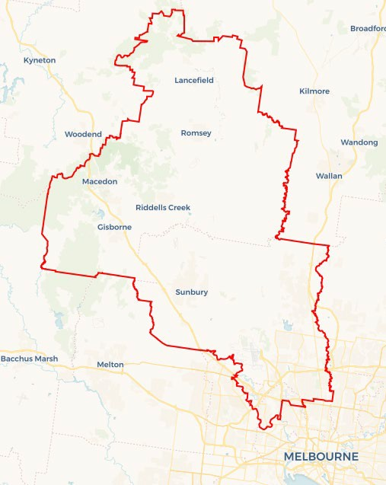

Explore labour market insights for the[North Western Melbourne](https://www.jobsandskills.gov.au/data/employment-region-dashboards-and-profiles/monthly-labour-market-dashboards) Employment Region

## North Western Melbourne Employment Region | VIC | January 2025

Workforce Australia Local Jobs (Local Jobs) is a program designed to support customised approaches for accelerating reskilling, upskilling, and creating employment pathways to address current and emerging local workforce needs.

**Local Jobs elements**

**Local Jobs Plan**

The Local Jobs Plan sets out the skills and employment challenges and priorities of the region, and associated strategies that will drive the design and implementation of activities

to address these challenges.

**Local Jobs and Skills Taskforce**

Each Employment Region has its own Taskforce. Representatives include local stakeholders who have demonstrated experience in upskilling, reskilling, and an ability to represent, connect and collaborate with others in the region to

meet labour market needs.

**Employment Facilitators**

Employment Facilitators and Support Officers support the delivery of the program by bringing together key stakeholders including businesses, employment services providers, and higher

education and training organisations.

**Local Recovery and National**

**Priority Funds**

The Local Recovery Fund supports projects that meet the priorities identified in the Local Jobs Plan. The National Priority Fund provides funding for innovative local solutions to address

structural barriers to employment.

# Local labour market challenges in the region

* Labour demand and skill shortages exist in the region’s major employing sectors including health care and social assistance, construction, manufacturing, transport, postal and warehousing.
* There is a significant population of multicultural communities, many of whom have unrecognised qualifications.
* Limited access to public transport including a lack of options that align to shift work start and end times.
* A high proportion of culturally and linguistically diverse (CaLD) and refugee communities face multiple challenges to employment such as transport and language and cultural challenges. Many face challenges in applying their skills and experience to the Australian labour market.
* The region has the highest youth unemployment rate in Victoria and a lower employment participation rate than the Australian national average.
* The proportion of the working-age population on income support is higher than the Victorian and Australian average.

## Local jobs and skills priorities and strategies in the region

## Priority 1 – Employment pathways into emerging industries

### What are our challenges and opportunities?

Manufacturing is a key industry in the region with other industries emerging such as early childhood, health care, transport, logistics with significant employment opportunities. Reskilling and upskilling clients in these industries will be required to meet this demand. We need to understand our emerging industries and the economic development of our region to support our response to industry around future workforce and skills requirements.

### How are we responding?

* Collaborating with local government, State Economic Development and Skills Authorities representatives across the region to identify emerging employment opportunities related to investment and infrastructure projects in growth industries.
* Engaging and collaborating with employers and industry to support skill development to understand current and future workforce requirements.
* Supporting key stakeholders, such as local Registered Training Organisations (RTOs), TAFEs, Local Learning and Employment Networks (LLEN) and Apprentice Connect Australia Providers who are aligned to our school network and play a key role in providing information related to emerging industries and future jobs.
* Introducing a future skills impact group which consists of regional key stakeholders who collaborate to understand emerging and future skills. This information will be used to inform skills program design and support alignment to industry requirements.

## Priority 2 – Young people (youth)

### What are our challenges and opportunities?

The youth unemployment rate for North Western Melbourne remains high against the average in Australia. A proportion of this cohort are disengaged from support services, including representation from multicultural communities.

### How are we responding?

* Supporting the development of targeted industry programs that encourage the employment of young people for the apprenticeship/traineeship sector.
* Introducing a youth impact group to identify future skills and youth employment pathways that support the development of youth co-designed job readiness programs.
* Collaborating with LLENs, local government youth services, the Hume Community Investment Committee and Workforce Australia Providers to increase the uptake and completion of work preparation programs.
* Facilitating the creation of targeted industry programs that motivate young people to explore and pursue apprenticeships and traineeships in these sectors.

## Priority 3 – Overcoming challenges to employment for multicultural communities

### What are our challenges and opportunities?

There are opportunities to address challenges to employment for CaLD clients by targeting supported employment pathways to job opportunities. Commonly reported challenges to employment include limited language, literacy and numeracy skills, lack of recognition of overseas qualifications, limited Australian work experience, limited access to transport and affordable housing close to employment and limited knowledge of Australian workplace culture and systems.

### How are we responding?

* Working with industry employers to build awareness of the challenges relating to transport and building capacity to change working hours to align with public transport options.
* Encouraging industry and employers to introduce revised policies in multiple languages, mitigating the need for new employees to be immediately fluent in English.
* Working with and promoting the Self Employment Assistance program for individuals interested in self-employment.
* Collaborating with and promoting the Overseas Qualification Assessment service to support overseas qualified migrants in continue in career pathways aligned to their qualifications.
* Collaborating with Community Settlement and Engagement Transition Support program provider, Migration Services – a Workforce Australia Specialist Provider - to educate and inform multicultural communities of the Australian workplace culture and systems.

## Priority 4 – Education, training and skills development

### What are our challenges and opportunities?

Our labour market covers a broad range of industry sectors and presents opportunities for employment growth to meet the ongoing high demand for workers in the region. Focusing on the skills development of local people will enhance access to employment and support the skills required by employers and industry.

### How are we responding?

* Engaging with industry and employers to identify and develop local programs that support opportunities for skills development and pathways to employment.
* Generating opportunities for skills development aligned with the needs of the local labour market, including apprenticeships and traineeships.
* Leveraging pre-employment programs such as Skills for Education and Employment, the Adult Migrant Education Program and Skills and Jobs Centres to assist individuals with low English literacy levels and limited labour market experience in Australia.
* Educating and encouraging businesses and industries to prioritise recruitment based on behaviours and competencies.
* Engaging with TAFE, education providers and RTOs to understand new and revised qualification opportunities.

## Priority 5 – Increasing female participation into employment

### What are our challenges and opportunities?

There are opportunities to engage with and support female clients in accessing employment opportunities aligned with local skill needs, including in traditionally   
male-dominated industry sectors across the region.

### How are we responding?

* Collaborating with the Community Revitalisation Committee and Workforce Australia’s Parent Pathways program, which includes members with lived experience, to gain a comprehensive understanding of the factors driving and supporting female participation.
* Identifying gaps in existing and planned employment and skills initiatives to developing inclusive, place-based approaches, including pre-employment, education and training programs aimed at achieving greater employment outcomes.
* Engaging with employers in industries that report shortages to facilitate the development of industry led training and employment initiatives that increase opportunities and outcomes for females.

## Priority 6 – Supporting business and industry through transition to Net Zero economy

### What are our challenges and opportunities?

The skills, training and education sectors face challenges in anticipating emerging, Net Zero economy in-demand skills. Specialist skills are required in manufacturing, transport, logistics and construction. The benefits of Net Zero investments are shared with community groups, including those who do not traditionally have high participation rates in the energy sector (e.g., CaLD communities, women and youth).

### How are we responding?

* Using employment region data and insights to identify skills and training gaps for future in-demand opportunities.
* Connecting industry and educational institutions to develop training for future skills needs.
* Supporting impacted businesses and supply chains and assisting them to identify opportunities within the Net Zero local economy.
* Working collaboratively across all levels of government to develop activities.
* Working as part of the Transition Support Network to guide employers through best practice retrenchment processes.

# Want to know more?

* Contact: David Turnbull, North Western Melbourne Employment Facilitator: [david.turnbull@employmentfacilitator.com.au](mailto:david.turnbull@employmentfacilitator.com.au)
* Visit: [Local Jobs](https://www.dewr.gov.au/local-jobs/employment-facilitators/victoria/north-western-melbourne) or [Workforce Australia](https://www.workforceaustralia.gov.au/" \t "_blank)



*The Department of Employment and Workplace Relations acknowledges the traditional owners and custodians of country throughout Australia and their continuing connection to land, waters, and community. We pay our respects to them and their cultures, and Elders past, present and emerging.*