


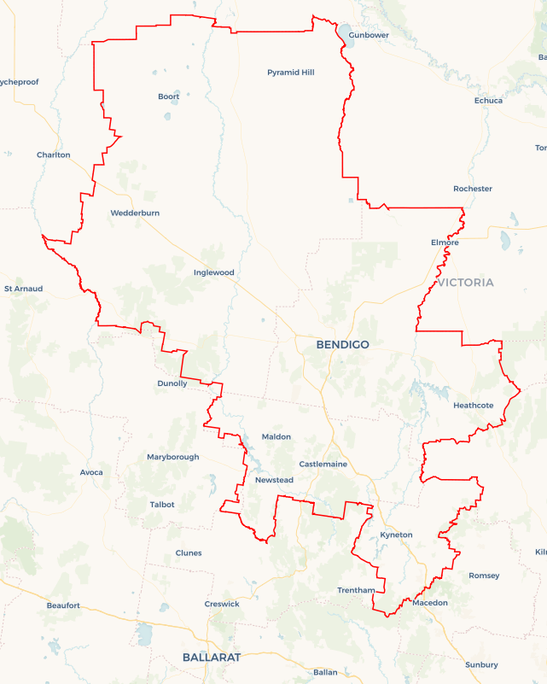
Local Jobs Plan
  - Bendigo Employment Region | Victoria | January 2026
Workforce Australia Local Jobs (Local Jobs) is a program that creates partnerships between business
and communities to meet local workforce needs, thereby improving employment outcomes.
Local Jobs operates in all 51 Employment Regions in Australia.

Local Jobs Overview

Local Jobs Plan
Each Employment Region has a Local Jobs Plan which outlines the labour market challenges in the region and the strategies to address these challenges.

Job Coordinators
Each Employment Region has a dedicated Job Coordinator who leverages existing resources, supports local labour markets through structural adjustments and retrenchments, and creates opportunities for collaboration between business and communities.

Local Jobs and Skills Taskforce
Each Employment Region has its own taskforce that meets regularly with the Job Coordinator to develop an understanding of challenges in the region and implement solutions. The taskforce is comprised of representatives from the region.

Local Jobs, Local People Grant
The Local Jobs, Local People grant funds activities that help people into ongoing employment or training. Activities must support local labour market needs.
Explore labour market insights for
Bendigo Employment Region

Local labour market challenges

- A high proportion of participants in employment services have been receiving assistance for more than 12 months and face complex challenges to employment.
- Youth unemployment in the region remains high.
- Labour and skills shortages are impacting ability for businesses to find suitable workers to operate and grow their business.
- Transitioning to a net zero economy will require new skills and jobs in traditional and emerging sectors.

Local priorities

Priority 1 – Long term participants in employment services

What are our challenges?
The proportion of participants receiving assistance from Workforce Australia Employment Services Providers for more than 12 months is significant. Individuals are ready to work but may need support with transport, health and housing. Place-based, tailored approaches are needed to prepare participants to enter or re-enter the workforce and retain employment.

How are we responding?
- Engage regularly with Workforce Australia Services Providers and the community to better understand challenges to training and employment. Meet with APM Employment, CVGT Employment and Axis Employment every two months to co-design place-based activities and resources that enable individuals to progress towards employment.
- Build the capacity of individuals to enter or re-enter the workforce. Support activities that address challenges to employment, build confidence, create aspiration, provide relevant skill sets and introduce individuals to local businesses with current employment opportunities.
- Raise awareness of the need for entrepreneurial capability and promote organisations that support self-employment initiatives.
- Produce guides that support businesses and individuals to better connect. These will provide insight into the supports available for individuals looking for employment and businesses looking for workers and will be updated every six months. Networking events promoting the guides will also help stakeholders and businesses connect.

Priority 2 – Youth unemployment

What are our challenges?
Youth unemployment (people aged 15 - 24 years) rates remain significantly higher than the total unemployment rate in the Bendigo Employment Region. Occupations with higher skill levels have strong forecasted growth to 2034 in the Bendigo Employment Region – many of which require apprenticeship or traineeship qualifications. There are opportunities to connect young people with employers.

How are we responding?
- Promote training and pathway to employment programs to young people and their support networks. Continue to engage with Employment Services Providers, the Transition to Work program, YO Bendigo, headspace Bendigo, School Based Apprenticeship and Traineeship programs and secondary school Careers Practitioners.
- Support aspirational speakers to engage with young people and raise awareness of the benefits of apprenticeships and traineeships. Collaborate with the Minerals Council of Australia and other stakeholders to deliver events in early 2026.
Connect businesses with entry-level apprenticeship and traineeship employment opportunities to the community. Arrange workplace tours in early 2026 to strengthen relationships between business, Employment Services Providers and Careers Practitioners.

Priority 3 – Occupations in demand

What are our challenges?
Local businesses have entry level and skilled employment opportunities. To continue to grow they need to recruit local people and provide opportunities for upskilling.

How are we responding?
- Work with local businesses and training providers to promote existing courses and job programs so more people can access and complete training.
- Connect businesses that have current and upcoming recruitment needs with Workforce Australia Employment Services Providers, training organisations, and other initiatives that support individuals into employment.
- Assist local businesses to make employment opportunities more accessible to individuals by increasing their capacity to recruit, onboard and retain employees. Provide resources and events that promote inclusion and diversity in the workplace. Support businesses to provide peer support and mentoring to participants with challenges to employment. Promote the benefits of culturally safe workplaces. Support programs that help people enter roles typically associated with a different gender. Co-design of training for businesses in the Construction Industry to attract and retain women, gender diverse and non-binary people will commence in late 2025 and the project will be delivered in late 2026.

Priority 4 – Skills for the future

What are our challenges?

Skill shortages are most common in occupations requiring an apprenticeship or traineeship. Jobs growth is expected to be highest across service industries and in jobs requiring higher level qualifications. The green economy and technologies provide cutting-edge opportunities requiring additional skills, new credentials and new occupations. Apprenticeships and traineeships provide an opportunity to equip individuals with the skills needed for many net zero carbon and green economy occupations.

How are we responding?
- Engage with industry to identify the employment opportunities available and the skills needed. Share this information with Workforce Australia Employment Services Providers and the community. Address skills shortages by recognising individuals’ existing skills and promoting these to industry.
- Strengthen connections between businesses, Workforce Australia Employment Services Providers, training organisations and other industry stakeholders. Building these relationships will streamline pathways into employment opportunities and increase participation in upskilling initiatives. Facilitate online information sessions, workplace tours and networking events.
- Raise awareness of the benefits of apprenticeships and traineeships to businesses and individuals as these employment opportunities provide training and skill development for occupations with strong forecasted demand. Relaunch the Local Apprenticeship and Traineeship Fact Sheet at a networking event in early 2026 to help stakeholders better connect and help individuals understand the supports available locally.
- Promote micro-credentials and short courses that build in-demand specialised skills locally. Support training that develops soft skills, entrepreneurial capability, digital literacy and pathways to higher education. Foster locally led initiatives that expand specialised services, create training opportunities and deliver place-based solutions such as work-integrated social enterprises. Throughout 2026, raise awareness by engaging directly with Employment Services Providers and stakeholders, including Learn Local providers.

Want to know more
- Contact Christopher Booth, Bendigo Job Coordinator at Chris.Booth@localjobs.org.au
- Visit Local Jobs or Workforce Australia

