


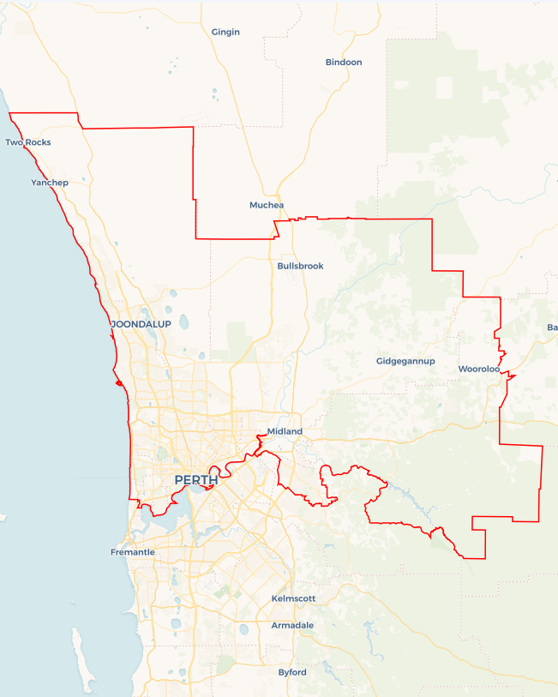
Local Jobs Plan
  - Perth North Employment Region | WA | February 2026
Workforce Australia Local Jobs (Local Jobs) is a program that creates partnerships between business
and communities to meet local workforce needs, thereby improving employment outcomes.
Local Jobs operates in all 51 Employment Regions in Australia.

Local Jobs Overview

Local Jobs Plan
Each Employment Region has a Local Jobs Plan which outlines the labour market challenges in the region and the strategies to address these challenges.

Job Coordinators
Each Employment Region has a dedicated Job Coordinator who leverages existing resources, supports local labour markets through structural adjustments and retrenchments, and creates opportunities for collaboration between business and communities.

Local Jobs and Skills Taskforce
Each Employment Region has its own taskforce that meets regularly with the Job Coordinator to develop an understanding of challenges in the region and implement solutions. The taskforce is comprised of representatives from the region.

Local Jobs, Local People Grant
The Local Jobs, Local People grant funds activities that help people into ongoing employment or training. Activities must support local labour market needs.
Explore labour market insights for the
Perth North Employment Region

Local labour market challenges

- An ageing population is driving increased demand for workers in the care and support sector, where attraction and retention remain ongoing challenges. This is further compounded by an ageing workforce and the implementation of decentralised care models designed to meet the needs of older Australians.
- Apprenticeship commencements have fallen to record lows, driven by a decline in employer opportunities, comparatively low apprentice wages, insufficient foundational skills, and limited work readiness among school leavers.
- Young people face limited and fragmented pathways from education, training and support systems into paid employment. Increasingly, entry-level roles demand prior experience, forcing many young people into insecure, casual or short-term work rather than sustainable employment.
- Historically low housing availability is constraining the labour market while simultaneously increasing housing insecurity. This challenge is compounded by the current cost of living crisis, with average weekly rents exceeding $700. In 2025, Greater Perth housing prices rose by 15.9%, pushing the median house price above $930,000.
- A proportion of Workforce Australia Participants experience intermittent casual employment and extended periods of unemployment. To improve workplace readiness, longer-duration training programs that incorporate motivation and resilience-building skills are often required to support sustainable employment outcomes.

Local priorities

Priority 1 – Address challenges and disincentives to work

What are our challenges?

Complex challenges to employment include housing insecurity, transport challenges and mental health illness. Support to develop teamwork, soft skills, resilience and motivation, combined with provision of on-the-job mentoring support and wrap around services, are crucial supports in building employment pathways for the most challenged individuals.

How are we responding?
- We are working with state government departments, specialist and community organisations to connect into existing programs and develop initiatives that support people to break down challenges that lead into employment opportunities.
- We are working with specialist organisations and programs to understand the issues and experiences surrounding mental health to develop support mechanisms for individuals.
- We are developing cohort specific strategies to better prepare individuals for the labour market.
- We are working with local businesses to create employment opportunities aligned with the labour needs through a focus on reducing challenges to employment.
- We are partnering with employers to promote flexible work options that accommodate individuals facing personal challenges, such as caregiving responsibilities or mental health conditions.
- We are working with specialist providers delivering financial literacy programs to help individuals manage costs associated with housing, travel and mental healthcare services.
- We are working with social enterprises to promote employment and training opportunities, address social challenges and provide supportive structures for people to return to work.

Priority 2 – Boost apprenticeship and traineeship commencements to match areas of need

What are our challenges?
Improving the collaboration with businesses and industry to address the skills requirement through training, upskilling, reskilling, apprenticeships and traineeships aligned with local employment needs and future infrastructure construction.

How are we responding?
- We are promoting emerging employment, education and training opportunities for clean energy careers.
- We are promoting careers linked to traineeships and apprenticeships to increase the workforce; with a focus on sectors experiencing skills shortages or listed on the Occupational Shortage List.
- We are working with employers to increase awareness of employment and training programs through Workforce Australia, Apprentice Connect Providers and Group Training Organisations to support the hiring and retention of staff.
- We are identifying and exploring employment opportunities for short, medium and long-term growth in civil and residential construction.
- We are working with new governing bodies to promote and create opportunities for emerging role and career opportunities.

Priority 3 – Activate industry

What are our challenges?
We want to activate industry to design and drive change by taking a strong role in workforce development, including identifying and promoting career pathways. By taking a ‘people first’ approach to workforce development, we aim to support the upskilling of individuals and the recognition and identification of transferable skills and knowledge as building blocks for future employees. This includes working with women and mature age individuals to support their re-entry to the workforce.

How are we responding?
- We are working with industries to co-design employment pathways and job opportunities to attract people into careers.
- We are partnering with employers to demystify and address preconceptions around the potential source of workers, stereotypes and unconscious bias. As part of this work, we promote and recognise the transferable skills and industry knowledge of mature age and culturally and linguistically diverse individuals.
- We are strengthening relationships with First Nations businesses to foster employment opportunities with organisations that value cultural safety.
- We are working with industry to encourage greater workforce participation from underrepresented groups – including women in trade, First Nations peoples and people with disability – to fill labour gaps.

Priority 4 – Largest Employing Industries

What are our challenges?
Healthcare and social assistance, construction, mining, retail trade and professional scientific and technical are the largest employing industries across the region. All are experiencing labour shortages, with some further challenged by high turnover, growth and/or long-term training requirements for qualifications (such as nursing and electrical qualifications). An ageing population is driving demand in the care and support sector, combined with changes in service delivery to include more in-home care.

How are we responding?
- We are promoting employment, education and training opportunities for each sector.
- We are working with state government departments to connect into existing programs and to develop initiatives that support individuals into employment opportunities.
- We are supporting entrepreneurship with a focus on new and emerging opportunities in the region.
- We are working with industry, such as aged care and construction, to attract younger workers and debunk perceived job conditions, career progression concerns and physical demands.
- We are working with specialist organisations and programs in automation and digitalisation in industries such as mining and emerging technologies to address shifting workforce needs, requiring targeted upskilling and reskilling initiatives.

Want to know more?
- Contact Jodie Dutton Perth North Employment Region Job Coordinator at jodie.dutton@pnlocaljobs.com.au
- Visit Local Jobs or Workforce Australia

