

Our Transition to Work Program

Workforce Australia - Transition to Work
Service Delivery Plan 2022-2027
Asuria provides a person-centred, intensive and dynamic Transition to Work Program.
We focus on enhancing your employability and vocational skills, while offering a comprehensive suite of social, resilience and well-being services.
- We believe in you
- We hear you and support you






- We help you get and keep your job

Assessments

Our Services

Well-Being Mentors

Tailored and personalised assessment tools to help determine your next steps.

Digital
Access to digital resources, eLearning and jobsearch boards.

Employment Support Specialists
Opportunities with our employer partners.
Dual servicing with a Well-Being Mentor.
Community Investment Fund Grants to support innovative solutions to local challenges.
Youth Advisory Committee Have your say on all aspects of the service.

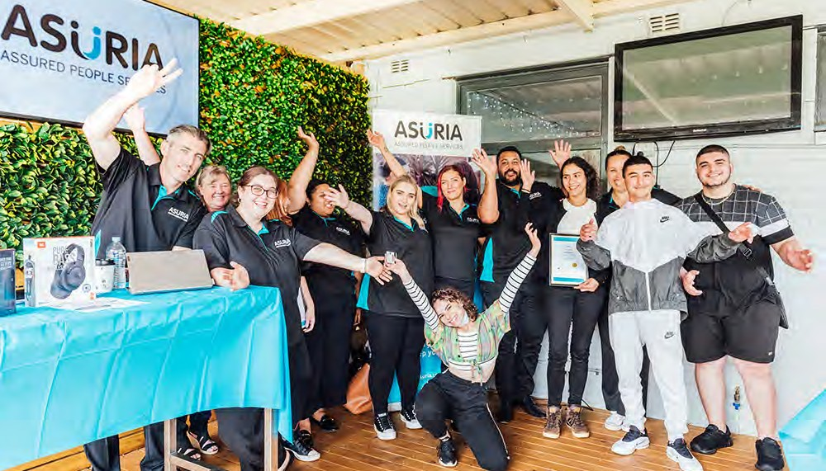
Transition to Work will be delivered through weekly face-to-face contact and will include:
 Upskiling and reskilling
Modern IT suites and breakout spaces
Discreet 1:1 rooms
 Free food and beverages
 Work experience opportunities
Youth orientated activities.

Our Locations Further Information

- Cranbourne • Narre Warren
Workforce Australia - Transition to Work is an


- Frankston
- Hastings
- Mornington
- Pakenham
- Rosebud
Australian Government Initiative. Contact Asuria.
P: 1800 773 338 E: contactus@asuria.com.au

