


Service Delivery Plan

The APM Employability Skills Training (EST) Service Delivery Plan sets out our commitments to participants, highlighting the unique service you can expect from us.

For EST participants, APM’s EST program will build participant’s employability skills that are relevant to the workplace. Participants will develop their knowledge, understanding and experience through the delivery of industry focused training in a work-like environment to create local employment pathways.
APM commits to:
- Providing local training in Lilydale, Preston, Epping, and Ringwood. Building employability skills that prepare you to access jobs in the local labour market. In the North-Eastern Melbourne Employment Region, this may include jobs in highest growth and largest employing industries of Health Care & Social Assistance, Construction, Retail and Education & Training.
- Conducting a skills audit to explore career options and help you identify your transferable skills to reach your vocational goals in your areas of interest.
- Assist you to build your digital literacy whilst accessing online career quizzes, creating and updating resumes, cover letters and job applications.
- Connecting you with local employers who will speak to you about the jobs they have available or invite you to work site tours.
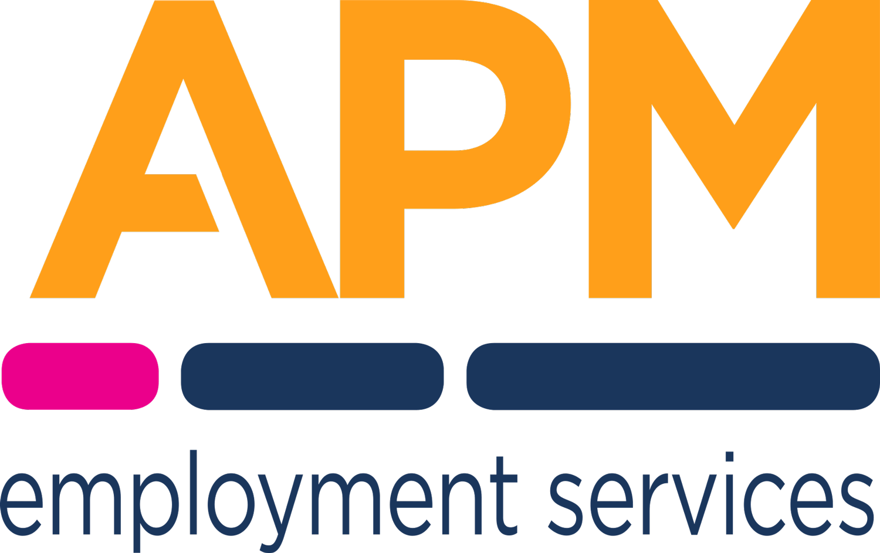
- You will hear from former participants and industry experts.
- You may access workplace visits as a part of our Industry Awareness Experiences with local Employers.
- Asking for your feedback to ensure we remain relevant and continue to meet the needs of participants in the local area.
- Offering additional tailored support depending on your needs, for example allied health services or links with local community service.

Jobs and Skills
APM can benefit participants by providing priority access to services from our partners.
- Employable Me can help find a job that suits you. Whatever barriers you face when looking for work, we’re here for you. Through Employable Me, you get the tools, guides and support to connect with active employers. Learn more about Employable Me here www.employableme.com

- Innovative Training and Recruitment (RTO ID 40206) provides access to accredited learning to develop role and industry specific skills. Learn more about Innovative Training and Recruitment here www.itandr.com.au

- Management Consultancy International (RTO ID 91088) provides access to accredited learning to develop role and industry specific skills. Learn more about Management Consultancy International here www.mci.edu.au

- Industry endorsement APM consults with relevant industry bodies to endorse our training to ensure it meets the current needs of industry

About APM
APM started in 1994 as a small team in Perth, Western Australia, looking to provide better vocational rehabilitation for injured workers so they could recover their health and stay in their jobs.
Today we’re an international human services provider with more than 1,000 locations across Australia,
New Zealand, United Kingdom, Europe, North America, and Asia.
Our purpose drives us. It’s why we come to work. It’s why we continue to grow. It’s how
we inspire excellence and exceptional service with everyone we meet.
Our services focus on enhancing an individual’s employability, health and wellbeing, and
social and economic participation in their community.
We take great pride in empowering people to realise their ambitions and aspirations through
sustainable employment, independence, better health and wellbeing, and increased social
participation.
Each year, APM supports more than 1 million people of all ages to live a better quality
of life.

Let’s get to work

