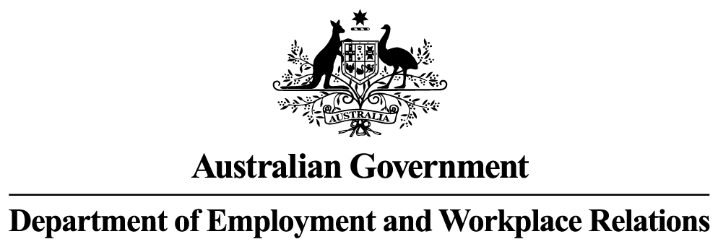

**Monthly Leading indicator of employment**

***june 2024***

The Monthly Leading Indicator of Employment (the Indicator) has now risen for five consecutive months from February to June 2024. This upturn is still tentative, as six consecutive monthly increases are needed to confirm a turning point (see Technical Notes).

The last confirmed turning point was a peak in the Indicator in March 2022, followed by 17 consecutive monthly declines to August 2023. This indicates that the annual trend rate of employment growth would continue to moderate and remain below its long-term trend rate of 2.8 per cent, after an average lag of 12-18 months. The annual trend rate of employment growth fell to 2.5 per cent in April 2024 (the most recent data) down from the recent high of 4.6 per cent over the year to September 2022.

LEVELS OF THE LEADING INDICATOR OF EMPLOYMENT AND CYCLICAL EMPLOYMENT

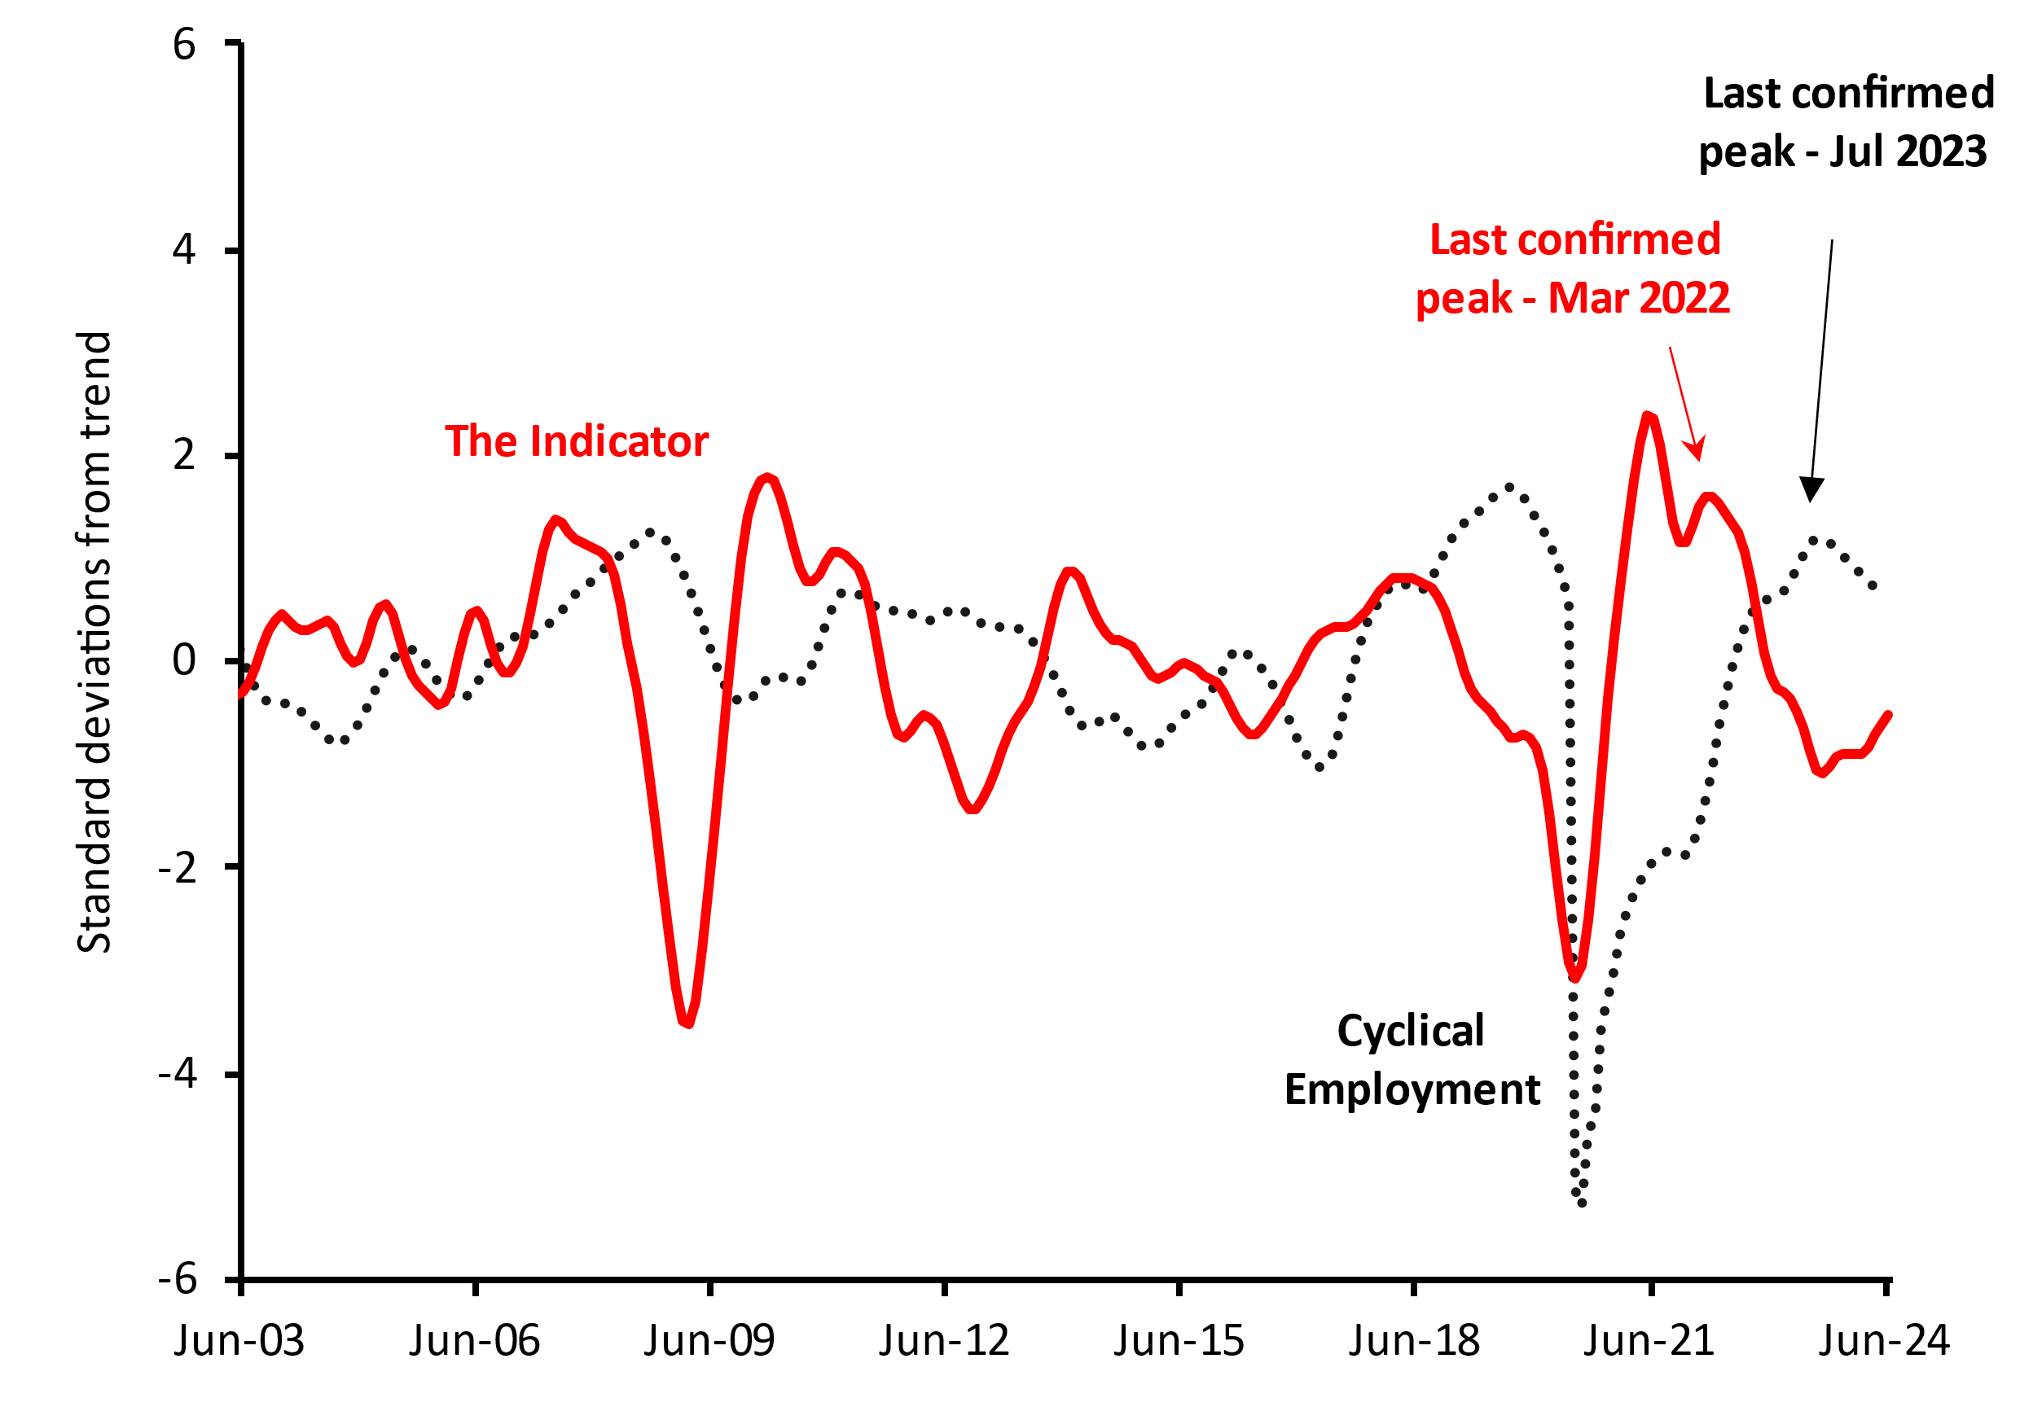

# Monthly CHANGES IN Value of Leading Indicator

|  |  |  |  |  |  |  |
| --- | --- | --- | --- | --- | --- | --- |
|  | **Jan-24** | **Feb-24** | **Mar-24** | **Apr-24** | **May-24** | **Jun-24** |
| **Change in Leading Indicator** | -0.021 | 0.015 | 0.072 | 0.102 | 0.097 | 0.104 |
| Note: Monthly changes in standard deviations from the cyclical trend. | | | | | | |

# Components of the Leading Indicator

|  |  |  |  |
| --- | --- | --- | --- |
| **Series** | **Contribution to change in Leading Indicator** | | |
| **Apr-24** | **May-24** | **Jun-24** |
| **China’s Purchasing Managers Index for Manufacturing Output** (June 2024 release) | 0.04 | 0.036 | 0.025 |
| **US Yield Difference (10-year vs. 3-month interest rates)** (June 2024 release) | 0.041 | 0.048 | 0.055 |
| **NAB Forward Orders Index** (May 2024 release) | -0.01 | -0.011 | -0.002 |
| **Westpac-Melbourne Institute Leading Index of Economic Activity** (May 2024 release) | 0.00 | 0.002 | 0.005 |
| **Westpac-Melbourne Institute Consumer Sentiment Index**  (May 2024 release) | 0.032 | 0.023 | 0.021 |
| ***Change in Leading Indicator:*** | ***0.102*** | ***0.097*** | ***0.104*** |

**Note:** The cyclical components of each series contribute to the monthly movements in the Indicator. Each series in the Indicator has the same weight of 20 per cent. The units of measurement for the contributions to change in the Indicator are monthly changes in the standard deviation from the long-term trend.

### Technical Notes

The Indicator is designed to provide advance warning of turning points in ‘cyclical employment’ (i.e. the deviation of the centred one-year trend in employment from the centred six-year trend). The average lead time of the Indicator over the series (i.e. the time between a peak or trough in the Indicator and the corresponding peak or trough in cyclical employment) is over a year.

A ‘turning point’ in the Indicator is confirmed when there are six consecutive monthly movements in the same direction after a turning point. A fall (or rise) in the Indicator does not necessarily mean that the level of employment will immediately fall (or rise). Rather, it implies that after a lag, the growth rate of employment may fall below (or rise above) its centred six-year trend rate.

The Indicator is the average of the normalised and standardised cyclical elements of the five series in the table above, which have been shown to lead cyclical employment consistently over a long period. The individual components and the composite Indicator for previous months are subject to revision when new monthly data become available.

#### RELEASE DETAILS

The Indicator is available on the Department of Employment and Workplace Relations website ([Monthly Leading Indicator of Employment Latest Release - Department of Employment and Workplace Relations, Australian Government (dewr.gov.au)](https://www.dewr.gov.au/employment-research/announcements/monthly-leading-indicator-employment-latest-release)). The July issue is scheduled for release on Wednesday 17 July 2024.

Contact OfficerS

Dr Thai Nguyen / Kerry Guan

Economic Analysis Section, Department of Employment and Workplace Relations

Email: [leading.indicator@dewr.gov.au](mailto:leading.indicator@dewr.gov.au)