

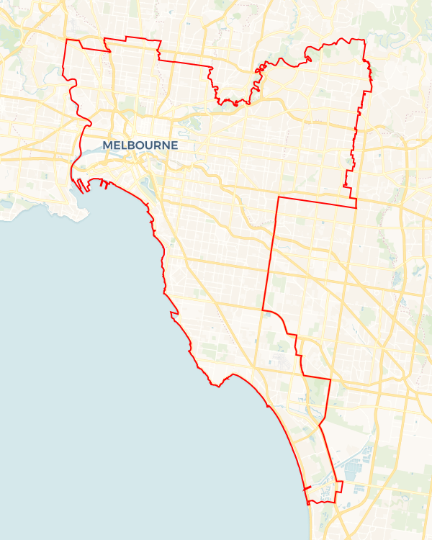Local Jobs Plan

Inner Metropolitan Melbourne Employment Region | VIC |January 2025

Workforce Australia Local Jobs (Local Jobs) is a program that supports tailored approaches to accelerate   
reskilling, upskilling and employment pathways in response to current and emerging local workforce needs.

## Local Jobs elements

### Local Jobs Plan

The Local Jobs Plan sets out the skills and employment challenges and priorities of the region, and associated strategies that will drive the design and implementation of activities to be implemented to address these challenges.

### Employment Facilitators

Employment Facilitators and Support Officers support the delivery of the program by bringing together key stakeholders including businesses, employment services providers, higher education and training organisations.

### Local Jobs and Skills Taskforce

Each Employment Region has its own Taskforce. Representatives include local stakeholders who have demonstrated experience in upskilling, reskilling, and an ability to represent, connect and collaborate with others in the region to meet labour market needs.

### Local Recovery and National Priority Funds

The Local Recovery Fund supports projects that meet the priorities identified in the Local Jobs Plan. The National Priority Fund provides funding for innovative local solutions to address structural barriers to employment.

Explore labour market insights for   
[Inner Metropolitan Melbourne](https://www.jobsandskills.gov.au/data/employment-region-dashboards-and-profiles/monthly-labour-market-dashboards) Employment Region

## Local labour market challenges in the region

* Skills shortages - persistent skills shortages due to the mismatch of skills in demand and the available skills in labour supply.
* Transport - public transport is often impractical for travel to areas outside the central business district and to neighbouring regions.
* Skills - Some cohorts need further foundation and employability skills such as literacy, numeracy, basic digital skills and communication.

## Local jobs and skills priorities and strategies in the region

### Priority 1 – Apprenticeships and traineeships

#### What are our challenges and opportunities?

Creating a thorough awareness and understanding in the region about apprenticeship and traineeship employment opportunities.

#### How are we responding?

* Collaborating with businesses, education providers and communities to co-design apprenticeship pathways.
* Engaging with employers and Registered Training Organisations to create training programs.
* Promoting the positive workforce benefits and entitlements of apprenticeships.
* Facilitating apprenticeships and traineeships in emerging and non-traditional sectors.

**Priority 2 – Youth**

#### What are our challenges and opportunities?

Youth continue to be disproportionately affected by the aftermath of COVID-19 restrictions, which contributes to persistent high youth unemployment and disengagement. There are skill shortages across multiple industries and there is an opportunity to match young people in the region to these underresourced sectors.

#### How are we responding?

* Working with Transition To Work providers to better understand, engage, support and match youth to suitable jobs and career parthways.
* Creating and promoting open days, jobs expos and ‘try-a-trade’ events that connect youth to entry-level roles with local businesses.
* Promoting vocational training, apprenticeships and traineeships through Apprenticeship Employment Network to extend our reach to young people.
* Engaging with organisations to address challenges to employment.
* Engaging with local businesses to create work experience opportunities to familiarise young people with employment.
* Collaborating with youth organisations and and local government to establish career pathways.

### Priority 3 – Supporting disadvantaged communities

#### What are our challenges and opportunities?

Disadvantaged community members represent a high volume of Workforce Australia caseloads in the region. Opportunities exist for us to work with local government areas, Local Learning and Employment Networks (LLENs), community organisations and social enterprises to address challenges to effective labour market engagement.

#### How are we responding?

* Using existing programs and training organisations to improve the skills of challenged participants to match the requirements of skills in demand in growth industries.
* Collaborating with organisations who value the attributes and benefits of a diverse workforce.
* Working with employment service providers to educate individuals on competency-based rather than time-based training progression.
* Collaborating with local councils, LLENs, community organisations, inclusive and social enterprises, Australian Apprenticeship Support Network providers and Group Training Organisations to target challenged cohorts and identify employment pathways or apprenticeships that best suits their capabilities and the needs of local business.

### Priority 4 – Culturally and linguistically diverse individuals

#### What are our challenges and opportunities?

The region has pockets with a high proportion of culturally and linguistically diverse (CaLD) residents. CaLD individuals require a supportive, tailored approach to upskilling to help overcome language challenges.

#### How are we responding?

* Collaborating with stakeholders to create bespoke programs that address business hesitancy in employing a diverse workforce.
* Working with our Local Jobs and Skills Taskforce to increase awareness of businesses to encourage the adoption of culturally safe workplaces, increasing employment opportunities for the CaLD community.
* Collaborating with Workforce Australia Employment Services Providers (providers) to support the CaLD community into self-employment by promoting the Workforce Australia Self-Employment Assistance programs.
* Working with local government areas and community organisations to facilitate projects to create targeted, localised, accessible information sessions as a   
  place-based approach.

### Priority 5 – Care sector

#### What are our challenges and opportunities?

The region has high levels of demand for entry-level personal assistant care workers in the aged and disability care sectors.

#### How are we responding?

* Facilitating collaboration between businesses in the care sectors, training and providers to identify and implement strategies to address labour force issues.
* Optimising the connection betweeen individuals and businesses in the care sectors.
* Establishing the Inner Metropolitan Melbourne Employment Region Aged Care Working Group to build a strategy through industry, training and providers to grow the pool of available workers for the aged care sector.
* Supporting high priority care sector workforce needs with sector-specific assistance.

## Want to know more?

* Contact: Peter Flugge, Inner Metropolitan Melbourne Employment Facilitator: [peter@ljp.org.au](mailto:peter@ljp.org.au)
* Visit: [Local Jobs](https://www.dewr.gov.au/local-jobs) or [Workforce Australia](https://www.workforceaustralia.gov.au/)