Certification of Compliance with the Guidelines on Information and Advertising Campaigns by Australian Government Departments and Agencies

I, Lisa Paul, certify that phase two of the Child Care Assistance Campaign complies with the Guidelines on Information and Advertising Campaigns by Australian Government Departments and Agencies and all relevant government policies and laws.

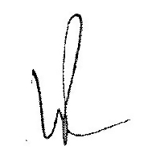
Lisa Paul, PSM
Secretary
Department of Education, Employment and Workplace Relations
24 May 2011

