

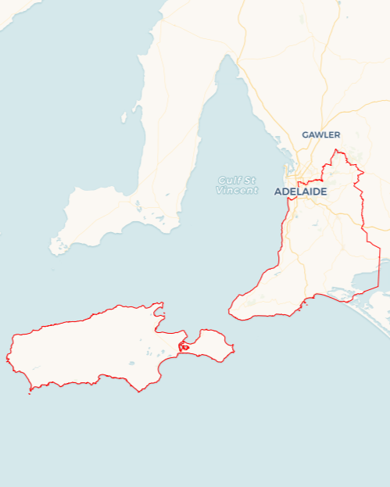Local Jobs Plan

****Adelaide South Employment Region**** | South Australia | ****July 2025****

Workforce Australia Local Jobs (Local Jobs) is a program that supports tailored approaches to accelerate   
reskilling, upskilling and employment pathways in response to current and emerging local workforce needs.

## Local Jobs elements

### Local Jobs Plan

The Local Jobs Plan sets out the skills and employment challenges and priorities of the region, and associated strategies that will drive the design and implementation of activities to be implemented to address these challenges.

### Job Coordinators

Job Coordinators and Support Officers support the delivery of the program by bringing together key stakeholders including businesses, employment services providers, higher education and training organisations.

### Local Jobs and Skills Taskforce

Each Employment Region has its own Taskforce. Representatives include local stakeholders who have demonstrated experience in upskilling, reskilling, and an ability to represent, connect and collaborate with others in the region to meet labour market needs.

### Program Funds

The Employment Region’s Local Initiatives Fund enables targeted local investments that support local labour market functioning. Further, from 2025/26, a central grants-based fund will respond to local needs and help progress broader employment service reform objectives

Explore labour market insights for the [Adelaide South](https://www.jobsandskills.gov.au/data/employment-region-dashboards-and-profiles/monthly-labour-market-dashboards) Employment Region

## Local labour market challenges in the region

* High demand for workers with many major projects such as Torrens to Darlington, Women’s and Children’s Hospital and key Defence supply chain recruitment drives scheduled to commence across the region.
* Areas across the region have differing challenges needing local solutions, with key factors such as transport, ageing populations and changing business operations requiring upskilling and reskilling.
* Housing and cost of living pressures for those both in and outside of the workforce.
* Private transport is often required for job opportunities, as public transport does not support cross-region travel or early/late work hours.
* Underemployment and untapped labour market exists due to casual work, pay disparity and significant number of hidden unemployed not counted in the labour market data.

**Local jobs and skills priorities and strategies in the region**

### Priority 1 – Support and empower local business and industry to maximise options for local employment solutions, including options for traineeships and apprenticeships

#### What are our challenges and opportunities?

Employers in the region have noted challenges in finding and retaining suitable staff. Some pockets across the region have higher youth unemployment levels, while others have an older population with people needing to reskill due to changing industry requirements

#### How are we responding?

* Ensuring that local workforce initiatives such as Adult Community Education and other government funded projects include appropriate supports and work experience elements to assist individuals to enter or re-enter the workforce.
* Collaborating with key industry bodies to raise awareness of apprenticeship and traineeship pathways, literacy and numeracy supports and provide opportunities for them to showcase roles to Workforce Australia providers in the region.
* Increasing access for businesses to seek appropriate training and reskilling for existing staff. This involves linking businesses with appropriate programs and opportunities to improve staff retention and prevent ongoing retrenchments
* Providing avenues for businesses to showcase roles at career events and business forums to give them an opportunity to meet with local candidates, with a particular focus on increasing workforce participation by women, young people and First Nations candidates.

### Priority 2 – Maximise opportunities for local jobs to be filled by local jobseekers, with a particular focus on the key sectors of care and support, construction and manufacturing

#### What are our challenges and opportunities?

Individuals are finding it difficult to enter or re-enter the workforce due to a variety of factors including lack of work readiness, digital capacity, transport barriers, motivation and confidence. Employers are often keen to hire local skilled workers across key sectors, but they are not confident that they will find the skills they need. Key infrastructure projects commencing in the next 12 months across the region also require a steady pipeline of workers, with industry participation targets set by Office the Industry Advocate for Long term unemployed candidates, trainees and apprentices and First Nations workers.

#### How are we responding?

* Working on local place-based solutions such as specific workforce planning activities for growth sectors, in collaboration with industry, councils, State Government, project leads and community members to ensure appropriate training pathways and providing options for individuals to learn more.
* Leveraging existing community and Industry partnerships with Headspace consortia, Positive Ageing Taskforce, Advanced Manufacturing Reference Group and Local Health Networks to facilitate connections for employment opportunities and training pathways in key growth sectors.
* Partnering with key business associations and regional leads such as Regional Development Australia, Chambers of Commerce and industry and Industry peaks to identify skills gaps and maximise employment and training opportunities across the region
* Promoting training pathways in key industries, including partnering with Apprentice Connect providers to showcase apprenticeship and traineeship opportunities.
* Coordinating targeted industry specific events for employers to meet locals seeking employment in sectors such as care and support, construction and advanced manufacturing.
* Utilising Taskforce members and their networks to raise awareness of specific regional and industry challenges and codesign initiatives to address these.
* Sharing best practices in workforce strategies throughout employer networks and showcasing innovative workforce strategies and tools to key business networks to showcase inclusive hiring practices.

### Priority 3 – Showcase and communicate information about career pathways, training options and community supports and programs

#### What are our challenges and opportunities?

There is often a mismatch between employer needs for staffing with the availability of localised training solutions. This is particularly evident in remote parts of the region such as Kangaroo Island.

#### How are we responding?

* Providing a mechanism (using Trello) to showcase activities, courses and employment opportunities to ensure information is accessible and available in a timely manner to employment service providers and community members across the entire Employment Region.
* Providing opportunities to employers and training organisations to showcase their current and pending opportunities directly to Workforce Australia providers, those seeking employment and those investigating traineeships and apprenticeships.
* Coordinating events and activities with councils, employer networks and growth industry partners via expos, events and forums.
* Providing a platform for Employment Service Providers, skills and training organisations and First Nations Groups to collaborate and showcase local initiatives, through regular Workforce Australia provider briefings both online and in person.
* Presenting at business networking events such as Southern Business Connections, Workforce Forums, Regional Summits and small business sessions about the range of support programs available.

### Priority 4 – Support local young people to gain employment

#### What are our challenges and opportunities?

#### Youth unemployment has remained high in certain parts of Adelaide South with many not engaged in either education or employment. There are many strong youth networks across the region all striving for the same priority to link young people to opportunities and training pathways with real tangible outcomes.

#### How are we responding?

* Partnering with Transition to Work providers on suitable programs to support and engage youth and presenting them with opportunities and increase take up of entry level opportunities.
* Communicating and vocational and other support programs from Headspace, Southern Youth Round Table, Southern Fleurieu Youth Network and Community Investment Committee who all have a focus on elevating opportunities for youth to create skills development pathways to meet workforce needs.
* Advocating with councils and other decision makers in the local community for options and opportunities for young people.
* Codesign suitable projects by meeting with young people and seeking their input into appropriate activities to better understand their challenges in moving into the jobs market.

**Priority 5 – Support older job seekers to tap into programs and opportunities for employment in key sectors**

#### What are our challenges and opportunities?

#### Mature aged job seekers bring a range of experiences to new employers but often lack the confidence in a rapidly changing jobs market. With a growing number of mature aged people leaving the workforce due to retrenchments (with retail store closures) there are often individuals who are not on welfare payments who may not be aware of additional supports.

#### How are we responding?

* Providing opportunities through community centres and local councils to ensure that older community members are aware of suitable activities and events to meet with employers and training organisations.
* Working with local Adult Community Education providers and Skills for Education and Employment providers to source tailored solutions for this cohort.
* Ensuring local businesses are well placed and provide links to available tools and resources so they become better able to support mid-career individuals as they transition to different sectors.
* Showcase opportunities regarding Adult Apprenticeships and upskilling opportunities.

**Priority 6 – First Nations Employment**

#### What are our challenges and opportunities?

First Nations people from the various nations in Adelaide South are still struggling to gain ongoing opportunities across the region. This is due to a variety of complex challenges including limited access to supportive employers and culturally safe workplaces.

#### How are we responding?

* We are engaging with Aboriginal Community Controlled Organisations to ensure understanding of suitable training or other initiatives that can be shared with Workforce Australia and Transition to Work providers for use with their First Nations customers.
* Sharing the expertise from specific First Nations organisations such as Reconciliation SA, Supply Nation and others to encourage increased First Nations engagement in the workforce.
* Supporting local First Nations events that showcase training opportunities, skills development, and employment pathways for First Nations community members.
* Listening to the voice of community members when designing and highlighting suitable programs

## Want to know more?

* Contact: Leanne Hill, Adelaide South Job Coordinator: [leanne.hill@mylocaljobsprogram.com.au](mailto:leanne.hill@mylocaljobsprogram.com.au)
* Visit: [Local Jobs](https://www.dewr.gov.au/local-jobs) or [Workforce Australia](https://www.workforceaustralia.gov.au/)