

Local Jobs Program
2020–2022
Evaluation Report

  - Published November 2022

Local Jobs Program 2020–2022 Evaluation Report
Social Ventures Australia (SVA) Consulting were commissioned by the (former) Australian Government Department of Education, Skills and Employment to evaluate the Local Jobs Program (LJP). This evaluation covers the initial 25 Employment Regions included in the LJP between September 2020 and June 2022 and excludes the expansion of the LJP to a further 26 Employment Regions announced in the 2021–22 Budget.
This report outlines the findings of the evaluation and includes a departmental response.
ISBN
978-1-76114-152-2 [PDF]
978-1-76114-145-4 [DOCX]
With the exception of the Commonwealth Coat of Arms, the Department’s logo, any material protected by a trade mark and where otherwise noted all material presented in this document is provided under a Creative Commons Attribution 4.0 International (https://creativecommons.org/licenses/by/4.0/) licence.
The details of the relevant licence conditions are available on the Creative Commons website (accessible using the links provided) as is the full legal code for the CC BY 4.0 International (https://creativecommons.org/licenses/by/4.0/legalcode)
The document must be attributed as the Local Jobs Program 2020–2022 Evaluation Report.

Social Ventures Australia acknowledges Traditional Owners of Country throughout Australia. We pay our respects to Aboriginal and Torres Strait Islander Elders past, present, and emerging. We also accept the invitation in the Uluru Statement from the Heart to walk together with Aboriginal and Torres Strait Islander peoples in a movement of the Australian people for a better future.
About Social Ventures Australia (SVA) Consulting
Social Ventures Australia (SVA) is a not-for-profit organisation that works with partners to alleviate disadvantage – towards an Australia where all people and communities thrive. We influence systems to deliver better social outcomes for people by learning about what works in communities, helping organisations be more effective, sharing our perspectives and advocating for change.
SVA Consulting is Australia’s leading not-for-profit consultancy. We focus solely on social impact and work with partners to increase their capacity to create positive change. Our team is passionate about what they do and use their diverse experience to work together to solve Australia’s most pressing challenges.
For more information contact us:
consulting@socialventures.com.au
SVA Consulting Professional Disclosure Statement
SVA Consulting have prepared this report in good faith on the basis of our research and information available to us at the date of publication, without any independent verification. Information has been obtained from sources that we believe to be reliable and up to date, but SVA do not guarantee the accuracy, completeness or currency of the information. The information in the report is general in nature and is not intended to and should not be used or relied upon by readers as the basis for any strategic, business, financial, tax, accounting, legal or regulatory decisions.
This report was prepared by SVA for the use and benefit of our client only and for the purpose for which it was provided. SVA does not accept any liability if this report is used for an alternate purpose from which it was intended, nor to any third party in respect of this report.

Contents
Glossary v
Executive summary vi
Departmental response to findings xxxii
1 The Local Jobs Program and evaluation overview 1
1.1. The Local Jobs Program 1
1.2 Evaluation strategy 8
2 Evaluation findings: implementation 10
2.1 The role and practice of Employment Facilitators 10
2.2 Local Jobs and Skills Taskforces and their contribution 26
2.3 Use of the Local Jobs Plan 35
2.4 The Local Recovery Fund 41
2.5 DESE’s role 58
3 Evaluation findings: outcomes 85
3.1 Local System Outcomes 85
3.2 Jobs and Skills Outcomes 90
3.3 Variation in outcomes across Employment Regions 98
3.4 Pathways to creating outcomes 104
3.5 Summary 106
4 Evaluation findings: enablers and barriers 108
4.1 Evidence of outcomes across the 13 primary regions 108
4.2 Enabling factors relating to implementation 110
4.3 Characteristics of effective Employment Facilitators 112
4.4 Local conditions and external factors 113
4.5 Challenges and opportunities 118
4.6 Summary 123
5 Lessons learned and concluding statement 125
5.1 Lessons for Employment Facilitators 125
5.2 Lessons for DESE 128
5.3 Broader policy and program management considerations 132
5.4 Concluding statement 133
Appendix A: Evaluation methodology 134
Appendix B: Overview of cross-regional analysis and derived variables 141
Appendix C: Variation in outcomes by region 146

Glossary
Activity Host | An organisation undertaking a Local Recovery Fund project
DES | Disability Employment Services
DESE | Department of Education, Skills and Employment  Note that while DESE was the department that administered the Local Jobs Program (LJP) during the time frame of the evaluation, as a result of machinery-of-government changes the name of the department administering the program became the Department of Employment and Workplace Relations (DEWR) from 1 July 2022.
National Office | DESE’s National Office program team providing overarching management and oversight of the LJP
State Office(s) | DESE’s State Offices provide program oversight and on-the-ground program management of the Employment Regions (and Employment Facilitators) in their state
Employment Facilitator | The individual responsible for delivering the LJP in each Employment Region – either contracted directly by DESE or through a subcontracting arrangement with a separate entity
Employment Region(s) | The local geographical regions where the LJP has been established
ESP | Employment Service Provider, also sometimes known as a jobactive provider
LJP | Local Jobs Program
LRF | Local Recovery Fund
Partnering Provider | The lead ESP contracted to partner with an Activity Host to deliver an LRF project
Relationship Manager | A DESE staff member from State Office responsible for managing the relationship with an individual Employment Facilitator
RET | Regional Employment Trials
RTO | Registered Training Organisation
SVA | Social Ventures Australia
Taskforce(s) | A Local Jobs and Skills Taskforce is set up in each Employment Region
Workforce Australia | DESE’s new employment services model, commencing 1 July 2022

Executive summary
This executive summary comprises 4 parts:
- Summary of the Local Jobs Program (LJP) and its evaluation. This section provides background information on the LJP and the evaluation.
- High-level findings against evaluation questions. This section identifies the high-level findings against the 3 evaluation questions that the evaluation sought to answer.
- Summary of key evaluation findings. This section identifies the most significant findings evident from the evaluation. Findings cover the LJP model, how the LJP is progressing and the outcomes achieved to date, challenges for implementation, the ‘enablers’ of achieving outcomes, key lessons, and policy and program questions for DESE to consider.
- Additional findings and evidence. This section identifies additional findings and evidence that are important to highlight for DESE’s consideration. It focuses on highlighting findings and evidence not presented earlier in the executive summary. Consequently, content presented earlier in the executive summary is not repeated unless necessary for contextualising the additional findings and evidence.
- Summary of the Local Jobs Program and its evaluation
The Local Jobs Program
The LJP was introduced on 1 September 2020 and was administered by the former Department of Education, Skills and Employment (DESE). The LJP is a collaborative initiative bringing together expertise and resources to develop employment solutions at a local level. A key focus of the program is to support the more effective local delivery of employment services, achieved by leveraging existing programs and resources, reducing duplication, and providing opportunities for local collaboration. Funding has been provided for local initiatives to fill gaps in local servicing to help job seekers into work or training opportunities aligned with local needs.
The LJP was initially implemented in 25 selected Employment Regions for the period between 1 September 2020 and 30 June 2022. It was subsequently expanded to all 51 Employment Regions from July 2021, and its funding extended to June 2025.
The LJP model
The LJP is modelled on a place-based approach to convening local stakeholders, resources and access to funding, to develop tailored local solutions to the labour market issues in each Employment Region. The model involves establishing several core program elements at the local level (the structured program elements). Each Employment Region contains:
- an Employment Facilitator and a Support Officer as the ‘local backbone’ entity driving local implementation – with Employment Facilitators coordinating local collaboration, and Support Officers providing logistic, secretarial and other support
- a Jobs and Skills Taskforce (Taskforce) of local stakeholders to support local implementation and represent the views of local businesses, Employment Service Providers (ESPs), government, training providers, and community services
- a Local Jobs Plan (the Jobs Plan) that defines the Employment Region’s employment and training priorities
- a Local Recovery Fund (LRF) to support local projects aligned to the priorities in the Jobs Plan.
DESE’s State and National Offices support whole-of-program implementation. The National Office oversees overarching governance and coordination, while the State Offices manage relationships with Employment Facilitators.
Employment Facilitators engage in a wide range of activities to support developing local solutions. In addition to coordinating the structured program elements described above, Employment Facilitators engage in a diverse range of more informal approaches to connecting and supporting local stakeholders, tailored to the local needs and context of each Employment Region (the unstructured program elements). The unstructured program elements provide additional flexibility to the LJP model which enables Employment Facilitators to respond to local opportunities and challenges as they emerge.
The LJP aims to achieve outcomes in the following 2 categories:
- Local System Outcomes: Positive outcomes as to how local stakeholders work together to develop local employment solutions. This category of outcomes is common to place-based initiatives such as the LJP. All place-based initiatives drive community outcomes by catalysing changes in how local systems work (rather than ‘directly’ supporting job seekers into work, for example). Evidence from other place-based initiatives suggests that creating changes in local systems takes time and should be understood as a staged approach. Accordingly, the LJP theory of change identifies that Local System Outcomes occur across 3 stages of maturity, starting with ‘Connecting’, then ‘Coordination’, and finally ‘Capacity Building’.
- Jobs and Skills Outcomes: Positive outcomes for job seekers, employers and ESPs with respect to employment, training, upskilling and reskilling, and meeting workforce needs. Jobs and Skills Outcomes can occur concurrently with Local System Outcomes through changes in how local stakeholders are working together.
About this evaluation
DESE commissioned SVA to conduct an evaluation of the LJP in April 2021. The purpose of the evaluation is to assess the appropriateness and effectiveness of the LJP in meeting the program objectives through answering the following key evaluation questions:
- Implementation: To what extent was the LJP implemented effectively?
- Outcomes: To what extent has the LJP improved the responsiveness of labour market interventions?
- Enablers and barriers: What practices and conditions enabled effective implementation and outcomes?
The scope of the evaluation includes the initial 25 Employment Regions over the period between September 2020 and June 2022 and excludes the expansion of the LJP to a further 26 Employment Regions announced in the 2021–22 Budget. It draws on data collection and consultations completed up to February 2022, including primary data collected through interviews with program stakeholders conducted between September and November 2021, and DESE’s program monitoring data.
Primary data sources collected and analysed to answer the evaluation questions included interviews with 111 program stakeholders, comprising Employment Facilitators (n=24), Taskforce members (n=47), LRF Activity hosts (n=14) and DESE staff from National Office (n=6) and State Offices (n=20); surveys of Employment Facilitators (n=22 responses) and Taskforce members (n=90 responses); and DESE’s program monitoring data.
The evaluation was focused on the effectiveness of the program at the whole-of-program level and does not report on the performance of individual Employment Regions or Employment Facilitators or the effectiveness of individual projects funded through the LRF. Rather, the evaluation uses data at the regional level to identify common patterns, lessons regarding how outcomes can be achieved, and insights about how the program can be improved in the future.
A theory of change for the LJP was developed as part of the evaluation to help answer the evaluation questions. The theory of change defined the characteristics of effective implementation for each of the program elements, within the context of other place-based initiatives. It also identified the outcomes expected to be achieved across different stages of maturity if the program is effectively implemented (described earlier).
The evaluation reflects a point-in-time assessment of how the LJP is progressing, having regard to the program’s theory of change. It should be recognised that the bulk of evaluation data was collected only approximately 12 months after the program formally commenced and there were significant differences in the amount of time Employment Facilitators had been in the role (ranging from 2 to 12 months). In some instances, DESE staff acted as interim facilitators until substantive Employment Facilitators were appointed, and their level of activity in engaging the Taskforce varied between regions. As place-based initiatives can take time before they achieve long-lasting improvements in local capacity, it is important to interpret the evaluation findings in the context of the start dates of substantive Employment Facilitators.

- High-level findings against evaluation questions
This section of the executive summary presents the high-level findings of the evaluation against the 3 evaluation questions.
High-level findings
- Implementation: To what extent was the LJP implemented effectively?
The evaluation found that, overall, each of the elements of the LJP model have been implemented as intended. In particular, the evaluation found that the flexibility provided to Employment Facilitators in the LJP meant they could adapt to changing labour markets at the local level – from rapidly responding to employment challenges caused by COVID-19, to addressing broader labour market challenges or considering long-term structural challenges in their region. While there have been some challenges with implementation – particularly around the timeliness of the LRF procurement processes, the reporting requirements for Employment Facilitators, occasionally inconsistent communication between State and National Office, and the engagement of Taskforces in some regions – these were raised most often in relation to the early stages of the program. DESE has subsequently worked to refine and improve its processes. These refinements are generally acknowledged by stakeholders as positive improvements, although some feel more work is required, particularly around the LRF.
- Outcomes: To what extent has the LJP improved the responsiveness of labour market interventions?
The evaluation found evidence the LJP has contributed to positive labour market outcomes across the 25 Employment Regions. The extent and types of outcomes created have varied significantly across the regions, with some more advanced than others along the ‘stages of maturity’ of the LJP theory of change. This variability reflected the significant differences in the amount of time substantive Employment Facilitators had been in the role (ranging from 2 to 12 months when the bulk of evaluation data was collected), as well as differences in how Employment Facilitators had implemented the program, and in local conditions across the regions.
The outcomes most observable to stakeholders are Local System Outcomes that relate to improvements in how local stakeholders are working together, sharing information, and collaborating. Jobs and Skills Outcomes were reported less often, although the evaluation still found many examples of how program activities contributed to these outcomes for job seekers, employers and ESPs. Most stakeholders felt the LJP was on the right path towards achieving a greater range of outcomes in the future.
- Enablers and barriers: What practices and conditions enabled effective implementation and outcomes?
Considering the LJP as a whole, the evaluation found most stakeholders overwhelmingly value the place-based approach underpinning the program and the focus on local issues and solutions. They believe this to be an effective approach to improving labour market outcomes at the local level and, in particular, addressing longstanding challenges for disadvantaged job seekers.
The evaluation also identified several specific conditions and practices that appear to enable greater outcomes across the Employment Regions. These include Employment Facilitators’ experience, skills and networks, a highly engaged and active Taskforce, and the local conditions of each region – in particular, the type of region (regional versus metropolitan) and the extent of existing relationships and collaboration between local stakeholders.
- Summary of key evaluation findings
This section of the executive summary identifies the most significant findings evident from the evaluation. Findings cover the design of the LJP model, how the LJP is progressing and the outcomes achieved to date, challenges for implementation, the ‘enablers’ of achieving outcomes, key lessons, and policy and program questions for DESE to consider.
LJP model: A large majority of stakeholders value the LJP model and believe that the program can make a positive contribution to local employment priorities
Taskforce members overwhelmingly value the place-based approach underpinning the program and the focus on local issues and solutions. They believe this to be an important approach to improving labour market outcomes at the local level, and in particular to addressing longstanding challenges for disadvantaged job seekers. Although stakeholders identified some challenges with implementation and areas where they thought the program could be improved (described further below), these were usually raised in the context of the rollout of an ambitious program seen as worthwhile and a step in the right direction to building local capacity and creating positive outcomes for job seekers and employers.
Employment Facilitators are also largely positive about the LJP model and the support they receive from DESE, in particular from their Relationship Manager. They feel that they have sufficient resourcing and the space and flexibility they need to tailor the program to their region, which are both key elements for effectively implementing a place-based initiative.
Outcomes and progress to date: There is evidence the LJP has contributed to positive outcomes and is on the path towards achieving a greater range of outcomes in the future, although the extent and types of outcomes observed have varied significantly between regions
Creating changes to local systems that enable Jobs and Skills Outcomes takes time, so results should be considered in the context of the amount of time substantive Employment Facilitators had been in the role (which varied significantly between regions). It can also be difficult to quantify the contribution of the LJP to these outcomes, as outcomes often occur indirectly and are several steps removed from the work of Employment Facilitators. Furthermore, observed outcomes reflect differences both in how Employment Facilitators have implemented the program, and in local conditions across the regions. This recognises that regions may have different ‘baselines’ in terms of how effectively local stakeholders were collaborating prior to the LJP (see below on ‘enablers’ for more on the relevant differences).
Despite these difficulties with identifying the LJP’s impact, there is evidence the LJP has contributed to outcomes across the 25 Employment Regions in scope for the evaluation. Reflecting this, all Employment Facilitators responding to the survey (n=22/25) perceived the LJP had made a positive contribution to outcomes in their region to at least some extent.
Evidence of the extent and types of outcomes created varied significantly across Employment Regions. In terms of Local Systems Outcomes, deeper data collection and analysis in 13 regions found that in 3 there was some evidence of the most progressed outcomes in the LJP theory of change (the Capacity Building stage), in 5 regions there was evidence of outcomes up to the Coordinating stage, in 4 regions evidence was limited to Connecting outcomes, and in one region it was ‘too early to tell’ if the LJP had created any positive impacts to date.
As can be expected in the early stages of a place-based program, the outcomes most observable to stakeholders across the program overall relate to improvements in how local stakeholders are working together, sharing information, and collaborating on local initiatives. This is aligned with the Connecting and Coordinating stages of outcomes described in the theory of change. Many examples of these outcomes were identified in interviews. In surveys completed between August and September 2021, overall, 73% of Employment Facilitators (n=16/22) and 69% of Taskforce members (n=57/83) strongly agreed that the LJP had contributed to at least one type of Local System Outcome in their Employment Region.
Jobs and Skills Outcomes were reported less often in interviews, although the evaluation still found many examples of how program activities have contributed to these outcomes across the Employment Regions for job seekers, employers and ESPs. There was also a sizeable portion of survey respondents – 68% of Employment Facilitators (n=15/22) and 59% of Taskforce members (n=49/83) – who strongly agreed that the LJP had contributed to at least one type of Jobs and Skills Outcome in their Employment Region.
While the LJP indirectly achieves Jobs and Skills Outcomes in most cases, notable exceptions to this are the outcomes created through LRF activities. The outcomes of these activities are more directly observable to the Employment Facilitator and Taskforce members, as they often work with Activity Hosts to develop the activity, while DESE also collects data on participant referrals to activities. However, widespread delays in the commencement of LRF activities during the COVID-19 pandemic resulted in few activities being completed during the data collection period.
Most stakeholders felt the LJP was on the right path towards achieving a greater range of outcomes in the future. While a large group of stakeholders stated in interviews that it was ‘too early to tell’ what the impact of the program would be for job seekers and employers, they generally felt that activities currently in the pipeline – in particular LRF projects – were likely to lead to positive outcomes. Most Taskforce members were also highly positive about their Employment Facilitators and how they were engaging with local stakeholders, while a majority also self-reported being highly engaged with the LJP. These are important factors that suggest activities to date can support increased outcomes in the future.
Implementation challenges: While there have been some early implementation challenges, DESE has sought to refine and improve its processes
Stakeholders raised several challenges regarding DESE’s LRF procurement process and contract management. Most significantly, in the consultation during September and November 2021, a majority of Employment Facilitators – as well as many Taskforce members, Activity Hosts and DESE State Office staff – felt that the LRF procurement processes were not fit for purpose for supporting the quick deployment of local solutions to address local employment needs, and that they adversely impacted local stakeholders’ (especially Taskforce members’ engagement with and buy-in to the LJP). Employment Facilitators also raised challenges regarding the reporting burden, which they felt substantially reduced the time they could spend ‘on the ground’ engaging with local stakeholders. There was also occasionally inconsistent communication between State and National Offices.
While most Taskforce members self-reported that their Taskforce was highly engaged with the LJP (79% of survey respondents), 11% of Taskforce members disagreed that this was the case. Several Employment Facilitators also raised challenges with the level of engagement of their Taskforce. Employment Facilitators attributed instances of poor engagement to members who were time poor, did not have the right motivation for joining, did not feel their input was valued, and did not have a clear understanding of the expectations of their role. Several Employment Facilitators also identified challenges with engagement where they had ‘inherited’ the Taskforce from an interim facilitator and did not have input on the selection of members. Employment Facilitators with less engaged Taskforces reported that it had proved challenging to encourage Taskforce members to be more active in their Taskforce. To help address this, many Employment Facilitators also wanted more opportunities to share lessons with each other on effective practices for working with local stakeholders.
The challenges described above were raised most often in relation to the early stages of the program, when DESE had to work quickly to establish the program in each Employment Region and develop new processes and governance structures. DESE has subsequently worked to refine and improve its processes. This has included considering opportunities to speed up the assessment of LRF proposals and to streamline reporting by Employment Facilitators. DESE has also sought to provide more opportunities for Employment Facilitators to share lessons on good practices, including how to effectively engage their Taskforce. These refinements are generally acknowledged by stakeholders as positive improvements, although some felt more work was required, particularly around the LRF.
Enablers: The evaluation identified the most important factors that appear to enable higher order outcomes in each Employment Region, including Employment Facilitators’ experience, skills and networks, a highly engaged and active Taskforce, and the local conditions of each region
Deeper analysis across 13 regions found common factors in the 3 Employment Regions that had evidence of outcomes in the Capacity Building stage (the most advanced stage of maturity in the LJP theory of change). Common practices and conditions across these Employment Regions included:
- Employment Facilitators with previous experience or established relationships in the region in a related role
- Taskforces that were highly engaged, had a diverse membership and were actively collaborating on projects
- Local Jobs Plans that were actively used to set the shared vision of the Taskforce and guide strategy and actions
- Employment Facilitators working with local stakeholders on solutions to long-term labour market issues (as well as short-term needs) and regularly engaging with ESPs
- Employment Facilitators believing that DESE provided them with effective support and sufficient autonomy and flexibility to tailor the LJP to their region.
Stakeholders particularly highlighted the important role Employment Facilitators play in achieving outcomes, as the driving force behind the LJP in each region. Four characteristics of Employment Facilitators were identified by stakeholders as key to their effectiveness:
- the ability to build strong relationships
- local knowledge of the region, its needs and its stakeholders
- an entrepreneurial mindset, including being proactive and innovative and ‘thinking outside the box’ to adapt the LJP to their Employment Region
- the ability to effectively mediate between government and community. These characteristics are key to an Employment Facilitator’s success in the role. However, Employment Facilitators also need support from DESE to be truly effective in the role.
All 3 Employment Regions with evidence of outcomes in the Capacity Building stage were also in regional areas (non-metropolitan). Despite a small sample size, this analysis and feedback from interviews suggests this may be because regional areas support more effective collaboration between local stakeholders. Several DESE staff members and Employment Facilitators attributed this to the fact that in regional areas, local stakeholders have more enduring relationships, labour market needs are more homogenous, and there is a lower concentration of other initiatives competing with the LJP and taking up local stakeholders’ time.
Lessons: The evaluation identified several lessons for DESE regarding how to best support Employment Facilitators and increase the LJP’s impact
The evaluation found that overall DESE has been effective in giving Employment Facilitators the support, space and flexibility they need to adapt and implement the LJP in their Employment Region. The LJP team in the National Office has also built increasing recognition across DESE of the unique nature of the program and how this may require different ways of working to support it. This support and communication should be continued and built upon in the future.
Throughout the evaluation, several opportunities for improving the support to Employment Facilitators were identified. Lessons for DESE from the evaluation relate to:
- enabling Employment Facilitators to be effective – including through recruiting the right people for the role, providing ongoing professional development and more opportunities to share lessons on effective approaches, building capacity within DESE to encourage Employment Facilitators to adopt an entrepreneurial approach, considering how DESE’s support might need to be adapted in regional versus metropolitan regions, and considering opportunities to further streamline reporting
- enabling Taskforces to be effective – by clarifying the roles and responsibilities of Taskforce members and ensuring there are clear and responsive processes for updating Taskforce membership to help Employment Facilitators get the best people in the room
- improving the LRF – by addressing issues in procurement and contracting processes, ensuring administrative requirements for Activity Hosts are proportionate to the size of funds, and increasing opportunities for local input into the LRF process where possible
- having a local presence in each region – for example, by attending local events to provide confidence that there is a line of sight between DESE and the work local stakeholders are doing, but also ensuring Employment Facilitators have sufficient autonomy and authority to do their work
- promoting ESPs’ engagement in the program – including encouraging collaboration on local solutions and prompting ESPs to refer participants to LRF activities.
Policy and program management considerations: The evaluation also identified several key questions for DESE to consider regarding the future direction of the program
These include:
- What are the long-term objectives for the LJP? Consultations throughout 2021 found that different stakeholders, including Employment Facilitators, DESE State Office staff and DESE National Office staff, expressed different perspectives on the long-term goals and priorities of the LJP. This included, for example, whether the program should focus on leveraging the Taskforce to connect job seekers and employers with immediate workforce needs, or bringing ESPs together to help the existing employment services system to be more effective, or developing new solutions to support job seekers with the most complex barriers to employment, or building the capacity of local stakeholders to develop solutions to big-picture, long-term labour market challenges. The LJP could focus on any of these objectives, and they are not mutually exclusive. However, Employment Facilitators have limited time and resources, and providing greater clarity on the long-term objectives of the program would help Employment Facilitators and DESE to choose where to focus. DESE could clarify the long-term objectives of the program and give Employment Facilitators the flexibility to determine the best approaches to work towards this objective within their region.
- How might the LJP best contribute to addressing emerging labour market challenges as Workforce Australia rolls out? The implementation of Workforce Australia will focus ESPs’ efforts on those who face more complex obstacles to sustainable employment. This greater complexity is likely to require more local collaborative action between ESPs, employers and other service providers to ensure more holistic employment solutions. The LJP could play an important role in fostering collaboration at the local level and providing leadership in identifying and addressing these complex challenges. DESE should consider how to best position the LJP to play this role effectively, and how this fits in with other priorities for the program.
- How might DESE improve future monitoring and evaluation of the LJP? The Jobs and Skills Outcomes created by the LJP are difficult to quantify and attribute to the program. This makes it difficult to evaluate the effectiveness and impact of the program. DESE should consider opportunities to improve data capture on the more ‘intangible’ impacts of the program while streamlining and reducing data collection focused on Employment Facilitators’ activities. DESE should also enhance data collection relating to the employment and training outcomes for job seekers participating in LRF projects, collect feedback from local stakeholders outside the Taskforce, and build on the LJP theory of change to communicate to stakeholders about the value of the contribution made by the LJP.
- Additional findings and evidence
This section of the executive summary identifies additional findings and evidence that are important to highlight for DESE to consider. It focuses on highlighting findings and evidence not presented earlier in the executive summary. Consequently, content presented earlier is not repeated, unless it is necessary for contextualising the additional findings and evidence.
Additional findings: implementation
This section presents additional findings and evidence on how the LJP has been implemented to date. Findings cover each of the program elements: Employment Facilitators and Support Officers, the Taskforces, the Local Jobs Plans, the LRF, and DESE’s support. Findings and evidence against each program element are presented in 3 subsections:
- the program elements intended role under the LJP theory of change
- how the program element was implemented
- the effectiveness of implementation, having regard to what was intended and what happened in practice (including consideration of any relevant challenges or enabling factors).
Employment Facilitators and Support Officers
Employment Facilitator role
Employment Facilitators are independent from DESE and engaged for the purpose of delivering the LJP in each Employment Region. Their primary role is to engage and work with local stakeholders to facilitate local solutions tailored to the employment priorities and local context of their region. This role includes a wide range of activities relating to both the structured program elements – such as chairing the Taskforce, developing and updating the Jobs Plan, and providing guidance on the LRF – and the unstructured program elements – the more informal approaches Employment Facilitators can use to connect and support local stakeholders.
Employment Facilitators have diverse backgrounds, including experience in similar employment facilitation roles, as well as with ESPs, training providers, local chambers of commerce or government, or in business and economic development. Approximately half of the Employment Facilitators had strong experience in their region or in a similar role.
Implementation of the Employment Facilitator role
The evaluation found variation in the approaches being adopted by Employment Facilitators. This variation covers the types of problems they are focusing on (e.g. short-term versus long-term), the stakeholders they are engaging with most, how they engage with them (including different collaboration structures), and the types of local solutions they are pursuing (e.g. through connecting local stakeholders, providing advice, promoting collaboration between ESPs, facilitating coordination between different levels of government and local stakeholders, and supporting collaboration on specific local initiatives).
The initiatives identified by Employment Facilitators and Taskforces can be funded by the LRF or by other funding sources, or require no funding at all. While the LRF provides a new funding source for developing projects providing local solutions, most Employment Facilitators reported actively supporting local initiatives by leveraging existing programs and funding available through other sources.
Effectively engaging Taskforce members is a central part of the Employment Facilitator role. Outside of the Taskforce, Employment Facilitators have also engaged with a wide range of stakeholder groups, primarily employers, government representatives and ESPs.
Employment Facilitators said that they mostly focused on those activities and approaches they assessed to be most relevant and effective for their region. They also identified that their choice of approach was influenced by their understanding of the objectives of the LJP. Other considerations included the priorities in their Jobs Plan; their own specific skills, expertise and networks; and the level of engagement and membership of their Taskforce.
The flexibility provided to Employment Facilitators meant they could adapt their role to respond to changing labour markets. As reported by some Employment Facilitators, they perceived a shift in the LJP’s focus as the economy bounced back – from rapidly responding to employment challenges caused by COVID-19, to responding to broader labour market challenges. Some Employment Facilitators also reported having increasingly taken a long-term focus to their region after the LJP was extended to 2025, such as by spending more time working with local stakeholders to consider long-term structural challenges in their region.
Assessing the implementation of the Employment Facilitator role
The design of the Employment Facilitator role reflects a key feature of a place-based approach, which is to establish a role to ‘connect the dots’ between local stakeholders, support local collaboration, and provide flexibility to tailor their approach to the needs and context of their Employment Region. Employment Facilitators’ activities indicate that they have been playing this role within each Employment Region.
Over 80% of surveyed Taskforce members agreed that their Employment Facilitator’s approach to building Taskforce engagement was effective. Stakeholder feedback highlighted several aspects of the Employment Facilitator role they felt were valuable. This included Employment Facilitators’ skills, knowledge and networks; their strong capacity to bring diverse stakeholder groups together to create connections and work collaboratively; and how they provide an independent local presence, but still have a line of sight to DESE. DESE staff also saw value in having an Employment Facilitator who can provide on-the-ground information and local intelligence to inform government policy.
Enablers
Stakeholders identified 4 characteristics of Employment Facilitators they felt were key to their effectiveness:
- the ability to build strong relationships
- local knowledge of the region, its needs and its key stakeholders
- an entrepreneurial mindset, including being proactive and innovative and thinking outside the box to adapt the LJP to their Employment Region
- the ability to effectively mediate between government and community.
The evaluation collected some evidence that these factors are associated with achieving higher order outcomes. In particular, all 3 Employment Facilitators in the regions with evidence of the most progressed outcomes in the Capacity Building stage had some prior experience or strong relationships in their Employment Region in a related role, and both Taskforce members and DESE perceived them as being highly effective at engaging and working with local stakeholders. Consultations also highlighted that effective Employment Facilitators had a strong focus on working with ESPs.
Challenges
New Employment Facilitators who did not have extensive relevant experience or networks in their region identified requiring time to build strong relationships and local knowledge. Some Employment Facilitators had challenges with the engagement of Taskforce members. This was most evident where Employment Facilitators had inherited the Taskforce from an interim Employment Facilitator staffed by DESE, and felt the Taskforce members were not the right mix. A large proportion of Employment Facilitators also felt the reporting burden was too high and adversely impacted the time they could spend engaging with local stakeholders. Many also wanted more opportunities to share lessons on effective approaches.
Differences in local conditions also posed challenges for some Employment Facilitators. Some Employment Facilitators in larger regions found it hard to promote effective collaboration between local stakeholders given the large distances and because the region covered multiple diverse labour markets that had different needs and priorities. Others in regions with a high concentration of similar initiatives also reported that it was harder to get engagement with local stakeholders, as the LJP had to compete with other programs for time and attention.
Support Officers
Support Officers were introduced to provide support with administrative and reporting requirements so that Employment Facilitators can spend more time on the central collaborative aspects of their role. The evaluation found that they have provided essential administrative, reporting and stakeholder engagement support. The majority of Employment Facilitators (77%) agreed that Support Officers are very to extremely effective in assisting their work. In some regions, Support Officers also assisted the Employment Facilitators with stakeholder engagement and project management.
The Taskforce
Taskforce role
The Taskforce is intended to bring together local stakeholders to promote and implement the LJP in their Employment Region. Taskforces comprise up to 10 local stakeholders across industry, education, ESPs, training providers, community organisations, and state and local government. Membership is voluntary and members may be refreshed through the life of the program. The initial membership and any changes must be approved by DESE. Chaired by the Employment Facilitator, the Taskforce is expected to provide advice on local priorities and work collaboratively to develop local solutions that improve Jobs and Skills Outcomes.
Implementation of the Taskforce
Taskforces are made up of a range of stakeholder groups, with greatest representation from government bodies (29%), industry representatives (17%), ESPs (17%) and employers (14%). Interviews found that Taskforce members’ reasons for participating in the LJP varied, with members most commonly reporting wanting to keep up to date with what was happening in their region, build awareness of their organisation’s work, and be part of driving employment solutions for their region.
The evaluation also found variation in how Taskforces were conducting their roles and collaborating. All were acting as an advisory body focused on information sharing and networking, and most were also more actively guiding LRF project development. A small minority also played a role as a collaborative platform working to drive the LJP and specific initiatives forward. The different roles can be considered along a spectrum of activity and are not mutually exclusive. Those Taskforces taking on a less active role are not necessarily less effective, but instead are taking a different approach.
Assessing the implementation of the Taskforce
The LJP theory of change assumes that for Taskforces to be effective, they need to have diverse membership that represents the key issues and stakeholders in their region. Taskforce members also need to be engaged, which requires members to have buy-in to the purpose of the LJP, have a clear understanding of their role, and be actively contributing to providing input and advice on the needs of their regions. Taskforces also need to work collaboratively with local stakeholders, including with Employment Facilitators and each other to progress opportunities in their regions.
Responses from the survey during September and November 2021 show that the majority of Employment Facilitators (91%) and Taskforce members (83%) agreed their Taskforces had the right mix of people to be successful. However, there were some Employment Facilitators who stated in interviews that the mix of members in their Taskforce could be improved – identifying that some did not have the right motivation, were not representing the key issues in the region or actively contributing, or were not at the right seniority level. Several Employment Facilitators who identified issues with their Taskforce membership explained that this was because they had ‘inherited’ the Taskforce from an interim Employment Facilitator. While they could subsequently replace members, several noted instances where DESE had not approved their proposed change, or the process for changing members had taken a long time.
Nearly 80% of surveyed Employment Facilitators and Taskforce members agreed that their Taskforce was highly engaged. The evaluation found that when members are engaged and taking on an active role, the Taskforce can be a valuable body for extending the reach of Employment Facilitators and the program, increasing connections, driving initiatives, bringing local intelligence and advocating for the LJP in their region. Reflecting this, around 80% of survey respondents agreed that Taskforce members have helped make new connections with important stakeholders, and over 60% agreed that Taskforces are collaborating on local initiatives as a result of the LJP.
However, 11% of Taskforce members disagreed that their Taskforce was highly engaged. Several Employment Facilitators in interviews also raised significant challenges with the engagement of members in their Taskforces. Employment Facilitators attributed low engagement to members being time poor, having the wrong motivation for participating, not feeling ownership of the program, not being the right mix, and having a lack of clarity about their roles. Employment Facilitators with less engaged Taskforces reported that it had proved challenging to encourage Taskforce members to take on a greater role beyond general information sharing and advice.
Most Taskforce members (79%) believed they had a clear understanding of the requirements of their role. However, Employment Facilitators were slightly less positive on this question, with only 59% agreeing. The difference between these 2 figures highlights the importance of ensuring clarity of roles between Employment Facilitators and Taskforce members, with interviews also highlighting some instances where this was not the case.
Enablers
The evaluation found that a highly engaged Taskforce was associated with the region having a history of local collaboration, as well as an Employment Facilitator with strong networks and existing relationships with members. Some Employment Facilitators also identified that setting up collaboration structures was helpful for supporting improved engagement and more effective collaboration between members, although what works in one region may not necessarily work in another. These collaboration structures included, for example, setting up issue-based and sub-regional working groups to provide Taskforce members with greater ownership of delivering local solutions, or chairing regular standing meetings with ESPs to support improved collaboration on job seeker caseloads.
The Local Jobs Plan
The role of the Local Jobs Plan
The Local Jobs Plan (the Jobs Plan) is intended to identify the key employment and training priorities for each Employment Region. It provides a framework for each region to work towards employment outcomes in the context of the local labour market, including for developing LRF projects aligned to local priorities. The Jobs Plan is intended to be developed by the Employment Facilitator and Taskforce and regularly updated. However, in some instances it was developed by an interim facilitator drawn from DESE. DESE must approve the Jobs Plan and any updates.
Implementation of the Local Jobs Plan
Employment Facilitators and Taskforces used a variety of data sources to develop their Jobs Plan. Survey responses showed that the majority of Employment Facilitators and Taskforces used government data when developing or updating their Jobs Plan. This includes labour market data sourced from the Australian Bureau of Statistics; the National Skills Commission’s Labour Market Information Portal data; and state government data. Taskforces and Employment Facilitators also provided input on local issues and priorities, although this was not the case initially where the Jobs Plan was developed by an interim Employment Facilitator from DESE, before the Taskforce was established.
The evaluation found that Jobs Plans were used in a variety of ways across the different Employment Regions. In some regions, the Jobs Plan was being used regularly as a strategic document to actively guide decision-making. In other regions it was predominantly used to guide the assessment and development of LRF proposals. In a few regions, it had limited use by Employment Facilitators and Taskforces after it was first developed, and was infrequently updated.
Assessing the implementation of the Local Jobs Plan
The LJP theory of change identifies that the Jobs Plan plays an important role by setting out a shared vision for each region, which is key for any successful place-based initiative. Evidence from other place-based initiatives suggests that a shared vision must address the needs of the region, provide a framework for a clear set of actions and be used to inform decisions and prioritise activities. It is also assumed that Taskforce members and other key local stakeholders should feel a sense of ownership of the Jobs Plan to ensure it is implemented effectively.
In assessing the implementation of the Jobs Plan, the evaluation found mixed views on whether Jobs Plans were being used regularly as a shared vision in each region. Most Employment Facilitators (95%, n=21/22) and Taskforce members (83%, n=72/87) thought the Jobs Plan identified the most important labour market challenges in their region. However, only slightly above half of Taskforce members felt ownership of the Jobs Plan and indicated they took responsibility for implementing it (53%, n=46/87), with almost a quarter disagreeing (21%, n=18/87). Similarly, while most Employment Facilitators (68%, n=15/22) and Taskforce members (66%, n=57/87) thought the Jobs Plan was used regularly to guide decision-making, there was a sizeable minority of Employment Facilitators (18%) and Taskforce members (20%) who disagreed that this was the case. As noted above, there were also some regions where the Jobs Plan appeared to be used infrequently or primarily to guide the development and assessment of LRF proposals – rather than more broadly as a shared vision.
Enablers
Analysis of survey responses identified a strong correlation between Taskforce members feeling ownership of the Jobs Plan, the Jobs Plan being used regularly to guide decision-making, and the Jobs Plan providing a clear set of actions to implement.
Challenges
Feedback from interviews suggests that the mixed ownership and use of Jobs Plans likely reflects that in some regions they were developed by interim Employment Facilitators from DESE, without initial input from the Taskforce and Employment Facilitator. Reflecting this, while most Employment Facilitators (68%) and Taskforce members (78%) felt they had sufficient opportunities to provide input into the Jobs Plan, a sizeable minority (approximately 10%) disagreed on this question. In interviews, some Taskforce members also attributed the mixed use of the Jobs Plan to the fact they felt the Jobs Plan did not have a strong enough focus on actions. This was reflected in survey responses, where 16% of Taskforce members (n=14/82) disagreed that the Jobs Plan provided a clear set of actions to implement. Other factors identified in interviews that may affect the usefulness of the Jobs Plan included that, in some stakeholders’ views, Jobs Plans are too generic and too lengthy, the template is restrictive, and the process for refreshing the Jobs Plan is time consuming and overly bureaucratic.
The Local Recovery Fund
The role of the LRF
The LRF is intended to support the development of local solutions by funding projects, or parts of projects, that are: designed to address employment and training priorities; aligned with the priorities identified in the Jobs Plan; and unlikely to be funded through existing sources of funding.
Employment Facilitators and Taskforces play a role in ensuring projects are developed collaboratively with local stakeholders and aligned to the priorities in the Jobs Plan. They have no formal role in assessments undertaken as part of DESE’s procurement process. Employment Facilitators and Taskforces may identify potential LJP projects and source proponents, or proponents may independently develop proposals and seek advice from the Employment Facilitator and the Taskforce. Activities funded through the LRF must also have an ESP as a Partnering Provider.
Implementation of the LRF
As at 21 March 2022, 121 projects had been approved for funding through the LRF across the 25 Employment Regions. Of these, 101 had executed contracts, while the remaining 20 had been approved but were still in contract negotiations with the respective Activity Hosts. There were 1,089 referrals of job seekers to LRF activities across the 25 Employment Regions as at 16 January 2022., The majority of referrals were individuals on Job Seeker Payments as a response to COVID-19, which aligned with the original intent of the program. In addition, 22% of individuals referred were on Youth Allowance, and 9% were on Parenting Payment.
LRF projects were focused on a diverse range of activities, industries, job seeker cohorts and employment needs. Approximately three-quarters of projects involved work readiness training, mentoring and support, and non-vocational upskilling. Industries with the highest numbers of projects were construction and manufacturing, tourism and hospitality, disability care, agriculture, and aged care. Projects were mostly targeted at supporting youth, Indigenous, and refugee and culturally and linguistically diverse (CALD) communities – cohorts that often have multiple barriers to employment.
DESE’s National Office staff indicate that as at 21 March 2022, few funded contracts for projects had been completed, while many others are also still to formally commence. DESE’s National Office staff and Employment Facilitators explained that this was because COVID-19 lockdowns delayed many projects. LRF Activity Hosts also indicated that the suspension of mutual obligation requirements during COVID-19 reduced the available pool of participants for those few activities that had commenced.
Assessing the implementation of the LRF
The LJP theory of change identifies an effective local fund as one that provides funds that are timely and flexible to local needs, allows for meaningful input from local stakeholders, and is supported by clear communication and procurement processes. In addition, the intention of the LRF was to provide funding for local labour market initiatives that could not secure funding from other sources.
In assessing the implementation of the LRF, the evaluation found that a large majority of stakeholders thought the LRF was an essential element of the LJP: 73% of Employment Facilitators and 85% of Taskforce members indicated that the LRF was essential to the success of the LJP. Stakeholder interviews identified 2 key reasons why they felt the LRF was important to the program: that the LRF was a useful ‘carrot’ to build initial buy-in to the program and bring local stakeholders to the table to collaborate; and that the funding was important for enabling initiatives that addressed local priorities, ensuring the LJP contributed to tangible actions for each region.
Stakeholders mostly believed that funded projects would make valuable contributions to addressing employment needs in their regions. Reflecting this, 95% of Employment Facilitators and 70% of Taskforce members responding to the survey agreed the LRF makes an important contribution to addressing the priorities in their region. A majority also viewed the LRF as filling a critical gap in available funding sources (82% of Employment Facilitators and 65% of Taskforce members). This generally reflected the views of stakeholders consulted in interviews, with most Activity Hosts indicating that the funding was critical to getting their specific project up and running.
Explaining why the fund was critical, several stakeholders said the LRF provided greater flexibility than other funding sources. In particular, they highlighted the scope within the fund parameters, which only require that projects ‘address one or more priorities identified in the Local Jobs Plan’ to fund a variety of projects aligned to local needs. Stakeholders particularly valued the scope within the LRF to provide wrap-around support, combining several different program components (including non-accredited training) to design a program that holistically caters for job seeker needs.
Enablers
Some Activity Hosts identified that department staff in their region had been playing a valuable role in influencing engagement from ESPs. They felt it was critical for DESE to work with ESPs to encourage their support, as they otherwise had few incentives to participate.
Challenges
While stakeholders felt the LRF was helpful for building initial buy-in to and engagement with the LJP, many felt there were significant challenges with the LRF’s procurement and contract management processes, which had a subsequent adverse impact on buy-in and engagement. Reflecting this, 64% of Employment Facilitators were not satisfied with the process for seeking funds, while 59% disagreed that DESE had sufficiently communicated regarding the LRF. These questions had the highest rate of negative responses across all survey questions, by about 20%. The next highest negative response rate related to Employment Facilitator reporting, with 40% of Employment Facilitators disagreeing that reporting requirements were appropriate. Interview data also showed there were Employment Facilitators and Taskforce members in almost all Employment Regions who raised challenges regarding the LRF.
Stakeholders raised a wide range of issues to do with the LRF processes. Most frequently identified were the long time frames in procurement, which stakeholders felt hampered the timeliness of projects and their responsiveness to local needs. Stakeholders also thought there was a lack of clarity on the funding parameters in the first procurement round, which resulted in a high number of proposals being refused. Some Taskforce members felt their input and advice on project proposals was not considered. They noted that this had adversely impacted their engagement with the LJP and willingness to contribute their time to the Taskforce. Some Activity Hosts also thought proposal development was resource intensive and disproportionate to the amount of funding. Other Activity Hosts from smaller organisations took issue with the milestone payment model, which meant they were dependant on participant referrals from ESPs for projects to be financially sustainable, and in some instances left them financially vulnerable.
Activity Hosts also gave mixed reports on their experiences of working with ESPs on LRF activities, and whether ESPs were helpful as Partnering Providers. While some found it to be a relatively smooth process and that the ESPs added a lot of value to the projects, others found it challenging to get appropriate engagement and consequently had issues with obtaining participant referrals. The different perspectives highlighted how Activity Hosts’ experience with ESPs was heavily dependent on the specific ESP and staff members involved in the activity.
DESE staff – from both State and National Offices – have acknowledged the challenges above and have been seeking to make improvements to the LRF processes within the constraints of the government's procurement frameworks and legislation. In particular, the procurement process has moved from fixed to rolling procurement rounds, so proposals can be considered in a timelier manner. DESE has also shifted to directly inviting applications, encouraging proponents to work in collaboration with Employment Facilitators and Taskforces so that proposals are more likely to be of higher quality and aligned to the priorities identified in the Jobs Plan for each region. DESE is also considering opportunities to reduce the administrative burden on Activity Hosts. Employment Facilitators have generally acknowledged these improvements to the process, although many felt more work was still required.
DESE’s support and program management
DESE’s role
DESE’s National Office is responsible for developing and overseeing the governance arrangements and overarching management for the program. This includes the procurement of Employment Facilitators, the development of governance arrangements for the Taskforces, financial oversight of LRF-funded projects, managing internal and external communications, managing program risk, and coordinating overall program reporting.
The primary role of DESE’s State Offices is to manage the local implementation of the LJP in the Employment Regions in their state. This is primarily achieved through State Office Relationship Managers, who manage Employment Facilitators’ contracts and provide direct support to them, the Support Officer and the Taskforce. This support includes acting as the government coordination point for the program, managing information flow, providing advice and guidance on government objectives for the program, and general program management support for implementation in each region. State Offices (through the roles of Account Manager and Contract Manager) are also responsible for undertaking assessment of LRF project proposals, and contract management and oversight of approved LRF projects.
Implementation of DESE’s support and program management
Every State Office staff member interviewed agreed providing Employment Facilitators with flexibility was critical to the success of the program, and that this was an important aspect of DESE’s role in supporting Employment Facilitators. DESE’s staff identified there were a range of ways in which they supported Employment Facilitators while providing them with flexibility. As a general principle, this involved communicating DESE’s objectives and vision for the program, and the parameters Employment Facilitators could act within, and then acting as a sounding board for Employment Facilitators to determine how they work towards those objectives within DESE’s processes for the program. They also highlighted the importance of working collaboratively with Employment Facilitators, which is very different to the typical contract management approach in other DESE programs.
There was variation across DESE’s State Office teams in the specific ways in which DESE staff – primarily Relationship Managers – were working to support Employment Facilitators. Examples of support provided identified in interviews included acting as a sounding board for the Employment Facilitator’s ideas and troubleshooting issues; clarifying objectives of the LJP and the scope of the LRF; providing advice on other government programs, policy, and funding sources; connecting Employment Facilitators with other contacts; providing guidance on DESE’s approval processes; sharing lessons on good practices; and attending Taskforce meetings and local events to directly answer questions from local stakeholders.
Assessing the implementation of DESE’s support and program management
The theory of change and evidence from other place-based initiatives suggests that DESE, as the central government entity funding and supporting the LJP, has a critical role to play in the LJP’s success. This includes providing an enabling authorising environment for Employment Facilitators to do their job, supporting Employment Facilitators to learn from each other, and facilitating the sharing of lessons and insights from the ground up into other parts of DESE.
In assessing the implementation of DESE’s support, the evaluation found that most Employment Facilitators felt they had sufficient support, authority and flexibility. In particular, 77% of Employment Facilitators agreed they had enough resourcing and support from DESE to deliver the LJP. Eighty-two per cent of Employment Facilitators agreed that the LJP gave them the authority and flexibility needed to implement initiatives and collaborate in their region. Employment Facilitators were particularly positive about the support they were receiving from their Relationship Managers, indicating in interviews that they had good working relationships, that Relationship Managers were approachable, and that they were a key resource to support and guide the implementation of the program in their region.
However, there was also a small group of Employment Facilitators who felt they had not received appropriate support from their Relationship Manager. These Employment Facilitators variously felt that their Relationship Manager did not have a strong understanding of the sector, was not responsive to communication, was acting like a ‘micromanager’, or did not have a strong focus on innovation; in some cases the role had been subject to a high degree of turnover. There were also some Employment Facilitators who felt that it would be of benefit if DESE were to facilitate more opportunities to share lessons on effective approaches to implementing the program.
Enablers
Several Employment Facilitators, Taskforce members and DESE staff highlighted the benefits of DESE having a presence on the ground in each Employment Region. In particular, they found it valuable when state-based teams attended Taskforce meetings and local events, and actively worked with ESPs in the region to support improved collaboration. Stakeholders felt this was important to demonstrate a clear line of sight between DESE and the work that was being done in each region as part of the LJP. As a result, local stakeholders had more confidence their input was being heard and considered by DESE. Stakeholders also thought this supported greater coordination between the different levels of government active in the regions. Employment Facilitators and DESE staff nevertheless cautioned that any local presence by DESE needed to be balanced with providing Employment Facilitators with flexibility and autonomy.
Stakeholders also highlighted the importance of DESE promoting collaboration between ESPs. Consultations in 2021, prior to the introduction of an initiative requiring jobactive providers to attend labour market briefings from Employment Facilitators, found that engagement from ESPs has varied across the Employment Regions, with some working collaboratively while others were reluctant to participate given historical attitudes to collaboration within the sector. Both Employment Facilitators and Activity Hosts felt that as DESE ultimately held the contracts with ESPs, it was critical for DESE to work with ESPs to encourage and influence their support, as they otherwise had few incentives to participate.
Provision of labour market data by DESE was also valued by Taskforce members. They felt that access to this data was one way they were getting value out of their participation in the program, as the data is helpful for understanding local problems and how they relate to their specific organisation.
Challenges
Stakeholders also raised some challenges regarding DESE’s program management. Most significantly, many Employment Facilitators felt that program reporting took up too much of their time, with over 40% disagreeing that reporting requirements were appropriate and practical. While these facilitators all acknowledged the need to monitor the implementation of the program and their performance, they felt that the amount of reporting was constraining the time they could spend on the ground engaging with local stakeholders. One Employment Facilitator estimated that reporting took up one week of every month of their Support Officer’s time. A newer Employment Facilitator estimated that reporting took up about 30% of their time.
DESE’s National Office staff indicated that they find reporting data valuable for understanding how Employment Facilitators are approaching their roles and contributing to collaborative efforts in their region. National Office staff also stated that the program reporting helped to demonstrate the impact of the program internally within DESE, and collected local insights that can inform management of other DESE programs. However, while many Relationship Managers and other DESE staff believed that this data was a useful measure of Employment Facilitators’ activities, they cautioned that it was not helpful for determining the outcomes Employment Facilitators were achieving and therefore also not fit for assessing Employment Facilitators’ performance. They believed that overfocusing on activity data metrics could potentially stifle Employment Facilitators’ flexibility and their capacity to adopt more innovative approaches. They explained that this was because Employment Facilitators’ work supporting local connections, collaboration and capacity building can often not be clearly associated with specific Jobs and Skills Outcomes. Given the challenges in attributing outcomes to the work of Employment Facilitators, this reporting data is therefore most appropriately interpreted in the context of the on-the-ground insights of Relationship Managers.
While most State Office staff were positive about how National Office was managing the program, some of them, as well as some Employment Facilitators and Taskforce members, also raised challenges with DESE’s broader approval processes and communication. These challenges included the timeliness of approval processes for the Jobs Plan and replacing Taskforce members, occasionally inconsistent communication between State and National Offices, and a lack of clarity on roles and responsibilities between State and National Offices. These challenges – and the others described above – were raised most often in the context of the earlier stages of the program, when DESE needed to rapidly develop new processes.
Several National Office staff reflected that having to work within available resourcing was a primary driver of most challenges in managing the program. In particular, they noted that staff resourcing had to be balanced with other competing priorities across DESE, such as the rollout of Workforce Australia, which required the reallocation of some staff previously working on the LJP. They also highlighted how the expansion of the program to the remaining 26 Employment Regions meant they had to dedicate resourcing to set up the enabling infrastructure in these regions, such as recruiting new Employment Facilitators. This made it harder to prioritise staff time towards improving existing processes.
Additional findings: outcomes
As noted earlier, the evaluation found evidence that the LJP is creating outcomes in the 25 Employment Regions in scope for the evaluation. Reflecting this, most Employment Facilitators and Taskforce members strongly agreed the program had contributed to at least one type of outcome – a Local System Outcome or a Jobs and Skills Outcome.
This section presents additional findings and evidence on the cited outcomes the LJP achieved, identified from the consultations and surveys during September and November 2021. At the time of data collection, substantive Employment Facilitators had been in the role for between 2 and 12 months. Findings cover Local System Outcomes, Jobs and Skills Outcomes, regional variation of outcomes, and the different ‘outcome pathways’ Employment Facilitators are using to create outcomes.
Local System Outcomes
Local System Outcomes in the Connecting stage of the theory of change were the outcomes most reported by stakeholders, both in interviews and in survey questions on outcomes. In the survey, the Local System Outcomes stakeholders most strongly agreed the LJP had contributed to increased local understanding of market challenges, improved information sharing and increased connections. Lower proportions of survey respondents strongly agreed the LJP had contributed to outcomes in the Coordinating and Capacity Building stages of the theory of change. Outcomes in these stages most strongly agreed to related to new local collaborations, and more effective integration of services for job seekers with complex barriers. Figure A highlights responses to the survey questions relating to Local System Outcomes.
Figure A: Survey responses from Employment Facilitators and Taskforces agreeing the program has contributed ‘a lot’ or ‘a great deal’ to Local System Outcomes in their region, by outcome and outcome stage (September–November 2021)
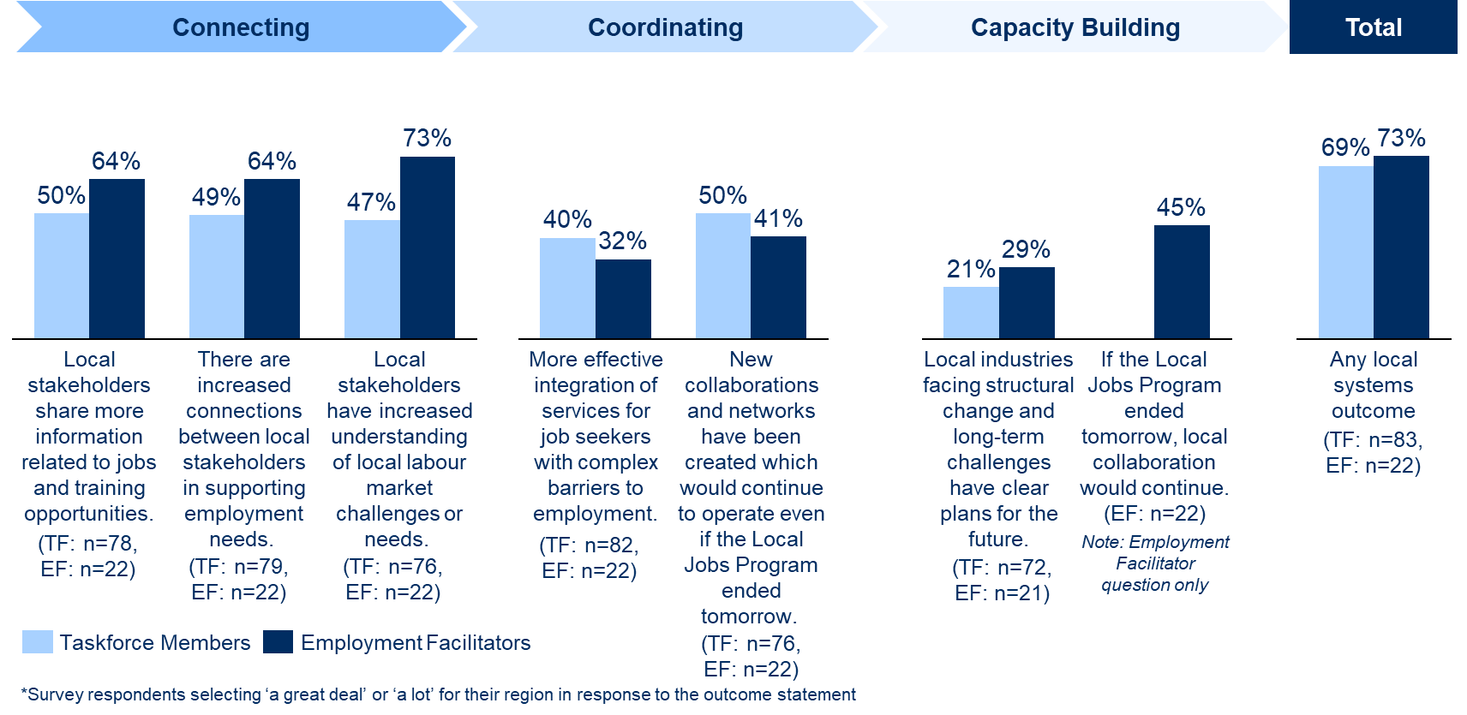
The greater incidence of Local System Outcomes in the Connecting Stage compared to the Coordinating Stage is consistent with the LJP theory of change, which describes that increasing connections and information flows between local stakeholders is necessary to increase coordination and local capacity.
Jobs and Skills Outcomes
As noted earlier, Jobs and Skills Outcomes were reported less often than Local System Outcomes in interviews. Survey responses on these outcomes were also slightly lower. This is also consistent with the LJP theory of change, which describes that place-based initiatives like the LJP aim to create Jobs and Skills Outcomes through creating Local System Outcomes. Therefore, it was expected that in the early stages of the program Employment Facilitators and Taskforce members would more readily observe and report the changes created by the LJP to local systems, rather than to local employment outcomes.
The evaluation still found many examples of how program activities have contributed to Jobs and Skills Outcomes across the Employment Regions for the target stakeholder groups of job seekers, employers and ESPs. Interviews identified a range of examples of Jobs and Skills Outcomes. Outcomes for job seekers most commonly identified in interviews included job placement opportunities from LRF-funded projects, jobs that resulted from ESPs working collaboratively to place job seekers, and jobs that resulted from connections made between ESPs and local employers through the Employment Facilitator or the Taskforce. Outcomes for employers mostly resulted from connections with other local stakeholders such as ESPs or RTOs.
A majority of survey respondents – 68% of Employment Facilitators (n=15/22) and 59% of Taskforce members (n=49/83) – strongly agreed that the LJP had contributed to at least one type of Jobs and Skills Outcome in their Employment Region. However, some outcomes were only reported by a minority of respondents. For example, only 25% of Employment Facilitators strongly agreed that the LJP had helped ESPs to better service their caseloads (n=4/20). Figure B highlights responses to the survey questions relating to Jobs and Skills Outcomes.
Figure B: Survey responses from Employment Facilitators and Taskforces agreeing the program has contributed ‘a lot’ or ‘a great deal’ to Jobs and Skills Outcomes in their region, by outcome and stakeholder type (September–November 2021)
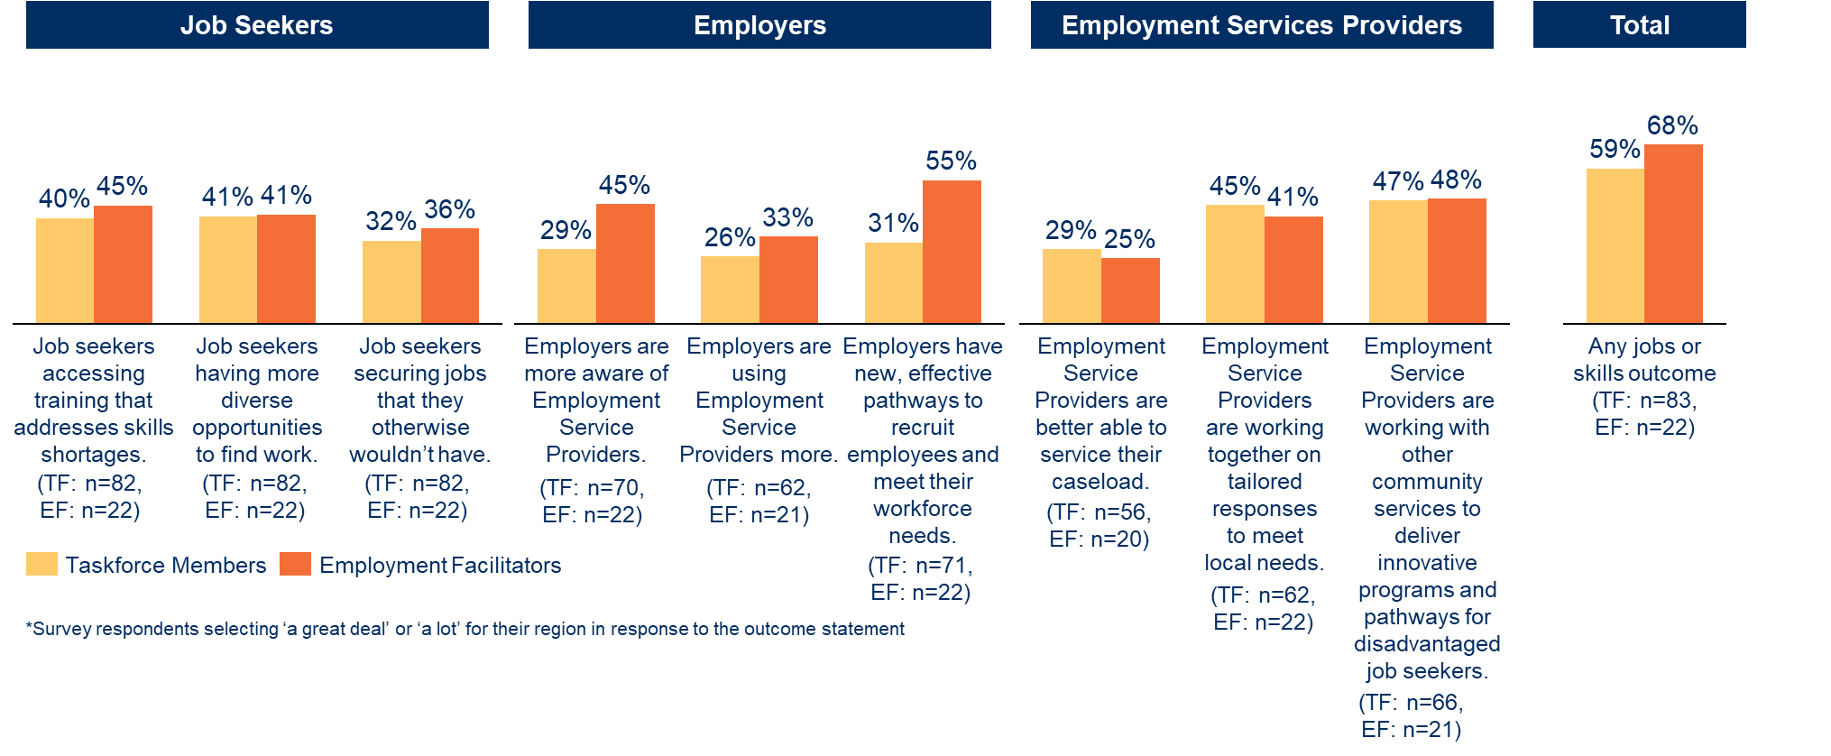
Variation in outcomes across Employment Regions
As noted earlier, the extent and types of outcomes the LJP has created to date have varied significantly across Employment Regions. Survey responses from Employment Facilitators across the 25 Employment Regions show a wide spread of responses across most questions on outcomes. Deeper data collection and analysis in 13 regions also found that 3 regions had some evidence of the most progressed outcomes in the LJP theory of change (the Capacity Building stage), 5 regions had evidence of outcomes up to the Coordinating stage, 4 regions only had evidence of Connecting outcomes, and in one region it was ‘too early to tell’ if the LJP had created any positive impacts to date.
The variation in outcomes reflects differences in how long substantive Employment Facilitators had been in the role, in how they had implemented the program, and in local conditions across the regions. This recognises that regions may have different ‘baselines’ in terms of how effectively local stakeholders were collaborating prior to the LJP, and that their Employment Facilitators have had different amounts of time to deliver outcomes.
Analysis of the implementation practices and conditions across the 13 selected regions found some commonalities in the 3 Employment Regions that appeared to be achieving outcomes at the Capacity Building stage (the most progressed stage of maturity in the LJP theory of change). These common practices and conditions included:
- Employment Facilitators who had previous experience or established relationships in the region in a related role
- Taskforces that were highly engaged, with a diverse membership, and actively collaborating on projects
- Jobs Plans that were actively used to set a shared vision for the Taskforce and guide strategy and actions
- Employment Facilitators working with local stakeholders on solutions to long-term labour market issues, as well as short-term needs, and regularly engaging with ESPs
- Employment Facilitators feeling that DESE provided them with effective support and sufficient autonomy and flexibility to tailor the LJP to their region.
The 3 Employment Regions that appeared to have reached the Capacity Building stage were also in regional areas. Although the sample size was small, this data, along with qualitative feedback from interviews, suggests that regional areas may support more effective local collaboration. Several DESE staff members and Employment Facilitators attributed this to the fact that in regional areas, local stakeholders have more enduring relationships, labour market needs are more homogenous, and there is a lower concentration of other initiatives competing with the LJP and taking up local stakeholders’ time. In contrast, in metropolitan regions, several State Office staff observed that relationships between local stakeholders are much weaker and there is a higher saturation of other initiatives and demands on stakeholders’ time.
Pathways to creating outcomes
Employment Facilitators and their Taskforces can take many different approaches to creating outcomes within both the structured and unstructured elements of the program. These approaches are referred to as ‘outcome pathways’. The following list highlights examples of some of the more common outcome pathways used by Employment Facilitators to create outcomes in their region, along with specific examples of the outcome pathways identified by stakeholders during interviews (Tables 4 and 5 in the body of the report provide further detail on outcome pathways):
- Local Recovery Fund Projects – for example, developing holistic employment training and work experience programs with integrated wrap-around supports targeting an industry in need of employees
- Connecting the dots through networks and local knowledge to support local stakeholders to work together to develop employment solutions – for example, connecting an employer with vacant positions with an ESP or training organisation
- Providing advice and guidance to local stakeholders – for example, providing advice to an employer on government funding available for taking on additional apprenticeships
- Supporting coordinated responses to long-term structural changes – for example, working with local stakeholders to plan for the upcoming expected closure of an energy plant and considering how job seekers can be transitioned to other industries
- Promoting increased collaboration between ESPs – for example, convening a monthly meeting of local ESPs to share information on common challenges and opportunities across the ESP caseload.
Additional findings: lessons for DESE
This section presents additional findings and evidence on lessons learned from the evaluation. This section is focused specifically on lessons for DESE regarding how it can effectively manage the program, covering what the evaluation found is working well and what could be improved. Lessons for Employment Facilitators regarding how they could approach their role are set out in the body of the report.
What is working well
The evaluation identified a range of lessons regarding what is working well with DESE’s support and program management:
- The flexibility within the LJP model has been critical for enabling Employment Facilitators to be effective. The LJP model provides a structure for collaborating with local stakeholders to take a flexible approach to meeting a region’s specific needs. The evaluation found the model has supported Employment Facilitators to take tailored approaches and been adaptive to changing labour markets, including enabling Employment Facilitators to take more of a long-term approach as the focus of the LJP shifted away from a more immediate response to COVID-19.
- The Employment Facilitator role is highly valued by local stakeholders. Stakeholders all agreed it was valuable to have a dedicated resource who understands the local context in their region and can support local collaboration. They appreciated having one point of contact as the ‘go-to person’ in their region for information and guidance on local priorities, local stakeholders, and government programs and funding sources. Employment Facilitators are also an important enabler of local collaboration, as a dedicated resource is critical for providing time-poor stakeholders with the capacity and resourcing to move from information sharing to taking action. Employment Facilitators’ independence from government also helps them to build engagement with local stakeholders, while at the same time their connection to the government supports their credibility.
- Most Employment Facilitators felt supported by DESE. Most Employment Facilitators reported they had sufficient support, authority and flexibility to adapt implementation of the LJP to the needs of their region. Most were also highly positive about the productive working relationships they had with their Relationship Managers, who were an important part of DESE’s support. DESE should continue supporting Employment Facilitators in a way that provides them with flexibility and avoids being overly prescriptive, recognising that Employment Facilitators have the best understanding of the specific needs and circumstances of their regions.
- It has been valuable for DESE to have a local presence in each region, but this needs to be done in a way that maintains space and autonomy for Employment Facilitators. The evaluation found that it can be valuable when DESE has a local presence in each region, such as by attending local events or Taskforce meetings. This can support Employment Facilitators’ credibility and the engagement of local stakeholders, providing confidence there is a line of sight between DESE and the work local stakeholders are doing. However, any local presence needs to be balanced with maintaining flexibility and autonomy for Employment Facilitators.
- The breadth of the LRF funding parameters has supported the development of solutions aligned to local needs. The fund parameters support the effectiveness of the LRF by providing funding for a wide variety of projects that meet local needs. Stakeholders particularly valued the scope within the LRF to fund projects that provide wrap-around support, combining several different program components to design a program that holistically caters for job seeker needs. Stakeholders attributed this to the fact that the LRF allowed for funding to go towards non-accredited training.
- Provision of labour market data by DESE is highly valued by Taskforce members. Taskforce members valued the labour market data provided by DESE as part of the development of the Jobs Plans. They felt that access to this data was one way they were getting value out of their participation in the program, as the data is helpful for understanding local problems and how they relate to their specific organisation.
What could be improved?
The evaluation identified a range of areas where DESE’s support and program management could be improved:
- Provide more opportunities for Employment Facilitators to share lessons and access ongoing professional development. Some Employment Facilitators indicated they wanted more opportunities to share lessons and that they would benefit from training on aspects of their role. As individual Employment Facilitators’ skills and experience were found to be a significant determinant of their effectiveness, DESE should consider opportunities to continue investing in their ongoing development. This could include further training and guidance in areas such as how to build an engaged Taskforce, relationship building, using the labour market data, and understanding different strategies for creating outcomes. Approaches to professional development could include peer-to-peer learning and sharing lessons between Employment Facilitators, targeted training or bringing in external experts from other place-based initiatives to learn about effective place-based practices. In facilitating the sharing of lessons, it is important that DESE not be overly prescriptive. to maximise Employment Facilitators’ flexibility. Lessons on effective approaches should therefore be considered as a ‘menu of ideas’ for Employment Facilitators to draw on according to the specific needs and circumstances of their region.
- Focus Employment Facilitator reporting on the minimum needed to be useful. Reporting is an important mechanism to provide local intelligence to DESE, inform ongoing improvements and keep Employment Facilitators accountable to DESE. However, reporting useful data is inherently challenging for the LJP because Employment Facilitators’ roles are highly flexible and diverse, and the outcomes of their work (for example, improving the coordination of local stakeholders) are difficult to capture in data. Many Employment Facilitators reported that monthly reporting to DESE is burdensome, detracts from time they could be spending engaging with local stakeholders, and focuses too heavily on outputs (such as number of meetings) that do not adequately reflect the essence of their work. DESE advises that reporting templates have been changed to reduce the reporting burden and increase scope to report on the diverse range of outcomes achieved in the LJP. While it is beyond the scope of this evaluation to suggest specific changes to DESE’s reporting framework and indicators, findings suggest there would be benefit in further streamlining reporting by considering the type and frequency of information collected. Where possible, reporting should also provide scope for Employment Facilitators to capture the less tangible outcomes of their work.
- Clarify roles and responsibilities for Taskforce members and ensure there is a clear and responsive process for replacing members. The evaluation found evidence that some Taskforce members did not have a clear understanding of their role. Others thought the current Taskforce member handbook was overly long and felt there would be benefit in a shorter (1- or 2-page) document outlining expectations of the role and the different ways members can contribute. Some Employment Facilitators also raised issues with the timeliness of DESE’s processes for replacing Taskforce members. Given that the mix and motivation of people on a Taskforce is an important enabler of engagement and effectiveness, it is important there is a timely process for replacing members, with clear guidance from DESE on eligibility requirements for new members.
- Consider opportunities to improve LRF processes. The LRF has faced several challenges in its implementation that risk undermining its potential to bring local stakeholders to the table and fund important local projects. DESE has made several improvements which are acknowledged by stakeholders; however, additional options should be considered within the constraints of the Commonwealth Procurement Rules and any relevant probity considerations. These include opportunities to speed up and streamline the process so the LRF can more rapidly respond to emerging needs in the region. DESE should also ensure administrative requirements are proportionate to the size of funds, as some Activity Hosts indicated they would not apply again due to the high administrative burden. DESE should also consider increasing opportunities for local input into LRF decisions, where appropriate.
- Promote ESPs’ engagement in the program. DESE can lean on ESPs to encourage them to engage with the Employment Facilitator and Taskforce and refer job seekers to funded activities. This was recognised by Employment Facilitators as an essential and unique role that DESE can play to support local efforts to improve coordination and collaboration between ESPs. While there was evidence some DESE staff were doing this, many stakeholders felt DESE could be playing a greater role in encouraging ESPs to participate and refer job seekers to LRF activities.
- Build capacity within DESE to encourage Employment Facilitators to adopt an entrepreneurial approach. The LJP requires that Employment Facilitators take an ‘entrepreneurial’ approach to implementing and adapting the program in their region – they need to be responsive, creative and collaborative. Some Relationship Managers expressed the view that Employment Facilitators are paid to figure out how to do this; however, this overlooks the important role that DESE, and particularly Relationship Managers, plays in supporting and enabling Employment Facilitators to work in this way. This means building relationships rather than managing contracts, relying on conversations, coaching and joint problem solving rather than metrics to manage performance. The evaluation found that most Relationship Managers are supporting Employment Facilitators in this way; however, there were still some opportunities for improvement. DESE could take additional steps to ensure these ways of working are understood by all Relationship Managers, including considering opportunities to provide training to Relationship Managers regarding how to approach their role.
- Ensure there are comprehensive plans in place to support program ‘transition’ points. The need to quickly roll out the program to the 25 Employment Regions meant that DESE had to use DESE staff to act as interim facilitators before the new Employment Facilitators came on board. These interim facilitators were responsible for developing the Local Jobs Plan and setting up the Taskforce. This has presented challenges for new Employment Facilitators who inherited what had been set up. In particular, these Employment Facilitators were more likely to report challenges relating to Taskforce engagement, and some Taskforce members felt less ownership of the Local Jobs Plan. Some Employment Facilitators also noted there was limited available onboarding support, which meant it took longer for them to get ‘up to speed’. While a change of this magnitude is unlikely to occur again, it highlights the importance of DESE managing transition points within program delivery. This may be particularly relevant where DESE replaces the Employment Facilitator in a particular region, and as ESP contracts roll over as part of the transition to Workforce Australia.
- Consider how DESE might need to adapt its support to Employment Facilitators depending on the different types of regions. The evaluation findings suggest that regional areas may support more effective local collaboration as stakeholders have more enduring relationships, labour market needs are more homogenous, and there is a lower concentration of other initiatives. In contrast, in metropolitan regions, relationships between local stakeholders are much weaker and there is a higher saturation of other initiatives and demands on stakeholders’ time. The different types of regions pose different challenges for Employment Facilitators and Taskforces in coordinating activity, so DESE should consider how it might need to adapt the focus and intensity of its support depending on the local conditions in each region. This might include increasing resourcing in areas with greater challenges, or an increased focus on facilitating the sharing of lessons between Employment Facilitators in similar types of regions.
Concluding statement
The LJP is an employment program using an innovative place-based model to improve the ability of local systems to respond to emerging labour market challenges. The program was initially implemented to respond to COVID-19 during an uncertain time, when there was a pressing need for innovative solutions to the localised and often complex challenges affecting Australia’s labour markets. This evaluation found evidence that the LJP has made a contribution to responding to these challenges, and that there is potential for greater outcomes in the future.
The extent and types of outcomes identified in this evaluation have varied significantly across Employment Regions. The variation reflects differences in the amount of time Employment Facilitators had been in the role, in how they had implemented the program, and in local conditions across the regions. Some Employment Regions have also faced barriers, most significantly around Taskforce member engagement and DESE’s processes for procuring and managing the LRF. Many of the barriers evident, in particular around the LRF’s processes, reflect that the LJP is a place-based, locally driven and highly flexible program, which requires an adaptive approach to contract management. DESE understands many of the challenges and has worked to find solutions and promote the different ways of working required to effectively implement the LJP.
A place-based approach needs time and resourcing to realise significant changes and build capacity in local systems. The extension to 2025 provides a helpful runway to work towards long-term outcomes. The program has also expanded to all 51 Employment Regions, so it will be important to ensure DESE has sufficient resourcing to support a program that has doubled in size, including resourcing required to consider and act on the opportunities for improvement and the lessons outlined in this evaluation.

Departmental response to findings
Local Jobs Program context
The Local Jobs Program is a collaborative initiative aimed at improving the function of local labour markets. A key focus of the program is bringing together expertise and resources to improve the local delivery of employment services. This is achieved by leveraging existing programs and resources, reducing duplication, and supporting local initiatives that help job seekers into work or training opportunities aligned with local needs.
The program involves several core program elements in each Employment Region, including:
- an Employment Facilitator and a Support Officer who drive community collaboration and local implementation of the LJP
- a Jobs and Skills Taskforce of local stakeholders that represents the views of local businesses, ESPs, government, training providers and community services and plays a central role in connecting, coordinating and leveraging existing programs and aligning efforts on the ground and deliver new initiatives to support local employment outcomes
- a Local Jobs Plan that is developed by the Taskforce and defines the Employment Region’s employment and training priorities
- a Local Recovery Fund to fill gaps in local servicing by supporting local projects that address the priorities in the Local Jobs Plan.
Employment Facilitators engage in a wide range of activities to support local solutions. The flexibility afforded to Employment Facilitators allows them to tailor their approach to their local community; adapt to changing labour market priorities; respond quickly to local challenges such as natural disasters; and capitalise on emerging opportunities.
Outcomes through the Local Jobs Program are often achieved indirectly through improved utilisation of existing labour market programs. The program aims to achieve:
- Local System Outcomes by improving how local stakeholders work together, share information, and collaborate to respond to local challenges and meet local needs
- Jobs and Skills Outcomes for job seekers and employers with respect to employment, training and reskilling to meet current and future local workforce needs.
Evidence from other place-based initiatives suggests that it takes time to create changes in local systems that generate long-lasting improvements in local capacity.

Evaluation context
The Local Jobs Program was initially announced in the 2020–21 Budget to be implemented in 25 Employment Regions for the period of 1 September 2020 to 30 June 2022. The program was expanded to all 51 Employment Regions, and extended to 30 June 2025, as part of the 2021–22 Budget.
The scope of the evaluation was limited to the initial 25 Employment Regions introduced in September 2020, which were then budgeted to 30 June 2022.
The evaluation gives a point-in-time assessment of the Local Jobs Program at the early stages of the program’s implementation.
The bulk of evaluation data was collected approximately 12 months after the program formally commenced. At this time, there were significant differences in the amount of time Employment Facilitators had been in the role (ranging from 2 to 12 months). Departmental staff acted as interim facilitators in the intervening periods.
A key part of the evaluation was the provision of emerging findings in interim reports to inform iterative enhancements to the program. For example, adjustments were made to the Local Recovery Fund procurement to address stakeholder feedback about time frames, and the department continues to look for opportunities to further streamline the procurement and contracting processes while retaining robust accountability for the expenditure of public money.
A second evaluation of the Local Jobs Program will be conducted between July 2022 and June 2025. The scope of that evaluation will include all 51 Employment Regions and will investigate the impact of the Local Jobs Program on local communities as the program continues to mature.
More recent evidence
Analysis of program data for the 25 Employment Regions introduced in September 2020 suggests that the influence and impact of Employment Facilitators has been increasing over time. For example:
- Program data shows that the number of ongoing collaborative initiatives supported by Employment Facilitators more than doubled from 198 in August 2021 to 460 in August 2022.
- Monthly Reporting demonstrates that Employment Facilitators are increasingly tapping into local networks to support Jobs and Skills Outcomes. For instance, during August 2022, 82 local employers were connected with ESPs to help address their workforce needs, compared with just 23 employers in August 2021.
This reflects the time required for Employment Facilitators to invest in connecting and strengthening networks, to build the trust and collaborative spirit required to drive Local System Outcomes and Jobs and Skills Outcomes.

- The Local Jobs Program and evaluation overview
This section provides an overview of the LJP, including the program logic and ‘theory of change’, and the evaluation strategy.
- Section 1.1 The Local Jobs Program
- Section 1.2 Evaluation strategy

The Local Jobs Program
    - Overview of the program
On 1 September 2020 the Australian Government announced the new $62.8 million Local Jobs Program (LJP) as part of the economic response to COVID-19 in the 2020–21 Budget. Recognising that locally developed placed-based solutions have the potential to effectively support the economic recovery of local labour markets, the LJP brings together expertise, resources and access to funding at a local level to support locally driven approaches to accelerate reskilling, upskilling and employment pathways for job seekers.
The LJP was initially implemented in 25 Employment Regions for the period between 1 September 2020 and 30 June 2022. These Employment Regions were selected based on an analysis by the National Skills Commission of regions that were the most impacted by COVID-19 and were experiencing ongoing disadvantage. In the 2021–22 Budget, the Australian Government announced a further $213.5 million for the Local Jobs Program to be expanded to all 51 Employment Regions across Australia from 1 July 2021 and extended to 30 June 2025.
Part of the original intent of the LJP was to help local labour markets respond rapidly to the impact of COVID-19 and get job seekers back into work as quickly as possible, in those regions that were hardest hit. The extension of the program into additional Employment Regions, and until June 2025, reflected a recognition that the LJP could play an important role in supporting local approaches to labour market challenges beyond COVID-19, and that the impact of COVID-19 on labour markets has continued to evolve.
    - The program logic
The LJP is modelled on a place-based approach to convening local stakeholders, resources and access to funding to develop tailored solutions for the specific issues faced in communities. The LJP model involves establishing several core elements at the local level. Each Employment Region contains the following elements:
A Local Employment Facilitator and Support Officer. Employment Facilitators are responsible for coordinating and collaborating with local stakeholders and government to deliver the LJP in their Employment Region. They convene local stakeholders to develop solutions to help job seekers find training and employment, and help employers meet their workplace needs. They chair the Local Jobs and Skills Taskforces to develop and implement the Local Jobs Plan. The Employment Facilitator is supported by a Support Officer with logistic and secretarial roles.
A Local Jobs and Skills Taskforce. These Taskforces are made up of representatives from local businesses, ESPs, government, training providers and community services. The Taskforce develops and updates the Local Jobs Plan, identifies employment and training priorities for the region, and implements strategies to drive employment outcomes by supporting job seekers in meeting local employment requirements.
A Local Jobs Plan. This is developed by the Employment Facilitator and Taskforce, and approved by DESE, to identify key employment and training priorities for the Employment Region.
A Local Recovery Fund. This provides access to a pool of funding to support small scale local activities in line with the priorities in the Local Jobs Plan. Employment Facilitators and Taskforces help identify potential LRF projects, and play a key role in supporting Activity Hosts to deliver LRF activities. The assessment on the application is undertaken as part of DESE’s procurement process.
DESE’s State and National Offices support. At the program level across all Employment Regions, DESE’s State and National Offices provide central government support, including a policy environment, contracting and procurement, communications, reporting and national coordination. This support includes providing labour market information by the National Skills Commission and the National Careers Institute. Each Employment Facilitator has a Relationship Manager at DESE’s State Office to support their work. DESE’s National Office is involved in providing policy and program guidance relating to the operation of the LJP.
The LJP aims to achieve outcomes in 2 categories: Local System Outcomes, and Jobs and Skills Outcomes.
Local System Outcomes are positive outcomes regarding how local stakeholders work together to develop local employment solutions. These outcomes are common to place-based initiatives such as the LJP. All place-based initiatives drive community outcomes by catalysing changes in how local systems work (rather than ‘directly’ supporting job seekers into work, for example). Other place-based initiatives suggest that creating changes in local systems takes time and should be understood as a staged approach. Accordingly, the LJP theory of change identifies that Local System Outcomes occur across 3 stages of maturity, starting with improving ‘Connecting’, then ‘Coordination’, and finally ‘Capacity Building’.
This category of outcomes includes, for example, increased connections and information sharing between local stakeholders, improved collaboration/linkages between ESPs and other service systems (e.g. housing, health, justice) on tailored responses to local needs, and the establishment of local structures that enable strategic local collaboration to address more complex workforce challenges.
Jobs and Skills Outcomes are positive outcomes for job seekers, employers and ESPs with respect to employment, training, upskilling and reskilling, and meeting workforce needs. Jobs and Skills Outcomes can occur concurrently with Local System Outcomes through changes in how local stakeholders are working together. This category of outcomes comprises:
jobs outcomes, such as instances of job seekers accessing jobs they otherwise would not have, employers using employment services more often, or ESPs collaborating on tailored responses to local needs
skills outcomes, such as increased pathways and programs in local regions for upskilling, reskilling and employment, and initiatives to address skills shortage in supporting local economic development.
The ultimate goal of the LJP is to achieve Jobs and Skills Outcomes. Local System Outcomes support and enhance these in the long term.
A visual summary of the core components of the LJP model, and the outcomes that it aims to achieve, is presented in a program logic diagram in Figure 1.
Figure 1: Program logic for the Local Jobs Program
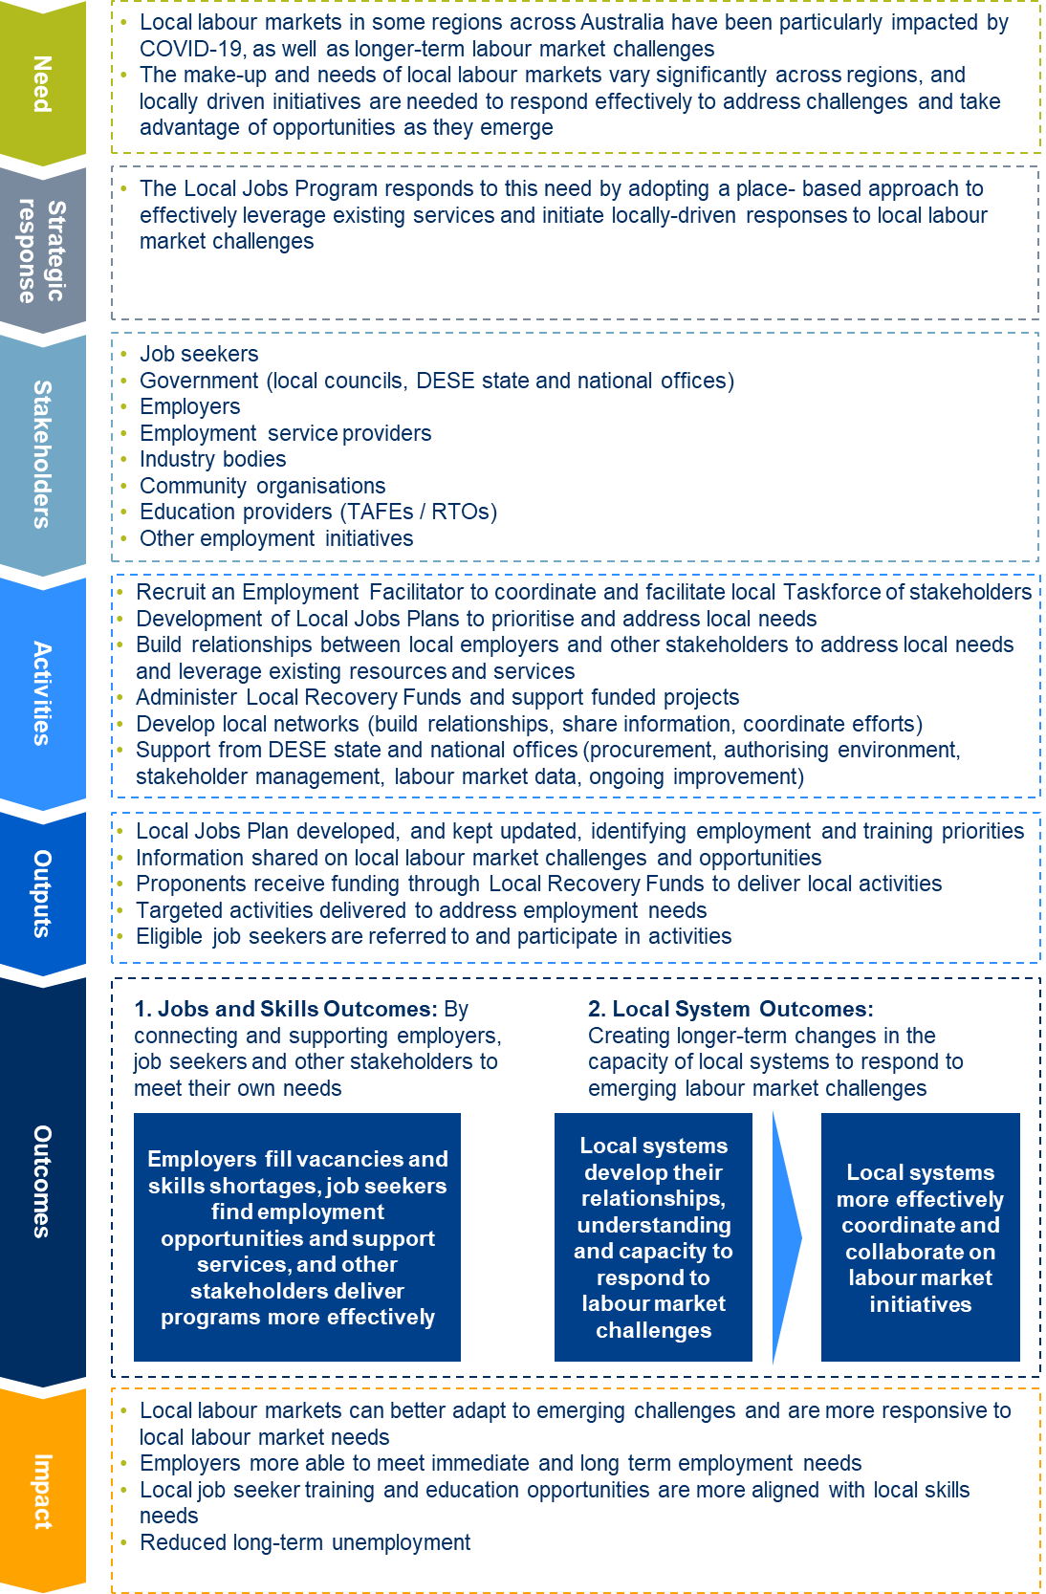

    - Theory of change
Built on the program logic (shown in Figure 1), a theory of change for the LJP was developed through conducting a targeted literature review to gather evidence from other place-based initiatives and locally driven labour market initiatives about good practice and what works. The literature review identified 5 key characteristics for effective place-based approaches, which can be broadly adapted and applied to the components of the LJP model. These characteristics and related LJP components (described in brackets) are:
- A shared vision and a common agenda (Local Jobs Plan)
- Bringing together diverse local stakeholders (Jobs and Skills Taskforce)
- Creating an enabling authorising environment for collaboration and building ownership (one of DESE’s roles)
- Effective governance structure and a central coordinating entity (Employment Facilitators as a ‘local backbone’ and DESE’s National and State Offices as a ‘central backbone’)
- Coordinating mutually reinforcing and flexible activities (role of and approach by Employment Facilitators).
The theory of change articulates how the LJP model is situated in a theoretical framework regarding similar place-based initiatives, and provides a framework against which to evaluate the program. The theory of change defined what ‘effective’ looks like for the LJP, including:
Implementation: How each of the components of the LJP model ought to function in order to be ‘effective’. The theory of change articulated a set of assumptions about the practices and attributes for each component, so that these could be validated through the evaluation.
Outcomes: What outcomes are made possible through the LJP when each of the components is implemented effectively. The theory of change defined different types of outcomes, for different stakeholders, which are made possible at different stages of maturity.
Figure 2 provides a visual representation of the LJP model as a place-based approach to creating outcomes.
Letters A–F identify the key components of the LJP model and how they interact to achieve outcomes. These components were described in Section 1.1.2. The literature review suggests that several aspects of the LJP components reflect features of effective practice in place-based initiatives. These features are also identified in Figure 2 in the text explaining each component.
Numbers 1–4 reflect the stages of maturity of the program.
  - Stage 1: Establishing is the first stage of the program, when each of the program components is established and implemented in each Employment Region.
  - Stages 2–4: Connecting, Coordinating, and Capacity Building are the 3 stages of outcomes expected to be achieved as the program matures. In each of stages 2–4 both Local System Outcomes and Jobs and Skills Outcomes are possible.
The stages of maturity of the LJP are presented as concentric circles, with the Employment Facilitator at the centre, reflecting that:
  - outcomes can occur concurrently, rather than requiring a linear progression over time
  - the types of outcomes that are achieved in each region are likely to vary, depending on the skill of Employment Facilitators and variations in local conditions
  - there is a positive feedback loop between program activities and outcomes, with improved outcomes leading to more effective program activities, in turn driving further outcomes. For example, as Employment Facilitators engage in activities creating connections in each region it leads to greater connectivity, in turn supporting Employment Facilitators to create connections more effectively in the future
The 2 categories of outcomes described above (Local System Outcomes and Jobs and Skills Outcomes) reflect the unique nature of labour market initiatives that are derived from on placed-based approaches and local flexibility. These achieve labour market outcomes through changing the way local actors are working together, as opposed to directly creating outcomes for job seekers by helping them secure work, as an ESP may do.
Figure 3 provides detail on the kinds of Jobs and Skills Outcomes and Local System Outcomes that are made possible, over the different stages of maturity, when the LJP is implemented effectively.
The original LJP theory of change document details the literature review findings and theoretical framework, and is available on request.

Figure 2: The Local Jobs Program in a theoretical framework
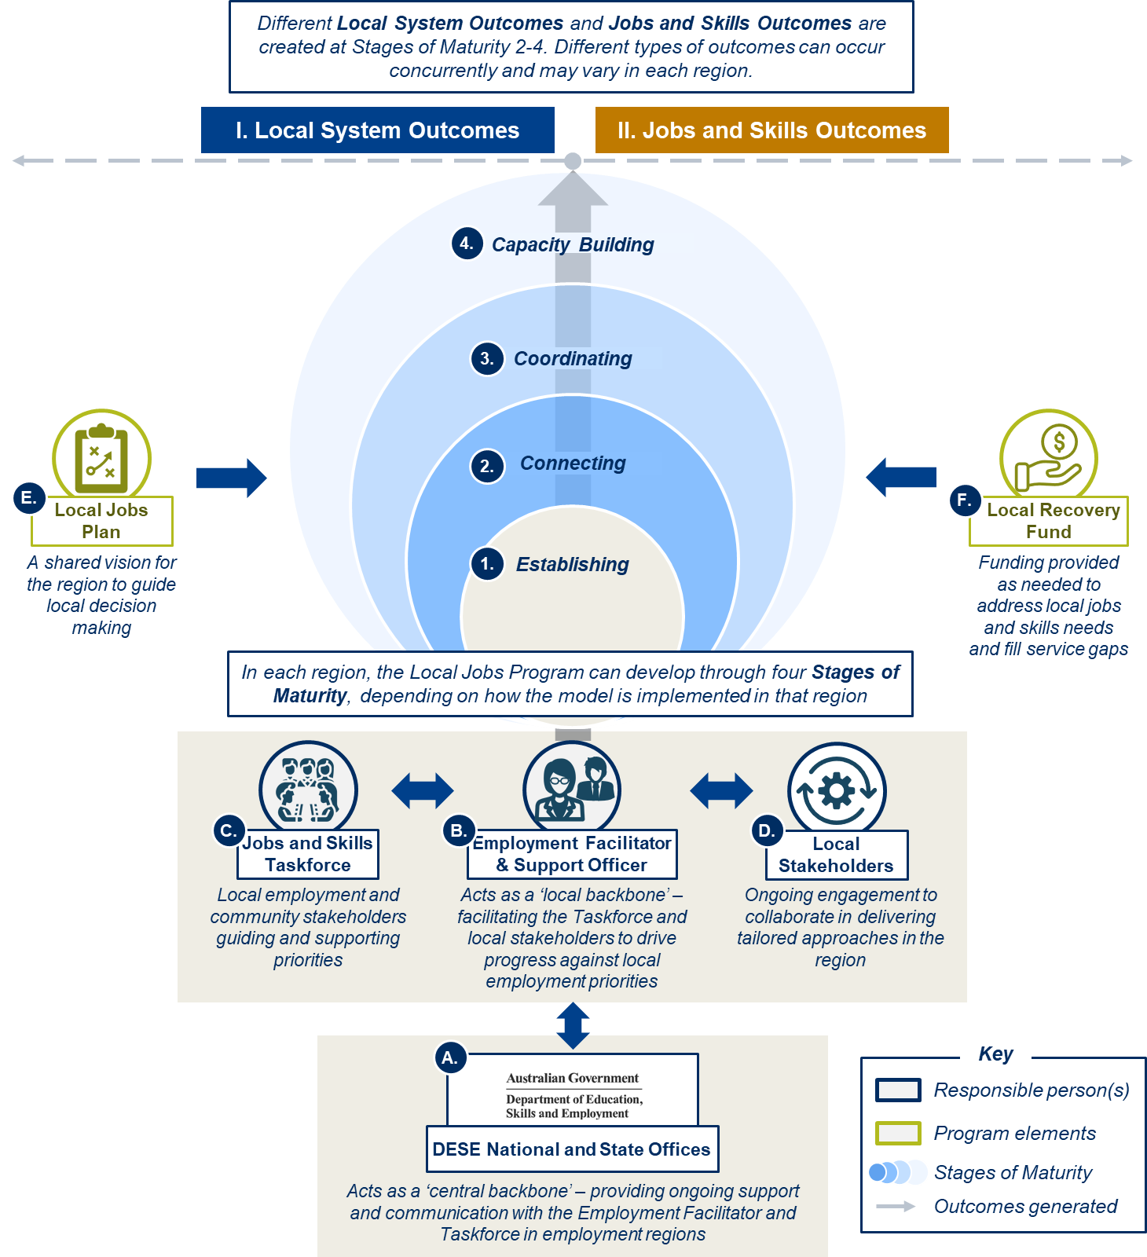

Figure 3: Summary of pathway to change for LJP
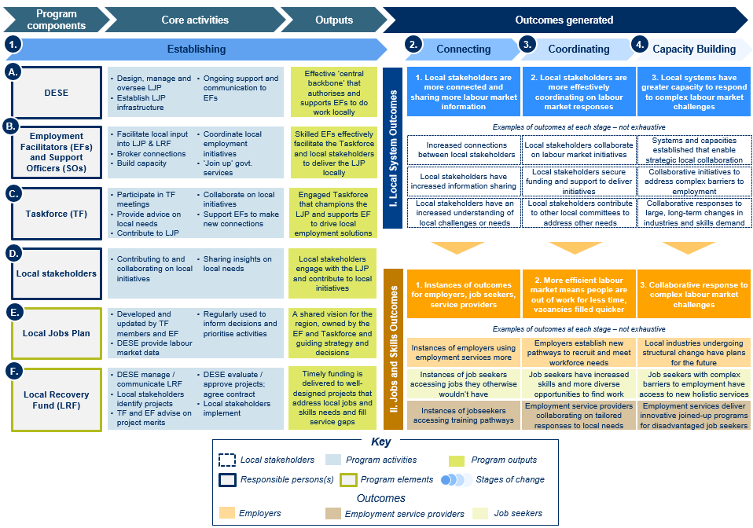

Evaluation strategy
    - Evaluation purpose and scope
DESE commissioned SVA to conduct an evaluation of the LJP in April 2021. The purpose of the LJP evaluation was to assess the appropriateness and effectiveness of the LJP in meeting the program objectives in the initial 25 Employment Regions over the period between September 2020 and 30 June 2022. The list of 25 Employment Regions is presented in Appendix A.
DESE will use the evaluation findings and learnings to help inform ongoing delivery and improvement of the LJP, as well as policy development around the role and value of locally led models to respond to local labour market challenges.
The evaluation scope excluded the following:
- Quantifying the net or total impact of the LJP. This includes quantifying the total impact of the program on the responsiveness of local labour markets or overall unemployment rates.
- Evaluating the relevance, effectiveness or efficiency of individual projects funded through the LRF. The evaluation did aim to assess whether the LRF was effectively administered and used, but evaluating the effectiveness of the individual LRF projects is not in scope for this evaluation.
- Evaluating the expanded and extended LJP announced in the 2021–22 Budget, i.e. in the 26 new Employment Regions from July 2021 and the existing 25 Employment Regions beyond June 2022.
    - Evaluation questions
The LJP evaluation aimed to answer the following question:
‘To what extent has the Local Jobs Program contributed to effective responses to local labour market challenges?’
To address this, 3 guiding evaluation questions were:
- Implementation: To what extent was the LJP implemented effectively?
- Outcomes: To what extent has the LJP improved the responsiveness of labour market interventions?
- Enablers and barriers: What practices and conditions enabled effective implementation and outcomes?
A list of sub-questions is presented in Appendix A.
    - Evaluation data and approaches
The evaluation made use of a combination of qualitative and quantitative data sourced from:
- consultations including interviews and online surveys to collect self-reported data and subjective feedback from all key stakeholders – including Employment Facilitators, Taskforce members, LRF Activity Hosts (who delivered LRF-funded projects), and staff from DESE’s State and National Offices.
- Employment Facilitators’ monthly reports, the Employment Services System database (ESSWeb) to access aggregated data on job seekers participating in LRF-funded activities, and program data on LRF projects.
It was not feasible to conduct surveys with job seekers participating in LRF-funded activities, due to logistical challenges in identifying, recruiting and reliably surveying participating job seekers. Furthermore, it was not possible to use ESSWeb data on the number of participating job seekers placed into employment through LRF projects, due to limitations in the data.
The evaluation methodology and data sources had limitations owing to the challenges of evaluating a complex place-based initiative across multiple and diverse contexts, including limitations in evaluating attribution of outcomes and developing a universal definition of success. The detail of the methodology and data description is presented in Appendix A.
Qualitative data from interviews and surveys were analysed using thematic analysis to identify patterns, common themes and divergent perspectives and, where possible, understand the prevalence of perspectives. Quantitative program data was analysed to understand the extent of program activities and how these varied across regions and states/territories.
One important aspect of the data analysis approach for the evaluation was to analyse and synthesise across the data sources at a regional level to identify any associations between how the LJP had been implemented in different regions, and the types and levels of outcomes achieved. This analysis was conducted by creating a set of ‘derived variables’ – placing each region in a set of categories based on the theory of change to draw a conclusion about the effectiveness of implementation and outcomes in that region. The purpose of this was not to assess the performance of individual regions or Employment Facilitators, but to identify common patterns or trends that may point to lessons learned for good practice and improving the program in the future. The detail of derived variables is presented in Appendix B.
The Local Jobs Program evaluation strategy and Local Jobs Program research plan documents provide further detail on all aspects of the evaluation methodology. These documents are available on request.

- Evaluation findings: implementation
This section presents the findings of the evaluation against the first evaluation question:
‘To what extent was the Local Jobs Program implemented effectively?’
This section outlines whether the following 5 key program components have been implemented as intended and have resulted in the intended outputs.
- Section 2.1: The role and practice of the Employment Facilitators and Support Officers
- Section 2.2: Local Jobs and Skills Taskforces and their contribution
- Section 2.3: Use of the Local Jobs Plan
- Section 2.4: The Local Recovery Fund
- Section 2.5: DESE’s role

The role and practice of Employment Facilitators

    - Who are Employment Facilitators?
Employment Facilitators are independent from DESE and engaged for the purpose of delivering the LJP. They can be employees of entities or they can be sole traders. Support Officers are contracted by Employment Facilitators (with DESE’s approval) as a full-time role.
When the LJP was introduced in September 2020, existing Regional Employment Trial (RET) Employment Facilitators in 11 regions were engaged to become the facilitators for the LJP. These Employment Facilitators already had relevant experience and were also able to take on the role for the LJP straightaway. New Employment Facilitators were recruited in another 14 regions (10 commenced 6 months prior to the evaluation data collection period while 4 were only in place for 3 months). Before the new facilitators commenced, DESE staff in the State Office filled in the role as interim facilitators.
Previous experience of Employment Facilitators
Interviews found that 11 out of 24 regions had Employment Facilitators with strong experience in their regions or similar roles. These Employment Facilitators had previously been involved in either the RET program or other government programs in the employment space and had at least 3 years’ experience as an Employment Facilitator or in a similar role. Another 10 Employment Facilitators had some experience in their region or the employment sector. This included previously holding roles in ESPs, Chamber of Commerce, training providers, government, business or economic development. The remaining 3 Employment Facilitators had little experience in similar roles, with backgrounds in other industries such as education, aged care or corporate training.
Employment Regions
Of the 25 Employment Regions, 12 are in metropolitan (metro) areas and the remaining 13 are in regional areas. The regions vary significantly in size: some regions cover a large geographic area or include distant locations, such as the Darwin Employment Region, which covers Darwin and Alice Springs; other regions cover only one part of a metro area, such as Sydney South West or Inner Metropolitan Melbourne, and have a much smaller geographic footprint.
    - What are their roles?
Employment Facilitators are required to engage in a wide range of activities which align to their contractual obligations. These activities broadly fall into 2 categories: ‘structured’ and ‘unstructured’ program elements (Figure 4):
- Structured program elements: These are the formal structures established by DESE to implement the program in each region (the Employment Facilitator, Taskforce, Local Jobs Plan and Local Recovery Fund), as well as the task of undertaking monthly reporting.
- Unstructured program elements: These are more informal approaches to connecting and supporting local stakeholders. Employment Facilitators tailor these elements to the local needs and context of their region.
Figure 4: Structured and unstructured program elements
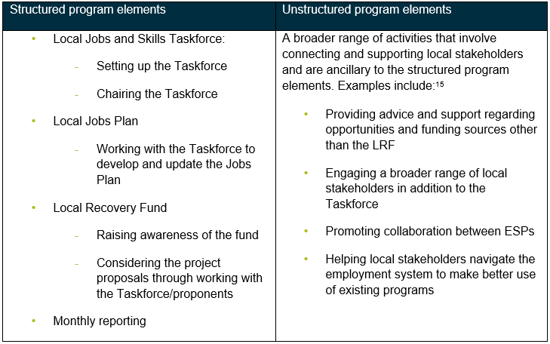
The role of the Employment Facilitator is essentially to support the implementation of the LJP in each Employment Region. The nature of structured and unstructured program elements, apart from reporting requirements, is similar in that they both involve engaging and connecting with local stakeholders (Taskforce members or stakeholders outside of the Taskforce) and contributing to local initiatives (either funded through the LRF or funded by other sources) to promote collaboration and address local employment issues.
Employment Facilitators are engaged under a contract arrangement; they need to dedicate time to ensuring delivery of and compliance with the terms of their contracts with DESE.
    - Approaches and activities reported by Employment Facilitators
The approaches and practices adopted by Employment Facilitators are influenced by their understanding of the objectives of the LJP. In the early insights consultation, Employment Facilitators described their task as both supporting employers to fill vacancies and maximising the prospects of unemployed people in employment services (i.e. those on the caseload of ESPs and online employment services) to access these opportunities. As local labour market needs changed, Employment Facilitators perceived a shift in the program’s focus from rapidly responding to retrenchments and other employment challenges caused by COVID-19, to responding to broader labour market challenges. Employment Facilitators perceived this shift partly as an adaptive response to local needs as they evolved.
Employment Facilitators’ choice as to the mix of approaches or activities is influenced by multiple factors, including:
- priorities in the Local Jobs Plan
- the local context and needs of the region
- the Employment Facilitator’s experience and skills and the strength of their networks
- how long the Employment Facilitator has been in their role and operating as a facilitator in their region
- membership and engagement of the Taskforce
- the Employment Facilitator’s understanding of DESE’s expectations for the program.
Effectively engaging Taskforce members in the LJP is a central part of the Employment Facilitator role, and every Employment Facilitator has approached this differently
Employment Facilitators play a key role in setting up and chairing the Taskforce and holding regular meetings with the Taskforce. Effectively engaging the Taskforce serves to facilitate information sharing among Taskforce members about industry needs and promote collaboration on effective solutions to employment challenges. Engaging the Taskforce can also lend itself to broadening the reach of the LJP, as Taskforce members become advocates for the LJP within their broader networks.
Employment Facilitators found that the best approach to building an engaged Taskforce varies from region to region and there is no single effective approach. One commonality appears to be that Taskforce members feel ownership of and are committed to the work of the Taskforce, and that their input is valued and relevant.
In the early insights consultation, interviewed Employment Facilitators reported that they had successfully established working groups in their Taskforce to increase engagement, participation and ownership. This was confirmed in additional interviews. Some regions established issue-based working groups, meaning they were formed around particular issue areas and brought in representatives from other local organisations working on these issues from outside the Taskforce. Other regions, including those that were large and remote, established location-based working groups to effectively convene Taskforce members operating in different parts of the region. These success stories provide examples of the types of entrepreneurial approaches to relationship building that could support improved engagement of Taskforce members (see Section 2.2.3 on Taskforce structures for further detail).
Some Employment Facilitators reported challenges with inheriting Taskforces from interim facilitators, including the view that the members were not the right mix and that there were some difficulties with the processes and time frames for replacing members.
Good practices that Employment Facilitators have adopted to engage their Taskforces across the regions include:
- ensuring the right mix of members to support effective collaboration
- refreshing Taskforce membership in regions where a Taskforce was inherited from an interim facilitator, or to increase the diversity of members, including to ensure the right mix of personalities and roles
- inviting Taskforce members to present on their area of expertise and having guest speakers attend Taskforce meetings to make meetings informative and to collectively increase Taskforce member knowledge of specific industries or employment challenges
- regularly meeting with Taskforce members one-on-one outside of standing Taskforce meetings to build relationships more informally
- providing resourcing for effective administration of Taskforce operations, to support collaboration and reduce time demands on busy Taskforce members
- providing updates on how Taskforce member input is used
- using meetings to have discussions or debates and to make decisions, not just as a forum for information sharing; this includes delegating decision-making and issue ownership where appropriate
- setting up working groups or subcommittees to address challenges in specific industries, including with members outside of the Taskforce
- arranging for DESE staff to have some presence in the region though attending Taskforce meetings or events
- taking a longer term strategic view to elevate the Taskforce role and provide greater ownership of the potential longer term impact the Taskforce could have on their region.
Some of these practices are described by Employment Facilitators.
‘The previous Taskforce was established by a DESE member. Previously I had very little interest from Taskforce members … I needed to be diplomatic when telling them that I was going to open up their positions for new members.’
– Employment Facilitator
‘Heads of organisations are on our Taskforce but they are so busy and it is hard to engage them. We have set up smaller working groups to address the issues in our region. To ensure we are getting the right people in we get Taskforce members to nominate people from their organisations to provide input and drive opportunities.’
– Employment Facilitator
‘Continuing to have higher level discussions at Taskforce meetings keeps them engaged, because they’re keen to see the economy of the region grow.’
– Employment Facilitator
‘I try to make the meetings informative. I am always finding out what they are doing. I always bring matters to the Taskforce for their consideration so they feel empowered, so that they are contributing to the different programs in the regions. It helps them form a good relationship.’
– Employment Facilitator
More details on Taskforce engagement from the perspective of Taskforce members are presented in sections 2.2.3 and 2.2.4.
Employment Facilitators have engaged with a wide range of stakeholder groups, including employers, government representatives and ESPs
As part of their role, Employment Facilitators engage with a range of stakeholder groups on a variety of topics. Program data shows there were 19,530 engagements reported by Employment Facilitators across the 25 Employment Regions between November 2020 and December 2021, with slightly over 50% in metropolitan (metro) areas and the rest in regional areas.
Employment Facilitators were most often meeting with employers, followed by government representatives and ESPs or facilitators, as seen in Figure 5. This figure also shows there is a higher proportion of engagements with ESPs in metro areas, and relatively more engagements with community organisations and ‘other’ (such as events and conferences) in regional areas.
Discussion topics were mostly around developing connections and addressing local needs, as seen in Figure 5. Metro regions had more discussions on the LRF or Taskforce and employment opportunities compared to regional areas. Regional areas had more discussions based on regular engagements and planning, as well as a variety of ‘other’ discussion topics such as events or conferences, the National Priority Fund, Regional Employment Trials, and regional economic updates.
Figure 5: Proportion of stakeholder engagements by stakeholder type and by discussion topic and region type (metro or regional) (November 2020–December 2021)
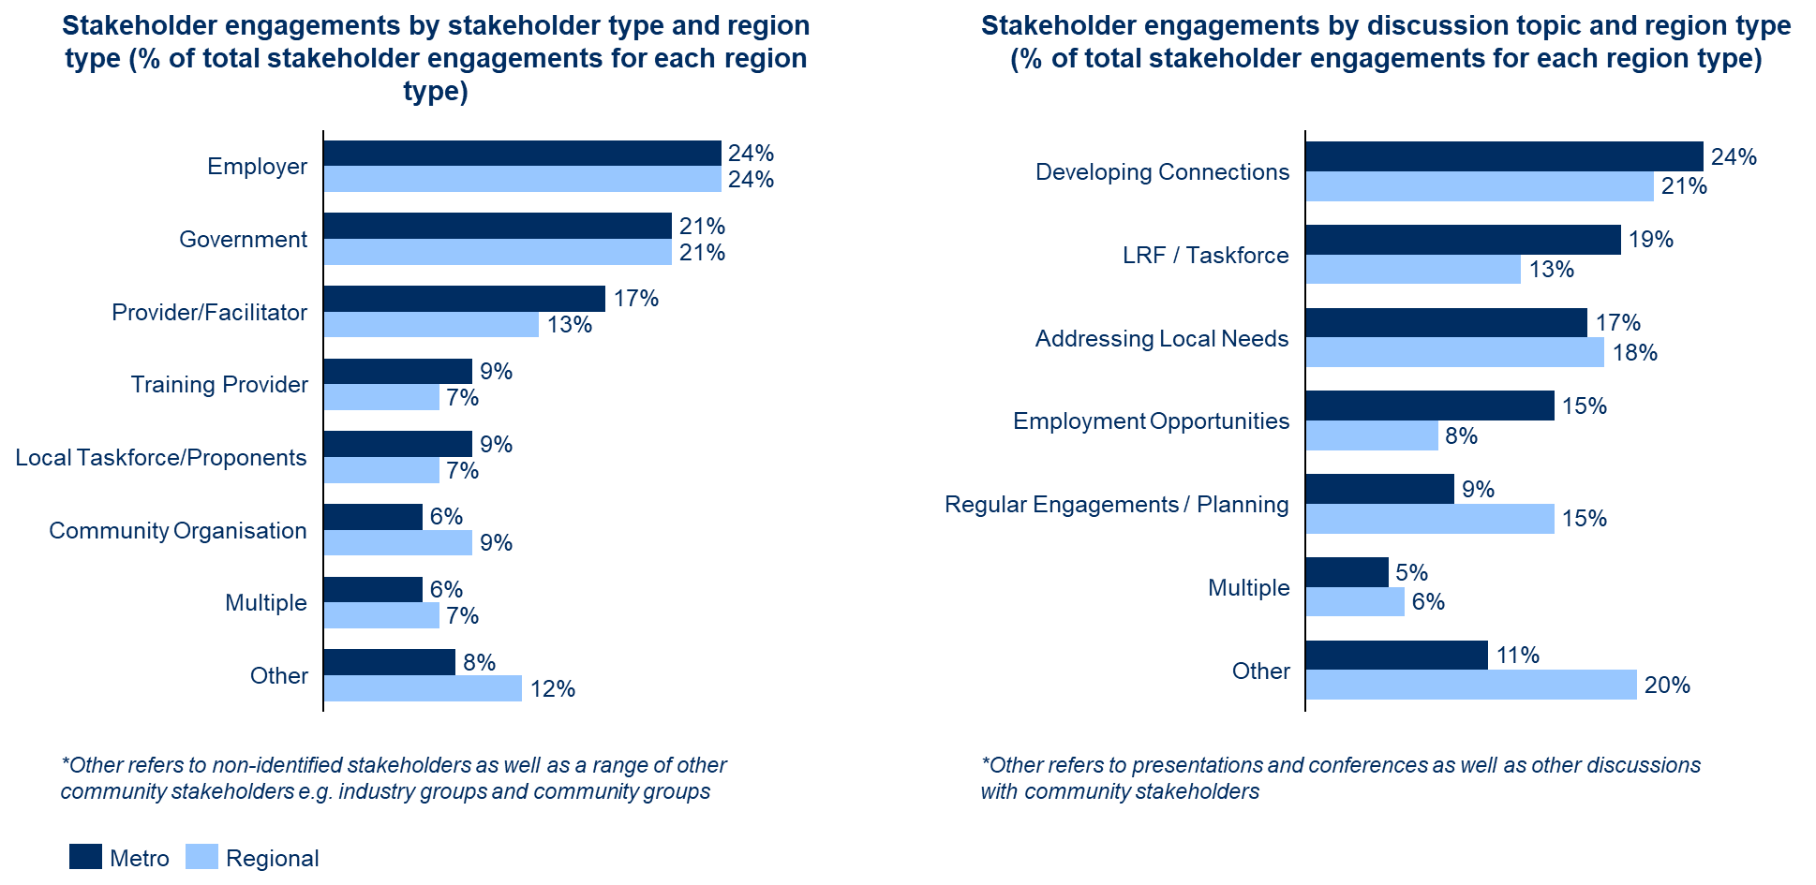
Interviews provided some examples of how Employment Facilitators are engaging ESPs and employers. To engage ESPs, Employment Facilitators had ESPs on the Taskforce, organised frequent ESP meetings to encourage information sharing and collaboration, or tapped into existing ESP forums.
One Employment Facilitator noted a large part of their role was brokering connections between ESPs and training opportunities.
‘A lot of my role is connecting training opportunities to ESPs … A big part of the role is brokering ... We are running lots of webinars … talking businesses through understanding labour force issues, understanding different employment programs out there. It is an education and awareness pieces to those programs through the webinars. We have been working with five hospitality initiatives. We are getting opportunities from businesses and connecting them to employment service providers.’
– Employment Facilitator
Approaches to engaging employers have included engaging representatives from large employers in a region on Taskforces, or tapping into Taskforce member networks to engage employers.
See Section 3.2 on Jobs and Skills Outcomes for more information on outcomes for ESPs and employers.
Quantitative data show there is variation across regions in the average number of engagements with stakeholders, ranging from 31 to 121 engagements per month. As seen in Figure 6, it appears that nearly half of the regions have fewer than 40 engagements per month.
Figure 6: Number and proportion of regions by average engagements per month (November 2020–December 2021)
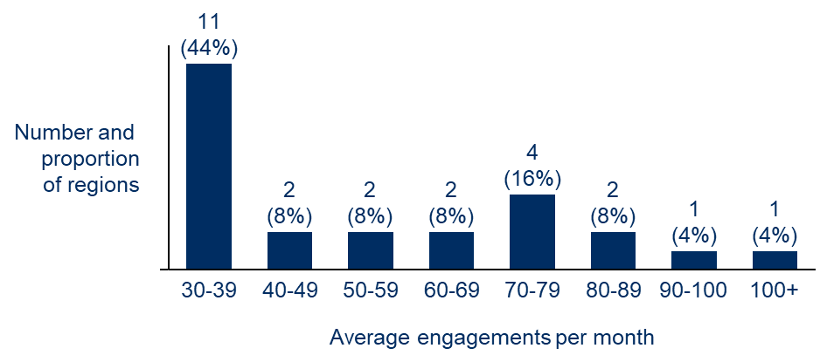
Note: Region (n=25)
Employment Facilitators have used the flexibility afforded by the role to take many different approaches to implementing the LJP in their Employment Region
In the early insights consultation, Employment Facilitators said that they mostly focused on those activities they assessed to be most relevant to their region. Examples of these activities are:
- Helping local stakeholders (e.g. employers, ESPs, registered training organisations) navigate the complexities of the employment system to make better use of existing programs
- Providing advice and support regarding opportunities and funding sources from federal, state and local government – for example, helping local employers find government grants
- Facilitating or contributing to other local networks around local labour market needs – for example, participating in other local committees, taskforces or initiatives focused on employment, skills and economic development run by local councils, peak bodies and state governments
- Promoting collaboration between ESPs to address common issues, as opposed to competing to place individual caseloads
- Supporting other stakeholders to collaborate on employment and skills projects, outside of the LRF activity – for example, connecting employers and schools in one region for a project to help students understand employment pathways and future careers
- Coordinating with different levels of government to share information and avoid duplication
- Acting as DESE’s representative in the local region
- Collecting intelligence about local labour market needs and challenges to provide to DESE to inform policy and program development
- Directly supporting specific employers or job seekers in response to large lay-offs – for example, speaking with groups of job seekers to help them understand their options for training, employment services and other support
- Contributing to other regional strategies responding to labour market needs.
The interviews found that all Employment Facilitators have engaged in general networking, connecting and information sharing, which aligns with their role description. Some examples of this in practice are highlighted in the following comments.
‘Our EF understands the local labour market really well, he can speak to a range of people, he is constantly asking us about our pain points and seeks to make connections and find solutions. He speaks very well to different types of stakeholders. He really holds his own and gets it.’
– Taskforce member
‘I have only good things to say about the EF. They are sharing information, we are informed well in advance about what is happening. They are good at getting us involved and seeking our input.’
– Taskforce member
See further information in Section 2.1.4.
While the LRF provides a new funding source for local projects, most Employment Facilitators actively support local initiatives to get off the ground without LRF funding
The activities undertaken by Employment Facilitators contribute to local initiatives, which can be funded by the LRF or from other sources. ‘LRF-related activities’ refers to activities relating to LRF project proposals being considered by the Employment Facilitator or Taskforce, and ‘non-LRF related activities’ refers to local initiatives or events that the Employment Facilitator contributed to and that were not funded under the LRF.
Comparing across regions, 12 regions have a roughly even split between reported LRF-related versus non-LRF related activities. As seen in Figure 7Error! Reference source not found., most regions reported LRF-related activities to be between 40% and 59% of total reported activities. Reported activities in the other 13 regions were more varied, which likely reflects that across the different regions some Employment Facilitators had a greater focus on the LRF relative to other outcome pathways.
Figure 7: LRF activities recorded per Employment Region as a proportion of total activities (LRF and non-LRF activities) (February–December 2021)
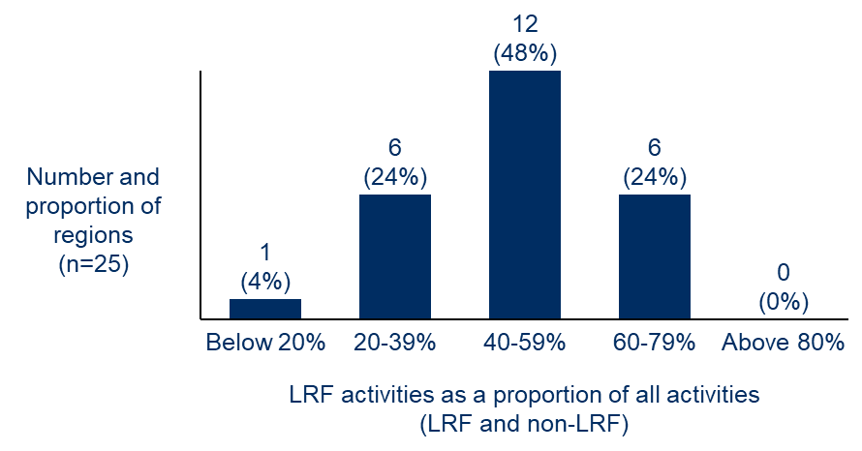
Slightly more non-LRF related activities (54%) were recorded in the overall program data. As shown in Figure 8Error! Reference source not found., Employment Facilitators had varied roles in non-LRF activities, including developing or implementing the non-LRF activities, which may be contributing to the design of an employment initiative or supporting the implementation of that initiative; advising or sharing information; or coordinating stakeholders.
Figure 8: Employment Facilitator roles in non-LRF related activities (July–December 2021)
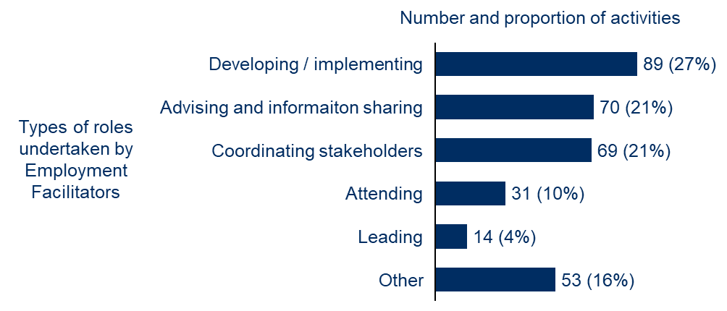

Non-LRF related activities were mostly funded or owned by government or ESPs or facilitators. This indicates that Employment Facilitators are ‘joining up’ government programs by supporting the delivery of other government initiatives. In addition, some community organisations, employers and training providers also owned or funded some activities.
In the early insights consultation, it appeared that in the early stages of the program, Employment Facilitators and Taskforces focused their efforts on identifying local projects that could be funded by the LRF as the primary activity of the LJP. However, over time Employment Facilitators appear to have shifted their views on the LRF as playing a more minor role. The LRF is considered by many as a fund of ‘last resort’ that should be used only when other sources of funding from federal, state and local governments are not suitable. Consultations with Employment Facilitators suggest that this shift was in part due to the challenges with the LRF process, and communication initially being unclear regarding the scope of the fund. Representatives from DESE nevertheless note that the view of the LRF as a fund to be used to fill funding gaps is more aligned with the intended purpose of the fund.
Interviews confirmed that the majority of Employment Facilitators are considering both LRF and non-LRF activities in their regions. Some Employment Facilitators noted that they focused on non-LRF funding sources due to the challenges with the LRF.
‘We are focusing on other funding sources outside of the LRF, due to the challenges with the LRF.’
– Employment Facilitator
‘We are doing some cool work outside of the LRF. It’s better to be the glue and work with people around existing funding. The LRF is too hard; most of our work is outside of the LRF.’
– Employment Facilitator
See more information on the LRF in Section 2.4.
The impacts of COVID-19 on labour market needs, LJP implementation, Taskforce engagement and LRF-funded activities varied significantly across Employment Regions
Lockdowns as a result of COVID-19 had a significant impact on the implementation of the program, with the eastern states most affected. For these regions, this meant Employment Facilitators had to arrange for Taskforce meetings to be held online. Some Employment Facilitators, particularly those newer to their regions, reported that this had an adverse impact on their capacity to build productive relationships between local stakeholders, as they believe that face-to-face engagement is more conducive to promoting effective collaboration.
On the other hand, in some cases Taskforce engagement was improved with a shift to remote meetings, particularly in larger regions which previously required significant travel from Employment Facilitators and Taskforce members. Moving online also helped Employment Facilitators in larger regions to engage more widely with local stakeholders.
The interviews provided examples of some of the impacts of COVID-19 for Employment Facilitators in implementing the LJP, including:
- Events were cancelled, such as jobs fairs.
- Hospitality and tourism industries were shut down, meaning training programs for those industries could not go ahead or were pushed back.
- Activity delays meant that in some regions it took longer than anticipated to get results.
- Suspension of mutual obligations for job seekers made it difficult to engage job seekers.
- Stakeholders were not as engaged in meetings (Taskforces, ESPs and other local stakeholders) due to Zoom fatigue and lockdowns, and some regions preferred face-to-face meetings.
‘COVID has had a big impact. We couldn’t meet in person with the Taskforce so it was hard to build engagement. It majorly affected industries in hospitality – that has been quite a focus.’
– Employment Facilitator
‘COVID has delayed what we want to do, slowed it down. We have an activity for women in warehousing, getting jobs with forklift licences. There is an influx of jobs but we can only train four people at a time. In 2019 we could train 20 at a time. It takes longer to get to the end point but it hasn’t stopped anything.’
– Employment Facilitator
‘COVID has meant more online calls and we don’t have to be there physically. It has created more work as we don’t have to travel between regions.’
– Employment Facilitator
Despite the many challenges posed by ongoing COVID lockdowns for many regions, some Employment Facilitators provided examples of how COVID had provided positive benefits for the program. This included reaching more stakeholders with online meetings and having more time to set plans for their regions.
‘I loved the impact [COVID] has had, as it brought back lots of skills into the state. By having to pivot to online delivery and making my team more flexible, it also allowed us to be more innovative. I think that it has also allowed us to reach more people as we were able to reach more people digitally.’
– Employment Facilitator
‘There was some benefit to COVID. It allowed us more time to plan. We changed our focus to industry engagement and awareness. If not for COVID, we likely would have rolled out more activities.’
– Employment Facilitator
While most Employment Facilitators are focused on responding to the present day needs of employers and job seekers, some are also working on longer term labour market issues
In the early insights consultation, some Employment Facilitators suggested that a marker of the LJP’s long-term success is that it leads to changes in how government agencies and other stakeholders work together to address local labour market challenges.
‘The program will have worked if it leaves a legacy of collaborative joined up functioning of government agencies, a greater awareness and uptake of government programs and a greater desire for locals to take charge of their own workforce development.’
– Employment Facilitator
‘The Program is about trying to create something sustainable at a local level. Our role is not to create a job for ourselves but to create an ecosystem that drives outcomes regardless of whether we are involved.’
– Employment Facilitator
With the extension of the program to 2025, Employment Facilitators are increasingly taking a longer term view of their region and anticipating future structural challenges. One Employment Facilitator recognised the importance of taking a long-term view to contribute to capacity building in their region.
‘We are here to learn, to assess our impact and to build genuine relationships on the ground. It is easy to focus on new shiny things such as the project I spoke about, but this project only goes for 4 years, and then what? My focus is on ensuring that we can deliver skills that can be sustained and that there is a legacy effect especially on the people that we engage through employment.’
– Employment Facilitator
Some regions have a desire to focus on their longer term market needs but appear to be more focused on short-term labour market issues. For example, one Employment Facilitator recognised that the drive for current recruitment, which was taking up most of their time, was limiting their ability to plan ahead.
‘There is a lot of urgency currently with recruitment. There is a lot of planning for long term, but the immediate need is so huge that it absorbs a lot of our time.’
– Employment Facilitator
Another Taskforce member noted the limitation of Taskforce membership, which was impacting their region’s ability to have a longer term focus.
‘There is an issue around the caps on how many people you can have on the Taskforce. It needs to have the right balance of people who can create short term vs long term outcomes. We don’t really need people who can create short term outcomes on the Taskforce.’
– Taskforce member
    - Stakeholders’ feedback on the Employment Facilitator’s role and practice
Most Taskforce members believe that their Employment Facilitator is effectively working with the Taskforce and implementing the LJP
Survey data shows that the majority of Taskforce members think the Employment Facilitator and Support Officer are effective in their roles. Over 80% of Taskforce members surveyed agreed that the Employment Facilitator’s approach to building Taskforce engagement was effective.
This was confirmed by consultations, with most Taskforce members thinking their Employment Facilitator was effective in implementing the LJP. One Taskforce member noted the importance of the Employment Facilitator.
‘The Employment Facilitator has been really important in helping us build relationship with other Taskforce members and potential partners.’
– Taskforce member
Interviews with Taskforce members provided some examples of what Employment Facilitators were doing well and what could be improved. In accordance with survey results, the majority of Taskforce members interviewed thought their Employment Facilitator was effective in their region. Examples of effectiveness included Employment Facilitators being very knowledgeable about a region, being able to connect local stakeholders, effectively engaging the Taskforce in meetings and supporting collaboration.
‘[The Employment Facilitator] is there, whether it’s a regional development round table, or a post-COVID recovery taskforce … He is building a presence and doing a really good job. He brought together a really diverse Taskforce ... he has been part of identifying key people and knowing the people who will put in the commitment and time. And he also brings in other people to the Taskforce who can contribute something else and support in different ways. He is a really good connector.’
– Taskforce member
‘The Employment Facilitator as a locally embedded operator has a strong influence on the Taskforce and community, and will continue to be an influencer on solutions to challenges in our region.’
– Taskforce member
Few Taskforce members provided examples of what Employment Facilitators could be doing to improve their effectiveness. However, some Taskforce members thought their Employment Facilitator could be delegating more to the Taskforce, or to subcommittees. For example:
‘I expected to be doing more between meetings. Taskforce members could be given specific projects or initiatives to pursue in smaller sub-groups.’
– Taskforce member
One Taskforce member also felt their Employment Facilitator lacked cultural competency in regard to understanding ways of working within Aboriginal and Torres Strait Islander businesses, limiting their effectiveness in the region.
‘The Employment Facilitator lacks Aboriginal and Torres Strait Islander cultural competency. Facilitators need to have some sort of assessment or understanding of their cultural competency. Ticking a box does not make you competent. Not sure what DESE’s processes are to recruit a facilitator is but they need to understand how they appreciate culture, how they appreciate the difference between a western culture and an Indigenous culture. Those terms need to be redefined. When someone talks about Aboriginal business capacity, they don’t understand that what we do is holistic, it’s different. It’s very important to co-design, you can’t assume agreement on key concepts when working with Aboriginal communities. Can’t have government saying we are going to come and fix this for you.’
– Taskforce member
The independence and local presence of Employment Facilitators are seen by most as critical for building local engagement and collaboration, while also feeding back to government
The importance of the Employment Facilitator role being independent from DESE was mentioned by a range of stakeholders in interviews as an important design element. One DESE staff member noted:
‘[Employment Facilitators] are seen as independent from DESE, which has been effective in gaining trust from the particular region and helps overcome perceptions.’
– DESE staff member
Many Employment Facilitators and Taskforce members interviewed felt there would be an ongoing need for an Employment Facilitator to support local collaboration. This highlights the value in having a dedicated resource to conduct this role. One Taskforce member noted:
‘The Employment Facilitator has been really important in helping us build relationships with other Taskforce members and potential partners.’
– Taskforce member
DESE State Office staff have provided some examples of how Employment Facilitators have influenced government operations. This includes informing different levels of government as to what is happening on the ground and contributing to connecting up of various government programs to reduce duplication of funding.
‘Working with Employment Facilitators has meant escalation of examples with real life issues that employers are facing in terms of being able to keep their businesses open. These are very important, as policy makers need this detail.’
– DESE staff member
‘Employment Facilitators have helped reduce funding duplication through interactions with state government.’
– DESE staff member
‘Working with Employment Facilitators have led to some exchange of insights and connecting up the various programs that DESE funds.’
– DESE staff member
The interviews provided an example of a region where an Employment Facilitator working with DESE staff led to incorporating feedback to iterate the program.
‘We are constantly feeding into policy and program settings and the LJP does focus on incorporating feedback and building on it.’
– DESE staff member
Employment Facilitators are in a unique position to help build new relationships between diverse stakeholder groups and promote collaboration
Some stakeholders highlighted that the Employment Facilitator had the ability to interact with a range of stakeholders, from job seekers to employers and government. In one region, a Taskforce member highlighted that their Employment Facilitator was:
‘Connecting the right people … has the ability to communicate with different people and support the vision of what we are trying to do in [our region].’
– Taskforce member
Beyond creating connections between stakeholders, consultations found that Employment Facilitators are promoting collaboration. Stakeholders recognised that it was valuable to have a dedicated resource who understood the local context, to support collaboration. One Taskforce member recognised this as:
‘The Employment Facilitator has been effective. Very driven, [they] understand the many different stakeholders involved. [They are] very good at getting them all to focus and collaborate together.’
– Taskforce member
On the other hand, stakeholders recognised that newer Employment Facilitators can take time to build relationships in their regions. Given the importance of building relationships within a region to engage local stakeholders, and that relationship building takes time, this can be expected. One DESE staff member noted:
‘It can take some time [for Employment Facilitators] to get to the point where things are happening as it takes time to build relationships.’
– DESE staff member
Employment Facilitators take varying roles in interacting with Activity Hosts in their regions. Interviews showed that most Activity Hosts were happy with the level of involvement from the Employment Facilitator.
‘I respected that [the Employment Facilitator] kept her distance. If we didn’t have a strong business development arm or presence in [our region] we may have needed more support. There wasn’t a big need for her involvement, so she kept her place. A different person might have made it more difficult.’
– Activity Host
The level of involvement of Employment Facilitators seemed to vary from limited involvement such as noted above, to more active engagement with Activity Hosts. The level of engagement is dependent on the Activity Hosts’ needs, with one Activity Host noting the deep engagement the Employment Facilitator had in shaping their project:
‘We worked very closely with [The Employment Facilitator]. I can’t speak highly enough of [the Employment Facilitator]. He was phenomenal in regard to his intel, connecting us with other stakeholders in the region. Through his direction we were able to shape the project and then pilot.’
– Activity Host
While there were few examples where an Activity Host described what was not working well with Employment Facilitators, one recognised some limitations. In this instance the Employment Facilitator was seen as a representative of DESE and not knowledgeable about the region. There was also a lack of understanding from the Employment Facilitator of what data Activity Hosts could share.
‘Employment Facilitators are representatives of DESE, and the setup is not transparent. Employment Facilitators are not fully across the labour market. This was demonstrated when the Employment Facilitator was looking to run a hospitality program in the middle of a lockdown … There are also some privacy issues; the Employment Facilitator has been asking for information that we are not able to share.’
– Activity Host
    - The role of Support Officers
Support Officers provide Employment Facilitators and Taskforces with essential administrative, reporting and stakeholder engagement support
Support Officers were introduced to provide support with administrative and reporting requirements so that Employment Facilitators can spend the majority of their time on the central collaborative aspects of their role.
Employment Facilitators were using their Support Officers to assist with their daily tasks. According to survey data, all Support Officers (100%) completed administrative tasks, and most (64%) assisted with reporting, as seen in Figure 9. In just under half of the regions, Support Officers also assisted Employment Facilitators with stakeholder engagement.
Figure 9: Survey responses from Employment Facilitators on tasks undertaken by Support Officers, as a proportion of total responses (n=22)
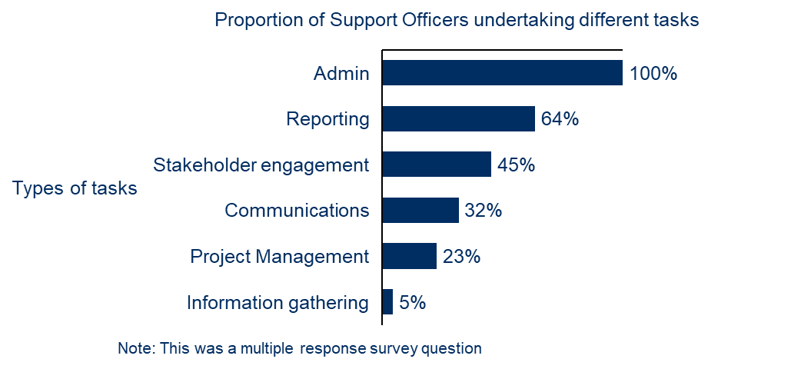
One Employment Facilitator described the role of their Support Officer as:
‘All secretariat services to the Taskforce, along with diverse project development and ad hoc activities in support of the Employment Facilitator role.’
– Employment Facilitator
Interviews also highlighted the value Employment Facilitators place on the Support Officer’s role in helping with program implementation:
‘Between the meetings my Support Officer is in touch with my Taskforce weekly or multiple times a day. It is really heartening to see her phone ringing more than mine as it shows that we are bringing value through our interactions with them.’
– Employment Facilitator
Overall, the majority of Employment Facilitators (77%) in the survey agreed that Support Officers are very to extremely effective in assisting their work.
Some Employment Facilitators did report challenges with the time required to manage subcontracting arrangements for Support Officers, although this was only a small portion of interviewees.
‘It has been really helpful having those support officer roles to help take work forward. However, the arrangements meant I went from delivering as an individual, to now a running team. That takes a chunk of delivery time away from me.’
– Employment Facilitator
    - Summary
The LJP theory of change has identified that in the context of a place-based approach, Employment Facilitators are central to implementing the LJP in each region, and Support Officers provide significant support to the Employment Facilitator. The design of the Employment Facilitator role reflects a feature of a place-based approach, which is to establish a role to ‘connect the dots’ between local stakeholders and support local collaboration, and provides the flexibility to tailor the facilitator’s approach to the needs and context of their Employment Region.
The Employment Facilitators’ role and practice in the LJP implementation is broadly consistent with the expectation stipulated in their contract – that is, to undertake a range of activities from both the structured and unstructured program elements. Their activities include general networking, information sharing and connecting across their Employment Regions through engaging local stakeholders and promoting collaboration.
The findings presented above demonstrate that there is wide variation in how Employment Facilitators are approaching their roles, as they tailor their approach to the priorities and needs of their Employment Region. The approach taken by an Employment Facilitator is dependent on a number of conditions including the Employment Facilitator’s experience in the region, the size and location of an Employment Region and the diversity of local stakeholders. These approaches need to consider the following:
- Newer Employment Facilitators in a region focus more on developing networking in the early stages as it takes time to build relationships and connections, while their more experienced peers have established networks.
- The approaches to building Taskforce engagement vary by local context. It is evident that, even in a larger and remote region where engagement can be challenging, it is possible to implement supporting structures to build relationships that could support improved engagement of Taskforce members.
- Given different local conditions, Employment Facilitators in metro areas appear to have more discussions with local stakeholders on the LRF and employment opportunities compared to regional areas, where discussions were more based on addressing local needs, regular engagements and planning, as well as other networking opportunities such as events and conferences.
- As it is one of the Employment Facilitator’s main roles to identify and assist with the LRF project applications, their effort and focus could also be influenced by the timing of the funding procurement cycles. In the early stage of the LJP, identifying local projects that could be funded by the LRF was reported by Employment Facilitators as the primary activity of the LJP
- Some Employment Facilitators reported taking an increasingly long-term focus to their region and anticipating future structural challenges, although most regions appeared to be more focused on short-term labour market issues.
The Employment Facilitator role is seen as important in supporting the connection and collaboration between local stakeholders. DESE sees value in having an Employment Facilitator who can provide on-the-ground information to inform government decisions.
The effectiveness of Employment Facilitators depends on their ability to adapt the program to the circumstances of their region. There are a range of enabling factors including personal attributes and skills that contribute to effective implementation. More information on enablers is presented in Section 4.

The LJP theory of change assumes that Support Officers play a role in supporting the Employment Facilitator to coordinate and communicate with local stakeholders, supporting the effective operation of the Taskforce and collecting and tracking program data to support reporting to DESE. The feedback from Employment Facilitators confirm that Support Officers have conducted their role as intended. In some regions, Support Officers were given the opportunity to assist the Employment Facilitator with stakeholder engagement that was not necessarily part of their contractual duties.

Local Jobs and Skills Taskforces and their contribution
The establishment of the Taskforce is intended to bring together local stakeholders across sectors and service areas to promote and deliver the LJP in their Employment Region. Chaired by the Employment Facilitator, the Taskforce is expected to work collaboratively to develop local solutions to improve Jobs and Skills Outcomes.
    - Taskforce memberships
The Taskforce is required to comprise up to 10 local stakeholders across industry, education, employment services, training providers, community organisations and state and local government. Membership of the Taskforce is voluntary and members may be refreshed through the life of the program. The membership of the Taskforce and any change to the membership is required to be approved by DESE.
Taskforces are made up of a range of stakeholder groups, with the greatest representation from government
Program data shows that Taskforces were made up of a range of stakeholder groups. Figure 10 shows that the majority of Taskforce members were government representatives (29%), followed by industry representatives (17%) and ESPs (17%). Employers were the fourth most represented group (14%).
Figure 10: Make-up of Taskforce membership by stakeholder type (December 2021)
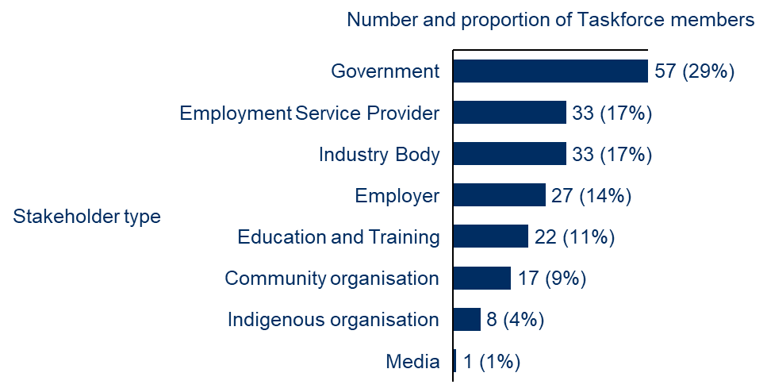
Note: Taskforce members (n=198)
Survey responses show that the majority of Employment Facilitators (91%) and Taskforce members (83%) agreed that their Taskforce had the right mix of people for it to be successful, as seen in Figure 11. An 8 percentage point difference between Employment Facilitators’ and Taskforce members’ views on this question may indicate misalignment on the optimal make-up of Taskforce membership for the Taskforce to be effective.
Figure 11: Survey responses on Taskforce membership make-up
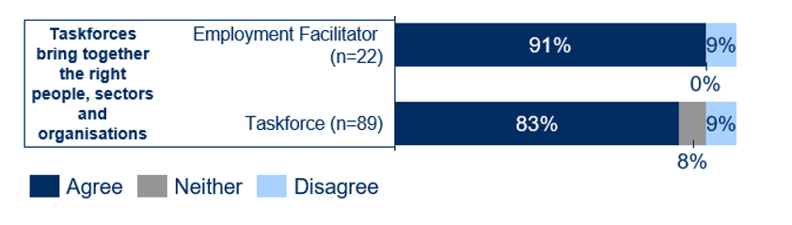
Interviews supported the view that most Taskforces had the right mix of members. One Taskforce member recognised the deliberate process of selecting Taskforce members to ensure Taskforce diversity, noting:
‘Our taskforce is diverse. [We are] thinking outside the box vs those we always interact with.’
– Taskforce member
Another Taskforce member noted the importance of diverse membership, stating:
‘[I am] not aware of a forum that has been brought together with the same level of expertise as has been achieved through the taskforce.’
– Taskforce member
One Employment Facilitator in a region that did not have the right mix of Taskforce members noted that while their Taskforce was active, it was not reflective of the overall labour market:
‘We need people who are networked and influential within their industry. Representatives of cohorts we need to work with such as employers or job seekers.’
– Employment Facilitator
This highlights the need for diversity and a broad range of experience for a Taskforce to be effective.
Some Employment Facilitators noted they had experienced difficulty in replacing Taskforce members. One Employment Facilitator noted that the expression of interest (EOI) was ‘a lengthy process’ and therefore not something they wanted to do frequently. Another noted their frustration with the EOI process:
‘The EOI process that has to be completed by participants doesn’t align with what DESE is looking for, and they are not approved to participate in the program.’
– Employment Facilitator
Interviews found that members’ reasons for participating in the LJP Taskforces were varied, but most interviews showed that Taskforce members wanted to keep up to date with what was happening in their region and to be part of driving employment solutions.
‘The Taskforce is an opportunity for us to provide information on what we do at the grassroots, to influence potential policy and agenda, into sustainable employment opportunities.’
– Taskforce member
‘I was already active in that space. Disability often gets missed and staff are needed in regional areas. I hope to achieve greater awareness across Taskforce representatives, industry representatives and others. I joined to know what’s going on, applications for the LRF are relevant to our work and we need to know what’s going on. I have met new people and the profile of the disability sector has increased. I have a project partner who is another member of taskforce, so that was a new connection.’
– Taskforce member
For some Taskforce members, this has contributed to a better understanding of how government works. For example:
‘The Taskforce has helped me understand how federal, state and local government work together on initiatives.’
– Taskforce member
    - Taskforce engagement
Most Taskforce members have been highly engaged in Taskforce meetings and activities, but some have faced challenges
Program data between February and December 2021, show that the total number of Taskforce meetings ranges from 5 to 11, and there is some positive correlation between the average number of Taskforce members and the total number of meetings (correlation=0.84).
Program data show that most regions had an average attendance rate of Taskforce meetings between 70% and 90% (as seen in Figure 12).
Figure 12: Average Taskforce member attendance at meetings, by number and proportion of regions (n=25)
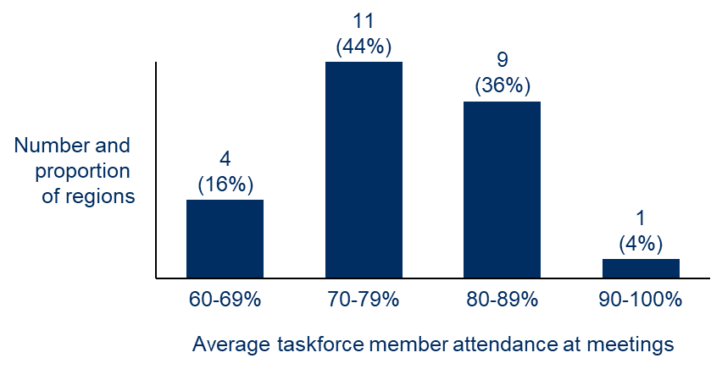
According to the surveys, the majority of Taskforce members are engaged, with 79% of Taskforce members agreeing in surveys that this was the case, as seen in Figure 13. Survey data also shows there is a correlation (0.69) between Taskforces having the right mix of members and their level of engagement.
Figure 13: Survey responses on Taskforce member engagement
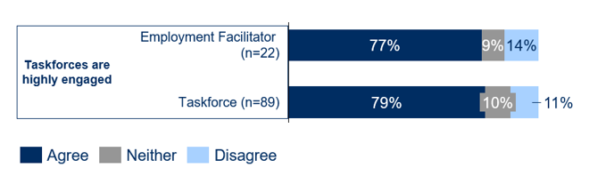
Survey data and interviews revealed that Taskforces that are more engaged tend to be in regions where an Employment Facilitator has strong existing relationships and a history of local collaboration. Where the Taskforce was less engaged, Employment Facilitators attributed the lack of engagement to members who:
- were time poor – often being very senior in their organisation and having multiple demands (including attending other similar committees)
- were primarily motivated to join the Taskforce to meet an individual organisational objective rather than directly contributing to solving common local challenges
- did not feel ownership of the program or that their input was valued – often reported as resulting from challenges with the LRF process
- did not have a clear understanding of the expectations of their role as a Taskforce member.
Other factors that contributed to a less engaged Taskforce included:
- Employment Facilitators inheriting a Taskforce from DESE without having input on the selection of members
- Taskforces not having the right mix of members given the key issues in the region. For example, a Taskforce may have a disproportionate number of members from one industry or stakeholder group.
One Employment Facilitator noted the challenges they had with their Taskforce, highlighting the different motivations of Taskforce members as a reason for this:
‘Some Taskforce members weren’t actively participating and not volunteering for sub-coms etc. [They were] just there for the image. Only three members were there for the right reasons.’
– Taskforce member
Most Taskforce members believe that they have a clear understanding of the requirements of their role, but Employment Facilitators are slightly less positive
The effective functioning of the Taskforce relies on its members having a good understanding of their role. The feedback from DESE staff also recognised the importance of ensuring the Taskforce members have a clear understanding of their role:
‘The Taskforce are valuable, but it requires work to ensure they are effective, to clarify expectations. Taskforce members have not understood their roles – [they were] too focused on the LRF early on. [They] need to make Taskforce members feel they are valued and adding value.’
– DESE staff member
Survey data found that 59% of Employment Facilitators thought their Taskforce had a clear understanding of their role and responsibilities – less than Taskforce members (79%), as seen in Figure 14. There was a positive correlation (0.66) between Employment Facilitators reporting their Taskforce members had a clear understanding of their role and reporting their Taskforce was engaged. This highlights the importance of clarity of roles in the Taskforce for overall engagement.
Figure 14: Survey responses on Taskforce members having a clear understanding of their role
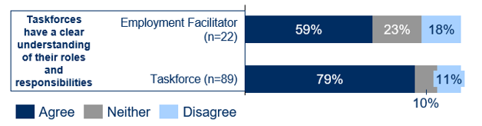
    - The role and contribution of Taskforces
Taskforces have adopted different roles in supporting the LJP
There is variation in how Taskforces are conducting their roles and collaborating. Interviews with Taskforce members highlighted that Taskforces are taking on different roles across Employment Regions. These roles, as described in
Figure 15, can be considered along a spectrum of activity and are not mutually exclusive, with some Taskforces playing one or all of these different roles. Those Taskforces taking on a less active role are not less effective, but instead are taking a different approach.
Figure 15: Taskforce roles in supporting the Local Jobs Program
Taskforce roles | Advisory body focused on information sharing and networking | Advisory body to guide LRF project development | Collaborative platform to drive the LJP and initiatives forward
Description | - A space for Taskforce members to share information and create additional networks  - A sounding board for Employment Facilitators, providing advice on local issues and how to address them | - A source for:  - ideas for potential LRF projects  - advice on how potential LRF projects address local needs | - Taskforce members actively participating in and owning the development and delivery of local initiatives (both within and outside of the LRF)
Rationale | - Improved information sharing enables local stakeholders to better understand local issues and, supports more coordinated and local responses  - Provides a source of local intelligence that DESE can use to inform:  - management of its portfolio of programs  - policy development | - Support development of local solutions  - Intended to increase the likelihood that projects funded through the LRF successfully address local needs | - Taskforce members ‘own’ local initiatives and facilitate collaboration with local stakeholder  - Taskforce members driving initiatives extends the reach and impact of the program beyond what an Employment Facilitator can achieve on their own
One Taskforce member said that their Taskforce had mostly been used for information sharing and networking.
‘At meetings we are provided with lots of information and opportunity to meet different stakeholders. The meetings are run very well. There is good commitment from the rest of the members … We are not collaborating with others yet. We focus on keeping up to date.’
– Taskforce member
Some Taskforces are taking on 2 or all of these roles. One Taskforce member noted their Taskforce’s role was both as an information sharing advisory body and in guiding potential LRF applications:
‘The key parts of my role as a Taskforce member include people coming to talk at meetings, revisiting the Jobs Plan to make sure it's correct and speaking to people to help them make submissions.’
– Taskforce member
Interviews provided examples of some regions taking on all 3 roles, and these regions seem to have more engaged Taskforce members. This could indicate that Taskforce engagement and taking on an active role are mutually reinforcing. For example, one Taskforce member noted the collaborative nature of their Taskforce, which had led to developing opportunities:
‘I spend most of my time raising awareness of the Taskforce, making my key stakeholders aware of the LJP and the opportunities like the LRF or the Employment Facilitator. Having support from the Employment Facilitator to gain support from the jobactives, is important. In some cases it can be hard to identify suitable job seekers. Having the Employment Facilitator has definitely increased collaboration. We have definitely spent time collaborating outside of the LFR and Jobs Fund on things like regional development opportunities. It has made those various relationships stronger because we are on the Taskforce together.’
– Taskforce member
A few Employment Regions recognised that their Taskforces were not very active and struggled to progress beyond networking and information sharing. In these regions, some stakeholders suggested the Taskforce should be more focused on action, taking on some of the additional roles described in
Figure 15. One Taskforce member noted:
‘[I] would love to see more collaboration on initiatives that the Taskforce can own together. Great we are identifying priorities, but not really any clear actions progressed to address them. [I] would like if there was a bit more action. [We have] identified a barrier, got all these organisations around the room, can we delve into more about what we can do to address problems.’
– Taskforce member
Employment Facilitators with less engaged Taskforces reported it had proved challenging to invite Taskforce members to take on a greater role beyond general information sharing and advice. Consultations suggest the roles played by Taskforces in different regions are primarily influenced by the local context and the level of engagement of Taskforce members.
Taskforces that play the most active role in the program are more engaged and tend to be in regions where an Employment Facilitator has strong existing relationships and a history of local collaboration. This could indicate that those regions with a history of stakeholder collaboration on employment solutions, or where an Employment Facilitator can draw on existing networks, can more easily support implementation of the LJP.
A lack of action seems to make some Taskforce members feel less motivated to participate, resulting in less engagement. These Taskforce members noted that additional structures such as working groups, having the right people on the Taskforce and monetary incentives could support increasing engagement and action.
‘It hasn’t been as active as I would have liked it to have been. I have lots of one on ones with Employment Facilitator, but I find the Taskforce meetings a bit long-winded. My role mainly involves attending the Taskforce meetings, which are two hours … I have been collaborating with EF a lot.’
– Taskforce member
‘The Taskforce could be achieving more, everyone is holding back … We collaborate and share in the room but there is not much action other than the meetings. Collaboration outside of the meetings is limited … it’s not considered an expectation of the Taskforce … The Employment Facilitator is working in the background. We need additional structures between meetings such as working groups.’
– Taskforce member
‘Taskforce meetings are a lot of talk and not much action. There is lots of discussion about tenders and grants. That’s probably why when the meeting comes up I can’t afford the time of day. If it was more productive we would see more results with people getting jobs … Some people on the panel don’t have that much influence to create jobs … maybe payment for attending might incentive people to attend more.’
– Taskforce member
Some Employment Facilitators have successfully set up collaboration structures within their Taskforce to build engagement and ownership
The Taskforce is expected to meet on a regular basis, as required. Key meeting agendas include establishing and updating a Local Jobs Plan and considering any project proposals that may be funded through the LRF. Collaboration structures provide a means for Employment Facilitators to support collaboration between otherwise time-poor stakeholders, who in the absence of this ‘backbone’ support would struggle to move from information sharing to taking action.
These structures have been identified through interviews to include:
- Issue-based working groups. These may be chaired by the Employment Facilitator or another Taskforce member. Examples identified through consultations draw membership from beyond the Taskforce to include a wider array of local stakeholders with an interest in the specific issue. Often this will include members focused on dealing with the issue operationally on the ground (in contrast to Taskforce members, who tend to be relatively senior and focused on strategy). For example, one region has 6 working groups focused on specific issues such as manufacturing, transport challenges and Aboriginal and Torres Strait Islander employment. These working groups are chaired by a Taskforce member with expertise in the specific area who reports back to the broader Taskforce.
- Sub-regional working groups. Sub-regional working groups have been formed in some larger Employment Regions. These support improved collaboration on a more local level, addressing variation in priorities across the broader region and enabling more regular face-to-face interactions given the larger distances between stakeholders. These sub-regional working groups help to address concerns from some stakeholders in large diverse regions that the LJP ‘is not local enough’.
- Standing meetings with ESPs. Some Employment Facilitators have set up standing meetings with all ESPs in their region, often monthly, or include additional ESPs who are not Taskforce members as observers at select Taskforce meetings. They report these groups have supported increased cooperation and information sharing between ESPs, helping to prevent ESPs’ tendency to work in silos. In addition, they increase the reach of the program to ESPs who are not directly involved with the local Taskforce.
- One-on-one meetings with Taskforce members in between meetings. Some Employment Facilitators reported having regular meetings with Taskforce members outside of Taskforce meetings. They indicated this supported improved relationships and increased Taskforce member engagement, ultimately helping to improve the effectiveness of how Taskforce members work together in joint meetings.
Of these structures, working groups appear to be the most commonly used, with 7 out of 13 primary regions reporting that some form of working group is being used in their region. Most of these appear to be issue-based working groups that involve Taskforce members and other external stakeholders. Four out of the 7 primary regions with a working group are taking on all 3 Taskforce roles, as described in Table 4, and another 2 are taking on 2 roles. This indicates that establishing working groups could support a more active Taskforce.
Most Taskforce members have contributed to the LJP by helping to make new connections and collaborating on local initiatives in their region
There is strong agreement in survey responses that Taskforce members have helped to make new connections with important stakeholders in their regions and are collaborating on local initiatives, as seen in Figure 16.Error! Reference source not found. However, interviews showed there are a range of ways Employment Facilitators are using their Taskforces to achieve this.
Figure 16: Survey responses on Taskforce member contribution to supporting connection and collaboration
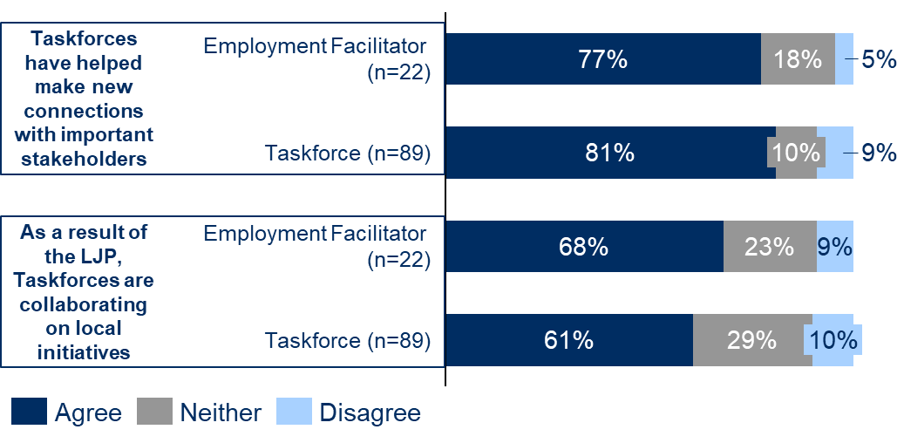
Taskforces are collaborating to develop new solutions to complex employment challenges across multiple bodies and organisations. One Taskforce member highlighted that their Taskforce had been collaborating internally and externally by setting up monthly meetings with ESPs to drive initiatives.
‘We look at different programs and strategies. We are looking at what is happening around the region with new employers, new opportunities and new initiatives, etc. Recently, apart from the Taskforce meetings, we started having monthly meetings with other Jobactive providers. We are collaborating on various initiatives together like forklift licences for women. We recently participated with a local jobs program funded through the LRF.’
– Taskforce member
Activity Hosts seem to have different level of engagement with the Taskforce. Some had little engagement, while others had someone from their organisation sitting on the Taskforce and therefore had a lot of engagement.
‘We received feedback on our proposal from the Taskforce, but didn’t have much interaction.’
– Activity Host
‘It has been good to have [a person from our organisation] on the Taskforce. It gives us an insight into what local opportunities are happening. It has helped us strengthen our bond with a range of organisations. It has been really good for us as an organisation to get involved in various activities and to provide our clients a broader set of opportunities.’
– Activity Host
There were no significant areas where Activity Hosts thought Taskforces could be improved.
    - Summary
For Taskforces to be effective, the LJP theory of change assumes that they need to have diverse membership that represents the key issues and stakeholders in each region. Taskforce members also need to be engaged, which involves members having a clear understanding of their role, ability to provide input and advice on the needs of their regions, and buy-in to the purpose of the LJP. Taskforces need to work collaboratively with local stakeholders, including with Employment Facilitators and each other to progress opportunities in their regions.
For Taskforces to achieve this, it is assumed that Employment Facilitators and DESE provide Taskforce members with opportunities for meaningful input, including into the Local Jobs Plan and LRF projects, and have appropriate governance arrangements to enable Taskforce members to work collaboratively.
In assessing the role of, and contributions by, the Taskforce, it is found that:
- Taskforces overall appear to have the diverse membership they need to be effective
- most Taskforces show high levels of engagement in implementing the LJP, though some regions have faced challenges in engagement. Taskforce members’ commitment, motivations for joining, and level of ownership they felt over the program contributed to engagement
- Taskforces are taking on different roles, leading to different levels of collaboration
- some Employment Facilitators have successfully set up collaboration structures in their Taskforce, such as working groups, which have helped to build further ownership and engagement
- the flexibility for Employment Facilitators to adopt different approaches to working with their Taskforce supports the adaptation of the LJP to the local context
- when members are engaged and taking on their role, the Taskforce can be a valuable body for extending the reach of Employment Facilitators and the program, increasing connections, driving initiatives, bringing local intelligence and advocating for the LJP in each region.
The Taskforce’s input to the Jobs Plan and the LRF projects is discussed further in Section 2.4 and Section 2.5.


Use of the Local Jobs Plan
The Local Jobs Plan (the Jobs Plan) is a document developed by the local stakeholders (the Employment Facilitator and the Taskforce) and used to identify key employment and training priorities for the Employment Region. The Jobs Plan provides a framework for driving employment outcomes in the context of the local labour market.
    - Developing and updating the Jobs Plan
The Jobs Plan is meant to be developed by local stakeholders to identify local priorities. This was the case for Employment Facilitators who transitioned from being RET facilitators; however, new Employment Facilitators inherited the Jobs Plan developed by the interim facilitators, who were DESE staff.
Most survey respondents felt they had sufficient input to the Jobs Plan, but some felt the process of developing and updating the Jobs Plan was ‘overly bureaucratic’
While it is expected that all Employment Facilitators and Taskforces had sufficient opportunities to provide input into developing the Jobs Plan, survey responses (as seen in Figure 17) show that less than 70% of Employment Facilitators (68%), and nearly 80% of Taskforce members (78%) felt this was the case.
Figure 17: Survey responses on Local Jobs Plan input
This likely reflects the situation that some Employment Facilitators inherited the Jobs Plan developed by interim facilitators. Some Taskforces, as a result, felt they had limited ability to have ownership of the Jobs Plan, likely resulting in a lack of buy-in from Taskforce members.
‘It doesn’t make sense that the Jobs Plan was already created. It would have given Taskforce a lot more ownership of what they were directing. I would have elected the Taskforce, and then first thing they would have done is work together to identify the priorities in the Jobs Plan. I have been involved in a review, but there is limited time for feedback … It impacted buy-in and engagement. The more ownership you give Taskforce members the more ownership they are going to take to action the priorities we identify in the Jobs Plan.’
– Taskforce member
This highlights a challenge in instances where the Jobs Plan has been developed by interim Employment Facilitators, which removes ownership from the Taskforce. Similarly, limited feedback opportunities for Taskforce members further discourages ownership of the Jobs Plan.
This is also shown in the survey response, as seen in Figure 18, that just over half of survey respondents agreed that the Taskforce felt ownership of the Jobs Plan and took responsibility for implementing it (55% of Employment Facilitators and 53% of Taskforce members). This is a lower rate of agreement than for other survey questions on the Jobs Plan, which may suggest that while stakeholders generally responded favourably about the Jobs Plan, they were not all personally invested in working to deliver the vision in the Jobs Plan.
Figure 18: Survey responses on Taskforce ownership of the Jobs Plan
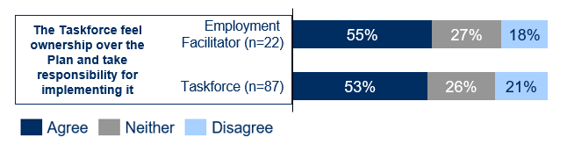
Although it is possible for the Employment Facilitator to update the Jobs Plan when needed, less than 80% felt empowered to change the Jobs Plan in response to changes in their region, as seen in Figure 19. Program data does not show the total number of Jobs Plans that have been approved through the LJP.
Figure 19: Survey responses on Employment Facilitators feeling empowered to change the Jobs Plan
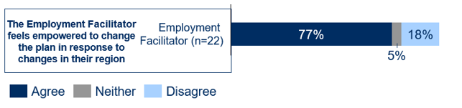
This is likely related to the process for the Jobs Plan to be refreshed and approved by DESE being ‘overly bureaucratic’, and the document template being not fit for purpose, according to interview feedback. Program data shows that there have been 197 rounds of feedback provided on the Jobs Plans over all 25 Employment Regions (from February to December 2021), an average of 8 rounds per region. In addition, interviews found that Employment Facilitators, Taskforces and DESE staff thought the process to refresh Jobs Plans was too lengthy due to multiple feedback rounds, and that the template was not fit for purpose. As a result, Employment Facilitators and Taskforces may feel it is not a good use of their time and effort to update the Jobs Plan.
‘Updating the Jobs Plan was pretty bureaucratic and too structured, not necessarily allowing us to focus on the needs of the region. I find that this is the part of the program that is a bit too rigid. It does not allow you to be flexible.’
– Taskforce member
‘The Jobs Plan is ok. it gives strategic direction but needs agility and flexibility to be able to jump on opportunities.’
– Taskforce member
‘We are in the process of updating our plan, it’s not an easy process. As part of the planning review, we reviewed the priorities in the Jobs Plan, which resulted in a few changes. Trying to formalise these changes with DESE has taken a long time.’
– Employment Facilitator
‘The Jobs Plan, what a nightmare! It is the longest body of work with absolutely nothing that genuinely pins it to the opportunities. It is not clear what the priorities are. We have done some work to update it but it quickly lost relevance. The idea is to ensure external people can access the Jobs Plan to understand the priorities … We need to have a document that is trimmed significantly.’
– DESE staff member
This view was also echoed by a DESE stakeholder who has visibility across a number of regions:
‘I’m not sure the Local Jobs Plan is essential. It’s a little restrictive. You can update it but the process is anchored in bureaucracy. They are not being accessed as a tool. [It provides] limited value given the amount of work that went into these.’
– DESE staff member
See more feedback in Section 2.3.2 regarding the use of the Jobs Plan.
A variety of data sources were used to develop Jobs Plans and some regions saw it as an initial exercise to collectively set the priorities for their region
Taskforces used a variety of data sources to develop the Jobs Plan. Survey responses show that the majority of Employment Facilitators and Taskforces used government data when developing or updating their Jobs Plan. This includes Australian Bureau of Statistics data, the National Skills Commission’s Labour Market Information Portal data, and state government data.
Interviews found that some Employment Regions used the development of the Jobs Plan as an initial exercise for the Taskforce to collectively decide on the priorities of their region. As highlighted in the literature, using the Jobs Plan to set a vision for the region in this way promotes Taskforce buy-in to the Jobs Plan and ownership of its actions.
‘We were working on the Jobs Plan for two months. We use it internally as a guiding document of what we are here to do. We also use it with ESPs to give them that overview of what the priorities are. We use it to give local labour market data information to ESPs through LJP, and it’s a good discussion point with new connections, to discuss the LJP and priorities in the region. There is a lot going on in [our region] so we want to make sure we are not duplicating things.’
– Employment Facilitator
    - Use of the Jobs Plan
The Jobs Plan is designed to provide a framework for driving employment outcomes in the context of the local labour market, so it is expected that the Jobs Plan is used to guide decision-making and support the implementation of a shared vision in the region.
Although there is mixed use of the Jobs Plan across regions, where Taskforce members feel more ownership of their Jobs Plan, they are using it to inform decisions
The Jobs Plan is being used in a variety of ways across the Employment Regions. In some regions the Jobs Plan is being used as a strategic document to actively guide decision-making, while in others it has had limited use by Employment Facilitators and Taskforces.
Survey responses indicate that some Employment Regions are using the Jobs Plan to guide decision-making in their regions, as seen in Figure 20 (68% of Employment Facilitators and 66% of Taskforce members). This is a lower rate of agreement than for other survey questions on the Jobs Plan, with a notable proportion of both Employment Facilitators and Taskforce members disagreeing (18% and 20% respectively). This reflects the Jobs Plan’s mixed success as a framework to support the implementation of an Employment Region’s shared vision.
Figure 20: Survey responses on the use of the Jobs Plan
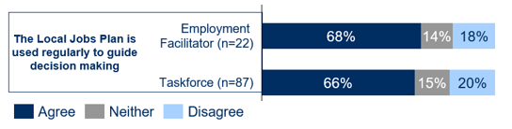
Interviews also highlighted mixed use of the Jobs Plan. Some were using the Jobs Plan regularly as a shared vision for the region and to guide decision-making. This is likely because they thought the Jobs Plan was a useful framework, setting out the priorities of the region and providing an effective tool to engage local stakeholders around a common vision.
‘The Jobs Plan helps me to work out who I will meet with or which opportunities I want to pursue. It helps us understand who we should be targeting or approaching to identify and pursue opportunities.’
– Employment Facilitator
‘The Jobs Plan helps me to work out who I will meet with or which opportunities I want to pursue. It helps us understand who we should be targeting or approaching to identify and pursue opportunities.’
– Employment Facilitator
Some were predominantly using the Jobs Plan to guide development and assessment of LRF proposals.
‘[The Jobs Plan is] critical to the development and approval of the projects that we have delivered. It is being used. It is publicly available which facilitates transparency. I am able to use the Jobs Plan to inform and influence stakeholders to better understand the region.’
– Employment Facilitator
‘We redrafted the Jobs Plan to make it more relevant to the priorities in [our region]... It’s used across the board with local stakeholders in every conversation. It’s shared as the pivotal document that needs to be used for any proponent wanting to put up a proposal to the LRF.’
– Employment Facilitator
One DESE staff member noted its usefulness for communicating priorities to DESE and other stakeholders:
‘[The Jobs Plan is] a good resource for community stakeholders and the Taskforce. [It’s] good for DESE to understand where to focus.’
– DESE staff member
A few reported having had limited use of the Jobs Plan. Those regions with limited use of the Jobs Plan reported limited Taskforce input and ownership, and the Jobs Plan being too generic as the reasons behind this.
‘[The Jobs Plan] has not been used by our Taskforce to drive our thinking. The Jobs Plan is very broad-brush statements so it’s not particularly specific enough to actually guide what we will do.’
– Employment Facilitator
‘We didn’t have a lot of input to the Jobs Plan … it had to be done quickly to get it set up. There was some consultation but no formal strategic planning process...It needs to be revisited and get strong commitment from the Taskforce.’
– Taskforce member
A Taskforce’s feeling ownership of the Jobs Plan was mentioned by many stakeholders as a contributing factor in how the Jobs Plan was perceived and used across the regions.
‘The Jobs Plan reflects the current situation. We have reviewed it 3 or 4 times, in light of COVID as what was important before is no longer possible now such as tourism jobs. Going forward we are going to review it every quarter.’
– Taskforce member
‘Although the Jobs Plan does give direction, the Taskforce may not be feeling as connected to it as each organisation has their own agenda.’
– DESE staff member
In addition, most survey respondents felt the Jobs Plan does identify the most important labour market challenges in the regions, but this does not always translate to a clear set of actions. According to the survey response (as seen in
Figure 21), most Employment Facilitators (95%) and Taskforce members (83%) felt the Jobs Plan provided a framework to identify the most important labour market challenges in their region. Yet fewer stakeholders (77% of Employment Facilitators and 67% of Taskforce members) agreed the Jobs Plan provided a clear set of actions to implement the priorities of the region. This indicates that some stakeholders may see a gap between identifying priorities in the Jobs Plan and defining actions to address them.
Figure 21: Survey responses on the usefulness of the Jobs Plan
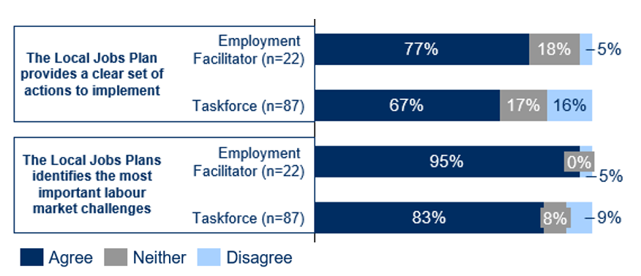
The identified factors affecting the effective use of the Jobs Plan were also evident in the survey data, which shows:
- Taskforces reporting the Jobs Plan has a clear set of actions to implement is highly correlated with Taskforces reporting the Jobs Plan is used regularly to guide decision-making (correlation=0.74).
- Taskforces reporting they feel ownership of the Jobs Plan is highly correlated with Taskforces reporting the Jobs Plan is used regularly to guide decision-making (correlation=0.74).
- Taskforces reporting the Jobs Plan has a clear set of actions to implement is highly correlated with Taskforces reporting they feel ownership of the Jobs Plan (correlation=0.71).
Similarly, survey data show a strong correlation between Employment Facilitators reporting that the Taskforce feel ownership of the Jobs Plan and that the Jobs Plan is being used regularly to guide decision-making (correlation=0.77).
Other factors that may affect the usefulness of the Jobs Plan, according to interview responses, include:
- It is too generic and a restrictive template that only identifies the issues, not who should be involved or how those issues will be addressed.
- It is hard to refresh the Jobs Plan as the process is overly bureaucratic.
- It is too lengthy, reducing stakeholder engagement in the Jobs Plan.
- It should be more closely aligned with other region priorities, including state priorities and other external strategies of the region, to ensure it is used.
    - Summary
The LJP theory of change noted that a shared vision and plan to achieve change in the region is a key part of a successful place-based initiative. Evidence from other place-based initiatives also suggests that a shared vision needs to address the needs of the region, provide a framework for a clear set of actions and be used to inform decisions and prioritise activities. The Jobs Plan is intended for this purpose in the LJP model. Employment Facilitators and Taskforces are expected to play a key role in developing the Jobs Plan. It is also assumed that Taskforce members and other key local stakeholders should feel a sense of ownership of the Jobs Plan to ensure it is implemented effectively.
In assessing the development and the use of the Jobs Plan in the LJP implementation, the evaluation found:
- It appears that developing the Jobs Plan requires collective efforts from the Employment Facilitators and Taskforce using DESE’s generic template and following DESE’s sign-off process. To some it was worth the effort and they took it as an initial exercise to set the local priorities; a few felt that it may not be a good use of their time and effort.
- While a variety of data sources were used to develop the Jobs Plan, the majority used government data.
- Most Taskforce members felt they had sufficient input to the Jobs Plan.
- Employment Facilitators who took on the role from the interim facilitators (DESE staff) were likely to have less input into the Jobs Plan and therefore to feel less ownership.
- Some regions reported positively about how the Jobs Plan had been used regularly as a shared vision and to guide decision-making. Some reported predominantly using the Jobs Plan to guide development of and/or provide feedback on LRF proposals.
- A few regions reported limited use of the Jobs Plan. They identified limited Taskforce input to and ownership of the Jobs Plan as the reasons behind this.
- Most survey respondents agreed that the Jobs Plan does identify the most important labour market challenges in the regions, but this does not always translate to a clear set of actions, which is likely to have limited the usefulness of the Jobs Plan.
- There is a strong correlation between Taskforce members reporting that the Jobs Plan provides a clear set of actions to implement, Taskforces feeling ownership of the Jobs Plan, and the Jobs Plan being used regularly to guide decision-making.
Despite limited use reported by some regions, the Jobs Plan has generally been used for the purpose intended in the LJP implementation, and Employment Facilitators and Taskforces mostly felt ownership of the Jobs Plan.


The Local Recovery Fund
The LRF is intended to fund projects, or parts of projects (known as LJP activities but generally defined as LRF projects in this report) that are:
- designed to address employment and training priorities, connect job seekers to training and employment and identify opportunities to better skill participants to meet local employer demand
- aligned with the priorities identified in the Jobs Plan
- unlikely to be funded through existing sources of funding.
The LRF is available to fund local activities with job seekers, employers, ESPs and other local stakeholders to respond to labour market needs.
    - Workflow for the LRF
Employment Facilitators, together with Taskforces, are designed to play a central role to ensure LJP projects are developed collaboratively with local stakeholders and aligned to the priorities in the Local Jobs Plan. Employment Facilitators and Taskforces may identify potential LJP projects and source proponents, and then work with the proponents to develop a project proposal. Proponents may also independently develop proposals; however, the intention is that they still engage with and seek feedback from the Employment Facilitator and Taskforce during the design and development of the LJP project. See the general workflow of the LRF in Figure 22.
Figure 22: General workflow for the LRF
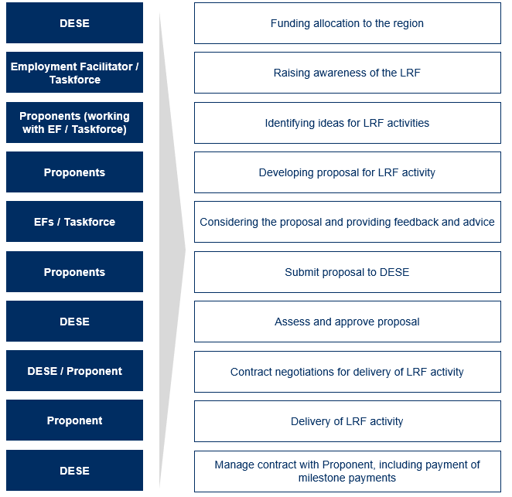
The procurement process for the LRF is governed by the processes set out in the request for proposal, as well as the Commonwealth Procurement Rules and the Public Governance, Performance and Accountability Act 2013. These processes aim to ensure that approved activities align with the needs identified in each Employment Region’s Local Jobs Plan and deliver value for money, and that the procurement processes have regard to appropriate probity considerations.
Employment Facilitators and Taskforces have no formal role in assessments undertaken as part of DESE’s procurement process; their role is in supporting Activity Hosts to deliver LRF Activities. With the support of the local Taskforce, they support Activity Hosts to develop ideas for projects, provide guidance on the application process, ensure employment opportunities for participants are maximised, and can assist in promoting the opportunity to ESPs.
Activities funded through the LRF must have an ESP as a Partnering Provider.
    - Projects funded through the LRF
The LRF has approved funding for over 120 local projects, which involve different activities, industries, job seeker cohorts and employment barriers
As at 21 March 2022, 121 projects had been approved for funding through the LRF across the 25 Employment Regions. Of these, 101 had executed contracts, while the remaining 20 had been approved but were still in contract negotiations with the respective Activity Hosts.
All regions had at least one LRF project approved for funding, with an average and median of 5 approved projects per region. The region with the most LRF projects approved for funding had 10 approved projects. Figure 23 identifies the number of regions that had defined numbers of approved projects.
Figure 23: Number of regions by number of approved LRF projects (as at March 2021)
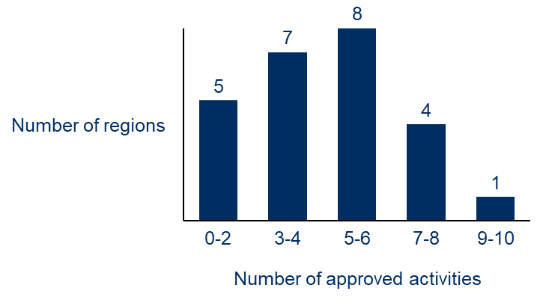
Note: Regions (n=25)
LRF projects are focused on a diverse range of activities, industries, job seeker cohorts and employment (see Figure 24):
- Activity types. Approximately three-quarters of projects involved work readiness training, mentoring and support, and non-vocational upskilling.
- Industry focus. Industries with the highest numbers of projects included construction and manufacturing, tourism and hospitality, disability care, agriculture, and aged care. There was also a high proportion of activities categorised as ‘other – not specified’, highlighting the breadth of industries projects were targeted at.
- Job seeker cohorts. Projects were mostly targeted at supporting youth, Indigenous, and refugee and culturally and linguistically diverse (CALD) communities, cohorts that often have multiple barriers to employment. Cumulatively, these cohorts were the target of 61% of LRF activities, although interestingly they made up only approximately 31% of the jobactive caseload as at 21 December 2021. In contrast, only 8% of projects were focused on mature aged people, although this cohort makes up approximately 30% of the jobactive caseload. This suggests that while projects had a strong focus on addressing cohorts with multiple barriers to employment, there was a more limited focus on the long-term-unemployed, as mature age job seekers are more likely than other groups to become and remain long-term unemployed
- Employment barriers. Almost half (41%) of all projects sought to address work inexperience. Other barriers addressed included cultural, participation avoidance, literacy and numeracy.
Figure 24: Breakdown of LRF projects by activity type, industry, cohort and employment barrier (November 2020–January 2022)
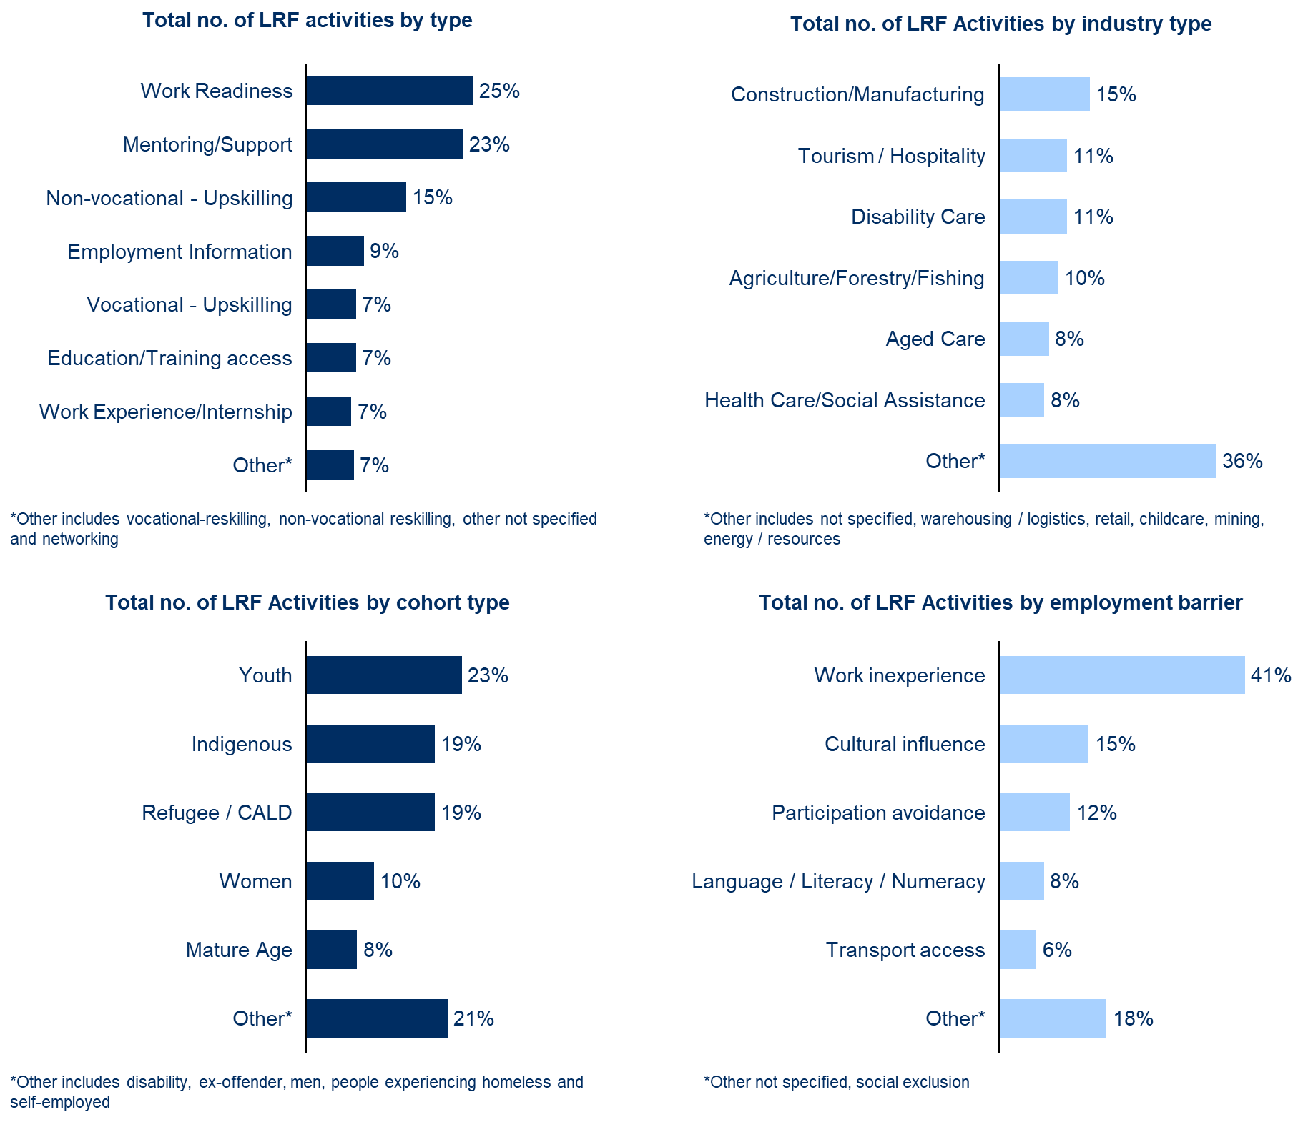
There have been 1,089 referrals of job seekers to LRF activities across the 25 Employment Regions as at 16 January 2022., The majority of referrals were individuals on Job Seeker Payment as a response to COVID-19, which aligned with the original intent of the program. In addition, 22% of individuals referred were on Youth Allowance, and 9% were on Parenting Payment. The characteristics of referred job seekers are set out in Table 1.
Table 1: Job seeker referral characteristics as at 16 January 2022
 | Characteristic | Number or % of job seekers
Referrals | Placement confirmed | 932 (86%)
 | Expected to start | 157 (14%)
 | Total referrals | 1,089
Gender | % female | 49%
 | % male | 51%
Indigenous | % Indigenous | 19%
Payment types | % on JobSeeker Payment | 69%
 | % on Youth Allowance | 19%
 | % on Parenting Payment | 8%
Highest educational attainment | % completed Secondary School | 22%
 | % completed up to Year 11 | 40%
 | % completed University or TAFE | 37%
COVID-19 caused delays in the delivery of the LRF-funded projects
DESE’s National Office staff indicated that to date few funded projects had been completed, while many others were also still to formally commence. DESE’s National Office staff and Employment Facilitators explained that this was because COVID-19 lockdowns delayed many projects. LRF Activity Hosts also indicated that the suspension of mutual obligation requirements during COVID-19 reduced the available pool of participants for those few activities that had commenced by the time of data collection for the evaluation.
    - Stakeholder feedback on the importance of the Local Recovery Fund
The LRF is widely seen as an essential element of the LJP model, particularly to build initial engagement with the program
A majority of surveyed respondents – 73% of Employment Facilitators and 85% of Taskforce members – thought the LRF was essential to the success of the LJP (Figure 25).
Figure 25: Survey responses on the importance of the LRF to the LJP
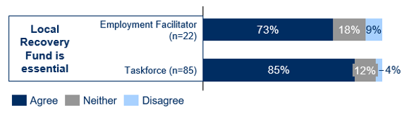
Stakeholder interviews identified 2 key reasons why they felt the LRF was important to the program:
- The LRF was a useful ‘carrot’ to build initial buy-in to the program and bring local stakeholders to the table to collaborate.
- The funding was important to enabling initiatives that addressed local priorities, ensuring the LJP contributed to tangible actions for each region.
Several Taskforce members reflected how the funding motivated them to participate in the Taskforce as they felt it would enable solutions aligned to both local needs and their organisations’ objectives, which highlights the importance of the LRF to build initial buy-in to the program.
‘There wouldn’t have been a program if there wasn’t a fund. Without the money [local stakeholders] wouldn’t have seen a purpose to join.’
– Taskforce member
‘Ultimately money talks. People come to the table when there is money involved and are more willing to put in effort and participate.’
– Taskforce member
‘The LRF was a key ‘hook’ to get industry engaged into thinking about how we can get people into jobs in different ways.’
– Taskforce member
Another Taskforce member specifically identified the value of the LRF in promoting increased engagement of employers with ESPs. They felt this was important given the longstanding reluctance of employers in their region to engage with ESPs.
‘Employers haven’t always had great attitudes to Jobactives in our regions. The [LRF] has been critical to encourage local employers to partner with Jobactives.’
– Taskforce member
A Partnering Provider who was also a Taskforce member also identified the value of the LRF to Employers:
‘A project of this scale would not have taken off without the LJP. Employers were not aware of the support local [ESPs] can provide to clients and employers, but now they recognise we can help with upskilling local job seekers to meet their needs.’
– Taskforce member / Partnering Provider
Employment Facilitators also felt the LRF was critical for building engagement, particularly at the beginning of the LJP when they were seeking to build new relationships and ‘sell’ the program.
‘The LRF has allowed me to get my foot in the door, as local stakeholders are more eager to you when you have some money to offer them.’
– Employment Facilitator
‘One Taskforce member wanted to join immediately, because their organisation was interested in putting in an application to the LRF.’
– Employment Facilitator
Stakeholders also felt the LRF was critical to ensuring the LJP supported tangible actions to address local priorities. They explained that this was a key factor that distinguished the LJP from other local committees, thereby helping to stop the LJP from being a ‘talkfest’ without any action taken on solutions.
‘We definitely need to have a fund sitting behind the program. Otherwise, meetings become just about sharing information and no action is possible.’
– Taskforce member
‘The LRF is critical to bridging the gap between talk and action.’
– Taskforce member
Several Taskforce members also felt the fund was important because they would have otherwise lacked the resources to develop and run relevant local initiatives. On this basis, they felt the LRF was an important enabler of increasing the LJP’s impact.
‘[The LRF is] absolutely important to the success of the program. We have little money to spend on targeted support to address employment barriers.’
– Taskforce member
‘I don’t think the program could be sustained without money. The capacity to get most activities off the ground is dependent on having the resources required to manage them.’
– Taskforce member
‘It really helps to have another bucket of money. It means we can increase the scope of what we are trying to achieve.’
– Taskforce member
While stakeholders felt the LRF was helpful for building initial buy-in to and engagement with the LJP, many felt challenges with the LRF process had a subsequent adverse impact on buy-in and engagement. Employment Facilitators also did not feel as strongly as Taskforce members about the importance of the fund for enabling local solutions. This is reflected in the 12 percentage point difference in the survey results presented in Figure 25, and in comments from Employment Facilitators in interviews stating they were using the LRF as one source of funding among many. In some instances, the LRF was the ‘fund of last resort’ due to the challenges with the procurement process.
‘Because the LRF’s funding model has been so ineffective I’ve had to move the discussion to other areas. As a result, the LRF itself hasn’t been able to continue building much buy-in to the LJP.’
– Employment Facilitator
‘There used to be a lot of buy-in to the LRF, but given the challenges with the fund there’s not much anymore.’
– Employment Facilitator
‘The LRF was helpful to get upfront attention and buy-in. But it’s not a huge amount of money and not what the LJP is about. There are other supports available so we use the LRF as a bucket of last resort, thinking about other ways we can resource solutions.’
– Employment Facilitator
‘Without the LRF the program could potentially continue. It’s been important, but not core funding. Just a top up to get things done that we couldn’t otherwise do.’
– Employment Facilitator
Most projects funded through the LRF are viewed as important for the region, and most would not have secured funding without the LRF
Stakeholders mostly believed that the funded projects would make valuable contributions to addressing employment needs in their regions. Reflecting this, 95% of Employment Facilitators and 70% of Taskforce members responding to the survey agreed the LRF makes an important contribution to addressing the priorities in their region (Figure 26). A majority also viewed the LRF as filling a critical gap in available funding sources (82% Employment Facilitators and 65% Taskforce members).
Figure 26: Survey responses on the importance of the LRF
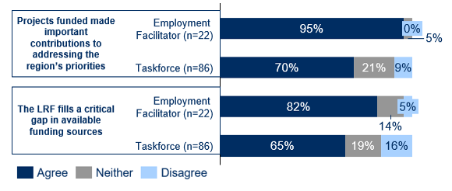
This generally reflected the views of stakeholders consulted in interviews, with most Activity Hosts interviewed indicating the funding was critical to getting their specific project up and running. Explaining why the fund was critical, several stakeholders said the LRF provided greater flexibility than other funding sources. In particular, they highlighted the scope within the fund parameters – which primarily only require that projects ‘address one or more priorities identified in the Local Jobs Plan’ – to fund a variety of projects aligned to local needs.
‘I like that the fund is focused on local needs and priorities. It’s essential to underpin the messages of the work being localised.’
– Taskforce member
Stakeholders particularly valued the scope within the LRF to provide wrap-around support, combining several different program components to design a program that holistically caters for job seeker needs.
‘It’s great that the LRF allows us to bring together a few different pieces of support without necessarily needing to come up with something super big or innovative. Job seekers just need a little support to be able to identify and take advantage of available opportunities, and the LRF means we can do that.’
– Activity Host
‘The LRF funded what is holistically required to get someone ready and keep them in work. For our program this included a range of different components, including training, career planning and mentoring.’
– Activity Host
Stakeholders attributed this capacity to provide wrap-around support to the fact that the LRF allowed for funding to go towards non-accredited training, in contrast to some state government funding tied to nationally accredited training. This led one Activity Host running a training program combining informal industry experience and networking to reflect that they would not have been able to fund their project through any other source.
‘There is no state government funding tailored this way, it’s all attached to national accreditation only. Our project is providing non-accredited training, so there’s no way we could have run it without the LRF.’
– Activity Host
Other Activity Hosts felt the scope to provide wrap-around support was particularly important for designing projects that could support more vulnerable cohorts, such as people with a disability and from a multicultural background. For example, one Activity Host from an Aboriginal and Torres Strait Islander organisation delivering a project focused on Indigenous employment in the construction industry stated:
‘We started the program with 2–3 days of training on “getting back to country”, aiming to help our participants get into the right headspace. And then we were also able to provide meals and mentoring. Adding all these elements together makes it way more likely that participants will attend and complete the program.’
– Activity Host
Most Employment Facilitators also felt that projects ultimately approved through the LRF filled gaps. However, some caveated this by saying they sometimes referred people to other potential funding sources due to challenges with the LRF procurement process.
Nevertheless, there were some stakeholders who felt that some projects could have been funded through other funding sources, or just duplicated existing programs. One Employment Facilitator noted that the LRF appears to have been identified by ESPs and registered training organisations as an alternative funding source for existing programs they previously failed to secure funding for. As a result, most proposals coming through to them for consideration were duplicates of existing programs.
One Employment Facilitator also expressly referred to using the LRF to pilot initiatives to identify good projects that could be scaled into more sustainably funded initiatives, an approach that some DESE staff felt would worth considering more in the future.
Reflecting this, a DESE State Manager noted:
‘We’re increasingly seeing proposals coming through that are a bit ‘cookie cutter’. There’s definitely an opportunity to drive a bit more innovation.’
– DESE State Manager
    - Stakeholder feedback on challenges in implementing the Local Recovery Fund
Procurement and contracting processes are seen as the major barrier to implementing the LRF effectively
Very few Employment Facilitators in interviews did not raise any significant issues with the LRF. Reflecting this view, one Employment Facilitator noted:
‘There hasn’t been a negative impact from the LRF. I don’t understand why others have found it so difficult to understand what it is there for. To me it has always been clear and I would clearly communicate this to my stakeholders.’
– Employment Facilitator
However, a majority of Employment Facilitators – as well as many Taskforce members, Activity Hosts and DESE State Office staff – raised significant challenges with the LRF’s procurement and contract management processes, as can be seen in Figure 27. In these stakeholders’ views, the LRF was the major barrier adversely impacting the effective implementation of the LJP. Reflecting this, 64% of Employment Facilitators were not satisfied with the process for seeking funds, while 59% disagreed that DESE has sufficiently communicated regarding the LRF (Figure 28). These questions had the highest negative responses across all survey questions by about 20%; the next highest negative response rate related to Employment Facilitator reporting, with 40% of Employment Facilitators disagreeing that reporting requirements were appropriate.
Figure 27: Survey responses on satisfaction with the LRF process
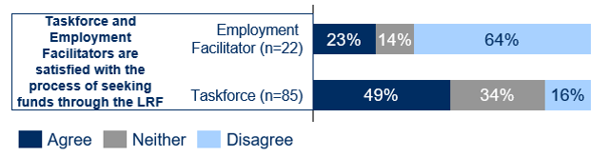
There were Employment Facilitators and Taskforce members in almost all Employment Regions who raised challenges with the LRF.
Long time frames in procurement hampered the timeliness and responsiveness of projects
One of the issues most frequently raised was the timeliness of LRF processes. Several Employment Facilitators indicated DESE initially took several months to evaluate funding proposals. Activity Hosts also indicated that once projects were approved, it took several more months to finalise the scope of the project with DESE and agree the contract. Some Employment Facilitators and Taskforce members reflected that this is too long to enable projects to be developed that are responsive to emerging local problems.
‘The program is all about getting people back into jobs and supporting local employers, so we need the money to hit the ground straightaway. The longer job seekers are disengaged the harder it is to get them back into the workforce, and when there is an employer has an urgent need, 6-9 months to get a project running is too long.’
– Employment Facilitator
‘The Project development phase was extremely long! The first conversation was in July 2020, we had the contract executed in August 2021, and then weren’t in a position to start until November 2021. That is way too long when Employers are looking for job seekers now.’
– Employment Facilitator
The first procurement round was hampered by a lack of clarity on funding parameters
A high volume of proposals were also refused in the first procurement round, which DESE staff, Employment Facilitators and Taskforce members attributed to uncertainty around the fund parameters and the types of projects likely to be approved. These challenges also had adverse impacts on stakeholders’ engagement with the fund and the broader program.
‘It would have helped to have some more guidance in the first procurement round on the types of projects DESE were looking for. We were flying blind and as a result all the proposals that were put forward were rejected.’
– Employment Facilitator
Some Taskforce members felt their input and advice on project proposals was not considered
Another common issue identified was how feedback from Employment Facilitators and Taskforce members was taken into account in the assessment and development of projects. Several Taskforce members interviewed felt that their input on proposals had not been considered. They felt that this meant that approved projects were not always optimally aligned to local needs.
‘I found it challenging that there seemed to be a disconnect between the local Taskforce and the funded activities. Initially we were sent a few proposals and were asked to review and advise on how the application could be strengthened. But there didn’t seem to be a requirement that our feed be considered, and I felt that in the end, there was a disconnect between the proposed activities and what would actually support local needs.’
– Taskforce member
‘The consultation process could do with a lot of work. My understanding of being on the Taskforce was that any proposed activities would be put to the Taskforce to discuss. But more often than not the projects were confidential and couldn’t be discussed. And then those we did provide advice on looked very different by the time they got approved. It seemed like our advice hadn’t been taken on board.’
– Taskforce member
Several Taskforce members also stated that the limited consideration of their application had impacted their engagement with the LJP and willingness to contribute their time to the Taskforce. Several Employment Facilitators also indicated that this had adversely impacted their credibility with local stakeholders, given that they are perceived to be DESE’s representative on the ground.
‘Keeping the trust has been really challenging at the beginning when the goal posts for the LRF kept changing.’
– Employment Facilitator
‘Our level of involvement in advising on potential projects has diminished over time, because we’ve realised our input ultimately isn’t important to the process.’
– Taskforce member
‘We shouldn’t have Taskforce members involved in the process if their feedback isn’t taken into account. There were some projects that came to the Taskforce that they didn’t support and those were the ones that DESE took forward. It puts Employment Facilitators in a difficult place. Our relationship is on the line. We build up trust, build credibility, and then it all gets harmed because of the process.’
– Employment Facilitator
Reflecting the link between the challenges with the LRF process and engagement, there is correlation (0.55) between survey questions to Taskforce members regarding their engagement with the program and their satisfaction with LRF processes.
Employment Facilitators also felt there should be more consultation beyond the submission of the project application
Several Employment Facilitators also raised as an issue being left out of discussions about projects once they were submitted for assessment. While they understood there were probity requirements that limited their input into the formal assessment process, they stated that being left out of contract negotiations meant there were instances where the final scope of the project had significantly changed without any input from the Employment Facilitator, and that the changes had not taken into account relevant local considerations.
‘We worked with an [Activity Host] for months to develop a proposal. Then they got invited to tender and we were effectively cut out and had no involvement in contract negotiations. DESE wouldn’t even give us a copy of the final implementation – we had to get it from [the Activity Host]. When we finally saw the Jobs Plan for the project there was no way it was actually going to get people into jobs. The program had gone from being an in-person program with barista training, a pre-employment program and a 32-hour placement with a social enterprise, to an online food preparation course followed by a short placement. There is no way it’s going to work.’
– Employment Facilitator
Activity Hosts gave mixed reports on their experiences of working with ESPs on LRF activities, and whether ESPs were helpful as Partnering Providers
Feedback from Activity Hosts was mixed regarding their experience of working with ESPs and whether it was helpful to require LRF activities to be co-delivered with an ESP as a Partnering Provider. While some found it to be a relatively smooth process and that the ESPs added a lot of value to the projects, others found it challenging to get appropriate engagement.
Activity Hosts who were positive about their experience with ESPs reflected that the key personnel were helpful and that the ESP was a critical part of the activity’s success.
‘The partnership worked well with the [Partnering Provider]. We have a good pre-existing relationship with them and haven’t had any issues. They provided good referrals for our project.’
– Activity Host
‘We couldn’t have delivered the project without [the ESP provider]. They were a great resource and very helpful. They had a good understanding of their caseload which helped us to ensure we had the right people attend and the right project team set up.’
– Activity Host
‘We got a lot out of working with our Partnering Provider. They increased the number of people coming through out activity. Their personal connection with job seekers really helped.’
– Activity Host
In contrast, Activity Hosts who had negative experiences highlighted challenges with the ESPs they engaged with and felt they did not add a lot of value to the project. In some instances they also identified adverse impacts from their participation.
‘It was really hard working with the JobActives on a 1-on-1 basis. It took a really a long time to get referrals in. There was not a lot of buy-in from JobActives and DESE had to get a bit more hands on There was not a lot of buy-in from Jobactives and DESE had to get a bit more hands on.’
– Activity Host
‘It was very challenging [working with the Partnering Provider]. We thought they were contacting the other Jobactives but they didn’t. And so very late in the party we had to try contact the other Jobactive providers ourselves to try get more participants. In the end, we found most of our participants ourselves. It seemed like [the Partnering Provider] wasn’t motivated to be involved and didn’t see any incentive to participate. I guess it’s a lot of work for them and I’m not sure they were getting any money for it.’
– Activity Host
‘Working with the Partnering Provider was one of the hardest parts of the process. They didn’t seem to understand what was required of them. They didn’t know their caseload well and didn’t seem to have a great attitude about helping them. As a result, we weren’t able to recruit many participants.’
– Activity Host
Some stakeholders also highlighted challenges with the requirement to work with an individual ESP as the lead Partnering Provider. They felt that this did not support collaboration between ESPs in the region.
‘Normally ESPs in our region are willing to be collaborative. In some circumstances though, some may not be willing to participate if you have partnerships with just one.’
– Activity Host
‘I don’t think it’s a reasonable requirement to have a Partnering Provider. If the Taskforce is there to support the project, then I don’t think we need a lead provider – it just creates tension with other ESPs.’
– Activity Host
The different perspectives above highlight how the experience with ESPs was heavily dependent on the specific ESP and staff members involved in the activity. As one Activity Host reflected:
‘If the employment consultants are switched on they will get the numbers. If they are not, no amount of support from senior executives will work. At that point you are just dealing with employment consultants who are overwhelmed.’
– Activity Host
While Activity Hosts’ experiences appeared to depend on the specific ESPs they worked with, some identified that DESE had been playing a valuable role influencing engagement from ESPs. They felt it was critical for DESE to work with ESPs to encourage their support, as they otherwise had few incentives to participate.
‘[DESE State Offices] staff have been a huge help in getting ESPs to engage. They sent a direct note to the ESPs in the region which led to be a big upswing in referrals.’
– Activity Host
‘We’ve had great support [from the DESE State Office team]. Our Partnering Providers were a little sluggish and reluctant to participate. But then DESE engaged with the providers to drum up support, which meant we got the referral numbers we needed. If not for DESE, we would only have had a handful of referrals. Ultimately, the power rests with DESE – they hold the “stick and carrot”, and if they tell the ESPs to do something they will.’
– Activity Host
‘Every time DESE got involved we got great results. It highlights just how influential they are. The mindset of many ESPs is that they are individual for-profit businesses, so it’s hard to get them to collaborate. The interaction from the DESE team made a phenomenal difference.’
– Activity Host
Proposal development and contract management processes were resource intensive and disproportionate to the amount of funding
Several stakeholders interviewed, including several Activity Hosts, Employment Facilitators, and DESE State Office and National Office staff, also felt the processes for proposal development and contract management were disproportionate to the size of funding. This placed a high resourcing and administrative burden on Activity Hosts trying to manage projects. They also identified challenges with the time and resourcing required for contract negotiations with DESE.
‘It took up a huge amount of our time to work with DESE to get the project over the line. We had multiple meetings, re-drafted multiple versions of our proposal, the budget and activity schedule, created a marketing flyer, drafted an MOU for our partners, and lots of other things. We’d basically spent all the money even before we started the project!’
– Activity Host
‘Working through the contract with DESE was really pedantic. Every detail had to be discussed and negotiated.’
– Activity Host
‘The process was way too onerous. It took us eight hours to respond to DESE’s initial questions and another 3–4 meetings. All up it was at least four full days of organisational time for multiple people, all for only $120K. Now the project has started we are required to constantly report on progress. There’s 10 questions for each report and we just don’t have the funding and resourcing to dedicate time to this.’
– Activity Host
One staff member from DESE’s National Office indicated that the higher administrative burden was in part a trade-off with the intention of the LRF to fund projects at a local level. These projects naturally tend to be of smaller value, and so may require greater relative effort to administer.
‘We recognise that it may feel like there is lots of admin because of the small-scale nature of funded programs. It’s hard to have LRF projects at such a small scale. Part of our messaging to Employment Facilitators was to be quite prudent on which projects to support, to ensure they were addressing local needs and just filling the gaps. This meant there were a lot of smaller projects. Of course, it would be much more efficient if we could give out 1 or 2 big contracts and that’s it. But that’s not the nature of the program, so it’s hard for us to get the same economies of scale.’
– DESE National Office staff member
The payment model and challenges with participant referrals may have placed a great burden on some Activity Hosts
Another concern raised by multiple Activity Hosts was the use of milestone payments, which meant many Activity Hosts were dependant on participant referrals from ESPs for projects to be financially sustainable. As noted above, obtaining sufficient referrals was itself a significant challenge, with many Activity Hosts reflecting they found it difficult to engage with ESPs and obtain referrals. This has placed the greatest burden on Activity Hosts that are smaller organisations, in some instances leaving them financially vulnerable when milestones cannot be met due to circumstances out of their control.
‘We didn’t know up front was that it was going to be milestone payments based on deliverables. This could have been communicated much better in the guidelines. It meant we had to put up the costs ourselves and get reimbursed. For the project to be sustainable we then had to do everything right in terms of delivery.’
– Activity Host
‘The project was high risk due to the reliance on the ESP provider. We are paid based on participant numbers but are relying on the ESP for participants. It’s a huge risk that we won’t get all the payments.’
– Activity Host
‘If we didn’t end up meeting the milestones because of low referrals then we would have effectively had to self-fund the project as we wouldn’t be paid by DESE.’
– Activity Host
‘The outcomes-payment model was really hard for us as a small Indigenous business. We had to wait until we had 10 participants confirmed in ESS [Employment Services System] before we received funding and then there were delays in DESE approving the invoices. It meant we had to cover a lot of costs to run the program up front.’
– Activity Host
As a result of these issues, and the resourcing and time commitment required to administer LRF projects, several Activity Hosts reflected that the ‘funding wasn’t worth the effort’ and that they would not apply again in the future or advise other local stakeholders to do so.
‘We’re not interested in putting in another project proposal after this experience – the process was way too onerous.’
– Activity Host
‘The project has cost me money in the end. I’d be pretty cautious about recommending others apply.’
– Activity Host
‘For $20,000 it was a huge amount of work. By the time you factor in our costs, including our staff’s time and wages, I’m not sure it was worth it.’
– Activity Host
Considering these challenges and potential improvements to the LRF, a DESE state director reflected:
‘It might be easier if the LRF was a grants program. For smaller organisations, it’s really hard for them to provide all the information we are asking for. It might be fine for a business chamber who can write applications full time, but it’s not OK for a local Aboriginal organisation – and these smaller organisations are often the ones best placed to support local communities.’
– DESE State Director
Job seeker eligibility requirements for LRF projects may exclude disadvantaged cohorts that are considered priorities in some regions
A handful of stakeholders interviewed also raise issues with cohorts of job seekers that were excluded from participating in LRF projects. Specific excluded cohorts identified by interviewees included the Disability Employment Services (DES) cohort, migrants who are not Australian citizens and do not hold certain visas, and people outside of the jobactive caseload, who can often have the greatest barriers to employment and are precluded from participating.
‘The restriction of LRF funding to Job Active clients misses the biggest gap, which are those people not listed with Jobactives on the caseload.’
– Taskforce member
‘I don’t understand why the LRF is limited to participants on ESPs caseload. Employers don’t care if someone is a registered job seeker, they just want to get someone in who can do the job. Disability Employment Services is a big player in our region, but we couldn’t include them in LRF activities. It makes me wonder, are we interested in getting people into employment, or is it only about people on ESPs’ caseloads?’
– Employment Facilitator
One Taskforce member from an Aboriginal and Torres Strait Islander organisation also felt the LRF processes did not take into account differences in cultures around how Aboriginal and Torres Strait Islander organisations approach businesses. Although they were reluctant to provide much further detail on this issue, they specifically pointed to the structuring of funding around milestone payments as a challenge (described earlier) and how LRF projects were developed and designed.
‘When people engage with us as an Aboriginal organisation they don’t understand that our approach and what we do is very different. It’s much more holistic. It’s very important that initiatives are co-designed. We can’t just assume agreement on key concepts or approaches when working with Aboriginal communities.’
– Taskforce member
Several Employment Facilitators reported that cumulatively these issues reduced their credibility, trust and authority with local stakeholders. In turn, they felt this adversely impacted the engagement of local stakeholders with the program as a whole. This was reflected in a positive correlation (0.55) between survey questions to Taskforce members regarding their engagement with the program and their satisfaction with LRF process. Several Taskforce members in interviews also questioned the value of their involvement in the program, and the authority of the Employment Facilitator to influence outcomes through the program.
DESE has made multiple improvements to the LRF processes since the first procurement round, which are acknowledged and valued by Employment Facilitators and Taskforce members
DESE staff – from both State and National Offices – have acknowledged the challenges discussed above and have been seeking to make improvements to the process within the constraints of government procurement frameworks and legislation. In particular, the procurement process has moved from fixed to rolling procurement rounds so that proposals can be considered in a more timely manner.
DESE has also shifted to directly inviting applications rather than an open tender, encouraging proponents to work in collaboration with Employment Facilitators and Taskforces so that proposals are more likely to be of higher quality and aligned to the priorities identified in the Local Jobs Plan for each region. DESE is also considering opportunities to reduce the administrative burden on Activity Hosts.
‘We’ve made a range of improvements to the LRF. We’ve moved to a rolling procurement process so there is a more dynamic assessment of proposals. It means we can assess proposals for a region when they are ready, rather than waiting until we have proposals for all regions at once. We’ve made changes to the types of information we collect from proponents in proposals – trying to make sure we get all the information we need up-front so that we don’t need to go backwards and forwards later during contract negotiations. We’re also looking at how we can reduce reporting depending on the project size, with three different value thresholds.’
– DESE National Office staff member
Employment Facilitators have generally acknowledged these improvements to the process.
‘The LRF has improved with the limited tender approach. My Taskforce now feels more connection to the projects and more drive towards what they are doing, because they have more ownership of the projects that are coming through.’
– Employment Facilitator
    - Summary
The LJP theory of change identifies an effective local fund as one that provides funds that are timely and flexible to local needs, allows for meaningful input from local stakeholders, and is supported by clear communication and procurement processes. In addition, the intention of the LRF was to provide funding for local labour market initiatives that would otherwise not secure funding from other sources.
In considering the intentions for the LRF, data collected for the evaluation suggests the following:
- The LRF is critical to the success of the LJP. It promoted initial engagement from local stakeholders and enables local solutions aligned to local needs, ensuring the LJP bridges the gap from talking about local needs to tangible actions.
- Although few funded projects have been completed to date, stakeholders feel funded projects will make valuable contributions to addressing local employment needs, and that many projects would have struggled to secure funding without the LRF.
- The fund parameters support the effectiveness of the LRF by providing flexible funding for a wide variety of projects that meet local needs and provide wrap-around support for job seekers.
- Procurement and contract management processes have presented significant challenges to timely funding of local activities.
- The challenges most frequently raised by stakeholders include the timeliness of the procurement process, how feedback from local stakeholders is considered, and the disproportionate administrative burden on Activity Hosts for developing and managing LRF projects.
- Cumulatively, these challenges have adversely impacted the timeliness of funded projects and local stakeholders’ buy-in to and engagement with the LJP, although DESE has subsequently made improvements, which stakeholders generally acknowledge as beneficial.

DESE’s role
As the central support for the LJP, DESE’s National and State Offices are responsible for policy, program and contract management, coordinating implementation of the program, financial oversight, liaison with key stakeholders and ensuring clear and consistent communication.
The National Office is responsible for developing and overseeing the program’s governance arrangements and overarching program management. This includes the procurement of Employment Facilitators, the development of governance arrangements for the Taskforces, financial oversight of LRF-funded projects, managing internal and external communications, managing program risk, and coordinating overall program reporting. The National Office also works with the National Skills Commission to develop and disseminate local labour market data, including on skills and labour needs for each region.
The primary role of the State Offices is to manage the implementation of the LJP in the Employment Regions in their state. This is primarily achieved through State Office Relationship Managers, who manage Employment Facilitators’ contracts and provide support to them, their Support Officer and Taskforces. This support includes acting as the government coordination point for the program, managing information flow and provide advice and guidance on government objectives for the program, and general program management support for implementation in each region. Relationship Managers are supported by State Managers, who have oversight of the Employment Regions within their state. The State Offices (through the roles of account and contract managers) are also responsible for undertaking assessment of LRF project proposals, and contract management and oversight of approved LRF projects.
    - DESE’s support
A key aspect of DESE’s role is to support Employment Facilitators while providing flexibility to tailor implementation to the needs of their Employment Region
As the LJP is a place-based initiative, a key feature inherent to its design is providing flexibility and autonomy for Employment Facilitators to adapt the implementation of the program to the specific needs and circumstances of their Employment Region.
Every State Office staff member interviewed agreed that providing Employment Facilitators with this flexibility was critical to the success of the program, and that this was an important aspect of DESE’s role in supporting Employment Facilitators. DESE staff reflected that providing flexibility was important because Employment Facilitators had the best knowledge of what was needed in their region. They also noted it is important that Employment Facilitators are seen as independent of DESE, as this supports Employment Facilitators to develop trust with local stakeholders and encourage local collaboration.
‘We do not have a place to be prescriptive. Employment Facilitators have the expertise and we don’t understand the potential of some of the conversations that they facilitate. They are the ones across the labour market and the key stakeholders in the region. Our role is therefore to make the Employment Facilitator feel comfortable and empower them to do what they were engaged to do and what they do best.’
– DESE State Manager
‘Employment Facilitators were employed for their skills, contacts and knowledge of their region. We’ve got to trust them that they know what is best, so I don’t interfere with their daily operations.’
– DESE Relationship Manager
‘Employment Facilitators are seen as independent of DESE. This is a big reason they are able to gain trust with local stakeholders, and overcome negative perceptions in the community about working with DESE and ESPs. In particular, businesses are more much willing to relate to someone who isn’t a government employer and actually understands their business.’
– DESE Relationship Manager
‘Authority and flexibility is inherent to the role of Employment Facilitators. Although they are “of” DESE, they are not “in” DESE. We need to give them a degree of autonomy to collaborate with local stakeholders, provided that they act within the parameters of the program.’
– DESE Relationship Manager
Several DESE staff indicated flexibility was most embedded in the unstructured program elements, where Employment Facilitators have a broader scope in how they work to create outcomes (see Section 2.1). Reflecting this, a DESE State Manager stated:
‘There is a difference between initiatives and ideas for more informal local solutions where Employment Facilitators have a lot of flexibility, and the LRF – which has a lot more process.’
– DESE State Manager

DESE staff identified there were a range of ways in which they sought to support Employment Facilitators while providing them with flexibility. As a general principle, this involved communicating DESE’s objectives and vision for the program, and the parameters Employment Facilitators could act within, and then acting as a sounding board for Employment Facilitators to determine how they work towards those objectives within DESE’s processes for the program. They also highlighted the importance of working collaboratively with Employment Facilitators, which is a very different approach to the typical contract management approach in other programs administered by DESE.
‘Our primary role is to help Employment Facilitators to navigate the government space and understand the program’s priorities.’
– DESE Relationship Manager
‘We try to give Employment Facilitators the freedom to do their job and be innovative, so our role is more about driving what the department is trying to achieve in terms of outcomes.’
– DESE State Manager
‘We should be giving Employment Facilitators space to try their ideas, even if they do not work out. My role therefore is to listen to their ideas and help them think them through and how they might align with the objectives for the program.’
– DESE Relationship Manager
‘We set the strategic direction for the program and provide information on the Department’s objectives. We provide the structure and support, and help Employment Facilitators to understand program requirements like reporting. And then within those structures, we provide guidance and support to Employment Facilitators to test their ideas and think through how to interpret the program requirements to suit their local context.’
– DESE Relationship Manager
‘Our role is to be a sounding board and add value to Employment Facilitators’ work – compared to other programs it’s much more about working collaboratively together as equals.’
– DESE Relationship Manager
DESE staff indicated that communicating DESE’s objectives for the program was particularly important in the early days of the LJP, as DESE sought to quickly roll out and refine the program.
‘A big part of our role is to help Employment Facilitators navigate us! [DESE]. A lot of initiatives were rolled out very quickly, so there wasn’t always a lot of time to through everything up front. A good example of this is the Taskforce and how their role has shifted over time. We’ve helped them to navigate the changes in messaging from DESE and to help them understand the program better.’
– DESE State Manager
There was variation across DESE’s state teams in the specific ways DESE staff – primarily Relationship Managers – were working to support Employment Facilitators. Examples of support provided identified in interviews included:
- acting as a sounding board for Employment Facilitators’ ideas and troubleshooting any issues they encounter
- clarifying objectives for the LJP and the scope of the LRF
- providing advice on other government programs, policy, and funding sources that may be available
- connecting Employment Facilitators with other contacts relevant to their work, such as by providing introductions to DESE staff in other program teams and contacts at ESPs or in state government
- providing relevant labour market data and other relevant information on labour market challenges and opportunities that DESE is aware of
- providing guidance and support on managing DESE’s approval processes, including helping Employment Facilitators to ‘remove blockages’ and making sure that the ‘administrative burden doesn’t get in the way of good ideas’, to ‘empower Employment Facilitators to do what they [are] good at’
- passing ‘on-the-ground’ insights from Employment Facilitators to relevant program staff and teams in DESE
- supporting Employment Facilitators to engage with ESPs
- supporting the initial recruitment of Support Officers
- sharing learnings on good practices other Employment Facilitators are adopting
- attending Taskforce meetings and local events to directly answer questions from local stakeholders.
Some of these specific aspects of DESE’s support are explored in more detail below. In particular, the evaluation explored DESEs local presence, how DESE shares local intelligence and insights on good practices, and how DESE supports Employment Facilitators to engage with ESPs.
Most Employment Facilitators felt they had sufficient support, authority and flexibility
As shown in Figure 28, most Employment Facilitators felt they had appropriate support from DESE. In particular, 77% of Employment Facilitators felt they had enough resourcing and support from DESE to deliver the LJP. Eighty-two per cent of Employment Facilitators also agreed that the LJP gave them the authority and flexibility needed to implement initiatives and collaborate in their region.
Figure 28: Survey responses from Employment Facilitators regarding DESE’s role
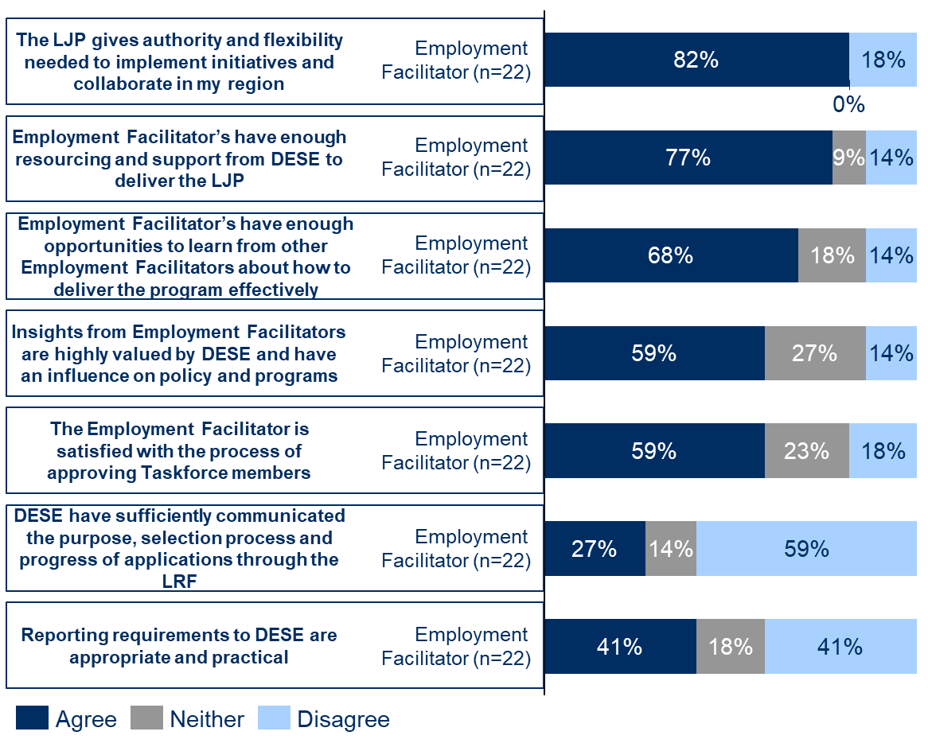
Employment Facilitator comments in interviews highlighted the ways in which they felt DESE had provided appropriate support and flexibility. In particular, they spoke positively of the local flexibility inherent to the design of the LJP, and to the supportive and collaborative role State Office staff were playing. This provided Employment Facilitators with trust and support to tailor the program to their region.
‘Authority and flexibility is what sets the LJP apart from other programs. It’s not a prescriptive program, we just need to adhere to broad processes and then DESE gives us a wide remit and flexibility in how we adapt the program to our region.’
– Employment Facilitator
‘One of the great things about the program that it is localised. Flexibility around the programs means that the work we do can really reflect the needs of our region.’
– Employment Facilitator
‘To the credit of DESE, they give Employment Facilitators a wide remit. There is a lot of trust in us that we know the regions and the people.’
– Employment Facilitator
‘I definitely feel like I’ve got flexibility. I have not been restricted with anything I wanted to do or be involved in. DESE has supported me with everything I have looked at.’
– Employment Facilitator
‘Yes I do have flexibility. It’s really important. If Employment Facilitators are doing their job properly than we are the ones who know what the opportunities are. I’ve been free to pursue these, and have not felt like I’ve been stifled in any way.’
– Employment Facilitator
‘DESE’s staff have been great. They’ve been approachable and there for support. They also want to think laterally and how we can make things work.’
– Employment Facilitator
‘I do think there is a sense that we are all working together on the same goals.’
– Employment Facilitator
However, while most Employment Facilitators felt they had appropriate support and flexibility, a small minority strongly disagreed this was the case. Other Employment Facilitators also made several qualifications to how they felt about the support they were receiving. These qualifications included:
- While they were generally positive about the support from DESE staff, there were some areas where they felt constraints with DESE’s broader processes, in particular the LRF (described in Section 2.4) and program reporting.
- The flexibility they were provided with could vary depending on the individual DESE staff member they were engaging with.
- Some Employment Facilitators felt the flexibility they received had changed over time: one Employment Facilitator felt that flexibility had reduced, while 2 felt that it had improved.
These perspectives are illustrated by the comments below.
‘I often feel like I’m being micromanaged by people who don’t understand the program from a local perspective.’
– Employment Facilitator
‘I mostly feel like I have flexibility, but there are some areas where that’s definitely not the case, particularly with the Local Recovery Fund.’
– Employment Facilitator
‘I feel like I have flexibility but ultimately this comes down to individual relationships.’
– Employment Facilitator
‘Initially I had flexibility, but it feels like it’s been reduced due to changes in the LRF guidelines over time.’
– Employment Facilitator
‘It felt like for the first part of the program there was a tremendous amount of oversight. And now there is a bit more freedom (although not quite!).’
– Employment Facilitator
The Employment Facilitators who felt constraints on their flexibility tended to be in Employment Regions that had more limited evidence of outcomes and that DESE staff felt were ‘lower performing’ regions (see Section 4.1 on enablers of outcomes for further detail). This likely reflects that DESE staff play a more directive role in managing Employment Facilitators where they feel they are performing below expectations. However, there were some instances where DESE staff appeared to be adopting a more prescriptive approach to managing Employment Facilitators that was not directly tied to the outcomes achieved in the region. Reflecting this, one senior State Office staff member stated:
‘We haven’t always had the right people in the Relationship Manager role and there has been a lot of churn. They need to be having strategic discussions together with Employment Facilitators and working collaboratively to solve issues.’
– DESE State Office staff member
In these instances, Employment Facilitators felt that the additional oversight from DESE had adversely impacted their flexibility to adapt the program to the needs of their region, highlighting there may be some areas of opportunity where DESE could adopt a more collaborative and entrepreneurial approach to managing the program.
Most Employment Facilitators had productive working relationships with their Relationship Managers and felt they were an important element of DESE’s support
Employment Facilitators’ main contact with and support from DESE is their Relationship Manager, a State Office staff member specifically appointed to manage the relationship with individual Employment Facilitators. Employment Facilitators and Relationship Managers reported communicating with each other on a regular basis, often weekly and in some instances almost every day.
As the key contact between Employment Facilitators and the broader department, Relationship Mangers are the primary channel for communicating DESE’s objectives for the program, and the first port of call for Employment Facilitators when they need support. Both Employment Facilitators and DESE’s State Office staff highlighted the importance of the Relationship Manager role:
‘Having the Relationship Manger assigned to us has been a brilliant move! It’s been really helpful to have a clear contact point we can go to for information and support.’
– Employment Facilitator
‘Relationship Managers are the most critical part of how we support Employment Facilitators. They are the front of house interface between DESE and what’s happening on the ground.’
– DESE State Office staff member
‘We are the conduit to the DESE program team and act as the connection from policy to delivery. The role flows both ways – we provide information to Employment Facilitators on policy and program settings and drive priorities, and in turn we take feedback from Employment Facilitators back to National Office.’
– DESE Relationship Manager
A large majority of Employment Facilitators were positive about the role their Relationship Managers were playing to support them to implement the program. They generally felt they had good working relationships with their Relationship Managers, that they were approachable, and that they were a key resource to support and guide them with implementing the program in their regions.
Employment Facilitators specifically identified appreciating that they felt their Relationship Manager:
- had positive motivations and intentions around the LJP
- played an active role in managing the program
- played an important role in sharing guidance on the objectives for the LJP and what was expected of Employment Facilitators
- was a valuable resource for proactively troubleshooting challenges
- was an important source of information on what was going on with other DESE programs, and in some instances helped to connect them with relevant contacts from those programs (e.g. the structural adjustments team).
Indicative of these perspectives, one Employment Facilitator stated:
‘I’ve found my Relationship Manager highly approachable and there for support. They’ve been great - they want to think laterally and how to make the program work.’
– Employment Facilitator
Another Employment Facilitator stated:
‘The key difference relative to other programs is that my Relationship Manager and DESE are very active. I see them at meetings, they make appearances at local events, and they’re always available for a chat. They’re great for guidance on how to interpret the [LRF] guidelines and give a clear steer on what is required. The info they have is also relevant, up to date and helpful.’
– Employment Facilitator
A small group of Employment Facilitators felt they had not received appropriate support from their Relationship Manager. These Employment Facilitators felt their Relationship Manager:
- did not have a strong understanding of the sector and the challenges faced by ESPs
- was busy and not as responsive to communication as they would like
- did not see them as part of a team and acted more like a Contract Manager than a Relationship Manager
- was reactive in their communication
- had been subject to a high degree of turnover, with 3 Relationship Managers in several months, each managing the relationship in a different way
- was acting like a ‘micromanager’ and being ‘dictatorial’ in their role
- did not have a strong focus on innovation and idea generation; this ‘doesn’t lend to flexibility’.
Some senior State Office staff members also raised inconsistencies with the approaches Relationship Managers were taking to support Employment Facilitators. As noted previously, in some instances Relationship Managers did not appear to have a good strategic understanding of how the program works and that they needed to work with Employment Facilitators in a collaborative and entrepreneurial way:
‘Some Relationship Managers and Employment Facilitators haven’t had the right strategic understanding of how the program works … For our part, we haven’t always had the right people in the Relationship Manager role and there has been a lot of churn… We’ve had to spend a lot of time trying to get the right Relationship Managers in place and helping them to understand how they need to work in a place-based program like the LJP.’
– DESE State Office staff member
The differing perspectives of Employment Facilitators on their Relationship Managers highlights how the effectiveness of the relationship can depend on the individuals involved. DESE’s National Office staff nevertheless felt DESE has an important role to play in providing guidance to Relationship Managers on how they should approach the management of Employment Facilitators. They recognised that to support Employment Facilitators to take an entrepreneurial approach to solving local employment challenges also requires DESE staff to work entrepreneurially and collaboratively.
Stakeholders felt it was valuable for DESE to have a local presence in each Employment Region, although this needed to be balanced with providing Employment Facilitators with flexibility
Several Employment Facilitators, Taskforce members and DESE staff highlighted the benefits of DESE having a presence on the ground in each Employment Region. In particular, they found it valuable when state-based teams made up of the relevant Relationship Managers and State Managers attended Taskforce meetings and local events, and actively worked with ESPs in the region to support improved collaboration.
Stakeholders felt this was important to demonstrate a clear line of sight between DESE and the work that was being done in each region as part of the LJP. As a result, local stakeholders had more confidence that their input was being heard and considered by DESE, helping to provide credibility to the program and promoting increased engagement by Taskforce members and local stakeholders. Several stakeholders also felt this supported greater coordination between the different levels of government working in each region, as there were more direct lines of communication. Some Relationship Managers also felt they were better able to support Employment Facilitators by having more visibility of the dynamics of the Taskforce.
‘Worthy of mention is that that DESE [State Office] has consistently supported the LJP with direct line of site. They have the capacity to get the minutes and see how things are going, or to chat with the Employment Facilitator, or to come to meetings. There has been face to face engagement every step of the way and its part of the reason why there is such strong engagement from Taskforce members across the region.’
– Taskforce member
‘We go out and visit the LRF projects. We also attend Taskforce meetings so that we can be available for questions. I feel it really adds “weight” to the Employment Facilitators role – it gives the Taskforce members confidents that messages they are sending through the Employment Facilitator are reaching us, and that Taskforce members are being heard.’
– DESE Relationship Manager
‘We often attend Taskforce meetings as observers or give an update and pop in and out. It means we are better placed to support Employment Facilitators by debriefing after meetings, helping to consider whether certain individuals or dominant and that discussions are being guided by the right priorities.’
– DESE Relationship Manager
‘The DESE State Office team have taken an active role to support collaboration with state government in our region. It’s been really valuable. I have to navigate between three different levels of government, so DESE’s involvement has helped us make sure we are complimenting other programs rather than overlapping with them.’
– Employment Facilitator
‘We’ve had great support [from the DESE State Office team]. Our Partnering Providers were a little sluggish and reluctant to participate. But then DESE engaged with the providers to drum up support, which meant we got the referral numbers we needed. If not for DESE, we would only have had a handful of referrals. Ultimately, the power rests with DESE – they hold the “stick and carrot”, and if they tell the ESPs to do something they will.’
– Activity Host
It is important, as agreed by stakeholders, that any such presence from DESE on the ground needs to be balanced with providing Employment Facilitators with space and autonomy to adapt the program to the needs of their region. For example, one Relationship Manager identified how the context of the Employment Region their Employment Facilitator had carriage over meant it was better that they stayed out of Taskforce meetings.
‘One of the Employment Facilitators doesn’t want us [DESE] present at Taskforce meetings. They feel that it enables more free flowing conversations given the stakeholders they have on the Taskforce. We recognise it’s important to give them the freedom to do that so we haven’t attended, and instead just made sure that the appropriate reporting takes place after meetings.’
– DESE Relationship Manager
Reflecting that there was an optimum balance of involvement from DESE, one Employment Facilitator consequently stated that DESE’s role on the ground must be more one of ‘sharing information’ and ‘active listening’.
Stakeholders highlighted the importance of DESE promoting collaboration between ESPs
Employment Facilitators and Activity Hosts thought it was valuable for DESE to play a role in promoting collaboration between ESPs. Activity hosts reported some valuable examples of DESE’s influence encouraging ESPs to increase collaboration. Some Employment Facilitators thought DESE could further support their engagement with ESPs by using its influence to encourage more sharing between ESPs and Employment Facilitators.
As noted earlier, engagement from ESPs has varied across the Employment Regions. While some have been working collaboratively through the LJP, many have been reluctant to participate given historical attitudes to collaboration with the sector. Stakeholders in interviews observed that this has in part been driven by the competitive procurement landscape, which has contributed to a tendency for many ESPs to work in silos.
Both Employment Facilitators and Activity Hosts felt that as DESE ultimately held the contracts with ESPs, it was critical for DESE to work with ESPs to encourage and influence their support, as they otherwise had few incentives to participate. Activity Hosts reflected that this was particularly important for obtaining referrals from ESPs to LRF projects, with some issues raised regarding ESPs’ engagement with and support for projects (see Section 2.4 regarding the LRF for more details). While examples of DESE playing such a role were identified, some Employment Facilitators and Activity Hosts reflected that this needed to happen more often.
‘We’ve had great support [from the DESE State Office team]. Our Partnering Providers were a little sluggish and reluctant to participate. But then DESE engaged with the providers to drum up support, which meant we got the referral numbers we needed. If not for DESE, we would only have had a handful of referrals. Ultimately, the power rests with DESE – they hold the “stick and carrot”, and if they tell the ESPs to do something they will.’
– Activity Host
‘[DESE State Offices] staff have been a huge help in getting ESPs to engage. They sent a direct note to the ESPs in the region which led to be a big upswing in referrals.’
– Activity Host
‘Every time DESE got involved we got great results. It highlights just how influential they are. The mindset of many ESPs is that they are individual for-profit businesses, so it’s hard to get them to collaborate. The interaction from the DESE team made a phenomenal difference.’
– Activity Host
‘DESE haven’t always responded as constructively to ESPs as I feel they could… but I get it in the context of the history of the system.’
– Employment Facilitator
‘We need more support from DESE to drive engagement from ESPs. The providers [ESPs] do not have to report to me information that they have on job seekers and I do not have authority to request that. It is only by choice.’
– Employment Facilitator
Provision of labour market data by DESE is valued by Taskforce members
Taskforce members valued the labour market data provided by DESE as part of the development of the Local Jobs Plans. They felt that access to this data was one way they were getting value out of their participation in the program, as the data is helpful for understanding local problems and how they relate to their specific organisation.
‘The labour market data from DESE has been really helpful for understanding where the core needs are in our region. It means we can be much more targeted in how we engage with specific cohorts.’
– Taskforce member
‘Our conversations have been really data-driven. It’s been great to have real time data so we are focused on current demands and needs.’
– Taskforce member
‘DESE circulate data in advance of Taskforce meetings. As a result, our conversations have been really data-driven. It’s been great to have real time data so we are focused on current demands and needs.’
– Taskforce member
‘As a [disability] peak body it’s important for us to be able to advocate and share knowledge with other stakeholders. Participation in the Taskforce has helped with this as we can keep our nose to the ground on what’s happening in the region. In particular the aggregated data from DESE has been helpful for us to understand key trends.’
– Taskforce member
Most Employment Facilitators felt DESE was proactive in the way it was providing labour market data, although there were 2 instances where they thought DESE could be more responsive to data requests, or that there would be benefit in greater distribution of data. These perspectives are illustrated in the comments below.
‘DESE have been really proactive with how they have provided. They’ve even been happy to have chats in person and I’ve been able to chat directly with the person in DESE responsible for labour market data.’
– Employment Facilitator
‘I think there would be benefit in sharing insights from the labour market data more widely. It could be really useful for the region as it takes a long time to analyse and draw insights from the data, but DESE has done a lot of the work by pulling it all together. However, sometimes I don’t get replies from DESE when asking questions about the data.’
– Employment Facilitator
Some Employment Facilitators would like a greater focus on sharing lessons and more support
As shown in Figure 28, 68% of Employment Facilitators responding to the survey agreed they had enough opportunities to learn from each other about how to deliver the program effectively. Employment Facilitators explained in interviews that a monthly meeting between all Employment Facilitators was helpful for this purpose, as were the newsletters from DESE regularly distributed to Employment Facilitators.
‘We generally meet monthly with all of the Employment Facilitators in our state. It’s been a good forum for hearing different perspectives and approaches for implementing the program.’
– Employment Facilitator
‘The newsletters from DESE have been useful – in particular the case studies have been a great way to share lessons and insights.’
– Employment Facilitator
However, there was a small proportion of Employment Facilitators who disagreed they had sufficient opportunities to share lessons. This was also raised by several Employment Facilitators in interviews, who felt there would be benefit if DESE were to facilitate more opportunities to share lessons on effective approaches for implementing the program. These Employment Facilitators felt this would improve their capabilities and the outcomes they could achieve by exposing them to a range of different approaches they could try in their Employment Regions. Some Employment Facilitators and DESE staff felt this would be particularly helpful for newer Employment Facilitators, given that Employment Facilitators received limited onboarding support.
‘There should be more opportunities to bring together Employment Facilitators to share learnings – currently it’s only once a month for state Employment Facilitators but it would be great to have a more regular forum for bouncing around ideas.’
– Employment Facilitator
‘We need more collaboration between Employment Facilitators so we can work things out collectively. There is such a great pool of knowledge, skills and solutions that exists amongst us, and by coming together It’s much better than working in regional silos.’
– Employment Facilitator
‘More sharing of best-practices would be really useful amongst Employment Facilitators – especially for the newer ones to help them get up to speed.’
– DESE State Office staff member
‘I didn’t really have any onboarding support from DESE. I had to rely completely on my support officer who was involved before me. If they weren’t there it would have taken me six months to get to where I am now, instead of two and a half months.’
– Employment Facilitator
‘New Employment Facilitators should have opportunities to be linked to mentors from other Employment Facilitators not in their region.’
– Employment Facilitator
‘I think it would be really helpful if there was a “how to guide” for new Employment Facilitators. It would have been helpful to have more constructive, practical support when I started out. When you are placed into a role like this, an assessment is made you are professional and capable and have everything required to deliver it. But guidance around practical examples would still have been really helpful. For example, we were one of the first regions to create a newsletter. There was no template, we just made it up. It now goes to several hundred stakeholders and Employment Facilitators in other regions have been picking this up. It’s the same with jobs fairs. If someone had shared these examples would have provided a strong foundation and saved us lots of time trying to figure things out by ourselves.’
– Employment Facilitator
The comment immediately above, along with comments from several DESE staff recorded below, suggests there are strong expectations of Employment Facilitators to have the knowledge and skills needed to deliver the program.
‘We are paying Employment Facilitators executive level salaries for their roles. As a result, there is an expectation that they have the capabilities to act in that space.’
– DESE State Office staff member
‘We pay them to have the skills and expertise to implement the program in their region.’
– DESE State Office staff member
‘Pay informs the level of flexibility that we afford to Employment Facilitators.’
– DESE State Office staff member
An inference underlying these comments is that DESE should not have to play a significant role in guiding Employment Facilitators, because Employment Facilitators were ultimately employed for their expertise and should have the capability to deliver from the outset. While that may be so, evidence from the literature on place-based programs highlights the importance of more collaborative ways of working. A key aspect of such a collaborative approach is the facilitation of lessons. The more DESE can support this through taking a more collaborative approach to program management, the greater Employment Facilitators’ capacity will be to adopt more effective approaches that lead to improved outcomes.
DESE helped Employment Facilitators navigate the implementation challenges posed by COVID-19
As described in Section 2.1.3, COVID-19 and related lockdowns impacted the implementation of the LJP by Employment Facilitators. Impacts were mixed across the Employment Regions, with the eastern states most affected.
Although data on this point is limited, DESE staff identified some examples of how they were tailoring their support to account for the challenges posed by COVID-19. Generally, they indicated that they tried to be flexible with Employment Facilitators and Activity Hosts to account for the uncertain environment they were operating in and to respond to challenges posed by lockdowns. Examples of this identified by DESE staff included being flexible with timelines for LRF activities and the format in which they were to be delivered, helping Employment Facilitators to understand the changing labour market as a result of COVID-19, and encouraging Employment Facilitators to be creative in how they engaged with local stakeholders.
‘With COVID-19 we tried to be flexible with the support we were providing. If there was a situation that we needed to respond to immediately then we had the flexibility within the program to do this and adapt.’
– DESE Relationship Manager
‘We’ve tried to build flexibility to adapt to COVID into some of the LRF activities. In some this has included varying contracts to enable a better delivery model.’
– DESE State Office staff member
‘A big part of our role with COVID was to help Employment Facilitators to understand the changing labour market, and to think through more creative ways to respond.’
– DESE Relationship Manager
    - Program and contract management
Relationship Managers play a role in managing the performance of Employment Facilitators against the KPIs in their contracts
An important aspect of a Relationship Manager’s role is to assess and manage the performance of Employment Facilitators. As part of its performance management framework, DESE requires Employment Facilitators to provide monthly reports on a range of measures, including data on:
- Employment Facilitator activities both relating to the LRF and outside of it
- Employment Facilitator engagements with local stakeholders
- insights and intelligence on local labour market conditions.
DESE’s National Office staff indicate they find reporting data valuable for understanding how Employment Facilitators are approaching their roles and who they are engaging with. They also indicate the aggregated reporting data has been critical for helping to ‘sell’ the program to a range of senior stakeholders.
Relationship Managers also identified a range of factors they considered to be indicative of high performance by an Employment Facilitator. These included that Employment Facilitators:
- are reporting a consistent volume of activities and engagements with local stakeholders through their monthly reports
- are having regular discussions with key stakeholders in their region
- are involved in developing ‘high quality’ activities, addressing the priorities identified in their Local Jobs Plan
- are proactive in working collaboratively with DESE
- have a clear understanding of the objectives of the program
- have a clear strategy for how they are working to deliver outcomes in their region
- are solution oriented, including considering innovative approaches to support local stakeholders
- are focused on jobs and skills outcomes and filling gaps, rather than solely connecting with local stakeholders
- have positive engagement and commitment from local stakeholders in the region, including from Taskforce members.
DESE monitors Employment Facilitators more closely when it feels they are performing below expectations
DESE staff report playing a stronger role monitoring Employment Facilitators whose performance they feel is lacking.
‘When Employment Facilitators’ performance is lacking we manage them more closely, making suggestions and being more active around what we are trying to achieve. We have to strike the balance between giving facilitators the freedom to do their job and be innovative, but also driving them towards the outcomes DESE is trying to achieve.’
– DESE State Manager
‘If an Employment Facilitator is performing well it means that we don’t need to engage with them as regularly. I only need to turn up when things aren’t going well.’
– DESE Relationship Manager
‘We give a lot more trust to high performing Employment Facilitators, whereas there is a lot less trust for those performing below expectations and we have to work with them more closely.’
– DESE State Office staff member
Relationship Managers identified a range of examples of how they would take a more active approach to manage lower performing Employment Facilitators, including:
- more regular engagements with Employment Facilitators
- attending Taskforce meetings
- spending more time reiterating DESE’s objectives for the program to ensure Employment Facilitators are prioritising their time appropriately
- communicating expectations for how Employment Facilitators should conduct their role
- providing suggestions on approaches Employment Facilitators could try
- probing Employment Facilitators on their longer term vision for the program and how their engagements with local stakeholders were going
- reviewing reporting more thoroughly, including identifying ‘deficiencies’ and seeking information from Employment Facilitators on how the reported activities are expected to lead to outcomes
- drawing Employment Facilitators’ attention to priorities in the Local Jobs Plan
- connecting their Employment Facilitator with other Employment Facilitators to encourage them to share lessons
- bringing in more senior State Office staff for significant performance management discussions.
‘For low performing facilitators we need to spend more time working with them to make sure they are focusing on the goals of the program and prioritising their time accordingly.’
– DESE Relationship Manager
‘I’ll make more suggestions, draw their attention to the Local Jobs Plan, and connect them with other Employment Facilitators to encourage thought sharing.’
– DESE Relationship Manager
‘I spend a lot of time going through monthly reports, asking Employment Facilitators about what the outcomes were from their activities, pushing them more on their approach.’
– DESE Relationship Manager
‘I’ll take a much closer look at their reporting to try give them more support. I’ll highlight what I see as deficiencies, explain the process and set expectations regarding the reporting we expect to see.’
– DESE Relationship Manager
Stakeholders felt data collected through reporting should be used with caution to manage Employment Facilitators’ performance
Many Relationship Managers and other DESE staff believed that while data from reporting was a useful measure of Employment Facilitators’ activities, it was not helpful for determining the outcomes Employment Facilitators were achieving. They explained this was because Employment Facilitators’ work supporting local connections, collaboration and capacity building can often not be clearly associated with specific job outcomes (e.g. an Employment Facilitator may make a connection between local stakeholders which results in a job, but they may not find out about the outcome after making the connection). As a result, they felt it was not appropriate to solely use this data to assess the performance of Employment Facilitators. They also believed that overfocusing on activity metrics could potentially adversely stifle Employment Facilitators’ flexibility and their capacity to adopt more innovative approaches. Noting the challenges in attributing outcomes to the work of Employment Facilitators, this reporting data is most appropriately interpreted in the context of the on-the-ground insights of Relationship Managers.
‘It’s hard to say who is high performing and who isn’t given the environment Employment Facilitators work in. From reporting we can get a sense of who is responsive, who is engaged, and who is busy. But in terms of impact, it’s hard to measure.’
– DESE National Office staff member
‘I know National Office have spent a lot of time thinking about a performance framework for Employment Facilitators. There is a lot of emphasis on data and numbers, and I can appreciate why that is the case. However, the unique nature of program comes with giving Employment Facilitators space to be entrepreneurial, and that means not being overly focused on numbers. While numbers might help us to manage Employment Facilitators that aren’t up to job, we have to be very careful to limit opportunities and the entrepreneurial approach that outstanding EFs are demonstrating.’
– DESE Relationship Manager
‘I don’t think the data we collect from facilitators is very helpful. It would be great to be able to say facilitators help placed X people in a job but it’s not that sort of program. It’s about building local capacity and making connections which will enable outcomes through other local parties. It’s the capacity building role that is hopefully the lasting legacy of the program and that’s not easily shown by saying X job seekers got into work".’
– DESE State Office staff member
The comments above highlight the challenge for DESE in balancing performance management with providing Employment Facilitators with appropriate flexibility. Discussions with Relationship Mangers suggested there was variation in how they were striking this balance. Some were taking a much more active and prescriptive role, as evident from the comments above where Relationship Managers describe closely interrogating reporting and making suggestions to Employment Facilitators on how to approach their role. Others tended to be more hands off, even going so far as to say that they ‘do not performance manage’ Employment Facilitators – as evident in the following comments.
‘We definitely do not performance manage Employment Facilitators as we do with other providers. Employment Facilitators bring different skillsets to the role and we purchase their expertise for a reason. If we have to performance manage them it means we got the wrong people in the role. We help them understand what performance is by setting expectations. For us, it’s about the qualitative aspects of the region and what they are doing: who they talk to, what they learnt, and the implications for us. We do not place much emphasis on the metrics.’
– DESE State Office staff member
‘Our approach is very different to how we manage performance in other programs. Core is having the Relationship Manager central to the process, to think more about how we can support the Employment Facilitator.’
– DESE State Office staff member
The approaches to support and performance management identified in the comments immediately above are most aligned to the literature on effective place-based initiatives. DESE may therefore wish to consider opportunities to encourage Relationship Managers to adopt these approaches, where appropriate (see Section 5 for more detail on lessons learned).
There may also be opportunities to consider the type and format of data collected through program reporting, to align this with more qualitative measures of Employment Facilitators’ performance. One Employment Facilitator noted that the switch to reporting through Excel made it harder to describe the intangible outcomes:
‘Reporting has changed over time. We’ve moved to more of an Excel style, which has less of storytelling element (vs a Word document). It’s made it harder to describe the value we are bringing and the more intangible outcomes we are contributing to.’
– Employment Facilitator
Similarly, a National Office staff member noted that using template reports can make it hard to identify what’s most important:
‘Template reports can make it hard to capture everything important. It might not pull out all the little gems that show the real value Employment Facilitators are adding.’
– DESE National Office staff member
Many Employment Facilitators felt program reporting took up too much of their time
Over 40% of Employment Facilitators disagreed that reporting requirements to DESE are appropriate and practical, as shown in Figure 28. Explaining why this was the case, Employment Facilitators in approximately 10 Employment Regions raised issues in interviews regarding the administrative burden required to complete program reporting. While they all acknowledged the need to monitor the implementation of the program and their performance, they felt complying with reporting requirements was adversely constraining the time they could spend on the ground engaging with local stakeholders. Reflecting this, one Employment Facilitator estimated that reporting took up one week of every month of their Support Officer’s time, with close support and oversight still required from the facilitator. A newer Employment Facilitator estimated reporting took up about 30% of their time:
‘Reporting takes up a huge amount of my time. There are all these different trackers we need to complete. I probably spent about 30% of my time on reporting, with 40–50% on the LRF. That only leaves me 20% to actually get out in the community and speak to people and connect.’
– Employment Facilitator
‘Reporting is getting a bit more streamlined, but it still takes my support officer close to a full week out of every month to do the report properly. There’s a lot of duplication between what is in Word and Excel. Sometimes deadlines can also be really tight, e.g. labour market summary briefings.’
– Employment Facilitator
‘We get new templates for reporting all the time. It’s hard to keep track of.’
– Employment Facilitator
‘There is a lot of reporting. The more time I don’t have to report, the more time I can actually go out into my region and work with local stakeholders.’
– Employment Facilitator
Several Employment Facilitators also suggested the reporting burden had increased over time as DESE requested new information without streamlining or considering the information they had already reported. DESE’s National Office staff acknowledged that additional requests had been made of Employment Facilitators over time, in part because Employment Facilitators were such a valuable source of local intelligence. As a result, there were times DESE found it helpful to collect local information that could support other relevant programs in DESE.
DESE’s National Office staff have acknowledged the challenges identified by stakeholders regarding program reporting, both in terms of the burden on Employment Facilitators and whether reporting is a good measure of success. DESE has consequently made some changes to the reporting process with a view to streamlining the data collected, and has indicated that it is actively considering other opportunities for improvement, including potentially reducing the frequency with which data is collected. These improvements to the reporting processes were acknowledged by some Employment Facilitators.
‘Whatever reporting system you will put in place someone will have a moan about it. I don’t have issues with it and to DESE credit, they’ve done a lot of work on engagement trackers to try smooth out the process. We are continuing to evolve.’
– Employment Facilitator
DESE staff felt local insights collected from Employment Facilitators were helpful for managing other DESE programs, although some opportunities were identified to use this data more
Part of DESE’s role in managing the LJP is ensuring that local insights and intelligence from Employment Facilitators are used to inform DESE’s broader policies and programs. These insights are collected through reporting from Employment Facilitators, feeding into a reporting dashboard managed by DESE that aggregates labour market intelligence. Local insights are also collected more informally by Relationship Managers, who pass this on to the program team in DESE when appropriate.
DESE’s National Office staff indicated that this local intelligence had been incredibly helpful for managing other DESE programs:
‘The LJP is really valuable for getting on the ground intelligence and reality testing our policies. There’s no point Canberra saying there is a shortage of chefs. It’s only relevant how this plays out on the ground. LJP helps us to get the on the ground intel. As a result we might say there is no point rolling out programs “a,b,c” here, because of local issues “x,y,z”.’
– DESE National Office staff member
As noted earlier, the value of Employment Facilitators’ local insights had prompted the National Office to reach out to Employment Facilitators in several instances with information requests relating to other DESE programs.
Approximately half of the State Office staff interviewed identified specific examples of where they had passed on local intelligence to influence DESE’s broader programs.
‘The local knowledge from Employment Facilitators is invaluable. It provides good feedback that National Office can use to develop policies for other programs. For example. we’ve helped pass on insights relevant to the Transition to Work program. It really helps us to see what is and isn’t working on the ground.’
– DESE State Office staff member
‘National Office responds well to the intelligence that Employment Facilitators provide. We’re regularly filtering strategically important things up the chain of the command.’
– DESE state office staff member
‘National Office have been very interested in what Employment Facilitators are saying about transport and housing shortages. Drivers license funding is a good example of DESE taking on Employment Facilitators input.’
– DESE Relationship Manager
‘We’re constantly feeding into policy and program settings, LJP does focus on incorporating feedback and building on it.’
– DESE Relationship Manager
‘We passed on some feedback to the program team around issues with visas. Employers were struggling because they had no access to overseas workers. We were able to provide real life examples of how these issues were playing out for employers and their capacity to keep their businesses open. It’s very important for policy makers to have this detail.’
– DESE Relationship Manager
However, there were also several State Office staff who were unclear on how local intelligence from Employment Facilitators was being used. One staff member noted how the processes around using local intelligence were informal and so it was not always clear what resulted from passing on insights to the program team. Another felt that there were opportunities to make greater use of local insights.
‘I’m not sure if the local intelligence has influenced policy. We don’t really hear how it gets used.’
– DESE Relationship Manager
‘Not sure how DESE is using the data that is being collected. It’s hard to see immediate cause and effect. Mechanisms for upwards feedback are quite informal - State Office passes information where possible to National Office through whichever mechanisms we have.’
– DESE State Office staff member
‘There is a big opportunity to make more use of the intelligence we get from Employment Facilitators.’
– DESE State Office staff member
National Office staff agreed there were opportunities to make better use of labour market intelligence.
‘We could definitely make more of the labour market intelligence we get, however it would require more resourcing to make the most of this.’
– DESE State Office staff member
There may also be opportunities to better communicate to Employment Facilitators how local intelligence is used. As shown in Figure 25, approximately 60% of Employment Facilitators believed that their insights were valued by DESE and influenced policy and the program. However, 14% of Employment Facilitators disagreed and there was a higher neutral response to this question (27%) compared to others, which may indicate Employment Facilitators were unsure how their insights were being used by DESE.
Only a few Employment Facilitators could identify specific instances in interviews where local intelligence from Employment Facilitators was used to inform DESE’s broader policies and programs. Communicating how local intelligence is used by DESE may help Employment Facilitators to appreciate the purpose of their time spent on reporting.
Activity Hosts had productive relationships with DESE staff managing LRF contracts; however, they also felt the contract management processes were disproportionate to the amount of funding
Interviewed Activity Hosts were positive about the relationships they had with DESE staff who were managing their contracts to deliver LRF projects. In particular, they felt DESE staff were supportive, committed to the success of the LRF projects, and open and transparent in how they engaged with Activity Hosts.
‘We loved how involved DESE were. They wanted to work with us to make sure the project would work. They came and visited the participants, they weren’t just numbers on a page. We really appreciated their commitment and involvement in the program.’
– Activity Host
‘I can’t speak highly enough of DESE crew. They are really supportive. A lot of this was new to us and they were really patient and helped us out. For example, we’ve never had to do a project plan before so they held a Teams meeting to talk us through it. And when we were locked down in covid, they were on the phone constantly for fortnightly conversations. A really nice gesture. It’s probably the nicest group we’ve had to deal with.’
– Activity Host
‘DESE were really open and transparent. They made themselves very accessible, it was very easy to pick up the phone and have a discussion. It made it much more like a partnership arrangement rather than just being one sided.’
– Activity Host
The DESE staff are great. We’ve got really good relationships with them. We have honest open and transparent conversations. They are sometimes apologetic for processes put in place by DESE – they don’t have full oversight of the program they are working with providers on.
– Activity Host
While Activity Hosts were positive about DESE staff they worked with, most raised substantial issues with the processes for contract management, feeling they were resource intensive and disproportionate to the size of funding. These issues are described in more detail in Section 2.4, regarding the LRF.
    - Program management and communication by DESE’s National Office
State Office staff were mostly positive about their relationships with the National Office and how they were managing the program
The LJP is an ambitious program for DESE. While built on the existing foundations of the RET, it has required DESE to adopt different ways of working more widely relative to other programs, and to quickly roll out and scale extensive enabling infrastructure in diverse regions across Australia.
While this has posed some challenges for the National Office as it has worked to quickly develop and implement new processes, State Office staff were mostly positive about program team staff and how they were managing the program. In particular, they felt:
- they had productive working relationships with staff from the National Office
- they were given appropriate authority to oversee the day-to-day management of the program in Employment Regions
- the program team was communicating regularly about the management of the program and kept the State Office in the loop
- the program team was responsive to emerging issues, and took the feedback of the State Office on board to consider improvements in how the program was managed.

‘National Office has been great!’
– DESE State Office staff member
‘We’ve got the strongest connection with National Office we’ve ever had. We’ve had a lot more influence and authority than we thought we would have, and they’ve really given us the space to play that role liaising between Employment Facilitators and National Office. I also feel we’ve been able to have a big role in shaping the national policy settings because we’ve hit the ground running.’
– DESE State Office staff member
‘There have been plenty of opportunity to engage with National Office. We’ve got a facilitator catch up every fortnight with representatives from National Office. There are also regular catch ups with everyone nationally.’
– DESE Relationship Manager
‘The program area is very responsive and very well set up. They are also willing to take advice from State Office as to where we think the program should head.’
– DESE Relationship Manager
‘We’ve got a good working relationship with National Office. Ultimately this comes down to the people and the personalities.’
– DESE Relationship Manager
‘We’re lucky with our contact person at National Office who carries our feedback. We don’t always agree with the program settings but have appreciated always having the opportunity to advocate directly.’
– DESE Relationship Manager
There were some challenges with communication, DESE’s approval processes, and delineating roles and responsibilities, which were raised most often in the earlier stages of the program
While most State Office staff were positive about how the National Office was managing the program, some of them, as well as some Employment Facilitators and Taskforce members, did raise challenges with DESE’s broader approval processes and communication. These challenges were raised most often in the context of the earlier stages of the program, when DESE needed to rapidly develop new processes. Stakeholders acknowledged that DESE had been working to subsequently make improvements.
Challenges were most frequently raised in relation to the procurement processes for the LRF, and the reporting burden for Employment Facilitators. Other challenges related to approval process for the Local Jobs Plan and Taskforce members, occasionally inconsistent communication between State and National Office, and a lack of clarity on roles and responsibilities. These latter challenges are considered in more detail below.
Some stakeholders felt the timeliness of DESE’s approval processes could be improved and that there were some instances where these processes had constrained local flexibility
In managing the program implementation of the LJP, DESE is also responsible for approving the Local Jobs Plan, approving Taskforce members, and assessing and approving the LRF project applications.
Some stakeholders felt the approval processes for these program elements could be improved, raising issues with the timeliness of the processes, and some instances where Employment Facilitators felt constrained when DESE rejected proposed changes to the Taskforce and Local Jobs Plan.
As noted in Section 2.4, several stakeholders felt the process for updating the Local Jobs Plan was too long and time consuming, and that the template for the Jobs Plan did not provide much flexibility. One Taskforce member noted:
‘Updating the Jobs Plan was pretty bureaucratic and too structured, not necessarily allowing us to focus on the needs of the region. I find that this is the part of the program that is a bit too rigid. It does not allow you to be flexible.’
– Taskforce member
An Employment Facilitator also stated:
‘There are way too many layers of management. Sometimes DESE will take control over your Local Jobs Plan or minutes from you Taskforce meetings. But they are not really adding value other than monitoring.’
– Employment Facilitator
Some State Office staff also felt this was the case.
‘Updating the Local Jobs Plan was a long process. There was a new template and everything had to be changed. We had 15 versions for one plan – I felt like this was a heavily over-engineered part of the program.’
– DESE State Office staff member
Several Employment Facilitators also raised issues with the processes for changing Taskforce members. As shown in Figure 28, only approximately 60% of Employment Facilitators agreed they were satisfied with the process for approving Taskforce members – with about 20% of responses disagreeing and a higher neutral response to this question compared to others about DESE’s support. Two Employment Facilitators specifically raised issues in interviews with replacing Taskforce members. One stated:
‘DESE wasn’t supportive of changing the Taskforce. We tried to bring on an employer we thought would be a great contribution but we’ve had to fight tooth and nail. It took six months for them to consider it and then they finally came back and said no. I don’t understand how they are employing us for our expertise, but then not trusting us.’
– Employment Facilitator
DESE’s State Office staff acknowledged some instances where they had rejected changes to the Taskforce put forward by Employment Facilitators. They explained this as part of the challenge of providing Employment Facilitators with autonomy, while at the same time setting expectations of how the program should operate.
The Employment Facilitator in our region wanted to bring someone on to the Taskforce that we didn’t think was appropriate for that setting. In that case we felt we had to draw a line
– DESE Relationship Manager
Some stakeholders felt communication was unclear in the earlier stages of the program
Some issues were also raised regarding communication from DESE. These were most often raised in the context of the early stages of the program when DESE was working to quickly roll the program out.
As noted in Section 2.4 regarding the LRF, some Employment Facilitators felt initial communication from DESE was unclear about the types of projects likely to be successful and the requirements for projects to be approved. Feedback to proponents on why projects were refused was also unclear and delayed. Several Employment Facilitators noted this had adverse impacts on their trust and credibility with local stakeholders. Reflecting this, as shown in Figure 28, nearly 60% of Employment Facilitators (59%) disagreed that DESE communicated the purpose, selection process and progress of applications through the LRF sufficiently, compared to 27% agreeing.
Some Employment Facilitators also raised issues with the coordination of general program communication, particularly in the early stages of the program. They felt that there was a high volume of communication from different people within DESE that was not well coordinated and aligned. They also identified some instances where they were left out of the loop on discussions relating to stakeholders in their Employment Region that they thought were important for them to have visibility of.
‘We get lots of emails and meetings. They have good intentions but they are not well coordinated and come from a range of different people within DESE.’
– Employment Facilitator
‘I feel that there could be better coordination of communication sometimes. We often get random emails from DESE about things we don’t know about. I feel there could be better messaging through our Relationship Manager.’
– Employment Facilitator
‘It’s been an issue with communication that DESE staff are quite busy. They aren’t always on top of where things are at. I was talking to a big employer in my region and found out DESE were also talking to them. I should have known that.’
– Employment Facilitator
State Office staff also felt there was some uncertainty around roles and responsibilities earlier in the program
Some Employment Facilitators and DESE’s State Office staff reported a lack of clarity about the roles of the State and National Offices in the early stages of the program. This uncertainty was perceived to have led to instances of duplication of communication (as described immediately above), confusion around reporting lines, and inefficient processes.
‘In the early days we did not know what the different roles were. Now we are much clearer. National Office found that there is a lot of things they’ve had to focus on to clarify this. There are occasionally rogue facilitators contacting Canberra, which is a no-no, but that’s now pretty uncommon.’
– DESE State Office staff member
‘The program challenges the clear delineation of roles between State and National Office. When procurement processes for the LRF weren’t working well there were tensions between National Office and State Office. It makes it really important to have strategies in place that ensure effective communication.’
– DESE State Office staff member
‘There can be a tension between State and National Office because roles and responsibilities are not always clear. Sometimes there is duplication. For example, an Employment Facilitator may go straight to National Office. Ultimately though there are a lot of effective working relationships and more often than not, all three parties engage together such as at our weekly catch up with Employment Facilitators that National Office staff attend.’
– DESE Relationship Manager
‘In the early days of the program there were too many “cooks in the kitchen from DESE”. Everyone had a distinct view.’
– Employment Facilitator
DESE has acknowledged these challenges and has been seeking to make improvements to refine its approval processes and communication
As the LJP has matured, DESE staff have been working to improve its processes and communication. As noted earlier, this has included a range of improvements to the LRF’s procurement processes to improve the timeliness of approvals and reduce the administrative burden on Activity Hosts, and to consider ways to streamline reporting for Employment Facilitators. DESE has also sought to get clearer in its messaging and to clarify roles and responsibilities between State and National Office.
‘The program is very different to others we’ve run so we’ve been thinking hard about how to be clearer with our messaging. It’s really important that National and State Offices are on the same page.’
– DESE National Office staff member
‘As the program varies across regions we can’t all tell Employment Facilitators the same thing. We can’t have a one size fits all approach to managing the program. It’s required us to do more work in how we think about how we manage the program. It’s required us to do more work in how we think about how we manage the program.’
– DESE National Office staff member
‘We have heard that in the past DESE has been criticised about bureaucracy and red tape, so along with National Office we’ve been focusing on streamlining things and being more responsive.’
– DESE State Office staff member
‘Given the program was rolled out so quickly policy and program setting were tailing behind delivery of the LJP. It’s the nature of implementing any new program and we’re now working to improve our settings to catch up.’
– DESE State Office staff member
DESE’s National Office staff felt that prioritising available resourcing is the underlying driver of many of the challenges in managing the program
Several National Office staff felt that having to prioritise limited resourcing was the primary driver of most challenges in managing the program. In particular, they noted that staff resourcing had to be balanced with other competing priorities across DESE, such as the rollout of Workforce Australia, which required the reallocation of some staff previously working on the LJP. They also highlighted how the expansion of the program to the remaining 26 Employment Regions meant they had to prioritise resourcing to set up the enabling infrastructure in these regions, such as recruiting new Employment Facilitators. This made it harder to prioritise staff time towards improving existing processes.
‘Almost all problems stem from a lack of resources or competing priorities (e.g. the [rollout] of NESM). External resourcing for each region is fine, it’s more of an internal issue around how we prioritise staff time to manage the program. It poses a challenge for what we hope to achieve and there is a risk the program might not realise its full potential.’
– DESE National Office staff member
‘Resourcing has been the biggest challenge. We had to expand the LJP to the other 26 regions while we were still bedding down the first 25. We effectively doubled the program at what was an important time for the original regions and this didn’t come along with doubling the number of staff.’
– DESE National Office staff member
‘Resourcing has been an ongoing battle, it’s meant we have had to put a lot of things on the backburner.’
– DESE National Office staff member
National Office staff identified a range of program gaps that they felt could be addressed with more resourcing. These included spending more time:
- providing regular and consistent feedback to Employment Facilitators
- communicating the benefits of the program, both to senior stakeholders and circling back to Employment Facilitators around the value of their work
- providing more opportunities for Employment Facilitators to share lessons, such as setting up forums
- convening groups of Employment Facilitators to collaborate on cross-regional issues
- refining policy and program settings
- using and sharing the labour market intelligence and insights from Employment Facilitators.
The LJP program team has played an important role in communicating the vision for the program, although there is still some uncertainty regarding long-term objectives
The LJP program team in the National Office has played an important role within DESE in articulating the LJP’s purpose and model, and why it is different and should be treated differently to other employment programs. The value of this role is evident in how most state-based staff were aligned around the unique place-based nature of the program, and the importance of providing Employment Facilitators with flexibility and autonomy.
However, there is potentially still some uncertainty around how aligned DESE staff are regarding the vision for the program. As noted earlier, some Relationship Managers could have adopted a more collaborative and entrepreneurial approach to the way they were working to support Employment Facilitators. One National Office staff member also reflected:
‘We’ve been good at selling the program upwards but I’m not so sure there is complete alignment below. Our senior stakeholders understand what the program is about but I’m not sure how much this has filtered downwards and whether everyone has the same view of success. It’s important we make sure that we keep passing the same message down, as if not it can have a big flow on effect – if people don’t understand the program or have gaps in their knowledge than they can’t support Employment Facilitators as effectively.’
– DESE National Office staff member
While most State Office staff were aligned around the different ways of working required to manage the program, there were also differing views on the long-term objectives for the program. When asked about what the long-term focus for the program should be, State Office staff tended to split into 2 distinct groups. The first group felt the long-term focus should be on more immediate jobs and that the primary role of Employment Facilitators was therefore to connect local stakeholders and leverage existing employment programs. The second group felt the program should focus more on supporting people with the most complex barriers to employment and building the capacity of local stakeholders, with a view to building a legacy that outlived the involvement of Employment Facilitators. Some of these different perspectives are captured in the following comments:
‘For me the program is still about getting unemployed people with the greatest needs into pathways towards a job.’
– DESE Relationship Manager
‘At the end of the day the program is about getting people into jobs as fast as possible.’
– DESE Relationship Manager
‘We should keep focusing on trying to fill gaps and making connections that lead to long term employment for people in the community.’
– DESE Relationship Manager
‘I think some of the greatest value of the program will come from making linkages to other existing Government programs.’
– DESE Relationship Manager
‘The whole nature of the LJP is about trying to improve outcomes in a way where we are building local capacity and making connections that extend beyond the role of the Employment Facilitator. It’s this capacity building role that is hopefully the lasting legacy of the program, so that when the program is over, we’ve left behind a sustainable collaborative infrastructure for the community.’
– DESE State Office staff member
‘We need to be focusing on longer-term goals. We need to be thinking more strategically about the long term needs of the region and looking ahead to future workforce demands and how we can support the community to grow and transition.’
– DESE Relationship Manager
‘The program is very much about the networks that are being established that in the future can be sustained.’
– DESE Relationship Manager
‘Initially we’ve been responding to COVID but going forward we need to step back and look at the broader labour market and structural issues like housing, transport and aged care. If we want to make real progress on these issues we need to be supporting communities to work together and advocate.’
– DESE Relationship Manager
‘With the switch to online management of the case load, the cohorts ESPs will be working with will be those with the biggest needs and barriers to finding work. Employment Facilitators will need to be more involved in working with the people who are trying to provide the training and support to these cohorts.’
– DESE Relationship Manager
    - Summary
The LJP was designed to enable local solutions that meet the unique needs of each Employment Region. A key assumption in the theory of change is therefore that Employment Facilitators are provided with the flexibility to tailor and adapt the program to the needs of their region.
Evidence from other place-based initiatives suggests that DESE, as the central government entity funding and supporting the LJP, has a critical role to play in the LJP’s success. This includes providing an enabling authorising environment for Employment Facilitators to do their job, supporting Employment Facilitators to learn from each other, and facilitating the sharing of lessons and insights from ‘the ground’ up into other parts of DESE.
In considering the key assumptions in the theory of change and evidence of best practice for other place-based initiatives, analysis of data collected for the evaluation suggests the following in relation to the support provided by DESE:
- Most Employment Facilitators felt they had sufficient support, authority and flexibility to adapt implementation of the LJP to the needs of their region, in particular having productive working relationships with their Relationship Managers, who were an important part of DESE’s support.
- Stakeholders found it valuable when DESE had a local presence in each Employment Region and promoted collaboration between ESPs. However, they qualified that this needed to be done in a way that maintains Employment Facilitators’ autonomy and flexibility. While stakeholders identified some examples of where this happened and led to positive outcomes, others felt DESE could be doing this more.
- Most Employment Facilitators felt they had enough opportunities to learn from each other; however, some wanted a greater focus on sharing lessons. As the LJP is a place-based program, DESE has a role to play to enable this sharing of lessons, rather than taking a more typical contract management approach and expecting Employment Facilitators to deliver with limited guidance and support.
- Stakeholders felt data collected through reporting should be used with caution to manage Employment Facilitators’ performance. As this data is only a good measure of Employment Facilitators’ activities rather than the outcomes they are achieving, if Relationship Managers are too prescriptive in interpreting this data there is a risk that it may adversely impact Employment Facilitators’ flexibility and capacity to adopt innovative approaches in their region.
- Many Employment Facilitators felt program reporting took up too much of their time and had impacted the time they had available to engage with local stakeholders on the ground. They nevertheless acknowledged that DESE has been seeking to make improvements to streamline reporting requirements.
- State Office staff were mostly positive about their relationships with National Office and how they were managing the program. While there have been some challenges with the processes developed for managing the program, including around the LRF, reporting requirements, communication and clarifying roles and responsibilities between State and National Office, these were mostly raised in the context of the initial rollout of the program, and DESE has been subsequently working to make improvements.
- The National Office program team’s capacity to make improvements to the LJP has been limited by having to balance resourcing with competing priorities across DESE in the context of the LJP being expanded to 26 more Employment Regions. As a result, there are still some opportunities to be realised around better supporting Employment Facilitators, ensuring consistent and clear communication, and maximising the use of local intelligence collected from Employment Facilitators to inform program and policy development
- The LJP program team has played an important role in communicating the vision for the program, although further clarification on long-term objectives for the LJP will be needed.
- Evaluation findings: outcomes
This section presents findings against the second evaluation question:
‘To what extent has the Local Jobs Program improved the responsiveness of labour market interventions?’
The program logic (see Section 1) describes that the program aims to achieve a range of outcomes, which can be grouped into 2 categories: Local System Outcomes, which pertain to positive changes in how local stakeholders work together to effectively respond to labour market challenges; and Jobs and Skills Outcomes, which are the positive outcomes that result for job seekers, employers and ESPs when local stakeholders and systems are working together more effectively.
This section presents evaluation findings on the extent to which the LJP has contributed to outcomes in both categories, and how this has varied across the 25 Employment Regions in scope. It has the following sections:
- Section 3.1: Local System Outcomes
- Section 3.2: Jobs and Skills Outcomes
- Section 3.3: Variation in outcomes across Employment Regions
- Section 3.4: Pathways to creating outcomes
- Section 3.5: Summary.

Local System Outcomes
    - What are Local System Outcomes?
Local System Outcomes are defined as positive changes in how local stakeholders work together to create local employment solutions that lead to Jobs and Skills Outcomes. These changes are common to place-based initiatives such as the LJP, as all place-based initiatives aim to drive outcomes for individuals and community members through catalysing changes in how local systems work (rather than ‘directly’ supporting job seekers into work, for example). Other place-based initiatives also suggest that creating change in local systems takes time and should be understood as a staged approach.
Based on these insights, the theory of change defined Local System Outcomes as occurring in 3 stages – Connecting, Coordinating, and Capability Building – called ‘stages of maturity’ (Figure 29).
Figure 29: Local System Outcomes
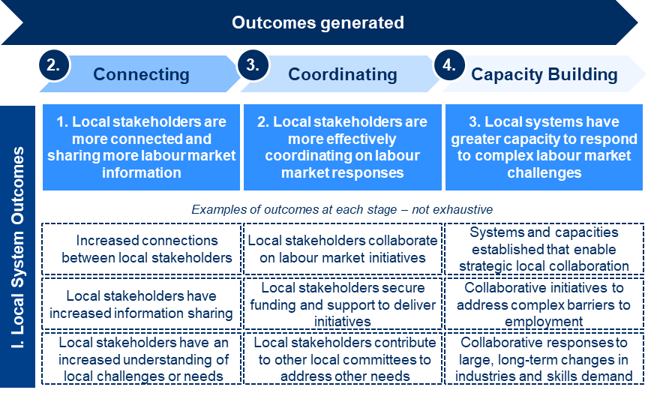
    - The LJP’s contribution to Local System Outcomes
According to the survey responses by Employment Facilitators and Taskforce members, all 25 Employment Regions have experienced at least some improvements in how local stakeholders are working together to respond to labour market challenges during the implementation of the LJP.
All Employment Facilitators and Taskforce members were invited to complete a survey that included questions on the extent to which the LJP had contributed to Local System Outcomes in the Connecting, Coordinating, and Capacity Building stages (Figure 30). Overall, 73% of Employment Facilitators and 69% of Taskforce members strongly agreed that the LJP had contributed to at least one type of Local Systems Outcome in their Employment Region across the different survey questions on Local Systems Outcomes (see Figure 30, ‘Total’ column).
In addition, these results suggest that overall, Local System Outcomes in the Connecting stage were most commonly reported by Employment Facilitators and Taskforce members, followed by those in the Coordinating and Capacity Building stages, respectively (Figure 30).
Connecting stage: A large proportion of Employment Facilitators and Taskforces have seen increased information sharing, new connections, and a greater understanding of local needs
In the Connecting phase, increased understanding of local labour market challenges or needs was the improvement most commonly reported in the survey by Employment Facilitators (73%), while local stakeholders sharing more information related to jobs and training opportunities was the improvement most commonly reported by Taskforce members (50%). Employment Facilitators in every Employment Region perceived that the LJP had contributed to at least one Local Systems Outcome in their region to any extent across the different survey questions on Local System Outcomes (see Table 3: Survey responses from Employment Facilitators on Jobs and Skills Outcomes (n=22)
Section 3.3 for findings on cross-regional variation in outcomes).
As seen in Figure 30, more than half of the survey respondents strongly agreed that:
- local stakeholders share more information related to jobs and training opportunities (64% of Employment Facilitators and 50% of Taskforce members)
- there are increased connections between local stakeholders in supporting employment needs (64% of Employment Facilitators and 49% of Taskforce members)
- local stakeholders have increased understanding of local labour market challenges or needs (73% of Employment Facilitators and 47% of Taskforce members).
There were some differences in responses to these outcome statements relating to the Connecting outcomes between Employment Facilitators and Taskforce members. A greater proportion of Employment Facilitators than Taskforce members strongly agreed that the LJP had contributed to all outcomes in the Connecting stage, as seen in Figure 30.
Figure 30: Survey responses from Employment Facilitators and Taskforces agreeing the program has contributed ‘a lot’ or ‘a great deal’ to Local System Outcomes in their region, by outcome and outcome stage (September–November 2021)
Interviews identified multiple examples of outcomes at the Connecting stage. These included:
- Taskforce members forming new relationships with other businesses, services and government
- Employment Facilitators bringing ESPs together to share about the programs they are running
- Employment Facilitators connecting ESPs to employers or community organisations with industry groups
- Taskforce members connecting with other networks and regional activities to respond to labour market challenges and other issues
- Taskforce members sharing information with each other about their labour market needs and challenges, and receiving information from the Employment Facilitator
- Employment Facilitators connecting local stakeholders who are tackling similar employment challenges to reduce duplication across programs
- Taskforce members increasing their knowledge of local ESPs’ offerings and the labour market issues in the region.
‘The Employment Facilitator has helped us to make our work more collaborative, connecting us with other key people in our industry.’
– Taskforce member
‘The flow of information has been consistently helpful. Before there was no central body where the information was coming from. Everyone now knows about the program. There’s information sharing even amongst the ESPs, this has never happened before.’
– Taskforce member
‘We are seeing outcomes in terms of connecting programs, creating awareness about what is going on. This can be drawn on to minimise duplication and improve outcomes for programs and stakeholders across the region.’
– Employment Facilitator
‘The value that I have got out of [the Taskforce] has been great. It’s been great to get more information about the regions and share insights into other sectors and common challenges.’
– Taskforce member
‘The Employment Facilitators play a bridging role between industry, community groups and ESPs – helping to bring everyone together and increase connection and information sharing.’
– Employment Facilitator
Interviewees noted that other valuable outcomes as a result of the LJP included forming new relationships, increasing awareness about local issues, and increasing the flow of information about labour market issues and opportunities. Furthermore, interviewees noted that these connections had led to further collaboration, for example between ESPs and employers. For instance, one commented that:
‘The Taskforce can provide information to ESPs to share with people looking for work. Identifying what training should be done, working with one organisation … ESPs are becoming more aware of the tools available, like working with Employment Facilitators.’
– Taskforce member
Coordinating stage: In many Employment Regions, stakeholders have also built on the increased connections to collaborate on new initiatives
According to the LJP theory of change, the relationships and networks formed by local systems in the Connecting stage provide the basis for local businesses, service providers and others to coordinate and collaborate to respond to labour market issues in new ways.
In the Coordinating stage, as seen in Figure 30, some survey respondents strongly agreed that:
- the program has contributed to more effective integration of services for job seekers with complex barriers to employment (32% of Employment Facilitators and 40% of Taskforce members)
- the program has resulted in new collaborations and networks which would continue to operate even if the LJP ended tomorrow (41% of Employment Facilitators and 50% of Taskforce members).
A higher proportion of Taskforce members than Employment Facilitators reported seeing Coordinating stage outcomes. This pattern is different to that in the Connecting phase, where Employment Facilitators more commonly reported outcomes. This could be because Taskforce members, being representatives from across industry and community, are directly involved in new collaborations and networks or the integration of services, and therefore have more visibility of these changes occurring. See Section 2.2.4 for more information on Taskforce collaboration.
Interviews identified some examples of outcomes in the Coordinating stage:
- Taskforce members collaborating with local stakeholders to tailor employment solutions to meet complex barriers to employment, including providing holistic wrap-around supports for job seekers
- Taskforce members collaborating with other local stakeholders to develop employment solutions outside of the LRF
- Taskforce members contributing to other working groups or committees to embed collaboration in their region, outside of the LJP.
‘A number of the Taskforce members have discussed ideas that may not fit with LJP funding, and they’ve been able to take them outside the program, to develop solutions amongst themselves For example, transport is limited and through the LJP local stakeholders have come together to engage with DESE of Transport and Main Roads to raise licensing as an issue.’
– Employment Facilitator
‘In terms of projects developed, there are those wrap-around services. We worked on developing these to be quite holistic, for example looking at financial wellbeing issues. We were seeing young people come into roles but they didn’t last long sometimes. So to counteract that we have been able to wrap around additional supports, such as nutritional advice so people can look after their bodies. In construction this has been a big problem.’
– Employment Facilitator
‘[Our region is] going through change, coal mines will shut. There is a lot of focus on how we can repurpose or restructure. We are using initiatives to talk to people, and to bring investment attraction to them. Taskforce members are looking at what we can do to collectively address this… We have worked with the construction training force to bring unemployed Indigenous youth into jobs. We developed a training program to put together a whole parcel of care. There are some special needs for these youth. The training program was designed to give them background support, by picking them up in the morning and putting them together in a supportive environment, ensuring we are wrapping support around different needs.’
– Taskforce member
‘We were able to establish a working group off the side for particular sectors, such as the aged-care and disability sectors. They have people who are different to the Taskforce and have been working as a group comes to come up with initiatives and ideas ‘
– Taskforce member
Capacity Building stage: Some regions have gone further to establish collaborations that are more likely to endure beyond the life of the LJP, and have a stronger focus on the long term
Forty-five per cent of Employment Facilitators reported that if the LJP ended tomorrow, local collaboration would continue. In addition, 29% of Employment Facilitators and 21% of Taskforce members reported that local industries facing structural change and long-term challenges had clear plans for the future in their regions.
While there are fewer examples of stakeholders developing long-term plans for industries facing long-term challenges, some regions did recognise that this was starting to take place. For example, a stakeholder in one region noted:
‘We are already addressing the longer-term issues. One of the next projects is to address driving licenses, a long-term barrier in our region, and we are already doing this.’
– Taskforce member
Some stakeholders also noted they were planning for longer term issues:
‘The Taskforce is currently identifying what the longer-term issues are. There is lots of planning happening, particularly at the lower level (not the higher university level)…the biggest markets in the area do not require higher level university skills, therefore it’s not a focus.’
– Employment Facilitator
‘There is a focus on the new industries to come into the region. There is a conversation ongoing as to what is coming, and how we can prepare the labour market. We need to ensure these industries have the adequate labour supply.’
– Employment Facilitator
It was noted by some stakeholders that the extension of the program had allowed them to begin considering longer term plans. For example, an Employment Facilitator noted:
‘Our focus has changed with the extension of funding. The extension means we can do longer-term planning in our regions. Before, seven of the Employment Facilitators had contracts that were only for one year, that doesn’t allow for long-term planning.’
– Employment Facilitator
DESE staff noted in interviews that while it is important to consider long-term plans for a region, the specific needs of the region should be the top priority. As a result, Employment Facilitators should be looking to where they can have the greatest impact in their region and strategically work towards this, which may require a stronger focus on short-term needs.
‘Employment Facilitators need to look further ahead, but ultimately it depends on what’s needed for each region. It’s about making an assessment of where they can have the best impact. Taskforces are an important avenue for having discussions about this. They should have more of a strategic approach to the region – rather than the COVID 2-year crisis model.’
– DESE staff member
Section 3.3 presents some further data on how Local System Outcomes – at the Connecting, Coordinating and Capacity Building stages – appear to have varied across Employment Regions.

Jobs and Skills Outcomes
    - What are Jobs and Skills Outcomes?
Jobs and Skills Outcomes are defined as positive changes for job seekers, employers, industry and ESPs with respect to employment, training, upskilling and reskilling, and meeting workforce needs.
As a place-based initiative, the LJP aims to create these outcomes as a result of creating changes in how local systems and stakeholders work together – in other words, through creating Local System Outcomes. The LJP theory of change identified changes for employers and ESPs which directly contribute to employment and training opportunities for job seekers. It is important to note that Jobs and Skills Outcomes occur concurrently with Local System Outcomes, and can occur in the short, medium and long term (Figure 31).
Figure 31: Jobs and Skills Outcomes
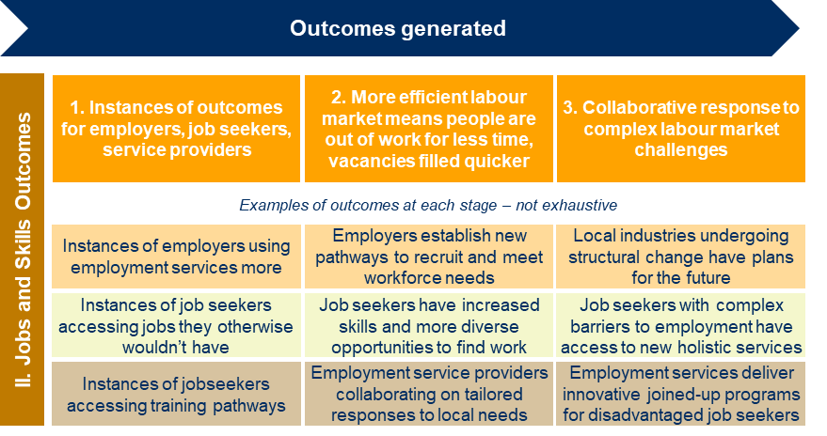
    - The LJP’s contribution to Jobs and Skills Outcomes
Survey results suggest that stakeholders perceive that the LJP has contributed to Jobs and Skills Outcomes in their regions. Overall, 68% of Employment Facilitators and 59% of Taskforce members strongly agreed that the LJP had contributed to at least one type of Jobs and Skills Outcome in their Employment Region across the different survey questions on Jobs and Skills Outcomes (see Figure 32, ‘Total’ column).
Figure 32: Survey responses from Employment Facilitators and Taskforces agreeing the program has contributed ‘a lot’ or ‘a great deal’ to Jobs and Skills Outcomes in their region, by outcome and stakeholder type (September–November 2021)
Furthermore, Employment Facilitators in every Employment Region perceived that the LJP had contributed to at least one Jobs and Skills Outcome in their region to any extent across the different survey questions on Jobs and Skills Outcomes (see Table 3: Survey responses from Employment Facilitators on Jobs and Skills Outcomes (n=22)
in Section 3.3, presenting cross-regional variation in outcomes).
Many stakeholders in interviews felt it was ‘too early to tell’ what the impact of the LJP would be on Jobs and Skills Outcomes in their Employment Region. Despite this, many of these stakeholders felt the program was on the right path for achieving these outcomes. This is expected based on the LJP theory of change, with Employment Facilitators – without direct connection to job seekers – tending to focus on developing Local System Outcomes in the program set-up phase.
‘I think it’s a bit early to say what the impact of the program will be. Many of the LRF activities are just starting.’
– Taskforce member
‘I think the LJP has the “capacity” to have an impact. There are some early indications we are on the right path.’
– Taskforce member
‘It’s too early to tell what the impact will be. We are just getting to know other Taskforce members. The conversations are much deeper, we’re sharing information and networks. I think this will lead to positive (jobs and skills) outcomes but its too early to really say.’
– Taskforce member
Some DESE staff also noted that it was difficult to quantify the Jobs and Skills outcomes the program had contributed to. This is because they often occur indirectly and are several steps removed from the work of Employment Facilitators. They noted, by way of example, that an Employment Facilitator may connect 2 local stakeholders and this may lead to an employer filling a vacancy; however, the Employment Facilitator is unlikely to have visibility over the final outcome of the connection.
‘It would be great to be able to quantify the work of facilitators and say they helped placed X people in a job, but it’s not that sort of program. It’s about building local capacity and making connections which will enable outcomes through other local parties.’
– DESE State Office staff member
The difference between the high proportion of positive survey results on questions regarding Jobs and Skills Outcomes and the high proportion of stakeholders in interviews that it was ‘too early to tell’ the impact of the program on Jobs and Skills Outcomes is likely to reflect the following differences in the wording of questions between surveys and interviews:
- In the interviews, the open-ended question on outcomes could have been limited by respondents’ understanding of outcomes, which may not have aligned with the statements presented in surveys. For example, in interviews respondents may have only perceived outcomes as job seekers securing a job, rather than the different outcomes described in the theory of change.
- In interviews, stakeholders were asked about the outcomes the program had created to date, asking them (in the past tense) effectively to consider only outcomes that the LJP had already led to.
- Survey questions asked more broadly about stakeholders’ perceptions on the outcomes the LJP had contributed to, which could include perceptions regarding outcomes that had already occurred or that would be likely to occur in the future as a result of activities to date.
- Survey questions also did not include a response option regarding whether it was ‘too early to tell’ the LJP’s contribution to outcomes.
The survey results also suggest that Local System Outcomes are more commonly reported than Jobs and Skills Outcomes (see Figure 31 and Figure 32). This provides some validation of the LJP theory of change, which describes that place-based initiatives like the LJP aim to create Jobs and Skills Outcomes, such as increased employment outcomes, through creating Local System Outcomes. The LJP does not directly place job seekers into employment – it indirectly enables this outcome by supporting other stakeholders to do this by connecting them, increasing the sharing of information and enabling collaboration. Therefore, it could be expected that Employment Facilitators and Taskforce members would more readily observe and report the changes created by the LJP to local systems, rather than to local employment outcomes.
Outcomes for job seekers: Many Employment Facilitators and Taskforces believe that the LJP has helped job seekers into training and provided more opportunities to find work and to secure employment; however, sufficient data was not available to quantify these outcomes
The LJP has contributed to supporting job seekers into employment and training opportunities, through both funded LRF activities and activities outside of the LRF. Limited data from the LRF projects are available, since there is a delay in the completion of projects with a focus on job placement (121 projects approved for funding as at 21 March 2022). Furthermore, job placement data from DESE’s ESSWeb database are considered not fit for use for LRF participants, as these participants may also be participating in a range of activities to assist them into a job, in addition to the LRF project.
In the absence of suitable program data on employment and training placements, survey responses show that over one-third of both Employment Facilitators and Taskforce members strongly agree that job seekers have greater access to training, have more diverse opportunities to find employment, and are securing employment (Figure 32).
Interviews with Employment Facilitators, Taskforces and LRF Activity Hosts identified several examples of outcomes for job seekers through the LJP, including:
- funding LRF projects that provide pre-employment training, support to overcome barriers to employment, work experience opportunities, and placements into jobs
- regularly convening local ESPs to discuss the job seekers on their caseloads and find ways of helping them to secure employment
- connecting businesses, ESPs and training organisations outside of the LRF to meet the workforce needs of an individual employer.
Some examples of these outcomes for job seekers have been described in interviews, such as:
‘[Our activity] is an employment support program for refugees, to help refugees to overcome employment barriers. It includes direct case management, English for work classes, IT classes, driver mentoring to assist people to get a license, volunteer mentors to help job seekers with resumes and interviews etc, checking in after the point of getting a job, discussing any issues with employers; working with employers to deliver cultural competency training for staff, providing information sessions about what it means to employ people from refugee backgrounds.’
– Activity Host
‘Under one of the projects we have seen good outcomes. It has had two intakes already. It is targeting middle aged women displaced by COVID who might want to work in childcare. It is taking women into a classroom, to teach them basic units of childcare, then exposing them to a work placement. Out of 14 who started, 11 are working full time or part time.’
– Employment Facilitator
‘We are working with industry, employers and ESPs to get job seekers into work. We have the ability to bring those collaborations together and work on the same page for the benefit of job seekers…There is a new hotel [in our region]. 65% of 140 new employees at the hotel were long-term unemployed…not through the LRF. The project wouldn’t have happened unless we got behind it.’
– Employment Facilitator
‘As a result of the expertise in the room [at Taskforce meetings], it has allowed us to consider skills shortages, and for those who are employment providers on the Taskforce, how to tailor their training and employment pathways to address those skills shortages in job seekers.’
– Taskforce member
‘Our Taskforce is very targeted to the gaps in industry such as the need for workers in fruit picking and the opportunities in health and aged care. There are a lot of vacancies of certain skill requirements. We have helped job seekers better understand the skills needed to obtain jobs.’
– Taskforce member
‘The LJP adds value to the job seekers because we are trying to get people into local initiatives. The LJP also allows us to bring opportunities to the region that align to the needs of job seekers in our region. For example, we have a program that assists job seekers to get drivers licence and then forklift licences for younger people. It focuses on providing skills where they are lacking.’
– Taskforce member
One Taskforce member highlighted the benefits for job seekers going through training programs provided through the LJP, even if they don’t secure a job.
‘It increases job seekers confidence through going through the training programs, and motivation, even for those who don’t get a job, they still get more skills.’
– Taskforce member
Outcomes for employers: A large proportion of Employment Facilitators and Taskforce members strongly agreed that the program had contributed to several outcomes for employers
Figure 32 shows that:
- 55% of Employment Facilitators and 31% of Taskforce members strongly agreed that they have seen examples of employers having new, effective pathways to recruit employees and meet their workforce needs
- 45% of Employment Facilitators and 29% of Taskforce members strongly agreed that employers are more aware of ESPs
- 33% of Employment Facilitators and 26% of Taskforce members strongly agreed that employers are using ESPs more.
In the interviews, some Taskforce members and Employment Facilitators identified examples of outcomes for employers in their region, particularly in relation to making connections between employers and other local stakeholders such as RTOs or ESPs.
‘We are now signing up employees to participate in a 9 week program, for a collaboration between TAFE and the defence industry network.’
– Taskforce member
‘Having a strong social media presence, and a voice [through the Chamber of Commerce], has showed employers there are multiple opportunities to address skills shortages. We haven’t had that before.’
– Taskforce member
‘We are filling job vacancies, but we are also seeing more strategic impacts. For example, we are looking at employers and understanding what productivity looks like in the first week of work. Some preparation is necessary in most industries.’
– Employment Facilitator
‘In Jobactive we can be stuck in our ways, looking at the same employers and the same industries. In jobactive we can be stuck in our ways, looking at the same employers and the same industries. The LJP, as well as COVID, have led to us branching out a lot more. There is more publicity for jobactive to employers.’
– Taskforce member
Others noted that the LJP had the potential to create outcomes for employers, even though they had not seen outcomes yet:
‘We haven’t seen outcomes yet but there is big potential. There is a huge skillset need and growth in demand for the disability workforce. It has a very high burnout rate, and it doesn’t yet require accreditation, but it soon will.’
– Taskforce member
Some Employment Facilitators and Taskforce members noted that creating outcomes for job seekers is also beneficial for employers and ESPs. One Taskforce member noted evidence of job seekers being able to access jobs they may otherwise not have been able to:
[The Employment Facilitator’s] role has started to “join the dots” and connect stakeholders to opportunities, including job seekers. It is extremely place-based, very focused on local solutions. Being focused on local job seekers, local job seekers are targeted for opportunities we uncover. By the same token, employers have been able to benefit – they have been able to tap into a labour source they hadn’t previously accessed.
– Taskforce member
A lot of this has been driven by the development of programs with industries and employers… We have a high demand for warehouse staff in [our region], and no supply. So we built a short-term program with a provider, we put 45 people through training, and 43 got a job. Lockdown was the only thing that affected it being more successful.
– Employment Facilitator
Outcomes for ESPs: Many Employment Facilitators and Taskforce members believe that the LJP has helped ESPs to collaborate better, but fewer believe that ESPs are now better able to service their caseloads
ESPs are an important stakeholder group for the LJP, given that the program aims to support the employment services system in responding to local job seeker and workforce needs. ESPs make up 17% of all Taskforce members (see Section 2).
On average 45% of surveyed Employment Facilitators strongly agreed that the program has contributed to ESPs working together more effectively with each other and other service providers (Figure 32). The proportion of respondents strongly agreeing that the program has contributed to ESPs being better able to service their caseload was much lower: only 29% of Taskforce members and 25% of Employment Facilitators. This could reflect a lack of visibility among Taskforce members and Employment Facilitators as to how ESPs are servicing their caseloads.
Interviews with Employment Facilitators and Taskforce members found some examples of how ESPs are working with Taskforces and other local stakeholders to address local employment challenges. These methods included:
- working groups established between ESPs and employers to address local job seeker needs and employer workforce challenges – for example, a cyber security group looking to create job opportunities in that sector, and a skillset training program being developed to align job seekers with job opportunities in a call centre
- ESPs meeting regularly and sharing vacancies to collaboratively service caseloads
- ESPs collaborating on solutions to job seeker needs and employer challenges, such as developing a transport system
- partnerships between ESPs and employers to develop tailored programs to suit employer workforce challenges – for example, working with a security provider to train job seekers for a new facility being developed in the region.
For example, one Employment Facilitator described a working group that had been set up to connect employers with ESPs:
‘We have developed a cyber security working group, which is employer run with ESPs. It is looking specifically to how we create opportunities for people in this space.’
– Employment Facilitator
A Taskforce member who sits on a working group also described the outcomes for ESPs as a result of this structure:
‘We had a call centre opportunity in [our region]. We did a presentation to our working group on how they could capture that opportunity under LJP. This created significant job opportunities and a skill set was put together to train people up. We are now working with jobactive databases to find job seekers.’
– Taskforce member
In some regions there were examples of ESPs working together and sharing caseloads, often supported by a structure such as monthly ESP meetings put in place by the Employment Facilitator. For example:
‘We are getting the ESPs together to share about the programs they’re running...often they won’t be able to completely fill a program with their own caseload, but talking and sharing allows them to get participants from other ESPs. It helps all of them manage their case load better and get better ratings and outcomes.’
– Employment Facilitator
A Taskforce member who represents an ESP recognised an increase in collaboration between ESPs as a result of regular meetings:
‘Since the time we started having meetings with other ESPs, we are starting to see some improvements in collaboration. We are seeing the added value…The LJP brings a common platform for special programs to be shared or created.’
– Taskforce member
One Employment Facilitator highlighted the program’s focus on promoting collaboration between ESPs, noting they had already been doing this by establishing a monthly ESP meeting. This resulted in a more collaborative working relationship between ESPs:
‘There is a current push in the program to engage ESPs, but we are already doing this, encouraging collaboration between ESPs. Now they do one-on-ones between themselves. The collaboration of ESPs is better in the sense of sharing vacancies etc, when they’re not able to fill them. ESPs are doing this between themselves with the LRF.’
– Employment Facilitator
Another Employment Facilitator noted that collaboration between ESPs as a result of the program had led to innovative programs and pathways for disadvantaged job seekers:
‘Several providers were providing labour independent of one another. Now they work together, and they share the vacancies and opportunities. As a group, they developed a transport system, as there’s no efficient public transport.’
– Employment Facilitator
There were fewer examples of ESPs working with other community services to deliver innovative programs and pathways for disadvantaged job seekers. However, one Taskforce member who represents an ESP shared an example of collaboration between their ESP and a large employer in their region to address a specific skill shortage, which resulted in outcomes for them, the employer and the job seekers:
‘We needed workforce recruitment in security for [a new facility]. Through the LJP and the Employment Facilitator we got a security program up. We partnered with [the security agency], the employer as there was an extra skillset needed for [the facility]. We got three job seekers referred to that program, they completed their qualifications and are now working at [the facility]. It’s a training qualification that a young person can’t afford. The investment is gold for a young person.’
– Taskforce member
In addition, an Employment Facilitator provided an example of how local stakeholders were working with ESPs to develop solutions to employment challenges:
‘A number of NDIS providers got together and identified the jobs and worked backwards. They identified the pathways and worked with ESPs to go through training opportunities.’
– Employment Facilitator
Some regions have noted challenges with engaging ESPs, including poor relationships among local stakeholders in a region, and ESPs’ having a lack of clarity about their role as a Partnering Provider.

Variation in outcomes across Employment Regions
Employment Facilitator survey responses show variation in the outcomes reported across the regions, as seen in Table 2: Number of surveyed Employment Facilitators responding to each Local System Outcome statement (n=22)
, Table 3: Survey responses from Employment Facilitators on Jobs and Skills Outcomes (n=22)
and Appendix C (Table 15 and Table 16). Results should be interpreted in the context of different start dates of substantive Employment Facilitators, and differences in their local conditions.
Employment Facilitator survey responses (n=22) have been used in the tables to show Employment Facilitators’ perceptions of the LJP’s contribution to both Local System Outcomes and Jobs and Skills Outcomes. These results are likely to reflect some positive bias, as the Employment Facilitators were reporting on the progress of the LJP in their own regions. It is also worth noting that 22 Employment Facilitators responded to the survey out of the 25 Employment Regions. Taskforce member perspectives have not been used in these tables, as not all Taskforce members recorded their Employment Region in survey responses. Taskforce member perspectives on outcomes have been summarised in Sections 3.1 and 3.2.
Local System Outcomes reported in Table 2 show there was wide variation in the extent of outcomes reported by Employment Facilitators across different regions. There were 5 response options for each question where Employment Facilitators could identify the LJP’s contribution to the specific outcome, ranging from ‘none at all’ to ‘a little’, ‘a moderate amount’, ‘a lot’ and finally ‘a great deal’. As evident from Table 2, there was a wide spread in Employment Facilitators’ perceptions of each of the specific outcomes. This is reflected by the fact that a proportion of Employment Facilitators selected from most response options for each question. For example, on the question of whether the LJP had contributed to ‘Local industries facing structural change and long-term challenges have clear plans for the future’, every response option was selected by at least 2 Employment Facilitators, with one Employment Facilitator not responding to the question.
Other interesting patterns evident from Table 2 include:
- There was stronger evidence (responses of ‘a lot’ or ‘a great deal’) of Connecting outcomes than of Coordinating or Capacity Building outcomes.
- Fewer Coordinating outcomes were reported (responses of ‘a little’) than other types of outcomes.
- ‘A moderate amount’ was the response option selected most across the outcome questions, followed by a ‘a great deal’, likely reflecting reversion to the mean and Employment Facilitators’ positive response bias.
- Only the Capacity Building outcomes had some Employment Facilitators reporting the LJP’s contribution as ‘none at all’, as can be expected in the earlier stages of the program. However, most Employment Facilitators responded ‘a little’ or ‘a moderate amount’ for these outcomes, showing they felt the program was starting to achieve these longer term changes.
Appendix C (Table 15) presents Employment Facilitators’ responses on Local System Outcomes by anonymised regions. This provides further evidence of the variation of outcomes across regions:
- Only one region reported strong outcomes (responses of ‘a lot’ or ‘a great deal’) across all outcomes in all 3 outcome stages.
- Five regions (regions 1, 2, 3, 5, 6) reported strong outcomes (responses of ‘a lot’ or ‘a great deal’) for at least one outcome in each stage.
- Eleven regions reported strong outcomes (responses of ‘a lot’ or ‘a great deal’) for at least one outcome in the Connecting and Coordinating stages.
- Sixteen regions reported strong outcomes (responses of ‘a lot’ or ‘a great deal’) for at least one outcome in the Connecting stage.

Table 2: Number of surveyed Employment Facilitators responding to each Local System Outcome statement (n=22)
Stage | Outcomes | None at all | A little | A moderate amount | A lot | A great deal | No response
Connecting | Local stakeholders share more information related to jobs and training opportunities. | 0 | 3 | 5 | 6 | 8 | 0
 | There are increased connections between local stakeholders in supporting employment needs. | 0 | 0 | 8 | 6 | 8 | 0
 | Local stakeholders have increased understanding of local labour market challenges or needs. | 0 | 1 | 5 | 9 | 7 | 0
Coordinating | More effective integration of services for job seekers with complex barriers to employment. | 0 | 8 | 7 | 4 | 3 | 0
 | New collaborations and networks have been created which would continue to operate even if the LJP ended tomorrow | 0 | 8 | 5 | 4 | 5 | 0
Capacity Building | Local industries facing structural change and long-term challenges have clear plans for the future. | 2 | 7 | 6 | 4 | 2 | 1
 | If the LJP ended tomorrow, local collaboration would continue | 3 | 1 | 8 | 0 | 5 | 5

Jobs and Skills Outcomes reported in Table 3: Survey responses from Employment Facilitators on Jobs and Skills Outcomes (n=22)
show variation across Employment Regions, with a similarly wide spread of responses from Employment Facilitators across all response options. Table 3 also shows variation in the extent of outcomes reported by Employment Facilitators across the different target stakeholder groups:
- Job seeker outcomes were most reported as ‘a moderate amount’, and ‘job seekers accessing training that addresses skills and shortages’ was the outcome reported to the greatest extent (‘a great deal’).
- Employer outcomes were reported with an even spread across all response options.
- ESP outcomes were most reported as ‘a little’ or ‘a moderate amount’.
- Outcomes across all stakeholder types were most reported as ‘a moderate amount’, followed by ‘a little’ and ‘a lot’.
Appendix C (Table 16) presents Employment Facilitators’ responses on Jobs and Skills Outcomes by anonymised regions. This provides further evidence of the variation of outcomes across regions:
- Two regions reported strong outcomes (responses of ‘a lot’, ‘a great deal’ or ‘strongly agree’) across all outcomes in all 3 outcome stages (regions 3 and 4).
- Eight regions (regions 1, 2, 3, 4, 6, 7, 10 and 13) reported strong outcomes (responses of ‘a great deal’ or ‘a lot’) for at least one outcome for each stakeholder group.
- Thirteen regions reported strong outcomes (responses of ‘a great deal’ or ‘a lot’) across at least 2 stakeholder types – e.g. a mix of job seekers and employers, employers and ESPs, or ESPs and job seekers.
- Eleven regions reported strong outcomes (responses of ‘a great deal’ or ‘a lot’) for at least one outcome for job seekers.
- Eleven regions reported strong outcomes (responses of ‘a great deal’ or ‘a lot’) for at least one outcome for employers.
- Ten regions reported strong outcomes (responses of ‘a great deal’ or ‘a lot’) for at least one outcome for ESPs.
Comparing the responses by anonymised region between Local System Outcomes (Appendix C, Table 15) and Jobs and Skills Outcomes (Appendix C, Table 16) also shows interesting patterns. For example:
- Region 16 reported 2 strong outcomes (responses of ‘a great deal’ or ‘a lot’) in the Connecting and Coordination stages of Local System Outcomes, and strong outcomes for job seekers across all outcomes, as well as a strong outcome for employers. This is an example of a region which did not need to achieve Local System Outcomes across all outcome stages (to the Capacity Building stage) to achieve Jobs and Skills Outcomes.
- Region 14 reported strong outcomes (responses of ‘a great deal’ or ‘a lot’) across the Connecting phase of Local System Outcomes, but only ‘a little’ or ‘a moderate amount’ of Jobs and Skills Outcomes across all stakeholder types, which could indicate that this region is still developing Jobs and Skills Outcomes.

Table 3: Survey responses from Employment Facilitators on Jobs and Skills Outcomes (n=22)
Stage | Outcomes | None at all | A little | A moderate amount | A lot | A great deal | No response
Job Seekers | Job seekers accessing training that addresses skills shortages. | 0 | 4 | 8 | 3 | 7 | 0
 | Job seekers having more diverse opportunities to find work. | 0 | 2 | 11 | 5 | 4 | 0
 | Job seekers securing jobs that they otherwise wouldn't have. | 0 | 6 | 8 | 4 | 4 | 0
Employers | Employers are more aware of ESPs. | 0 | 5 | 7 | 4 | 6 | 0
 | Employers are using ESPs more. | 2 | 6 | 6 | 5 | 2 | 1
 | Employers have new, effective pathways to recruit employees and meet their workforce needs. | 0 | 4 | 6 | 7 | 5 | 0
Employment Service Providers | ESPs are better able to service their caseload. | 0 | 8 | 7 | 3 | 2 | 2
 | ESPs are working together on tailored responses to meet local needs. | 1 | 5 | 7 | 6 | 3 | 0
 | ESPs are working with other community services to deliver innovative programs and pathways for disadvantaged job seekers. | 1 | 5 | 5 | 7 | 3 | 1

Pathways to creating outcomes
The LJP theory of change describes that, as a place-based initiative, the relationship between implementation and outcomes is non-linear: Employment Facilitators and their Taskforces can take many different approaches to create outcomes, and there is more than one way to create each of the outcomes.
In order to define how outcomes are created through the LJP, analysis of the examples of outcomes highlighted through interviews suggests that several ‘outcome pathways’ can be defined. Table 4 and Table 5 highlight some of the more common outcome pathways used by Employment Facilitators to create outcomes in their region. These are not intended to be exhaustive and there may be many other ways to create outcomes. The table describes specific examples of the outcome pathways that were identified by stakeholders during interviews. The final column of each table highlights the Local System Outcomes or Jobs and Skills Outcomes created through these pathways (as reported by stakeholders).
Table 4: Structured program elements – outcome pathways identified in consultations
Outcome pathway | Description | Examples identified in stakeholder interviews | Resulting outcomes
Local Recovery Fund projects | Developing targeted projects funded through the LJP to address specific local employment issues or priorities. | Developing holistic employment training and work experience programs with integrated wrap-around supports targeting an industry in need of employees. | Jobs and skills outcome – capacity building. Job seekers with complex barriers to employment have access to new holistic services.
Facilitating information sharing and collaboration between Taskforce members | Drawing on the expertise and skills of Taskforce members to promote information sharing and collaboration on local issues. | Encouraging Taskforce members to rotate sharing and presenting about their industry or organisation in Taskforce meetings, providing the group with greater knowledge of employment challenges. | Local system outcome – connecting. Taskforce members have increased information about local labour market challenges, and increased understanding of opportunities to collaborate.

Table 5: Unstructured program elements – outcome pathways evident from stakeholder consultations
Outcome pathway | Description | Examples identified in stakeholder interviews | Resulting outcomes
Connecting the dots through networks and local knowledge to support local stakeholders to work together to develop employment solutions | Drawing on Employment Facilitators’ knowledge and networks to connect stakeholders with complementary problems or needs. | Connecting an employer with vacant positions with an ESP or training organisation. | Local system outcome – connecting. Increased connections between local stakeholders.  Jobs and skills outcome – connecting. Instances of employers using employment services more.  Jobs and skills outcome – coordinating. Employers establish new pathways to recruit and meet workforce needs.
Facilitating coordinated responses to common local challenges | Bringing stakeholder groups affected by a common challenge together to facilitate increased information sharing and coordinated responses. This may be on an ad hoc basis or through a formal collaborative structure. | Promoting information sharing between different levels of government on significant structural challenges in the region, e.g. the impending closure of a large industry.  Convening working groups of local stakeholders focused on Aboriginal and Torres Strait Islander employment or local transport challenges. | Local system outcome – coordinating. Local stakeholders collaborate on labour market initiatives.  Local system outcome – capacity building. Systems and capacities established that enable strategic local collaboration.
Providing advice and guidance to local stakeholders | Providing advice and guidance to local stakeholders to support them to navigate the complexities of the employment system and government programs. | Providing advice to a local stakeholder on funding opportunities, e.g. to an employer to take on additional apprenticeships or to a registered training organisation to access funding from different levels of government. | Local system outcome – coordinating. Local stakeholders collaborate on labour market initiatives.  Local system outcome – coordinating. Local stakeholders secure funding and support to deliver initiatives.  Jobs and skills outcome – coordinating. Improved reach and effectiveness of government programs and initiatives.
Facilitating or supporting the development of initiatives outside of the LRF | Facilitating or supporting the development of initiatives or projects outside of the LRF. These might receive funding through other funding sources (e.g. state or local government), or not require additional funding. | A group of local stakeholders lobbying the federal government to reduce time frames between booking and undertaking a provisional licence test to support job seekers attended training and work placements. | Local system outcome – coordinating. Local stakeholders contribute to other local committees to address other needs.  Local system outcome – capacity building. Collaborative initiatives to address complex barriers to employment.
Promoting increased collaboration between ESPs | Bringing ESPs together to support increased collaboration and coordination on issues common across their caseloads. | Convening a monthly meeting of local ESPs to share information on common challenges and opportunities across the ESP caseload. | Jobs and skills outcome – coordinating. ESPs collaborating on tailored responses to local needs.  Jobs and skills outcome – connecting. Instances of job seekers accessing jobs they otherwise wouldn’t have.
Building local capacity | Working to build local capacity and structures to support collaboration beyond the direct involvement of the Employment Facilitator. | Providing Support Officer resourcing to support local working groups and promote improved local relationships and new approaches to local collaboration, without the Employment Facilitator necessarily chairing or attending the working groups themselves. | Local system outcome – coordinating. Local stakeholders collaborate on labour market initiatives.  Local System Outcome – coordinating. Local stakeholders contribute to other local committees to address other needs.
Supporting coordinated responses to long-term structural changes | Focusing on longer term structural problems in the region (as well as the short-term needs of employers and job seekers). | Planning for the upcoming expected closure of an energy plant and considering how job seekers can be transitioned to other industries. | Local System Outcome – capacity building. Systems and capacities established that enable strategic local collaboration.

Summary
The LJP theory of change defines the outcomes the program intends to create. These outcomes reflect the design of the LJP as a place-based approach to addressing labour market challenges, with outcomes defined in 2 categories:
- Local System Outcomes – the positive changes in how local stakeholders work together to create positive outcomes
- Jobs and Skills Outcomes – the positive changes for job seekers, employers, industry and ESPs with respect to employment, training, upskilling and reskilling, and meeting workforce needs.
Findings on the extent to which the LJP has achieved these outcomes were drawn from interviews and surveys with Employment Facilitators, Taskforce members, Activity Hosts and DESE staff. Program data on the number of job seekers placed into employment or training through LRF-funded activities had limitations and could not be used for the evaluation.
Findings on perceived outcomes were primarily based on the proportion of survey responses where respondents strongly agreed that the program had contributed to the specific outcome identified in the question (i.e. selecting ‘a lot’ or ‘a great deal’ in their response). The evaluation found:
- Most Employment Facilitators and Taskforces strongly agreed that the program had contributed to at least some outcomes in their region in the Local System Outcomes and/or Jobs and Skills Outcomes categories.
- More survey respondents strongly agreed that the program had contributed to Local System Outcomes than Jobs and Skills Outcomes. This validates the LJP theory of change, which describes that place-based initiatives like the LJP aim to create Jobs and Skills Outcomes, such as increased employment outcomes, through creating Local System Outcomes. The LJP does not directly place job seekers into employment – it indirectly enables this outcome by supporting other stakeholders to do this by connecting them, increasing the sharing of information, and enabling collaboration. Therefore, we could expect that Employment Facilitators and Taskforce members would more readily observe and report the changes created by the LJP to local systems, rather than to local employment outcomes.
- Local System Outcomes in the Connecting stage were the most commonly reported. This is also consistent with the theory of change, which describes that increasing connections and information flows between local stakeholders is necessary to increase coordination and local capacity.
- A sizeable portion of respondents strongly agreed that the program had contributed to various types of Jobs and Skills Outcomes, specifically for the different target stakeholder groups of job seekers, employers and ESPs. The level of strong agreement was lower on the LJP’s contribution to job seekers being able to secure jobs that they otherwise would not have, likely due to the relatively early stage of the program when this data was collected.
- There were nevertheless many stakeholders in interviews who felt it was ‘too soon to tell’ what the impact of the LJP would be for Jobs and Skills Outcomes, while others noted that the impact is difficult to quantify as outcomes often occur indirectly and are several steps removed from the work of Employment Facilitators.
- Survey responses from Employment Facilitators suggest that outcomes have varied widely across Employment Regions, both in type and in prevalence. While this data only reflects the perceptions of Employment Facilitators, further analysis of cross-regional variation in outcomes presented in Section 4 draws on interview data from Taskforce members and others, and suggests that some Employment Regions have more progressed outcomes than others.
- Qualitative data from interviews found numerous examples of the different ways in which Employment Facilitators and Taskforces have worked through both the structured and unstructured elements of the LJP to create both Local System Outcomes and Jobs and Skills Outcomes. These were described as different outcome pathways. While not an exhaustive list, the outcome pathways help to define some of the approaches that can be used to create outcomes.
The evaluation found that the outcomes achieved through the LJP has varied widely across regions. Section 4 presents insights into why outcomes have varied and identifies important factors that are associated with more progressed outcomes.

- Evaluation findings: enablers and barriers
This section presents findings against the third evaluation question of the evaluation:
‘What practices and conditions enabled effective implementation and outcomes?’
Accordingly, this section presents insights from the evaluation on why the LJP has been implemented more effectively and appears to be achieving greater outcomes to date in some Employment Regions.
Section 2 presented findings regarding how Employment Facilitators and Taskforces have implemented the program and the extent to which this has aligned with what was intended. Section 3 considered the outcomes attributable to the program, including identifying in Section 3.3 that there is variation in the outcomes reported by Employment Facilitators across the different Employment Regions.
This section brings together the findings in Section 2 and Section 3, to identify the common factors across the 13 primary regions that acted as enablers (or barriers) to effective implementation and outcomes. To do this:
- Section 4.1 presents the results of analysis identifying the different outcome stages each Employment Region has evidence of, as defined in the LJP theory of change
- Section 4.2 then presents the results of analysis identifying common patterns and conditions across these regions, to identify which factors appear to be enabling more effective implementation
- Section 4.3 highlights the skills and attributes that stakeholders perceive as critical to Employment Facilitators’ capacity to effectively engage with local stakeholders and implement the LJP
- Section 4.4 identifies some of the ways in which local conditions have varied across the Employment Region. These conditions are also likely to affect the effectiveness of delivery
- Section 4.5 summarises the key challenges and barriers that have impacted the program – noting that more detail on most of these challenges was presented in Section 2
- Section 4.6 summarises the findings on the enablers and barriers to effective implementation.
Appendix B provides further detail on the analysis undertaken to identify the enablers to effective implementation, including identifying the common data points that were analysed for each primary region (known as ‘derived variables’).

Evidence of outcomes across the 13 primary regions
This section presents the results of analysis identifying the different outcome stages each Employment Region has evidence of, as defined in the LJP theory of change.
Additional data collection was conducted in 13 of the 25 Employment Regions (refer to the methodology in Appendix A). As well as interviews with the Employment Facilitators in these regions, additional interviews were also held with 3 to 4 Taskforce members in each Employment Region, as well as with State Office staff who supported Employment Facilitators. The additional data collected was used to conduct deeper data analysis as to how the LJP was implemented in these 13 Employment Regions, including to determine how far each region had progressed through the 3 ‘stages of maturity’ for Local System Outcomes: Connecting, Coordinating, and Capacity Building (see Appendix A for further detail on the methodology).
This analysis is important because it enables the evaluation to identify whether some Employment Regions have progressed further through the 3 outcome ‘stages of maturity’, to help understand the enablers and barriers that influence this progress. These enablers are explored further from Section 4.2 onwards.
It should be stressed that the findings on outcome stages presented in this section should not be taken as definitive conclusions regarding the performance of any one individual Employment Region and the program as a whole. The primary purpose of placing regions in outcome stages is to consider the enablers and barriers influencing progress.
There are also limitations with the data used for this purpose. Employment Regions were placed in outcome stages based on available data – in particular survey and interview data from Employment Facilitators and Taskforce members – and no data was available quantifying the Jobs and Skills Outcomes from LRF activities. Therefore, there may be outcomes that occurred but are not captured in the available data, in particular the views of local stakeholders outside of the Taskforce – recognising that Taskforce members and Employment Facilitators do not have direct visibility over all of the impacts of their activities.
These limitations aside, the cross-regional analysis suggests that some regions have reached later stages of maturity than others. Figure 33 identifies the number of regions with evidence of outcomes in each outcome stage, identified by the most progressed stage of outcomes there was evidence of (noting that regions with outcomes in later stages also had evidence of outcomes in the preceding stages – reflecting the ‘journey’ of the program as it matures in each Employment Region).
Figure 33: Number of primary regions by outcome stage
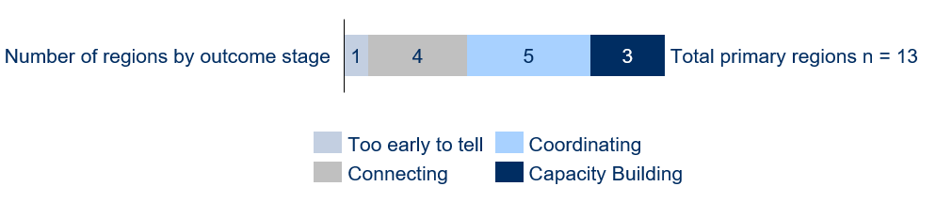
As evident from Figure 33:
- there was one region where it was too early to tell what the impact of the program was
- 4 regions had evidence of outcomes up to and including the Connecting stage
- 5 regions had evidence of outcomes up to and including the Coordinating Stage (also including evidence of outcomes in the Connecting stage)
- 3 regions had evidence of outcomes up to and including the Capacity Building stage (also including evidence of outcomes in the Connecting and Coordinating stages).
Employment Regions were placed in outcome stages through an analysis of available data points on outcomes in each region. Table 14 in Appendix B provides anonymised examples of the data points drawn on from one region in each outcome stage, to illustrate what the different stages of outcomes look like.
The next sections present the results of further analysis to understand the enablers and barriers that helped and hindered Employment Regions’ progression through the 3 stages of maturity in the LJP theory of change.

Enabling factors relating to implementation
As noted in Section 4.1, the evaluation found that 3 Employment Regions demonstrated evidence of achieving outcomes in the Capacity Building stage. Further cross-regional analysis of how the LJP was implemented in all 3 regions found several common features. While the sample size is small, the analysis suggests these features may be important enablers of effective implementation and outcomes. The features common to these 3 regions are:
- All 3 Employment Facilitators had some pre-existing experience or strong relationships in the region in a related role, and both Taskforce members and DESE perceived them as being highly effective at engaging and working with local stakeholders. Comments from both DESE and Taskforce members, and evidence from the literature review on effective brokers and facilitators, highlight the importance of these attributes to achieving outcomes, given the role of Employment Facilitators as the linchpin of the program – driving the program in each region to facilitate improved connection and collaboration between local stakeholders (see Section 4.3 for more detail on the attributes of effective Employment Facilitators).
- The Taskforces of all 3 regions were highly engaged, had a good mix of members, and were playing a more active role as a ‘collaborative platform to drive the LJP and initiatives forward (both within and outside of the LRF)’. Several Employment Facilitators identified how a highly engaged Taskforce can ‘extend the reach’ of an Employment Facilitator and what can be achieved. They explained that as only one individual (albeit with a Support Officer), there was only so much they could do by themselves. Having Taskforce members willing to take ownership in collaborating on initiatives therefore acted as a ‘multiplier’ regarding the outcomes that could be achieved. The mix of Taskforce members was one factor Employment Facilitators and Taskforce members identified as critical to creating a highly engaged Taskforce (see Section 5 for further insights regarding effective strategies for building Taskforce engagement).
- The Local Jobs Plan in all 3 regions was being regularly used as a shared vision to guide strategy and actions (including in relation to initiatives outside of the LRF). While some stakeholders questioned the utility of the Local Jobs Plan, in the 3 regions using the Jobs Plan regularly as a shared vision, Employment Facilitators highlighted the importance of the Jobs Plan – both to unite and to influence local stakeholders around what they are trying to achieve, and as a ‘guiding document’ to prioritise their actions. The literature on effective place-based initiatives also highlights the importance of local stakeholders having and working towards a shared vision.
- In all 3 regions, Employment Facilitators’ approach to creating outcomes included drawing from a wide range of outcome pathways, having some focus on long-term labour market issues for their region, regularly engaging with ESPs in their region, and actively working to build the capacity of local stakeholders. Comments from Employment Facilitators and DESE’s Relationship Managers suggests more effective Employment Facilitators are not overly focused on one way of creating outcomes (e.g. the LRF), and are instead proactively drawing from a range of outcome pathways to solve local problems. Similarly, they are also thinking more strategically – taking a long-term focus and actively working towards a defined vision for the region, as well as working to build the capacity of local stakeholders to leave behind a legacy that outlives the Employment Facilitator. They also identify effective Employment Facilitators as having a strong focus on working with ESPs – given ESPs are a key leverage point for achieving outcomes through the existing employment services system. See Section 4.3 for further detail on the attributes and skills of effective Employment Facilitators.
- Employment Facilitators in all 3 regions felt DESE had provided them with effective support, and sufficient autonomy and flexibility to tailor the LJP in their region. Both Employment Facilitators and DESE staff highlighted the importance of Employment Facilitators having sufficient autonomy and flexibility as critical to the success of the program. They explained that Employment Facilitators have the deepest knowledge of the needs for their region, and that it is important they have flexibility to adapt and prioritise their approach to focus on addressing these needs. This aligns with the literature on effective place-based initiatives, which emphasised the importance of local flexibility. Employment Facilitators also highlighted the importance of having sufficient resources to manage implementation of the program in each region, with the Support Officers funded by DESE key to enabling greater collaboration by time-poor Taskforce members and local stakeholders.
Conversely, the evaluation found evidence that 5 of the 13 primary regions had only achieved Local System Outcomes in the Connecting stage, or stakeholders otherwise thought it was ‘too early to tell’ what the impact of the program has been. Analysis of how the LJP was implemented in these regions also found several common features, and important points of difference, with the 3 regions that appear to have reached the Capacity Building stage. In particular, these 5 regions were all more likely to have:
- Taskforces with low (3/5) or medium (2/5) engagement, and where stakeholders raised some issues (3/5) or were lukewarm regarding the mix of members (2/5)
- Taskforces playing a less active role relative to those Taskforces that were collaboratively driving initiatives forward, with their role primarily as an advisory body focused on information sharing and networking (2/5), or also actively guiding the development of LRF projects (3/5)
- a Local Jobs Plan that had limited or no regular use (3/5), or was only predominantly used to guide the development and assessment of LRF proposals (2/5)
- Employment Facilitators whose approach had limited or no focus on long-term labour market issues for their region (3/5), and did not include actively working to build capacity of local stakeholders (2/5)
- stakeholders who felt they faced some constraints from DESE as to how they could tailor the LJP in their region (3/5).
As is evident from this list, many of the features of how the LJP was implemented in the more progressed regions were absent in the least progressed regions – providing further evidence of the impact of the enablers described above on achieving outcomes. These findings also provide emerging evidence validating several of the assumptions in the theory of change regarding Employment Facilitators, Taskforces, the Local Jobs Plan and DESE’s role.
It should be noted that just because the enablers identified above are not present in a region, it does not mean the LJP cannot lead to outcomes or improvements in that region. Indeed, the evidence reflects that even where some of these factors are not present, it is still possible for the program to contribute to positive outcomes in the regions – in particular, with outcomes in the Connecting stage generally present.
However, for outcomes in the more mature Capacity Building stage to be possible, evidence collected to date indicates the enablers identified above need to be present.

Characteristics of effective Employment Facilitators
As noted in Section 4.2, the derived variables analysis identified 2 factors that Employment Facilitators in the 3 most progressed Employment Regions had in common. In particular, all 3 Employment Facilitators in the most progressed regions had some pre-existing experience or relationships in the region in a related role; and Taskforce members and DESE perceived the Employment Facilitators in these regions as being highly effective at engaging and working with local stakeholders.
Delving more deeply into the data reveals some interesting differences in the backgrounds of Employment Facilitators in these 3 regions. Of the 3 Employment Facilitators in the most progressed regions:
- one had deep networks in the Employment Region and direct experience in a similar role as a facilitator for the RET
- one was newer to their Employment Region but brought deep networks and experience from an adjacent Employment Region where they had experience in a similar role as a facilitator for the RET
- one had never been in a directly similar role as a facilitator before but had previously worked for many years at an ESP based in their Employment Region.
These differences suggest that a variety of backgrounds may be conducive to Employment Facilitators’ success – although it is nevertheless critical that Employment Facilitators have some common attributes and skills.
Feedback from interviews provides further detail on the common skills and attributes stakeholders perceive as critical to Employment Facilitators’ capacity to effectively engage with local stakeholders and implement the LJP. This is outlined in Section 4.3.1. and the ‘lessons learned’ discussion in Section 5.
Some National Office staff suggested that Employment Facilitators engaged through subcontracting arrangements were less effective than those directly employed by DESE. Data considered for the cross-regional analysis was inconclusive on this point. However, there were some comments from stakeholders that suggested there may be a relationship. In particular, some DESE State Office staff noted there was a higher turnover of Employment Facilitators engaged in subcontracting arrangements, as a result of changes in staffing personnel in the companies that held the head contracts. An Employment Facilitator who was a subcontractor also noted they had found this arrangement challenging for receiving support from DESE:
‘I’ve found it quite challenging as I’m not the deed holder with DESE. I’m employed under a sub-contracting arrangement. It’s meant I’m five people removed from the decision makers who can offer me support.’
– DESE Relationship Manager

    - Skills and attributes of effective Employment Facilitators
Consultations identified 4 key characteristics of an effective Employment Facilitator:
- Strong relationships. The ability to build strong relationships is a critical skill for Employment Facilitators. Employment Facilitators who brought established relationships and networks from previous roles were able to leverage these in commencing their roles.
- Local knowledge. Employment Facilitators with a history in their region benefit from having knowledge of local businesses, industries, programs, organisations and funding opportunities.
- Entrepreneurial mindset. Most Employment Facilitators identified the need to be entrepreneurial to involve stakeholders in developing solutions to local labour market challenges within existing systems. This included being proactive and innovative and thinking outside the box to adapt the LJP to the circumstances on the ground.
- Ability to mediate between government and community. Some Employment Facilitators described their role as being ‘with the government, not from the government’ – understanding how government works, what funding opportunities and supports are available, and how to work with ESPs. This enables Employment Facilitators to support businesses and communities to make use of existing services and programs to meet their needs.
The first 2 characteristics – strong relationships and local knowledge – can take time to build, and Employment Facilitators who were playing a similar role in their region prior to the LJP appeared more likely to ‘hit the ground running’.
The ‘lessons learned’ discussion in Section 5 considers some of the general approaches stakeholders think effective Employment Facilitators are adopting.

Local conditions and external factors
    - Variation in local conditions
Employment Regions covering regional areas were associated with achieving evidence of progressed outcomes, relative to those covering metropolitan and remote areas
Local conditions vary across the Employment Regions and are likely to also affect the implementation of the LJP.
Of the 13 primary regions, 8 covered regional areas, 4 were metropolitan, and one was remote. Breaking down the primary regions by region type and their outcome stage provides evidence of an association between region type and outcomes, as shown in Figure 34.
Figure 34: Number of regions with evidence of outcomes by outcome stage and region type
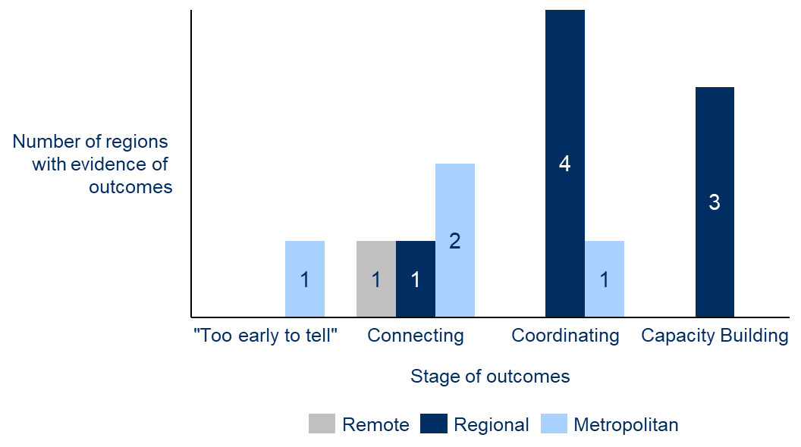
As evident from Figure 34:
- There were 8 primary regions covering regional areas. Seven of these (87.5%) had evidence of outcomes in the more mature outcome stages (Coordinating or Capacity Building).
- There were 4 primary regions covering metropolitan areas. Only one of these (25%) had evidence of outcomes in the more mature outcome stages (Coordinating or Capacity Building),
- One primary region covered a remote area. This region had evidence of outcomes in the Connecting stage.
The above cross-regional analysis also identifies that all 3 of the Employment Regions demonstrating evidence of achieving outcomes in the Capacity Building stage covered regional areas, rather than being in metropolitan or remote areas. Conversely, of the 5 regions that only had evidence of outcomes in the Connecting stage, or where stakeholders otherwise thought it was ‘too early to tell’ what the impact of the program had been, 3 were located in metropolitan areas, while one covered a remote area.
Although the sample size is small, the data above, along with qualitative feedback from interviews, suggests regional areas may support more effective local collaboration. Several DESE staff members and Employment Facilitators attributed this to the fact that in regional areas, local stakeholders have more enduring relationships, labour market needs are more homogenous, and there is a lower concentration of other initiatives competing with the LJP and taking up local stakeholders’ time.
In contrast, several State Office staff observed that in metropolitan regions, relationships between local stakeholders are much weaker and there is a higher saturation of other initiatives and demands on stakeholders’ time. For example, one State Office staff member who oversaw multiple Employment Regions stated:
‘I’m not sure how useful the LJP is in metropolitan areas. It’s much harder to build long term relationships. There is a high churn of people in key employer organisations, whereas in regional areas you will be dealing with the same people and there is much more continuity of relationships.’
– DESE State Office manager
Another Staff Office staff member stated:
‘It’s a much more crowded landscape in metropolitan areas. Employers are much bigger and are working on their own initiatives to employ staff. There are also a lot more demands on everyone’s time. I’m not sure it’s as helpful to send an Employment Facilitator, whereas in regional areas it can make a big difference.’
– DESE State Office Manager
The constraints on stakeholders’ time in these regions is also reflected in the derived variables analysis, with Taskforce members in the metropolitan Employment Regions tending to have lower engagement relative to Taskforces in regional areas.
While regional areas seem to support effective collaboration, some stakeholders reflected that where regions were very large, it was challenging to align stakeholders around a common set of labour market needs. They noted that there were often different labour market needs across the sub-regions making up these Employment Regions, and that stakeholders tended to also be fragmented across the different sub-regions. For example, DESE’s Relationship Manager overseeing the remote Employment Region stated:
‘I think the Employment Region needs to be separated into smaller regions. The sub-regions are all very different – they have different issues, different businesses, and different caseloads. The Employment Facilitator is having to travel all around but if you really want traction, then we need to have someone based on the ground in each of the sub-regions to help build local relationships.’
– DESE Relationship Manager
Another State Office staff member said:
‘Some of the regions are huge! They can be made up of so many diverse labour markets and have large distances. It can be hard to manage and get face to face engagement with stakeholders.’
– DESE State Office staff
The large size of one Employment Region prompted one Taskforce member to reflect:
‘The Local Jobs Program is not local enough.’
– Taskforce member
The comments above highlight the importance of ensuring that Employment Regions are aligned around common labour market issues and stakeholder groups. In larger regions, this may require Employment Facilitators to explore opportunities for collaboration at a more local level. This could be through sub-regional or issue-focused working groups. See Section 5 (lessons learned) for further detail on potential approaches.
Other local conditions are also likely to impact implementation, although the exact impact cannot be conclusively determined from available data
Survey responses identify some other differences in local conditions across the Employment Regions, including the size of the region, its history of collaboration, and the presence of similar initiatives to the LJP.
As seen in Figure 35, survey data shows that in some regions (35%) there are other initiatives operating that are similar to the LJP. Nearly half (42%) of respondents believe the LJP complements these other initiatives, although some (18%), particularly Taskforce members (19%), believe it competes for time and attention.
Figure 35: Survey responses from Employment Facilitators and Taskforces on whether their Employment Region has other initiatives like the LJP and whether these initiatives complement the LJP
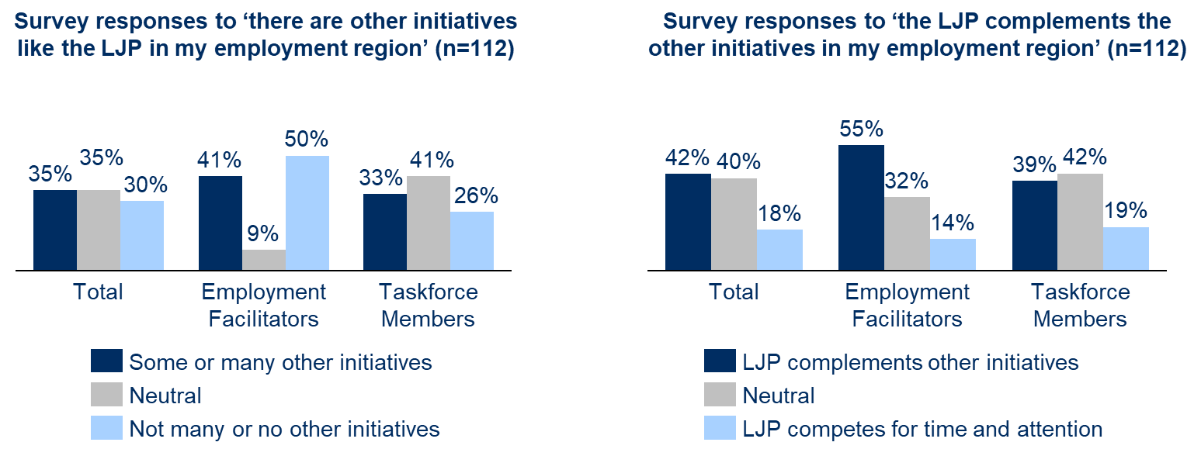
Other local factors that may influence the implementation of the program are identified in Figure 36. Notably:
- a majority of stakeholders (55%) reported that their region has a history of collaboration
- 39% of survey respondents indicated they think the size and population spread of employment in their region is presenting barriers to implementing the LJP.
Figure 36: Survey responses from Employment Facilitators and Taskforces on whether their Employment Region has a history of collaboration and on the region’s size and population spread
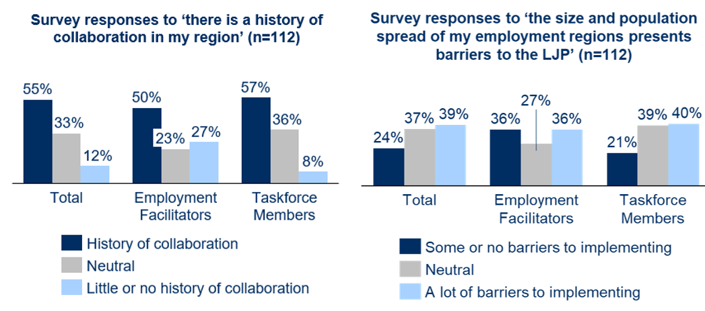
Data on the local conditions presented in Figure 35 and Figure 36 is inconsistent at the level of individual regions. As a result, it is not possible to conclusively determine the impact of these conditions on implementation, with no clear evidence of an association between these conditions and the stages of outcomes achieved. Nevertheless, comments from interviews – outlined above and below – suggest these conditions are likely to have some impact on implementation.
As described above, stakeholders identified that regional areas – which were associated with more progressed outcomes – tended to have deeper relationships between local stakeholders. Several stakeholders also identified that these deeper relationships meant regional areas tended to have stronger histories of collaboration, compared to metropolitan areas where the landscape was much more competitive.
Several stakeholders also felt that very large Employment Regions posed challenges for Employment Facilitators trying to implementing the program. In particular, as evident in the comments on the preceding 2 pages from DESE’s Relationship Managers, larger regions often covered multiple diverse labour markets that had different needs and issues. As a result, it was harder for Employment Facilitators to bring stakeholders together to focus on common issues. The large distances also made it more difficult for Employment Facilitators to engage with local stakeholders face to face, requiring them to split their time across the different sub-regional areas. These perspectives were also reflected in comments from Employment Facilitators overseeing very large regions. For example, one Employment Facilitator covering an Employment Region made up of several distinct sub-regions stated:
‘The biggest challenges for me are geographical as I oversee two regions that are significantly different. It means I have to be everything to everybody, and as a result I’ve had to be reactive rather than proactive with what I can work on.’
– Employment Facilitator
Stakeholders also felt that the effectiveness of implementation may be influenced by whether there was a high concentration of similar initiatives in the Employment Region. Interestingly, views were mixed on whether the impact was positive or negative. Some stakeholders thought that in some of these regions the LJP played a valuable role in promoting improved coordination in what was a very crowded landscape, whereas in others, the LJP was contributing to duplication and creating further demands on time-poor local stakeholders.
‘Our region has an incredibly crowded landscape. Previously there hasn’t been good coordination, with lots of duplication and overlap. The LJP is helping to improve this though.’
– Employment Facilitator
‘The LJP has helped to reduce funding duplication through our interactions with state government as part of the program.’
– DESE State Office staff member
‘State government is very proactive in our Employment Region. It’s resulted in almost complete duplication in offering between state and federal (including funding and resources).’
– Employment Facilitator
‘In our region there is a lot of trying to solve the same problem. There hasn’t been great collaboration so far, so we are trying to take a ‘helicopter view’ to try and understand what already exists across the region and how we can add value.’
– Employment Facilitator
‘There are a lot of similar committees in our region. I’m on four boards and six different committees all working on similar issues. A big part of my role is therefore trying to improve coordinating, trying to avoid duplication and making sure we are connecting the right people.’
– Taskforce member
The perspectives above highlight the importance of considering how the LJP can add value and improve coordination in regions with a high concentration of similar initiatives, rather than contributing to duplication and competition.
    - Impact of COVID-19
Lockdowns as a result of COVID-19 also had an impact on the implementation of the program, with the eastern states most affected. For these regions the lockdowns meant Taskforce meetings had to be held online. Some Employment Facilitators, particularly those newer to a region, reported that this had an adverse impact on their capacity to build productive relationships between local stakeholders, feeling that face-to-face engagement is more conducive to promoting effective collaboration. On the other hand, in some cases Taskforce engagement was improved with a shift to remote meetings, particularly in larger regions where Employment Facilitators and Taskforce members would otherwise have travelled to meetings in person. Moving online also helped Employment Facilitators in larger regions to engage more widely with local stakeholders.
Some LRF activities were also significantly affected by COVID-19. Activities that focused on providing work experience in industries such as hospitality or retail were effectively closed down, and some activities involving face-to-face practical training were delayed as they could not be moved online. Time frames for activity approvals were also increased, with ongoing disruptions and uncertainty. Additionally, there were some challenges in engaging job seekers for LRF activities. Mutual obligations were suspended and many job seekers were additionally facing significant health and financial struggles as a result of the pandemic, or constrained by lockdowns.
Reflecting the mixed impacts of COVID-19, there does not appear to be a strong association between the extent of the impact of COVID-19 in individual regions – identified as part of the derived variables analysis – and the stage of outcomes achieved to date, as shown in Figure 37.
Figure 37: Number of regions with evidence of outcomes by outcome stage and impact of COVID-19
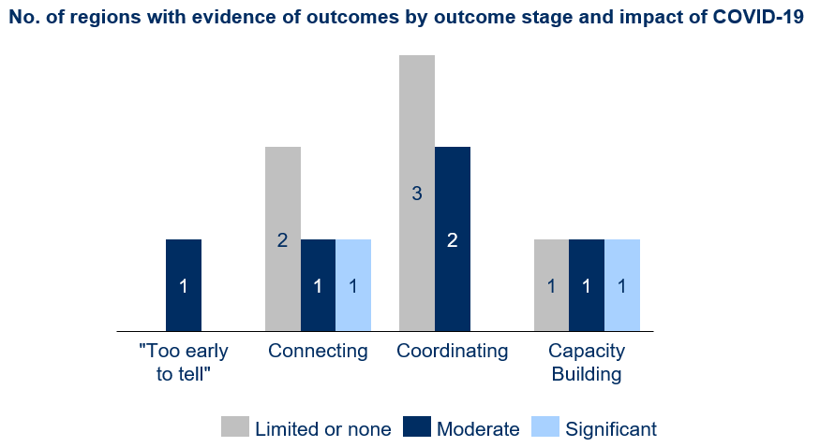

Challenges and opportunities
A large majority of stakeholders interviewed valued the LJP, appreciating the place-based nature of the program and the focus on local issues and solutions. They believed the LJP model to be an effective way to improve labour market outcomes at the local level, and in particular to address longstanding challenges for disadvantaged job seekers.
Some stakeholders nevertheless also raised challenges and opportunities for improvement regarding the design of the LJP, as well as operational challenges they felt had proved to be barriers to effective implementation. These challenges are considered in detail in Section 2 of this report, which presents data on how the different program elements have been implemented to date, including noting challenges that related to each specific program element.
This section builds on the detail in Section 2 to summarise stakeholders’ views on:
- the key design and operational challenges and their impacts on implementation and the outcomes achieved to date
- potential opportunities for improvement to address the challenges.
This summary, presented in Table 6, is included to provide a list of key areas for DESE to consider where stakeholders felt implementation could be improved, with a view to considering options for increasing the impact of the LJP. Section 5 builds on this list to provide further lessons from the evaluation for DESE to consider in these areas.
Note that the list of challenges in Table 6 is not exhaustive, with only the biggest challenges stakeholders identified presented. A more comprehensive overview of the challenges for implementation is presented in Section 2.
The challenges in Table 6 should also be considered in the context of the LJP being a program highly valued by local stakeholders, while DESE has also already been actively working to consider and implement improvements to the LJP in these areas.
Table 6: Stakeholder perspectives on key program design and operational challenges and potential opportunities for improvement
Challenge | Potential opportunities for improvement identified by stakeholders
1. Ensure the Local Recovery Fund is responsive to local needs. The LRF is designed to fund local projects to respond to local labour market needs. However, stakeholders feel the procurement and contract management processes have proved challenging – in particular, highlighting the timeliness of the approval processes, uncertainty around how local input is incorporated into projects, and the administrative burden on Activity Hosts relative to the amount of funding provided.  These challenges have caused delays in projects being approved and, in some instances, meant the scope of approved projects was not optimally suited to local needs. Some Employment Facilitators also felt the processes had adversely impacted their credibility with local stakeholders, with the potential also to impact local stakeholders’ and Activity Hosts’ participation in the program in the future.  DESE has since made improvements to the LRF procurement processes by switching to a rolling procurement process, and it is also actively considering other opportunities for improvement that may be possible within existing procurement rules, such as reducing the information collected from Activity Hosts depending on the size of the contract. | - Consider opportunities to speed up the procurement process and contract negotiations and approval  - Consider opportunities to provide for more flexible funding, such as making a smaller pool of funding available for discretionary use by Employment Facilitators and the Taskforce. This could be used for small events, communications, or jobs fairs  - Ensure LRF procurement processes incorporate input from Employment Facilitators and Taskforce members, and communicate clearly how this input is used  - Consider opportunities to involve Employment Facilitators in the contract negotiation process to ensure the scope of approved projects is optimally aligned to local needs  - Review LRF processes to ensure they are aligned with Aboriginal and Torres Strait Islander approaches and ways of working  - Increase the job seeker eligibility requirements to include participants from DES and other cohorts that would benefit from support  - Switch the LRF from milestone payments to grant funding to reduce the burden on Activity Hosts  - Add an EOI stage to the procurement proposal that only requires a short (2-page) proposal, so that proponents do not overinvest time before it is clear a project has potential  - Add a field on the application form to prompt proponents to identify whether they have consulted with the Employment Facilitator  - Extend the completion date for LRF projects beyond 30 June as this date is arbitrary and not necessarily aligned to achieving the best outcomes for projects
2. Balance local flexibility with managing Employment Facilitators’ performance. A key element of the design of the LJP is ensuring DESE provides Employment Facilitators with local flexibility – yet DESE needs to balance this with setting minimum expectations for how Employment Facilitators should implement their role, and to assess their performance against defined KPIs. Data from the evaluation suggests DESE has mostly struck a good balance to date and that Employment Facilitators feel they have appropriate flexibility. However, there were some instances where DESE staff appeared to be taking a more prescriptive approach to managing Employment Facilitators and their performance, with a stronger focus on interrogating program reporting.  As program reporting is focused on activity metrics rather than outcomes, stakeholders identified there is a risk this approach could stifle Employment Facilitators’ flexibility to adopt more innovative approaches. Many Employment Facilitators also felt they were spending too much time completing program reporting, which had adversely impacted the time they could spend on the ground engaging with local stakeholders.  DESE has acknowledged the challenges identified by stakeholders regarding program reporting, in terms of both the burden on Employment Facilitators and whether reporting is a good measure of success. DESE has consequently made some changes to the reporting process with a view to streamlining the data collected and has indicated that it is actively considering other opportunities for improvement, including potentially reducing the frequency with which data is collected. | - Provide more training and guidance to DESE staff on how to manage Employment Facilitators more entrepreneurially in a way that supports local flexibility  - When providing information to Employment Facilitators on different approaches they can apply, frame them as guidance and as a ‘menu of ideas’, rather than being prescriptive  - Consider further opportunities to streamline reporting, including considering the type and frequency of information collected  - Review the performance management framework for Employment Facilitators, with a view to reducing the focus on short-term activity metrics and providing space to consider the more intangible outcomes Employment Facilitators are achieving.
3. Build and maintain Taskforce members’ engagement. Employment Facilitators in some regions highlighted challenges with building and maintaining Taskforce member engagement. They attributed this to a range of reasons – most significantly that they did not feel the Taskforce had the right mix of members who were willing to contribute, and that there had been a lack of clarity regarding how Taskforce members were expected to contribute.  These challenges with Taskforce member engagement had limited how actively some Taskforce members were contributing to the program. As a result, this had limited the scope of some Employment Facilitators to leverage their Taskforce to achieve improved outcomes in their Employment Regions. | - Develop a short (1-page) document outlining expectations for Taskforce members and the different ways they can contribute (as the Taskforce member handbook is too long and bureaucratic)  - Provide more flexibility for Employment Facilitators to replace Taskforce members they feel are not good contributors  - Promote the sharing of effective approaches Employment Facilitators can use to engage Taskforce members
4. Promote greater collaboration between ESPs. Employment Facilitators and Activity Hosts in some regions indicated ESPs had been reluctant to work together and engage with the LJP. They attributed this to the competitive nature of the employment services system, which means many ESPs tend to work in silos. As a result, some Activity Hosts had issues with obtaining sufficient participant referrals from ESPs to LRF projects.  In some instances, DESE staff had addressed this by engaging with ESPs to encourage their involvement. Stakeholders identified this as critical and felt it could be happening more, as ESPs’ contracts are ultimately held by DESE and without its instruction they otherwise do not have an incentive to participate. | - Encourage State Office staff to engage with ESPs to promote their participation in the LJP  - Provide more frequent communication to ESPs regarding the LJP  - Consider opportunities to better include ESPs who are not members of the Taskforce, such as by rotating the ESP on the Taskforce, or facilitating ESP working groups in each Employment Region
5. Manage the quick rollout of the program and establish enabling infrastructure. The need to quickly roll out the program to the 25 Employment Regions meant that DESE had to use departmental staff to act as interim facilitators before the new Employment Facilitators came on board. These interim facilitators were responsible for developing the Local Jobs Plan and setting up the Taskforce. This has presented challenges for new Employment Facilitators who inherited what had been set up. In particular, they reported more issues with Taskforce engagement, and some Taskforce members felt less ownership of the Local Jobs Plan. | - No specific opportunities – such a situation is unlikely to occur once the program has been established, but it is a reflection on the importance of DESE’s transition-management processes that may still be relevant to the program implementation over time. This may be particularly relevant where DESE considers replacing the Employment Facilitator in a particular region
6. Manage continuous improvements to the LJP and provide increased support to Employment Facilitators among other competing priorities within DESE. As noted with the challenge above, DESE had to quickly roll out the program to the 25 Employment Regions. This also required working quickly to develop new processes to manage the program. Stakeholders identified challenges with the initial processes put in place, including the processes for the LRF, program reporting, and approval of the Local Jobs Plans and Taskforce members, as well as occasionally inconsistent communication between State and National Office and a lack of clarity on their roles and responsibilities. Employment Facilitators also indicated they would like DESE to support them better by providing more opportunities to share learnings.  Several National Office staff felt that having to prioritise limited resourcing was the primary driver of most of these challenges. They noted that staff resourcing had to be balanced with other competing priorities across DESE, such as the rollout of Workforce Australia and expansion of the LJP the remaining 26 Employment Regions. Although DESE has made some improvements in these areas, these resourcing constraints made it harder to prioritise more staff time towards improving the implementation of the program and the outcomes that can be achieved in the future. | - Consider opportunities to provide more flexibility with the templates for the Local Jobs Plan  - Consider ways the Local Jobs Plan could be made more action focused  - Consider opportunities to speed up the approvals processes for the Local Jobs Plan and replacing Taskforce members  - Increase opportunities for Employment Facilitators to share learnings on effective approaches  - Provide structured training to Employment Facilitators on skills relative to their role, e.g. how to use labour market data, what to include on an agenda, approaches to facilitating Taskforce meetings  - Provide one-on-one mentoring opportunities for Employment Facilitators with other more experienced Employment Facilitators  - Develop a ‘how to’ guide for new Employment Facilitators to support them with onboarding  - Facilitate open ‘think tank’ sessions for Employment Facilitators in addition to the yearly conference to provide space for collaboration on similar projects and issues  - Develop a process for Employment Facilitators to refer projects or stakeholders that cut across multiple Employment Regions  - Proactively brief Employment Facilitators on the changes to Workforce Australia  - Develop more formal processes for using local intelligence and insights from Employment Facilitators to inform policy and program development across DESE  - Introduce customer relationship management (CRM) software to support Employment Facilitators’ business and relationship development
7. Ensure implementation of the LJP can be tailored to the local contexts of different Employment Regions. The LJP is being implemented in very different regions. Although a key feature of the LJP is to provide scope for local variation, there is some evidence that suggests the LJP is more effective in regional areas that have more homogonous labour market needs and where there are deeper relationships between local stakeholders. In contrast, in Employment Regions in metropolitan areas Employment Facilitators found it harder to get engagement from local stakeholders among other competing demands on their time. Similarly, in very large Employment Regions covering large areas, stakeholders and labour market issues were often fragmented, making it harder for Employment Facilitators to collaborative with local stakeholders around common labour market needs. | - Consider how DESE support might need to be adjusted depending on the type of Employment Region to best enable effective implementation  - Consider opportunities to align collaboration around common labour market issues or stakeholder groups, e.g. through sub-regional or issue-focused working groups

Summary
Analysis of the 13 primary regions identifies that some regions have reached later stages of maturity than others. Of the 13 primary regions, 3 had evidence of outcomes in the most progressed outcome stage in the theory of change (the Capacity Building stage). A further 5 regions had evidence of outcomes up to and including the Coordinating Stage. Three regions had evidence of outcomes only up to and including the Connecting stage, while in one region it was too early to tell what the impact of the program was.
In considering the features common to the most and least progressed regions, as well as feedback from interviews, it is possible to identify several ‘enablers of success’. These include:
- The Employment Facilitator has some pre-existing experience or relationships in the region in a related role, and has the skills and attributes to effectively engage and work with local stakeholders.
- Taskforce members are highly engaged and playing an active role in driving initiatives in the region.
- The Local Jobs Plan is being regularly used as a shared vision to guide strategy and actions.
- The Employment Facilitator’s approach to creating outcomes includes drawing from a wide range of outcome pathways, having some focus on long-term labour market issues for their region, regularly engaging with ESPs in their region, and actively working to build the capacity of local stakeholders.
- DESE is providing Employment Facilitators with effective support, and Employment Facilitators feel they have sufficient autonomy and flexibility from DESE to tailor the LJP in their region.
Local conditions also appear to influence the effectiveness of implementation across the different Employment Regions. The LJP appears to be most effective in regional Employment Regions where local stakeholders have deeper existing relationships and a stronger history of collaboration, and the labour market needs of the region are relatively homogenous. In Employment Regions where there is a high concentration of similar projects, the LJP can either add value by promoting improved coordination between these different initiatives or contribute to duplication and increased competition for local stakeholders’ time.
For those regions with only evidence of outcomes in the earlier stages of maturity, the question arises as to how Employment Facilitators and DESE can work towards putting in place the enablers identified above. This is explored further in the lessons learned presented in Section 5.
While a large majority of stakeholders value the LJP and appreciate the place-based focus of the program, there have also been a range of challenges with the model that have proved to be barriers to implementation and the outcomes the LJP has achieved to date. These include:
- Ensuring the Local Recovery Fund is responsive to local needs
- Balancing local flexibility with setting expectations for and managing Employment Facilitators’ performance
- Building and maintaining Taskforce members’ engagement
- Promoting collaboration between ESPs
- Managing the quick rollout of the program and establishing enabling infrastructure
- Managing continuous improvements to the LJP and providing increased support to Employment Facilitators amongst other competing priorities within DESE, including expanding the LJP to an additional 26 regions
- Ensuring implementation of the LJP can be tailored to the local contexts of different Employment Regions.
DESE has already been actively working to implement improvements to the LJP to address these challenges, as well as considering other opportunities for improvements.

- Lessons learned and concluding statement
This section summarises the lessons learned through the evaluation about how Employment Facilitators and DESE can implement the LJP effectively. It also identifies opportunities to improve the program to support improved implementation and outcomes. The section closes with concluding statements about the overall achievements of the program and future considerations.
This evaluation provides Employment Facilitators, Taskforce members, and DESE with an opportunity to learn how the LJP can be implemented more effectively to create better outcomes in local labour markets. It also provides insights into broader policy questions for DESE about the ongoing development of place-based practice within the department, for the LJP and future place-based initiatives. These lessons are summarised below, for both Employment Facilitators and DESE.

Lessons for Employment Facilitators
Employment Facilitators implementing the program can draw several lessons from the evaluation findings. The lessons summarised below are informed by a synthesis of Employment Facilitators’ experiences, perspectives shared by Taskforce members, Activity Hosts and DESE staff on practices used by effective Employment Facilitators, and the cross-regional analysis of implementation and outcomes shared in Section 4. While none of the practices below are ‘silver bullets’, and some practices may work well in one region but not others, Employment Facilitators would benefit from experimenting and adapting these practices to the circumstances of their own region.
    - Employment Facilitators conducting their role effectively
- Use a wide range of outcome pathways to achieve results. Effective Employment Facilitators were described as thinking broadly about the best approaches to meeting the goals identified in their Local Jobs Plan, and taking multiple courses of action, rather than being focused on a single approach. For example, in addition to focusing on getting projects funded by the LRF, effective Employment Facilitators may also be connecting employers and service providers with shared interests, or supporting stakeholders to leverage other existing sources of funding and support to meet their needs.
- Adapt to the needs of the Employment Region. The LJP provides a structure for Employment Facilitators to collaborate with local stakeholders and to take a flexible approach to meeting a region’s specific needs. Effective Employment Facilitators were more able to take advantage of this flexibility to adapt and find ways forward. For example, in a region with a high concentration of similar employment programs and existing relationships, Employment Facilitators may focus on information sharing and coordination. In contrast, in a region with limited programs they may need to spend more time on relationship and capacity building.
- Think about long-term needs, not just the short term. While all Employment Facilitators are actively addressing short-term needs in their region (reflecting the initial objective of the program as a response to the impacts of COVID-19), some appear to also have a stronger focus on longer term needs. Specifically, Employment Facilitators in each of the Employment Regions that had demonstrated Local System Outcomes in the Capacity Building stage (see Section 4) were found to be working with their Taskforce on responding to the long-term needs of their region. This included both thinking strategically about the types of issues affecting the region (e.g. short-term versus long-term structural challenges like workforce development), and contributing to local capacity building to support continued outcomes beyond the direct involvement of the Employment Facilitator (e.g. building relationships that outlive the program and setting up local collaboration structures that could be continued by local stakeholders if the LJP were to conclude).
- Become a recognised authority and critical stakeholder. Effective Employment Facilitators were described by Taskforce members and DESE staff as being the ‘go-to person’ if someone needed information about local businesses, services, issues and resources in a region. These Facilitators kept themselves widely informed and connected with key stakeholders. The deeper their knowledge, the better they can align their approach to the local context and support local stakeholders to navigate the complexities of the employment services system and government programs.
- Consider ways to promote collaboration with local stakeholders beyond those who are members of the Taskforce. The Taskforce is the key mechanism by which Employment Facilitators work to promote collaboration between local stakeholders. Membership numbers are limited to ensure the size of the Taskforce supports effective collaboration. However, this also means Taskforces may not represent the views of all relevant local stakeholders. Employment Facilitators should consider ways they can bring the voices of other local stakeholders – particularly those most at risk of exclusion, like Aboriginal and Torres Strait Island Australians and people with disability. This may include periodically reflecting on and updating Taskforce membership, introducing working groups that include a broader range of local stakeholders, or facilitating regional forums.
- Promote greater collaboration between ESPs. Effective Employment Facilitators ensured that ESPs were engaged in the program and realised value through it. Consultations suggest this is an important leverage point for achieving outcomes, given the prominent role ESPs play within the employment system. Stakeholders indicate that ESPs have traditionally acted in silos as a result of competitive contracting arrangements, and that Employment Facilitators (with DESE’s support) can play a valuable role in supporting improved information sharing and collaboration. To support this, it is important that Employment Facilitators promote collaboration with all ESPs in their region and not just those on the Taskforce. This could include rotating the ESP that sits on the Taskforce (if appropriate) and holding regular meetings with local ESPs to encourage sharing of caseload opportunities.
    - Building an engaged Taskforce
The evaluation found that building Taskforce relationships and ownership of the LJP is a key enabler of Taskforce members’ willingness to actively engage with the LJP and increase its effectiveness. Some Employment Facilitators appeared to have greater success than others in building an active and engaged Taskforce. Employment Facilitators cannot control whether Taskforce members decide to attend meetings or how much to engage, but they can take steps to encourage engagement by ensuring Taskforces are getting value out of their involvement.
- Ensure the right people are in the room. The evaluation found that Taskforces generally had good representation across a range of sectors and industry. However, some stakeholders observed that some Taskforce members did not bring other attributes that are conducive to collaboration – these included a commitment to the goals of the LJP, being motivated to help the local community, and the right level of seniority. Employment Facilitators could, where possible, ensure that individuals joining their Taskforce have these attributes. To date, some Employment Facilitators have had limited opportunity to decide who joins their Taskforce – the decision has been made by DESE and/or an Interim Employment Facilitator prior to a permanent Facilitator joining. DESE should consider options to increase Employment Facilitators’ ownership of Taskforce membership decisions, which in some instances may require replacing Taskforce members who Employment Facilitators feel are not the right fit (see further below).
- Set up enabling governance structures. Some Employment Facilitators had success with issue-based working groups – bringing together Taskforce members and other local stakeholders around specific issue areas or job seeker groups – while others used sub-regional working groups to coordinate activity in very large Employment Regions. While they may not be appropriate in all circumstances, particularly where Taskforce members are time poor, these working groups were found to be effective in delegating decision-making and building ownership for the LJP among Taskforce members.
- Ensure DESE has a visible presence in the Employment Region. Inviting DESE staff to attend some Taskforce meetings, working groups or events (as appropriate) supports Taskforce members to know their input has a pathway to influence.
- Build relationships with Taskforce members. Holding one-on-one meetings or phone calls with Taskforce members outside of the monthly meetings helps to build relationships and acknowledge Taskforce members’ contributions.
- Connect Taskforce members with each other and their region. This can include bringing in local stakeholders and experts to discuss issues affecting the region, or giving Taskforce members rotating opportunities to present on their own business, industry and challenges.
- Provide administrative support to meetings and working groups. Many Taskforce members are busy and involved in multiple initiatives in their local community. Employment Facilitators and Support Officers can support Taskforce members to work together effectively by helping to manage meetings efficiently, share focused agendas, circulate minutes and maintain ongoing communication to support effective use of time and lead into actions. This can support Taskforce members to take more active roles in the LJP, such as through working groups, by minimising the demands on their time and freeing them up to provide more active strategic input.
    - Using the LRF successfully
The evaluation identified several challenges with communication and procurement processes underpinning the LRF (see Section 4 on these challenges). Lessons learned for DESE on addressing these challenges are summarised below. The evaluation also found that some Employment Facilitators appeared to be more successful than others in navigating these challenges to use the LRF to fund local projects. Lessons for other Employment Facilitators under the current settings of the LRF include:
- Identify and leverage other funding sources beyond the LRF. The LRF is intended to complement existing funding sources and fill gaps. Some Employment Facilitators had a greater awareness of the range of grants and funds provided by state, federal and non-government sources to fund small labour market projects. These Facilitators provided a valuable resource by connecting local employers and ESPs with existing funding sources, where appropriate, rather than turning to the LRF as a first port of call.
- Help develop project ideas so they have the best chance of securing funding. Employment Facilitators who reported greater success with the LRF process tended to get more involved in vetting project ideas and supporting project proponents to refine ideas, so they were more likely to be successful in their funding applications to DESE. Encouraging Employment Facilitators and Taskforce members to work closely with project proponents and keeping them aware of the types of projects that are successful could streamline the project approval process.
    - Working effectively with DESE
DESE’s State and National Offices are key stakeholders for Employment Facilitators. Employment Facilitators can help build a positive working relationship with DESE through:
- Proactively communicate with DESE about their approach for the region. This includes clearly articulating how day-to-day activities contribute to the Employment Facilitator’s vision for the region, rather than solely focusing on reporting activities in isolation. Clear communication contributes to DESE’s state representatives being able to support Employment Facilitators more effectively through leveraging their networks (see next point). It also helps provide confidence to the Relationship Manager regarding the Employment Facilitator’s approach, encouraging greater trust and levels of flexibility and autonomy.
- Leverage support and networks from across DESE to contribute to local employment solutions. Employment Facilitators are actively considering where involvement from DESE may support local employment solutions. This might include working with DESE’s structural adjustments team on long-term structural challenges or drawing on DESE to support increased collaboration and referrals between ESPs on LRF activities.

Lessons for DESE
DESE is central to the success of the LJP. As the ‘central backbone’ entity of the LJP, it provides the enabling infrastructure and authorising environment for the entire program. Employment Facilitators are contracted to adapt and implement the program to meet the needs of their region, and DESE has a critical role to play in supporting and enabling Employment Facilitators to be effective.
    - Enabling Employment Facilitators to be effective
- Recruit Employment Facilitators with the attributes and skills identified as enablers. As noted above, Employment Facilitators’ attributes and skills were identified as one of the primary enablers of success. Recruiting the right people for the role is critical. Job description and assessment criteria should give the best chance of recruiting candidates with the mindset, skills, and experience needed to be effective. Where the required attributes and skills are not being demonstrated, DESE should consider whether investing in professional development (see below) or replacing Employment Facilitators is the best option, given the time it takes to build productive relationships.
- Provide ongoing professional development for Employment Facilitators. Individual Employment Facilitators’ skills and experience were found in the evaluation to be a significant determinant of their effectiveness. DESE should consider opportunities to continue investing in their ongoing development and training. This could include in areas such as how to build an engaged Taskforce, relationship building, using the labour market data, and understanding strategies to create outcomes. Approaches to professional development could include peer-to-peer learning and sharing lessons between Employment Facilitators, targeted training or bringing in external experts from other place-based initiatives to learn about effective place-based practice.
- Build capacity within DESE to encourage Employment Facilitators to adopt an entrepreneurial approach. The LJP requires that Employment Facilitators take an ‘entrepreneurial’ approach to implementing and adapting the program in their region – they need to be responsive, creative and collaborative. Some Relationship Managers expressed the view that Employment Facilitators are paid to figure out how to do this; however, this overlooks the important role that DESE, and particularly Relationship Managers, plays in supporting and enabling Employment Facilitators to work in this way. This means building relationships rather than managing contracts, relying on conversations, coaching and joint problem solving rather than metrics to manage performance. The evaluation found that most Relationship Managers are supporting Employment Facilitators in this way; however, there were still some opportunities for improvement. DESE could take additional steps to ensure these ways of working are understood by all Relationship Managers, including considering opportunities to provide training to Relationship Managers regarding how to approach their role.
- Promote ESPs’ engagement in the program. DESE has the ability to lean on ESPs to encourage them to engage with the Employment Facilitator and Taskforce and refer job seekers to funded activities. This was recognised by Employment Facilitators as an essential and unique role that DESE can play to support local efforts to improve coordination and collaboration between ESPs.
- Have a local presence in the regions, but do this in a way that maintains space and autonomy for Employment Facilitators. DESE having a local presence in each region (such as by attending local events or Taskforce meetings) can support Employment Facilitators’ credibility and engagement from local stakeholders, providing confidence there is a line of sight between DESE and the work local stakeholders are doing. However, any local presence needs to be balanced with maintaining flexibility and autonomy for Employment Facilitators. DESE should consider ways to have a presence in the regions while still taking a ‘back seat’ to give Employment Facilitators space to lead the program. This means DESE staff being more focused on ‘active listening’, sharing information, and considering how they can support Employment Facilitators and local stakeholders – rather than driving the program themselves.
- Share insights with Employment Facilitators on approaches that may be effective, but don’t be prescriptive. DESE staff have visibility across regions on the different approaches Employment Facilitators are taking and which of these appear to be effective. DESE can support Employment Facilitators by sharing these approaches, but it is important not to be prescriptive to maximise Employment Facilitators’ flexibility. Consider framing advice to Employment Facilitators as a ‘menu of ideas’ for them to draw on according to the specific needs and circumstances of their region.
- Consider how DESE might need to adapt its support to Employment Facilitators depending on the different types of regions. The evaluation findings suggest that regional areas may support more effective local collaboration as stakeholders have more enduring relationships, labour market needs are more homogenous, and there is a lower concentration of other initiatives. In contrast, in metropolitan regions, relationships between local stakeholders are much weaker and there is a higher saturation of other initiatives and demands on stakeholders’ time. Remote areas also have unique characteristics, with enormous geographic areas and fragmented labour markets. Each type of Employment Region poses different challenges for the Employment Facilitator and the Taskforce in coordinating activity, so DESE should consider how it might need to adapt the focus and intensity of its support depending on the local conditions in each region. This might include increasing resourcing in areas with the greater challenges, or a greater focus on facilitating the sharing of lessons between Employment Facilitators in similar types of regions.
- Focus Employment Facilitator reporting on the minimum needed to be useful. Reporting is an important mechanism to provide local intelligence to DESE, inform ongoing program improvements and keep Employment Facilitators accountable to DESE. However, reporting useful data is inherently challenging for the LJP because Employment Facilitators’ roles are highly flexible and diverse, and the outcomes of their work (for example, improving the coordination of local stakeholders) are difficult to capture in data. Many Employment Facilitators reported that monthly reporting to DESE is burdensome, detracts from time they could be spending engaging with local stakeholders, and focuses too heavily on outputs (such as number of meetings) that do not adequately reflect the essence of their work. DESE advises that reporting templates have been changed to reduce reporting burden and increase scope to report on the diverse range of outcomes achieved in the LJP. It is beyond the scope of this evaluation to suggest further specific changes to DESE’s reporting framework and indicators, but findings do suggest several options:
  - Approach reporting in the context of relationship management rather than contract management. Relationship Managers’ regular meetings with Employment Facilitators provide a better opportunity for facilitators to ‘report’ on their activities and focus areas, and discuss their strategies, outcomes and the less tangible aspects of their work. As these meetings occur anyway, reporting can focus on a smaller number of indicators.
  - Seek Employment Facilitators’ input on how to improve the utility of reporting to DESE to mitigate the administrative burden and improve the usefulness of data.
  - Consider reducing the frequency of reporting from monthly to bimonthly or quarterly.
  - Provide sufficient space in reporting forms for Employment Facilitators to capture the less tangible outcomes of their work. Describing how Employment Facilitators’ activity has contributed to Local System Outcomes and Jobs and Skills Outcomes involves providing sufficient context and explanation. Forms that focus too much on collecting quantitative metrics will miss out on opportunities to do this.
    - Enabling Taskforces to be effective
- Clarify roles and responsibilities. It is key to building Taskforce members’ engagement that they have clarity on what the role involves, what is required of them, and what is in/out of scope. This ensures that Taskforce members know what they are signing up to and that they have bought into LJP’s goals and their role in the initiative. To support this DESE could develop a short (1–2 page) document, noting that some Taskforce members find the current Taskforce member handbook long and unclear.
- Improve the process for recruiting or replacing Taskforce members to help Employment Facilitators get the best people in the room. Given that the mix of people on a Taskforce is an important enabler of engagement and effectiveness, it is important that processes enable Employment Facilitators to update Taskforce membership when needed. For example, in circumstances where an Employment Facilitator inherits a Taskforce that is not engaged, or engagement and interest decline significantly over time, Employment Facilitators would be supported by clarity on the processes to replace Taskforce members; a responsive process to do this; and clear guidance from DESE on eligibility requirements for new Taskforce members.
    - Improving the LRF
The evaluation found that a large majority of Employment Facilitators and Taskforce members view the LRF as an essential component of the LJP, because it helps ‘bring people to the table’ and provides funding to get local projects off the ground. But the LRF has faced several challenges in its implementation that risk undermining its potential to bring people to the table and fund important local projects. DESE has made several improvements in the LRF process (summarised in Section 2) in response to issues with the initial rounds of funding. Lessons from the evaluation validate the need for these improvements and raise additional options that should be considered. These options should be considered within the constraints of the Commonwealth Procurement Rules and any relevant probity considerations.
- Speed up the process to enable rapid responses to local needs. DESE staff acknowledged in interviews that the first procurement round of the LRF took too long to ‘get funds out the door’ to successful Activity Hosts. While the changes made to the tender process after the first round of funding should help to shorten the process in the future, DESE should continue to find ways of streamlining the process so that the LRF can fulfil its purpose of helping local stakeholders rapidly respond to emerging needs in their region.
- Ensure administrative requirements are proportionate to the size of funds. Several stakeholders noted that the administrative requirements for the LRF are disproportionate. This covers all stages of the process for Activity Hosts – applying for funding, negotiating the contract, and then delivering the activity and reporting to DESE. Some Activity Hosts even shared that they would not apply to the LRF again due to the administrative burden.
- Increase opportunities for local input into LRF decisions, where appropriate. Employment Facilitators and Taskforce members could provide input into the LRF process at 3 stages: development of a funding proposal, assessment of proposals, and contracting for successful proposals. Input into the assessment and contracting stages is limited due to legislation around government procurement and probity rules. However, DESE could consider options to improve the process at all 3 stages:
  - Development: Consider including an EOI process as part of the development stage, where proponents are required to submit a short (2-page) proposal for DESE to rapidly consider. This can help to formalise and strengthen input from Employment Facilitators and Taskforce members into the process.
  - Assessment: While there are constraints around Employment Facilitators and Taskforce members providing input into the assessment of LRF applications, DESE should consider any opportunities for Employment Facilitators to provide targeted advice.
  - Contracting: If Employment Facilitators are kept completely in the dark about decisions in the contracting stage, it can lead to contracts and agreements that are not workable. DESE should consider opportunities to leverage Employment Facilitators’ knowledge of the local context for projects, within the constraints of relevant legislation.
- Improve communication around the process. DESE should consider how to improve communication with Employment Facilitators and Activity Hosts about the process to evaluate proposals so that they have a better understanding of timelines and progress through the process. This includes clarifying how Employment Facilitators’ and Taskforce members’ input feeds into the process – important for maintaining Employment Facilitators’ credibility with local stakeholders, as well as Taskforce members’ engagement.
- Consider options to grant Employment Facilitators delegation over a small pool of discretionary funds. This would enable Employment Facilitators, in collaboration with Taskforce members, to rapidly approve funding for small, time-sensitive activities such as financial support for events. These funds would need to be explicitly tied to priorities in the Local Jobs Plan, with oversight from DESE’s decision-making to regional bodies.
- Consider the job seeker eligibility requirements for funded projects. At present, local activities for job seekers on the DES caseload, migrants who are not Australian citizens and do not hold certain visas, and people outside the jobactive caseload are not eligible for funded projects. This excludes important subsets of job seekers. The rollout of Workforce Australia will likely have a significant impact on the cohorts of job seekers serviced offline by ESPs, making this a good time to review the job seeker exclusions for LRF-funded activities.
- Fund longer projects. The extension of LJP funding to the end of June 2025 opens an opportunity for the program to address some of the longer term challenges facing labour markets. It also opens an opportunity for the LRF to take a longer term view. DESE could consider separate criteria and time frames for different project types, including projects focused on rapidly responding to the needs of employers or job seekers in the short term; projects focused on developing longer term solutions to broader issues affecting the region; and projects piloting innovative models that have the potential to be scaled if successful.

Broader policy and program management considerations
Place-based approaches to creating positive change in a community involve a very different way of working, which steps outside of conventional programming, contract management and procurement. While the LJP does not represent the first time that DESE has funded a place-based approach to driving labour market outcomes, it represents a significant scaling of this way of working, raising several broader policy questions for DESE to consider:
- What are the long-term objectives for the LJP? The evaluation found that different stakeholders, including Employment Facilitators, State Office staff and National Office staff, expressed different perspectives on the long-term goals and priorities of the LJP. This included, for example, whether the program should focus on leveraging the Taskforce to connect job seekers and employers with immediate workforce needs, or bringing ESPs together to help the existing employment services system to be more effective, or developing new solutions to support job seekers with the most complex barriers to employment, or building the capacity of local stakeholders to develop solutions to big-picture long-term labour market challenges. The LJP could focus on any of these objectives. However, Employment Facilitators have limited time and resources, and providing greater clarity on the long-term objectives of the program would help Employment Facilitators and DESE to choose where to focus. DESE could clarify the long-term objectives of the program and give Employment Facilitators the flexibility to determine the best approaches to work towards this objective within their region.
- How might the LJP best contribute to addressing emerging labour market challenges as Workforce Australia rolls out? Workforce Australia will fundamentally change the composition of the job seeker caseload serviced by ESPs ‘offline’, as most of the easier to place job seekers move to online delivery. This could have significant implications for the role and importance of the LJP as an initiative to bring together local government agencies, ESPs, other services and employers to create employment outcomes for job seekers who are facing greater barriers to employment. The LJP has shown that it has the potential to support local collaboration, and therefore provides an opportunity to help local labour markets respond to emerging challenges with the Workforce Australia rollout. Workforce Australia raises several considerations for DESE:
  - Will the rollout mean the LJP should focus more explicitly on improving employment and training outcomes for job seekers facing more significant barriers to employment – reflecting the likely composition of ESPs’ caseloads in the future?
  - How might the rollout affect the composition of Taskforces? Will it affect the types of organisations that are interested in participating? Will it affect the types of organisations that are most important to include?
  - What might this mean for the best use of the LRF? Will it mean changes in the types of projects or job seekers that should be funded?
  - What role should Employment Facilitators play to support the rollout of Workforce Australia? While they could be a valuable resource to support the rollout, how would this fit with other priorities for how they use their time and the broader primary goals of the LJP?
- How might DESE improve future monitoring and evaluation of the LJP? The Jobs and Skills Outcomes created by the LJP are difficult to quantify and attribute to the program. This makes it difficult to evaluate the effectiveness of the program and communicate this to others. DESE should consider:
  - improving data capture on employment and training outcomes achieved for job seekers participating in the LRF
  - exploring opportunities to capture feedback on the LJP from local stakeholders outside of the Taskforce, to better understand the impact on the broader community. This evaluation only spoke with stakeholders involved in delivering the program, so external perspectives could not be included
  - building on the theory of change developed for this evaluation to communicate to senior stakeholders about the value of the contribution made by the LJP, and how some of the more intangible benefits for local stakeholders cannot be easily quantified.

Concluding statement
The LJP is an employment program using an innovative model to improve the ability of local systems to respond to emerging labour market challenges. The program was implemented as a response to COVID-19, at a time when there is a pressing need for innovative solutions to the localised and often complex challenges affecting Australia’s labour markets. These challenges include growing inequality, an ageing workforce, technology-driven changes in industry and workforce needs, COVID-19 and climate change. Place-based approaches like the LJP provide a model for developing these solutions – by bringing together leaders from across different sectors to look at problems in new ways and collaborate around solutions, all built on strong relationships.
The rollout of Workforce Australia will also fundamentally change the face of the employment services system and how to best meet the needs of job seekers and employers. With this happening, maintaining a local presence becomes even more important to help ESPs respond to the growing needs of the ‘offline’ caseload.
The LJP has the potential to contribute to responding to these challenges by providing a platform for building connectivity between different parts of systems that support job seekers and employers, improving coordination of effort and activity, and building capacity of all stakeholders to respond to the issues of tomorrow. This evaluation found evidence that the LJP has in fact made a contribution to responding to these challenges, and that there is potential for greater outcomes in the future. However, the extent and types of outcomes identified in this evaluation have varied significantly across Employment Regions. The variation reflects differences in how long Employment Facilitators had been in their role, in how they have implemented the program, and in local conditions across the regions. Some Employment Regions, regional areas in particular, appear to be doing well in improving local collaboration, while others have faced challenges. This evaluation presents some insights into how DESE could support better implementation and outcomes, and potentially enhance the LJP model.
Challenges faced during implementation reflect that the LJP is a place-based, locally driven and flexible program, which requires an adaptive approach to contract management. Limits to the adaptiveness of DESE’s approach were particularly observed at the earlier stage of the program in the procurement and contracting processes of the LRF, Employment Facilitator reporting requirements, and processes to manage or recruit and replace Taskforce members. DESE understands many of these challenges and has worked to find solutions and encourage the different ways of working required to effectively implement the LJP. Building entrepreneurial capacity and adjusting processes to enable more agile ways of working will continue to be important for the future success of the program.
Place-based approaches need time to realise significant changes and build capacity in local systems, and sufficient resourcing to have an impact on large labour markets. The extension to 2025 provides a helpful runway to work towards long-term outcomes. As the program has expanded to all 51 Employment Regions it will be important to ensure DESE has sufficient resourcing for the National Office team to support a program that has doubled in size. This includes resourcing required to consider and act on the opportunities for improvement and the lessons outlined in this evaluation, while also servicing the whole country, and whether the resourcing and structure of the LJP model is appropriate across metropolitan, regional and remote areas of different sizes.

Appendix A: Evaluation methodology
The overarching question that the LJP evaluation aims to answer is:
‘To what extent has the Local Jobs Program contributed to effective responses to local labour market challenges?’
In developing this evaluation strategy, this overarching question has been broken down into the evaluation questions and sub-questions in Table 7.
Table 7: Evaluation questions and sub-questions
Evaluation questions | Sub-questions
1. Implementation: To what extent was the Local Jobs Program implemented effectively? | - How have Employment Facilitators, Support Officers and Jobs and Skills Taskforces conducted their roles?  - To what extent were Employment Facilitators and Jobs and Skills Taskforces effective in enabling key stakeholder groups to provide meaningful input into developing local approaches – in particular through the development of Local Jobs Plans?  - Were Local Recovery Funds effectively administered and used?
2. Outcomes: To what extent has the Local Jobs Program improved the responsiveness of labour market interventions? | - To what extent has the Local Jobs Program improved how local stakeholder groups collaborate and share information in relation to local employment challenges and priorities? How?  - To what extent has the Local Jobs Program leveraged, enhanced and complemented existing labour market programs and engaged with the necessary stakeholders? How?  - To what extent has the Local Jobs Program engaged with employers and helped to address their needs? How?  - To what extent has the Local Jobs Program contributed to employment outcomes or pathways (including upskilling and reskilling) for job seekers? How?  - To what extent has the Local Jobs Program enhanced the responsiveness of labour markets to short- and long-term challenges?  - What, if any, unintended outcomes has the Local Jobs Program created?
3. Enablers and barriers: What practices and conditions enabled effective implementation and outcomes? | - What are the enablers or barriers for Employment Facilitators and Local Jobs and Skills Taskforces to effectively conduct their roles?  - What practices at the federal/state level enabled effective implementation and outcomes?  - How did local conditions and external factors influence implementation and outcomes across the Local Jobs Program regions?
Data collection methods
The evaluation used the following quantitative and qualitative data sources:
- Literature review of existing literature on place-based approaches and employment programs
- Document review of DESE’s program documents and data
- Semi-structured interviews with 111 key program stakeholders (see ‘Qualitative data’ section)
- Analysis of program monitoring data (see ‘Quantitative data’ section)
- Surveys of 22 Employment Facilitators and 90 Taskforce members (see ‘Quantitative data’ section)
See Table 8 for a summary of the sample size for semi-structured interviews and Table 9 for the sample size of surveys. See Table 10 for an overview of DESE’s program monitoring data and documentation that was reviewed.
Qualitative data
Tables 8 and 9 break down the number of consultations completed for the LJP evaluation by state and stakeholder role, and the number of surveys completed by stakeholder group.
Table 8: Breakdown of stakeholder consultations by state and role
State | Employment Facilitator | Taskforce member | LJP Activity Host | State Office | Total stakeholder consultations
QLD | 5 | 6 | 3 | 4 | 18
TAS | 2 | 9 | 2 | 2 | 15
SA | 2 | 4 | 1 | 2 | 9
NT | 1 | 3 | 0 | 2 | 6
WA | 2 | 7 | 2 | 1 | 12
VIC | 5 | 7 | 5 | 3 | 20
NSW | 7 | 11 | 1 | 6 | 25
National Office | n/a | n/a | n/a | n/a | 6
Total | 24 | 47 | 14 | 20 | 111
Table 9: Breakdown of surveys completed by stakeholder group
Stakeholder group | No. of surveys completed
Employment Facilitator | 22
Taskforce member | 90
Total | 112
Quantitative data
Quantitative data analysed to inform this report came from 2 primary sources: program reporting data provided by DESE and collected as part of program monitoring, and survey feedback from Employment Facilitators and Taskforce members collected for the specific purpose of this evaluation.
Table 10: Data sources used for the quantitative insights report
Data type | Data source | Data time frame
Program data | Engagement Dashboard – Employment Facilitator reported engagements across Employment Regions | November 2020 – December 2021
 | Activity Dashboard – Employment Facilitator reported Taskforce engagement, LRF activities and non-LRF activities by region | February–December 2021
 | LRF Activity Summary – summary of LRF activities by type, cohorts involved, industry type and employment barriers | As at December 2021
 | LRF Activity Participant Data – referral data to LRF activities by region and demographic types | As at January 2022
 | Labour Market Intel Dashboard – labour opportunities and shortages by region | March–December 2021
 | LJP Taskforce membership | As at December 2021
Survey data | Employment Facilitator survey | Collected August–September 2021  Sample size: 22 (out of 25)
 | Taskforce member survey | Collected August–September 2021  Sample size: 90 (out of ~195)

Surveys were also sent to LRF Activity Hosts; however, only 3 – partially completed – responses were received. Due to the low response and completion rates, this data has been excluded from this report.
It was also agreed with DESE not to distribute a survey to LRF activity participants, for the following reasons:
- The evaluation is focused on the LJP as a whole, rather than the effectiveness of individual LRF activities or regions, with LRF activity participants not being well positioned to comment on the program overall.
- There are logistical challenges with contacting activity participants through LRF Activity Hosts.
- Few LRF activities had been completed to date, due to delays caused by COVID-19, so the potential sample data pool would be small.
- Other data sources could be drawn from to answer the evaluation questions.
Sample for Employment Regions
Employment Regions have been split into 13 primary regions and 12 secondary regions. The sampling for each Employment Region is indicated in Table 11.
Sampling for primary regions was undertaken with a view to:
- broadly ensuring a representative sample of regions, having regard to states and geographic demographics (e.g. between metro and regional regions)
- focusing on regions with the greatest likelihood of providing insights regarding how the program can work effectively. Consequently, a greater proportion of regions where the LJP is more established were selected.
To inform the sampling, the following information provided by DESE was considered for each region:
- The regional class (i.e. metro versus regional)
- Whether the Employment Facilitator in that region was consulted for the early insights study
- Whether the Employment Facilitator was previously working as a facilitator under the Regional Employment Trials
- The number of approved LRF activities in each region
- Taskforce member engagement (as measured by average attendance rates for Taskforce meetings in April–May 2021)
- The potential for the region to be a useful case study for how the LJP can be effectively implemented.
Table 11: Breakdown of stakeholder consultations by Employment Region
State | Employment Region | Sample | No. of interviews
QLD | Cairns | Primary | 5
 | Wide Bay and Sunshine Coast | Secondary | 4
 | Townsville | Secondary | 1
 | Wivenhoe | Primary | 5
 | Gold Coast | Secondary | 3
TAS | North and North West Tasmania | Primary | 8
 | Hobart and Southern Tasmania | Primary | 6
SA | Murray and South East | Primary | 7
 | North West Country | Secondary | 0
 | Adelaide North | Secondary | 1
WA | Perth South | Primary | 6
 | South West WA | Primary | 6
NT | Darwin and Alice Springs | Primary | 5
VIC | Gippsland | Primary | 7
 | Western Melbourne | Primary | 6
 | Inner Metropolitan Melbourne | Secondary | 3
 | North Western Melbourne | Secondary | 2
 | South Eastern Melbourne and Peninsula | Secondary | 1
NSW | Illawarra South Coast | Primary | 6
 | Hunter | Primary | 5
 | New England and North West | Secondary | 2
 | Mid North Coast | Secondary | 2
 | North Coast | Secondary | 1
 | Sydney Greater West | Secondary | 2
 | Sydney South West | Primary | 6
DESE | n/a | Primary | 11
Total |  |  | 111
Table 12 summarises the number of Taskforce members sampled for interviews, by sector:
Table 12: Sample size for Taskforce members by sector
Sector | Sample size
Employers | 8
Industry body | 8
State government | 1
ESP | 12
Indigenous organisation | 3
Not-for-profit | 8
Government | 6
Education and training | 3
Data analysis
The evaluation used the following types of data analysis:
- Descriptive analysis of quantitative program monitoring data: aggregation, analysis and calculations of means and proportions. The primary data sources for this analysis were program monitoring and Employment Services System data held by DESE.
- Descriptive analysis of quantitative survey data: aggregation, analysis, calculations and comparison of means and proportions. This also includes identifying correlations between responses on select survey questions by coding the underlying responses numerically.
- Thematic analysis of qualitative data: the qualitative data collected through semi-structured interviews and surveys was analysed using thematic analysis to identify patterns and common themes to help answer the evaluation questions. To structure the analysis, key variables were identified for how the program is implemented in each region. All interview notes were entered into an Excel table, interview responses were coded and organised into categories, and common patterns were identified and grouped by region and program element.
Ethics
The evaluation proposal was submitted to DESE’s Ethics Review Panel for assessment. The panel agreed that the project held negligible risk and could proceed without further ethics approval, as at 6 July 2021.
Methodology limitations
The evaluation methodology faced the following limitations:
- The evaluation faced limitations in attributing certain outcomes to the LJP due to challenges in defining a counterfactual. For example, in most regions the LJP operates alongside other initiatives (some of which will pre-exist the LJP) that aim to bring local stakeholders together to develop local solutions to labour market challenges. To respond to this limitation the evaluation aimed to identify pre-existing and complementary initiatives and understand their interaction or relationship with the LJP in that region.
- It was not possible to develop a universal definition of ‘success’ to evaluate and compare performance for all LJP regions. Therefore, the evaluation sought to understand the relationship between conditions, activities and outcomes in each region to understand what activities under which conditions appear to have been effective in creating outcomes.
- It was not possible to visit all 25 regions or interview all Taskforce members and other local stakeholders. To mitigate the impact of this on data quality, the sampling of regions for more extensive consultations ensured a representative mix, including sampling criteria such as a mix of metro, regional and remote regions, regions across jurisdictions, and regions perceived by DESE staff as ‘high performing’ and ‘low performing’ (among other criteria). Furthermore, online surveys were used to capture qualitative data from large samples of Taskforce members and other local stakeholders.
- Qualitative data collected through interviews, focus groups and surveys are affected by personal bias. Therefore, it was critical to triangulate data by interviewing multiple stakeholders in each region and validating qualitative data, where appropriate, with quantitative data.
- The impact of COVID-19 meant that all interviews were required to be conducted online, and the impact of COVID-19 on LRF activities partly informed the decision to not survey LRF activity participants.
- Limitations in program monitoring data included:
  - Most program data are based on Employment Facilitators’ self-reporting to DESE and may therefore be subject to response bias, with Employment Facilitators potentially inclined to report their activities and the outcomes achieved more favourably.
  - While DESE collects program reporting data through a standardised template, some Employment Facilitators may interpret and use the template differently. As a result, there is likely to be variation in how Employment Facilitators report and quantify their activities. For example, one Employment Facilitator may record an engagement with multiple stakeholders as one event, whereas others may report an event for each stakeholder.
  - Data collection time frames for data sources vary due to changes in DESE’s reporting processes and methods since the commencement of the program. Some sources provide cumulative monthly data over the life of the program or most of 2021, while other sources are point in time (as at January 2022).
- Limitations in survey data included:
  - Region specification was optional for survey respondents, meaning that for 28% of responses (or 31 in total) it is not possible to map survey responses to a specific region.
  - There is likely to be response bias, with surveys most likely completed by those Taskforce members who are most engaged in the program. This is less of an issue for interview data referred to in the qualitative insights report, as Taskforce members were randomly selected for interviews.
  - Survey responses on outcomes are based on respondents’ self-perceptions of whether the program has contributed to the outcomes, and should not be taken as definitive evidence that an outcome has occurred.
  - Survey data were only collected from stakeholders directly participating in the program (i.e. Employment Facilitators and Taskforce members), and therefore do not capture the views of stakeholders external to the program.
  - Survey data did not include responses from Activity Hosts, given that the sample size collected was not sufficient.
  - There was no survey for job seekers, given that their involvement with the program is at an activity level and this evaluation was not considering the effectiveness of activities.
  - Survey data were collected at a specific point in time – August to September 2021 – and may not reflect Employment Facilitators’ and Taskforce members’ current attitudes to the program.

Appendix B: Overview of cross-regional analysis and derived variables
The factors influencing the success of the program were explored through data analysis of how the program has been implemented in the 13 primary regions. This analysis involved identifying common variables (also known as ‘derived variables’) which reflect:
- the different approaches adopted by Employment Facilitators to implement the program in each region
- other variations in local conditions that may affect the impact and effectiveness of the program (e.g. the size of the region, whether the region has a high concentration of similar programs or a history of collaboration).
The ‘derived variables’ were developed based on the key assumptions regarding effective implementation for each program element. The derived variables were then used to place each region in a set of categories based on the theory of change to draw a conclusion about how the different program elements had been implemented in each region. The derived variables are set out in Table 13.
Analysis was also undertaken to identify the stages of outcomes each region had evidence of, based on a synthesis of all data available on outcomes – primarily data from surveys and interviews, noting there was limited reliable program data available on specific job placements and skills outcomes as a result of LRF projects. Examples of the data points drawn on to place Employment Regions are set out in Table 13.
Patterns were then compared across the 13 primary Employment Regions, seeking to identify which derived variables were associated with a region being further progressed along the outcomes stages of maturity. This including considering potential patterns in the relationships between implementation of different program elements, regional context, and outcomes achieved.
It should be noted that regions were placed into the options for each derived variable based on available data. These should not be considered definitive conclusions regarding how the program is being implemented in each region, but rather as the leading answer based on data considered in the evaluation. In particular, the classifications of Employment Regions into outcome stages should not be taken as definitive conclusions regarding the performance of any individual Employment Region or of the program as a whole. The primary purpose of placing regions in outcome stages is to consider the enablers and barriers influencing progress.

Table 13: Derived variables
Program element | Derived variable | Options
Employment Facilitator | Employment Facilitator’s history, experience, relationships in the region | Deep history, networks and experience in the region in a similar role  Some experience or relationships in the region  Little to no previous experience or relationships in the region
Jobs Plan | Use of plan | Limited or no use (effectively put in the drawer after development)  Predominantly used to guide development and assessment of LRF proposals  Regularly used as a shared vision for the region to guide strategy and actions (including in relation to initiatives outside of the LRF)
Taskforce | Engagement | High engagement  Medium engagement  Low engagement
Implementation approach | Employment Facilitator focus | Engaging in general networking, connecting, advice and information sharing  Primarily focused on LRF activities  Also focusing on initiatives outside LRF (regardless of funding source)  Actively working to build capacity of local organisations and stakeholders  Drawing from a range of outcome pathways  Strong focus on a small number of outcome pathways (e.g. on the LRF)  Actively working to promote collaboration and coordination with key local stakeholders (e.g. government) and ESPs
 | Engagement with key stakeholder groups | - Actively and regularly engaging with ESPs in the region to promote greater collaboration between them (not just ESPs who are on the Taskforce)  - Limited or infrequent engagement with ESPs in the region beyond those on the Taskforce
 | Role / primary activities of Taskforce | - Primarily an advisory body, focused on information sharing and networking  - Option 1 AND also actively guiding the development of LRF projects  - Options 1 and 2 AND also playing a role as a collaborative platform to drive the LJP and initiatives forward (both within and outside of the LRF)
 | Taskforce collaboration structures | - Employment Facilitator or Taskforce members have set up additional governance structures or meetings to support collaboration  - No additional formal structures or meetings set up
 | Short-term versus long-term focus | - Employment Facilitator and Taskforce have some focus on structural / long-term / big-picture labour market issues  - Employment Facilitator and Taskforce have limited or no focus on these issues
DESE’s support | Employment Facilitator autonomy and flexibility | - Employment Facilitator feels DESE staff have provided them with the autonomy and flexibility to tailor the LJP in their region  - Employment Facilitator feels some constraints from DESE in how they approach the program in their region
 | DESE’s support | - DESE providing effective support and communication for the program in the region – for Employment Facilitators, Taskforce members and Activity Hosts  - Some issues with the support from DESE in the region – for Employment Facilitators, Taskforce members and Activity Hosts
Regional context | Type of region | - Metro  - Regional  - Remote
 | COVID impact | - Limited or none  - Moderate  - Significant
Outcomes | Jobs and Skills Outcomes | - Job seekers supported into employment  - Job seekers supported into training, upskilling, reskilling  - Excluded job seekers supported to overcome barriers  - Employers using employment services more  - Employers filling vacancies
 | Local System Outcomes | - Increased connections and relationships  - Increased information sharing and knowledge of what’s going on in the region  - Increased coordination of local stakeholders activities to address local challenges / better use of existing services and funding  - Increased collaboration – stakeholders collaborating in new ways and working on initiatives together,  - Increased capacity building – developing long-term plans
 | Stage of outcomes | - Too early to tell  - Connecting  - Coordinating  - Capacity Building

Table 14: Examples of data points drawn on in cross-regional analysis to identify the outcome stage achieved by each Employment Region
Region | Outcome stage | Data points providing evidence of outcome stages achieved in this region
1 | Too early to tell | - The Employment Facilitator in this region had only been in place for several months, having taken over from an interim Employment Facilitator.  - Most Taskforce members interviewed felt it was too early to tell what the impact of the program would be. When asked about the existence of specific outcomes, they tended to respond they hadn’t seen them so far.  - One Taskforce member notes some networking had occurred, but others felt there hasn’t been much collaboration between Taskforce members.  - Survey responses on outcomes were mixed and inconclusive. Only 2 survey responses from Taskforce members were attributable to this region and they mostly indicated the program had made ‘a little’ contribution to outcomes, or ‘none at all’.  - One LRF project had been approved at the time of data collection but had yet to commence.  - DESE’s Relationship Manager observed that despite good intentions from Taskforce members, the region ‘has not been a shining star in terms of outcomes so far’.
2 | Connecting | - Employment Facilitator reports their focus to date has been ‘working to build relationships and connections, and trying to bring people to the table to collaborate’.  - Most outcomes identified by Taskforce members in interviews related to improved connections and information sharing.  - There was limited data on jobs and skills outcomes, with several Taskforce members noting it was soon to tell what these may be.  - One Local Recovery Fund activity had nevertheless commenced, with the Activity Host indicating the first intake had been completed – with 8/10 participants successfully completing the activity – and further intakes to come  - There were only three survey responses attributable to this region, most reporting the LJP has made a ‘moderate’ contribution on the specific outcomes queried  - DESE’s Relationship Manager thought the Employment Facilitator was doing well, but notes they are newer to the role.
3 | Coordinating | - Stakeholders interviewed identified a range of examples of local system outcomes relating to improved connection, coordination, and collaboration.  - For example, the Employment Facilitator had brought together key stakeholders in the agricultural sector through a number of stakeholder groups (e.g. a farmers group, local councils), and was working to coordinate responses to common issues  - A working group was also established to develop a coordinated response to local transport issues – a key barrier for local job seekers  - The Employment Facilitator felt there had been substantial improvements in the way ESPs were working together, highlighting an example of how several providers were coordinating regarding their caseload, to support filling vacancies for local meatworks employer  - While difficult to quantify, there were some specific examples of Jobs and Skills Outcomes identified above (such as the example relating to the meatworks employer).  - There were only 2 survey responses attributable to this region, but they reported on most questions that the LJP had contributed to the specific outcomes ‘a great deal’ or ‘a lot’.  - DESE’s Relationship Manager felt the Employment Facilitator was doing a good job and engaging in a range of positive activities that were hard to quantify the impact of – in particular around engaging with local ESPs.
4 | Capacity Building | - Stakeholders interviewed identified a range of local system outcomes relating to improved connection, information sharing, coordination, as well as a few instances of capacity building.  - Coordination outcomes identified were extensive – included far greater coordination of different levels of government, significant improvements in collaboration between ESPs, and the development of coordinated responses to long-term structural changes (e.g. the transition of a local community from a focus on mining to renewables).  - Some more limited instances of Capacity Building outcomes also identified, in particular through the Employment Facilitator setting up local structures to support improved local collaboration (e.g. working with a local TAFE to set up a roundtable under the auspices of the LJP).  - While some stakeholders thought it was too early for extensive Jobs and Skills Outcomes, a range of examples were identified in interviews – including through more ‘wrap-around’ employment solutions to address social barriers to employment.  - The region was the furthest progressed of all Employment Regions with LRF activities, several of which had led to identifiable Jobs and Skills Outcomes.  - There were 5 survey responses attributable to this region, with most responses reporting the LJP had contributed to the specific outcomes ‘a great deal’ or ‘a lot’.  - DESE’s Relationship Manager and National Office staff felt the Employment Facilitator in this region was one of the highest performers.

Appendix C: Variation in outcomes by region
Table 15: Survey responses from Employment Facilitators on Local System Outcomes
Local System Outcomes
 | 1. Connecting |  |  |  | 2. Coordinating |  | 3. Capacity Building
Employment Region | Increased information flow | Increased connections |  | Increased understanding of labour markets | More effective integration of services | New durable collaborations and networks | Long-term plans for local industry |  | Local collaboration would continue
1 | A great deal | A great deal |  | A great deal | A great deal | A great deal | A great deal |  | Strongly agree
2 | A great deal | A great deal |  | A great deal | A great deal | A lot | A great deal |  | Neither agree nor disagree
3 | A great deal | A great deal |  | A lot | A great deal | A great deal | A moderate amount |  | Strongly agree
4 | A great deal | A great deal |  | A great deal | A lot | A great deal | A moderate amount |  | Somewhat agree
5 | A great deal | A great deal |  | A great deal | A lot | A great deal | A lot |  | Strongly disagree
6 | A great deal | A lot |  | A lot | A moderate amount | A lot | A lot |  | Strongly agree
7 | A great deal | A great deal |  | A great deal | A moderate amount | A little | A lot |  | Strongly agree
8 | A lot | A lot |  | A lot | A little | A lot | A little |  | Somewhat agree
9 | A lot | A great deal |  | A great deal | A little | A little | A moderate amount |  | Somewhat agree
10 | A great deal | A great deal |  | A lot | A moderate amount | A little | A lot |  | Neither agree nor disagree
11 | A lot | A lot |  | A great deal | A lot | A little | A little |  | Somewhat disagree
12 | A lot | A lot |  | A lot | A little | A lot | None at all |  | Strongly disagree
13 | A lot | A moderate amount |  | A lot | A moderate amount | A great deal | A moderate amount |  | Neither agree nor disagree
14 | A lot | A lot |  | A lot | A little | A moderate amount | A moderate amount |  | Neither agree nor disagree
15 | A moderate amount | A lot |  | A lot | A little | A little | A little |  | Somewhat agree
16 | A little | A moderate amount |  | A lot | A lot | A little | A little |  | Somewhat agree
17 | A moderate amount | A moderate amount |  | A moderate amount | A moderate amount | A moderate amount | A little |  | Neither agree nor disagree
18 | A little | A moderate amount |  | A moderate amount | A moderate amount | A little | A little |  | Somewhat agree
19 | A moderate amount | A moderate amount |  | A moderate amount | A moderate amount | A moderate amount | A moderate amount |  | Strongly agree
20 | A moderate amount | A moderate amount |  | A little | A little | A moderate amount | None at all |  | Strongly disagree
21 | A moderate amount | A moderate amount |  | A moderate amount | A little | A little | A little |  | Somewhat agree
22 | A little | A moderate amount |  | A moderate amount | A little | A moderate amount | No response |  | Somewhat agree
Table 16: Survey responses from Employment Facilitators on Jobs and Skills Outcomes
Jobs and Skills Outcomes
 | Job seekers |  |  |  |  |  | Employers |  |  |  |  |  | ESPs
Employment Region | Accessing training | More diverse work opportunities |  |  |  | Securing jobs they otherwise wouldn’t have | More aware of ESPs | Using ESPs more |  | New pathways to recruit employees |  | Better able to service their caseloads |  | Working together on tailored responses | Working with other community services
1 | A great deal | A great deal |  |  |  | A great deal | A great deal | A moderate amount |  | A great deal |  | A lot |  | A great deal | A great deal
2 | A lot | A lot |  |  |  | A lot | A great deal | A great deal |  | A great deal |  | A moderate amount |  | A lot | A lot
3 | A great deal | A lot |  |  |  | A great deal | A great deal | A lot |  | A great deal |  | A great deal |  | A great deal | A great deal
4 | A great deal | A great deal |  |  |  | A great deal | A lot | A lot |  | A lot |  | A lot |  | A lot | A lot
5 | A moderate amount | A moderate amount |  |  |  | A moderate amount | A great deal | A lot |  | A great deal |  | A moderate amount |  | A little | A little
6 | A great deal | A lot |  |  |  | A lot | A moderate amount | A moderate amount |  | A lot |  | A great deal |  | A moderate amount | A lot
7 | A moderate amount | A great deal |  |  |  | A moderate amount | A great deal | A great deal |  | A great deal |  | A moderate amount |  | A lot | A lot
8 | A moderate amount | A moderate amount |  |  |  | A moderate amount | A lot | A moderate amount |  | A moderate amount |  | A moderate amount |  | A lot | A lot
9 | A great deal | A moderate amount |  |  |  | A great deal | A little | None at all |  | A little |  | A little |  | None at all | None at all
10 | A lot | A moderate amount |  |  |  | A lot | A moderate amount | A moderate amount |  | A lot |  | A lot |  | A great deal | A great deal
11 | A lot | A lot |  |  |  | A moderate amount | A great deal | A lot |  | A lot |  | A little |  | A little | A moderate amount
12 | A moderate amount | A little |  |  |  | A moderate amount | A lot | A moderate amount |  | A lot |  | No response |  | A little | No response
13 | A great deal | A lot |  |  |  | A moderate amount | A moderate amount | A little |  | A lot |  | A moderate amount |  | A lot | A lot
14 | A moderate amount | A moderate amount |  |  |  | A little | A moderate amount | A little |  | No response |  | A moderate amount |  | A little | No response
15 | A moderate amount | A moderate amount |  |  |  | A moderate amount | A lot | A lot |  | A moderate amount |  | A moderate amount |  | A lot | A lot
16 | A great deal | A great deal |  |  |  | A lot | A little | A little |  | A lot |  | A little |  | A little | A little
17 | A moderate amount | A moderate amount |  |  |  | A little | A little | A moderate amount |  | A moderate amount |  | A little |  | A moderate amount | A moderate amount
18 | A little | A moderate amount |  |  |  | A little | A moderate amount | A little |  | A little |  | A moderate amount |  | A moderate amount | A little
19 | A moderate amount | A moderate amount |  |  |  | A moderate amount | A moderate amount | None at all |  | A moderate amount |  | A little |  | A moderate amount | A moderate amount
20 | A little | A little |  |  |  | A little | A little | A little |  | A little |  | A little |  | A moderate amount | A moderate amount
21 | A little | A moderate amount |  |  |  | A little | A moderate amount | A little |  | A moderate amount |  | A little |  | A little | A little
22 | A little | A moderate amount |  |  |  | A little | A little | A little |  | A moderate amount |  | A little |  | A moderate amount | A moderate amount

Note that, as a result of machinery-of-government changes, from 1 July 2022, the department administering the program became the Department of Employment and Workplace Relations.
There is likely to be some positive response bias with the survey data, as respondents were likely those Taskforce members most engaged with the LJP. Note also that the proportion of stakeholders who strongly agreed on individual questions regarding Local System Outcomes ranged from 21% to 73%.
The proportion of stakeholders who strongly agreed on individual questions regarding Jobs and Skills Outcomes ranged from 25% to 55%.
Known as LJP activities but generally defined as LRF projects in this report.
Note that referrals were only identified in 19 of the 25 Employment Regions, with no participant information recorded at the time regarding LRF projects in the other 6 regions.
Total referrals includes those job seekers who are ‘expected to start’ and those who have a ‘placement confirmed’ according to program participant data.
DESE, Request for Proposal for Local Jobs Program Activities for the Local Jobs Program 2020—2022, p. 15.
Additional data collection was conducted in 13 selected regions to enable deeper analysis (refer to the methodology at Appendix A).
Collaborative initiatives include approved Local Recovery Fund activities and current local initiatives funded through other sources which are either led or supported by the Employment Facilitator.
Local Jobs Program – Fact Sheet (https://www.dese.gov.au/local-jobsprogram/resources/local-jobs-fact-sheet).
Creating jobs and rebuilding our economy | 2021–22 Budget, pp. 19–20.
Employment Facilitators in some cases were contracted by DESE and in many cases were the employee of the organisation that has the contract.
Only 24 Employment Facilitators were interviewed, as DESE advised to not include the Employment Facilitator from one region.
Employment Facilitator and Support Services for the Local Jobs Program Deed 2020–2022.
Note that when DESE staff acted as interim facilitators, their level of activity varied between regions; some did not hold Taskforce meetings.
In the early insights consultation, a sample of 6 Employment Facilitators were interviewed.
There may be some duplication of these numbers as the figures do not quantify unique activities and Employment Facilitators may report the same activity multiple times in different months while the activity is in the pipeline.
As described in the LJP theory of change document.
Request for Proposal for Local Jobs Program Activities for the Local Jobs Program 2020–2022.
Request for Proposal for Local Jobs Program Activities for the Local Jobs Program 2020–2022.
Activities, industries, job seeker cohorts and employment barriers are as defined in DESE’s program reporting from DESE’s Qilk app. Reporting in this app summarises the LRF projects based on DESE’s interpretation of the focus of the project and as a result projects may have multiple focuses that are not recorded in the reporting.
jobactive caseload data, accessed at https://lmip.gov.au/default.aspx?LMIP/Downloads/EmploymentRegion
Department of Employment (Ian Neville) 2016, Overview of the Australian labour market: challenges and opportunities, presented to the NESA National Conference 2016, Canberra, August, in Wickramasinghe, S & Bowman, D 2017, Help, but not real help: mature age job seeker perspectives on employment services in Australia, Brotherhood of St Laurence, Fitzroy, Vic.
Total referrals includes those job seekers who are ‘expected to start’ and those who have a ‘placement confirmed’ according to program participant data.
Note that referrals were only identified in 19 of the 25 Employment Regions, with no participant information recorded at the time regarding LRF projects in the other 6 regions.
‘Expected to start’ refers to a participant who has been referred to an activity but has not yet been confirmed to commence. ‘Placement confirmed’ refers to a participant who has been confirmed as commencing an activity.
Some participants had no formal educational attainment (1%) and some had unknown educational attainment (1%).
DESE, Request for Proposal for Local Jobs Program Activities for the Local Jobs Program 2020–2022, p. 15.
Note that an initiative was introduced to require jobactive providers attend labour market briefings from Employment Facilitators.
EF Contract Deed.
Adding together all positive survey responses identifying the LJP’s contribution to the outcome as ‘a little’, ‘a moderate amount’, ‘a lot’, or ‘a great deal’.
‘Strongly agreed’ survey response rates were calculated by adding together all survey responses that indicated the LJP had contributed to the outcome in the question ‘a lot’ or ‘a great deal’. All subsequent responses to survey questions on outcomes presented in this section have been calculated in this way.
Adding together all positive survey responses identifying the LJP’s contribution to the outcome as ‘a little’, ‘a moderate amount’, ‘a lot’, or ‘a great deal’.
‘Strongly agreed’ here is defined as including respondents who said that the LJP had contributed ‘a lot’ or ‘a great deal’ to each of the outcome statements. All subsequent responses to survey questions on outcomes presented in this section have been calculated in this way.
Adding together all positive survey responses identifying the LJP’s contribution to the outcome as ‘a little’, ‘a moderate amount’, ‘a lot’, or ‘a great deal’.
See Section 2.3 on the Local Recovery Fund for more detail.
This data is the same data used in figures 31 and 32.
It was optional to provide an Employment Region for all survey respondents.
Anonymised region numbers are the same as for Table 15 (i.e. Region 1 is the same region in both tables).
This region did not respond to all outcome survey questions.
The other 12 Employment Regions included in the scope of the evaluation were not included in this analysis because insufficient qualitative data was collected from Taskforce members and DESE State Office staff involved in those regions to conduct sufficient analysis.
Employment Facilitator only question, on a 5-point scale from strongly disagree to strongly agree.

