


Stakeholder Kit
  - Workforce Australia for Business

Last updated: June 2024

Introduction
Workforce Australia is the Australian Government’s largest employment services program and operates across all regional and metropolitan areas in Australia. Workforce Australia commenced on 4 July 2022, as the new employment services network.
Workforce Australia includes two main service levels, Workforce Australia Online and Workforce Australia Services, delivered by providers under contractual licensing arrangements. There are also a range of complementary services and programs are also available under the Workforce Australia umbrella to offer tailored assistance to businesses.
Workforce Australia offers businesses a simpler and more connected recruitment service through:
- improved online matching, shortlisting and dynamic servicing based on business needs
- tailored provider services that offer post-placement support and financial incentives
- reduced administration and red tape to simplify and speed up the recruitment process.

Spread the word
You have received this stakeholder kit to share information about how Workforce Australia supports business and industry with recruitment and workforce planning solutions. In this kit you will find a range of promotional resources and information, including social media posts, videos and case studies, to help you promote Workforce Australia and the support and training services available.

Promoting on social media
Social media is a great promotional tool to use as you can reach a large number of people. This includes the ability for your audience to like and share posts with a wider range of people. We encourage you to share these posts on your own social media networks to help spread the word about Workforce Australia for Business. More information on how to do this is below.
Don’t forget to tag us in your social media posts and use these hashtags, #WorkforceAustraliaforBusiness or #WorkforceAustralia or #smallbusinessau or #smallbizau
Social media channels that can be tagged in posts:

@Workforce Australia

@Workforce Australia for Business

Key messages
Workforce Australia assists businesses, at no-cost, to find and hire individuals that meet their needs.
Workforce Australia assists businesses through Workforce Australia Online, Workforce Australia Services, and complementary services and supports that target business or industry.
- Workforce Australia Online: Access to an online service that helps businesses to search and find suitable candidates for their jobs.
  - Access to a range of online resources and information that support recruitment and workforce planning.
  - Registration/sign-in process provides security for business users.
  - Business profiles can be used to market the business and attract candidates.
  - Advertising jobs is intuitive and easy for businesses to manage.
  - Filtering of the candidate pool allows businesses to find suitable individuals even before posting vacancies.
  - Simple communication channels between businesses and individuals.
- Workforce Australia Services: Personalised end-to-end recruitment support to meet business needs delivered by a network of providers.
  - Providers work with businesses to find the right candidate and secure jobs for participants on their caseload.
  - Providers have good knowledge of their local labour market.
  - Providers help identify skills and training opportunities that will suit a business.
  - Organise training, licences or other support participants may need for a job.
  - Have access to a range of pre-employment programs.
  - Post-placement support through the first eight weeks to help secure employment.
  - Assist employers to access wage subsidies and other supports.
- Complementary Services: Programs, resources and projects to support businesses and industries through bespoke recruitment and workforce solutions.
  - A range of mechanisms to work with peak bodies and large businesses to connect industries with potential workers.
  - Promote and support priority industries and occupations.
  - Place-based solutions that address local labour market challenges.
  - Co-designed projects that address specific workforce needs.
  - Resources for businesses needing to prepare individuals for entry-level roles or to up-skill/re-skill existing employees.
  - Resources to guide businesses through best practice retrenchment processes.
Promotional Products
There are a number of promotional products available for you to promote online, through a website or through social media.

Video
There are 4 videos available to promote Workforce Australia for Business. Below are the viostream links as well as a description and an example of copy to be used in promotion. Using the viostream links will ensure that you are always using the most up to date version of the video. If you require the files to be downloaded, please contact communication@dewr.gov.au
Video Title and viostream link | Promotional copy
Register for Workforce Australia  https://share.viostream.com/o99eudd47xhh5 | Are you registered with Workforce Australia?  Workforce Australia Online provides you with a free recruitment platform designed to help find and hire the right people.  To access our online services you need to use your digital identity such as myGovID.  To help you find the right people for your business register today. Find out more and watch our explainer video here: https://www.workforceaustralia.gov.au/businesses/about/how-to/user-guides/register
Create a Business Profile  https://share.viostream.com/o99eudd4gp3zu | Did you know you can market your business to thousands of candidates for free!  By creating a Workforce Australia business profile, you can attract candidates to apply to work for your business.  Visit Workforce Australia and create a business profile today. Find out more and watch our explainer video here: https://www.workforceaustralia.gov.au/businesses/help/hire/platform
Advertise a job  https://share.viostream.com/o99eudd4gp3z1 | Are you trying to fill a vacancy?  You can advertise your jobs quickly and easily on Workforce Australia at no cost. Following simple steps you are able to describe what your business is looking for and include any additional details about the role. To make your ad stand out, find out more and watch our explainer video here: https://www.workforceaustralia.gov.au/businesses/help/hire/platform
Search and Review Candidates  https://share.viostream.com/o99eudd4gp368 | Did you know that through Workforce Australia you can easily identify candidates that match your business needs?  Using the ‘find candidate’ tool, you can identify potential candidates that suit your current or future recruitment needs. You can filter candidates by their recent experience, skills, qualifications, licences and more.  Find out more and watch our explainer video here: https://www.workforceaustralia.gov.au/businesses/help/hire/platform

Website content
Below are examples of website content that you may use on your website.

Example 1
Workforce Australia supports business and industry with tailored recruitment and workforce planning. Workforce Australia Online for Business streamlines how businesses find and hire the right people, with the right skills, at the right time.
You can advertise a job on Workforce Australia Online for Business, get support from an Employment Services Provider or call the Digital Services Contact Centre (DSCC) for assistance.
For more information visit: https://www.workforceaustralia.gov.au/businesses/
Example 2
Workforce Australia provides businesses with access to free information and services to help them advertise job vacancies and recruit staff.
Businesses can access services to help them:
- advertise a job
- advertise a harvest job
- find a provider to help them find the right candidates
- discover financial help to hire staff
For more information visit: https://www.workforceaustralia.gov.au/businesses/
Newsletter content
Headline: Free support available to help you hire, recruit and train employees
Description: Did you know there is a free, government-funded employment service available to help your business?
Through Workforce Australia you can access:
- Help to hire staff
- Financial support for hiring
- Support with trialing and training candidates
- Workforce planning and market insights
- New business support
- Recruitment tips and advice.
Button: Learn more
URL: https://www.workforceaustralia.gov.au/businesses/

Social media
Below are examples of posts that can be used to promote Workforce Australia for Business in various channels. Included below are example social tiles to accompany the post, we will produce new tiles for you if required. If you would like to use this content to post about Workforce Australia for Business or if you would like to co-collaborate on social media, please be in touch via communication@dewr.gov.au

Channel | Content | Accompanying social tile
Twitter  NB: 280-character limit. | Are you looking to hire new employees? Workforce Australia for Business can help! With a range of tools and filters available to help you find the best candidate for your needs. Learn more: https://www.workforceaustralia.gov.au/businesses/help/advice/hiring-employee  #smallbusinessau | 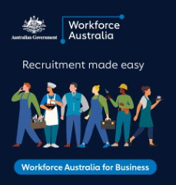
LinkedIn | Workforce Australia for Business has programs and supports available for different industries and businesses. You can work with Workforce Australia to develop workforce solutions suitable for your business, your local area or your industry. To learn more visit: https://www.workforceaustralia.gov.au/businesses/ | 
LinkedIn  Twitter | There are great opportunities and incentives to advertise a job on Workforce Australia.  Your business could benefit from tools which are designed to help you find and hire the right people, including screening questions and shortlisting candidates for roles.  For more info, visit https://lnkd.in/gj4m2bEE | 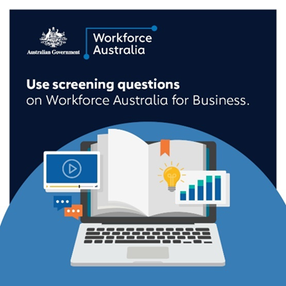

Digital posters, postcards and brochures
Factsheets, postcards, and a flyer are available for use and can be downloaded from the DEWR website. If you require a certain format of these please contact: communication@dewr.gov.au

Factsheet
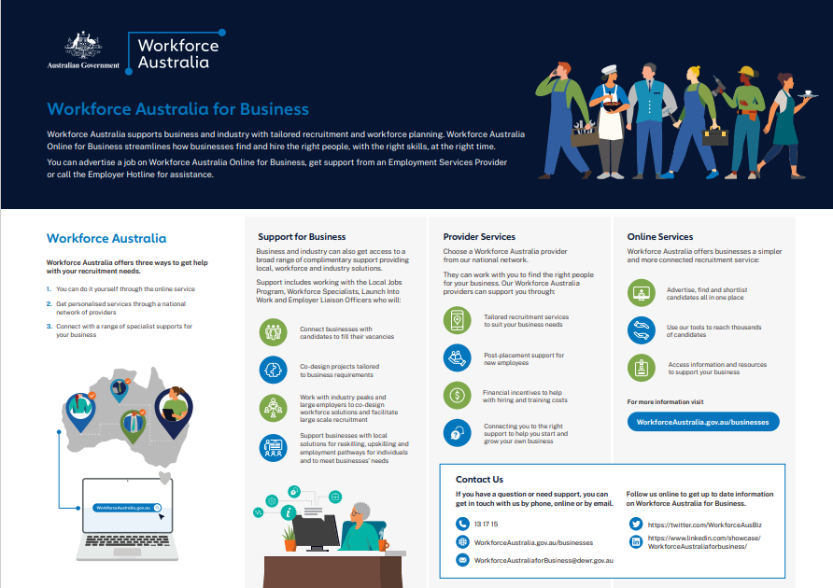
https://www.dewr.gov.au/workforce-australia/resources/workforce-australia-business-factsheet

Business Flyer
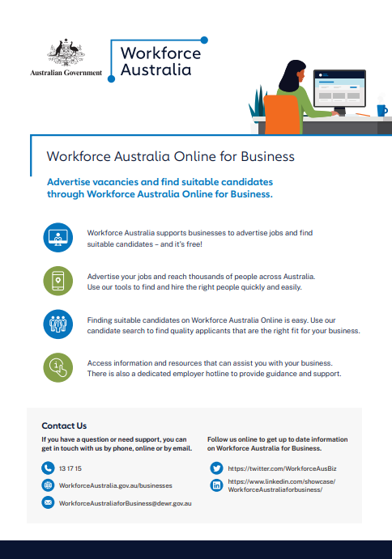
https://www.dewr.gov.au/workforce-australia/resources/workforce-australia-online-business-flyer

Postcards
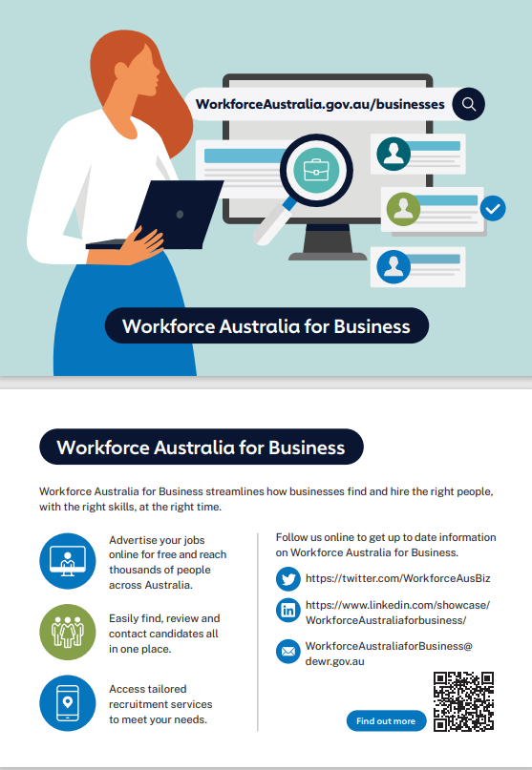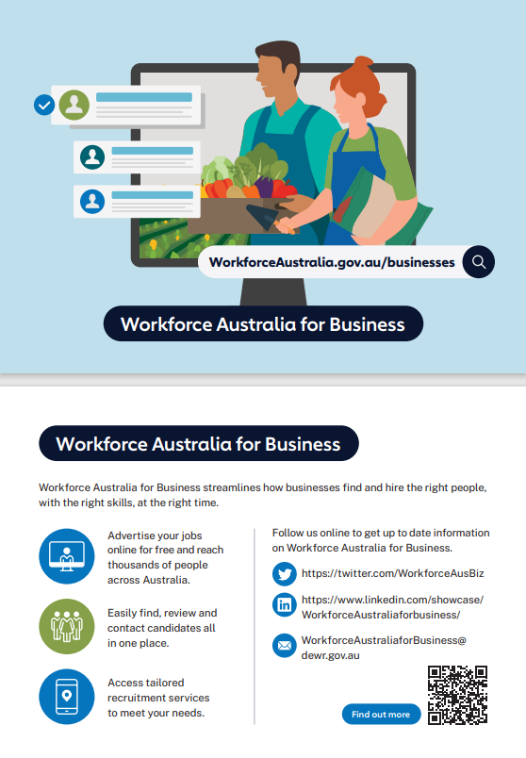
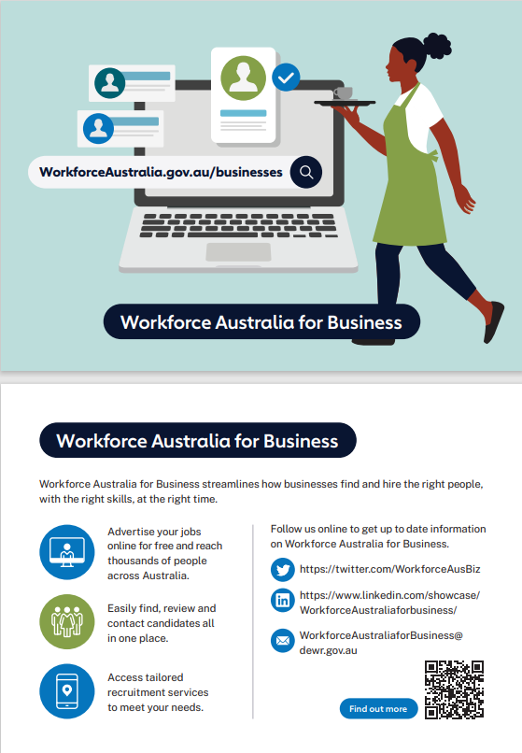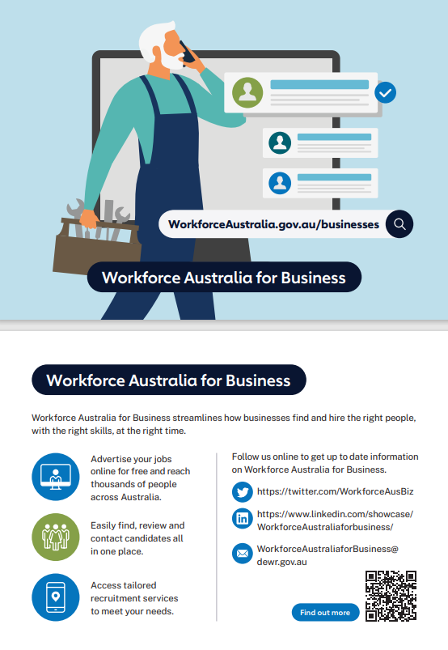
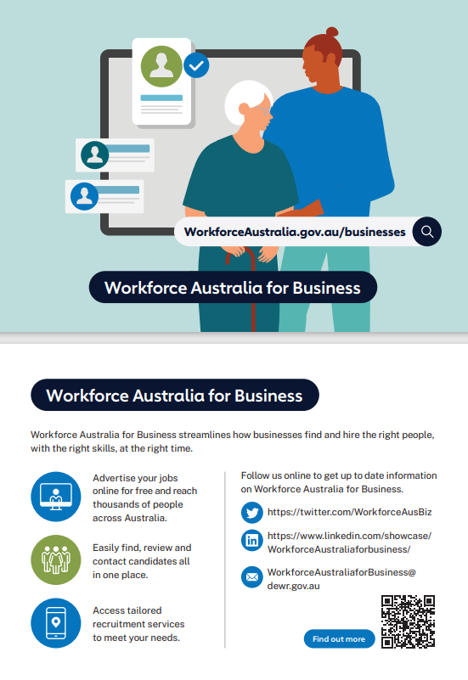
https://www.dewr.gov.au/workforce-australia/resources/workforce-australia-business-postcard-admin
https://www.dewr.gov.au/workforce-australia/resources/workforce-australia-business-postcard-harvest
https://www.dewr.gov.au/workforce-australia/resources/workforce-australia-business-postcard-hospitality
https://www.dewr.gov.au/workforce-australia/resources/workforce-australia-business-postcard-construction
https://www.dewr.gov.au/workforce-australia/resources/workforce-australia-business-postcard-healthcare

Workforce Australia for Business User Journey
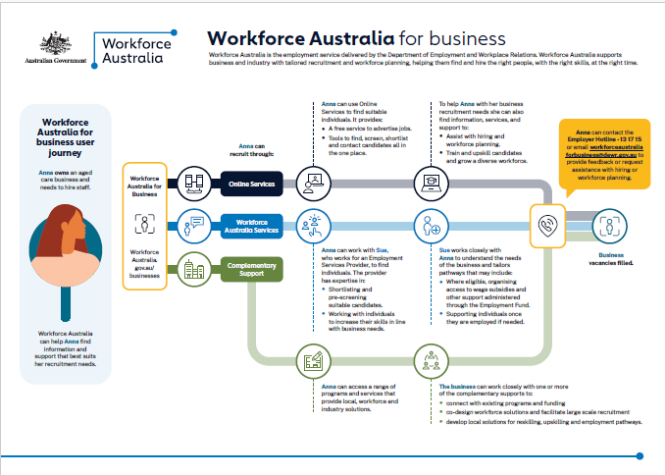
www.dewr.gov.au/resources/workforce-australia

Frequently Asked Questions

What if my audience live in different states and territories across Australia?
The information provided in this pack is applicable across Australia.

Can I modify the suggested posts and example articles contained in the toolkit?
Yes. The sample posts and articles provided in this pack are provided as a guide only, please feel free to tailor to your audience. To ensure the message is accurate can you please provide a draft to communication@dewr.gov.au prior to posting.

I have written a specific post to promote these programs. Can the department share my posts on Workforce Australia social media channels?
Yes, where appropriate. Please contact communication@dewr.gov.au for us to consider sharing your post.

Contact
For more information, or additional content you might like to use on your communication channels, please email the Communication and Media Branch at the Department of Employment and Workplace Relations at communication@dewr.gov.au

