Annual Statistical Report

January – December 2024

Title

Creative Commons

With the exception of the Commonwealth Coat of Arms, the Department’s logo, any material protected by a trade mark and where otherwise noted all material presented in this document is provided under a [Creative Commons Attribution 4.0 International](https://creativecommons.org/licenses/by/4.0/) (https://creativecommons.org/licenses/by/4.0/) licence.

The details of the relevant licence conditions are available on the Creative Commons website (accessible using the links provided) as is the full legal code for the [CC BY 4.0 International](https://creativecommons.org/licenses/by/4.0/legalcode) (https://creativecommons.org/licenses/by/4.0/legalcode)

The document must be attributed as the Annual Statistical Report – 2024. Data referenced in this report are from the Australian Government Department of Employment and Workplace Relations.

This report is for the 2024 calendar year data and reported as of the extraction date of 4 April 2025.

Contents

Introduction 2

Background 2

Executive summary 3

Key findings 5

Time series analysis of the VSL program – 2017 to 2024 5

Student level focus 6

Employment status, reason for studying and Field of Education, 2024 8

VSL students’ demographic profile 9

Location – Where are students studying? 13

Provider level focus 13

Unit of study completions 16

Additional information on VSL providers and courses 18

Glossary 19

# Introduction

This report provides information on VET Student Loans (VSL) provided to eligible students in 2024. Also included is a detailed analysis of the VSL student population, including a breakdown by age, gender, location, provider type and demographics.

To be eligible to access a VET Student Loan, students must meet the requirements as set out under Part 2, Division 2 of the [*VET Student Loans Act 2016*](https://www.legislation.gov.au/C2016A00098/latest/text)(the Act).

While two six-monthly reports have been issued for 2024, these cannot be combined to provide the 2024 Annual Report, as data can be updated by providers after the reporting period. Furthermore, student counts and enrolment counts are calculated across the entire year, so a student that studied in both halves of the year will only be counted once in this annual report, whereas they would have been reported in each of the six-monthly reports.

# Background

The VSL program commenced on 1 January 2017. It replaced the VET FEE-HELP scheme, which closed to new students on 31 December 2016. The program offers income contingent loans to eligible students studying approved course(s) at the Diploma level and above.

The Australian Government Department of Employment and Workplace Relations (DEWR) is responsible for managing and regulating the VSL program as opposed to course accreditation, course delivery and provider regulation more broadly, which are the responsibility of the Australian Skills Quality Authority.

The loan amount available to eligible students is based on the type of course they are enrolled in. The list of VSL approved courses and maximum loan amounts by course tier for 2024 is available in the [VSL (Courses and Loan Caps) Determination (Compilation No. 14) 2016](https://www.legislation.gov.au/F2016L02016/latest/text).

The data tables provided as an attachment to this report present detailed information on VSL student numbers, approved course providers, loan amounts, courses, tuition fee amounts, and course completions for 2024. The data was extracted as at 4 April 2025. As this is a live dataset, and providers may continue to amend their records, minor changes to the 2024 data may occur after the extraction date. However, the report will not be amended due to these changes.

# Executive summary

VSL student numbers have decreased year on year, falling from a peak of 57,874 in 2018 to 24,295 in 2024. Student numbers decreased 1.7% from 24,721 in 2023. The ongoing decline in VSL student numbers can be partially attributed to the availability of Fee Free TAFE. The decline in previous years may have also been influenced by the now discontinued JobTrainer program. VSL Loan amounts also decreased each year from a peak in 2018 of $278.7 million to $221.6 million in 2023 before increasing in 2024 to $239.6 million.

In 2024, 24,295 eligible students undertook study in approved courses under the Australian Government VSL program. Tuition fees charged by approved providers to these students were approximately $250 million. The total VSL amount paid to meet the cost of tuition was around $240 million (about 96% of total tuition fees) and students paid the remaining $10 million (4%) as student contributions.

The average tuition fees for VSL courses in 2024 was around $10,000 (including aviation related courses, which typically have the highest tuition fees) and the average VSL loan per student was around $9,863. Excluding aviation related courses, the average VSL loan amount paid in 2024 was lower at around $6,511. VSL students reporting to be employed while studying accounted for 64% of all VSL students and about 31% reported their reasons to undertake study was to gain employment.

Almost two thirds of VSL students identify as female (15,283). About a third (8,763) identify as male, and a small number identified as indeterminate/intersex/unspecified. Young people, 25 and under, account for 58% of total VSL students, while 26 to 35-year-olds account for almost a quarter of total VSL students.

First Nations students made up 2.7% (660) of VSL students, with an average VSL loan amount of $7,873. This is slightly lower than 2023 but aligns with the representation of First Nations people in the general population[1] [2]. Culturally and Linguistically Diverse (CALD) students comprised 15.3% (3,713) and 13.1% (3,463) reported living with disability, which is lower than for the general population[3].

Almost one fifth (18%) of VSL students in 2024 reported they were living outside the major cities.

While in-person training remains the most popular mode of delivery, for about 73% of VSL enrolments, students also undertook study in other ways, including online employer-based training and online.

Diploma of Beauty therapy was the most popular course with 2,687 VSL students, surpassing Nursing, which has fallen to second place following a 51% decline in VSL student numbers from 2023 to 2024.

Aviation demand continues to increase and accounted for 34% of VSL loans paid to a small population of 7% of the students.

In 2024, 186 Registered Training Organisations (RTOs) were approved VSL providers. This represents about 5% of approximately 4,000 RTOs that deliver VET courses.

The VSL unit of study completion rate for 2024 was 85.3%. This measures the proportion of units of study successfully completed by VSL students in 2024. Enrolments for the 24,000 VSL students makes up less than 1% of the total VET enrolments in 2024. When measured at the diploma and advanced diploma course levels VSL accounts for 6% of the total VET enrolments.

Private providers accounted for the largest share of VSL students (40.4%), followed by TAFE (36.7%) and other public providers (23.1%). Royal Melbourne Institute of Technology (RMIT) was the largest VSL provider in 2024 with 3,397 students (14%), overtaking TAFE Queensland from 2023.

The key findings section below provides additional information on VSL providers’ and students’ characteristics, including their First Nations status, gender and location.

# Key findings

This section provides an overview of the VSL program from 2017 to 2024 and detailed analysis of the 2024 calendar year data. This includes a breakdown of student numbers and loans by provider type, monthly figures, state, gender, age and First Nations status.

## Time series analysis of the VSL program – 2017 to 2024

Between 2017 and 2024 calendar years, the Australian Government provided around $2 billion through the VSL program to eligible providers to assist eligible students to study. Over this period, the program assisted an average of 40,506 students with $246.2 million in VSL loans per year.

The number of VSL students has decreased year on year since 2018. Total VSL loan amounts per year decreased from 2018 to 2023, then increased slightly in 2024. See Figure 1 below.

VSL student numbers have decreased by 58% from a peak of 57,874 in 2018 to 24,295 in 2024. Part of the decrease in demand for VSL may be attributed to in-demand courses being offered at no cost by many states under the Fee-Free TAFE program since 2023. The overall effect of Fee-Free TAFE is likely to be limited by changes to the list of courses and number of places offered by each state from one year to the next as well as the increased demand for non-VSL courses. The overall decline in demand for VSL may have also been influenced by the JobTrainer program, which offered free or low-cost vocational training to jobseekers and young people from 2020 to 2023. Other influences may include delayed effects of broader changes in labour market trends.

Figure 1: VSL student numbers and VSL loan amount (2017–2024)

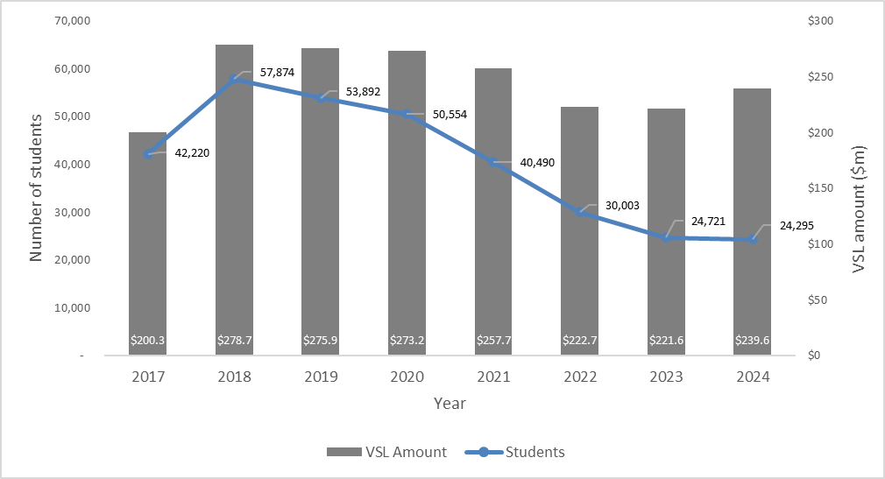

Changes in the number of VSL providers over time are shown in Figure 2. The number of providers has decreased steadily (by 12%) since 2021. This could be influenced by the Job Trainer and Fee-Free TAFE programs, or other economic factors, reducing the demand for VSL. However, the distribution of each provider type has remained stable across the life of the VSL program (see Figure 3), suggesting that no provider types are disproportionately affected by this.

Figure 2: Active provider numbers and VSL loan amount (2017–2024)

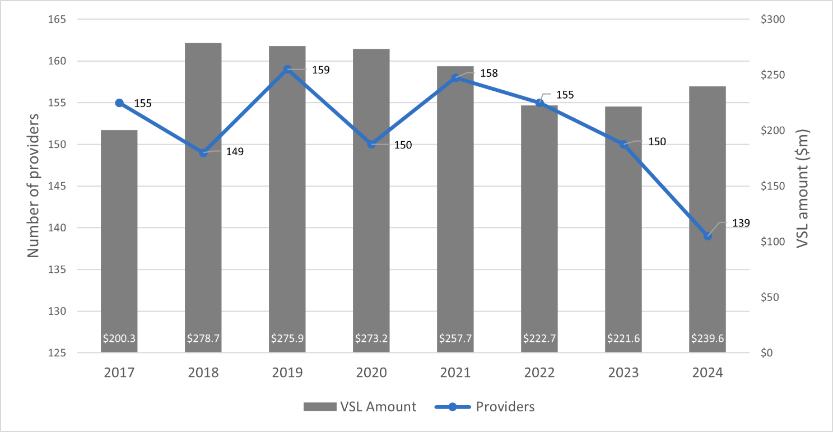

Figure 3: Distribution of provider type for each year (2027–2024)

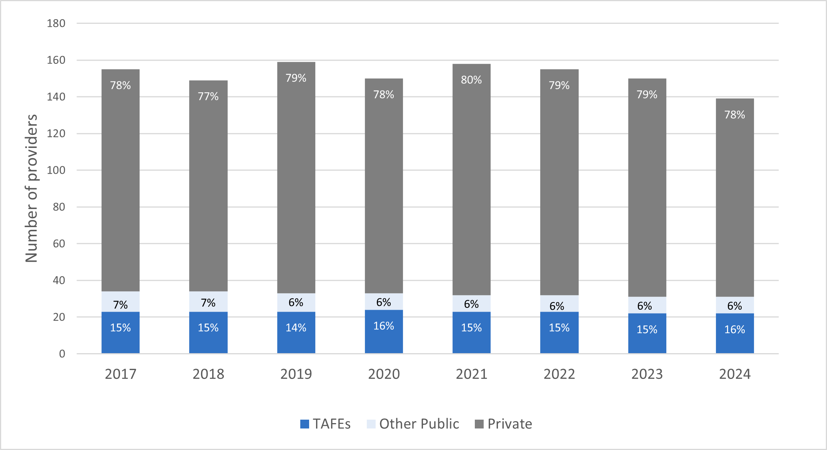

## Student level focus

In 2024, the VSL program supported 24,295 students and delivered $239.6 million in VSL loans. The month a student begins receiving VSL each year is determined by the census date of the student’s first unit for the year. This is used to estimate the timing of course enrolment, as the student’s first census date for the year will usually be shortly after enrolment (except when students enrol a long time before commencing or commence their course before 2024). Figure 4 shows the number of VSL students in each month, based on the census date of their first unit in 2024. About 49% of VSL students were estimated to have enrolled in the first quarter of 2024. The monthly student figures based on this measure show intakes around March and September.

Figure 4: VSL student numbers by census month of first unit, 2024

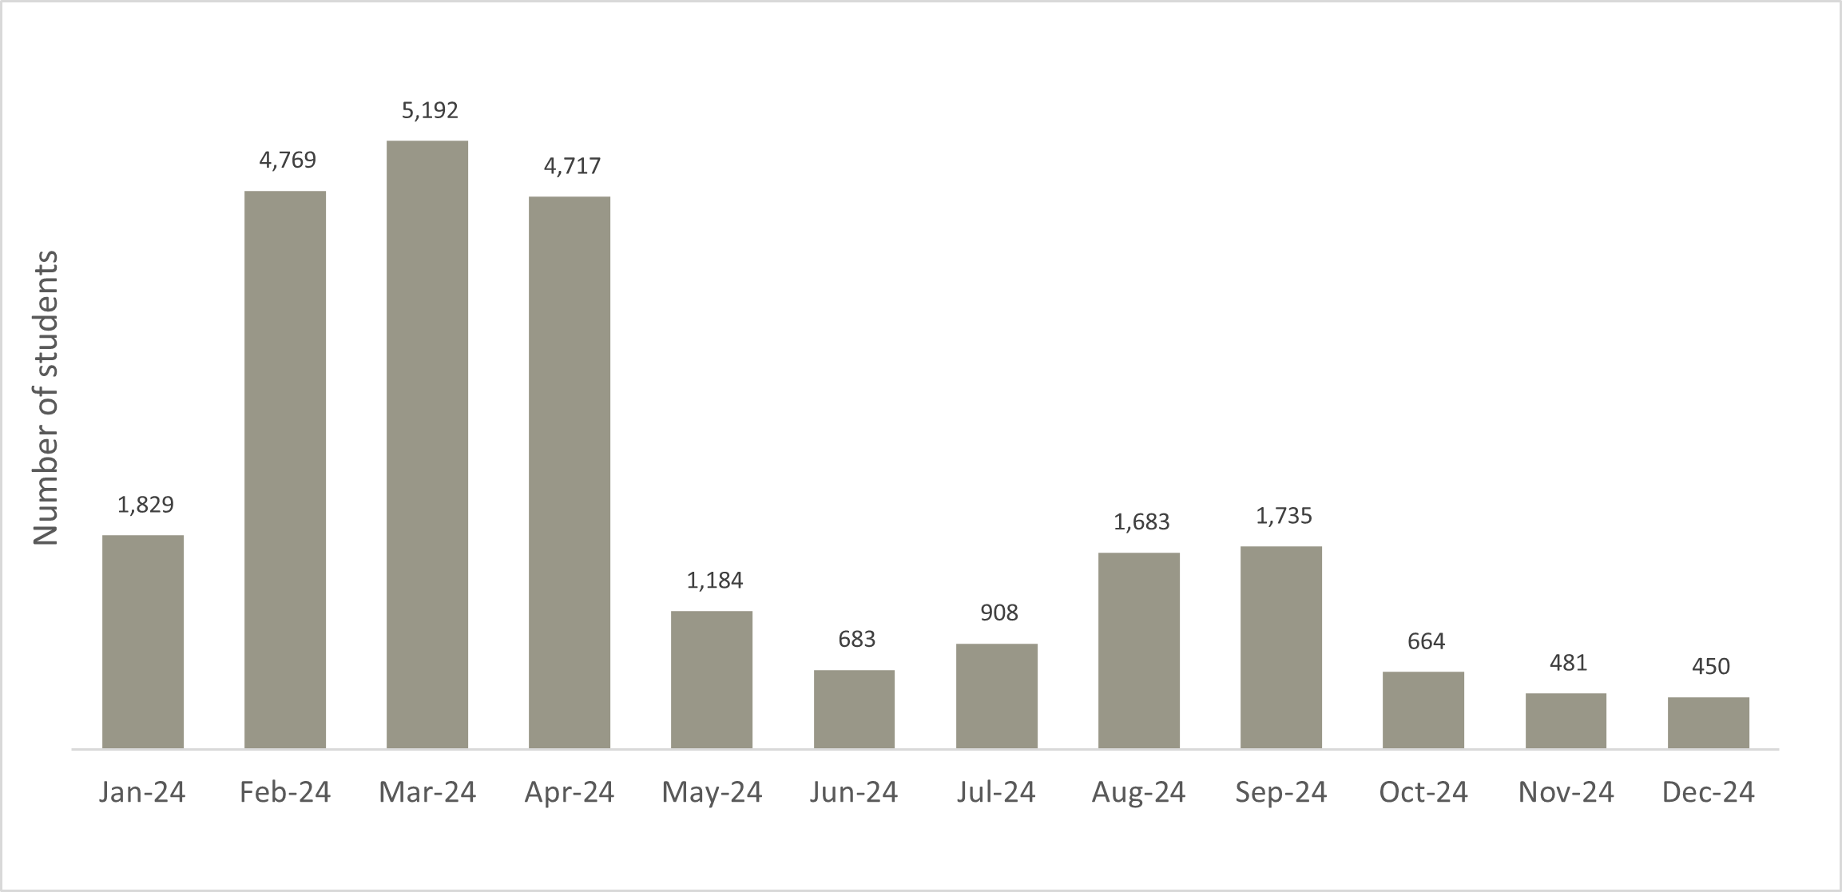

Figure 5: Values of monthly VSL loans and tuition fees, 2024

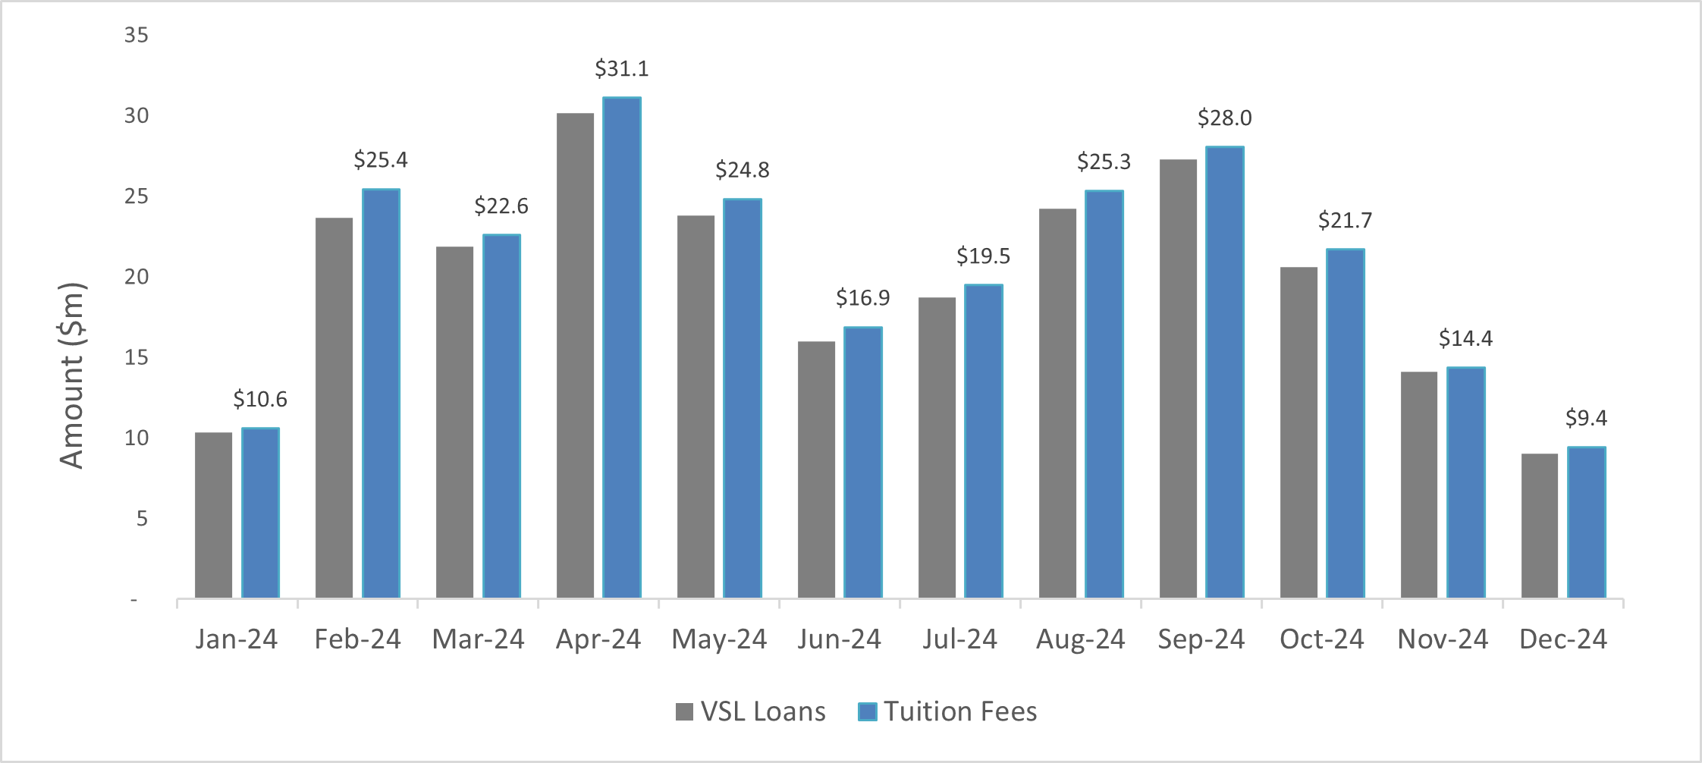

The average loan amount per student in 2024 was $9,863. Excluding aviation related courses, the average amount per student in 2024 was $6,511. About 79% of the students in non-aviation courses accessed loans of up to $10,000 as shown in Table 1. In contrast, only 16.4% of aviation students had loans totalling less than $20,000 (see Table 2). The loan amounts for each student are affected by some known factors including the type of course, course cost and level of tuition fee contribution paid by the student.

Table 1: Total VSL loan amount per student (excluding aviation courses*), 2024

|  |  |  |
| --- | --- | --- |
| Loan Amount* | Number of students | Share of total |
| Up to $500 | 421 | 1.86% |
| $501 to $1,000 | 1,115 | 4.93% |
| $1,001 to $2,000 | 2,214 | 9.79% |
| $2,001 to $5,000 | 7,131 | 31.54% |
| $5,001 to $7,500 | 4,356 | 19.26% |
| $7,501 to $10,000 | 2,587 | 11.44% |
| $10,001 to $15,000 | 2,531 | 11.19% |
| $15,001 to $20,000 | 1,404 | 6.21% |
| $20,000+ | 853 | 3.77% |
| **Total** | **22,612** | **100.00%** |

*Courses are categorised as aviation-related if the course name contains the words ‘aviation’ or ‘aeroskill’. Units are excluded from calculation in this table if they are linked to a course enrolment which is aviation related.

Table 2: Total VSL loan amount per student for aviation related courses, 2024

|  |  |  |
| --- | --- | --- |
| Loan Amount* | Number of students | Share of total |
| Up to $500 | 2 | 0.12% |
| $501 to $1,000 | 5 | 0.30% |
| $1,001 to $2,000 | 1 | 0.06% |
| $2,001 to $5,000 | 22 | 1.31% |
| $5,001 to $7,500 | 18 | 1.07% |
| $7,501 to $10,000 | 57 | 3.39% |
| $10,001 to $15,000 | 82 | 4.87% |
| $15,001 to $20,000 | 89 | 5.29% |
| $20,000+ | 1,407 | 83.60% |
| **Total** | **1,683** | **100%** |

*Courses are categorised as aviation-related if the course name contains the words ‘aviation’ or ‘aeroskill’. Units are only included in calculation for this table if they are linked to a course enrolment which is aviation related.

## Employment status, reason for studying and Field of Education, 2024

As part of VSL program, students are surveyed prior, during and post study. The questions include their employment status, reasons they studied and satisfaction with their provider. The 63.7% of VSL students reporting to be employed prior to commencing their studies, is unchanged from the 2023 reported figure.

Figure 6 shows the reasons provided by students for studying VSL approved courses. The top 3 reasons were to ‘To get a job (30.5%), ‘To try for a different career’ (14.1%) and for ‘personal development’ (12.5%).

Figure 6: Proportion of study reasons by VSL enrolment, 2024

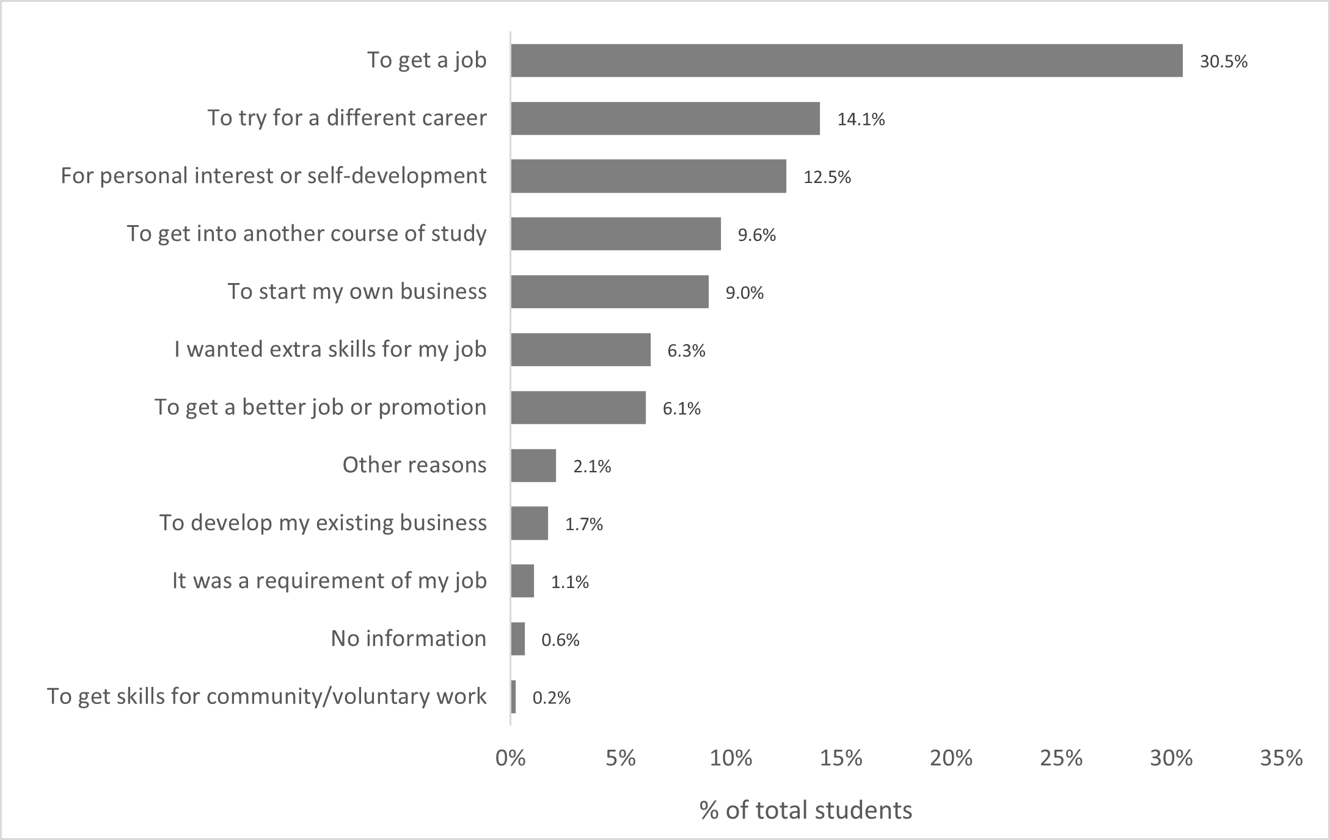

The Australian Standard of Classification of Education (ASCED) developed by the Australian Bureau of Statistics (ABS) has been used to classify the VET courses into field of education. Figure 7 shows the distribution of student numbers by broad field of education. Creative Arts was the most popular field of education with 18.8% of all students, followed by Health with 18.0% of all students. Society and Culture and Management and Commerce followed this, with 16.6 and 16.5% respectively.

Figure 7: Proportion of student in Field of Education, 2024

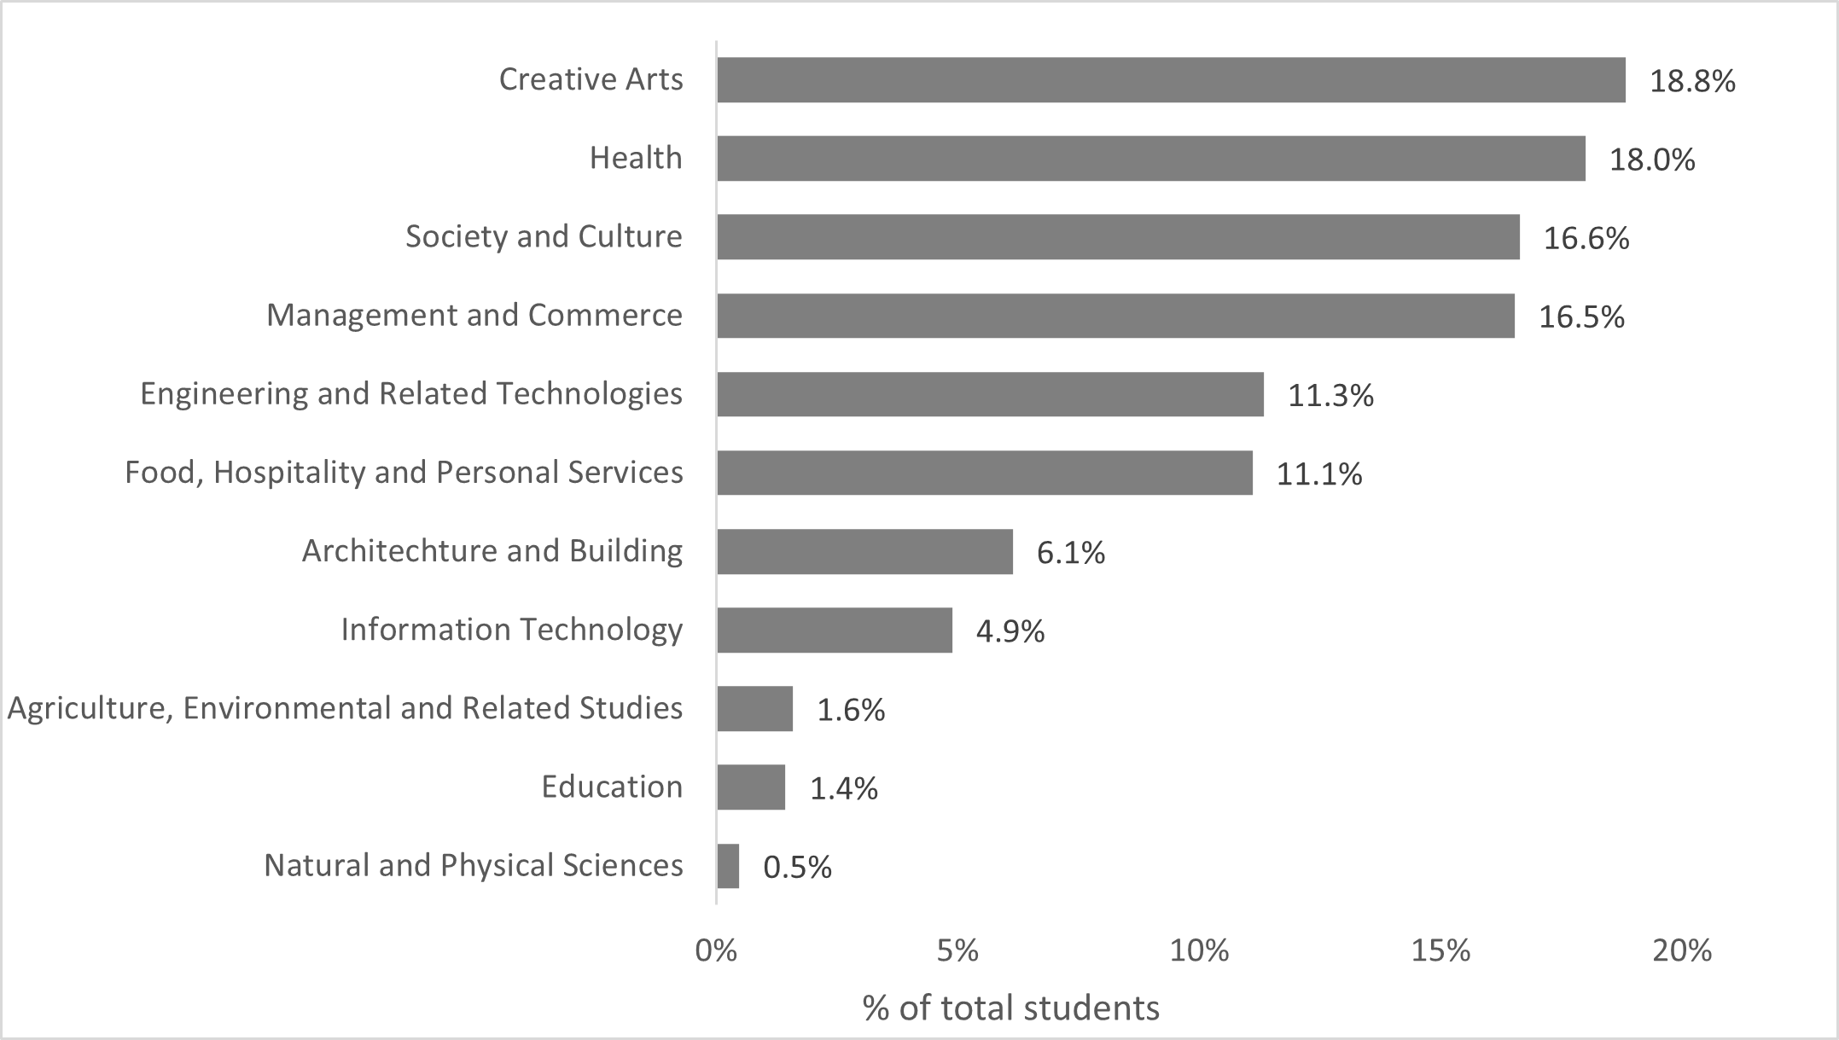

# VSL students’ demographic profile

Students who identified as female accessed VSL more than other gender categories, and students identifying as male students represented about a third (8,763) of all VSL students, as shown in Figure 8.

Figure 8: Number of VSL students by gender*, 2024

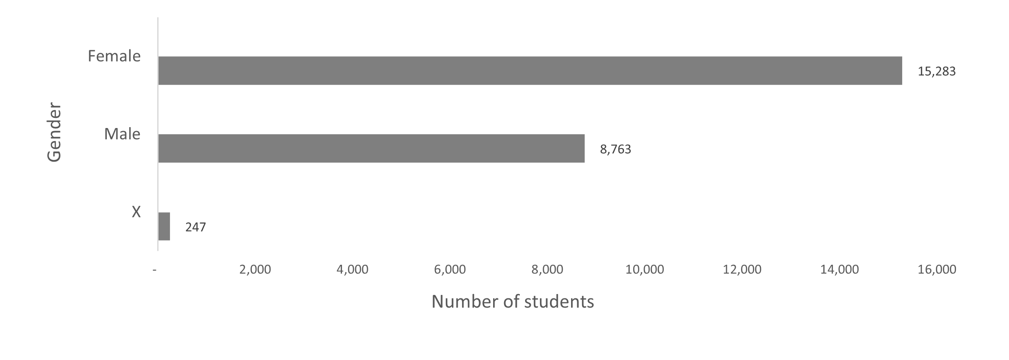

*Based on three options of Male, Female or X (Indeterminate/Intersex/Unspecified) provided to respondents when asked to specify their gender.

The most popular courses studied by Female VSL students were Diploma of Beauty Therapy, Diploma of Nursing, and Diploma of Salon Management. The most popular course studied by male VSL students was Diploma of Aviation (Commercial Pilot Licence – Aeroplane). The most popular courses for students that identified as Indeterminate/Intersex/Unspecified are Diploma of Visual Arts, Diploma of Screen and Media and Diploma of Library and Information Services. Additional information on the top courses by student numbers and by female and male gender is in Tables 3 and 4 below.

Table 3: Top 10 courses studied by female VSL students, 2024

|  |  |  |
| --- | --- | --- |
| Course Name | Number of female students | Share of total female students |
| Diploma of Beauty Therapy | 2,674 | 17.50% |
| Diploma of Nursing | 1,794 | 11.74% |
| Diploma of Salon Management | 1,359 | 8.89% |
| Diploma of Counselling | 849 | 5.56% |
| Diploma of Remedial Massage | 829 | 5.42% |
| Diploma of Screen and Media | 633 | 4.14% |
| Diploma of Library and Information Services | 554 | 3.62% |
| Diploma of Community Services | 548 | 3.59% |
| Diploma of Interior Design | 533 | 3.49% |
| Diploma of Visual Arts | 530 | 3.47% |

Table 4: Top 10 courses studied by male VSL students, 2024

|  |  |  |
| --- | --- | --- |
| Course Name | Number of male students | Share of total male students |
| Diploma of Aviation (Commercial Pilot Licence - Aeroplane) | 998 | 11.39% |
| Diploma of Information Technology | 702 | 8.01% |
| Diploma of Screen and Media | 686 | 7.83% |
| Diploma of Aviation (Instrument Rating) | 500 | 5.71% |
| Diploma of Business | 497 | 5.67% |
| Diploma of Sport | 377 | 4.30% |
| Diploma of Visual Arts | 374 | 4.27% |
| Advanced Diploma of Building Design (Architectural) | 347 | 3.96% |
| Diploma of Remedial Massage | 336 | 3.83% |
| Diploma of Music | 278 | 3.17% |

VSL students aged 25 years old or younger accounted for over half of all VSL students, and ages 26 to 35 years account for almost a quarter (see Figure 9). The majority of VSL students identifying as female can be seen in all age brackets (see Table 5).

Figure 9: Percentage of VSL students by age breakdown, 2024

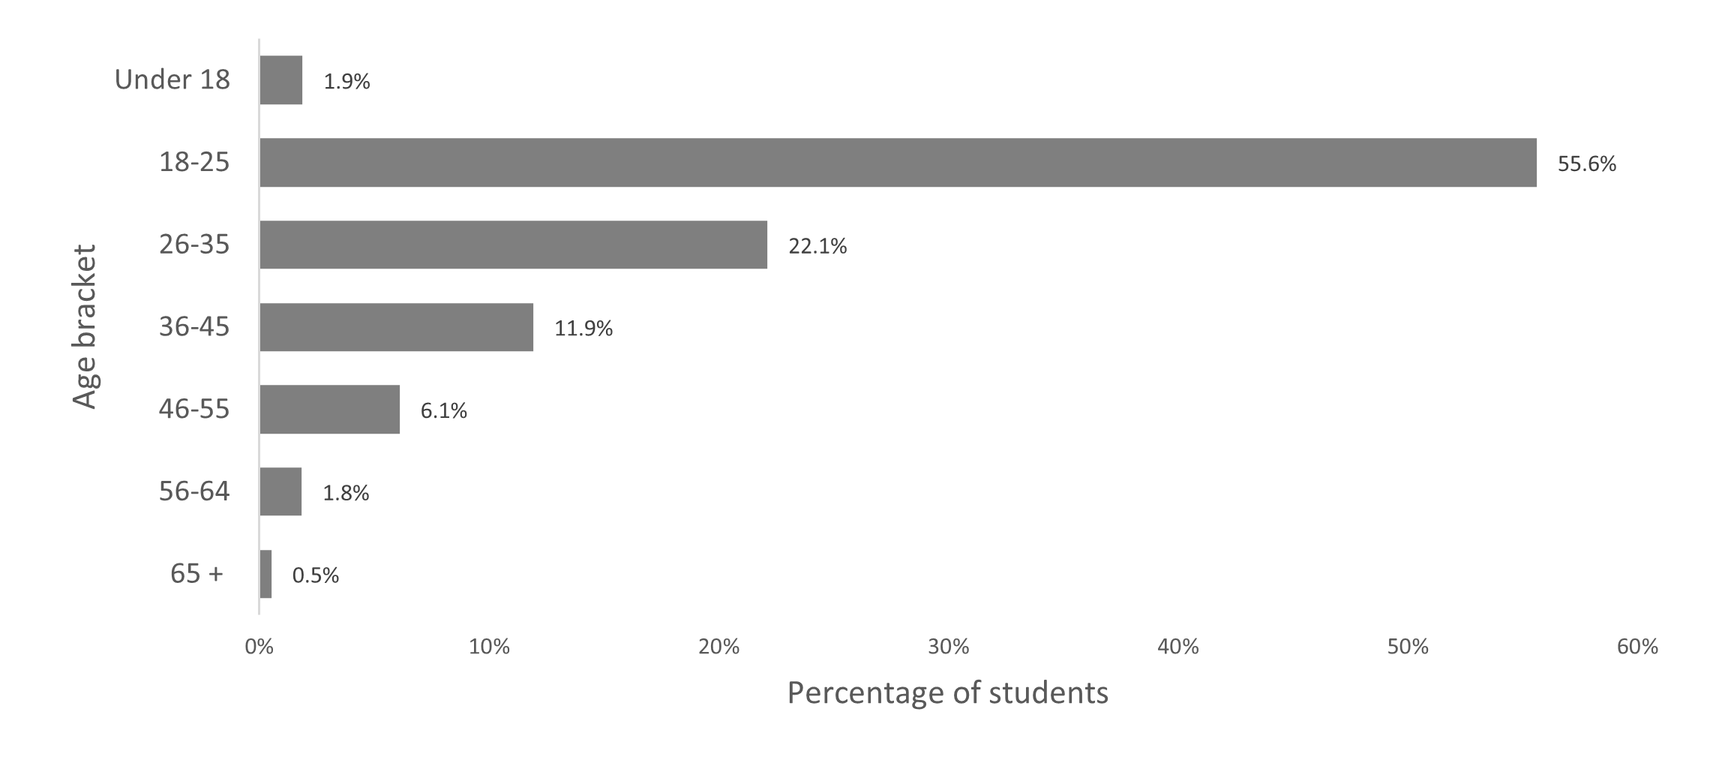

Table 5: Age bracket by gender, 2024

|  |  |  |  |  |  |  |
| --- | --- | --- | --- | --- | --- | --- |
| Age bracket | Female | | Indeterminate/ Intersex/ Unspecified | | Male | |
| Students | % of age bracket | Students | % of age bracket | Students | % of age bracket |
| Under 18 | 396 | 87% | <5 | 0.66% | 58 | 12.69% |
| 18-25 | 7,811 | 58% | 193 | 1.43% | 5,506 | 40.75% |
| 26-35 | 3,512 | 65% | 43 | 0.80% | 1,818 | 33.84% |
| 36-45 | 2,088 | 72% | <5 | 0.14% | 803 | 27.73% |
| 46-55 | 1068 | 72% | <5 | 0.27% | 411 | 27.71% |
| 56-64 | 329 | 74% | - | 0.00% | 118 | 26.40% |
| 65 + | 79 | 62% | - | 0.00% | 49 | 38.28% |
| Total | **15,283** | **63%** | **247** | **1.02%** | **8,763** | **36.07%** |

Age appears to influence gender differences in the most popular courses (see Tables 6 and 7). There is no gender difference in the most popular course for students 56 years and older. The majority of under 18s are females studying Diploma of Beauty Therapy. However, this is only a small portion of total Diploma of Beauty Therapy students, with the majority being females aged 18-25 years.

The majority of students enrolled in Diploma of Aviation (Commercial Pilot Licence - Aeroplane) are males aged 18-25. Most other age bracket/gender combinations only account for a small portion of total enrolments for their most popular course. However, this portion is higher for females than males in each age bracket except 65+. The same can be seen for representation of enrolments for each top course in all females versus all males. This could suggest that female students preference the top courses for their cohorts more strongly than males do for theirs, with this gender difference declining with increasing age. This could also be due to higher overall numbers of female students than males in each age bracket.

Table 6: Top course for females by age brackets

|  |  |  |  |  |  |  |
| --- | --- | --- | --- | --- | --- | --- |
| Age bracket | Top course for female students | Students | % of all females in age bracket | % of age bracket total | % of all females | % of course total |
| Under 18 | Diploma of Beauty Therapy | 276 | 69.70% | 60.39% | 1.81% | 10.27% |
| 18-25 | Diploma of Beauty Therapy | 1,823 | 23.34% | 13.49% | 11.93% | 67.85% |
| 26-35 | Diploma of Nursing | 494 | 14.07% | 9.19% | 3.23% | 24.54% |
| 36-45 | Diploma of Nursing | 359 | 17.19% | 12.40% | 2.35% | 17.83% |
| 46-55 | Diploma of Counselling | 155 | 14.51% | 10.45% | 1.01% | 14.25% |
| 56-64 | Diploma of Counselling | 53 | 16.11% | 11.86% | 0.35% | 4.87% |
| 65 + | Diploma of Counselling | 16 | 20.25% | 12.50% | 0.10% | 1.47% |

Table 7: Top courses for males by age brackets

|  |  |  |  |  |  |  |
| --- | --- | --- | --- | --- | --- | --- |
| Age bracket | Top course for male students | Students | % of all  males in  age bracket | % of age bracket  total | % of all males | % of course total |
| Under 18 | Diploma of Screen and Media | 13 | 22.41% | 2.84% | 0.15% | 0.96% |
| 18-25 | Diploma of Aviation (Commercial Pilot Licence - Aeroplane) | 729 | 13.24% | 5.40% | 8.32% | 60.85% |
| 26-35 | Diploma of Aviation (Commercial Pilot Licence - Aeroplane) | 191 | 10.51% | 3.55% | 2.18% | 15.94% |
| 36-45 | Diploma of Remedial Massage | 78 | 9.71% | 2.69% | 0.89% | 6.68% |
| 46-55 | Diploma of Remedial Massage | 36 | 8.76% | 2.43% | 0.41% | 3.08% |
| 56-64 | Diploma of Counselling | 16 | 13.56% | 3.58% | 0.18% | 1.47% |
| 65 + | Diploma of Counselling | 10 | 20.41% | 7.81% | 0.11% | 0.92% |

About 2.7% (660) of VSL students identified as being First Nations decreasing slightly from 2023, whereas First Nations in the general population remained stable at 3.8%.[4] [5] Of First Nations VSL students, 72.9% (481) are female (10% higher than the general VSL population).

Culturally and Linguistically Diverse (CALD) students comprised 15.3% (3,713) of VSL students which is lower than the 22.8% for the general population[6]. The 13.1% (3,186) students reported to be living with disability is lower than the 21.4% for the general population[7]. This difference could be explained by age bracket. As the majority of VSL students are under 25 years old, the percentage in the general population for similar age groups (13.9% for 15-24 years old) should also be considered in comparisons.

## Location – Where are students studying?

Victoria (38.8%) had the largest number of students, followed by Queensland (22.9%), and New South Wales (20.1%), see Table 8.

Students who reported to live outside the major cities make up 18% of total VSL students.

Table 8: Number of VSL students by states and territories, 2024

|  |  |  |
| --- | --- | --- |
| States and Territories | Number of students | Share of total |
| Australian Capital Territory | 252 | 1.04% |
| New South Wales | 4,889 | 20.12% |
| Northern Territory | 87 | 0.36% |
| Queensland | 5,568 | 22.92% |
| South Australia | 2,002 | 8.24% |
| Tasmania | 463 | 1.91% |
| Victoria | 9,435 | 38.84% |
| Western Australia | 1,584 | 6.52% |
| *N/A | 19 | 0.08% |
| **Total** | **24,295** | **100.00%** |

*Missing reported addresses/state indicator

## Provider level focus

In 2024, 186 RTOs operated as approved course providers. Of these, 139 (75 per cent) were active in 2024 (defined as reporting at least one student who accessed the VSL program).

A breakdown of the 139 active approved course providers, with students in 2024 by provider type is below:

* 22 TAFEs
* Nine other public institutions (including public universities and other non-TAFE publicly owned providers), and
* 108 private providers (including private universities, and both not-for-profit and ‑for-profit private providers).

Private providers remain the main provider type in the VSL program, with 9,825 students and $151.2 million in loans. This is consistent with 2023, prior to which TAFE was the main provider type based on student number and loan amount. This shift and its continuation in 2024 could be attributed to a drop in VSL student numbers due to Fee-Free TAFE. However, this could also be influenced by other economic factors affecting provider registrations, closures, or mergers.

Public providers (TAFEs and other public providers) account for about 59.7% of students who accessed VSL in 2024, up 1.8% from the 2023 share. Table 9 shows the number and share of students by provider type.

Table 9: Number of active VSL providers and students by provider type, 2024

|  |  |  |  |  |
| --- | --- | --- | --- | --- |
| Provider Type | Providers | | Students | |
|  | **Number** | **Percentage** | **Number** | **Percentage** |
| TAFE | 22 | 15.8% | 8,905 | 36.6% |
| Other Public | 9 | 6.5% | 5,609 | 23.0% |
| Private | 108 | 77.7% | 9,825 | 40.4% |
| **Total** | **139** | **100.0%** | **24,339\*** | **100.0%** |

* The total is not a unique count of students as some students studied across multiple provider types

Private providers accounted for 63.1% of the total VSL amount ($151.2 million). Conversely, public providers accounted for 36.9% ($88.4 million) of the total VSL amount. The average loan for a student studying at TAFE was about $5,766, other public providers about $6,618, and private providers about $15,386. These averages are influenced by factors like the type of courses (e.g. aviation is predominantly private) and student upfront contribution.

Most of the $89.5 million in total tuition fees charged to VSL students at public providers (TAFEs and/or other public providers) was covered by VSL (98.8%). This share is lower for VSL students at private providers (94.4%). See Table 10 below.

Table 10: Tuition fees, VSL amount, and amount paid upfront by provider type, 2024

|  |  |  |  |  |  |  |
| --- | --- | --- | --- | --- | --- | --- |
| Provider Type | *Tuition Charged Amount | | VET Students Loan Amount | | Upfront Paid Amount | |
| ($, m) | Percentage | ($, m) | Percentage | ($, m) | Percentage |
| TAFE | 52.0 | 20.8% | 51.3 | 21.4% | 0.7 | 6.5% |
| Other Public | 37.5 | 15.0% | 37.1 | 15.5% | 0.4 | 4.0% |
| Private | 160.1 | 64.1% | 151.2 | 63.1% | 8.9 | 89.5% |
| **Total** | **249.6** | **100.0%** | **239.6** | **100.0%** | **10.0** | **100.0%** |

* Percentage figures may not add up due to rounding.

Across the program, the number of students per provider vary within and across provider types. On average, a VSL provider has 175 students, with the average of 91 students at private providers and an average of 405 at TAFEs. Table 11 shows the number of providers in each size bracket, and the total number of students across all providers in each size bracket.

Just over half the total VSL providers with students reported having up to 50 VSL-assisted students. This means that there are a small number of VSL providers with large numbers of VSL assisted students (mostly public providers).

Table 11: Provider size by number of students

|  |  |  |  |  |
| --- | --- | --- | --- | --- |
| Bracket by students | Providers | | Students | |
| **Number** | **Percentage** | **Number** | **Percentage** |
| Up to 20 | 46 | 33.1% | 349 | 1.4% |
| 21 to 50 | 28 | 20.1% | 1,020 | 4.2% |
| 51 to 100 | 20 | 14.4% | 1,417 | 5.8% |
| 101 to 250 | 23 | 16.5% | 3,446 | 14.1% |
| 250+ | 22 | 15.8% | 18,182 | 74.5% |
| **Total** | **139** | **100.0%** | **24,414\*** | **100.0%** |

* The total is not a unique count of students as some students studied across multiple providers

Figure 10 shows the proportion of VSL students for each provider type within each state and territory. Victoria and Northern Territory have proportionately large numbers of VSL students in other public providers. This could be due to the location of dual sector universities with proportionately large numbers of VSL students.

Figure 10: Percentage of VSL students by provider type within each state*, 2024

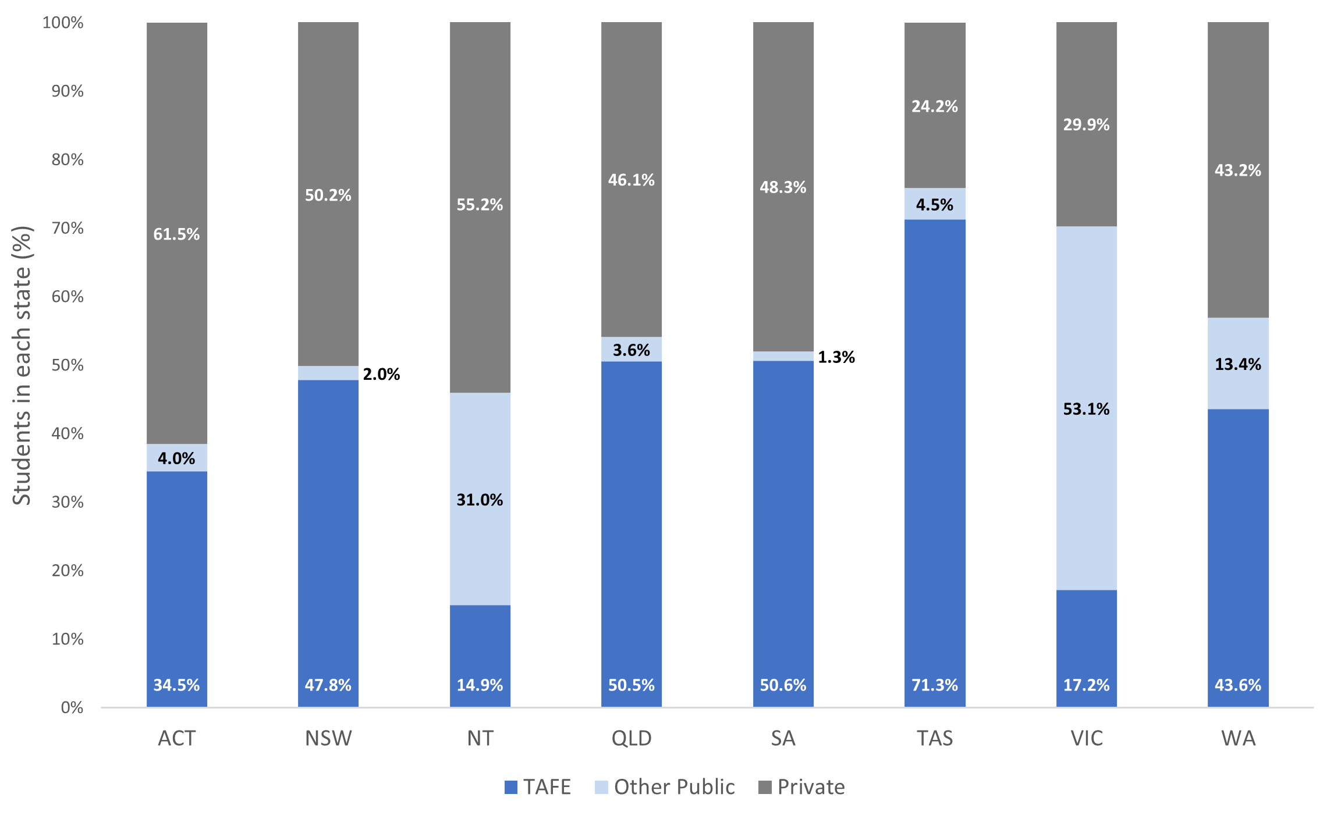

* The state is based on the student’s home address

Table 12 shows the distribution of students across states for each provider type. Victoria has the most students in other public providers (89%), and QLD had the most TAFE students (32%). Of the total students at private providers, 79.9% were spread roughly evenly across NSW, QLD, and VIC.

Table 12: Distribution of students across states for each provider type

| States and Territories | TAFE | Other Public | Private |
| --- | --- | --- | --- |
| Australian Capital Territory | 0.98% | 0.18% | 1.58% |
| New South Wales | 26.23% | 1.78% | 25.00% |
| Northern Territory | 0.15% | 0.48% | 0.49% |
| Queensland | 31.59% | 3.57% | 26.13% |
| South Australia | 11.39% | 0.46% | 9.84% |
| Tasmania | 3.71% | 0.37% | 1.14% |
| Victoria | 18.19% | 89.32% | 28.74% |
| Western Australia | 7.75% | 3.78% | 6.97% |
| *N/A | 0.02% | 0.05% | 0.14% |
| **Total** | **100%** | **100%** | **100%** |

*Missing reported addresses/state indicator

## Unit of study completions

The unit of study completion rate for the approximately 24,000 VSL students that studied at 186 VSL providers in 2024 was 85.3%. It is calculated by dividing the number of passed units by the number of all units undertaken. VSL providers represent less than 5% of the total RTOs and VSL enrolments made up only 1%[8] of total VET enrolments in 2024. When measured at the diploma and advanced diploma course levels VSL only account for 6% of the total VET enrolments.

Figure 11 shows the unit of study completion rates breakdown by proportion of providers.

It is expected that some VSL students commencing their courses in 2024 are unlikely to have completed all units by 31 December 2024. About 71% (132) of approved providers reported a unit of study outcome, and the remaining 54 had no students or reported all their students’ units of study as in progress. Of the 132 providers with reported unit of study completion rates, 118 (89%) had a completion rate above 50% and almost three quarters reported a completion rate above 80%.

Figure 11: Distribution of VSL unit of study completion rates and number of providers

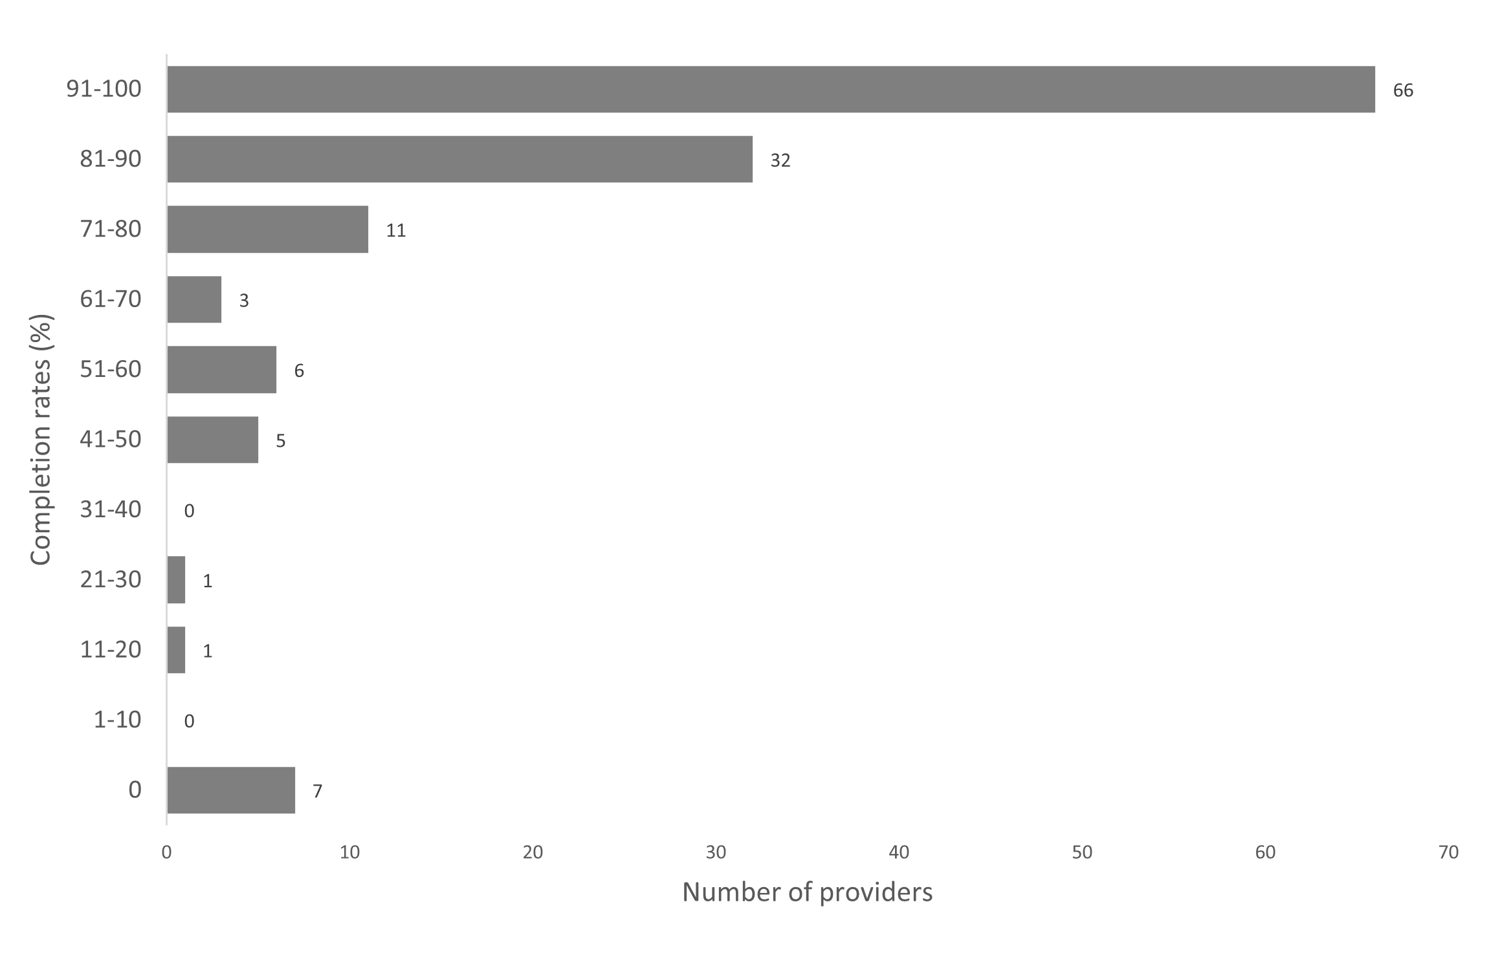

Excludes providers with no reported students and/or reported all student’s units of study as in progress

The completion rates determined in this report:

* only covers students who used the VSL program in the 2024 calendar year
* includes course completion data reported as of 4 April 2025 so that a completed course with a final census day in 2024 may be excluded if completed after 4 April 2025
* may be different to the DEWR reported Performance measure of unit completions due to the difference in as-at reporting periods.

VSL legislation requires that courses be reported across at least three ‘parts’ (reported as units of study). Thus, reporting on unit of study completion rates provides an alternative way of presenting information on VSL students’ progression through their courses. VSL providers are required to report unit of study outcomes in a timely manner[9]. The unit of study completion rate is the proportion of units of study successfully passed as a share of total units of study undertaken. This calculation uses the Equivalent Full Time Student Load (EFTSL) rather than students or unit enrolments. Ongoing units of study are excluded from the completion rate calculation. Units of study includes units that providers reported VSL students to have withdrawn from, failed, or successfully completed.

# Additional information on VSL providers and courses

The Addendum Table 1 provides the VSL data listed in the report for the reporting period 1 January 2024 to 31 December 2024.

The Addendum Tables 2 to 6 provide additional information on approved course providers and eligible courses offered.

These tables rank providers in order of number of VSL students (Table 2), value of loans paid (Table 3), and rank courses by number of VSL students (Table 4) and in order of value of loans paid (Table 5) and total value of loans paid to individual VSL provider(s) including the course breakdown (Table 6).

These tables also provide the following:

* VSL student numbers (Table 2 and 3)
* course enrolment numbers (Tables 4 and 5)
* Equivalent Full-Time Student Load (EFTSL) by provider and by course
* tuition fees charged
* the amount of the tuition fees paid up-front (paid directly to the provider by the student, rather than deferred through a VSL loan)
* the value of VSL loans
* tuition fees per student (Tables 2 and 3)
* tuition fees per course enrolment (Tables 4 and 5)
* tuition fees per EFTSL
* loan amount per student (Tables 2 and 3)
* loan amount per course enrolment (Tables 4 and 5)
* loan amount per EFTSL
* enrolments, loans, tuition fees, students completing courses and unit of study completion rates by provider and course (Table 6).

Note, some courses appear multiple time in Tables 4 and 5 as both superseding and superseded courses were valid in the reporting period.

# Glossary

|  |  |
| --- | --- |
| Term | Definition/Meaning |
| Approved course | A course that meets the requirements of Section 13 (Division 3) of the Act. |
| Approved course provider | Bodies that are approved to offer VSL in accordance with the Act. This may include TAFEs, other public providers, and private providers. |
| Australian Government Department of Employment and Workplace Relations | The Commonwealth department that administers the VSL program. |
| Census year | The reporting period for the report: 1 January 2024 to 31 December 2024. |
| Unit of Study completion rate | The proportion of units of study that were passed, of the total units of study undertaken, with units of study measured in Equivalent Full Time Student Load (EFTSL). |
| Eligible students | To be an eligible student for VSL, the person must satisfy section 9 (Division 2) of the Act. This includes the citizenship and residency status, enrolment and application and academic suitability requirements. |
| Enrolment | The number of courses students studied in the reporting period. |
| Loan amount | The VSL amount paid by the Commonwealth to an eligible student to undertake approved courses as described in the Act, excluding upfront amounts paid and/or contributed by the student. |
| Provider type | Whether the provider is a TAFE, other public provider (including public universities and other non-TAFE publicly owned providers) or private provider (including private universities and both not-for-profit and for-profit private providers). |
| *VET Student Loans Act 2016* | The principal Commonwealth legislation governing the VSL program. |
| VET Student Loans Rules 2016 | The Rules as made by the Minister for Skills and Training under the Act to provide for the administration of the requirements of the Act. |
| VSL students | Students that paid tuition fees partly or fully using the VSL program. |
| VET Student Loan | See loan amount |
| Tuition fees | Fees charged by approved providers to students for their courses. |
| Public providers | TAFEs and other public providers |

1. Data for general national First Nations population was sourced from [the estimates and projections for First Nations populations on the ABS website](https://www.abs.gov.au/statistics/people/aboriginal-and-torres-strait-islander-peoples/estimates-and-projections-australian-aboriginal-and-torres-strait-islander-population/2011-2031).
2. Data for the total general Australian population was sourced from [population statistics on the ABS website](https://www.abs.gov.au/statistics/people/population). This was used to derive the percentage of demographic groups within the general Australian population.
3. Data for general national population of people living with a disability was sourced from [disability statistics on the ABS website](https://www.abs.gov.au/media-centre/media-releases/55-million-australians-have-disability). The most recent data available is from 2022.
4. Data for general national First Nations population was sourced from [the estimates and projections for First Nations populations on the ABS website](https://www.abs.gov.au/statistics/people/aboriginal-and-torres-strait-islander-peoples/estimates-and-projections-australian-aboriginal-and-torres-strait-islander-population/2011-2031).
5. Data for the total general Australian population was sourced from [population statistics on the ABS website](https://www.abs.gov.au/statistics/people/population). This was used to derive the percentage of demographic groups within the general Australian population.
6. Data for general CALD population was sourced from the [cultural diversity statistics on the ABS website](https://www.abs.gov.au/articles/cultural-diversity-australia). data is from 2021.
7. Data for general national population of people living with a disability was sourced from [disability statistics on the ABS website](https://www.abs.gov.au/media-centre/media-releases/55-million-australians-have-disability). The most recent data available is from 2022.
8. Data is sourced from [Training.gov.au](https://training.gov.au/search?searchText=&searchType=RTO&status=0)
9. Providers are to report unit of study outcome to the Tertiary Collection of Student Information ([TCSI](https://www.tcsisupport.gov.au/element/355))