

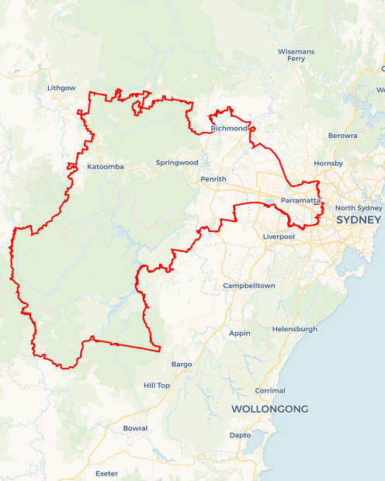Local Jobs Plan

Sydney Greater West Employment Region | NSW | ****March 2025****

Workforce Australia Local Jobs (Local Jobs) is a program that supports tailored approaches to accelerate   
reskilling, upskilling and employment pathways in response to current and emerging local workforce needs.

## Local Jobs elements

### Local Jobs Plan

The Local Jobs Plan sets out the skills and employment challenges and priorities of the region, and associated strategies that will drive the design and implementation of activities to be implemented to address these challenges.

### Job Coordinators

Job Coordinators and Support Officers support the delivery of the program by bringing together key stakeholders including businesses, employment services providers, higher education and training organisations.

### Local Jobs and Skills Taskforce

Each Employment Region has its own Taskforce. Representatives include local stakeholders who have demonstrated experience in upskilling, reskilling, and an ability to represent, connect and collaborate with others in the region to meet labour market needs.

### Program Funds

The Employment Region’s Local Initiatives Fund enables targeted local investments that support local labour market functioning. Further, from 2025/26, a central grants-based fund will respond to local needs and help progress broader employment service reform objectives.

Explore labour market insights for the  
[Sydney Greater West](https://www.jobsandskills.gov.au/work/employment-region-dashboards-and-profiles/monthly-labour-market-dashboards) Employment Region

## Local labour market challenges in the region

* Supporting the changing nature of employment opportunities across a region that incorporates an ‘established city’ versus an ‘establishing city’ (namely Bradfield City/Western Sydney Aerotropolis).
* The majority of employment in the region can be attributed to healthcare and social assistance, retail, trade, construction, professional, scientific and technical services and manufacturing, all of which have current and predicted skills gaps.
* Increasing demand for individuals to possess competent language, literacy, numeracy and digital skills, often hindering eligibility for job opportunities.
* Below average workforce participation and/or labour market challenges for several cohorts in the region, including youth, culturally and linguistically diverse (CALD) individuals, First Nations peoples, migrants, parents returning to work, mature age workers and long-term unemployed.
* As a major settlement area for migrants and new arrivals, the region has a significant CALD population who require specialised, tailored assistance to facilitate a smooth transition into Australian society and the local workforce.
* Vacancies requiring individuals to have a bachelor's degree or higher qualification.

## Local jobs and skills priorities and strategies in the region

### Priority 1 – Focusing employment supports in areas of distinct challenge

#### What are our challenges and opportunities?

There is a large volume of employment opportunities in in-demand industries across the region, including entry-level opportunities and positions obtainable through Vocational Education Training (VET) pathways. There is opportunity to support individuals living in areas of high level of unemployment and who may face multiple barriers to employment (such as long term unemployment, limited work experience, ex-offender history, part-time or non-standard work hours and transportation) to connect with available supports and opportunities. Specific focus will be given to initiatives and activities in local priority areas of Bidwill, Hebersham, Emerton, Lethbridge Park, Tregear, Whalan, Mt Druitt, St Marys, Auburn, Granville, Merrylands, Girrawheen, Chester Hill, Sefton and Fairfield East.

**How are we responding?**

We are working closely with local key stakeholders to influence, support and deliver opportunities that:

* Assist businesses to understand how to proactively support the employment of people living in areas of high level of unemployment and who may face multiple barriers to employment.
* Initiate community or private transport solutions that connect in-need communities to local employment hubs or training opportunities, implementing models that transport individuals from one location to a place of employment or training.
* Support the establishment of new routes of transport that connect people living in areas of high level of unemployment with neighbouring employment areas or business parks.
* Hosting roundtables and/or working groups consisting of government, industry, employment services, training organisations and community to address community needs that impact employment.
* Provide place-based and accessible activities such as training and upskilling opportunities, careers support, aspiration events and employment drives that consider the challenges faced by long term unemployed people.
* Support the use of positive language and concepts of building trust between Workforce Australia Employment Service Providers (providers), individuals and industry.

### Priority 2 – Targeted strategies that support migrants to gain employment in roles that match their skills and education

#### What are our challenges and opportunities?

Migrants in the region often face significant challenges in re-credentialing qualifications to meet Australian standards. Additionally, differences in communication styles and small professional networks can hinder progress into higher-skilled roles. With a significant number of higher skilled employment opportunities in in-demand industries across the region (health, construction, manufacturing and professional services), there is opportunity to support employers to better understand professional capacity of the region’s CALD and migrant people and to increase education on recruitment biases and recredentialling avenues.   
**How are we responding?**

We are working closely with local key stakeholders to influence, support and deliver strategies that support the region’s CALD and migrant people, including:

* Educating businesses on this cohort’s potential, including how to proactively support the employment of migrants.
* Working with businesses to simplify application processes, reassess application requirements for entry-level positions, deliver on-site recruitment open days and place-based interviews and effectively leverage providers to connect with locally-available candidates.
* Working with businesses to co-design pre-employment and employment pathways for currently available positions that:
* Support ongoing and meaningful work.
* Support the development and delivery of workplace mentoring programs that provide an increased understanding of workplace cultures and expedite the development of professional networks.
* Support those who have overseas qualifications and/or work experience through individual career advancement mapping that considers the region's context and re-credentialing or recognition or prior learning pathways.
* Deliver industry-specific place-based training and upskilling opportunities that consider and support CALD and migrant people and offer work-integrated learning opportunities.
* Support individuals to strengthen their communication, language, literacy, numeracy and digital skills and increase understanding of workplace health and safety practices.
* Assisting providers to support individuals through the re-credentialling of overseas qualifications process and improve their knowledge of appropriate employment pathways.

### Priority 3 – Build confidence and capacity for employment in First Nations Australians

#### What are our challenges and opportunities?

The region encompasses the third-largest economy in Australia and continues to grow with numerous infrastructure projects currently underway and planned for the future. As the region's infrastructure expands, there is a growing demand for skilled and unskilled workers to support continued economic development.

Acknowledging the significant number of First Nations people seeking employment in the region, various stakeholders—including corporate entities, local governments, state governments and federal governments—are invested in promoting the inclusion and development of First Nations peoples. This commitment aligns with the National Closing the Gap Targets, specifically targets 7 and 8, which focus on ensuring that youth are engaged in employment or education and fostering strong economic participation and development for individuals and their communities. There is opportunity to support, develop and connect First Nations people with mega infrastructure projects, government departments, training and education pathways and employment opportunities in industries that are   
in-demand.

#### How are we responding?

We are working closely with local key stakeholders to influence, support and deliver strategies that support the region’s First Nations people, including:

* Delivering place-based cultural activities that expand participant’s aspirations, resilience, self-worth, connection to community and sense of confidence.
* Working with businesses to understand this cohort’s potential and how to proactively support the employment of First Nations people in their business.
* Educating businesses on workplace cultural readiness assessments, First Nations inclusion plans and cultural training.
* Working with businesses to simplify application processes, deliver on-site recruitment open days and place-based interviews and effectively leverage providers to connect with locally-available First Nations candidates.
* Support to develop of culturally appropriate employment programs and educational pathways that assist First Nations peoples to strengthen their language, literacy, numeracy and digital skills and increase understanding of workplace health and safety practices.

## Want to know more?

* Contact: Jamie Petschy, Sydney Greater West Job Coordinator: Jamie.petschy@SGWlocaljobs.com.au
* Visit: [Local Jobs](https://www.dewr.gov.au/local-jobs) or [Workforce Australia](https://www.workforceaustralia.gov.au/)