


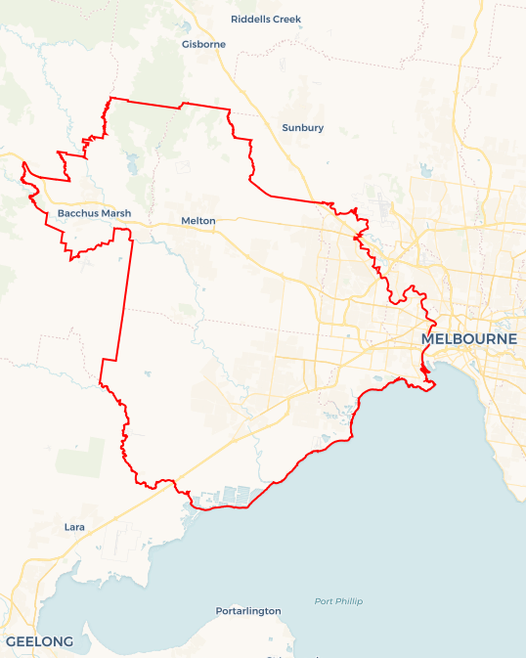
Local Jobs Plan
  - Western Melbourne Employment Region | Victoria | May 2026
Workforce Australia Local Jobs (Local Jobs) is a program that creates partnerships between business
and communities to meet local workforce needs, thereby improving employment outcomes.
Local Jobs operates in all 51 Employment Regions in Australia.

Local Jobs Overview

Local Jobs Plan
Each Employment Region has a Local Jobs Plan which outlines the labour market challenges in the region and the strategies to address these challenges.

Job Coordinators
Each Employment Region has a dedicated Job Coordinator who leverages existing resources, supports local labour markets through structural adjustments and retrenchments, and creates opportunities for collaboration between business and communities.

Local Jobs and Skills Taskforce
Each Employment Region has its own taskforce that meets regularly with the Job Coordinator to develop an understanding of challenges in the region and implement solutions. The taskforce is comprised of representatives from the region.

Local Jobs, Local People Grant
The Local Jobs, Local People grant funds activities that help people into ongoing employment or training. Activities must support local labour market needs.
Explore labour market insights for the
Western Melbourne Employment Region

Local labour market challenges
- Western Melbourne has a diverse labour market profile presenting strong job opportunities in growth industries and skills-in-demand sectors, the region has a history of labour market and social challenges.
- The proportion of the working age population on income support in Western Melbourne is higher than the Victorian average.
- Young people represent a large percentage of the Workforce Australia caseload in the Western Melbourne region.
- Foundation skills, such as literacy, numeracy and digital proficiency, are lacking in some participant groups such as young people, culturally and linguistically diverse people and First Nations, impacting labour market participation.
- Access to public transport and lack of public transport options that align with the start and end times for roles involving shift work.

Local priorities

Priority 1 – Priority industries: transport and logistics, health care and social assistance

What are our challenges?
Western Melbourne is experiencing strong employment demand in the transport and logistics and health care and social assistance sectors with workforce shortages posing a key challenge to continued growth. The transport sector faces ongoing shortages, while in health and social assistance, demand for nurses, aged care, disability and childcare workers is outpacing supply – particularly in growth areas like Melton and Footscray. By further analysing these sectors and leveraging existing government programs, there is clear opportunity to create pathways that support local workforce to move into these in-demand industries.

How are we responding?
- Partnering with employers, industry and stakeholders, including Western Health, Healio Care and transport and logistics industry bodies to support workforce pathways aligned to local demand across priority pathways.
- Piloting innovative, industry-led programs that equip participants with skills and confidence, create direct employment pathways, and boost awareness through place-based activities that educate on available roles, training options and qualifications.
- Working with employers to understand workforce needs and promote Workforce Australia supports to assist with recruitment, retention and workforce development, particularly in growth areas such as Melton and Footscray.

Priority 2 – Employment pathways into major projects

What are our challenges?
Major infrastructure and construction projects across Western Melbourne are driving significant demand for skilled workers; however, barriers, including skills gaps, limited awareness of pathways and limited access to training, continue to impact local participation. This presents an opportunity to strengthen employment pathways and connect local job seekers to apprenticeships, training and job opportunities linked to major projects.

How are we responding?
- Partnering with major employers and stakeholders including Lendlease, Workforce Australia Employment Services Providers and the Victoria University Skills and Jobs Centre to support workforce pathways aligned to major infrastructure demand.
- Supporting employment pathways tied to major projects such as Melton Hospital, Sunshine Superhub, Melbourne Airport Rail and Level Crossing Removal by collaborating with government, industry and training providers to deliver demand-led initiatives that connect local job seekers to apprenticeships, traineeships and direct employment.
- Working with employers to promote accessible pathways into major projects, including supporting social procurement outcomes and educating employers on Workforce Australia supports.

Priority 3 – Young people (youth)

What are our challenges?
Young people in Western Melbourne continue to experience higher rates of unemployment and underemployment, with many facing barriers including limited work experience, lack of employability skills and reduced connection to employers. This presents an opportunity to strengthen pathways into employment and training, while supporting young people to build the skills and confidence needed to enter the workforce.

How are we responding?
- Partnering with stakeholders such as the Western Bulldogs Community Foundation and Apprenticeship Connect Australia providers to deliver youth-focused initiatives, including Youth Fest in the West, industry immersion days, career exploration activities and workshops. We engage directly with young people to ensure programs reflect their needs, aspirations and lived experience, while building employability skills and supporting pathways into apprenticeships, traineeships and priority industries, and improving long-term job readiness.
- Collaborating with Local Learning and Employment Networks to expand career support programs in schools for students and professionals. Additionally, through businesses such as Youth Projects, Third Culture, and local youth centres, we are supporting initiatives that help businesses recruit and retain young people at risk of disengaging from employment or education. We are also supporting organisations that connect young people with suitable employment opportunities.
- Supporting the development of employability skills, including workplace etiquette, communication and understanding of workplace rights, while working with partners like Fruit2Work to support young people, including those with justice system involvement, to improve job readiness and access sustainable employment outcomes.

Priority 4 – Challenges to employment for multicultural communities

What are our challenges?
People from multicultural communities in Western Melbourne often face barriers to employment, including lower levels of written and spoken English and digital literacy, limited understanding of the Australian labour market, unrecognised overseas qualifications, reduced access to professional networks and limited employment history. This presents an opportunity to strengthen inclusive, culturally appropriate and demand-led pathways that improve participation and connection to employment opportunities.

How are we responding?
- Partnering with providers such as PaddyFacts, Sarina Russo, Wyndham Community Education Centre, multicultural organisations and community stakeholders to deliver targeted digital skills programs, build confidence and capability, and co-design culturally appropriate supports that open up stronger employment pathways for Culturally and Linguistically Diverse (CALD) participants.
- Collaborating with employers and stakeholders across priority industries to address barriers, including language, transport, workplace culture, soft skills and access to professional networks, and to promote inclusive recruitment and employment practices.
- Engaging with multicultural communities, community leaders and local stakeholders to better understand emerging employment barriers and opportunities, ensuring Local Jobs initiatives remain responsive to community needs and align with local labour market demand.

Priority 5 – Supporting women into employment

What are our challenges?
Women in Western Melbourne continue to face a range of barriers to workforce participation including caring responsibilities, reduced access to flexible work and underrepresentation in non-traditional industries, with intersectional disadvantage further impacting outcomes for women of colour, older women, women with a disability and those with complex backgrounds. This presents an opportunity to strengthen inclusive, demand-led pathways across priority industries.

How are we responding?
- Create employment pathways for women into industries facing workforce shortages. This includes partnering with employers, industry, employment service providers, training organisations and local councils to co-design and deliver initiatives that provide industry exposure, mentoring and direct recruitment opportunities aligned with local labour market demand.
- Work with local governments, community organisations, and service providers to reduce barriers to employment through tailored supports that build job readiness, confidence, and workforce participation. Targeted engagement activities, industry immersion experiences, expos, and networking events help promote careers in non-traditional industries and boost awareness of career options.
- Support programs that strengthen employer capability to recruit, retain and support women through inclusive practices and positive workplace cultures. By facilitating partnerships and encouraging collaboration across the employment, education, training, and community sectors, we connect women with job opportunities in priority industries, including key entry-level roles in tourism and hospitality. This approach fosters innovative, place-based solutions that deliver sustainable employment outcomes.

Priority 6 – Supporting First Nations peoples

What are our challenges?
First Nations peoples in Western Melbourne still face significant barriers to employment, such as limited access to culturally safe workplaces, challenges with education, digital skills and transport. This highlights the need to strengthen culturally safe, demand-driven pathways and build stronger connections between First Nations communities, employers and local training providers.

How are we responding?
- Partnering with First Nations organisations and employment service providers, including Mob Jobs and SYC to co-design and deliver culturally appropriate, employer linked initiatives such as the Start Your Deadly Careers Program. Supporting culturally safe, demand led pathways across all priority industries, ensuring clear alignment between First Nations participants and local employment opportunities.
- Embedding culturally safe practices across all Local Jobs programs and working with employers and training organisations to strengthen the capability to recruit, retain and support First Nations employees.
- Facilitating access to industry exposure, training and wrap-around supports to address barriers, including educational gaps, digital skills, transport and access to employment opportunities.

Want to know more?
- Contact: Kylie Olsen, Western Melbourne Job Coordinator: kylie.olsen@mylocaljobsprogram.com.au
- Visit: Local Jobs or Workforce Australia

