

Local Jobs Plan

Far West Orana (inc Broken Hill) ****Employment Region**** | NSW | ****March 2025****

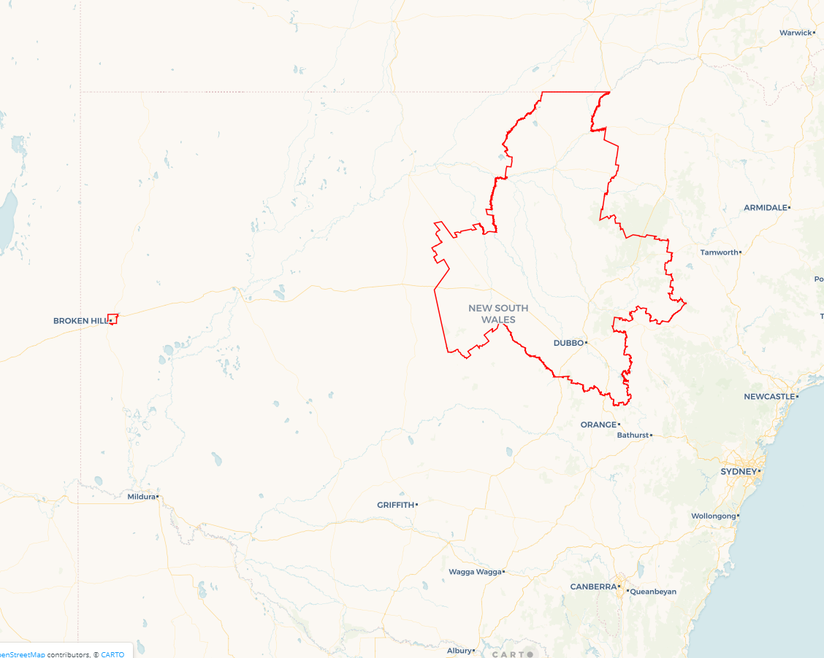Workforce Australia Local Jobs (Local Jobs) is a program that supports tailored approaches to accelerate   
reskilling, upskilling and employment pathways in response to current and emerging local workforce needs.

## Local Jobs elements

### Local Jobs Plan

The Local Jobs Plan sets out the skills and employment challenges and priorities of the region, and associated strategies that will drive the design and implementation of activities to be implemented to address these challenges.

### Job Coordinators

Job Coordinators and Support Officers support the delivery of the program by bringing together key stakeholders including businesses, employment services providers, higher education and training organisations.

### Local Jobs and Skills Taskforce

Each Employment Region has its own Taskforce. Representatives include local stakeholders who have demonstrated experience in upskilling, reskilling, and an ability to represent, connect and collaborate with others in the region to meet labour market needs.

### Program Funds

The Employment Region’s Local Initiatives Fund enables targeted local investments that support local labour market functioning. Further, from 2025/26, a central grants-based fund will respond to local needs and help progress broader employment service reform objectives.

Explore labour market insights for   
[Far West Orana (includes Broken Hill)](https://www.jobsandskills.gov.au/work/employment-region-dashboards-and-profiles/monthly-labour-market-dashboards) Employment Region

## Local labour market challenges in the region

* Limited public and accessible transport options.
* Chronic housing shortage across all Local Government Areas (LGAs).
* High First Nations participant cohort, including high unemployment of First Nations youth.
* High reliance on seasonal work and workers due to predominance of agricultural and agribusinesses in the region.
* Underemployment and underutilisation of workers.
* Limited access to local tertiary education and vocational training opportunities. In particular, face to face delivery of training in regional, rural and remote locations, which has been identified as critical to engagement and success of participants.
* Educational attainment rates are relatively low within the region.
* Critical lack of childcare across most LGAs.
* Retention of local skilled workforce.

## Local jobs and skills priorities and strategies in the region

### Priority 1 – Infrastructure Projects

#### What are our challenges?

We need to develop industry-led and employer focused training and employment initiatives for the multitude of current and projected regional infrastructure projects.

#### How are we responding?

* Building stronger pathways to employment in the region through the identification of intervention points. We’re developing a regional register of current, pending and potential infrastructure and development projects to identify recruitment needs, required skills and timelines to guide local participants into jobs.
* Mapping existing federal, state and local government resources to ensure training and employment opportunities are leveraged, to the fullest extent, locally.
* Developing innovative and agile training, reskilling, upskilling and work experience projects including, where appropriate, the facilitation of micro-credential courses, graduate certificates and employer focused traineeships, apprenticeships and internships.
* Liaising with employers to (a) identify the range of entry levels to jobs and promote the consideration of hiring participants with partial qualifications, who can then learn practical experience and develop their qualifications while employed and (b) identify opportunities for cross collaboration with like employers to develop entry level and training opportunities, with a focus on building regional capacity through local employment.
* Encouraging collaboration between employers and potential mentors who can assist employers strategise and develop employment solutions through a longer-term lens.

### Priority 2 – First Nations Participants

#### What are our challenges?

We need to support equitable access to the local labour market for First Nations peoples by building clearer pathways to employment and training opportunities.

#### How are we responding?

* Working with First Nations Assemblies, Lands Councils and Elders in the community to create meaningful employment opportunities in areas that have significance for First Nations peoples.
* Ensuring educational resources and cultural guidance are provided to assist businesses and employers in their recruitment and onboarding processes.
* Creating local registers of (a) potential projects, including projects that have identified workforce diversity goals and (b) government, education, health and youth services that can be used as employment supports.
* Identifying projects that target First Nations participants for training and employment.
* Promoting training, upskilling, workforce diversity and the range of government resources available to support recruitment and participant retention.
* Promoting education, training and employment programs and leverage local partnerships with Charles Sturt University, TAFE NSW and registered training organisations (RTOs) to provide formal education and training opportunities to geographically dispersed towns in the region, coupled with cultural awareness programs for maximum efficacy. This includes working with First Nations training organisations to provide services in the community.
* Working with First Nations education and training organisations to create sustainable, ongoing employment models and opportunities in the region.

### Priority 3 – Health Care and Social Assistance

#### What are our challenges?

We need to promote Australian Government initiatives and leverage key partnerships to facilitate reskilling and upskilling of participants into Health Care and Social Assistance sectors to build a job-ready skilled workforce.

#### How are we responding?

* Working with government programs, government business development and workforce strategy personnel and local employers to increase visibility of employment options within the sector and provide training pathways and employment opportunities for participants.
* Working with education and training organisations to ensure there are suitable and attractive options for participants to upskill or reskill to meet industry needs. This includes, where appropriate, the facilitation of micro-credential courses, graduate certificates and industry-led traineeships, apprenticeships and internships, with wrap around support for both individuals and employers to facilitate and encourage completion of training.
* Generating awareness for (a) participants to explore multiple career pathways in this sector, not limited by perceptions of roles being confined to hygiene or personal care and focussing on the diversity of roles, including administrative, operational or preparatory duties and (b) youth in the career pathways presented in the sector, linking employment with traineeships, apprenticeships and internship opportunities to showcase the variety of jobs and careers on offer.
* Holding government and industry-led education sessions for sole traders and start-ups to develop business and local employment options within the care, health and community services space.

### Priority 4 – Agriculture

#### What are our challenges?

We need to facilitate job opportunities within the agriculture sector by connecting local projects, training and employment pipelines to participants.

#### How are we responding?

* Exploring opportunities to integrate Agribusinesses with localised infrastructure projects, such as transportation and logistics chains, to boost employment options locally.
* Identifying (a) potential projects and create a workforce map of seasonal labour market needs and (b) government funding opportunities, including grant options for local businesses.
* Facilitating partnerships with local RTOs, educational institutions and other training organisations to upskill and train the local labour force and to investigate and identify transferrable skill sets that can be brought from other sectors into agriculture.
* Holding government and industry-led education sessions to inform local participants of the various types of work and career pathways offered in the agriculture industry.

### Priority 5 – Youth

#### What are our challenges?

We need to develop and implement local strategies to support youth to connect with education and training linked to local employment opportunities.

#### How are we responding?

* Creating a register of locally available youth services, programs and initiatives to inform and design potential education, training and employment pathways.
* Building stronger partnerships between schools, employers and training organisations to ensure regional specific employment and training opportunities are communicated to students in a timely manner. This includes the facilitation of work placement opportunities within identified local industries.
* Utilising youth support services and First Nations organisations to assist in mentorship programs to help steer youth into sustainable employment pathways.
* Holding industry-led career/education sessions for youth to highlight industry specific career options and link available jobs to young participants.

### Priority 6 – Retail, Hospitality and Tourism

#### What are our challenges?

We need to develop industry-led and employer focused training and employment initiatives to decrease severe labour shortages.

#### How are we responding?

* Exploring opportunities to connect tourism, hospitality and retail sectors for mutual collaboration around regional events of significance, to meet the demand from anticipated population and workforce increases across the region to 2025, to boost employment options locally.
* Identifying an annual calendar of events in the region and creating a workforce map of associated labour market needs (e.g. Mundi Mundi Bash in Broken Hill).
* Identifying government funding opportunities for initiatives in the tourism, hospitality and retail sectors, including grant options for local businesses and explore current and anticipated impediments to attracting potential employees to these sectors.
* Facilitating partnerships with local RTOs, educational institutions and other training organisations to upskill and train the local labour force and to investigate and identify opportunities to market roles in the retail, hospitality and tourism sectors.
* Holding government and industry-led education sessions to inform local participants of the various types of work and career pathways offered in the tourism, hospitality and retail sectors.

## Want to know more?

* Contact: Bronwyn Pearson, Far West Orana (inc Broken Hill) Job Coordinator: [ef@farwestoranaljp.com](mailto:ef@farwestoranaljp.com)
* Visit: [Local Jobs](https://www.dewr.gov.au/local-jobs) or [Workforce Australia](https://www.workforceaustralia.gov.au/)