


Workforce Australia Online handbook
  - Improving your experience

With the exception of the Commonwealth Coat of Arms, the Department’s logo, any material protected by a trade mark and where otherwise noted all material presented in this document is provided under a Creative Commons Attribution 4.0 Australia licence.
The details of the relevant licence conditions are available on the Creative Commons website (accessible using the links provided) as is the full legal code for the CC BY 4.0 AU licence.
The document must be attributed as the Workforce Australia Online Handbook.

Contents
Chapter 1. Purpose of this handbook 5
Chapter 2. Overview of Workforce Australia Online 5
2.1 What to expect in Workforce Australia Online 5
2.2 Where to get help 6
2.3 Help with the cost of work-related items 7
Chapter 3. Eligibility, referral and commencement 10
3.1 Signing in to Workforce Australia Online 10
3.2 Differences between Workforce Australia, Services Australia and Centrelink 11
3.3 Applying for income support 12
3.4 RapidConnect 12
3.5 Assessment of your personal circumstances 13
3.6 Commencing in Workforce Australia Online 14
3.7 Completing your profile 14
Chapter 4. Mutual Obligation Requirements, Job Plans, points and job search 16
4.1 Mutual Obligation Requirements 16
4.2 Job Plan 16
4.3 Updating a Job Plan 18
4.4 Meeting your points target and job search requirement 19
4.5 Reporting work, tasks and activities to earn points 20
4.6 Earning points for tasks completed during an activity 21
4.7 Points reporting period 21
4.8 Banking additional points 21
4.9 Submit good-quality applications 22
4.10 How to submit good-quality applications 22
Chapter 5. Activity requirement 22
5.1 Meeting your activity requirement 23
5.2 Not meeting your activity requirement 23
Chapter 6. Targeted Compliance Framework 23
6.1 Compliance zones and symbols 24
6.2 The first time you don’t meet a requirement 25
6.3 The first time you don’t meet your points requirement 25
6.4 Reconnection Requirements 25
6.5 Capability Interview and Capability Assessment 26
Chapter 7. Digital Service Review 26
Chapter 8. Time in Workforce Australia Online and transfers 27
8.1 Transfer from Workforce Australia Online to provider services 28
8.2 Return to Workforce Australia Online 29
8.3 Transfer from a provider to Workforce Australia Online 29

Chapter 9. Privacy and complaints 30
9.1 Managing private information 30
9.2 Complaints 30
Workforce Australia Online journey 31
Mutual obligations requirements in Workforce Australia overview 32
Points Based Activation System overview 33
Online Services Task List 34

Document Control
Version | Change Description | Date
1.0 | D24/4096420: Initial release | 30 September 2024
1.1 | D25/58636: Added Online Services Checklist | 8 January 2025
1.2 | D25/707838: Updated TCF content | 6 March 2025
1.3 | D25/2375432: Updated Digital EF content | 28 May 2025
1.4 | D25/8287165: Updated Digital EF and TCF content | 6 November 2025
1.5 | D26/2020358: Updated Assessments content | 10 April 2026
NOTE: This version of this document was valid at the time it was printed. Please regularly check for any updated versions.

Chapter 1. Purpose of this handbook
This handbook provides consolidated information about Workforce Australia Online. It is designed to help people who have been referred to Workforce Australia Online for support.
You can send any suggestions for improving this document to onlineemploymentservice@dewr.gov.au. We value your feedback. This handbook is not a stand-alone document and does not contain all policies and procedures relating to Workforce Australia Online delivered by the Department of Employment and Workplace Relations. We aim to provide the most up-to-date information in this handbook, however, policies and procedures can change. We encourage you to visit workforceaustralia.gov.au for the latest updates.

Chapter 2. Overview of Workforce Australia Online
Workforce Australia is the Australian Government’s employment service. It includes Workforce Australia Online and a network of providers to deliver personalised support (Workforce Australia Services).
You are generally eligible for Workforce Australia Online if you:
- are receiving government income support (a Centrelink payment)
- have mutual obligation requirements
- have been assessed as digitally capable, job-ready and capable of finding work without help from a provider.
Workforce Australia Online gives you a level of autonomy and flexibility on how and when you interact with employment services. For example, you can report on the study you’re doing and search for tips on attending interviews. While a range of support is available when you participate in Workforce Australia Online, there is a lot more support available in Workforce Australia Services with a provider.
Most of the support and reporting you’ll have in Workforce Australia Online is done through the Workforce Australia platform. You can transfer to a Workforce Australia Services provider at any time, if you feel that provider servicing is more suited to you.
In Workforce Australia Online you’re supported by the Digital Services Contact Centre, which is more than just a help desk. They also help you manage your participation in Workforce Australia Online. For example, they may be able to adjust your reporting requirements if your circumstances change or help you to access additional support. For more information, see the Where to get help section.
Online Services Task List will help you remember what you need to do during your 12 months in Online Services. The Workforce Australia Online journey flow chart outlines features of the service at a high-level.

2.1 What to expect in Workforce Australia Online
In Workforce Australia Online, there’s a range of information, tools and resources online to help you find a job. The Workforce Australia website allows you to:
- build a profile highlighting your skills, experience and qualifications, which registered employers can view
- agree to, and update, your Job Plan, which details what you’ve agreed to do in return for your Centrelink payment
- get information about how to meet your mutual obligation requirements and report them (if applicable)
- learn about the Points Based Activation System, and how to report your activities
- use information included in your profile to create a resume
- get job alerts based on information in your profile and your job preferences
- read inbox messages and SMS, based on your preference, and monitor employer notifications about job vacancies.
Some popular resources on the Workforce Australia website are:
- Find a job
- How to search and apply for jobs on Workforce Australia
- Job Switch
- Online learning modules
- Activities
- Explore training options
- What are mutual obligation requirements?
- If you have a points target
If this handbook doesn’t answer all your questions, visit the Workforce Australia website or contact the Digital Services Contact Centre on 1800 314 677 or DigitalServices@dewr.gov.au

2.2 Where to get help
The Digital Services Contact Centre supports you by providing information and assistance. When you call the Digital Services Contact Centre, you can discuss your personal circumstances, ask to waive or reduce your job search requirements or assess whether Workforce Australia Online is the right fit for you. You can call or email the Digital Services Contact Centre at any time in Workforce Australia Online. The Digital Services Contact Centre can also call you directly in some situations.
The Digital Services Contact Centre can:
- connect you to complementary programs, activities and other support services
- help with the cost of certain items to find and start a job, or to move for a new job
- explain and, if needed, adjust your mutual obligation and points requirements and the support available to you
- check whether the online service is suitable for you and help if you want to move to provider servicing.
You can also search the Ask Izzy website that connects people in need with housing, a meal, money help, family violence support, counselling and much more. It is free and anonymous, with thousands of services listed across Australia.

2.3 Help with the cost of work-related items
People in Workforce Australia Online can request help with the cost of certain items to find and start a job, or to move for a new job. The type and amount of support you can get depends on your circumstances.
Items that may be supported, depending on your eligibility, the discretion of the Digital Service Contact Centre, documentary evidence and relevance, include:
- accredited training
- clothing and personal protective equipment
- driver’s licence, including licence test fees, licence fees and renewal of licences for classifications
C (car) and R (motorcycle)
- petrol vouchers
- phone credit and internet data
- police check
- public transport cards and top ups
- relocation assistance, including short-term accommodation, disturbance costs, removalist costs and travel costs
- workplace checks, including Working with Children, Working with Vulnerable People, and Aged Care Sector checks, or National Disability Insurance Scheme Worker screening checks
- work-related licences
- work-related training, including but not limited to barista training, asbestos awareness and other non-accredited training.
Further information is available in Workforce Australia. Follow the steps below:
- Sign in to Workforce Australia via myGov.
- Go to Coaching and Support in the main menu.
- Select Government Payments and Assistance.
- Select Request help with costs for work items, training, or relocation.
On this page you will find:
- eligibility information
- the goods and services you can request help with
- online forms to request help under various categories
- information about requests you’ve submitted.
To make a request you can either:
- contact the Digital Service Contact Centre (DSCC) on 1800 314 677, or
- submit your request for help online.
To submit your request for help online, follow the below steps:
- Go to Request help with costs for work items, training, or relocation.
- Select the What you can request.
- Click on the relevant category and follow the instructions within the form to make your request.
You can Save and continue or Save and exit at any time.

Figure 1: What you can request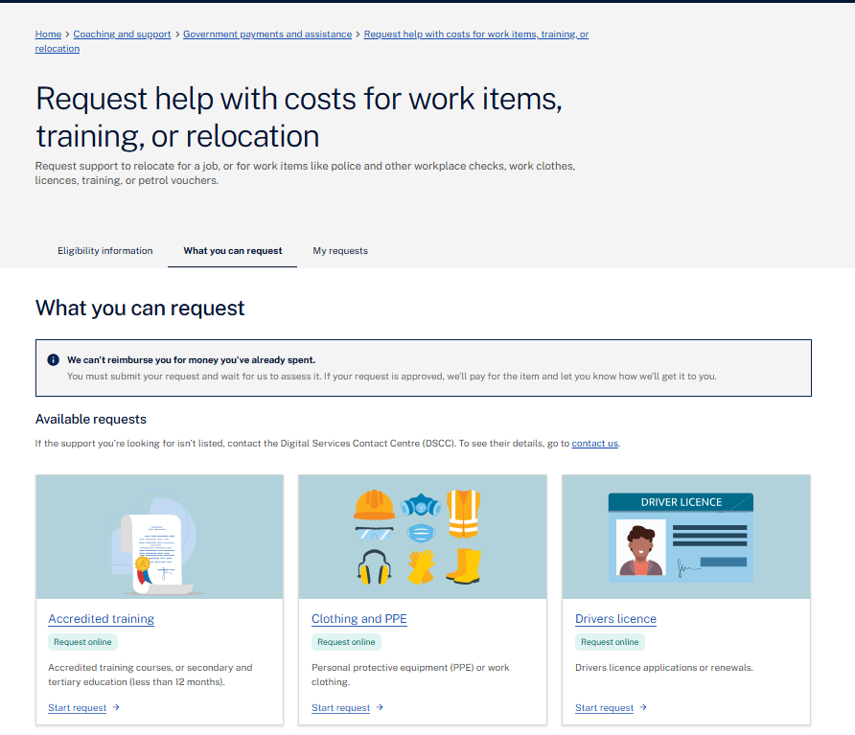
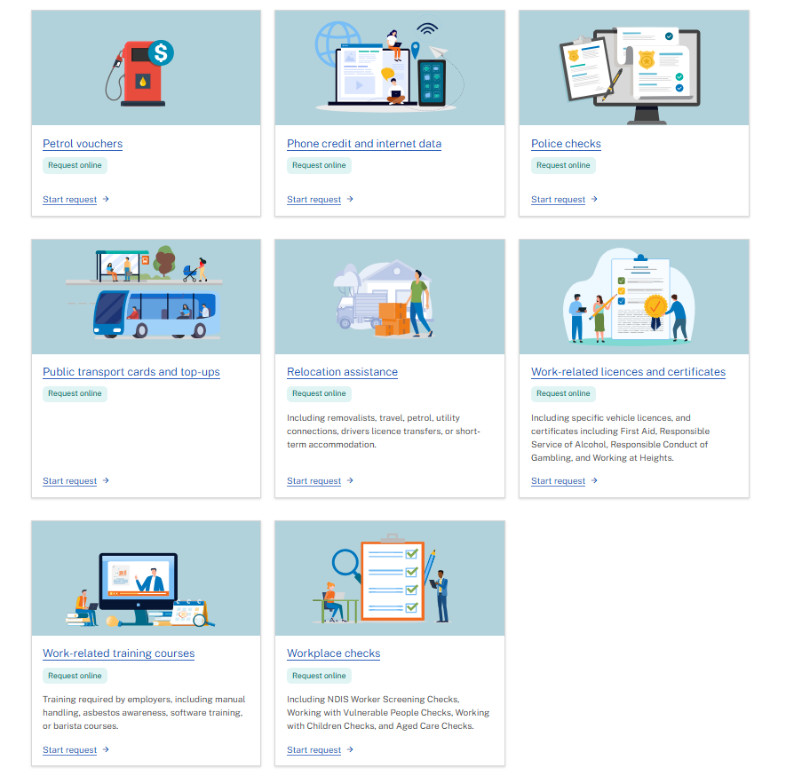
You may be asked to provide additional information or supply quotes for the item or service before a decision can be made. You can do this online by following these steps:
- Go to Request help with costs for work items, training, or relocation.
- Select My requests.
- Find your request in the list. Requests that require additional information or quotes will have Quotes required and More information needed flags. Example below.
- Select the 3 dots on the right side of the request.
- Select Provide quotes.
- Once you’ve uploaded the relevant quotes, select Submit to have your request assessed.
You can Save and continue or Save and exit at any time.
Figure 2: My requests
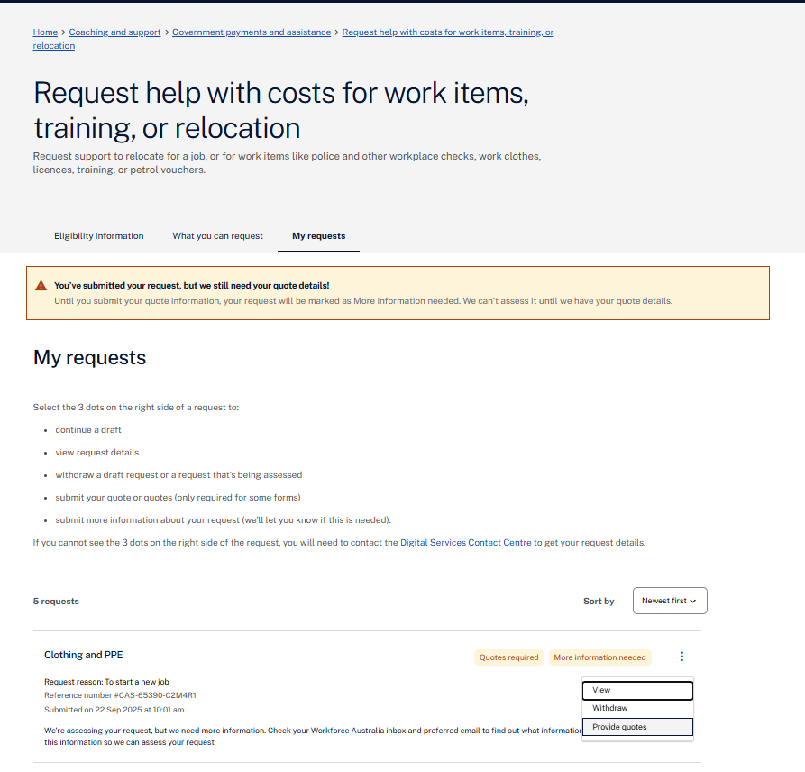
The Digital Services Contact Centre will assess your request based on the information and quotes (if required) provided. Your previous requests will be reviewed as part of the assessment process. The below funding principles must also be met for your request to progress:
- provides work-related tools, skills and experience that assist an eligible person in finding and keeping a job in the relevant labour market
- provides value for money
- complies with any work, health and safety laws that may apply
- withstands public scrutiny
- will not bring the Services, the Digital Services Contact Centre or the department into disrepute.
There is no guarantee that your request for funding will be approved. If your request is approved, the Digital Services Contact Centre will arrange payment to the supplier for the item for which you have been approved. You cannot be reimbursed for items you have already purchased.

Chapter 3. Eligibility, referral and commencement
This chapter outlines who is eligible for Workforce Australia Online, how you enter the service and how long you can stay in it.
You can be referred to Workforce Australia Online from Centrelink, Workforce Australia Employment Services Providers, or from another employment service.
Anyone with a myGov account can use the Workforce Australia website. You don’t have to be receiving Centrelink payment. However, access to financial support is not available to the general public through the Digital Services Contact Centre, and not everyone will have mutual obligation requirements.

3.1 Signing in to Workforce Australia Online
You’ll need a myGov account to register with Workforce Australia. To get started, you first need to link Workforce Australia to your myGov account.
If you have trouble linking Workforce Australia in your myGov account, try to unlink it and sign out of myGov. Then sign back in to re-link Workforce Australia.
Sign in using your Workforce Australia account:
- Go to the Workforce Australia website
- Select Sign in or register in the menu section and choose the Individuals option from the drop-down list. This will take you to the myGov website.
- Enter your details to sign in to your myGov account.
- Enter the security code sent to your device.
- Your Workforce Australia homepage will open.
Sign in using the Workforce Australia app:
- Download the Workforce Australia app
- Open the app and select Sign in with myGov.
- Enter your details to sign in to your myGov account.
- Enter the security code sent to your device.
- Your Workforce Australia homepage will open.
Figure 3: myGov sign in page  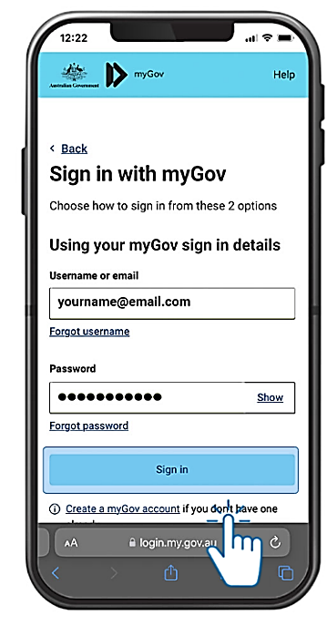 | Figure 4: Workforce Australia homepage  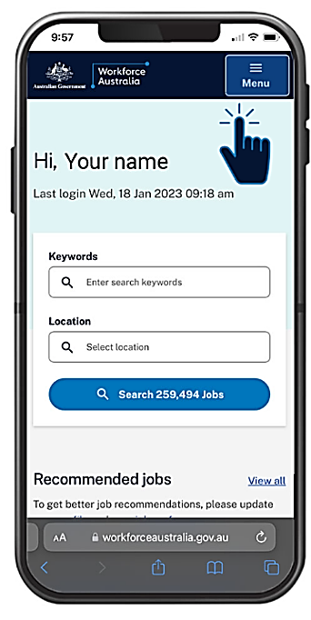
When you sign in, you can explore what’s available in your Workforce Australia account. You’ll get access to tools and features to help you with your job search. You can start using these straight away, even before you have your appointment with Services Australia.
For more information, visit the register to get started webpage or contact the Digital Services Contact Centre.

3.2 Differences between Workforce Australia, Services Australia and Centrelink
Services Australia is an agency of the Australian Government. It delivers a range of welfare payments, health insurance payments, child support payments and other support services to eligible Australian citizens and permanent residents. Centrelink is the part of Services Australia that delivers social security payments and services to Australians.
Workforce Australia is an Australian Government program managed by the Department of Employment and Workplace Relations. It delivers employment services to people receiving certain Centrelink payments and helps Australian businesses to find and hire staff.
Contact Centrelink | Contact the Digital Services Contact Centre
You need to tell Centrelink about issues related to your Centrelink payment.  For example, contact Centrelink to report:  - your income  - a change of address  - a medical illness  - personal circumstances that impact your ability to look for employment and may make you eligible for an exemption from your mutual obligation requirements. | You need to contact us via the Digital Services Contact Centre, if your circumstances change or you have concerns related to Workforce Australia Online.  For example, contact the Digital Services Contact Centre about:  - your ability to meet your obligations  - your monthly points target  - reporting your work  - how to use the Workforce Australia website.
The following table explains when to contact Centrelink and when to contact the Digital Services Contact Centre.

3.3 Applying for income support
There’s a range of Centrelink payments that can help you when you’re looking for work. Generally, you can claim these payments online via your Centrelink account which is linked to myGov.
Before you submit an online claim, you’ll need to book an appointment. The appointment will generally be scheduled within 2 days. For more information, visit the Centrelink website at servicesaustralia.gov.au.
You will also receive a notification by email or text, welcoming you to Workforce Australia. This will explain how to connect to the Workforce Australia Online platform and how to do tasks, such as completing your Job Seeker Snapshot and profile before your eligibility for Workforce Australia Online is confirmed.
If you don’t complete the Job Seeker Snapshot online it will be completed during your appointment with Centrelink. The information you provide in your Job Seeker Snapshot questionnaire will decide whether you will connect with a Workforce Australia Services or Transition to Work provider or be referred to Workforce Australia Online.
Centrelink will also use this information to work out whether you need to connect to Workforce Australia before your payment can commence.

3.4 RapidConnect
People claiming income support are assisted to rejoin the workforce quickly by being immediately connected with a Workforce Australia provider or Workforce Australia Online. This is called RapidConnect.
If you’re claiming JobSeeker Payment or Youth Allowance and you’re referred to Workforce Australia Online, you must agree to your Job Plan before your payment can start. To agree to your Job Plan, you will need to sign into your Workforce Australia Online account on the webpage or app.
In certain circumstances people are exempt from RapidConnect. This is determined by Centrelink. If you’re exempt from RapidConnect you’re not required to agree to a Job Plan before your allowance is payable but may still be required to be connected to Workforce Australia.
If you have questions or need help to agree to your Job Plan, contact the Digital Services Contact Centre.

3.5 Assessment of your personal circumstances
When you apply for a Centrelink payment with mutual obligation requirements, you’ll be asked to complete an assessment called a Job Seeker Snapshot to help us understand your personal circumstances, skills, experience, your job confidence, capacity to work, any labour market disadvantage you might face, and whether you are able to self-manage your requirements online. This is to make sure you’re referred to the most appropriate service for your needs.
Figure 5: Assessing the support you need – Job Seeker Snapshot
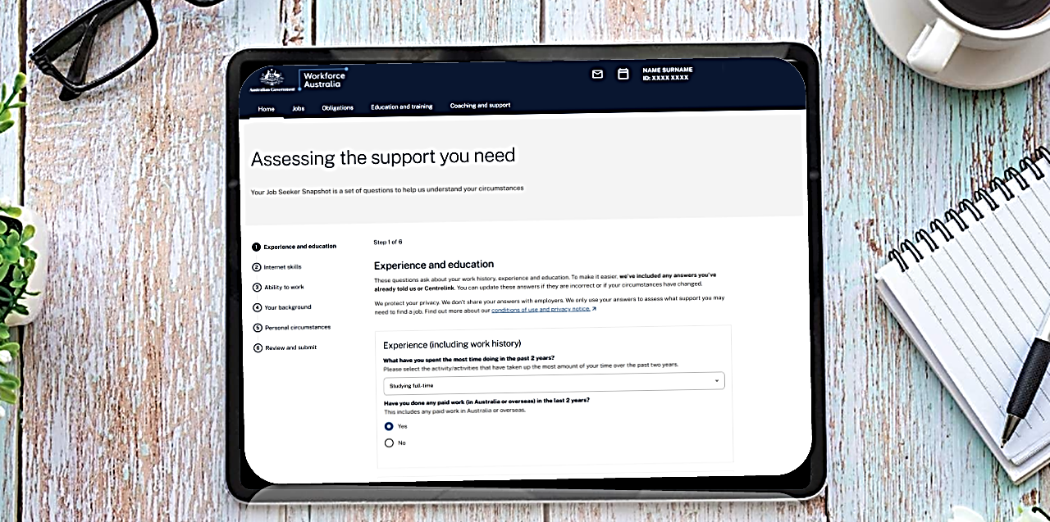
If you have a long-term medical condition or disability, you may be referred to an Employment Services Assessment (ESAt), conducted by Centrelink, to determine your capacity to work and the right employment service for you.
Centrelink staff will then work out if an ESAt is appropriate and will contact you to schedule an appointment for further assessment. This may recommend that you receive support from an Inclusive Employment Australia provider or that you no longer need to participate in Workforce Australia. If so, you will be transferred to Inclusive Employment Australia.
You should update your Job Seeker Snapshot online if your circumstances change and follow the auto-referral prompts or contact Centrelink or the Digital Services Contact Centre for assistance.

3.6 Commencing in Workforce Australia Online
If you’ve been referred to Workforce Australia Online, you’ll need to complete your profile and agree to your Job Plan to commence in Workforce Australia Online. This is done through the Workforce Australia website.
How you agree to your Job Plan may vary, depending on whether you’re subject to RapidConnect or RapidConnect exempt:
- If you’re subject to RapidConnect (via Centrelink), you must agree to your Job Plan before your payment can commence.
- If you’re exempt from RapidConnect (via Centrelink), once your Centrelink payment has been granted, we will send you a message asking that you complete your Job Plan. If you don’t complete your Job Plan, your Centrelink payment may be put on hold
- If you’re transferring from a Workforce Australia Services Provider, you must agree to your Job Plan within 2 business days, otherwise the Targeted Compliance Framework applies and your payment may go on hold. See Chapter 6 of this document, for more detail.

3.7 Completing your profile
You need to complete your profile before you can finalise your Job Plan. Your Workforce Australia profile is like an online resume. You can highlight information such as your employment preferences, skills, qualifications and work history.
Benefits of having a complete and up-to-date profile include:
- making applying for jobs on WorkforceAustralia.gov.au quick and easy
- allowing employers to find you and contact you about potential job opportunities
- helping match you with employment opportunities. You can also receive alerts about suitable jobs helping you become a competitive job candidate.
If you’re reporting points (see Chapter 4. Job Plans, mutual obligation requirements, points and job search), you can earn points for completing your profile. You can also earn points for keeping your profile up to date. Find out more about how to Create your profile.
Figure 6: Example of profile page
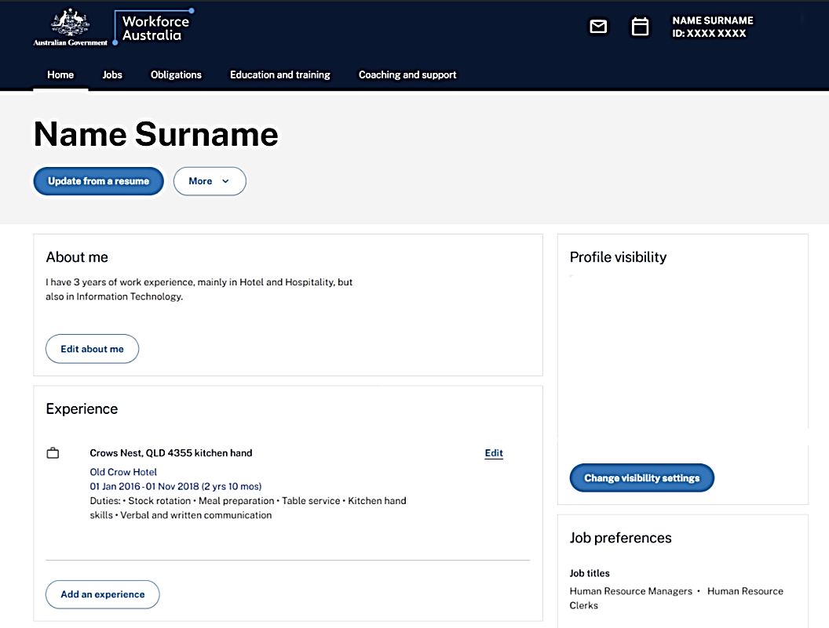
To access and build your profile, you need to either:
    - sign in to Workforce Australia, or
    - open the Workforce Australia app and select Sign in with myGov.
Writing each section of your profile
There are 7 sections of the profile. When you write your profile, especially the About Me section, think about how you want to present yourself to businesses. Try to be as specific as possible when entering your experience, education and skills.
Learn more about How to write a great profile.
Figure 7: Menu page  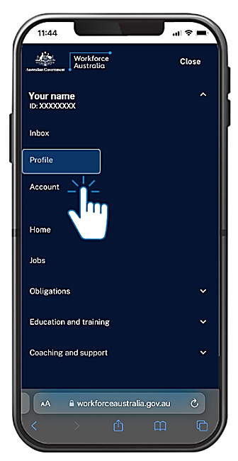 | Figure 8: About me  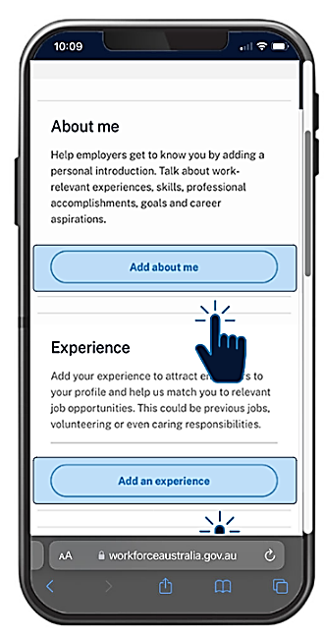 | Figure 9: Education  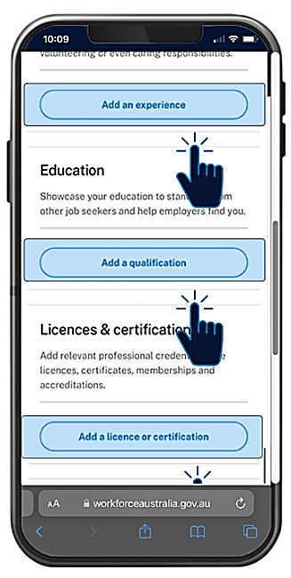 | Figure 10: Skills and Languages  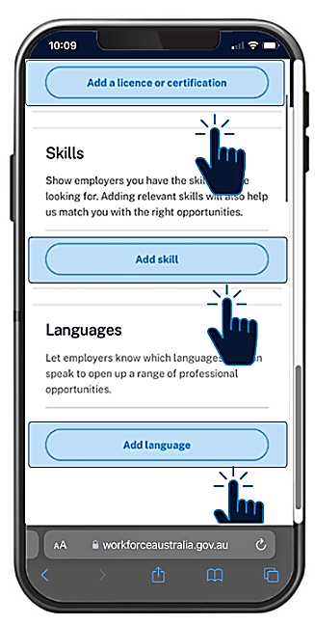
Manage the privacy setting in your account
The privacy settings in your account control who can view your profile. You can set your profile as ‘standard’ or ‘hidden’.
Standard means businesses registered with Workforce Australia can find and view your profile at any time. If you have the skills or experience employers need, they may contact you. You can also create a public link and share your profile with any person or business.
Hidden means your profile can only be viewed by a registered business when you apply for one of their jobs on the Workforce Australia digital platform. When you submit your application, the business can view your profile for 90 days. You can withdraw or extend the 90-day period. Find out more on how to Manage or remove your sensitive information.
If you have other questions about your Workforce Australia profile, contact the Digital Services Contact Centre.

Chapter 4. Mutual Obligation Requirements, Job Plans, points and job search
This chapter provides information about mutual obligation requirements, Job Plans and the Points Based Activation System (PBAS), commonly referred to as the points requirement, for people in Workforce Australia Online.

4.1 Mutual Obligation Requirements
Mutual obligation requirements are the tasks and activities you agree to do in return for your Centrelink payment. You can see a flow chart of your mutual obligations and compliance.
You may have mutual obligation requirements if you’re getting certain Centrelink payments. Payments include:
- JobSeeker Payment
- Youth Allowance for job seekers
- Parenting Payment after your youngest child turns 6
- Special Benefit paid under certain conditions.
Mutual obligation requirements are the tasks and activities that you agree to do in exchange for your income support payment and to help you on your journey to find a job. You agree to these obligations when you agree to your Job Plan (see section below). We may temporarily pause your obligations in certain circumstances – for example, in cases of natural disasters.
If you can’t meet your obligations, you can contact Centrelink or Digital Services Contact Centre to discuss your circumstances. For more information about obligations visit If you can’t meet your obligations.

4.2 Job Plan
If you’re looking for work and getting Centrelink payments, you’ll need to have a Job Plan. Your Job Plan details what you’ve agreed to do in return for your Centrelink payment.
If you’re in Workforce Australia Online and self-managing, we’ll send you a message to review and agree to your Job Plan in your Workforce Australia account.
Figure 11: Example of a Job Plan task on a Workforce Australia account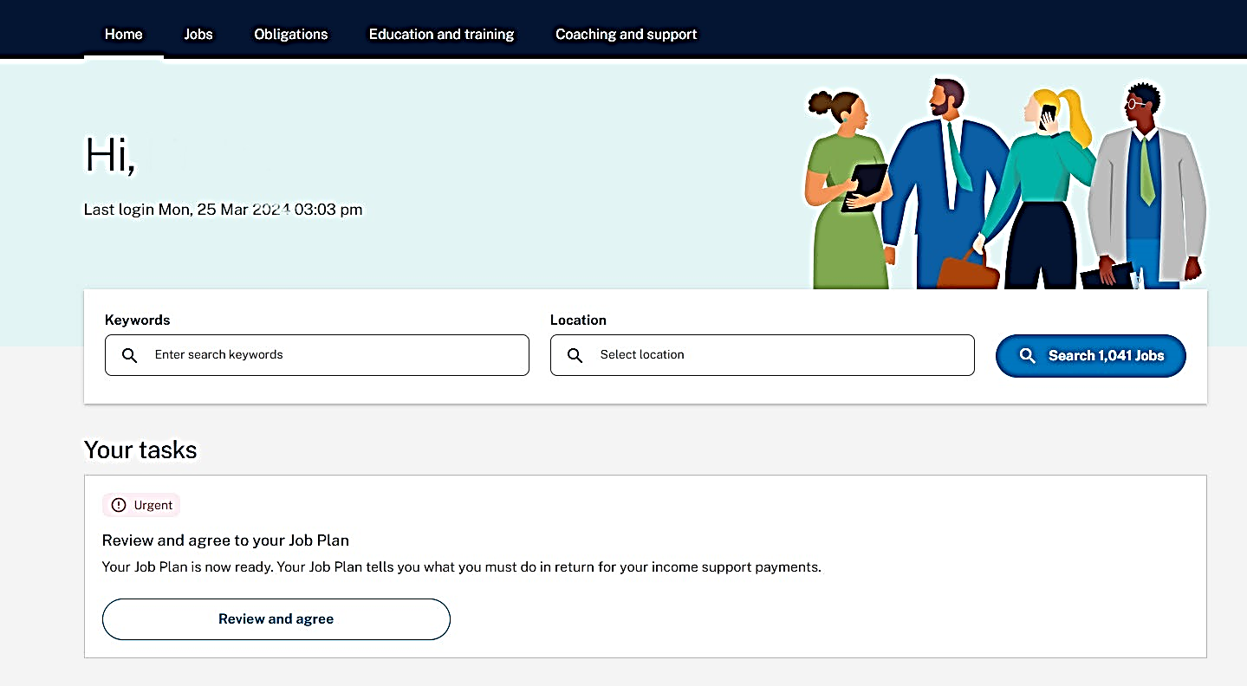
Your Job Plan will generally include the requirement to:
- meet a Points Requirement
  - the Points Target will be displayed on your Workforce Australia account, and you can report tasks and activities through your ‘Report and Earn’ page.
  - the ‘Report and Earn’ page can be accessed by logging into your Workforce Australia online account on the Workforce Australia website or app
- attend and act appropriately during any compulsory appointments with the department or third parties
- attend and act appropriately during a job interview
- accept any offer of a suitable job and not voluntarily leave a suitable job
- accurately record or report attendance at activities.
Most people receiving a Centrelink payment with mutual obligation requirements need to agree to meet these requirements.
You can agree to a Job Plan online or get help from the Digital Services Contact Centre.
If you're having trouble finding or agreeing to your Job Plan, you can:
- unlink and relink your Workforce Australia account in myGov
- merge multiple accounts – see Merge your accounts
- check you have completed your Job Seeker Snapshot
- check you have completed your profile.
If these don’t resolve the issue, contact the Digital Services Contact Centre for assistance.

Figure 12: Example of the ‘Agreeing to your Job Plan’ page
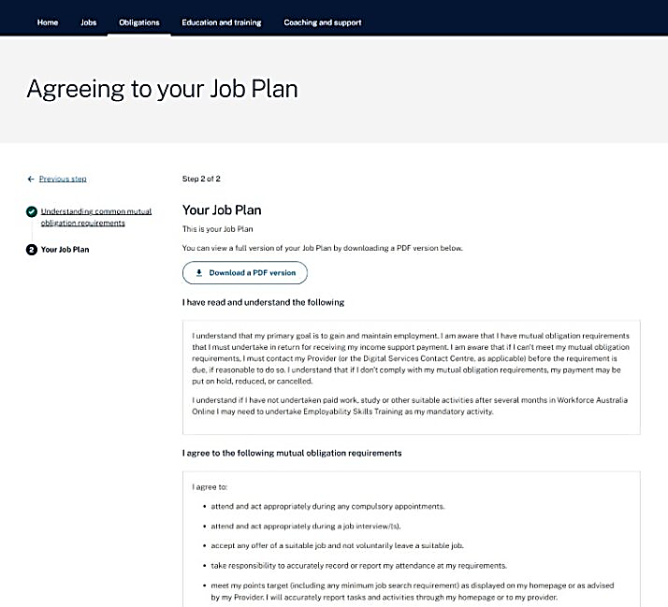

4.3 Updating a Job Plan
You need to review and update your Job Plan when:
- your circumstances change
- you have agreed to undertake Employability Skills Training to meet your mandatory activity requirement
- you’re no longer required to complete Employability Skills Training
- a Capability Interview or Capability Assessment requires you to do new activities.
A notification will be sent to you and an alert will appear under ‘your tasks’ on your Workforce Australia Online account. You have up to 2 business days ‘think time’ to consider and agree to the updated Job Plan.
Note: You can only update your Job Plan if you don’t have any outstanding compliance action. You may have compliance action if you haven’t met your obligations – for example, if you haven’t met your points targets or job search requirement. If you haven’t addressed the compliance action within 28 days, you will be exited from Workforce Australia Online and your Centrelink payment may be impacted. If you have any concerns, contact the Digital Services Contact Centre.

4.4 Meeting your points target and job search requirement
As part of your mutual obligation requirements, you generally have a points requirement, which includes a points target and a job search requirement. This means you’ll need to earn a minimum number of points and undertake a number of job searches as agreed (usually 4), for each monthly points reporting period. See a flow chart of your Points Based Activation System.
If you have a points target and job search requirement, you need to complete both, or your Centrelink payment may be put on hold. You will need to sign in through myGov to see this information on your Workforce Australia homepage.
The maximum points target for each points reporting period is 100 including 4 job searches. Your points target may be automatically reduced in some circumstances, for example if you:
- live in an area with fewer job opportunities
- have a partial work capacity (15-29 hours per week)
- are a principal carer parent with a child aged 6 years or over
- are 55 years or over
- Carer Allowance recipient.
The Digital Services Contact Centre can also adjust your points target and your job search requirement based on your temporary circumstances such as illness, access to transport, or family and caring responsibilities. It is important to contact the Digital Services Contact Centre if you have circumstances that may impact your ability to meet your mutual obligations.
You earn points by reporting the tasks and activities you’ve done. You won’t be able to meet your points target unless you also meet your job search requirement if you have one. You can choose the tasks and activities to meet your points target and that support your employment journey. These can include paid work, study, attending a job interview, updating your profile, or doing online learning modules on Workforce Australia website.

13: Example of the ‘Report and earn points’ screen
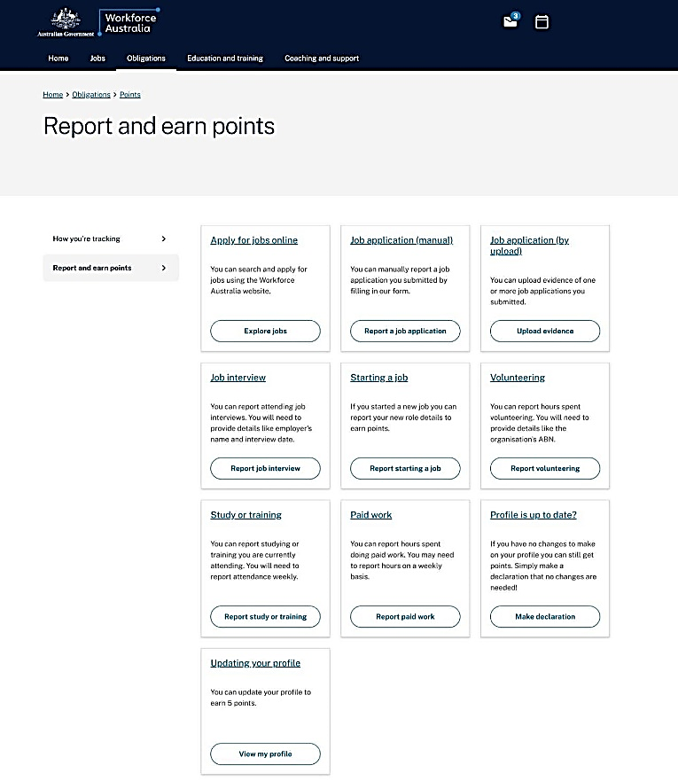

You can do more than the minimum number of Job Searches you are required to do in a points reporting period. These additional Job Searches will earn points and contribute to your Points Requirement.
You can only meet your points requirement (if you have one), if you complete the number of job searches shown on your Workforce Australia Online homepage.
More information on how to earn and report points is available on the Workforce Australia website.

4.5 Reporting work, tasks and activities to earn points
You earn points towards your points target by reporting work, tasks and activities by using the Workforce Australia app or the Workforce Australia website.
Once the points have been reported, you will automatically be allocated the points. There are different ways to report depending on what you’re reporting. For more information, visit How to earn points.
If you are self-employed, visit If you're a freelancer or self-employed page for information on how to earn points to meet your mutual obligations.
For one-off tasks, such as job interviews, you must report each completed task by using the Workforce Australia account or Workforce Australia app.
If you are working, you can earn 5 points towards your monthly points target for every 5 hours of paid work. You can also earn 50 points for starting a new job. This includes full-time, casual, part-time or short-term work. To learn more about how to report a new job or how to report ongoing paid work to earn points, visit Show you did paid work.
For activities, points will be allocated when you report your attendance. You will either need to book the activity listed on Activities to support you into work or advise the Digital Services Contact Centre that you’re doing a new activity such as a study and training course. You will then need to confirm your attendance to receive points. It’s important to confirm your attendance as soon as you’ve done the activity. Note: If you’re required to attend Employability Skills Training at the mandatory activation point, you must attend each allocated session, or your payment may be put on hold.
If you’re unable to attend, please contact the Digital Services Contact Centre.

4.6 Earning points for tasks completed during an activity
You can report the completion of a task and earn points if it was done as part of another activity.
For example, a Job Search, qualification, or short course (such as a construction industry White Card or forklift licence) completed while participating in Employability Skills Training can be reported as a task completed during your points reporting period. This would be in addition to the points earned from attending the activity.

4.7 Points reporting period
Each person has their own points reporting period each month. Generally, your points reporting period starts on the day you agree to your first Job Plan.
For example, if you agree to your Job Plan and commence in Workforce Australia Online on 17 January, your points reporting period will start from this day and will end on 16 February. Your next points reporting period will start on 17 February.
However, there are some instances where your reporting period may be less than a month (e.g. due to an exemption), so it is important you check your Workforce Australia online account regularly, so you know when your reporting is due.
You will get reminders about reporting your tasks and activities:
- 15 calendar days before the end of your points reporting period, and
- 5 calendar days before the end of your points reporting period.

4.8 Banking additional points
If you exceed your points target for the current points reporting period, the additional points may be ‘banked’. They can be used to reduce the points target of your next points reporting period. Your points will automatically be banked at the start of the next points reporting period.
No more than half of your points target can be banked at any time. For example, if your points target is 80 and you earn 120 points, you can bank the additional 40 points for the next points reporting period. However, if your points target is 80 and you earn 130 points, you can still only bank an additional 40 points for the next points reporting period. The 10 additional points will not be banked.
Banked points will round up to the nearest 5 points. For example, if your points target is 75, you can bank half of your points target, which is 37.5. In this instance, the total of points able to be banked will be rounded up to 40 points.
For more information about what you can do if you do not meet your points target, read Chapter 4.

4.9 Submit good-quality applications
We check the quality of your job searches to make sure you’re applying for the right kind of jobs, reporting the details correctly and submitting good quality applications. It’s important to only apply for jobs you have a genuine chance of getting. You should only apply for jobs you’re qualified for and have the right skills. For example, don’t apply to be a delivery driver if you don’t have a driver licence.

4.10 How to submit good-quality applications
When we review your job search efforts, we are looking at each individual application to see if they have:
- clearly identified the employer, the position and the employer’s contact details
- tailored your applications to suit the requirements of the role
- applied for jobs that are suitable for your skills, qualifications and experience.
We’ll also look at the overall variety of your job search efforts over time, to see if you have:
- used a variety of application methods where appropriate (such as online, email, in person or by phone)
- applied for suitable jobs in different types of industries and occupations
- applied for jobs at different levels of pay and seniority, suitable to your skills and experience.
- uploaded appropriate, readable and related material.
For more information on submitting good-quality applications, visit If you must apply for jobs.

Chapter 5. Activity requirement
If you’re not working, studying or learning any skills in an activity during your first few months in Workforce Australia Online, you’ll have an appointment with the Digital Services Contact Centre. This phone appointment is to make sure you’re using the support available to help improve your chances of getting a job.
You can meet your activity requirement with a wide range of activities, work or study. These include courses or training to build your skills, gain relevant experience and prepare for work. You need to advise of any types of work, study or activities you may have been doing. You can report this directly on the website or advise the Digital Services Contact Centre. If you’re not doing any of these, you may be referred to Employability Skills Training, which you must attend.
You’ll receive a message advising you to report any existing work or study. This message will also offer you the choice to do a range of activities available to you.

5.1 Meeting your activity requirement
You can meet your activation requirement by doing and reporting:
- at least 45 hours of paid employment
- accredited education and training that is at least 4 weeks in duration (but also less than 12 months duration)
- a suitable activity such as
  - Adult Migrant Employment Program
  - Career Transition Assistance
  - Employability Skills Training
  - Exploring Self-employment Workshop or Self-Employment Assistance
  - Skills for Education and Employment
  - other local, state or federal government programs with an employment focus, such as the Indigenous Skills and Employment program. You will need to contact the DSCC to report these.
  - Free TAFE courses.

5.2 Not meeting your activity requirement
If you don’t meet your activity requirement, the Digital Services Contact Centre will book you in for an appointment to discuss any work, study or activities you’ve done to date. You need to attend this appointment, or your payment may be put on hold.
Depending on your needs, the Digital Services Contact Centre may:
- enrol you in Employability Skills Training to help develop the skills that employers want, explore career options, and build job search, workplace and industry specific skills
- work with you to determine if another activity would be more suitable
- update your circumstances on the Workforce Australia website
- work out if you require further support from Centrelink or a Workforce Australia Services Provider
- make sure your mutual obligation requirements and points target are suited to your circumstances and negotiate any changes required with you.
The Targeted Compliance Framework will apply if you don’t respond to the Digital Services Contact Centre calls at the scheduled appointment, or don’t attend your Employability Skills Training.

Chapter 6. Targeted Compliance Framework
The Targeted Compliance Framework applies to all people with mutual obligation requirements. It applies if you have not met your points requirement, including the minimum job search requirement, by the end of your points reporting period. It also applies if you don’t answer the phone after the Digital Services Contact Centre notifies you that they have booked you in for an appointment, or if you don’t attend your Employability Skills Training.
If you know beforehand that you won’t be able to meet a requirement, you should contact the DSCC before your requirement is due to inform them that you will not be able to meet it.
If you do miss a requirement, you will receive a notification that you have 5 business days to make up the requirement. This 5 business days is called ‘Resolution Time’ because it gives you time to resolve non-compliance before your payment is put on hold. You can call the Digital Service Contact Centre (DSCC) if you have a good reason for not meeting the requirement and not telling them beforehand.
For more information about the Targeted Compliance Framework, visit Compliance, demerits and zones or you can call the Digital Services Contact Centre and they will:
- make sure your requirements are tailored to your current circumstances and updating those circumstances with you if they change
- explain how to meet your requirements
- explain how and when to report your attendance at activities and the tasks you have completed to meet your points requirement.
If you’re having trouble reporting your attendance at an activity or recording a completed task, tell the DSCC so they can record it for you.
You can see if you’re meeting your requirements on your Workforce Australia homepage. Your homepage will show you:
- how many points you have reported so far
- how long you have left in your current reporting period
- when you need to report
- which compliance zone you’re in.

6.1 Compliance zones and symbols
There are 3 compliance zones with their own colour-coded symbol. You can see these symbols on your Workforce Australia homepage and your participation history page. You can also see them when you sign in to the Workforce Australia app.
Green Zone  The Green Zone means you’re meeting your requirements – this is where you’ll commence when you first start receiving your payment. To stay in the Green Zone, you just need to make sure you’re meeting all of your requirements. | 
Warning Zone  You have demerits: An exclamation point in a circle means you’re in the Warning Zone. You’ll move into the Warning Zone if you get one or more demerits.  If you get 3 demerits, you’ll have a Capability Interview with the Digital Services Contact Centre. This interview is to discuss your requirements and see if they’re right for you.  If you get 5 demerits, you’ll have a Capability Assessment with Centrelink so they can assess if your requirements are suitable.  When you’re in the Warning Zone, your demerits last for 6 months before they expire. To get back to the Green Zone, you need to meet all your requirements until your demerits expire. | 
Penalty Zone  A circle with a red cross represents the Penalty Zone. Decisions in the Penalty Zone are currently paused while the way decisions are made is reviewed.  After your Capability Assessment, we will move you back to the Green Zone and reset your demerits to zero. This is to ensure you do not receive any Centrelink payment reductions or cancellations in the Penalty Zone. You may also get new requirements that better match your circumstances. | 

6.2 The first time you don’t meet a requirement
The first time you don’t meet a requirement after entering Workforce Australia Employment Services, Targeted Compliance Framework won’t apply. Instead, you’ll get a reminder:
- that you need to tell us beforehand if you can’t meet a requirement
- where to find information on your requirements
- of what will happen if you don’t meet your requirements again.
This allows you time to familiarise yourself with your requirements before any consequences, such as payment suspensions or demerits, apply.
The exception to this is if you don’t agree to your Job Plan. If you don’t agree to your Job Plan, the Targeted Compliance Framework may apply even if it is your first missed requirement after entering Workforce Australia Employment Services.
Following this initial warning, if you don’t meet your mutual obligation requirements, the Targeted Compliance Framework then applies.

6.3 The first time you don’t meet your points requirement
If you don’t meet your points requirements (either your points target and/or your minimum job search requirement), this will result in a Points Based Failure. The first time you get a Points Based Failure, your income support payment will go on hold after Resolution Time if you don’t call the Digital Services Contact Centre with a good reason for not meeting your Points Requirement and not telling us beforehand, or, if you don’t have a good reason, to meet the reconnection requirement.
The first time you don’t meet your Points Requirement, your reconnection requirement will be automatically set to ‘light touch’.
To meet your light touch reconnection requirement, you will need to complete an online declaration to confirm your understanding of your Points Requirements. If you can’t do this online, you can call the DSCC for assistance. If you do this during Resolution Time, your payment won’t be suspended.
You’re only eligible for light touch Reconnection once.

6.4 Reconnection Requirements
If you have another Points Based Failure after your light touch reconnection requirement, you’ll need to make up all the points you missed to meet the reconnection requirement. You do this by submitting the number of job searches equivalent to the number of points you missed.
If you don’t agree to your Job Plan by the due date, you’ll also have a reconnection requirement. The reconnection requirement will usually be to agree to your Job Plan.
If you do your reconnection requirement during Resolution Time, your payment won’t go on hold. If you wait until after the resolution time has ended, your payment will stay on hold until you meet your reconnection requirement.
You will also get a demerit on your record. If you have a good reason for not meeting your Points Requirement or not agreeing to your Job Plan, and not telling the DSCC beforehand, contact the DSCC. They may be able to remove the demerit from your record.
If you have any questions or concerns or if you can’t meet your reconnection requirement, the Digital Services Contact Centre can help you.

6.5 Capability Interview and Capability Assessment
If you get 3 demerits on your record in 6 months, your reconnection requirement will be to have a Capability Interview with the DSCC. If your payment is on hold, you’ll need to participate in the Capability Interview for your payment to be restored.
You will receive a notification telling you to contact the DSCC to arrange the Capability Interview. The Capability Interview will usually be scheduled to occur within 2 business days from when you call.
The DSCC will call you for the Capability Interview at the time you arranged with them. If you don’t answer the call and participate in the Capability Interview, your payment will stay or go on hold. At the Capability Interview, the DSCC will discuss your mutual obligation requirements with you to make sure they are right for your circumstances and that you understand how to meet them.
If the result of the Capability Interview is that your requirements are not appropriate to your circumstances, you’ll go back to the Green Zone, and your demerits will be removed. The Digital Services Contact Centre may adjust your requirements to be appropriate to your circumstances, and you may need to agree to a new Job Plan.
If the result of the Capability Interview is that your requirements are appropriate to your circumstances and you are capable of meeting them, you’ll stay in the Warning Zone and keep your demerits.
If you get 5 demerits in 6 months, you’ll have a Capability Assessment with Services Australia so they can assess if your requirements are suitable. You will be notified about how to contact Services Australia for the Capability Assessment. If your payment is on hold, you need to contact Services Australia to arrange the Capability Assessment to have your payment restored. Services Australia will usually conduct the Capability Assessment straight away.
After the Capability Assessment, you’ll be returned to the Green Zone, and your demerits will be removed. If Services Australia determines you are not capable of meeting your requirement, you’ll be transferred to a provider for additional support. You may also get new requirements that better suit your circumstances.

Chapter 7. Digital Service Review
A Digital Service Review can be undertaken to determine whether Workforce Australia Online remains appropriate for you, or if you may benefit from the support of a provider. You may be directed to a voluntary online assessment at 4 and 8 months of service, unless already in employment, study, or training.
The Digital Service Review provides an opportunity to review your access and ability to use the Workforce Australia Online. Depending on your responses to the Digital Service Review, you may be provided information on Workforce Australia Online that can help you find a job, or you may be encouraged to transfer from Workforce Australia Online to a provider.
If you’re directed to voluntarily complete a 4 or 8 month Digital Service Review, it will appear as a to-do item when you log into your Workforce Australia homepage.
Figure 14: Example of your to-do-item for a Digital Services Review in Workforce Australia account
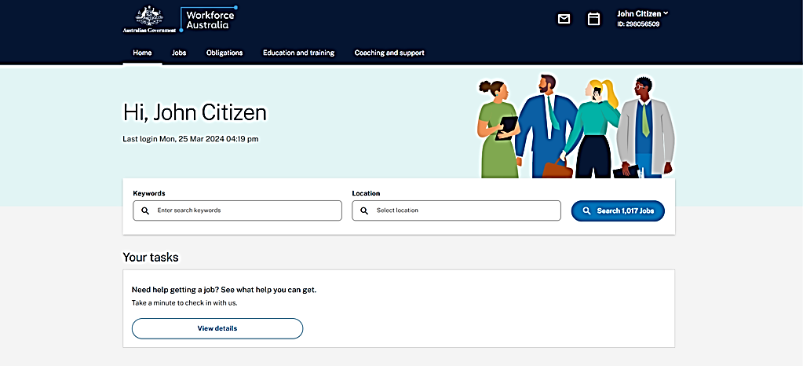
When you select the to-do item, you will be prompted to navigate to the assessment.
Based on the responses you provide in the Digital Service Review you may be given the opportunity to consider moving to provider servicing. You can also choose to move to a provider at any point in time by either using the Workforce Australia Online platform and accessing your account or contacting the Digital Services Contact Centre.

Chapter 8. Time in Workforce Australia Online and transfers
You can participate in Workforce Australia Online for up to 12 months after which the department may then transfer you to a Workforce Australia Services provider. If you meet paid work or study requirements you will be able to stay in Workforce Australia Online for an additional 6 months. We’ll let you know when it’s getting close to the time when you may need to transfer.
Once you transfer, you’ll receive personalised support from a provider in Workforce Australia Services. You won’t be able to return to Workforce Australia Online after you have transferred.
The transfer to Workforce Australia Services won’t affect your Centrelink payments but you’ll need to keep meeting your obligations online until you’ve:
- had your first meeting with your provider
- discussed your Job Plan with your provider.
You may be able to stay in Workforce Australia Online for up to 18 months if you’re declaring enough work or study. We will check that you have reported and earned points for eligible work or study in the reporting period covering your 12th month participating in Workforce Australia Online.
To remain in Workforce Australia Online for up to 18 months we will check that you have declared:
- that you completed 60 hours or more of eligible work, or
- that you participated in eligible study for 28 days or more in the reporting period that covers your 12th month in Workforce Australia Online.
You will receive a notification 4 weeks before you may be transferred to a provider alerting you to the fact that you’re close to your maximum time in Workforce Australia Online. This notification will let you know what you need to do to stay in Workforce Australia Online or how you can transfer to a provider. A notification will also be sent one week before your transfer to a provider, if you receive this notification the Department will be transferring you to a provider.
It is important to report your work and study throughout your points period and not leave it until the very end of the period. This will ensure that you receive the correct notification and most up to date information as to whether you will be referred to a Workforce Australia Services provider. If you have any queries, please contact the Digital Services Contact Centre as soon as possible so we can quickly clarify any issues relating to your circumstances and stop a transfer if appropriate in the circumstances.
If you’re working or studying, you need to tell us. Find out how to report a new job or ongoing work or declare study or training. For more information contact the Digital Services Contact Centre.

8.1 Transfer from Workforce Australia Online to provider services
If you’re having difficulty with Workforce Australia Online, feel like you need more support or you would prefer face-to-face servicing, you can move to provider services at any time. You can do this by either using the Workforce Australia Online platform and accessing your account or by contacting the Digital Services Contact Centre. Centrelink can’t action the transfer to a provider for you.
Figure 15: Example of the transfer to a provider on your Workforce Australia Online account.
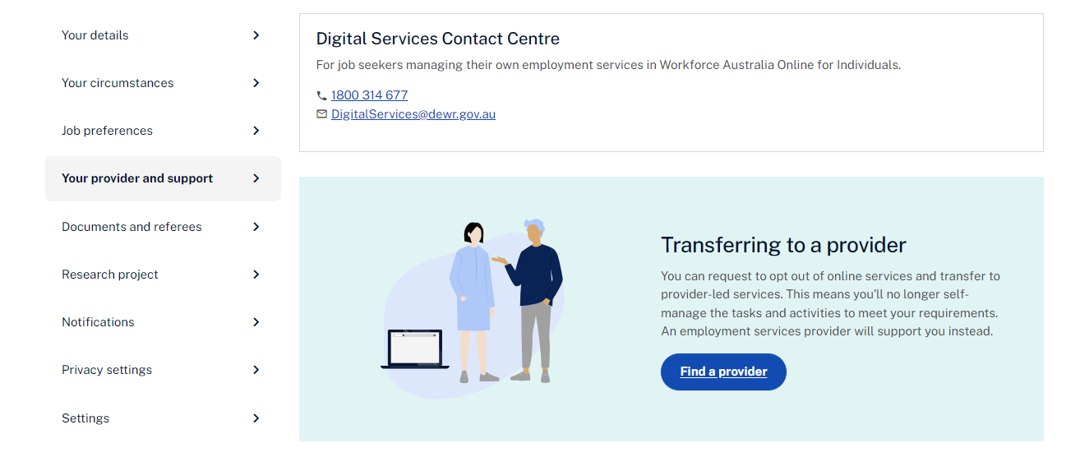

Figure 16: Example of the opt out of Workforce Australia Online screen on your Workforce Australia Online account.
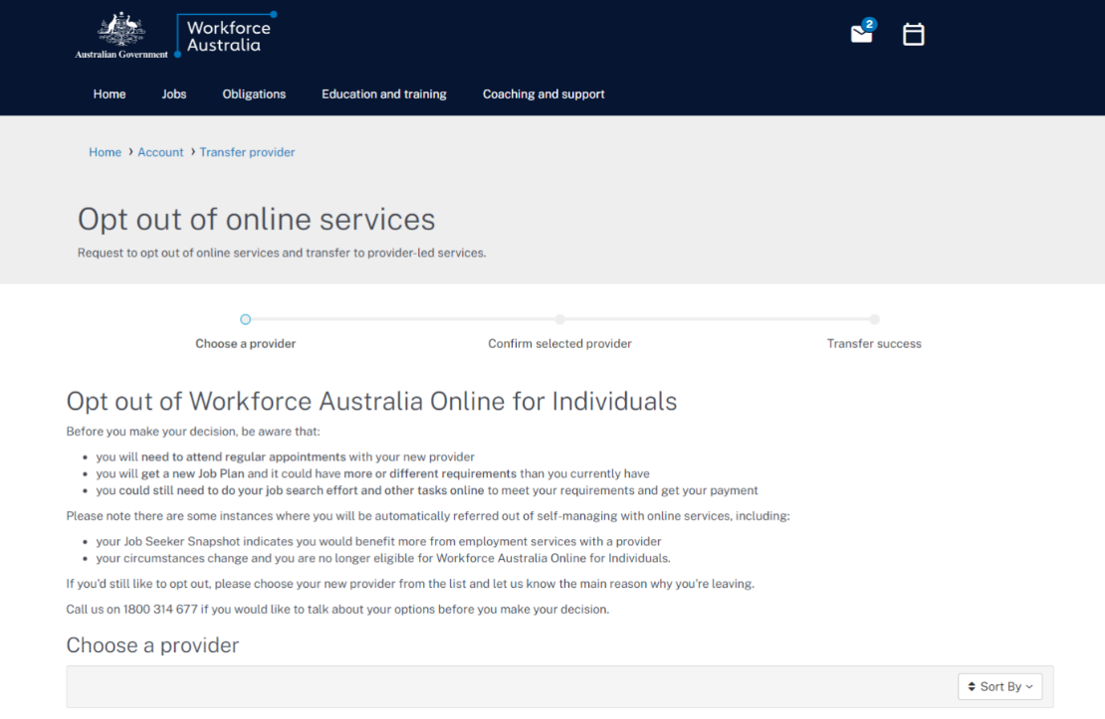
For more support, follow how to Transfer to a Provider in Employment service for people claiming income support.

8.2 Return to Workforce Australia Online
You can only participate in Online Services once per period of unemployment. A period of unemployment is the time between when you registered for Centrelink payment with Centrelink and when you exit employment services for 3 months or more. This means that once you transfer to a provider, you won’t be able to return to Workforce Australia Online in the same period of unemployment.

8.3 Transfer from a provider to Workforce Australia Online
If you’re with a provider, and have not already participated in Workforce Australia Online, you may be able to transfer to Workforce Australia Online to self-manage your obligations. Only your provider can request this transfer on your behalf.
To be eligible for this transfer, your provider needs to:
- assess you’re able to self-manage in Workforce Australia Online, including that you have access to the technology you’ll need
- be able to contact you via email and mobile phone
- agree you’ll benefit from participating in Workforce Australia Online
- confirm you’ve linked your Workforce Australia account to myGov
- ensure you understand and agree to the transfer.

You’re not eligible to transfer in certain circumstances, if you:
- have already participated in Workforce Australia Online in your current period of unemployment (that’s the time since you registered with Centrelink or directly registered with a provider)
- have been assessed as needing provider support
- haven’t registered for myGov and linked your Workforce Australia account.
If you want to transfer to Workforce Australia Online, talk to your provider. If your provider agrees, they’ll submit a transfer request form to the department’s National Customer Service Line. The National Customer Service Line will assess the request and your eligibility. They’ll then send you and your provider an email with the outcome. You must continue with your provider until the transfer request is approved.

Chapter 9. Privacy and complaints

9.1 Managing private information
Please refer to the Privacy and conditions webpage for detailed information on how your personal information will be used and the circumstances in which it may be disclosed to another party.

9.2 Complaints
If you’re not satisfied with the service you’ve received, you should talk to the Digital Services Contact Centre.
If you're still concerned or don't feel comfortable talking to the Digital Services Contact Centre, you can contact the National Customer Service Line.

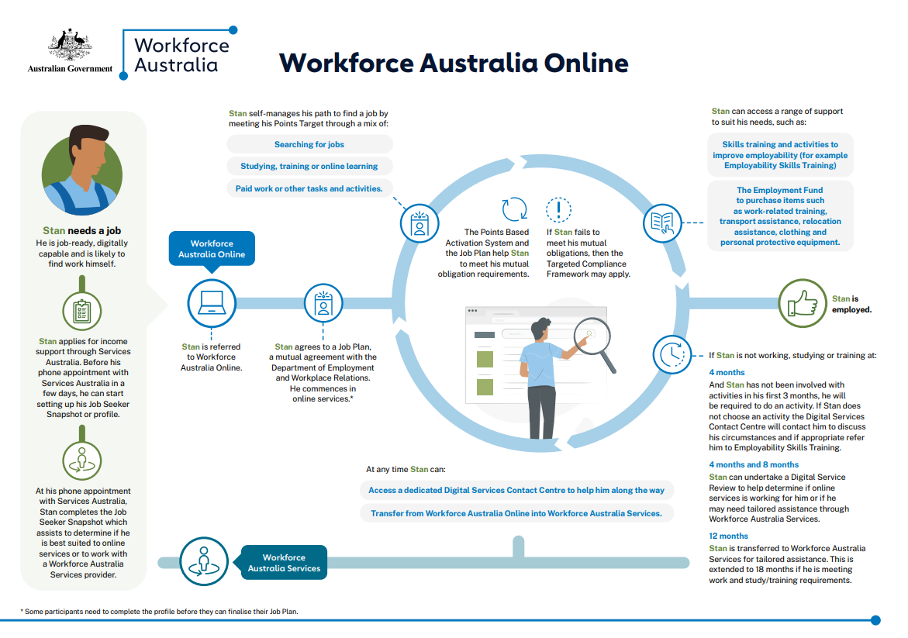
Workforce Australia Online journey

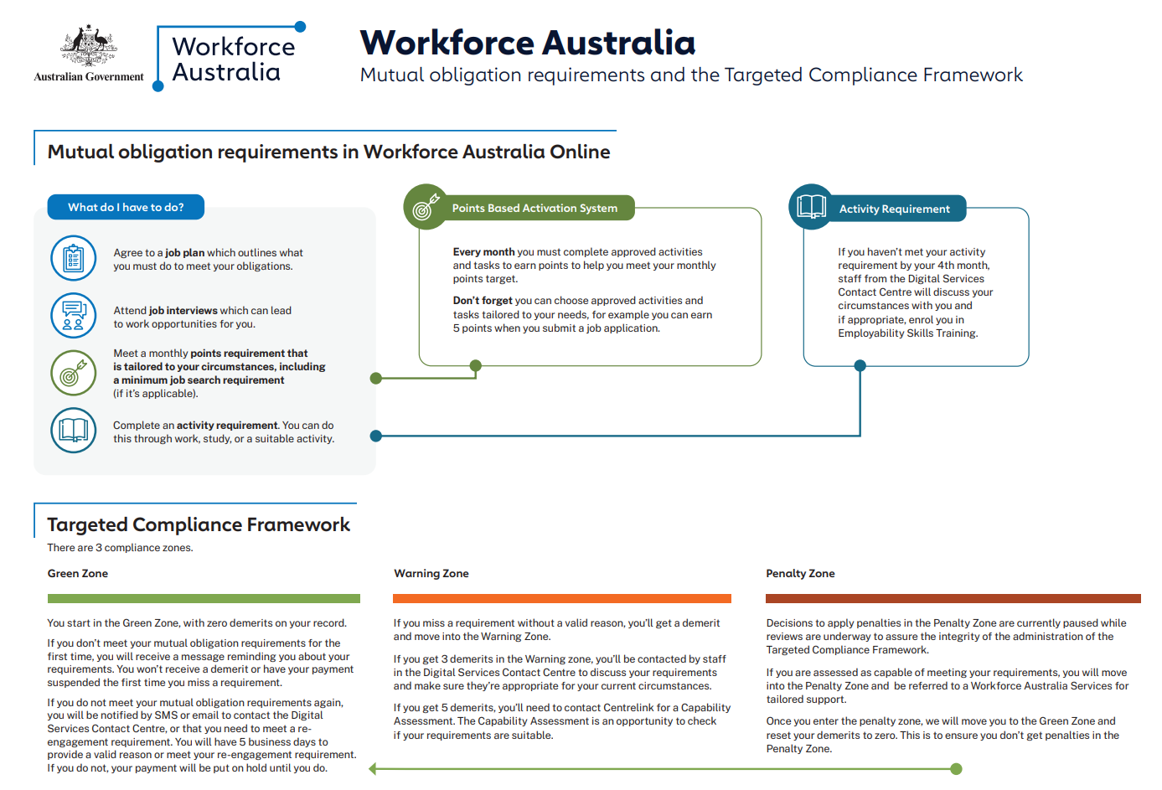
Mutual obligations requirements in Workforce Australia overview

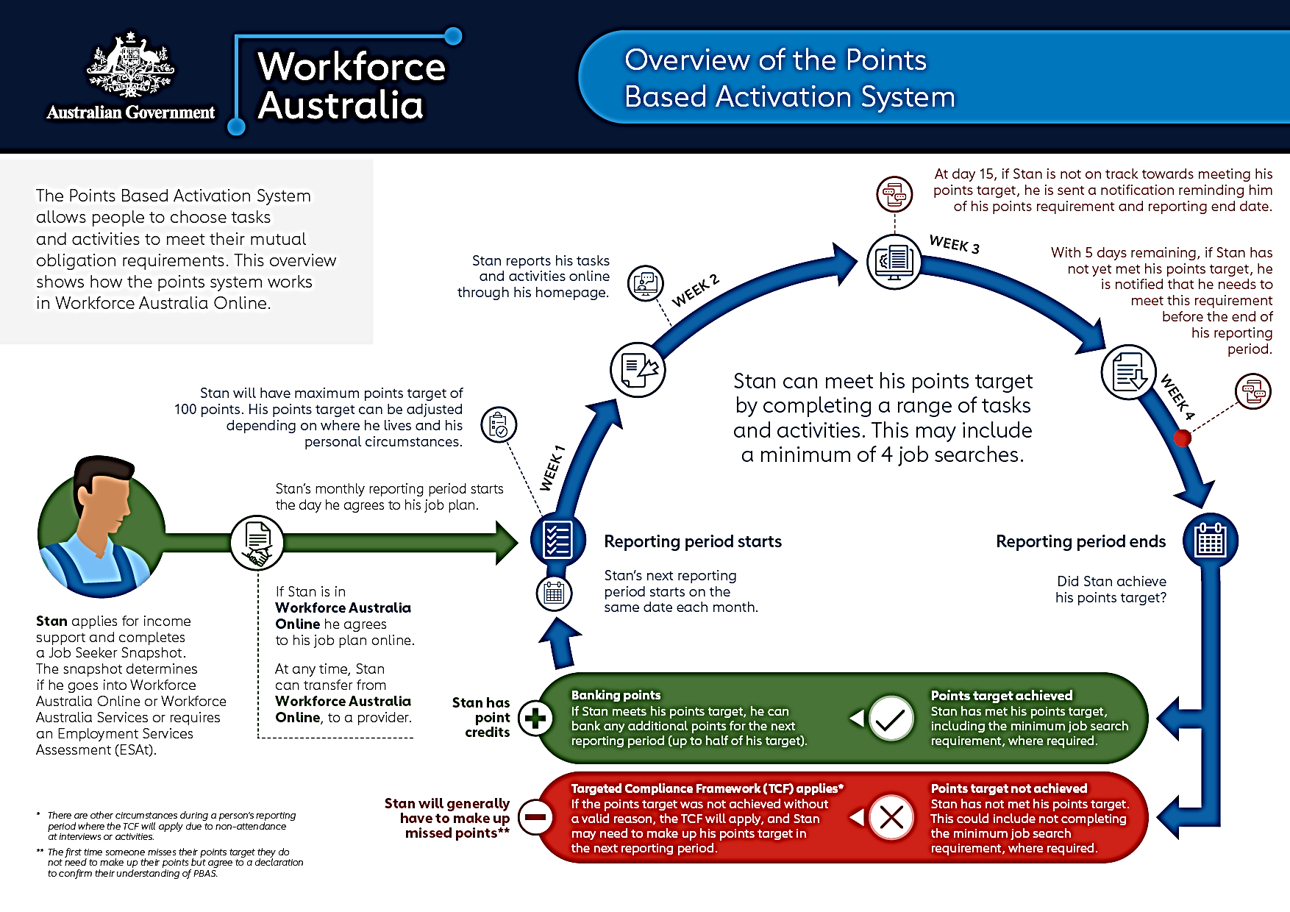
Points Based Activation System overview

Online Services Task List
When | What do I have to do
Week 1 | Complete initial set up - Link Workforce Australia in MyGov (10 min), complete Job Seeker snapshot (10 min), profile (30 min) and agree to Job Plan (5 min).
Week 1 | Learn about your mutual obligation requirements and how to meet them (10-15 min)
Anytime | You can move to a provider at any time if you feel like you need more support or you would prefer face-to-face servicing. You can transfer online in a few seconds.
Every month | Meeting your points target and job search requirement.
4 months later | Meeting your Activity requirement - If you’re not working, studying or undertaking any training in your first few months in Workforce Australia Online, you’ll receive an appointment notification from the Digital Services Contact Centre. At this phone appointment the Digital Services Contact Centre will tell you about the supports available to help improve your chances of getting a job and may refer you to Employability Skills Training.
At 4 months | You can complete a Digital Service Review to confirm that Online Services is appropriate for you (2 min). You can find a link to the review under your Workforce Australia Online Account.
Every month | Make sure to report paid work and/or approved study as part of your points requirement in each relevant month. Please note, you still need to report your employment income separately to Centrelink purposes. Reporting work, tasks and Activities to earn points
When something changes | Have your circumstances changed? Review your Job Seeker snapshot and update your circumstances (10-15 minutes).
Regularly | Regularly check your inbox for any compulsory appointments booked with the DSCC to make sure you don’t miss them.
Anytime | Call the DSCC to negotiate points target and/or job search requirement to meet personal circumstances.
At 8 months | You can complete a second Digital Service Review (2 min) to flag any issues and confirm that Online Services is still appropriate for you.
At 12 Months in Online Services | Your time in Online services is at an end, unless you’re working or studying. You will receive a notification about being referred to a provider in your area. If you have a specific provider in mind, you can transfer to this provider via the Workforce Australia website before your automatic transfer date and we will make sure that you move to your preferred provider.
At 18 Months in Online Services | 18 months is a maximum you can stay in Online Service. After 18 months in Online Services, you will be referred to a provider in your area unless you transfer via the website.

