

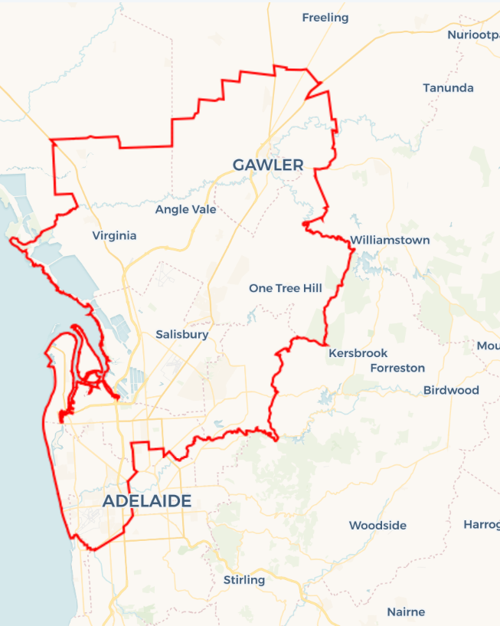Local Jobs Plan

Adelaide North ****Employment Region**** | SA | ****November 2024****

Workforce Australia Local Jobs (Local Jobs) is a program that supports tailored approaches to accelerate   
reskilling, upskilling and employment pathways in response to current and emerging local workforce needs.

## Local Jobs elements

### Local Jobs Plan

The Local Jobs Plan sets out the skills and employment challenges and priorities of the region, and associated strategies that will drive the design and implementation of activities to be implemented to address these challenges.

### Employment Facilitators

Employment Facilitators and Support Officers support the delivery of the program by bringing together key stakeholders including businesses, employment services providers, and higher education and training organisations.

### Local Jobs and Skills Taskforce

Each Employment Region has its own Taskforce. Representatives include local stakeholders who have demonstrated experience in upskilling, reskilling, and an ability to represent, connect and collaborate with others in the region to meet labour market needs.

### Local Recovery and National Priority Funds

The Local Recovery Fund supports projects that meet the priorities identified in the Local Jobs Plan. The National Priority Fund provides funding for innovative local solutions to address structural barriers to employment.

Explore labour market insights for the  
[Adelaide North](https://www.jobsandskills.gov.au/work/employment-region-dashboards-and-profiles/monthly-labour-market-dashboards) Employment Region

## Local labour market challenges in the region

* High demand for entry level and skilled workers in growth sectors such as healthcare, building, civil construction and defence.
* Below average participation and low completion rates for apprentices and trainees.
* Lower educational achievement in some areas resulting in lower levels of literacy and numeracy, including digital literacy and access.
* Limited public transport outside metropolitan Adelaide and limited access to learner driver support impacting work and training opportunities, particularly affecting young people.
* High degree of labour market challenges experienced by key cohorts such as youth, culturally and linguistically diverse (CALD) and First Nations peoples across the region.

## Local jobs and skills priorities and strategies in the region

### Priority 1 – Supply chain – transport and logistics

#### What are our challenges and opportunities?

The supply chain sector is experiencing challenges in attracting and retaining a skilled workforce to load and unload freight from shipping, rail and trucking and to drive goods across metropolitan, country and interstate regions.

#### How are we responding?

* Adelaide North Local Jobs (Local Jobs) is collaborating with shipping, rail and trucking businesses, group training organisations, training companies and other stakeholders to build the profile and raise awareness of employment opportunities in the sector. The Local Jobs and Skills Taskforce (the Taskforce) and stakeholders are working in collaboration with the First Nation’s community to create pathways into each area of the transport and logistics industry.
* Local Jobs is working with local stakeholders to coordinate the range of training options related to current labour demand in the region to provide people with a single, streamlined pathway to upskilling and reskilling information. Pre-employment training and programs in this sector are underrepresented and need more support.
* Local Jobs is working with all levels of government to advocate for the industry in finding funding and program solutions to upskill new and existing workers in the sector.

### Priority 2 – Care and support sector – health, disability, aged and childcare

#### What are our challenges and opportunities?

A national shortage above 1 million people over the next 40 years is forecast. The Adelaide North Employment Region requires 5000 more workers in the next decade in the public hospital setting alone. Significant support is required to gain the workforce attraction and retention required to meet local needs.

#### How are we responding?

* Local Jobs is working with the Northern Adelaide health wellbeing partnership and stakeholders across the network to attract and retain local people to the growth sector. The group is coordinating a range of training options (full qualification, short course and micro-credential) directly linked to current labour demand in the region to provide people with a single, streamlined pathway to upskilling and reskilling information. The group is also exploring funding options for a Northern Adelaide Health precinct careers and skills hub to be included in the new health development within the City of Playford.
* Supporting industry and employers with promotion and showcasing of innovative projects available across the region in person or at online information sessions.
* The health, disability and aged care sector is well represented in the annual Western Adelaide Jobs Expo and the ‘Western Work in the Care Sector’ forum,   
  co-designed with the City of Charles Sturt along with other targeted events, has assisted local people with their pathway into the industry.

### Priority 3 – Building and civil construction

#### What are our challenges and opportunities?

The building and civil construction industry is facing significant workforce demands. Driven by government priorities such as the National Housing Accord, the Australian Skills Guarantee and major infrastructure and community development activities, the need for workers in the sector will continue to grow. In the short to medium term, building and construction of the South Road project continuing from West Thebarton in Adelaide’s west and Defence projects still to be built in Adelaide North and northwest, means the demand for building and construction workers remains significantly high.

#### How are we responding?

* Local Jobs is working with industry specialists and employers to create partnerships and community groups that will see an increased pipeline in engagement into the sector. Specific First Nations construction programs are in development to attract and retain workforce participation across the large infrastructure projects in the region. Strong promotion for women into apprenticeships in non-traditional trades is also a focus.
* The Taskforce is working together to identify infrastructure projects in the region and gain the understanding of recruitment needs, required skills and timelines. The Employment Facilitator and Support Officer remain involved in current industry working groups targeting diversity and inclusion amongst their workforce and trade/project packages.

### Priority 4 – Agribusiness

#### What are our challenges and opportunities?

There are large numbers of vacancies in the agriculture and horticulture sector which were previously fulfilled by backpackers and migrants. Limited transport and infrastructure in the Northern Adelaide plains has also been a significant challenge. The industry needs solutions to the challenges in accessing suitable skills, training and education for the new and existing workforce across their sector.

#### How are we responding?

* The Taskforce is working closely with industry experts, community organisations and employers to create skills and training programs to provide employment pathways for local participants to enter the sector.
* Local Jobs is working with the Northern Adelaide Plains Food Cluster to promote and advocate opportunities within the employers of the region through videos on social media, expos, participant workshops and forums.
* Local Jobs is working with the Northern Adelaide Plains food cluster to support the development of a localised training centre, utilising the Virginia Horticulture Centre as a base for the program. This has the potential to bring employees to the region through collaboration to solve worker and training challenges.

### Priority 5 – Young people

#### What are our challenges and opportunities?

Youth unemployment in the Adelaide North Employment Region has remained consistently above national and state averages for decades. There are high levels of disengagement in education, training and employment which have led to additional challenges to participation in the workforce. Tailored approaches are needed in assisting the young people in navigating towards earning and learning opportunities.

#### How are we responding?

* Local Jobs partner with local services and community groups including First Nations people. Local Jobs have assisted in the creation and co-designing of projects to deliver vocational and non-vocational programs to improve the pipeline and pathways of young people entering education, training, and employment. These are tailored accordingly to the needs of the young people with culturally appropriate delivery and considerations for both First Nations and multicultural young peoples.
* Local Jobs are involved in multiple working groups associated with assisting young people across the community. The network across the working groups range between employers, government agencies, employment services, community services and education.
* Local Jobs are working with stakeholders to create events and forums to improve the knowledge of what is available in the current labour market, along with asking young people for their voice on what they need or what is missing.
* Local Jobs is co-designing tailored workshops promoting how to help individuals into self-employment, work, apprenticeship and traineeship opportunities, site tours, community-based projects, mental health supports and services.

### Priority 6 – Culturally and linguistically diverse participants

#### What are our challenges and opportunities?

The Adelaide North Employment Region has many participants from a migrant and refugee background with underutilised capacity that would assist in the current demands if supported and trained in the local market needs.

#### How are we responding?

* The Taskforce is working on the development of a video library of different career opportunities in the areas of the highest needs in the region, converting it into the languages of the highest representation across Workforce Australia Employment Services Providers.
* The Taskforce is developing and implementing overarching industry-specific recruitment models in areas of regional skills shortages that expedite business and individual connections. These will be tailored to individual business needs and enable collaboration to increase engagement. We are working with experts in the field of cultural awareness for employers and implementing a better understanding of workplace culture for participants.
* Creating workshops and events that assist in addressing the challenges to employment, including a tailored approach to women from a diverse background on engaging and connecting to appropriate services and pathways to education, training and employment.
* Local Jobs is supporting individuals and businesses to build entrepreneurial capability and innovation in response to new and emerging economic opportunities in the region.

## Want to know more?

* Contact: Rosslyn Ward, Adelaide North Employment Facilitator: Rosslyn.Ward@employmentfacilitator.com.au
* Visit: [Local Jobs](https://www.dewr.gov.au/local-jobs) or [Workforce Australia](https://www.workforceaustralia.gov.au/)