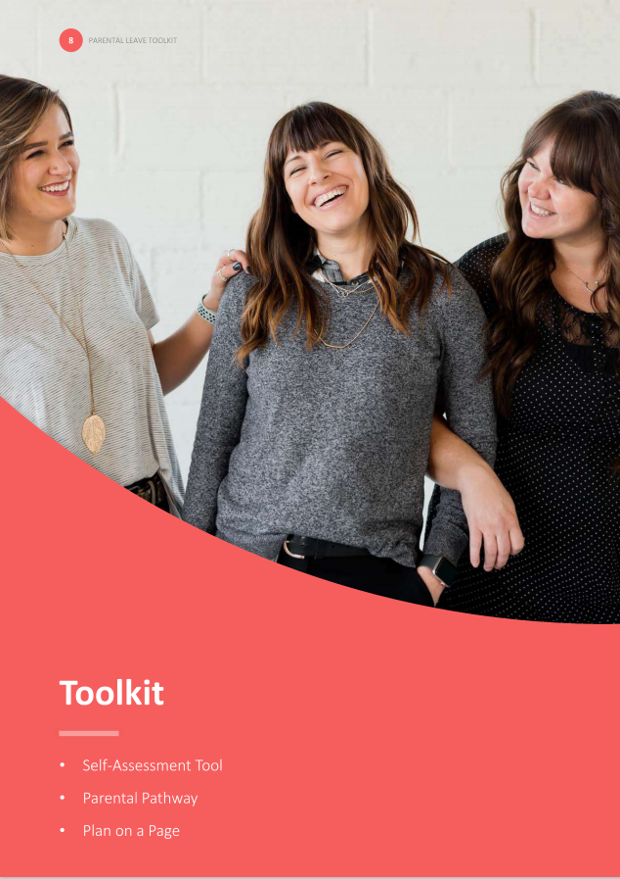

* Designing for your environment
* The Parental Pathway

# Designing for your environment

**Improvements don’t have to involve wholesale change or significant financial investment. There are small but impactful practices that businesses can adopt to improve the employee experience.**

It is important that solutions work within your unique context. As a first step, focus on deepening your understanding of the current employee experience. Deliberately observe, reflect, capture, and unearth practices that are working in your business and engage in open dialogue with staff to elicit their views.

It is useful to remember that a number of impactful initiatives and networks will already be in operation across the business. These may take the guise of WhatsApp groups, peer to peer relationships or, informal baby clothing exchanges, operating under the radar.

A ‘Parental Pathway’ or ‘user map’ may support you to surface, tailor, target and, scale solutions for your business. It may also help you to unearth ‘the moments that matter’ – transformative snippets of time that have a lasting emotional impact on how individuals feel. To develop your parental pathway/ pathways:

| **Initiative** |  |
| --- | --- |
| **1. ASK THE EXECUTIVE** | **Notes** |
| Use the self assessment tool (P10) to initiate a conversation with leaders or the executive team. Use the outputs of the conversation to help to scope that parental pathway and determine whether to develop a high level map showing the end to end experience, or a more detailed map that focuses on a particular interaction. | Click or tap here to enter text. |
| **2. GATHER THE RELEVANT DATA** | **Notes** |
| Examine your HR data. Look for patterns of new parents within the business.   * + Are there peak times that staff leave the business?   + Where is the largest concentration of staff who have recently become parents?   + What information can you gather from annual performance reviews or staff engagement surveys? | Click or tap here to enter text. |
| **3. CONSULT WITH STAFF** | **Notes** |
| Seek diverse and broad views across levels, teams, domains, roles and subject areas. Speak with parents, managers, pregnant staff and recent returners about their experiences. Consider asking them about the moments that mattered to them:   * + What worked?   + What didn’t work?   + Who did you rely on for support and guidance?   + What advice would you give to new or expectant parents? | Click or tap here to enter text. |
| **4. CONSOLIDATE** | **Notes** |
| Put together the information you have and create personas based on common experience. Sketch a journey in the format of step by step interactions, with a focus on:   * + The moments that matter or touch points and interactions with would be, expectant and returning parents   + Channels where interactions occur   + The emotional state of individuals during interaction   + Pain points | Click or tap here to enter text. |
| **5. VALIDATE AND REFINE** | **Notes** |
| The parental pathway should support in the development of a truthful narrative and help to create a shared vision for the future.  When the pathway has been created, take time to validate it. Engage and broaden the consultation group to help test and challenge assumptions.  Use additional information and responses to ensure your parental pathway is representative of real cases. | Click or tap here to enter text. |
| **6. CLOSE THE LOOP** | **Notes** |
| Diversity and inclusion initiatives are most effective when the executive or leadership team own initiatives and outcomes. Once the parental pathway has been completed, be sure to share your finding with them, and use it as a tool to collectively identify initiatives and actions to be executed with HR assistance.  Remember to focus on the moments that matter, targeting critical transitions points that are likely to derail or strain even the most competent working parents. Focusing attention on these pivotal points can help keep employees focused and engaged in the moment and longer term. | Click or tap here to enter text. |

# 

# The Parental Pathway

## Figure 1 and Figure 2 on the following page show the ‘Parental Pathway’. They look at two common scenarios faced by women in the workforce.

The first of these depicts a poor experience and is characterised by uncertainty, stress and concerns about career progression. This scenario reflects the experience of many women, whose mental health, and commitment to work is adversely effected by an absence of clear support.

The second pathway shows an optimised experience, where the organisation views parental leave as a brief interlude in an otherwise long term career. In this scenario, the woman in question is clear about company policies and entitlements, is supported by her manager and has avenues in which she can stay connected to the business whilst on parental leave.

## The pathways can help businesses to recognise the ‘moments that matter’ and support you to develop and enhance your own.

Figure 1: PARENTAL PATHWAY: POOR EXPERIENCE



Figure 2: PARENTAL PATHWAY: OPTIMISED EXPERIENCE