


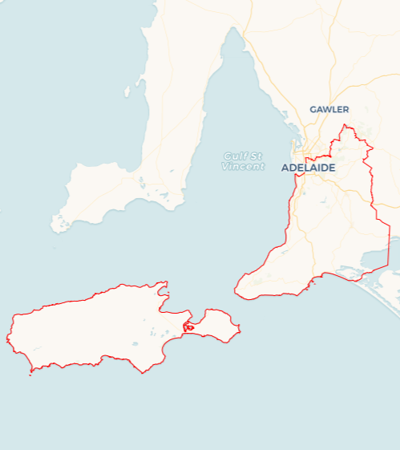
Local Jobs Plan
  - Adelaide South Employment Region | South Australia | July 2026
Workforce Australia Local Jobs (Local Jobs) is a program that creates partnerships between business
and communities to meet local workforce needs, thereby improving employment outcomes.
Local Jobs operates in all 51 Employment Regions in Australia.

Local Jobs Overview

Local Jobs Plan
Each Employment Region has a Local Jobs Plan which outlines the labour market challenges in the region and the strategies to address these challenges.

Job Coordinators
Each Employment Region has a dedicated Job Coordinator who leverages existing resources, supports local labour markets through structural adjustments and retrenchments, and creates opportunities for collaboration between business and communities.

Local Jobs and Skills Taskforce
Each Employment Region has its own taskforce that meets regularly with the Job Coordinator to develop an understanding of challenges in the region and implement solutions. The taskforce is comprised of representatives from the region.

Local Jobs, Local People Grant
The Local Jobs, Local People grant funds activities that help people into ongoing employment or training. Activities must support local labour market needs.
Explore labour market insights for the
Adelaide South Employment Region

Local labour market challenges

- High demand for workers with many major projects such as Torrens to Darlington and Women’s and Children’s Hospital and key Defence supply chain recruitment drives in progress across the region.
- Areas across the region have differing challenges needing local solutions, with key factors such as transport, ageing populations and changing business operations requiring upskilling and reskilling.
- Housing and cost of living pressures for those both in and outside of the workforce.
- Private transport is often required for job opportunities, as public transport does not support cross-region travel or early/late work hours.
- Underemployment and untapped labour market exists due to casual work, pay disparity and significant number of hidden unemployed not counted in the labour market data.
Local priorities

Priority 1 – Support and empower local business and industry to maximise options for local employment solutions, including options for traineeships and apprenticeships

What are our challenges?
Employers in the region have noted challenges in finding and retaining suitable staff. Some pockets across the region have higher youth unemployment levels, while others have an older population with people needing to reskill due to changing industry requirements.

How are we responding?
- Ensuring that local workforce initiatives such as Adult Community Education and other government funded projects include appropriate supports and work experience elements to assist individuals to enter or re-enter the workforce.
- Collaborating with key industry bodies to raise awareness of apprenticeship and traineeship pathways, literacy and numeracy support and provide opportunities for them to showcase roles to Workforce Australia Employment Services Providers in the region.
- Increasing access for businesses to seek appropriate training and reskilling for existing staff. This involves linking businesses with appropriate programs and opportunities to improve staff retention and prevent ongoing retrenchments.
- Providing avenues for businesses to showcase roles at career events and business forums to give them an opportunity to meet with local candidates, with a particular focus on increasing workforce participation by women, young people and First Nations candidates.

Priority 2 – Maximise opportunities for local jobs to be filled by local jobseekers, with a particular focus on the key sectors of care and support, construction and manufacturing

What are our challenges?
Individuals face challenges entering or re-entering the workforce due to barriers such as limited work readiness, digital skills, transport access, motivation and confidence. While employers across key sectors are seeking local skilled workers, they are often uncertain about finding the talent they need. At the same time, major regional infrastructure projects require a sustainable workforce pipeline to meet industry participation targets for long-term employed people, trainees and apprentices, and First Nations workers.
How are we responding?
- Developing place-based workforce solutions with industry, councils, labour hire, government and communities to support workforce planning and promote training pathways in growth sectors.
- Leveraging community, industry and regional partnerships to identify skill gaps and increase employment and training opportunities.
- Promoting training, apprenticeship and traineeship pathways in key industries through partnerships with employers and Apprentice Connect Australia Providers.
- Connecting employers and job seekers through targeted industry events in sectors such as care and support, construction and advanced manufacturing.
- Engaging Taskforce members and business networks to raise awareness of workforce challenges, co-design solutions, and share innovative and inclusive workforce practices.

Priority 3 – Showcase and communicate information about career pathways, training options and community supports and programs

What are our challenges?
There is often a mismatch between employer needs for staffing with the availability of localised training solutions. This is particularly evident in remote parts of the region such as Kangaroo Island.

How are we responding?
- Providing accessible and timely information on employment, training, community activities and support services across the Employment Region through a range of communication and engagement channels.
- Promoting current and emerging employment, training, traineeship and apprenticeship opportunities by connecting employers and training organisations with job seekers and Employment Services Providers.
- Coordinating and supporting expos, forums, networking events and other workforce initiatives in partnership with councils, employer networks, industry stakeholders, and growth sectors.
- Facilitating collaboration between Employment Services Providers, training organisations, First Nations groups and community partners through regular engagement, information sharing and the promotion of local initiatives and support programs.

Priority 4 – Support local young people to gain employment

What are our challenges?
Youth unemployment has remained high in certain parts of Adelaide South with many not engaged in either education or employment. There are many strong youth networks across the region all striving for the same priority to link young people to opportunities and training pathways with tangible outcomes.

How are we responding?
- Partnering with Transition to Work providers on suitable programs to support and engage youth and presenting them with opportunities and increase take up of entry level opportunities, with a focus on future proofing their skills to take up new and emerging opportunities.
- Communicating vocational and other support programs from Headspace, Southern Youth Round Table, Southern Fleurieu Youth Network and Community Investment Committee who all have a focus on elevating opportunities for youth to create skills development pathways to meet workforce needs.
- Advocating with councils and other decision makers in the local community for options and opportunities for young people.
- Codesigning suitable projects by meeting with young people and seeking their input into appropriate activities to better understand their challenges in moving into the jobs market.

Priority 5 – Support older job seekers to tap into programs and opportunities for employment in key sectors

What are our challenges?
Mature aged job seekers bring valuable skills and experience to employers but can lack confidence in a rapidly changing labour market. With increasing numbers leaving the workforce due to retrenchments, including retail closures, many may be unaware of available employment and support services, particularly if they are not receiving welfare payments.

How are we responding?
- Providing opportunities through community centres and local councils to ensure that older community members are aware of suitable activities and events to meet with employers and training organisations, including increasing digital capability in readiness for future careers.
- Working with local Adult Community Education providers and Skills for Education and Employment Program providers to source tailored solutions for this cohort.
- Ensuring local businesses are well placed and provide links to available tools and resources so they become better able to support mid-career individuals as they transition to different sectors.
- Showcasing opportunities regarding Adult Apprenticeships and upskilling opportunities.

Priority 6 – First Nations employment

What are our challenges?
First Nations people across Adelaide South continue to face barriers to accessing employment, including limited visibility of support services and a lack of culturally supportive workplaces. There is an opportunity to better align actions with Closing the Gap priorities, strengthen community-led approaches, and improve employer capability through stronger local partnerships.

How are we responding?
- Increasing awareness of First Nations training, employment and support services through partnerships with Aboriginal Community Controlled Organisations and local First Nations organisations, such as Tauondi Aboriginal Pathways Centre, Neporendi, The Circle and RAW.
- Strengthening ongoing consultation with Aboriginal community members and experts to inform program design and align activities with Closing the Gap priorities.
- Building employer capability and cultural safety by supporting appropriate recruitment, onboarding, and retention practices through engagement between employers and HR managers with Aboriginal specific organisations.
- Supporting First Nations-led employment and community initiatives by facilitating events that connect culture, training and employment pathways, improving access to information, strengthening connections between providers and jobseekers, encouraging First Nations procurement and ACCO participation in grants and tenders.

Want to know more?
- Contact: Leanne Hill, Adelaide South Job Coordinator: leanne.hill@mylocaljobsprogram.com.au
- Visit: Local Jobs or Workforce Australia

