


VET Workforce Blueprint
  - October 2024

© Commonwealth of Australia 2024

The material in this document is licensed under a Creative Commons Attribution 4.0 International license, with the exception of:
- the Commonwealth Coat of Arms
- this department’s logo
- any third-party material
- any material protected by a trade mark, and
- any images and/or photographs.
More information on this CC BY license is set out at the creative commons website: www.creativecommons.org.
Enquiries about this license and any use of this document can be sent to: copyright@dewr.gov.au.
Use of all or part of this document must include the following attribution:
© Commonwealth of Australia 2024
The terms of use for the Commonwealth Coat of Arms are available from the Department of the Prime Minister and Cabinet’s website:
https://www.pmc.gov.au/honours-and-symbols/commonwealth-coat-arms

Contents
Figures i
Tables i
Skills and Workforce Ministerial Council foreword ii
Glossary of terms iii
Blueprint opportunities and actions v
A blueprint for the VET workforce viii
Executive summary ix
Chapter 1: Context
Introduction 1
Sector overview 1
TAFE at the heart 4
Blueprint goals 5
Consultation 6
Conclusion 6
Chapter 2: The VET workforce
Introduction 7
Size, roles and demographic makeup of the workforce 7
Employment context of the workforce 13
Pathways in and out of the VET teacher, trainer and assessor workforce 16
Skills, education and qualifications 19
Income and employment patterns 22
Conclusion 24

Chapter 3: Opportunities and actions
Introduction 26
A blueprint for real change 26
Opportunity 1 28
Opportunity 2 31
Opportunity 3 41
Opportunity 4 51
Opportunity 5 57
Opportunity 6 61
Opportunity 7 64
Opportunity 8 67
Other issues for further consideration 69
Conclusion 71
Chapter 4: A blueprint for continuous improvement
Introduction 72
Know more 72
Practise what works 74
Connect to wider reforms 75
Appendix A: VET Workforce Blueprint Steering Group members 77
Appendix B: Data tables 79
Appendix C: List of submissions 84

Figures
Figure 1: Growth in job advertisements from February 2014 to February 2024 by occupation 3
Figure 2: JSA VET workforce taxonomy 9
Figure 3: Proportion of ages in the VET and Australian workforces, 2021 11
Figure 4: Movements into and out of Vocational Education Teacher, FY2011–12 to 2019–20 18
Figure 5: Highest qualification for VET workforce segments and Australian workforce, 2021 20
Figure 6: Proportion of subject enrolments by delivery mode, 2019 to 2021 21
Figure 7: Percentage of public and private VET teachers total personal income by
range, 2021 22
Figure 8: Proportion of casuals in selected occupations and across workforce, 2014 to 2023 24
Figure 9: Alignment of Blueprint goals and opportunities 27
Figure 10: Main reason for undertaking training, Certificate IV TAE (graduates 2016 to 2023) 35
Figure 11: Industry of employment for Certificate IV in Training and Assessment
qualification graduates after training (of those employed), 2022 36

Tables
Table 1: Demographic breakdown of VET workforce by segment, 2024 10
Table 2: Average age of VET workforce by segment, 2022 11
Table 3: Occupational movements into Vocational Education Teacher, FY2011–12 to 2019–20 17
Table 4: Occupation movements out of Vocational Education Teacher, FY2011–12 to 2019–20 19
Table 5: Vacancy data by selected education occupations, 2021 to 2023 32
Table 6: Completions in VET teacher, trainer and assessor pipeline and related training, 2016 to 2022 34
Table 7: Summary of different administrative and compliance elements for the VET sector and examples of these in practice 64
Table 8: Actions to ‘know more’ about the VET workforce 73
Table 9: Actions to ‘practise what works’ for the VET workforce 74
Table 10: Actions to ‘connect to wider reforms’ in the VET sector 76

Skills and Workforce Ministerial Council foreword
The vocational education and training (VET) sector plays an essential role in providing pathways to secure, well-paid jobs and ensures communities and employers have the skills they need. VET is critical to ensuring the Australian labour market has the depth and breadth of skilled individuals to meet the needs of the changing economy.
A capable and well-supported VET workforce is key to a strong and vibrant VET sector. It is the shared ambition of all Skills Ministers that our VET workforce is dynamic and inclusive and can help learners gain the skills they need for the challenges and opportunities that lie ahead. This includes the move to renewables and net zero carbon emissions, an ageing population, growth in the care and support sector, technological transformation and broader global and economic shifts.
Through the VET Workforce Blueprint, we acknowledge the excellent work of this unique workforce and the commitment to ensuring high-quality learner experiences across a large, diverse and complex sector. A career in VET is valuable and rewarding, allowing experienced individuals to pass on their knowledge to learners. VET professionals display significant passion and commitment each and every day, changing lives by opening up learning and career pathways for millions of Australians. The job isn’t easy, but it is worthwhile. This workforce deserves recognition and acknowledgement, and to see meaningful action.
TAFEs are at the heart of the VET sector. These valued and trusted public institutions support local communities and industries, as well as assist governments to meet Australia’s social and economic goals. Our National TAFE Network and TAFE Centres of Excellence will drive innovation. They will be empowered to identify and take the lead on solutions for their own workforce challenges. They will also enhance the focus on teaching and learning by sharing best practice across the nation.
Governments and key stakeholders will need to continue focusing on building the VET workforce over the coming years to respond to the challenges faced, including in regional and remote areas. Ongoing collaboration between governments, industry and the VET sector is vital to harness opportunities that strengthen the VET workforce and ensure success.
A spirit of cooperation has underpinned the development of this Blueprint. Stakeholders have committed their time to help understand the challenges, opportunities and actions that affect the VET workforce. We thank everyone who contributed to this process, including a range of TAFE and other registered training organisation (RTO) staff, VET and industry sector peak organisations, unions and employers. We would also like to thank the members of the VET Workforce Blueprint Steering Group for their expertise, engagement and contributions.
This Blueprint is a down payment and a strong commitment from governments to ensure those working in the sector are seen, heard and valued. It will be reviewed regularly so it remains responsive to the changes in the VET sector and the Australian economy. It signifies the beginning of further conversations about how to ensure the VET workforce is strong, the VET sector is the best it can be and the Australian workforce has the skilled individuals it needs.
Skills and Workforce Ministerial Council, October 2024

Glossary of terms
Term | Definition
accredited courses | Accredited courses are developed to fill skills and knowledge gaps that are not covered by Training Packages.
adult and community education (ACE) | Adult learning programs that are delivered by not-for-profit organisations in community settings.
ANZSCO | Australian and New Zealand Standard Classification of Occupations
Australian Qualifications Framework (AQF) | The Australian Qualifications Framework is the national policy for regulated qualifications in Australian education and training.
ASQA | Australian Skills Quality Authority
Certificate IV TAE | The Certificate IV in Training and Assessment, which is included in the Training and Education Training Package.
digital literacy skills | Digital literacy refers to the skills and competencies needed to use digital technologies to achieve personal goals, enhance employability skills and support education and training.
dual professional | Teachers, trainers and assessors who have relevant qualifications and expertise in vocational education and training methodology and their industry area.
dual sector provider | An institution that provides VET qualifications in addition to their higher education qualifications.
EAL | English as an additional language
ERTO | Enterprise registered training organisation
JSA | Jobs and Skills Australia
JSC | Jobs and Skills Councils
LLND | Language, literacy, numeracy and digital literacy
NCVER | National Centre for Vocational Education Research
NSA | National Skills Agreement
RTO | Registered training organisation
Skills Priority List (SPL) | The Skills Priority List is an annual publication produced by JSA.
Standards for RTOs | Standards for Registered Training Organisations
Steering Group | VET Workforce Blueprint Steering Group. This includes representatives from the Australian Government, states and territories, unions, VET and employer peak bodies and VET experts.
TAE | Training and Education
TAFE | Technical and Further Education
TESOL | Teaching English to Speakers of Other Languages
Training Package | Training Packages specify the knowledge and skills required by individuals to perform effectively in the workplace, expressed in units of competency.
Universal Design for Learning | Universal Design for Learning is a teaching and learning approach that works to accommodate the needs and abilities of all learners.
VET | Vocational education and training

Blueprint opportunities and actions
The VET Workforce Blueprint identifies 8 opportunities and 14 associated actions to support and grow a sustainable VET workforce in Australia. These are outlined in the table below.
All stakeholders, including governments, RTOs, industry, peak organisations, unions and employers, have a role to play in taking action to support meaningful and long-term change. It is expected that there will be responses to the actions in the Blueprint at the national, local, industry or training provider level, in line with local and regional contexts and priorities.
The Blueprint will support a continuous improvement approach that ensures actions remain responsive to changes in the VET sector and the Australian economy more broadly. This continuous improvement approach will operate as part of a 5-year cycle and be subject to monitoring and evaluation through Skills Ministers.
Opportunities | Actions
- Building a better understanding of the VET workforce | Action 1: Undertake comprehensive occupational mapping for the VET workforce to identify and inform broader actions to strengthen pathways into, and through, the VET workforce.  Action 2: Develop a VET workforce data strategy to enable the collection of VET workforce data to support and enable informed policy and workforce strategies, and inform ongoing research.  Action 3: Establish an ongoing research program to develop a robust evidence base for key workforce issues.  Other supporting actions: 7 and 8
- Attracting people into the VET workforce, particularly teachers, trainers and assessors | Action 4: Develop targeted, coordinated and sequenced promotion strategies and activities to boost the profile of VET workforce careers and attract more people into the sector.  Action 5: Increase industry involvement in employer and RTO led responses, and encourage and facilitate industry led responses, to VET workforce challenges.  Action 6: Develop localised and bespoke First Nations strategies to build the First Nations VET workforce. These will be developed from the ground up in partnership with First Nations peoples.  Action 7: Through the development of a 10-year National Foundation Skills Strategy to identify critical actions to strengthen the foundation skills sector, consider opportunities to grow and support the foundation skills workforce.  Action 8: Through the development of a National VET for Secondary Students Strategy, explore opportunities to grow and support the teacher, trainer and assessor workforce delivering VET.  Other supporting actions: 9, 10 and 11
- Making it easier for high-quality teachers, trainers and assessors to enter and stay in the VET workforce | Action 9: Invest in innovative VET workforce pathways through scaling up existing initiatives and/or piloting new models which contribute to an uplift in workforce capacity or capability.  Action 10: Develop initiatives to attract people into, and support and retain people in, VET workforce careers.  Other supporting actions: 5 and 12
- Supporting professional learning, career progression and industry currency | Action 11: Implement targeted professional learning to address key industry and pedagogical priorities, including embedding best practice in inclusivity, respect and gender issues into training delivery and VET workforce culture.  Other supporting actions: 9, 10 and 14
- Providing more support for early career teachers, trainers and assessors | Action 12: Monitor and evaluate the impact of the Training and Education (TAE) Training Package to ensure it supports teachers, trainers and assessors in the VET workforce, and promote the undertaking of higher-level qualifications to provide opportunities for ongoing practitioner development.  Other supporting actions: 9, 10 and 11
- Developing and resourcing staff to support learners with diverse and complex needs | This opportunity will be realised through a collection of actions that will support the VET workforce to better support different learner cohorts through targeted, context-specific actions.  Supporting actions: 2, 6, 7, 8, 11 and 12
- Reducing administrative and compliance burden | Action 13: Undertake work to map and analyse compliance and administrative burden and implement strategies to reduce this burden, where appropriate, for the VET workforce.  Other supporting actions: 1
- Supporting TAFEs at the heart of the VET sector | Action 14: Embed TAFE workforce leadership as a key activity of the National TAFE Network.  Other supporting actions: 1, 4, 9 and 11

A blueprint for the VET workforce
The Blueprint will support a continuous improvement cycle that ensures actions remain responsive to changes in the VET sector and the Australian economy more broadly. It identifies a suite of actions that align with a range of opportunities to grow and support the VET workforce.
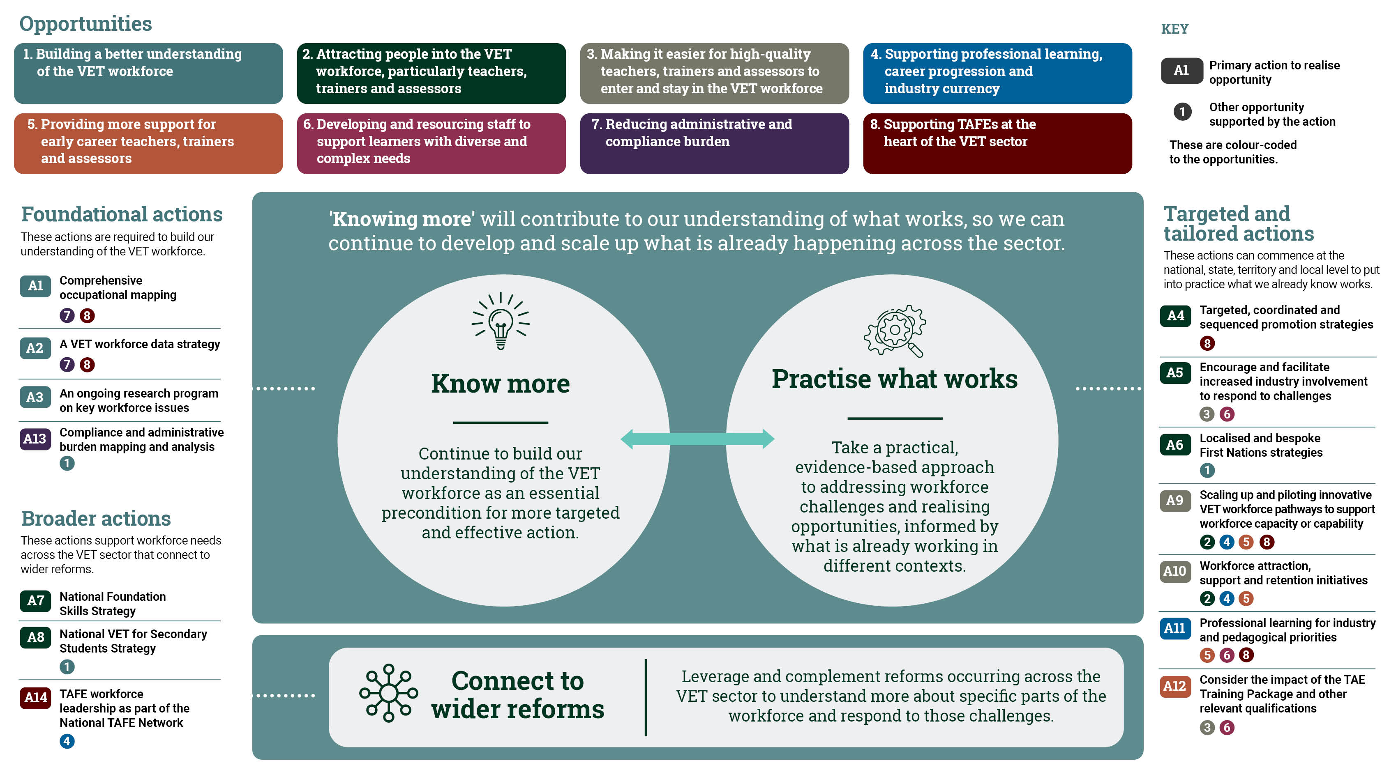

Executive summary

The VET sector and its workforce is critical to the future of individual Australians, industry and the country as a whole.
The VET sector provides millions of Australians with the skills they need for secure and well-paid jobs. It is also a doorway to opportunity for people who have faced barriers to education, training and work. The VET sector makes a significant national contribution, ensuring employers have the skilled employees they need – including in many industries that are a national priority, as identified in the National Skills Agreement (NSA), or facing a skills shortage.
The VET sector’s workforce is the foundation upon which this all rests. There are a variety of roles and contexts, including different types of RTOs, courses and qualifications, learner profiles and needs, and aligned to different industries. TAFEs play an important role within the sector. They are responsible for delivering high-quality public training, supporting local communities and industries, and helping governments meet Australia’s social and economic objectives. TAFEs do this across Australia, and often have a key presence in regional, rural and remote communities.
The VET workforce is under pressure. The number of positions is growing and will continue to grow, yet the supply of workers is already not keeping up with demand. This is especially true for VET teachers, trainers and assessors. This imbalance between demand for staff and supply is affected by several challenges facing the workforce.
Consultation with the sector identified 8 key opportunities to attract, retain, develop and sustain the workforce.
As part of the process for developing the Blueprint, VET sector stakeholders identified 8 critical opportunities to help attract, retain and develop the VET workforce.
Opportunity 1 – Building a better understanding of the VET workforce: An improved data collection and a comprehensive understanding of the roles across the VET workforce will inform workforce strategy and planning policy. There are also opportunities for further research on how to respond to VET workforce challenges.
Opportunity 2 – Attracting people into the VET workforce, particularly teachers, trainers and assessors: RTOs are finding it hard to fill vacancies and the number of staff isn’t increasing sufficiently to meet current and forecast demand. We have opportunities to increase the number of people entering the workforce, encourage those completing a VET teaching qualification to take up a teaching role and promote a better understanding of the roles and opportunities available.
Opportunity 3 – Making it easier for high-quality teachers, trainers and assessors to enter and stay in the VET workforce: Barriers to entry pose a challenge to improving the supply of teachers, trainers and assessors. These include the cost and time needed to attain required qualifications and a lack of recognition of other qualifications and experiences. If these are overcome, more people could be supported into a VET teaching career.
Opportunity 4 – Supporting professional learning, career progression and industry currency: This includes addressing the cost to all staff – but particularly teachers, trainers and assessors – of accessing professional learning. It also includes the availability of courses, the lack of clarity about what is required to meet industry currency requirements for teachers, trainers and assessors, and unclear career structures and progression pathways for the VET workforce as a whole.
Opportunity 5 – Providing more support for early career teachers, trainers and assessors: This includes monitoring and evaluating the impact of the Certificate IV in Training and Assessment and the Training and Education (TAE) Training Package to ensure it supports learners to complete and move into teaching roles. There are opportunities to strengthen supports for early career teachers, trainers and assessors through on-the-job support, mentoring and professional development.
Opportunity 6 – Developing and resourcing staff to support learners with diverse and complex needs: While it is important to support a diverse range of learner needs, staff currently feel under supported and under resourced to do this well. There is an opportunity to address this and improve retention by taking action on issues related to workload, the need for learner support training and ongoing professional development.
Opportunity 7 – Reducing administrative and compliance burden: While recognising the need for a high degree of quality, staff – and especially teachers, trainers and assessors – feel overwhelmed by the administrative and compliance requirements of their roles. A better understanding of compliance and administration burden, and addressing this where possible, could help improve job satisfaction and allow the VET workforce to focus on training delivery.
Opportunity 8 – Supporting TAFEs at the heart of the VET sector: As large, complex, not-for-profit, publicly owned educational entities, TAFEs play a critical role in meeting Australia’s skill needs and face unique workforce challenges. These challenges will require targeted and nuanced responses.

The VET Workforce Blueprint recognises the importance of the VET workforce, the challenges facing it, and the actions needed to support it.
The Blueprint identifies a series of actions that aim to address many of the pressing challenges faced by the VET workforce. The overall goals of the Blueprint and its actions:
- Growing the workforce: Increasing the number of people entering the VET workforce pipeline to ensure long-term supply of the staff needed.
- Retaining and developing the workforce: Improving retention and supporting workforce capability to ensure a sustainable, highly skilled and quality VET workforce, both now and into the future.
- Understanding the workforce: Developing a data collection on the VET workforce and undertaking foundational work and research to better understand the various roles and pathways across all VET contexts.
The actions in the Blueprint aim to support the VET sector and its workforce, with all stakeholders needing to play a part in responding to the challenges and opportunities. The Blueprint will be reviewed as part of a 5-year cycle to ensure it remains responsive to challenges affecting the VET workforce. It will be reviewed and refreshed as further data and research becomes available to inform further effective actions to build and support a sustainable VET workforce.

Chapter 1: Context

Introduction
This chapter provides an overview of the VET sector, its workforce and the complexity of its operating environment and delivery contexts. With the economy experiencing skills shortages across key and emerging industries where VET is critical to delivering a skilled workforce, the need for a skilled and sustainable VET workforce continues to grow. This is placing significant pressure on the sector. Having a better understanding of these challenges and the opportunities to grow, retain and develop the VET workforce, will enable informed responses, both now and into the future.

Sector overview

Vocational education and training is critical to supporting the skills needs of individual Australians, as well as industry and the Australian economy.
The VET sector has long been critical in equipping Australian workers with the skills they need for secure and well-paid jobs, including those that have faced barriers to education, training and work. In doing so, the VET sector also helps to ensure employers and the economy have the supply of skilled workers needed for Australia to prosper and that no one is held back or left behind.
Current data shows skills shortages are increasing across many industries in all parts of Australia. In 2023, 36% of occupations in Australia were experiencing a skills shortage nationally, which was 5 percentage points higher than in 2022. These shortages affect Australia’s ability to respond to economic opportunities and challenges, including in the nationally critical clean energy, care, manufacturing and digital and technology sectors.
Many of the sectors of the economy experiencing shortages require skills delivered through the VET sector. This includes early childhood education, nursing, aged and disability care, electrotechnology, civil engineering and different types of trades. These and other sectors will continue to grow and projections show that over the next decade around 44% of new jobs will require a VET qualification.

The scale of VET delivery is large and diverse, and growing to meet the needs of individuals, employers and the economy.
In Australia, there are over 4,000 RTOs delivering training. These include TAFEs, private RTOs, dual sector providers, enterprise RTOs, RTOs with a volunteer workforce, adult and community education providers, Aboriginal Community Controlled RTOs, and RTOs delivering VET to secondary students.
Broadly, these types of RTOs play different roles and undertake specific training activities within the sector. Types of RTOs:
- Generalist providers – these do not have a specific focus on a subject area or learner type. They instead offer a wide range of programs to a diverse learner base. These providers generally have program and industry specialists on staff.
- Program-focused providers – these specialise in a particular subject area or areas and generally have program or industry specialists on staff.
- Cohort-specific providers – these focus on a specific cohort of learner or industry. This includes associations; enterprise providers; school-based RTOs and other providers that deliver to secondary students; international student specialised providers; adult and community education providers and First Nations specialist providers.
In 2022, 4.5 million learners were enrolled in nationally recognised training. Some learners were enrolled in one or more program, including some in subjects that were not part of a nationally recognised program and others in a combination of both.

Given the scale, importance and growth of VET in Australia, the need for a skilled and sustainable VET workforce will be increasingly critical.
The NSA identifies that for VET to continue to contribute to economic and social outcomes for Australians, including productivity, labour supply, wellbeing and inclusion and resilience, it requires a skilled workforce. As the demand for skills in many sectors of the economy continues to grow, so too does the demand for people to join the VET workforce.
Over the 10 years from February 2014 to February 2024, online job advertisements for VET teachers, trainers and assessors grew by just over 200% compared to a growth of around 80% across all occupations (Figure 1). In fact, all teaching and lecturing roles experienced similar or higher growth, indicating significant demand for teachers across all education sectors.
Figure 1: Growth in job advertisements from February 2014 to February 2024 by occupation
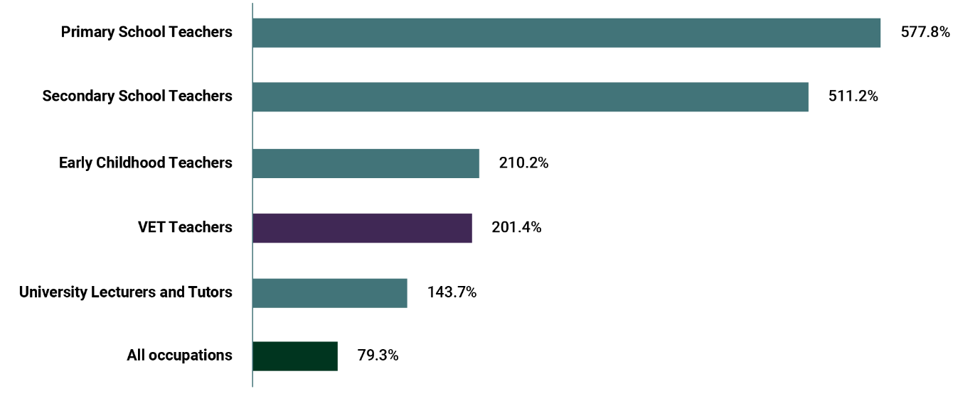
Source: Jobs and Skills Australia (JSA), VET Workforce Study, 2024, p 108. View the data table for Figure 1 at Appendix B, Table A1.
Notably, current growth and future projections of demand do not factor in the additional 300,000 Fee-Free TAFE and vocational educational courses being delivered through the Fee-Free TAFE Skills Agreement (formerly the 12-Month Skills Agreement) from 2024. This is in addition to the over 355,000 places the Australian Government, in partnership with state and territory governments, delivered in 2023. These additional places contribute to generating further demand for VET staff and, in particular, VET teachers, trainers and assessors.
Another significant driver of demand is where there are emerging industries, critical skills and workforce shortages. National priorities under the NSA identify these areas of need as supporting the net zero transformation, sustaining essential care services, developing Australia’s sovereign capability and food security, and ensuring Australia’s digital and technology capability. With more focus on, and investment in, these sectors, the demand for skilled individuals continues to grow, as does the call on the VET sector to support building these skills for tens of thousands of Australians.

This Blueprint builds on work undertaken to date and outlines goals and actions to support and grow a sustainable, high-quality and valued VET workforce.
The Blueprint builds on earlier work undertaken to quantify the size, profile and importance of the VET workforce, as well as the issues and challenges it has faced during various policy and funding shifts. Past reports have tackled the challenges associated with optimising the VET workforce and the experience of staff during these periods. This includes the Kangan and Fleming reports from the 1970s and reports by the Productivity Commission (2011) and the National Centre for Vocational Education Research (NCVER) workforce survey (2020).
There is also a body of research that has been undertaken with a focus on VET workforce development, strengthening educational practice and leadership, improving provider and practitioner capability, and linkages between industry and the VET workforce. More recently, the House of Representatives Standing Committee on Employment, Education and Training report (2024) explored how perceptions of the VET sector influence education choices and employer views and practices.
The Jobs and Skills Australia (JSA) VET Workforce Study was commissioned to support development of the Blueprint. The study profiles the VET workforce using existing and new datasets to:
- understand the size, composition and characteristics of the current workforce
- define the key job roles in the sector
- analyse the pathways in, out and within the sector.
The Blueprint focuses on key trends from the JSA study and insights from stakeholder consultations to consolidate our understanding of the current VET workforce.

TAFE at the heart

The Blueprint builds on the focus of governments on strengthening the TAFE sector.
TAFEs have long played a key role in Australia’s VET sector and have been a key foundation of the VET workforce. As the primary public providers of VET, TAFEs are large educational entities. They range in size – from delivering to over 400,000 learners each year across one entity, to regional TAFEs operating as separate entities delivering to around 10,000 learners each year. TAFEs offer a comprehensive range of VET courses and qualifications and have a significant role in training skilled workers for emerging and key industries. They are the largest employer of VET staff and the largest trainers of VET teachers, trainers and assessors. They are the primary providers of foundation skills training and vocational education in many key geographic locations and they deliver higher education.
Without a strong TAFE system, there cannot be a strong VET sector. In recognition of this, all Australian governments have agreed to build a high-performing and world-class VET sector with TAFE ‘at the heart’. Governments are putting TAFE at the centre of a diverse, vibrant, high-quality skills and training system. This includes through the introduction of Fee-Free TAFE and investments in TAFE Centres of Excellence and the National TAFE Network.
TAFEs have a unique responsibility to provide access to upskilling and training to Australians from all walks of life to help them share in Australia’s prosperity. They are a trusted partner driving quality improvements across the VET sector and supporting innovation to deliver a skilled workforce for Australian industries, both now and into the future.

Blueprint goals

The Blueprint has 3 clear goals.
This first iteration of the Blueprint lays out 3 primary goals and actions to create momentum in addressing key opportunities and challenges facing the VET workforce:
- Increasing the number of people entering the VET workforce pipeline to ensure the long-term supply of the staff needed.
- Retaining and developing the workforce: Improving retention and supporting workforce capability to ensure a sustainable, highly skilled and quality VET workforce, both now and into the future.
- Understanding the workforce: Developing a data collection on the VET workforce and undertaking foundational work and research to better understand the various roles and pathways across all VET contexts.
In the context of these goals, the Blueprint includes the following details:
- The makeup of the VET workforce, including roles, demographic makeup, employment context and conditions, pathways in and out of the workforce and the levels of skills and qualifications in the workforce.
- Opportunities and actions for the VET workforce (Chapter 3): The key pressing challenges facing the workforce, the opportunities for national, local, industry and provider responses, including for regional, remote and rural communities, and actions that all stakeholders can take to realise these opportunities.
- A blueprint for continuous improvement in VET workforce development (Chapter 4): The key aspects of a continuous improvement approach to developing actions for the VET workforce.
The Australian Government is investing up to $100 million over 5 years through the NSA to support strengthening the VET workforce. This includes $70 million over 5 years for state and territory initiatives and $30 million to support agreed areas of national action. The Australian Government’s financial contributions to states and territories will be matched by the relevant jurisdictions.
This investment demonstrates the commitment of Skills Ministers to strengthen and build the VET workforce to ensure Australia’s VET sector is world class and supports areas of national priority, as outlined in the NSA.

Consultation
The Blueprint has been developed through consultation with the sector and builds on previous engagement to better understand challenges and opportunities, now and into the future.
The development of the Blueprint has been informed by the perspectives and insights provided by over 300 stakeholders through 25 roundtable consultations. These stakeholders included RTO staff, peak VET sector organisations, unions and industry organisations. The consultation included roundtables in each state and territory, and roundtables for the focus areas of VET for secondary students, First Nations peoples, foundation skills, and regional, rural and remote. Through a public submissions process, 102 responses were received and 44 people who have recently left the VET workforce completed a survey to inform the Blueprint.
The VET Workforce Blueprint Steering Group, appointed by the Hon Brendan O’Connor MP, Minister for Skills and Training, guided the development of the Blueprint, drawing on the members’ extensive experience of the VET sector and its workforce. The Steering Group included representation from the Australian Government, states and territories, VET sector stakeholders, individuals with expertise, unions representing the VET workforce, and employer peak bodies. A list of Steering Group members is provided at Appendix A.

Conclusion
VET is vital to Australia’s economic and social fabric, giving both individuals and industry the skills they need to thrive. With an already large, diverse and complex sector experiencing growth, and forecasts of future growth, the need to grow and support the VET workforce is critical. Recognising this, the Blueprint provides a vision and a set of actions that will help to ensure the VET workforce is attracting new talent, retaining and developing existing talent, improving the experience of the workforce and addressing key barriers they face.
A key element of the Blueprint is acknowledging and promoting that working as a teacher, trainer and assessor is a valued and rewarding career. Individuals make a meaningful impact on the lives of learners and contribute to the training of a new generation of workers. The Blueprint builds on work undertaken to date, has been informed by consultation with the sector and the VET Workforce Study, and includes perspectives from a range of VET providers, their staff, industry, unions, employers, peak bodies and other VET stakeholders.

Chapter 2: The VET workforce

Introduction
This chapter provides a consolidated view of the modern VET workforce profile. It builds on previous work and supplements it with new data from JSA’s VET Workforce Study, which was commissioned to underpin the Blueprint. It includes insights about understanding the:
size, roles and demographic makeup of the workforce
employment contexts of the workforce
pathways in, out and within the VET teacher, trainer and assessor workforce.
This chapter also presents a contemporary picture of the skills, education and qualifications profile of the VET workforce and its income and employment patterns.

Size, roles and demographic makeup of the workforce

Estimates of the total size of the workforce vary and current data collections lack precision.
There are different estimates of the total size of the Australian VET workforce. The 2 most significant estimates were undertaken by the Productivity Commission in 2011, which estimated the total VET workforce was 223,000 people, and by NCVER, which estimated the total VET workforce was 246,000 people in 2019, including 71,000 teachers. Both estimates faced limitations. The Productivity Commission’s findings relied on the synthesis of multiple data sources that had ranging estimates, and NCVER’s report had a limited survey sample size and limited data collection on key demographics. This presents ongoing difficulty in estimating both the overall size of the VET workforce and the distribution of the workforce across different RTO types. A comprehensive national data collection or census on the exact composition and size of the Australian VET workforce has not been completed and poses a significant data gap.
The VET Workforce Study provides a contemporary and more thorough profile. Importantly, it also highlights ongoing issues with VET workforce data collection and estimating the overall size of the VET workforce. These include:
- a reliance on Census data to count the VET workforce, which had limitations resulting in underestimates
- challenges identifying all VET teachers, trainers and assessors, as well as both their industry and teaching qualifications (for example, a VET trainer who also works in industry counted as something other than a VET teacher and only one highest qualification being recorded in the Census)
- issues accounting for volunteers, secondary teachers working in VET and VET teachers, trainers and assessors working across multiple RTOs
- Australian Bureau of Statistics (ABS) occupation and industry reporting codes that do not fully reflect current VET delivery and the modern Australian workforce.

Despite uncertainty about the overall size of the workforce, there are estimates of role types and their relative size.
The VET Workforce Study includes a workforce taxonomy (Figure 2). This taxonomy categorises the VET workforce into 6 occupation segments and profiles example job roles under each segment. The taxonomy’s purpose is to provide a framework for government and the broader VET sector to better understand VET workforce roles.
Figure 2: JSA VET workforce taxonomy
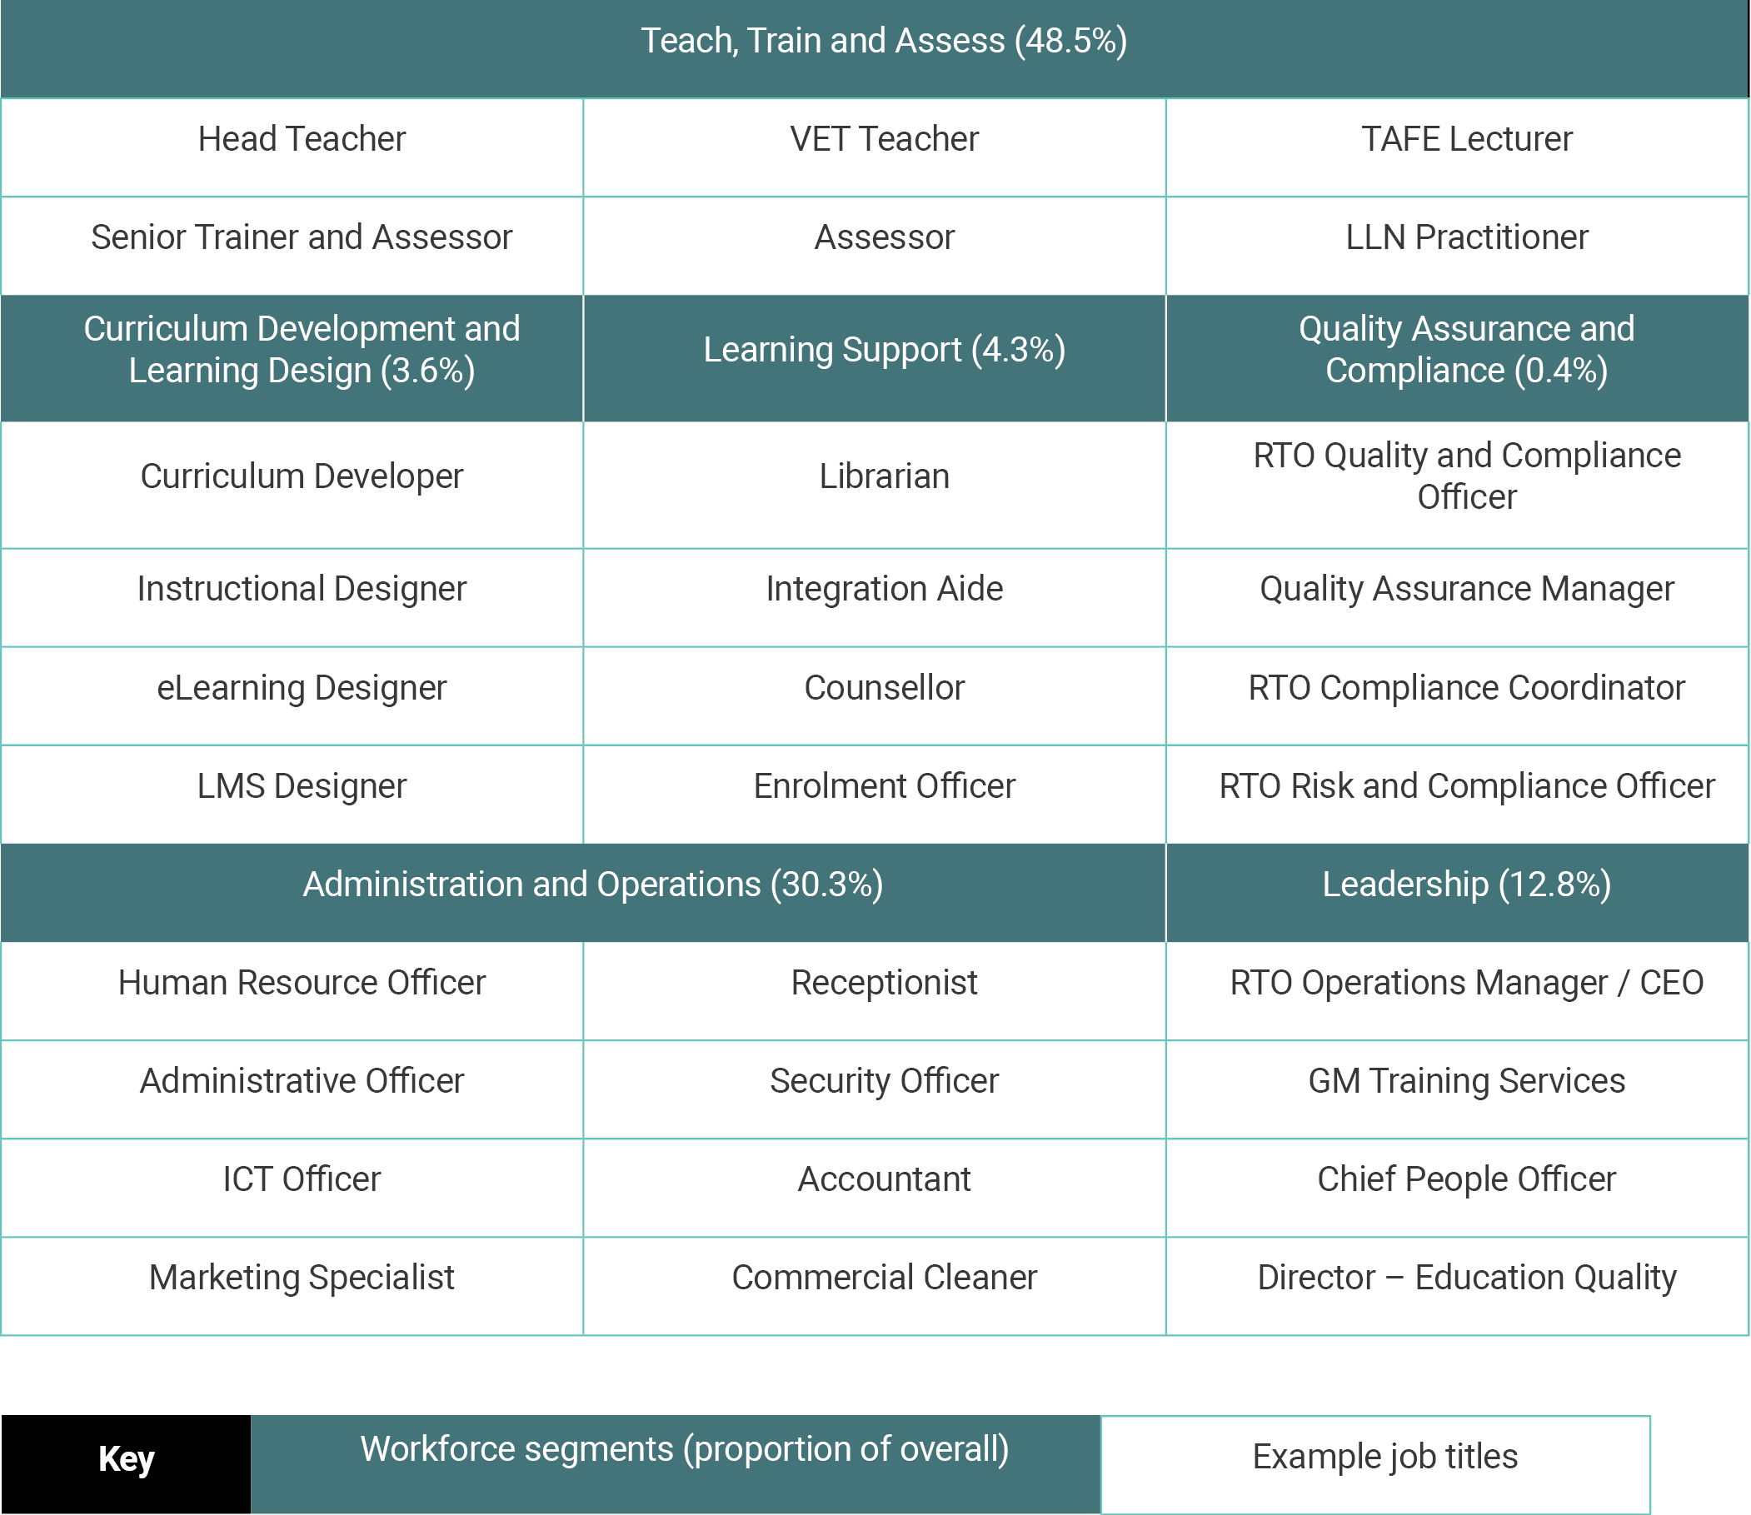
Source: JSA, VET Workforce Study, 2024, p 13.
While the list of job roles in Figure 2 is not exhaustive, it profiles some of the key areas of work in the VET workforce.
As an analytical framework for 2021 Census data, the taxonomy allowed JSA to estimate the relative proportional size of each VET workforce segment. In summary, this shows that:
- 48.5% of the workforce are in Teach, Train and Assess
- 3.6% of the workforce are in Curriculum Development and Learning Design
- 4.3% of the workforce are in Learning Support
- 0.4% of the workforce are in Quality Assurance and Compliance
- 30.3% of the workforce are in Administration and Operations
- 12.8% of the workforce are in Leadership.
The VET Workforce Study also includes an initial occupational framework that sits under the taxonomy. This framework identifies a spectrum of teaching, training and assessing roles ranging from working under supervision to senior roles.
It should be noted that different parts of the VET sector and their workplace contexts can have implications for the taxonomy. For example, a larger RTO or TAFE may have clear and distinct roles as described above, but in medium-sized or small-sized RTOs, roles may cut across more than one segment.

There is also a good understanding of the workforce’s demographic diversity.
The VET Workforce Study also provides a demographic breakdown of the VET workforce, by segment, and is compared against the entire Australian workforce (Table 1). This includes age, gender, First Nations status, if a person was born overseas, and if a person speaks a language other than English (LOTE) at home.
Table 1: Demographic breakdown of VET workforce by segment, 2024
 | Average age | Female | First Nations | Born overseas | LOTE at home
VET workforce | 47.3 | 57.2% | 2.1% | 33.0% | 20.5%
Teach, Train and Assess | 48.1 | 51.1% | 1.8% | 31.4% | 18.2%
Curriculum Development and Learning Design | 45.3 | 61.7% | 2.3% | 29.9% | 16.8%
Learning Support | 41.9 | 76.4% | 6.0% | 30.2% | 21.7%
Quality Assurance and Compliance | 39.4 | 70.4% | less than 0.1% | 35.5% | 19.9%
Administration and Operations | 35.7 | 64.6% | 2.0% | 35.7% | 24.5%
Leadership | 46.2 | 56.6% | 1.8% | 34.7% | 20.4%
Australian workforce | 40.1 | 48.5% | 2.2% | 32.4% | 23.4%
Source: JSA, VET Workforce Study, 2024, p 31.
Note: A small proportion of those in the VET workforce total are not included in taxonomy segments due to missing occupational codes.

The VET workforce is more mature on average than the overall workforce.
The VET workforce has an average age of 47.3 years, with 46.5% aged 50 years or older. In comparison, the Australian workforce average age is 40.1 years. This average age has been slowly increasing over the past 15 years and reflects a broader trend across the whole workforce. Figure 3 shows the proportions of the VET workforce by age group. It identifies the VET workforce has a proportionally older workforce in age brackets that are over 40 years.
Figure 3: Proportion of ages in the VET and Australian workforces, 2021
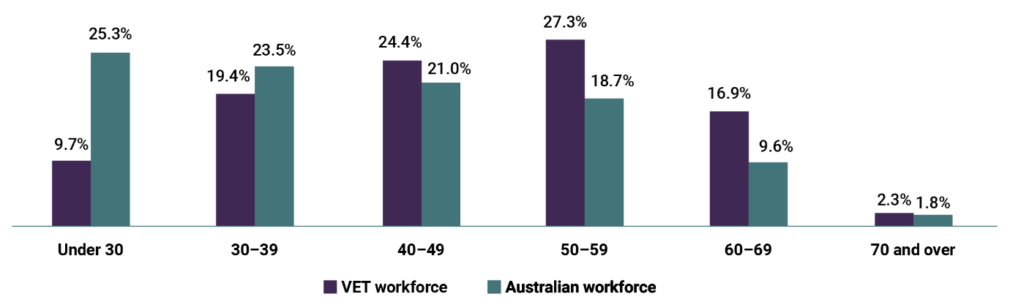
Source: JSA, VET Workforce Study, 2024, p 33.
Note: ‘VET workforce’ includes all ANZSCO 2422 Vocational Education Teachers and all ANZSIC 8101 Technical and Vocational Education & Training. Proportions do not sum to 100% due to ABS data perturbation.
View the data table for Figure 3 at Appendix B, Table A2.
Table 2: Average age of VET workforce by segment, 2022
VET workforce segment | Average age
Teach, Train and Assess | 48.1
Curriculum Development and Learning Design | 45.3
Learning Support | 41.9
Quality Assurance and Compliance | 39.4
Administration and Operations | 35.7
Leadership | 46.2
Source: JSA, VET Workforce Study, 2024, p 31.
The teaching, training and assessing segment of the VET workforce is the oldest (Table 2), which is also true across Australia for TAFEs. However, it is important to note there is a substantial difference in age profile of the workforce depending on the type of RTO. Earlier research by the Productivity Commission suggests a substantial difference in average age between TAFE staff (older) and non-TAFE staff (younger).
The training pipeline of future teachers, trainers and assessors is also becoming more mature. In 2021, almost 30% of Certificate IV TAE graduates were over 50 years, which is an increase from 2015. Some stakeholders shared that teaching, training and assessing can be perceived as a ‘retirement job’, with one trade union representative reflecting that ‘training is seen as an occupation that workers take up when they can no longer work on the tools’. During consultations some stakeholders challenged this perception when it was raised. They identified that what attracted them to the profession was the opportunity to skill the new generation of their occupation or industry workforce, that they thought they would enjoy the job role and it provided a ‘change in pace’ from their industry role as well as new opportunities.

The majority of the VET workforce identify as female, including in key segments.
People identifying as female comprise a majority of the overall VET workforce and in each of the VET workforce segments. This includes the Learning Support (76.4%), Leadership (56.6%) and Teach, Train and Assess segments (51.1%). In general, the proportion of people identifying as female in the total VET workforce has been steadily increasing over time. It increased by around 5 percentage points in the decade to 2020–21.

The VET workforce is slightly less culturally and linguistically diverse than the overall workforce.
The VET workforce has largely the same proportion of workers born overseas as the Australian workforce overall. The proportion of staff born overseas varies substantially by VET workforce segment, with Learning Support, Curriculum Development and Learning Design, and Quality Assurance and Compliance particularly underrepresented. The VET workforce across all segments, except Administration and Operations, is less likely to speak a language other than English at home compared to the workforce overall.

First Nations peoples are underrepresented in many segments of the VET workforce compared to the overall workforce.
Although the VET workforce overall has comparable First Nations representation compared to the broader Australian workforce, only the Learning Support and Curriculum Development and Learning Design workforce segments have a higher proportion. All other segments have a lower proportion. Most critically, First Nations teachers, trainers and assessors are underrepresented in both the current workforce and among graduates of the key VET teaching credential, the Certificate IV TAE.
This is notable, given the First Nations population aged between 15 and 64 participates in VET at a rate double that of the non-First Nations population. In addition, in very remote and on-community delivery contexts, delivery of VET by First Nations staff (especially teachers, trainers and assessors) correlates with more positive learner outcomes.

Employment context of the workforce

VET staff work in different RTO types, sizes and contexts all around Australia.
The professional environment that VET staff work in varies greatly. They are employed by RTOs of varying size, complexity and location, and some staff work in highly specialised delivery contexts. This results in diverse workforces with differing needs, composition and employment conditions.

There is significant variation in RTO size, type and complexity.
There are a range of RTO types:
- TAFEs are typically the largest and most complex institutions in terms of workforce and learner populations. All 23 TAFEs comprise less than 1% of the total number of RTOs but represent a much larger proportion of the VET workforce. Unlike private training providers who may specialise, TAFEs offer a wide range of programs across foundation skills, vocational education and higher education, as well as across many industries.
- Private training providers are the most varied provider type. Some offer a range of training products, with others focusing on training for a particular industry or training area. The size of private training providers can range from very small businesses with a small number of staff, to very large institutions delivering training to a high number of learners. This is the largest subsector in terms of the number of RTOs (80%).
- School RTOs are secondary schools offering VET programs delivered by staff employed at those schools. If a school is not an RTO, VET programs can be delivered through a variety of models – for example, auspicing or partnership arrangements with an RTO, or learners attending an external RTO. Further details on these models are provided on page 17. Schools comprise approximately 10% of all RTOs.
- Adult and community education (ACE) providers deliver nationally recognised training across a variety of educational fields if they are an RTO, as well as informal and non-vocational programs, which may provide opportunities for learners to engage in further education or employment opportunities. Informal and non-vocational programs typically include employability skills and language, literacy, numeracy and digital literacy (LLND) skills. ACE providers comprise 5% of all RTOs.
- Enterprise registered training organisations (ERTOs) are companies that deliver nationally recognised training to their own workers and represent 3.5% of the sector. Trainers and assessors at these organisations often deliver training concurrently with their industry roles at that organisation, or for a limited time before returning to their industry role.
- Dual-sector universities offer VET programs in addition to their higher education qualifications. These represent the smallest proportion of all RTOs at approximately 0.5%.
Jobs and Skills Australia has developed a typology for RTOs based on their broad focus. Within this, each of the different provider types can be categorised under generalist, program-focused and cohort-specific. The description of these categories:
- Generalist: providers that do not have a focus area in terms of subject area or learner type. These providers offer a wide range of programs to a diverse learner base. This category includes public providers, community providers, fee-for-service private providers and mixed-funding private providers. These providers generally have program and industry specialists on staff.
- Program-focused: providers that specialise, based on enrolment patterns, in a particular subject area. Program-focused providers include targeted program specialists and industry specialists and generally have program or industry specialists on staff.
- Cohort-specific: providers that focus on specific cohorts of learner or industry. The cohort-specific providers include associations, enterprise providers, school-based RTOs and other providers that deliver to secondary students, providers that specialise in international students, adult and community education providers, and First Nations specialists.

There are also some highly specialised delivery contexts for teachers, trainers and assessors.
Within the range of RTO types outlined above, there are staff that work in different and complex contexts. Some examples:
- Foundation skills delivery: This delivery includes both LLND and employability skills. Learners who need help with these skills are often from diverse backgrounds and may have different educational needs, requiring teachers to hold specialised qualifications. For example, teachers who deliver English as an additional language (EAL) courses are required to hold higher-level Teaching English to Speakers of Other Languages (TESOL) qualifications or equivalent, in addition to the Certificate IV TAE.
- Delivery in a First Nations context: Staff that identify as First Nations, as well as staff at RTOs that are First Nations owned or operated, such as Aboriginal Community Controlled RTOs, deliver in a distinct context. Delivery by First Nations teachers and provision of culturally appropriate pastoral care, leads to higher success rates for First Nations learners.
- VET delivered to secondary students: As outlined in the JSA report, there are 5 models of VET delivery to secondary students. Delivery can occur either on the school campus or off site at a TAFE or private RTO. These models include the:
- school or school sector as an RTO delivers training and issues the qualification
- school has an auspice or partnership arrangement with an external RTO, where the school delivers the training and the qualification is issued by the RTO
- school engages an RTO to deliver training at the school or at the RTO, where the RTO delivers training and issues the qualification
- students attend an external RTO – this could be a TAFE, another school or a private RTO
- students undertake school-based apprenticeships through the school or an external RTO, and have an arrangement with an employer.
Where teachers are employed by the school, delivery occurs in a complex intersection of 2 regulatory environments: the teacher registration framework and the Standards for RTOs. Compounding this, teacher registration and school operational requirements differ significantly across jurisdictions. This can affect both the administration and compliance requirements, as well as the day-to-day delivery of VET in the classroom (such as having different class lengths and location requirements).
Other delivery contexts that have distinct and additional operating challenges include ERTO staff, volunteer trainers and assessors, staff in very small private RTOs, and staff in regional, rural and remote locations.

The VET sector and its workforce operate in a complex regulatory environment.
National standards for the VET sector are agreed by the Australian Government, and all state and territory governments, and are supported by a framework of legislation and standards. These include the:
- National Vocational Education and Training Regulator Act 2011 (Cth)
- VET Quality Framework, which includes the Standards for RTOs and the Australian Qualifications Framework
- Standards for VET Accredited Courses 2021
- Standards for VET Regulators 2015
- Training Package Organising Framework, which includes the Standards for Training Packages.
There are 3 VET regulators in Australia responsible for regulating RTOs and approving accredited courses. The Australian Skills Quality Authority (ASQA) is the national VET regulator, regulating approximately 90% of RTOs. This includes all RTOs offering online courses, cross-jurisdiction courses and courses for overseas learners. The Victorian Registration and Qualifications Authority and the Western Australian Training and Accreditation Council have regulatory responsibilities for RTOs that deliver only to domestic students within their own jurisdictions.
Providers that deliver training and conduct assessments need to meet requirements outlined in the Standards for RTOs. TAFE enterprise agreements and the Educational Services (Post-Secondary Education) Award 2020 also apply to VET workforce roles. Combined, these define the roles, qualification requirements and common standards for most positions in the sector. The Standards for RTOs specify that an RTO’s training and assessments can only be delivered by a person who has and maintains:
- vocational competencies at least to the level being delivered and assessed
- current industry skills relevant to the training being delivered
- current knowledge and skills in vocational training and learning to inform their training and assessment.
The Standards for RTOs also describe the requirements that an organisation must meet to be an RTO. This includes trainer and assessor requirements and to ensure that training delivered meets industry requirements, as set out in Training Packages and accredited courses. The Standards for RTOs also ensure RTOs operate ethically and consider the needs of both learners and industry.
As of March 2024, all teachers, trainers and assessors must hold one of the following:
- the 2022 Certificate IV TAE, 2016 Certificate IV TAE, or the 2010 Certificate IV TAE plus 2 additional units
- a diploma or higher-level qualification in adult education
- a qualification that enables registration as a secondary school teacher, plus an additional assessor skill set or the VET delivered to school students teacher enhancement skill set.
A VET teacher, trainer and assessor who does not hold one of these required qualifications may work under the supervision of another VET teacher who satisfies the above criteria. In addition, an individual actively working towards the Certificate IV TAE or Diploma from the TAE Training Package can work under supervision. Further information can be found at the Department of Employment and Workplace Relations website.
There may be additional qualification requirements for teachers, trainers and assessors operating in distinctive delivery contexts. For example, in a secondary school context they may need an initial teacher education qualification and teacher registration as well as their VET credential and vocational competency. For foundation skills and EAL contexts, teachers are often required to have a higher adult education qualification in LLND or TESOL in addition to holding a Certificate IV TAE.

Pathways in and out of the VET teacher, trainer and assessor workforce

There are 3 main ‘pathways’ for professionals to enter into VET teacher, trainer and assessor careers.
The VET Workforce Study identified that teachers, trainers and assessors make up 48.5% of VET workforce roles. It also included analysis of teacher, trainer and assessor pathways into the VET sector. It showed there are 3 main pathways for individuals who move into VET teacher occupations:
- educators who previously worked in different education sector occupations, including in universities and schools
- industry professionals who previously worked in a VET-relevant vocational occupation
- corporate and administration professionals – origin roles in this pathway could include office management or program administration.
Data limitations mean that previous occupations of almost half of the individuals who move into VET are not known, which is most often due to income tax returns of these individuals not being filed. However, this is unlikely to affect the trends in the existing data. A summary of the former occupations held by people moving into the VET teacher, trainer and assessor workforce is at Table 3.
Table 3: Occupational movements into Vocational Education Teacher, FY2011–12 to 2019–20
Occupation | Proportion of Vocational Education Teachers who were in this occupation in the year before entering the VET workforce
Education | 28.3%
Vocational | 16.5%
Corporate and administrative | 9.2%
Unknown or no income tax return | 46.1%
Source: JSA, VET Workforce Study, 2024, p 125.

The VET teacher occupation typically loses more people each year than it gains and this workforce turns over at a higher rate compared to similar sectors.
In the 8 years before the COVID-19 pandemic, the VET teaching profession experienced a net loss of staff each year – that is, more people leaving than entering (Figure 4). During this period, a higher proportion of VET teachers left the VET workforce compared to both those in other teaching occupations and those across all professional occupations (in most years). The challenges and opportunities section of the Blueprint contains some insights about why this is the case and whether this trend is likely to continue following the pandemic.
Figure 4: Movements into and out of Vocational Education Teacher, FY2011–12 to 2019–20
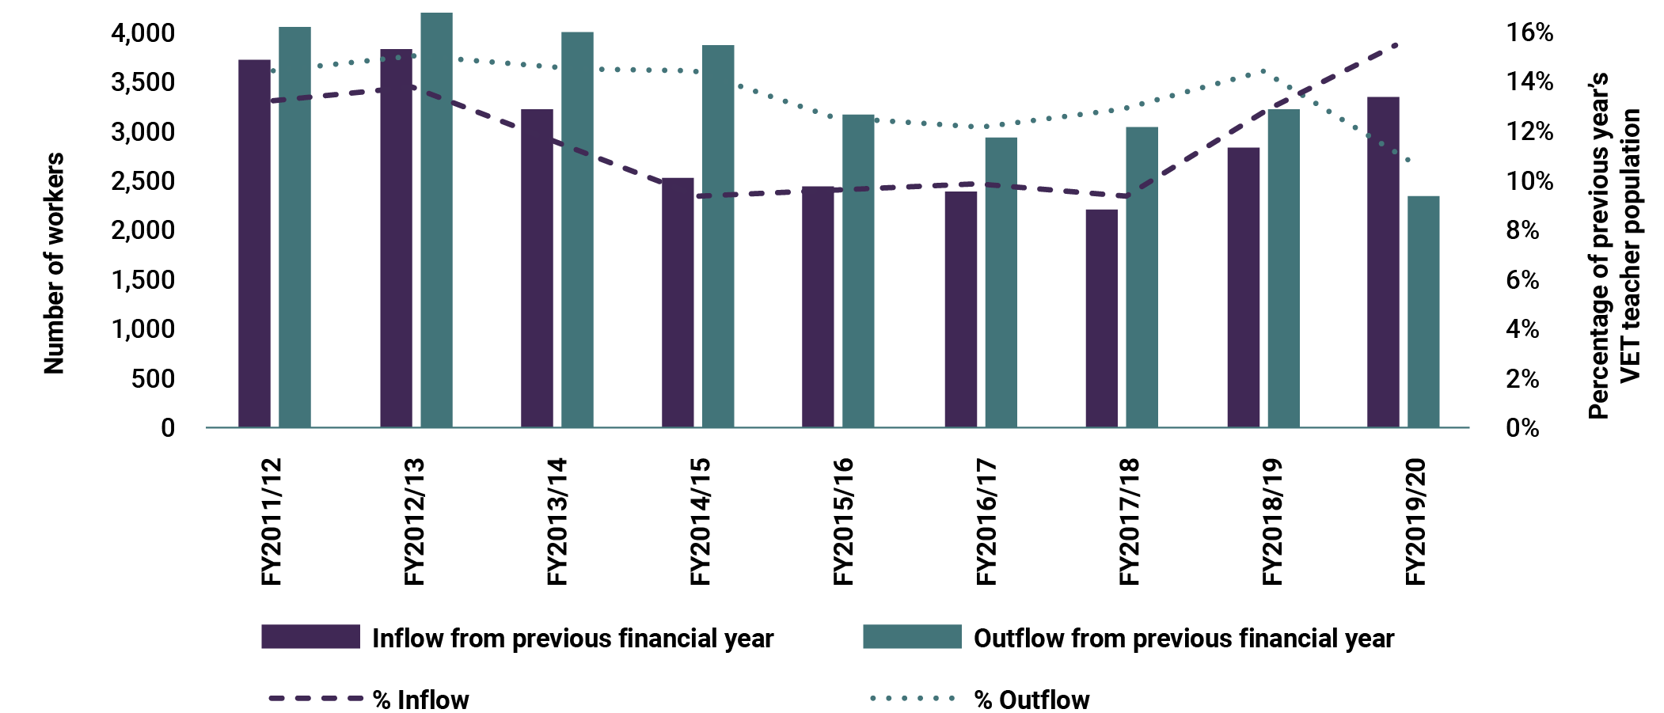
Source: JSA, VET Workforce Study, 2024, p 122. View the data table for Figure 4 at Appendix B, Table A3.
A substantially higher proportion of VET teachers move into other occupations each year compared to teachers in university or secondary school contexts. This is a consistent trend for at least the last decade. Although the proportion of ‘outflow’ VET teachers dipped in the 2020–21 financial year, this trend was consistent across all professions and largely due to the impacts of the COVID-19 pandemic, which reduced how often people moved between jobs. Regardless, the ‘gap’ during these years remains, which indicates that VET teachers were still more likely to move to other occupations compared to other professions.
There is a widely held view among stakeholders that many teachers leaving VET are being drawn back to industry. However, data shows the most likely destination for a person moving from being a VET teacher is to other teaching or education roles. This occurs at a rate almost 4 times more than those moving to a job in industry (Table 4). Outflows to managerial or administrative occupations are also higher than to vocational occupations, which may represent career progression within the VET sector. However, it is difficult to know the full picture of specific occupational transitions in subsequent years, as data is unavailable on over half of those individuals who leave the sector.

Migration as a direct pathway into the VET teacher, trainer and assessor workforce has historically been limited.
While the proportion of the VET teachers, trainers and assessors born overseas closely resembles the workforce, only 19.2% of VET teachers, trainers and assessors born overseas have arrived since 2011, compared to 33.8% of the Australian workforce. This may indicate it was not typically their first job on arrival in Australia.
Analysis of take-up of visas relevant to the VET workforce (subclasses 408, 489, 482, 187, 494 and 491) further confirms the skilled migration pathway has not been heavily utilised as a source of VET teachers, trainers and assessors, with generally under 20 visas granted per year over the last decade.
This is unsurprising given the requirements for VET teachers, trainers and assessors to be qualified in vocational education and training and their vocational area, as well as have current industry skills. There is likely to be a limited number of people able to immediately start a teacher, trainer and assessor role with no additional study or experience.
Table 4: Occupation movements out of Vocational Education Teacher, FY2011–12 to 2019–20
Occupation | Proportion of Vocational Education Teachers who were in this occupation the year after leaving the VET workforce
Education | 25.7%
Vocational | 7.2%
Corporate and administrative | 9.6%
Unknown or no income tax return | 57.6%
Source: JSA, VET Workforce Study, 2024, p 125.

Skills, education and qualifications

The VET workforce has a relatively high level of education on average, largely due to the ‘dual professional’ status of teachers, trainers and assessors.
Becoming a VET practitioner is an ongoing journey, not a destination, involving vocational and educational preparation; a transition to VET; and continuing practise and updating of skills to maintain the dual professionalism that is required to train, assess and respond to the changing needs of industry.
In general, the VET workforce has a higher level of qualification than the wider labour market. VET staff are almost twice as likely to hold a postgraduate degree qualification and substantially more likely to hold a bachelor degree, advanced diploma or diploma (Figure 5). It is possible this could be attributed to the requirement for teachers, trainers and assessors – the largest segment of the VET workforce – to be both skilled VET practitioners and current in the industry skills, knowledge and vocational competencies in the areas they are teaching.
Figure 5: Highest qualification for VET workforce segments and Australian workforce, 2021
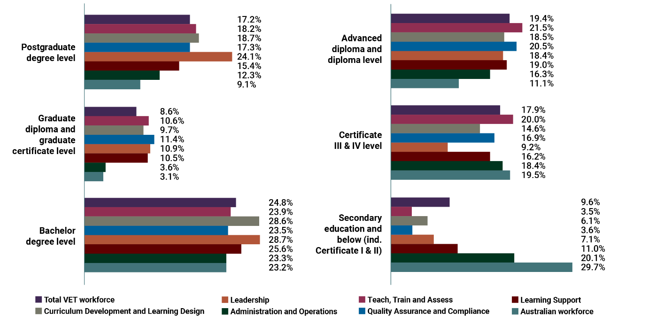
Source: JSA, VET Workforce Study, 2024, p 36.
Note: Due to non-stated responses, not all categories equal 100%.
View the data table for Figure 5 at Appendix B, Table A4.
Three-quarters of the VET teacher, trainer and assessor segment of the VET workforce hold a qualification at diploma level or above. In 2019, the highest teaching qualification held by 77.1% of VET teachers, trainers and assessors was a Certificate IV TAE. This suggests that most diploma qualifications and above held by teachers, trainers and assessors are likely to be generalist or industry-specific qualifications rather than teaching qualifications. More research is required to better understand the different qualifications the VET workforce hold.

Increasingly, large portions of the VET workforce require digital skills.
VET is delivered through a variety of different training modes, including classroom-based, online, workplace-based or blended models. The COVID-19 pandemic led to a growth in online and blended delivery and an associated decline in delivery that includes no online component (Figure 6).
Figure 6: Proportion of subject enrolments by delivery mode, 2019 to 2021
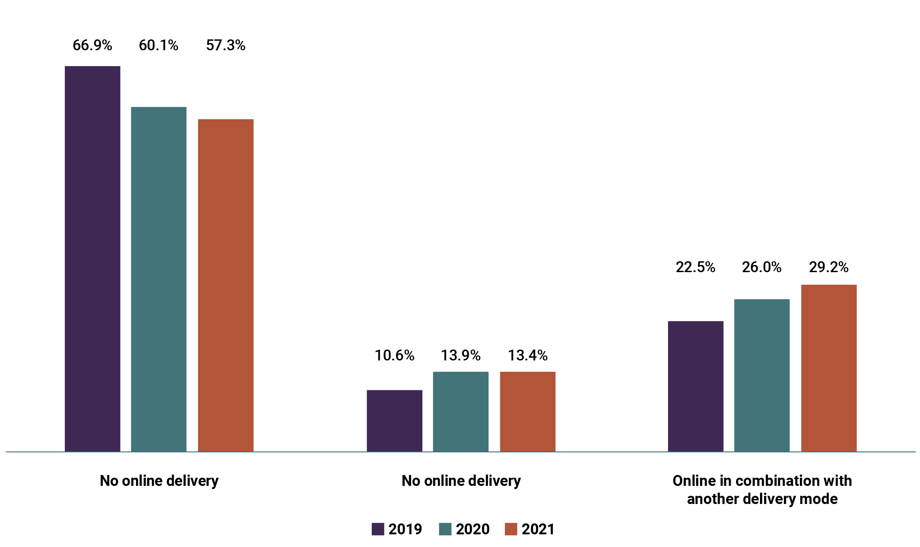
Source: S Hume, T Griffin and NCVER, Delivery of VET: Emerging Trends in Response to the COVID-19 Pandemic, 2022, p 2.
View the data table for Figure 6 at Appendix B, Table A5.
During consultations, stakeholders indicated the need for the workforce – and especially teachers, trainers and assessors – to have digital skills has been steadily increasing over the past decade or so. This includes technology for delivery and assessment, supporting learners to use technology, and staying current with increased digitisation and technological use in industry and as specified in training products.
The shift towards more VET delivery being wholly or partially online and the increased demand to understand and be able to teach digital literacy skills, has implications for the VET workforce. ASQA’s Strategic Review of Online Learning found the rapid shift to online learning due to the COVID-19 pandemic necessitated changes to the pedagogical approaches to teaching. The key implication for the sector broadly is more demand for VET staff, especially teachers, trainers and assessors, with digital literacy and digital technology skills, and experience with planning and delivering online learning.

Income and employment patterns

The VET workforce overall has a higher average income than the Australian workforce generally, but this skews heavily depending on the role and is lower compared to other education sectors.
The average annual income for the VET workforce (about $81,000) is 8% higher than the Australian workforce in general (about $75,000).
For teachers, trainers and assessors, stakeholders highlighted that some teachers, trainers and assessors may have lower incomes than their industry peers in industries such as trades and engineering, or higher incomes compared to industries such as hairdressing or care-based industries.
VET teachers at public institutions, including dual sector universities and TAFEs, generally earn more than those at private RTOs (Figure 7). TAFE teachers, trainers and assessors and TAFE staff in general, tend to be employed under union bargained enterprise agreements, where pay is set higher than award.
Figure 7: Percentage of public and private VET teachers total personal income by range, 2021
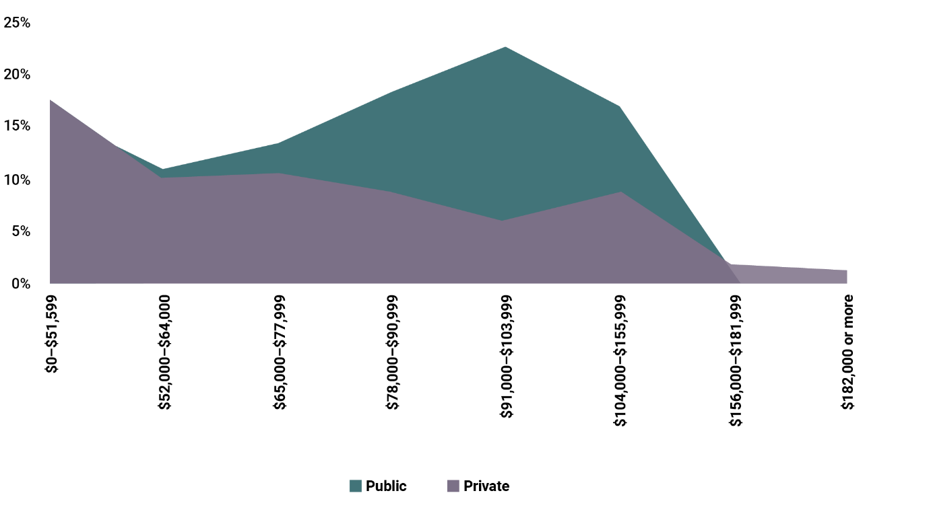
Source: JSA, VET Workforce Study, 2024, p 52.
Note: Weekly reported income is annualised.
View the data table for Figure 7 at Appendix B, Table A6.
The average gender pay gap is 16% across the VET workforce and women earn $14,773 less on average than their male colleagues. This pay gap reduced to 7% for full-time roles in the Teach, Train and Assess segment, and 9% for full-time roles across the whole VET workforce. There is some variation across different VET workforce segments and it is most pronounced in Administration and Operations at 19%. Learning Support, which is also the most feminised workforce, has the lowest pay gap of 9% overall and a -1% pay gap for full-time workers, meaning women in full-time Learning Support roles earn 1% more.

The VET workforce has a relatively similar employment profile compared to the Australian workforce overall, but teachers, trainers and assessors have much higher rates of casualisation.
[One major challenge is] over-reliance on casual and short-term contracts of employment for trainers and assessors, which makes it difficult for them to deliver high quality education and training programs. (Union representative)
The VET workforce has a similar employment profile to the Australian workforce overall, with comparable levels of full and part-time employment, except for those employed as a teacher, trainer or assessor, who are more likely to work part-time hours. Staff in Quality Assurance and Compliance and Leadership roles are more likely to work full-time hours. Teachers, trainers and assessors and staff in Learning Support roles are the least likely to be in full-time employment. VET teachers are also more likely than the Australian workforce to be on fixed-term contracts or work in casual employment.
Consistent with this data, the VET workforce on average reports working similar numbers of hours per week as the workforce overall. Staff in the Leadership and Quality Assurance and Compliance segments work substantially more hours on average. Staff in the Teacher, Trainer and Assess and Learning Support segments work fewer hours on average, likely because of the higher rates of part-time and casual employment in those roles. In addition, stakeholders indicated some examples where teachers, trainers and assessors may only be paid for delivery hours and not for hours spent completing compliance documentation or maintaining industry currency. For example:
The simple question how does anyone work full time as a trainer and assessor and manage to stay current, with relevant practical work in the industry? I have seen people doing their currency as unpaid work for many hours … It is a huge burden on trainers and great deal of stress too. (Former VET teacher)
The VET Workforce Study data supports feedback from stakeholders in consultations that teachers, trainers and assessors have higher rates of casualisation compared to other sectors in the Australian economy. In comparison to other education sectors, VET teachers, trainers and assessors are less casualised than university lecturers and tutors. However, they have 3 times the rate of casualisation compared to secondary school teachers (Figure 8).
Noting the limitations of VET workforce data in identifying VET teachers, trainers and assessors due to their dual professional status, and that some may work primarily in industry, there needs to be further research to identify the drivers of casualisation, and where these may affect attracting and retaining the VET workforce. These drivers also appear to differ between RTO types and individual RTOs.
Figure 8: Proportion of casuals in selected occupations and across workforce, 2014 to 2023
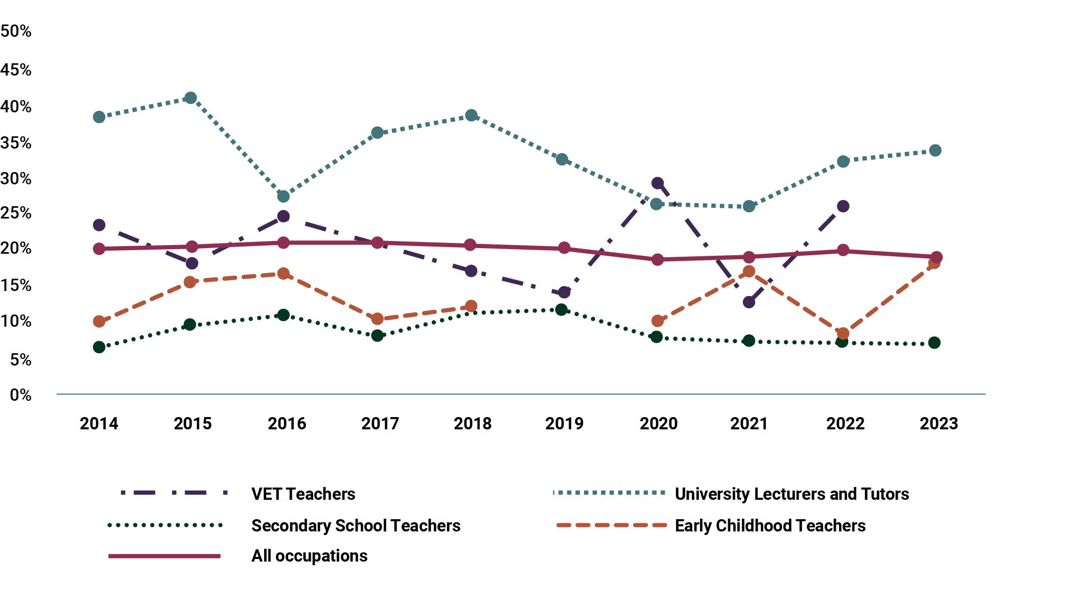
Source: JSA, VET Workforce Study, 2024, p 44.
Note: Some data points have been omitted due to unreliable estimates.
View the data table for Figure 8 at Appendix B, Table A7.

Conclusion
The VET workforce is complex and affected by regulatory requirements. Different types of VET staff work in RTOs of different types, sizes and contexts, and each of those RTOs have a different focus – although broadly these can be categorised as generalist providers, program-specific providers, or cohort-specific providers.
Within the range of providers, the workforce also exhibits great diversity. While estimates of the size of the VET workforce vary and lack precision, there is a reasonable understanding of the proportional breakdown of different role types. It is also clear the VET workforce is more mature when compared to the broader Australian workforce, and with a majority identifying as female and having less First Nations representation. In terms of employment conditions and characteristics, the VET workforce tends to have slightly higher average incomes, higher levels of education and a similar employment profile when compared to the Australian workforce. One noteworthy exception is that VET teacher, trainer and assessor roles tend to be more casualised than the broader VET workforce and the Australian workforce generally.
The VET teacher occupation typically loses more people each year than it gains and the workforce turns over at a higher rate than other sectors. This is largely because the main pathways into these roles have challenges. The next chapter explores ways to address these challenges.

Chapter 3: Opportunities and actions

Introduction
This chapter examines the current understanding of the challenges and opportunities facing the modern VET workforce and the actions that can be taken in response, in collaboration with all stakeholders. Importantly, this draws upon key insights from stakeholder consultations, which explored different perspectives across the range of roles, RTO types and delivery contexts. Stakeholders also shared a broad range of examples and case studies of effective initiatives to support the VET workforce.

A blueprint for real change

Blueprint goals, challenges and opportunities
Governments and stakeholders share the view that for the VET sector and its workforce to continue to successfully meet the demands of learners, industry and the community, the key goals for the Blueprint should be growing, retaining and developing, and understanding the workforce.
Consultations provided stakeholders with an opportunity to share insights about the challenges that need to be addressed and the opportunities for action the Blueprint could include. Stakeholders also provided examples and case studies of initiatives individual jurisdictions or RTOs are using on the ground to overcome these challenges at a local level, and which may provide opportunity for scaling up or replicating in other contexts. Figure 9 sets out how each of these opportunities align with the Blueprint’s goals.
These challenges and opportunities are not all new. As outlined in Chapter 1, various inquiries and reports have focused on the challenges of optimising the VET workforce and improving the experience of staff. This includes the Kangan and Fleming reports from the 1970s and more contemporary work, such as reports by the Productivity Commission (2011) and the NCVER workforce survey (2020). More recently, the House of Representatives Standing Committee on Employment, Education and Training report (2024) explored how perceptions of the VET sector affect education choices and employer views and practices.
Figure 9: Alignment of Blueprint goals and opportunities
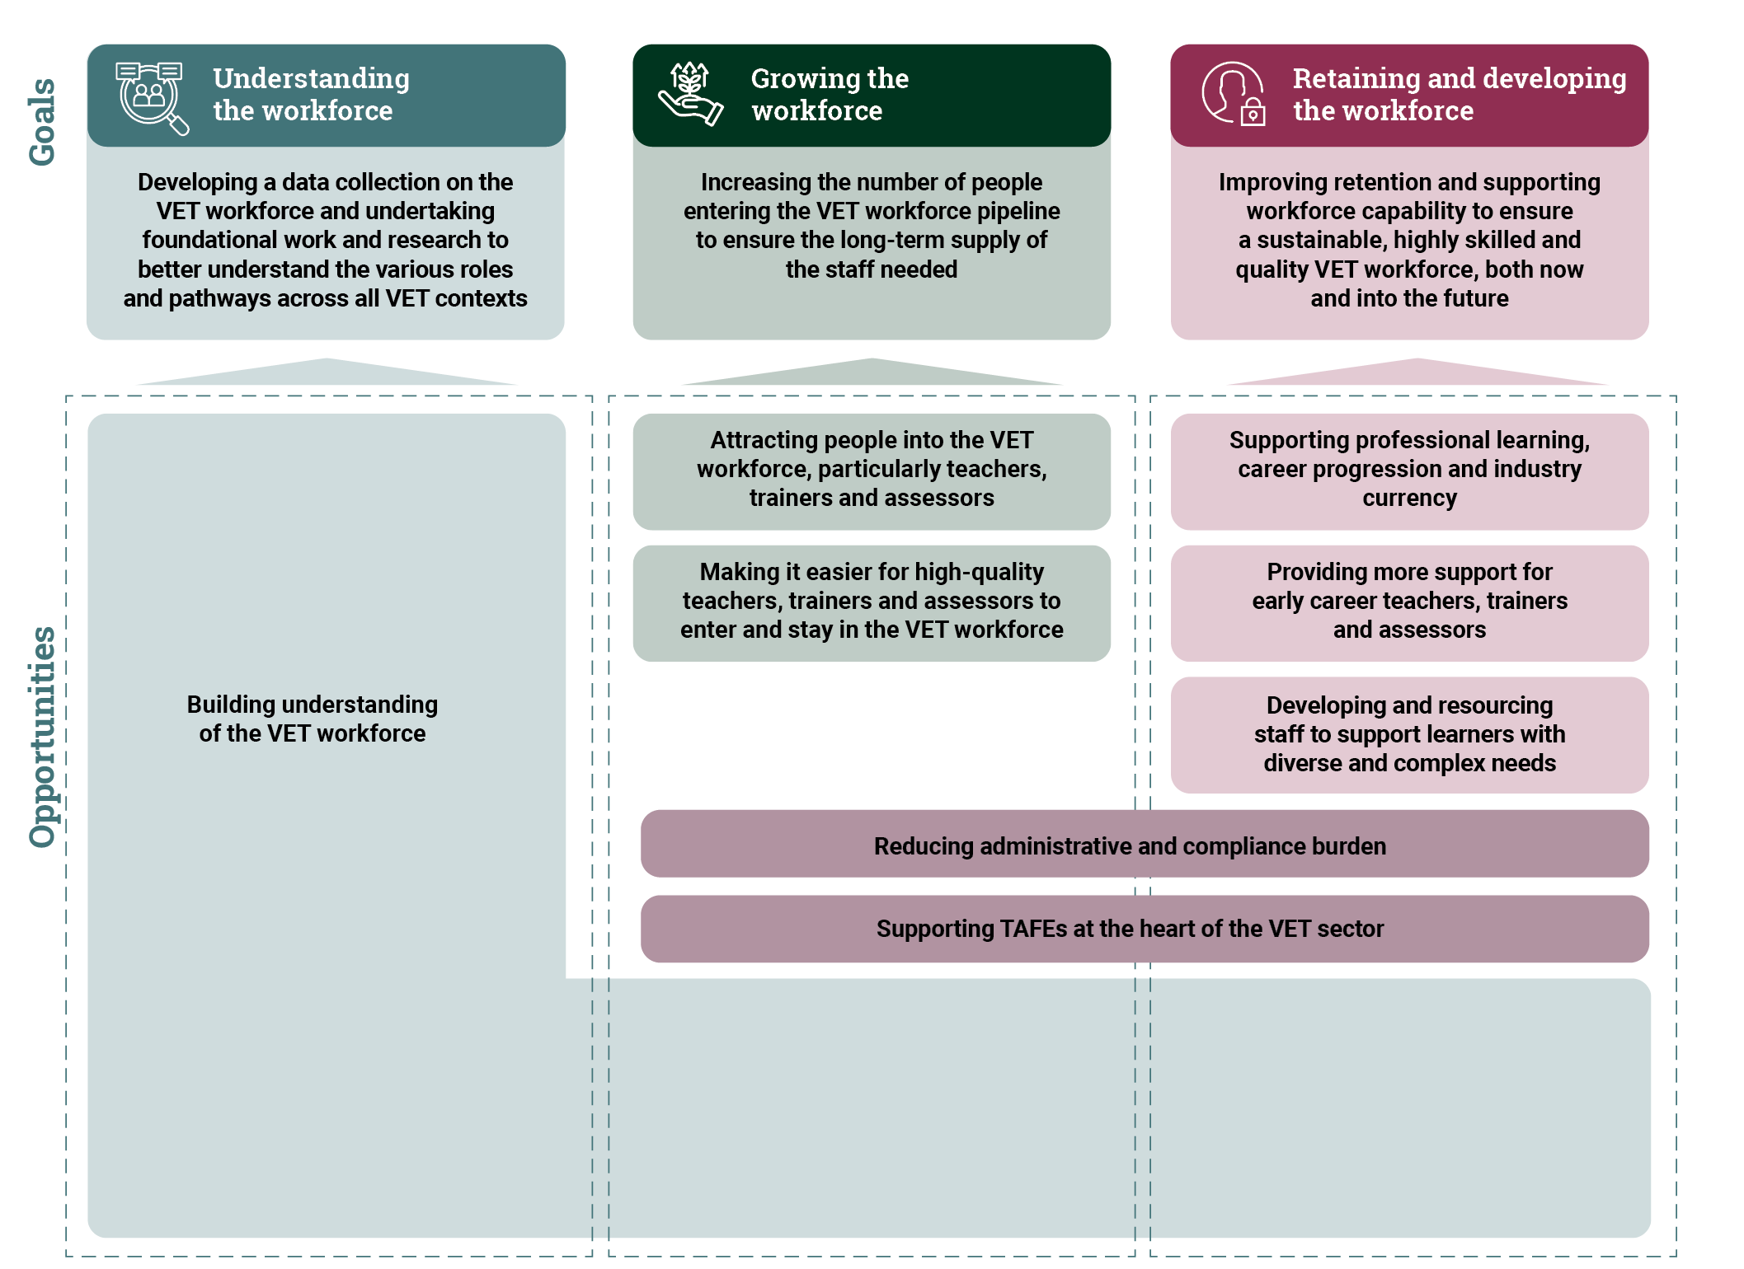

A focus on teachers, trainers and assessors
The challenges and opportunities are focused primarily on the needs of teachers, trainers and assessors and reflect what was heard during consultation with the VET sector. The teacher, trainer and assessor workforce is made up of people who have a variety of backgrounds and experiences. Some of these people identify strongly as being educators or trainers, while others see themselves more embedded in their industry role.
Consultations revealed some key insights, including that these roles:
- make up the segment of the workforce facing the most attraction and retention issues, and it is the segment of the VET workforce that stakeholders were most focused on addressing
- are the entry point for many staff who may move to other segments of the workforce, including leadership and curriculum development roles. By supporting attraction and retention at this part of the pipeline, it opens up supply for other VET workforce roles
- have very specific entry requirements and working conditions, as opposed to general support and administration roles, which have fewer requirements for entry, and generally look similar to equivalent roles in different sectors.
In addition, between 2011 and 2021 the:
- Australian workforce grew by 15.8%
- overall VET workforce size remained relatively stable
- number of VET teachers declined by 18.1%.
This demonstrates the need for action to support building and retaining the whole VET sector, with a particular focus on the Teach, Train and Assess segment of the VET workforce.

A call to action
Outlining the challenges and opportunities facing the sector is not enough. Current data indicates the need to address these challenges, and realise these opportunities, is becoming more urgent. Alongside the analysis about challenges and opportunities in this chapter, the Blueprint sets out a number of practical actions that all stakeholders can take at either the national, local, industry or training provider level to support and grow a sustainable VET workforce, in line with local contexts and priorities. These actions are embedded in each of the subsections that follow.
Skills Ministers appreciate the contributions made by stakeholders – including case studies of their own practice. They also recognise that success will require continued collaboration with RTO staff, including teachers, trainers and assessors, peak organisations, industry employers and unions, in taking action to support meaningful and long-term change.

Opportunity 1
Building a better understanding of the VET workforce
A diverse VET workforce is fundamental to support, grow and sustain the VET workforce. To achieve this, the problems must be correctly understood and diagnosed. This will require the federal government to collect a comprehensive and true data set on diversity across the workforce (Union organisation)
Addressing the challenges faced by the VET workforce and realising opportunities requires quality data to understand the workforce, identify and priorities issues and develop solutions. If making new efforts and investments, it is critical to be able to track progress and identify what is, and what is not, working.
Despite this, there is currently no regular, national, fit-for-purpose VET workforce data collection. For the collections that are available, there are inconsistencies that make it hard to track progress over time. These limitations, and their impact, are briefly outlined in this section of the Blueprint. They are explored in more detail in Chapter 2 and in the JSA VET Workforce Study.

There are vastly different estimates on the size of the workforce.
Due to the high demand for VET staff in the future, and particularly teachers, trainers and assessors, accurate data on the workforce will be more critical. There is currently no consistent measure of the size of the workforce, either at a single point in time or as part of a regular, national data collection. In addition, there needs to be nationally consistent data on retention and turnover.

There is an incomplete understanding of roles in the workforce.
While the JSA role taxonomy developed recently is a good start, there is not currently a comprehensive and deep understanding of VET workforce roles. This includes roles for part-time or casual training and/or assessment, and roles that are primarily in industry.
There is an opportunity to map VET workforce roles and their associated:
- duties and responsibilities, including within specific VET delivery contexts
- technical and pedagogical capability requirements
- relationships with other roles
- career paths
- entry and transition points
- credential requirements
- professional development requirements
- industry currency requirements
- conditions of work.
Mapping roles could also build on:
- existing frameworks across the VET sector to provide a more system-level view – for example, some individual RTOs already have capability frameworks for different roles
- the current work of Jobs and Skills Councils (JSCs) in understanding industry-specific roles
- analysis of international activity, such as the development of educator standards.
It is anticipated that any mapping would focus on roles that are involved in the delivery of nationally recognised training, and be subject to close consultation within the sector to scope and undertake the exercise. Further work from the Australian Government and JSA to support the mapping could include identifying:
- opportunities for career progression and professionalisation for the VET workforce
- capability gaps, development opportunities and shortages across VET workforce types
- barriers to attracting people into the VET workforce – for example, compliance burden or competition with other sectors, and challenges associated with working in remote, rural and regional areas of Australia.
Action 1: Undertake comprehensive occupational mapping for the VET workforce to identify and inform broader actions to strengthen pathways into, and through, the VET workforce.

The data that exists lacks sophistication and precision.
Mapping how engagement of skilled industry workers with the sector takes place … may also help to raise awareness of career pathways in the sector and remove uncertainty that may act as a barrier to entry. (Industry peak)
Data on the VET workforce can sometimes present the workforce as a homogenous group and fail to recognise the distinct profiles across different contexts. In addition to different RTO types and roles, some of these distinct profiles include staff who are:
- First Nations
- regional and remote
- working across multiple RTOs or multiple sectors
- volunteer trainers
- secondary school teachers delivering VET in schools
- holding multiple jobs across both VET and industry.
A national and consistent data collection would seek to overcome issues with:
- identifying VET trainers, their industry and their teaching qualifications, due to their dual professional status
- accounting for volunteers, secondary teachers working in VET, and VET trainers working across multiple RTOs
- ABS occupation and industry reporting codes that do not fully reflect current VET delivery.
A national, regular and fit-for-purpose data collection for the VET workforce would act as a ‘single source of truth’. It would provide an up-to-date and accurate understanding of the composition and profile of the VET workforce and enable more sophisticated disaggregation by RTO type and job roles. It would help governments and the sector to take more targeted action to address challenges and opportunities relating to attraction, retention and development. It would also enable regular data reporting to states and territories and other key stakeholders.
Action in this area may involve expanding data collection in a targeted way and creating partnerships and data-sharing arrangements with other organisations. Any action would need to be taken in close consultation with the sector, with staged implementation to minimise compliance burden.
Action 2: Develop a VET workforce data strategy to enable the collection of VET workforce data to support and enable informed policy and workforce strategies, and inform ongoing research.

There are workforce challenges that need further research.
Even following the consultation and data work that led to the development of this Blueprint, there are a range of workforce challenges affecting the VET workforce that are unable to be fully understood without a program of comprehensive research.
More research could support better understanding of the kinds of issues raised during consultations, such as:
- the effect of casualisation and psychosocial challenges on attraction and retention
- teaching practice approaches to support areas of need
- the implications of generative AI.
This would assist with the development of initiatives and strategies that support attraction and retention in the VET workforce. Research could also provide opportunities to build the capability of existing highly capable educators in applied research, which will be important for a more integrated and aligned tertiary education sector.
Specific research priorities could be developed through seeking sector wide input and encouraging a collaborative approach to the research and its resulting products for the sector to use. It will be important to map existing research and identify the key gaps that need to be addressed. Any research program could be embedded in the work program for JSA or similar bodies and would be consistent with broader strategic research.
Action 3: Establish an ongoing research program to develop a robust evidence base for key workforce issues.

Opportunity 2
Attracting people into the VET workforce, particularly teachers, trainers and assessors
Beyond understanding the workforce better, consultations identified that the most significant overall challenge facing the VET workforce is attracting people into roles, particularly teacher, trainer and assessor roles. Data shows that there are not enough people entering the VET workforce to take up these roles to meet current demand, let alone the demand forecast in the future.

There is growing demand for teachers, trainers and assessors, with RTOs finding it harder to fill vacant teaching positions than other sectors in Australian education.
Employment projections produced by Victoria University for JSA indicate that VET teacher, trainer and assessor employment demand is projected to grow by 12% (or 3,800 people) in the next 5 years and by 21% (or 6,900 people) over the next decade. This projected growth exceeds the employment projections for total occupations (an average of 7% over 5 years and 14% over 10 years).
The Skills Priority List (SPL), an annual publication produced by JSA, shows there was a shortage of teachers, trainers and assessors in every jurisdiction in Australia in both 2022 and 2023. VET workforce shortages affect training for industries with their own workforce shortages, particularly those that are experiencing high learner enrolments into relevant VET qualifications. In consultations, stakeholders noted the VET workforce is competing with industry for a limited supply of vocationally skilled workers. This is occurring against a background of strong and continued growth in workforce demand in those industries, with key skills shortages identified by stakeholders in aged and disability care, early childhood education and care, carpentry and electrotechnology trades.
On a like-for-like comparison with other education sectors, the Survey of Employers who have Recently Advertised (SERA) shows that from January 2021 to August 2023, the VET sector is behind every other education sector on key measures of vacancy fill rate, applications per vacancy and suitable applications per vacancy – ranking last or equal last on every metric (Table 5).
Table 5: Vacancy data by selected education occupations, 2021 to 2023
ANZSCO occupation | Vacancy fill rate | Applicants per vacancy | Suitable applicants per vacancy
Vocational Education Teacher | 50% | 5.09 | 1.23
University Lecturer | 81% | 14.19 | 2.93
Secondary School Teacher | 75% | 6.17 | 1.72
Primary School Teacher | 74% | 8.49 | 3.19
Early Childhood (Pre-primary School) Teacher | 50% | 5.81 | 1.42
Source: JSA, VET Workforce Study, 2024, p 110.
While individual employers in the VET sector will have different experiences, at a sector-wide level this indicates the challenges include:
- a national shortage of teachers, trainers and assessors
- low inflows into vacant positions
- a lack of suitable applicants applying for each role, with only half of all advertised roles being filled.
With the number of VET teacher, trainer and assessor roles forecast to continue to grow, this challenge will become greater unless efforts are made to increase the number of people entering the VET workforce into these roles.
Outside of teaching, training and assessing, the projected growth for other relevant roles includes Education Managers (21% over 10 years) and Education Advisers and Reviewers (17% over 10 years). Similarly, more education support roles have also shown strong projected growth across all education sectors.

The number of teachers, trainers and assessors is not growing fast enough to meet forecast demand, and there are several barriers that constrain growth, with some unique to the VET sector.
Stakeholder consultation and data show there are several concerning trends in the supply of those who might in the future be qualified to work and teach in the VET sector.

The flow of teachers, trainers and assessors into the workforce pipeline has substantially slowed.
The Certificate IV TAE is the minimum qualification requirement for entry into the VET workforce as a teacher, trainer and assessor. Completions data for this qualification provide an indication of the available supply of qualified VET teachers, trainers and assessors for the VET workforce pipeline. NCVER data shows the number of people completing this course decreased by 28% between 2016 and 2022 (Table 6), at a time of growing demand for teachers, trainers and assessors.
While there was a significant increase in completions in 2019, this was driven by the TAE upgrade. This upgrade required all existing teachers, trainers and assessors who held the 2010 version of the Certificate IV TAE to obtain 2 core units to meet the requirements in the Standards for RTOs (Design and develop assessment tools and Address adult language, literacy and numeracy). Undertaking these units resulted in some teachers, trainers and assessors enrolling into the Certificate IV TAE qualification.
Consultation feedback identified that the 2019 TAE Training Package upgrade was a significant impost on teachers, trainers and assessors, leading to a section of the workforce close to retirement leaving the sector. Given this, any future changes or updates to the Training Package should not be applied wholistically to the current workforce.
In addition, the delivery of VET by those working under supervision, combined with completions of diploma and higher-level qualifications, has not grown at a rate that offsets the decline in Certificate IV TAE completions. While skill sets under the Certificate IV TAE that allow individuals to train and assess under supervision have grown considerably, overall they are still low. Compounding this, 85% of 2022 graduates of the Diploma of VET and Diploma of Training Design and Development are unlikely to be new entrants to the VET workforce (Table 6).
Table 6: Completions in VET teacher, trainer and assessor pipeline and related training, 2016 to 2022
Qualification | 2016 | 2017 | 2018 | 2019 | 2020 | 2021 | 2022
Certificate IV TAE | 21,635 | 20,065 | 9,972 | 34,235 | 16,730 | 16,469 | 15,609
Diplomas and above in TAE Training Package | 1,747 | 1,963 | 803 | 1,213 | 1,179 | 945 | 917
Other VET qualifications in adult education at diploma and above | 242 | 300 | 254 | 294 | 524 | 1,155 | 1,603
Specified skill sets that support delivery of VET under supervision | 205 | 223 | 658 | 967 | 1,124 | 1,371 | 1,685
Source: JSA, VET Workforce Study, 2024, p 112.
In 2021, enrolments in university VET teacher education qualifications were reported to be in the low hundreds. Recent information provided by the Australian Council of Deans of Education Vocational Education Group (ACDEVEG) members from 3 of the 6 universities offering VET teacher training qualifications for the VET sector has identified a steady increase of students, with over 750 in training in 2024. The JSA VET Workforce Study identified the need for further work with key stakeholders, such as ACDEVEG, to understand how higher education qualifications contribute to VET workforce development, and how to improve data collection into the future.
If encouragement and support for higher-level qualifications is not prioritised, the number of universities offering VET teaching qualifications will dwindle further, exacerbating the loss of expertise in both VET teacher training and VET research. (Peak body)

There are many people who complete key VET teaching qualifications who do not become teachers, trainers and assessors.
Data suggests there are many people who undertake relevant qualifications for the VET workforce who never intend to be teachers, trainers and assessors, or who may intend to but do not make the occupational transition for a variety of reasons. Data shows that only 11.1% of Certificate IV TAE graduates in 2022 became new VET teachers (that is, they were not already practicing VET teachers). This suggests qualification completions are not always adding new people to the VET workforce pipeline.
n the National Student Outcomes Survey administered by NCVER, approximately one in 4 (26.3%) of those who completed the Certificate IV TAE in 2022 indicated they undertook the qualification to get a job, start their own business or try for a different job. Around two-thirds (67.6%) said they were completing the qualification as a requirement of their job, to get extra skills for their current job or to get a better job or promotion (Figure 10). These trends have been stable since 2016, except for 2019 and 2020, which could be attributed to the 2019 TAE upgrade. As noted in the previous section, this required existing teachers, trainers and assessors to undertake 2 additional units of competency.
Figure 10: Main reason for undertaking training, Certificate IV TAE (graduates 2016 to 2023)
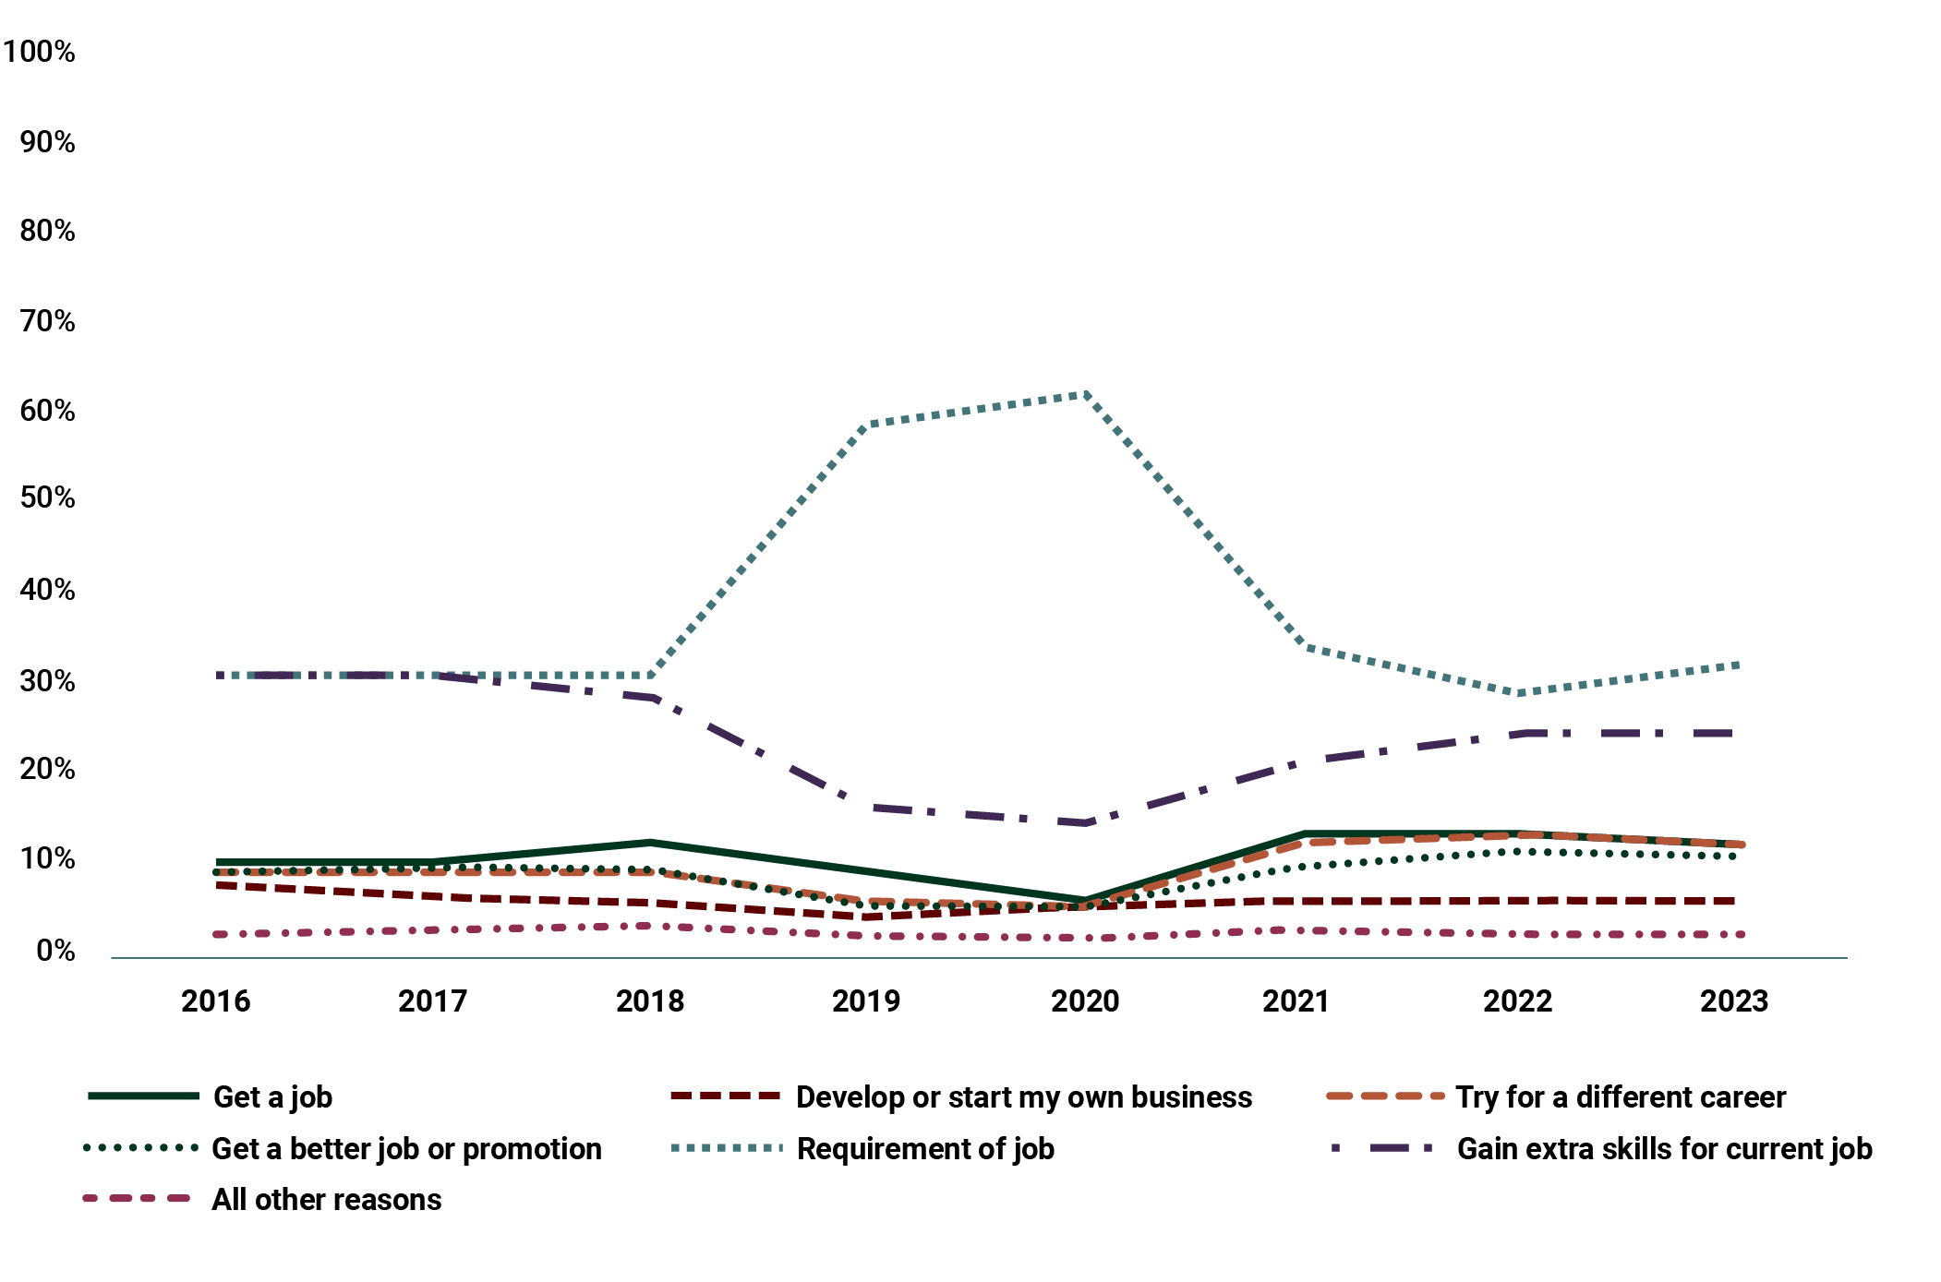
Source: NCVER, National Student Outcomes Survey, 2022.
View the data table for Figure 10 at Appendix B, Table A8.
Transitions data also provides evidence to support these trends. Of those completing the Certificate IV TAE in 2019, less than 5% moved into new teacher, trainer and assessor roles in 2020 to 2021 from other occupations
in 2017 to 2018. More broadly, less than 50% of Certificate IV TAE graduates from 2021 were employed in education and training jobs in 2022 (Figure 11).
Figure 11: Industry of employment for Certificate IV in Training and Assessment qualification graduates after training (of those employed), 2022
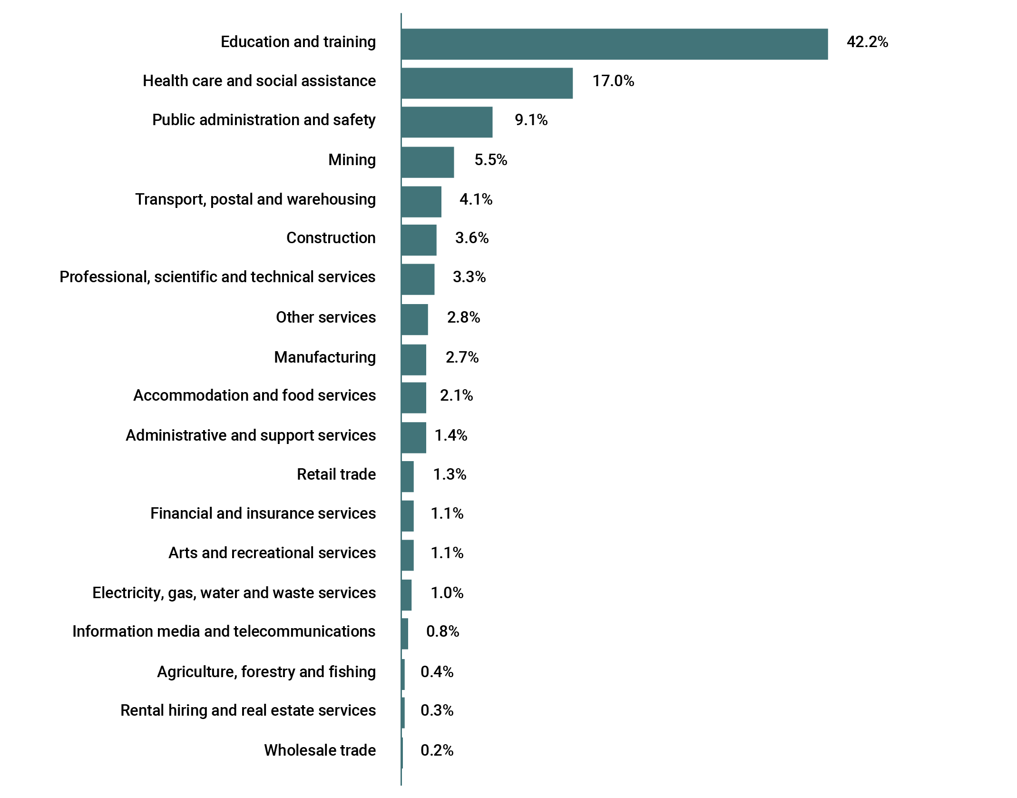
Source: JSA, VET Workforce Study, 2024, p 119.
View the data table for Figure 11 at Appendix B, Table A9.
Further, data shows that for graduates of diplomas (delivered in the VET sector) or higher education qualifications in adult education, there is only a small increase in the number of people who move into a VET teacher, trainer and assessor role. For graduates of diplomas which have a focus on adult education (delivered in the VET sector), 22.6% were already VET teachers the year before they graduated. After graduation, the proportion of people who were VET teachers increased slightly to 23.6%. This shows low movement from other occupations into VET teaching roles.
The VET Workforce Study finds there is very minor variation in employment pre- and post-graduation across most relevant occupations, suggesting these diploma-level, and above, adult education qualifications are being used to upskill the existing workforce rather than supply the pipeline for new VET teachers. There is a poor perception and awareness of VET workforce roles – particularly teaching, training and assessor roles.
One of the recurring themes raised in consultations was about challenges related to the perceptions of being a VET teacher, and of the VET sector more broadly.
The low perception of being a TAFE teacher is a barrier to attracting people into the workforce. This is a broader cultural problem. ‘Those who can’t do, teach’ is a common cultural phrase that you hear and symbolises the public perception of teaching. Students often bring these cultural understandings into the classroom and this undermines their relationship with the sector. (RTO manager)
Some stakeholders indicated that this poor perception of the role impacts consideration of it as a long-term career goal. One former teacher described that many view it as ‘something you stumble into… Many [industry professionals] don’t see it as a full-time, permanent career.’
Feedback also indicated there is a general lack of awareness of the range of VET workforce careers available, and a need to improve awareness and understanding of opportunities in the VET sector generally.
In building the perception and awareness of VET sector roles, stakeholders noted that localised efforts tailored to specific roles, industries and cohorts are more likely to be effective, but should form part of an overall coordinated effort to address the supply challenge. This helps to build greater public understanding of the VET workforce’s importance to the economy and the diverse range of pathways and careers available.
Efforts to build the profile and esteem of VET careers could include targeted strategies focused on critical industries and underrepresented cohorts, and could:
- draw on the National Careers Institute’s capacity and expertise and make use of its Your Career website
- make use of existing state or territory campaigns and promotions
- engage TAFE Centres for Excellence, industry, and JSCs for industry-specific and targeted content, particularly in national priority areas.
The occupational mapping would inform any promotion strategies to ensure campaign activities reach key target audiences.
Action 4: Develop targeted, coordinated and sequenced promotion strategies and activities to boost the profile of VET workforce careers and attract more people into the sector.

There is a need to involve industry more actively in the development of the VET workforce.
Industry’s involvement is integral to the sustainability of the future VET workforce, and industry is the ultimate beneficiary of these efforts, as a larger and better VET workforce can train more workers for Australia’s industries. Stakeholders agree that ‘bringing all players to the table’, including through a tripartite approach, is a precondition for success and will ensure localised and industry-specific actions are effective.
JSCs are centrally placed to drive industry collaboration, and support industry in identifying and delivering on relevant responses to VET workforce issues. Through their workforce planning, stakeholder engagement and early activities, JSCs have already identified VET workforce challenges relevant to the industry sectors they support that need to be addressed. JSCs are a central voice for their industry sectors and work closely with employers, unions and governments to understand skills and workforce needs, but industry engagement does not rest with JSCs alone. There needs to be broader and sustained engagement between relevant stakeholders, including RTOs, employers and industry.
In addition, to maximise opportunities to attract and retain staff, RTOs have a role in ensuring they not only engage with industry on VET workforce solutions, but are also employers of choice. For example, by offering competitive wages, job security and a range of flexible and supportive conditions.
Increasing engagement with industry and involving it in responding to VET workforce challenges could include:
- engaging JSCs to work with their industry partners to develop effective and specific actions to build and develop the VET workforce, such as:
- promoting, attracting and retaining under-represented groups
- strategies to encourage VET career pathways in regional rural and remote areas
- creating succession plans in small and niche industries with an ageing workforce
- forging industry compacts and opportunities for practising VET teachers to spend time in companies to maintain industry currency
- using state and territory industry engagement methods to encourage employers to have ‘skin in the game’ through industry compacts, where relevant, and partnerships with RTOs.
Closer collaboration with the VET sector may also provide reciprocal opportunities for industry to support their own workers and address some of their own workforce challenges. For example, those moving into retirement or unable to continue in their industry role may consider teaching, training and assessing roles as a way to continue to engage with and contribute their expertise to industry.
Action 5: Increase industry involvement in employer and RTO led responses, and encourage and facilitate industry led responses, to VET workforce challenges.

There is a need for bespoke approaches for some workforce cohorts and delivery contexts.
Addressing the challenge of attraction will not be solved with a one-size-fits-all approach, given the VET workforce is not homogenous. There is also a need to take targeted and localised actions to ensure people are taking up roles working in specialised contexts, including actions to attract and retain First Nations peoples, foundation skills practitioners, and those delivering VET to secondary school students.

Building the First Nations VET workforce
As highlighted in Chapter 2, First Nations peoples are significantly underrepresented in the VET teaching, training and assessing workforce. However, they participate as learners at double the rate of the non-First Nations population aged between 15 and 64.
Stakeholders indicated the lack of recognition of the local skills, knowledge and community connection of First Nations peoples is a source of frustration for some potential First Nations staff. However, in addressing this challenge, First Nations stakeholders outlined that, to be successful, any strategy to build the First Nations VET workforce should be developed by First Nations peoples, and this may require local variance to ensure success. Outcomes of strategies to build and support the First Nations workforce should also be defined in partnership with First Nations peoples, and may include measures such as increased employment and career progression of First Nations peoples in the VET workforce.
There are opportunities to build on best practice already in First Nations owned or operated organisations, ACE providers, and TAFEs to improve the attraction and retention of First Nations staff. Strategies developed to build the First Nations VET workforce could include:
- building cultural competency and responsiveness within the sector
- developing targeted First Nations marketing campaigns, including in remote areas
- developing culturally appropriate resources to support those moving into the sector
- looking at how to better incorporate First Nations skills, knowledge and community connections into the delivery of training.
Work in this area could be informed by JSA’s research into the First Nations VET workforce and will seek to make use of collaboration mechanisms at the state and territory level.
Action 6: Develop localised and bespoke First Nations strategies to build the First Nations VET workforce. These will be developed from the ground up in partnership with First Nations peoples.

Foundation skills practitioners and VET workforce delivering training to secondary school students
Foundation skills practitioners are highly skilled and specialised members of the VET workforce. Stakeholder feedback from consultations identified a critical need to address current and future shortages to support the delivery of foundation skills training. This is particularly important as foundation skills – and the practitioners that deliver them – are critical enablers of the success of the VET sector and its workforce as a whole, and the overall success of learners.
The need to strengthen the foundation skills workforce was also emphasised in the final report from the 2022 House of Representatives inquiry into adult literacy and its importance. The report recommended the Australian Government work with state and territory governments to develop and implement a national strategy to renew the adult language, literacy, numeracy and digital literacy education workforce.
Chapter 2 of this Blueprint also highlighted there are a range of specific challenges and barriers for the VET workforce delivering training to secondary students. These vary depending on the school and teacher registration arrangements in each jurisdiction. Stakeholders were clear that attracting people into these roles will require bespoke consideration and action.
Some of the Blueprint’s actions aimed at supporting the attraction and retention of the broader VET workforce will have a flow-on effect for both the foundation skills workforce and those delivering training to secondary school students. In particular, the occupational mapping and further research enabled by the VET workforce data strategy will provide insights into the complex nature of these workforces and provide an evidence base to inform further action.
Development of strategies for these workforces could provide the opportunity to work with stakeholders to consider barriers and potential actions identified through the Blueprint to ensure responses will have impact, and to identify if other actions are required to address specific areas of need.
Action 7: Through the development of a 10-year National Foundation Skills Strategy to identify critical actions to strengthen the foundation skills sector, consider opportunities to grow and support the foundation skills workforce.

Action 8: Through the development of a National VET for Secondary Students Strategy, explore opportunities to grow and support the teacher, trainer and assessor workforce delivering VET.

Existing strategies being used by RTOs to attract more people to VET workforce roles.
Stakeholders provided examples of strategies from RTOs and states and territories to attract more people to VET workforce roles. These included recruitment campaigns to build more awareness and understanding of the roles available and of their value, and financial incentives to offset the costs of being in the VET workforce, including the costs of obtaining a required qualification. The case study included below outlines an example.

Western Australia’s Be More Campaign
This campaign positioned TAFE as an employer of choice and connected personal motivation and higher purpose drivers to encourage industry professionals to consider becoming TAFE teachers. The campaign attempted to drive behaviour change through testimonials from real TAFE lecturers teaching in priority industries and encouraged a diverse mix of applicants, including Aboriginal and Torres Strait Islander people, women and young people. The campaign highlighted the benefits and opportunities of working in the WA TAFE sector and emphasised the role training plays in contributing to WA’s economy.

Opportunity 3
Making it easier for high-quality teachers, trainers and assessors to enter and stay in the VET workforce
In the NT we have a very small population. Few people hold the [trade] qualification, let alone experience and a [Certificate IV] TAE qualification … [it means that] experienced people have too many hoops to jump through to become VET teachers.
(RTO manager in the Northern Territory)
In addition to supply and demand challenges associated with the current and future VET workforce – in particular with teacher, trainer and assessor roles – data and feedback from consultations revealed both universal and cohort-specific barriers to entering the VET workforce. Stakeholders indicated entering the VET workforce can be more difficult than other industries, and these barriers can diminish the interest or ability of people to take up roles in the VET sector.
While qualifications are one way of ensuring those working in the sector are capable and deliver high-quality training, stakeholder submissions identified that current requirements are one of the most significant barriers to entering the VET workforce. In relation to the Certificate IV TAE, the major concern raised was that it does not effectively accommodate the varied and complex mix of skills and knowledge required to support teachers, trainers and assessors in their role.
While the TAE Training Package was reviewed in 2022, some stakeholders indicated the Certificate IV TAE is still too compliance focused and does not adequately prepare individuals for the variety of job roles in the sector. However, stakeholders indicated the stackable approach, greater flexibility and elective options available in the Certificate IV TAE are welcome improvements. Including a practicum unit as an elective was also identified as beneficial.
Stakeholders were also clear that any further changes to the TAE Training Package should not be applied to already qualified and practising teachers, trainers and assessors. They indicated the upgrade required in 2019 led to many in the sector leaving the profession, particularly those close to retirement.
More information about these challenges is outlined under Opportunity 5, which focuses on the content of the Certificate IV TAE.

The cost, time and effort needed to gain required qualifications.
Feedback from roundtable consultations suggested that many potential VET sector staff cannot afford to take time off from their current paid employment to undertake the study needed to move into teacher, trainer and assessor roles. Some stakeholders also observed that entry qualifications can be expensive without a subsidy.
Despite acknowledging there is a baseline expectation of an individual’s knowledge and skills to teach, train and assess through undertaking relevant qualifications, stakeholders were of the view the Certificate IV TAE content is difficult for some learners and takes a considerable amount of time to complete. Further, some course offerings are difficult to undertake if a person is working, due to the location of courses and mode of delivery.
Stakeholders indicated that some industry professionals who want to move into a VET workforce teacher, trainer and assessor role might find completing an Australian Qualifications Framework (AQF) Level 4 qualification challenging. Although these individuals may have difficulty completing the Certificate IV TAE, they bring strong vocational skills and industry expertise, as well as experience imparting their knowledge to junior workers, which makes them highly regarded as potential teachers, trainers and assessors. It was raised in consultations that RTOs and policymakers need to continue focusing on providing structure and support for these skilled individuals to better utilise them in the workforce, such as teaching in teams.

A lack of recognition of other qualifications and experiences.
Feedback from consultations indicated that qualified school teachers found the content of the Certificate IV TAE to be unnecessary given their qualifications and experience, and that their past experience and qualifications should be recognised as satisfying the requirements of the Standards for RTOs. Similarly, TESOL and adult LLND teachers brought extensive experience to teaching, training and assessing roles, as well as having specialised teaching qualifications, often including postgraduate qualifications. For these types of potential teachers, stakeholders indicated the Certificate IV TAE qualification does not materially add to their skills.
Stakeholders identified that the local skills, knowledge and community connection of First Nations peoples was not adequately recognised. The requirement for potential First Nations teachers, trainers and assessors to complete a formal qualification before they can teach in the VET sector is a source of frustration for them, as well as for RTOs who would like to employ them in these roles.
Recent changes to the Standards for RTOs have addressed some of these concerns. These changes include:
- enabling individuals who hold an education degree that allows registration as a secondary school teacher to be engaged as trainers and/or assessors under supervision or without supervision if they hold an additional specified TAE skill set
- enabling individuals actively working towards the Certificate IV TAE or diploma from the TAE Training Package to deliver training and contribute to assessment under supervision
- enabling broader use of industry experts in the delivery of training, providing RTOs can demonstrate the relevant expertise and skills of these experts.
Further information on these changes are available on the Department of Employment and Workplace Relations website.
Stakeholder submissions identified that current credential and industry currency requirements were the most significant barrier to attracting people into the VET workforce. Stakeholders felt strongly that the most effective way to assist movement between industry and the VET workforce would be better recognition of the skills and experience of industry experts, which could be achieved through further formal recognition of this expertise in relevant education credentials.

More flexible and accessible pathways.
These challenges indicate that there are opportunities to build more flexible and accessible pathways into the VET workforce, including tailored approaches for unrepresented and ‘untapped’ cohorts. For example, investment could be made in scaling up and/or piloting innovative workforce pathways across different jurisdictions to test more flexible, accessible and supported delivery models for TAE and other qualifications that improve attraction and retention. These could include:
- ‘earn while you learn’ models to support work-integrated pathways, including traineeships and apprenticeships
- accelerated pathways that enable participants to complete full qualifications in an appropriately condensed period, with appropriate delivery arrangements to support quality learning outcomes
- taster pathways, secondments and joint appointments from industry
- industry currency models to support and encourage trainers to be released back into industry, which supports developing industry skills
- bespoke arrangements that use recognition of prior learning and experience to create more accessible entry points for priority roles.
In addition, there are opportunities for governments to promote the recent changes to the Standards for RTOs that support additional flexibility for RTOs to support expansion of the teacher, trainer and assessor workforce and clarify the role of industry experts in delivery of training, including through VET regulator channels.

Difficulty recruiting staff in outer regional and remote areas.
There are challenges obtaining qualifications in regional and remote settings due to the availability of the Certificate IV TAE in these areas. In particular, there are challenges meeting classroom delivery requirements, which are often seen as beneficial for learners.
Recruiting and retaining staff in outer regional and remote settings can also be difficult because major regional centres often house large industry ‘players’ who compete for recruits, and can also offer services and amenities that smaller or outer regional and remote areas do not.
Stakeholders in regional and remote contexts reflect that travel time and distances to work are significantly higher than metropolitan areas. This affects attraction to these roles, as well contributing to teacher, trainer and assessor ‘burnout’ or attrition, especially for those who are required to travel between multiple campuses. Travel distance challenges are felt even more by VET workforces in regional and remote contexts, where stakeholders shared in consultations that teachers, trainers and assessors may need to travel over 100 km multiple times a week.

Low inflow into teacher, training and assessor roles from skilled migration.
There have been several attempts to use the skilled migration system to increase the supply of VET teachers, trainers and assessors and other staff, but uptake has been modest. As mentioned in the previous chapter, currently the ANZSCO occupation Vocational Education Teacher is, and has been since 2018, an eligible skilled occupation on the Regional Occupation List under 6 different types of visa (subclass 407, 489, 482, 187, 494, 491). However, over the last decade fewer than 20 visas have been granted per year.

Existing strategies being used by RTOs to overcome barriers to entry to teacher, trainer and assessor roles.
Improving the flexibility of entry and exposure to the sector is an important step to increasing the supply of dual professionals that have the desirable blend of (current) industry experience and formal qualifications in the delivery of training and assessment.
(Industry peak organisation)
During consultations, stakeholders detailed strategies from RTOs and states and territories to overcome barriers to workforce entry and offer innovative employment-based or work-integrated pathways into the VET workforce – in particular for teacher, trainer and assessor roles. These are included as case studies below.

TasTAFE’s Associate Teacher Program
The Associate Teacher Program is an introductory program to attract, support and train new teachers, trainers and assessors. It is an earn and learn model, with 20 weeks of training in which learners complete the Certificate IV TAE and practical teaching as an Associate Teacher, a role created by TasTAFE to enable learners to enter the classroom quickly and build their experience. The program includes wrap-around support and mentoring and ongoing support from another trainer in the same industry. The cost of the Certificate IV TAE is covered by TasTAFE, supported by the Tasmanian Department of Education and learners earn an income while beginning their teaching career.

TAFE NSW Paid to Learn Program
Established by TAFE NSW in late 2022, Paid to Learn (PTL) fast tracks the transition of qualified industry professionals into vocational teacher roles. The full-time, 14-week program combines peer observations, teaching under supervision, and Certificate IV TAE study.
PTL scholars are supported by a dedicated capability team, head teacher, and a teacher mentor or ‘buddy’, ensuring a smooth transition to the classroom. Scholars receive specialised capability uplift in contemporary teaching methodologies, digital skills and teaching tools, along with wellbeing support. A typical week includes 2 days on campus observing teaching practice, one day for capability uplift, and 2 days Certificate IV TAE study. This comprehensive, blended approach ensures scholars have everything they need to start their teaching career feeling both competent and confident.
Key outcomes as at 2024 include:
- positive graduate outcomes and success in alleviating actual and perceived barriers to a VET teaching career
- 143 teachers started the program, with 139 completions (97% completion rate across 3 cohorts)
- 135 of 139 teachers are currently still employed by TAFE (97% retention rate)
- a significant decrease in delayed student intake due to additional teaching capacity
- stabilised teacher workloads due to reduced excess teaching hours.
TAFE NSW credits the success of the PTL Program to wrap-around support, implementing feedback, and ongoing commitment to communication with all stakeholders.

Supporting First Nations teachers in WA to become VET teachers
Kimberley Aboriginal Medical Services Council (KAMSC) is an Aboriginal Community Controlled Organisation (ACCO), which is comprised of other ACCO members delivering health services in the Kimberley region of Western Australia. KAMSC collaborates with member organisations to identify qualified people working in industry who have an interest in teaching VET.
KAMSC funds and guides learners through completing the Certificate IV TAE part-time over a 2-year period in stackable skill sets to effectively build knowledge of VET teaching. Program flexibility and wrap-around support are key to producing successful results, acknowledging that learners must balance work, travel, family and care responsibilities and cultural needs. This program recently received funding from the Australian Government to work with the National Aboriginal Community Controlled Health Organisation to build a workforce of First Nations teachers who can travel to deliver place-based learning and assessment and grow the First Nations VET workforce.

Supporting learners to enter the VET workforce in a private RTO setting
EIM Training collaborates with industry to provide expert guest trainers to students. Through this relationship, EIM collaborates with industry to identify individuals with industry knowledge and who may be interested in training. Learners are brought into a training role as Class Assistants working under a supervision model, while undertaking the Certificate IV TAE at the learner’s cost. After completing the foundation Certificate IV TAE units, learners are then able to work independently with VET students while still under supervision. Once the Certificate IV TAE is completed and the teacher has completed 12 months of service at EIM, they are reimbursed the cost of the qualification.

Chisholm Institute’s contextualised TAE course and Earn and Learn Pathway
In Victoria, Chisholm Institute has contextualised a Certificate IV TAE qualification to the construction sector.
Initially, students were able to continue working in their field while also teaching apprentice classes on a casual basis as subject matter experts, and then use that teaching experience to support their progress in the qualification. In subsequent programs, teachers have been engaged under full-time teaching contracts and complete 3 days per week studying their Certificate IV TAE, while spending the remaining 2 days in the classroom or in workshops with a dedicated mentor teacher. The new teachers move from shadowing their mentor to teaching under supervision to teaching independently. To support teacher shortages, the program has also been expanded to support the development of teachers in the English as an additional language (EAL) space.

Far West Orana’s Local Jobs Plan growing and supporting new VET workforce in Broken Hill
The Department of Employment and Workplace Relations Local Jobs Program (LJP) connects employers, individuals and RTOs under a customised regional Local Jobs Plan and local support team. In 2022, the Far West Orana LJP team identified that Broken Hill had not had locally delivered training in hairdressing in almost a decade, affecting both the local industry and local job seekers.
The LJP team facilitated a roundtable meeting with local salon owners and key stakeholders, and through this event they connected with a young salon owner interested in becoming qualified to teach hairdressing. The LJP team sourced a private RTO who offered a 12-month part-time online Certificate IV TAE, and enrolled the learner under the NSW Government’s Smart & Skilled funding. The learner received wrap-around support from the LJP team during their studies and is now employed part-time at Broken Hill TAFE to deliver Certificate II Salon Assistant and Hairdressing Statement of Attainment courses. There are five local individuals enrolled in the Certificate II course, and the Hairdressing Statement of Attainment course was fully subscribed after opening with 12 students. The team are currently working with another two local hairdressers and a barber to find suitable funded Certificate IV TAE places.

The Victorian Department of Education’s VET Trainer Career Pathway Pilot Program
The Department of Education is leading an innovative employment pathway pilot in partnership with WorkSafe Victoria (WSV), which aims to build the supply of VET trainers in schools.
Industry professionals who are part of WSV’s Return to Work Program have rich industry skills and experience but may not be able to return to their pre-injury employment. This program offers a retraining pathway for these individuals to teach the next generation of learners. The Department of Education supports participants to:
- complete the Certificate IV in Training and Assessment
- engage in supplementary professional learning to support them to step into a classroom
- access additional support that they may need to return to study
- undertake a school placement with mentoring
- identify and apply for VET trainer opportunities.
At the conclusion of the program, participants will be qualified to deliver VET in schools, TAFEs or other RTOs. Of the 7 participants that commenced the pilot program in 2023, 4 have commenced full-time work in a VET trainer role and the remaining 3 will be supported to identify VET trainer roles when ready. The department continues to test the model with a second pilot running in 2024 and will explore expanding the program in 2025.

Skills SA’s Accelerate Scholarship pilot
Delivered over 2022 and 2023, the Accelerate Scholarship pilot supported 49 VET educators from 22 RTOs in South Australia to enhance their practice through a diploma-level teaching qualification and engaging in a Scholars’ Network, which included monthly extension workshops on key teaching topics and opportunities to share and reflect on practice.
Scholarships were valued at $3,000. For regional educators, an additional $1,000 was available to support travel and accommodation costs.
Alumni indicated the scholarship program assisted and inspired them to improve their practice in designing and delivering engaging and effective learning and assessment experiences, and meeting the needs of diverse students.
Two scholarship alumni were nominated for South Australian Training Awards, with one alumnus winning in their category. Other alumni have been promoted to leadership or specialist roles, including quality improvement at course, faculty and RTO level.

Action 9: Invest in innovative VET workforce pathways through scaling up existing initiatives and/or piloting new models which contribute to an uplift in workforce capacity or capability.
Stakeholders also acknowledge that recent changes to the Standards for RTOs have increased flexibility, allowing organisations to address some of these challenges already. One key organisation described them as having ‘afforded greater flexibility and transitional arrangements for the [teacher,] trainer and assessor workforce’. The positive effects of these changes will continue to contribute to the sector, attracting a broader pool of people into VET workforce roles.
Examples of initiatives that may be funded could include:
- initiatives to provide financial support for practitioners in national priority industries to move into the VET teaching workforce
- initiatives to share staff between industry and the local RTO in small regional communities
- facilitating collaboration between multiple RTOs to demonstrate a ‘hub’ approach to providing professional learning.
Governments and the VET sector can work together to support more local, bespoke approaches by providing targeted funding in the right places. For example, focused and time-limited grants could help to develop further actions to grow and support a sustainable VET workforce, particularly where there are opportunities for an immediate uplift in workforce capacity or capability.

Any grants would need to:
- be able to be applied for by any stakeholder relevant to the VET sector including RTOs, peak bodies, unions and industry bodies
- focus on the workforce challenges identified in the Blueprint or a clearly defined local challenge or context
- require recipients to provide evidence of outcomes, including helping address one of the challenges or improvements in their specific context
- be assessed against clear objectives and criteria.
In addition, introducing more initiatives and incentives could help to reduce barriers to entry and provide an immediate boost to attracting people into a VET career. It could also help to retain the current workforce to support sustainable long-term supply. These initiatives should help to:
- offset the impacts, including time and effort associated with supporting people into VET workforce pathways for priority roles
- incentivise people who hold TAE Training Package qualifications to either enter or return to the VET workforce
- incentivise the existing VET workforce to undertake higher qualifications.
Initiatives to help attract and retain people could also take a variety of different forms depending on the context. Initiatives include:
- scholarships and bursaries
- employer support to encourage the release of staff to engage in mentoring
- industry currency and professional development
- incentives that target specific priority industry areas and help support employees to enter the VET workforce, in turn ensuring a pipeline of qualified workers for these industry areas
- initiatives to target specific priority cohorts to support completing qualifications and moving into VET workforce roles. This could be extended to include specialist roles and areas of high need (NSA areas of skills priority; First Nations; regional and remote; foundation skills; and women in underrepresented areas).
Action 10: Develop initiatives to attract people into, and support and retain people in, VET workforce careers.

Opportunity 4
Supporting professional learning, career progression and industry currency
Trainers find it is hard to keep up with professional development and industry currency requirements … We schedule it in the RTO I work for, but we are finding that [trainers] are overwhelmed and they always feel like they are running behind. (Teacher and RTO manager)
Alongside the challenge of ensuring a supply of workers are entering the VET workforce pipeline, there are challenges associated with making high-quality professional learning and career progression available to the current VET workforce – particularly teachers, trainers and assessors. This is an essential provision for the continued support and ongoing development of the workforce and to support the retention of staff.

Cost, time commitment and course availability are the main barriers to uptake of professional learning.
Feedback from consultations indicated that the cost of professional learning can be prohibitive if not subsidised or fully funded by their employer. While some RTOs deliver and fund professional learning for their staff, stakeholders identified challenges with providing professional learning, including costs associated with time release and backfill requirements.
Stakeholders shared that many VET staff do not have enough time to complete professional learning in addition to their existing workload, particularly those who work part-time or casually, or those teaching VET in a secondary school context. For teachers who deliver VET in secondary schools, this can be compounded if they are required to undertake professional development to meet both the VET and school regulatory requirements. This is also an issue for teachers, trainers and assessors, who are required to complete professional learning and maintain industry currency under the Standards for RTOs.
Stakeholders also indicated that teachers, trainers and assessors lack access to relevant and high-quality professional learning for teaching practice and methodology, for specific industry and course contexts, and for supporting particular students. Stakeholders indicated this is particularly acute in regional and remote settings, where accessing local face-to-face professional development opportunities is often difficult. More broadly, people often have difficulties in finding the right professional learning and connecting with other professionals in this environment.
Action 11: Implement targeted professional learning to address key industry and pedagogical priorities, including embedding best practice in inclusivity, respect and gender issues into training delivery and VET workforce culture.

There is a lack of clarity about what is required to meet industry currency requirements for teachers, trainers and assessors.
Industry currency needs more clarification. I am always searching for ways for the trainers to gain this without impacting on them delivering training. (RTO manager)
While industry currency looks different across sectors and industries, in general stakeholders were of the view that there is insufficient guidance on learning and experiences required to ‘stay current’ for teachers, trainers and assessors. There were calls for clear advice to be provided to the VET sector to reduce uncertainty for organisations and staff.
One particular issue experienced by RTOs, and a major barrier to releasing staff to maintain their industry currency, is the difficulty in backfilling appropriately qualified
teachers, trainers and assessors. Stakeholder feedback indicated the sector-wide skill shortage of teachers, trainers and assessors was an additional challenge.

There are unclear career structures and progression pathways in the VET sector.
Consultation revealed that compared to other industry sectors, including workforces in other education sectors, there is a perception the VET workforce often has unclear career structures and progression pathways. This poses a challenge for both attracting and retaining high-quality staff.
Given that many people who are, or could be, employed in the VET sector – especially teachers, trainers and assessors – are dual-qualified professionals, clearer progression pathways and better employment conditions offered in other sectors could entice staff away from the VET sector. Or this could stop them considering working in the sector all together.
Feedback from consultation also highlighted the perception that taking on more senior roles leads to additional compliance and administration work and reduces teaching time and contact with learners. This was seen as a disincentive as it takes the teacher, trainer and assessor away from the work that was the primary reason they embarked on a career in the VET workforce.
Stakeholders reflected that despite VET being one of Australia’s more feminised workforces, there is a perception that there are fewer opportunities for women to advance, which may affect how many are attracted to the VET workforce.
This glass ceiling effect can discourage ambitious candidates from entering these fields and contribute to high turnover rates as employees leave in search of better opportunities. (Advocacy group)

Existing strategies being used by RTOs to streamline professional learning, industry currency, and career structures.
Consultations highlighted that individual RTOs take a range of approaches to ensure teachers, trainers and assessors have access to high-quality professional learning, career progression pathways and opportunities to maintain industry currency. This includes:
- developing frameworks that set out expectations for staff capabilities
- identifying or delivering professional learning that aligns with these capabilities or other priority learning areas
- encouraging and supporting higher-level qualifications
- delivering different types of professional learning, including resources, modules, courses, coaching, mentoring and communities of practice
- recording and tracking professional learning
- maintaining industry currency, such as through industry exchanges, release arrangements and secondments.
Some of these examples and approaches are included as case studies in this section.

Charles Darwin University VET Educator Capability Framework
Charles Darwin University’s (CDU) VET capability framework was implemented in 2018 and revised in 2020 through extensive internal collaboration between CDU’s capability team and the teams who would be using the framework and benchmarked nationally. The framework is designed to be flexible so that staff can self-identify the level at which they currently sit, rather than being aligned to a capability level based on their job role alone.
There are 3 capability tiers in ascending order: competent, proficient and lead; and 4 domains: professional practices, educational design skills, teaching and assessment practices, and digital skills (including the application of digital skills to the other 3 domains). Notably, the framework includes capability areas in cultural awareness and sensitivity and support for students with diverse needs.
The framework is used by:
- staff to guide their self-reflection and underpin their professional development planning conversation with their team leader
- the capability team to conduct a skills inventory within teams and identify areas of strength and areas for improvement.
CDU pairs the capability framework with a Skills Kiosk, an intranet which breaks down large development topics further into component parts with resources and training included.

TAFE SA VET Educator Capability Framework
Professional VET educators underpin quality learning, teaching and assessment at TAFE SA.
The TAFE SA VET Educator Capability Framework is designed to enhance the specialist skills and knowledge of all educators. It provides a developmental framework of capabilities and acknowledges educators can have varying degrees of proficiency.
TAFE SA has 5 levels of VET educators: New, Lecturer, Accomplished, Senior and Principal. The framework outlines the required capabilities for each. These capabilities are grouped into Domains and Skill Areas.
The framework enables educators to benchmark their existing capabilities and plan a pathway for progression using professional learning programs and activities to build and enhance skills.
This framework is particularly effective in structuring Performance Management and Development conversations, enabling educators to validate and reflect on their teaching performance. In addition, TAFE SA’s Centre for Educator Practice has developed skills analysis tools for educators to rate their capability levels through self-analysis.
The professional learning initiatives provided by the Centre for Educator Practice are aligned with the capabilities in the framework, ensuring that all activities support the relevant Domains or Skill Areas. This alignment guarantees that professional development is targeted, fostering continuous improvement. Training relevant to each domain is offered regularly, with opportunities to build digital skills in greatest demand as educators seek to enhance their online delivery.
The framework represents best practice by providing a structured, developmental approach to capability building. It supports educators in planning and delivering effective teaching, validates performance through structured reflection, and aligns professional development with organisational objectives.

Chisholm Institute’s Educator Passport
Chisholm Institute in Victoria has created an app that easily maps and tracks educators’ professional learning and maintenance of industry currency.
The app can be both a self-assessment tool for teachers, trainers and assessors to track professional development, and a workforce planning tool for use by HR that aligns to organisational needs and enables workforce capability mapping and planning. Training modules included on the platform have been mapped to regulatory standards and it is Chisholm Institute’s intention to continue enhancing the app, including the development of a digital Vocational Currency Map for interstate use. This app is in use in 7 Victorian TAFEs and one dual sector provider.

TAFE Queensland’s Professional Learning Program
The Professional Learning (PL) Program is based on TAFE Queensland’s educator capability framework and is guided by a formal capability strategy.
TAFE Queensland’s educator capability development network design an annual program of events to support and grow the capacity and capability of educators by identifying, prioritising and responding to professional development needs. The annual Virtual Summit begins each yearly PL cycle, with a range of sessions delivered by vocational experts, gain exposure to emerging technologies and practices. There was a total of 27 sessions on offer in 2023, with 2301 educators in attendance. The overall satisfaction with the Virtual Summit is very high, with a satisfaction score of 88% of attendees surveyed.
Educators can register to attend over 120 professional development webinars or access a curated catalogue of recorded webinars online throughout each year. Further opportunities include formal accredited training (including the Diploma of Training and Assessment), non-accredited training modules, and a directory of external professional development opportunities.
The success of the PL Program is highlighted by the 15,035 educator attendees recorded in 2023, with an average satisfaction rating of 94%. The Program has an annual budget of approximately $65,000.

WA’s TAFE College Lecturer Industry Placement Program
The TAFE College Lecturer Industry Placement (CLIP) Program connects WA TAFE college lecturers with first-hand experience of industry’s skills and workforce needs through industry placements. The CLIP Program provides lecturers from across the State with opportunities to immerse themselves in contemporary industry practice and take these valuable insights back to the TAFE colleges to prepare the future workforce. The program also includes a Lecturer Currency Framework outlining what is needed to remain current and approved currency activities and how to access them. This program is supported by the Western Australian Government.

Charles Darwin University’s Industry Release Program
This program is provisioned in the CDU enterprise bargaining agreement and offers trainers and assessors paid and unpaid return-to-industry time.
As part of career development planning with their team leader, staff can identify a workplace to help them retain and advance their workplace-based skills and knowledge. Staff can access 21 days of paid flexible non-teaching time to complete industry-based practice and learning. In addition, staff who are in their second or subsequent year of employment can apply for up to 12 months return to industry leave, 8 weeks of which is paid. The experience trainers bring back to the classroom ensures students are taught the most up-to-date practices in their industry.

Opportunity 5
Providing more support for early career teachers, trainers and assessors
Many stakeholders indicated that TAE Training Package qualifications, and in particular the Certificate IV, do not adequately prepare people for teacher, trainer and assessor roles.
I have a big problem with the Certificate IV TAE that [it] is not fit for purpose. The Cert IV TAE is heavy on compliance and teaching theory and lacking in practical preparation for the job … When I started teaching, the Cert IV education gave me an idea how the overall system works. However, in terms of classroom teaching work, I had to rely on common sense, existing people skills and professional industry knowledge. (VET teacher)
There were some instances where it was not always clear whether stakeholders expressed these views about the most recent TAE Training Package from 2022 (TAE40122) or the older 2016 version (TAE40116). The key differences between the 2 versions relate to the structure and content of the qualifications:
- The total number of units increased from 10 (9 core and one elective) to 12 (6 core and 6 elective), which increases the learning requirements of the course and the total amount of content covered. The increase in the number of elective units was designed to allow the Certificate IV TAE to provide more tailored learning pathways that align with specific industry or workforce needs.
- The new version offers a broader range of elective units, including on training and assessing in online environments, recognition of prior learning, workplace-based learning, and support for learners with disability.
- A practicum has been included as a newly created elective unit. The unit applies to entry-level VET teachers and trainers to provide them with skills and knowledge required to implement effective teaching and training practice.

The Certificate IV TAE has limitations in preparing people to be able to teach.
The Certificate IV TAE is the minimum entry-level qualification for people who would like to enter the VET workforce and embark on a career as a VET teacher, trainer and assessor. As such, stakeholder feedback centred on a need for people undertaking this qualification to be well supported, trained effectively and to have the required teaching strategies and skills to enable their career as a teacher, trainer and assessor. Some stakeholders had concerns about the content and delivery of the Certificate IV TAE, expressing the view that graduates may not always be suitably equipped to teach upon completion.
A typical trainer and assessor at our RTO requires a minimum of 6 months before they are competent to lead an accredited course. (RTO manager)

The content is heavily compliance focused and some content is lacking.
Stakeholder feedback highlighted that the Certificate IV TAE is focused on the administrative and compliance aspects of the VET sector, and should have a greater focus on teaching methodology and learner support in the classroom. Digital skills, cultural sensitivity, and addressing learner wellbeing and diverse needs all featured in stakeholder feedback as important inclusions that are not well covered in the Certificate IV TAE.

The Certificate IV TAE does not meet the diverse range of learner needs, including for those who have relevant education expertise or, conversely, those with little or no previous teaching experience.
I had to constantly retrain in a Certificate IV TAE upgrade despite having a Master of Education. (Former VET teacher)
Stakeholders felt the Certificate IV TAE could be more flexible and tailored to the specific needs of the person undertaking it. This could include different, and potentially less, content for those who have a previous education background and qualification. It could also include different, and potentially more, support and content for those who have industry experience, or those with little formal education experience.

People enrolled in the Certificate IV TAE would benefit from more support to enable completion.
The pivotal role of mentors cannot be overstated – they are crucial for guiding and nurturing new trainers, addressing the shortage by creating a self-sustaining system of expertise and experience. (VET community of practice)
Stakeholders were of the view that additional support may be beneficial to help people successfully undertake the Certificate IV TAE. This could include additional wrap-around services, such as mentoring and appropriate learning support for those learners who require it, especially for those who have not undertaken a similar AQF level qualification before.

Continuing to improve the TAE Training Package and promote higher-level qualifications.
There is a clear need to ensure the TAE Training Package includes relevant and flexible products that support a range of entry points, and a diverse range of teaching, training and assessing roles. This may also include other relevant workforce roles that ensure high-quality student learning. There is also a need to promote higher-level qualifications and professional development that supports practitioners to continue building their skills and capabilities.
Continuing to improve the TAE Training Package and promoting the undertaking of higher-level qualifications could include:
- developing and promoting resources to support implementing and delivering the 2022 Training Package
- promoting the Certificate IV TAE as a valuable entry-level qualification, as well as the opportunity and skills that higher-level qualifications provide, including as an opportunity for professional development
- promoting the benefits of current higher-level qualifications available, and encouraging individuals to undertake these as part of professional development
- researching whether new and/or higher-level qualifications should be developed to fill gaps and needs identified by the sector, supported by the development of occupational mapping
- considering further opportunities through the Training Package, the Certificate IV TAE, and intersections with Qualifications Reform to ensure improvements are made to support teachers, trainers and assessors, including those who work in regional, rural and remote areas.
Future changes to the Training Package would be informed by the occupational mapping and identification of entry points, career progression and transitions between roles. Given the impact on the sector identified in consultations regarding the 2019 TAE upgrade, any future changes or updates to the Training Package should not be applied to the current workforce.
Action 12: Monitor and evaluate the impact of the Training and Education (TAE) Training Package to ensure it supports teachers, trainers and assessors in the VET workforce, and promote the undertaking of higher-level qualifications to provide opportunities for ongoing practitioner development.

There is not enough support offered to early career teachers, trainers and assessors.
[TAE learners] can find that they need additional mentoring to develop confidence and succeed in their roles. They can find a difference between industry and classroom training they may not have been prepared for. This barrier creates additional recruitment issues for us when newly employed trainers are not retained. (RTO manager)
Stakeholders were clear that more support and mentoring is needed for new teachers, trainers and assessors upon entering the workforce, and that it should be differentiated based on experience and need. This is a particular issue for some individuals who may previously have been ‘on the tools’ and are undertaking a teaching role for the first time.
Many in the sector feel that wrap-around supports, mentoring, or a ‘buddy’ system would help retain people and help early career teachers, trainers and assessors to deliver training. However, feedback pointed to some RTOs not having the resources to effectively provide this, and support would be welcome.
The case studies below provide examples of support for learners or early career VET teachers, trainers and assessors.

TAFE Queensland’s Educator Induction Program
This program is designed to support the transition of newly qualified educators into a teaching role. The program aligns to the TAFE Queensland Educator Induction framework, which is structured in progression stages over 12 months. Participants have access to online modules to build vocational knowledge and skills to support their students’ success.
Feedback from the training highlights the importance of offering content that is accessible, can be taken at the participant’s own pace and is relevant to a point in time in their teaching. In conjunction with online training, educators are provided with a Starter Kit containing customised information relating to their region and delivery area. New educators work closely with a designated mentor and the Educator Capability Members from their region. Once all induction professional learning activities, educators receive a certificate of completion as evidence of teaching currency.
Qualitative feedback of the program is positive and shows appreciation of the support provided that enables educators to gain confidence and capability in their teaching role. For example, one participant said that ‘the educator induction program offered a well-structured and supportive onboarding experience. It covered essential topics, provided practical insights, and featured a valuable mentorship component’.

TAFE NSW Aboriginal Advocate role
The Aboriginal Advocate role is a vital support and resource for all Aboriginal TAFE NSW staff. The advocate role is designed to be fluid to enable advocates to support staff in whatever capacity is needed, from providing career advice or planning, directing or following up on queries, to acting as a support in challenging personal or professional circumstances.
TAFE NSW employs 2 advocates for over 350 Aboriginal staff, and continues to innovate in attracting, retaining and developing Aboriginal staff. Ensuring commitments to Aboriginal staff are delivered has been an important element to establishing trust and connection. For example, TAFE NSW has been focused on providing structure and opportunity for Aboriginal staff to receive not just the professional leadership they need through the established Aboriginal Leadership Group, but also cultural leadership through connection to Elders within TAFE NSW and inclusion of Elders’ voices in the organisation’s actions.

Opportunity 6
Developing and resourcing staff to support learners with diverse and complex needs
All educators need to ensure that their delivery is meeting universal learning design requirements for inclusion. This ongoing professional development would be a small project but is required if there is to be a genuineness of inclusion and equity. (Peak body)
The VET sector provides an important opportunity to Australians to access economic and social inclusion. The sector also supports the participation of learners from a diverse range of backgrounds and experiences. For example, of all learners in 2022:
- 17% were from the lowest socio-economic status areas
- 28% were from regional and remote areas
- 3.6% identified they were from First Nations communities
- 3.9% identified as having disability
- 14% spoke a language other than English
- 5% were international students.
Amid such diversity, stakeholders recognise the importance of VET teachers and RTOs being equipped to support learners, with some stakeholders identifying a recent increase in the numbers of learners needing support. This includes the development of resources for teachers, trainers and assessors and wrap-around support services for learners to be provided by RTOs.
Stakeholder consultation indicated that teachers, trainers and assessors can feel unprepared to support learners for a variety of reasons. This includes the workload involved, a lack of specific training in TAE Training Package, and insufficient professional development opportunities in this area.
Many students have complex needs and trainers are not educated to understand these needs and not informed about the students. They are expected to accommodate training and assessment without guidance or support. (RTO manager)
An example of best practice provided by stakeholders in relation to First Nations learners was that they thrive when:
- taught by First Nations peoples
- offered specialised support designed by First Nations peoples
- training is delivered in a culturally safe and appropriate way.
This model of delivery should be more widely available.
Stakeholders also identified that people in regional, rural and remote contexts can experience more difficulty in terms of access and equity in regard to educational opportunities. This includes complex learner needs that some teachers, trainers and assessors support to ensure learners can successfully undertake their training journey.
This opportunity will be realised through a collection of actions that will better equip the VET workforce to support different learner cohorts through foundational, targeted and context-specific actions.

Existing strategies being used by RTOs to equip staff to engage with a diverse range of learners.
Feedback from consultation highlighted that some RTOs are taking a deliberate approach to supporting a diverse range of learners. Examples included professional development focussed on embedding Universal Design for Learning principles, and LLND upskilling for VET teachers. Case studies of some of these examples are provided below.

TAFE Queensland’s Inclusive Teaching training and non-accredited training modules
Included in TAFE Queensland’s PL Program are a selection of self-paced online training modules aimed to enhance educators’ teaching practices to respect and value the diversity of learners. These include modules such as supporting students with a disability, First Nations cultural awareness training, and best practice in designing accessible courses. In addition, TAFE Queensland provides a dedicated training course that helps educators design and deliver learning experiences that meet the needs and preferences of all learners. These training modules contribute to teaching quality and currency and provide educators the opportunity to practise inclusivity by design in the classroom.

VET Development Centre in Victoria
Established in 2005, the VET Development Centre (VDC) is funded by the Victorian Government to provide professional development to Victorian Skills First providers to raise the professional standing of people working in the VET sector. VDC also provides fee-for-service professional learning and bespoke customised professional development to all teaching and non-teaching staff in the VET sector across Australia and internationally. There are no membership fees to access VDC services.
VDC provides professional development on a range of different topics, and has an extensive list of professional learning opportunities for VET teachers, trainers and assessors in managing and providing for diverse cohorts, ranging from one-hour webinars to full day workshops. Topics include, but are not limited to, teaching and learning strategies, First Nations cultural awareness, delivering trauma-aware education and teaching students with anxiety and neurodiversity, LLND needs, and supporting students experiencing family violence. VDC’s programs have very high attendance, with 15,000 attendees at events and programs in 2023 and a 95% satisfaction rating by attendees surveyed.
VDC also runs a 2-day in-person National VET Teaching & Learning Conference encompassing all areas of VET practice, including supporting diverse needs, and has done so for almost 2 decades, with online delivery from 2020 to 2022.
Developing and resourcing staff to support learners with diverse and complex needs can be achieved through a combination of different actions:
- Developing data strategies would enable the collection of critical workforce data on current workforce capability and opportunities to better equip staff with the skills they need to successfully support learners.
- Wider reforms, including developing localised and bespoke First Nations strategies to build the First Nations VET workforce, as well as developing a 10-year National Foundation Skills Strategy to identify actions to strengthen the foundation skills sector, would enable the sector to leverage the skills and experience of First Nations and foundations skills staff, respectively, to support a range of learners with diverse and complex needs.
- Supporting learners with diverse and complex needs could be one of the priorities for more targeted professional learning. This includes supporting learners from both a pedagogical perspective but also in the context of inclusivity, respect and gender issues.
- Continuing to improve the TAE Training Package and promote the undertaking of high-level qualifications could include a focus on equipping staff with the skills they need to support all learners.

Opportunity 7
Reducing administrative and compliance burden
[The administrative burden] impacts retention more than attraction, but it still does impact attraction. If a role is already hard to get into, and [the applicant] catches wind that [they’ll] likely get bogged down in a pile of paperwork, it impacts attraction. (RTO manager)
While regulation, and its associated administrative and compliance requirements, is necessary to sustain a high-quality VET sector, stakeholders indicated current levels are high and create challenges for RTOs and their staff. This is particularly acute for teachers, trainers and assessors. These activities often become a significant part of their role, taking them away from the primary reason they joined the VET workforce. Some of these administrative and compliance elements are outlined in Table 7.
Table 7: Summary of different administrative and compliance elements for the VET sector and examples of these in practice
Element of compliance and administration | Examples in practice for RTOs and their workforces
Institutional administration | Individual RTOs have policies and procedures to ensure they are complying with various regulatory and program requirements. This includes, for example, data and reporting, record keeping and administration to ensure learner records are accurate and up to date.  The administrative burden associated with these activities may vary according to the size and type of RTO, with teachers, trainers and assessors required to undertake and support RTO administration requirements.
Standards for RTOs | RTOs are required to comply with the Standards for RTOs to ensure training delivery, assessment, learner enrolment, learner support and administration align with the intent of the standards.
Training Package requirements | Changes to Training Packages require RTOs to ensure training products on their scope of registration are current and learners are transitioned into updated or new training products, where appropriate.  Mapping the changes, and updating training and assessment materials and strategies is also undertaken to ensure staff and training resources and equipment for delivery are current and meet the Training Package requirements.
Industry currency and professional development | Undertaking professional development, maintaining industry currency, and ensuring this is appropriately supported and evidenced, imposes an administrative and compliance burden on RTOs and teachers, trainers and assessors.
Program and contract obligations (Commonwealth, state and territory) | Different subsidised training contracts and programs have varied compliance, data, reporting and contractual requirements, which are additional to the Standards for RTOs. This also includes separate audit and evidence requirements.
Stakeholders also indicated administrative and compliance burden can vary depending on an RTO’s operational settings. For example:
- complex operations, including mixed funding sources, delivery in multiple jurisdictions, or multi-sector delivery
- small providers, who may not have many, or any, staff dedicated to compliance, with this work falling on executives, teachers and other non-specialist staff
- delivery of VET in schools where the additional workload of introducing new VET programs falls on the teacher delivering VET, rather than the school’s administrative staff.
Stakeholders shared that administrative burden is a particular challenge for training providers with a volunteer workforce, as it is unreasonable to expect staff who are not paid to undertake administrative and compliance activities that are not related, and in addition, to their agreed role.
Our volunteers are passionate about drowning prevention and passing on their skills to others. The paperwork side of things does not interest them, and this is an ongoing struggle for us to minimise the burden on them, while maintaining compliance. (RTO)
At the core of stakeholder concerns and dissatisfaction with the administrative and compliance requirements of the VET sector is that it acts as a barrier to workforce attraction, retention, development and delivery. Stakeholders emphasised that the time spent undertaking compliance and administration activities is time taken away from delivery, planning and development.

High administrative and compliance demands create a perception that the VET workforce has a high workload and undermines work satisfaction.
The workload for compliance has gone beyond onerous to demoralising. You start to wonder what you became a teacher for, because it wasn’t to do paperwork, it was to teach.
(VET teacher)
Many VET staff are seeking flexibility and work–life balance, however, this is undermined by high administrative workloads that often result in staff working additional hours. This affects how potential staff perceive the VET workforce. Stakeholders also said that workload and compliance burden is a major factor in lowering employee job satisfaction and a driver for staff choosing to leave the VET sector.

High administrative and compliance requirements affect the quality of training delivery and impacts professional learning time.
I spent 2 hours each day on compliance paperwork, not on teaching prep or developing better resources for the class. (Former VET teacher)
Consultation feedback highlighted concerns about the administrative load experienced by teachers, trainers and assessors. Stakeholders detailed that a large amount of time was spent on administrative and compliance work, completed at the expense of time spent on teaching-related tasks.
Beyond immediate classroom planning and delivery, the sector said that training and professional learning focuses too much on administration and compliance at the expense of quality teaching, industry currency, or other training. This is particularly acute at smaller private RTOs where there may not be sufficient administration resources.
Better understanding the administrative and compliance requirements for the VET workforce would help to identify opportunities to reduce unnecessary burden. This could lead to increased staff satisfaction and an ability for staff to better undertake their roles, leading to a decrease in workforce attrition.
There could be opportunities for governments to partner with jurisdictions to undertake pilot projects to map and analyse compliance requirements to:
- identify duplicative or unnecessary requirements that can be reduced or rescinded across all RTOs
- develop a model for use across other jurisdictions
- support expanding the model across the other states and territories.

In particular, there are likely opportunities for:
- improving processes and employing specialist compliance roles at the RTO level to reduce the burden on VET teachers, trainers and assessors
- building on existing actions, such as changes to the Standards for RTO and Qualification Reform, to further streamline compliance requirements
- driving efficiencies and improvements in the Training Packages by JSCs
- comparing with other sectors to identify innovative opportunities to reduce compliance burden, noting that VET requires a nuanced approach to regulation to deliver skills for a range of industries.
Action 13: Undertake work to map and analyse compliance and administrative burden and implement strategies to reduce this burden, where appropriate, for the VET workforce.

Opportunity 8
Supporting TAFEs at the heart of the VET sector
As outlined in previous chapters, TAFEs are large, complex public education organisations that deliver a range of education training programs across the spectrum of foundational skills, vocational education and higher education. The purpose of TAFE is to be an integral part of their state or territory government on the delivery of economic, community and regional outcomes.
The TAFE workforce itself is not homogenous and must be seen against the backdrop of the significant range of industries that TAFEs serve. TAFE provides access to training for Australians from all walks of life, while supporting government to meet industry needs for a skilled workforce, both now and into the future. TAFEs are also expected to drive improvement and innovation across the VET sector, so that all RTOs can deliver high-quality training for learners.
For these reasons, TAFEs face unique workforce challenges that reflect their important role in the VET sector. They must attract and retain a creative and capable workforce that can work across a diverse range of roles and industries and, in particular, in new and emerging industries that are critical to Australia’s prosperity. Teacher, trainer and assessor shortages are impacting their ability to service these industries, but there are also shortages across professional support roles that may inhibit the ability of TAFEs to support national reform efforts.

Leveraging the strength of TAFEs at the heart of the VET sector.
During consultation, stakeholders highlighted the unique role of TAFEs in supporting government to deliver a suite of critical reforms in the VET sector, including Fee-Free TAFE, TAFE Centres of Excellence and the National TAFE Network. TAFEs are also expected to play an important role in supporting a more integrated tertiary education sector under the Universities Accord.
TAFEs will need to:
- support a workforce that can meet unique industry needs now and in the future, including new industries
- prioritise the needs of all learners
- develop the capabilities needed for a more integrated tertiary education sector, including through closer ties with universities.
Existing efforts from within TAFE leadership to drive more national networking have been elevated through clear and shared ambitions of all governments and underpinned by investment through the National Skills Agreement. This represents an opportunity that can be harnessed through the actions in the Blueprint so that TAFE itself is identifying and leading the activities that will best work to ensure a viable and vibrant workforce, as well as promoting and embedding these activities to support long-term leadership development of the TAFE workforce across Australia.
For example, a National TAFE Network, inclusive of TAFE stakeholders, could be resourced and empowered to take an active role in sustaining, developing and supporting the TAFE workforce and education practice. This includes:
- building workforce capability for teachers and administrators to support entry and career advancement, including collaboration across jurisdictions and supporting infrastructure
- sharing successful workforce recruitment and retention strategies across TAFEs
- leveraging the TAFE Centres of Excellence to develop leadership capability across TAFEs
- sharing workforce learnings and knowledge from the TAFE Centres of Excellence and industry with TAFEs across Australia.
There is also an opportunity to facilitate collaboration across TAFE Centres of Excellence, the National TAFE Network and JSCs to support industry-led responses to address VET workforce challenges in areas of critical need. This includes collaboration with key employers in critical and emerging industries to support ways to attract and recruit from industry for the TAFE workforce in areas of skill shortage.
Action 14: Embed TAFE workforce leadership as a key activity of the National TAFE Network.

Other issues for further consideration
Consultation with the sector explored several issues and challenges relating to employment conditions, which can act as a disincentive for people to choose a role in VET. In some cases, it was noted industry or other education sectors can offer better conditions.

High rates of casualisation experienced by the teacher, trainer and assessor workforce.
Casualisation and fixed-term contracts are the biggest issue. We are dual professionals, but expected to maintain a mortgage and living costs on a casual wage. (VET teacher)
While casual employment can be a preferred arrangement for some people, stakeholders identified high rates of casual work among the VET teaching workforce as a barrier to attraction and retention. The data confirms this, with VET teachers more casualised (27.3%) than the general workforce (21.1%). The rate of casualisation of VET teachers has increased by 12.1% since 2014, compared to a 0.3% decrease across the entire labour market.
As noted earlier, there are VET workforce data limitations in identifying VET teachers, trainers and assessors due to their dual professional status and given that some of the workforce may be employed primarily in industry. The lack of data limits understanding of the extent to which casualisation may be impacted by these factors and by other employment conditions. There needs to be further research to identify the drivers of casualisation, and where these may be having impacts on the attraction and retention of the VET workforce.

Inability to compete on teacher, trainer and assessor pay and conditions compared with some industries.
An enormous attraction of the energy industry for apprentices is the good, secure wage many electrical workers draw. Workers are faced with taking a significant pay cut when shifting to training roles in the VET sector. (Union organisation)
The average annual salary for VET teachers in 2021 was $81,245. However, there is a large disparity between the typical salaries at private RTOs and public TAFEs. Most entry-level TAFE teachers with a Certificate IV TAE commence at $85,000 or above, with starting salaries ranging between $72,000 and $89,000.
Current limitations in data collection make it difficult to accurately determine average salaries in private RTOs. However, considering that the typical commencing TAFE salary is higher than the average salary across all VET teachers, this suggests that other subsectors of the workforce, including those in private RTOs, may earn closer to the Educational Services (Post-Secondary Education) Modern Award 2020 rate of $58,363 for entry-level teachers. This was confirmed by stakeholders throughout the consultations.
Employers in some key industries – such as mining, construction, trades and other education sectors – can offer more competitive pay and working conditions compared to the VET sector. This can make it challenging for VET to attract and retain people from industry, especially in some geographic areas with high concentrations of certain industries and/or localised skills shortages in some fields. Conversely, people in other sectors – such as aged care and early childhood education and care – may improve their pay when moving into the VET workforce.
In other fields of education, graduate teachers in all states and territories begin on salaries that are near or above the average annual salary for VET teachers referenced previously, and can go on to earn much higher salaries (noting the evidence that TAFE teachers also earn above this average amount). For example, Secondary School Teachers and University Lecturers and Tutors (as classified under ANZSCO) earn 14.8% and 44.9% more than the general Australian workforce respectively, based on median total weekly cash earnings. Both earn more than the median VET workforce earnings, which is 11.1% more than the general Australian workforce. This disparity in salary, combined with the higher rates of casualisation, make attracting educators from other fields of education very difficult.
Many RTOs, teachers, trainers and assessors said the challenges with salary not only creates retention issues in the context of competition with other industries, but can result in the workforce feeling undervalued. One former VET teacher said that the reason they left the workforce was because they did ‘not [feel] recognised for the amount of work [I did], and my teaching [was] not being valued as much as it should’.

Competition for staff between different RTOs.
Stakeholders identified that smaller RTOs can find it more challenging to attract and retain staff compared to larger RTOs and TAFEs that offer more competitive wages, conditions and job security. Union bargained TAFE enterprise agreements in many states and territories support better paid and more secure jobs by specifying higher rates of pay and limiting the rates of casual and fixed-term employment.
In addition to wages, conditions and job security, there are other factors that influence becoming an employer of choice. This includes support for personal development, employee equal opportunity, social inclusion and fair treatment, and safe and supportive working conditions. Providing these conditions can encourage people to apply for roles within an organisation, and increase job satisfaction and retention.

Existing strategies being employed by RTOs to improve employment conditions.
Pay, conditions and the casualisation of the VET workforce were identified as key concerns for stakeholders. Stakeholders indicated this affects the ability of RTOs to recruit and retain staff, particularly for smaller RTOs. Inability to compete on pay and conditions with some industries and other education sectors was raised as a barrier to the attraction and retention of the VET workforce. Stakeholders identified that some RTOs are actively working to improve job quality by employing staff on a permanent basis, where possible. An example provided by one RTO was of a policy that has been implemented requiring hiring staff on a permanent basis in the first instance, before being able to consider temporary or casual staff to fill the role.

Conclusion
An increasing number of learners are engaging in the VET sector, with further participation expected in the coming years, while the VET sector faces significant challenges in attracting and retaining qualified professionals – particularly teachers, trainers, and assessors. Compounding this is a notable shortage of individuals entering the workforce pipeline, exacerbated by various barriers such as perception issues, qualification requirements, and lack of support for early career professionals.
Opportunities to address these challenges include improving recognition of alternative qualifications, streamlining entry pathways, enhancing professional learning opportunities, and providing better support for diverse learner needs. In addition, reducing administrative burden and having a better understanding of the sector, including through the collection of national data, are crucial for the long-term sustainability and growth in the VET sector.
There are also other factors that contribute to the attraction and retention of teachers, trainers and assessors. These include opportunities for secure work and support for professional development and career progression. When employers are competing with other industries and education sectors, they need to consider these factors so they are positioned as employers of choice, and organisations where employees feel valued and supported.

Chapter 4: A blueprint for continuous improvement

Introduction
The Blueprint is a collaborative national strategy that aims to grow and support a sustainable and capable VET workforce, including in regional Australia. To achieve this objective, it must include a continuous improvement approach to support the VET workforce over time and remain responsive to changes in the VET sector and Australian economy more broadly.
There are 3 key aspects of continuous improvement under the Blueprint:
- Continue to build our understanding of the VET workforce as an essential precondition for more targeted and effective action.
- Practise what works: Take a practical, evidence-based approach to addressing workforce challenges and realising opportunities, informed by what is already working in different contexts.
- Connect to wider reforms: Leverage and complement broader reforms in the VET sector to maximise the impact of the Blueprint on the VET workforce and sector generally.
This will operate as part of a 5-year cycle and be subject to monitoring and evaluation through Skills Ministers.
This chapter describes each aspect of continuous improvement in more detail, and the specific actions that support them.

Know more
As outlined in Chapter 1, the Blueprint combines new work from JSA with insights from recent stakeholder consultations to consolidate our understanding of the modern VET workforce in 2024, including key long-term trends and challenges and opportunities in the sector. This builds on earlier work undertaken over a number of decades to better understand the complexity of the VET workforce.
The Blueprint acknowledges that continuing to build our understanding of the VET workforce – particularly during a time of rapid change for the Australian economy – is an essential precondition for taking targeted action to effectively address challenges relating to attracting, retaining and developing the workforce. For example, we need a deeper understanding of workforce roles and their pathways and transition points to support more sustainable workforce pathways in different industries.
Action is needed to develop a national data collection to lay the foundations for the next significant leap in our understanding of the modern VET workforce. In addition, further research is needed, including occupational mapping, to plan more strategically for the future and develop local actions that are tailored to specific contexts.
Table 8 summarises actions that will help governments and the sector to ‘know more’ about the VET workforce.
Table 8: Actions to ‘know more’ about the VET workforce
Action | How this will help us to ‘know more’
- Undertake comprehensive occupational mapping for the VET workforce to identify and inform broader actions to strengthen pathways into, and through, the VET workforce. | Occupational mapping will help us better understand workforce roles and their associated requirements, duties, capabilities, pathways, transition points and relationships with other roles.
- Develop a VET workforce data strategy to enable the collection of VET workforce data to support and enable informed policy and workforce strategies, and inform ongoing research. | A data strategy will help us to fill current information gaps relating to workforce qualifications; teachers, trainers and assessors working in alternative settings; and industry contexts.
- Establish an ongoing research program to develop a robust evidence base for key workforce issues. | Ongoing research will develop deeper understanding in areas such as casualisation of the VET workforce, the impact of AI, teaching practice, psychosocial challenges and other key research gaps. This work will be informed by mapping existing research.
- Undertake work to map and analyse compliance and administrative burden and implement strategies to reduce this burden, where appropriate, for the VET workforce. | Compliance and administrative burden mapping will help us better understand and alleviate the ‘pain points’ on the ground.

Practise what works
Although we need to continue to build our understanding of the VET workforce, there is an immediate opportunity to take a practical, evidence-based approach now to better address workforce challenges. This includes recognising what is already occurring in the sector and seeking to scale up these activities or adapt them to other contexts.
All stakeholders – government, RTOs, industry, peak organisations, unions and employers – can take action to practise ‘what works’ at both the national and local levels. The actions summarised in Table 9 can be implemented in a variety of VET contexts in a way that works best for RTOs and their staff. Actions can be reviewed and revised when our understanding of the VET workforce and ‘what works’ evolves and sheds new light on the most effective approaches.
Table 9: Actions to ‘practise what works’ for the VET workforce
Action | How this will help us to ‘practise what works’
- Develop targeted, coordinated and sequenced promotion strategies and activities to boost the profile of VET workforce careers and attract more people into the sector. | Promotion strategies will be tailored locally to specific roles, industries and contexts. They will also draw on the occupational mapping and integrate with other actions, such as initiatives and grants programs.
- Increase industry involvement in employer and RTO led responses, and encourage and facilitate industry led responses, to VET workforce challenges. | Industry, and the extensive experience it brings, is critical to developing the VET workforce, including transitions between industry and VET and maintaining industry currency.
- Develop localised and bespoke First Nations strategies to build the First Nations VET workforce. These will be developed from the ground up in partnership with First Nations peoples. | First Nations stakeholders know what works in attracting, retaining and supporting First Nations peoples in the VET workforce. They can also lead the development of effective approaches to build broader cultural competency and responsiveness in the sector. Strategies developed could leverage opportunities, or build upon existing best practice, occurring across the sector.
- Invest in innovative VET workforce pathways through scaling up existing initiatives and/or piloting new models which contribute to an uplift in workforce capacity or capability. | Scaling up and piloting initiatives enables governments and the sector to quickly identify what works and support these approaches more widely. This includes interventions with a strong evidence base and local support.
- Develop initiatives to attract people into, and support and retain people in, VET workforce careers. | Initiatives can target specific barriers to entry, including the cost, time and effort of undertaking qualifications and transitioning from an industry career.
- Implement targeted professional learning to address key industry and pedagogical priorities, including embedding best practice in inclusivity, respect and gender issues into training delivery and VET workforce culture. | Providing targeted professional learning enables the VET workforce to build on their foundational qualifications, support excellence in delivery and progress in their careers.
- Monitor and evaluate the impact of the Training and Education (TAE) Training Package to ensure it supports teachers, trainers and assessors in the VET workforce, and promote the undertaking of higher-level qualifications to provide opportunities for ongoing practitioner development. | Providing opportunities for ongoing practitioner development through improvement of the TAE Training Package, informed by the occupational mapping, will ensure that qualifications remain relevant and responsive to VET workforce challenges.

Connect to wider reforms
The Blueprint has been developed in the context of broader reforms occurring in the VET sector. It is critical that Blueprint actions connect to – and complement – these wider reforms.
The Australian Government and states and territories are working collaboratively on areas of agreed national priority under the NSA to address Australia’s skills needs and ensure TAFE is at the centre of the VET sector. This includes the development of TAFE Centres of Excellence, which focus on critical and emerging industries, and the National TAFE Network to strengthen teaching and learning practice.
The development of a 10-year National Foundation Skills Strategy to strengthen the quality and sustainability of the sector is also part of the NSA. The 10-year National Foundation Skills Strategy will identify critical actions to strengthen the sector, which may include support for the foundation skills workforce. Leveraging this process will ensure that governments have considered the future supply of teachers to provide essential foundation skills training for all Australians who need it.
Governments are also working together to develop a National VET for Secondary Students Strategy. This will explore opportunities to grow and support the teacher, trainer and assessor workforce delivering high-quality, learner-centred, industry-relevant VET to secondary students.
The Blueprint’s actions will complement changes being made to the Standards for RTOs that will come into effect in 2025, which include support for more flexible and innovative training delivery. It will also leverage changes being made under Qualification Reform, to ensure that the VET sector is responsive, fit for purpose and supports the needs of its diverse users. In March 2024, Skills Ministers agreed to road test a model that preserves qualifications that are working well, while enabling new qualification models to serve different purposes, supporting flexible training, recognition of prior learning and mobility across industries.
Table 10 summarises the actions in the Blueprint that will connect to wider reforms in the VET sector.
Table 10: Actions to ‘connect to wider reforms’ in the VET sector
Action | How this will help us to ‘connect to wider reforms’
- Through the development of a 10-year National Foundation Skills Strategy to identify critical actions to strengthen the foundation skills sector, consider opportunities to grow and support the foundation skills workforce. | Considering a sustainable foundation skills workforce connects to broader government efforts to support Australians with low levels of foundation skills, who have left school, to access the training they need. These include support for the ACE sector through the NSA, and the Australian Government’s redesigned Skills for Education and Employment program from 1 July 2024.
- Through the development of a National VET for Secondary Students Strategy, explore opportunities to grow and support the teacher, trainer and assessor workforce delivering VET. | This strategy will support the reduction of barriers to entry faced by the workforce delivering VET to secondary students and consider opportunities to support attraction and retention.
- Embed TAFE workforce leadership as a key activity of the National TAFE Network. | Leveraging the National TAFE Network connects to broader government efforts to put TAFE at the centre of a high-performing and world-class VET sector. This includes the introduction of Fee-Free TAFE and the TAFE Centres of Excellence.

Appendix A: VET Workforce Blueprint Steering Group members

Chair
Ms Renae Houston, First Assistant Secretary, Industry Engagement and Quality Division, Skills and Training Group, Department of Employment and Workplace Relations

State and territory representatives
Ms Bec Curtain, Director, Policy and Strategy, Skills SA, South Australia
Dr Ross Kelly, Director, Policy Planning and Research, Department of Training and Workforce Development, Western Australia
Ms Trish Mullins, Director, Skills Policy, Department of Education and Training, New South Wales

VET peak bodies
Ms Jenny Dodd, Chief Executive Officer, TAFE Directors Australia
Ms Evelyn Goodwin, Manager Policy and Projects, Community Colleges Australia
Ms Jenny Macaffer, Chief Executive Officer, Adult Learning Australia
Ms Pamela Simon, President, Enterprise Registered Training Organisation Association
Mr Troy Williams, Chief Executive Officer, Independent Tertiary Education Council Australia

Unions
Dr Alison Barnes, President, National Tertiary Education Union
Mr Liam O’Brien, Assistant Secretary, Australian Council of Trade Unions
Ms Maxine Sharkey, Federal TAFE Secretary, Australian Education Union

Industry peak bodies
Ms Pieta Davis, Director of Skills, Business Council of Australia
Ms Natalie Heazlewood, Director (Steering Group member until April 2024) – replaced by Dr Jodie Trembath, Director, Australian Chamber of Commerce and Industry
Ms Megan Lilly, Executive Director, Australian Industry Group

Individuals with expertise
Mr John Firth, Education and Schooling Sector Specialist
Ms Robyn O’Brien, Education and Training Specialist
Dr Damian Oliver, Assistant Secretary, Jobs and Skills Australia
Ms Marie Persson, Education and Training Specialist
Ms Maria Peters, Education and Training Specialist
Mr Andrew Shaw, Education and Training Specialist (Steering Group member until August 2023)
Professor Erica Smith, Emeritus Professor of Vocational Education and Training, Federation University

Appendix B: Data tables
The tables in this appendix describe the data for each chart in the Blueprint. The data for 8 of these tables was sourced from the JSA VET Workforce Study. Table A5 was sourced from Delivery of VET: Emerging Trends in Response to the COVID-19 Pandemic (S Hume, T Griffin and NCVER, 2022).
Table A1 Data table for Figure 1: Growth in job advertisements from February 2014 to February 2024 by occupation
Primary School Teachers | Secondary School Teachers | Early Childhood Teachers | VET Teachers | University Lecturers and Tutors | All occupations
577.8% | 511.2% | 210.2% | 201.4% | 143.7% | 79.3%
Back to Figure 1
Table A2 Data table for Figure 3: Proportion of ages in the VET and Australian workforces, 2021
 | Under 30 | 30–39 | 40–49 | 50–59 | 60–69 | 70 and over
VET workforce | 9.7% | 19.4% | 24.4% | 27.3% | 16.9% | 2.3%
Australian workforce | 25.3% | 23.5% | 21.0% | 18.7% | 9.6% | 1.8%
Back to Figure 3
Table A3 Data table for Figure 4: Movements into and out of Vocational Education Teacher, FY2011–12 to 2019–20
Financial year | Inflow from previous financial year | Inflow as a percentage of previous year’s VET teacher population | Outflow from previous financial year | Outflow as a percentage of previous year’s VET teacher population
FY2011/2012 | 3,710 | 13.2% | 4,045 | 14.4%
FY2012/2013 | 3,830 | 13.7% | 4,190 | 15.0%
FY2013/2014 | 3,220 | 11.7% | 4,005 | 14.6%
FY2014/2015 | 2,520 | 9.4% | 3,860 | 14.4%
FY2015/2016 | 2,435 | 9.6% | 3,160 | 12.5%
FY2016/2017 | 2,380 | 9.8% | 2,935 | 12.1%
FY2017/2018 | 2,205 | 9.4% | 3,020 | 12.9%
FY2018/2019 | 2,830 | 12.7% | 3,210 | 14.4%
FY2019/2020 | 3,340 | 15.5% | 2,340 | 10.9%
Back to Figure 4
Table A4 Data table for Figure 5: Highest qualification for VET workforce segments and Australian workforce, 2021
 | Secondary education and below (incl. Certificate I & II) | Certificate III & IV level | Advanced diploma and diploma level | Bachelor degree level | Graduate diploma and graduate certificate level | Postgraduate degree level
Total VET workforce | 9.6% | 17.9% | 19.4% | 24.8% | 8.6% | 17.2%
Teach, Train and Assess | 3.5% | 20.0% | 21.5% | 23.9% | 10.6% | 18.2%
Curriculum Development and Learning Design | 6.1% | 14.6% | 18.5% | 28.6% | 9.7% | 18.7%
Quality Assurance and Compliance | 3.6% | 16.9% | 20.5% | 23.5% | 11.4% | 17.3%
Leadership | 7.1% | 9.2% | 18.4% | 28.7% | 10.9% | 24.1%
Learning Support | 11.0% | 16.2% | 19.0% | 25.6% | 10.5% | 15.4%
Administration and Operations | 20.1% | 18.3% | 16.3% | 23.3% | 3.6% | 12.3%
Australian workforce | 29.7% | 19.5% | 11.1% | 23.2% | 3.1% | 9.1%
Back to Figure 5
Table A5 Data table for Figure 6: Proportion of subject enrolments by delivery mode, 2019 to 2021
 | 2019 | 2020 | 2021
No online delivery | 66.9% | 60.1% | 57.3%
Online only delivery | 10.6% | 13.9% | 13.4%
Online in combination with another delivery mode | 22.5% | 26.0% | 29.2%
Back to Figure 6
Table A6 Data table for Figure 7: Percentage of public and private VET teachers total personal income by range, 2021
Income | Public RTO | Private RTO
$0–$51,599 | 16.2% | 17.7%
$52,000–$64,999 | 10.8% | 10.0%
$65,000–$77,999 | 13.4% | 10.4%
$78,000–$90,999 | 18.2% | 8.8%
$91,000–$103,999 | 22.5% | 5.7%
$104,000–$155,999 | 16.8% | 8.5%
$156,000–$181,999 | 1.1% | 1.8%
$182,000 or more | 0.6% | 1.3%
Back to Figure 7
Table A7 Data table for Figure 8: Proportion of casuals in selected occupations and across workforce, 2014 to 2023
 | 2014 | 2015 | 2016 | 2017 | 2018 | 2019 | 2020 | 2021 | 2022 | 2023
VET Teachers | 23.1% | 17.9% | 24.4% | 20.9% | 16.9% | 13.8% | 29.1% | 12.6% | 25.9% | Data unavailable
University Lecturers and Tutors | 38.3% | 40.9% | 26.5% | 35.9% | 38.2% | 32.1% | 26.1% | 25.6% | 31.7% | 33.5%
Secondary School Teachers | 6.4% | 9.5% | 10.8% | 7.9% | 11.3% | 11.5% | 7.7% | 7.1% | 7.0% | 6.9%
Early Childhood Teachers | 9.9% | 15.5% | 16.4% | 10.1% | 11.8% | Data unavailable | 9.8% | 16.8% | 8.2% | 18.0%
All occupations | 19.7% | 20.0% | 20.7% | 20.7% | 20.4% | 20.1% | 18.3% | 18.7% | 19.8% | 18.9%
Note: Some data points have been omitted due to unreliable estimates.
Back to Figure 8
Table A8 Data table for Figure 10: Main reason for undertaking training, Certificate IV TAE (graduates 2016 to 2023)
 | 2016 | 2017 | 2018 | 2019 | 2020 | 2021 | 2022 | 2023
Get a job | 9.8% | 10.1% | 12.3% | 8.6% | 6.0% | 13.2% | 13.3% | 12.1%
Develop or start my own business | 2.3% | 3.1% | 3.4% | 1.7% | 1.7% | 2.8% | 2.3% | 2.2%
Try for a different career | 9.6% | 9.0% | 9.2% | 5.8% | 5.3% | 12.4% | 13.3% | 12.0%
Get a better job or promotion | 9.1% | 9.7% | 9.3% | 5.3% | 5.0% | 9.9% | 11.4% | 10.9%
Requirement of job | 31.0% | 30.8% | 31.6% | 58.6% | 61.9% | 34.2% | 28.9% | 31.7%
Gain extra skills for current job | 30.5% | 31.0% | 28.5% | 16.0% | 14.8% | 21.5% | 24.7% | 25.0%
All other reasons | 7.6% | 6.2% | 5.7% | 4.1% | 5.3% | 5.9% | 5.9% | 6.0%
Back to Figure 10
Table A9 Data table for Figure 11: Industry of employment for Certificate IV in Training and Assessment qualification graduates after training (of those employed), 2022
Industry | Percentage of graduates
Education and training | 42.2%
Health care and social assistance | 17.0%
Public administration and safety | 9.1%
Mining | 5.5%
Transport, postal and warehousing | 4.1%
Construction | 3.6%
Professional, scientific and technical services | 3.3%
Other services | 2.8%
Manufacturing | 2.7%
Accommodation and food services | 2.1%
Administrative and support services | 1.4%
Retail trade | 1.3%
Financial and insurance services | 1.1%
Arts and recreational services | 1.1%
Electricity, gas, water and waste services | 1.0%
Information media and telecommunications | 0.8%
Agriculture, forestry and fishing | 0.4%
Rental hiring and real estate services | 0.3%
Wholesale trade | 0.2%
Back to Figure 11

Appendix C: List of submissions
The submission process opened on 26 February 2024 and received a total of 102 submissions. Submissions were received from individuals, RTOs from a range of contexts, peak bodies, unions, advocacy organisations, government and other organisations.
Authors who gave permission for their submission to be identified and attributed:
- Australian Chamber of Commerce and Industry
- Australian Council of Deans of Education Vocational Education Group
- Australian Education Union
- Australian Industry Group
- Australian Nursing & Midwifery Federation
- Australian Retailers Association
- Bishop Druitt College
- Bricklaying Education Australia
- Canberra Institute of Technology
- Catholic Schools NSW
- Central Queensland University
- Charles Colclough
- CHM Alliance Pty Ltd
- Edmund Rice Education Australia Flexible Schools Ltd
- Edutemps Pty Ltd
- Electrical Trades Union of Australia
- Electrical Training Academy RTO Pty Ltd
- Independent Education Union of Australia
- Independent Schools Australia
- Irrigation Australia Ltd
- Manufacturing Skills Queensland
- Master Builders Australia
- Master Electricians Australia
- National Centre for Vocational Education Research
- Phillip Bevan
- Queensland Tourism Industry Council
- Queensland Water
- Relationships Australia SA
- SA Power Networks
- Science in Australia Gender Equity
- Surf Life Saving Australia
- Surveyors Australia
- The Gordon TAFE
- VET Communities of Practice, NT
- The College at Western Sydney University
- Women in Adult and Vocational Education

Department of Employment and Workplace Relations, National Skills Agreement, Australian Government, 2023, p 3.
Jobs and Skills Australia (JSA), 2023 Skills Priority List Key Findings Report, 2023, p 6.
Treasury, Working Future: The Australian Government’s White Paper on Jobs and Opportunities, Australian Government, 2023, p 119.
JSA, RTO Typology: Methodology Paper, 2024, p 2.
National Centre for Vocational Education Research (NCVER), Total VET Students and Courses 2022, 2023.
Department of Employment and Workplace Relations, National Skills Agreement, Australian Government, 2023, p 5.
JSA, VET Workforce Study, 2024, p 130.
Committee on Technical and Further Education, TAFE in Australia: Report on Needs in Technical and Further Education, 1974; Technical and Further Education Council Staff Development Advisory Committee, Formal Preparation of TAFE Teachers in Australia, 1978; Productivity Commission, Vocational Education and Training Workforce, 2011; G Knight, I White and P Granfield, Understanding the Australian Vocational Education and Training Workforce, NCVER, 2020.
House of Representatives Standing Committee on Employment, Education and Training, Shared Vision, Equal Pathways, 2024.
Productivity Commission, Vocational Education and Training Workforce, 2011, p 37; G Knight, I White and P Granfield, Understanding the Australian Vocational Education and Training Workforce, NCVER, 2020, p 7.
JSA, VET Workforce Study, 2024, pp 6–7.
JSA, VET Workforce Study, 2024, pp 12–15.
Productivity Commission, Vocational Education and Training Workforce, 2011.
JSA, VET Workforce Study, 2024, p 114.
JSA, VET Workforce Study, 2024, p 32.
JSA, VET Workforce Study, 2024, pp 37–38.
NCVER, Indigenous VET Participation Report, 2017.
NCVER, Indigenous VET Participation Report, 2017.
NCVER, Total VET Students and Courses 2022, 2023.
Noting William Angliss Institute is a specialist centre for foods, tourism, hospitality and events education and training.
JSA, VET Workforce Study, 2024, p 85.
Australian Skills Quality Authority (ASQA), Clause 1.13 to 1.16 – Employ skilled trainers and assessors, 2021 Census of Population and Housing, 2024, accessed April 2024.
http://www.dewr.gov.au/skills-reform/quality-reforms/early-changes-current-standards-rtos
JSA, VET Workforce Study, 2024, p 124.
JSA, VET Workforce Study, 2024, pp 121–122.
JSA, VET Workforce Study, 2024, p 121.
JSA, VET Workforce Study, 2024, pp 125–126.
JSA, VET Workforce Study, 2024, p 68.
JSA, VET Workforce Study, 2024, p 68 and p 131.
M Tyler & D Dymock, Attracting Industry Experts to Become VET Practitioners: A Journey, Not a Destination, NCVER, 2021, p 7.
JSA, VET Workforce Study, 2024, p 35.
G Knight, I White and P Granfield, Understanding the Australian Vocational Education and Training Workforce, NCVER, 2020, p 16.
ASQA, Strategic Review of Online Learning, 2023, p 14.
JSA, VET Workforce Study, 2024, p 46.
JSA, VET Workforce Study, 2024, p 132.
JSA, VET Workforce Study, 2024, p 44.
JSA, VET Workforce Study, 2024, pp 41–43.
Committee on Technical and Further Education, TAFE in Australia: Report on Needs in Technical and Further Education, 2024; Technical and Further Education Council Staff Development Advisory Committee, Formal Preparation of TAFE Teachers in Australia, 1978; Productivity Commission, Vocational Education and Training Workforce, 2011; G Knight, I White and P Granfield, Understanding the Australian Vocational Education and Training Workforce, NCVER, 2020.
House of Representatives Standing Committee on Employment, Education and Training, Shared Vision, Equal Pathways, 2024.
JSA, VET Workforce Study, 2024, pp 61–102.
JSA, VET Workforce Study, 2024, p 27.
JSA, VET Workforce Study, 2024, p 104.
JSA, VET Workforce Study, 2024, p 110.
JSA, VET Workforce Study, 2024, p 105.
JSA, VET Workforce Study, 2024, p 111.
Examples include Graduate Diploma of Management (Learning) – from the BSB Training Package (1,101 completions in 2022); and Diploma of TESOL (Teaching English to Speakers of Other Languages) – a nationally accredited qualification that was not part of any Training Package (63 completions in 2022).
Includes TAESS0008/TAESS00013 Enterprise Trainer – Mentoring, TAESS00007/TAESS00014 Enterprise Trainer – Presenting, TAESS000015 Enterprise Trainer and Assessor.
JSA, VET Workforce Study, 2024, p 65.
Data supplied by members of the Australian Council of Deans of Education Vocational Education Group, July 2024. Data is a ‘to date’ figure as at 9 July 2024 and captures all students in training.
JSA, VET Workforce Study, 2024, p 111 and p 130.
NCVER, National Student Outcomes Survey, 2022, unpublished.
JSA, VET Workforce Study, 2024, p 120.
JSA, VET Workforce Study, 2024, p 122.
House of Representatives Standing Committee on Employment, Education and Training, Commonwealth of Australia, Don’t Take it as Read – Inquiry into Adult Literacy and its Importance, March 2022, p 166.
https://www.dewr.gov.au/skills-reform/quality-reforms/early-changes-current-standards-rtos
JSA, VET Workforce Study, 2024, p 68.
Australian Government, https://training.gov.au, Qualification details TAE40116 – Certificate IV in Training and Assessment (Release 3, TAE40122 – Certificate IV in Training and Assessment (Release 1), accessed March 2024.
NCVER, Total VET Students and Courses 2022 [DataBuilder], 2023, accessed 17 November 2023.
JSA, VET Workforce Study, 2024, p 44.
ABS, Characteristics of Employment, Australia, 2022.
JSA, VET Workforce Study, 2024, p 46.
JSA, VET Workforce Study, 2024, p 51.
JSA, VET Workforce Study, 2024, p 47.

