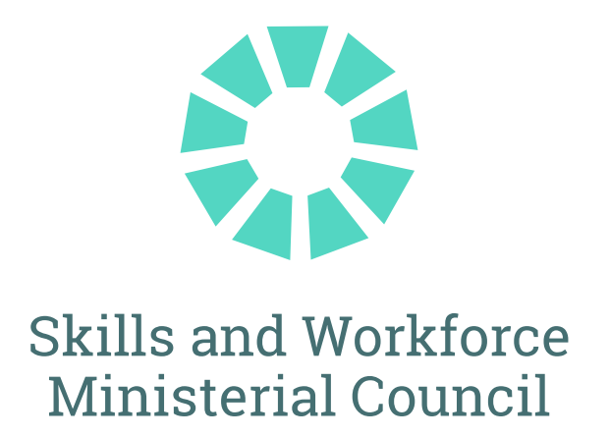

The Hon Andrew Giles MP
Minister for Skills and Training
The Hon Gayle Tierney MLC
Victoria
Minister for Skills and TAFE

The Hon Steve Whan MP
New South Wales
Minister for Skills, TAFE and Tertiary Education

The Hon Ros Bates MP
Queensland
Minister for Finance, Trade, Employment and Training

Ms Jodie Hanns MLA
Western Australia
Parliamentary Secretary for Skills and TAFE

The Hon Felix Ellis MP
Tasmania
Minister for Skills and Jobs

Mr Michael Pettersson MLA
Australian Capital Territory
Minister for Skills, Training and Industrial Relations

Senior officials observed the meeting for the South Australian and Northern Territory Governments.

JOINT COMMUNIQUÉ
20 March 2026

COMMUNIQUE

MEETING OF FEDERAL, STATE AND TERRITORY SKILLS MINISTERS
Skills Ministers from the Commonwealth, states and territories met today at the Automotive Centre of Excellence, Bendigo and Kangan Institute in Melbourne to discuss shared national priorities for the skills system, including strengthening the essential care workforce, progressing tertiary system harmonisation and maintaining a high‑quality VET sector. Ministers outlined their continued commitment to coordinated national action that supports learners, employers and communities, and delivers a responsive, trusted and future‑focused skills system.
Over the past year Skills Ministers made significant progress to deliver on Policy Initiatives under the National Skills Agreement (NSA), including significant process across the TAFE Centres of Excellence program. In 2026 the focus will be on implementation of the initiatives and sustained effort to deliver a high quality, accessible and responsive VET system.
Ministers toured the Kangan Institute Hydrogen Project to gain firsthand insight into Australia’s first dedicated training initiative preparing the automotive workforce with specialised skills for servicing, maintaining and safely operating hydrogen‑powered heavy vehicles as the technology moves toward commercial use.
Australian Tertiary Education Commission
Ministers engaged with Professor Barney Glover AO, interim Chief Commissioner of the Australian Tertiary Education Commission, to drive a joined‑up tertiary system and shape the establishment of ATEC. Ministers discussed their expectations for the Tertiary Roadmap, which will set out actions to better connect VET and higher education, including through developing a national credit recognition framework, that reflects parity of esteem between VET and higher education. State and territory governments expressed their strong interest in contributing to the national credit recognition framework.
Jobs and Skills Australia
Skills Ministers welcomed Jobs and Skills Australia’s 2025–26 workplan and the proposed approach to a multiyear program, offering advice on how JSA’s insights and integrated data capability can further strengthen VET system decision‑making and help shape national skills priorities.
Sustaining Essential Care Services
Skills Ministers reaffirmed their shared focus on sustaining a strong and resilient essential care workforce. Ministers welcomed progress under national VET reforms, including Free TAFE, TAFE Centres of Excellence and commitments through the National Skills Agreement and Jurisdictional Action Plans.
Ministers received an update from HumanAbility Jobs and Skills Council on its work to support a skilled care and support workforce, covering workforce planning, training product development and industry stewardship.
Ministers highlighted the continued need for collaboration to secure a sustainable workforce pipeline, improve access to training in regional and remote communities and support pathways that reflect the evolving nature of care and support work. They reiterated their commitment to ensuring Australians can access high quality, culturally safe and responsive care services.
National AI Plan
Skills Ministers highlighted the Future Skills Organisation’s national role in sparking an ambitious, economy‑wide conversation on AI skills, driving momentum to equip Australians for an AI‑powered future and helping ensure this technological shift delivers a fairer, stronger Australia for everyone.
Future Apprenticeships and Traineeships
Skills Ministers agreed on next steps to improve the pathway for prospective apprentices and trainees to commence and complete apprenticeships. Ministers committed to deepening their shared understanding of apprenticeship challenges across jurisdictions and progressing strategies to strengthen the apprenticeship system.
Quality and Integrity in VET
Skills Ministers received an update on the important work being done by the Australian Skills Quality Authority (ASQA) to support the quality and integrity of the VET system. Skills Ministers noted the significant progress in addressing integrity issues and to driving an uplift in quality outcomes. Ministers are focused on embedding excellence in VET to support high public confidence that the VET system is meeting the needs of learners, industry and the community.
National Centre for Vocational Education Research
Professor the Hon Verity Firth AM, Board Chair, and Mr John King, Managing Director, provided an update on progress by the National Centre for Vocational Education Research (NCVER) in delivering work under its Statement of Intent.
Skills Ministers noted the appointment of Ms Elaine Gillespie, Victorian Vice President of TAFE and Adult Provision & Federal TAFE President at the Australian Education Union to the NCVER Board of Directors as the Australian Council of Trade Unions (ACTU) representative. Ms Kim Eldridge, Executive Director of Skills South Australia has been nominated to the Board as the small jurisdiction representative.
The year ahead
Skills Ministers recognise the central role of an effective skills and training system in lifting productivity and in meeting the workforce needs of the Australian economy. Skills Ministers will meet again in June 2026, including a focus on the supply of skilled workforce to deliver the housing supply.
FRIDAY, 20 March 2026

MEDIA CONTACTS:
Minister Giles (Commonwealth):
Alex Collum
0468 795 648
alex.collum@dewr.gov.au

Minister Whan (NSW):
Anthony Puntoriero
0466 504 142
anthony.puntoriero@minister.nsw.gov.au

Minister Tierney (Vic):
Jackson Stiles
0447 061 023
jackson.stiles@minsatff.vic.gov.au

Minister Bates (Qld):
Brendan Morris
0428 962 414
brendan.morris@ministerial.qld.gov.au

Minister Sanderson (WA):
Chris Manly
0448 298 197
chris.manly@dpc.wa.gov.au

Minister Boyer (SA):
Nadine De Bono
0487 878 077
nadine.debono@sa.gov.au

Minister Ellis (Tas):
Will Sanderson
0487 190 927
will.sanderson@dpac.tas.gov.au

Minister Hersey (NT):
Zac Webster
0466 102 011
zac.webster@nt.gov.au

Minister Pettersson (ACT):
Jasmine Dickinson
0407 261 488
jasmine.dickinson@act.gov.au

