

Department

of Education

and Training

Corporate Plan

2015-19

www.education.gov.au
Opportunity through learning.

With the exception of the Commonwealth Coat of Arms, the Department’s logo, any material protected by a trade mark and where otherwise noted all material presented in this document is provided under a Creative Commons Attribution 3.0 Australia (http://creativecommons.org/licenses/by/3.0/au/) licence.
The details of the relevant licence conditions are available on the Creative Commons website (accessible using the links provided) as is the full legal code for the CC BY 3.0 AU licence (http://creativecommons.org/licenses/by/3.0/au/legalcode).
The document must be attributed as the ‘Department of Education and Training Corporate Plan 2015-19’.

Contents
Introduction 4
Secretary’s foreword 4
This document 5
Purpose 6
Our vision 6
Our mission 6
Our outcomes 6
Our goals 6
Our values and culture 7
Indigenous business is everyone’s business 8
Key areas of focus 8
Environment 9
Performance 12
Outcome 1 12
Goal 1: Support quality early learning and schooling 12
Outcome 2 16
Goal 2: Excel through knowledge 16
Goal 3: Build skills and capability 19
Evaluations 22
Capabilities 23
Goal 4: Enable business areas 23
Our pathways 24
Workforce planning 25
ICT capability 26
Shared Services Centre 26
Reducing red tape and driving innovation 27
Risk oversight and management 28
Administered programmes 29
Financials 31

Introduction

Secretary’s foreword
I, as the accountable authority of the Department of Education and Training, am pleased to present the Department of Education and Training Corporate Plan 2015-19 (Corporate Plan), which covers the period of four years (2015/16 – 2018/19), as required under paragraph 35(1)(b) of the Public Governance, Performance and Accountability Act 2013.
Our Corporate Plan begins with our vision: ‘opportunity through learning’. These three words encapsulate so much. Our department provides opportunity to build a stronger more productive economy, opportunity to build stronger communities and opportunity for a more equitable society. We enable learning that is lifelong through early learning, formal education and training, and through the richness of discovery and research.
I am proud of our critical role in supporting every student’s educational achievement which leads to increases in Australia’s productivity and innovation. This requires us to work closely with education providers to continuously strengthen the industry and maximise its effectiveness and attractiveness to domestic and international students.
Our Corporate Plan also identifies the skills and capabilities of our people that are critical to our success. It explains our values and culture and how we behave when doing our work. It also shows our commitment to improving educational opportunities for Aboriginal and Torres Strait Islander peoples. For us, Indigenous business is everyone’s business.
I would like to thank everyone who has contributed to developing the Corporate Plan. The plan will build a shared understanding of our goals, priorities, and measures of performance so we can work together to achieve our vision of opportunity through learning.
Lisa Paul AO PSM
August 2015

This document
The Corporate Plan is the department’s key planning document, however it does not sit in isolation. It is one of several strategic documents that provides transparency to our planned and then delivered operations, including performance. The department takes a considered staged approach to its performance planning and reporting activities, starting with entity-wide business planning, outlined in the diagram below.
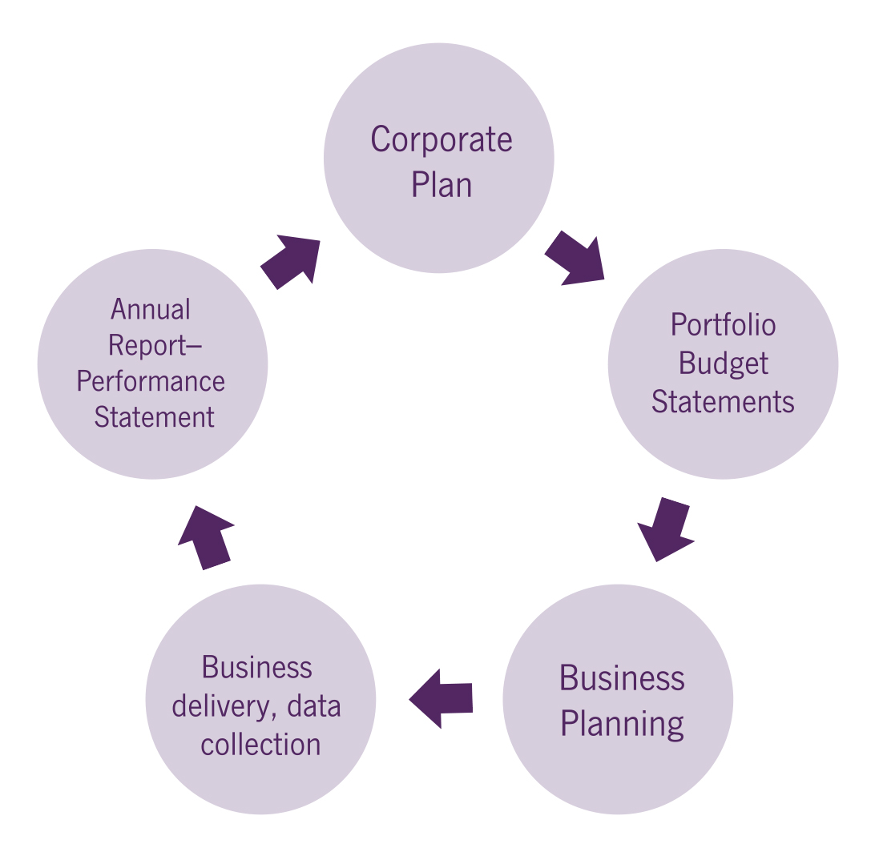
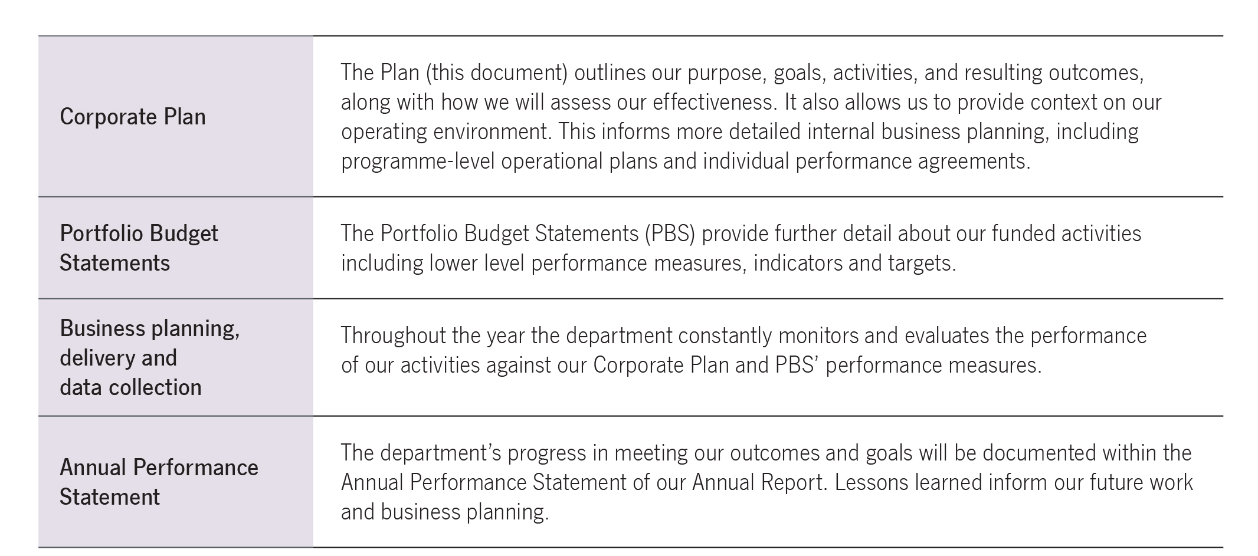
Figure 1: Context in which this document should be read

Purpose

Our vision
Opportunity through learning.

Our mission
Opportunity through learning transforms lives. We aim to provide learning opportunities for everyone, from children starting preschool to school, vocational and university students achieving their potential, international students using our quality universities, to the global impact of research. We want to be recognised for delivering and enabling quality, value for money education services to the Australian community.
The department’s work reflects the Australian Government’s priorities for education. We provide evidence-based, well informed and highly regarded advice to support our ministers and stakeholders. We work together and in partnership with our stakeholders to achieve our vision.

Our outcomes
The department’s 2015-16 Portfolio Budget Statements (PBS) identifies two Outcomes for which the department is responsible for delivering:
- Outcome 1: Quality early learning, schooling, student outcomes and transitions to and from school through parent engagement, quality teaching and learning environments.
- Outcome 2: Promote growth in economic productivity and social wellbeing through access to quality higher education, international education, international quality research, skills and training.

Our goals
Our goals describe the areas of work we will focus on to achieve our vision and deliver upon our two outcomes. We know we will only achieve success in our goals by collaborating with one another. Success in early learning, for example, will result in better outcomes in schooling and higher education and vocational learning. Across all of our goals we work to reduce red tape while striving for excellence.
The department strives to achieve our vision through the delivery of four goals:
- Support quality early learning and schooling
- Excel through knowledge
- Build skills and capability
- Enable business areas.
Goal 4 is about enabling our success delivery of the first three goals. The deliverables and performance measures associated with this enabling goal are identified within the capability section of this plan.
As outlined in Figure 2, the department’s vision and mission is communicated through two PBS outcomes, which are achieved through the delivery of four goals, supported by a range of programme and policy activities. The performance of these activities in delivering against the goals and outcomes are reviewed in line with the Department of Education and Training Evaluation Plan.
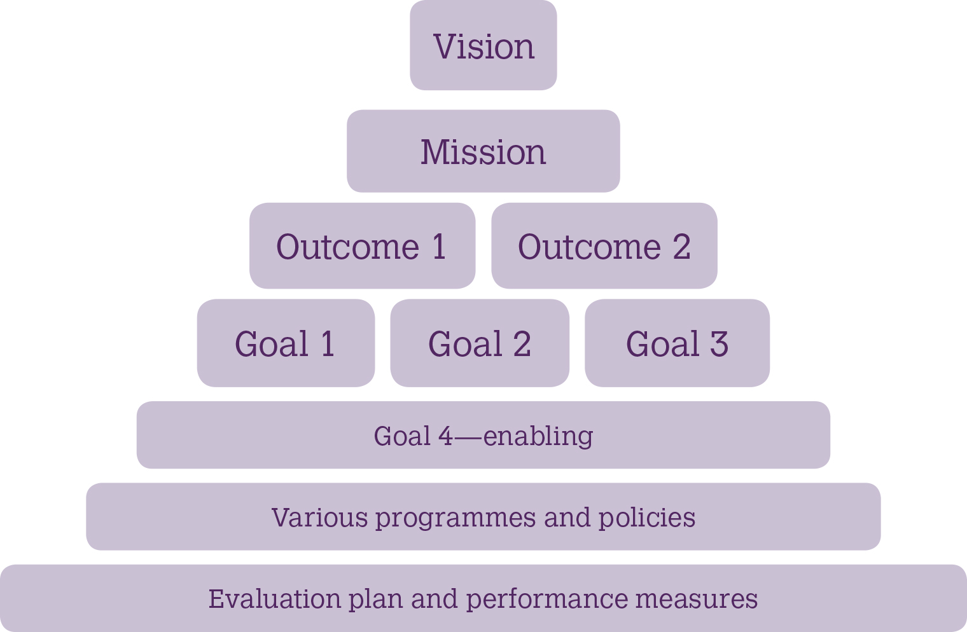

Figure 2: Department of Education and Training strategic overview

Our values and culture
We proudly uphold the Australian Public Service values and employment principles. We are impartial, committed to service, accountable, respectful and ethical. We support these values by creating a culture where:
- we are consultative and responsive
- we value learning, research, discovery and opportunity
- we innovate to achieve our business outcomes more efficiently
- we collaborate internally and externally to reach our goals
- we lead by example at all levels and pride ourselves on being professional, high performing and innovative
- we care for and support each other and value the skills, difference and diversity of our people
- we celebrate our successes and learn from our experiences.

Indigenous business is everyone’s business
The department supports the Government’s priority to work with Aboriginal and Torres Strait Islander peoples, communities and business to build a better future and improve opportunities. The department develops and delivers education policies and programmes by working with Aboriginal and Torres Strait Islander peoples, respecting their cultures and building our own cultural capability.
We also proudly support the Government’s Indigenous procurement policy as a means of fostering Aboriginal and Torres Strait Islander business and creating jobs and employing more Indigenous Australians.
Our employees are encouraged to embrace and value the important contribution Aboriginal and Torres Strait Islander peoples make to our department and wider Australian society. The department’s Reconciliation Action Plan (RAP) is a formal commitment and call to action for all our employees to ensure Indigenous business is part of their day-to-day business.

Key areas of focus
The department has a number of strategic areas of focus to help all Australians have access to quality education, regardless of their age or stage of life.
In our lead role in national policies and programmes in education we will be working closely with our key stakeholders to meet these areas of focus. They are:
- reverse falling school education outcomes
- improve access to quality compulsory and post−school education
- create a more connected education system that is easier to navigate
- address the distortions of the tertiary education sector
- employ market mechanisms effectively to lift VET quality
- promote upskilling and skills utilisation in the workforce
- improve the sustainability and effectiveness of Government funding
- preserve and extend Australia's share of global education markets
- strengthen the higher education system
- integrate Australia's research effort more directly into the national innovation system.

Environment
The Government is committed to strengthening economic growth and social wellbeing through better access to quality preschool, schooling and higher education, vocational education and training, international education and research. The department is strongly committed to providing opportunity through learning: our overarching purpose is to build stronger communities and a stronger economy by enriching early learning, supporting quality education and research, as well as building skills and capability.
The broader environment in which the department is pursuing these goals is changing. The Australian economy is transitioning to a knowledge-based economy which is increasingly dependent on having a highly educated and skilled workforce. The Government’s investment in education has increased sharply in recent years. However, despite the increase in spending, there has been both an absolute and relative decline in student outcomes in schools.
The strategic environment in which the department works is also undergoing considerable change. This includes significant and ongoing fiscal constraint in line with the Government’s commitment to Budget repair, and efforts to streamline the public sector through the Smaller Government Footprint agenda.
In this context, the department will continue to maximise workforce productivity and streamline processes to ensure the agency remains efficient, effective and accountable. In support of the Government’s commitment to reducing red tape, the department will continue to examine our regulatory frameworks and requirements to ensure the administrative requirements and costs of working with Government are appropriate.
The education and training sector is multifaceted and education is delivered through a complex mix of government, not for profit, religious, private and corporate entities. Our policies, programmes and stakeholder engagement need to respond to and reflect this complex delivery environment.
A person’s engagement with learning can also be complex. Most begin their education in preschool, however, as the years progress, people’s educational experiences can vary greatly. In particular, people from disadvantaged backgrounds face many barriers to continuing their education. Some may re-engage with formal education at different stages of their lives.
Role of state and territory governments
As part of Federation arrangements, responsibility for education rests with both Commonwealth and state governments. The Commonwealth performs a national leadership role and provides funding to the states and territories for the purpose of supporting education and training. This supports the delivery of quality education programmes across early childhood, schools, higher education and training. A number of portfolio agencies support the Department of Education and Training to deliver the Government’s education priorities.
The Government is examining options to reform the Federation to reduce duplication and ensure responsibilities and lines of accountability are clear. The outcomes of this review are likely to impact on the scale and scope of the department’s responsibilities, and affect our work with schools and youth, skills and training and higher education during the life of this plan.
An evolving education system
The Government is committed to developing a more competitive, quality, diverse and innovative education system. To realise this objective, the department will continue to progress the Government’s reform agenda, in the school education, higher education and vocational education and training sectors.
Innovation and research are essential to productivity growth. They are part of the process of knowledge creation, which drives economic growth through enabling new ideas to both the business and non-business sectors to deliver products and services more efficiently. The department will continue to support the Government’s commitment to restoring a focus on science, technology, engineering and mathematics, and to growing innovation and productivity through measures connected to the Industry Innovation and Competitiveness Agenda and the Boosting Commercial Returns from Research strategies.
The international education sector is Australia’s fourth largest export industry and contributed over $17 billion to the economy in 14. The industry is growing, with the latest data showing a 10 per cent increase in enrolments for the year-to-date (June 2015). A key challenge will be continuing to drive the quality and outcomes from our education sector to ensure international competitiveness and attractiveness. In recognition of the importance of this industry for Australia’s ongoing economic prosperity, the Government released the Draft Strategy for International Education in April 2015 for consultation. The strategy, once finalised, will set a clear path for sustainable growth and strengthen all aspects of Australia’s international education and training engagement.
Changes in technology require us to rethink how we do our business and also the role and delivery of education in the future. In particular, interactive social technologies present opportunities to better deliver policy, improve services and increase citizen engagement and participation.
Future demand for learning
The 2015 Intergenerational Report, published by the Treasury, makes clear that Australia’s population is expected to grow, and increase in median age over the next 40 years. For example, the number of people aged between 15 and 64 for every person aged 65 and over has fallen from 7.3 people in 1975 to an estimated 4.5 people today. By 2055, this is projected to nearly halve again to 2.7 people. This demographic shift will have implications for the economy.
The projected decline in the proportion of the population participating in the labour force (from 64.6 per cent now to 62.4 per cent by 2054-55) will mean lower economic growth over the projection period. These demographic changes will place a greater focus on policies directed at building lifelong learning opportunities that support workforce participation through all stages of life.
Our complex environment
Figure 3 outlines our internal and external operating environment in which we work to achieve our vision.
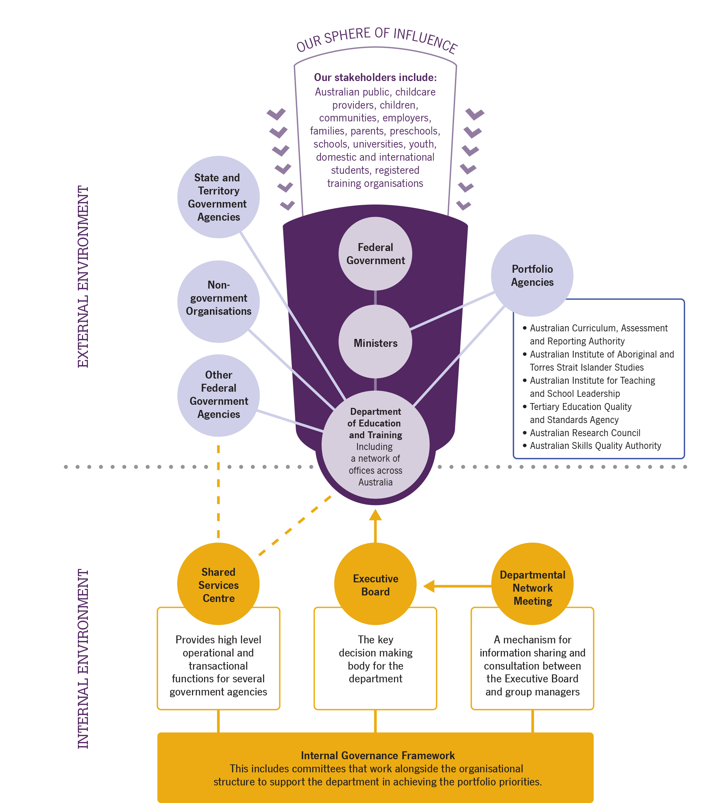

Figure 3: Department of Education and Training internal and external operating environment

Performance
Outcome 1: Improved early learning, schooling, student educational outcomes and transitions to and from school through access to quality support, parent engagement, quality teaching and learning environments.

Goal 1: Support quality early learning and schooling
Support a high-quality school education system, including preschool, with improved outcomes for Australia’s students through a focus on quality teaching, school autonomy, parent engagement and a robust Australian curriculum.
- Support for early learning programmes to facilitate children’s transition to full-time school.
- Sustainable needs-based school funding to support improved student outcomes
- Partner with state and territory governments and non-government schooling authorities to achieve national policy priorities
- Measure educational outcomes through national assessments and international benchmarking
- Take a lead in building national evidence to inform decision making.
Challenges:
Preschool education
Preschool education has been shown to make an important contribution to children’s development and school readiness. This role is recognised through the commitment of Australian and state and territory governments to provide universal access to preschool programmes for Australian children aged four and five. A significant challenge remains to increase participation in preschool across Australia, particularly among Indigenous, vulnerable and disadvantaged children, who stand to benefit most from preschool participation.
School education
The delivery of school education is the constitutional responsibility of the states and territories. The Commonwealth works in partnership with state and territory governments and non-government education authorities to provide funding, develop and implement national policy priorities, assess performance and support other education initiatives.
Australian Government funding for schooling has nearly doubled in real terms over the period between 2000 and 2013. Despite this increase in funding, the performance of Australian students in international testing has declined in both absolute and relative terms in the key learning areas of reading, maths and science. This decline is a result of fewer Australian students classified as ‘high performers’ and an increase in the number of low performers. There is also a substantial gap in student achievement between Indigenous and non-Indigenous students.
This performance record demonstrates that, while school resourcing is important, it is crucial that funding be spent effectively and in ways that lift performance and student outcomes.
Priorities:
The Australian Government is focused on supporting quality early childhood education and universal access to support child development in the early years and prepare children for full-time school. In the 2015-16 Budget, the Government committed an additional $840 million over two years to support universal access to preschool programmes across Australia as an interim response to the Productivity Commission Report into Childcare and Early Childhood Learning. As recommended by the Productivity Commission, longer term arrangements for preschool will be considered in the context of the White Paper on the Reform of the Federation. The Australian Government, and the states and territories, are working together to improve the quality of data collected.
By drawing on national and international evidence to improve the educational outcomes of students and the performance of schools, the Australian Government has identified four reform areas that have a material impact on student performance: quality teaching, school autonomy, a robust Australian curriculum and increased parent engagement. The Government will work with state and territory governments and non-government schools to implement key reforms in these areas. The Government’s approach is not just about funding, it is about improving schooling through initiatives that can have a significant impact on student outcomes.
Deliverables:
- ensure all children have access to, and participate in, quality preschool programmes in the year before full-time school
- implement national priorities for schooling under the Students First package of reforms: quality teaching, school autonomy, parent engagement and a strong and robust Australian curriculum
- contribute to the operating costs of government and non-government primary and secondary schools through needs-based funding
- improve national assessments, data collection and the information available to policy-makers, education authorities, teachers and parents.
Annual performance measures:
- proportion of children, including Indigenous, vulnerable and disadvantaged children, enrolled in the year before full-time school in quality early childhood education programmes
- high-level targets and measures outlined in the Australian Education Act 2013 and the Education Council’s Measurement Framework for Schooling in Australia, including national performance, participation and Year 12 or equivalent attainment rates.
Goal 1: Support quality early learning and schooling
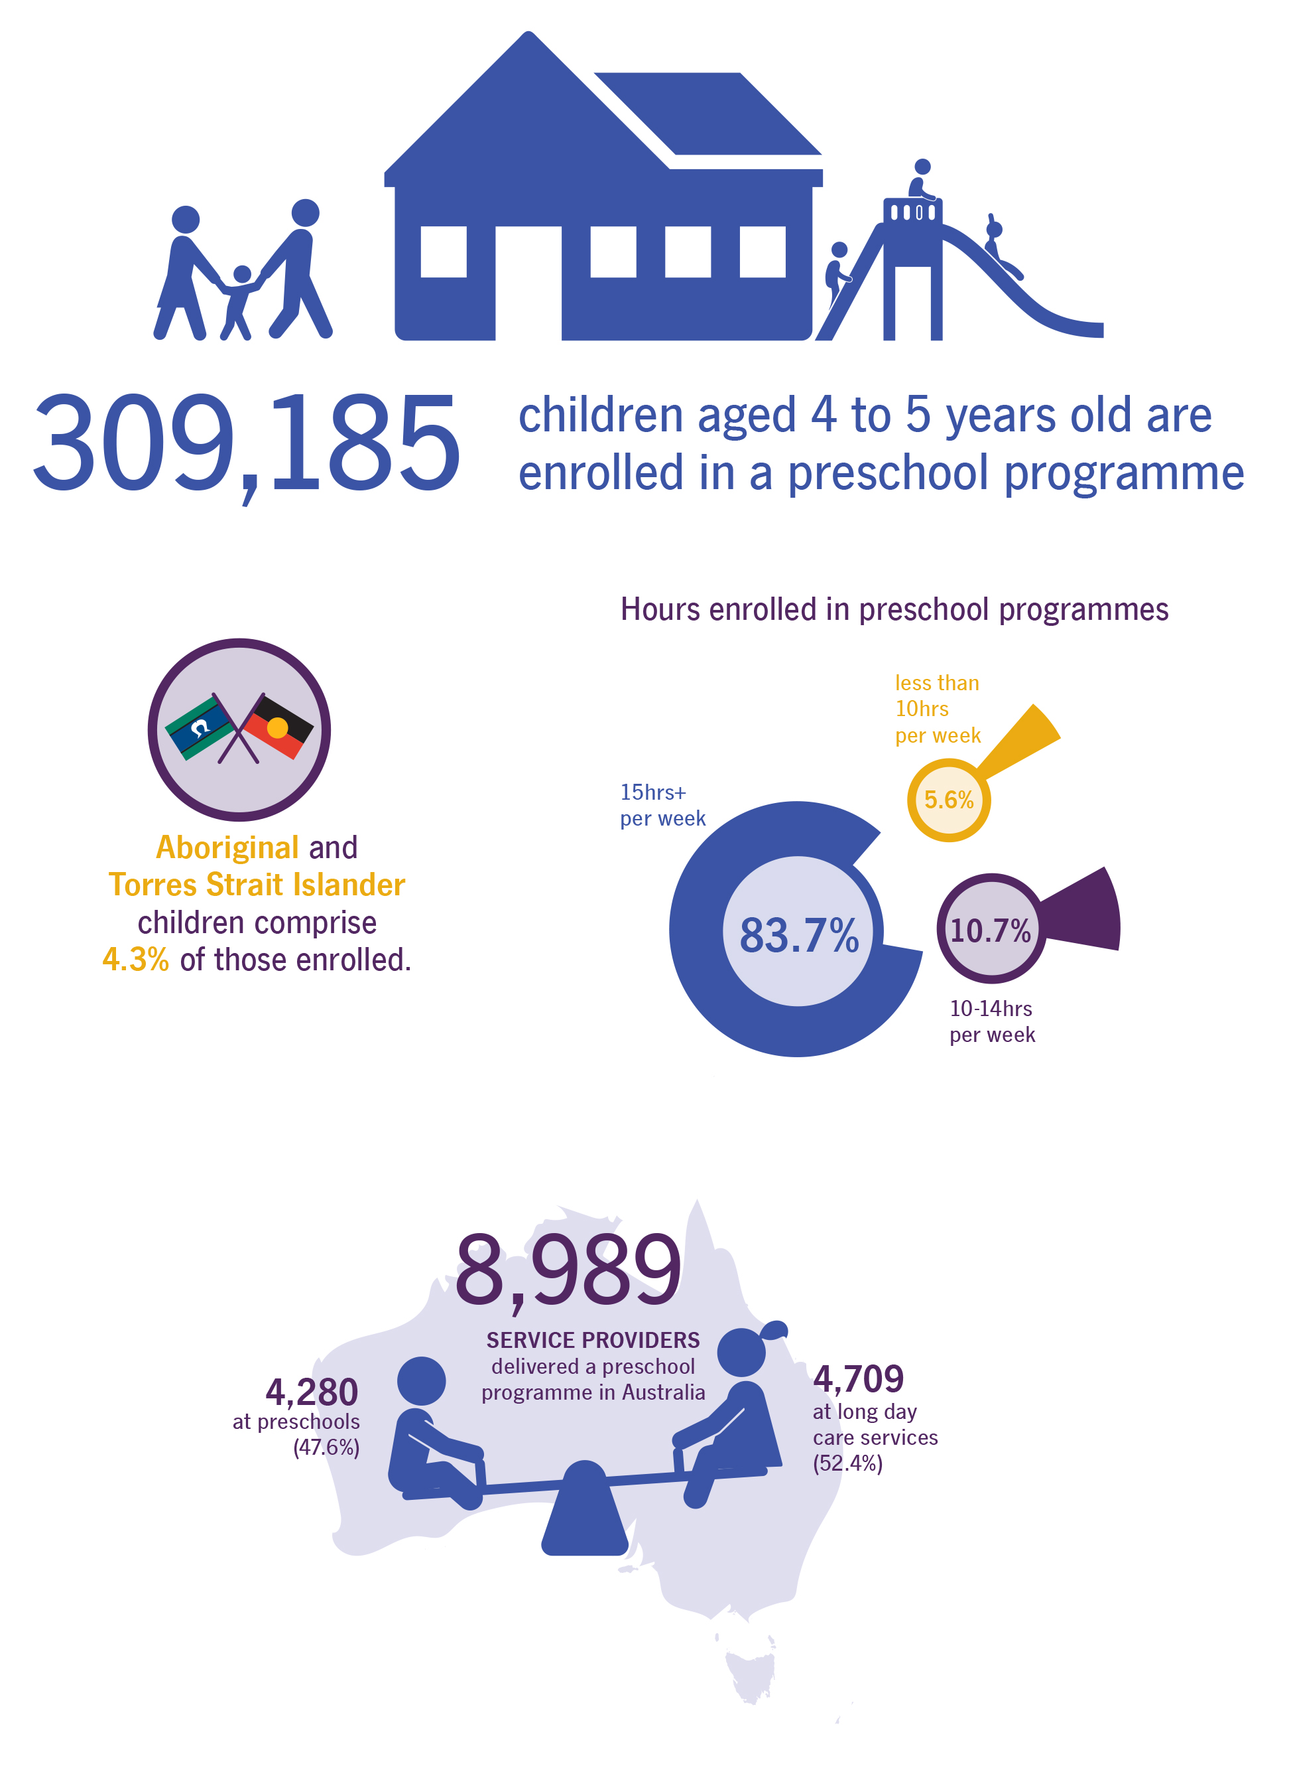
Source: http://www.abs.gov.au/ausstats/abs@.nsf/mf/4240.0
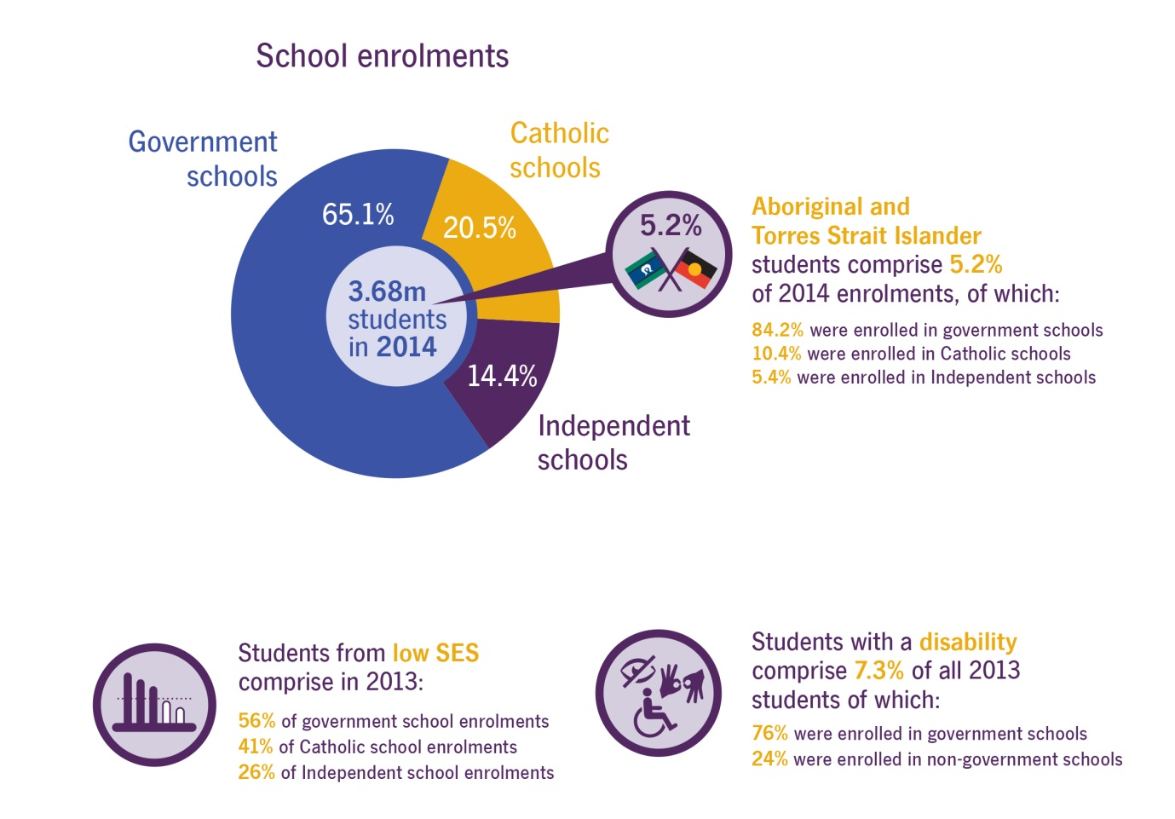

Sources:
2014 statistics from ABS (2014) Schools Australia 2014, cat. No 4221.0 Table 43a; 2013 statistics from ABS (2014) Schools Australia 2013, cat. No 4221.0 Table 4A.31, and My School, 2010-2013 (ACARA)
Outcome 2: Promote growth in economic productivity and social wellbeing through access to quality higher education, international education, and international quality research, skills and training.

Goal 2: Excel through knowledge
Enable the delivery of quality higher education, international education and research that contributes to Australia’s society and the global economy.
- Policies, funding and systems support high quality higher education and research
- Higher education and research outcomes demonstrate the relationship between education, research and prosperity
- Policy settings and growth in the sector inspires confidence from international providers and students and engages Australia with the region.
Challenges:
The challenge for the department is to maintain and enhance the quality of Australia’s domestic and international market presence, ensuring a highly skilled workforce which focuses on students having opportunities for access, participation and success and delivering quality, excellence, collaboration, diversity and sustainability in research.
By actively engaging with stakeholders and ensuring that policies are adequately matched with resourcing, the department will be able to assist the higher education sector in meeting government objectives.
Priorities:
In partnership with vocational education and training (VET) providers, universities and other higher education institutions and industry, the Government is working to promote a world class tertiary education system and research sector which are innovative, competitive and globally connected.
Our top priorities include reforming Australia’s higher education sector to ensure it is fair, sustainable and provides a quality education for all students, improving Australia’s economic performance through better translation of publicly funded research into commercial outcomes, and maintaining Australia’s status as a world leader in international education.
In partnership with vocational education and training (VET) providers, universities and other higher education institutions and industry, the Government is working to promote a world class tertiary education system and research sector which are innovative, competitive and globally connected.
Deliverables:
- remove the up-front cost barriers to tertiary education and training, including through subsidised tuition for higher education
- establish a new institute for learning and teaching excellence in universities
- improve higher education access and participation, and to ensure that the quality of our higher education system is maintained and improved
- invest in Australian higher education research and research capacity
- support major research infrastructure that underpins world-class research activity in Australia and provides the platform for collaboration between the research sector, industry and government
- build the capacity and reputation of Australian education and develop regional and global engagement
- implement legislative, systems and business processes to support the higher education reforms
- deregulate higher education, in collaboration with jurisdictions and other bodies such as TEQSA
- develop a new national strategy for Australia’s international education sector.
Annual performance measures:
- increased student participation in higher education, including by previously under-represented groups
- improved infrastructure for tertiary education
- improved quality in higher education
- increased participation in science and maths
- sustained research performance, transparency and accountability of Australian higher education providers
- sustained number of students completing higher degrees by research
- improved research performance of less research-intensive universities
- increased number of participants in activities promoting research-based careers
- increased access to research infrastructure to facilitate and support collaborative research activities
- survey of international students’ satisfaction with studying and living in Australia
- students who are able to repay their HELP debts do so
- high quality policy advice to Government on the higher education sector.
Goal 2: Excel through knowledge
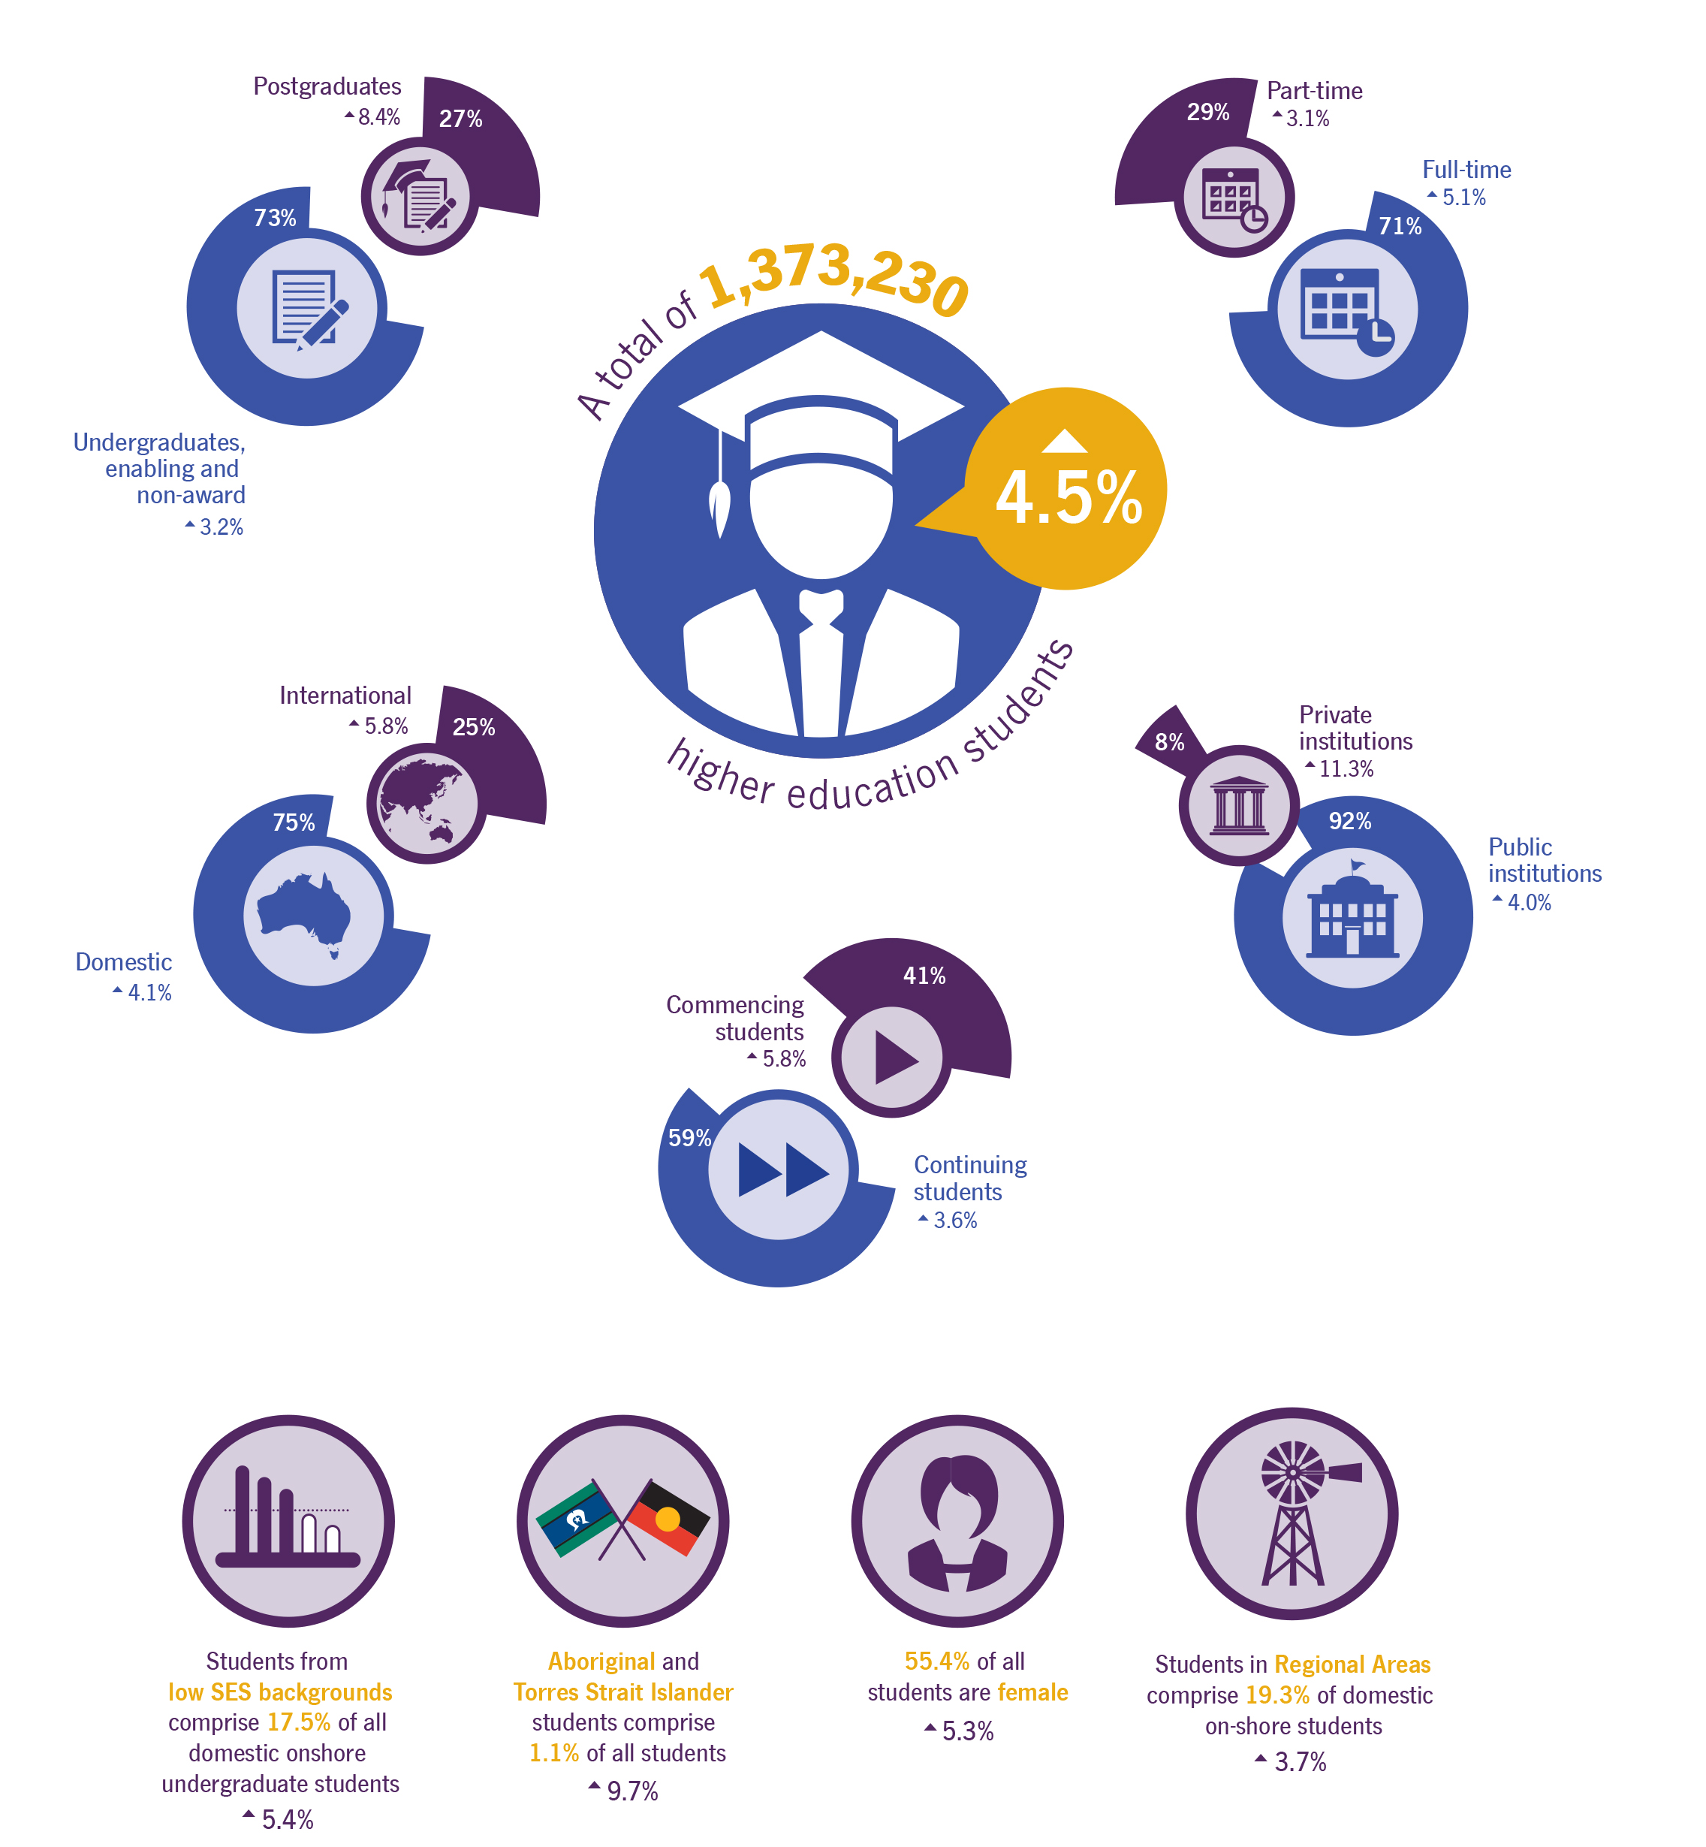
2014 Higher Education Statistics (comparison data 2013).
Source: Department of Education and Training Selected Higher Education Statistics

Goal 3: Build skills and capability
Ensure that Australia’s workforce has the capability to respond to the needs of current and emerging industries, thus contributing to their global competitiveness.
- Skills and training tailored to the needs of current and emerging industries.
- Training pathways that are more responsive to the needs of workers wishing to enhance their skills.
Challenges:
The sector is undergoing significant transition with reforms in regulation, funding and information to ensure that skills meet the needs of students and employers now and in the future. The challenge for the department is to continue to lift the quality of training providers and their courses, and to increase the job prospects of students to ensure workforce trend demands are met.
The department’s inclusive approach to policy and programme development by engaging openly and meaningfully with stakeholders, will ensure the department is positioned to achieve the best outcome for students, employers and industry.
Priorities:
Ensure a highly skilled workforce, by focusing on providing all students with opportunities for access, participation and success. Create an effective and efficient skills and training system that is industry-led and delivers the skills Australian employers need.
Better linking training to real jobs and delivering improved employment outcomes. Ensuring better consumer information leads to increased quality and maintaining the good reputation of the VET sector, both here and overseas.
Deliverables:
- develop an effective and efficient national training system that meets the needs of Australia’s current and emerging industries, including:
  - improving access to training
  - facilitating training that will enhance Australian businesses’ competitiveness in global markets
  - increase completions of apprenticeships and develop the skills of the Australian workforce.
- develop policies that will improve the VET sector through three principles:
  - Jobs – stronger linkages between training and real jobs, to delivering better employment outcomes and more effective regulation
  - Quality – standards for training providers, and stronger consumer protection
  - Status – increasing the VET sector’s reputation nationally and internationally.
Annual performance measures:
- growth in the number and proportion of Australians with VET skills (includes measurement of whether employed or not)
- growth in the apprenticeship completion rate
- change in reported employer satisfaction with vocationally-trained graduates
- change in reported student satisfaction, including proportion of students reporting improved employment status
- changes in individual returns from investment in education and training, including employment and wages
- change in indicators of quality of training, including regulatory actions and revisions to training packages
- progress towards National Partnership on Skills Reform outcomes (greater accessibility, transparency, quality and efficiency of the VET system)
- policy work and advice performance measures that support the delivery of specified outputs or projects, facilitate reforms or reward those jurisdictions that deliver on nationally significant reforms.
Goal 3: Build skills and capability
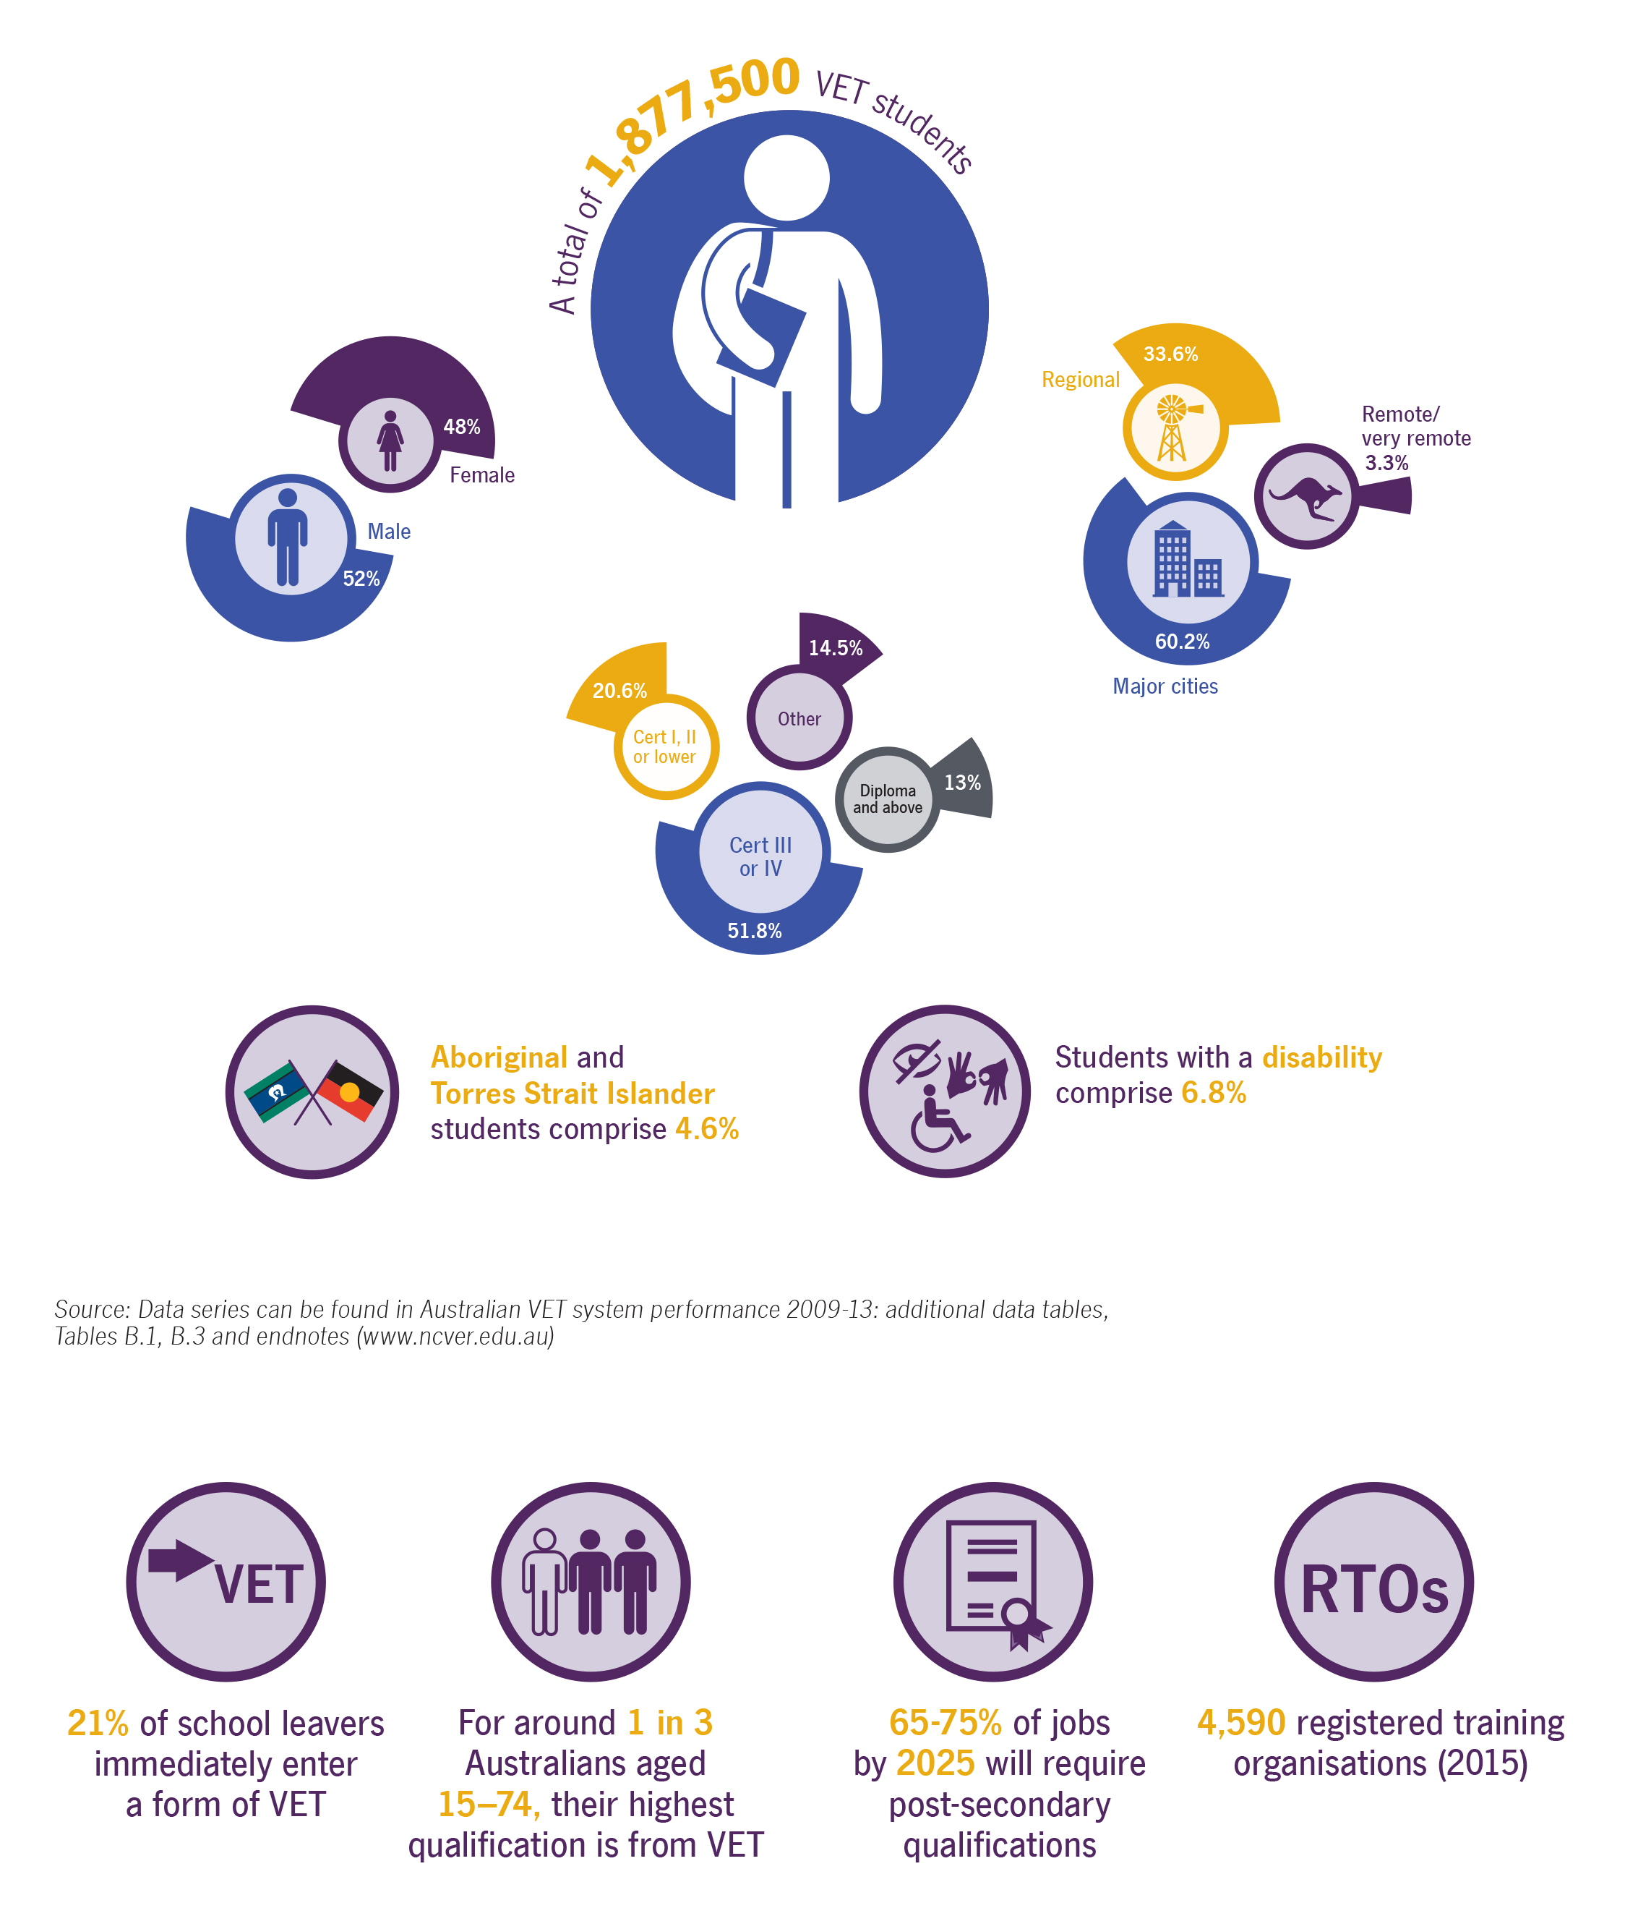

Sources: ABS Survey of education and work, May 2014 table 17; Australian Workplace and Productivity Agency: Future Focus - 2013 National Workforce Development Strategy

Evaluations
The department supports a strong evidence-based culture to systematically and objectively assess the impact of our policies and programmes. Through this we can determine the quality of delivery, impact and efficiency of our activities. It also helps us determine best practice approaches.
The Department of Education and Training Evaluation Plan 2015–2017 sits alongside the Department of Education Corporate Plan 2015–19 and sets our broad evaluation goals as part of our performance framework. The plan affirms that evaluation supports policy and programme development. It sets out the aims of the department’s evaluation agenda and its priorities.
The department recognises that the capabilities of our people will be a key driver of the quality of the evaluation activities set out in this document.

Capabilities
In light of the complex operating environment, to achieve our outcomes for Government, priority is given to building our capacity to formulate rigorous policy, and share and analyse data, to solidify the department’s role in providing national leadership in education with Australia.
The department is structured into three main clusters: Schools and Youth (Outcome 1), Higher Education, Research and International, and Skills and Training (Outcome 2). The clusters are supported by two corporate groups within the department, and the Shared Services Centre which provides transactional corporate and enabling services.
The department’s fourth and final goal, ‘Enable business areas’, is aimed at supporting and enabling our capability. This goal is achieved through our strong governance arrangements, business planning process and the People Capability Framework.

Goal 4: Enable business areas
Our internal corporate services and Shared Services Centre (SSC) work collaboratively to support business areas in achieving their goals and maintaining productivity and excellence within a constrained fiscal environment.
- Corporate areas offer strategic services and expertise to the department’s business areas.
- Corporate services are delivered seamlessly without compromising accountability, compliance or quality.
- Reliable technologies and systems are accessible and support our ministers, the department and stakeholders to strive for better ways of working.
Challenges:
The key challenge for the corporate groups is supporting the wider department to effectively operate, enabling it to deliver its goals through delivery of an appropriate governance structure and improved capability and enabling technology/systems. The Functional and Efficiency Review, currently underway, will guide the department’s future direction, including business model, to ensure our continued effectiveness and efficiency.
Priorities:
A key part of the department’s work in driving efficient government administration will involve the implementation of Functional and Efficiency Review recommendations and improving its performance information.

Our pathways
Our pathways describe how we will get the job done. They articulate our behaviours and ways of working that reflect what is most important to us as we work towards achieving our goals. Our pathways describe the expectations of ourselves and guide how we work with each other and our stakeholders. Our pathways help us strive to be the best we can be and can be summarised into four pathways: respond and deliver, excellence through evidence, empower our people, and capability through diversity.
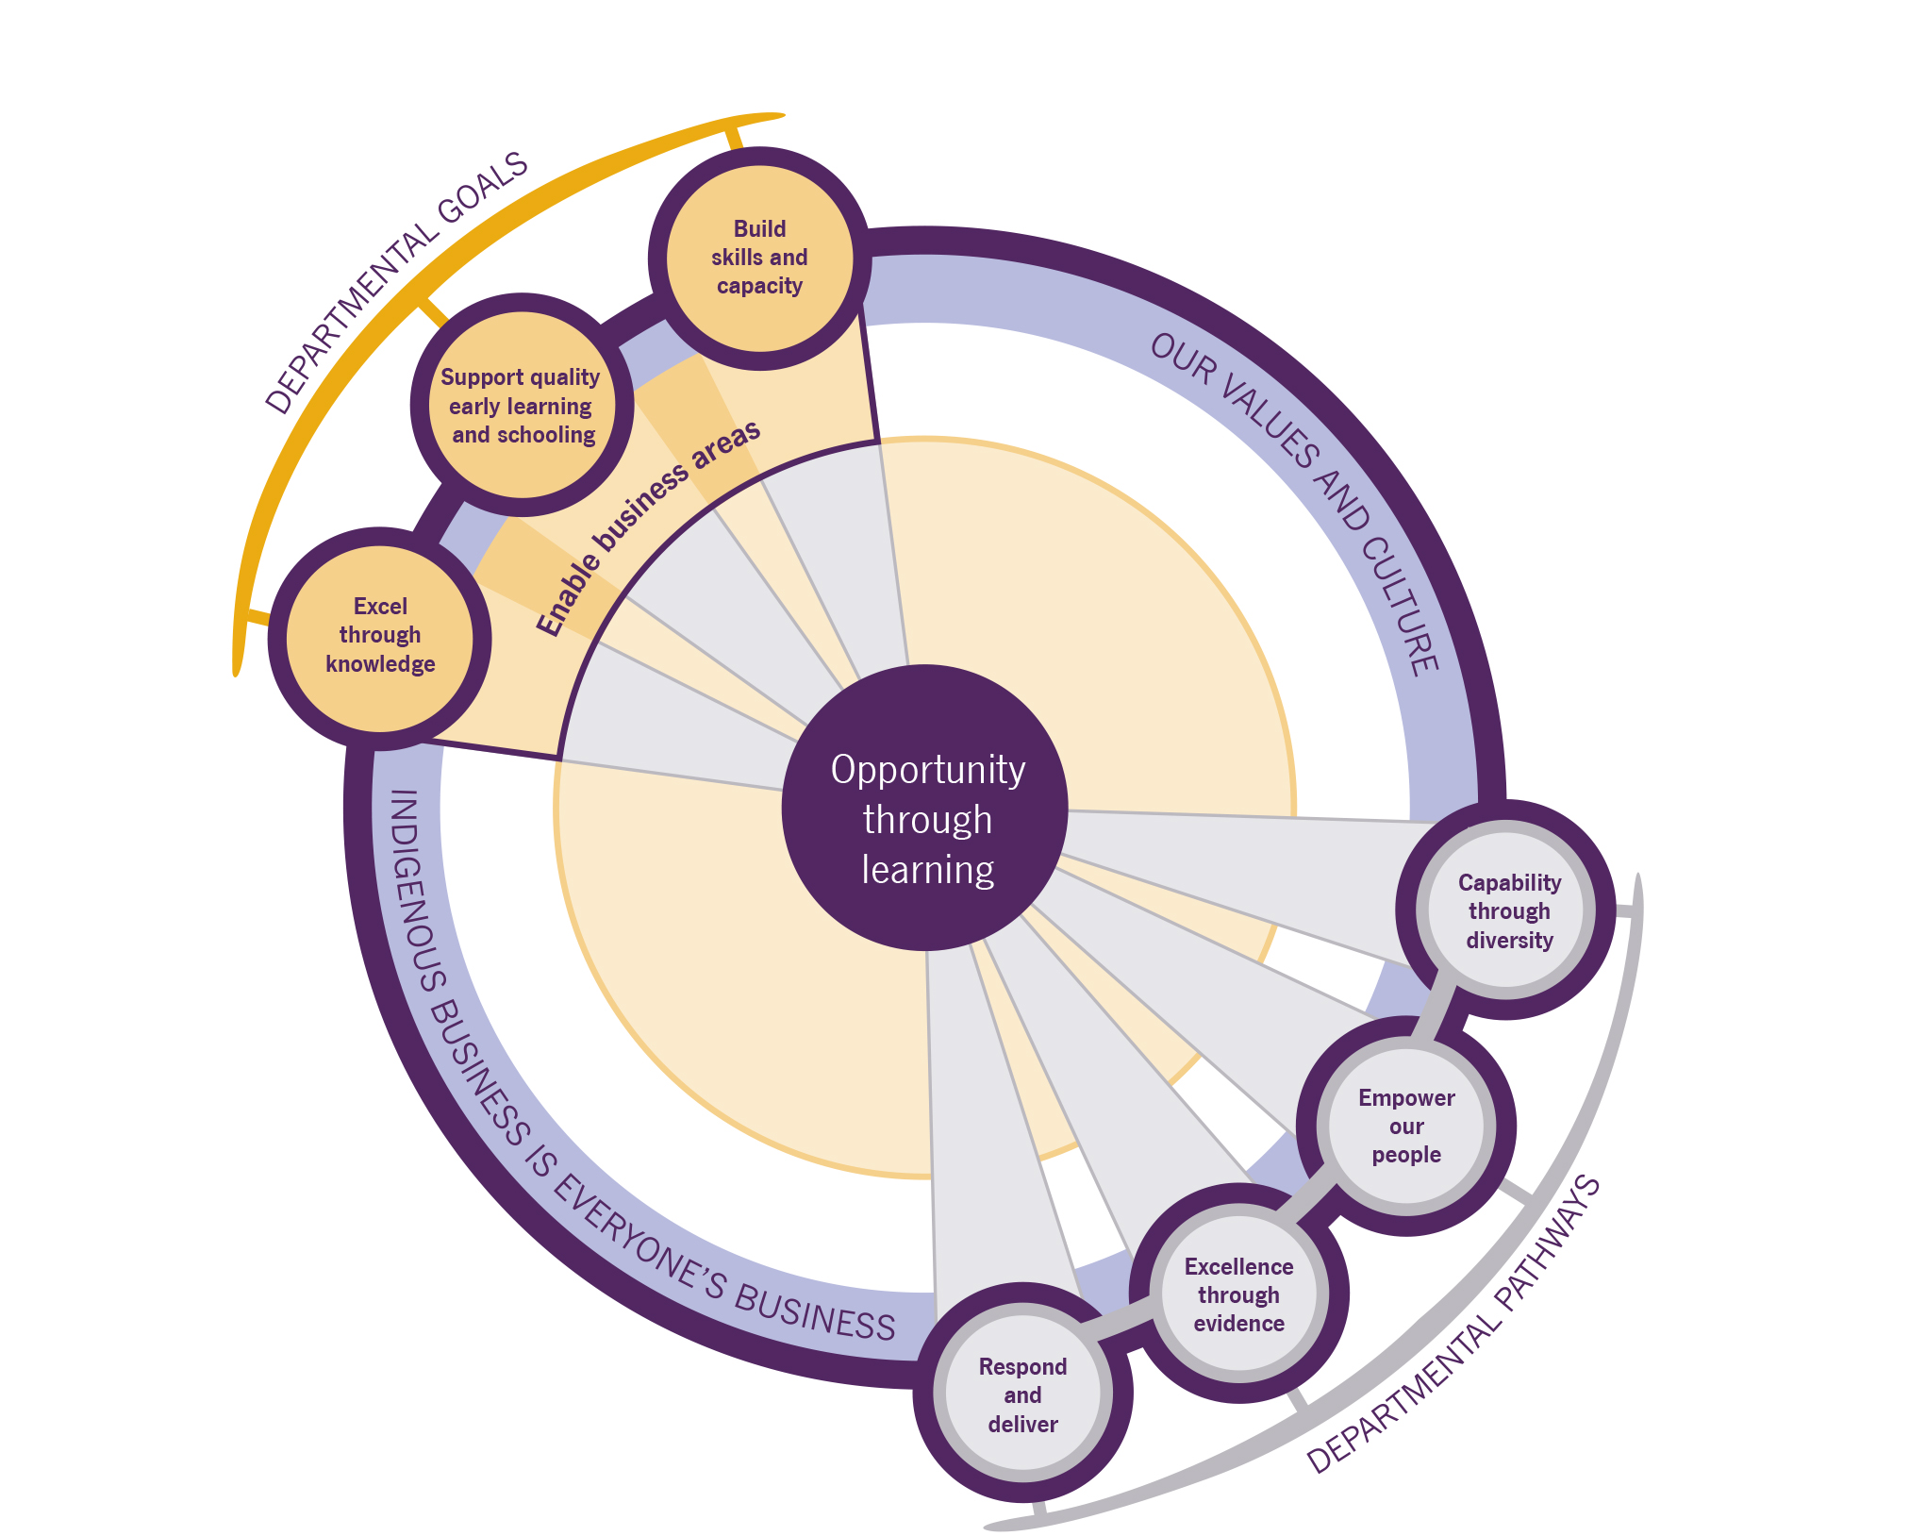
Figure 4: Relationship between the various strategic components of the Corporate Plan.

Workforce planning
The Department of Education and Training operates in an increasingly complex policy environment, with a range of international and domestic drivers impacting on the department’s priorities and future workforce requirements.
Ensuring that the department remains responsive to the needs of government, in an environment of fiscal constraint and change, will require a diverse workforce where people:
- develop and implement effective policy underpinned by robust analysis, data and evidence
- take a strategic approach to internal and external communications
- embrace change and lead others
- collaborate, think globally, and innovate locally
- take a whole-of-department approach to Indigenous policy and cultural competency.
The department’s workforce planning strategies address the gap between our current and required future workforce and the impact of existing workforce trends that, without intervention, are likely to continue in the longer term.
Our recruitment policies and practices also reflect that Indigenous business is everyone’s business, ensuring our people have an appropriate level of cultural understanding from day one. They also ensure our Aboriginal and Torres Strait Islander employees are supported to reach their full potential, recognising that their unique skills and experiences are vital in supporting the department’s priorities.
Our strategies include implementation of:
- the APS Optimal Management Structures (OMS) Framework
- a departmental Learning and Development (L&D) Action Plan and leadership strategy (known as Leadership in Education and Training)
- the department’s Diversity Strategy and Aboriginal and Torres Strait Islander Recruitment, Retention and Career Development Plan
- the Indigenous Business Is Everyone’s Business framework, which helps ensure we build appropriate workforce capabilities and that we have the right programme and policy settings in place to support Indigenous outcomes
- mobility arrangements that facilitate the movement of individuals to different roles within the department and in other agencies
- an attendance management strategy and toolkit.
The department will also:
- develop and implement a single departmental Enterprise Agreement
- continue with the current suite of entry-level development programmes to promote workforce renewal and build leadership capability.
Performance measures:
- the department’s management structures support business delivery and ensure that people are undertaking work at the right classification levels and exercising appropriate spans of control and delegation
- the department builds the workforce it needs and harnesses the benefits of diversity and inclusion
- the department’s Enterprise Agreement provides an affordable set of employee terms and conditions and provides flexibility to support organisational productivity and performance.

ICT capability
To help meet current challenges and respond to future demands, the department’s approach to capability is centred around maximising the use of tools and technology to inform and support strategic policy development and achieve business outcomes, support innovation and agile working arrangements. Our investment choices are guided by the department’s strategic priorities.
Key capability focus areas include:
- encouraging and enabling innovation
- an analytics and evidence culture, support by data, systems and technology
- a focus on user-centred design and benefits driven investment to deliver strategic priorities
- strong design governance
- maturing our portfolio, programme and project capabilities
- fully utilising our current investments to maximise organisational outcomes, and rationalising our application portfolio
- leveraging our knowledge and technology to reform business processes.
The department will continue to be a leader in technology utilisation, including the adoption of cloud, supporting the Shared Services Centre (SSC) and utilising technology to help deliver efficient business processes that meet the needs of users and delivery of, and support for, whole of government initiatives. This includes the Whole of Government Parliamentary Workflow Solution, which is delivered by the department.

Shared Services Centre
The department has, in conjunction with the Department of Employment, contributed people and resources towards the development of the Shared Services Centre (SSC). The SSC provides corporate and technology services to Australian Government customers and is accountable to both the Department of Education and Training and the Department of Employment. The SSC was created out of recognition that a single, larger service delivery organisation could offer economies of scale and foster innovative practice.
The SSC is committed to continuous service improvement and the commitment to provide analysis and advice regarding solutions that best fit customer needs. The SSC aims to:
- reduce complexity and implement best practice processes in technology and automation
- deliver comprehensive metrics allowing for monitoring and improvement of service offerings and performance
- drive operational excellence through feedback from employees and customers and by benchmarking with industry best practice
- develop high quality management information to underpin and support service delivery.
The department retains a range of corporate areas to provide services not covered by the SSC, and our internal corporate services and the SSC work collaboratively to support business areas in achieving their goals.

Reducing red tape and driving innovation
The department is committed to the government’s deregulation agenda, which focuses on eliminating inefficient or unnecessary regulation that imposes burdens on business, individuals and community organisations. To this end, the department has established a deregulation unit to lead the implementation of the deregulation agenda, as well as an internal deregulation committee with senior representation from across the department to provide strategic oversight.
Innovation is central to growth in national productivity and an innovative public sector is central to improving national outcomes. The department is committed to driving innovation within the workplace. As part of this commitment the department holds Innovation Month each year to engage with employees and encourage them to come up with, and try, new and innovative ideas.

Risk oversight and management
The Department of Education and Training is committed to good corporate governance and sound management practices, which includes a structured approach to the management of risk. Our risk management framework and policy is based upon the Australian and New Zealand Standard for Risk Management (AS/NZS ISO 31000:2009) and draws upon the Australian Government’s Better Practice Guide for Risk Management.
Our risk management policy and framework describe our approach to managing risks at all levels of the organisation. The framework promotes risk management as an integral component of core business delivery and encourages all employees to manage risk as part of their everyday responsibilities. The framework supports our people in identifying, treating and monitoring risks related to potential threats, harm, losses, failures and opportunities in the development, implementation and management of government programmes. Risk management also forms a core part of our business planning cycle.
Our Audit Committee provides independent strategic assurance on the appropriateness of the department’s risk controls and compliance framework.
To support our structured approach to risk identification, risk treatment and monitoring, the department has in place its own enterprise-wide risk management system, RiskActive. RiskActive is supported by online learning modules that assist people in gaining a general understanding of the concepts of risk management. In conjunction with these tools, workshops are run with business units to help identify specific risks and assist employees to understand all aspects of risk management.

Administered programmes
Goal 1: Support quality early learning and schooling
- Programme 1.1: Government Schools National Support
  - Government Schools – Recurrent grants
- Programme 1.2: Non-Government Schools National Support
  - Non- Government Schools – Recurrent grants
  - Non-Government Schools – Capital grants
  - Short Term Emergency Assistance
  - Non-Government Representative Bodies
- Programme 1.3: Early Learning and Schools Support
  - Grants and Awards
  - Quality Outcomes
  - Helping Children with Autism
  - Maths and Science Participation
  - Teach for Australia
  - Flexible Literacy Learning for Remote Primary Schools
  - National Assessment Reform
  - Science, Technology, Engineering, and Mathematics (STEM)
  - Improving the Teaching of Foreign Languages
  - Australian Early Development Census
  - Universal Access to Preschool – Research Development
  - Early Learning Languages Australia (ELLA)
  - Australian Government Response to TEMAG
- Programme 1.4: Trade Training Centres in Schools
- Programme 1.6: Youth Support
  - Youth Engagement
  - National Youth Affairs Research Scheme
Goal 2: Excel through knowledge
- Programme 2.1: Commonwealth Grant Scheme
- Programme 2.2 Higher Education Superannuation Scheme
- Programme 2.3: Higher Education Support
  - Diversity and Structural Reform
  - Higher Education Participation Programme
  - National Institutes
  - Promotion of Excellence in Learning and Teaching in Higher Education
  - Education Investment Fund (out to 2016-17)
  - Disability Support Programme
  - Quality Indicators for Teaching and Learning
  - Quality Initiatives
  - Education Investment Fund – Higher Education (2015-16 only)
  - National Disability Coordination Officer
- Programme 2.4: Higher Education Loan Programme
  - HECS-HELP
  - FEE-HELP
  - OS-HELP
  - SA-HELP
  - VET FEE-HELP
- Programme 2.5: Investment in Higher Education Research
  - Sustainable Research Excellence initiative
  - Research Infrastructure Block Grants
  - Research Investment Adjustment Scheme
  - Joint Research Engagement Programme
  - Research Training
  - Australian Postgraduate Awards
  - International Postgraduate Research
- Programme 2.6: Research Capacity
  - Collaborative Research Network Programme (2015-16 only)
  - Commonwealth – ANU Strategic Relationships
  - National Collaborative Research Infrastructure Strategy (out to 2016-17 only)
  - Australia Consensus
  - Higher Education Research Promotion Programme
- Programme 2.7: International Education Support
  - Overseas Student Tuition Fund
  - International Education Support
Goal 3: Build skills and capability
- Programme 2.8: Building Skills and Capability
  - Industry Competitiveness
  - Skills Development
  - Access to Training
  - Support for the National Training System

Financials
Goal 1: Support quality early learning and schooling
Programme | 2015-16  $‘000 | 2016-17  $‘000 | 2017-18  $‘000 | 2018-19  $‘000 | Total  $‘000
1.1 Government Schools National Support | 5,746,174 | 6,358,918 | 6,851,941 | 7,140,104 | 26,097,137
1.2 Non-Government Schools National Support | 9,996,812 | 10,652,948 | 11,178,660 | 11,619,991 | 43,448,411
1.3 Early Learning and Schools Support | 99,633 | 77,676 | 64,082 | 58,743 | 300,134
1.4 Trade Training Centres in Schools | 1,005 | - | - | - | 1,005
1.5 More Support for Students with Disabilities* | - | - | - | - | -
1.6 Youth Support | 774 | 775 | 240 | 240 | 2,029
Total | 15,844,398 | 17,090,317 | 18,094,923 | 18,819,078 | 69,848,716
* Programme 1.5 More Support for Students with Disabilities ceased at the end of the 2014-15 financial year.
Goal 2: Excel through knowledge
Programme | 2015-16  $‘000 | 2016-17  $‘000 | 2017-18  $‘000 | 2018-19  $‘000 | Total  $‘000
2.1 Commonwealth Grant Scheme | 6,652,630 | 6,439,337 | 6,528,925 | 6,677,054 | 26,297,946
2.2 Higher Education Superannuation Programme | 261,565 | 258,873 | 254,829 | 250,274 | 1,025,541
2.3 Higher Education Support | 519,487 | 450,625 | 435,025 | 438,777 | 1,843,914
2.4 Higher Education Loan Programme | 2,407,891 | 3,074,478 | 3,759,218 | 4,431,889 | 13,673,476
2.5 Investment in Higher Education Research | 1,803,439 | 1,707,057 | 1,862,821 | 1,854,582 | 7,227,899
2.6 Research Capacity | 180,501 | 166,183 | 16,345 | 15,076 | 378,105
2.7 International Education Support | 55,481 | 54,601 | 50,851 | 50,855 | 211,788
Total | 11,880,994 | 12,151,154 | 12,908,014 | 13,718,507 | 50,658,669

Goal 3: Build skills and capability
Programme | 2015-16  $‘000 | 2016-17  $‘000 | 2017-18  $‘000 | 2018-19  $‘000 | Total  $‘000
2.8 Building Skills and Capability | 1,508,664 | 1,462,019 | 1,503,912 | 1,531,961 | 6,006,556
Total | 1,508,664 | 1,462,019 | 1,503,912 | 1,531,961 | 6,006,556

Goal 4: Enable business areas
Programme | 2015-16  $‘000 | 2016-17  $‘000 | 2017-18  $‘000 | 2018-19  $‘000 | Total  $‘000
Departmental | 255,206 | 248,203 | 247,373 | 249,645 | 1,000,432
Capital | 33,216 | 23,355 | 23,309 | 22,523 | 102,403
Total | 288,422 | 271,558 | 270,682 | 272,168 | 1,102,835

Source: Portfolio Budget Statements 2015-16 Education and Training Portfolio



Contacts
PlanPerform@education.gov.au
www.education.gov.au
National Office Address:
50 Marcus Clarke Street
Canberra City Australia 2600

