Slide 1 Overview of the Geelong region
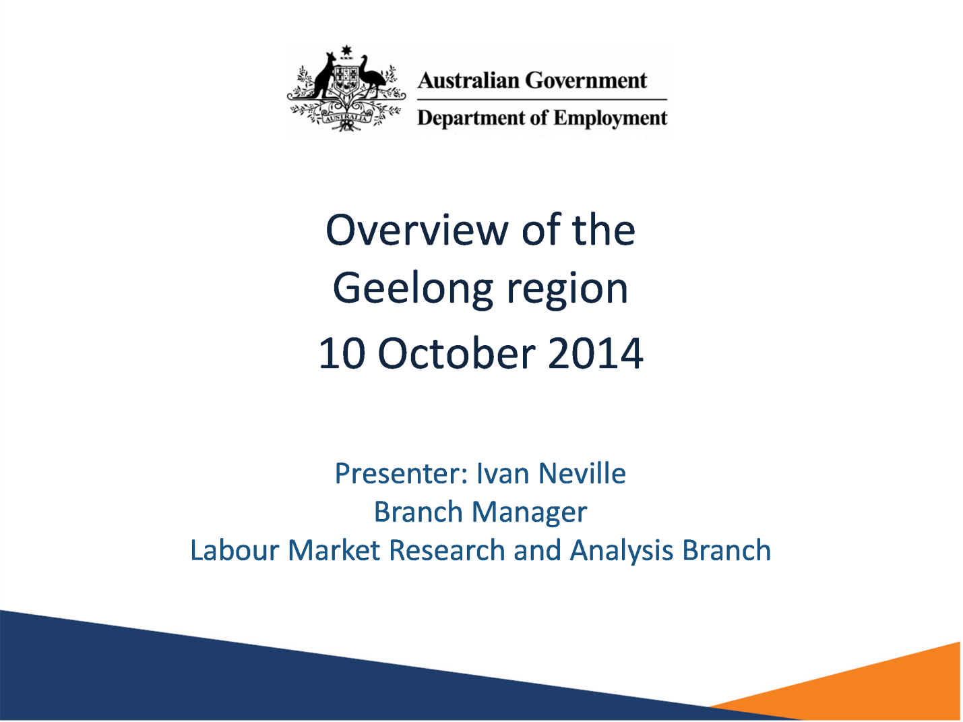

Notes
10 October 2014
Presented by Ivan Neville
Labour Market Research and Analysis Branch
Department of Employment
www.employment.gov.au

Slide 2 Employment growth slowing in Victoria
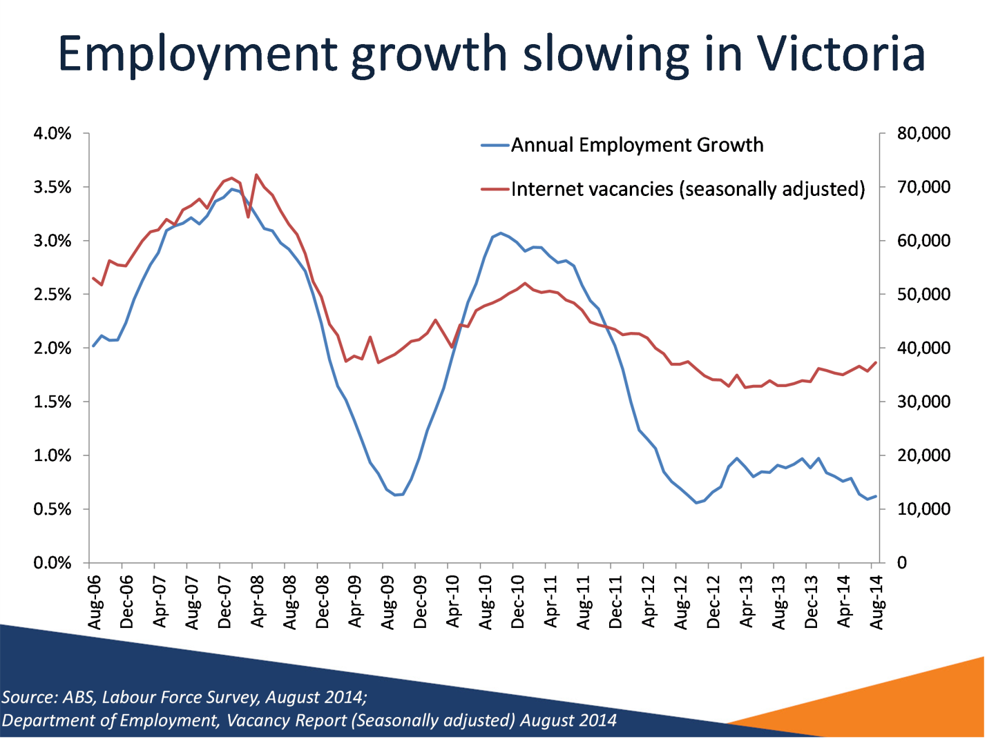

Notes
Source: ABS, Labour Force Survey, August 2014; Department of Employment, Vacancy Report (Seasonally adjusted) August 2014
This graph shows how both annual employment growth and Internet vacancies have declined over the past eight years.

Slide 3 Manufacturing declining in Victoria

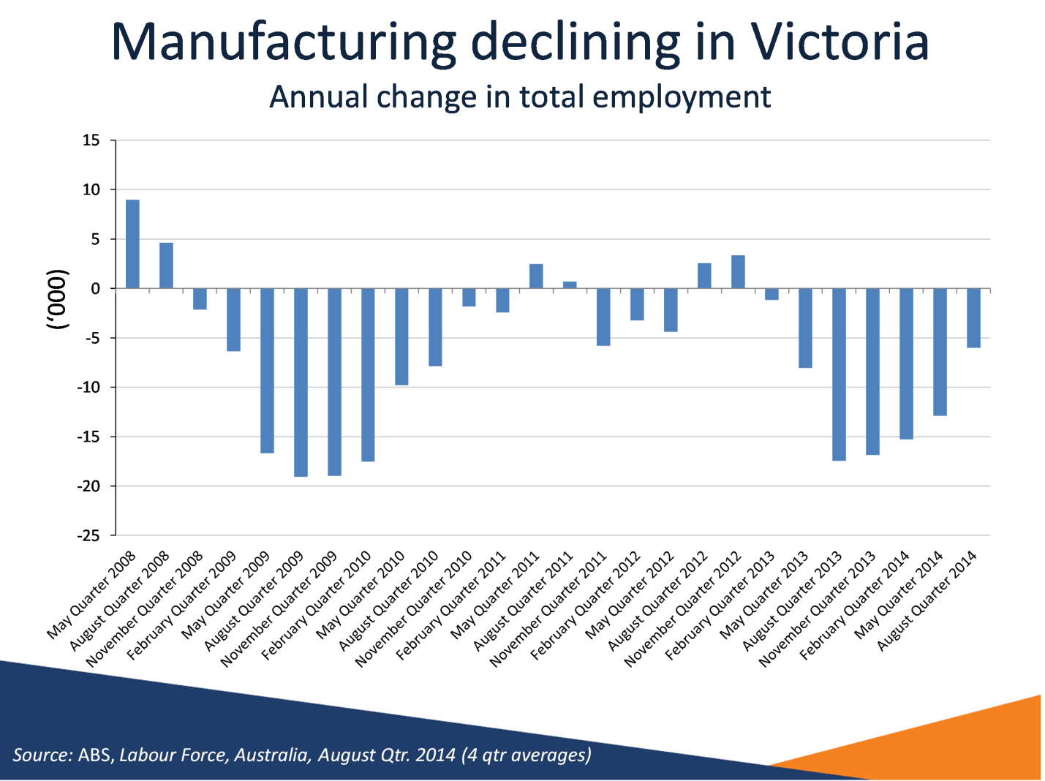

Notes
Source: ABS, Labour Force, Australia, August Qtr. 2014 (4 qtr averages)
The annual change in total employment in the manufacturing sector in Victoria has been negative for most quarters since 2008. In particular, two sustained periods of negative annual growth occurred from the November quarter 2008 to the February quarter 2011, and from the February Quarter 2013 to the August quarter 2014.

Slide 4 Greater Geelong Local Government Area
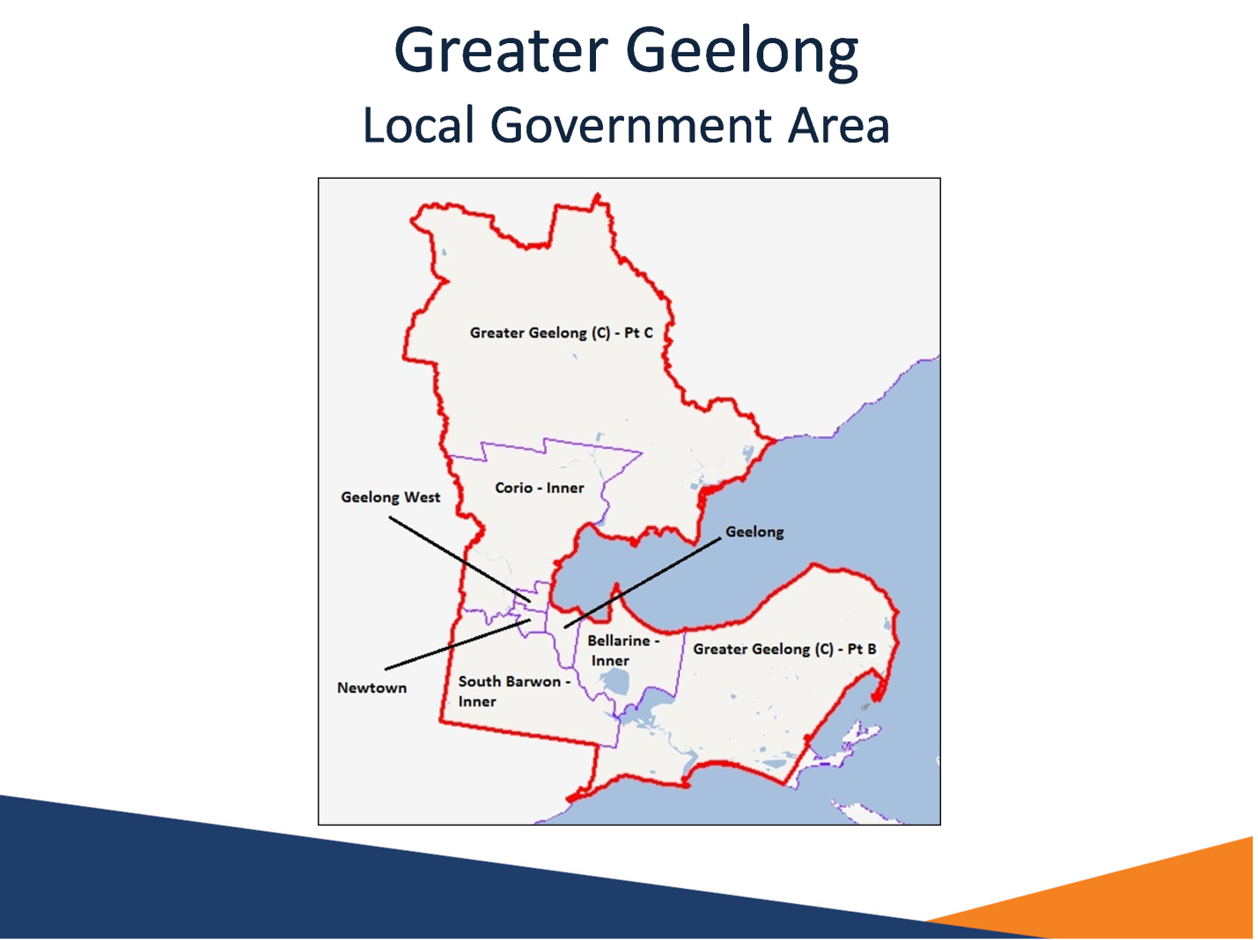

Notes
The Greater Geelong Local Government Area (LGA) is made up of the following Statistical Local Areas:
Bellarine - Inner
Corio - Inner
Geelong
Geelong West
Greater Geelong (C) - Pt B
Greater Geelong (C) - Pt C
Newtown
South Barwon - Inner
Some statistics reported in this presentation are based on the Geelong Statistical Area 4 (SA4).
The Greater Geelong LGA fits wholly within the Geelong SA4 and at the time of the 2011 Census made up 84 per cent of its working age population.

Slide 5 Snapshot of the Region
Indicator | Geelong | Victoria
Unemployment rate | 6.5% | 6.7%*
Participation rate (adult population) | 57.6% | 64.6%*
Proportion of 25-34 year olds completed Year 12 | 72% | 79%
Income support recipients (15-64 years old) | 21% | 17%
Proportion of disengaged youth (20-24 years old) | 13% | 11%

Notes
* September 2014
Source: ABS, Census of Population and Housing, 2011; ABS Labour Force Survey, Geelong SA4 (Aug 14) & Victoria (Sep 14); Department of Employment, Administrative data, June 2014; ABS Estimated Resident Population, 2011
The indicators reported in this table reveal that there are some areas of labour market disadvantage in Geelong. These include a lower participation rate compared with Victoria, a lower proportion of 25-34 year olds who have completed Year 12, a larger proportion of the working age population on income support, and a larger proportion of youth who are neither working nor studying.

Slide 6 Population profile
Region | Adult Population (15+) | Growth  2006 to 2011 (15+) | Proportion of Adult Population 65 + | Median Age 2011
Bellarine SLA | 20,405 | 6% | 21% | 40
Corio SLA | 47,233 | 4% | 19% | 38
Geelong SLA | 10,325 | 3% | 17% | 38
Geelong SLA | 12,034 | 2% | 16% | 37
South Barwon SLA | 44,305 | 8% | 21% | 39
Greater Geelong - Pt B SLA | 31,116 | 10% | 25% | 44
Greater Geelong LGA | 176,007 | 6% | 20% | 39
Australia | 18,111,460 | 9% | 17% | 37

Notes
Source: Estimated Residential Population, 2011 and 2006; ABS, Census of Population and Housing, 2011
Overall, the adult population in Geelong grew by 6 per cent from 2006 to 2011, smaller compared with Australia (9 per cent).
The proportion of the adult population aged 65 years and older in the Greater Geelong LGA (20 per cent) is larger compared with Australia (17 per cent).

Slide 7 Age distribution
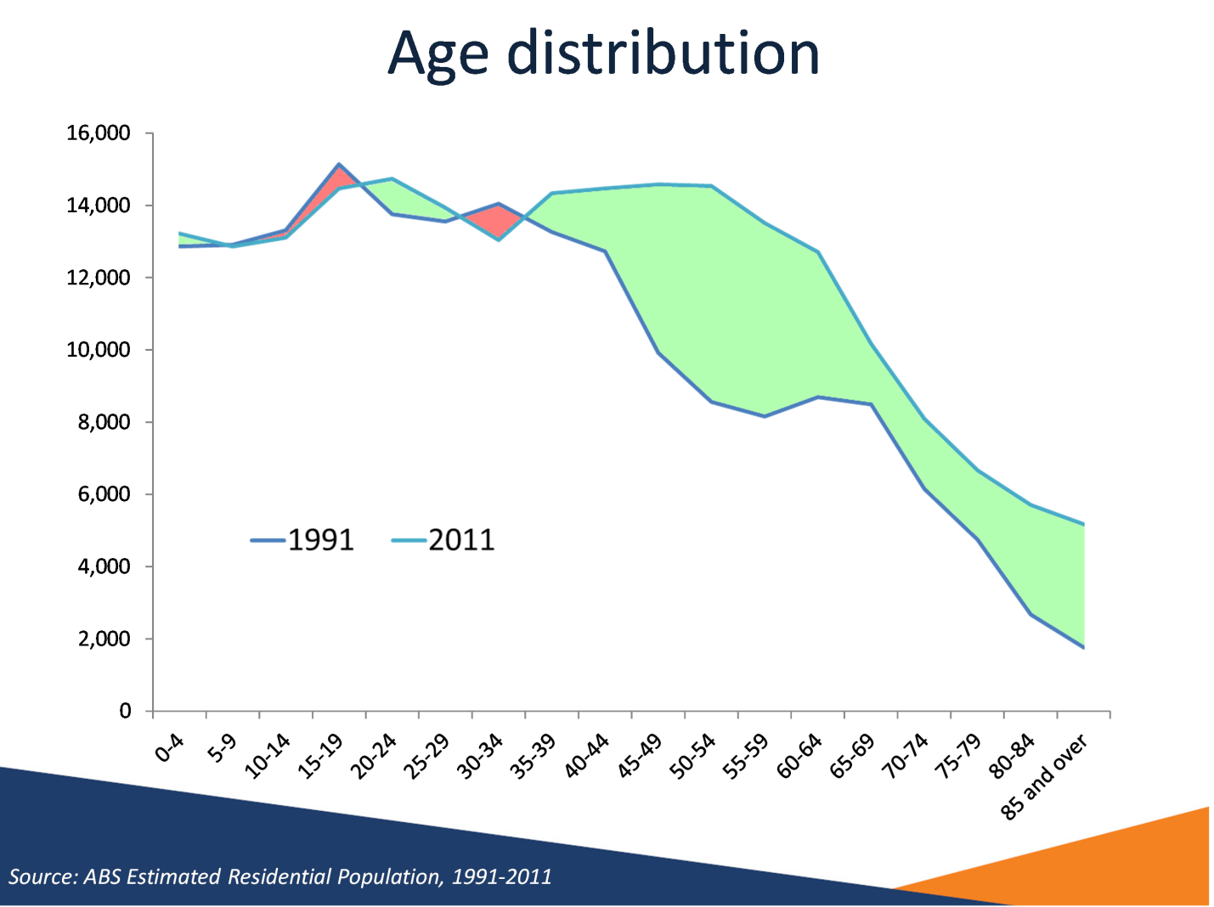

Notes
Source: ABS Estimated Residential Population, 1991-2011
This graph shows the age distributions of the Greater Geelong LGA from 1991 to 2011. It shows large population growth in the older age brackets, and little or negative growth in the younger age brackets, suggesting an ageing population.

Slide 8 Unemployment rate increasing
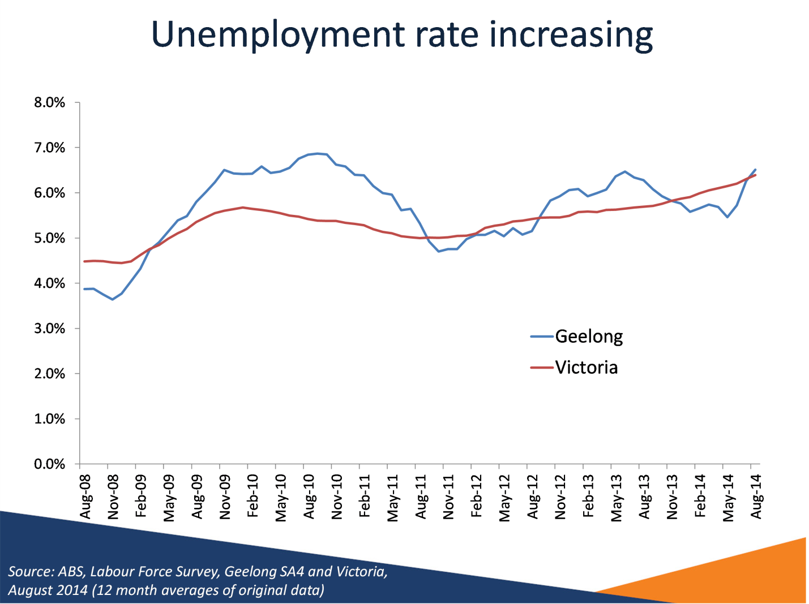

Notes
Source: ABS Labour Force Survey, Geelong SA4 and Victoria, August 2014 (12 month averages of original data)
This graph shows that Geelong’s unemployment rate has been increasing, generally in line with the increasing unemployment rate for Victoria.
Note: The unemployment rate for Victoria in this slide is calculated using a 12 month average of original data from the ABS Labour Force Survey, as opposed to the original data in slide 5 – ‘Snapshot of the region’.

Slide 9 Decline in male full-time employment since GFC - Geelong
Time period | Employed full-time |  | Employed part-time
Time period | Males | Females | Males | Females
September 2008 – August 2014 | -4200 | -200 | +0 | +2200

Notes
Source: ABS, Labour Force Survey, August 2014
Since September 2008, male full-time employment has decreased by 4200 employed persons, while female part-time employment has increased by 2200 employed persons.

Slide 10 High youth unemployment
Region | Youth Unemployment rate  (August 2014) | Youth Participation rate  (August 2014)
Geelong | 18.3% | 61.6%
Victoria | 14.1% | 65.3%
Australia | 12.9% | 66.5%

Notes
Source: ABS, Labour Force Survey, August 2014, 12 month averages of original data
The Geelong SA4 has a particularly high youth unemployment rate (18.3 per cent) compared with Australia (12.9 per cent). It has increased greatly over the last year from 12.5 per cent.

Slide 11 What are youth doing?
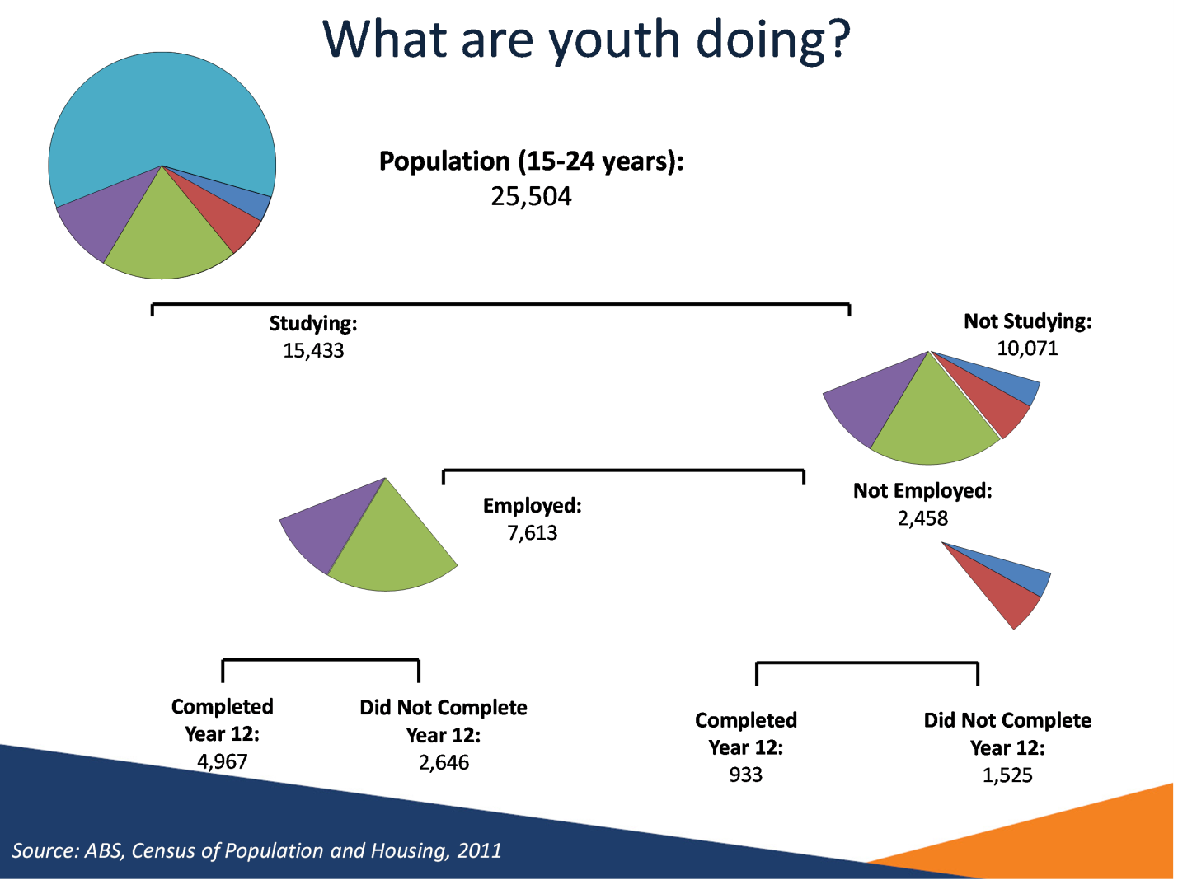

Notes
Source: ABS, Census of Population and Housing, 2011
At the time of the 2011 Census, there were 25,504 15-24 year olds in the Greater Geelong LGA, of which 10,071 were not studying.
Note: Not stated records for FT/PT Student Status, Labour Force Status and Higher Year of School Completed have not been included.

Slide 12 High levels of youth disengagement – 20 – 24 years
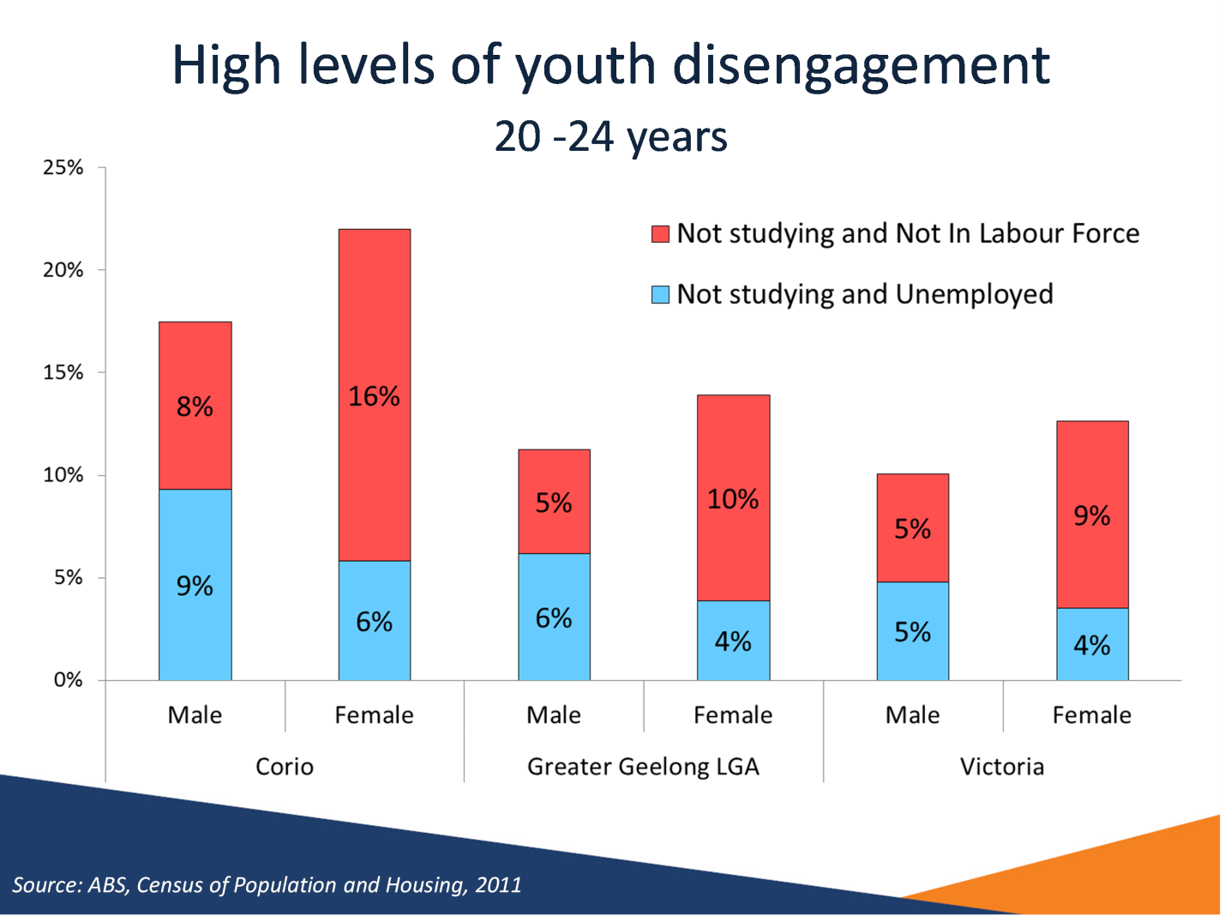

Notes
Source: ABS, Census of Population and Housing, 2011
At the time of the 2011 Census, 13 per cent of young adults (persons aged 20 to 24 years) in the Greater Geelong LGA were neither working nor studying. This figure is notably higher when compared with Victoria (11 per cent), but on a par with Australia (13 per cent).
For young adult males in Geelong, 5 per cent were not in the labour force and not studying and 6 per cent were unemployed and not studying. For young adult females in Geelong, 10 per cent were not in the labour force and not studying and a further 4 per cent were unemployed and not studying.
Although as a whole young people in the Greater Geelong LGA tend to be engaged, there are still pockets of disengagement, particularly in the Corio – Inner SLA. For young adult males in Corio, 8 per cent were not in the labour force and not studying and 9 per cent were unemployed and not studying. For young adult females in Corio 16 per cent were not in the labour force and not studying and a further 6 per cent were unemployed and not studying.

Slide 13 Improving the employment prospects of young Australians – employers’ perspectives
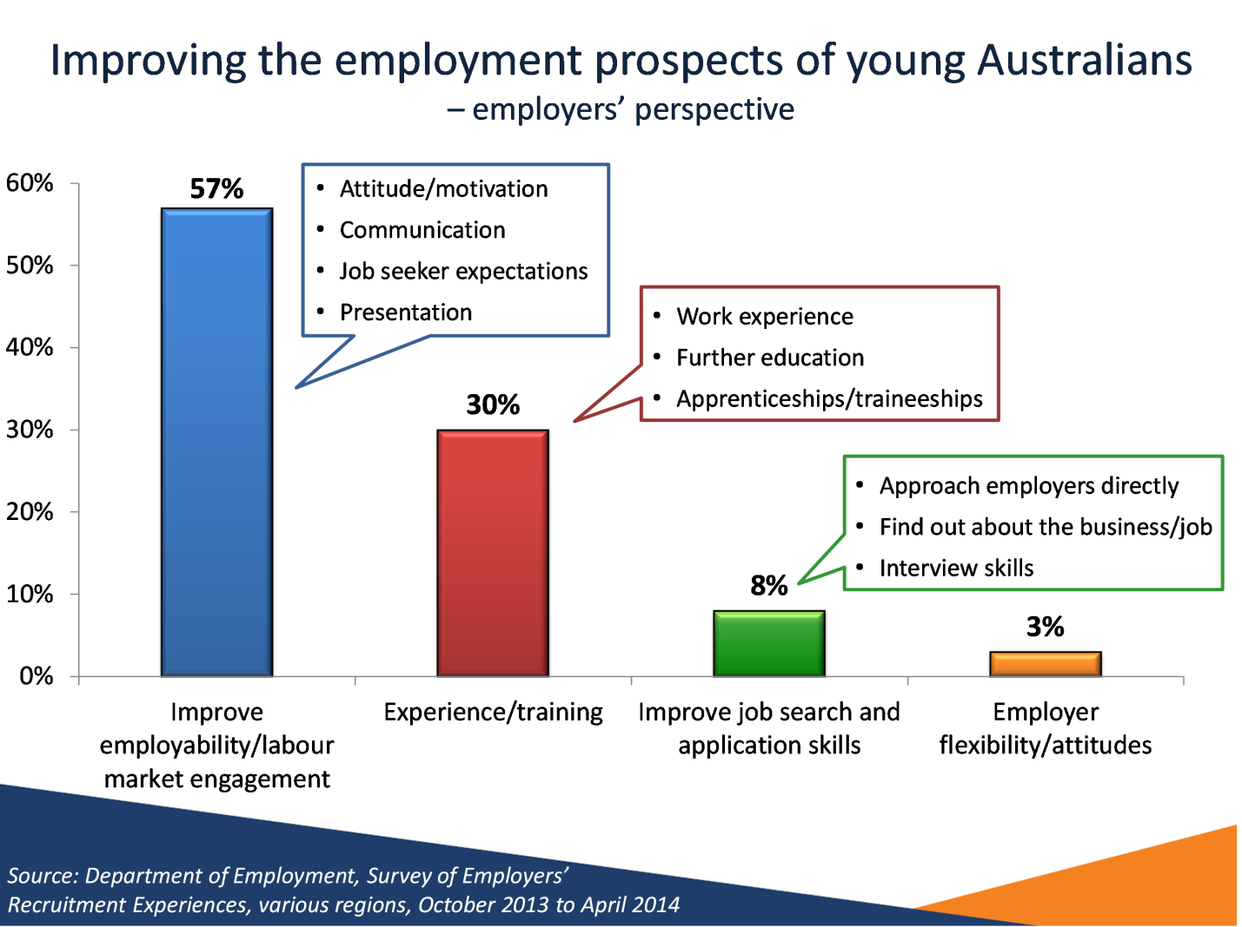

Notes
Source: Department of Employment, Survey of Employers’ Recruitment Experiences, various regions, October 2013 to April 2014
This graph is based on employer responses from the Gladstone, Bundaberg-Hervey Bay, Central Victoria, Port Augusta - Whyalla - Port Pirie, Sydney West and Blue Mountains, Illawarra, Caboolture-Sunshine Coast and Tasmania regions between October 2013 and April 2014.
While a total of 3142 employers were surveyed, the percentages reported in this graph are based on the 69 per cent who provided a response. Some responses were coded to multiple categories.
Over half of employers (57 per cent) believed that improving employability and labour market engagement would improve youth labour market outcomes, most particularly:
- Attitude/motivation
- Communication
- Job seeker expectations
- Presentation
A substantial proportion of employers (30 per cent) believed that work experience and further education or training would improve youth labour market outcomes, in particular:
- Work experience
- Education
- Traineeships/Apprenticeships

Slide 14 Long term unemployment
Region | Long-term unemployed  (52 weeks or more) |  | Average duration of unemployment (weeks)
Region | Persons | % of unemployed | Average duration of unemployment (weeks)
Geelong | 1,700 | 21.1% | 34
Victoria | 38,800 | 19.8% | 37
Australia | 157,600 | 21.6% | 40

Notes
Source: ABS Labour Force, August 2014 (12 month averages of original data)
The above table shows the proportion of unemployed people who have been unemployed for 52 weeks or more. In the Geelong SA4, 21.1 per cent of unemployed people are long-term unemployed, or about 1 in 5 unemployed persons. This is in line with corresponding proportions for Victoria (19.8 per cent) and Australia (21.6 per cent).
However the average duration of unemployment overall (34 weeks) is lower compared with Victoria (37 weeks) and Australia (40 weeks).

Slide 15 Large proportion of income support recipients in some areas
Region | % WAP on benefits  (June 2014) | % Change in number of recipients  (June 2013 - 2014) | % WAP on unemployment benefits  (June 2014) | % Change in number of recipients  (June 2013 - 2014)
Bellarine | 24% | 2% | 8% | 5%
Corio | 28% | 2% | 10% | 6%
Geelong | 22% | 1% | 7% | 3%
Geelong West | 19% | 0% | 7% | 6%
Greater Geelong LGA | 21% | 3% | 7% | 6%
Victoria | 17% | 2% | 5% | 5%

Notes
Source: Department of Employment, Administrative data, June 2014 & 2013; ABS Estimated Resident Population, 2011
In June 2014, 21 per cent of the Working Age Population (WAP) was in receipt of an income support benefit in the Greater Geelong LGA. This was larger when compared with Victoria (17 per cent). In the Corio – Inner SLA more than a quarter (28 per cent) of the WAP was in receipt of an income support payment.
Overall, the number of income support recipients (WAP) in the Greater Geelong LGA increased by 3 per cent in the 12 months to June 2014.
Some 7 per cent of the Geelong WAP were in receipt of an unemployment benefit, higher than the state (5 per cent).
10 per cent of the WAP in the Corio – Inner SLA was in receipt of an unemployment benefit.

Slide 16 Many families are jobless – families with children under 15
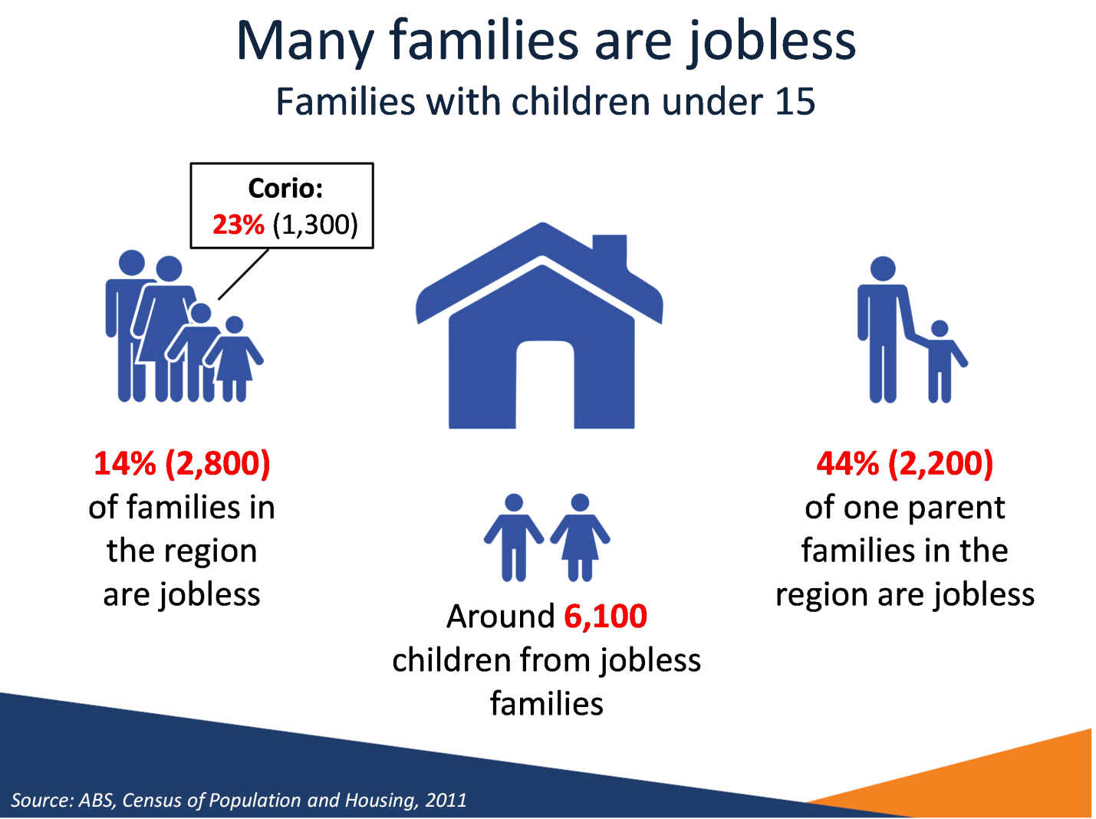

Notes
Source: ABS, Census of Population and Housing, 2011
At the time of the 2011 census, 14 per cent of families with children under 15 in the Greater Geelong LGA did not have an employed parent, slightly higher compared with Victoria (13 per cent). The proportion of lone parent families which were jobless (44 per cent) was on a par with Victoria (43 per cent).
The Corio – Inner SLA had a particularly large proportion of families with children under 15 which were jobless (23 per cent) and a large proportion of lone parent families with children under 15 which were jobless (54 per cent).

Slide 17 Largest employing industries
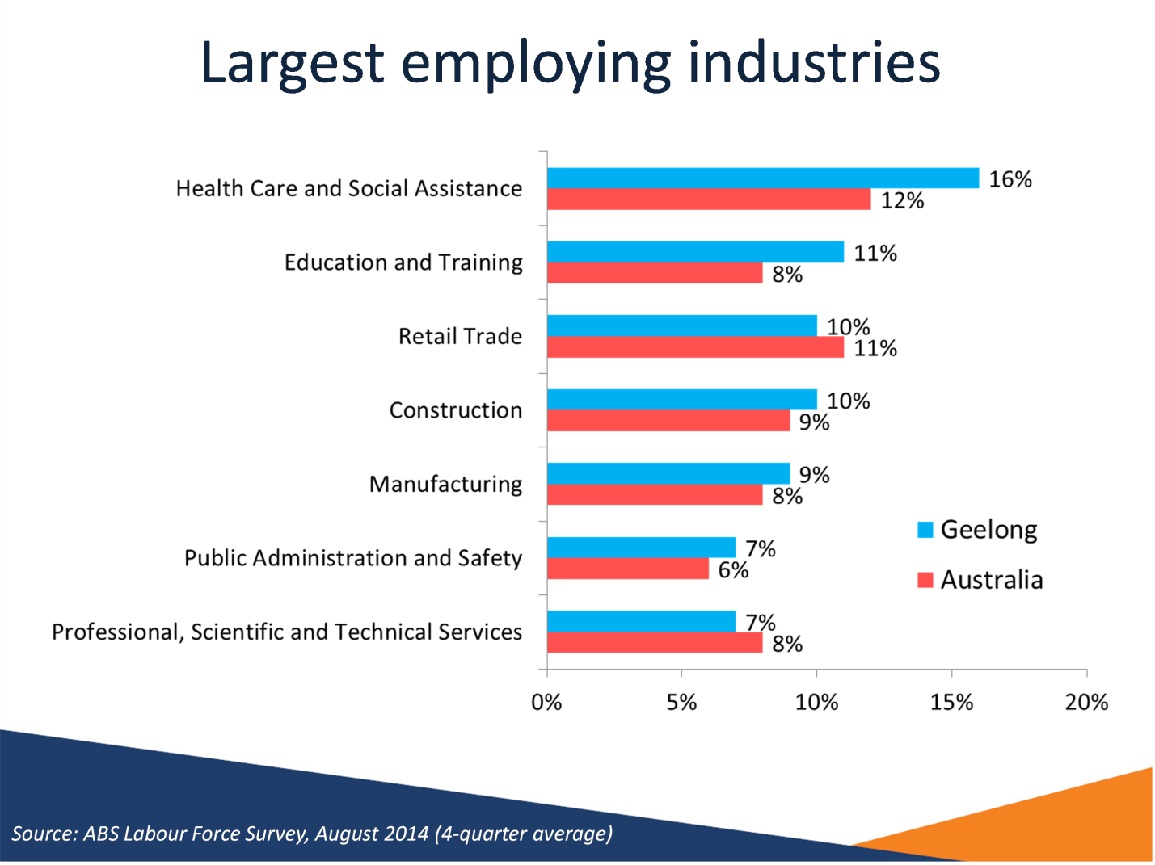

Notes
Source: ABS Labour Force Survey, August 2014 (4-quarter average)
In Geelong the Health Care and Social Assistance industry is the largest employing industry, making up 16 per cent of total employment as of August 2014. This was followed by the Education and Training (11 per cent of total employment), Retail (10 per cent), Construction (10 per cent) and Manufacturing (9 per cent) industries.

Slide 18 Fewer lower skilled opportunities in Manufacturing – Greater Geelong LGA
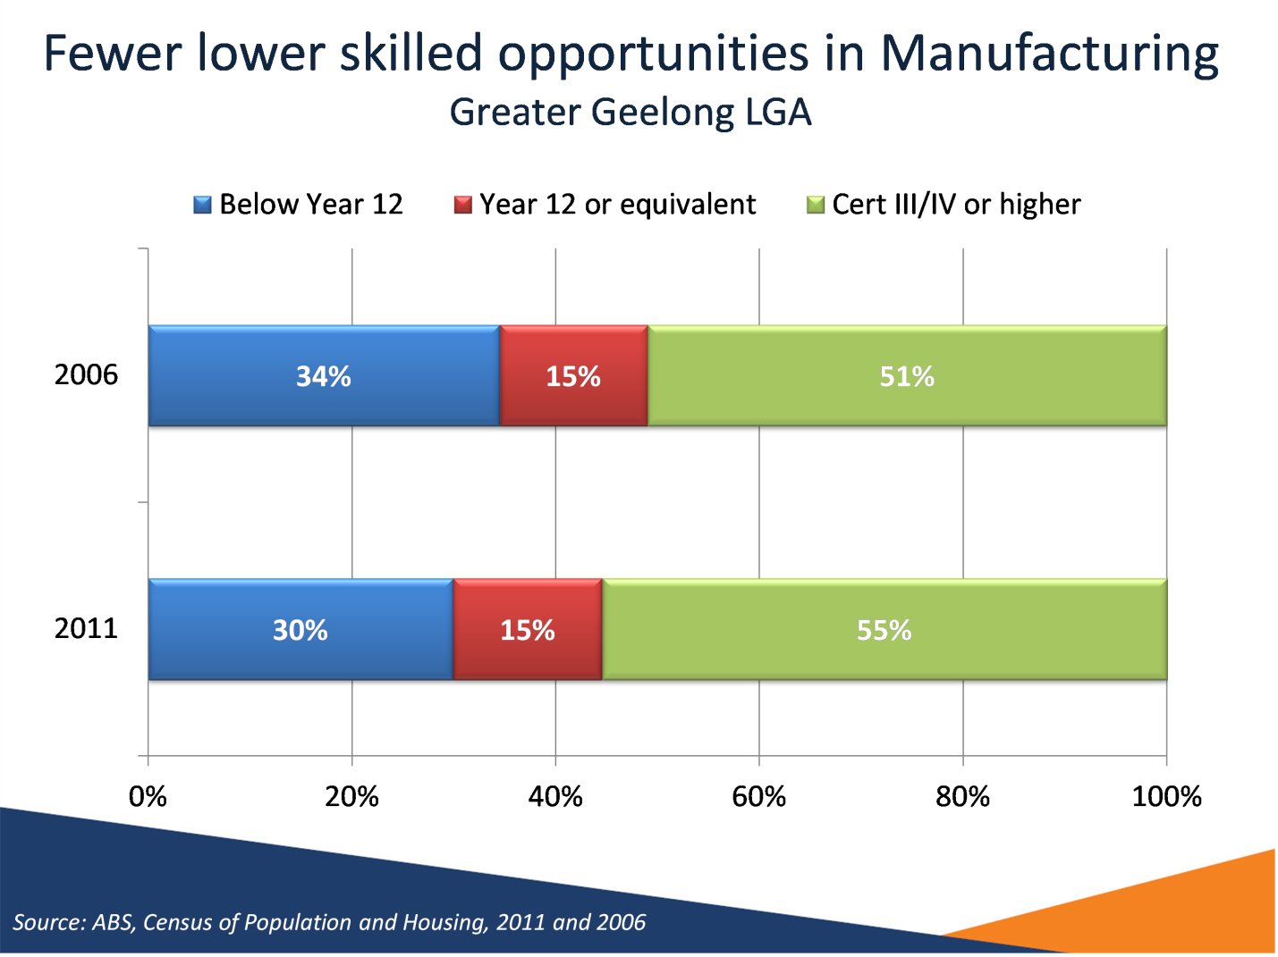

Notes
Source: ABS, Census of Population and Housing, 2011 and 2006
This graph shows that from 2006 to 2011 in the Greater Geelong LGA, the education level of manufacturing workers has shifted. There has been a decrease in the proportion of workers who did not complete Year 12 and had no further education, and an increase in the proportion of workers who had a certificate 3 or 4 or higher level of education.

Slide 19 Occupations on the rise and in decline – Geelong, 2006 to 2011
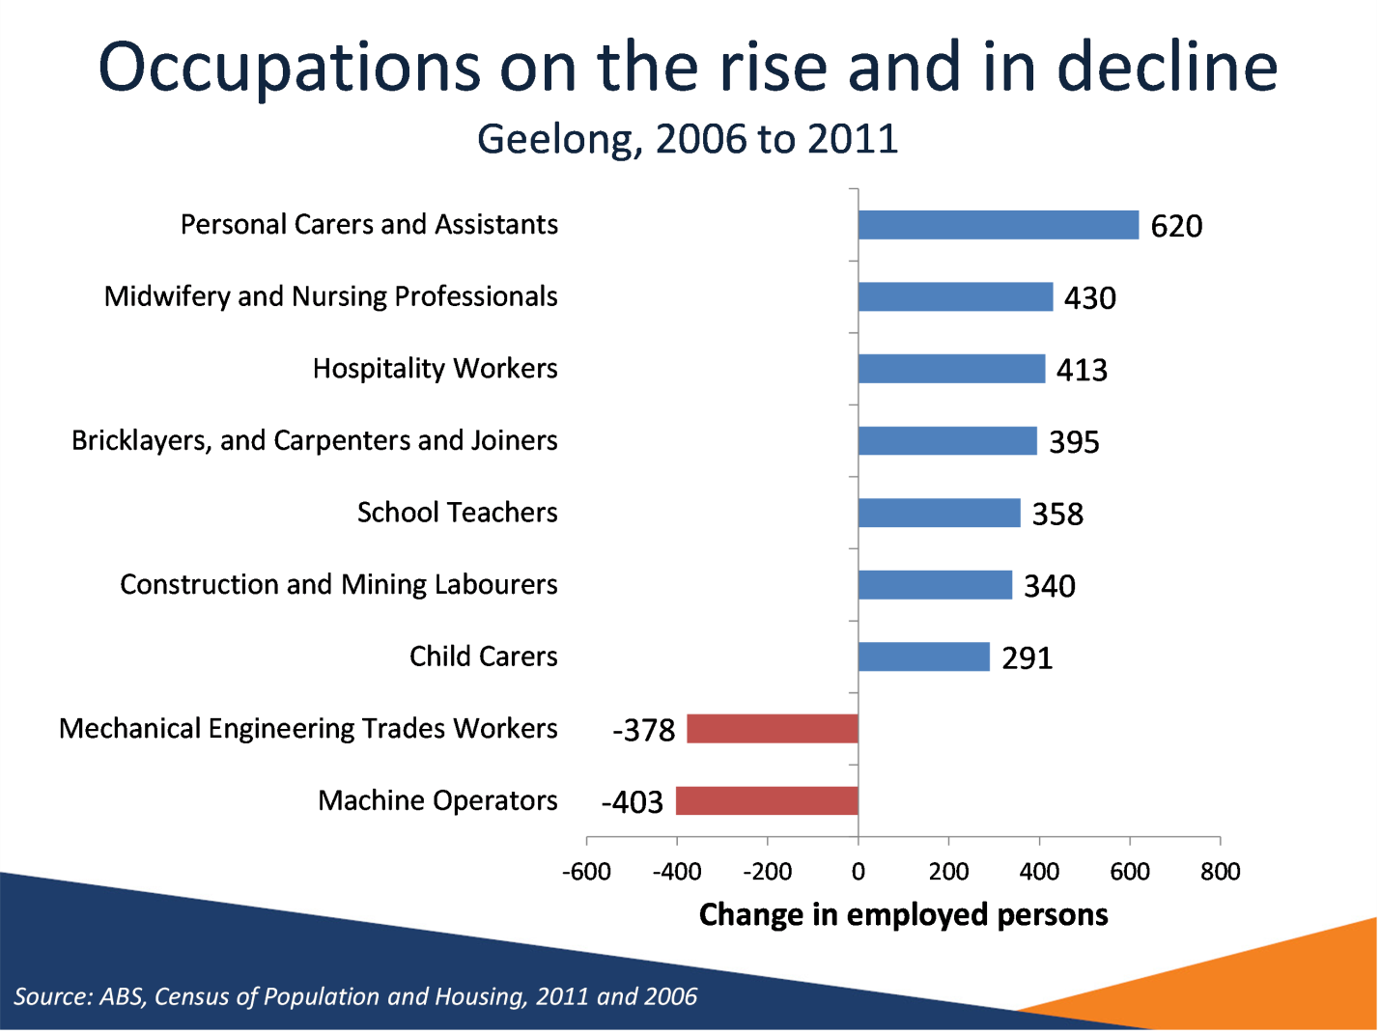

Notes
Source: ABS, Census of Population and Housing, 2011 and 2006
This graph shows which occupations declined or grew the most between 2006 and 2011 in the Greater Geelong LGA. The occupations which grew the most were Personal Carers and Assistants (620 persons) and Midwifery and Nursing Professionals (430 persons). Occupations which declined the most included Machine Operators (-403 workers) and Mechanical Engineers and Trades Workers (-378 persons).

Slide 20 Projected continued structural change – Geelong, five years to November 2018
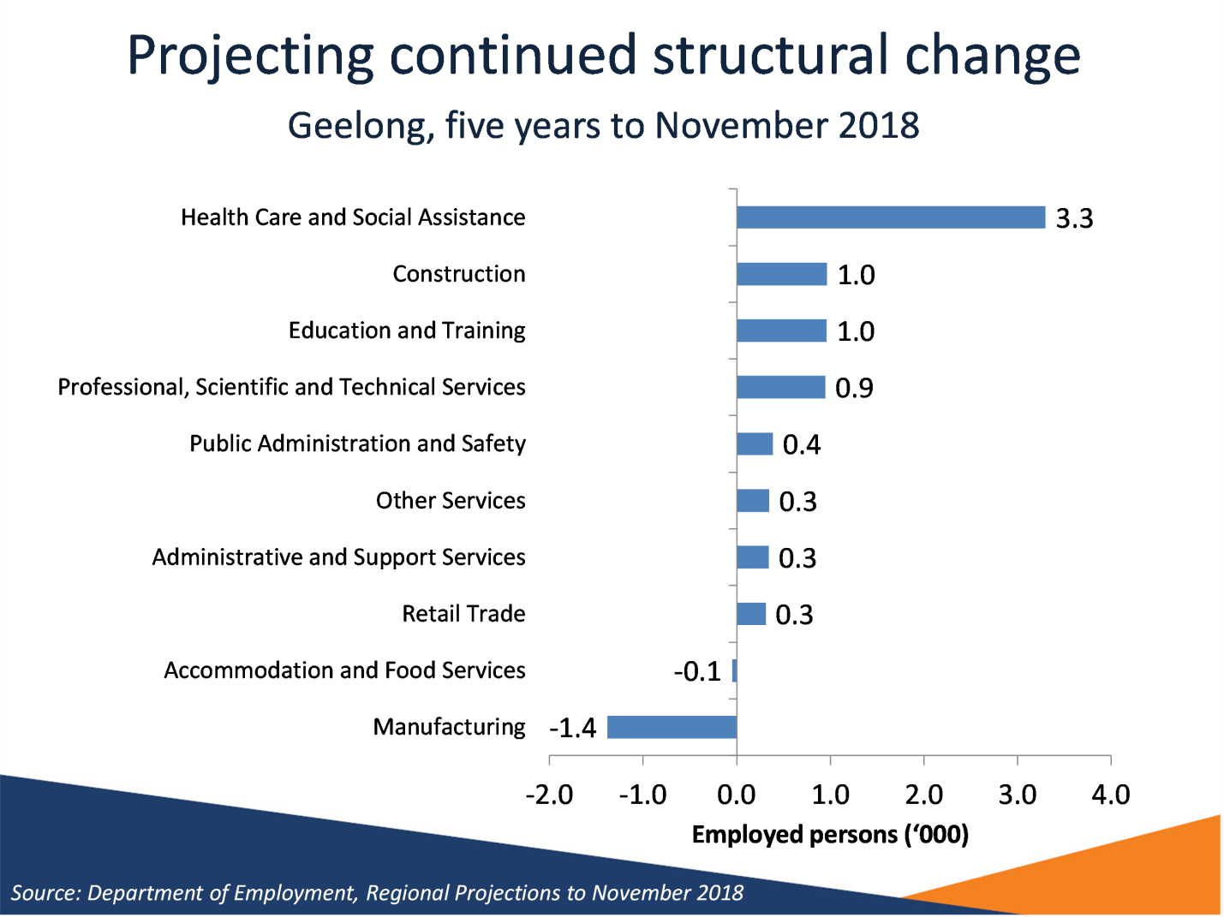

Notes
Source: Department of Employment, Regional Projections to November 2018
As shown in the graph, the Department projects that in the five years to November 2013, the Health Care and Social Assistance industry will increase by 3300 employed persons, and the Manufacturing industry will decline by 1400 employed persons.

Slide 21 Transitional challenges
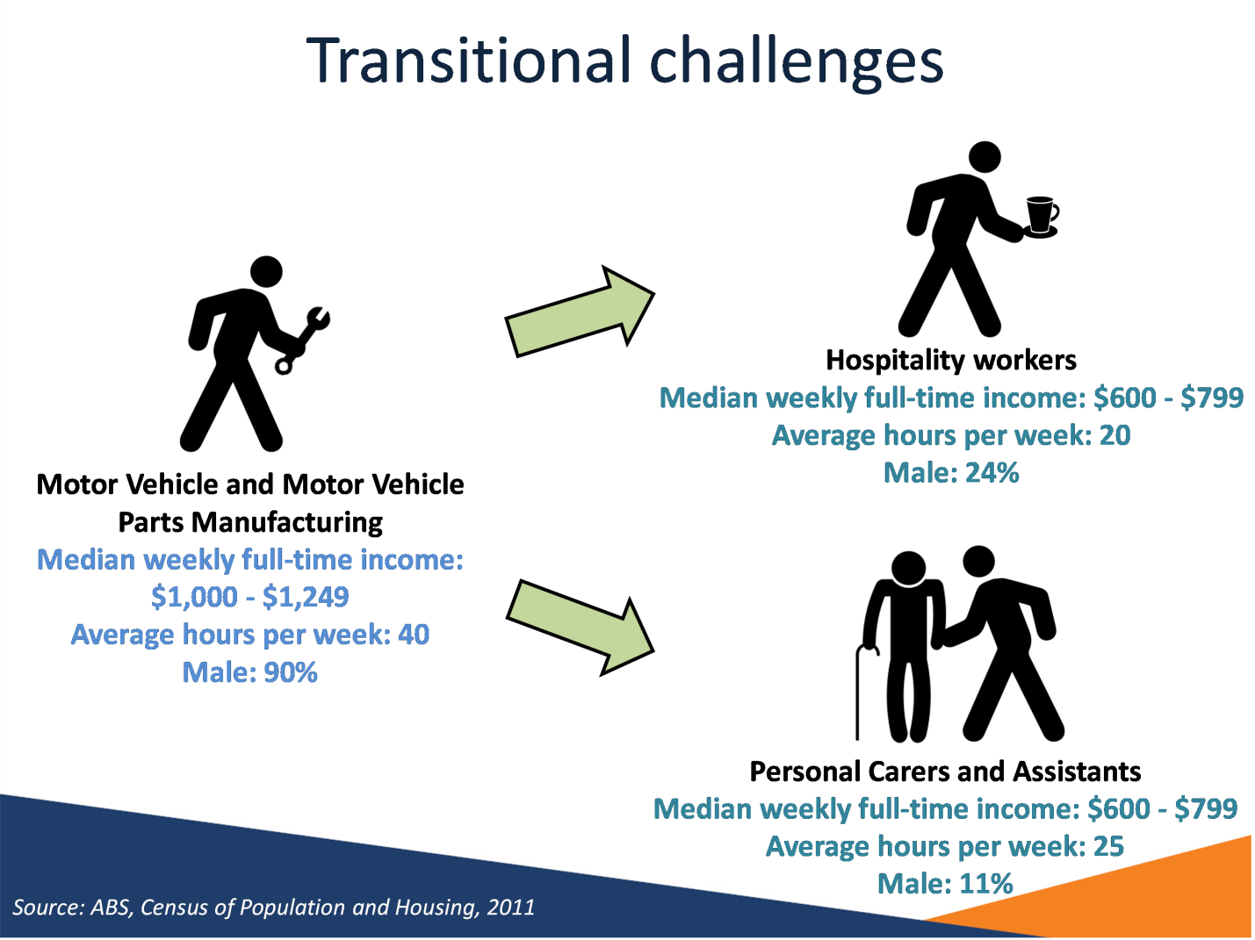

Notes
Source: ABS, Census of Population and Housing, 2011
This slide highlights some of the transitional challenges ex-auto industry workers may face when striving to regain employment. Although Hospitality Workers and Personal Carers and Assistants are among the occupations which have grown the most from 2006 to 2011, they will in general offer a lower salary and fewer hours per week than occupations in the Motor Vehicle and Motor Vehicle Parts Manufacturing industry.

Slide 22 Hints for workers recently made redundant
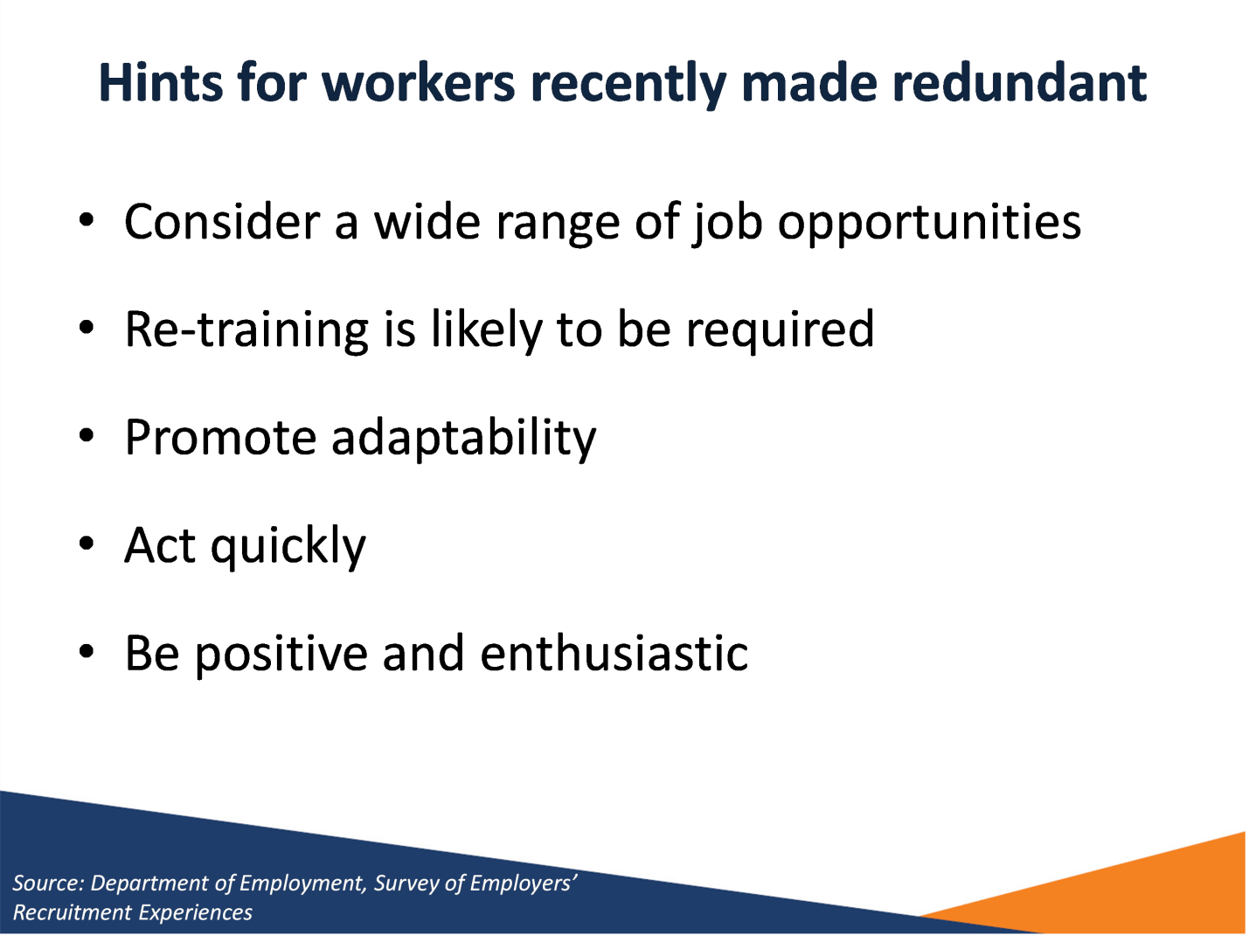

Notes
Source: Department of Employment, Survey of Employers’ Recruitment Experiences
Consider a wide range of job opportunities
Re-training is likely to be required
Promote adaptability
Act quickly
Be positive and enthusiastic

Slide 23 Educational attainment
Region | Completed  Year 12 | Attained Advanced Diploma, Diploma or Certificate III & IV | Attained Bachelor Degree or Higher
Bellarine | 64% | 42% | 18%
Corio | 63% | 33% | 19%
Geelong | 80% | 29% | 44%
Geelong West | 82% | 33% | 41%
South Barwon | 79% | 35% | 36%
Greater Geelong - Pt B | 72% | 39% | 29%
Greater Geelong LGA | 72% | 35% | 30%
Victoria | 79% | 29% | 32%

Notes
Source: ABS, Census of Population and Housing, 2011
Job seekers who have not completed Year 12 and have limited experience in the workforce are likely to lack many basic employability skills that employers value and look for in applicants, particularly for lower skilled vacancies and entry level positions such as apprenticeships and traineeships.
At the time of the 2011 Census, the proportion of 25 to 34 year olds in the Greater Geelong LGA who had completed Year 12 or equivalent was 72 per cent, smaller compared with Victoria (79 per cent).
30 per cent of 25-34 year olds in the Greater Geelong LGA had attained a Bachelor Degree or Higher, lower than Victoria (32 per cent). However, the proportion of people in LGA who attained an Advanced Diploma, Diploma, or Certificate III and IV level (35 per cent) was larger than Victoria (29 per cent).

Slide 24 Educational attainment and labour market outcomes – Greater Geelong LGA
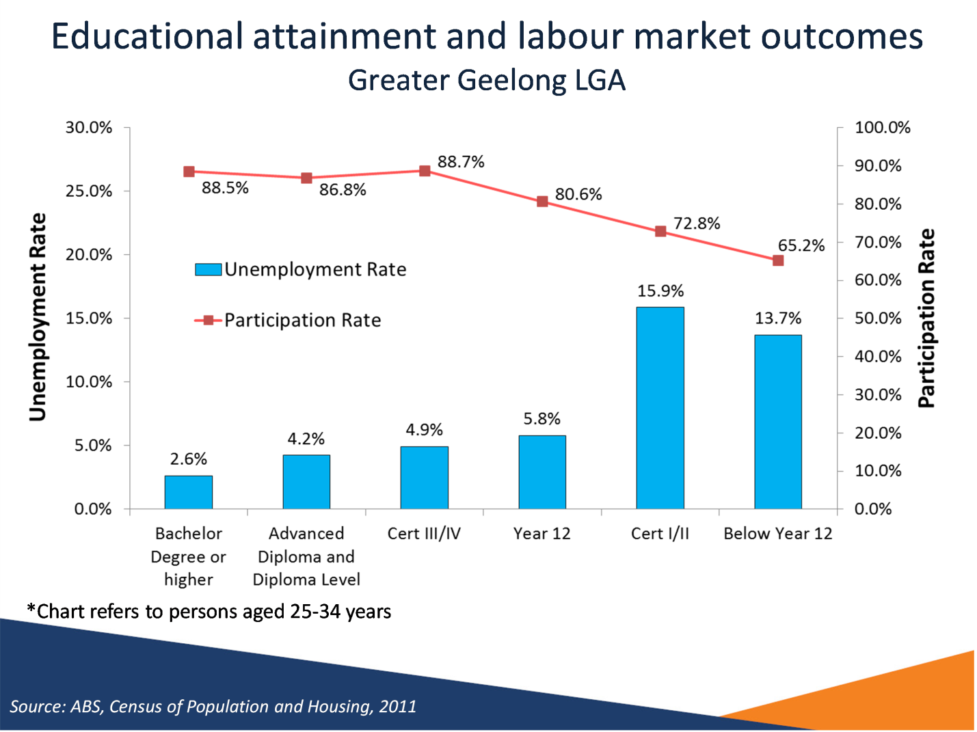

Notes
Source: ABS, Census of Population and Housing, 2011
There is a strong relationship between educational attainment and employment outcomes. For those aged 25 to 34 years in the Greater Geelong LGA, there were high unemployment rates for those who had completed Certificate I & II but had not completed Year 12 (15.9 per cent) and those who did not complete Year 12 without any further post school qualification (13.7 per cent).
Unemployment rates are considerably lower for those who have completed a tertiary education at the Bachelor degree, Advanced Diploma and Diploma Level. It should also be noted that employment outcomes are better for those who have attained Certificate Levels III or IV. This emphasises the importance of post school education in ensuring success in gaining employment.

Slide 25 Travel outside Greater Geelong for work
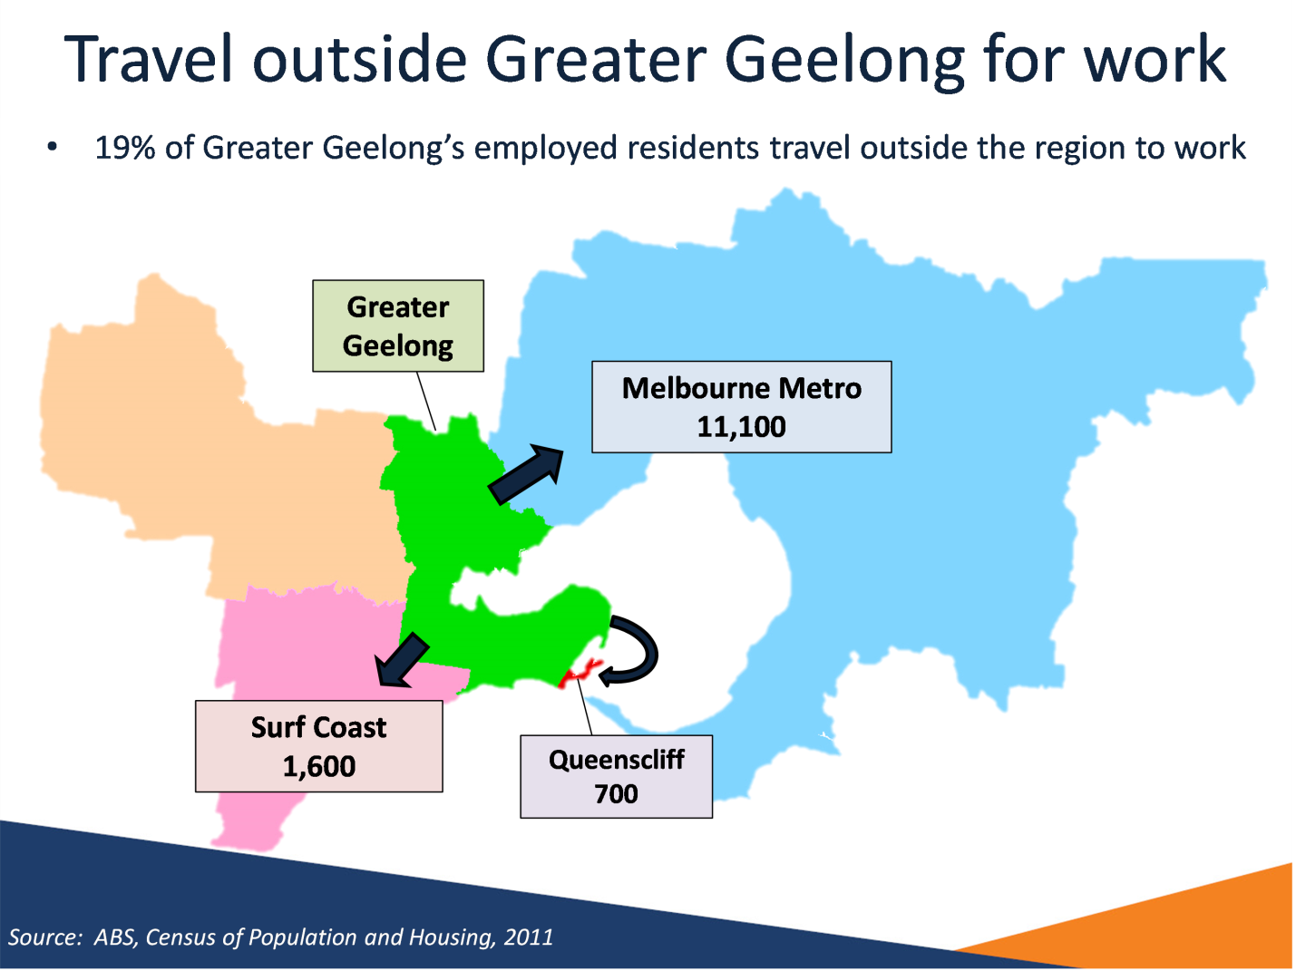

Notes
Source: ABS, Census of Population and Housing, 2011
At the time of the 2011 Census, around 80,600 employed people of working age (15-64 years) were residing in Greater Geelong LGA. Of those people, 81 per cent (65,300 people) worked in the LGA.
The remaining 19 per cent (15,400 people) travelled outside of the LGA for work. The largest proportions travelled to:
- Melbourne Metro (11,100 people or 72 per cent of people travelling outside the LGA for work)
  - Wyndham LGA (within Melbourne Metro, 2,000 people or 13 per cent)
- Surf Coast LGA (1,600 per cent or 11 per cent of people travelling outside the LGA for work)
Living outside Greater Geelong and travelling to the LGA for work:
At the time of the 2011 Census, 76,900 people were employed in the Greater Geelong LGA. Of those people working in the LGA, 85 per cent (65,300 people) lived in the LGA.
The remaining 15 per cent (11,600 people) lived outside the LGA and travelled to the LGA to work. The largest proportions travelled from:
- Surf Coast LGA (4,100 people or 36 per cent of people travelling to the LGA for work)
- Melbourne Metro (3,600 people or 31 per cent of people travelling to the LGA for work)
- Golden Plains LGA (2,400 people or 20 per cent of people travelling to the LGA for work)
Calculated using Working Age Population (15-64).

Slide 26 What are employers telling us?


Slide 27 Recruitment experiences remain subdued…
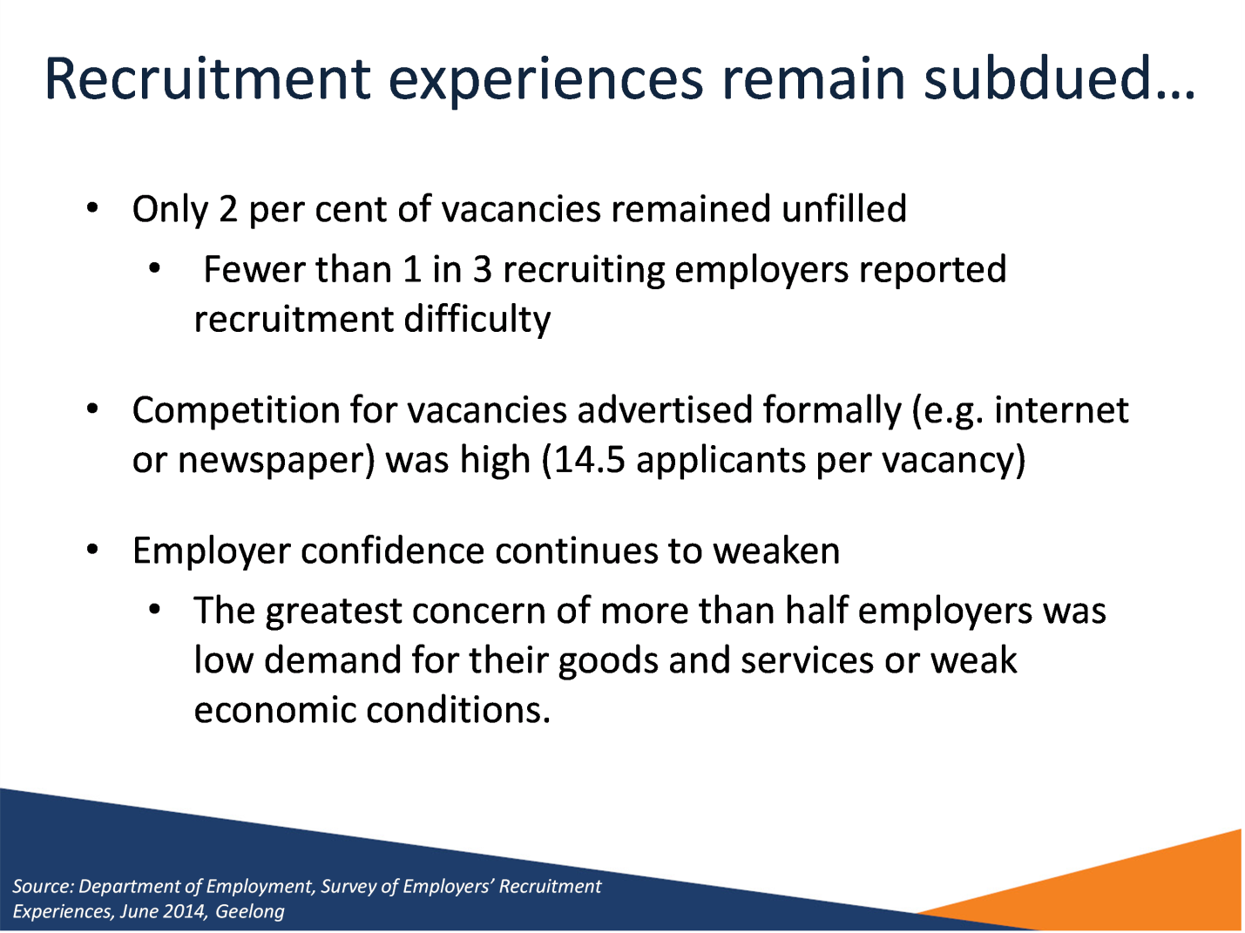

Notes
Source: Department of Employment, Survey of Employers’ Recruitment Experiences, June 2014, Geelong
Only 2 per cent of vacancies remained unfilled
- Fewer than 1 in 3 recruiting employers reported recruitment difficulty
Competition for vacancies advertised formally (e.g. internet or newspaper) was high (14.5 applicants per vacancy)
Employer confidence continues to weaken
- The greatest concern of more than half employers was low demand for their goods and services or weak economic conditions.

Slide 28 …but opportunities still exist in some industries
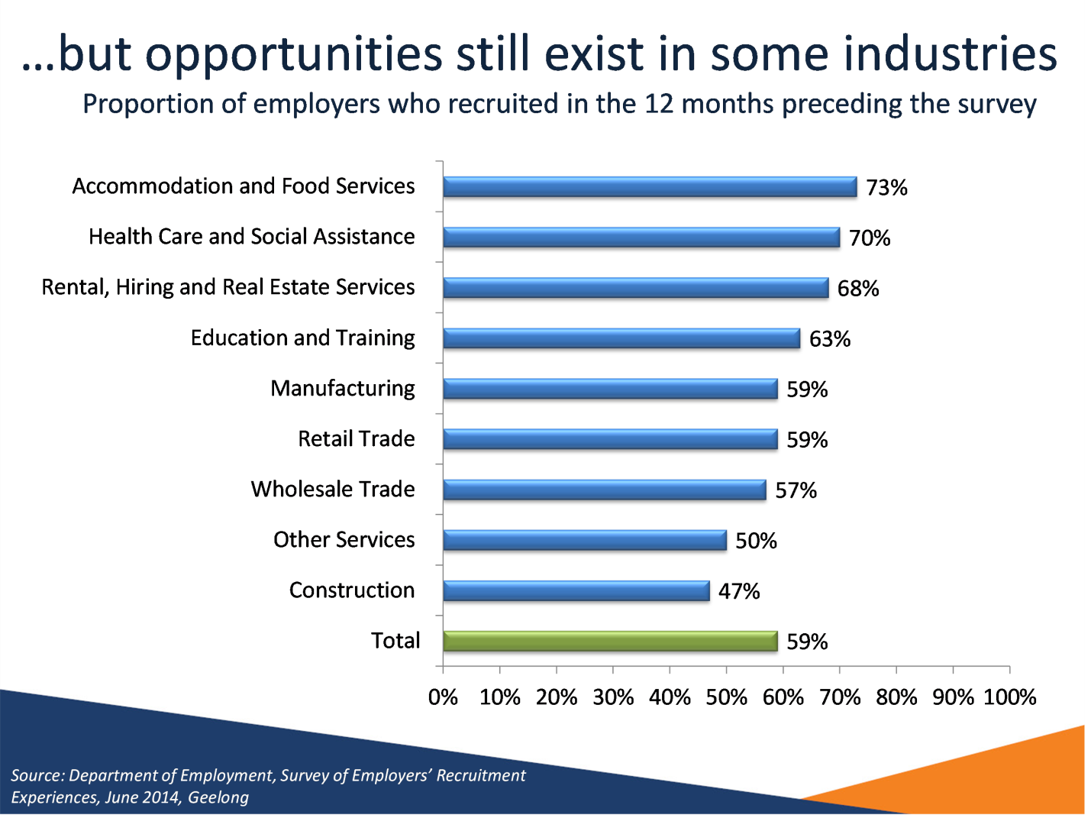

Notes
Source: Department of Employment, Survey of Employers’ Recruitment Experiences, June 2014, Geelong
This graph shows the proportions of employers by industry who recruited in the 12 months preceding the survey. Employers from the Accommodation and Food Services industry (73 per cent), Health Care and Social Assistance industry (70 per cent) and Rental, Hiring and Real Estate Services industry (68 per cent) most commonly recruited in the 12 months preceding the survey.

Slide 29 Many employment opportunities are only advertised informally
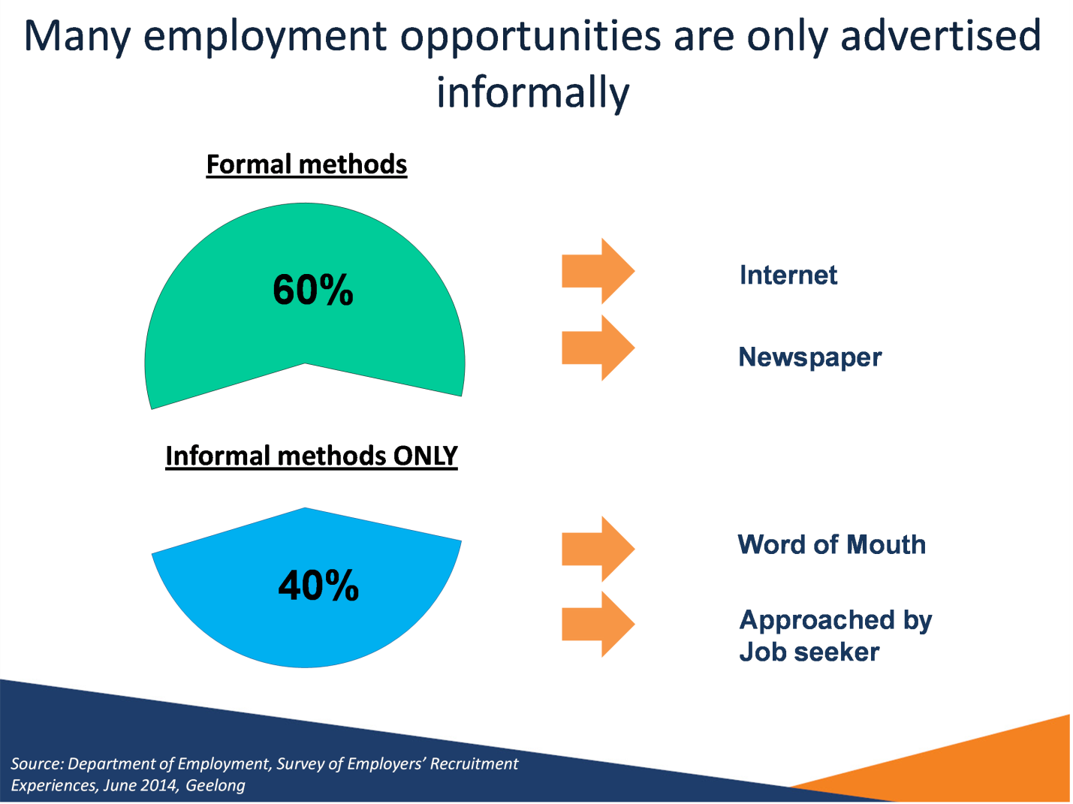

Notes
Source: Department of Employment, Survey of Employers’ Recruitment Experiences, Geelong, June 2014
More than half of recruiting employers (60 per cent) used formal methods to advertise for vacancies (i.e. Internet, Newspaper).
A still significant proportion (40 per cent) of employers used informal methods ONLY to advertise for vacancies (i.e. Word of Mouth, Approached by job seeker).

Slide 30 Reasons applicants didn’t get an interview – for formally advertised vacancies - Geelong
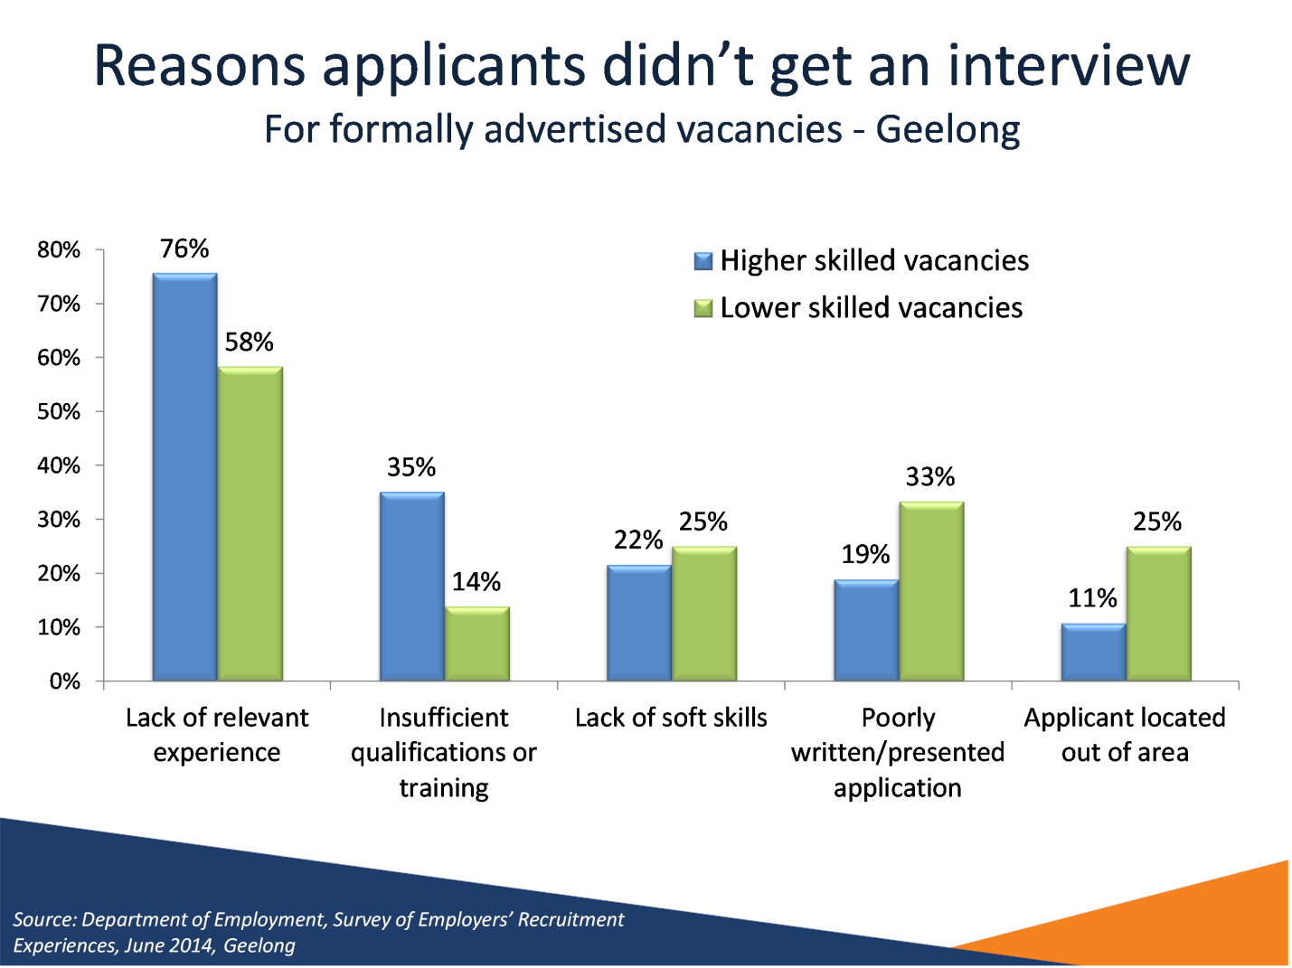

Notes
Source: Department of Employment, Survey of Employers’ Recruitment Experiences, June 2014, Geelong
The majority of applicants for formally advertised vacancies in Geelong didn’t get an interview (78 per cent).
This graph shows that for higher skilled vacancies (skill levels 1, 2 and 3), applicants most commonly didn’t qualify for an interview due to lack of experience (76 per cent) and insufficient qualifications and training (35 per cent).
However, for lower skilled vacancies (skill levels 4 and 5), a lack of relevant experience was still the most common reason (58 per cent) applicants didn’t qualify for an interview. The second most common reason for lower skilled vacancies was a poorly written/presented application (33 per cent).

Slide 31 Personality traits and employability skills that employers in Geelong viewed as essential
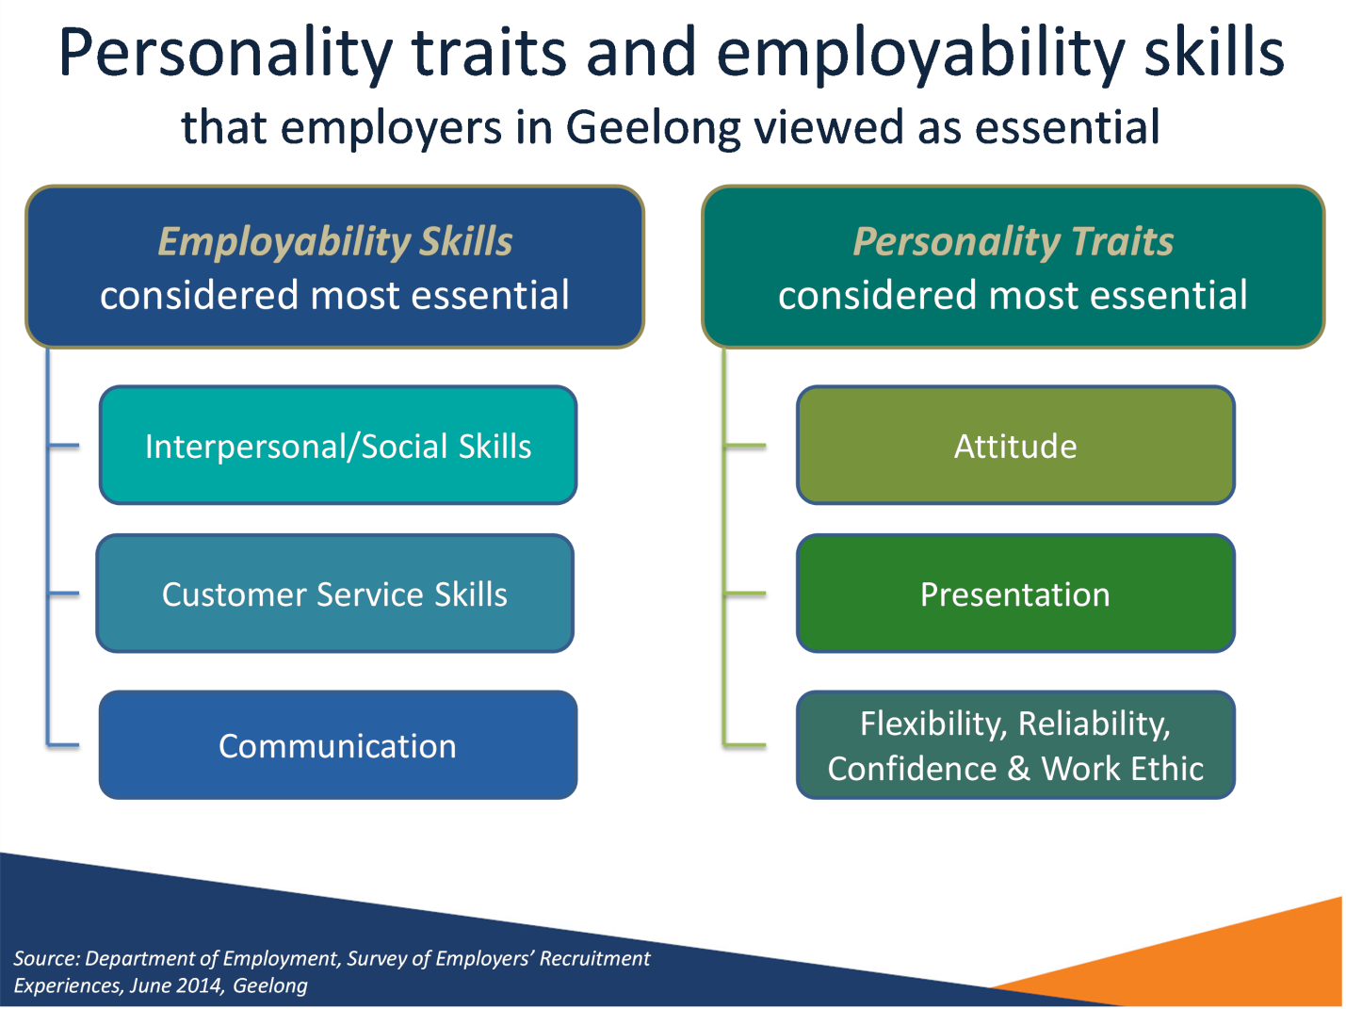

Notes
Source: Department of Employment, Survey of Employers’ Recruitment Experiences, June 2014, Geelong
Employers in Geelong viewed the following employability skills and personality traits as essential:
Employability skills:
- Interpersonal/Social Skills
- Customer Service Skills
- Communication
Personality traits:
- Attitude
- Presentation
- Flexibility, Reliability, Confidence and Work Ethic

Slide 32 Employers’ concerns for the future - Geelong
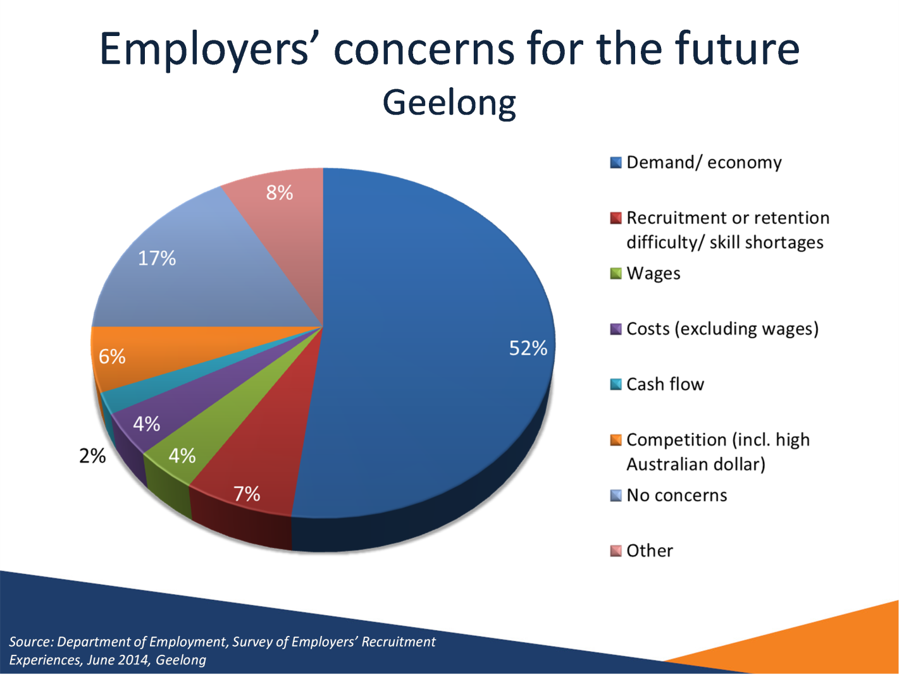

Notes
Source: Department of Employment, Survey of Employers’ Recruitment Experiences, June 2014, Geelong
By far the single greatest future concern for employers was a downturn in the economy and demand for their services/products (52% of employers). This is higher compared with the 2013 survey, in which 45% of employers reported the economy or demand for their services/products as their single greatest concern.
Recruitment or retention difficulty/skill shortages was a concern for 7% of employers.

Slide 33 Conclusion
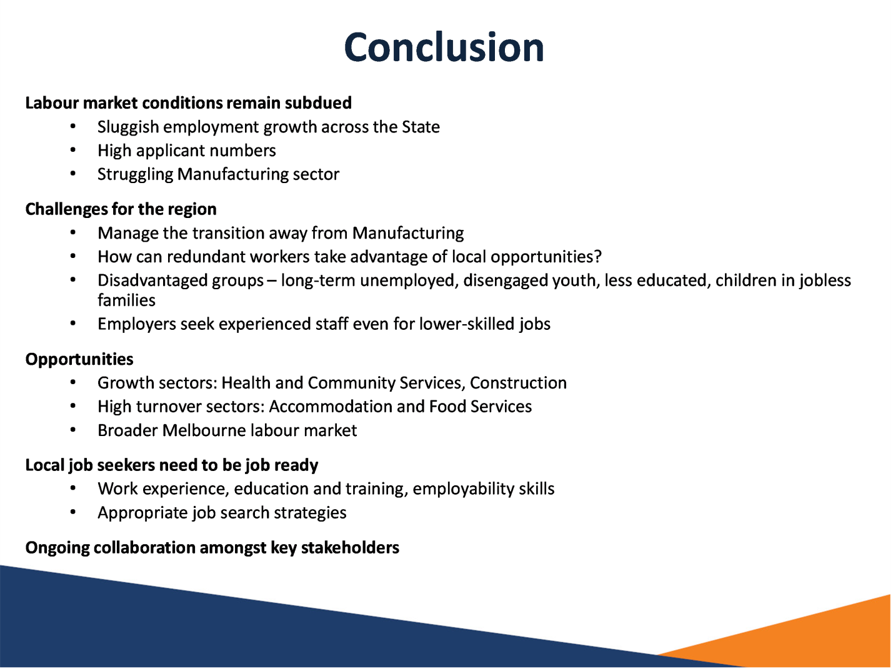

Notes
Labour market conditions remain subdued
- Sluggish employment growth across the State
- High applicant numbers
- Struggling Manufacturing sector
Challenges for the region
- Manage the transition away from Manufacturing
- How can redundant workers take advantage of local opportunities?
- Disadvantaged groups – long-term unemployed, disengaged youth, less educated, children in jobless families
- Employers seek experienced staff even for lower-skilled jobs
Opportunities
- Growth sectors: Health and Community Services, Construction
- High turnover sectors: Accommodation and Food Services
- Broader Melbourne labour market
Local job seekers need to be job ready
- Work experience, education and training, employability skills
- Appropriate job search strategies
Ongoing collaboration amongst key stakeholders

Slide 34 Further information


Notes
More information on labour market conditions and other research on small areas can be found on the web sites listed in the slide above.
A report on the survey findings for the Greater Geelong LGA is available on the regional reports section of the Department of Employment web site.
Thank you.

Slide 35


Notes
If you have any questions about the presentation please contact the Recruitment Analysis and Employer Surveys sections on 1800 059 439 or email recruitmentsurveys@employment.gov.au

Slide 36


