Final report to
the Commonwealth and states and territories

21 december 2015
REVIEW OF THE NATIONAL PARTNERSHIP AGREEMENT ON SKILLS REFORM
Final report

ACIL ALLEN CONSULTING PTY LTD
ABN 68 102 652 148
161 Wakefield street
Adelaide sa 5000
AUSTRALIA
t +61 8 8122 4965
Level FIFTEEN
127 Creek Street
Brisbane QLD 4000
Australia
T+61 7 3009 8700
F+61 7 3009 8799
Level TWO
33 Ainslie Place
CANBERRA ACT 2600
AUSTRALIA
T+61 2 6103 8200
F+61 2 6103 8233
Level NINE
60 Collins Street
MELBOURNE VIC 3000
AUSTRALIA
T+61 3 8650 6000
F+61 3 9654 6363
Level one
50 Pitt Street
SYDNEY NSW 2000
AUSTRALIA
T+61 2 8272 5100
F+61 2 9247 2455
level twelve, bgc centre
28 the esplanade
PERTH WA 6000
AUSTRALIA
T+61 8 9449 9600
F+61 8 9322 3955
acilallen.com.au
© acil Allen Consulting 2015

          - Glossary of terms i
- Executive Summary ii
    - 1
      - Overview of the National Partnership Agreement on Skills Reform 1
1.1 Design and history of the National Partnership Agreement on Skills Reform 1
1.2 The operation of the NP 2
1.3 This Review 5
1.4 Review methodology 5
1.5 The structure of this report 6
    - 2
      - An accessible and equitable training system (Outcome 1) 8
2.1 Overview of the outcome 8
2.2 Activities under the outcome 9
2.3 The outcomes of activities in progress under Outcome 1 10
2.4 Conclusions 28
    - 3
      - A more transparent VET Sector (Outcome 2) 29
3.1 Overview of the outcome 29
3.2 Activities under the outcome 29
3.3 The outcomes of activities in progress under Outcome 2 31
3.4 Conclusions 34
    - 4
      - A higher quality VET sector (Outcome 3) 36
4.1 Overview of the outcome 36
4.2 Activities under the outcome 36
4.3 The outcomes of activities in progress under Outcome 3 37
4.4 Conclusions 45
    - 5
      - A more efficient and responsive VET sector (Outcome 4) 46
5.1 Overview of the outcome 46
5.2 Activities under the outcome 47
5.3 The outcomes of activities in progress under Outcome 4 48
5.4 Conclusions 52
    - 6
      - National Partnership Agreement on Skills Reform VET training outcomes 54
6.1 Overview 54
6.2 Progress on the overall training outcomes 54
6.3 Progress on jurisdiction training outcomes 55
6.4 Conclusions 57
    - 7
      - Recommendations for future Commonwealth-state agreements 59
7.1 Learning from jurisdictional experiences 59
7.2 Conditions that have and will support reform progress 64
7.3 Priorities for future reform in the training system 67
          - References 77
  - Appendices
    - A
      - National Partnership Agreement on Skills Reform VET training outcomes (detailed) A–1
A.1 Jurisdictions progress on training outcomes A–1
    - B
      - Terms of Reference and Review scope B–15
B.1 Terms of Reference B–15
B.2 Project scope B–17
    - C
      - Review Assessment Framework and research questions C–1
    - D
      - Consultations overview D–1

            - Figures
Figure 1.1 Distribution of Payments under the NP 4
Figure 1.2 Estimated Commonwealth financial contribution – VET structural reform and training outcomes 4
Figure 2.1 Enrolments by highest funding source, Australia 11
Figure 2.2 change in enrolments by funding type, 2008-2009 (average) – 2014 12
Figure 2.3 VET enrolments and the working age population 13
Figure 2.4 Enrolments in Certificates I and II qualifications, and courses below Certificate I 14
Figure 2.5 enrolments that increase students’ highest qualification to Certificate III or above, Australia 15
Figure 2.6 working age Australians not holding a Certificate III or higher 15
Figure 2.7 Number of courses in which there were subsidised enrolments 16
Figure 2.8 Number of RTO – course combinations in which there were subsidised enrolments 17
Figure 2.9 Change in market concentration 18
Figure 2.10 RTOs with subsidised VET FEE-HELP enrolments 19
Figure 2.11 subsidised VET FEE-HELP ELIGIBLE and non-eligible enrolments in higher level QUALIFICATIONS 20
Figure 2.12 subsidised VET FEE-HELP ELIGIBILITY AND TAKE UP 21
Figure 2.13 subsidised VET FEE-HELP enrolments 21
Figure 2.14 Subsidised Diploma and ADvanced diploma enrolments 22
Figure 2.15 All Diploma and ADvanced diploma enrolments 23
Figure 2.16 CERTIFICATE IV TriAl course enrolments 24
Figure 2.17 Proportion of new HELP debt not expected to be repaid 26
Figure 4.1 Estimated Programme completion rates and subject load pass rates 39
Figure 4.2 Summary of SOS Training Outcome indicators across Australia 40
Figure 4.3 Change in SOS responses by provider type 42
Figure 4.4 Distribution of course groups by proportion satisfied with training 43
Figure 4.5 Proportion of employers satisfied with training as a job requirement 44
Figure 4.6 Proportion of employers satisfied with training as a job requirement 44
Figure 5.1 TAFE market share 50
Figure 5.2 Providers Delivering subsidised training in multiple jurisdictions, 2014 52
Figure 5.3 Students undertaking training in a state other than their home state 52
Figure 6.1 cumulative Australian qualification completions above baseline since 2012 55
Figure A.1 Progress against NP Implementation plan training outcomes – New South Wales A–2
Figure A.2 Progress against NP IMPLEMENTATION Plan training outcomes – Victoria A–4
Figure A.3 Progress against NP Implementation Plan Training outcomes – Queensland A–6
Figure A.4 Progress against NP Implementation plan training outcomes – South Australia A–8
Figure A.5 Progress against NP Implementation plan training outcomes – Western Australia A–10
Figure A.6 Progress against NP Implementation plan training outcomes – Tasmania A–12
Figure A.7 Progress against NP Implementation plan training outcomes – Northern Territory A–13
Figure A.8 Progress against NP Implementation plan training outcomes – Australian Capital Territory A–14

            - Tables
Table 2.1 indicative VET FEE-HELP debt cost allocation 26
Table 3.1 nationally recognised training activity reported by RTOs by funding and provider type 30
Table 4.1 Average, minimum and maximum change (by state) in the SOS indicators, average of 2009-2010 to 2015 41
Table 6.1 Summary of jurisdictions’ progress against training outcomes 56
Table 7.1 Summary of recommendations 69
Table C.1 overview of assessment framework and research questions C–2
Table C.2 Assessment framework C–3
Table C.3 Good practice research questions C–1
Table D.1 stakeholder consultation details D–2

            - Boxes
Box 2.1 OVerview of VET FEE-HELP 10
Box 2.2 Recent POLICY changes related to VET FEE-HELP 25

Glossary of terms

ACE | Adult and community education
AQTF | Australian Quality Training Framework
ASQA | Australian Skills Quality Authority
AVETMISS | Australian Vocational Education and Training Management Information Statistical Standard
DNER | Debt not expected to be repaid
ICLs | Income contingent loans
IGA-FFR | Intergovernmental Agreement on Federal Financial Relations
IPs | Implementation Plans
NASWD | National Agreement for Skills and Workforce Development
NCVER | National Centre for Vocational Education Research
NP | National Partnership Agreement on Skills Reform
RTOs | Registered training organisations
TAC | Training Accreditation Council (Western Australia)
TAFE | Technical and further education
TVA | Total VET activity
USI | Unique student identifier
VRQA | Victorian Registration and Qualifications Authority
Executive Summary
  - This Review
In 2012 the Commonwealth and states and territories committed to a National Partnership Agreement on Skills Reform (NP). The agreement set out the goals and structures of intergovernmental VET funding and reform for the period 2012-13 to 2016-17.
The NP was created in accordance with the provisions of the Intergovernmental Agreement on Federal Financial Relations (IGA-FFR), and is directed to achieving the reform directions agreed under the National Agreement on Skills and Workforce Development (NASWD).
The NP has the objective of a ‘VET system that delivers a productive and highly skilled workforce which contributes to Australia’s economic future, and to enable all working age Australians to develop the skills and qualifications needed to participate effectively in the labour market.’
In pursuit of this objective, the NP seeks to achieve a wide range of outcomes, as described in clause 21:
a. more accessible training for working age Australians and, in particular, a more equitable training system, which provides greater opportunities for participation in education and training;
b. a more transparent VET sector, which enables better understanding of the VET activity that is occurring in each jurisdiction;
c. a higher quality VET sector, which delivers learning experiences and qualifications that are relevant to individuals, employers and industry;
d. a more efficient VET sector, which is responsive to the needs of students, employers and industry
This Review of the NP has been commissioned as called for by the agreement itself. Its Terms of Reference were agreed between the Commonwealth, states and territories, and include that the Review ‘will examine the effectiveness of the National Partnership in delivering the agreed objective, outcomes and outputs, noting it may inform future policy settings…’.
The Review has examined ‘progress of the structural reforms and training outcomes’, noting that the jurisdictionally flexible reforms have differed across the states and territories and are at different stages of implementation. While the Review has considered progress within individual states and territories, its focus has remained on progress at the national level.
To inform future VET policy, the Review has identified examples of good practice across different aspects of the training system and has considered and made recommendations on future objectives, outcomes and outputs that could form the basis of any future Commonwealth–state agreements.
The report structured first addresses the specific outcomes of the NP, then considers good practice and future reform:
- Chapter 1: Overview of the National Partnership Agreement on Skills Reform
- Chapter 2: An accessible and equitable training system (Outcome 1)
- Chapter 3: A more transparent VET sector (Outcome 2)
- Chapter 4: A higher quality VET sector (Outcome 3)
- Chapter 5: A more efficient and responsive VET sector (Outcome 4)
- Chapter 6: National Partnership Agreement on Skills Reform VET training outcomes
- Chapter 7: Recommendations for future Commonwealth-state agreements
The appendices provide greater detail on jurisdictional training outcomes and the background to the Review
  - Accessibility (Outcome 1)
Key Finding 1 Accessibility
There is moderately strong evidence to conclude that the outcomes of accessibility and choice have increased since the baseline years of 2008-2009. In recent years, however, growth in a number of relevant indicators has been negative, including in the total number of courses available.
Expansion in student accessibility and choice is due in part to the introduction of an entitlement in each state and territory, and to the extension of VET FEE-HELP to subsidised higher level qualifications.
As more jurisdictions’ entitlement models take effect, and as more jurisdictions and RTOs opt in to the subsidised VET FEE-HELP programme, it is expected that accessibility and choice will improve.
Most states and territories have reported that accessibility has improved or will improve as a result of the introduction of both the student entitlement and subsidised VET FEE-HELP. Enrolments in VET increased significantly (albeit with a reduction in one jurisdiction since 2012), and the proportion of the working age population without a higher level qualification has steadily fallen. However, in recent years, growth on a number of the relevant indicators—such as total enrolments, and the number of provider-course combinations in which there were subsidised enrolments—has been negative. It would appear that fiscal constraints have often played an important role in driving to these reductions.
As government subsidised training has become more contestable, student choice—as measured by the number of provider-course combinations—has increased, while the total number of courses available has decreased in most jurisdictions. Market concentration has decreased in some jurisdictions, but not all. Accessibility and choice are expected to increase, as the introduction of several states’ entitlement models in the past 18 months takes effect in the market.
The expansion of VET FEE-HELP to subsidised Diploma, Advanced Diploma and selected Certificate IV courses has also improved accessibility. Subsidised VET FEE-HELP has increased, as has the proportion of subsidised courses for which it is available. This trend of increasing reliance of subsidised VET FEE-HELP is expected to continue to increase as more RTOs and their students opt in to the programme. However, there are concerns that this improved accessibility has had the unintended consequence of encouraging some unsuitable students to commence higher level courses where they face no upfront fees, rather than more suitable lower level courses.
  - Transparency (Outcome 2)
Key Finding 2 Transparency
There is strong consensus that transparency initiatives, in particular TVA and the USI have been successfully implemented, but that it will take some years of data collection before these initiatives can yield significant benefits.
Although all jurisdictions have made material investments in the development and provision of consumer information, further attention is required in relation to information on quality, price, and entitlement limitations in order to improve the transparency of the VET sector.
Stakeholders consulted as part of this Review provided mixed views on the achievement of the outcome of a ‘more transparent VET sector, which enables better understanding of the VET activity that is occurring in each jurisdiction.’
The implementation of TVA reporting and the USI has the strong support of the states and territories and other stakeholders. However, apart from these, and the introduction of quarterly reporting of publicly funded training activity, there was a general view that data reporting and sharing had not significantly changed.
TVA and the USI are important initiatives that were already underway, and have since benefited from the impetus and imprimatur of the NP. The implementation of each has seen some issues but is generally on track. These are major initiatives that should lead to significant benefits for the transparency of the market and for policy-makers, but not for at least two years during which potential issues with data quality and completeness are addressed, and a more complete baseline is established.
There was also strong support among stakeholders for a continued focus on improving consumer information, with all stakeholders concerned that students are able to access the most relevant information as easily as possible. All jurisdictions have made investments in both improving the understanding of how consumers access and use information to inform decisions leading to a VET enrolment, and in providing relevant and current information in a user-centric way. However, this has not led to the desired improvements in consumer awareness, mainly because there continues to be generally inadequate information on important aspects such as training prices, quality, and entitlement limitations.
  - Quality (Outcome 3)
Key Finding 3 Quality
There is strong evidence that the growth of training throughout the NP has been accompanied by significant quality issues related to provider practices.
These quality issues may be in part due to the pace and scale at which the NP reforms were implemented. Also considered a factor is the uncertainty in the respective contract management responsibilities of state and territory governments (as purchasers) and the national regulator, although these have recently become more clearly defined.
The quality of VET delivery has been highlighted as a key issue throughout this and a number of other recent reviews. These concerns are borne out in some high profile cases, as well as an overall decline in both student and employer satisfaction with training.
In a relatively short period the NP sought to introduce significant concurrent changes in a large number of areas, including a significant increase in the number of publicly subsidised private RTOs, an overall increase in the volume of enrolments, and the continuing expansion of income contingent loans (ICLs) to the VET sector.
While completion rates have increased since 2009, they have fallen since 2012, and are particularly low for subsidised students assisted by VET FEE-HELP. It is not possible to tell whether this reduction in completion rates is due to the introduction of entitlement models, or to other factors.
A possible factor in a decline in quality is the reported lack of clarity around the role of the purchaser compared with the role of the regulator. With the benefit of hindsight, many stakeholders agreed that the system would have benefited from a stronger regulatory role, but also acknowledged that the state training authorities as the purchasers have primary responsibility for ensuring public subsidies deliver high quality training.
A significant level of quality issues appear to be associated with fee for service VET FEE-HELP enrolments, however analysis of this is beyond the scope of this Review.
  - Efficiency and responsiveness (Outcome 4)
Key Finding 4 Efficiency and responsiveness
While there have been some improvements in government-to-government information sharing, to-date these have been largely positional and specific benefits are yet to be realised. This may improve with further data collection and sharing throughout the remainder of the NP via the relevant working groups and bilateral exchanges.
There is clear evidence of a wide variety of steps being taken across the jurisdictions to improve the ability of public providers to operate effectively in an environment of greater competition—including investments in systems, organisational structures, governance, legislation, funding, and branding—and there is more that will need to be done. This shift to a more commercially competitive model, however, appears to have created an issue for some public providers in maintaining an appropriate balance with their non-commercial functions as a public provider.

While the headline reference to ‘efficiency and responsiveness’ suggests a focus on VET sector wide performance, the outputs and activities that are intended to support this outcome relate predominantly to the public provider and to government-to-government information exchange.
In relation to government-to-government information sharing, the most significant improvements have been through the new information being collected through TVA and the USI. Government-to-government information sharing has been largely in an establishment phase and, as such, is reported to have had limited effect to-date.
In relation to the treatment of public providers, there is clear evidence of a wide variety of steps being taken across the jurisdictions to improve the ability of public providers to operate effectively in an environment of greater competition—including changes and investments in systems, organisational structures, governance, legislation, funding, and branding. At the same time, there is also a view that these changes sometimes fail to appropriately recognise or balance the other non-commercial functions and roles of public providers, though there are limited data available to quantify this.
The NP recognises that public providers serve an important function in ‘servicing the training needs of industry, regions and local communities’, and that their role ‘spans high level training and workforce development for industries and improved skill and job outcomes for disadvantaged learners and communities’. In other words, the NP recognises that public providers are more than ‘just another provider’, though would benefit from greater guidance and specification in this regard.
Stakeholders expressed some concern regarding the juncture between student entitlement models and various Commonwealth training programmes and other funding streams. There was a view that improved coordination between funding from the two levels of government would improve the effectiveness of VET sector reforms.
  - Implementation plan training outcome targets
Key Finding 5 VET training outcomes
The national target of 375,000 completions was exceeded by jurisdictions, by a considerable margin and well ahead of schedule in 2013.
The evidence suggests that most jurisdictions are on track to meet or exceed their agreed jurisdiction specific VET training outcome targets. Across the jurisdictions, over 70 per cent of the training outcome targets have already been met.

In 2013, national cumulative completions had reached 407,000, exceeding the 2016 target of 375,000 by 32,000. At a jurisdictional level, 29 of the 40 the training outcome targets have already been met. For those training outcome targets that have not yet been met, it is not possible to determine whether the state-based entitlement schemes and Commonwealth programmes will result in those targets being reached.
Given that many jurisdictions have already exceeded their cumulative 2016 target, they will meet their interim targets irrespective of and future actions. As jurisdictions receive NP payments for meeting interim cumulative completion targets prior to 2016, it will be difficult to attribute any future completions growth in these jurisdictions to the NP payments themselves.
  - Learning from jurisdictional experiences
While not necessarily always a direct result of formal NP activities, there has been a strong level of both formal and informal practice sharing among the jurisdictions. The flexible implementation arrangements have meant that those jurisdictions that introduced their student entitlement schemes later have had the opportunity to learn from those that preceded them. This is apparent for example in the ACT’s body of research ‘reflecting on the experiences of other state and territory governments’, which in turn underpin the design of its Skilled Capital entitlement. It is important that this be encouraged, particularly as more and better data become available, with the results reflected back into future reforms.
Decisions around the implementation of the NP, and in particular the design of student entitlement models, have been influenced by a range of local conditions and priorities, fiscal constraints, and political objectives. As such, the Review has focused on the common lessons and practices that appear to have had the most beneficial impact and could be applied elsewhere.
Elements of good practice where there has been substantial cumulative learning across all jurisdictions are listed below. Some of these practices may appear obvious or self-evident given the intensive journey that all jurisdictions have been on with the NP, and it may be the case that some of these lessons have limited applicability to jurisdictions that have committed to particular entitlement designs going forward. It is the contention of this report that these good practices would have been of substantial value to jurisdictions at the outset of the NP, and could have been a valuable dimension to the NP itself.
Key Finding 6 Good practice lessons
The good practice lessons identified through this Review are:
- Striking a balance between the targeting of available budgets and the need to provide a genuine entitlement to a breadth of training options
- Determining appropriate levels of subsidy based on an understanding of true costs, and on an appropriate level of student contributions
- Avoiding the use of single purpose subsidies to address multiple policy objectives
- Being selective in the appointment of quality providers
- Establishing the ability to monitor and reject providers that do not meet government or student expectations
- Embedding the voice of employers in both the macro policy design and, where possible, the micro purchasing decision
- Understanding and investing in the suite of information required by consumers
- Building in sufficient time for the staged implementation of major reform activities
- Aligning the level of funding with the reform objectives and intended outcomes
- Monitoring and addressing overlaps between different government programs
- Being explicit about the role of public providers in a contestable market
- Providing a level playing field in contestable markets

  - Conditions that have and will support reform progress
In addition to the practice elements listed above that have emerged as part of this Review, clear lessons can also be drawn from the reflections of stakeholders in the Commonwealth and states and territories on the conditions that have contributed to or hindered reform progress under this NP. Some of these reform conditions are general, or at least broadly applicable across a variety of reform experiences, while others are more particular to VET. They all have relevance to any future reform of the VET system, and have been influential in shaping the Review’s recommendations in this regard.
      - Well linked objectives, activities, outputs and outcomes
A key condition for reform progress raised throughout the Review was for public policy to be clear on the objectives and outcomes being sought. The overarching objective of the NP and the overarching objectives of the NASWD were relatively clear, however the four outcomes were at a high level and not well supported with specific definitions, indicators or measures.
In addition, some aspects of the reform activities or outputs listed in the main body of the NP were not well linked to outcomes. Successful reform requires the identified activities unambiguously contribute to well-defined goals. For example, the outcome of a more ‘efficient and responsive VET sector’ adopted a narrow definition of “efficient and responsive” by only including activities in relation to government-to-government information sharing and the role of the public provider.
      - Clear roles and responsibilities
The NP clearly differentiated between National Reforms and Jurisdictionally Flexible Reforms, and the roles and responsibilities across jurisdictions. This can be credited with providing a high degree of certainty regarding the respective parts to be played by the Commonwealth and states and territories in the implementation.
There remained, however, areas of ambiguity, such as the roles of the Commonwealth, states and territories and RTOs in the provision of consumer information. Additionally, in the regulation of the VET sector, most jurisdictions have referred the relevant powers to the national regulator, while in a very similar area of activity—that is, determining which providers should be contracted to deliver publicly subsidised training—the state-based criteria encouraged by the NP has led to substantively different approaches, including a different and concurrent approach for subsidised VET FEE-HELP approval.
      - Well-articulated reform context
Stakeholder experiences and reflections with this NP indicate that reform is more likely to succeed if there is a deep and sound appreciation of the reform context, including the history of reform and industry structure and characteristics. The NP was designed to explicitly recognise the substantially different starting points across the states and territories in terms of the regional economic and demographic characteristics, the jurisdiction’s fiscal circumstances, the structure and commercial orientation of the public providers, and the extent of experience with managing a contestable training market.
Where the NP was perhaps not so strong was in balancing jurisdictional flexibility with a clearer definition of the expected endpoint, or the level of inter-jurisdictional coherence that would be required at the end of the reform period. Many stakeholders contended that while jurisdictional flexibility was a deliberate feature of the NP, the substantially different entitlement models across the jurisdictions that has resulted was unintended and counterproductive.
      - Effective assessment framework
The experience of this Review in part emphasises the importance of both the framework and the operational arrangements for the ongoing and summative evaluation of any major reform programme. While the development of individual state and territory Implementation Plans and subsequent reporting via Annual Performance Reports was executed effectively, a clearer specification of the intended outcomes and the inclusion of performance measures would have facilitated clearer expectations around the expected performance of parties to the agreement.
In the NP area where outcome indicators were specified—namely VET system training outcomes—the reliance on cumulative targets and how such targets are set may need to be reconsidered in the future. The cumulative targets under the current NP look like they will be (or in some cases have already been) exceeded ahead of schedule. This means that, at least for some jurisdictions, the conditions for receiving training outcomes payments in the NP (accounting for 35 per cent of all payments) have already been met and, as such, may have limited impact on driving further improvements. There is a case for reconsidering how these cumulative targets are set in future NPs, so that any rapid short-term growth does not dampen incentives for future improvements.
      - Policy and programme coherence across the VET sector
There are a number of VET policy issues outside of the scope of the NP itself, and therefore outside the scope of this Review, which have had an influence on the conditions for NP reform. The most significant of these are fee for service VET FEE-HELP, the National Workforce Development Fund and the Industry Skills Fund, and Commonwealth apprenticeship incentives and Trade Support Loans. The extent to which these policies and programmes have created supportive conditions for reform is mixed, and future reform would benefit from greater coherence between initiatives in the VET sector.
Even though these broader issues are outside the scope of this Review, they are important in relation to informing future VET sector reform. As such, the concluding discussion and recommendations in the next section necessarily touch on some issues outside of the NP itself.
  - Priorities for any future reform in the training system
With less than two years of the NP remaining, this Review has been commissioned to assess the extent to which the agreed reforms are delivering on the intended outcomes. It has also been tasked to inform future Commonwealth-state arrangements including any considerations for future reform of the VET sector.
In terms of the outcomes themselves, the Review has found evidence of good progress against providing more accessible training for working age Australians (Outcome 1), and on a more efficient VET sector, which is responsive to the needs of students, employers and industry, particularly in the reform of TAFE institutes (Outcome 4). Most jurisdictions are also on track to meet or exceed their agreed jurisdiction specific VET training outcome targets, a large majority of the training outcome targets having already been met.
Further work is required to enable a better understanding of VET activity that is occurring in each jurisdiction and to provide consumers with the information they need (Outcome 2) and to achieve a higher quality VET sector which delivers learning experiences and qualifications that are relevant to individuals, employers and industry (Outcome 3).
With respect to informing future Commonwealth-state agreements, the following priority considerations for any future reform of the VET sector have been developed with the understanding that the two processes of the VET Reform Agenda and the Reform of the Federation White Paper are well underway, and do not seek to pre-empt the outcomes of those processes. They will also be impacted by and need to be considered alongside other changes in train to VET FEE-HELP, reforms to the regulatory framework and ASQA, Training Package reform, and new national industry engagement processes.
They build specifically on the good practices and conditions for successful reform as outlined earlier. Importantly the suggested recommendations should not be treated as stand-alone initiatives, but have been developed as a suite of inter-dependent and mutually reinforcing elements that will be important in defining any future agreements and thereby supporting effective implementation of any further reforms. While the areas of focus or priority are proposed as recommendations, they are necessarily general for the reasons described above. Therefore, rather than prescribe specific actions, they are intended to provide an input to and help inform consideration of any future VET reform alongside the other related initiatives underway.
    - Guided by an overarching roadmap
While the NP has had a significant impact in initiating reform, the Review findings indicate that more needs to be done. The NP was necessarily high level in many of its aspirations and is now being asked to provide greater definition in a number of areas. In particular, the VET sector is becoming increasingly complex and diverse, serving a number of skills segments—including technical trades, general business related occupations, para-professional and professional licensing, providing foundation skills, achieving access and equity for regional and disadvantaged populations, as well as pathways to employment or further study. As such, the VET sector has multiple purposes and will need to continue to respond, with even greater flexibility, to the skills needs of students and businesses in the face of continued rapid changes in the economy, including in the labour market and in technology.
In facing these reform pressures, the VET sector has not had the benefit of a detailed contemporary national assessment of the full breadth of student, industry and community needs, in the same way that the 2008 Bradley Review of Higher Education has provided to that sector. Future Commonwealth-state arrangements should therefore be informed by a detailed roadmap for the VET sector, one that establishes the place and purpose of VET and enables a more definitive specification of the most appropriate future reform actions and outcomes to meet the objectives of the NASWD, and to determine what changes to the national training system architecture and the respective roles of all parties are required.
Recommendation 1 An overarching roadmap
Any further reform beyond the current NP should be guided by the development of a strategic roadmap that provides a clear articulation of the role and purpose of VET within the broader education and workforce development systems in Australia, and defines staged goals for achieving the transition.
    - Underpinned by a national training system architecture
The Review heard widespread support for the retention of a student entitlement approach. At the same time there were strong calls for improvements to the architecture of the reform elements, and for better targeting of government support and investment.
Under the NP, different jurisdiction-based entitlement schemes have emerged, driven by local needs and different VET system starting points, the differing pace of reform adopted by jurisdictions and varied fiscal constraints. The entitlement reforms have also been implemented within an environment of significant Commonwealth VET activity including the National Workforce Development Fund (now the Industry Skills Fund), new employment services arrangements (Job Active), and changes to the incentives for ‘existing worker’ traineeships. These have in some instances resulted in some competing or conflicting policy actions, with unintended consequences in training enrolment decisions.
Many stakeholders commented on the apparent fragmentation of the national training market and how this is creating a system that is more complex for those involved in accessing VET across borders, and more complex for the significant minority delivering VET across borders. The lack of national coherence also appears to have led to a diminished understanding of the ‘identity’ or role of VET and undermined community awareness and confidence in the VET system. It is important to note that addressing this does not necessarily require a single, nor indeed consistent or harmonised approach nationally, as there are clear regional differences in both the labour market and community service requirements across states and territories. Any move towards a greater level of convergence would therefore need to identify improvements that should be nationally consistent and those that should be regionally specific.
A particular area to be examined should be the impact of differing subsidies across jurisdictional borders, or between similar courses, and the impacts of these on national employers and students wishing to move states either as part of their study or subsequent vocational pathways. Also, the differing regulatory and contractual management hurdles for providers, and whether and where they impact student choice and competition, should be examined.
More broadly, the system architecture should take account of accompanying shifts in the higher education and the schools sectors, including greater offerings of degree and sub-degree qualifications in higher education and increasing awareness of the role of foundation level qualifications to bridge between school education and pathways to employment or further education. Each have had implications for, and changed the nature of student and employer choices in relation to, the VET system.
Recommendation 2 A national training system architecture
The architecture of the national training system should be defined and agreed, determining the elements where consistency across jurisdictions is critical to the achievement of outcomes, and those where local flexibility is necessary for the achievement of these outcomes.
    - Focused by measured outcomes targets
While the NP provides high level guidance on the outcomes sought from the structural reforms, there is a strong focus on output indicators to drive implementation. Building on the progress made under the NP to-date, any next stage of reform and future Commonwealth-state arrangements would benefit from the establishment of more specific outcome indicators, including measures in relation to training participation, population upskilling, and labour market and community service outcomes.
It is important that the measures and targets set for outcomes be clearly linked to the NP and allow clear identification of contributions from other programmes or funding sources. Moreover, the targets should be set so as to continue to encourage investment in improvement, even if they are reached ahead of time.
Particular attention should also be given to strengthening measures of training quality, not just in the training delivery itself but in its relevance to, and the vocational outcomes for the student. Additionally, monitoring the effectiveness of market design under the reform would be assisted by tracking of factors such as training prices, provider market concentration, and trends in student choices of training pathways.
While the NP has focused on qualification completions as the primary measure of successful training outcomes, this could be expanded to also consider skill sets (units of competency), as well as the training and employment pathways facilitated. Assessment of success should also take into consideration students’ motivations for training, expected as well as observed training and employment pathways, and the extent to which the strength of outcomes varies across courses and systems.
Some of these indicators could be set at a national level while others may need to be determined, or at least complemented, on a jurisdiction-by-jurisdiction basis.
Recommendation 3 Measured outcomes
Investment should be made in identifying which performance indicators reflect the specific desired outcomes of the VET sector, with careful consideration of the motivations of the student and of the funder, and leveraging of the current data collections and infrastructure established or progressed through the NP.
    - Led by industry and student demand
The Review heard consistently that industry and employer engagement with the VET system is declining and that training providers are in a strong position of influence. There could be a number of contributing factors to this, such as the perceived complexity of the system or the lack of appropriate mechanisms or processes for interaction between employers, students and training providers.
Some stakeholders are concerned that, contrary to the objectives of the NP and NASWD, the increase in enrolments has been largely supply driven, not demand led. In some instances, government funding through the student entitlement and VET FEE-HELP has also created strong supply-side incentives resulting in unintended or perverse outcomes.
Consumers would benefit from better information on pricing, as would governments from better information on the costs of provision. Better information on labour market demand, trends and earning potential would help students in making training choices, and would help better target public funding to highest labour market need.
Options for stronger involvement and interaction between students and employers should also be considered, such as through greater provision of work-based training, or in some cases more instances of employer co-contributions to the cost in addition to those government and student contributions. The experience with User Choice in apprenticeships and traineeships and the National Workforce Development Fund has demonstrated that employer buy-in and sign-off is an important and effective cornerstone of contestability.
Recommendation 4 Industry and student led
Any future reforms should have a greater focus of the skill needs of priority industries, building on the current increased choice and contestability of training options which, while increasing accessibility, in many instances remain supply driven. This should include greater information for students, for example in relation to training pricing and quality, and be matched to labour market trends and earning potential.
    - Protected with quality safeguards
A key finding of the Review is that the reforms aimed at increasing the demand-led nature of the VET system through market redesign have had difficulties in maintaining, let alone improving, the quality of training provision. A range of issues and concerns have been identified in relation to the quality of training and in particular, assessment of students (including the practice of using subcontractors to deliver training), potentially unsustainable growth in enrolments, aggressive marketing practices, poor student selection processes (including the enrolment of students that are not suited or sufficiently prepared for higher level qualifications), and enrolments in areas of low labour market demand.
Some of these issues are transitional, to some extent compounded by the speed of the reform and the concurrent regulatory and funding changes; in particular the transfer of regulatory responsibility from the states to the national regulator (ASQA), and the expanded availability of income contingent loans (VET FEE-HELP) at the Diploma and Advanced Diploma level.
Specific attention is required in relation to clarifying the regulatory, purchasing and provision roles, and the strengthening of regulatory powers and compliance monitoring. Consideration should be given to greater consistency in these roles across jurisdictions, to ensure that students and employers can have confidence in a quality standard that applies nationally.
Issues with provider practice in relation to VET FEE-HELP, though far more prevalent in the private provider market, also require particular attention. This includes the introduction of a more comprehensive quality framework hurdle as originally flagged in the NP. In order to address concerns with VET FEE-HELP, the Commonwealth introduced a number of measures over the course of 2015 and announced that it would be introducing a new model for VET FEE-HELP to commence in 2017.
Recommendation 5 Quality safeguards
Future reforms should prioritise clear specification of regulatory and contractual arrangements to ensure improvements in choice and access are matched by improvements in quality.
    - Reinforced with defined public provision
There have been significant steps taken by state and territory governments in relation to public provision. While it has been widely acknowledged that public providers have generally improved their efficiency and responsiveness, there is also recognition that more remains to be done, both in defining the expectations on and obligations of the public provider, as well as in the public provider clearly defining the commercial realities of providing a suite of contestable and non-contestable services.
While this tension between the labour market focus of the student entitlement and the broader role of the public provider is acknowledged explicitly in the NP, a number of stakeholders suggested that these different objectives are not always held in balance. Indeed, important community service and educational roles of the public provider were in some instances being eroded in pursuit of the efficiency and responsiveness measures within the NP. Transformation of the public provider role requires a steady, evolutionary process, otherwise there are strong risks of losing the value invested in the current capacity and capability of public provision.
Any future reform in this area requires government expectations for non-market services to be clearly identified and the cost disadvantages of providing these accurately priced and funded. This includes addressing competitive non-neutralities, workforce and IR policies, maintaining public assets, governance and reporting obligations.
Recommendation 6 Defined public provision
The role and expected activities of the public provider, both contestable and non-contestable, should be clearly and transparently articulated, costed, and funded accordingly.
    - Resourced with coordinated and stable funding
While nationally the level of public investment per student/per hour of training has decreased (Noonan 2015), for some jurisdictions the introduction of the demand driven student entitlement has seen large increases in student training activity that have exceeded budget projections. This has created funding sustainability issues and has influenced key aspects of initial policy design and implementation. The consequence has been a level of market instability and uncertainty, with some reputational loss to the overall reform agenda. Corrective future financial planning is hindered by a limited understanding of the true cost of training delivery, or an efficient subsidy, particularly with the emergence of many new training providers.
Government funding needs to be allocated in a strategic way to address the different segments of the sector over time. VET reform should allow for staged periods of transformation with consolidation, and should provide for stability of funding, with reasonable longer term certainty in the quantum of funding and how the quantum is used, including provision for the costs of reform as well for training funding.
Future entitlement funding arrangements should also be determined in concert with initiatives or funding available through other related or complementary programmes, whether in the education or employment services sectors.
Income contingent loans also require particularly attention. They need to take into account both private and public returns to training and may be appropriate at other levels of VET in addition to Diplomas and Graduate Diplomas, but require greater controls on quality and relevance, and an accurate methodology for allocating subsidised VET FEE-HELP debt costs between governments.
Recommendation 7 Coordinated funding
Any future reform of the VET sector should be supported with public funding that is allocated across the VET system in a way that provides market stability, with reasonable long term certainty in the quantum of funding, and takes into account all related funding channels.

Table ES 1 Priority considerations
Objective |  |  | Consideration
 | 1 | Guided by an overarching roadmap | Any further reform beyond the current NP should be guided by the development of a strategic roadmap that provides a clear articulation of the role and purpose of VET within the broader education and workforce development systems in Australia, and defines staged goals for achieving the transition.  Will provide any future agreements with more detailed linkages between objectives, activities, outputs and outcomes
 | 2 | Underpinned by a national training system architecture | The architecture of the national training system should be defined and agreed, determining the elements where consistency across jurisdictions is critical to the achievement of training outcomes, and those where local flexibility is necessary for the achievement of these outcomes.  Will provide any future agreements with specification of the training system elements and where jurisdictional flexibility is essential for attainment of outcomes.
 | 3 | Focussed by measured outcomes targets | Investment should be made in the development and measurement of performance indicators that reflect the specific desired outcomes of the VET sector, with careful consideration of the motivations of the student and of the funder, and building on the current data collections and infrastructure established or progressed through the NP.  Will provide any future agreements with indicators and targets that drive the desired activities and outcomes.
 | 4 | Led by industry and student demand | Any future reforms should have a greater focus of the skill needs of priority industries, building on the current increased choice and contestability of training options which, while increasing accessibility, in many instances remain supply driven. This should include greater information for students, for example in relation to training pricing and quality, and matched to labour market trends and earning potential.  Will allow any future agreements to specify and fund activities that encourage greater levels of industry and student demand.
 | 5 | Protected with quality safeguards | Future reforms should prioritise clear specification of regulatory and contractual arrangements to ensure improvements in choice and access are matched by improvements in quality.  Will allow any future agreements to specify quality goals and hurdles as a pre-condition to use of public funds.
 | 6 | Reinforced with defined public provision | The role and expected activities of the public provider, both contestable and non-contestable, should be clearly and transparently articulated, costed, and funded accordingly.  Will enable any future agreements to clarify and drive the role of the public provider, particularly in relation to non-contestable service obligations.
 | 7 | Resourced with coordinated and stable funding | Any future reform of the VET sector should be supported with public funding that is allocated across the VET system in a way that provides market stability, with reasonable long term certainty in the quantum of funding, and takes into account all related funding channels.  Will ensure any future agreements are based on a sound understanding of the quantum and timeframe of funds required to achieve the expected outcomes.
 | Source: ACIL Allen Consulting

Overview of the National Partnership Agreement on Skills Reform | 1
 | Overview of the National Partnership Agreement on Skills Reform

Design and history of the National Partnership Agreement on Skills Reform

Skills reform in Australia
Vocational education and training (VET) plays a critical role in ensuring that Australians have the specific and transferable skills necessary to participate and be productive in the labour market, and contribute to economic growth.
Over recent decades, governments and other stakeholders have worked to improve the VET system’s effectiveness and efficiency, and its responsiveness to the needs of students, employers and the economy.
In the early 1990s, the Australian state and territory governments established a national training system through the introduction of national recognition and regulation of qualifications and mutual recognition of training providers’ registration (Ryan 2011). The establishment of the Australian National Training Authority (ANTA) in 1993 and the associated FitzGerald Report (1994), which found the VET system placed insufficient focus on student and industry needs and preferences, gave further impetus to VET reform.
User Choice in apprenticeships/traineeships was introduced from 1996 whereby apprentices and employers could choose among government-approved RTOs for the off-the-job training component of the apprenticeship (FitzGerald & Noonan 2014). Concurrently, the decision was made to introduce national Training Packages across a wide range of industries and occupations. This was realised in 1998 with the introduction of the New Apprenticeship System which merged trades apprenticeships and traineeships in other occupation areas. Qualifications in apprenticeships and traineeships was articulated within the Australian Qualification Framework (AQF). The first wave of Training Packages were implemented in 1999.
While prior to the mid-1990s almost all VET funding was directed through TAFE institutes, in the late 1990s and 2000s state and territory governments began purchasing more non-apprenticeship VET training from non-government providers (see, for example, Peake 2013).
Further reform of the apprenticeship and traineeship system was undertaken in the early 2000s. The New Apprenticeship System was re-launched as Australian Apprenticeships and included Australian School-based Apprenticeships.
In 2008, the Council of Australian Governments (COAG) initiated major reforms of the VET system in order to increase participation in VET, particularly at higher qualification levels. The Productivity Places Programme was established to provide funding of training places to job seekers and existing workers in identified areas of skills shortages. Additionally, the VET FEE-HELP Assistance Scheme commenced in 2009 to allow eligible students studying higher-level VET qualifications at approved training organisation to take out an income contingent loan (ICL) to cover all or part of their tuition fees.
The establishment of Skills Australia in 2008 (to become the Australian Workforce and Productivity Agency (AWPA) in 2012 before being merged into the then Department of Industry in 2014) and the subsequent national agreements on skills reform played an important role in initiating the more recent round of VET reform. The principle of User Choice is now being extended to VET more broadly through a student entitlement model (FitzGerald & Noonan 2014).

The National Partnership Agreement on Skills Reform
The Commonwealth and states and territories committed to the National Partnership Agreement on Skills Reform (NP) in 2012. The agreement set out the goals and structures of intergovernmental VET funding and reform for the period 2012-13 to 2016-17.
The NP was created in accordance with the provisions of the Intergovernmental Agreement on Federal Financial Relations (IGA-FFR), and is directed to achieving the reform directions agreed under the National Agreement on Skills and Workforce Development (NASWD).
The NASWD sets high level, economy wide targets for educational attainment out to 2021:
- Halve the proportion of Australian nationally aged 20-64 without qualifications at Certificate III level and above between 2009 and 2020
- Double the number of higher level qualification completions (Diploma and Advanced Diploma) nationally between 2009 and 2020.
The NP is supported by eight Implementation Plans (IPs)—agreements between each state and territory government and the Commonwealth.

Objective, outcomes and outputs
The NP has the objective of a ‘VET system that delivers a productive and highly skilled workforce which contributes to Australia’s economic future, and to enable all working age Australians to develop the skills and qualifications needed to participate effectively in the labour market.’
In pursuit of this objective, the NP seeks to achieve a wide range of outcomes, as described in clause 21:
a. more accessible training for working age Australians and, in particular, a more equitable training system, which provides greater opportunities for participation in education and training;
b. a more transparent VET sector, which enables better understanding of the VET activity that is occurring in each jurisdiction;
c. a higher quality VET sector, which delivers learning experiences and qualifications that are relevant to individuals, employers and industry;
d. a more efficient VET sector, which is responsive to the needs of students, employers and industry

The operation of the NP

Governance
Governance of the NP is shaped by Council of Australian Governments (COAG) governance arrangements. At the commencement of the NP, the Standing Council for Tertiary Education, Skills and Employment (SCOTESE) was the relevant Ministerial Council for the NP. The National Senior Officials Committee (NSOC) was its administrative arm, overseeing the implementation of the NP.
Under current arrangements, the COAG Industry and Skills Council (CISC) is comprised of the state and territory ministers for skills, training and industry and leads national development of the VET sector. The Industry and Skills Secretaries meetings are comprised of Departmental Secretaries or equivalents from both the Commonwealth and jurisdictions and follow up on the work of the CISC.
Performance is monitored by reference to the reform outputs and training outcomes detailed in the NP and the IPs. Jurisdictions provide an Annual Performance Report to the Commonwealth for each year of the NP, reporting against agreed structural reform milestones and VET training outcomes.

Roles and responsibilities
The NP sets out the roles and responsibilities of the Commonwealth and state and territories in clauses 33 to 38.
Broadly speaking, the Commonwealth is responsible for monitoring and assessment of performance, providing financial contributions to the states and territories, operation of the income contingent loan scheme, and leading key national initiatives (including the My Skills website and the Unique Student Identifier (USI)).
The states and territories are responsible for the implementation of agreed reforms, monitoring and reporting their performance in delivering the specified outputs and outcomes.
Under the NP, joint responsibilities including developing and agreeing the IPS, funding ICLs, sharing data, and conducting evaluations of NP activities.

Implementation plans
The purpose of the IPs is to establish the jurisdiction-specific schedule for the implementation of the NP. Each IP contains project descriptions and milestones for the structural reforms, with recognition of each jurisdiction’s context and starting point for reform. The links between the structural reform projects undertaken as part of the NP and existing jurisdictional reforms or projects are also identified.
The IPs also elaborate the estimated Commonwealth financial contributions, by structural reform payments and training outcomes payments. The cost-sharing arrangements for clients of Commonwealth employment services providers referred to subsidised accredited training is also included.

Financial arrangements
Under the NP, payments to the states and territories fall into three categories:
- ‘in advance payments’, made in the first two years and to cover upfront costs
- ‘structural reform milestone’ payments, potentially made in all years based on reform achievements, differently weighed for the four reform output areas
- ‘training outcomes’ payments, potentially made in 2015-16 and 2016-17 based on the achievement of training targets.
The share of each payment type in overall NP funding is set out in Figure 1.1.
Figure 1.1 Distribution of Payments under the NP
Source: the NP
Figure 1.2 shows the timing of payments from the Commonwealth to the states and territories over the life of the NP. More than half of the payments are to take place in the final two years of the NP.
Figure 1.2 Estimated Commonwealth financial contribution – VET structural reform and training outcomes
Source: the NP

Performance monitoring and reporting
Each year (from 2013 to 2017), each jurisdiction provides to the Commonwealth an Annual Performance Report by April 30. The reports are based on information from the previous calendar year and discuss the structural reform project milestones as agreed in each jurisdiction’s IP. The Annual Performance Reports also includes reporting on achievement of VET training outcomes against agreed jurisdictional targets.
To data, all Annual Performance Reports have been acquitted and each jurisdiction has received the funding allocations set out in their respective IPs.

This Review
This Review of the NP has been commissioned as called for by the agreement itself in clauses 54 to 58:
54. A review of progress of both VET structural reforms and training outcomes will be completed by 31 December 2015, focusing in particular on the outcomes of transparency reforms and state reform of funding to providers and enterprises through the introduction of a national training entitlement and ICLs. The outcomes of the review may inform future Commonwealth-State funding arrangements.
55. The review will explicitly examine the implementation of income contingent loans and management of bad and doubtful debt and will also consider progress on the reform activities referred to in Clause 8.
56. Some individual reform outputs may be reviewed prior to 31 December 2015, as agreed in consultation between the Commonwealth and the States.
57. Terms of reference for the review will be agreed by all jurisdictions by 30 April 2013.
58. Separate to the review, the Standing Council on Tertiary Education, Skills and Employment will appoint and determine the terms of reference of an Expert Panel in 2015, to examine options for future VET funding arrangements based on data and evidence collected as a result of this Agreement. The Expert Panel will report to all governments in the second half of 2016.
The Review’s Terms of Reference as agreed between the Commonwealth, states and territories are provided in Appendix B. They include that the Review ‘will examine the effectiveness of the National Partnership in delivering the agreed objective, outcomes and outputs, noting it may inform future policy settings…’
As such, this Review has examined ‘progress of the structural reforms and training outcomes’, noting that the jurisdictionally flexible reforms have differed across the states and territories and are at different stages of implementation. While this Review has considered progress within individual states and territories, its focus has remained on progress at the national level.
The Review is restricted to the scope of the NP, and therefore does not analyse the outcomes of concurrent VET reforms outside of the NP, such as fee for service VET FEE-HELP or apprenticeships policy, though some reference is made to these in later sections of the report oriented around informing future VET policy. In doing this, the Review has identified and drawn on good practices across different aspects of the training system to consider and make recommendations on future objectives, outcomes and outputs that could form the basis of future Commonwealth–state agreements.

Review methodology
The Review developed an Assessment Framework to guide the analysis of the information and data collected, including a set indicators mapped to the five outcomes of the NP. The Review also established good practice research questions for the outcomes and research questions to guide the recommendations on future reform. The Review Assessment Framework and research questions are in Appendix C.
The Review has sought evidence from data collection and analysis across three broad areas:
- Document review: examination of the IPs and all Annual Performance Reports under the NP, including information on the reform activities undertaken by the Commonwealth and states and territories, and on the training outcomes targets of each jurisdiction.
- Consultations: nation-wide consultations were conducted with Commonwealth, state and territory officials from central agencies and departments of education and training. Other stakeholders consulted for this Review included representatives from public and private providers of training, industry groups and regulatory bodies. Further detail on the consultations is in Appendix D.
- Data analysis: the following datasets were analysed:
  - National Centre for Vocational Education Research (NCVER) Students and Courses collection
  - NCVER completion rates modelling
  - NCVER Student Outcomes Survey (SOS)
  - VET FEE-HELP Statistical Reports
  - training.gov.au
  - selected data provided by the states and territories.
All of the data analysis using NCVER datasets undertaken by ACIL Allen for the Review has been reviewed and validated by NCVER.
The scope of analysis is constrained to the data that are currently available, that is all publicly subsidised activity and fee for service activity delivered at public providers. This is the scope of all analysis presented, unless otherwise noted. The likely significant but largely unreported market that is funded by fee for service enrolments will be better captured by the Total VET Activity (TVA) data collection. This is in the process of implementation and is discussed further in chapter 3.
As a further note on the scope of data analysed and presented in this report, as of 2014 NCVER removed ACE fee for service provision from the scope of the Government-funded Students and Courses and SOS collection. This revised scope was backdated in NCVER data, so that currently available time series data are internally consistent (i.e. of the same scope throughout), and has been used for the general analysis of Students and Courses and SOS presented here.
However, when analysing the progress of jurisdictions against the training outcomes targets agreed to in the implementation plans, it was necessary to use the previous scope (i.e. including ACE fee for service), since the baselines and targets were based on this scope. This has therefore required the following adjustments:
- For 2012 and 2013 data, a ratio of ACE fee for service to total provision was calculated, separately for each year, and for each jurisdiction and qualification level, and used to adjust commencement and completions observations to estimate what the observations would have been under the previous scope.
- For 2014 data, Government-funded ACE activity was removed from the data, and all ACE activity was added, from the recently-released Total VET Activity dataset. This latter data set includes both Government-funded and fee for service activity, and effectively restores the 2014 data to the previous scope.
Throughout the report, unless otherwise noted, ‘enrolments’ refers to program or course enrolments, rather than to individual students.

The structure of this report
The remainder of this report is structured first around the specific outcomes of the NP, then considers good practice and future reform. The appendices provide greater detail on jurisdiction training outcomes and the background to the Review:
- Chapter 2: An accessible and equitable training system (Outcome 1)
- Chapter 3: A more transparent VET sector (Outcome 2)
- Chapter 4: A higher quality VET sector (Outcome 3)
- Chapter 5: A more efficient and responsive VET sector (Outcome 4)
- Chapter 6: National Partnership Agreement on Skills Reform VET training outcomes
- Chapter 7: Recommendations for future Commonwealth-state agreements
- Appendices:
  - Appendix A: National Partnership Agreement on Skills Reform VET training outcomes (detailed)
  - Appendix B: Terms of Reference and Review scope
  - Appendix C: Review Assessment Framework and research questions
  - Appendix D: Consultations overview

Chapters 2 to 5
The four high level outcomes chapters (chapters 2 to 5) are structured as follows:
- Overview of the Outcome. This section notes the NP’s description of the Outcome and, using the related outputs called for in the NP, defines the scope of the Review’s analysis related to the Outcome. This discussion is necessary as in some cases the wording of the Outcome is only loosely related to the activities specified in the NP. The scope of the Review is to assess the outcomes of the NP, which by definition can only cover the outcomes of those activities which the NP required of signatories.
- Activities under the Outcome. This section discusses progress on the activities related to the Outcome. That is, the actions of the Commonwealth and states and territories in implementing the NP.
- The outcomes of activities in progress under the Outcome: This section analyses the impact of activities related to the Outcome, including, where relevant, data analysis of training enrolments, completions and outcomes.
- Conclusions: This section draws together the preceding three sections and sets out an overall finding for the outcome.
In addition to the quantitative analysis of relevant data gathered, information from stakeholder consultations has provided the Review with further insight into outcomes progress, the experience of implementing reform and the range of consequences arising from implementation. These insights are included in the Review’s discussion of outcomes.
The four outcomes chapters primarily report information and data at the national level, and do not contain comparisons of activities or outcomes in individual states and territories. Rather the range of activities and outcomes across jurisdictions are discussed, without identifying individual states and territories.

Chapter 6
Chapter 6 provides an overview of the NP VET training outcomes, as discussed in clauses 30 to 32 of the NP and detailed in the IPs. Appendix A sets out in greater detail, the NP VET training outcomes over time.
Chapter 6 and Appendix A include examination of outcomes at the individual jurisdiction level, against the respective NP VET training outcomes that each state and territory agreed with the Commonwealth.

Chapter 7
Chapter 7 discusses good practices that have emerged to-date through the implementation of the NP. These practices, together with consideration of outcomes to-date, help to inform the Review’s recommendations for possible future reform.

An accessible and equitable training system (Outcome 1) | 2
 | An accessible and equitable training system (Outcome 1)

Overview of the outcome
The first outcome listed in clause 21 of the NP refers to:
more accessible training for working age Australians and, in particular, a more equitable training system, which provides greater opportunities for participation in education and training;
These different starting points were reflected in the different activities and targets agreed to in each jurisdiction’s Implementation Plan. All, however, included activities and targets in accordance with clause 28 of the NP:
28. Jurisdictions will create a more accessible and equitable training system through:
a. introducing and strengthening a national entitlement to a government subsidised training place to a minimum of the first Certificate III qualification (see Schedule 3) which:
i. is accessible through any registered training organisation (RTO), public or private, which meets state-based criteria for access to the national training entitlement; and
ii. is available as a minimum to all working age Australians (from post-school to age pension age) without a Certificate lll or higher qualification, subject to meeting minimum entry requirements and state based criteria; and
iii. includes foundation skills or lower qualifications contained within the Certificate lll qualification.
b. supporting expansion of the Commonwealth’s ICL scheme to improve the accessibility of higher level qualifications and work with the Commonwealth to enhance a quality framework including state and Commonwealth quality requirements for RTOs to access ICLs (see Schedule 4).
While clause 21 of the NP refers to a ‘more equitable training system’, activities under clause 28 refer only to accessibility issues. Clauses 31 and 32, under ‘VET system: training outcomes’ refer to specific equity targets in terms of commencements or completions. The targets that each jurisdiction agreed to in the implementation plans in relation to NP clauses 31 and 32, and progress against those targets, are therefore discussed in chapter 6.
Clause 28b also notes that the Commonwealth and states and territories aim to ‘enhance a quality framework including state and Commonwealth quality requirements for RTOs to access ICLs.’ This area is addressed in chapter 4 which discusses outcomes related to training quality, whereas ICL activities and impact of the ICL expansion on accessibility are discussed in this chapter.

Activities under the outcome

Accessibility of training
The activities undertaken to increase training accessibility vary widely by jurisdiction, reflecting differing contexts and starting points, and the implementation flexibility afforded to jurisdictions in the NP, particularly in relation to the design of each jurisdiction’s respective student entitlement scheme.
Jurisdictions had the flexibility to determine state-based eligibility criteria for RTOs to deliver publicly subsidised training under the entitlement and, as a general rule, different criteria have been adopted across jurisdictions. Some jurisdictions developed criteria from first principles, while others based entitlement criteria on the approach taken through User Choice.
Jurisdictions also had flexibility in many aspects of the entitlement design, including which students were eligible, the level of subsidy provided (and whether students were required to pay upfront charges), and the list of qualifications eligible for subsidies. Overall, there was variation between jurisdictions in most aspects, notably:
- Whether RTOs were subsidised for delivery of all qualifications on their scope of registration, or required to apply to deliver specific qualifications, or in particular geographic regions.
- The nature and extent of priority industry and occupation qualification lists, under which different subsidy and entitlement rules applied.
- Whether interstate providers were permitted to deliver qualifications under the entitlement system.
- Whether students were required to pay a proportion of the tuition fees.
- States and territories have the flexibility to determine minimum entry requirements and the criteria for access to the student entitlement and, as a general rule, the criteria adopted are different across jurisdictions. In broad terms, however, all states and territories have made—or are making—the student entitlement available to working age Australians without a Certificate lll or higher qualification. Some states have an upskilling criterion while others do not.
- Another key difference that has emerged between jurisdictions is in the use of enrolment caps. Some states and territories implemented an entirely uncapped model, some took a rolling allocation approach, and some applied caps at a qualification level when enrolments were deemed to have reached levels that were unsustainable or beyond need. Some jurisdictions also managed demand by varying subsidy levels.
In addition to significant variation in design of entitlement systems between jurisdictions, there has been variation in the timing of implementation. Some had implemented entitlement systems prior to the signing of the NP, while others have only recently introduced their entitlement systems in the last 18 months. The relatively limited time for these entitlement systems impacts the degree to which conclusions can be made as to the longer-term impacts of entitlement systems, and the outcomes achieved in this aspect of the NP.

Income-contingent loans
The VET FEE-HELP programme was established in 2009. Box 2.1 provides an overview of the programme. VET FEE-HELP was originally only available for students enrolled in higher level qualifications under fee for service (as opposed to publicly subsidised) places. In addition, VET FEE-HELP was initially restricted to RTOs that could demonstrate an articulation arrangement with a higher education provider.
The NP sets out (in Schedule 4) the process by which VET FEE-HELP would be extended to subsidised Diploma and Advanced Diploma enrolments, and trialled for selected Certificate IV enrolments.
Box 2.1 OVerview of VET FEE-HELP
VET FEE-HELP was introduced in 2009 as part of the Commonwealth’s Higher Education Loan Program (HELP), and was the first programme to provide ICLs to assist students with VET course fees.
Initially VET FEE-HELP was available to full fee paying students undertaking eligible VET Diplomas, Advanced Diplomas, Graduate Certificates and Graduate Diplomas (Grosvenor Management Consulting 2011). Under the NP, VET FEE-HELP has, progressively across the states and territories, been opened up to subsidised students undertaking Diplomas and Advanced Diplomas.
Under the VET FEE-HELP programme, the Commonwealth provides a loan to the student by paying the student’s tuition fee directly to the RTO, with the student making repayments to the Commonwealth through the Australian Tax Office if their annual income exceeds a threshold. In 2015-16 the repayment threshold is $54,126—the repayment rate begins at 4 per cent of gross annual income, rising in 0.5 per cent increments to 8 per cent when the individual’s income rises above $100,519.
Students may borrow up to $97,728 in total under the VET FEE-HELP and FEE‑HELP (for fee paying higher education courses) programmes over their lifetime. A 20 per cent loan fee applies for VET FEE‑HELP loans accessed by fee for service students, but there is no loan fee for subsidised students. The loan fee does not count towards an individual’s total debt limit.
There is no interest charged on VET FEE‑HELP debts, but debts are subject to yearly indexation based on the Consumer Price Index (CPI), to maintain their real value.
Recent Commonwealth reforms to the VET FEE-HELP scheme are set out in Box 2.2 in section 2.3.2.
Source: acil allen consulting
In order to access VET FEE-HELP for subsidised Diploma and Advanced Diploma places under the NP, states and territories had to meet a number of requirements as set out in Schedule 4 of the NP. Each state and territory has carried out these activities which included establishing a training entitlement (as discussed above).
States and territories have also agreed to pay half of bad and doubtful debt costs and interest rate subsidy costs related to VET FEE-HELP debt for subsidised enrolments incurred in their jurisdiction. All jurisdictions have developed systems to ensure the weighted average loan value does not exceed an agreed set limit (currently $5,000), and undertaken activities to ensure that public providers offering VET FEE-HELP for subsidised courses comply with the relevant legislative requirements and guidelines.
To support the extension of VET FEE-HELP to subsidised higher level training, the Commonwealth has removed the 20 per cent loan fee for subsidised VET FEE-HELP enrolments.
As a result of all these activities under the NP, students in all states and territories can now access VET FEE-HELP for subsidised Diploma and Advanced Diploma courses if studying at an approved VET FEE-HELP provider.
The NP also called for a VET FEE-HELP Certificate IV Trial, which has been developed and is currently being implemented in five states. As a result, VET FEE-HELP is also available to students in NSW, Victoria, SA, Queensland and WA, studying specified subsidised Certificate IV courses. The Certificate IV Trial is running from 13 January 2014 to 31 December 2016.

The outcomes of activities in progress under Outcome 1

Accessibility of training
Government stakeholders noted that the NP funding arrangements and the need to ensure fiscal sustainability have had a significant influence on states and territories’ decisions regarding the design and implementation of their student entitlements. In particular, funding received by jurisdictions under the NP was capped, ‘back-ended’ to the latter years of the agreement, and needed to pay for both the costs of reform, as well as additional training places. States and territories adopted a wide variety of measures to ensure that the cost of training under the student entitlement does not exceed the funding available.
This section presents and discusses data on enrolment trends, participation in VET, trends in lower level qualifications and upskilling, and student choice.

Enrolment trends
Figure 2.1 shows enrolments for Australia by highest funding source. The majority (73 per cent in 2014) of enrolments receive Commonwealth and State general funding.
The figure shows significant growth in total enrolments between 2008 and 2012, after which enrolments reduced to 2014. Enrolments funded by Commonwealth and State General Funding, which would correspond with funding allocated to student entitlement schemes, fell between 2012 and 2013, and between 2013 and 2014, in all but two jurisdictions.
The fall in enrolments in this latter period coincides with the timing during which most jurisdictions have implemented their entitlement schemes. However, no attribution can be made on the basis of these data alone as a number of other factors, such as changes to other government incentives and programmes, and wider economic conditions, are likely to have also played a role in this recent result.
Figure 2.1 Enrolments by highest funding source, Australia
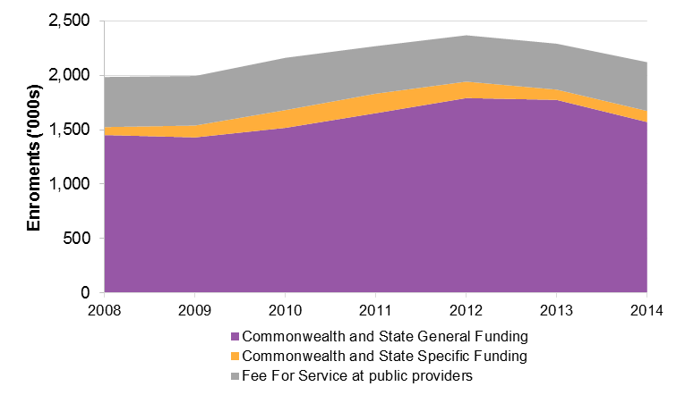
Note: In accordance with the scope of available NCVER data, fee for service includes only that delivered at public providers.
Source: NCVER Government-funded Students and courses, program enrolments (as of the 2014 scope, excluding ACE fee for service)
Figure 2.2 shows the percentage change by funding type for Australia from 2008-2009 to 2014. Despite falls since 2012, Commonwealth and State general funded enrolments in 2014 remain almost 10 per cent higher than in 2008-2009. However, this national figure hides significant variation in growth in publicly subsidised enrolments between jurisdictions. Over the period, growth in enrolments funded by Commonwealth and State General Funding ranged from -15 per cent to 57 per cent. Growth in enrolments under this funding source was negative in five jurisdictions.
Figure 2.2 change in enrolments by funding type, 2008-2009 (average) – 2014
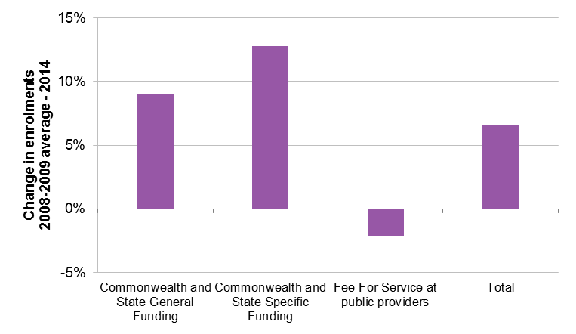
Note: in accordance with the scope of available NCVER data, fee for service includes only that delivered at public providers.
Source: NCVER Government-funded Students and courses, program enrolments (as of the 2014 scope, excluding ACE fee for service)

VET participation
Figure 2.3 shows VET enrolments as a proportion of the working age population, and the proportion of the working age population undertaking VET.
VET enrolments as a proportion of the working age population increased from the 2008 baseline of approximately 12 per cent to approximately 14 per cent in 2012, before returning to 2008 levels in 2014. The proportion of the working age population enrolled in VET, however, remained more than 10 per cent above 2008 levels in 2014, meaning that while total activity levels have not increased after accounting for population growth, the proportion of the working age population engaged in some way in VET has increased.
Figure 2.3 VET enrolments and the working age population
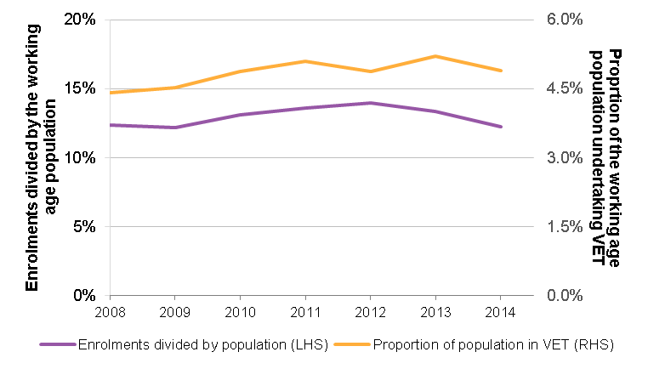
Note: Working age is considered to be 15-64
Source: NCVER Government-funded Students and courses, program enrolments (as of the 2014 scope, excluding ACE fee for service); ABS 2014 – Cat no. 6227.0 – Education and work

Lower level qualifications and upskilling
A focus of the NP is to create a broad entitlement to training, up to and including Certificate III, with the underlying aim of increasing the qualification profile of the Australian workforce. The specific targeting of the requisite lower lever qualifications and the promotion of upskilling have therefore been a key feature of most entitlement schemes.
Clause 28 of the NP refers to the need for entitlement schemes to contain ‘foundations skills or lower qualifications’. There is no nationally consistent definition of what constitutes a foundation skills course—some jurisdictions have defined lists of qualifications considered foundation skills, while others do not. Some jurisdictions report increases in enrolments in their foundation skills list courses.
As there is no national definition of foundations skills courses, the following analysis is of ‘lower qualifications’—that is all qualifications at Certificate I and II level, and courses below Certificate I level (this includes nationally and state accredited training).
Figure 2.4 shows enrolments in enrolments in Certificates I and II qualifications and courses below Certificate I across Australia between 2008 and 2014. Enrolments have declined from 2008-2009 to 2014, by an average of 36 per cent. This fall was consistent across all jurisdictions.
Figure 2.4 Enrolments in Certificates I and II qualifications, and courses below Certificate I
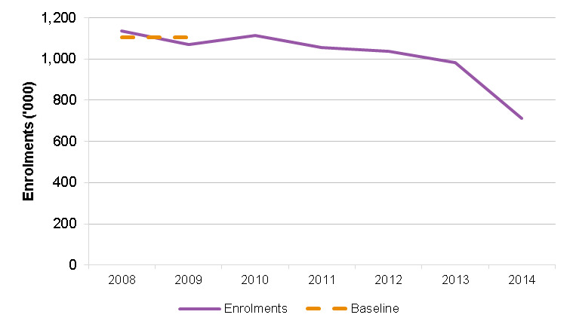
Note: Includes all qualifications at Certificate I and II level, and courses at below Certificate I level
Source: NCVER Government-funded Students and courses, program enrolments (as of the 2014 scope, excluding ACE fee for service)
While there has been an overall national decline in ‘lower level’ qualifications as defined, it is important to note that there is considerable variation in both the practice and outcomes in this regard. Some jurisdictions have seen substantial growth in recent years in certain specific ‘lower level’ qualifications and other locally accredited literacy and numeracy courses that are funded as part of foundation skills course lists.
Reductions in the volume of lower level qualifications, and of total enrolments as a proportion of the working age population are likely due to a number of factors, including a general increase in the qualification level of the workforce, changing funding rules, enrolment caps and changes to employment services contracting arrangements (including introduction of ‘earn or learn’ provisions for access to welfare payments). It is expected that total enrolments will increase in the near future, as recently introduced entitlement schemes take effect. However, since it is not possible to directly attribute current changes to recently introduced entitlement schemes, or to anticipate near-term trends, at the conclusion of the NP it will be important to reassess whether this has occurred.
Figure 2.5 shows the number of enrolments that increase students’ highest qualification level to Certificate III or above. This has grown by approximately 200,000 enrolments (or 34 per cent from the 2008-2009 baseline) across Australia. However, there is significant variation between jurisdictions: two jurisdictions experienced negative growth, and the range of growth on this measure was between -15 per cent and 88 per cent. In all, by this measure only one jurisdiction experienced positive growth between 2013 and 2014.
Figure 2.5 enrolments that increase students’ highest qualification to Certificate III or above, Australia
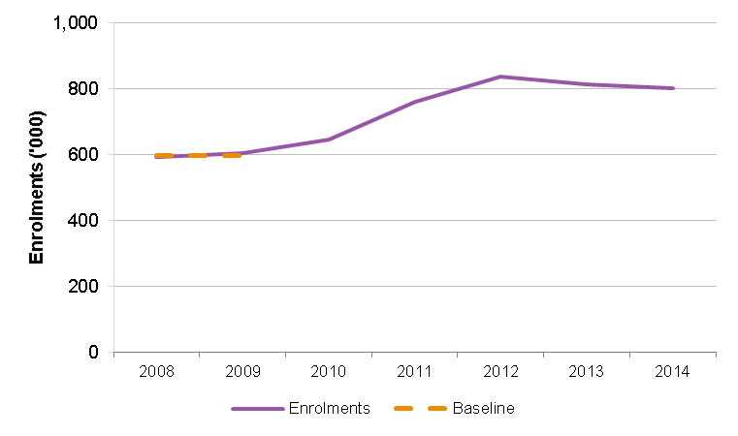
Source: NCVER Government-funded Students and courses, program enrolments (as of the 2014 scope, excluding ACE fee for service)
Figure 2.6 shows that the proportion of working age Australians not holding a Certificate III or higher has been falling, from the 2008-09 baseline of around 48 per cent to just over 41 per cent in 2014, a reduction of 12.8 per cent over the time period. Note that higher education completions would also have contributed to this result.
Figure 2.6 working age Australians not holding a Certificate III or higher
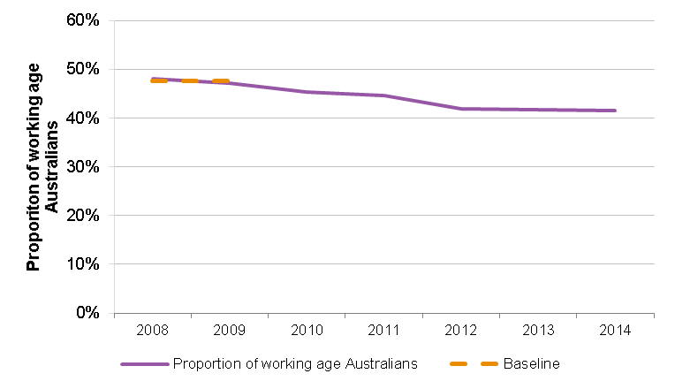
Note: Working age is considered to be 15-64
Source: ABS 2014 – Cat no. 6227.0 – Education and work

Student choice
In line with the pursuit of an environment of greater competition, the number of providers in the publicly funded VET system has increased, though this has not always meant an increase in the number of subsidised courses available to students. Some jurisdictions noted that reducing the number of subsidised courses was a deliberate strategy to ensure fiscal sustainability. Figure 2.7 shows the number of courses in which there were subsidised enrolments between 2008 and 2014 across Australia. This is not necessarily the same as courses in which subsidies were available, as there may have been courses for which subsidies were available, but in which there were no enrolments, and which therefore were not captured by the available data.
The figure shows a general reduction in the number of subsidised courses, the latest some 18 per cent down from the 2008-09 baseline., This change varies significantly across jurisdictions, from -17 per cent to 23 per cent. The number of subsidised courses fell across the period in all but three jurisdictions.
Figure 2.7 Number of courses in which there were subsidised enrolments
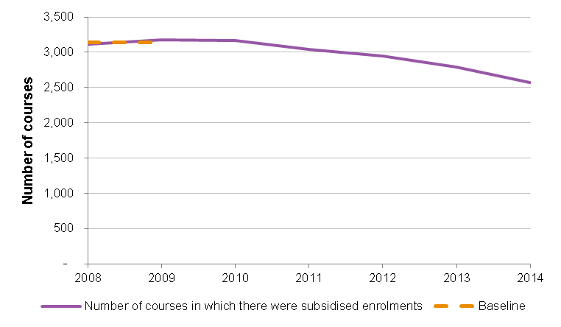
Source: NCVER Government-funded Students and courses, program enrolments (as of the 2014 scope, excluding ACE fee for service)
Figure 2.8 shows the number of unique RTO-course combinations in which there were subsidised enrolments between 2008 and 2014, which is another way of representing the change in choice of provider and course. As with Figure 2.7, in reality, the number of RTO-course combinations may understate actual choice, since there may be courses offered at particular RTOs in which there were no subsidised enrolments, which are not captured by available data.
The figure shows that the number of RTO-course combinations across Australia in which there were subsidised enrolments increased by approximately 7 per cent over the period, in effect representing an increase in choice. However, the change varies significantly by jurisdiction. Growth was negative in three jurisdictions, and ranged from -16 per cent to 65 per cent.
Figure 2.8 Number of RTO – course combinations in which there were subsidised enrolments
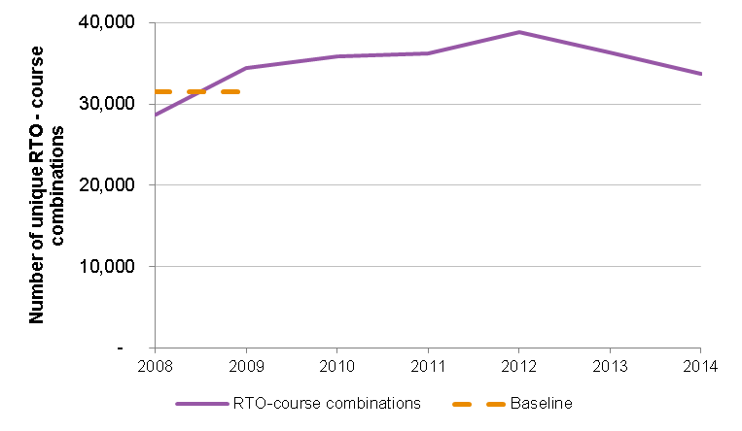
Source: NCVER Government-funded Students and courses, program enrolments (as of the 2014 scope, excluding ACE fee for service)
Another way of examining student choice is via measures of market concentration, that is, the extent to which enrolments may be concentrated in many or few providers. The Herfindahl Index of market concentration shows the degree to which enrolments are concentrated in particular providers, shown in Figure 2.9. The index takes a value of 1 when all enrolments are delivered by a single provider (a monopoly), and becomes smaller as enrolments are more evenly distributed across a large number of providers in a competitive market.
The overall figure across Australia shows a low and decreasing Herfindahl index, indicating decreasing concentration, and increasing competition, between 2008 and 2014. Market concentration in the publicly subsidised VET market across Australia has decreased by approximately 40 per cent relative to the 2008-2009 baseline. It is important to note that, while there are increasing trends towards availability of online provision, training markets remain relatively geographically discrete, at least at the jurisdiction level. While treating Australia as a single training market requires caution as it overlooks regional differences, the trend in decreasing market concentration is some indication that the country, on the whole, is moving towards increasingly competitive markets.
At the jurisdiction level, both the market concentration and changes in concentration varied significantly. In some jurisdictions, market concentration in 2014 was as high as 0.6, primarily due to markets being concentrated in a single TAFE institute. In others, it was almost 0.01, indicating a market characterised by many public and private providers. Over the period, market concentration decreased in all but one jurisdiction, with changes ranging from 7 per cent (increased market concentration) to -76 per cent (decreased market concentration).
Analysis of market concentration—particularly comparison of market concentration between jurisdictions—is to some extent impacted by the varying administrative arrangements regarding TAFE governance. In some jurisdictions, each TAFE campus is registered and operated as a separate RTO, whereas in others, TAFE is treated as a single entity.
Figure 2.9 Change in market concentration
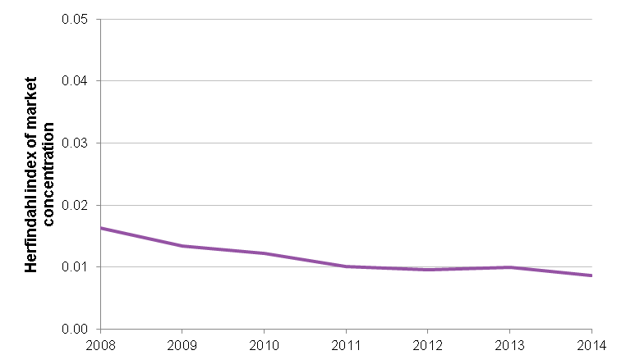
Source: NCVER Government-funded Students and courses, program enrolments (as of the 2014 scope, excluding ACE fee for service)

Income contingent loans
The NP calls for the ‘expansion of the Commonwealth’s ICL scheme to improve the accessibility of higher level qualifications’, where higher level qualifications refers to Diploma and Advanced Diploma courses and some Certificate IV courses on a trial basis.
The ‘expansion of the Commonwealth’s ICL scheme to improve the accessibility of higher level qualifications’ can be measured by examining:
- the number of RTOs offering subsidised VET FEE-HELP places
- the proportion of subsidised higher level qualification enrolments which are VET FEE-HELP eligible
- take up of VET FEE-HELP in subsidised enrolments that are VET FEE-HELP eligible
- national Diploma, Advanced Diploma, Certificate IV Trial course enrolments
It is important to note in the years 2009 to 2011, only one jurisdiction had subsidised VET FEE-HELP enrolments; in 2012 and 2013 this rose to two jurisdictions. The 2014, seven states and territories recorded subsidised VET FEE-HELP enrolments.
Consistent with the scope of the NP and the scope of the Review set out in section 1.3, the analysis in this section of the report is restricted to subsidised VET FEE-HELP enrolments, and only offers analysis of fee for service VET FEE-HELP as a point of comparison. For context, fee for service VET FEE-HELP accounted for 86 per cent of VET FEE-HELP enrolments and 94 per cent of VET FEE-HELP loan values in 2014 (with subsidised VET FEE-HELP accounting for the remaining 14 per cent and 6 per cent respectively).

RTOs offering subsidised VET FEE-HELP places
Figure 2.10 sets out the number of RTOs with subsidised VET FEE-HELP enrolments. The number of RTOs with subsidised VET FEE-HELP has risen from 22 in 2009 to 82 in 2014, indicating an improvement in accessibility to subsidised training.
While the number of RTOs with subsidised VET FEE-HELP enrolments has grown, at 82 it is still relatively low compared to the number of RTOs with subsidised Diploma and Advanced Diploma enrolments (769), although it compares more favourably to the number of RTOs with fee for service VET FEE-HELP enrolments (210). The relatively low number of RTOs with subsidised VET FEE-HELP enrolments is in part this is due to the fact that five jurisdictions only began offering subsidised VET FEE-HELP enrolments in 2014.
Figure 2.10 RTOs with subsidised VET FEE-HELP enrolments
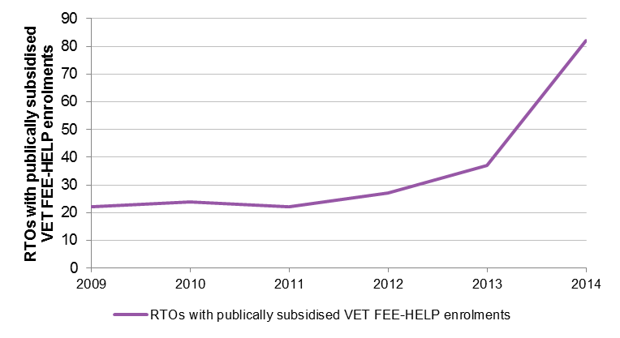
Source: VET FEE-HELP Statistical REport (various years)

Subsidised VET FEE-HELP eligible enrolments and take up
Figure 2.11 shows the total number of subsidised enrolments in higher level qualifications, separated into whether enrolments are VET FEE-HELP eligible or not. The reason some enrolments are ineligible for VET FEE-HELP is because they take place at a RTO which is not an approved VET FEE-HELP provider, or because the RTO is in a jurisdiction where VET FEE-HELP for subsidised enrolments was not yet operational.
The data show that VET FEE-HELP eligible enrolments have risen from 8 per cent of subsidised enrolments in higher level qualifications in 2008 to 31 per cent in 2014.
Figure 2.11 subsidised VET FEE-HELP ELIGIBLE and non-eligible enrolments in higher level QUALIFICATIONS
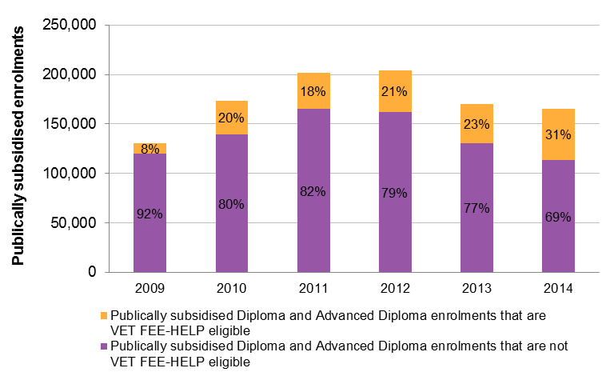
Source: Commonwealth Department of Education and Training, VET FEE-HELP Statistical REport (various years) and custom data request
Figure 2.12 shows the take up of VET FEE-HELP by eligible subsidised students enrolled at approved VET FEE‑HELP providers in jurisdictions offering VET FEE-HELP for subsidised enrolments.
In 2009, 8 per cent of subsidised students who were eligible for VET FEE-HELP took up a loan. This rose to more than half of subsidised students in 2014 (58 per cent). By comparison, 94 per cent of students that were eligible for fee for service VET FEE-HELP took up a loan. This difference in take up may be due to the difference in course fees for subsidised and fee for service students—in 2014 the average tuition fee per equivalent full-time student load (EFTSL) for subsidised VET FEE-HELP enrolments was $4,857, compared to $14,144 for fee for service VET FEE-HELP enrolments.
Figure 2.12 subsidised VET FEE-HELP ELIGIBILITY AND TAKE UP
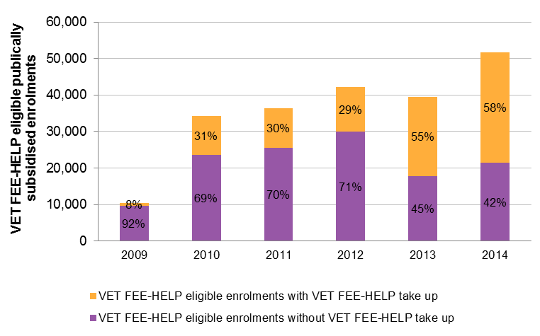
Source: VET FEE-HELP Statistical REport (various years)

Subsidised VET FEE-HELP enrolment trends
Figure 2.13 shows considerable growth in subsidised VET FEE-HELP enrolments since VET FEE-HELP was established in 2009. Growth in enrolments was 76 per cent in 2013 and 39 per cent in 2014.
Figure 2.13 subsidised VET FEE-HELP enrolments
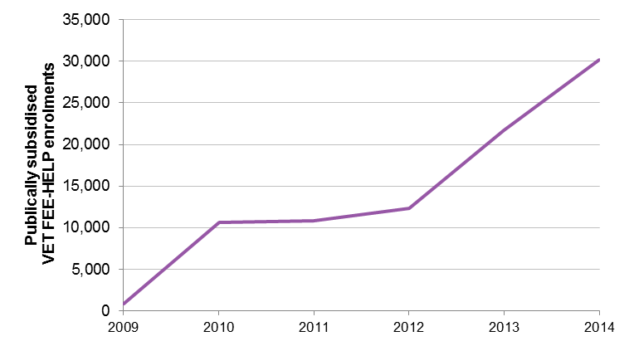
Source: VET FEE-HELP Statistical REport (various years)
Figure 2.14 shows subsidised Diploma and Advanced Diploma enrolments over 2008-2014. Diploma enrolments grew strongly to 2011, before falling in 2013 and 2014. Advanced Diploma enrolments grew slowly to 2011, before falling significantly in 2013 and 2014.
Figure 2.14 Subsidised Diploma and ADvanced diploma enrolments
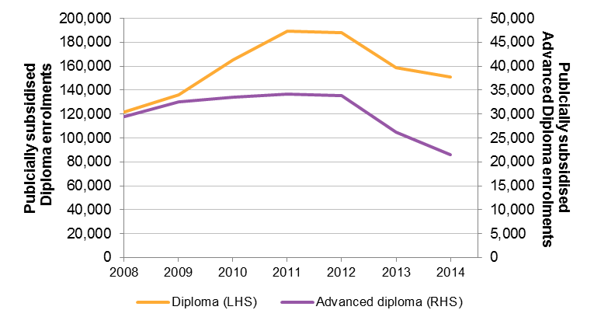
Source: NCVER Government-funded Students and courses, program enrolments (as of the 2014 scope, excluding ACE fee for service)
While there has been a significant increase in the number and share of subsidised VET FEE-HELP enrolments, Figure 2.14 shows that, since 2012, overall higher level qualification enrolments have nonetheless decreased considerably.
This does not, however, indicate that subsidised VET FEE-HELP has not increased accessibility. Importantly, as indicated in Figure 2.15, a portion of higher level qualification activity has moved from the subsidised market to the fee for service market. As Figure 2.15 uses pre-TVA data, it only includes fee for service enrolment data from public providers and private providers that voluntarily report their fee for service activity. Using the VET FEE-HELP dataset, it is estimated that at least 150,000 additional fee for service Diploma and Advanced Diploma enrolments took place in 2014 that were likely not captured by NCVER Student and Courses data for that year.
A number of factors are driving the move from subsidised enrolments to fee for service enrolments, primarily the availability of VET FEE-HELP loans and related policy changes. Consultations for this Review indicated that some states and territories have factored in the availability of VET FEE-HELP for higher level qualifications into the design of their entitlement and reduced the number of funded courses and levels of subsidies available under the entitlement at the Diploma and Advanced Diploma level.
Figure 2.15 shows that NCVER Student and Courses recorded Diploma and Advanced Diploma enrolments (collectively) are only down 3.6 per cent from their peak in 2012, while the share of enrolments that are fee for service has increased from 18 per cent to 36 per cent since VET FEE-HELP was introduced. If the data captured the full extent of the fee for service market, it is likely (as noted above) that there would be as many as an additional 70,000 enrolments in 2014. As such, there has likely been no fall in overall Diploma and Advanced Diploma enrolments, and an even greater shift to the fee for service market than Figure 2.15 indicates.
Figure 2.15 All Diploma and ADvanced diploma enrolments
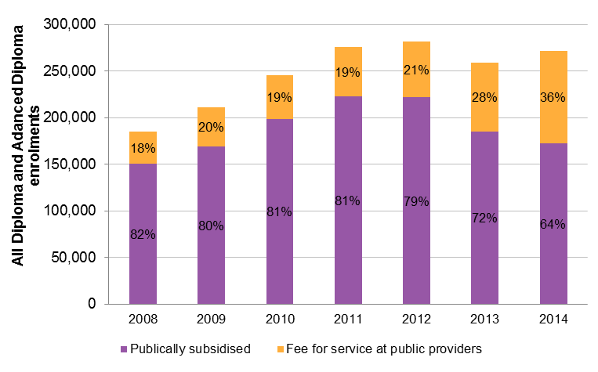
Source: NCVER Government-funded Students and courses, program enrolments (as of the 2014 scope, excluding ACE fee for service)
In summary, the VET FEE-HELP expansion to subsidised enrolments has increased accessibility, with considerable growth in subsidised VET FEE-HELP enrolments in 2013 and 2014. The VET FEE-HELP scheme appears to have had a greater impact in expanding the fee for service market than in subsidised training. It is expected that the impact of the VET FEE-HELP expansion to subsidised enrolments will increase as more RTOs and their students opt in to the programme.

Subsidised VET FEE-HELP Certificate IV Trial
Figure 2.16 sets out all subsidised enrolments in the selected VET FEE-HELP Certificate IV Trial qualifications, not just those that have taken up a VET FEE-HELP loan (the VET FEE-HELP Statistical Reports do not report on Certificate IV VET FEE-HELP enrolments). It shows that enrolment growth in the selected courses in 2014 was 18 per cent, relative to a 6 per cent fall in enrolments among non-Trial courses in the five states in which the Trial is taking place. While this does not control for other factors that could be driving enrolment in the Trial Certificate IV qualifications, it provides some early indication that the Trial is improving the accessibility of training in the selected courses.
Figure 2.16 CERTIFICATE IV TriAl course enrolments
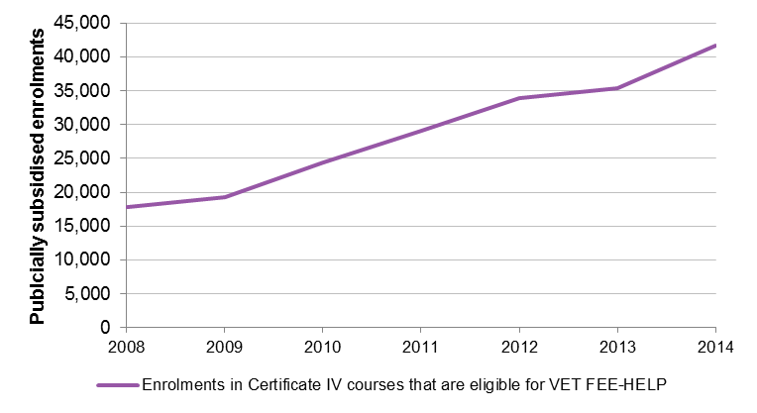
Source: NCVER Government-funded Students and courses, program enrolments (as of the 2014 scope, excluding ACE fee for service)

VET FEE-HELP associated issues
In consultations for the Review, some stakeholders expressed the view that there were unintended adverse consequences of the increased accessibility generated by the expansion of VET FEE-HELP. In particular, it was reported that VET FEE-HELP potentially distorts student choice by making it initially more affordable to undertake a course at a higher qualification level when other qualifications may be more suitable.
For example, a student may face upfront fees for a Certificate III course (as it is not covered by the entitlement, or the student has used up their entitlement) but face no upfront fees for a Diploma course due to VET FEE-HELP. In such a case, the student may choose the Diploma course, even though they may be more suited to a Certificate III course, to avoid paying upfront fees.
In some cases, the student may not have the aptitude to complete the course, in which case a lower qualification may be more suitable. In other cases, the distortion may lead to students choosing a course they are not suited to, or a course that is not likely to deliver a job outcome. Diploma and Advanced Diploma level courses are generally directed at those that have or will have managerial or supervisory level responsibilities and are therefore rarely suited for those seeking to enter the formal labour market for the first time.
Stakeholders argued that greater policy coherence is needed here to ensure that the desired intention of increased access to higher level courses through VET FEE-HELP does not result in unintended adverse consequences.
In order to address concerns with VET FEE-HELP, the Commonwealth introduced a number of measures over the course of 2015 to enhance consumer protections for VET FEE-HELP students and improve the administration of the scheme (see Box 2.2). In December 2015, the Commonwealth also announced that it would be introducing a new model for VET FEE-HELP to commence in 2017.
Box 2.2 Recent POLICY changes related to VET FEE-HELP
The Commonwealth made a number of policy changes related to VET FEE-HELP over the course of 2015. These include:
- Effective 1 April 2015:
  - The banning of inducements to entice students to enrol under the VET FEE-HELP scheme.
- Effective 1 July 2015:
  - Tighter rules regarding VET marketing and recruitment practices, such as not marketing courses as ‘free’ when students are required to repay their VET FEE-HELP loan to the Commonwealth.
  - Stronger disclosure requirements regarding student rights and obligations.
  - Banning of withdrawal fees to prevent a student withdrawing from a unit of study.
- Effective 1 January 2016:
  - Providers must apply a student entry procedure to ensure a prospective student is academically suited to the course.
  - Providers must issue a student with a VET FEE-HELP Invoice Notice at least 14 days prior to each census date for a VET unit study. (The census date is the date when the student fee becomes payable.)
  - A provider must determine at least three fee-periods for charging purposes for each course to ensure the debt is incurred in line with progress.
  - A provider must not accept a Request for a VET FEE-HELP loan form from a person who is under the age of 18 unless a parent or guardian has co-signed the form.
  - A provider must not accept a Request for a VET FEE-HELP loan from a student until a two-day gap period has elapsed after enrolment.
  - A person may apply to the Department of Education for a remission of their VET FEE-HELP debt where the person was subject to inappropriate behaviour by a provider or its agent or associate that occurs from 1 January 2016.
  - The total loan limit for existing providers will be frozen at 2015 levels.
  - Certain providers will be paid in arrears.
  - Where there are concerns about a provider’s performance, payments will be paused for new enrolments.
  - Infringements or civil penalties will apply where a provider breaches certain requirements.
  - More stringent financial assessment criteria for providers and applicants for VET provider approval.
  - RTOs seeking approval to offer VET FEE-HELP will require a minimum 5 year trading history and must have delivered the relevant courses for 5 years or more.
  - Trustees of a trust cannot be approved as a VET FEE-HELP provider.
  - Providers must generate a minimum of 20 per cent of total revenue through non-HELP sources.
  - RTOs applying to become VET FEE-HELP providers and existing providers may be required to provide evidence of access to cash or cash equivalent assets equalling a certain proportion of their annual expenses.
  - RTOs applying to become VET FEE-HELP providers that are unsuccessful will not be able to re-apply for six months.
In December 2015, the Australian Government announced that it would be introducing a new model for VET FEE-HELP to commence in 2017.
Source: Birmingham 2015, Hartsuyker 2015, Higher Education Support Act 2003

Management of subsidised VET FEE-HELP bad and doubtful debt

The costs of income contingent loan programmes
The NP states that the Review ‘will explicitly examine… management of bad and doubtful [subsidised VET FEE-HELP related] debt’ (clause 55).
The Commonwealth operates five tertiary ICL programmes, including VET FEE-HELP, under the High Education Loan Program (HELP). The Commonwealth incurs two costs from its tertiary ICL programmes:
- The debt not expected to be repaid (DNER) subsidy. Commonwealth ICLs are income contingent and some students will not exceed the repayment income threshold for a sufficient number of years to repay their debt. Since Commonwealth ICL debts are forgiven on death, a portion of debt is not expected to be repaid.
- The public debt interest cost (or the interest subsidy / deferral subsidy). Commonwealth ICLs are indexed to the CPI, which is normally below the Commonwealth’s cost of borrowing. The gap between these two figures is the public debt interest cost.
The Commonwealth calculates both of these costs as a percentage of new ICL debt incurred each year. These calculations are made at the HELP level—that is, individual cost percentages are not calculated for VET FEE-HELP debt, or any of the other four HELP sub-programmes.
Figure 2.17 sets out the DNER cost percentage for new HELP debt for financial years 2010-11 to 2014-15. The figure has been trending up slightly over the last five years. In 2014-15 the DNER was 20 per cent.
Figure 2.17 Proportion of new HELP debt not expected to be repaid
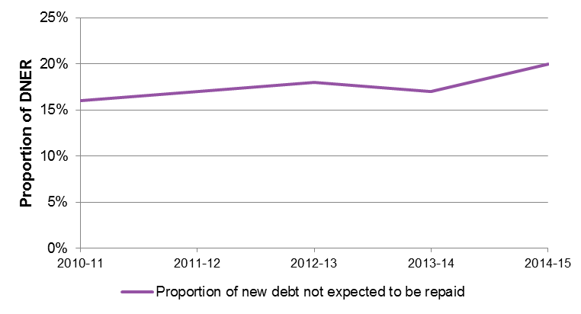
Source: Department of industry annual reports 2011-12, 2012-13; Department of Education annual report 2013-14; Department of Education portfolio budget statement 2015-16
The public debt interest cost in 2013-14 was 9.5 per cent of new loans. A time series of these costs is not available.

The management of subsidised VET FEE-HELP debt
The cost of the VET FEE-HELP programme for subsidised training in each jurisdiction is shared equally between the Commonwealth and states and territories. A worked example of the debt cost calculations using 2013-14 DNER and public debt interest costs for one jurisdiction is set out in Table 2.1.
Table 2.1 indicative VET FEE-HELP debt cost allocation
 |  | VET FEE-HELP debt in Jurisdiction A | Costs
 |  | VET FEE-HELP debt in Jurisdiction A | New HELP debt DNER (16.9%) | Public debt interest cost (9.5%) | Total cost
 | Total
 | VET FEE-HELP Debt | $10,000,000 | $1,691,000 | $950,000 | $2,641,000
 | Cost allocation
 | Commonwealth share | n/a | $845,500 | $475,000 | $1,320,500
 | Jurisdiction A share | n/a | $845,500 | $475,000 | $1,320,500
 | Source: acil allen consulting

In 2014, subsidised VET FEE-HELP loans totalled $108 million, with $18 million of DNER and $10 million in public debt interest costs. As a result, subsidised VET FEE-HELP in 2014 cost the Commonwealth and state and territories collectively $28 million, or $14 million to be met by the Commonwealth and $14 million to be met by the states and territories, according to their share of debt incurred.
As noted above, the DNER figure used to establish the cost of the VET FEE-HELP programme is the DNER for all HELP debt (including higher education ICLs). This is due to the difficulty in estimating DNER cost percentages for new sub-programmes such VET FEE-HELP without the experience of a sufficient number of cohorts for which repayment behaviour could be analysed.
This means that the current bad and doubtful debt costs allocation methodology leads to a less accurate outcome, with the Commonwealth and some jurisdictions potentially bearing a greater or lesser share of the costs than would be the case under a more accurate DNER methodology.
First, the level of costs allocated to the states and territories is likely to be too low because VET qualification holders are ‘less likely to repay HELP debt than higher education qualification holders because of their lower earnings profiles’ (Norton 2015). Compared to the current proportion of accumulated HELP DNER of 21 per cent:
- one estimate puts the DNER figure for all subsidised and fee for service VET FEE-HELP debt at 40 per cent (Norton 2015)
- another estimate for VET FEE-HELP loans DNER is 38 per cent for women and 24 per cent for men (based on a loan size of $8,000 with no surcharge) (Higgins and Chapman 2015).
Second, the higher rate of non-completion in VET and among VET FEE-HELP debtors is often not factored into these calculations and would lead to an underestimation of DNER rates that ought to be borne by the states and territories.
While it is highly likely that calculating the DNER at the VET FEE-HELP programme level would reveal the scheme to be more costly to government than under the current methodology, it is important to recognise that there is also likely to be a difference between the DNER of subsidised VET FEE-HELP debt and fee for service VET FEE HELP debt. If this was not taken into account when allocating costs between the Commonwealth and states and territories under a revised approach, the cost to states and territories would be over-estimated due to the inclusion of fee for service VET FEE-HELP debt because of the higher loan values and lower completion rates of fee for service VET FEE-HELP.
The DNER of a set of debt will be lower if each debtor holds a smaller amount of debt, all things being equal. As a result, the DNER for subsidised VET FEE-HELP debt is likely to be lower than for fee for service VET FEE-HELP debt. As set out in the NP, subsidised VET FEE-HELP loan amounts must have a weighted average value of less than $5,000. The weighted average value for a subsidised VET FEE-HELP loan was $4,857 in 2014, compared an average loan value of $14,144 for fee for service VET FEE-HELP.
Furthermore, the DNER of a set of debt will be lower if more debtors complete their qualification, all things being equal, due to qualification holders’ higher incomes. As discussed below in section 4.3.2, fee for service VET FEE-HELP enrolments have a lower completion rate than subsidised VET FEE-HELP enrolments, pushing up the DNER for the former.
On both of these issues—loan amounts and completion rates—there may be differences between jurisdictions in the subsidised VET FEE-HELP market (although data are limited on loan amount differences and jurisdiction-level subsidised VET FEE-HELP completion rates are not available).
Therefore, to more accurately reflect the cost of the VET FEE-HELP expansion to subsidised courses across the Commonwealth and states and territories, a more robust DNER methodology should:
- be based on just subsidised VET FEE-HELP debt, separate from other HELP programmes
- take into account the respective weighted average loan values for each state and territory
- take into account the completion rates for subsidised VET FEE-HELP students in each state and territory.
This would address the current situation whereby states and territories do not face the true costs of subsidised VET FEE-HELP loans incurred in their respective jurisdictions. In particular, this would ensure that the VET FEE-HELP costs that may arise as a result of changes to policies in a given jurisdiction (for example reductions in subsidies and increased average loan values) are not shared across all other jurisdictions.

Conclusions
Most states and territories agree that accessibility has improved or will improve as a result of the introduction of both the student entitlement and subsidised VET FEE-HELP. Enrolments in VET increased significantly (albeit with a reduction in one jurisdiction since 2012), and the proportion of the working age population without a higher level qualification has steadily fallen. However, in recent years, growth on a number of the relevant indicators—such as total enrolments, and the number of provider-course combinations in which there were subsidised enrolments—has been negative. It would appear that fiscal constraints have often played an important role in driving these reductions.
As government subsidised training has become more contestable, student choice—as measured by the number of provider-course combinations—has increased, while the total number of courses available has decreased in most jurisdictions. Market concentration has decreased in some jurisdictions, but not all. Accessibility and choice are expected to increase, as the introduction of several states’ entitlement models in the past 18 months takes effect in the market.
The expansion of VET FEE-HELP to subsidised Diploma, Advanced Diploma and selected Certificate IV courses has also improved accessibility. Subsidised VET FEE-HELP has increased, as has the proportion of subsidised courses for which it is available. This trend of increasing reliance on subsidised VET FEE-HELP is expected to continue to increase as more RTOs and their students opt in to the programme. However, there are concerns that this improved accessibility has had the unintended consequence of encouraging some students to commence higher level courses where they face no upfront fees, rather than more suitable lower level courses.
Key Finding 1
There is moderately strong evidence to conclude that the outcomes of accessibility and choice have increased since the baseline years of 2008-2009. In recent years, however, growth on a number of relevant indicators has been negative, including in the total number of courses available.
Expansion in student accessibility and choice is due in part to the introduction of an entitlement in each state and territory, and to the extension of VET FEE-HELP to subsidised higher level qualifications.
As more jurisdictions’ entitlement models take effect, and as more jurisdictions and RTOs opt in to the subsidised VET FEE-HELP programme, it is expected that accessibility and choice will improve.

A more transparent VET Sector (Outcome 2) | 3
 | A more transparent VET Sector (Outcome 2)

Overview of the outcome
The second outcome of the NP (listed in clause 21) refers to:
a more transparent VET sector, which enables better understanding of the VET activity that is occurring in each jurisdiction
This outcome encompasses the main areas of National Reforms (as opposed to the other outcomes which are Jurisdictionally Flexible Reforms) and in Clause 26, four outputs are listed.
26. Jurisdictions will create a more transparent VET sector through:
a. enhancing national data collections including better measurement of total VET activity for all RTOs;
b. improving timelines for data sharing and reporting;
c. finalising the operational, funding, governance and State and Commonwealth legislative arrangements for the implementation of the USI; and
d. improving consumer information through development of proposals for release of comparable data on the national My Skills website and on RTOs’ own websites, with data to include quality of providers, prices, government support, including subsidies, and labour market information.
The activities under this outcome are unique in that they involve considerable joint action by both the Commonwealth and state and territory governments.

Activities under the outcome

The rollout of Total VET Activity
The commitment to Total VET Activity (TVA) in the NP was the culmination of an extended period of investment in national VET provider collection data and sought to address a well-established gap in the reporting of training activity. As far back as 2010, it has been a condition of registration under the Australian Quality Training Framework (AQTF) that RTOs have systems in place to provide the regulator with Australian Vocational Education and Training Management Information Statistical Standard (AVETMISS) compliant data.
As the COAG decision Regulation Impact Statement (RIS) identified:
The current national reporting requirements do not support a comprehensive picture of all nationally recognised VET activity undertaken and outcomes achieved, as only those RTOs that are government funded or receive government payments through state training authorities are required to submit data to the national VET provider collection.
This gap in reporting, which the TVA addresses, is illustrated in the table below.
Table 3.1 nationally recognised training activity reported by RTOs by funding and provider type
Funding type |  | Provider type
 |  | TAFE and other public providers | Other providers | Community education providers
 | Through government  funding agreements | Mandatory reporting | Mandatory reporting | Mandatory reporting
 | Fee for service | Mandatory reporting | Voluntary reporting (with ~2600 providers supplying none) | Mandatory reporting
 | Source: TVA RIS https://ris.govspace.gov.au/files/2012/11/tva-decision-ris.pdf
The NP set out a broad timeline for implementation of the TVA. In 2013, it was decided that mandatory reporting of VET activity from all providers would commence from 1 January 2014. Consistent with the submission of training activity data to-date, TVA forms part of the AVETMISS of which the National Centre for Vocational Education Research (NCVER) is the custodian.
RTOs were required to report their 2014 training activity to NCVER in February 2015, either directly or via their state training authority (NCVER 2014), although some RTOs were granted exemptions.
States and territories have supported the implementation of TVA through their participation and engagement on the TVA Working Group and by facilitating uptake and compliance in their communication with RTOs, and in the collation of data from those RTOs that opted to submit via the relevant state training authorities.

Implementation of the Unique Student Identifier
Following the agreement to implement the Unique Student Identified (USI) in the NP, the Commonwealth and states and territories worked through a process of finalising the operational, funding, governance and legislative arrangements for the implementation of the USI, in accordance with the general implementation schedule in Schedule 2 of the NP.
From 1 January 2015, a student is required to have a valid USI before a training organisation can issue a qualification or statement of attainment. A USI is generally created by the student, though some students may be assisted by their RTO.
The USI initiative was developed jointly by the Commonwealth and states and territories in consultation with stakeholders, supported through Commonwealth legislation. The legislation underpinning the USI is mirrored in the Standards for NVR Registered Training Organisations made under the NVR Act as well as the AQTF.
Another key part of the implementation of the USI was the appointment of the Student Identifiers Registrar (a statutory position), which is assisted by the USI Office in the Commonwealth Department of Education and Training.

Improving consumer information through the national My Skills website
The My Skills website is the national directory of VET organisations and courses, launched in 2012. It provides consolidated information about RTOs, and qualifications in a consistent searchable format to assist students, job seekers and workers select appropriate training pathways and options.
The My Skills was updated in mid-2015, with improvements to how information is presented, as well as new features including:
- Courses linked to skills in demand in each state and territory.
- Overall student satisfaction and employment outcomes for the 230 most popular courses.
- A VET FEE HELP course calculator to assist eligible consumers understand their potential future debt.
- Identification of government contracted training providers.
- A modern, tablet-optimised homepage design.
In addition to the My Skills website, most jurisdictions have made a substantial investment in improving consumer information through a training website/portal, generally coinciding with the launch of their respective student entitlement schemes. For example, the Victorian Skills Gateway was launched by the Victorian Department of Education and Training in 2012 as a ‘one-stop-shop’ for information about occupations, courses and training providers in Victoria. Similarly, the Queensland Skills Gateway was launched in mid-2014. In most cases, the new online resources have been designed to ensure compatibility with mobile devices.
In some jurisdictions, the government has also sought to improve the availability of VET consumer information through mass media campaigns and/or the appointment of advisors/counsellors to assist individuals and employers navigate the local/regional training market and associated funding through the local training entitlement.

Improving timelines for data sharing and reporting
Activities in relation to the implementation of TVA, and to a lesser extent the USI and the My Skills and other website, constitute a significant part of the efforts by the Commonwealth and states and territories to improve the timelines for data sharing and reporting. The move to the quarterly publication of data on government-funded enrolments in 2015 was also a key area of investment in this regard.
In a number of jurisdictions, these changes have required investment in and upgrades of the relevant systems for data collection, administration and reporting.
The other notable activity in this area has been the ongoing submission to the Commonwealth of Annual Performance Reports by the states and territories in accordance with clause 42 of the NP.

The outcomes of activities in progress under Outcome 2

Total VET activity and Unique Student Identifier
TVA and the USI were implemented as two distinct but complementary and strongly connected measures. In particular, the USI would not have been possible (or at least substantially weakened) without the introduction of TVA, as there would have been large segments of the VET student population that would continue to be missed in the AVETMISS reporting.
Both Commonwealth and state and territory government stakeholders agreed that discussions on TVA and the USI were well-advanced at the time of signing the NP. There were mixed views on the role of the NP in this regard, whether it was critical in ensuring or even accelerating progress on these initiatives, or merely formalised what was already well underway. The former were of the view that without the NP the size of the implementation challenge including the pace of implementation alongside numerous other changes across the VET sector could have derailed or substantially delayed either or both TVA and the USI.
Notwithstanding some early concerns around the burden of reporting and some initial implementation challenges, most stakeholders viewed that both TVA and the USI have been successfully implemented. All the operational, funding, governance, technical and legislative requirements were resolved as planned, but some uncertainty remains around rules with respect to the publication of data.
Concerns with early implementation were raised, with particular reference to the quality of data submissions and the timeliness of implementation. However, these issues are considered to have since been resolved, or would likely be addressed in the near future.
There were also some concerns that were raised regarding the completeness of the data and potential issues arising from the granting of TVA reporting exemptions. Early estimates indicate that the vast majority of RTOs and enrolments have already been captured in the reporting to-date.
That being said, most stakeholders noted that the benefits of both TVA and USI would not be fully apparent for at least one to two years. This passage of time would be necessary to allow for ongoing improvement in the quality and completeness of the data. Furthermore, much of the data being collected for the first time would not be easily interpreted given the absence of a meaningful baseline for analysis.
In the medium to long term, stakeholders considered that the benefits of TVA and the USI to government and students are potentially significant, particularly in the formulation and evaluation of future VET policy and informing student choice. As the TVA RIS noted:
In short, the absence of a robust picture of VET activity for government agencies responsible for VET has undoubtedly resulted in inaccurate targeting of resources, an inability to monitor the full outcomes and uncertain outcomes from given resource outlays
The main benefits of the USI that were identified by stakeholders consulted as part of this Review were consistent with those benefits listed on the USI website, namely:
- Students being able to get a complete record of their Australia-wide VET achievements from a single, secure and accurate online source
- Immediate access to VET records, which can be quickly given to employers, other training organisations and other organisations as proof of VET achievements
- Smarter regulation that is evidence-based to address poor quality training and more transparency in the VET sector
- Streamlined assessment of course prerequisites, credit transfers and the assessment of eligibility for funding assistance.
Stakeholders from both the Commonwealth and the state and territory governments were particularly interested in the ability to analyse longitudinal VET data as a result of the USI, and the application of such analysis in the development of future policies and programmes.

Consumer information
Stakeholders generally agreed that improved consumer information is critical in an environment of increased student choice. At the same time, a large proportion of stakeholders also noted that consumer information needs to work in concert with robust regulation and market oversight. Some stakeholders held the view that consumer information could be highly effective in some segments and for some VET products, and that it ultimately depended on the ability of the individual as well as the breadth of options and RTOs. However, most stakeholders (particularly those that expressed deep concerns regarding the quality of VET—see Section 4.3) took the view that consumer information cannot be expected to make up for issues in relation to regulation and market oversight. This is based on the understanding that given that education is an experience good, many prospective students are not well placed to assess the quality, value or outcomes of different training options at the point of decision.
It is apparent that these debates are being played out in a period during which substantial effort and investment is being made by both the Commonwealth and states and territories in:
- Research to advance the underpinning theory regarding consumer choice in VET—market research and other such studies have been commissioned by both the Commonwealth and state and territory governments in order to support the development of new information channels, including at least one joint project commissioned through the Senior Skills Officials Network (SSON).
- The practical delivery of information, primarily through online channels—as discussed above, the Commonwealth’s My Skills website and the various websites and other communication campaigns by the states and territories have been implemented to improve consumer access to relevant information, coinciding with the introduction of their respective student entitlement models. In addition to informing consumers through websites, the Commonwealth regularly attends career fairs and other events to promote the VET sector to students.
The evolution of the consumer information environment for VET can be observed in part in the changes to the My Skills website following its recent relaunch in 2015. Some stakeholders suggested that information was not presented in a way that was easily understood by students or parents in the initial release of the My Skills website. The recently relaunched website, however, is considered to be a material improvement; in addition to the complete restructuring of the site, the other notable changes have been the linking of courses to skills in demand in each state and territory, the inclusion of student satisfaction ratings and employment outcomes (for the 230 most popular courses), and the identification of training providers contracted by state training authorities in each jurisdiction.
The publication of information in relation to the state and territory subsidised courses on the My Skills website is dependent on the timely sharing of information on the publicly subsidised training lists and other relevant information by each jurisdiction.
As discussed in the previous section, individual states and territories have also provided additional information for consumers to coincide with the launch of their student entitlement models; every jurisdiction has to varying degrees implemented a new or updated training website or portal. In the words of one stakeholder, ‘this information used to be buried’ but has now been made more accessible to students who are looking to exercise choice over their course and RTO.
In some instances, these websites cover all available training in the jurisdiction (including for example, fee for service courses), and in other cases these websites are focused on training available through the student entitlement. While not considered a major issue, there is some debate around whether information on options should be entitlement/programme specific, or the full suite of training options regardless of funding source.
While websites represent one of, if not the, primary source of consumer information, this Review was not able to obtain complete or comparable data on the effectiveness or popularity of such sites. Findings from consultations indicated that a more user-centric approach and design would be beneficial, and recent design changes to My Skills may address this. The lack of data limits the firm conclusions that can be drawn, but it does appear that, based on data provided by jurisdictions, visits to state training agency websites are on the rise, with marked increases in a relatively short period in some cases. Visits to My Skills are also on the rise, and the number of visits in the last 12 months has trebled from the previous year.
Notwithstanding the emphasis on the role of regulation and other measures that would constitute consumer protection (as discussed above), stakeholders were generally of the view that the additional information being provided by the Commonwealth and state training authorities is likely to be useful to a prospective VET student looking to exercise choice over different courses and training providers.
However, two areas were consistently flagged as requiring further attention—namely information on pricing and provider quality. On the whole, there is generally limited information available on prices, including the level of government subsidy. While the publication of prices are mandated in some states and territories, it was suggested that even in those cases, the reliability or accessibility of pricing information can be poor. These consultation findings are supported by the findings on VET consumer information needs jointly commissioned by SSON.
Efforts are being undertaken through SSON to understand how providers’ average or maximum course fees can be published for consumers. The report commissioned by SSON has identified that consumers rank total course costs and approximate course fees as the two most important issues in choosing a training course. The Commonwealth notes that the variation of subsidies by jurisdiction, both in general and for students with particular characteristics, together with the ability of employers to negotiate training fees, means that different consumers may pay a different price for the same course. The report commissioned by SSON confirms that consumers seek the ability to discern between specific offerings (i.e. the maximum price to compare providers) as well as general areas of study (i.e. the average price to compare courses). Where available, the average price in general areas of study is provided on My Skills. From October 2015, it is a requirement that providers offering VET FEE-HELP subsidised places report on the total cost of these courses. Additionally, a small number of RTOs have chosen to include price information on My Skills.
As for information on provider quality, it would appear that indicators of quality at the individual RTO level are yet to be developed or implemented. As a result, prospective students can only rely on whether an RTO is an accredited provider, and also whether it has been awarded a contract with the state training authority (variously referred to as being on the approved provider list or prequalified provider list). The fact that these contracted RTOs are required to meet state-based criteria as well as national accreditation standards provides prospective students with some additional degree of information regarding provider quality. A number of stakeholders pointed to the rating system proposed by the Victorian Education and Training Funding Review as a prospective emerging model for rating RTO quality.
SSON is considering the inclusion of a provider dashboard on My Skills to inform consumers about the qualitative differences between providers. This will respond to research commissioned by SSON which found that a majority of students had attempted to compare providers on My Skills, but had found it too difficult to do so. Consumers reported that they felt that comparative ratings should come from an official and independent source.
A third area mentioned in some consultations is information in relation to limits on a student entitlement to training. The primary concern in this instance is whether or not an individual contemplating training understands the eligibility criteria for government subsidies attached to different options, and when or how the entitlement to those subsidies might be exhausted.
The limited availability of information on quality, price, and entitlement limitations is sufficiently prominent to mean that the investments to-date have not achieved the level of transparency deemed desirable.

Data sharing and reporting
As outlined earlier, the main additional areas of improved data sharing and reporting have been the introduction of TVA and the USI, and the move from annual to quarterly reporting for publicly subsidised training.
Beyond that, data sharing and reporting has not appear to have undergone any other marked improvements since the introduction of the NP, and the vast majority of data sharing and reporting is in line with past practice.
There are two mechanisms through which the Commonwealth and states and territories work together on data related issues and initiatives: the Data Working Group and the Completions and Outcomes Methodology Working Group. While actual results to-date are limited, the groups are considered to have the potential to improve the timely sharing of information between jurisdictions, as discussed further in chapter 5.
Apart from the particular measures explicitly mentioned in clause 26, a number of stakeholders have pointed out that the objective of improved data sharing and reporting to promote transparency in the VET sector has seen limited progress because there was insufficient clarity or detail around the respective jurisdictional responsibilities for the implementation of this particular outcome. One key example cited, was the lack of clarity around whether it was intended that some pieces of consumer information were the responsibility of the government (and if so which level or agency) or the RTO. The need for the clear delineation of responsibility between different levels of government here is an area for future focus as discussed in chapter 7.

Conclusions
Stakeholders consulted as part of this Review provided mixed views on the achievement of the outcome of a ‘more transparent VET sector, which enables better understanding of the VET activity that is occurring in each jurisdiction.’
The implementation of TVA reporting and the USI has the strong support of the states and territories and other stakeholders, and fills major gaps in VET sector data. However, apart from TVA and the USI, and the introduction of quarterly reporting of publicly funded training activity, there was a general view that data reporting and sharing had not significantly changed.
TVA and the USI are important initiatives that were already underway, and have since benefited from the impetus and imprimatur of the NP. The implementation of each has seen some issues but is generally on track. These are major initiatives that should lead to significant benefits for the transparency of the market and for policy-makers, but not for at least two years during which potential issues with data quality and completeness are addressed, and a more complete baseline is established.
There was also strong support among stakeholders for a continued focus on improving consumer information, with all stakeholders concerned that students are able to access the most relevant information as easily as possible. All jurisdictions have made investments in both improving the understanding of how consumers access and use information to inform decisions leading to a VET enrolment, and in providing relevant and current information in a user-centric way. However, this has not led to improvements in consumer awareness to the extent that would be desirable, mainly because there continues to be generally inadequate information on prices, quality, and entitlement limitations.
Key Finding 2
There is strong consensus that transparency initiatives, in particular TVA and the USI have been successfully implemented, but that it will take some years of data collection before these initiatives can yield significant benefits.
Although all jurisdictions have made material investments in the development and provision of consumer information, further attention is required in relation to information on quality, price, and entitlement limitations in order to improve the transparency of the VET sector.

A higher quality VET sector (Outcome 3) | 4
 | A higher quality VET sector (Outcome 3)

Overview of the outcome
Outcome three, listed in clause 21 of the NP refers to:
a higher quality VET sector, which delivers learning experiences and qualifications that are relevant to individuals, employers and industry.
Clause 27 of the NP states that:
27. Jurisdictions will improve the quality of VET teaching and training through:
a. implementation of criteria specific to each state for access to public subsidy funding and / or complementary strategies that take account of the competition in local training markets and pattern of reforms and could include monitoring, evaluation, performance and quality indicators for providers.
b. development and piloting of independent validation of RTO assessment practices with a view to informing the development of a national model.
c. publication of information on the quality of providers as indicated in clause 26d.
The latter (clause 27c) is covered in relation to the transparency outcome discussed in in chapter 3.

Activities under the outcome
As discussed in chapter 2, jurisdictions had considerable flexibility under the NP in the design and implementation of their respective student entitlements. A key aspect of this flexibility is the way in which RTOs are contracted based on ‘state specific criteria’, and the extent to which states and territories monitor and independently validate RTO assessment practices. For example, states and territories varied in either allowing contracted RTOs to provide subsidised training in any course on their scope of registration, or requiring RTOs to tender to deliver specific qualifications, or to deliver training in specific regions.
Concurrently with the implementation of the NP, the Australian Skills Quality Authority (ASQA) was given regulatory responsibility for ensuring the quality of VET provision, through the VET Quality Framework:
aimed at achieving greater national consistency in the way RTOs are registered and monitored and in how standards in the vocational education and training sector are enforced.
www.asqa.gov.au
All jurisdictions identified—in their implementation plans—actions for ensuring maintained or improved quality of training under the NP. These varied significantly by jurisdiction, and included:
- working with the national regulatory (ASQA) to improve regulation and monitoring of quality outcomes
- revising eligibility and assessment criteria for access to public subsidies, to incorporate criteria around the quality of systems and training outcomes
- risk profiling of RTOs, compared with RTO self-assessment or revised pre-qualified supplier processes
- implementing performance monitoring frameworks
- implementing requirements for providers to institute professional development and improve capability
- providing clear avenues for complaint by students
- seeking structured feedback from students and employers on satisfaction with training.
Some jurisdictions undertook active contract management where RTO activity was determined to be of poor quality or in breach of contract, and monitored this through enrolment behaviour, and RTO-reported student satisfaction, completion rates, training improvements and professional development activities.
Most jurisdictions undertook pilot projects of external validation of RTO assessment practices. These included industry validation of RTO assessments, including that conducted in schools.

The outcomes of activities in progress under Outcome 3
Assessing quality in VET has been a long-standing challenge since the introduction of competency based training. Assessing the outcomes delivered by the NP in this area requires the use of proxy indicators and levels of satisfaction among students, employers and industry.
Commonly used indicators that have been analysed below as part of the Review of the NP include:
- Completion rates, where low completion rates generally result when students are not suited to training, when training does not meet students’ needs or expectations, or when the quality of training is inadequate. However, failure to complete a qualification may also reflect the fact that students or their employers seek training in a specific skill set, and that their enrolment in a full qualification may be the result of jurisdictional subsidy rules.
- Student satisfaction with training, which is an indicator of how well training suits the needs of students, is particularly relevant, but difficult to measure accurately at a detailed level.
- Student outcomes from training, including whether students achieved their objectives, including job-related or other objectives.
- Employer views of the quality and relevance of training.

The role of government in ensuring quality training
Stakeholders strongly supported the important role of government in maintaining and improving the quality of VET teaching and training, but highlighted the challenges introduced by concurrent introduction of the NP reforms with the transfer of regulatory responsibility to ASQA.
An issue consistently identified by stakeholders is the need for clarity around the respective roles of the regulator and the purchaser of training. Some hold the view that ensuring quality VET provision is primarily, if not solely the responsibility of the sector regulator (primarily ASQA). Others, including most state and territory governments, consider that the regulation of the VET sector provides a baseline level of quality—training provider registration, and action taken if RTOs are found to act contrary to the interests of students and the community—and that additional controls should be applied where the government is expending significant funds (contract management and market oversight).
Feedback from both states and territories and RTOs makes it clear that the purchaser has a significant degree of control and discretion through their contractual (as opposed to a regulatory) relationship with RTOs, in part due to access to more up-to-date and detailed information than that available to the national regulator.

Quality of provision
Throughout the consultations on this project and other recent reviews, the quality of VET has been highlighted as a key concern. This includes high profile cases of poor quality delivery and concerns about the process and outcomes of introduction of VET FEE-HELP for higher level qualifications.
Stakeholders expressed concern that, in the absence of RTO quality information, some industries are developing informal white and black lists of providers (for example, as in the Early Childhood Education and Care industry).
Further, while there are high profile cases of poor quality delivery and a widespread concern about a general deterioration of quality in VET, there is concern that this affects the public perception of all providers. There appears a gap in knowledge about the extent to which deterioration in quality in VET is widespread, or is concentrated in particular parts of the market.
The indicators used in this Review to assess quality in VET are:
- Completion rates.
- Student satisfaction and reported outcomes.
- Employer satisfaction.

Completion rates in VET
Completion rates in VET are difficult to determine accurately, though this will be aided in the future with the introduction of the Unique Student Identifier. As such the analysis here relies on detailed NCVER modelling. This analysis is not restricted to the NP, but rather is for all subsidised enrolments, and will not be impacted by entitlements introduced in recent years.
Figure 4.1 shows estimated programme completion rates, and subject load pass rates, across Australia, for the period 2009–13. Overall, programme completion rates have risen by approximately 6 per cent, from 32 per cent in 2009 to 34 per cent in 2013. 2014 completion rates vary significantly across jurisdictions, from approximately 26 per cent to 41 per cent. (It is understood that the lower end figure of 26 per cent is artificially low, owing to technical reporting issues in one jurisdiction.) The change in completion rates also varies significantly, ranging from a 12 per cent reduction to a 91 per cent increase.
Subject load pass rates, or module completion rates, are far higher than programme completion rates. Over the period, subject load pass rates have increased slightly across Australia (by 2.7 per cent). This change varies by jurisdiction, from a reduction of approximately 3 per cent, to an increase of almost 8 per cent.
Figure 4.1 Estimated Programme completion rates and subject load pass rates
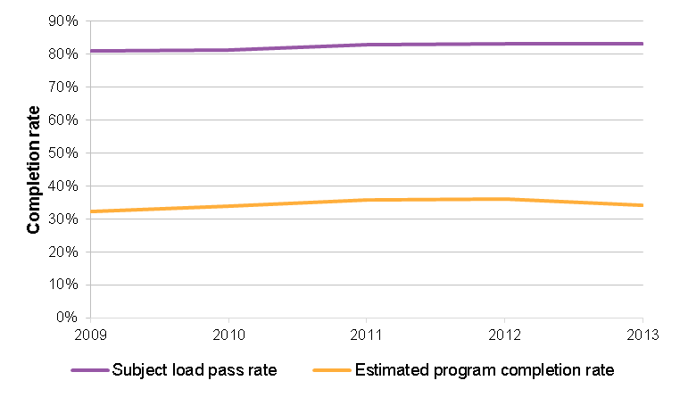
Source: NCVER 2015 – The likelihood of COMPLETING a government-funded VET program 2009-13
VET FEE-HELP data allow the tracking of students from commencement through to completion. Completions rates are not modelled, but instead calculated over a three year period from commencement. Of subsidised VET FEE-HELP students commencing in 2012, 30.1 per cent had completed their qualification—below the completion rate (33.0 per cent) for subsidised VET FEE-HELP eligible students who did not take out a VET FEE-HELP loan. Both of these completion rates are considerably below the NCVER modelled rate for all subsidised Diploma and above enrolments of 43.8 per cent for 2011 commencements.
It is not clear what is driving the difference between subsidised VET FEE-HELP completion rates and NCVER modelled subsidised completion rates more broadly. While the NCVER modelled completion rates include all jurisdictions, the VET FEE-HELP completion rate only includes the two jurisdictions which had subsidised VET FEE-HELP enrolments at the time of the base year of 2012. As the modelled completion rates in the NCVER analysis of these two jurisdictions are on par with the average, any issues specific to these two jurisdictions are unlikely to be significant in explaining the difference in subsidised VET FEE-HELP enrolments. There is no reason to believe that there are material differences between students in subsidised VET FEE-HELP eligible Diploma and above courses and those in subsidised ineligible courses. And subsidised RTOs which have to meet the additional requirements to become a VET FEE-HELP provider, could not be assumed to offer poorer quality training.
As a result, the difference in the VET FEE-HELP dataset rate and the NCVER modelled rate may be simply related to the methodologies adopted.
In summary, considering both general completion rates and subsidised VET FEE-HELP completion rates, while completion rates have increased since 2009, they have fallen since 2012, and are particularly low for subsidised students assisted by VET FEE-HELP. It is not possible to tell whether this reduction in completion rates is due to the introduction of entitlement models, or other factors.

Student satisfaction with and outcomes from training
The Student Outcomes Survey (SOS) is an annual survey, conducted by the NCVER, of VET students in Australia. The SOS is undertaken in the year following training, meaning that respondents will have finished training between approximately 5 and 18 months prior to undertaking the survey.
Four questions from the SOS can be used to inform analysis of change in quality of training over the period of the NP:
- Were students satisfied with their training?
- Where students satisfied with the quality of teaching in their training?
- Did students receive a job-related benefit from their training?
- Did students achieve their main reason for study?
Analysis in this section has not been tested for statistical significance but the range of outcomes by jurisdictions are shown where possible.
Figure 4.2 summarises the four SOS indicators over the period 2009-2010 to 2015. In aggregate across the country there has been little change in these indicators over the period, however there is significant variation between states and territories in each of the indicators, discussed further below.
Unless otherwise noted, where reference is made to ‘per cent change’ in the SOS analysis, this means the per cent change in the proportion of students reporting each Training Outcome. As an illustrative example only, this means that if the proportion of students that are satisfied with their training fell from 70 per cent to 35 per cent, this would be referred to as a 50 per cent fall, rather than a 35 percentage point fall, unless otherwise noted.

Figure 4.2 Summary of SOS Training Outcome indicators across Australia
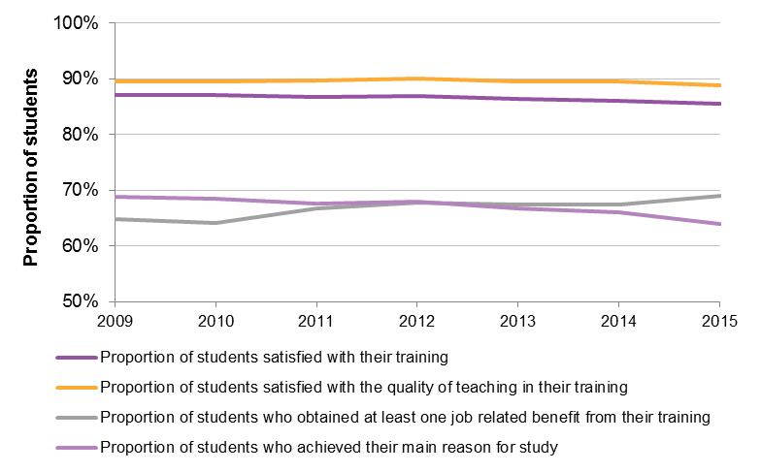
Source: NCVER Student OUTCOMES survey CURF (as of the 2014 scope, excluding ACE fee for service)
The NP baseline (the average of 2008 and 2009) is reflected in the 2009 and 2010 SOS data. Since 2015 is the most recent year of SOS data available, the period of analysis of SOS is 2009-10 (baseline) to 2015, which corresponds to training undertaken and completed in the years 2008-09 (baseline) to 2014.
Table 4.1 summarises the change in the four indicators between 2009-2010 and 2015. The four indicators tell a mixed story. On average, the proportion of students stating that they received a job-related benefit from training increased significantly across the period, while the other three indicators decreased. At the jurisdiction level, the range of these changes was significant—for example, satisfaction with training fell 3.4 per cent in one jurisdiction, while rising 3.0 per cent in another.

Table 4.1 Average, minimum and maximum change (by state) in the SOS indicators, average of 2009-2010 to 2015
 |  | Satisfaction with training | Satisfaction with teaching | Job-related benefit | Main reason for study
 | Average | -1.7% | -1.7% | +6.8% | -6.8%
 | Minimum | -3.4% | -3.4% | +3.3% | -13.9%
 | Maximum | +3.0% | +3.0% | +9.3% | +2.4%
Note: Minimum and Maximum refer to the jurisdiction with the lowest and highest change in each indicator
Source: NCVER Student OUTCOMES survey CURF (as of the 2014 scope, excluding ACE fee for service)

SOS responses by provider type
Figure 4.3 shows the change in the proportion of students satisfied with training, between 2009-10 and 2015, by provider type, for each of the four SOS indicators. Over the period:
- Responses among students studying at public providers improved for only one indicator—the proportion receiving a job-related benefit from training.
- Responses among students studying at ACE providers improved on the same indicator, but declined on the remaining three.
- Responses among students studying at private providers declined on all four indicators.
The fact that all providers have also seen varying degrees of falls in student ratings is a general issue. The fact that providers other than public providers generally declined in terms of student satisfaction is of particular concern given that one of the objectives of the NP is to promote greater innovation and responsiveness to the needs of students, and to increase competition in the market for VET. Whether or not these results are driven by implementation of entitlement models, or pre-date implementation, is unclear. However, the conclusion remains the same: using student satisfaction and student outcomes as a proxy for quality, there appears to have been a deterioration in quality among the part of the sector that the NP has sought to grow.
Figure 4.3 Change in SOS responses by provider type
Change in the proportion of students satisfied with training, 2009-2010 – 2015  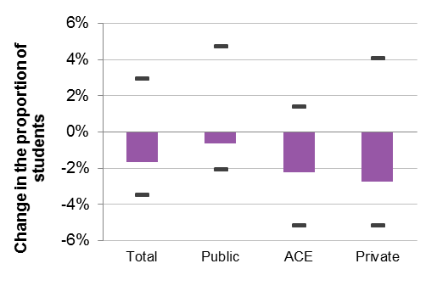 | Change in the proportion of students satisfied with the quality of teaching in their training, 2009-2010 – 2015  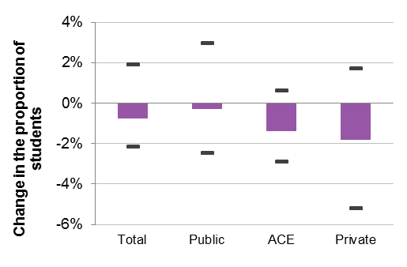
Change in the proportion of students receiving a job-related benefit from training, 2009-2010 – 2015  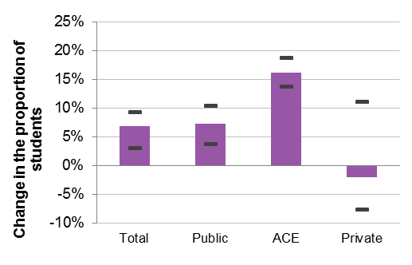 | Change in the proportion of students who achieved their main reason for study, 2009-2010 – 2015  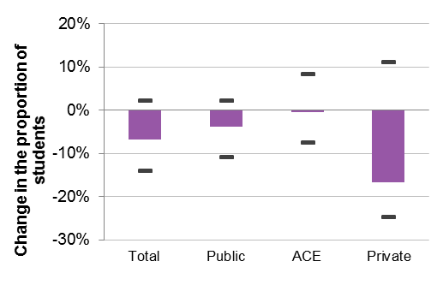
Note: The markers represent maximum and minimum change within jurisdictions. Sufficient data to calculate the change in ACE providers were only available for two jurisdictions.
Source: NCVER Student OUTCOMES survey CURF (as of the 2014 scope, excluding ACE fee for service)
Many stakeholders noted that although quality has been an ongoing issue for the VET sector, anecdotally the decrease in quality in recent years has been particularly marked, and has come partly as a result of the way in which growth in training activity has been managed. While overall student satisfaction with training has decreased slightly, of specific interest is whether there are particular segments of the market in which it has decreased significantly, and if so, how large these segments are.
Figure 4.4 shows satisfaction with training by course. The analysis combined two years of data into one, to increase sample sizes, grouped courses based upon concordances recorded in www.training.gov.au, and discarded the resultant course groups with fewer than five respondents. 1,039 course groups remain, and are shown in the figures.
The distribution (on the left of the figure) of courses by the proportion of students satisfied with training. The figure shows a small number (approximately 5 per cent) of courses with 100 per cent satisfaction, and an even decline across the system, with a small number of courses exhibiting low satisfaction—22 per cent at its lowest.
The figure also shows (on the right) the percentage change in the proportion satisfied with training between 2009-2010 (combined) and 2014-2015 (combined). Approximately 50 per cent of course groups increased, and 50 per cent decreased in the proportion satisfied with training across the period.
Figure 4.4 Distribution of course groups by proportion satisfied with training
Distribution of course groups by proportion satisfied with training, 2013-2015 | Distribution of course groups by change in proportion satisfied with training, 2009-2010—2013-2015
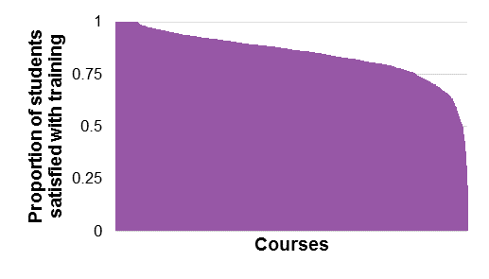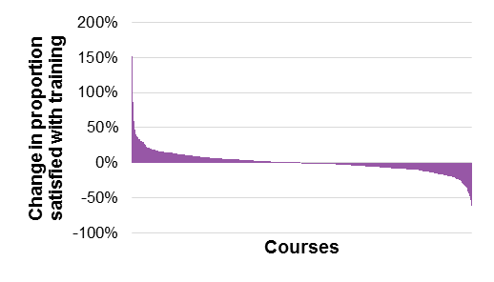
Source: NCVER Student OUTCOMES survey CURF (as of the 2014 scope, excluding ACE fee for service); NCVER Government-funded Students and courses (As of the 2014 scope, excluding ACE fee for service)
The analysis is weighted by 2014 enrolments to take into account the size of different courses. In approximately 178 per cent of the market, the proportion satisfied with training increased by more than or equal to 10 per cent. In approximately 15 per cent of the market, the proportion satisfied decreased by more than or equal to 10 per cent.
This pattern is not explained by provider type (different types of providers are distributed relatively evenly by the change in proportion satisfied), by course level, or by field of education. This means that the changes in the proportion of students satisfied with training (as a proxy for the quality of training), while distributed very unevenly across the market, are not concentrated in any particular part of the market. While there has been an overall slight reduction in quality (as measured by student satisfaction) over the course of the NP, there has been a significant reduction in some parts of the market, matched by a significant improvement in others.

Employer views of the VET system
Employer satisfaction with as a job requirement, shown in Figure 4.5, has declined slightly across Australia since 2009. This reduction in employer satisfaction warrants careful monitoring, given the important role of industry and employers in identifying and raising the quality of training provision as noted by many consulted for the Review. While the gradual reduction in satisfaction reversed somewhat between 2013 and 2015 for apprentices and trainees and nationally recognised training, for vocational qualifications the downward trend has continued.
Figure 4.6 shows the proportion of employers satisfied with training by training and provider type. The figure shows that satisfaction with apprentice and trainee training is low, relative to nationally recognised and unaccredited training and that, aside from apprentice and trainee training, satisfaction with training undertaken at TAFE is higher than that undertaken at private providers.

Figure 4.5 Proportion of employers satisfied with training as a job requirement
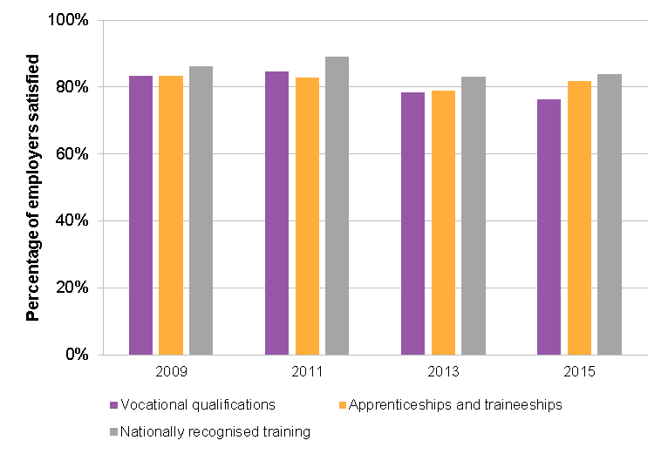
Source: NCVER Employers’ use and views of the VET system, multiple years

Figure 4.6 Proportion of employers satisfied with training as a job requirement
Apprentices and trainees  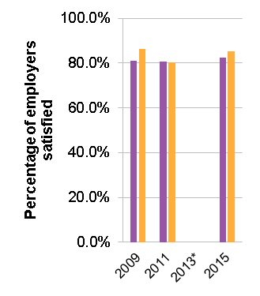 | Nationally recognised training  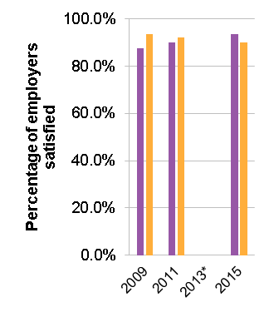 | Unaccredited training  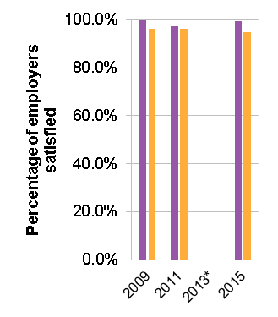
Note: * Data for 2013 are not available by provider type
Source: NCVER Employers’ use and views of the VET system, multiple years

External validation of RTO assessment practices
While trials of external validation were taking place in each states and territories, few stakeholders felt they were in a position to make an informed comment on the outcomes that have resulted from these trials. Where they did offer a view, there was a concern that external validations were, in part, skewed by their overly strong focus on students who had achieved employment outcomes, and not capturing the experiences of those who remained unemployed.
Additionally, stakeholders were concerned that the heavy use of “VET teaching and assessment language” is hindering industry understanding of independent validation, and their ability to contribute to the process. Many consider that the role of industry and employers in raising the quality of VET is critical, and should be more strongly emphasised.
There was also some general criticism that there is a poor understanding of this aspect of the NP and its expected outcomes, in particular the NP’s endpoint of “informing the development of a national model”, however the Review notes that the timing of consultations with stakeholders prevented consideration of a forthcoming report on the outcomes of external validation pilots.

Conclusions
The quality of VET has been highlighted as a key issue throughout this and a number of other recent reviews. These concerns are borne out in some high profile cases, as well as an overall decline in both student and employer satisfaction with training.
In a relatively short period, the NP sought to introduce significant concurrent changes in a large number of areas, including a significant increase in the number of publicly subsidised private RTOs, an overall increase in the volume of enrolments, and the continuing expansion of ICLs to the VET sector.
While completion rates have increased since 2009, they have fallen since 2012, and are particularly low for subsidised students assisted by VET FEE-HELP. It is not possible to tell whether this reduction in completion rates is due to the introduction of entitlement models, or to other factors.
A possible factor in a decline in quality is the reported lack of clarity around the role of the purchaser compared with the role of the regulator. With the benefit of hindsight, many stakeholders agree that the system would have benefited by a stronger regulatory role, but also acknowledge that the state training authorities as the purchasers have primary responsibility for ensuring public subsidies deliver high quality training.
A significant level of quality issues are associated with fee for service VET FEE-HELP enrolments, however this is beyond the scope of this Review.
Key Finding 3
There is strong evidence that the growth of training throughout the NP has been accompanied by significant quality issues related to provider practices.
These quality issues may be in part due to the pace and scale at which the NP reforms were implemented. Also considered a factor is the uncertainty in the respective contract management responsibilities of state and territory governments (as purchasers) and the national regulator, although these have recently become more clearly defined.

A more efficient and responsive VET sector (Outcome 4) | 5
 | A more efficient and responsive VET sector (Outcome 4)

Overview of the outcome
The fourth outcome listed in clause 21 of the NP refers to:
a more efficient VET sector, which is responsive to the needs of students, employers and industry.
This is one of the areas of Jurisdictionally Flexible Reforms and in clause 29, two outputs are listed:
29. Jurisdictions will improve the efficiency and responsiveness of the VET system through:
a. improvements in government-to-government information exchange through development of a shared information model to cover data on all forms of government funding for training (including capital), pricing, training activity (including hours and qualifications) and outcomes with details to allow analysis of variations by characteristics of the student, location of provider and mode of delivery, as input to the review referred to in Part 6; and data on higher education participation, courses and outcomes with details to allow analysis of variations by characteristics of the student and provider; and
b. development and implementation of strategies which enable public providers to operate effectively in an environment of greater competition, recognising their important function in servicing the training needs of industry, regions and local communities, and their role that spans high level training and workforce development for industries and improved skill and job outcomes for disadvantaged learners and communities.
This Outcome has a broad focus and three features are noted to provide some context for its treatment in this chapter.
First, its headline reference to ‘efficiency and responsiveness’ suggests a focus on VET sector wide performance while the outputs and activities that are intended to support the outcome relate predominantly to the public provider and to government-to-government information exchange (see clause 29). For example, this outcome area of the NP does not capture activities that would improve the allocative efficiency of resources across the VET sector, or the productive/technical efficiency in the delivery of training and assessment in other areas (apart from the efficiency of the public provider). Similarly, this outcome area of the NP does not explicitly include activities that would emphasise the responsiveness of the sector to the changing skills needs of firms and industry, structural change in the economy, technological change, or other aspects of responsiveness that may typically come to mind (apart from the responsiveness of the public provider).
Consistent with the Review framework and methodology outlined in sections 1.4 and 1.5, this chapter adopts the narrow definition of ‘efficiency and responsiveness’, as articulated in clause 29. Questions of efficiency and responsiveness are further discussed in section 7.3, concerning priorities for future reform in the training system.
Second, the issue of government-to-government information exchange has a strong alignment with the Outcome 2 focus on transparency, discussed in chapter 3. As such, this chapter references relevant activities and outcomes in chapter 3 where appropriate.
Third, it is apparent that each of the two sub-clauses in clause 29 seek to capture a variety of inter-connected but parallel factors. For example, clause 29a, in relation to government-to-government information exchange, comprises two sub-components:
- Development of a shared information model: ‘to cover data on all forms of government funding (for training, pricing, and training activity) and training outcomes (by characteristics of the student, location of provider and mode of delivery), as input to the review referred to in Part 6’ of the NP.
- Data on higher education: including ‘participation, courses and outcomes with details to allow analysis of variations by characteristics of the student and provider’.
Similarly, clause 29b makes reference to the development and implementation of strategies which:
- ‘Enable public providers to operate effectively in an environment of greater competition’.
- Recognise ‘public providers for their function in servicing the training needs of industry, regions and local communities’.
- Recognise public providers for their ‘role that spans high level training and workforce development for industries and improved skill and job outcomes for disadvantaged learners and communities’.
Therefore, to the extent possible, consideration of the efficiency and responsiveness that has been achieved through the NP is based on these more detailed definitions.
In addition to clause 29, this chapter also examines the extent to which measures covered by clauses 8a and 8b have been addressed:
8. To the extent that the following measures are incorporated in jurisdiction Implementation Plans, progress will be considered in the review of the Agreement outlined in Part 6:
a. improve linkages between Registered Training Organisations (RTOs), employment services providers, employers and Centrelink at state and local levels to improve outcomes;
b. improve alignment and develop a complementary approach to VET and higher education, including identification of opportunities to align regulation, barriers to smooth transition pathways (including but not restricted to financial, regulatory and assessment) and barriers to a more open tertiary market, and interoperability of student identifier systems
In accordance with clause 8, jurisdictions had the option of including in their implementation plans measures to improve linkages and alignment between the training sector and other sectors (like employment service providers), and the higher education sector. On the whole, there appears to have been limited activity in this area. Most states and territories have not included such measures in their respective implementation plans.

Activities under the outcome

Improvements in government-to-government information exchange
In line with the outcome and outputs set out in the NP, the Commonwealth and state and territory governments have been working together to develop a shared information model that will provide data on government funding for training and the performance of the VET system. This work has been undertaken through the Government-to-Government Shared Information Model Working Group.
The process through which the states and territories submit their Annual Performance Reports to the Commonwealth also constitutes a contribution towards this outcome.
It is also the case that the jurisdictions share information on an as-needed basis. One example noted in the Annual Performance Reports is the sharing of pricing and subsidy information for the top 30 qualifications in 2014-15 in each jurisdiction.
In line with the intent of the NP (captured in clause 29a and Part 6), this Review has also provided an opportunity to improve government-to-government information exchange. Firstly, the Terms of Reference for the Review were developed jointly through the SSON and CISC in 2015. Secondly, as outlined in section 1.4, the Review developed a detailed set of indicators mapped to the outcome areas of the NP.
As called for in Schedule 4 of the NP, the Commonwealth and states and territories have been working to share information on the expansion of VET FEE-HELP to subsidised Diploma, Advanced Diploma and selected Certificate IV courses (see section 2.2.2 for a discussion of other activities related to VET FEE-HELP).
An ICL Working Group has been established which has dealt with implementation matters, thus allowing information sharing between the Commonwealth and states and territories, and between states and territories, on the VET FEE-HELP expansion to subsidised higher level qualifications.
The Commonwealth has provided the states and territories access to a live VET FEE-HELP database, which provides subsidised VET FEE-HELP debt data as soon as it is verified, to allow states and territories to anticipate their potential VET FEE-HELP costs.

Strategies in relation to public providers
Clause 29b specifically recognises the both the significance of and the challenges facing Australia’s public providers.
While the term ‘public providers’ is intended to encompass not only the 60 or so TAFE institutes but also the various other publicly owned providers such as agricultural colleges and the like, much of the focus of jurisdictions’ activities have been on TAFE institutes. There is much less visibility around the actions that have been taken with respect to non-TAFE public providers.
With the introduction of entitlement schemes and increased contestability, jurisdictions have committed to, and implemented, a wide range of measures to enable their TAFE institutes to operate more effectively in an environment of greater competition. The various approaches that have been employed to achieve this outcome include:
- the institution of funding formulae to recognise the cost disadvantages of TAFE
- governance and/or legislative changes to improve institutional autonomy
- the appointment of suitable directors and board members to improve commercial focus
- a clearer articulation of the expectations of their respective public providers in ministerial statements or charters
- the development of asset strategies and plans to improve utilisation
- the reorganisation of entities
- investment in the requisite IT infrastructure
- marketing and rebranding campaigns.
Jurisdictions have implemented at least three of these approaches. In a number of states and territories, some of these were already in place prior to the introduction of the NP and strategies in relation to the transformation of TAFE institutes in most jurisdictions are ongoing.
In many cases the changes have been communicated as part and parcel of the introduction of a jurisdiction’s entitlement scheme.

The outcomes of activities in progress under Outcome 4

Improvements in government-to-government information exchange
While the Government-to-Government Shared Information Model Working Group has been the primary vehicle for achieving Outcome 4, it is understood that the group has met infrequently and has not yet developed the shared information model described in the NP.
The Working Group did set up a mechanism, referred to as ‘Lighthouse’, to collect information on programs directly administered by the Commonwealth, and agreed to and exchanged some information via Govdex. However, there was difficulty in getting full agreement to and exchange of all the items of information. As such, the mechanism was reported to have had limited effect to-date.
This Review itself will provide an opportunity for government-to-government information exchange and thereby contribute to this outcome through a number of ways. First, the indicator framework that has been applied may provide a useful starting point for future outcomes measures for the VET sector. In particular, some of the indicator analysis combines multiple datasets that have not been analysed or reported to any significant degree to-date.
Second, as indicated in section 1.4, a number of indicators that were developed did require the new supply of data from the states and territories. It is important to note here that the timelines for the Review has meant that these indicators were developed without significant consultation with the jurisdictions. The development of indicators was also inclined towards data that are easily accessible and available on a nationally consistent basis.
In consultations conducted for this Review, some state and territory government representatives indicated that, until recently, there had not been sufficient Commonwealth information on the extent of their VET FEE-HELP liability. With access to the live VET FEE-HELP database, it is expected that this will improve. At the same time, the Commonwealth noted that greater information from states and territories on forecasted subsidised VET-FEE HELP eligible qualifications would assist with the Commonwealth’s VET FEE-HELP debt forecasts.
Greater information sharing regarding market design is considered beneficial by all parties. More broadly on VET FEE-HELP, some state and territory government representatives contended that greater involvement with and information sharing on VET FEE-HELP policy would aid state and territory VET market design. The Commonwealth observed that further information sharing of state and territory subsidy settings would aid in the design of Commonwealth programmes.

Strategies in relation to public providers
In line with the implementation flexibility afforded to the states and territories in the NP, the extent of the exposure of public providers to competition varies by jurisdiction. Decisions regarding the extent of market contestability have been based in the main on the state training authority’s assessment of the preparedness of the public providers (predominantly TAFE institutes) and/or assessment of the breadth and depth of alternative providers in training markets at a regional level.
As a result, some jurisdictions have limited the extent of the increase in contestability at the outset, based for example on an assessment that the non-public provider training market is not sufficiently developed to be able to deliver the full suite of qualifications required at a high level of quality. Some have allowed the extent of the increase in contestability to be determined on the basis of state-based merit criteria, whereby the public and non-public providers are awarded an allocation of enrolments based on a competitive application process. Others have moved to a largely equal treatment of public and non-public providers in the publicly subsidised VET market.
Figure 5.1 shows the TAFE market share in the publicly subsidised VET market (which can be considered a proxy for the extent of contestability) over the course of the NP. The figure shows that TAFE market share has decreased significantly, from 76 per cent in 2008 to 52 per cent in 2014, a reduction of 31 per cent. This varies across jurisdictions, however, with TAFE maintaining its market share in one jurisdiction, and seeing a reduction of over 60 per cent in another.
Figure 5.1 TAFE market share
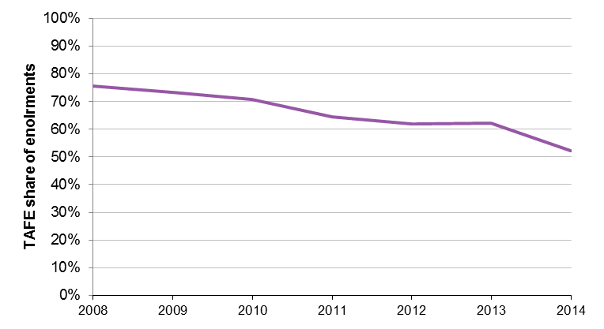
Source: NCVER Government-funded Students and courses (As of the 2014 scope, excluding ACE fee for service)
Section 2.3.1 provides further analysis of the extent to which provider choice and contestability has increased since the introduction of the NP.
As a result of firstly the increased contestability (to varying degrees as outlined above), and secondly the various measures to enable public providers to operate more effectively in an environment of greater competition, there appears to be widespread agreement that public providers have improved their efficiency and responsiveness.
That being said, many stakeholders in government and the public provider sector accept that there is room for further improvement, and many view the changes to-date as but the initial steps in a measured and steady process of transformation. Many acknowledged that the role of the public provider has and will continue to be of considerable interest to government, communities, industry and private providers, and transformation of that role and the institutions therefore requires careful management.
It is widely understood that TAFE institutes face cost differentials relative to private and community providers, primarily owing to the costs associated with industrial relations arrangements and capital maintenance. Jurisdictions generally provide funding to TAFE institutes for any cost disadvantages, although some stakeholders note that the basis for calculating the funding could be based on more rigorous methodologies.
While competitive neutrality has been a long standing issue in the VET sector, the issue was not often raised in relation to the implementation of student entitlement models. Some private RTOs did refer to the lack of a consistently level playing field, particularly when TAFE institutes were able to secure a high proportion of contestable funds, or when TAFE institutes received a higher rate of public subsidy. At the same time, a number of public providers raised the issue that some of the expectations placed on their services rendered them uncompetitive, and that this was further complicated by their differing industrial awards and asset base profiles.
A recurring theme throughout the consultations with TAFE institutes was in reference to the tension between the labour market focus of the student entitlement, and the broader role of the public provider, as acknowledged in clause 29b of the NP. On the one hand, the treatment of TAFE as ‘just another provider’ delivering training to meet labour market need in a contestable market was in some jurisdictions becoming a dominant paradigm. On the other hand, states and territories and public providers face the need to manage community expectations of ‘their’ public provider.
A number of stakeholders suggested that the dual objectives of TAFE institutes in relation to vocational and labour market outcomes, and social, educational and community outcomes have not always been held in balance in the transformation of the role of the public providers.

Linkages and alignment
As discussed in section 5.1, there appears to have been limited explicit activity to improve linkages and alignment between the training sector and other sectors. Most states and territories did not include measures relating to linkages and alignment in their implementation plans.
Where linkages and alignment measures were included in implementation plans, two issues are noted. Firstly, it is difficult to ascertain whether relevant measures were developed specifically to address the linkages and alignment clauses (8a and 8b) of the NP, or whether existing linkages and alignment projects or programmes that were ongoing or imminent were simply noted.
Secondly, the implementation progress of measures that were committed to in the Implementation Plans are difficult to track through the Annual Performance Reports.
Not many stakeholders were in a position to comment on this aspect of the NP. The feedback that was provided had the following general themes:
- Changes to the Commonwealth employment programs, and to the incentives for existing worker traineeships, may have had unintended consequences.
- The recent introduction of new jobactive providers and contracts was seen as an area where the policies of the Commonwealth have a significant degree of intersection with the student entitlement, but where there has been limited coordination.
- Other contracted government service providers face different incentives to those faced by publicly funded RTOs—for example that jobactive providers are interested in job outcomes while RTOs are more interested in training and training pathways.
- In cases where contacted providers of other government programs operate across state borders it can be difficult to navigate different state entitlement systems.
Linked to this last point, stakeholders commented on the complexities that arise for students undertaking training interstate or training providers operating across state or territory borders. As illustrated by Figure 5.2, while the vast majority of providers operate in only one jurisdiction, a significant minority—over 10 per cent—operate in two, and 7 per cent operate in more than two.
Figure 5.3 shows the proportion of subsidised and fee for service VET students undertaking training in a state other than their home state. There is a significant difference between subsidised and fee for service training in this regard. Almost a fifth of students undertaking fee for service training do so in a state other than their own—almost double the same figure in 2008. This compares with only 2 per cent of subsidised students.
Issues around students and providers interacting with the VET system across borders are discussed further in section 7.3.
Figure 5.2 Providers Delivering subsidised training in multiple jurisdictions, 2014
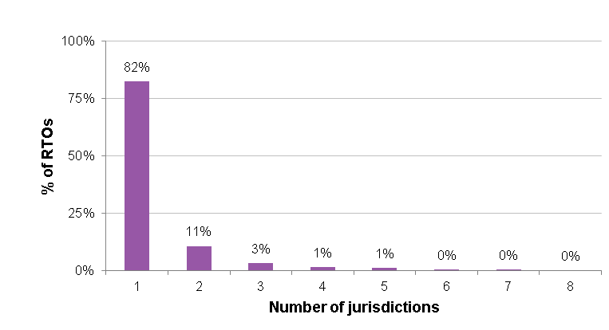
Source: NCVER Government-funded Students and courses (As of the 2014 scope, excluding ACE fee for service)
Figure 5.3 Students undertaking training in a state other than their home state
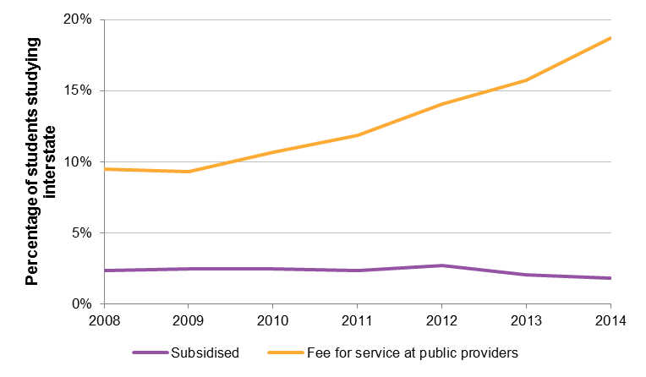
Note: in accordance with the scope of available NCVER data, fee for service includes only that delivered at public providers.
Source: NCVER Government-funded Students and courses (As of the 2014 scope, excluding ACE fee for service)

Conclusions
In relation to government-to-government information sharing, the most significant improvements have been through the new information being collected through TVA and the USI (as discussed in chapter 3). It is reasonable to say that government-to-government information sharing has to-date been largely positional and the benefits are yet to be realised.
In relation to the treatment of public providers, there is clear evidence of a wide variety of steps being taken across the jurisdictions to improve the ability of public providers to operate effectively in an environment of greater competition—including changes and investments in systems, organisational structures, governance, legislation, funding, and branding. At the same time, there is also a view that these changes sometimes fail to appropriately recognise or balance the other non-commercial functions and roles of public providers, though there are limited data available to quantify this.
The NP recognises that public providers serve an important function in ‘servicing the training needs of industry, regions and local communities’, and that their role ‘spans high level training and workforce development for industries and improved skill and job outcomes for disadvantaged learners and communities’. In other words, the NP recognises that public providers are more than ‘just another provider’, though would benefit from greater guidance and specification in this regard.
Stakeholders expressed some concern regarding the juncture between student entitlement models and various Commonwealth training programmes and other funding streams. There was a view that improved coordination between funding from the two levels of government would improve the effectiveness of VET sector reforms.
Key Finding 4
While there have been some improvements in government-to-government information sharing, to-date these have been largely positional and specific benefits are yet to be realised. This may improve with further data collection and sharing throughout the remainder of the NP via the relevant working groups and bilateral exchanges.
There is clear evidence of a wide variety of steps being taken across the jurisdictions to improve the ability of public providers to operate effectively in an environment of greater competition—including investments in systems, organisational structures, governance, legislation, funding, and branding—and there is more that will need to be done. This shift to a more commercially competitive model, however, appears to have created an issue for some public providers in maintaining an appropriate balance with their non-commercial functions as a public provider.

National Partnership Agreement on Skills Reform VET training outcomes | 6
 | National Partnership Agreement on Skills Reform VET training outcomes

Overview
The following chapter details jurisdictions progress towards the VET system training outcome targets of the NP. The NP broadly defines VET system training outcomes as increased overall commencements; increased commencements or completions for higher qualification and indigenous Australians; and additional outcomes identified by jurisdictions relating to areas of priority. The NP defines in detail the VET system training outcomes in clauses 30 to 32:
VET system: training outcomes
30. The efficiency and responsiveness of the VET system and equity objectives will be improved through an increase in overall training activity measured by an increase in completions of qualifications in the order of 375,000 nationally over the life of this Agreement. State targets are to be negotiated and will be measured using a standard methodology and a common baseline of the average of 2008 and 2009 calendar year data. Completions funded through Commonwealth initiatives such as the National Workforce Development Fund will contribute to the national increase in completions of qualifications.
31. Improvements, either above trend growth rates or from an agreed baseline, for particular areas of priority will be negotiated on a bilateral basis and measured using a standard methodology, where appropriate, including commencements or completions for:
a. higher qualifications (Certificate III, IV, diploma and/or advanced diploma); and
b. Indigenous Australians.
32. States are required to identify two additional targets such as a cumulative increase in government funded Australian Qualifications Framework (AQF) qualification commencements, completions or equivalent full-time students in areas of priority such as rural and remote areas, students with disability or from low socio-economic status backgrounds, groups of policy focus (e.g. long-term unemployed, youth, single and teen parents or mature aged workers), or in a skills priority area.
Jurisdiction have individual targets which were determined in negotiations with the Commonwealth and are specified in jurisdictions’ IPs. In this chapter, each jurisdictions’ progress is measured by comparing NCVER commencement and completions data, to the VET system training outcome targets. This represents an assessment of progress towards those targets rather than assessment of attainment, given that jurisdictions are not expected to meet any targets until the final two years of the NP

Progress on the overall training outcomes
The NP states in clause 30 that qualifications completions are to increase by 375,000 above the 2008 and 2009 common baseline between 2012 and 2016. The 375,000 target is a joint national target which explicitly includes the completions achieved through Commonwealth initiatives.
Figure 6.1 shows national cumulative completions above the 2008 and 2009 baseline since 2012, and the 375,000 national qualification completions target. The national target was exceeded by jurisdictions by a considerable margin well ahead of schedule in 2013. By 2013 national cumulative completions had reached 407,000, exceeding the 2016 target by 32,000.
The significant growth in completions is likely attributable to rapid growth in select states as well as additional commencements in Commonwealth funded programmes such as the Productivity Placements Program (PPP) and National Workforce Development Fund (NWDF). Given that the joint national target was not apportioned across the Commonwealth or state and territory governments, no analysis has been included in this Review with respect to the relative contributions of completion growth.
Figure 6.1 cumulative Australian qualification completions above baseline since 2012
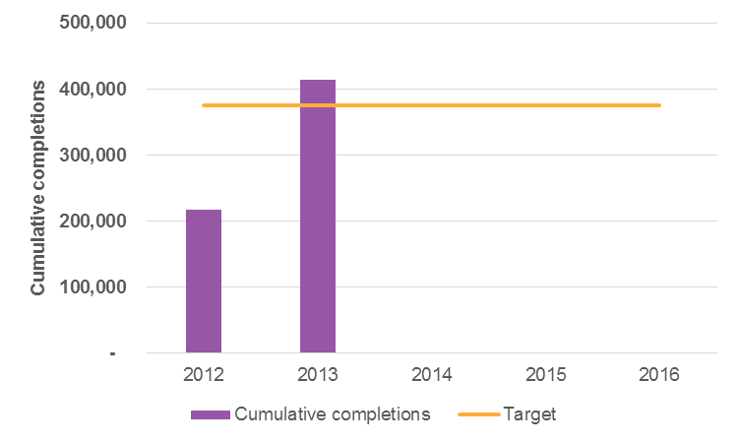
Note: Baseline completions is 370,349, which is the average 2008 and 2009 completions
Source: NCVER Government-funded Students and courses (As of the pre-2014 scope, including ACE fee for service – see section 1.4)

Progress on jurisdiction training outcomes
This section explores the extent to which jurisdictions are on track to meet their VET system training outcome targets. VET system training outcomes are defined in clauses 30 to 32 of the NP (section 6.1) and in the individual jurisdictions’ IPs.
Table 6.1 summarises jurisdictions progress on training outcomes. Most jurisdictions are on track to meet or have exceed their 2016 jurisdiction specific VET training outcome targets. Across the jurisdictions, over 70 per cent of the training outcome targets have already been met. It is not possible to determine if those jurisdictions that are either on track or lagging behind the expected levels of commencements/completions will reach their targets. In order to assist readability here, the detailed quantitative analysis by jurisdiction is provided in Appendix A.
It is noted here, however, that assessment of NSW training outcome 4 and WA training outcome 5 involves a series break, due to the use by NCVER of ARIA 2011 to assess remoteness from 2011 onwards, where previously remoteness had been assessed using ARIA 2006. Because remoteness has generally decreased over time, a smaller proportion of the population, and therefore fewer students, that would have been classified as remote as of the 2006 Census are classified as remote as of the 2011 Census.
In order to properly assess NSW progress against training outcome 4 and WA against training outcome 5, it may be appropriate for either NCVER to prepare data using ARIA 2006 remoteness classifications for training years 2011 onward, or for baselines to be revised or targets renegotiated to reflect the series break. Both options would allow for more equitable comparison. There were no other similar jurisdiction-specific data issues identified during the Review.

Table 6.1 Summary of jurisdictions’ progress against training outcomes
 |  | Training Outcome 1 | Training Outcome 2 | Training Outcome 3 | Training Outcome 4 | Training Outcome 5
 | NSW
 | Definition | Aggregate qualification completions | Government funded and fee for service commencements in higher qualifications | AQF completions by Indigenous students | Government funded and fee for service AQF commencements by regional and remote students | Government funded and domestic fee for service AQF commencements in value-add services
 | Current | 51,469 (as of 2013) | 138,356 (as of 2014) | 4,039 (as of 2013) | 56,531* (as of 2014) | 83,794 (as of 2014)
 | Target | 80,332 | 69,200 | 2,700 | 43,100 | 22,800
 | Comment | On track | 2016 target exceeded | 2016 target exceeded | 2016 target exceeded | 2016 target exceeded
 | Victoria
 | Definition | Aggregate qualification completions | Completions of higher qualifications (Certificate III and above) | Commencements of higher qualifications by Indigenous Australians (Certificate III and above) | Commencements by students with a disability | Commencements by individuals who are unemployed at the time of enrolment
 | Current | 228,475 (as of 2013) | 185,063 (as of 2013) | 6,017 (as of 2014) | 66,111 (as of 2014) | 262,672 (as of 2014)
 | Target | 62,202 | 68,998 | 2,063 | 22,311 | 63,865
 | Comment | 2016 target exceeded | 2016 target exceeded | 2016 target exceeded | 2016 target exceeded | 2016 target exceeded
 | Queensland
 | Definition | Aggregate qualification completions | Completions of higher qualifications (Certificate III and above) | Completions of qualifications by Indigenous Australians (Certificate I and above) | Completions of qualifications by students with a disability (Certificate I and above) | Number of apprentice new commencements
 | Current | 47,394 (as of 2013) | 45,941 (as of 2013) | 4,050 (as of 2013) | 3,382 (as of 2013) | 4,000 (as of 2014)
 | Target | 51,048 | 13,411 | 3,125 | 3,034 | 6,946
 | Comment | On track | 2016 target exceeded | 2016 target exceeded | 2016 target exceeded | On track
 | SA
 | Definition | Aggregate qualification completions | Completions of higher qualifications (Certificate III and IV, Diploma and Advanced Diploma) | Completions by Indigenous Australians | Completions by Australians with a disability | Completions by mature-aged (45-64) employed Australians
 | Current | 48,634 (as of 2013) | 32,307 (as of 2013) | 1,601 (as of 2013) | 4,656 (as of 2013) | 6,206 (as of 2013)
 | Target | 18,158 | 9,610 | 380 | 760 | 1,720
 | Comment | 2016 target exceeded | 2016 target exceeded | 2016 target exceeded | 2016 target exceeded | 2016 target exceeded
 | WA
 | Definition | Aggregate qualification completions | Completions of higher qualifications (Certificate III and above) | Completions by Indigenous Australians (Certificate II and above) | Completions by students with a disability (Certificate II and above) | Regional and remote area qualification completions (Certificate III and above)
 | Current | 26,319 (as of 2013) | 21,809 (as of 2013) | 2,430 (as of 2013) | 1,514 (as of 2013) | 8,291** (as of 2013)
 | Target | 26,073 | 17,864 | 712 | 793 | 5,919
 | Comment | 2016 target exceeded | 2016 target exceeded | 2016 target exceeded | 2016 target exceeded | 2016 target exceeded
 | Tasmania
 | Definition | Aggregate qualification completions | Completions of higher qualifications (Certificate III and above) | Completions of qualifications by Indigenous Australians | Completions of qualifications by students from low socio-economic status areas | Completion of selected qualifications from agriculture, aquaculture, community services and NBN industry sectors
 | Current | 2,355 (as of 2013) | 1,344 (as of 2013) | 401 (as of 2013) | 4,072 (as of 2013) | -
 | Target | 5,593 | 3,782 | 179 | 1,651 | 327
 | Comment | On track | On track | 2016 target exceeded | 2016 target exceeded | No data
 | NT
 | Definition | Aggregate qualification completions | Commencements (Certificate III and above) | Commencements by Indigenous Australians (Certificate III and above) | Unit completions | Trade Commencements
 | Current | 4,416 (as of 2013) | 3,842 (as of 2014) | 639 (as of 2014) | 24,535 (as of 2013) | -
 | Target | 2,585 | 4,561 | 1,310 | 40,437 | 541
 | Comment | 2016 target exceeded | On track | On track | On track | No data
 | ACT
 | Definition | Aggregate qualification completions | Commencements of higher qualifications (Certificate III and above) | Commencements of higher qualifications by Indigenous Australians | Commencements of qualifications by Australians with a disability | Qualification completions by mature age workers (40+)
 | Current | 4,616 (as of 2013) | 12,702 (as of 2014) | 654 (as of 2014) | 1,582 (as of 2014) | 1,235 (as of 2013)
 | Target | 4,007 | 11,524 | 286 | 988 | 912
 | Comment | 2016 target exceeded | 2016 target exceeded | 2016 target exceeded | 2016 target exceeded | 2016 target exceeded
Notes: *Due to the ABS ARIA series break, discussed above the figure, NSW requested their training outcome 4 baseline to be adjusted downwards, using data prepared by NCVER using ARIA 2011
** Due to the ABS ARIA series break discussed above the figure, WA requested their training outcome 5 observations be adjusted upwards, using data prepared by NCVER using ARIA 2006
Source: NCVER Government-funded Students and courses (As of the pre-2014 scope, including ACE fee for service – see section 1.4)

Conclusions
The national target of 375,000 completions was exceeded by jurisdictions, by a considerable margin and well ahead of schedule in 2013. In 2013, national cumulative completions had reached 414,000, exceeding the 2016 target by almost 39,000.
Individually, most jurisdictions also appear on track to meet or exceed their agreed jurisdiction specific VET training outcome targets. In fact, across the jurisdictions, over 70 per cent of the training outcome targets have already been met. For those jurisdictions that are either on track or lagging behind the expected levels of commencements/completions, it is not possible to determine whether the state-based entitlement schemes and Commonwealth programmes will result in those targets being reached.
Given that many jurisdictions have already exceeded their cumulative 2016 target, they will meet their interim targets irrespective of actions taken in the future. As jurisdictions receive NP payments for meeting interim cumulative completion targets prior to 2016, this will render it difficult to attribute any future completions growth in these jurisdictions to the NP payments themselves.

Key Finding 5 VET Training Outcomes
The national target of 375,000 completions was exceeded by jurisdictions, by a considerable margin and well ahead of schedule in 2013.
The evidence suggests that most jurisdictions are on track to meet or exceed their agreed jurisdiction specific VET training outcome targets. Across the jurisdictions, over 70 per cent of the training outcome targets have already been met.

Recommendations for future Commonwealth-state agreements | 7
 | Recommendations for future Commonwealth-state agreements
With less than two years of the NP remaining, this Review has been commissioned to assess the extent to which the agreed reforms are delivering on the intended outcomes. It has also been tasked to inform future Commonwealth-state arrangements including any considerations for future reform of the VET sector.
In terms of the outcomes themselves, the Review has found evidence of good progress against providing more accessible training for working age Australians (Outcome 1), and on a more efficient VET sector, which is responsive to the needs of students, employers and industry, particularly in the reform of TAFE institutes (Outcome 4). Most jurisdictions are also on track to meet or exceed their agreed jurisdiction specific VET training outcome targets, with over 70 per cent of the training outcome targets having already been met.
Further work is still required to enable a better understanding of VET activity that is occurring in each jurisdiction and to provide consumers with the information they need (Outcome 2) and to achieve a higher quality VET sector which delivers learning experiences and qualifications that are relevant to individuals, employers and industry (Outcome 3).
This chapter examines reform progress and appropriateness with a view to informing future Commonwealth-state agreements. It also considers good practice and conditions for successful future reform.

Learning from jurisdictional experiences
While not necessarily always a direct result of formal NP activities, there has been a strong level of both formal and informal practice sharing among the jurisdictions. The flexible implementation arrangements have meant that those jurisdictions that introduced their student entitlement schemes later have had the opportunity to learn from those that preceded them. This is apparent for example in the ACT’s body of research ‘reflecting on the experiences of other state and territory governments’, which in turn underpin the design of its Skilled Capital entitlement. It is important that this be encouraged, particularly as more and better data become available, with the results reflected back into future reforms.
The following is a list of good practice elements based on the cumulative experience across all jurisdictions. In the case of the NP, it is clear that assessment of good practice is highly dependent on context and circumstance. Decisions around the implementation of the NP, and in particular the design of student entitlement models, have been influenced by a range of local conditions and priorities, fiscal constraints, and political objectives. As such, the focus of this section is less on jurisdiction specific examples and case studies, and more on the general lessons and practices that appear to have had the most beneficial impact.
In identifying these good practices, a further consideration has been the recognition that there are few practices with universal acclaim, with different stakeholders having at times contrasting views on the merits of similar practices. The focus on lessons that are generalisable avoids the potential distraction that could come from focussing on specific examples that are open to challenge in their detail.
Some of these good practices may appear obvious or self-evident given the intensive change and ensuing reflection that all jurisdictions have undertaken with the NP, and it may be the case that some of these lessons have limited applicability to jurisdictions that have committed to particular entitlement designs going forward. It is the contention of this report that these good practices would have been of substantial value to jurisdictions at the outset of the NP, and could have been a valuable dimension to the NP itself.
      - Striking a balance between the targeting of available budgets and the need to provide a genuine entitlement to a breath of training options
Accessibility is a broad notion that is ultimately determined by many features of market design and, as outlined in section 2.2.1, a range of practices have been adopted across jurisdictions with respect to criteria governing student eligibility, the assessment of RTOs seeking to be providers of subsidised training, and the selection of, and subsidy setting for, courses covered by the entitlement. Among the range of practices adopted, a clear lesson that emerges is the need to be selective about which courses and/or cohorts of the population receive government funding, particularly when there are binding fiscal constraints.
As a general rule, the approach of targeting students and courses is preferred to attempting to provide funding for ‘everything’ at a nominal rate of subsidy. Commencing with a narrow entitlement with the opportunity to expand with time is also preferable to creating market and student expectations of a broad entitlement and subsequently having to narrow the range of options over time.
Given that the NP prescribed that the national entitlement had to be available ‘as a minimum to all working age Australians’, jurisdictions have not been able to target the entitlement on the basis of age (outside of the ‘working age’ criterion). While this has promoted the development of a broad entitlement catering to almost all age groups, the states and territories have had less flexibility in being able to target particular cohorts. Where it has occurred, targeting particular cohorts has been on the basis of exclusionary criteria, with some states for example adopting an ‘upskilling’ criteria and/or limits to the number of qualifications per person that are publicly subsidised.
There is of course a balance that needs to be struck between the appropriate targeting of limited resources, and the need to be able to offer a genuine entitlement to training across a broad cross-section of courses and industries (see section 2.3.1 for analysis of the breadth of subsidised courses at a national level). It is beyond the scope of this review to prescribe the appropriate breadth of an entitlement to training or to highlight which jurisdictions have succeeded in this regard. It is worth noting here though that the number of qualifications for which subsidises are available in a given jurisdiction varies widely, between approximately 300 and 3,000 qualifications (NSW Auditor General 2015).
      - Determining appropriate levels of subsidy based on an understanding of true costs, and an appropriate level of student contributions
The targeting of available funding for VET needs to be based on an appropriate level of subsidy for a given course, taking into account variations in the cost of provision arising from course locations (metropolitan or regional), learning environment (face-to-face or online), the type of course itself (including infrastructure intensity), student characteristics and learning needs, and the expected value of the training to the public and the individual. Most if not all jurisdictions apply a higher rate of subsidy for delivery in regional and remote areas, but the magnitude of that additional subsidy varies. In some jurisdictions, such as NSW and Victoria, the additional subsidy is in the range of 10 to 20 per cent, whereas it can be twice as high in a remote region compared to a metropolitan area in WA.
Some jurisdictions, for example Victoria, have undertaken more detailed studies into the cost of delivery, however most states and territories appear to rely primarily on a combination of the nominal/payable hours specified in the Victorian Purchasing Guides, and historical subsidy rates. The costs of VET are unlikely to be subject to large variations on the basis of inter-jurisdictional differences and as such, there is a strong case for the jurisdictions to work together to develop a contemporary evidence base of the cost of efficient and effective delivery.
One potential good practice that could be more widely adopted in the future is the calculation of subsidies based on units of competency—as is the case in South Australia—rather than based on the qualification. As training packages become more diverse and more flexible, there is a risk that the subsidies at a qualification level do not reflect the true cumulative cost of delivering various units of competency. The disadvantage of this approach is that it makes pricing more complex for consumers because the subsidy for a given qualification may vary according to the units of competency that are included.
At the same time, it is clear that it is appropriate for the costs of training to be augmented through student fees, in particular fees supported by ICLs, when there is evidence of private returns to training (reforms under the NP related to ICLs are detailed in section 2.2.2). Under the present variety of subsidy setting approaches, it appears that the underlying evidence base of costs are often largely historically-based. Reviews by the Essential Services Commission (ESC 2011) and the Independent Pricing and Regulatory Tribunal (IPART 2014) have supported the development of a contemporary theoretical and practical understanding of the costs of VET delivery. The underlying approach to determining the fee ratio in NSW is a good example of how out-of-pocket fees can be aligned according to expected private benefits, with the fee ratio rising with higher qualification levels, and for subsequent additional post-school qualifications.
A practice often commended is to avoid fee-free courses. While it is not unreasonable to expect consumers to be discerning when accessing a free product, there is a generally strong agreement that in the VET sector out-of-pocket fees ensure a higher degree of commitment to study and ensures that the onus is on prospective students to select training that represents value for money. Queensland and Western Australia for example generally require that a non-zero fee be charged for all subsidised courses. There is however insufficient information on whether a very low or nominal fee is sufficient to have the desired effects. (Issues related to the lack of upfront fees for VET FEE-HELP assisted training are discussed in section 2.3.2.)
While there is strong agreement that minimum course fees constitution good practice, there is less consensus however around the need for maximum limits on fees. Some jurisdictions like WA maintain caps on fees, whereas others like Victoria, South Australia and Queensland have effectively introduced fee deregulation.
      - Avoiding the use of single purpose subsidies to address multiple policy objectives
A key entitlement design decision is the extent to which the rate of subsidy can or should be used to address a range of policy objectives. In particular, a variety of views and approaches exist in relation to whether the rate of subsidy is an appropriate lever to achieve fiscal sustainability, or to influence demand and supply in order to direct training delivery at specific skills needs. A principle of good practice in this respect is to ensure that subsidies are applied for the primary purpose of addressing the positive externalities of training. An argument advanced by some, in particular the Essential Services Commission (ESC 2011), is that other indirect objectives or issues in the market should, where possible, be addressed by separate more direct policies or levers.
      - Being selective in the appointment of quality providers
In the same way that a selective approach to determining which courses are subsidised is advocated, many stakeholders advised that a selective approach to the appointment of approved RTOs is an important element of good market design (as detailed in section 4.3). The importance of strict criteria around the selection of providers is apparent in the way that jurisdictions like Victoria have sought to improve the stringency of their requirements over time.
The objective here is not to create an excessive additional regulatory burden and/or limit market entry or competition, rather to ensure that sufficiently stringent state-based criteria for RTO eligibility are in place as part of the initial selection and contracting process, and that state training authorities are in a position to monitor market behaviour.
      - Establishing the ability to monitor and reject providers that do not meet government or student expectations
Some jurisdictions have monitored the publicly subsidised market and publicly subsidised RTOs, and acted to remove RTO access to subsidies where issues are identified. Good practice dictates that the capacity, capability and necessary contractual powers must be in place at the outset to allow state training authorities to do this. It would appear that this approach to contract management is most effective when it is understood to be additional to, rather than a replication of, RTO registration and regulatory frameworks (as administered by ASQA or jurisdiction-based regulatory agencies). In order to manage the compliance and administrative burden, these quality assurance criteria and processes are most impactful when states and territories have a clear understanding of the regulator’s domain, avoid unnecessary overlaps, and share information frequently and as a matter of course.
A related area of good practice is in the way that payments to contracted providers are structured. Jurisdictions that pay RTOs on completion or that ‘backend’ payments to a greater degree—for example Queensland and the ACT—are better placed to restrict the flow of funds to RTOs that may be underperforming. Other jurisdictions that pay providers on an ongoing basis—for example Victoria —need substantial monitoring capabilities and contractual powers to withhold or even claw back funding where necessary.
Having said this, contract management should not viewed as the sole lever available to manage provider behaviour and market balance. For example, two other related sub-elements of good practice in this domain were identified. Firstly, a wide range of intervention powers may be required in the early phases of the introduction of a new funding model, especially if the frameworks for provider monitoring and controls may not be fully developed or understood. This allows state training authorities a degree of flexibility to allow the necessary systems to improve and evolve. Second, all providers should receive clear communication regarding the government’s ongoing and emerging approach, including any changes within or to the regulatory and compliance frameworks.
      - Embedding the voice of employers in both the macro policy design and, where possible, the micro purchasing decision
The NP has sought to support the relevance and responsiveness of VET to the needs of industry in the achievement of its structural reforms (see section 5.3.3). While there has been considerable variation in practice across jurisdictions, an inclusive consultative approach with employers and industry advisory bodies with broad memberships was flagged as a necessary part of the policy design and implementation process. These arrangements support the identification of trends in state-based training needs while avoiding the potential for a small number of industries to promote narrow interests.
One example of the voice of employers influencing the design of the entitlement model was the approach taken in Queensland with the Queensland Skills and Training Taskforce and the introduction of Jobs Queensland, which primarily comprised industry leaders. In addition, there is widespread agreement that market design needs to balance student choice with industry demand, noting that these are not mutually exclusive, and should often be mutually reinforcing. Where possible, involving employers in individual purchasing decisions, as in the case of the user choice model of apprenticeships and traineeships (and other enterprise-based programmes) was considered to be an effective means of ensuring training quality, relevance, and graduate employability.
      - Understanding and investing in the suite of information required by consumers
In implementing reforms around student choice and contestability, jurisdictions have sought to understand the range of information students need to assist their decisions about training (see sections 3.2 and 3.3). The reform experience suggests that this information include:
- the industries and occupations associated with different courses and qualifications (vocational pathways)
- employment outcomes for graduates
- what to look for in quality training provision including RTO and course ratings
- the cost of training, available government subsidies and other support.
In the past, there has been a tendency to provide students with information that is available to hand often based on existing administrative datasets, but it is now becoming apparent that information needs to be collected, analysed, and presented in ways that provide prospective students with immediate, direct and meaningful advice. This is understandably a challenging task requiring dedicated initial and ongoing investment.
      - Building in sufficient time for the staged implementation of major reform activities
The introduction of a training entitlement, and in particular the combination of increased contestability and increased choice, is in effect the creation of a market for publicly subsidised training by each jurisdiction. Given the significance of this change and the uncertainty in relation to how providers and students will respond, a gradual and planned transition—including a piloting phase as adopted by Victoria and Queensland—is critical practice in achieving successful reform. If for, any reason, key elements are not in place, these should be either addressed as a matter of urgency or appropriate delays introduced until they have been able to be addressed.
      - Aligning the level of funding with the reform objectives and intended outcomes
The implementation of the NP has illuminated the tension between fiscal sustainability and uncapped accessibility that would generally be expected of a demand-driven entitlement. The NP itself does not contain specific mechanisms to resolve this tension but does acknowledge in Schedule 3 relating to the student entitlement that ‘Jurisdictions may also implement strategies to manage the uptake of the entitlement to balance supply and demand within their jurisdiction and budget constraints.’
It is apparent that some jurisdictions have experienced genuine challenges in implementing student entitlement models that are intended to cater to unmet demand, particularly within an environment of static or contracting funds. In such cases, there is the need to either make the argument for more appropriate quantum of funding to support expansionary reforms, or else targeting reforms more narrowly as necessary.
      - Monitoring and addressing overlaps between different government programmes
VET is an increasingly inter-connected area of public policy, with established and increasingly closer links with the employment services sector, incomes support payments and policies, labour market policy, structural adjustment policy, schooling, and the higher education sector.
Where possible there needs to be appropriate coordination and coherence established across the relevant programmes and funding sources, both within and across levels of government; this is admittedly a significant challenge for public policy and administration (see section 5.3.3 for discussion of relevant issues under the NP). One early example of good practice in this respect was the development of cost-sharing arrangements between the Commonwealth and the jurisdictions for clients of employment services providers undertaking subsidised training (included as an attachment to the NSW Implementation Plan).
      - Being explicit about the role of public providers in a contestable market
Clarification of the role of public providers in a contestable training market ensures that students and employers understand the purpose and function of public providers in their community. This is particularly important where structural reforms have in some way altered the activities and services undertaken by public providers (see section 5.2.2).
The transformation of public providers in a contestable market is most effectively supported where jurisdictions provide a clear definition of the public provider’s non-commercial functions and role. This includes identification of the public provider’s community service obligations, such as their commitments to the provision of training in thin markets, social and equity objectives of governments and their role as providers of community infrastructure.
      - Providing a level playing field in contestable markets
With the aim of achieving competitive neutrality and a level playing field, another good practice identified is the funding of public providers on an equal basis as private providers for the provision of contestable training. For example, in NSW, Victoria, Queensland, and WA, TAFE institutes receive the same rates of subsidy as private RTOs and ACE providers.
This is not to say that the cost disadvantages of public providers should not be appropriately recognised (as discussed in section 5.3.2). Such costs must be accounted for and addressed in a direct and transparent way, and with sufficient rigour to ensure that public providers are not in a position to offer training at artificially low prices relative to the broader market. Many jurisdictions provide public providers with additional annual and/or periodic grants (at times undisclosed) but it is beyond the scope of this review to determine whether these grants have been based on the explicit and appropriate accounting of the additional costs borne by public providers.

Conditions that have and will support reform progress
In addition to the good practice lessons listed above that have emerged as part of this Review, clear lessons can also be drawn from the reflections of stakeholders in the Commonwealth and states and territories on the conditions that have contributed to or hindered reform progress under this NP. Some of these reform conditions are general, or at least broadly applicable across a variety of reform experiences, while others are more particular to VET. They all have relevance to any future reform of the VET system, and have been influential in shaping the Review’s recommendations in this regard.
      - Well linked objectives, activities, outputs and outcomes
A key condition for reform progress raised throughout the Review was for public policy to be clear on the objectives and outcomes being sought. The overarching objective of the NP (in clause 20) and the overarching objectives of the NASWD (replicated in clause 6) were relatively clear, however the four outcomes (in Clause 21) were at a high level and not well supported with specific definitions, indicators or measures.
In addition, some aspects of the reform activities or outputs listed in the main body of the NP were not well linked to outcomes. Successful reform requires the identified activities unambiguously contribute to well-defined goals (preferably underpinned by a logic model). Chapter 5 for example discusses how the outcome of a more ‘efficient and responsive VET sector’ took a narrow definition of ‘efficient and responsive’ by only including activities in relation to government-to-government information sharing and the role of the public provider.
      - Clear roles and responsibilities
Clear roles and responsibilities constitutes another important reform pre-condition. The NP clearly differentiated between National Reforms (clause 26) and Jurisdictionally Flexible Reforms (clause 27 to 29), and the roles and responsibilities across jurisdictions (in Part 3). This can be credited with ensuring a high degree of certainty regarding the respective parts to be played by the Commonwealth and states and territories in the implementation.
However, there were nonetheless a few examples identified during the Review of where some ambiguity remained. For example, clause 26d allowed for some ambiguity regarding the roles of the Commonwealth, states and territories and RTOs in the provision of consumer information (see section 3.3.2 for a full discussion of the provision of consumer information).
Where joint responsibilities are necessary, accountability for implementation can be maintained to some extent by being clear on which party plays the lead role. Additionally, in the regulation of the VET sector, most jurisdictions have referred the relevant powers to the national regulator, while in a very similar area of activity—that is, determining which providers should be contracted to deliver publicly subsidised training—the state-based criteria encouraged by the NP has led to substantively different approaches (see section 2.2.1). The process by which providers apply for VET FEE-HELP provider approval is an additional regulatory step.
      - Well-articulated reform context
Stakeholder experiences and reflections with this NP indicate that reform is more likely to succeed if there is a deep and sound appreciation of the reform context, including the history of reform and industry structure and characteristics. The NP was designed to explicitly recognise the substantially different starting points across the states and territories in terms of the regional economic and demographic characteristics, the jurisdiction’s fiscal circumstances, the structure and commercial orientation of the public providers, and the extent of experience with managing a contestable training market. These were important reasons to have jurisdictionally flexible reforms.
Where the NP was perhaps not so strong was in balancing jurisdictional flexibility with a clearer definition of the expected endpoint, or the level of inter-jurisdictional coherence that would be required at the end of the reform period. Many stakeholders contended that while jurisdictional flexibility was a deliberate feature of the NP, the substantially different entitlement models across the jurisdictions that has resulted was unintended and counterproductive.
In the case of two of the more ambitious national initiatives contained in the NP—namely the implementation of TVA and the USI—it would appear that an important precondition for successful reform is the long-term investment in the case for, and nature of, reform and its implementation. Both TVA and the USI were developed (and to a point agreed) well in advanced of the final formal agreement as part of the NP (as discussed further in section 3.3.1).
      - Effective assessment framework
The experience of this Review in part emphasises the importance of both the framework and the operational arrangements for the ongoing and summative evaluation of any major reform programme. The framework and arrangements for ongoing monitoring of implementation against agreed commitments needs to be maintained. The development of individual state and territory IPs and subsequent reporting via Annual Performance Reports was executed effectively. In addition, while this report ostensibly delivers on the execution of the Review of the NP as required in clause 54 to 58, a clearer specification of the intended outcomes and the inclusion of performance measures in the NP would have facilitated clearer expectations around the expected performance of parties to the agreement.
In the one area of the NP where outcome indicators were specified, in relation to VET system training outcomes (described in in clauses 30 to 32 and specified in individual implementation plans, and analysed in Chapter 6), the reliance on cumulative targets and how such targets are set may need to be reconsidered in the future.
The cumulative targets under the current NP look like they will be (or have already been) exceeded ahead of schedule, which means that, at least for some jurisdictions, the conditions for receiving training outcomes payments in the NP (accounting for 35 per cent of all payments) have already been met and, as such, may have limited impact on driving further improvements.
While the targets have been met ahead of time (as set out in Chapter 6), this is not to say that the targets were necessarily set too low. While it has not been within the scope of the Review to examine whether the national or the jurisdictional targets were sufficiently ambitious, there is a case for reconsidering how these cumulative targets are set in future NPs, so that any rapid short-term growth does not dampen incentives for future improvements.

Policy and programme coherence across the VET sector
There are a number of VET policy issues outside of the scope of the NP itself, and therefore outside the scope of this Review, which have had an influence on the conditions for NP reform. The most significant of which are fee for service VET FEE-HELP, the NWDF and the Industry Skills Fund, and Commonwealth apprenticeship incentives and Trade Support Loans.
As noted in section 2.2.2, the extension of VET FEE-HELP to subsided enrolments is an important part of the NP, but the NP does not address fee for service VET FEE-HELP. Section 2.3.2 discusses the relative sizes of each part of the VET FEE-HELP market—fee for service VET FEE-HELP accounted for 86 per cent of VET FEE-HELP enrolments and 94 per cent of VET FEE-HELP loan values in 2014.
In large part due to the considerable growth in the fee for service VET FEE-HELP market, the number of fee for service VET FEE HELP enrolments in Diploma and Advanced Diploma courses now exceeds the number of total enrolments in subsidised Diploma and Advanced Diploma courses (subsidised VET FEE-HELP and non-VET FEE-HELP combined).
As a result of the size of the fee for service VET FEE HELP market and the considerable issues with provider behaviour in this market (Senate Education and Employment References Committee 2015), future VET reforms should ensure that the operation of the fee for service VET FEE HELP market aligns with and fully supports state and territory reform efforts. As discussed in section 2.3.2 the impact on student choice of no upfront fees for VET FEE HELP Diploma and Advanced Diploma courses, but fees for some courses below this level, is seen by stakeholders as particularly important. (Recent Commonwealth reforms to VET FEE-HELP, prior to the introduction of a new model in 2017, are set out in Box 2.2 in section 2.3.2.)
During the implementation of the NP, the Commonwealth NWDF provided co-funding for businesses and other organisations to upskill their workforce. The NWDF was closed in March 2014. The Commonwealth Industry Skills Fund, established in January 2015, aims to support 200,000 targeted training places over four years. The Fund provides skills advice and co-contributes with business to fund training for employees. These Commonwealth programmes are well placed to complement NP reforms by assisting the upskilling of employees, while state and territory entitlement models have a greater focus on school-leavers and job seekers (while also funding employee training in many instances), although there has been reportedly insufficient coordination in design or implementation of some aspects of these programmes.
Other relevant Commonwealth programmes include apprenticeship incentives and Trade Support Loans. Commonwealth apprenticeship incentives provide payments to employers of registered apprentices and trainees to assist with the cost of on-the-job training. Trade Support Loans are loans paid in instalments (up to $20,000 over the life of an apprenticeship) to assist apprentices with costs while they undertake their apprenticeship. Both of these programmes can have an impact on demand for training subsidised by states and territories—for example, changes in the level of employer incentives could lead similar directional changes in demand for apprenticeships, and therefore apprenticeship training (most of which is support by state and territory governments).
Even though these broader issues are outside the scope of this Review, they are important in the Review’s obligation in relation to recommendations informing future VET sector reform. As such, the discussion and recommendations in the next section necessarily touch on some issues outside of the NP itself.

Priorities for future reform in the training system
In addition to the NP, there are two key government processes recently initiated and currently underway in relation to reform of Australia’s VET sector.
First, the VET Reform Agenda forms one of the four pillars of Australia's Industry, Innovation and Competitiveness Agenda launched by the Prime Minister in 2014. In order to take this agenda forward, the Council of Australian Government’s Industry and Skills Council (CISC) agreed to six objectives for reform of the VET system in April 2014:
- A national VET system which is governed effectively with clear roles and responsibilities for industry, the Commonwealth and the states and territories
- A national system of streamlined industry-defined qualifications that is able to respond flexibly to major national and state priorities and emerging areas of skills need
- Trade apprenticeships that are appropriately valued and utilised as a career pathway
- A modern and responsive national regulatory system that applies a risk-management approach and supports a competitive and well-functioning market
- Informed consumers who have access to the information they need to make choices about providers and training that meets their needs
- Targeted and efficient government funding that considers inconsistencies between jurisdictions or disruption to the fee for service market.
Following an extended period of consultation, a number of VET reforms have since been announced and implemented by the Commonwealth in order to deliver on these objectives. This process is ongoing.
Second, the Commonwealth has committed to work with the states and territories to produce a Reform of the Federation White Paper by the end of 2015. When the leaders of all Australian jurisdictions met in July 2015 to discuss the Federation White Paper, they agreed that a better trained workforce is essential to grow Australia’s economy and create jobs but there is a misalignment between the jobs individuals are trained for and the jobs business needs doing. Leaders agreed that reform of the VET sector is needed so that training helps young people get jobs when they complete training, as well as providing real pathways for older workers to transition between careers. The leaders committed to change that will see a more demand driven system, greater engagement with business about their skills needs to deal with emerging industries and new ways to help support students.
The VET Reform Agenda and the Reform of the Federation White Paper both acknowledge that Australia is part of a global economy and society, and is increasingly facing pressures in the nature of work, firms, technology, the population and its education. This is necessitating significant restructuring of industries and it is a critical time within which to be reviewing the NP and how governments work together to achieve the appropriate skills and workforce development required into the future.
This remainder of this section draws together the findings of the Review to set out areas for future focus in any further reform of the VET sector. They have been developed and are proposed with the understanding that the two processes of the VET Reform Agenda and the Reform of the Federation White Paper are well underway, and do not seek to pre-empt the outcomes of those processes. They will also be impacted by, and need to be considered alongside, other changes in train to VET FEE-HELP (see Box 2.2), reforms to the VET regulatory framework and ASQA, Training Package reform, and new national industry engagement processes.
The suggested areas are based on a combination of stakeholder views gathered as part of the Review (such as in relation to a well-articulated reform context with policy coherence and clear roles and responsibilities) as well as specific issues identified in examining data in relation to the NP’s outputs and outcomes (such as well linked objectives and activities). They also build on the good practice experiences and lessons as outlined earlier in this chapter.
The recommendations are first summarised in Table 7.1 below, then discussed more fully in the following sections. Importantly, the report needs to be considered as a whole when interpreting its conclusions and the suggested recommendations. These should not be treated as stand-alone initiatives, but have been developed as a suite of inter-dependent and mutually reinforcing elements that will be important in defining any future agreements and thereby supporting effective implementation of any further reforms.
As a final prefacing note, while the areas of focus or priority are proposed as recommendations, they are necessarily general for the reasons described above. Therefore, rather than prescribe specific actions, they are intended to provide an input to and help inform consideration of any future VET reform alongside the other related initiatives underway. The specific way in which the recommendation will assist any future arrangements are indicated in italics in Table 7.1.

Table 7.1 Summary of recommendations
Objective |  |  | Recommendation
 | 1 | Guided by an overarching roadmap | Any further reform beyond the current NP should be guided by the development of a strategic roadmap that provides a clear articulation of the role and purpose of VET within the broader education and workforce development systems in Australia, and defines staged goals for achieving the transition.  Will provide any future agreements with more detailed linkages between objectives, activities, outputs and outcomes
 | 2 | Underpinned by a national training system architecture | The architecture of the national training system should be defined and agreed, determining the elements where consistency across jurisdictions is critical to the achievement of outcomes, and those where local flexibility is necessary for the achievement of these outcomes.  Will provide any future agreements with specification of the training system elements and where jurisdictional flexibility is essential for attainment of outcomes.
 | 3 | Focussed by measured outcomes targets | Investment should be made in identifying which performance indicators reflect the specific desired outcomes of the VET sector, with careful consideration of the motivations of the student and of the funder, and leveraging of the current data collections and infrastructure established or progressed through the NP.  Will provide any future agreements with indicators and targets that drive the desired activities and outcomes.
 | 4 | Led by industry and student demand | Any future reforms should have a greater focus of the skill needs of priority industries, building on the current increased choice and contestability of training options which, while increasing accessibility, in many instances remain supply driven. This should include greater information for students, for example in relation to training pricing and quality, and matched to labour market trends and earning potential.  Will allow any future agreements to specify and fund activities that encourage greater levels of industry and student demand.
 | 5 | Protected with quality safeguards | Future reforms should prioritise clear specification of regulatory and contractual arrangements to ensure improvements in choice and access are matched by improvements in quality.  Will allow any future agreements to specify quality goals and hurdles as a pre-condition to use of public funds.
 | 6 | Reinforced with defined public provision | The role and expected activities of the public provider, both contestable and non-contestable, should be clearly and transparently articulated, costed, and funded accordingly.  Will enable any future agreements to clarify the role of the public provider, particularly in relation to non-contestable service obligations.
 | 7 | Resourced with coordinated and stable funding | Any future reform of the VET sector should be supported with public funding that is allocated across the VET system in a way that provides market stability, with reasonable long term certainty in the quantum of funding, and takes into account all related funding channels.  Will ensure any future agreements are based on a sound understanding of the quantum and timeframe of funds required to achieve the expected outcomes.
 | Source: ACIL Allen 2015
    - Guided by an overarching roadmap
The VET sector has been the subject of multiple reforms and reviews over the past decades, going as far back as the 1974 TAFE in Australia report by the Australian Committee on Technical and Further Education (the ‘Kangan Report)’, through to more recently the 2011 Skills Australia report on Skills for Prosperity – a roadmap for VET.
These reports have variously identified the vision and objectives for the VET sector in Australia, with much commonality with the current NP, though it is important that these be refreshed and contemporised in the face of the economic and social changes taking place in Australia. For example, the 1994 ‘FitzGerald report’ to the former Australian National Training Authority, Successful Reform – Competitive Skills for Australians and Australian Enterprises, proposed a number of improvements sought in the present reform activities, in particular refocussing national training reforms on the demand side, recognising government regulatory responsibilities to ensure the integrity of the ‘social currency’ of the recognisability and portability of skills, and establishing a network for best workplace practice.
While the NP has had a significant impact in triggering reform, the Review findings indicate that more needs to be done. The NP was necessarily high level in many of its aspirations and is now being asked to provide greater definition in a number of areas. In particular, the VET sector is becoming increasingly complex and diverse, serving a number of skills segments—including technical trades, general business related occupations, para-professional professional licensing, providing foundation skills, achieving access and equity for regional and disadvantaged populations, as well as pathways to employment or further study. As such, the VET sector is not homogenous but has multiple purposes or ‘sub-systems’. It will therefore need to continue to respond, at even greater levels of flexibility, to the skills needs of students and businesses in the face of continued rapid changes in the economy, including in the labour market and in technology. Student outcomes are central and this justifies stronger emphasis in the articulation of role and purpose of VET.
In facing these reform pressures, the VET sector has not had the benefit of a detailed contemporary national assessment of the full breadth of student and industry needs, in the same way that the 2008 Bradley Review of Higher Education has provided to that sector. Future Commonwealth-state arrangements should therefore be informed by a detailed roadmap for the VET sector, one that establishes the role and purpose of VET, including its sub-systems, and provides guidance on questions such as:
- what specific outcomes does and will the Australian economy and community need from the VET sector vis-à-vis the broader education sector
- how should the VET sector interface and interrelate within the broader policy and programme environment, including the education and workforce development sectors, and over what timeframes
- what specifically is the role of government, in relation to that of industry, providers and students
- what are the appropriate stages and goals for future reform of the VET sector.
With this as the starting point, it will be possible to specify more definitively the most appropriate future reform actions and outcomes to meet the objectives of the NASWD, and to determine what changes to the national training system architecture and the respective roles of all parties are required. These are the subject of the further and more specific recommendations that follow.
Recommendation 1 – An overarching VET roadmap
Any further reform beyond the current NP should be guided by the development of a strategic roadmap that provides a clear articulation of the role and purpose of VET within the broader education and workforce development systems in Australia, and defines staged goals for achieving the transition.
    - Underpinned by a national training system architecture
Currently, VET is funded by both the Commonwealth and states and territories, and differences exist between states and territories entitlement systems. Under the NP, different jurisdiction-based entitlement schemes have emerged, driven by local needs and different VET system starting points, and due to the differing pace of reform adopted by jurisdictions and varied fiscal constraints.
The entitlement reforms have also been implemented within an environment of significant Commonwealth VET activity including the NWDF (and now the Industry Skills Fund), new employment services arrangements (Job Active), and changes to the incentives for ‘existing worker’ traineeships. These have in some instances resulted in, to some extent, competing or conflicting policy actions, with unintended consequences in training enrolment decisions.
More broadly, there have been accompanying shifts in the higher education and the schools sectors, including greater offerings of degree and sub-degree qualifications in higher education and increasing awareness of the role of foundation level qualifications to bridge between school education and pathways to employment or further education. Each have had implications on, and changed the nature of student and employer choices in relation to, the VET system.
The Review heard widespread support for the retention of a student entitlement approach. At the same time there were strong calls for improvements to the architecture of the reform elements, and for better targeting of government support and investment.
Many stakeholders commented on the apparent fragmentation of the national training market and how this is creating a system that is complex and disjointed (differences between jurisdictional approaches are discussed in section 2.2.1). While the need for jurisdictional flexibility in reforms was acknowledged as essential at the outset of the NP, it has led to three fundamental issues. First, the system is more complex for those involved in accessing VET across borders, including those populations that move between jurisdictions over a lifetime, those populations that live close to jurisdictional boundaries, and multi-state or national employers (see section 5.3.3 for analysis of students undertaking training across borders). Second, the system is more complex for the significant minority delivering VET across borders due to the different requirements and processes for RTOs to become a contracted provider of subsidised training under the distinct student entitlement schemes (see section 5.3.3 for analysis of RTOs delivering training across borders). This has the potential to act as a brake on competition as providers are either explicitly prohibited, or discouraged, from competing in multiple markets due jurisdictional specific requirements and differences in funding approaches, and therefore required RTO business models. Third, and perhaps most significant in the longer term, is a diminished understanding of the ‘identity’ or role of VET due to the lack of national coherence. A key theme emerging from the consultations for this Review was that changes through various reform processes in recent years have undermined community awareness and confidence in the VET system.
On one hand, stakeholders highlighted the importance of maintaining local/regional flexibility in any future Commonwealth-state arrangements, primarily because labour markets, the breadth of RTOs, and student socio-demographics vary at a local/regional level. The experience with harmonisation in other areas of policy have also shown that improved national consistency in the VET sector may not be easy to achieve and may not yield as significant benefits as initially expected.
At the same time, many stakeholders accepted that some elements of the VET system should be nationally consistent, in a similar way to how regulation of RTOs is now in large part a national function. Any move towards a greater level of convergence would therefore need to identify aspects that would benefit from being nationally consistent and those that should be regionally specific. For example, some aspects of the contractual requirements for providers to be a publicly funded may not need to be subject to jurisdictional differences, while the prioritisation of some courses or industries over others and the extent of contestability may be highly sensitive to regional differences.
It is important to note, however, that there should not be consistency for consistency’s sake. Rather, there is a need to determine where the varying approaches go beyond being a mere inconvenience for a few, and are in fact inhibiting effective achievement of outcomes sought by many—particularly improved student accessibility through contestable provision of training—and to establish which specific elements should be more coherent and at what level.
The very presence of differing views on where consistency is or not required to achieve the NP outcomes is the purpose of proposing additional specification of the national training system architecture. This requires specific and detailed examination, which will be aided through the TVA and USI advances made during the NP, of national training system elements such as training products, provider registration and market design. Importantly, the reference here to a national training system architecture is not intended to imply a ‘one-size-fits-all’ approach, rather specifying where flexibility and consistency are beneficial. A particular area to be examined should be the impact of differing subsidies across jurisdictional borders, or between similar courses, and the impacts of these on national employers and students wishing to move states either as part of their study or subsequent vocational pathways. Also whether and where the impact of differing regulatory and contractual management hurdles for providers is negatively impacting student choice and competition between providers.
Recommendation 2 – A National training system ARCHITECTURE
The architecture of the national training system should be defined and agreed, determining the elements where consistency across jurisdictions is critical to the achievement of outcomes, and those where local flexibility is necessary for the achievement of these outcomes.
    - Focused by measured outcomes targets
While the NP provides high level guidance on the outcomes sought from the structural reforms, there is a strong focus in the NP on output indicators to drive implementation. Building on the progress made under the NP to-date, the next stage of reform and future Commonwealth-state arrangements would benefit from the establishment of more specific outcome indicators, including measures in relation to training participation, population upskilling, and labour market and community service outcomes.
It is important that the measures and targets set for outcomes be clearly linked to the NP and allow clear identification where there may be contribution from other programmes or funding sources. Moreover, the targets should be set so as to continue to encourage investment in improvement. Sole use of cumulative targets should be critically reviewed, with alternatives sought to foster continual improvement. For example, incentive payments could be made for achievement of cumulative targets, as in the current NP, with additional ongoing incentives paid for achievement of annual incremental improvements.
The Review’s findings in relation to unintended provider practices suggest that particular attention should also be given to strengthening measures of training quality, not just in the training delivery itself but its relevance to, and the vocational outcomes for the student. Additionally, monitoring the effectiveness of market design under the reform would be assisted by tracking of factors such as training prices, provider market concentration, as well as trends in student choices of training pathways.
In particular, the progress of data collection in relation to the TVA and USI under the NP means that more meaningful reporting of longer term outcomes is now possible. While the NP has focused on qualification completions as the primary measure of successful training outcomes, this could be expanded to also consider skill sets (units of competency), as well as the training and employment pathways facilitated.
Assessment of success should also take into consideration students’ motivations for and outcomes from training, expected as well as observed training and employment pathways, and the extent to which the strength of outcomes varies across courses and systems. Assessment of outcomes requires a detailed understanding of the reasons students undertake training and the expected value to the student, employers and the public. This would require some careful underpinning analysis of the expected levels of public and private benefits of both qualifications and skill sets.
Some of these indicators could be set at a national level while others may need be determined, or at least complemented, on a jurisdiction-by-jurisdiction basis.
Recommendation 3 – measured outcomes
Investment should be made in identifying which performance indicators reflect the specific desired outcomes of the VET sector, with careful consideration of the motivations of the student and of the funder, and leveraging of the current data collections and infrastructure established or progressed through the NP.
    - Led by industry and student demand
The Review heard consistently that industry and employer engagement with the VET system is declining. There could be a number of contributing factors, such as the perceived complexity of the system or the lack of appropriate mechanisms or processes for interaction between employers, students and training providers. Indeed, with the ending of the former Industry Advisory Training Boards (ITABs) and Industry Skills Councils (ISCs), the forums for industry engagement can now differ quite markedly across the jurisdictions and industry sectors. The establishment of the Australian Industry and Skills Committee (AISC) has been introduced as one initiative to streamline and strengthen the effectiveness of governance arrangements and give industry a greater role within the decision making processes for the VET sector.
The complexity of and variations within the VET sector has meant that training providers are in a strong position of influence. Some stakeholders are concerned that, contrary to the objectives of the NP and NASWD, the increase in enrolments has been largely supply driven, not demand led. In some instances, government funding through the student entitlement and VET FEE-HELP has also created strong supply-side incentives resulting in unintended or perverse outcomes.
The NP anticipated at least some of this with its emphasis on students and consumers making informed choices. In this regard, online information support services such as My Skills, as well jurisdictional training portals were established, but these require further work. A specific area that requires greater levels of information and transparency for consumers is that regarding provider characteristics (including enrolment and completions profiles) to help students and employers compare and determine provider relevance and quality to their own specific needs.
Consumers would also benefit from better information on pricing, as governments would on better information on the costs of provision. Better information on labour market demand, trends and earning potential would help students in making training choices, and would help better target public funding at highest labour market need.
A general theme raised throughout the Review was the importance of close involvement and interaction between students and employers. This could be through options such as greater provision of work-based training, or in some cases more instances of employer co-contributions to the cost in addition to those government and student contributions. The experience with User Choice in apprenticeships and traineeships and the NWDF has demonstrated that employer buy-in and sign-off is an important and effective cornerstone of contestability.
Recommendation 4 – industry and student led
Any future reforms should have a greater focus of the skill needs of priority industries, building on the current increased choice and contestability of training options which, while increasing accessibility, in many instances remain supply driven. This should include greater information for students, for example in relation to training pricing and quality, and matched to labour market trends and earning potential.
    - Protected with quality safeguards
A key finding of the Review is that the reforms aimed at increasing the demand-led mature of the VET system through market redesign has had difficulties in maintaining, let alone improving, the quality of training provision. A range of issues and concerns have been identified in relation to the quality of training and in particular, assessment of students (including the practice of using subcontractors to deliver training), potentially unsustainable growth in enrolments, aggressive marketing practices, poor student selection processes (including the enrolment of students that are not suited or sufficiently prepared for higher level qualifications), and enrolments in areas of low labour market demand.
Some of these issues are transitional, to some extent compounded by speed of the reform and the concurrent regulatory and funding changes; in particular the transfer of regulatory responsibility from the states to the national regulator (ASQA), and the expanded availability of income contingent loans (VET FEE-HELP) at the Diploma and Advanced Diploma level.
While the Commonwealth has recently acted to address concerns with VET FEE-HELP (Box 2.2), further reform across the sector needs to be supported by clarification of the regulatory, purchasing and provision roles, and strengthening of regulatory powers and assessment mechanisms. Subject to the results of the current trials on external validation of assessment and qualifications, such or similar approaches should be strongly featured in improving VET quality. There should also be consideration given to greater consistency in these roles across jurisdictions, to ensure that students and employers can have confidence in a quality standard that applies nationally.
Specific attention is needed to address the lag between ‘on-paper’ registration of new providers and the time for any issues with training delivery practices to become evident. For long standing providers with a track record of demonstrable quality, this is less of an issue, though this is not always the case.
Issues with provider practice in relation to VET FEE-HELP, though far more prevalent in the private provider market, also require particular attention. This includes the introduction of a more comprehensive quality framework hurdle as originally flagged in the NP. As set out in Box 2.2 in section 2.3.2, the Commonwealth has already introduced measures to address concerns with VET FEE-HELP, prior to the introduction of a new model in 2017.
Recommendation 5 – Quality safeguards
Future reforms should prioritise clear specification of regulatory and contractual arrangements to ensure improvements in choice and access are matched by improvements in quality.
    - Reinforced with defined public provision
There have been significant steps taken by state and territory governments in relation to public provision (see section 5.3.2). High-level commitments were provided in the NASWD and NP, and a range of more detailed pricing and governance changes have been implemented by jurisdictions, for example through the transition of TAFEs to become statutory entities with commercial boards, some even moving to a completely equal treatment of public provider in the market for publicly subsidised training. Most jurisdictions have instituted a clearer articulation of the expectations of their respective public providers, with some jurisdictions having made a significant investment in the restructuring and repositioning of the public provider in relation to the more contestable VET market.
While it was acknowledged widely in consultations for this Review that public providers have generally improved their efficiency and responsiveness, there was also recognition that more remains to be done, both in defining the expectations on and obligations of the public provider, as well as in the public provider clearly defining the commercial realities of providing a suite of contestable and non-contestable services.
Public provision in VET like schooling and higher education, is a merit good, and as such cannot be treated purely on the basis of ability or willingness to pay. While this tension between the labour market focus of the student entitlement and the broader role of the public provider is acknowledged explicitly in the NP, a number of stakeholders suggested that these different objectives are not always held in balance. Indeed, important community service and educational roles of the public provider were in some instances being eroded in pursuit of the efficiency and responsiveness measures within the NP. Transformation of the public provider role requires a steady, evolutionary process, otherwise there are strong risks of losing the value invested in the development of the current capacity and capability of public provision.
Areas where there can be an important role for the public provider, both nationally and regionally, include:
- being the first responders to high investment-low return training needs
- being the providers of last resort in marginal/non-commercial areas of training delivery
- delivering on the social and equity objectives of government
- as civic institutions and providers of community infrastructure
- providing a quality yardstick, particularly for long-established courses.
Future reform in this area requires government expectations for non-market services to be clearly identified and the cost disadvantages of providing these accurately priced and funded. This includes addressing competitive non-neutralities, including workforce and IR policies, maintaining public assets, governance and reporting obligations. As per the earlier discussion on national consistency under the national training system architecture, this is an area where clear specification of which aspects of public provision require jurisdictional flexibility (such as regionally specific ‘thin’ markets), and where there are benefits from adopting consistent approaches to public provision.
Recommendation 6 – defined public provision
The role and expected activities of the public provider, both contestable and non-contestable, should be clearly and transparently articulated, costed, and funded accordingly.
    - Resourced with coordinated and stable funding
Nationally, the level of public VET investment per student/per hour of training has decreased (Noonan 2015). For some jurisdictions, however, the introduction of the demand driven student entitlements has seen large increases in student training activity that have exceeded budget projections. This has created funding sustainability issues and has influenced key aspects of their initial policy design and implementation. The consequence has been a level of market instability and uncertainty, with some reputational loss to the overall reform agenda.
More generally, training subsidy rates have been used to not just to address the positive externalities of VET, but also to encourage or discourage supply, and to achieve fiscal sustainability. This dual and at times multiple objective use of training subsidies has led to some frequent and often significant change to market design in some jurisdictions, resulting in an environment of instability and uncertainty for students, providers and employers/industry.
The NP funding has provided significant stimulus to accelerate the desired structural reforms and achievement of outcomes. At the same time, student entitlements have been impacted by fiscal sustainability issues, particularly where there has been large and largely unanticipated growth in training volumes. Corrective future financial planning is hindered by a limited understanding of the true cost of training delivery, or an efficient subsidy, particularly with the emergence of many new training providers.
Government funding needs to be allocated in a strategic way to address the different segments of the sector over time. A broad based contestable market may be a key feature of funding design, and the NP has delivered aspects of this, but it may not need to be the only universal funding model.
VET reform should allow for staged periods of transformation with consolidation, and should provide for stability of funding, with reasonable longer term certainty in the quantum of funding and how the quantum is used, including provision for the costs of reform as well for training funding. To this end, the fiscal experience under the NP indicates that future reform requires the support of detailed modelling to determine the reforms’ long term funding implications. Such modelling should take into consideration jurisdictional differences and inform stable entitlement arrangements that factor in government, student, and in certain cases employer contributions. Future funding should also take into account the ultimate removal of the differential that remains in a number of jurisdictions for the provision of those services by public providers that are genuinely contestable.
Future entitlement funding arrangements should be determined in concert with initiatives or funding available through other related or complementary programmes, whether in the education or employment services sectors. As examples, workforce development funds that build employer capability while promoting employer relevant training for the existing workforce have been widely acknowledged in stakeholder consultations for this Review as a relatively effective model. Equally, tendered regional provision for vulnerable groups may be appropriate for some large programmes as has been the case in Skills for Education and Employment (SEE) Programme. Programmes with the primary purpose of providing pathways to higher education should be consistent with funding in the higher education sector.
Income contingent loans also require careful treatment. They need to take into account both private and public returns to training and may be appropriate at other levels of VET in addition to Diplomas and Graduate Diplomas, but this will require greater controls on quality and relevance. It will also require an accurate methodology for allocating subsidised VET FEE-HELP debt costs between governments.
Recommendation 7 – coordinated funding
Any future reform of the VET sector should be supported with public funding that is allocated across the VET system in a way that provides market stability, with reasonable long term certainty in the quantum of funding, and takes into account all related funding channels.

References
Aroney, N 2015, Federalism and subsidiarity: principles and processes in the reform of the Australian Federation, Australian Attorney-General’s Department Constitutional Law Symposium, 1 May 2015: Canberra.
Birmingham, S 2015, ‘Government’s stronger training laws pass Parliament’, Media Release, 17 March, Canberra.
Bita, N 2015, Debt up as private courses cost four times TAFE, The Australian, March 16, accessed: http://www.theaustralian.com.au/national-affairs/education/debt-up-as-private-courses-cost-four-times-tafe/story-fn59nlz9-1227263836611
Correy, S 2015, ‘Training colleges in the spotlight’, Radio National: Rear Vision, accessed: http://www.abc.net.au/radionational/programs/rearvision/training-colleges-in-the-spotlight/6359810
Essential Services Commission 2011, VET fee and funding review: blueprint for change, Vol. 1, September 2011, Melbourne.
FitzGerald et al 1994, ‘Successful Reform Competitive Skills for Australians and Australian Enterprises’, Allen Consulting Group report to ANTA, Melbourne.
FitzGerald, V & Noonan, P 2014, ‘Case study of reform in the Federation: Vocational Education and Training’ in CEDA, ‘A Federation for the 21st Century’, CEDA, Melbourne.
Grosvenor Management Consulting 2011, ‘Post Implementation Review of the VET FEE-HELP Assistance Scheme’, report to Department of Education Employment and Workplace Relations, Canberra.
Hartsuyker, L 2015, ‘VET FEE-HELP Bill to push dodgy providers out of the market’, Media Release, 15 October 2015, Canberra.
Higgins, T and Chapman, B, 2015, Feasibility and design of a tertiary education entitlement in Australia: modelling and costing a universal income contingent loan, commissioned report to the Mitchell Institute for Health and Education Policy, Melbourne.
Karmel T 2014, The contribution of education to economic growth in Australia, 1997-2009, Occasional Paper, NCVER: Adelaide.
Lindquist, E, Vincent S and Wanna J (eds.) 2011, Delivering policy reform: anchoring significant reforms in turbulent times, ANU Press and ANZSOG: Canberra.
NSW Auditor General 2015, VET Reform: performance audit – Department of Education and Communities, NSW Audit Office, Sydney.
Noonan, P 2015, VET funding in Australia and the role of TAFE, presentation to the TAFE Directors Australia conference, 2 September 2014, Sydney.
Norton A 2015, Submission 11, Submission to the Inquiry into the operation, regulation and funding of private vocational education and training (VET) providers in Australia, Education and Employment References Committee, October 2015, The Senate: Canberra.
Peake, K 2012, ‘Next Steps for Refocusing Vocational Training in Victoria – Supporting a Modern Workforce’, Presentation to VISTA Association of VET Professionals, 9 April 2013.
Senate Education and Employment References Committee 2015, Inquiry into the operation, regulation and funding of private vocational education and training (VET) providers in Australia, October 2015, The Senate: Canberra.
Tomazin, F 2015, ‘Tertiary shake-up as student satisfaction hits “rock bottom”’, April 5, accessed: http://www.theage.com.au/victoria/tertiary-shakeup-as-student-satisfaction-hits-rock-bottom-20150403-1meb75.html
Victorian Department of Education and Training 2015, ‘Review of Quality Assurance in Victoria’s VET System: Government response’, Victorian Department of Education and Training, Melbourne

Appendices

National Partnership Agreement on Skills Reform VET training outcomes (detailed) | A
 | National Partnership Agreement on Skills Reform VET training outcomes (detailed)

Jurisdictions progress on training outcomes
This appendix details progress on the NP training outcomes set out in each jurisdiction’s IP.
    - New South Wales
Figure A.1 details the progress NSW has made towards their agreed training outcomes since 2012. NSW training outcomes include:
- Training Outcome 1: Aggregate qualification completion
- Training Outcome 2: Government funded and fee for service commencements in higher qualifications
- Training Outcome 3: AQF completions by Indigenous students
- Training Outcome 4: Government funded and fee for service AQF commencements by regional and remote students
- Training Outcome 5: Government funded and domestic fee for service AQF commencements in value-add services
NSW is on track to meet four of the five training outcome targets and has already exceeded training outcome targets 2, 3, and 5. NSW is tracking below to the annual targets for training outcome 4 and noticeably above the annual target for training outcome 1.
It should be noted that, assessment of NSW training outcome 4 and WA training outcome 5 involves a series break, due to the use by NCVER of ARIA 2011 to assess remoteness from 2011 onwards, where previously remoteness had been assessed using ARIA 2006. Because remoteness has generally decreased over time, a smaller proportion of the population, and therefore fewer students, that would have been classified as remote as of the 2006 Census are classified as remote as of the 2011 Census.
In order to fairly assess NSW progress against training outcome 4 and WA against training outcome 5, it may be appropriate for NCVER to either prepare data using ARIA 2006 remoteness classifications, or for baselines to be revised or targets renegotiated to reflect the series break.

Figure A.1 Progress against NP Implementation plan training outcomes – New South Wales
Training Outcome 1: Aggregate qualification completion  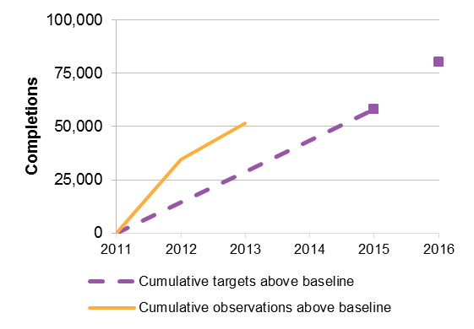 | Training Outcome 2: Government funded and fee for service  commencements in higher qualifications  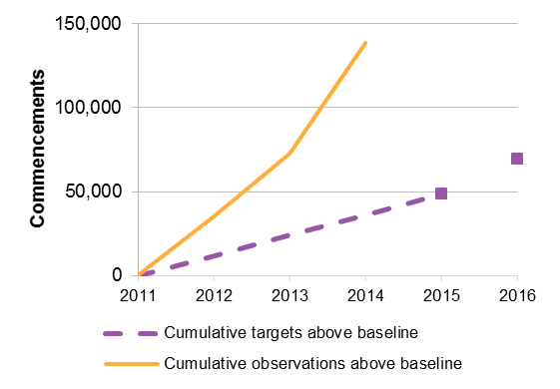
Training Outcome 3: AQF completions by Indigenous students  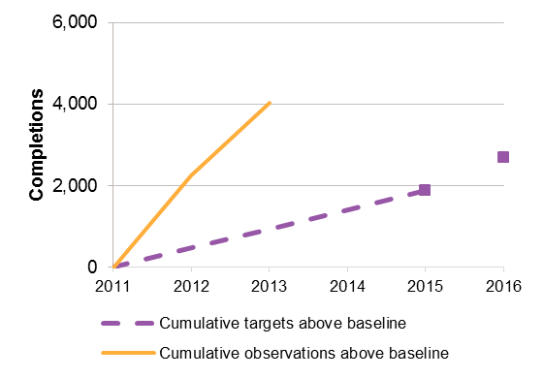 | Training Outcome 4: Government funded and fee for service AQF commencements by regional and remote students  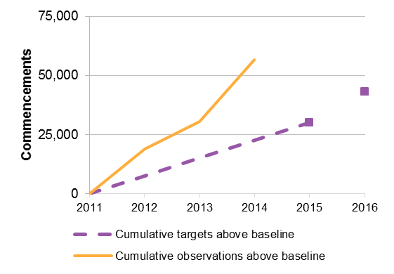
Training Outcome 5: Government funded and domestic fee for
service AQF commencements in value-add services
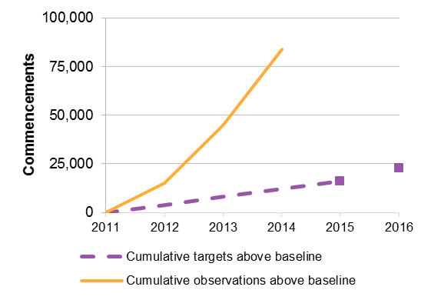
Note: The purple squares represent the training outcome targets. Training Outcomes 4’s baseline is adjusted to reflect the change from ARIA+2006 values to ARIA+2011, the adjusted baseline assumes ARIA+2011.
Source: NCVER GOVERNMENT-FUNDED STUDENTS AND COURSES (AS OF THE PRE-2014 SCOPE, INCLUDING ACE FEE FOR SERVICE – SEE SECTION 1.4)

    - Victoria
Figure A.2 details the progress Victoria has made towards their agreed training outcomes since 2012. Victoria’s training outcomes include:
- Training Outcome 1: Aggregate qualification completions
- Training Outcome 2: Completions of higher qualifications (Certificate III and above)
- Training Outcome 3: Commencements of higher qualifications by Indigenous Australians (Certificate III and above)
- Training Outcome 4: Commencements by students with a disability
- Training Outcome 5: Commencements by individuals who are unemployed at the time of enrolment
Victoria has already exceeded each of their five training outcome targets by a significant margin.
Figure A.2 Progress against NP IMPLEMENTATION Plan training outcomes – Victoria
Training Outcome 1: Aggregate qualification completions  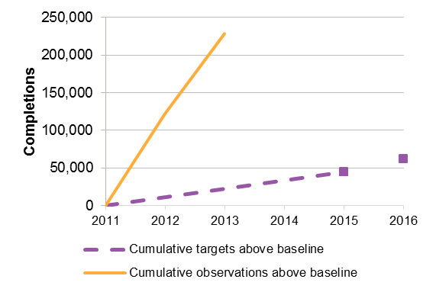 | Training Outcome 2: Completions of higher qualifications  (Certificate III and above)  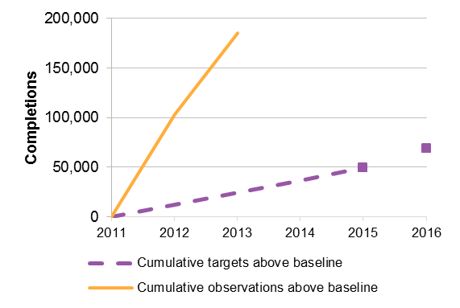
Training Outcome 3: Commencements of higher qualifications by  Indigenous Australians (Certificate III and above)  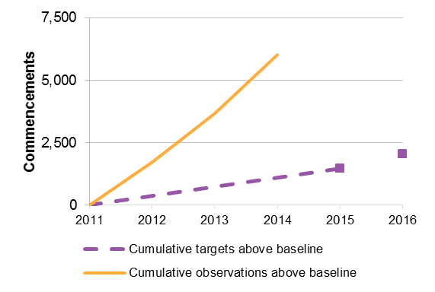 | Training Outcome 4: Commencements by students with a disability  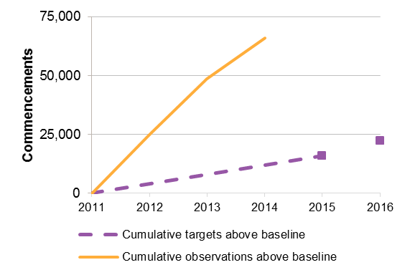
Training Outcome 5: Commencements by individuals who
are unemployed at the time of enrolment
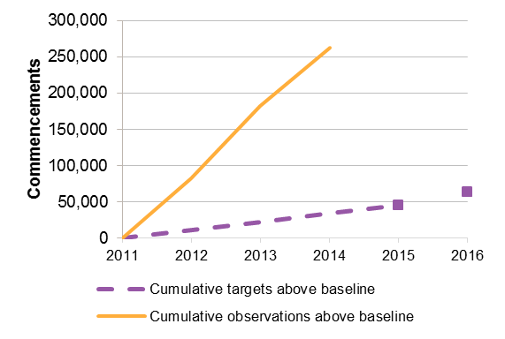
Note: the purple squares represent the training outcome targets.
Source: NCVER Government-funded Students and courses (As of the pre-2014 scope, including ACE fee for service – see section 1.4)

    - Queensland
Figure A.3 details the progress Queensland has made towards their agreed training outcomes since 2012. Queensland’s training outcomes include:
- Training Outcome 1: Aggregate qualification completions
- Training Outcome 2: Completions of higher qualifications (Certificate III and above)
- Training Outcome 3: Completions of qualifications by Indigenous Australians (Certificate I and above)
- Training Outcome 4: Completions of qualifications by students with a disability (Certificate I and above)
- Training Outcome 5: Number of apprentice new commencements
Queensland is on track to meet all training outcome targets and has already exceeded training outcome targets 2, 3, and 4. Queensland is tracking very close to the annual target for training outcome 5 and is tracking noticeably above the annual target for training outcome 1.
Figure A.3 Progress against NP Implementation Plan Training outcomes – Queensland
Training Outcome 1: Aggregate qualification completions  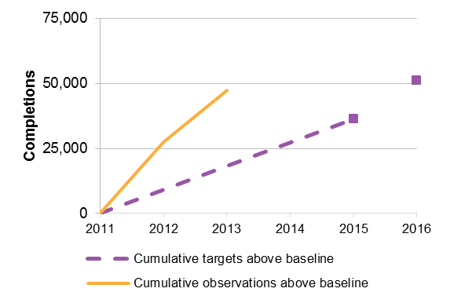 | Training Outcome 2: Completions of higher qualifications  (Certificate III and above)  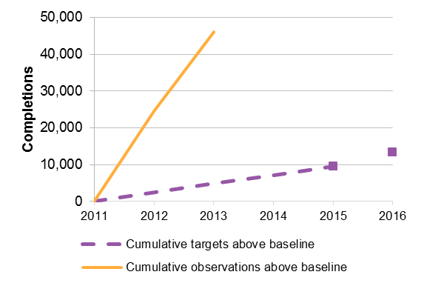
Training Outcome 3: Completions of qualifications by  Indigenous Australians (Certificate I and above)  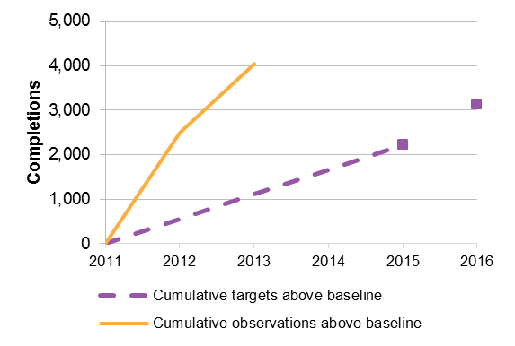 | Training Outcome 4: Completions of qualifications by students with a disability (Certificate I and above)  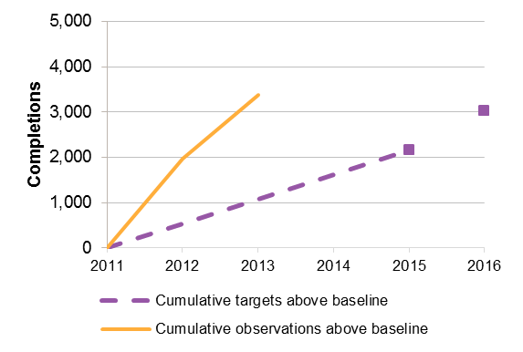
Training Outcome 5: Number of apprentice new commencements
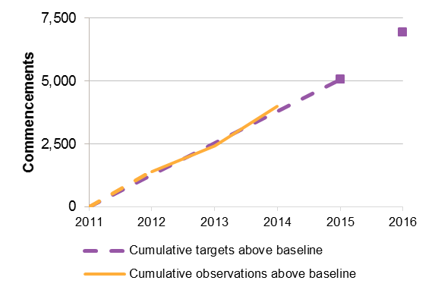
Note: The purple squares represent the training outcome targets. A linear approximation has been used due to data limitations for Training Outcome 5 ‘cumulative observations above baseline’ which is represented by the dashed yellow line.
Source: NCVER Government-funded Students and courses (As of the pre-2014 scope, including ACE fee for service – see section 1.4)

    - South Australia
Figure A.4 details the progress SA has made towards their agreed training outcomes since 2012. SA training outcomes include:
- Training Outcome 1: Aggregate qualification completions
- Training Outcome 2: Completions of higher qualifications (Certificate III and IV, Diploma and Advanced Diploma)
- Training Outcome 3: Completions by Indigenous Australians
- Training Outcome 4: Completions by Australians with a disability
- Training Outcome 5: Completions by mature-aged (45-64) employed Australians
SA has already exceeded each of their five training outcome targets by a significant margin.
Figure A.4 Progress against NP Implementation plan training outcomes – South Australia
Training Outcome 1: Aggregate qualification completions  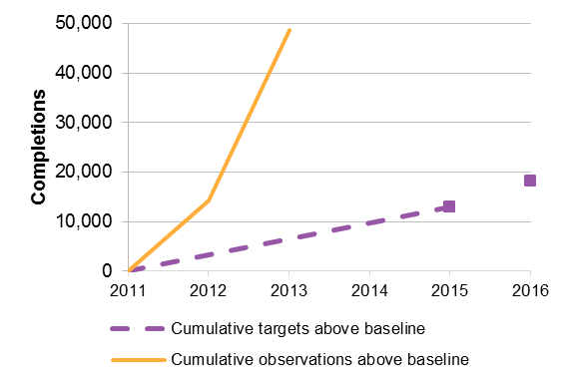 | Training Outcome 2: Completions of higher qualifications  (Certificate III and IV, Diploma and Advanced Diploma)  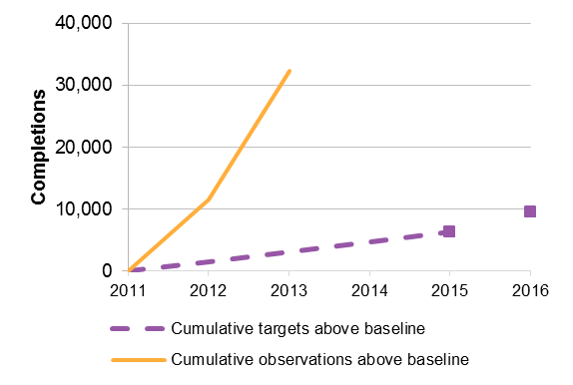
Training Outcome 3: Completions by Indigenous Australians  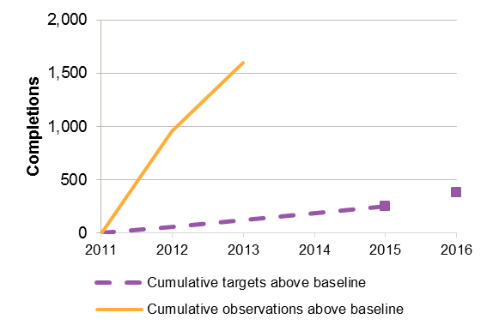 | Training Outcome 4: Completions by Australians with a disability  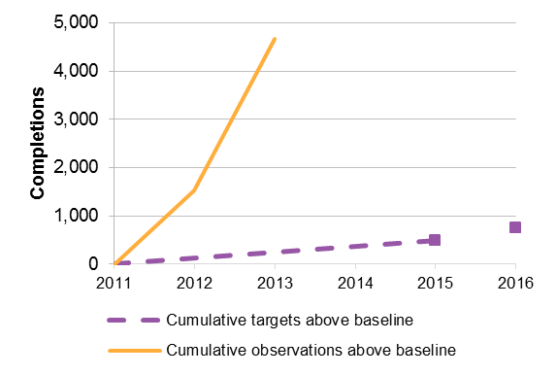
Training Outcome 5: Completions by mature-aged (45-64)
employed Australians
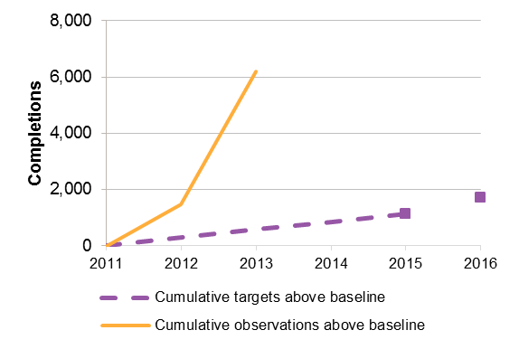
Note: the purple squares represent the training outcome targets.
Source: NCVER Government-funded Students and courses (As of the pre-2014 scope, including ACE fee for service – see section 1.4)

    - Western Australia
Figure A.5 details the progress WA has made towards their agreed training outcomes since 2012. WA training outcomes include:
- Training Outcome 1: Aggregate qualification completions
- Training Outcome 2: Completions of higher qualifications (Certificate III and above)
- Training Outcome 3: Completions by Indigenous Australians (Certificate II and above)
- Training Outcome 4: Commencements by students with a disability (Certificate II and above)
- Training Outcome 5: Regional and remote area qualification completions (Certificate III and above)
WA has already exceeded each of their five training outcome targets.
Figure A.5 Progress against NP Implementation plan training outcomes – Western Australia
Training Outcome 1: Aggregate qualification completions  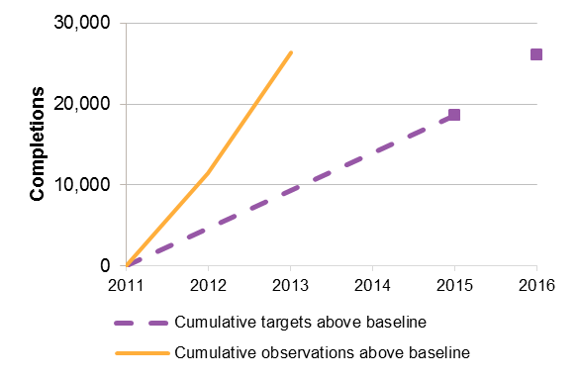 | Training Outcome 2: Completions of higher qualifications  (Certificate III and above)  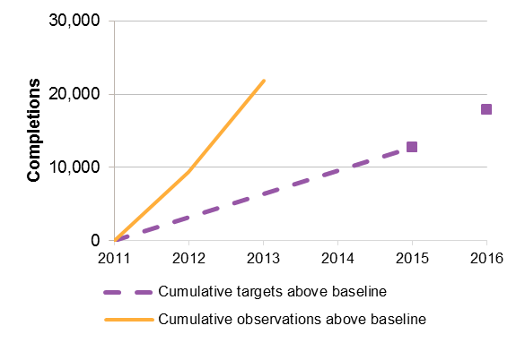
Training Outcome 3: Completions by Indigenous Australians  (Certificate II and above)  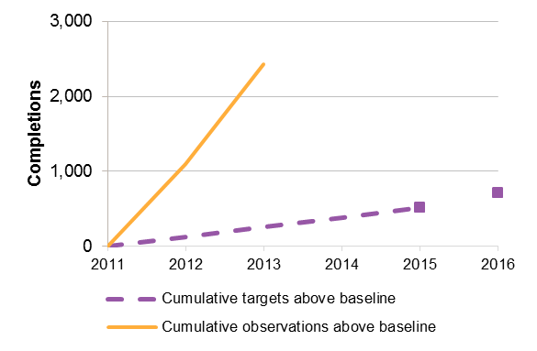 | Training Outcome 4: Completions by students with a disability  (Certificate II and above)  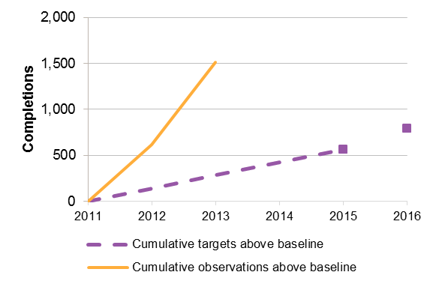
Training Outcome 5: Regional and remote area qualification
Completions (Certificate III and above)
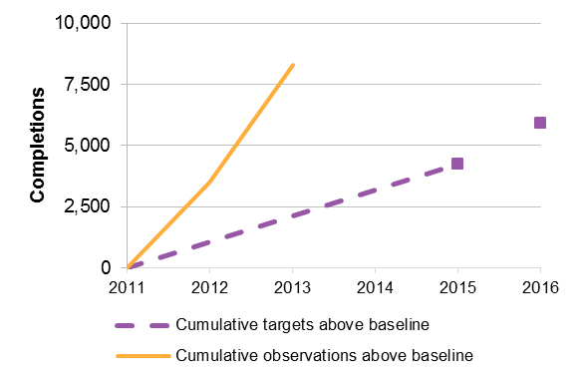
Note: The purple squares represent the training outcome targets. Training outcome 5: As stated in section 6.3 regarding NSW training outcome 4, the ARIA remoteness classification used in WA Training Outcome 5 contains a series break. Training Outcomes 5’s observations are adjusted to reflect the change from ARIA+2006 values to ARIA+2011, the observation are adjusted to correspond to a baseline which assumes ARIA+2006.
Source: NCVER Government-funded Students and courses (As of the pre-2014 scope, including ACE fee for service – see section 1.4)

    - Tasmania
Figure A.6 details the progress Tasmania has made towards their agreed training outcomes since 2012. Tasmania’s training outcomes include:
- Training Outcome 1: Aggregate qualification completions
- Training Outcome 2: Completions of higher qualifications (Certificate III and above)
- Training Outcome 3: Completions of qualifications by Indigenous Australians
- Training Outcome 4: Completions of qualifications by students from low socio-economic status areas
- Training Outcome 5: Completion of selected qualifications from agriculture, aquaculture, community services and NBN industry sectors
Tasmania is on track to meet training outcome targets 1, 2, 3 and 4, and has already exceeded training outcome targets 3 and 4. Tasmania is tracking very close to the annual targets for training outcomes 1 and 2.
Due to issues clarifying the definitions used in training outcome 5, training outcome 5 is not shown in Figure A.6.
There was a notable decline in higher qualifications in 2013, Tasmania notes in their 2014 Annual Performance Report:
Notably, there has been a decline in completions under apprentice and trainee training contracts; a flow on effect from declines in commencements which has been evident Australia wide, following the finalisation of global financial crisis projects and the impact of changes to Australian Apprentices employer incentive programs.
There has been evidence of a recovery in apprentice and trainee commencements during 2014 which should be reflected in completions in future years.
This decline in apprentice and trainee completions is also counter balanced in Tasmania by strategies to support improved workforce outcomes and business productivity, such as funding skills sets and extending training funding to existing workers, particularly those in service industries

Figure A.6 Progress against NP Implementation plan training outcomes – Tasmania
Training Outcome 1: Aggregate qualification completions  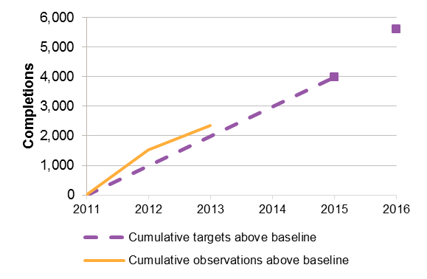 | Training Outcome 2: Completions of higher qualifications  (Certificate III and above)  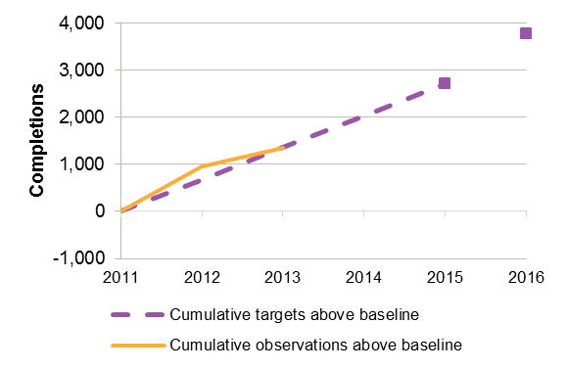
Training Outcome 3: Completions of qualifications by  Indigenous Australians  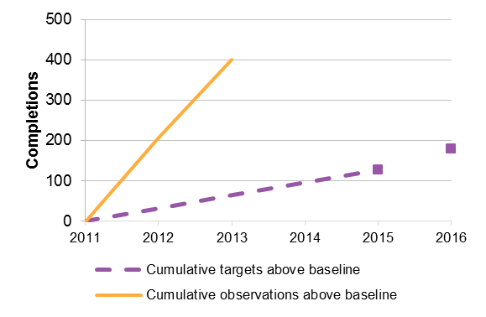 | Training Outcome 4: Completions of qualifications by students from low socio-economic status areas  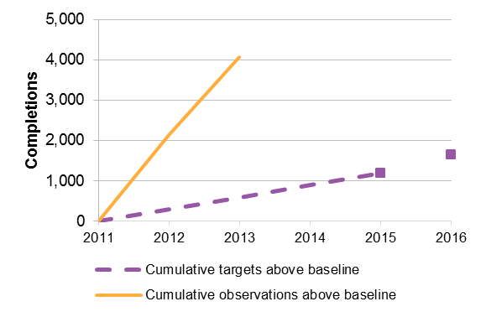
Note: The purple squares represent the training outcome targets. Training Outcome 4 has a break in the series it due to the introduction of SEIFA 2011 (previously on SEIFA 2006). There are only four training outcomes listed for Tasmania due to issues clarifying the of definitions used in Training Outcome 5
Source: NCVER Government-funded Students and courses (As of the pre-2014 scope, including ACE fee for service – see section 1.4)

    - Northern Territory
Figure A.7 details the progress the NT has made towards their agreed training outcomes since 2012. NT training outcomes include:
- Training Outcome 1: Aggregate qualification completions
- Training Outcome 2: Commencements (Certificate III and above)
- Training Outcome 3: Commencements by Indigenous Australians (Certificate III and above)
- Training Outcome 4: Unit completions
- Training Outcome 5: Trade Commencements
The NT is on track to meet training outcome targets 1, 2, 3, and 4 and has already exceeded training outcome targets 1. Training outcome 3 and 4 are tracking close to the annual targets, though training outcome 3 fell to below the annual target in 2014. Training outcome 2 is tracking noticeably above the annual target.
Due to issues clarifying the definitions used in training outcome 5, training outcome 5 is not shown in Figure A.7.
There was a notable decline in unit completions in 2013, the NT notes in their 2014 Annual Performance Report:
A decline has been experienced in unit completions across the NT. Increased activity in regional areas through programs from the Commonwealth, including the NT Emergency Response and the introduction of the Remote Jobs and Communities Program has affected enrolments and completions.

Figure A.7 Progress against NP Implementation plan training outcomes – Northern Territory
Training Outcome 1: Aggregate qualification completions  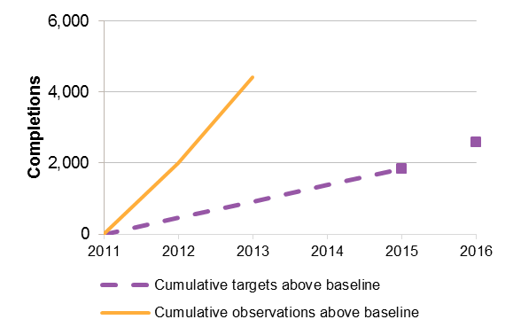 | Training Outcome 2: Commencements (Certificate III and above)  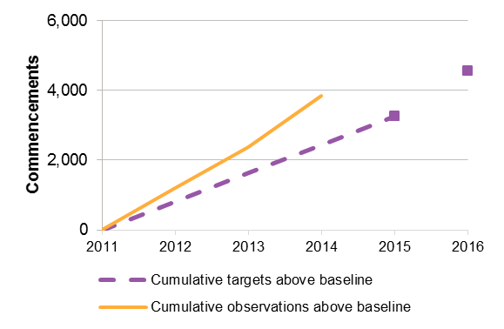
Training Outcome 3: Commencements by Indigenous Australians  (Certificate III and above)  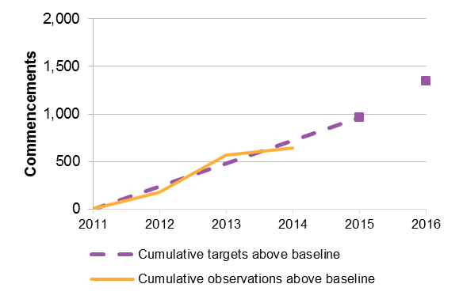 | Training Outcome 4: Unit completions  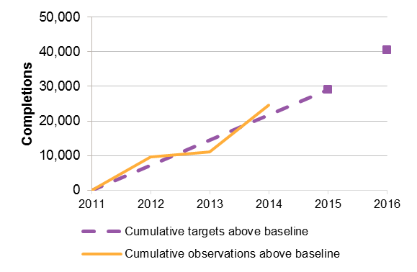
Note: The purple squares represent the Training outcome targets. There are only four training outcomes listed for Northern Territory due to issues clarifying the of definitions used in Training Outcome 5
Source: NCVER Government-funded Students and courses (As of the pre-2014 scope, including ACE fee for service – see section 1.4)

    - Australian Capital Territory
Figure A.8 details the progress ACT has made towards their agreed training outcomes since 2012. ACT training outcomes include:
- Training Outcome 1: Aggregate qualification completions
- Training Outcome 2: Commencements of higher qualifications (Certificate III and above)
- Training Outcome 3: Commencements of higher qualifications by Indigenous Australians
- Training Outcome 4: Commencements of qualifications by Australians with a disability
- Training Outcome 5: Qualification completions by mature age workers (40+)
ACT has already exceeded each of their five training outcome targets by a significant margin.
Figure A.8 Progress against NP Implementation plan training outcomes – Australian Capital Territory
Training Outcome 1: Aggregate qualification completions  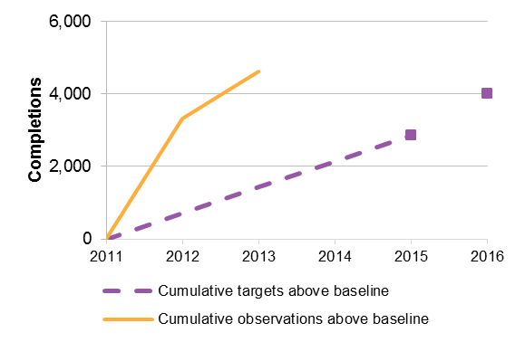 | Training Outcome 2: Commencements of higher qualifications  (Certificate III and above)  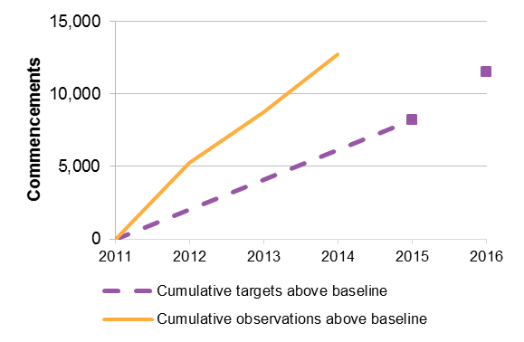
Training Outcome 3: Commencements of higher qualifications  by Indigenous Australians  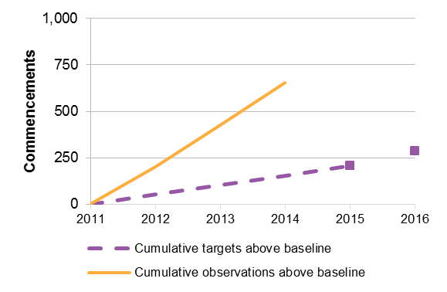 | Training Outcome 4: Commencements of qualifications  by Australians with a disability  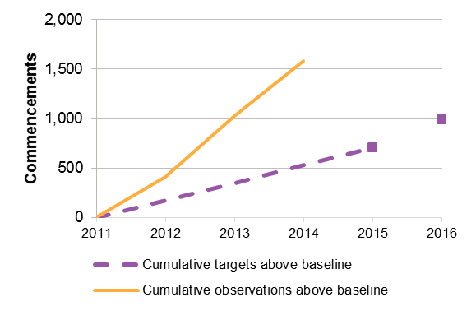
Training Outcome 5: Qualification completions by mature
age workers (40+)
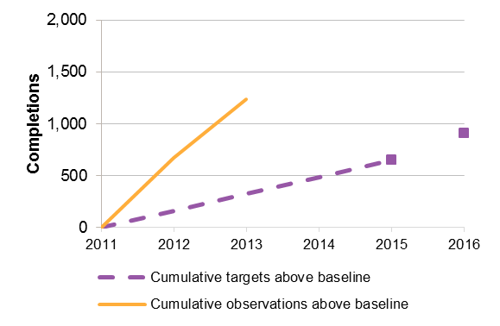
Note: the purple squares represent the Training Outcome targets.
Source: NCVER Government-funded Students and courses (As of the pre-2014 scope, including ACE fee for service – see section 1.4)

Terms of Reference and Review scope | B
 | Terms of Reference and Review scope

Terms of Reference
Context
Under the National Partnership Agreement on Skills Reform (National Partnership), $1.75 billion of Commonwealth funding is available to States and Territories from 2012–13 to 2016–17 for skills reform and training outcomes. The National Partnership complements the National Agreement for Skills and Workforce Development (NASWD) and the annual payment of around $1.4 billion to States and Territories to subsidise training. Both the NASWD and National Partnership were agreed by the Council of Australian Governments on 13 April 2012.
The National Partnership Agreement requires a review of the progress of its structural reforms and training outcomes be completed by 31 December 2015 (clause 54 to 57 refer).
Scope
The review will examine the effectiveness of the National Partnership in delivering the agreed objective, outcomes and outputs, noting it may inform future policy settings (clause 54 refers) and recommend future objectives, outcomes and outputs that could form the basis of future Commonwealth–State agreements.
The review will consider the progress of the National Partnership in achieving its objective as stated in clause 20:
a VET system that delivers a productive and highly skilled workforce which contributes to Australia’s economic future, and to enable all working age Australians to develop the skills and qualifications needed to participate effectively in the labour market
and outcomes as stated in clause 21:
a. more accessible training for working age Australians and, in particular, a more equitable training system, which provides greater opportunities for participation in education and training;
b. a more transparent VET sector, which enables a better understanding of VET activity that is occurring in each jurisdiction;
c. a higher quality VET sector, which delivers learning experiences and qualifications that are relevant to individuals, employers and industry; and
d. a more efficient VET sector, which is responsive to the needs of students, employers and industry.
The review will note the progress of the structural reforms and training outcomes, reported as required by the agreement, and examine whether the outputs outlined in clauses 22 to 32 of the National Partnership are contributing to the achievement of the stated objective and outcomes or otherwise impacting upon VET outcomes. The review’s assessment will take into account the fact that ‘jurisdictionally flexible reforms’ have differed considerably across the states and that jurisdictions were at different stages of reform at the commencement of the NP. Information from recent reviews undertaken within jurisdictions into their own VET arrangements may also be taken into account.
As the review will inform consideration of policy settings for possible future Commonwealth–State arrangements, the review will also:
- identify examples of best practice across different aspects of the training system to support knowledge-sharing between jurisdictions; and
- provide recommendations for ministers’ consideration on priorities for future reform in the training system.
Structural reforms
The review of the structural reforms outlined in clauses 23 to 29 will:
- note progress made in achieving the outputs; and
- assess whether the outputs, or other associated policy measures, are delivering the National Partnership objective and outcomes, or otherwise impacting on VET outcomes:
  - report on any explanations for why the outputs are not achieving the objective;
  - report on the impacts of associated jurisdictional policy reforms; and
  - offer suggestions for alterations that might be more effective or measures that might reflect best practice to inform future arrangements beyond the current National Partnership.
This review of structural reforms will also:
- examine the extent to which the outputs have contributed to the reform directions outlined in the NASWD, particularly with respect to facilitating the operation of a more open and competitive training market;
- identify best practice examples arising from different jurisdictional reforms, including opportunities to share ‘lessons learned’ between jurisdictions for consideration of future actions beyond the current National Partnership;
- identify what conditions contributed to or hindered progress, including any preconditions needed to support successful structural reforms, such as establishing clear baselines and understanding of current states of play;
- assess the extent to which reforms have enabled public providers to operate more effectively in an environment of greater competition; and
- examine how the reforms have contributed to a VET system which is more responsive to student and employer choice.
The review will explicitly examine the implementation of income contingent loans and management of bad and doubtful debt and will also consider progress on the reform activities referred to in clause 8 (as per clause 55).
Training outcomes
The review will examine the extent to which training outcomes in the VET system have improved as per clauses 30 to 32 of the National Partnership. This will include reviewing training outcome completion targets to confirm the data that is to be used to assess performance against the targets and resolve any issues related to data revisions.
To help inform policy settings for future Commonwealth–State arrangements, the review will also consider whether the training outcomes indicator of improvements in completions is the best target to support the National Partnership’s outcomes and objective and recommend any other more preferable measures which could be considered in future agreements.
Joint reform activities
The review will examine the progress of and success of joint reform activities outlined in states’ and territories’ Implementation Plans as per clause 8 of the National Partnership.
Facilitate transfer and sharing of information
The review is expected to facilitate a streamlined process for the transfer and sharing of information to support the better operation of the VET system and improved quality and employment outcomes. The information provided by jurisdictions to support the review will contribute to the achievement of the reform direction outlined in clause 29 a (improvements in government-to-government information exchange).

Project scope
The Review will cover the years 2011-2014. As the NP was signed in mid-2012, 2011 provides a clean baseline for the analysis of outcome changes caused by the NP. The most recent full year of training data which will allow comparison to this baseline is 2014.
Commonwealth and jurisdictions VET policy under the NP continues to evolve. As a result, it is important that the Review has a clear period of VET policy changes to analyse, rather than attempting to analyse VET policy as it continues to evolve as the Review is carried out. For consistency with the data analysis, the Review’s analysis of VET policy will also be constrained to 2011-2014. All reforms undertaken under the NP up to the end of 2014 will be covered in the Review, and any VET policy changes made in 2015 will not.
To the extent possible, all analysis undertaken as part of the Review is limited to subsidised training activity. In the case of VET FEE-HELP, the analysis is also limited to subsidised training activity. This scope means that all fee for service VET activity is excluded from the Review.

Review Assessment Framework and research questions | C
 | Review Assessment Framework and research questions
To meet the terms of reference of the NP Review, the Review will:
- Assess the outcomes of the NP
- Identify good practice under the NP
- Identify conditions which contribute to or hinder NP-related reform
- Based on good practice under the NP, provide recommendations for future Commonwealth-state agreements
To assess the outcomes of the NP, the Review will use an Assessment Framework, with multiple indicators across the five NP outcomes. Further, three sets of research questions have been developed to identify good practice and the conditions contributing to, or hindering, NP-related reform, and to provide recommendations for future Commonwealth-state agreements.
Table C.1 provides an overview of the Assessment Framework and research questions, which are detailed in the following sections.
Table C.1 overview of assessment framework and research questions
NP outcomes |  | Assessment framework | Good practice | Conditions supporting/ hindering reform | Future Commonwealth-State agreements
 | More accessible training for working age Australians and, in particular, a more equitable training system, which provides greater opportunities for participation in education and training | 18 indicators | 13 research questions across 4 domains | 2 overarching research questions | 4 overarching research questions
 | A more transparent VET sector, which enables better understanding of the VET activity that is occurring in each jurisdiction | 8 indicators | 5 research questions across 2 domains | 2 overarching research questions | 4 overarching research questions
 | A higher quality VET sector, which delivers learning experiences and qualifications that are relevant to individuals, employers and industry | 6 indicators | 2 research questions across 2 domains | 2 overarching research questions | 4 overarching research questions
 | A more efficient VET sector, which is responsive to the needs of students, employers and industry. | 6 indicators | 2 research questions across 1 domain | 2 overarching research questions | 4 overarching research questions
 | VET system training outcomes | 1 national indicator and multiple jurisdiction-specific indicators | Not applicable | 2 overarching research questions | 4 overarching research questions
 | Source: ACIL allen Consulting

Assessment Framework
The Assessment Framework will assess the performance of the NP against its five outcomes. The NP’s five outcomes are the four outcomes listed in clause 21 of the NP, and the ‘training outcomes’ in clause 30 and in jurisdiction IPs (referred to in clauses 31 and 32).
Throughout, the Review will take into account the fact that ‘jurisdictionally flexible reforms’ have ‘differed considerably across the states and that jurisdictions were at different stages of reform at the commencement of the NPA’. Specifically in the Assessment Framework, to reflect the different starting points of the jurisdictions, the indicators will measure change between 2011 and 2014 (the last year for which full data exist), rather than levels in 2014.
The Assessment Framework is set out in Table C.2. The table includes the five outcomes, corresponding indictors and the data source/s for each indicator.
The first four sets of indicators are based on the NP as a whole, not just derived from the text of the four outcomes listed in clause 21. For example, the fourth outcome (‘a more efficient VET sector, which is responsive to the needs of students, employers and industry’, clause 21d) is interpreted to refer to information exchange outcomes and public provider outcomes, as this context in which efficiency and responsiveness are referred in the NP (see clause 29).

Table C.2 Assessment framework
NP outcome |  |  | Indicator | Data source
 |  | Outcome 1
 |  | More accessible training for working age Australians and, in particular, a more equitable training system, which provides greater opportunities for participation in education and training | - Percent change between 2011 and 2014 in the proportion of qualifications that are subsidised | Jurisdiction data (request required)
 |  |  | - Percent change between 2011 and 2014 in the number of publicly-subsidised enrolments | NCVER Students and Courses
 |  |  | - Percent change between 2011 and 2014 in the number of RTO/course combinations offered in the jurisdiction to publicly-subsidised students | Jurisdiction data (request required)
 |  |  | - Percent change between 2011 and 2014 in the take up of training across a wider variety of courses at a larger number of RTOs, as measured by the change in the Herfindahl-Hirschman Index | NCVER Students and Courses (custom data request required)
 |  |  | - Average subsidy rate relativity between public and private RTOs in the entitlement funding formula, for years 2011 to 2014 (based on actual subsidies paid) | Jurisdiction data (request required)
 |  |  | - Percent change between 2011 and 2014 in the proportion of working age Australians without a Certificate III or higher qualification that are able to access subsidised training (subject to minimum entry requirements and state-based criteria) | NCVER Students and Courses  Survey of Education and Work (SEW)  ABS Census data
 |  |  | - Percent change between 2011 and 2014 in the number of VET enrolments as a proportion of the population of working age Australians | NCVER Students and Courses  ABS Census data
 |  |  | - Percent change between 2011 and 2014 of the proportion of enrolments that increase students’ qualification to Certificate III or above | NCVER Students and Courses
 |  |  | - Percent change between 2011 and 2014 in the number of enrolments in foundation skills or Certificate I and II qualifications | NCVER Students and Courses
 |  |  | - Proportion of students with a subsidised place receiving an ICL in ICL eligible courses | VET FEE-HELP Data Collection
 |  |  | - Percent change between 2011 and 2014 in the proportion of students receiving an ICL in ICL eligible courses | VET FEE-HELP Data Collection
 |  |  | - Percent change between 2011 and 2014 in the number of RTO/course combinations in ICLs are available | VET FEE-HELP Data Collection  Jurisdiction data (request required)
 |  |  | - Indicators 1-8 and 27-30 for only VET-FEE HELP enrolments | Various
 |  |  | - The Commonwealth, jurisdictions and other stakeholders’ assessment of the quality requirements for RTOs to access ICLs | Consultations
 |  |  | - The level and proportion of VET FEE-HELP debt that is bad and doubtful. | Commonwealth data (request required)  Document review
 |  |  | - Percent change between 2011 and 2014 in the proportion of bad and doubtful VET FEE-HELP debt | VET FEE-HELP Data Collection
 |  |  | - The Commonwealth, jurisdictions and other stakeholders’ assessment of the effectiveness of government activities to reduce bad and doubtful debt | Consultations
 |  |  | - Frequency and accuracy of information sharing between the Commonwealth and jurisdictions on bad and doubtful debt obligations. | Consultations  Document review
 | Outcome 2
 | A more transparent VET sector, which enables better understanding of the VET activity that is occurring in each jurisdiction |  | - Percent change between 2011 and 2014 in the proportion of VET activity for all RTOs captured in national data collections | Document review
 |  |  | - The Commonwealth, jurisdictions and other stakeholders’ assessment of improvements in measurement of VET activity | Consultations
 |  |  | - Change between 2011 and 2014 in the time between collection and sharing / reporting of key datasets | Consultations  Commonwealth and jurisdiction data (request required)
 |  |  | - The Commonwealth, jurisdictions and other stakeholders’ assessment of whether, and if so how, the introduction of TVA and a USI enabled better understanding of VET activity | Consultations
 |  |  | - Percent change in the number of visitors to Commonwealth and jurisdiction VET consumer information websites | Commonwealth and jurisdiction data (request required)
 |  |  | - The extent to which consumer information has increased at the same time as market design reform has increased student choice | Consultations  Jurisdiction data (request required)
 |  |  | - The Commonwealth, jurisdictions and other stakeholders’ assessment of whether VET market consumers are better informed about quality, prices, government support, and the labour market | Consultations
 |  | Outcome 3
 |  | A higher quality VET sector, which delivers learning experiences and qualifications that are relevant to individuals, employers and industry | - Percent change between 2011 and 2014 in the proportion of students satisfied with their training | Student Outcomes Survey
 |  |  | - Percent change between 2011 and 2014 in the proportion students satisfied with the quality of teaching in their training | Student Outcomes Survey
 |  |  | - Percent change between 2011 and 2014 in the proportion students receiving a job relative benefit from their training | Student Outcomes Survey
 |  |  | - Percent change between 2011 and 2014 in the proportion students completing training | NCVER data (request required)
 |  |  | - Percent change between 2011 and 2014 in the proportion of employers satisfied with training | Survey of Employer Use and Views of the VET System
 |  |  | - The Commonwealth, jurisdictions and other stakeholders’ assessment of whether the jurisdictions policies have improved VET regulation. | Consultations
 |  | Outcome 4
 |  | A more efficient VET sector, which is responsive to the needs of students, employers and industry. | - The Commonwealth, jurisdictions and other stakeholders’ assessment of the impact of improved government-to-government information | Consultations
 |  |  | - Public providers’ contestable government revenue as a proportion of total public provider government revenue | Report on Government Services
 |  |  | - The Commonwealth, jurisdictions and other stakeholders’ assessment of whether public providers are appropriately exposed to market competition | Consultations
 |  |  | - The Commonwealth, jurisdictions and other stakeholders’ assessment of whether public providers are appropriately supported to carry out their function in servicing the training needs of industry, regions and local communities, and their role that spans high level training and workforce development for industries and improved skill and job outcomes for disadvantaged learners and communities. | Consultations
 |  |  | - The Commonwealth, jurisdictions and other stakeholders’ assessment of whether (if applicable) the jurisdictions policies have increased linkages between RTOs, employment services providers, employers and Centrelink at state and local levels | Consultations
 |  |  | - The Commonwealth, jurisdictions and other stakeholders’ assessment of whether (if applicable) the jurisdictions’ policies have increased alignment and complementarity between the VET and higher education systems | Consultations
 |  | VET system training outcomes
 |  | VET system training outcomes | - The extent to which the Commonwealth and jurisdictions are on track to increase total qualification completions by 375,000 between 2011 and 2015 | NCVER data (request required)
 |  | VET system training outcomes | - The extent to which each jurisdiction is on track to improve commencements or completions in areas of priority (as negotiated on a bilateral basis) | NCVER Students and Courses  NCVER data (request required)
 |  | Source: acil allen consulting, based on the NP

Good practice research questions
The review terms of reference calls for the identification of good practice to:
- ‘support knowledge-sharing between jurisdictions’
- ‘inform future arrangements beyond the current National Partnership’.
The good practice part of the Review will examine activity related to the four NP outcomes in clause 21. The narrow quantitative ‘training outcomes’ indicators in clause 30 and in jurisdiction Implementation Plans (referred to in clauses 31 and 32) are not relevant to the examination of good practice.
In order to provide a framework with which to explore good practice, within each of the NP’s four relevant outcomes we have identified domains of practice. As with the Assessment Framework, each outcome’s domain/s and the corresponding research questions are informed by the totality of the NP, not just the text of each outcome. For example, in the NP, outcome 4 covers public providers and data sharing, as opposed to other areas of efficiency and responsiveness.
Table C.3 sets out the 22 good practice research questions, and how they relate to the four outcomes and the nine domains of practice. Relevant NP clauses to these outcomes are also indicated.
The key source of information for the good practice research questions will be the consultations conducted as part of the Review. Supplementary sources of data include Implementation Plans, jurisdiction annual reports and other aspects of the document review.
Table C.3 Good practice research questions
NP outcomes |  | Domains of practice | Research questions to identify good practice
 | Outcome 1 [Clauses 21a, 28, 31-31]
 | More accessible training for working age Australians and, in particular, a more equitable training system, which provides greater opportunities for participation in education and training | Student accessibility | - How have jurisdictions made training more accessible and increased participation?  - How have jurisdictions made the training system more equitable?  - How have jurisdictions increased student choice?  - How have jurisdictions determined student eligibility for VET funding?
 |  | Market design | - How have jurisdictions managed RTO access to public subsidies?  - How have jurisdictions managed issues of competitive neutrality?  - How have jurisdictions determined which courses, industries and regions receive funding?
 |  | Funding sustainability | - How have jurisdictions introduced a training entitlement while maintaining funding sustainability?  - How have jurisdictions monitored their VET funding?  - What strategies have jurisdictions uses to readjust policy settings when funding sustainability is at risk?
 |  | ICLs | - How have the Commonwealth and jurisdictions increased access with ICLs?  - How have the Commonwealth and jurisdictions managed student and provider access to ICLs?  - How have the Commonwealth and jurisdictions managed bad and doubtful VET FEE-HELP debts?
 | Outcome 2 [Clauses, 21b, 26]
 | A more transparent VET sector, which enables better understanding of the VET activity that is occurring in each jurisdiction | Data collection and sharing | - How have the Commonwealth and jurisdictions improved the sharing of government-to-government information?
 |  | Consumer information | - How have jurisdictions collected information on training course prices?  - How have jurisdictions measured quality?  - How have the Commonwealth and jurisdictions provided consumers with VET market information?  - How have jurisdictions increased consumer information in line with increased consumer choice?
 | Outcome 3 [Clauses 21c, 27]
 | A higher quality VET sector, which delivers learning experiences and qualifications that are relevant to individuals, employers and industry | Quality regulation | - How have the Commonwealth and jurisdictions regulated the quality of VET providers?
 |  | Industry links | - How have jurisdictions included the views of individuals, employers and industry in VET policy?
 | Outcome 4 [Clauses 21d, 29]
 | A more efficient VET sector, which is responsive to the needs of students, employers and industry | Public providers | - How have jurisdictions enabled public providers to operate effectively in an environment of greater competition?  - How have jurisdictions enabled public providers to service the training needs of industry, regions and local communities, and deliver high level training and workforce development for industries and improved skill and job outcomes for disadvantaged learners and communities?
 | Source: ACIl Allen Consulting

Research questions to identify conditions for reform
The terms of reference requires the Review to examine ‘what conditions contributed to or hindered progress’ on the structure reforms agreed to under the NP. This this end, the Review will examine the following research questions:
- What conditions contributed to or hindered progress on the NP reforms?
- What are the preconditions needed to support successful structural reforms?
The primary source of information for these research questions will be consultations conducted as part of the Review.

Research questions to inform future Commonwealth-state agreements
The terms of reference notes that the Review should inform future Commonwealth-state agreements. This this end, the Review will examine the following research questions:
- Are the NP reform actions and outcomes appropriate to meet the objectives of the NASWD?
- Is the training outcomes indicator of improvements in completions the best target to support the National Partnership’s outcomes and objective, or are there more preferable measures which could be used in future Commonwealth-state agreements?
- How could ‘lessons learned’ from the current NP be shared between jurisdictions for consideration of future actions?
- What are potential objectives, outcomes and outputs for future Commonwealth-state agreements?
- What are potential priorities for future reform in the training system?
The main source of information for these research questions will be consultations conducted as part of the Review. Supplementary sources of data include NCVER data collections, Implementation Plans and jurisdiction annual reports.
In keeping with the terms of reference, the Review will advise on future Commonwealth-state agreements, and not on potential policy actions that could be undertaken under the current NP prior to its cessation in 2016-17.

Consultations overview | D
 | Consultations overview
Consultations were conducted with stakeholders from the Commonwealth, states and territories, regulatory and data agencies, public and private providers, and industry groups. At the Commonwealth level, and in the states and territories, consultation was sought with the departments responsible for VET and NP implementation, as well as with the central agencies.
The final scope of consultation within the Commonwealth and state and territory governments was determined by advice from relevant government officials on the location of responsibilities and experience in the implementation of the NP. For this reason, not all states and territories included central agencies in their stakeholder group.
A total of 43 interviews and roundtables were conducted. Table D.1 indicates the spread of consultations across locations and stakeholder groups. The public provider and private provider roundtables attracted 33 training organisations, resulting in the Review consulting with stakeholders from 65 organisations in total.
The project plan envisioned 55 interviews and roundtables, but a number of stakeholders chose not to participate in the Review consultations (as indicated in the table), often because they felt they could not usefully comment on the NP.
Table D.1 stakeholder consultation details
 |  | Brisbane | Canberra | Sydney | Melbourne | Perth | Adelaide | Hobart | Darwin | Total/Target
 | State and Territory Government officials
 | Education and Training | 1 | 1 | 1 | 1 | 1 | 1 | 1 | 1 | 8/8
 | First Minister and Cabinet | Unavail-able | 1 | 1 | 1 | Declined | Declined | 1 | 1 | 5/8
 | Treasury | 1 | 1 | 1 | 1 | Declined | Declined | Declined | 1 | 5/8
 | Commonwealth Government officials
 | Department of Education and Training |  | 4 |  |  |  |  |  |  | 4/2
 | Department of Employment |  | 1 |  |  |  |  |  |  | 1/1
 | Department of Prime Minister and Cabinet |  | Declined |  |  |  |  |  |  | 0/1
 | Other government stakeholders
 | AISC |  | Unavail-able |  |  |  |  |  |  | 0/1
 | NCVER |  |  |  |  |  | 1* |  |  | 1/1
 | ASQA | 1 |  |  |  |  |  |  |  | 1/1
 | Training providers
 | TAFE Directors Australia |  |  | 1 |  |  |  |  |  | 1/1
 | Public providers | 1* | 1 | 3 | 3 | Declined | 1 | Unavail-able | 1 | 6/8
 | Private providers | 4 | Declined | 8 | 8 | Declined | 1 | 2 | Declined | 5/8
 | ACPET head office |  |  |  | 1* |  |  |  |  | 1/1
 | Community Colleges Australia |  |  | 1 |  |  |  |  |  | 1/1
 | Industry stakeholders
 | AiG |  |  |  | 1 |  |  |  |  | 1/1
 | ACCI |  | Declined |  |  |  |  |  |  | 0/1
 | BCA |  |  |  | 1 |  |  |  |  | 1/1
 | Group Training Australia |  |  | 1 |  |  |  |  |  | 1/1
 | National Association of Australian Apprenticeships Centres |  | 1 |  |  |  |  |  |  | 1/1
 | Total |  |  |  |  |  |  |  |  | 43/55

Source: ACIL Allen Consulting

ACIL ALLEN CONSULTING PTY LTD
ABN 68 102 652 148
acilallen.com.au

About ACIL Allen consulting
ACIL Allen Consulting is one of the largest independent, economic, public policy, and public affairs management consulting firms in Australia.
We advise companies, institutions and governments on economics, policy and corporate public affairs management.
We provide senior advisory services that bring unparalleled strategic thinking and real world experience to bear on problem solving and strategy formulation.

For students undertaking medicine, dentistry and veterinary science courses (as defined in the Higher Education Support Act 2003) the FEE‑HELP limit is $122,162.
Not all Diploma and Advanced Diploma courses are subsidised. Each state and territory determines the Diploma and Advanced Diploma courses it will subsidise.
12.8 per cent is the percentage reduction in the proportion of working age Australians without a Certificate III or higher, as distinct from a percentage point reduction – the percentage point reduction is approximately 7 percentage points.
In 2014, NCVER Student and Courses only captures publically subsidised VET FEE-HELP and fee for service VET FEE-HELP that occurs at public providers. The 150,000 figure is determined by taking the total number of VET FEE-HELP enrolments minus public provider fee for service VET FEE-HELP enrolments.
The five are: HECS-HELP, FEE-HELP, VET FEE-HELP, OS-HELP, and SA-HELP.
For example, a higher weighted average loan value would push up the DNER, as would a lower completion rate—all things being equal, both would increase the chance a loan would not be repaid in full.
As set out in Box 2.2 in section 2.3.2, in 2015 the Commonwealth introduced measures to address concerns with VET FEE-HELP, prior to the introduction of a new model in 2017.
Data from 2014 VET FEE-HELP Statistical Report.
The three year completion rate for fee for service VET FEE-HELP enrolments is lower than both rates at 19.7 per cent for 2012 commencing students.
Breaking down outcome indicators by funding source shows a mixed story. Under Commonwealth and State general funding, three indicators deteriorated over the period, with only the proportion of students receiving a job-related benefit from training increasing (by approximately 6 per cent). The proportion of students satisfied with their training decreased by approximately 2 per cent; the proportion achieving their main reason for training decreased by approximately 8 per cent, and the proportion satisfied with the quality of teaching in their training decreased by less than 1 per cent. Under specific purpose funding, the changes were almost in the opposite direction, increasing for all indicators.
As set out in Box 2.2 in section 2.3.2, in 2015 the Commonwealth introduced measures to address concerns with VET FEE-HELP, prior to the introduction of a new model in 2017.
jobactive is the Commonwealth’s employment service program.
There is risk that even accounting for these factors, a fixed subsidy approach could insufficiently support a varied market with providers operating at different and legitimate cost bases. To some extent the ability of providers to charge fees (and thus raise revenue in addition to the subsidy rate) mitigates against this risk—for example, if higher quality providers incur higher costs, they can recoup these costs through charging students who are willing to pay for higher quality training.
As noted in section 4.3.1, some stakeholders consulted for this Review hold the view that ensuring quality VET provision is primarily, if not solely the responsibility of the sector regulator (primarily ASQA). Others consider that the regulation of the VET sector provides a baseline level of quality and that additional controls should be applied where the government is expending significant funds.
In 2014, the number of fee for service VET FEE HELP enrolments in Diploma and Advanced Diploma courses was 185,886 (VET FEE-HELP Statistical Report 2014). The number of state and territory and Commonwealth subsidised Diploma and Advanced Diploma enrolments was 172,543 (NCVER students and Courses Collection).
The NPA Review Terms of Reference.

