


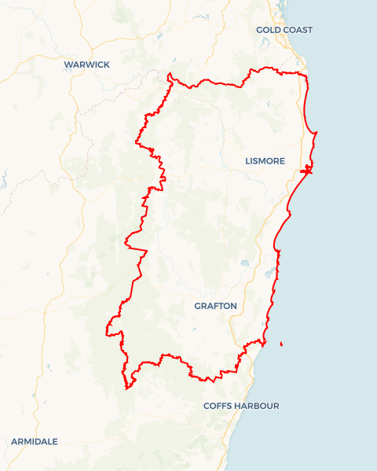
Local Jobs Plan
  - North Coast Employment Region | NSW | March 2026
Workforce Australia Local Jobs (Local Jobs) is a program that creates partnerships between business and communities to meet local workforce needs, thereby improving employment outcomes.
Local Jobs operates in all 51 Employment Regions in Australia.

Local Jobs Overview

Local Jobs Plan
Each Employment Region has a Local Jobs Plan which outlines the labour market challenges in the region and the strategies to address these challenges.

Job Coordinators
Each Employment Region has a dedicated Job Coordinator who leverages existing resources, supports local labour markets through structural adjustments and retrenchments, and creates opportunities for collaboration between business and communities.

Local Jobs and Skills Taskforce
Each Employment Region has its own taskforce that meets regularly with the Job Coordinator to develop an understanding of challenges in the region and implement solutions. The taskforce is comprised of representatives from the region.

Local Jobs, Local People Grant
The Local Jobs, Local People grant funds activities that help people into ongoing employment or training. Activities must support local labour market needs.
Explore labour market insights for
North Coast Employment Region

Local labour market challenges
- The unemployment rate is similar to that of NSW overall, and as it is low, the available labour market pool is limited.
- Mature aged people and First Nations people experience additional challenges securing employment and make up a considerable proportion of the Workforce Australia caseload. The challenges include not having formal qualifications that match modern workforce expectations.
- In the more remote areas of the region there are fewer employment opportunities and limited public transport services.
- There are intergenerational unemployment challenges and pockets of disengagement for some young people on the North Coast. Also, some sectors of the local business community can be reluctant to employ young people.
- There are a variety of complexities involved in securing adequately skilled workers in growth and demand industries. Entry-level work is available, but the roles, responsibilities and reward are not considered attractive by many individuals. Growth and demand sectors include construction, aged care, disability support, logistics, hospitality, retail, seasonal agricultural work, and meat processing.
- Labour shortages in the aged care sector have remained a key focus of the Local Jobs and Skills Taskforce over the past five years. Although recent wage increases have provided some relief, other industries are an attractive alternative due to higher pay, lower physical strain, clearer career pathways and more flexible working arrangements. As the labour shortage is now a national issue, aged care is no longer classified as a specific regional priority. Nonetheless, the Local Jobs and Skills Taskforce will continue to actively support the sector through targeted recruitment events, training initiatives, and connections to traineeship and apprenticeship service providers.

- The North Coast has an ageing workforce with the median age of employees being higher than the rest of NSW. This is especially the case for sectors including health care, social assistance and logistics. These sectors will have an increased outflow of retiring workers in coming years and enticing a new generation of workers is proving difficult.
- Affordable accommodation continues to be a key challenge for many low to middle income workers. This makes it difficult to attract and retain workers.
- The region has one of the highest natural hazard risk profiles in NSW, having endured multiple catastrophic weather events in recent years, including ex-Tropical Cyclone Alfred in 2025 and the major flooding in February 2022. Ongoing recovery and reconstruction efforts continue to place significant pressure on the local workforce, driving increased demand for skilled labour across the construction and trades sectors and further exacerbating an already highly constrained skills labour market.
- The NSW Government has announced a temporary moratorium on timber harvesting within the Great Koala National Park, affecting approximately 176,000 hectares of designated State Forest. In response, the Government has introduced comprehensive financial assistance measures for employees of Wood Supply Agreement holders and for harvesting operators contracted by the Forestry Corporation of NSW who are directly impacted. Support is also being provided to the affected workforce through reskilling and upskilling initiatives to facilitate career transition opportunities.

Local priorities

Priority 1 – First Nations and young people

What are our challenges?
First Nations people experience particularly high labour market disadvantage. Support needs to be culturally appropriate and enticing, including through the use of creative arts. Young people within the region have limited labour market experience and often underdeveloped soft skills.

How are we responding?
- We host Indigenous Employer Connection Events in each local government area focusing on targeted learning and employment pathways for cohorts that have a high incidence of unemployment and/or underemployment.
- We create skills development pre-employment pathways aligned with growth sectors like construction.
- We collaborate with key industry and training stakeholders to design flexible traineeship and apprenticeship models that integrate on-the-job experience with formal accredited training, rather than treating them as separate processes. These employment and training pathways bring together registered training organisations (RTO) and employers to provide participants with industry-specific skills, practical experience, and recognised accredited qualifications that support direct support into employment opportunities with the employers involved.
- We engage with Workforce Australia Employment Services Providers (including the specialist provider for First Nations people) and the Self-Employment Assistance program to help young people into self-employment in sectors including wellbeing, fitness, digital solutions, and creative arts.

Priority 2 – Driver licence support

What are our challenges?
There is limited public transport on the North Coast, combined with inconsistent and expensive learner driver services. This is reducing employment opportunities for a significant number of people on income support, particularly young people, migrants, First Nations people and the long-term unemployed. Innovative thinking and initiatives are required to help people get their driver licence.

How are we responding?
- We operate a mobile driver-training simulator program that rotates through all local government areas across the North Coast, providing accessible and consistent driver-skill development for participants throughout the region.
- We are encouraging access to the Driver Licensing Access Program (funded by the NSW Government and delivered locally by ACE Community College) to help people obtain a driver licence.
- We are seeking assistance from ACE Community College, Transport NSW and other stakeholders to host information sessions about obtaining a driver licence.

Priority 3 – Apprenticeships, traditional trades and construction

What are our challenges?
The Northern Rivers region is now entering its fourth year of recovery following two catastrophic weather events. Substantial investment continues to flow into large-scale rebuilding and infrastructure programs across the North Coast. This sustained level of construction activity requires ongoing coordination to maximise emerging opportunities, streamline regional responses, and address the significant demand for skilled tradespeople needed to deliver these major projects. Opportunities will also arise at the Richmond Valley Regional Job Creation Precinct as it is developed. In addition, significant incentives and support packages are expected to be offered to local tradespeople to encourage relocation to Queensland, driven by the extensive construction program underway in preparation for the Brisbane 2032 Olympic and Paralympic Games.

How are we responding?
- We are collaborating with construction organisations through engagement with the Reconstruction Authority NSW to build stronger pathways to employment in the trades and construction industries. This includes developing pre-employment programs that focus on employability and industry-specific skills for entry-level roles and apprenticeship opportunities.
- We are linking businesses to Apprenticeship Connect Australia providers to help facilitate greater entry to apprenticeships and traineeships.
- We are engaging with local government, RTOs, and industry training stakeholders to develop and deliver recruitment solutions. This includes direct recruitment (through facilitating face to face connections) and short course upskilling to support skills transferability into the construction and trades industry.

Priority 4 – Supporting women into secure employment

What are our challenges?

Women comprise a small proportion of workers in male-dominated sectors such as manufacturing and construction which have low rates of casualisation. Greater representation of women would ease skill shortages and provide women with greater access to secure employment. Skill shortages in sectors where women are highly represented, such as aged care, may present opportunities to work with employers to reduce casualisation.

How are we responding?
- We work with employers to develop tailored training programs (including programs designed by women) to help women into male-dominated sectors.
- We are building a networking group for women re-entering the workforce.
- We are collaborating with local governments to develop programs and employment events that increase female participation in the workforce.
- We are working with employers to reduce casualisation in sectors with a high representation of women and difficulty filling vacancies.

Want to know more?
- Contact: Terri Grendon, North Coast Job Coordinator, coordinator@northcoastljp.work
- Visit Local Jobs or Workforce Australia

