


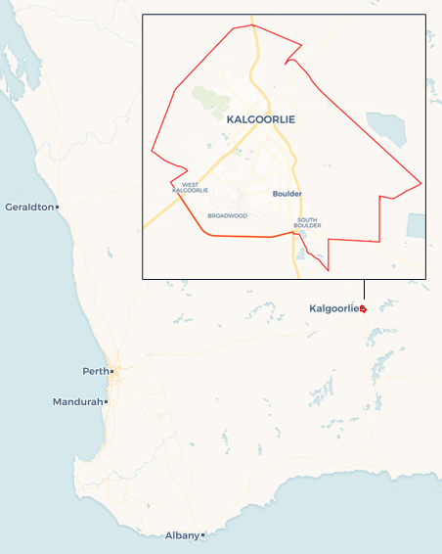
Local Jobs Plan
  - Kalgoorlie | WA | July 2026
Workforce Australia Local Jobs (Local Jobs) is a program that creates partnerships between business and communities to meet local workforce needs, thereby improving employment outcomes.
Local Jobs operates in all 51 Employment Regions in Australia.

Local Jobs Overview

Local Jobs Plan
Each Employment Region has a Local Jobs Plan which outlines the labour market challenges in the region and the strategies to address these challenges.

Job Coordinators
Each Employment Region has a dedicated Job Coordinator who leverages existing resources, supports local labour markets through structural adjustments and retrenchments, and creates opportunities for collaboration between business and communities.

Local Jobs and Skills Taskforce
Each Employment Region has its own taskforce that meets regularly with the Job Coordinator to develop an understanding of challenges in the region and implement solutions. The taskforce is comprised of representatives from the region.

Local Jobs, Local People Grant
The Local Jobs, Local People grant funds activities that help people into ongoing employment or training. Activities must support local labour market needs.
Explore labour market insights for the
Kalgoorlie Employment Region

Local labour market challenges

- The mining and resources sector continues to absorb a large portion of the available workforce creating significant labour shortages in other essential industries such as hospitality, accommodation services, childcare, health, aged care and disability.
- Kalgoorlie’s workforce is characterised by high mobility and frequent turnover, particularly in industries outside of mining.
- Long term unemployed with entrenched barriers, including low literacy and numeracy levels particularly for Youth and First Nations Australians.
- First Nations Australians experiencing employment disparities.
- Challenges related to lack affordable housing options, limited childcare services, transport options, homelessness, limited work experience, absence of soft skills, justice system involvement, generational unemployment and substance misuse.
- Registered Training Organisations in the region face challenges in recruiting and retaining qualified trainers.

Local priorities

Priority 1 – Business and industry engagement

What are our challenges?

Local businesses are facing increasing difficulty in attracting and retaining skilled workers, largely due to the rise of fly-in fly-out employment, mining wages, conditions and the migration of talent to larger metropolitan areas such as Perth. This creates an opportunity to utilise the local caseload and develop them to fill industry need.

How are we responding?
- We are collaborating with Kalgoorlie key industry bodies to identify workforce challenges and promote programs that support both sustainability and community employment outcomes.
- We are curating and distributing a bi-monthly newsletter that has localised content ensuring employers are informed about current labour market trends, workforce demands and available business support tools.
- We are updating the business and industry sectors with labour market trends to build long term career pathways and stable employment relationships.
- We are working closely with stakeholders to promote grant opportunities and available support practises to create opportunities for long term unemployed.
- We are deepening our engagement with businesses to expand culturally safe employment opportunities.
- We are partnering with employers to explore mentoring practises to support new employees as they integrate into the workforce.

Priority 2 – Pathways into local industries with labour shortages

What are our challenges?

Kalgoorlie faces ongoing challenges in delivering training that aligns with local industry needs. Limited qualified trainers, course availability, and low awareness of existing programs restrict access to upskilling, particularly for key sectors like aged care, hospitality, trades and childcare.
How are we responding?
- We are working with Registered Training Organisations, TAFEs and employers to align course offerings with current and emerging industry demand.
- We are promoting flexible delivery models, including mobile training units, on-site learning and blended formats to reach remote and disengaged learners.
- We are raising awareness of available training pathways through community outreach, expos and digital campaigns.
- We are engaging with businesses, local organisations and community members to investigate long term childcare strategies.
- We are exploring short term solutions and tailored support with Workforce Australia Employment Services Providers to address entrenched barriers in key sector employment markets including aged care, disability support, childcare and mining.
- We are collaborating with the broader Kalgoorlie community and industry sectors to develop strategies addressing homelessness, affordable housing, and living options, with the aim of removing barriers to relocation and housing that directly impact individuals’ ability to secure and sustain employment.

Priority 3 – Effective engagement with cohorts on education training and other pathways

What are our challenges?

Kalgoorlie has a diverse and transient population, with many participants moving frequently, making it harder to stay connected with existing supports. Awareness of available support programs including post-employment assistance is low. By promoting these programs there is an opportunity to engage these cohorts to address barriers.
How are we responding?
- We are promoting entry level programs and industry specific workshops offered by local stakeholders to boost engagement.
- We are working with Workforce Australia Employment Services Providers to identify challenges that cohorts face and promote pathways to local support services to address their needs.
- We are working with stakeholders to provide accurate information regarding the available post placement supports.
- We are connecting employment services providers to driver training and mentorship programs so participants can gain access to a driver’s licenses and streamline the process for obtaining ID.
- We are connecting employment service providers to key social service providers to support cohorts facing complex and interrelated challenges that may prevent individuals from entering or re-entering the workforce, especially in sectors with immediate labour needs.
- We are working with Workforce Australia Employment Services Providers to deliver foundational literacy, numeracy and digital training and skills gap workshops, particularly among long term unemployed individuals and those who have not completed secondary education.
- Engaging with local businesses to explore inclusive and creative recruitment strategies, highlighting the potential of long-term unemployed individuals, youth and First Nations people and promoting pathways to diversify the workforce.

Priority 4 – Promote inclusive employment and cultural safety for First Nations people

What are our challenges?

First Nations peoples bring rich cultural knowledge, leadership, and strong community connections to the workplace. There is an opportunity to further strengthen inclusive employment by embedding culturally safe practices and increasing First Nations representation at all levels, including leadership. Through intentional, targeted and collaborative approaches, organisations can create environments where First Nations peoples are supported to thrive and contribute fully.

How are we responding?
- We are partnering with Aboriginal Community-Controlled Organisations to bring awareness to First Nations participants of opportunities by hosting roundtable discussion, community outreach, expos, creative initiatives and digital campaigns.
- We are collaborating with Aboriginal Community-Controlled Organisations to develop community led initiatives to create inclusive pathways to meaningful employment opportunities, training and self-belief.
- We are providing awareness to employers and employment service providers to undertake ongoing cultural awareness and safety training to create inclusive and respectful workplaces.
- We are developing an awareness of the available support services; community organisations and programs focused on assisting to address challenges for First Nations participants.
- We are highlighting First Nations professionals who inspire others and have agree to share their success stories to transform their lives, overcome barriers and enter the workforce.

Want to know more?
- Contact Merri Best, Kalgoorlie Job Coordinator at Meredith.Best@dewr.gov.au
- Visit Local Jobs or Workforce Australia

