

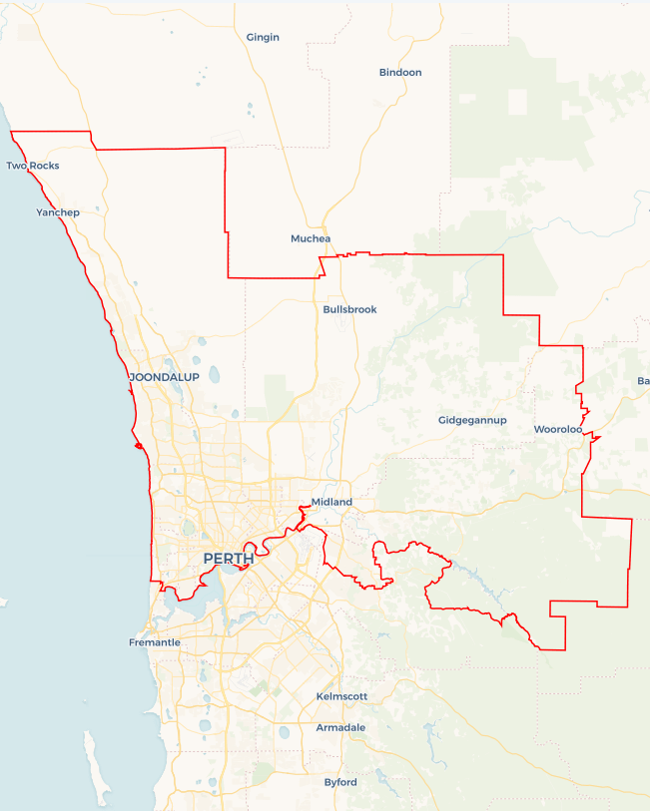Local Jobs Plan

Perth North ****Employment Region**** | WA | ****May 2025****

Workforce Australia Local Jobs (Local Jobs) is a program that supports tailored approaches to accelerate   
reskilling, upskilling and employment pathways in response to current and emerging local workforce needs.

## Local Jobs elements

### Local Jobs Plan

The Local Jobs Plan sets out the skills and employment challenges and priorities of the region, and associated strategies that will drive the design and implementation of activities to be implemented to address these challenges.

### Job Coordinators

Job Coordinators and Support Officers support the delivery of the program by bringing together key stakeholders including businesses, employment services providers, higher education and training organisations.

### Local Jobs and Skills Taskforce

Each Employment Region has its own Taskforce. Representatives include local stakeholders who have demonstrated experience in upskilling, reskilling, and an ability to represent, connect and collaborate with others in the region to meet labour market needs.

### Program Funds

The Employment Region’s Local Initiatives Fund enables targeted local investments that support local labour market functioning. Further, from 2025/26, a central grants-based fund will respond to local needs and help progress broader employment service reform objectives.

Explore labour market insights for the  
[Perth North](https://www.jobsandskills.gov.au/data/employment-region-dashboards-and-profiles/monthly-labour-market-dashboards) Employment Region

## Local labour market challenges in the region

* An ageing population is driving demand for staff in the care and support sector. Attracting people to this sector is a major, ongoing challenge.
* Known and predicted skills shortages in multiple sectors, including construction, retail, care and technology. Volatility in the retail sector is impacting commencement in the sector.
* Historically low rates of housing availability are impacting the labour market and simultaneously increasing experiences of housing insecurity. This is further impacted by the current cost of living crisis.
* There are difficulties attracting people to the primary industry sector, which is facing shortages due to a reduction in generational farming. This is a result of young people seeking different career opportunities.

## Local jobs and skills priorities and strategies in the region

### Priority 1 – Address challenges and disincentives to work

#### What are our challenges and opportunities?

#### Complex challenges to employment include housing insecurity, transport challenges and mental health illness. Support to develop teamwork, soft skills, resilience and motivation, combined with provision of on-the-job mentoring support and wrap around services, are crucial supports in building employment pathways for the most challenged individuals.

#### How are we responding?

* We are working with state government departments and specialist organisations to connect into existing programs and develop initiatives that support people to break down challenges that lead into employment opportunities.
* We are working with specialist organisations and programs to understand the issues and experiences surrounding mental health to develop support mechanisms for individuals.
* We are developing cohort specific strategies to better prepare individuals for the labour market.
* We are working with local businesses to create employment opportunities aligned with the labour needs through a focus on reducing challenges to employment.
* We are partnering with employers to promote flexible work options that accommodate individuals facing personal challenges, such as caregiving responsibilities or mental health conditions.
* We are working with specialist providers delivering financial literacy programs to help individuals manage costs associated with housing, travel and mental healthcare services.
* We are working with Social Enterprises to promote employment and training opportunities, address social challenges and provide supportive structures for people to return to work.

### Priority 2 – Boost apprenticeship and traineeship commencements to match areas of industry need

#### What are our challenges and opportunities?

Improving the collaboration with businesses and industry to address the skills requirement through training, upskilling, reskilling, apprenticeships and traineeships aligned with local employment needs and future infrastructure construction.

#### How are we responding?

* We are promoting emerging employment, education and training opportunities for clean energy careers.
* We are promoting careers linked to traineeships and apprenticeships to increase the workforce; with a focus on sectors experiencing skills shortages or listed on the Occupational Shortage List.
* We are targeting engagement with businesses to explore and better understand vacancies and skill gaps.
* We are identifying and exploring employment opportunities for short, medium and long-term growth in civil and residential construction.
* We are working with new governing bodies to promote and create opportunities for emerging role and career opportunities.

### Priority 3 – Activate Industry

#### What are our challenges and opportunities?

We want to activate industry to design and drive change by taking a strong role in workforce development, including identifying and promoting career pathways. By taking a ‘people first’ approach to workforce development, we aim to support the upskilling of individuals and the recognition and identification of transferable skills and knowledge as building blocks for future employees. This includes working with women and mature age individuals to support their re-entry to the workforce.

#### How are we responding?

* We are working with industries to co-design employment pathways and job opportunities to attract people into careers.
* We will hold industry forums to gain real time insights into labour markets, employment challenges and develop responses to support industry needs.
* We are partnering with employers to demystify and address preconceptions around the potential source of workers, stereotypes and unconscious bias. As part of this work, we promote and recognise the transferable skills and industry knowledge of mature age and culturally and linguistically diverse individuals.
* We are strengthening relationships with First Nations businesses to foster employment opportunities with organisations that value cultural safety.
* We are working with industry to encourage greater workforce participation from underrepresented groups – including women in trade, First Nations peoples and people with disability – to fill labour gaps.

### Priority 4 – Largest Employing Industries

#### What are our challenges and opportunities?

Healthcare and social assistance, construction, mining, retail trade and professional scientific and technical are the largest employing industries across the region. All are experiencing labour shortages, with some further challenged by high turnover, growth and/or long-term training requirements for qualifications (such as nursing and electrical qualifications). An ageing population is driving demand in the care and support sector, combined with changes in service delivery to include more in-home care.

#### How are we responding?

* We are exploring how to recruit, support and engage staff in roles to support each sector.
* We are promoting employment, education and training opportunities for each sector.
* We are working with state government departments to connect into existing programs and to develop initiatives that support individuals into employment opportunities.
* We are working with industries and businesses to create workforce attraction and retention strategies where appropriate. This includes supporting entrepreneurship with a focus on new and emerging opportunities in the region.
* We are working with industry, such as aged care and construction, to attract younger workers and debunk perceived job conditions, career progression concerns and physical demands.
* We are working with specialist organisations and programs in automation and digitalisation in industries such as mining and emerging technologies to address shifting workforce needs, requiring targeted upskilling and reskilling initiatives.

## Want to know more?

* Contact: Jodie Dutton, Perth North WA Job Coordinator: [pn@employmentfacilitatorwa.com.au](mailto:pn@employmentfacilitatorwa.com.au)
* Visit: [Local Jobs](https://www.dewr.gov.au/local-jobs) or [Workforce Australia](https://www.workforceaustralia.gov.au/)