

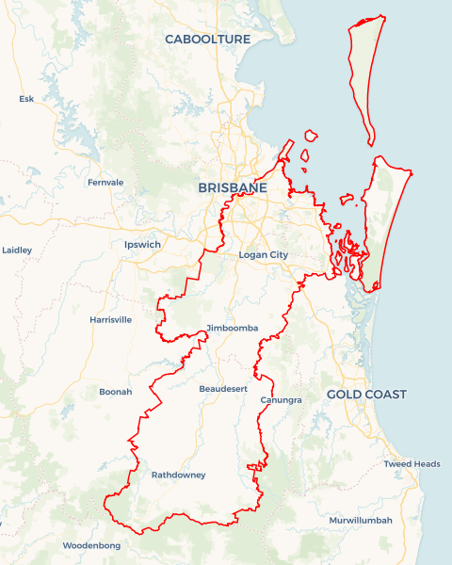Local Jobs Plan

Brisbane South East ****Employment Region**** | QLD | ****July 2025****

Workforce Australia Local Jobs (Local Jobs) is a program that supports tailored approaches to accelerate   
reskilling, upskilling and employment pathways in response to current and emerging local workforce needs.

## Local Jobs elements

### Local Jobs Plan

The Local Jobs Plan sets out the skills and employment challenges and priorities of the region, and associated strategies that will drive the design and implementation of activities to be implemented to address these challenges.

### Jobs Coordinator

Jobs Coordinators and Support Officers support the delivery of the program by bringing together key stakeholders including businesses, employment services providers, higher education and training organisations.

### Local Jobs and Skills Taskforce

Each Employment Region has its own Taskforce. Representatives include local stakeholders who have demonstrated experience in upskilling, reskilling, and an ability to represent, connect and collaborate with others in the region to meet labour market needs.

**Program Funds**   
The Employment Region’s Local Initiatives Fund enables targeted local investments that support local labour market functioning. Further, from 2025/26, a central grants-based fund will respond to local needs and help progress broader employment service reform objectives.

## Local labour market challenges in the region

* Projected shortfalls of skilled labour in existing, growth and emerging sectors, including health and community care services, manufacturing, construction, retail, hospitality and tourism, and green energy.
* Diversity of multiple small labour markets with varying industry bases and workforce needs and cohorts including First Nations people, people with disabilities, people from culturally diverse backgrounds, mature ageworkers, and youth, who require specific tailored employment solutions. Gender equity, within these labour markets, is also a focus.
* Housing, transport, costs of living pressures, domestic and family violence, and undiagnosed mental health conditions make it difficult for businesses to attract, engage and retain workers.
* Meeting future demand for workforce for major projects, including the 2032 Brisbane Olympics, with some venues located in the Brisbane South East Employment Region, as well as Logan to Gold Coast Fast Rail Project and various other significant infrastructure and civil projects. This includes demand for First Nations, culturally diverse, youth, female and mature aged employees as part of major project workforce commitments.

## Local jobs and skills priorities and strategies in the region

### Priority 1 – Local workforce activation

#### What are our challenges and opportunities?

* To work with key stakeholders to identify short and medium-term employment opportunities in existing, emerging and future industry in the Brisbane South East Employment Region.
* To develop place-based strategies to meet local employment demand. This includes identifying wrap around servicing opportunities focusing on key groups including First Nations people, people with disabilities, people from culturally and linguistically diverse backgrounds, mature age workers, and youth.

#### How are we responding?

* We are developing strategies to identify suitable individuals in the Brisbane South EastEmployment Region to work in existing, emerging and future industries.
* We are developing programs in partnership with key stakeholders to provide tailored support such as mentoring, for the identified target groups and industry sectors.
* We are creating, promoting, and enhancing training and development pathways for suitable individuals to gain employment in these industry sectors.
* We are consulting with industry representatives, businesses and associations to develop and refine strategies and deliver workshops to industry and employment services providers, to assist in recruitment, retention and capacity building for their sector, including facilitating knowledge of government support, to ensure sustained employment and a reduction in staff turnover.
* We have established a First Nations Employment Action Group and a Multicultural Employment Action Group with key community stakeholder membership to focus on addressing and overcoming challenges to employment such as access to jobs, access to training, negative employer perceptions and low language, literacy and numeracy levels that exist within the diverse population residing in Brisbane South East.
* We have developed an employment services provider Leaders group to develop solutions to address existing and emerging participant challenges, & service delivery issues to enable increased participation, in the labour market of participants managed under Workforce Australia.

### Priority 2 – Promotion of pre–employment initiatives, training, upskilling and pre-apprenticeship / apprenticeship opportunities to align with projected skills shortages

#### What are our challenges and opportunities?

* The Brisbane South East Employment Region is experiencing a shortage of work ready, skilled, qualified workers and tradespeople to meet current and projected future demand.
* To increase employer awareness and take up of apprenticeships and traineeships to meet industry demand, in existing and emerging industries operating, or working within the Brisbane South East Employment Region labour market
* To identify new opportunities in the Brisbane South East Employment Region, including those in the advanced manufacturing, hydrogen/clean energy, and technical sectors.
* To collaborate with employment services providers, schools, and other stakeholders to develop employment pathways that align with these emerging industries and job markets.
* To identify future major projects in the region and engage with government agencies and contractors to identify social impact commitments and skillsets needed to meet the labour requirements of these projects, including promotion of apprenticeship and traineeship options.

#### How are we responding?

* We are promoting the benefits of hiring work ready participants, graduates, apprentices and trainees, through various forums and direct engagement with businesses.
* We will develop a ‘train and retain’ strategy for newly skilled participants, apprentices and trainees to ensure greater retention of people within industry and skills shortage areas.
* We are identifying local employment and skill needs associated with preparation for the 2032 Olympic Games and emerging industries in Brisbane South East Employment Region by participating in sectorial workforce development groups.
* We are sharing job vacancy opportunities in these sectors to ensure matching against businesses’ specifications.
* We have created the Brisbane South East Local Jobs Program Bulletin Board to actively promote employment pathways to stakeholders who assist those looking for work, including employment services providers, schools, training providers and community organisations.

### Priority 3 – Bridging the gap between people’s skills and business requirements

#### What are our challenges and opportunities?

* To understand employer and industry requirements and expectations in relation to their existing, emerging and future workforce needs.
* To understand the gaps in skills and attributes of the available workforce.
* To develop and co-design pre-employment preparation programs to support participants to better meet the needs of businesses.
* To identify the required skills and pathways to skill, re-skill and up-skill participants to meet demand for existing, emerging and future industry.

#### How are we responding?

* We engage with local businesses and industry to identify their requirements and specifications for job opportunities.
* We encourage local business to consider what skillsets are absolutely necessary for a productive worker where there is a shortage of skilled labour and tradespeople.
* We are engaging with employment services providers to appropriately match individuals against the job requirements.
* We are assisting to develop and co-design pre-employment programs with input from businesses and industry.
* We are identifying and negotiating with Registered Training Organisations who have pre-approval for funding to deliver these programs. We work closely with proponents applying for state or commonwealth funding.
* We are engaging with businesses in the selection of participants and delivery of programs.
* We evaluate the effectiveness of programs through participant engagement, completion and consequent employment.
* We are promoting programs and supports that will assist businesses in expanding working hours and provide opportunities for local unemployed people.
* We are identifying the local ‘hidden’ workforce and encourage businesses to use the vacancy filling services of the employment services provider network.
* We are identifying future major projects and will engage with contractors and sub-contractors to source local job opportunities and understand the social impact commitments of major projects.
* We will develop and deliver retention and capacity workshops to businesses and employment services providers to ensure quality job matching, leading to sustained employment and reduced turnover for businesses.
* We are developing in partnership, with employment services providers, community organisations and government, various industry specific and general, job expos, that have proven to be successful in providing an alternate recruitment method, and lead to immediate employment based person to person interaction.
* Where skill gaps are identified with the potential workforce we will develop and co-design pre-employment programs to meet identified employment needs.
* Sourcing funding for pre-employment programs from all levels of government and business / industry.
* Engaging employment services providers in monitoring and evaluating the success of pre-employment programs.
* Engaging businesses in presentations and virtual presentations on their job vacancies to the employment services provider group.
* Engaging with employment services providers to analyse their caseloads by occupation and sub-region to assist in identifying any mismatch between business requirements and available unemployed individuals.

## Want to know more?

* Contact: Simon Nicholls, Brisbane South East Jobs Coordinator: [simon.nicholls@mylocaljobsprogram.com.au](mailto:simon.nicholls@mylocaljobsprogram.com.au)
* Visit: [Local Jobs](https://www.dewr.gov.au/local-jobs) or [Workforce Australia](https://www.workforceaustralia.gov.au/)