

Local Jobs Plan

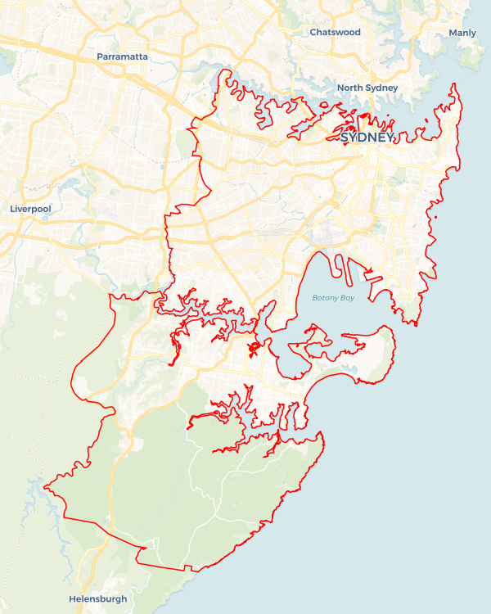Sydney East Metro ****Employment Region**** | NSW | ****September 2025****

Workforce Australia Local Jobs (Local Jobs) is a program that creates partnerships between business

and communities to meet local workforce needs, thereby improving employment outcomes. Local Jobs

operates in all 51 Employment Regions.

## Local Jobs Overview

### Local Jobs Plan

Each Employment Region has a Local Jobs Plan which outlines the labour market challenges in the region and the strategies to address these challenges.

### Job Coordinators

Each Employment Region has a dedicated Job Coordinator who leverages existing resources, supports local labour markets through structural adjustments and retrenchments, and creates opportunities for collaboration between business and communities.

### Local Jobs and Skills Taskforce

Each Employment Region has its own taskforce that meets regularly with the Job Coordinator to develop an understanding of challenges in the region and implement solutions. The taskforce is comprised of representatives from the region.

### Local Jobs, Local People Grant

The Local Jobs, Local People grant funds activities that help people into ongoing employment or training. Activities must support local labour market needs.

Explore labour market insights for the   
[Sydney East Metro](https://www.jobsandskills.gov.au/work/employment-region-dashboards-and-profiles/monthly-labour-market-dashboards)  Employment Region

## Local labour market challenges in the region

* There is high demand for entry-level workers in the following industries: accommodation and food services; health care and social assistance; and retail trade.
* There are increasing skills shortages in the following industries: construction; healthcare and social assistance; and accommodation and food services.
* There has been a decrease in employer engagement with Workforce Australia Employment Services Providers.
* Completion rates for apprenticeships and traineeships in the region remain a persistent challenge, particularly in non-trade areas.
* There are ongoing employment challenges for First Nations people, people from multicultural communities, and disengaged young people. These include limited social support, sense of displacement, and recovery from trauma or discrimination.
* The number of people classified as very long-term unemployed has increased.

## Local jobs and skills priorities and strategies in the region

### Priority 1 – Creating opportunities for collaboration that support local business

#### What are our challenges and opportunities?

Employer engagement with Workforce Australia Employment Services Providers is low. A key priority for the Sydney East Metro Employment Region is to foster stronger collaboration between employers and Workforce Australia Employment Services Providers to co-design training pathways that equip job seekers with the practical skills needed for roles in priority industries.

#### How are we responding?

* We are fostering collaboration through industry networking events and forums that promote inclusive hiring and connect businesses with resources to support diverse workforce development.
* We are delivering recruitment drives, employment expos, training programs and targeted information sessions that connect job seekers with employers and highlight alternative career pathways, particularly for priority cohorts.
* We are partnering with local stakeholders to co-design industry-specific pathways, including qualifications, short courses, micro-credentials, and bespoke training aligned to current regional labour market needs.
* We are supporting entrepreneurship by linking individuals and small businesses with emerging opportunities through tailored skills development pathways.
* We are leveraging the Local Jobs and Skills Taskforce to develop recruitment models that address local skills shortages through collaboration between employers, training providers, and Workforce Australia Employment Services Providers.

### Priority 2 – Hospitality and tourism

#### What are our challenges and opportunities?

The accommodation and food services industry experiences high turnover, seasonal and inconsistent hiring practices, and limited vacancy visibility due to informal recruitment channels. Expectations that candidates must have prior experience create further challenges for entry-level job seekers. Partnerships with industry peak bodies provide opportunities to connect employers with job seekers through structured pathways and targeted training solutions.

#### How are we responding?

* We are collaborating with stakeholders across the region to encourage job seekers to choose the industry as a career option while directly engaging with employers in the Sydney East Metro Employment Region.
* We are partnering with local organisations to deliver a range of training options, including full qualifications, short courses, and employer-specific micro-credentials, aligned with regional labour market demand. We also facilitate expos and open days that connect individuals with training providers, employers, and industry bodies to support upskilling and reskilling.
* Through our Local Jobs and Skills Taskforce, we are working to develop industry-specific recruitment models tailored to skills shortages. These models are designed to meet business needs and promote collaboration with employment services and training providers across the region.

### Priority 3 – Multicultural communities

#### What are our challenges and opportunities?

Workforce Australia Employment Service Providers in the region report that most of their caseloads come from multicultural communities, who often experience challenges such as limited English, unrecognised overseas qualifications, and unfamiliarity with Australian workplace norms. Many people in this cohort also do not have a driver’s licence or the confidence to drive on Australian roads, which limits their access to training and employment opportunities. Targeted supports, such as culturally tailored employment services, language and mentoring programs, driving lessons, and recognition pathways for international skills, can greatly improve employment outcomes.

#### How are we responding?

* We are collaborating with stakeholders across the region to raise awareness of employment opportunities and promote the benefits of hiring people from multicultural communities.
* In partnership with local organisations, we coordinate a variety of training options—including full qualifications, short courses, and employer-specific micro-credentials aligned with current labour market demand. We also facilitate employment expos connect individuals with training providers, industry stakeholders, and potential employers.
* Through our Jobs and Skills Taskforce, we are developing cohort-specific recruitment models tailored to areas of skills shortage. These models align with the strengths of target cohorts and are customised to meet individual business needs, enabling closer collaboration with employment services and training providers.
* We support both individuals and businesses to build entrepreneurial capability by leveraging connections across the Sydney East Metro network, helping them respond to new and emerging economic opportunities.

### Priority 4 – First Nations people

#### What are our challenges and opportunities?

The unemployment rate is disproportionately high for First Nations people in the region.

#### How are we responding?

* We are coordinating a range of bespoke training, upskilling and mentoring opportunities that are linked to current labour demands in the region. This will provide local First Nations communities opportunities to connect with local employers. We are undertaking stakeholder engagement regarding the development of industry-specific employment and training models for First Nations people to better match them with suitable jobs.
* We are supporting First Nations people to seek their desired career paths through training, direct recruitment opportunities and, job matching with inclusive and culturally safe workplaces.
* We hold regular Indigenous Advisory Committee meetings to workshop ways to break down structural challenges for First Nations people.

### Priority 5 – Youth

#### What are our challenges and opportunities?

There are high numbers of young people in the region who are not engaging in education or employment. Providing support early in their career journey helps set them up for long-term success and contributes to the region’s economic growth and development.

#### How are we responding?

* We are connecting youth services to vocational programs that support young people towards job-readiness.
* We are working with local stakeholders to design and deliver pre-employment programs to support disengaged young people to take up apprenticeships or traineeship in priority industries.
* We are creating skills development pathways aligned with priority industries to support youth entrepreneurship.
* We are collaborating with local governments to deliver youth careers and employment expos, ensuring there are opportunities for young people to connect with industry stakeholders.

## Want to know more?

* Contact: Kelly Hayes, Sydney East Metro Employment Region Job Coordinator: [Kelly.Hayes@SEMlocaljobs.com.au](mailto:Kelly.Hayes@SEMlocaljobs.com.au)
* Visit: [Local Jobs](https://www.dewr.gov.au/local-jobs) or [Workforce Australia](https://www.workforceaustralia.gov.au/)