Targeted Compliance Framework

Making sure it is working well

   | The Australian Government  - Department of Social Services wrote this.  We say DSS for short.  - Department of Employment and Workplace Relations  We say DEWR for short.  When you see the word we it means DSS and DEWR.
 | We wrote this in an easy to read way.  We use pictures to explain some ideas.
 | We have some words in bold.  This means the letters are thicker and darker.  These are important words.
 | This is an Easy Read summary of another document.  This means it has the most important ideas.
 | You can ask for help to read this document.  You can ask  - A friend  - Family members  - A support person.

Contents

Making sure the Targeted Compliance Framework is working well | 5
What we have done so far | 9
Decisions made so far | 11
Support | 16
What is next | 17

Making sure the Targeted Compliance Framework is working well

 | We have laws for  - People who get Centrelink money for not having a job  We call this job seeker.
 | - The things they need to do to get their Centrelink money.  We call these activities.  Laws are rules for how we live.
 | The Targeted Compliance Framework is the rules we have for people who do not do their activities without a good reason.  We call it TCF for short.
 | If people do not do their activities they can have their Centrelink money  - Stopped  - Changed.
 | We are doing a review of this law.  A review is when you check what  - Works  - Needs to change.
 | We have made sure the review is  - Done in a fair way  - Following the law.
 | We have an independent person checking our computer systems.  Independent means separate to the government.
 | This means we are checking if our computer systems are following the rules.
 | We do not think our computer systems are following the rules at all times.
 | We are also looking to see if decisions are  - Being made properly  - Following the law.
 | We will keep updating information to show what  - Decisions we are making
 | - We have done to fix the issues.

What we have done so far

You can read about what the Secretary of DEWR has said about the issues on the website.

The Secretary is a leader for a government department.

Every government department has a different leader.

 | You can go to the website.  www.aph.gov.au/-/media/Estimates/eet/add2425/DEWR_-_Opening_Statement.pdf?la=en&hash=40DD83352878CD595477B88C6C09FBE513E3ABDA  It is not in Easy Read.
 | We will keep telling you what we are doing to fix the issues.  You can go to our website.  www.dewr.gov.au/assuring-integrity-targeted-compliance-framework/announcements/assuring-integrity-targeted-compliance-framework  It is not Easy Read.

Decisions made so far

 | We have listened to the people doing the reviews.  We have made the decision to stop some parts for now.
 | The reviews have helped us find out that some parts of our computer system are not following  - The law  - Our policies.  Policies are plans for how to do things.
 | When the computer system does not follow the rules people might have their Centrelink payments  - Stopped  - Changed.  This might happen when it is against the rules.
 | We want to stop this from happening.
 | You can go to our website to see  - What you need to do  - Any decisions we make.  www.dewr.gov.au/resources/assuring-integrity-targeted-compliance-framework
 | On 24 September 2024 DEWR stopped for now cancelling Centrelink money for people who are not doing their activities on purpose.  They have 4 weeks to start doing them again.  This is called a reconnection requirement.
You can read more about this decision on our website.

www.dewr.gov.au/assuring-integrity-targeted-compliance-framework/decision-pause-cancellations-peoples-social-security-participation-payments-not-meeting-reconnection/information-job-seekers

It is Easy Read.
 | In July 2024 we stopped for now cancelling Centrelink money for people who do not do the activities.
You can read more about this decision on our website.

www.dewr.gov.au/assuring-integrity-targeted-compliance-framework/decision-pause-payment-cancellation-decisions-due-persistent-mutual-obligation-failures/information-job-seekers

It is Easy Read.
 | On 5 March we stopped for now cancelling Centrelink money if people  - Choose to leave their job.  This can be called unemployment failure.
 | There is a set amount of time that we do not pay Centrelink money for unemployment failure.
You can read more about this decision on our website.

www.dewr.gov.au/assuring-integrity-targeted-compliance-framework/decision-pause-cancellations-peoples-social-security-participation-payments-and-impose-nonpayment/information-job-seekers

It is Easy Read.
 | On 6 March 2025 we stopped for now changes to Centrelink money if people do not do the activities.  - Choose to leave their job
You can read more about this decision on our website.

www.dewr.gov.au/assuring-integrity-targeted-compliance-framework/decision-pause-reductions-peoples-social-security-participation-payments-due-persistent-mutual/information-jobseekers

It is Easy Read.

Support

 | You might  - Have questions
 | - Be worried
 | - Want to make a complaint.  Complaints are when you tell someone they have not done a good job.  Everyone has the right to make a complaint.
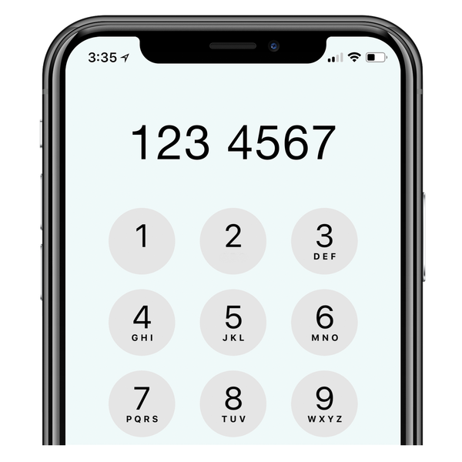 | You can call the DEWR National Customer Service Line  1800 805 260

What is next

 | We will keep working to make sure the decisions  - Follow the law  - Are fair.
If we do not believe the decisions

- Follow the law
- Are fair

We will stop them right away.
We need to make sure that any changes to

- The way we do things
 | - Our computer systems
- The law

Are done in the right way.
 | We are working on this.

Images in this Easy Read must not be used or copied without permission

