


Service Delivery Plan

The APM Employability Skills Training (EST) Service Delivery Plan sets out our commitments to employers and industry stakeholders, highlighting the unique service you can expect from us.

APM’s EST program will build Job Seeker’s employability skills that are relevant to the workplace. Job Seekers will develop their knowledge, understanding and experience through the delivery of industry focused training in a work-like environment to create local employment pathways.

APM commits to:
- Working with you to tailor programs ensuring they equip participants to best fit your staffing needs.
- Give you access to our job ready participants through arranged workplace visits as a part of our Industry Awareness Experiences to see if they are the right fit for your business.
- Where eligible, we will assist you to access a Wage Subsidy when you hire a participant.
- If your Employee is a new Apprentice or Trainee, we will connect you to our network of Apprenticeship Support and Group Training Providers.
- We will tailor recruitment packages included pre-employment training pre-screening, and support you with onboarding new staff members.
- Give you access to assistance and resources 24/7 via Employable Me, our online platform where you can post your job vacancies and find potential candidates who are ready to work.
- Providing local training in Warrnambool and Colac ensuring access to local job seekers.
- Building employability skills focussed on the local labour market. In the South Coast of Victoria Employment Region, this may include jobs in highest growth and largest employing industries of Health Care & Social Assistance, Agriculture, Renewable Energy, Retail Trade, Manufacturing, Accommodation & Food Services, and Education & Training.

Jobs and Skills
APM can benefit employers by providing priority access to services from our partners.
- Employable Me can help match your vacancies to people who are looking for work now. Through Employable Me, you get the tools, guides and support to connect with active participants. Learn more about Employable Me here www.employableme.com

- Innovative Training and Recruitment (RTO ID 40206) provides access to accredited learning to develop role and industry specific skills. Learn more about Innovative Training and Recruitment here www.itandr.com.au

- Management Consultancy International (RTO ID 91088) provides access to accredited learning to develop role and industry specific skills. Learn more about Management Consultancy International here www.mci.edu.au

- Industry endorsement APM consults with relevant industry bodies to endorse our training to ensure it meets the current needs of industry

About APM
APM started in 1994 as a small team in Perth, Western Australia, looking to provide better vocational rehabilitation for injured workers so they could recover their health and stay in their jobs.
Today we’re an international human services provider with more than 1,000 locations across Australia,
New Zealand, United Kingdom, Europe, North America, and Asia.
Our purpose drives us. It’s why we come to work. It’s why we continue to grow. It’s how
we inspire excellence and exceptional service with everyone we meet.
Our services focus on enhancing an individual’s employability, health and wellbeing, and
social and economic participation in their community.
We take great pride in empowering people to realise their ambitions and aspirations through
sustainable employment, independence, better health and wellbeing, and increased social
participation.
Each year, APM supports more than 1 million people of all ages to live a better quality
of life.

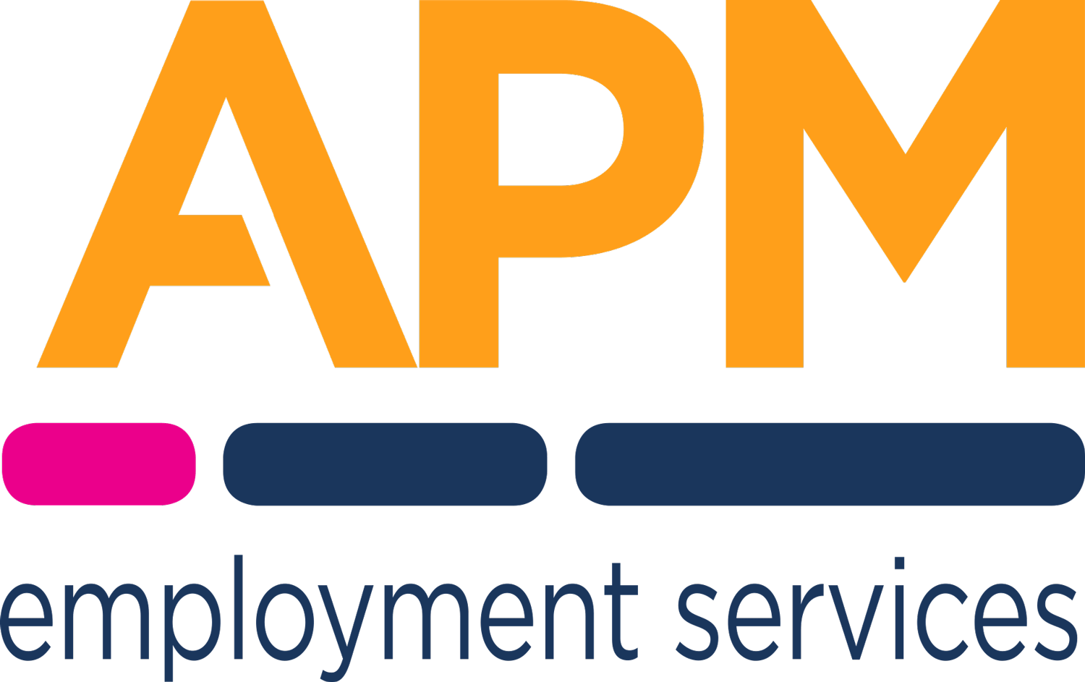
Let’s get to work

