

Jobactive
Employment Services Outcomes Report
January 2017 – December 2017

Contents
Key Observations - JANUARY 2017 to DECEMBER 2017 3
What is jobactive? 4
jobactive 5
Beginning in jobactive 6
jobactive tailor’s assistance to the individual 7
Services and assistance delivered to job seekers 8
Getting a job 9
Keeping a job – Paid outcomes 10
Work for the Dole and other Activities 11
Leaving jobactive 13
Employment following jobactive assistance 14
Outcome measures and definitions 17

ISBN: 978-1-76051-572-0

Key Observations - JANUARY 2017 to DECEMBER 2017
49.5 per cent of job seekers participating in jobactive between 1 January 2017 and 31 December 2017 were in employment three months later.
- 59.1 per cent of Stream A job seekers were employed three months after participating in jobactive,
- 43.5 per cent of Stream B job seekers were employed three months after participating in jobactive,
- 27.2 per cent of Stream C job seekers were employed three months after participating in jobactive.
Of the job seekers who were employed:
- 23.3 per cent were in full-time employment,
- 26.1 per cent were in part-time employment,
- 54.6 per cent were in casual employment.
More than 370,000 job placements were recorded between 1 January 2017 and 31 December 2017 with:
- 65.0 per cent leading to a paid 4 week outcome,
- 58.0 per cent leading to a paid 12 week outcome,
- 41.0 per cent leading to a paid 26 week outcome.
Survey data demonstrates that during the 1 January 2017 and 31 December 2017 period:
- 35.4 per cent of job seekers were employed three months after exiting a training activity,
- 25.4 per cent of job seekers were employed three months after exiting a Work for the Dole activity,
- 26.4 per cent of job seekers were employed three months after exiting a Voluntary Work activity.
Job seekers report that participation in Work for the Dole improved their soft skills:
- 71.7 per cent reported it improved their communication skills.
- 73.4 per cent reported it improved their ability to keep to a routine,
- 74.9 per cent reported it improved their desire to find a job,
- 75.9 per cent reported it improved their ability to adapt to a new environment,

What is jobactive?
jobactive is the Australian Government’s way of helping more Australians into work. It is an employment program that connects job seekers to employers, and is delivered in over 1,700 locations across Australia.
The Department of Jobs and Small Business monitors what happens to job seekers in jobactive through the Post-Program Monitoring (PPM) surveys. These surveys measure a range of items such as a job seeker’s labour market status, and their satisfaction with various aspects of employment services.
This report describes the experiences of job seekers in jobactive, using information from the Department’s administration databases and the PPM surveys.
jobactive began on 1 July 2015 and replaced the previous employment services model, Job Services Australia.

jobactive
The Government, through the Department of Jobs and Small Business, contracts organisations across Australia to be the face of the jobactive program and to directly assist people into sustainable employment. These organisations are called providers.
Providers help job seekers in jobactive by providing assistance and advice to help progress them on their journey towards employment.
Providers do this by:
- helping people meet their participation requirements,
- assisting people to overcome personal barriers,
- helping people get work experience,
- helping people into training courses,
- assisting with résumés and interview techniques,
- providing advice on how to look for work,
- connecting people seeking jobs with employers.

How do you become a part of jobactive?
Generally, a job seeker will start in jobactive when they first apply for income support (such as Newstart or Youth Allowance). Some income support payments have conditions, and a job seeker has to participate in jobactive to meet them.
Some job seekers may not have to participate in jobactive, but may volunteer to participate in jobactive for up to 6 months. In the period January 2017 to December 2017, more than 545,000 job seekers were referred to jobactive.

Beginning in jobactive
A job seeker will start in jobactive by attending an initial appointment with their jobactive provider. The job seeker and the provider will agree on a job plan – a road map for the job seeker to progress towards employment.
Around 455,000 people across Australia commenced in jobactive between 1 January 2017 and 31 December 2017.
There is usually an increase in commencements early in the year, as many people leave school or university and enter the job market.
Figure 1: Number of job seekers commencing in jobactive by month
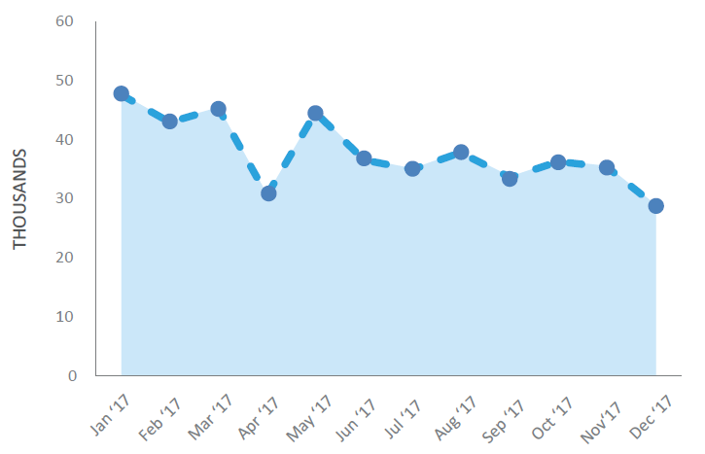

jobactive tailor’s assistance to the individual
Once a job seeker starts in jobactive, their barriers to employment are assessed using the Job Seeker Classification Instrument (JSCI), a questionnaire the job seeker and the Department of Human Services fill out together. Sometimes, an additional assessment is required, called an Employment Services Assessment (ESAt). This additional assessment helps to identify job seekers with additional barriers to employment who may benefit from more intensive support in Stream C.
Job seekers are allocated to one of three streams, based on their JSCI score and the kinds of barriers they are likely to face in obtaining employment. As at 31 December 2017 there were 704,221 job seekers participating in jobactive.
- Stream A job seekers are the most job ready. They comprise around 41.5 per cent of job seekers in jobactive. Volunteer job seekers receive services through Stream A for up to six months.
- Stream B job seekers face some barriers to employment (for example, language barriers), and require their provider to play a greater role to help them become job ready. Stream B job seekers make up 42.1 per cent of all job seekers.
- The most disadvantaged job seekers identified through the ESAt are assisted through Stream C, comprising 16.4 per cent of jobactive job seekers. Stream C job seekers have multiple and complex barriers that need to be addressed so that they can take up and retain a job. These may include physical and/or mental health issues, or low capacity to work.
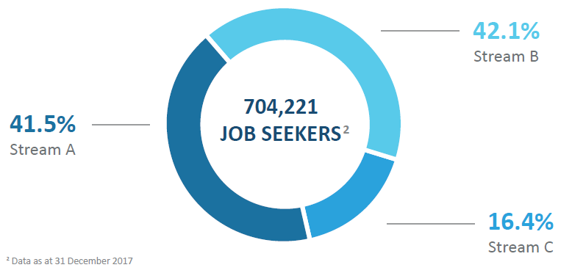

Services and assistance delivered to job seekers
Providers deliver assistance to job seekers based on their individual needs and their Stream. jobactive providers assist job seekers with their search to find and keep a job, such as providing advice or assisting with their resume, as well as helping them meet their participation obligations and overcome any vocational or non-vocational barriers to employment.
jobactive providers help job seekers to
Find and keep a job
- Develop a job plan
- Develop and write a résumé
- Prepare for job interviews
- Gain access to computers
- Get referrals to job vacancies
- Develop skills that local employers need
- Access wage subsidies
Overcome vocational and non-vocational barriers
- Provide work-related items, professional services, relevant training and support for job seekers
- Provide additional intensive support services such as counselling, homeless services, mental health services, and other medical treatments
Meet participation obligations
- Look for up to 20 jobs per month
- Attend regular appointments
- Undertake activities that will help develop skills local employers are looking for

Getting a job
A key component of jobactive is placing job seekers into employment. When a job seeker finds a job, whether on their own or with assistance from their provider, that job is called a ‘job placement’.
More than 370,000 job placements were recorded in jobactive during the period January 2017 and December 2017. Providers receive fees, called outcome payments, paid by the Department of Jobs and Small Business, for helping a job seeker into a job. There are three main types of outcome fees:
- If a job seeker is placed in a job, remains employed for four weeks, and reduces their income support payments by at least 60 per cent, the provider receives a four week outcome payment.

- The provider receives a 12 week outcome payment if the job seeker remains employed for 12 weeks and continues to have reduced their income support payments by at least 60 per cent.

- Finally, a provider receives a 26 week outcome payment if the job seeker remains employed for 26 weeks and reduces their reliance on income support by 100 per cent.
Number of job seekers placed in a job by month
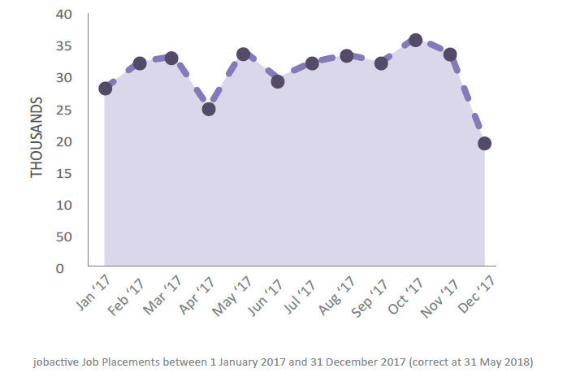

Keeping a job – Paid outcomes
The rate at which job placements convert to paid outcomes gives an indication of whether job seekers are keeping their job. They are a measure of sustainable employment. In the period January 2017 to December 2017:
- 65.0 per cent of job placements led to a 60 per cent reduction in income support and a paid four week outcome.
- 58.0 per cent of job placements led to a 60 per cent reduction in income support and a paid 12 week outcome.
- 41.0 per cent of job placements led to a 100 per cent income support reduction and a paid 26 week outcome.
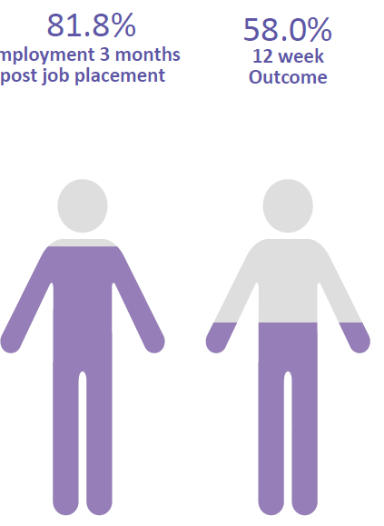
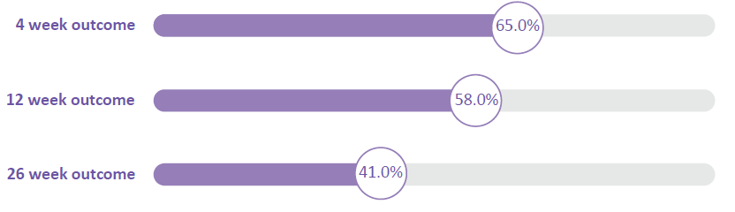
KEEPING A JOB
Conversion rates and paid outcomes are not the only indication a job seeker is employed. The PPM job placement survey contacts job seekers three months after commencing in a job placement.
Survey results show 81.8 per cent of job seekers were employed three months after commencing in a job placement. Yet only 58.0 per cent of these job placements led to a paid 12 week outcome.
This is because job seekers may be employed in a different job, or the employment or job placement does not meet the conditions for a paid outcome. The employment may be temporary or have insufficient hours to reduce a job seeker’s reliance on income support by at least 60 per cent.

Work for the Dole and other Activities
Not all job seekers go straight into employment. Some undertake mutual obligation activities to get them closer to work. These activities aim to improve job seekers’ soft skills.
Work for the Dole (WfD) activities are aimed at developing soft skills and empowering job seekers through work experience and teamwork, while also giving back to the community that supports them. Other activities may include part-time work, vocational training or work experience placements.

ACTIVITIES
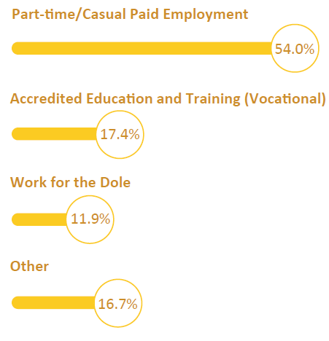
Between 1 January 2017 and 31 December 2017, there were almost 940,719 commencements in activities.
The highest numbers of activity commencements were recorded for part time employment, with 54.0 per cent of total commencements.
Of activity commencements 17.4 per cent were in accredited education and training activities and 11.9 per cent of commencements were in Work for the Dole activities.

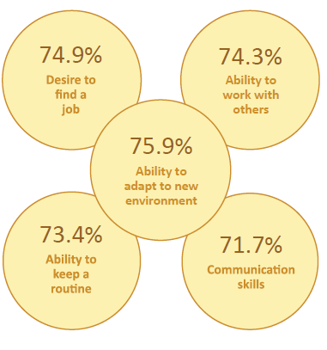
JOB SEEKERS REPORT PARTICIPATION IN WORK FOR THE DOLE HAS A POSITIVE IMPACT ON THEIR SOFT SKILLS
Job seekers reported that their soft skills improved as a result of taking part in a Work for the Dole activity.
The most commonly improved soft skills are shown in the graph opposite. For example, 75.9 per cent of job seekers reported an improvement in their ability to adapt to a new environment

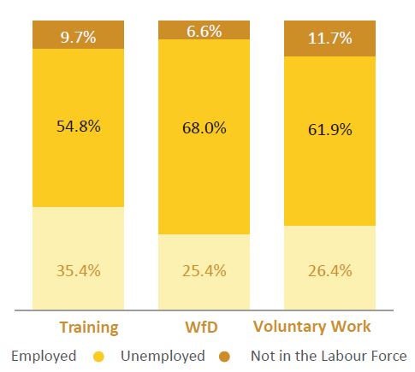
EMPLOYMENT FOLLOWING ACTIVITIES
Survey data shows that during the period 1 January 2017 to 31 December 2017:
- 35.4 per cent of job seekers were employed, three months after they exited a training activity.
- 25.4 per cent of job seekers were employed, three months after they exited a WfD activity.
- 26.4 per cent of job seekers were employed, three months after they exited a Voluntary Work activity.

Leaving jobactive
Job seekers exit the jobactive program when they leave income support, or stay on income support but no longer have requirements to take part in employment services. Volunteer job seekers must exit jobactive after six months of assistance.
Job seekers often exit the program when they have found employment. Survey data shows that almost two thirds of job seekers who exited jobactive are employed three months after exiting.

Program exists by month
Around 585,000, job seekers exited the jobactive program during the period January 2017 to December 2017.
Program exits tend to be seasonal, there is a big spike in exits in the first few months of the year, with many school and university leavers finding employment quickly.
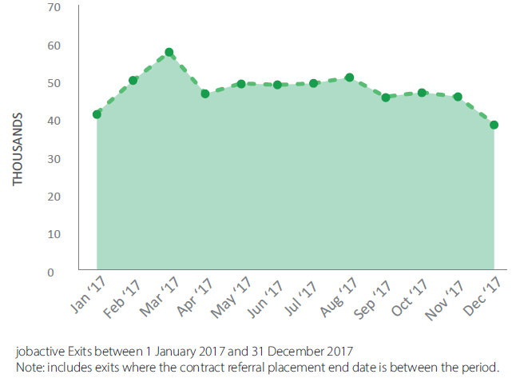

Employment following jobactive assistance
The Department measures whether job seekers have moved into employment following assistance in jobactive through the PPM streams survey. The Department surveys a sample of job seekers three months after they have taken part in jobactive.

Jobactive employment rates
Exited jobactive:
- 63.6 per cent of job seekers who exited jobactive in the period January 2017 to December 2017, were in employment three months after exiting.
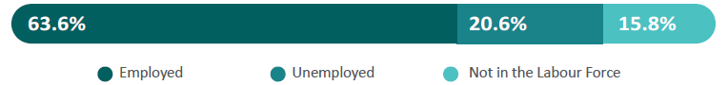
Remained in jobactive:
- Not all job seekers exit jobactive. Job seekers who were still in jobactive at the end of a month were surveyed three months later, throughout the period January 2017 to December 2017. Of job seekers who were still participating in jobactive in the period January 2017 to December 2017, 39.8 per cent were in employment three months later.
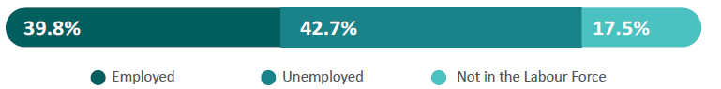
Overall jobactive
- These populations are combined to produce an overall figure for job seekers who participated in jobactive in the period January 2017 to December 2017. 49.5 per cent of job seekers who participated in jobactive between 1 January 2017 and 31 December 2017 were employed, three months later.
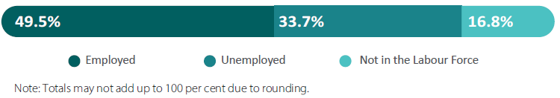

Jobactive employment rates by stream
Stream A job seekers tend to have a higher employment rate, as they are the most ‘job ready’, with 59.1 per cent employed three months after participating in jobactive.
Stream C has a lower employment rate, with 27.2 per cent of job seekers employed three months after participation in jobactive.
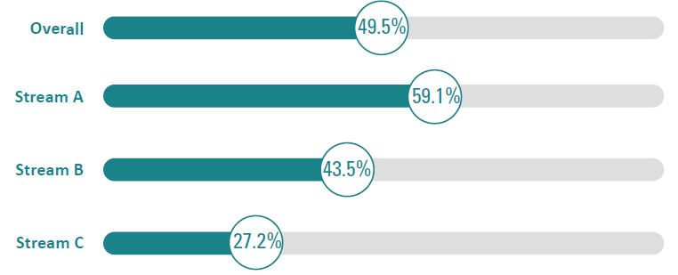

Employment type
Overall, jobactive job seekers who are in employment tend to be in part-time and casual jobs. This refers to job seekers who exited jobactive and who were still on the caseload.
- 26.1 per cent of job seekers are employed part-time and 23.3 per cent were employed full-time.
- 54.6 per cent of employed job seekers were in casual employment.
- 47.1 per cent of employed job seekers would prefer to work more hours.
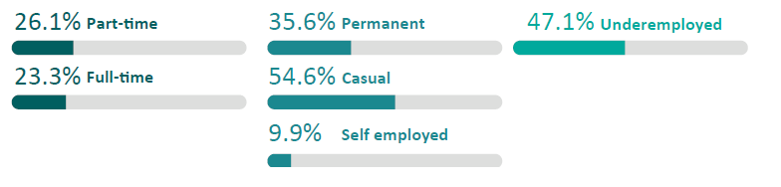

Jobactive education and training
Many job seekers decide to participate in education or training to improve their employability. Around than one in six job seekers are undertaking one or more forms of study, three months after participating in jobactive.
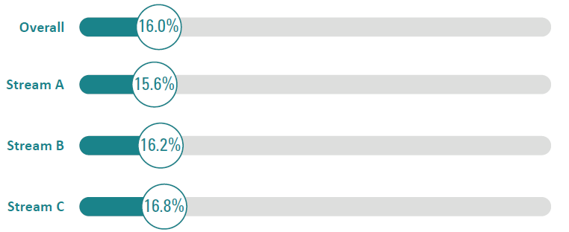
Study type
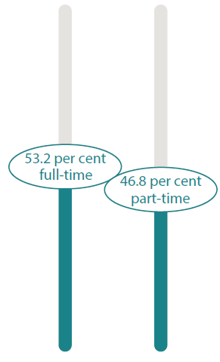
jobactive job seekers study full-time and part-time, and at the certificate or university level.
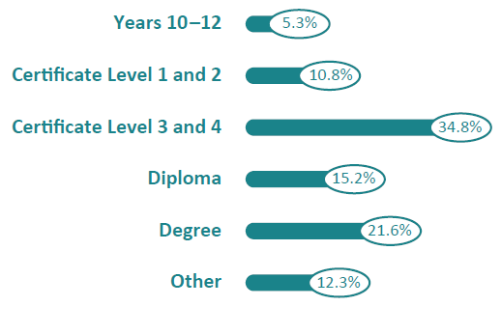

Outcome measures and definitions
Employment: A job seeker is considered employed if they indicate that they work one or more hours, on average, per week. The employment rate is the proportion of total job seekers who are employed.
Unemployed: Job seekers are considered unemployed when they respond that they are not employed but are seeking work. The unemployment rate is unemployed job seekers as a proportion of all job seekers.
Not in the Labour Force (NILF): Job seekers are considered Not In the Labour Force (NILF) when they indicate that they are not working and are not looking for work. The NILF rate is NILF job seekers as a proportion of all job seekers.
Job placement: A job placement occurs when a job seeker finds a job, either on their own or with assistance from their provider. This job is referred to as a ‘job placement’.
Provider: a jobactive provider is an organisation contracted through the Department of Jobs and Small Business to provide employment services to local employers and job seekers, including helping job seekers to find and keep a job and employers to meet their recruitment needs.
Paid outcome: A paid outcome is when a provider receives a payment from the Department of Jobs and Small Business for helping a job seeker into a job, where the job seeker stays in the job for a certain period of time and reduces their reliance on income support payments.
Employed full-time: Job seekers are considered to be in full-time employment when they work 35 or more hours per week. The full-time employment rate refers to full-time employed job seekers as a proportion of all job seekers.
Employed part-time: A job seeker is considered to be in part-time employment when they work less than 35 hours per week. The part-time employment rate refers to part-time employed job seekers as a proportion of all job seekers.
Underemployment: The underemployment rate refers to employed job seekers who would like to work more hours, as a proportion of all employed job seekers (this includes both employees and self-employed job seekers).
Streams Labour Force survey: This survey asks selected job seekers about their employment and education status, whether they are looking for work, and whether their jobactive provider assisted them in finding a job, three months after participation in jobactive. A sample of job seekers are selected if they have exited jobactive, or are on the jobactive caseload at the end of a month, and are surveyed three months later.
Streams Skills and Satisfaction survey: Selected job seekers are asked whether they received services from their provider, and about their level of satisfaction with service provision. A sample of job seekers are selected if they have exited jobactive, or are on the jobactive caseload at the end of a month, and are surveyed three months later.
Job Placement survey: This survey draws on a sample of job seekers who have recorded a job placement, three months after commencing in their job placement, questions about their current employment and education status and whether they are looking for work.
Activities Labour Force Status Survey: This survey asks a sample of job seekers who have participated in an approved activity (e.g. Work for the Dole) about their employment and education status, whether they are looking for work, and whether they have used the skills gained from participation in an activity in finding a job. The survey is conducted three months after a job seeker has exited an approved activity.
Activities Skills and Satisfaction survey: This survey asks a sample of job seekers who have participated in an approved activity about their level of satisfaction with the activity, and about improvements in their soft skills as a result of participating in the activity. The survey is conducted six weeks after a job seeker starts an approved activity.

