

Jobactive
Employment Services Outcomes Report
October 2017 – September 2018

Contents
KEY OBSERVATIONS 3
What is jobactive? 4
jobactive 5
Beginning in jobactive 6
jobactive tailors assistance to the individual 7
Services and assistance delivered to participants 8
Getting a job 9
Work for the Dole and other Activities 11
Leaving jobactive 13
Employment following jobactive assistance 14
Outcome measures and definitions 16

ISSN: 2209-9697

Key Observations - October 2017 to september 2018
48.8 per cent of people participating in jobactive between 1 October 2017 and 30 September 2018 were in employment three months later.
- 59.1 per cent of Stream A participants were employed three months after participating in jobactive,
- 43.0 per cent of Stream B participants were employed three months after participating in jobactive,
- 26.5 per cent of Stream C participants were employed three months after participating in jobactive.
Of the participants who were employed:
- 47.1 per cent were in full-time employment,
- 52.9 per cent were in part-time employment,
- 54.6 per cent were in casual employment.
Between 1 October 2017 and 30 September 2018, almost 350,000 job placements were recorded with:
- 66.7 per cent leading to a paid 4 week outcome,
- 59.3 per cent leading to a paid 12 week outcome,
- 42.8 per cent leading to a paid 26 week outcome.
Survey data demonstrates that during the 1 October 2017 and 30 September 2018 period:
- 36.7 per cent of participants were employed three months after exiting a training activity,
- 27.2 per cent of participants were employed three months after exiting a Work for the Dole activity,
- 25.2 per cent of participants were employed three months after exiting a Voluntary Work activity.
Participants report that participation in Work for the Dole improved their soft skills:
- 77.7 per cent reported it improved their ability to adapt to a new environment,
- 75.5 per cent reported it improved their desire to find a job,
- 74.3 per cent reported it improved their ability to keep to a routine,
- 74.3 per cent reported it improved their communication skills.

What is jobactive?
jobactive is the Australian Government’s way of helping more Australians into work. It is an employment program that connects participants to employers, and is delivered in around 1,700 locations across Australia. jobactive began on 1 July 2015 and replaced the previous employment services program, Job Services Australia.
The Department of Employment, Skills, Small and Family Business monitors what happens to participants in jobactive through the Post-Program Monitoring (PPM) surveys. These surveys measure a range of items such as a participant’s labour market status, and their satisfaction with various aspects of employment services.
This report describes the experiences of participants in jobactive, using information from the Department’s administration databases and the PPM surveys.

jobactive
The Government, through the Department of Employment, Skills, Small and Family Business contracts organisations across Australia to be the face of the jobactive program and to directly assist people into sustainable employment. These organisations are called providers.
Providers help participants in jobactive by providing assistance and advice to help progress them on their journey towards employment.
Providers do this by:
- helping people meet their participation requirements,
- assisting people to overcome personal barriers,
- helping people get work experience,
- helping people into training courses,
- assisting with résumés and interview techniques,
- providing advice on how to look for work,
- connecting people seeking jobs with employers.

How do you become a part of jobactive?
Generally, a participant will start in jobactive when they first apply for income support (such as Newstart or Youth Allowance). Some income support payments have conditions, and a participant has to participate in jobactive to meet them.
Some participants may not have to participate in jobactive, but may volunteer to participate in jobactive for up to 6 months

Beginning in jobactive
A participant will start in jobactive by attending an initial appointment with their jobactive provider. The participant and the provider will agree on a job plan – a road map for the participant to progress towards employment.
Around 392,000 people across Australia commenced in jobactive between 1 October 2017 and 30 September 2018.
There is usually an increase in commencements early in the year, as many people leave school or university and enter the job market.
Figure 1: Number of participants commencing in jobactive by month
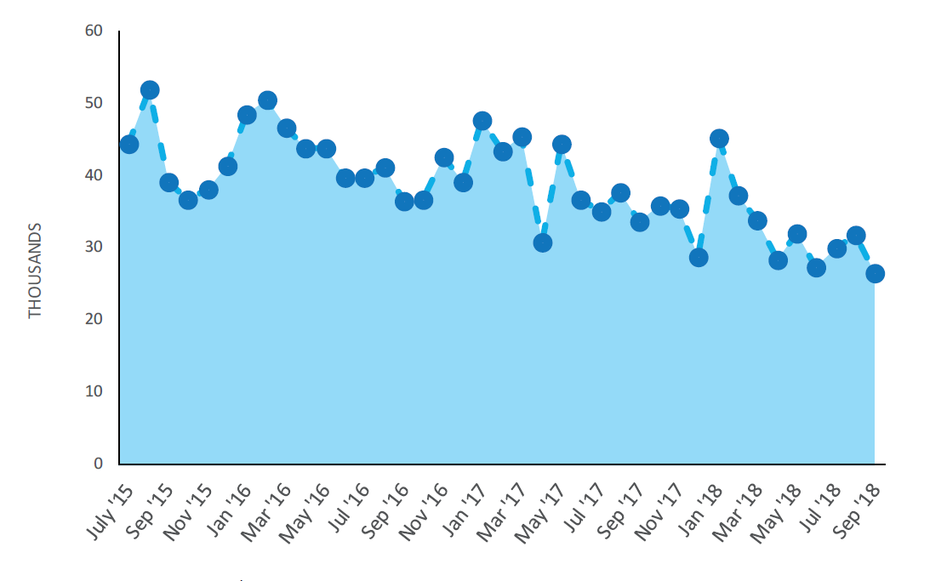Data as at 30 April 2019

jobactive tailor’s assistance to the individual
Once a participant starts in jobactive, their barriers to employment are assessed using the Jobseeker Classification Instrument (JSCI), a questionnaire the participant and the Department of Human Services fill out together. Sometimes, an additional assessment called an Employment Services Assessment (ESAt) is required. This additional assessment helps to identify participants with additional barriers to employment who may benefit from more intensive support in Stream C.
Participants are allocated to one of three streams, based on their JSCI score and the kinds of barriers they are likely to face in obtaining employment. On 30 September 2018 there were 638,391 participants in jobactive;
- Stream A participants are the most job ready. They comprised 40.3 per cent of participants in jobactive. Volunteer participants receive services through Stream A for up to six months.
- Stream B participants face some barriers to employment (for example, language barriers), and require their provider to play a greater role to help them become job ready. Stream B participants make up 43.0 per cent of all participants.
- The most disadvantaged participants identified through the ESAt are assisted through Stream C, comprising 16.7 per cent of jobactive participants. Stream C participants have multiple and complex barriers that need to be addressed so that they can take up and retain a job. These may include physical and/or mental health issues, or low capacity to work.
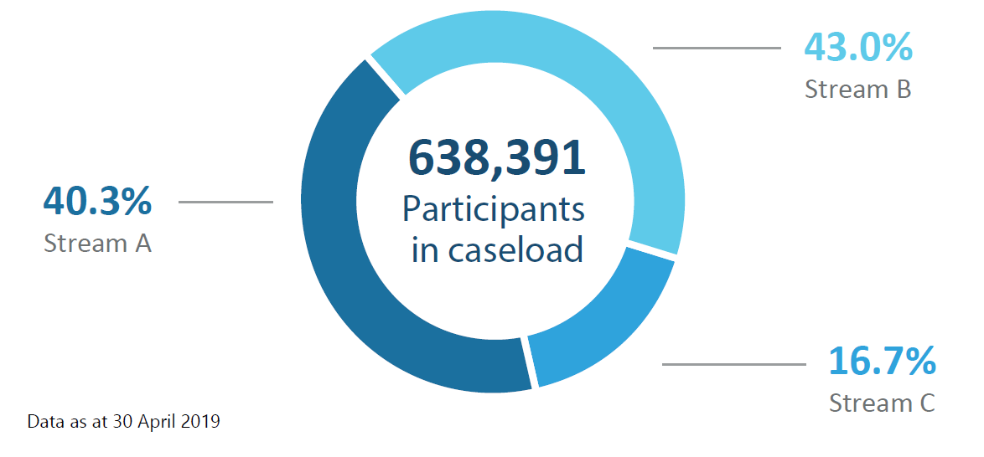

Services and assistance delivered to participants
Providers deliver assistance to participants based on their individual needs and their Stream. jobactive providers assist participants with their search to find and keep a job, such as providing advice or assisting with their résumé, as well as helping them meet their participation obligations and overcome any vocational or non-vocational barriers to employment.
jobactive providers help participants to
Find and keep a job
- Develop a job plan
- Develop and write a résumé
- Prepare for job interviews
- Gain access to computers
- Get referrals to job vacancies
- Develop skills that local employers need
- Access wage subsidies
Overcome vocational and non-vocational barriers
- Provide work-related items, professional services, relevant training and support for participants
- Provide additional intensive support services such as counselling, homeless services, mental health services, and other medical treatments
Meet participation obligations
- Look for up to 20 jobs per month
- Attend regular appointments
- Undertake activities that will help develop skills local employers are looking for

Getting a job
A key component of jobactive is placing participants into employment. When a participant finds a job, whether on their own or with assistance from their provider, that job is called a ‘job placement’.
Providers receive fees, called outcome payments, paid by the Department of Employment, Skills, Small and Family Business, for helping a participant into a job. There are three main types of outcome fees:
- If a participant is placed in a job, remains employed for four weeks, and reduces their income support payments by at least 60 per cent, the provider receives a four week outcome payment.

- The provider receives a 12 week outcome payment if the participant remains employed for 12 weeks and continues to have reduced their income support payments by at least 60 per cent.

- Finally, a provider receives a 26 week outcome payment if the participant remains employed for 26 weeks and reduces their reliance on income support by 100 per cent.
346,000 job placements were recorded in jobactive during the period October 2017 and September 2018. Placement patterns are also seasonal, with the highest number typically recorded in October and November and a dip over December/January period.
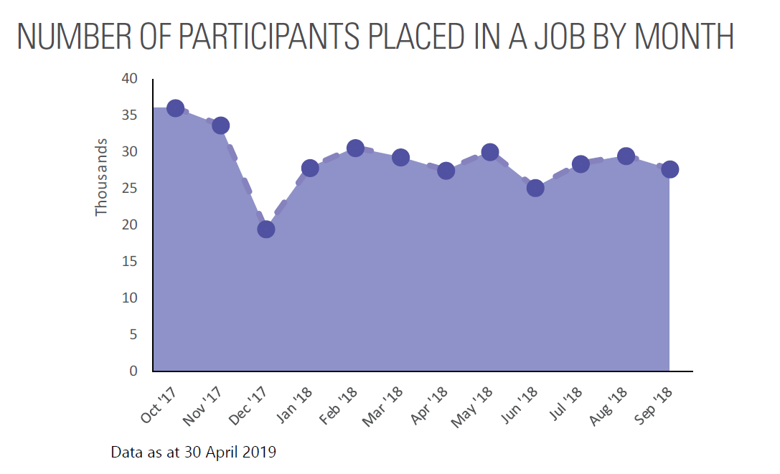

Keeping a job – Paid outcomes
The rate at which job placements convert to paid outcomes is a measure of sustainable employment. In the period October 2017 and September 2018:
- 66.7 per cent of job placements led to a 60 per cent reduction in income support and a paid four week outcome.
- 59.3 per cent of job placements led to a 60 per cent reduction in income support and a paid 12 week outcome.
- 42.8 per cent of job placements led to a 100 per cent income support reduction and a paid 26 week outcome.
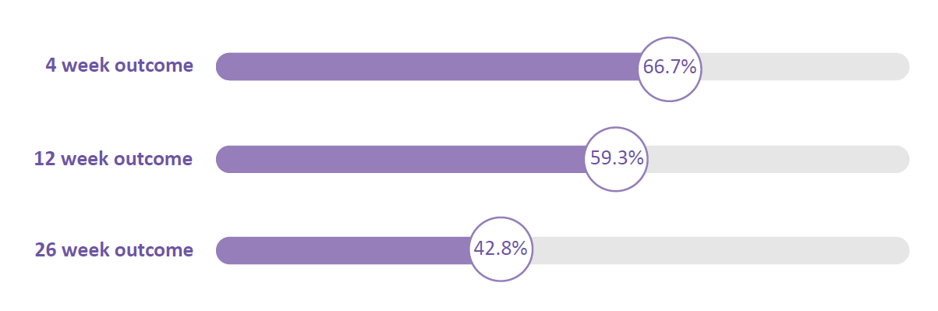
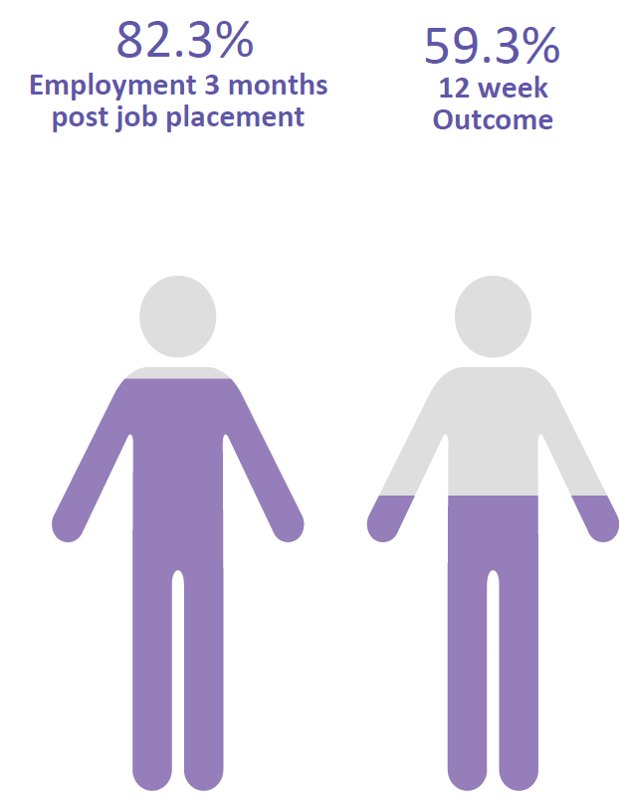
KEEPING A JOB
Conversion rates and paid outcomes are not the only indication a jobactive participant is employed. The PPM job placement survey contacts participants three months after commencing in a job placement.
Survey results show 82.3 per cent of participants were employed three months after commencing in a job placement. Of these 59.3 per cent of these job placements led to a paid 12 week outcome.
This is because participants may be employed in a different job, or the employment or job placement does not meet the conditions for a paid outcome. The employment may be temporary or have insufficient hours to reduce a participant’s reliance on income support by at least 60 per cent.

Work for the Dole and other Activities
Not all participants go straight into employment. Some undertake mutual obligation activities to get them closer to work. These activities aim to improve participants’ soft skills.
Work for the Dole activities are aimed at developing soft skills and empowering participants through work experience and teamwork, while also giving back to the community that supports them. Other mutual obligation activities may include part-time work, vocational training or work experience placements.

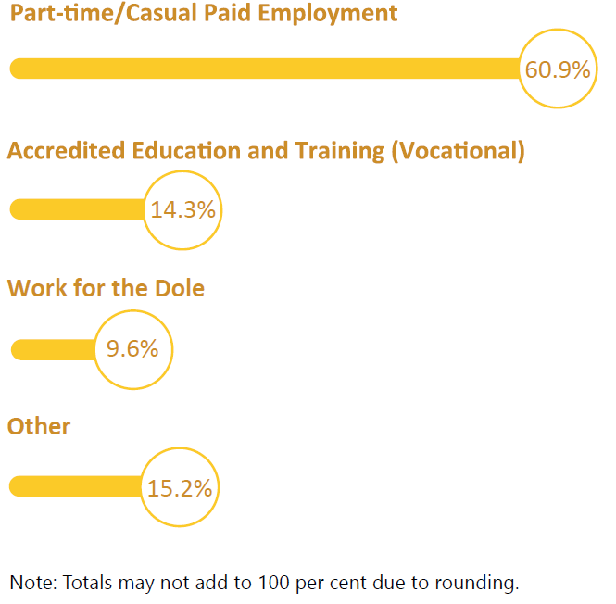
ACTIVITIES
Between 1 October 2017 and 30 September 2018, there were over 1 million commencements in activities.
The majority of activity commencements recorded were for part time employment, representing 60.9 per cent of total commencements.
Around one in seven commencements, were in accredited education and training activities and one in ten were in Work for the Dole activities.

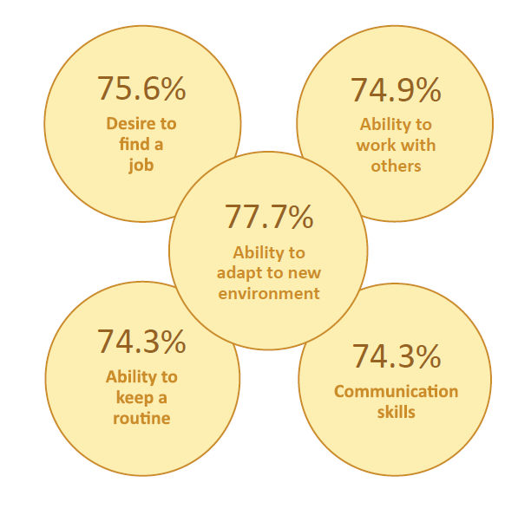
PARTICIPATION IN WORK FOR THE DOLE HAS A POSITIVE IMPACT ON THEIR SOFT SKILLS
Participants reported that their soft skills improved as a result of taking part in a Work for the Dole activity.
The most commonly improved soft skills are shown in the graph opposite. For example, 77.7 per cent of participants reported an improvement in their ability to adapt to a new environment.

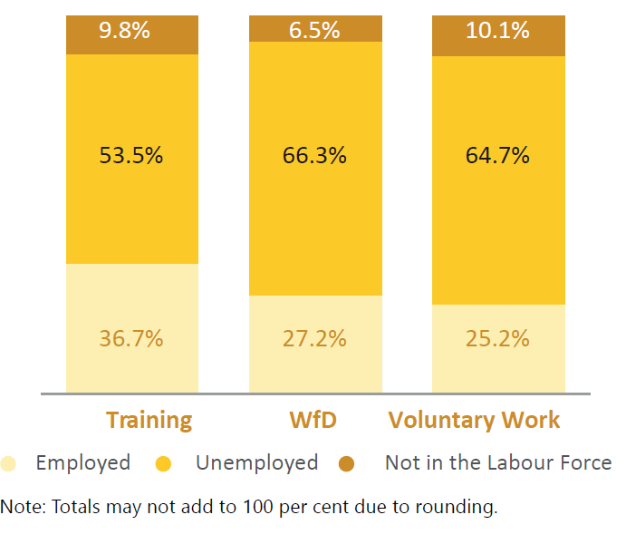
EMPLOYMENT FOLLOWING ACTIVITIES
Survey data shows that during the period 1 October 2017 and 30 September 2018:
- 36.7 per cent of participants were employed, three months after they exited a training activity.
- 27.2 per cent of participants were employed, three months after they exited a WfD activity.
- 25.2 per cent of participants were employed, three months after they exited a Voluntary Work activity.

Leaving jobactive
Participants exit the jobactive program when they leave income support, or when they stay on income support but are no longer required to take part in employment services. Volunteer participants must exit jobactive after six months of assistance.
Participants often exit the program when they have found employment. Survey data shows that almost two thirds of participants who exited jobactive are employed three months after exiting.

Program exits by month
Around 534,000, participants exited the jobactive program during the period October 2017 to September 2018.
Program exits tend to be seasonal. There is a spike in exits early in the year, with many school and university leavers finding employment quickly.
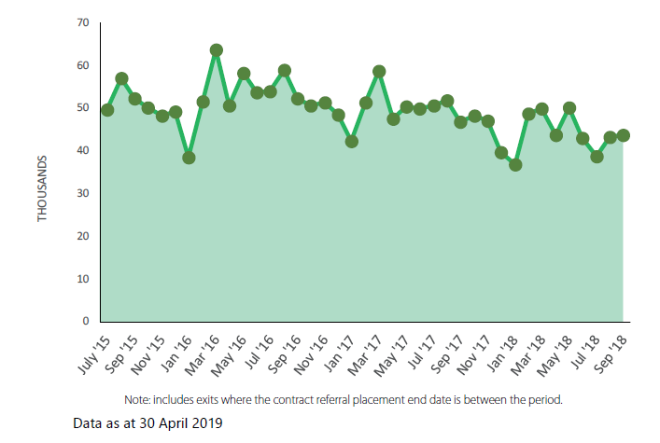

Employment following jobactive assistance
The Department measures whether participants have moved into employment following assistance in jobactive through the PPM streams survey. The Department surveys a sample of participants three months after they have taken part in jobactive.

Jobactive employment rates
Exited jobactive:
- 63.4 per cent of participants who exited jobactive in the period October 2017 to September 2018, were in employment three months after exiting.
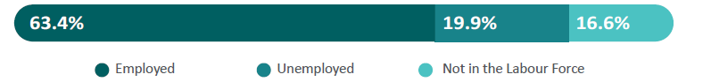
Remained in jobactive:
- Not all participants exit jobactive. A sample of participants who were still in jobactive at the end of a given month were surveyed three months later; Of those who participated in jobactive in the period October 2017 to September 2018 and were still in the program three months later, 39.0 per cent were in employment.
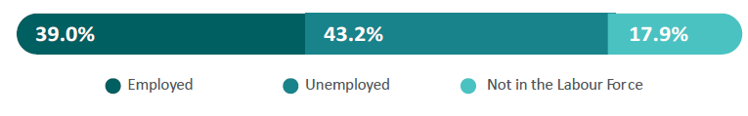
Overall jobactive:
- These populations are combined to produce an overall figure for jobactive participants. 48.8 per cent of participants in jobactive between 1 October 2017 and 30 September 2018 were employed, three months later.
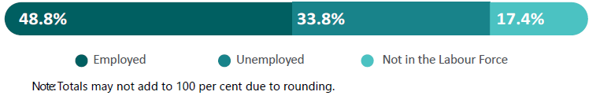

Jobactive employment rates by stream
Stream A participants tend to have a higher employment rate, as they are the most ‘job ready’, with 59.1 per cent employed three months after participating in jobactive.
Stream C has the lowest employment rate of the three streams, with 26.5 per cent of participants employed three months after participation in jobactive.
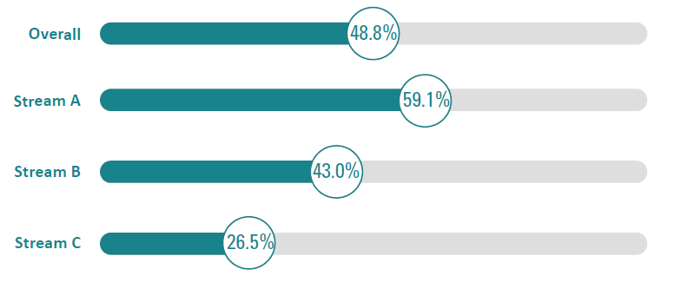

Employment type
Overall, jobactive participants who are in employment tend to be in part-time and casual jobs. This refers to people who had exited jobactive as well as participants still in the program.
- 25.8 per cent of participants are employed part-time and 23.0 per cent were employed full-time.
- 54.6 per cent of employed participants were in casual employment.
- 47.2 per cent of employed participants would prefer to work more hours.
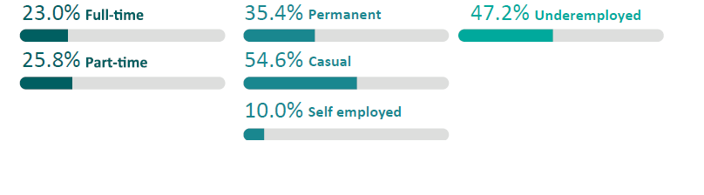

Jobactive education and training
Many participants decide to take up education or training to improve their employability. Around one in six participants are undertaking one or more forms of study three months after participating in jobactive.
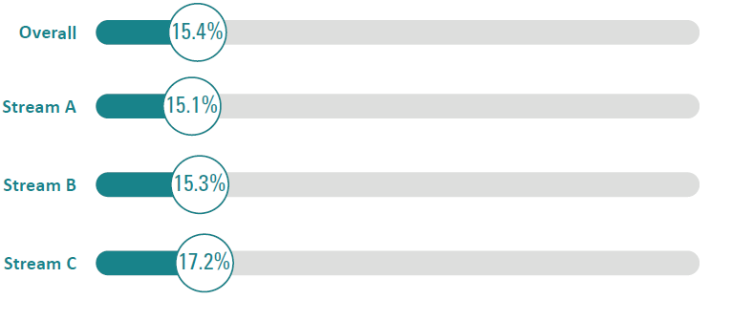
Study type
jobactive participants study full-time and part-time, and at the certificate or university level.
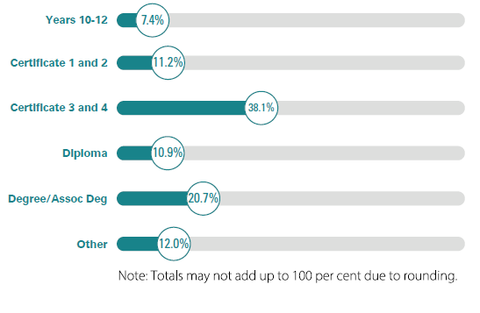
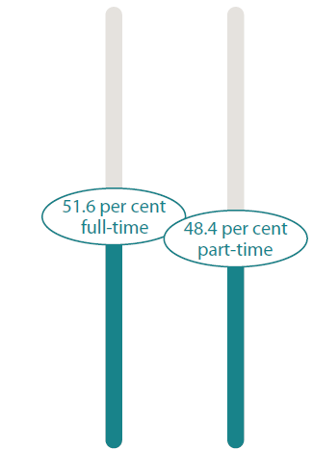

Outcome measures and definitions
Employment: A participant is considered employed if they indicate that they work one or more hours, on average, per week. The employment rate is the proportion of total participants who are employed.
Unemployed: Participants are considered unemployed when they respond that they are not employed but are seeking work. The unemployment rate is unemployed participants as a proportion of all participants.
Not in the Labour Force (NILF): Participants are considered Not In the Labour Force (NILF) when they indicate that they are not working and are not looking for work. The NILF rate is NILF participants as a proportion of all participants.
Job placement: A job placement occurs when a participant finds a job, either on their own or with assistance from their provider. This job is referred to as a ‘job placement’.
Provider: a jobactive provider is an organisation contracted through the Department of Employment, Skills, Small and Family Business to provide employment services to local employers and participants, including helping participants to find and keep a job and employers to meet their recruitment needs.
Paid outcome: A paid outcome is when a provider receives a payment from the Department of Employment, Skills, Small and Family Business for helping a participant into a job, where the participant stays in the job for a certain period of time and reduces their reliance on income support payments.
Employed full-time: Participants are considered to be in full-time employment when they work 35 or more hours per week. The full-time employment rate refers to full-time employed participants as a proportion of all participants.
Employed part-time: A participant is considered to be in part-time employment when they work less than 35 hours per week. The part-time employment rate refers to part-time employed participants as a proportion of all participants.
Underemployment: The underemployment rate refers to employed participants who would like to work more hours, as a proportion of all employed participants (this includes both employees and self-employed participants).
Streams Labour Force survey: This survey asks selected participants about their employment and education status, whether they are looking for work, and whether their jobactive provider assisted them in finding a job, three months after participation in jobactive. A sample of participants are selected if they have exited jobactive, or are on the jobactive caseload at the end of a month, and are surveyed three months later.
Streams Skills and Satisfaction survey: Selected participants are asked whether they received services from their provider, and about their level of satisfaction with service provision. A sample of participants are selected if they have exited jobactive, or are on the jobactive caseload at the end of a month, and are surveyed three months later.
Job Placement survey: This survey draws on a sample of participants who have recorded a job placement, three months after commencing in their job placement, questions about their current employment and education status and whether they are looking for work.
Activities Labour Force Status Survey: This survey asks a sample of participants who have participated in an approved activity (e.g. Work for the Dole) about their employment and education status, whether they are looking for work, and whether they have used the skills gained from participation in an activity in finding a job. The survey is conducted three months after a participant has exited an approved activity.
Activities Skills and Satisfaction survey: This survey asks a sample of participants who have participated in an approved activity about their level of satisfaction with the activity, and about improvements in their soft skills as a result of participating in the activity. The survey is conducted six weeks after a participant starts an approved activity.

