


Employment Services Outcomes Report (jobactive)
  - OCTOBER 2018 to SEPTEMBER 2019

ISSN: 2209-9697
With the exception of the Commonwealth Coat of Arms, the Department’s logo, any material protected by a trade mark and where otherwise noted all material presented in this document is provided under a Creative Commons Attribution 4.0 Australia licence.
The details of the relevant licence conditions are available on the Creative Commons website (accessible using the links provided) as is the full legal code for the CC BY 4.0 AU licence.
The document must be attributed as the Employment Services Outcomes Report (jobactive) October 2018 to September 2019.

Contents
Key observations – October 2018 to September 2019 4
What is jobactive? 5
jobactive 6
Services and assistance delivered to participants 7
Beginning in jobactive 8
jobactive tailors assistance to the individual 9
Getting a job 10
Work for the Dole and other activities 13
Leaving jobactive 16
Employment following jobactive assistance 17
Outcome measures and definitions 21

Key observations – October 2018 to September 2019
47.4 per cent of people participating in jobactive in the period 1 October 2018 to 30 September 2019 were in employment three months later. Post-participation employment rates vary by Stream:
- 57.5 per cent for Stream A participants
- 41.2 per cent for Stream B participants
- 26.7 per cent for Stream C participants.
Of the participants who were employed:
- 46.6 per cent were in full-time employment and 53.4 per cent were in part-time employment
- 53.9 per cent were in casual employment.
The large majority (81.9 per cent) of jobactive participants were employed three months after achieving a recorded job placement.
Employment rates differ between participants who have exited and those who remain in jobactive:
- 61.4 per cent for participants who have exited jobactive
- 37.6 per cent for participants still in jobactive.
From 1 October 2018 to 30 September 2019, around 306,000 job placements were recorded with:
- 66.3 per cent leading to a paid four-week outcome
- 59.0 per cent leading to a paid 12-week outcome
- 42.8 per cent leading to a paid 26-week outcome.
Survey data demonstrates that during the period 1 October 2018 to 30 September 2019:
- 30.3 per cent of participants were employed three months after exiting a training activity
- 23.1 per cent of participants were employed three months after exiting Work for the Dole
- 21.0 per cent of participants were employed three months after exiting Voluntary Work.
Participants reported that participation in Work for the Dole improved their soft skills:
- 79.2 per cent reported it improved their ability to adapt to a new environment
- 76.8 per cent reported it improved their desire to find a job
- 75.5 per cent reported it improved their ability to work with others
- 75.0 per cent reported it improved their understanding of the workplace
- 73.9 per cent reported it improved their ability to keep a routine.

What is jobactive?
jobactive is the Australian Government’s largest program focused on helping Australians into work. It is an employment program that connects participants to employers and is delivered in around 1700 locations across Australia. jobactive began on 1 July 2015 and replaced the previous employment services program, Job Services Australia.
The Department of Education, Skills and Employment monitors what happens to participants in jobactive through Post-Program Monitoring (PPM) surveys. These surveys measure a range of items such as a participant’s labour market status and their satisfaction with various aspects of employment services.
This report describes the experiences of participants in jobactive using information from the department’s administration databases and the PPM surveys.

New Employment Services Trial
A new employment services model is being developed following extensive consultation with more than 1400 stakeholders including job seekers, employment services providers, industry representatives, employers and peak bodies, and independent advice delivered by the Employment Services Expert Advisory Panel in its report to Government.
From 1 July 2019, key elements of the new model are being refined and tested through the New Employment Services Trial. The trial is being underway in two Employment Regions – Adelaide South, South Australia and Mid North Coast, New South Wales. Participants in the trial are not included in the surveys covered in this report as other, trial-specific monitoring and evaluation activities are taking place.

jobactive
The Government, through the Department of Education, Skills and Employment, contracts organisations across Australia to directly assist people into sustainable employment through the jobactive program. These organisations are called providers.
Providers help jobactive participants by providing assistance and advice to help progress them on their journey towards employment.
Providers do this by helping participants:  - meet their participation requirements  - overcome personal barriers  - get work experience  - undertake training courses  - prepare résumés and learn interview techniques  - with advice on how to look for work  - connect with employers.  Providers deliver assistance to participants based on individual needs. Assistance includes:  - support to find and keep a job  - help with overcoming vocational and  non-vocational barriers to employment  - support and advice on how to meet mutual obligation requirements. | 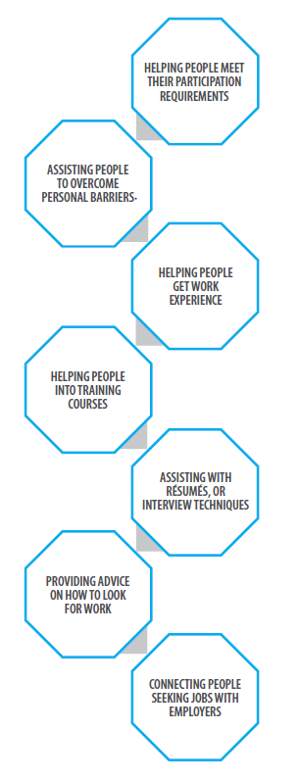

Services and assistance delivered to participants
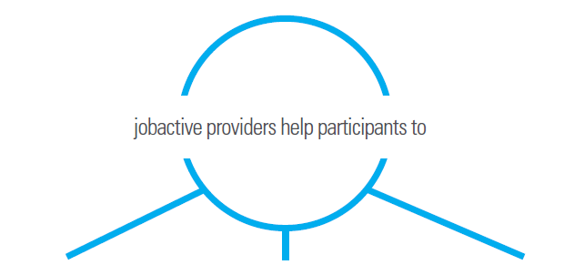
Find and keep a job  - Develop a Job Plan  - Develop and write a résumé  - Prepare for job interviews  - Gain access to computers  - Get referrals to job vacancies  - Develop skills needed by local employers  - Access wage subsidies | Overcome vocational and non-vocational barriers  - Provide work-related items, professional services, relevant training and support for participants  - Provide additional intensive support services such as counselling, homeless services, mental health services, and other medical treatments | Meet participation obligations  - Look for up to 20 jobs per month  - Attend regular appointments  - Undertake activities that will help develop skills needed by local employers

Beginning in jobactive

How do you become part of jobactive?
Generally, a participant will start in jobactive when they first apply for income support (such as JobSeeker Payment). Some income support payments have conditions and a participant has to participate in jobactive to meet them.
Some individuals may not have to participate in jobactive, but may volunteer to do so.
Typically, a participant starts in jobactive by attending an initial appointment with their jobactive provider. The participant and the provider will agree on a Job Plan – a road map for the participant to progress towards employment.
Around 407,000 people across Australia commenced in jobactive in the period 1 October 2018 to 30 September 2019.
There is usually an increase in commencements early in the year, as many people leave school or university and enter the job market.
Chart 1: Number of participants commencing in jobactive by month from July 2015 to September 2019
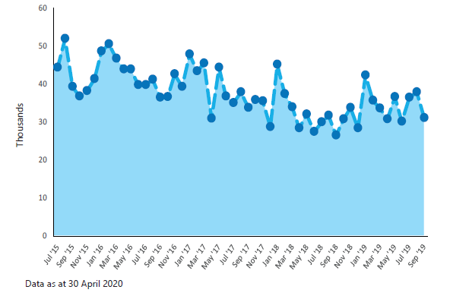

jobactive tailors assistance to the individual
Under jobactive the Job Seeker Classification Instrument (JSCI) is used to determine a job seeker’s eligibility for Stream A and Stream B. The JSCI questionnaire assesses a participant’s individual circumstances that may affect their path to employment such as location, educational level and English language skills. The JSCI (also known as the Job Seeker Snapshot when delivered online) is initially conducted by Services Australia, or self-administered by the participant, upon entry to employment services.
The JSCI also identifies participants who have multiple or complex circumstances that may require an additional Employment Services Assessment (ESAt). An ESAt is required before a participant can be referred to Stream C or other Government programs such as Disability Employment Services, which is administered by the Department of Social Services.
On 30 September 2019 there were around 609,000 participants in jobactive:
- Stream A participants are the most job ready. They comprised 39.7 per cent of participants in jobactive. Volunteer participants receive services through Stream A.
- Stream B participants face some barriers to employment (for example, language barriers), and require their provider to play a greater role to help them become job ready. Stream B participants made up 44.0 per cent of all participants.
- The most disadvantaged participants identified through the ESAt are assisted through Stream C, comprising 16.3 per cent of jobactive participants. Stream C participants have multiple and complex barriers that need to be addressed so that they can take up and retain a job. These may include physical and/or mental health conditions or restricted work capacity.
Chart 2: jobactive caseload by Stream
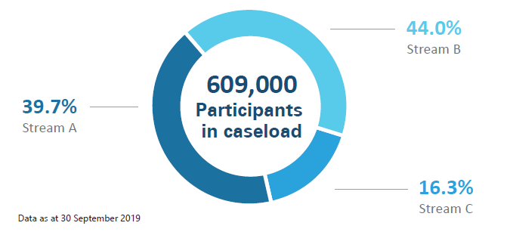

Getting a job
A key component of jobactive is placing participants into employment. When a participant finds a job, whether on their own or with assistance from their provider, that job is called a job placement.
Providers receive fees, called outcome payments, paid by the Department of Education, Skills and Employment, for helping a participant into a job. There are three main types of outcome fees:
- If a participant finds a job, remains employed for four weeks and reduces their income support payments by at least 60 per cent, the provider receives a four-week outcome payment.
- The provider receives a 12-week outcome payment if the participant remains employed for 12 weeks and continues to have reduced their income support payments by at least 60 per cent.
- Finally, a provider receives a 26-week outcome payment if the participant remains employed for 26 weeks and reduces their reliance on income support by 100 per cent.
Outcomes for job seekers with a Partial Work Capacity or who are Principal Carer Parents will take into account their part-time requirements.
Around 306,000 job placements were recorded in jobactive in the period 1 October 2018 to 30 September 2019. The number of placements for this 12 month period was lower than in previous years in line with an ongoing decline in the caseload size. Placement patterns are generally seasonal, with the highest number recorded in spring and a dip around December.
Chart 3: Number of participants placed in a job by month from July 2015 to September 2019
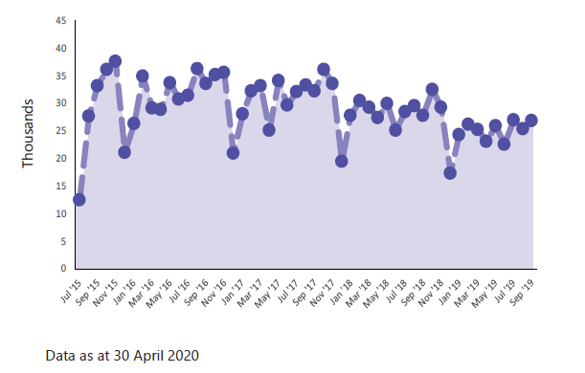

Keeping a job – paid outcomes
The rate at which job placements convert to paid outcomes is a measure of sustainable employment.
In the period 1 October 2018 to 30 September 2019:
- 66.3 per cent of job placements led to a 60 per cent reduction in income support and a paid four-week outcome
- 59.0 per cent of job placements led to a 60 per cent reduction in income support and a paid 12-week outcome
- 42.8 per cent of job placements led to a 100 per cent income support reduction and a paid 26-week outcome.
Chart 4: Conversion rates for paid outcomes
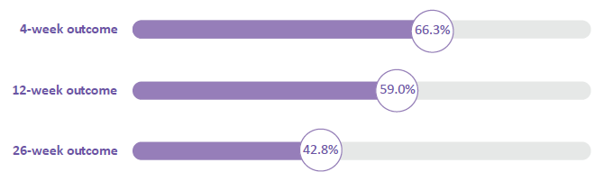

Keeping a job
Conversion rates and paid outcomes are not the only indication a jobactive participant is employed. The PPM Job Placement survey contacts participants three months after commencing in a job placement.
Survey results show 81.9 per cent of participants were in employment three months after a job placement was recorded by their provider.
This is higher than the 12-week conversion rate, as employment may be in a different job or in a job that does not meet the conditions for a paid outcome. For example, the employment may have insufficient hours to reduce the participants’ reliance on income support by at least 60 per cent.

Chart 5: Employment outcomes v 12-week outcomes
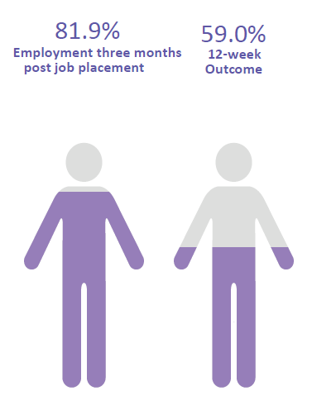

Work for the Dole and other activities
Not all participants go straight into employment. Some undertake mutual obligation activities to improve their chances of getting work. These activities aim to improve participants’ soft skills.
Work for the Dole activities are aimed at developing skills and empowering participants through work experience and teamwork, while also giving back to the community that supports them. Other mutual obligation activities may include part-time work, vocational training or work experience placements.

Activities
Between 1 October 2018 and 30 September 2019, there were around 873,000 commencements in activities. Note that a participant may commence in more than one type of activity.
The most common activity undertaken was part-time and casual employment, representing 54.8 per cent of total commencements.
Around one in seven commencements were in accredited education and training activities and one in eight were in Work for the Dole activities.
The category “Other” includes commencements in activities such as interventions (6.4 percent), Non-Accredited Education and Training (Vocational) (5.1 per cent), PaTH – Employability Skills Training (4.6 per cent) and other Government Programmes (1.9 per cent).
Chart 6: Commencements by activity type
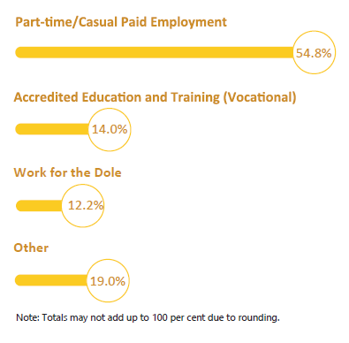

Work for the Dole participation has a positive impact on soft skills
Participants reported that their soft skills improved as a result of taking part in a Work for the Dole activity.
The most commonly improved soft skills are shown in Chart 7. For example, 79.2 per cent of participants reported an improvement in their ability to adapt to a new environment
Chart 7: Soft skill improvement following participation in Work for the Dole
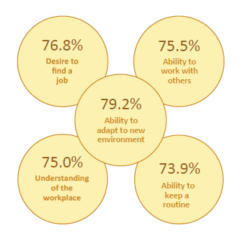

Employment following activities
Survey data shows that during the period 1 October 2018 to 30 September 2019:
- 30.3 per cent of participants were employed three months after they exited a training activity
- 23.1 per cent of participants were employed three months after they exited a Work for the Dole activity
- 21.0 per cent of participants were employed three months after they exited a Voluntary Work activity.
Chart 8: Employment rates following activity participation
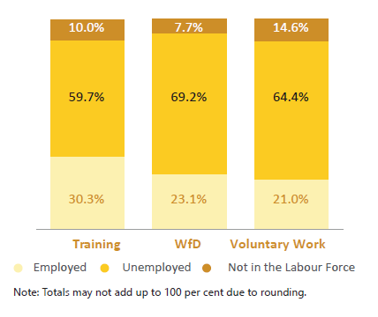

Leaving jobactive
Participants exit the jobactive program when they leave income support, or when they stay on income support but are no longer required to take part in employment services.

Program exits by month
Around 489,000 participants exited the jobactive program during the period 1 October 2018 to 30 September 2019. Exit numbers have been trending down as the number of people on the caseload declined.
Program exits tend to be seasonal. There is a spike in exits around March every year, which could be attributed to school and university leavers, who commenced, late in the previous year, finding employment or returning to full-time study.
Chart 9: jobactive exits by month from July 2015 to September 2019
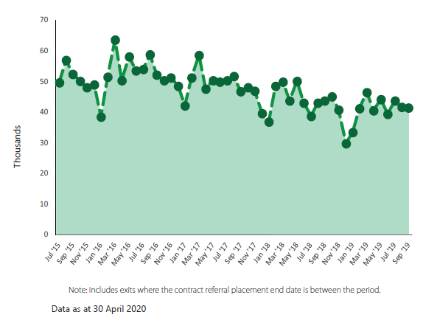

Employment following jobactive assistance
The Department of Education, Skills and Employment measures whether participants have moved into employment following assistance in jobactive through the PPM Streams Labour Force survey. The department surveys a sample of participants three months after they have taken part in jobactive.

jobactive employment rates
- A sample of participants who exited jobactive were surveyed three months later. 61.4 per cent of participants who exited jobactive in the period 1 October 2018 to 30 September 2019 were in employment three months after exiting.
Chart 10: Employment outcomes for those who exited jobactive
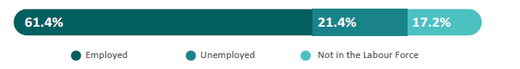
- A sample of participants still in jobactive at the end of a given month were surveyed three months later. 37.6 per cent of participants who remained in jobactive at the end of each month of the period 1 October 2018 to 30 September 2019 were employed three months later.
Chart 11: Employment outcomes for those who remained in jobactive
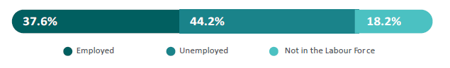
- These populations are combined to produce an overall figure for jobactive participants. 47.4 per cent of participants in jobactive during the period 1 October 2018 to 30 September 2019 were employed three months later.
Chart 12: Employment outcomes for all jobactive participants
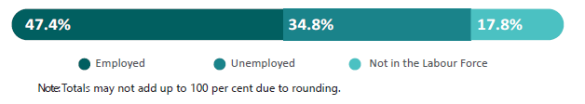

jobactive employment rates by stream
Stream A participants tend to have a higher employment rate as they are the most ‘job ready’, with 57.5 per cent employed three months after participating in jobactive.
Stream C has the lowest employment rate of the three streams, with 26.7 per cent of participants employed three months after participation in jobactive.
Chart 13: Employment rates by Stream
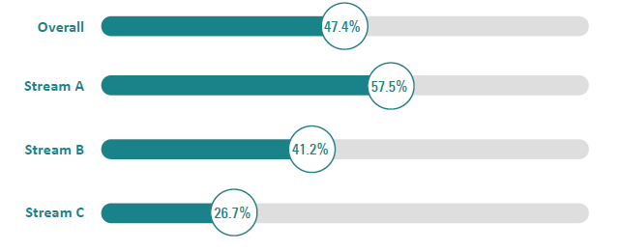

Employment type
For jobactive participants part-time and full-time employment rates are roughly similar with 25.3 per cent of participants employed part time and 22.1 per cent employed full time.
Chart 14: Full-time and part-time employment rates
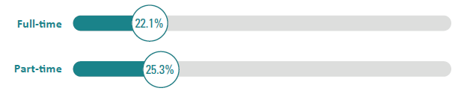
As a percentage of participants who were employed:
- 53.4 per cent were in employment part time and 46.6 per cent full time
- 53.9 per cent were in casual employment

Chart 15: Permanent employment, casual employment and self-employment
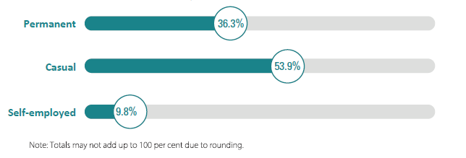
For participants who were employed, 46.7 per cent would prefer to work more hours – (underemployed).
Chart 16: Underemployment
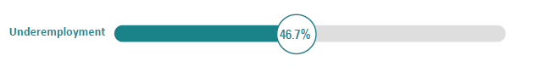

jobactive education and training
Many participants decide to take up education or training to improve their employability. More than one in seven participants were undertaking study three months after participating in jobactive. There was little difference between Streams — 15.3 per cent of Stream A participants, 14.8 per cent of Stream B participants, and 14.5 per cent of Stream C participants were studying three months later.

Study type
jobactive participants are equally likely to study full time as part time, and most commonly study at the Certificate 3 or 4 level.

Chart 17: Types and levels of study
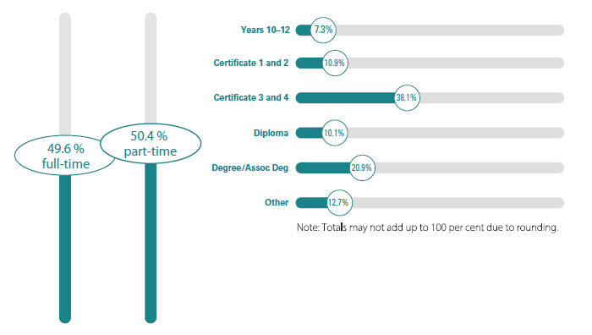

Outcome measures and definitions
Employment: A participant is considered employed if they indicate that they work one or more hours on average per week. The employment rate is the proportion of total participants who are employed.
Unemployed: Participants are considered unemployed when they respond that they are not employed but are seeking work. The unemployment rate is unemployed participants as a proportion of all participants.
Not In the Labour Force (NILF): Participants are considered Not In the Labour Force (NILF) when they indicate that they are not working and are not looking for work. The NILF rate is NILF participants as a proportion of all participants.
Job placement: A job placement occurs when a participant finds a job, either on their own or with assistance from their provider.
Provider: A jobactive provider is an organisation contracted through the Department of Education, Skills and Employment to provide employment services to local employers and participants, including helping participants to find and keep a job and employers to meet their recruitment needs.
Paid outcome: A paid outcome is when a provider receives a payment from the Department of Education, Skills and Employment for helping a participant into a job, where the participant stays in the job for a certain period of time and reduces their reliance on income support payments.
Employed full time: Participants are considered to be in full-time employment when they work 35 or more hours per week. The full-time employment rate refers to full-time employed participants as a proportion of all participants.
Employed part time: A participant is considered to be in part-time employment when they work less than 35 hours per week. The part-time employment rate refers to part-time employed participants as a proportion of all participants.
Underemployment: The underemployment rate refers to employed participants who would like to work more hours, as a proportion of all employed participants (this includes both employees and self-employed participants).
Streams Labour Force survey: This survey asks selected participants about their employment and education status, whether they are looking for work, and whether their jobactive provider assisted them in finding a job, three months after participation in jobactive. A sample of participants are selected if they have exited jobactive or are on the jobactive caseload at the end of a month. They are surveyed three months later.

Streams Skills and Satisfaction survey: Selected participants are asked whether they received services from their provider and about their level of satisfaction with service provision. A sample of participants are selected if they have exited jobactive or are on the jobactive caseload at the end of a month. They are surveyed three months later.
Job Placement survey: This survey asks a sample of participants who have a recorded job placement about their current employment and education status and whether they are looking for work. The survey is conducted three months after the participant has commenced in their job placement.
Activities Labour Force Status survey: This survey asks a sample of participants who have participated in an approved activity (e.g. Work for the Dole) about their employment and education status, whether they are looking for work, and whether they have used the skills gained from participation in an activity in finding a job. The survey is conducted three months after a participant has exited an approved activity.
Activities Skills and Satisfaction survey: This survey asks a sample of participants who have participated in an activity about their level of satisfaction with the activity and about improvements in their soft skills as a result of participating in the activity. The survey is conducted three months after a participant has started an activity.

