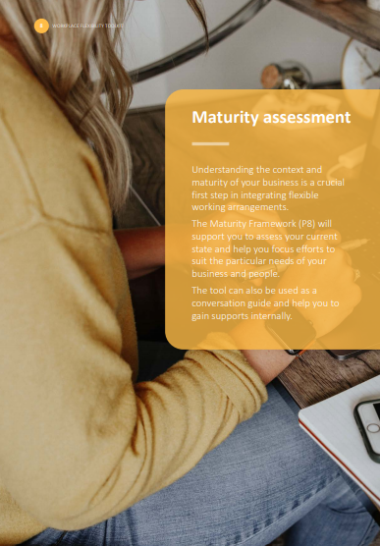

**Maturity assessment**

Understanding the context and maturity of your business is a crucial first step in integrating flexible working arrangements.

The Maturity Framework will support you to assess your current state and help you focus efforts to suit the particular needs of your business and people.

The tool can also be used as a conversation guide and help you to gain supports internally.

The Flexible by Design Framework has been developed by the Public Service Commission in Queensland to support businesses to find the ‘flexibility within flexibility.’ Understanding where your business sits within this framework can help to guide and focus efforts.

|  | **CHANGE THE POLICY** | **CONSIDER THE PRACTICE** |  |
| --- | --- | --- | --- |
|  |  |  |  |
|  | **TRADITIONAL** | **DEVELOPING** | **FLEXIBLE BY DESIGN** |
| **ORGANISATION** | * Limited appreciation for the benefits of flexible work. * Regulated approach to flexible work, and a workplace that is slow to respond to change. * Full-time is default for recruitment | * Appreciates the benefits of flexible work and incorporates into business-as-usual. * Deliberate emphasis on flexibility across the organisation, but application is siloed and segmented. * Promotes flexible work opportunities during recruitment. | * Embeds flexible work to capitalise on diversity dividend – better business outcomes. Diversity dividend = flexibility encourages diversity, diversity enables inclusion, inclusion creates innovation, innovation drives high performance. * Mutually beneficial flexible arrangements that align with service delivery optimise and prioritise business performance. * Attract and retain employees that value balance and flexibility, and want innovative and contemporary approaches to work. |
| **EMPLOYEES** | * Limited uptake of flexible work. * Flexible work requests are initiated by employees and seen as a problem to address behind closed doors. * Lack of trust from colleagues and excessive hours seen as a badge of honour. * No one promotes or shares stories about flexible work | * Moderate uptake of flexible work. * Managers accommodate individual requests so work-life conflict is minimised. * Teams accommodate arrangements, but feel others have to pick up the load left by flexible work arrangements. * Some employees work flexibly, but do not tend to promote or share stories. | * All employees can request flexible work – flexible work is the norm and reflects diverse workers, work and workplaces. * Teams create flexible work approaches that are less about rules, process and structure, and more about culture, outcomes, ways of thinking and wellbeing. * Solutions demonstrate give and take, trust, open communication, cooperation, negotiation and ethics. * Employees proudly share and promote flexible work stories. |
| **PROCESS** | * Employees and managers agree formal and relatively static arrangements. * Risk averse and bureaucratic approval processes where health, safety and wellbeing is not an organisational priority. * Limited access to mobile technology and modern workspaces. * Time and tasks used as primary measure of performance. | * Managers and employees agree to formal and informal arrangements. * Managers and employees are risk aware and understand health, safety and wellbeing priorities. * Greater emphasis on collaborative space, mobile technology and team processes that support flexible work. * Flexible work used as a benefit or reward for high performance. | * Embeds flexible work into all roles – managers demonstrate how roles work flexibly and lead by example. * Health, safety and wellbeing is an organisational priority and engages with risk intelligence to focus on solutions. * Collaborative work environments and mobile technology support success. * Frequent meaningful conversations about outcomes measure employee performance. |