Targeted Compliance Framework

Statement

   | The Australian Government  - Department of Social Services wrote this.  We say DSS for short.  - Department of Employment and Workplace Relations  We say DEWR for short.  When you see the word we it means DSS and DEWR.
 | We wrote this in an easy to read way.  We use pictures to explain some ideas.
 | We have some words in bold.  This means the letters are thicker and darker.  These are important words.
 | This is an Easy Read summary of another document.  This means it has the most important ideas.
 | You can ask for help to read this document.  You can ask  - A friend  - Family members  - A support person.

Contents

About the finding a job law | 5
Checking that it is working | 7
Decisions that have been made | 10
Reasons for the decisions | 13
What is next | 15

About the finding a job law

 | There is a law about finding a job.  Laws are rules for how we live.
 | The law says what people need to do to  - Find a job  - Keep a job.  We call these activities.
 | Everyone will have different activities.
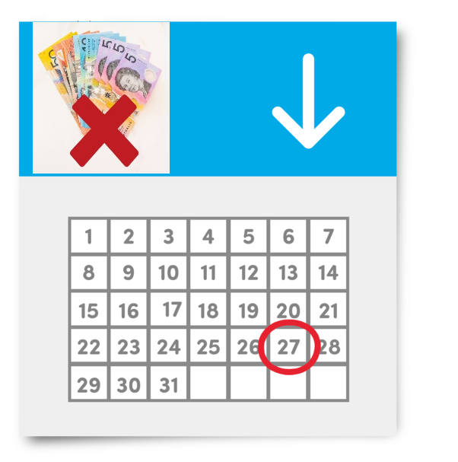 | If you do not do the activities your money from Centrelink can be  - Stopped for now  - Less  - Cancelled.
 | Cancelled means we can decide to stop them completely.  This means you would not get any money from Centrelink.
 | The government checks that laws are working.  We sometimes make changes to the law to make it better.

Checking that it is working

 | We are doing a review of this law.  A review is when you check what  - Works  - Needs to change.
 | We have made sure the review is  - Done in a fair way  - Following the law.
 | We have an independent person checking our computer systems.  Independent means separate to the government.
 | This means we are checking if our computer systems are following the rules.
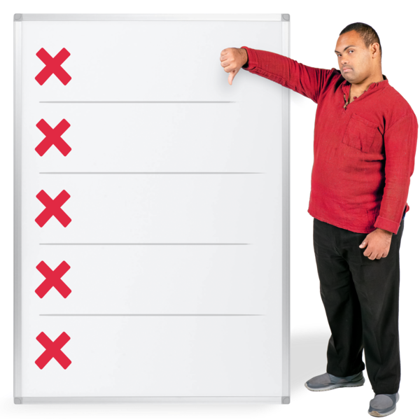 | We do not think our computer systems are following the rules at all times.
 | We will also look at decisions that have been made to  - Change  - Stop  Money from Centrelink for not doing activities.
 | We want to make sure the decisions are  - Fair  - Following the law.
   | We have decided to stop some of these decisions for now.  Some of the decisions have not followed  - The law  - Our policies.  Policies are plans for how to do things.  Stop for now means people will not have their Centrelink money  - Changed  - Stopped  For some reasons until we know that our computer systems are following the rules.

Decisions that have been made

 | 2 decisions have been made recently.
 | 1. We will stop for now changes to Centrelink money if people do not do the activities.
 | 2. We will stop for now cancelling Centrelink money if people  - Choose to leave their job.  This can be called unemployment failure.
 | There is a set amount of time that we do not pay Centrelink money for unemployment failure.
 | We have made other decisions.  On 4 July 2024 we stopped for now cancelling Centrelink money for people who do not do the activities.
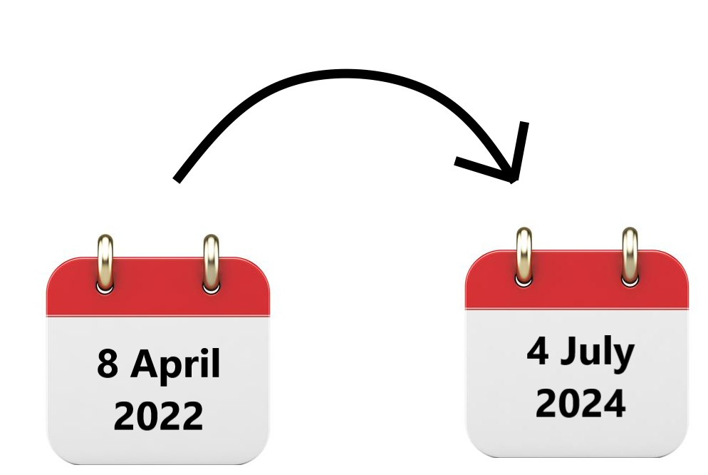 | We will look at all the decisions made about this between  - 8 April 2022  - 4 July 2024.  We will start that soon.
 | You can read more about this on our website.  www.aph.gov.au/-/media/Estimates/eet/add2425/DEWR_-_Opening_Statement.pdf?la=en&hash=40DD83352878CD595477B88C6C09FBE513E3ABDA  It is not Easy Read.
 | On 24 September 2024 DEWR stopped for now cancelling Centrelink money for people who are not doing their activities on purpose.  They have 4 weeks to start doing them again.  This is called a reconnection requirement.
 | All the decisions we have made are still stopped.
You can read more about

- Our decisions
- What this means for you

On our website.

www.aph.gov.au/-/media/Estimates/eet/add2425/DEWR_-_Opening_Statement.pdf?la=en&hash=40DD83352878CD595477B88C6C09FBE513E3ABDA

It is not Easy Read.

Reasons for the decisions

 | The government has laws to follow to make sure things are done in a fair way.  We are worried that our computer systems are not following the rules at all times.  We need to make sure this is fixed quickly.
 | Decisions have been made to make sure Centrelink money is not  - Changed  - Stopped  When the computer system is not following the rules.
 | We are responsible to make sure our computer systems are following the rules.
 | We need to make sure that Centrelink money is only  - Changed  - Stopped  If the law says we can.

What is next

 | We will tell you any decisions we make.
 | We will work with people who have to follow these rules to understand  - Decisions we have made
 | - Their rights.  Rights are rules about treating everyone  - Fair  - Equal.
 | We will keep listening to what is found in the reviews.
If we do not believe the decisions

- Follow the law
- Are fair

We will stop them right away.

Images in this Easy Read must not be used or copied without permission

