

Skills Organisations Pilots

Agenda and Background Paper Sydney Roundtable  
September 2019

ISBN

Creative Commons

With the exception of the Commonwealth Coat of Arms, the Department’s logo, any material protected by a trade mark and where otherwise noted all material presented in this document is provided under a [Creative Commons Attribution 3.0 Australia](http://creativecommons.org/licenses/by/3.0/au/) licence.

The details of the relevant licence conditions are available on the Creative Commons website (accessible using the links provided) as is the full legal code for the [CC BY 3.0 AU licence](http://creativecommons.org/licenses/by/3.0/au/legalcode).

The document must be attributed as the Skills Organisation Pilots-background paper.

Contents

Disclaimer 4

Agenda – Skills Organisation pilots roundtable 5

Digital Technologies 5

Context for the Skills Organisations pilots 7

The role of vocational education and training (VET) 7

A vision for VET 7

Australian Government Budget initiatives 8

Purpose of the roundtables 9

Discuss the existing arrangements for the development of training packages and industry engagement across the skills pipeline 9

Discuss the key challenges with the existing arrangements 9

Discuss the potential opportunities afforded by the pilots to trial new approaches 9

Discuss possible success measures to evaluate the impact of the Skills Organisation pilots 10

Discuss the proposed staging of the pilots and next steps 10

Attachment 1 12

Attachment 1 - Skills Pipeline explained 13

Forecast & Identify Phase 13

Design & Develop Phase 14

Policy & Governance 14

Skills Standards Development 15

National Skills Framework 17

Implementation phase 18

Delivery phase 19

Outcome phase 20

# Disclaimer

The objectives of the roundtables are to:

* enable the Commonwealth to provide information in relation to the Skills Organisations pilots
* consult with industry on a range of issues relating to the Skills Organisations pilots.

Conduct of these roundtables is not a representation by the Commonwealth that:

* any future procurement process will occur in respect of the Skills Organisations pilots
* if a procurement does occur in respect of the Skills Organisation pilot, that this will be the same as any process discussed at the roundtables.

Industry participants who choose to participate in the roundtables will not obtain any unfair advantage in any subsequent procurement process connected with the Skills Organisations pilots.

Industry participants who choose to participate in the roundtables will not obtain any unfair advantage in any subsequent procurement process connected with the Skills Organisations pilots.

Any responses made during the roundtables will not be considered as part of the evaluation of any future procurement process. Similarly, industry participants who do not participate in the roundtables will not incur any disadvantage in any subsequent procurement process connected with the Skills Organisations pilots.

A summary of the outcomes of the roundtables, including details of any responses made during the roundtables, may be distributed to third parties and made publicly available in any subsequent procurement process related to the Skills Organisations pilots.

Any information provided in relation to these roundtables is for background information purposes only and the Commonwealth makes no representations or warranties that the information will be accurate or complete.

# Agenda – Skills Organisation pilots roundtable

## Digital Technologies

**Date and Time**: 26 September 2019; 10.00am – 4.00pm  
**Venue:** Pullman Hotel, Sydney Airport

## Human Services Care

**Date and Time**: 25 September 2019; 10.00am – 4.00pm  
**Venue:** Pullman Hotel, Sydney Airport

| **Time** | **Agenda item** |
| --- | --- |
| 10.00am | **Open** |
| 10.00am –  10.10am | **Welcome and introductions** |
| 10.10am –  10.30am | **Context and Background**   * Overview of VET Vision and Budget measures * Focus of the day: Skills Organisations pilots * Industry specific context |
| 10.30am –  10.45am | **Existing approaches to skills development**   * Brief overview of the current skills pipeline, including industry involvement in developing training packages |
| 10.45am –  11.15am | **Areas for improvement**   * Discussion of the key issues identified through reviews and consultation with industry and governments * Seeking industry’s input on areas for improvement and opportunities the Skills Organisations could provide or leverage |
| 11.30am –  12.00pm | **Objectives of the pilots**   * Discussion on the objectives and expected outcomes of the pilots |
| 12.00pm –  1.00pm | **Scope and parameters of the pilots**   * Scope and parameters of the pilots * Timing and the phased approach to design and implementation of the pilots |
| 1.00pm –  1.45pm | Lunch |
| 1.15pm –  3.15pm | **Establishing the new Skills Organisations**   * What qualities are we collectively looking for in a Skills Organisation to lead the pilot? * Options for/models of governance and composition of the funded entity * Identification of organisations interested in participating in the pilot |
| 3.15pm –  3.45pm | **Evaluation of the pilots**   * How will we measure success? * How can we leverage lessons from the pilots into existing structures and processes? |
| 3.45pm –  4.00pm | **Next Steps** |
| 4.00pm | **Close** |

# Context for the Skills Organisations pilots

## The role of vocational education and training (VET)

From childcare to land management, from machinists to maritime workers, the vocational education and training system is the key to ensuring that Australians have the skills needed for the jobs in demand across the nation.

For school leavers and those entering the workforce for the first time, VET provides critical work readiness skills and real experience in work-like environments. For others who are working in jobs that are rapidly changing, VET provides them with the skills and qualifications needed to harness new technologies and seize new opportunities.

VET touches almost every Australian and Australian business. With just as many students aged between 15 – 19 as 40 – 49, the VET system needs to respond to the needs of Australians wherever they are in their career (NCVER 2018).

A recent review of the national training system - [Expert Review of Australia's Vocational Education and Training System](https://www.pmc.gov.au/resource-centre/domestic-policy/vet-review/strengthening-skills-expert-review-australias-vocational-education-and-training-system) (the Joyce Review) found that VET qualification development can be slow and that some key challenges relate to:

* lack of confidence in the vocational education and training (VET) system
* a cumbersome and bureaucratic qualifications development system, that is slow to respond to changes in industry skills needs
* disconnect between national qualifications and local skills requirements
* complex and overly prescriptive training products
* significant variations in the quality of training delivery between providers, and consequential variations in graduate quality.

## A vision for VET

Australian governments collectively recognise that delivering high quality is a shared responsibility and there is a need both for national consistency in a number of key areas while maintaining flexibility to meet local needs. A VET system is envisaged that:

* provides workforce skills and relevant, up-to-date qualifications that are well-matched to the evolving opportunities and challenges of Australia’s modern economy
* is flexible in providing skills at all points in an individual’s career cycle whether it be foundational training, initial training, upskilling or re-skilling
* delivers high-quality education and training for all learners in recognition that VET and higher education are equally valued pathways into employment
* provides useful and accessible careers information that enables prospective learners and trainees to make informed decisions about their future
* is responsive to the needs of private industry and the public sector, ensuring employers have ready access to a highly skilled and adaptable workforce, while acknowledging industry has shared responsibility for growing a skilled economy
* provides VET qualifications to school students that are valued by employers and provides a clear pathway from school to careers that require VET qualifications
* delivers positive opportunities and outcomes for all Australians regardless of geographic, social or personal circumstances. This includes access for learners in regional, rural and remote areas, and to foundational skills when individuals need them.

## Australian Government Budget initiatives

As part of the 2019-20 Federal Budget, the Australian Government announced the $525 million [Skills Package – delivering skills for today and tomorrow](https://www.employment.gov.au/delivering-skills-today-and-tomorrow) (Skills Package). Through the Skills Package the Australian Government is putting in place the building blocks for reforms identified in the Joyce Review. The Skills Package is intended to strengthen Australia’s VET system to ensure that it remains responsive, respected and flexible, providing Australians with the skills they need to succeed in the modern workplace and providing business with the workers they need to grow a strong economy.

As part of the Skills Package, the Government committed $41.7 million to pilot two Skills Organisations. The Skills Organisation pilots will target two key priority industries:

* human services care (which may encompass one or more of aged care, early childhood education and care and disability services)
* digital technologies (including a focus on cyber security).

The Joyce Review proposed Skills Organisations be owned by industry and take a leadership role to support the VET system better meet the needs of employers, the economy and learners. Under the Budget initiative, the Department of Employment, Skills, Small and Family Business (the Department) will support the target industries to develop and establish these pilots.

For more information about the **Skills Package**, see the [Department’s website](https://www.employment.gov.au/delivering-skills-today-and-tomorrow).

# Purpose of the roundtables

To progress design and implementation of the Skills Organisation pilots, the Department is holding two roundtables with industry peak bodies, small and large employers, employee representative and others – one for the human services care sector and one for the digital technologies sector.

The purpose of these roundtables is to seek input and expertise from stakeholders in the target industries to further develop the scope and parameters of the two Skills Organisations pilots. The Department is seeking industry’s views on a range of elements to ensure the Skills Organisations pilots meet industry needs. The roundtables provide an opportunity to:

### Discuss the existing arrangements for the development of training packages and industry engagement across the skills pipeline

* Existing industry-led arrangements, within the national training system, predominately focus on skills identification and the development of national training packages.
* Training packages are sets of nationally endorsed standards and qualifications, which specify the skills and knowledge required to perform effectively in the workplace. They provide the standards and qualification structures against which Registered Training Organisations (RTOs) train and assess the skills of individuals. RTOs use training packages as the basis for developing learning strategies to support individual learners’ needs, abilities and circumstances.
* Training packages are currently developed by Industry Reference Committees (IRCs), working with Skill Service Organisations (SSO), to ensure that industry skill requirements are reflected in the national training system. IRCs report to the Australian Industry and Skills Committee (AISC), which refers training packages to the COAG Skills Council for final approval.
* Currently, the Department engages six SSOs to support the 66 IRCs to identify industry skill needs and develop qualifications.
* An overview of the national skills pipeline, which includes the areas highlighted above, is provided at **Attachment 1.**

### Discuss the key challenges with the existing arrangements

* While the Joyce Review identified some challenges and areas for improvement, the roundtables will provide an opportunity for stakeholders from the human services sectors and digital technologies to discuss some of the challenges in relation: to training package development; quality delivery; and learner outcomes.
* The roundtable will provide an opportunity to identify changes or new approaches that could be trialled through the Skills Organisation pilots.

### Discuss the potential opportunities afforded by the pilots to trial new approaches

* Skills Organisations pilots are an opportunity for the human services care and digital technologies industries to shape the national training system so that it is more responsive to their skills needs and to enhance the learner experience.
* Potential areas in which the pilots could trial new approaches include:
  + skills gaps/needs - for example developing strong feedback loops to better engage industry, develop better methods to identify current and future skills needs, identify common skills needs across related industries
  + qualification development that is more responsive to industry requirements - for example utilise innovative methods and technologies to streamline industry consultation, support development of microcredentials and accredited courses in response to emerging skills needs, work with related industries to support common skills needs
  + work-based training placements - for example directly working with RTOs and employers to encourage and provide placements
  + industry collaborations with RTOs to improve delivery of VET qualifications
  + identification of high-performing RTOs based on graduate outcomes, engagement with industry or other industry-relevant criteria
  + assessment of VET graduates to provide confidence to industry - for example through independent assessment, capstone test, and external validation of RTO assessment.
* Through each Skills Organisation pilot, industry will determine which stage/s of the skills pipeline would benefit from trialling new approaches to improve responsiveness and alignment with industry needs.

### Discuss possible success measures to evaluate the impact of the Skills Organisation pilots

* In addition to providing value to the pilot industries themselves, the Skills Organisation pilots will provide an evidence base to inform future Government decisions on implementation of new approaches beyond the pilots. Key success measures for the pilots that will inform future decisions will include (but not be limited to) the extent to which the pilots demonstrate:
  + capacity and capability (including through governance arrangements) to represent the diverse needs of sectors within its remit
  + increased responsiveness of training package development
  + increased confidence in the quality of training delivery by RTOs and quality of graduates
  + effectiveness of feedback loops from employers, learners and RTOs to continuously improve training package development and delivery
  + support for mobility of skills and workers within and across industries.
* An evaluation will be designed and operate alongside the two pilot Skills Organisations to help build an evidence base for the expansion of the pilots. The evaluation is expected to commence from early 2020.

### Discuss the proposed staging of the pilots and next steps

* The Government will work with each Skills Organisation pilot to facilitate successful delivery of its work program within or alongside existing national architecture and arrangements.
* Subject to industry consultations, the Skills Organisations pilots are expected to be implemented in the following phases:
  + Phase 1 (to end December 2019) will focus on establishing arrangements for the pilots and associated governance. While one or more bodies may be the primary lead(s) for this phase, it will require broad engagement with industry, RTOs and learners.
  + Phase 2 (December 2019 to March 2020) will focus on standing up the pilot Skills Organisation and developing a work plan setting out the scope, parameters, priorities and activities to be progressed through the pilots.
  + Phase 3 (from mid-2020) will involve the implementation of the pilot in line with the agreed work plan.

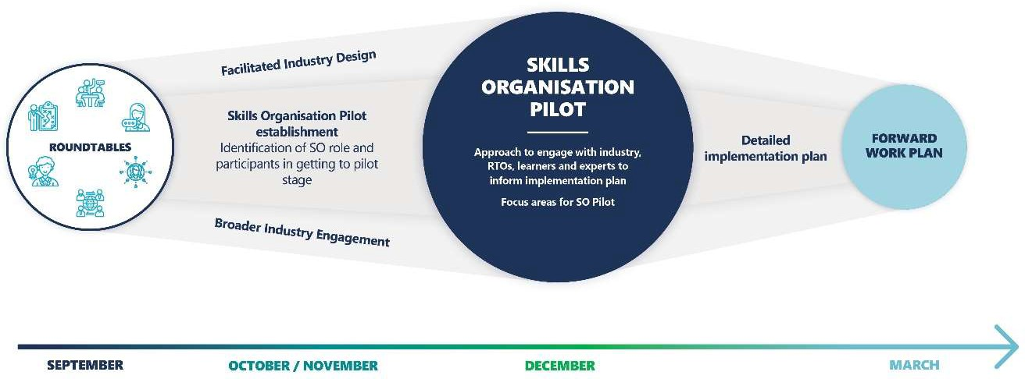

# Attachment 1

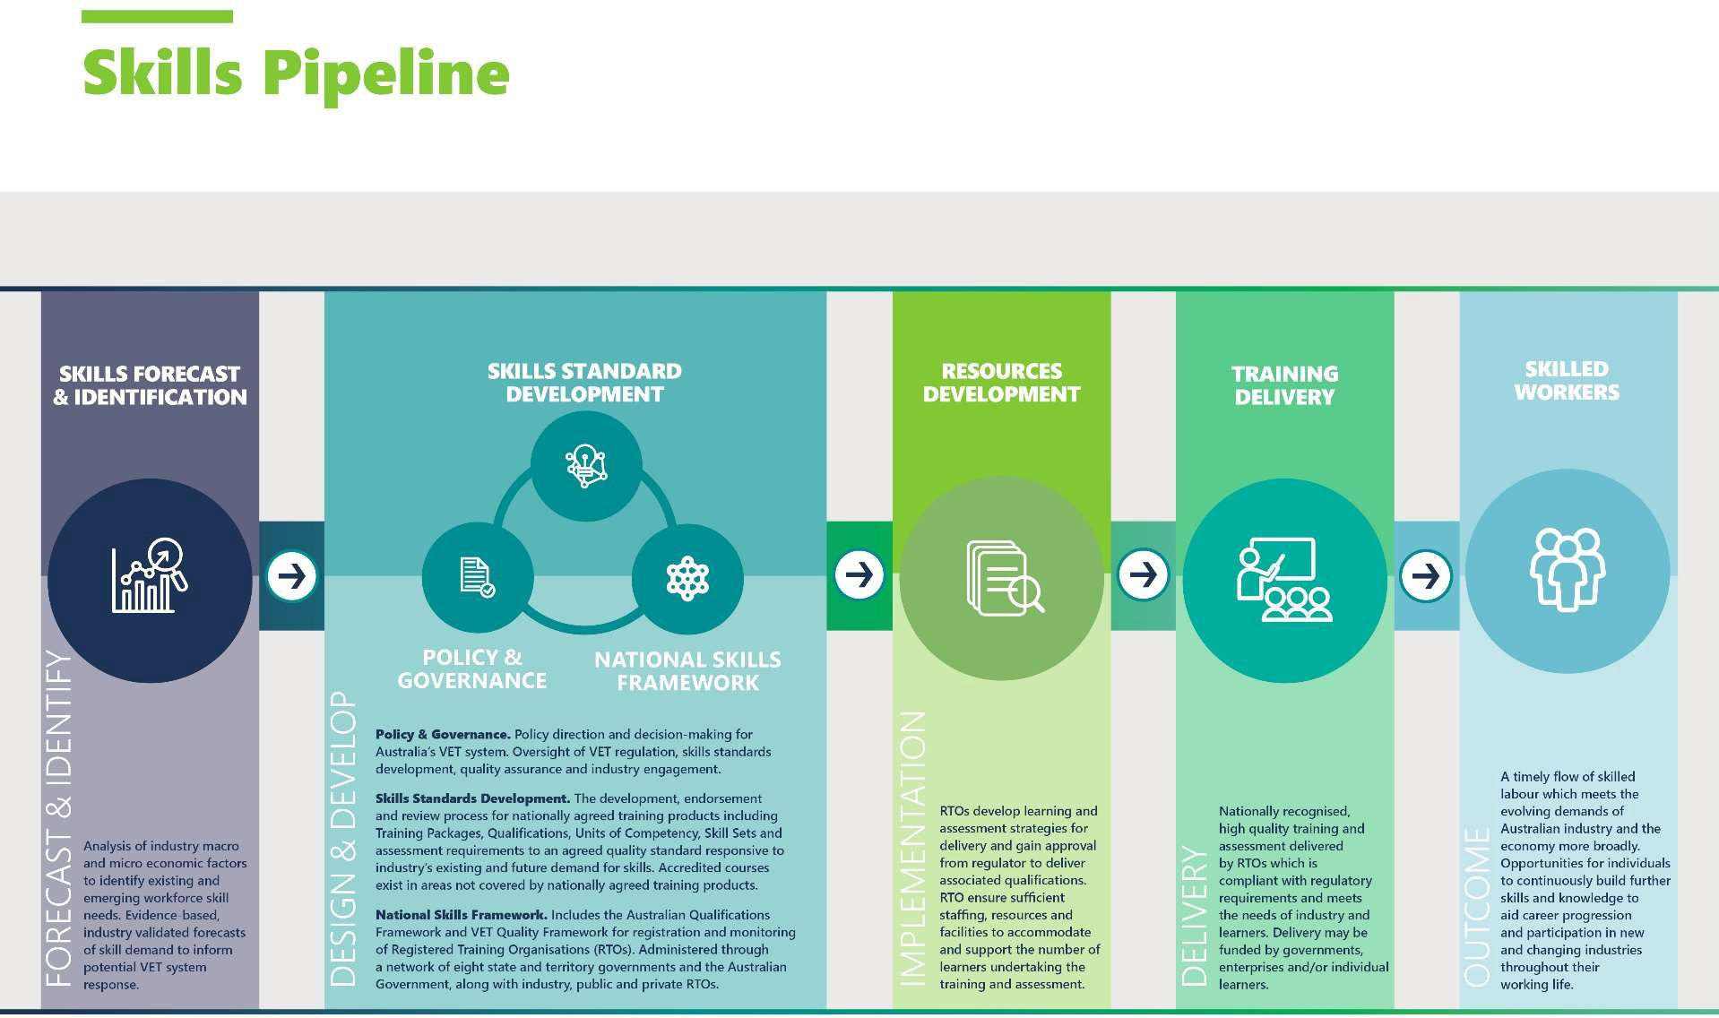

## Attachment 1 - Skills Pipeline explained

The skills pipeline diagram describes a demand-driven, responsive and flexible VET system which delivers skilled workers to meet the evolving demands of Australian industry and the economy more broadly.

### Forecast & Identify Phase

A high-quality VET system requires:

* genuine industry input into determining the national priorities for Australia’s VET system
* high-level, independent, evidence-based industry advice on the future shape of the Australian economy and the projected workforce size and skill needs by industry sector;
* real-time, delivery-level advice to ensure training effort produces a timely flow of skilled workers which meets the evolving demands of Australian industry.

This phase of the pipeline involves analysis of industry macro and micro economic factors to identify existing and emerging workforce skill needs. Followed by evidence-based, industry validated forecasts of skill demand to inform potential VET system response.

It is not assumed that every demand identified in this phase requires a consequent system change or new training product to be developed. Contraction of particular sectors may reduce widespread demand for skills in those areas and it is equally important to identify these trends to identify legitimate pathways to other sectors and job roles.

#### 2019 VET System

Annually Industry Reference Committees (IRCs)oversight and approve the development of a Skills Forecast and a Proposed Schedule of Work by its supporting Skills Service Organisation (SSO) which is submitted to the Australian Industry and Skills Committee (AISC). Together these documents:

* provide intelligence at the industry/sector level including qualitative and quantitative data, analysis of new and emerging skills, and associated training needs for that industry/sector (industry analysis)
* provide advice about the optimal timing for reviewing relevant training packages (which is informed by the industry analysis)
* inform training package development.

### Design & Develop Phase

This phase of the pipeline has three interlinked components which operate collectively to provide governance for the VET system, establish the frameworks that provide the foundations of the system and provide the policies to support the development, endorsement and review process for nationally agreed training products. The interdependencies between these three components relate to the intersecting jurisdictional responsibilities for VET which require significant cooperation and coordination among governments across system design and development to ensure a high-quality VET system.

The design of Australia’s VET system ensures that regardless of skill level, industry sector or where within Australia the training takes place, a learner’s skills are nationally recognised, portable between enterprises and across jurisdictional boundaries.

### Policy & Governance

The Council of Australian Governments (COAG) Skills Council (Skills Council) is mandated to provide leadership and direction for the VET sector. The Commonwealth and States and Territory governments share responsibility for the architecture that provides national qualifications that are recognised across all States and Territories. The Commonwealth currently funds the development and maintenance of the nationally endorsed training packages developed by industry to ensure skills are portable and labour is mobile.

#### 2019 VET System

The Australian Industry and Skills Committee (AISC) provides advice to the Skills Council on the implementation of national VET policies, and approves nationally recognised training packages for implementation in the VET system.

The AISC draws on advice from its network of Industry Reference Committees (IRCs). IRCs are made up of people with experience, skills and knowledge of their particular industry sector and are responsible for developing training packages that meet the needs of Australian industry.

IRCs provide a forum for industry engagement with the VET system; direct the review, development and implementation of training package content relevant to the industry sectors they cover; and act as a conduit for industry feedback to the AISC and governments on industry trends. IRC members are drawn from enterprises, associations, peak bodies, unions, training organisations and industry regulators.

### Skills Standards Development

This component covers the development, endorsement and review process for nationally agreed training products including Training Packages, Qualifications, Units of Competency, Skill Sets and assessment requirements to an agreed quality standard and that is responsive to industry’s existing and future demand for skills. Accredited courses may exist in areas not covered by nationally agreed training products. Ensuring expert advice on the skills and knowledge required to perform competently in the workplace for codification into nationally endorsed qualifications and Skill Sets is a fundamental tenant of Australia’s competency-based VET system.

A training package is a set of nationally endorsed standards and qualifications which specify the skills and knowledge required to perform effectively in the workplace. Importantly, they are not curriculum and do not prescribe how an individual should be trained. They provide the standards and qualification structures against which Registered Training Organisations (RTOs) train and formally assess the skills of individuals. RTOs use training packages as the basis for developing learning strategies to match individual learners’ needs, abilities and circumstances.

Training packages and the standards they contain serve as the central currency of the VET system. It is estimated that Training Packages cover around 85 per cent of occupations within the Australian economy. As the codification of skills and knowledge, training packages play an integral role in enterprise productivity and economic strategy:

* They are utilised in licensing, regulation and certification, and in the development of industrial awards;
* They are integrated into enterprise workforce development strategies and provide a structured framework for job design, recruitment, work organisation and skills audits, up- skilling and performance management in the workplace;
* They are leveraged by governments to give effect to specific policy imperatives or skill needs in the economy and to drive economic and social reform, for example, building drought preparedness;
* They allow industry to benchmark against national and international industry best practice;
* They provide a framework for career progression and support pathways into further education through VET in Schools programs and articulation, apprenticeships and traineeships and on- the-job training.

They support national and international recognition of skills and qualifications, they underpin the mobility of skilled labour, and Provide benchmarks for recognising informal learning and experience.

#### 2019 VET System

Standards for Training Packages apply to the design and development of training packages for endorsement consideration by the AISC. The Standards are supported by two policies: Training Package Products Policy which supports the design of training packages and the Training Package Development and Endorsement Process Policy.

The Industry Reference Committee Operating Framework establishes the minimum operating requirements for all IRCs. Training Packages are developed by IRCs with technical expertise provided by Skills Service Organisations (SSO), to ensure that the national training system is driven by industry’s nationally agreed skill requirements. The role of each SSO is to:

* facilitate engagement across industry and the training sector; facilitate the development of Training Packages for consideration by their relevant IRCs
* provide project management, information management, operational and secretariat support to the IRCs assigned to them
* provide technical writing skills to support their IRCs in preparing technical specifications for Training Packages and other products
* manage the Training Packages through the endorsement process on behalf of IRCs.

### National Skills Framework

The final component of this phase establishes the policy for nationally recognised qualifications and ensures delivery of learning and assessment is quality assured. Responsive to the need for lifelong learning and the realities of domestic and global labour migration, national qualifications frameworks are a fast-growing phenomenon throughout both the developed and developing world. They seek to:

* ensure relativity between and consistency within qualification levels
* support lifelong learning by making learning pathways clearly visible
* strengthen the link between the education and training sector and the labour market
* promote learner and skilled worker mobility
* provide a reference point for quality assurance.

The opening-up of the market for education and training, including VET, has increased the importance of regulation and quality assurance mechanisms in ensuring the integrity of qualifications. In general, the principles and practices of regulatory and quality assurance systems for VET, and other education sectors, in Australia and overseas are have much in common.

#### 2019 VET System

The national skills framework includes the **Australian Qualifications Framework** and VET Quality Framework for registration and monitoring of Registered Training Organisations (RTOs). It is administered through a network of eight state and territory governments and the Australian Government, along with industry, public and private RTOs. National standards for regulation of RTOs focus on both the viability of the business and its ability to deliver high quality training and assessment.

The Australian Skills Quality Authority (ASQA) is the national regulator for Australia’s VET sector. ASQA regulates accredited courses and RTOs to ensure nationally approved quality standards are met. Separate regulators in Victoria and Western Australia continue to register and regulate RTOs which deliver training to domestic students only in those states.

### Implementation phase

This phase of the pipeline involves the development of learning and assessment resources by RTO’s. VET regulators oversee performance against defined standards to ensure nationally consistent, high-quality training and assessment across the system. This ensures students, employers, the community and governments can have confidence in the integrity and credibility of national qualifications issued by RTOs.

Standards for RTOs describe the requirements that RTOs must meet and ensure the training and assessment they deliver by meets industry requirements (as set out in training packages and accredited courses). Typically, standards describe outcomes RTOs must achieve, but do not prescribe methods by which RTOs should achieve those outcomes thereby encouraging flexibility and innovation while assuring the quality of training. VET regulators are governed by legislation which outlines the approach they take to initial registration of RTOs and activities to audit ongoing RTO compliance.

RTOs are responsible for having effective training and assessment strategies and practices. This includes providing a sufficient ‘amount of training’ to meet the requirements of the training product and for students to develop the skills and knowledge they need. To deliver quality training and assessment, RTOs also need adequate staffing, resources and facilities.

#### 2019 VET System

The **Standards for Registered Training Organisations 2015** (the Standards) were endorsed by the Council of Australian Governments (COAG) Industry and Skills Council in 2014. The Standards are enabled by the National Vocational Education and Training Regulator Act 2011 (NVETR Act). Under the Standards an RTO must ensure, for all of its scope of registration, and consistent with its training and assessment strategies, sufficient:

* trainers and assessors to deliver the training and assessment
* educational and support services to meet the needs of the learner cohort/s undertaking the training and assessment
* learning resources to enable learners to meet the requirements for each unit of competency, and which are accessible to the learner regardless of location or mode of delivery
* • facilities, whether physical or virtual, and equipment to accommodate and support the number of learners undertaking the training and assessment.

### Delivery phase

This phase of the pipeline involves a responsive training system capable of delivering nationally recognised, high quality training and assessment which is compliant with VET and other relevant regulatory requirements and meets the needs of industry and learners. The States and Territories are largely responsible for the delivery and operation of VET in their own jurisdictions, including funding of RTOs and the matching of funded training delivery to local economic priorities.

Delivery may be funded by governments, enterprises and/or individual learners. High quality delivery and assessment by RTOs is assured through a national, risk-based approach to auditing and monitoring that considers both performance and compliance. Some international systems ensure transparency of outcome by mandating reporting requirements including employer/ learner satisfaction as well as key delivery metrics.

The risk that an individual is assessed and certified as possessing competencies that do not accurately reflect their true ability to apply the associated skills and knowledge creates the potential for adverse effects on students, employers, industry, governments, and the community.

#### 2019 VET System

As at 4 September 2019 there were 4,145 RTOs registered to deliver VET in Australia. Trainer and assessor capability have been identified by ASQA as a critical concern for the VET sector in three consecutive regulatory strategies, and the 2019-21 strategy proposes the continuance of this work and a new focus on VET in Schools. The quality of trainers and assessors is directly linked to the quality of teaching and assessment, and therefore, student outcomes, across the entire VET sector.

### Outcome phase

This phase is about ensuring a timely flow of skilled labour to meet the evolving demands of Australian industry and the economy more broadly. As industries continue to evolve, and technologies/automation transform and reshape individual regions, businesses and job roles, this phase must also ensure that working age individuals can continue to build the skills and knowledge needed for their ongoing participation in the workforce.

#### 2019 VET System

The VET sector has more recently seen falling enrolments. After an increase which peaked at 2012, participation rates have been decreasing across the sector. From the peak of 7.06% of working age adults participating in the VET sector in 2012, these numbers have fallen to 5% in 2017.1

The changing needs of industry drive the need to rethink what the Australian VET sector offers. On one hand, VET has a valuable role as the main provider of professional preparation for many industries, and therefore retains a role in fostering industry-specific skills. On the other hand, VET education must also equip graduates with durable and transferable skills.

1 Noonan & Pilcher, 2018