


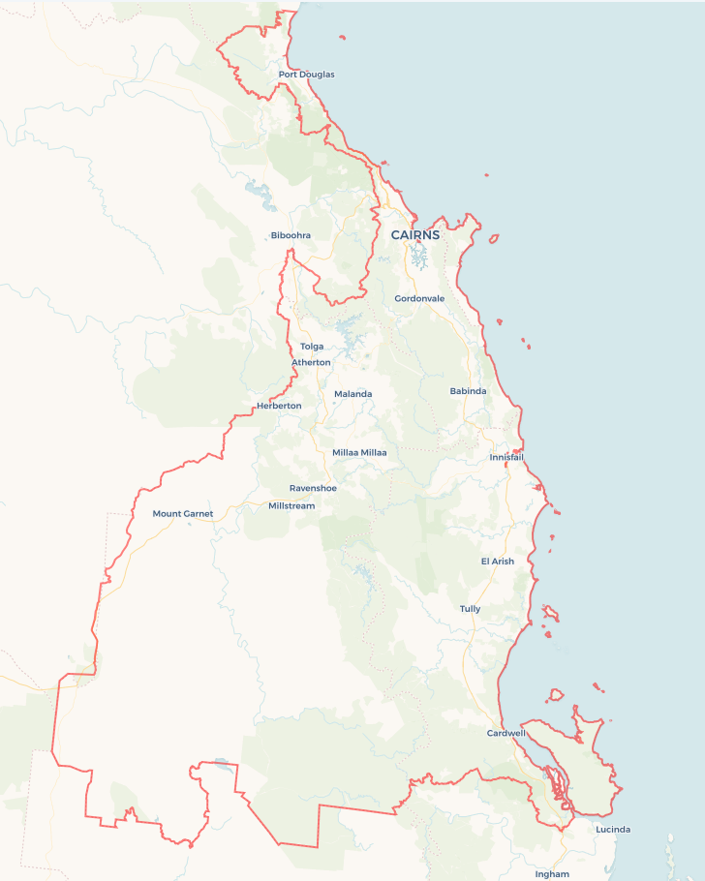
Local Jobs Plan
  - Cairns Employment Region | QLD | August 2026
Workforce Australia Local Jobs (Local Jobs) is a program that creates partnerships between business
and communities to meet local workforce needs, thereby improving employment outcomes.
Local Jobs operates in all 51 Employment Regions in Australia.

Local Jobs Overview

Local Jobs Plan
Each Employment Region has a Local Jobs Plan which outlines the labour market challenges in the region and the strategies to address these challenges.

Job Coordinators
Each Employment Region has a dedicated Job Coordinator who leverages existing resources, supports local labour markets through structural adjustments and retrenchments, and creates opportunities for collaboration between business and communities.

Local Jobs and Skills Taskforce
Each Employment Region has its own taskforce that meets regularly with the Job Coordinator to develop an understanding of challenges in the region and implement solutions. The taskforce is comprised of representatives from the region.

Local Jobs, Local People Grant
The Local Jobs, Local People grant funds activities that help people into ongoing employment or training. Activities must support local labour market needs.
Explore labour market insights for the
Cairns Employment Region

Local labour market challenges
- Retention of skilled workers across all sectors and continued development of regional skills capability.
- Workforce participation barriers experienced by First Nations people, young people, people with disability and other underrepresented cohorts.
- Long-term unemployment and an ageing workforce, including supporting individuals to remain connected to employment & training opportunities.
- Limited connectivity (communications and transport) across geographically dispersed population communities.
- Natural disasters, economic disruption and structural adjustments impacting businesses, workers and local labour market conditions.
- Cost of living pressures, including ongoing housing affordability and availability challenges.
- Growing workforce demand across key industries, including aviation, construction, agriculture, maritime and care sectors (particularly aged and childcare).
- Small and medium business capacity to attract, recruit, train and retain entry-level workers, including apprentices and trainees.

Local priorities

Priority 1 – Maximising local workforce participation and skills development to meet current and emerging industry needs

What are our challenges?

Significant public and private investment across the Cairns region continues to drive demand for skilled workers, particularly in construction, transport and logistics, health care and social assistance, manufacturing, marine and aviation industries and professional services. Workforce shortages, housing pressures and competition for labour continue to impact local employers, creating opportunities to strengthen local workforce capability through vocational pathways, apprenticeships, traineeships and greater participation from underrepresented cohorts.

How are we responding?
- Encouraging uptake of apprenticeships, wage subsidy and training programs to increase awareness through promotion, education and direct engagement.
- Supporting employers to develop workforce solutions that strengthen attraction, recruitment and retention outcomes.
- Continuing to map major projects, workforce requirements and emerging skills needs to better align jobseeker and training pathways with future opportunities.
- Strengthening integrated service models to improve outcomes for registered individuals, through collaboration and coordination, recognising complex needs and multi-agency contribution.
- Supporting implementation of regional workforce strategies and industry action plans.
- Creating multiple entry points into employment for individuals experiencing disadvantage or barriers into workforce participation.
- Promoting local career pathways and employment opportunities that encourage people to live, work and build careers within the region.
- Supporting workforce participation initiatives for First Nations peoples, young people, women, mature age workers, people with disability and other underrepresented cohorts.

Priority 2 – Creating workforce pathways into priority industries and supporting transferable skills across sectors

What are our challenges?

Demand for skilled workers continues to exceed supply across emerging and priority industries in our region. Opportunities exist to strengthen workforce pipelines through industry-led training, targeted recruitment and stronger employer, education and employment service partnerships.

How are we responding?
- Supporting cross sector skilling and workforce development initiatives that address identified skills shortages and increase workforce flexibility.
- Engaging with industry leaders, employer groups and workforce representatives to better understand current and emerging workforce needs.
- Supporting the development of industry-led training pathways aligned to local workforce demand and employment opportunities.
- Supporting implementation of regional and industry workforce strategies where they align with identified Local Jobs priorities.
- Identifying opportunities that support emerging industries and new employment pathways across the industry.
- Promoting flexible training and employment models that allow individuals to earn and learn while building industry-relevant skills. This includes apprenticeships, traineeships, work placement and cadetship opportunities.
- Supporting initiatives that increase awareness of local career opportunities and encourage workforce participation across priority and emerging industries.

Priority 3 – Supporting equitable access to employment, training and workforce participation

What are our challenges?

First Nations people, young people, women, people with disability, CALD communities, students, parents returning to work, long-term unemployed and other underrepresented individuals continue to experience barriers to workforce participation. Growing industries provide opportunities to create more inclusive employment and training pathways through collaborative local approaches.

How are we responding?
- Supporting the development of culturally appropriate, accessible and inclusive employment and training initiatives through strategic activities, project engagement and community partnerships.
- Supporting access to tailored, face to face careers guidance and workforce information that helps individuals make informed education, training and employment decisions.
- Creating opportunities through Local Jobs forums, industry engagement activities and other events to link individuals with local employment, training and career opportunities.
- Advocating for greater access to diverse, accessible and flexible training options across the region.
- Supporting coordinated and co-designed training options with businesses and training providers that allow individuals to earn and learn while building skills aligned to local workforce needs.
- Supporting partnerships between employers, education providers, employment services and community organisations to develop sustainable employment and training pathways.
- Developing skilling and employment responses that reflect the perspective and needs of individuals with diverse cultural backgrounds, abilities and personal circumstances.
- Working with employers to promote workforce diversity and increase opportunities for First Nations people, young people, women, people with disability, CALD communities and other underrepresented groups.

Priority 4 – Facilitating transitions to new employment and self-employment opportunities and supporting workforce adaptability

What are our challenges?

Economic, technological and industry change, together with natural disasters and workforce shortages, continue to reshape regional labour market needs. Strengthening workforce adaptability, reskilling and entrepreneurship can help individuals remain connected to employment and support business resilience.

How are we responding?
- Supporting initiatives that help individuals transition into new employment, self-employment, career pathways or industries in response to changing workforce demands.
- Promoting reskilling and upskilling opportunities that enable individuals to build skills aligned with current and emerging labour needs.
- Working with employers, training providers, employment services and business support organisations to identify workforce transition opportunities and develop practical pathways into employment and self-employment.
- Supporting workforce responses that assist business, workers and communities impacted by natural disasters, economic disruption or structural adjustment.
- Sharing information about workforce trends, skills needs, business development supports and available services to assist individuals and businesses to respond to changing labour market conditions.
- Participating in and supporting local employment, careers, business and workforce development events that connect individuals with opportunities across the region.
- Encouraging collaboration between industry, education providers, community organisations and business support networks to support lifelong learning, entrepreneurship and workforce adaptability.

Want to know more?
- Contact: Kate Montgomery, Cairns Employment Region Job Coordinator: Kate.Montgomery@dewr.gov.au
- Visit: Local Jobs or Workforce Australia

