


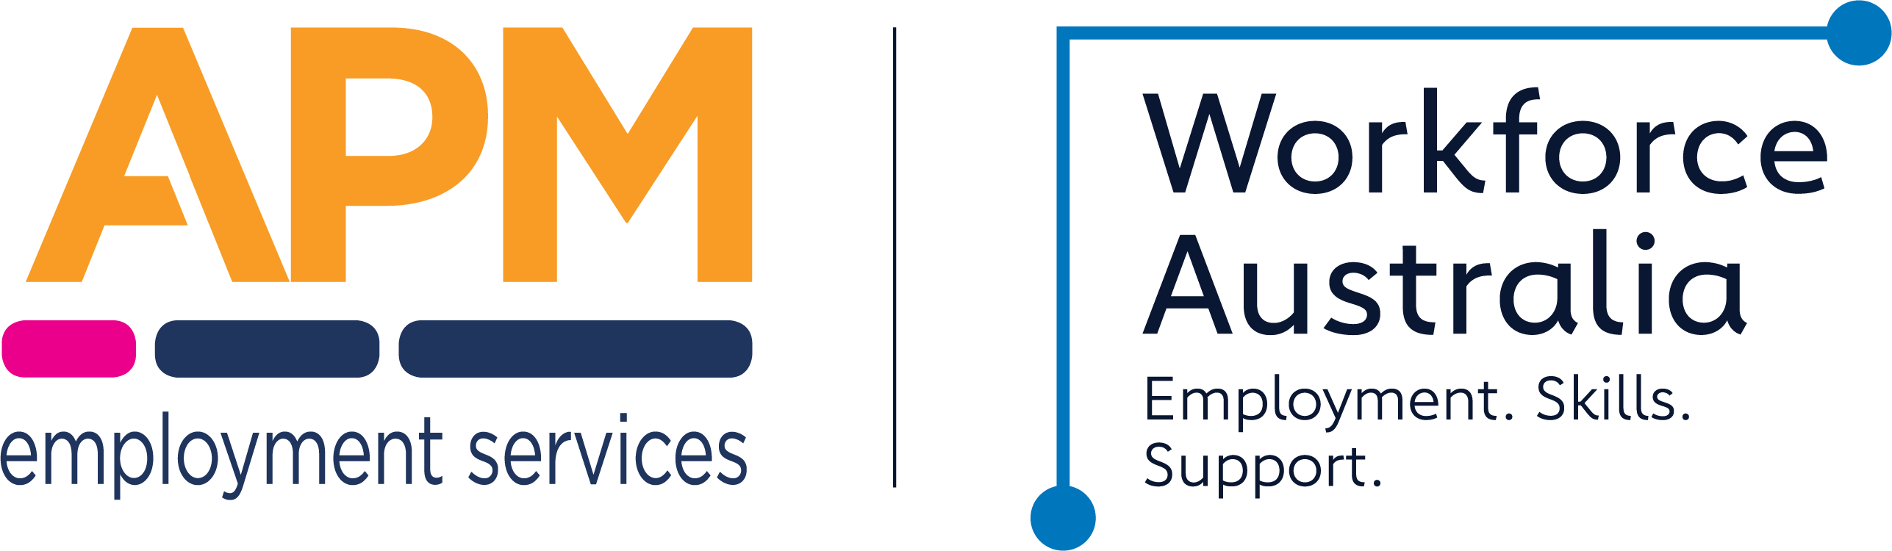

Service Delivery Plan
The APM Transition to Work Service Delivery Plan sets out our commitments to young people and employers, highlighting unique services you can expect from us across Burwood, Hurstville, Lakemba, Rockdale, Sutherland, Ashfield, Belmore, Campsie, Caringbah, Kogarah, Mascot, Miranda, Punchbowl, Engadine, Jannali, Leichhardt, North Strathfield, Strathfield.
For young people, APM commits to giving you the assistance and support to find and keep a job by:
- Connecting you with a Youth Support Worker to help you succeed with education or employment
- Providing one-on-one support through your Youth Support Worker including:
  - An initial meeting to identify your strengths, goals and support needs through our Pathway Assessment Tool, leading to an agreed Job Plan of activities that meets your requirements
  - Ongoing fortnightly contacts (minimum). We offer flexible servicing via the phone or virtual meetings when your circumstances prevent you from being available face to face
- Inviting your feedback on how we’re doing through our Youth Advisory Group where you can inform our current and future activities, ensuring we remain relevant and continue to meet the needs of young people in your local area
- Connecting you with our Boost activities to build practical skills and enhance your job search
- Giving you a personalised login for Employable Me giving you access to APM jobs & resources 24/7
- Offering you additional tailored support depending on your needs, for example Youth Activation Packages, allied health services or links with local community services
- Supporting you once you start work, including access to 24/7 tele-health counselling and the Wellbeing Gateway as well as practical support such as work wear and ongoing training

For employers, APM commits to:
- Providing you with an end-to-end recruitment service. We’ll get to know your business and make it easy for you to connect with a dedicated APM Account Manager
- Giving you access to assistance and resources 24/7 via Employable Me, our online platform where you can post jobs and find candidates. By using Employable Me to find your employees, you can find out how to access significant benefits and reduce hiring costs
- Where eligible, we will assist you to access the Youth Bonus Wage Subsidy when you hire a young person
- Offering tailored recruitment packages including pre-employment training to ensure customisation of your needs and the appropriate supports to meet them
- Supporting the induction of your new hire from APM with close contact for the first 4 weeks, then tailored Progression support for 26 weeks ensuring sustainability of the job and the potential to further up skill your employee
- Connecting you with our network of Apprenticeship Support and Group Training Providers to discuss how apprenticeships and traineeships can benefit your business.

Networks and Support
APM can benefit young people and employers by providing priority access to services from our partners.
Wellbeing
- 24/7 Telehealth Counselling with Assure Programs provide accessible support when you need it, connecting you to Allied Health Professionals to help address issues quickly.
- Learn more about the Wellbeing Gateway here www.assureprograms.com.au
- Wellbeing Gateway is your mental health and wellbeing companion supporting you to thrive at work, in health and life, providing:
  - Confidential service at no cost to you. Wellbeing Gateway provides wellbeing coaching and support when you need it by an experienced health professional at the touch of a button
  - A comprehensive range of content, engaging programs and activities which are regularly updated across a diverse range of topics and formats to manage your work, health and life journey to ensure you have the strategies and guidance to thrive
  - Learn more about the Wellbeing Gateway here www.assureprograms.com.au
- Referrals to local services this includes local partnerships with Youth Off the Streets for crisis support, ABC Driving School for transport assistance, TAFE & Licenses for Work qualifications to commence work, Weave Youth & Community Services, Kurranulla Aboriginal Corp. for counselling, cultural and crisis support to list just a few!
Jobs and Skills
APM can add real value to young people and employers by providing priority access to services from our partners.
- Employable Me can help find a job that suits you. Whatever barriers you face when looking for work, we’re here for you. Through Employable Me, you get the tools, guides and support to connect with active employers and employees. Learn more about Employable Me here www.employableme.com
- Innovative Training and Recruitment (RTO ID 40206) provides access to accredited learning to develop role and industry specific skills. Learning more about Innovative Training and Recruitment here www.itandr.com.au
- Youth Advisory Sessions are available to eligible young people, and delivered by APM Employment Specialist Career Counsellors who are members of the Career Development Association of Australia

About APM
APM started in 1994 as a small team in Perth, Western Australia, looking to provide better vocational rehabilitation for injured workers so they could recover their health and stay in their jobs.
Today we’re an international human services provider with more than 1,000 locations across Australia, New Zealand, United Kingdom, Europe, North America, and Asia. We employ more than 9,000 people across 11 countries with a global purpose - to enable better lives.
Our purpose drives us. It’s why we come to work. It’s why we continue to grow.
It’s how we inspire excellence and exceptional service with everyone we meet.
Our services focus on enhancing an individual’s employability, health and wellbeing, and social and economic participation in their community.
We take great pride in empowering people to realise their ambitions and aspirations through sustainable employment, independence, better health and wellbeing, and increased social participation.
Each year, APM supports more than 1 million people of all ages to live a better quality of life.
Got questions – call now 1800 276 276 or TtW@apm.net.au– Otherwise Let’s get to work!


