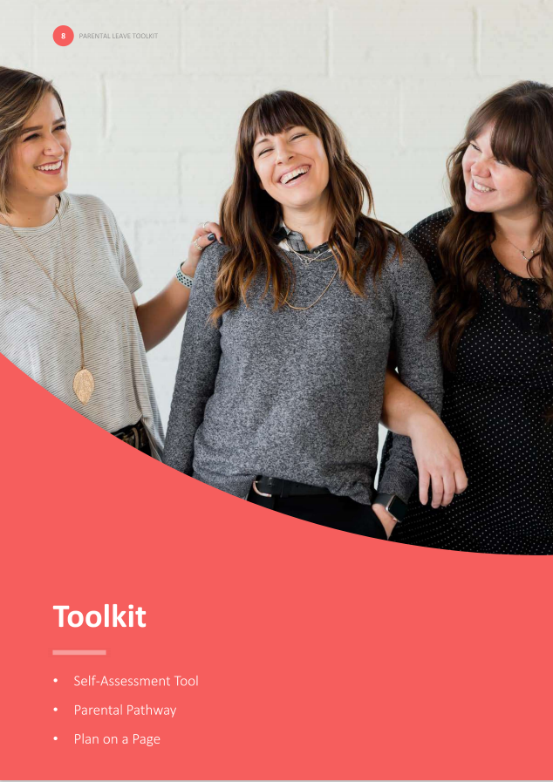
- Plan on a Page example

Plan on a Page example

To support employees and managers to have regular, honest and open dialogue about transitions and aspirations pre and post parental leave, consider developing a Parental Leave Plan on a Page. The template helps managers to see employees through a different lens and could be used as a dynamic document, updated before, during and following return.
Employee: Claire Marshall

CONTACT DETAILS
PHONE: 0314 356 879
EMAIL: Claire.Marshall@Hotmail.com

GETTING READY
CONVERSATION FREQUENCY:
Monthly discussion with manager
KEY DATES
HANDOVER PERIOD: May – June 2020
LEAVE PERIOD: 1 June 2020 – March 2021
DUE DATE: 15 June 2020
ON MY MIND
MEDICAL: Wondering about taking time for antenatal care, and whether I need to take leave or manage within my given hours.
PROFESSIONAL: Ensuring I am considered during performance evaluation and appraisal.
OTHER: Seeking confirmation of contractual maternity pay.
IMMEDIATE:
Promotion to Senior Designer
LONG TERM:
Team leader

WHILE I’M AWAY
STAYING IN TOUCH:
PREFERRED CHANNELS: SMS or email
FREQUENCY: Fortnightly
TOPICS: Organisation restructures, promotion opportunities and team social events.

RE-INTEGRATION
TRAINING AND DEVELOPMENT
- Mandatory risk training on return
- Human centred design
CHANGES TO WORK PATTERNS AND SCHEDULES
KEEPING IN TOUCH DAYS: To be utilised for training and planning days.
FLEXIBLE WORK REQUEST: Request to work part time (Monday – Wednesday)
SUPPORT NETWORKS
Member of the parents at work network
Regular catch ups with manager (fortnightly)

