

The Skills and
Training Incentive
2019–2021
Evaluation Report
Published November 2022

ISBN
978-1-76114-491-2 [PDF]
978-1-76114-492-9 [DOCX]
With the exception of the Commonwealth Coat of Arms, the Department’s logo, any material protected by a trade mark and where otherwise noted all material presented in this document is provided under a Creative Commons Attribution 4.0 International licence
(https://creativecommons.org/licenses/by/4.0/).
The details of the relevant licence conditions are available on the Creative Commons website (accessible using the links provided) as is the full legal code for the CC BY 4.0 International licence (https://creativecommons.org/licenses/by/4.0/legalcode).
The document must be attributed as The Skills and Training Incentive 2019–2021 Evaluation Report.

EY Sweeny was commissioned by the (former) Australian Government Department of Education, Skills and Employment to evaluate the Skills and Training Incentive between September 2020 and June 2021.
This report outlines the findings of the evaluation and includes a departmental response.

Contents
Executive summary v
Departmental response to findings x
Section 1: Introduction 1
Section 2: Methodology 6
Section 3: Context and background 12
Section 4: Reach, uptake and applicant profile 18
Section 5: Implementation and delivery 24
Section 6: The co-contribution model 27
Section 7: Impact on learning and training 37
Section 8: Employer and provider engagement and support 41
Section 9: Conclusions and suggestions 45
Appendix 1: Literature review 48
Appendix 2: Fieldwork instruments 56
Appendix 3: Evaluation matrix 81
Appendix 4: Limitations around counting Incentive participants 85

Report disclaimer: Our Report may be relied upon by the Department of Education, Skills and Employment for the purpose set out in the scope section/proposal only pursuant to the terms of our Work Order Variation dated 16 September 2020. We disclaim all responsibility to any other party for any loss or liability that the other party may suffer or incur arising from or relating to or in any way connected with the contents of our report, the provision of our report to the other party or the reliance upon our report by the other party.

Executive summary
The Skills and Training Incentive (‘SATI’ or ‘the Incentive’) was announced as part of the More Choices for a Longer Life package in the 2018–19 Budget and is managed by the Department of Education, Skills and Training (the department). The Incentive was originally made available from 1 January 2019 to 31 December 2020 for up to 3,600 participants per year (total of 7,200) and provided up to $2,200 (GST inclusive) to fund up to 50% of fees for training identified through the Skills Checkpoint for Older Workers (‘Skills Checkpoint’) program, also managed by the department. The Incentive was subsequently extended to 30 June 2022, for up to 3,600 participants per year. Both programs are open to individuals aged 45 to 70 who are employed and at risk of entering the income support system, or unemployed within the last 9 months (originally within 3 months, extended to 9 months as of 31 July 2020) and not registered for assistance through an Australian Government employment services program.
The department is required to monitor and evaluate Australian Government employment services and programs under the terms of the Public Governance, Performance and Accountability Act 2013 (PGPA Act) and specific directives from Cabinet. EY Sweeney was commissioned to undertake an evaluation of the Incentive. The following report outlines the findings from this evaluation.

Evaluation methodology
This evaluation focused on answering the 4 Key Evaluation Questions (KEQ) listed below to assess the effectiveness and appropriateness of the Skills and Training Incentive. These questions were developed and refined in consultation with the department and based on a program logic model that had been developed by the department prior to the evaluation commencing.
An evaluation matrix developed and refined in consultation with the department identified a range of sub-questions within each Key Evaluation Question, also to be addressed by the evaluation. Each sub-question is presented throughout the body of this report. The program logic model is shown in Figure 1 and the evaluation matrix can be found in Appendix 3.
The 4 Key Evaluation Questions were:
- KEQ 1: Was the design of the Incentive relevant and effective in engaging mature age people to take up the training identified?
- KEQ 2: Did the co-contribution model act as an incentive for training participants to undertake the training?
- KEQ 3: To what extent did the design of the Incentive encourage employers to make a co-contribution to a staff member’s training?
- KEQ 4: What is the reach (e.g., number and diversity of participants) of the Incentive?
It is important to note that this evaluation was initiated prior to the onset of the COVID-19 pandemic. The impact of this has been:
- Project delays: The Australian Government’s response to the COVID-19 pandemic meant that the evaluation of the Incentive was delayed by several months. Following this delay, the design of the evaluation was updated to reflect the new timeframes.
- Appetite for training: The uptake of the Incentive was impacted by the pandemic (as is outlined later in this report). Widespread industry uncertainty prompted Australians to undertake training and development to ensure that they are suitably skilled for a longer future within the workforce. As a result, providers were often reacting to high demand, as participants sought to take advantage of this Incentive to facilitate training.

Overview of data collection
The evaluation utilised quantitative and qualitative data to address the evaluation questions. Results have been reported at the whole program level, factoring in feedback from various stakeholders with different types of involvement.
Data sources include the data collected for the delivery of the Skills Checkpoint Program and the Incentive, as well as bespoke collection strategies specifically designed for the Skills and Training Incentive evaluation, including:
- a rapid review of literature related to similar programs
- qualitative consultation data collected by EY, involving Skills Checkpoint providers (‘providers’), employers and Skills Checkpoint and Incentive participants
- quantitative Skills Checkpoint and Incentive participant surveys undertaken by EY.

Key findings
The key findings of the evaluation address both the Key Evaluation Questions and their associated sub-questions. As there is considerable interrelationship between sub-questions from different Key Evaluation Questions, findings are first presented in 5 sections which address the sub-questions grouped according to the following themes:
- Reach, uptake and applicant profile (KEQ 4)
- Implementation and delivery (KEQ 1)
- Co-contribution model (KEQ 2 & 3)
- Impact on learning and training (KEQ 1, 2 & 3)
- Employer and provider engagement and support (KEQ 1 & 3).
The last section of this summary then presents an overview of evaluation findings against each of the 4 Key Evaluation Questions.
The key findings against each of the 5 theme areas of the evaluation are outlined below.

Reach, uptake and applicant profile (KEQ 4)
The Skills and Training Incentive has reached a new and relatively diverse audience among the mature age cohort where there is a real need to ensure skills are updated to increase longevity in the workforce. The following key findings were observed:
- One in 4 participants were unemployed at the time of accessing the Incentive, with approximately half of these having been made redundant – some for more than 9 months, suggesting that a small number are potentially at risk of entering the support system.
- A sizable proportion of participants were employed either full or part time and were looking to prevent themselves from having to access government support.
- The Incentive largely catered to individuals who are proactive and engaged with the workforce and who are therefore seeking to futureproof their career.
- The real estate and property sector appears to have benefited from use of the Incentive, which could be as a result of the change in registration requirements within the sector.

Implementation and delivery (KEQ 1)
Overall, the program was generally implemented and delivered as intended, with participants reporting high satisfaction with the application process. Some delivery challenges were identified, however, indicating room for improvement in the delivery of the Incentive. The following challenges were identified:
- Invoicing issues increasing administrative burden and delaying training commencement (13%)
- Misinformation about the Incentive eligibility criteria (11%)
- Inefficient administration delaying the application process (11%).
While not related to the SATI program or its delivery, an additional challenge faced by participants and employers was delay in finding or organising suitable training (15%).

Co-contribution model (KEQ 2 & 3)
The co-contribution model was found to be largely relevant and appropriate, with key findings including:
- The co-contribution model made training more affordable, with 87% of Incentive participants satisfied with the amount funded by the government.
- The co-contribution model strongly motivated individuals to fund training opportunities, with 46% stating that they had co-funded training which they would have otherwise been unlikely to do.
- The co-contribution model did not provide sufficient financial assistance for those experiencing financial hardship, however. It also did not increase the financial viability of training for a smaller proportion of individuals, including those living in metropolitan areas.
- One in 2 (49%) Incentive participants accessed training to develop their existing skillset for use in their current role or with a new employer and 40% accessed training to retrain for a new role or career with a new employer.
- Employers who recognised the value of training were more likely to co-fund training opportunities as a result of being able to access the Incentive.

Impact on learning and training (KEQ 1, 2 & 3)
The Incentive had the following impact on learning and training:
- The Incentive made the decision to undertake training much easier for participants, though there was already recognition of the importance of professional training amongst employers and participants, and a proportion of participants would have sought to upskill regardless.
- Overall, individuals co-funding training were investing in themselves and, as a result, there was a greater level of responsibility towards completion of the learning.

Employer and provider engagement and support (KEQ 1 & 3)
Employers and providers generally regarded the Incentive positively, with key findings as follows:
- Employers were supportive of the Incentive when the training undertaken had a tangible business benefit.
- Employers generally believed that they had influenced the training selected or that the recommended training aligned with the requirements of their business.
- The real estate industry was strongly represented. The industry requires employees to hold a real estate license and its reliance on formalised training suggests it is an industry that may have invested in training regardless of the Incentive.
- Providers were particularly positive about the Incentive, believing it filled an important gap in the market. They highlighted that much of their effort had gone towards filling the demand from participants and that employers were less engaged with the Incentive.

Key Evaluation Questions addressed
The following key findings were observed against the Key Evaluation Questions:

KEQ 1: Was the design of the Incentive relevant and effective in engaging mature age people to take up the training identified?
- The design is highly relevant and appropriate to engaging mature age people to participate in training, as it is targeted to a cohort with a significant need for work-related training that has not been addressed through existing programs and supports.
- The program’s design is also relevant due to the vulnerability experienced by this cohort as a result of ageism in the workforce, with the Incentive offering easier access to training opportunities that increase this cohort’s employability.
- While there remains a proportion of people who would have undertaken training regardless of the Incentive, the financial assistance it offered made the decision to undertake training much easier for many people.

KEQ 2: Did the co-contribution model act as an incentive for training participants to undertake the training?
- The co-contribution model is effective at engaging participants to commit to and complete training because committing their own funds to training made them invested in completing it.
- Most participants considered the amount funded by the Incentive sufficient, but it does not provide adequate support for those experiencing financial hardship who cannot afford upfront payment of the co-contribution amount.

KEQ 3: To what extent did the design of the Incentive program encourage employers to make a co-contribution to a staff member’s training?
- Among the small proportion of employers who paid the co-contribution, the model made it easier for some to co-fund employee training opportunities, with smaller businesses indicating they would have been unlikely to do so in the absence of the Incentive.
- Some employers would have likely funded training regardless of the Incentive, particularly due to ongoing licensing and training requirements in some industries.

KEQ 4: What is the reach (e.g., number and diversity of participants) of the Skills and Training Incentive?
- The Skills and Training Incentive reached a new and relatively diverse audience, and one that can benefit greatly from training and upskilling to increase their longevity in the workforce.
- Responding to the high demand, particularly during the COVID-19 pandemic, meant engagement from providers was mostly reactive rather than proactive. As a result, providers largely responded to demand from individuals and were able to invest very limited time promoting the Incentive to employers.
- Providers highlighted the difficulties they faced in keeping up with the demand for the Incentive, highlighting the appetite from the market for this funding.

Suggestions to improve the Incentive
Although the Incentive has been positively received and is clearly catering to a new audience who require ongoing training to help them stay competitive, the following considerations may improve the Incentive in future:
- Proactive monitoring of industries: Greater targeting of the Incentive towards industries and individuals who really need it and who are unlikely to undertake training without it.
- Greater assistance to those in financial hardship: Enable those facing financial challenges greater access to the Incentive.
- Reallocation of funds: Providing more allocations or maximising the available funds through a pool accessible money, rather than individual allocations.
- Addressing administrative issues: This includes minimising misinformation and streamlining the application and invoicing process.
- Ongoing review: Conducting ongoing evaluation and review of the Incentive to identify opportunities for refinement and improvement.


Departmental response to findings

Skills and Training Incentive context
The Skills and Training Incentive (the Incentive) is an initiative under the 2018 More Choices for a Longer Life package and commenced in January 2019 as a 2-year trial. It is aimed at assisting mature Australians who are employed or recently unemployed to invest in their training and adopt a lifelong approach to skills development, thereby reducing their risk of entering the income support system. In December 2020 the Incentive was extended until 30 June 2022, and on 7 December 2021 the Government announced a further extension of the Incentive until 30 June 2024, along with increases to the number of Incentives available each year.
The Incentive is tied to the Skills Checkpoint for Older Workers program and is available to participants who have completed a Skills Checkpoint assessment and have a Career Plan that identifies training opportunities (accredited or non-accredited) linked to either their current job, a future opportunity, an industry in demand, or an occupation in national shortage on the National Skills Commission’s Skills Priority List published June 2021.
When the initiative was introduced, eligibility for the Skills Checkpoint and the Incentive included:
- Australian citizen or permanent resident
- aged 45 to 70 years old at the date the application form is lodged with the provider
- either:
  - employed and at risk of entering the income support system (for example, those in industries undergoing structural adjustment)
  - unemployed for no more than 3 consecutive months and not registered for assistance through an employment services program such as jobactive.
The length of unemployment changed to up to 9 months in 2020.
Eligible participants can access up to $2,200 (GST Inclusive) to fund training for reskilling or upskilling opportunities. From 1 January 2019 to 31 December 2021, up to 3,600 Incentives were available each year and either the participant or their current employer needed to match the government contribution.

Next steps and enhancements
The evaluation provided valuable insights and suggestions regarding potential program and policy enhancements for the Skills and Training Incentive.
The department agrees with the insights and suggestions included in the evaluation report.
Enhancements to the program, derived from the evaluation report’s suggestions, were implemented in the expansion and extension of the Incentive, which commenced 1 January 2022.
On 7 December 2021 the Government announced a further extension of the Incentive until 30 June 2024, which included:
- an extra 16,950 Incentives from 1 January 2022 to 30 June 2024, increasing the total number to 7,500 Incentives per year until 30 June 2024
- an increase in the government contribution to up to 75% of the course cost for training related to an occupation in national shortage on the National Skills Commission Skills Priority List, published June 2021, up to $2,200 (GST inclusive).
To deliver this further extension, the Department conducted a tender exercise, and a new, national contract was awarded commencing on 1 October 2022 for the service provision of the Skills Checkpoint for Older Workers Program and the Skills and Training Incentive. This new contract included further enhancements to the program.
Enhancements included:
- Providing ongoing support to older Australians
The Incentive was extended to 30 June 2024 to provide support to up to an extra 16,950 participants with their training needs to remain in the workforce longer. The Skills Checkpoint will also continue, as the gateway to the Incentive, with a doubling of places to up to 10,000 available per year.
- Greater targeting of the Incentive towards skills shortages and industries and individuals most in need
From 1 January 2022 the Incentive expanded to increase the government contribution to course costs to up to 75% up to $2,200 (GST inclusive), for training related to occupations in national shortage on the National Skills Commission Skills Priority List.
From 1 October 2022 the Incentive was further expanded to include course costs up to 75% up to $2,200 (GST inclusive), for training related to occupations with strong future demand, as identified on the National Skills Commission Skills Priority List.
The department continues to work closely with the Incentive provider to expand their communication plans to include targeted advertising of the Incentive to industries in need and reduce misinformation. Further, a comprehensive communication and stakeholder engagement marketing plan was developed by the provider for implementation from 1 October 2022.
- Improving access for participants experiencing financial hardship through alternative pathways
Eligibility for the Skills Checkpoint for Older Workers Program has been broadened to include persons aged 40 years and over, and to allow participants to be unemployed for up to 12 consecutive months (previously up to 9 months).
The government contribution was also increased from up to 50% to up to 75%, up to $2,200 (GST Inclusive) for training related to occupations in national shortage, or occupations with strong future demand as identified on the National Skills Commission Skills Priority List.
Additional allocations to increase the number of Incentives available
From 1 January 2022 the number of Incentives available to eligible participants increased from 3,600 to 7,500 per year to 30 June 2024.
- Streamlining administrative processes to reduce barriers to uptake
Work has been completed in this area including improved program and privacy guidelines and training material, and improvements to the non-RTO training approvals administrative processes.
Participants and providers are able to execute documents electronically for the program.
Improvements to the department’s IT system were implemented from 1 October 2022 in line with the new contract for the service provision of the Skills Checkpoint for Older Workers Program and Skills and Training Incentive.
Another improvement to the delivery of the program is to continue to allow the provider to service participants either virtually or face to face.

Section 1: Introduction

The Department of Education, Skills and Employment (the department) is required to progressively monitor and evaluate Australian Government employment services and programs under the terms of the Public Governance, Performance and Accountability Act 2013 (PGPA Act) and specific directives from Cabinet.
The department commissioned EY Sweeney to undertake an evaluation of the Skills and Training Incentive. The following report outlines the findings from this evaluation.

Background
The 2016 Australian Human Rights Commission ‘Willing to Work’ national inquiry report found that mature age people face numerous barriers to employment, including difficulty in accessing relevant training.
Previous research conducted by the department has indicated that employers valued the skills and experiences that mature age people bring to the workplace. However, employers also noted the importance of mature age workers ensuring that their skills remain up to date and noted that ongoing training may often be required to achieve this.
To help individuals build skills to remain in the workforce longer, the Australian Government funded a national rollout of the Skills Checkpoint for Older Workers (Skills Checkpoint) from November 2018. This program is based on a model that was piloted by the then Department of Education and Training from 2015 to 2016 and provides eligible Australians with advice and guidance on transitioning into new roles within their current industry or pathways to a new career, including referral to relevant education and training options. The Skills and Training Incentive (Incentive) was announced as part of the More Choices for a Longer Life package in the 2018–19 Budget. The Incentive was originally made available from 1 January 2019 to 31 December 2020 for up to 3,600 participants per year (total of 7,200) and provided up to $2,200 (GST inclusive) to jointly fund training identified through the Skills Checkpoint program. This was subsequently extended to 30 June 2022, for up to 3,600 participants per year.
Both programs are open to individuals aged 45 to 70 who are employed and at risk of entering the income support system, or unemployed within the last 9 months (originally within 3 months, extended to 9 months as of 31 July 2020) and not registered for assistance through an Australian Government employment services program.

Skills Checkpoint and Skills and Training Incentive overview
Two Skills Checkpoint providers (The BUSY Group Ltd and VERTO Ltd) started delivering Skills Checkpoint services in November 2018. They are contracted to provide services to up to 20,000 Australians over 4 years (up to 5,000 per financial year) in the locations shown in Table 1.
Table 1: Skills Checkpoint provider locations
Organisation | States/territories
The BUSY Group Ltd | Queensland, South Australia, Western Australia, Tasmania and the Northern Territory
VERTO Ltd | New South Wales, Victoria and the Australian Capital Territory
Each participant undertakes online or face-to-face testing to assess their skill levels and identify any gaps that may:
- limit their capacity to change careers or enter into a new role in their current occupation
- affect their capacity to perform in their current role.
The testing also measures each participant’s aptitude for a variety of training pathways and occupations.
Following the testing, the provider develops a career plan for the participant with recommendations and information on employment pathways and (if applicable) appropriate training options. An advisory interview is then held to discuss the outcomes of the testing and career plan.
Where the career plan recommends training, the participant has the option to utilise the Incentive. The training must be relevant to the participant in one or more of the following ways, by being linked to:
- their current job (e.g. upgrading skills)
- a future job opportunity
- an industry or skill in demand.
The training can be accredited or non-accredited. To ensure a joint investment approach, the participant or their current employer must match the Incentive up to $2,200 GST inclusive, and must fund any cost above this amount. The provider then refers the participant to the training organisation and enrols them in the training course.
The provider is responsible for managing and administering the payment of the Incentive. This involves making a single payment to the training organisation, which includes the co-contribution and government contribution. The provider pays the government contribution out of its own funds and seeks reimbursement from the department.
The provider is required to promote the services to potential participants and stakeholders to maximise the uptake of the services. Both providers submitted a marketing plan to the department outlining how they will promote the services.
As of 31 December 2020:
- 7,055 participants have completed a Skills Checkpoint assessment
- 5,195 Skills and Training Incentives have been committed.
It is important to note that these figures were recorded prior to the Skills and Training Incentive being extended.

Evaluation context
The evaluation reviews the design, implementation and outcomes of the Skills and Training Incentive to explore its effectiveness and appropriateness for this cohort against the Key Evaluation Questions listed below. The evaluation also aims to generate insights to support the future delivery of the program and other skills development programs.
The evaluation is both formative (i.e. evolving and adapting as insights are gathered) and summative (i.e. assessment made following data collection), assessing program design, operation and effectiveness. The evaluation is informed by a program logic model outlining the program inputs, activities and outputs, along with expected immediate, intermediate and ultimate outcomes. This was developed through a collaborative workshop within the department and was then refined in consultation with the evaluation team (see the program logic model (Figure 1)).
The evaluation focuses on the implementation and impact of identified aspects of the Skills and Training Incentive, as outlined in the Key Evaluation Questions. Furthermore, given the close links between the Skills and Training Incentive and the Skills Checkpoint, the relationship and interactions between these elements has also been acknowledged in the evaluation. Where possible, the evaluation assessed the extent to which the COVID-19 pandemic and associated restrictions may have affected the implementation and experience of the Incentive.
As a result of the Australian Government’s response to the COVID-19 pandemic, the evaluation of the Incentive was delayed. Following this delay, the design of the evaluation was revised to reflect the new timeframes.
The pandemic impacted uptake of the Incentive, as widespread industry uncertainty prompted Australians to undertake training and development to ensure that they are suitably skilled for a longer future within the workforce. As a result, providers were often reacting to high demand, as participants sought to take advantage of the Incentive to facilitate training.

Figure 1: Program logic model
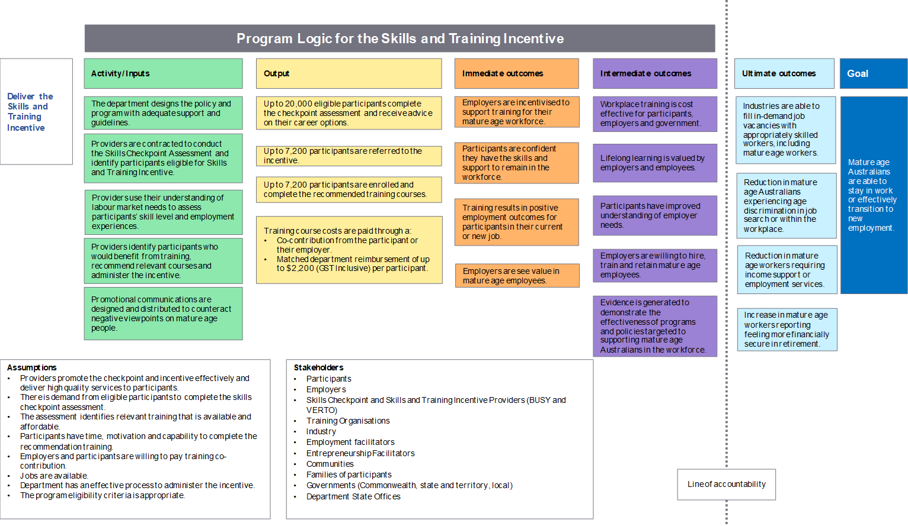

Key Evaluation Questions
This project focuses on answering the 4 Key Evaluation Questions (KEQs), as well as each of their associated sub-questions (Appendix 3). The KEQs assess the efficiency, effectiveness and appropriateness of the Skills and Training Incentive. They are:
- KEQ 1: Was the design of the Incentive relevant and effective in engaging mature age people to take up the training identified?
- KEQ 2: Did the co-contribution model act as an incentive for training participants to undertake the training?
- KEQ 3: To what extent did the design of the Incentive encourage employers to make a co-contribution to a staff member’s training?
- KEQ 4: What is the reach (e.g., number and diversity of participants) of the Incentive?
The sub-questions associated with the KEQs are interrelated. Therefore, the main body of the report is structured to present findings by groupings of related sub-questions from across each KEQ, with 5 theme areas identified. The evaluation sub-questions addressed are presented at the beginning of each section of the report. The following 5 themes were identified:
- Reach, uptake and applicant profile (KEQ 4)
- Implementation and delivery (KEQ 1)
- Co-contribution model (KEQ 2 & 3)
- Impact on learning and training (KEQ 1, 2 & 3)
- Employer and provider engagement and support (KEQ 1 & 3).
The final section of the report, titled ‘Conclusions and suggestions’, summarises the evaluation findings against each of the 4 KEQs.
The evaluation matrix containing the KEQs and their associated sub-questions, information requirements and data sources is provided in Appendix 3.

Section 2: Methodology

This evaluation employed qualitative and quantitative research to address the evaluation questions. Policy, design and process appropriateness questions were predominantly addressed through qualitative research methods, with both research strategies used to gain insights into participant engagement and effectiveness. Administrative data was used to assess the reach of the Skills and Training Incentive program, exploring the extent to which the Incentive engaged individual participants and employers to co-fund training. Administrative and survey data was used to investigate drivers or linkages to outcomes which were measured by the participant surveys. Results were reported at the whole program level and, for the survey data, disaggregated for different demographic groups where relevant.

Data sources
Data sources for the evaluation included the department’s existing data systems, the Skills Checkpoint providers’ data, and bespoke collection strategies specifically designed for the Skills and Training Incentive evaluation, including:
- a rapid review of literature related to similar programs
- qualitative interview data collected by EY
- participant surveys undertaken by EY.
Figure 2 summarises the evaluation’s data and information sources.
Figure 2: Data and information sources
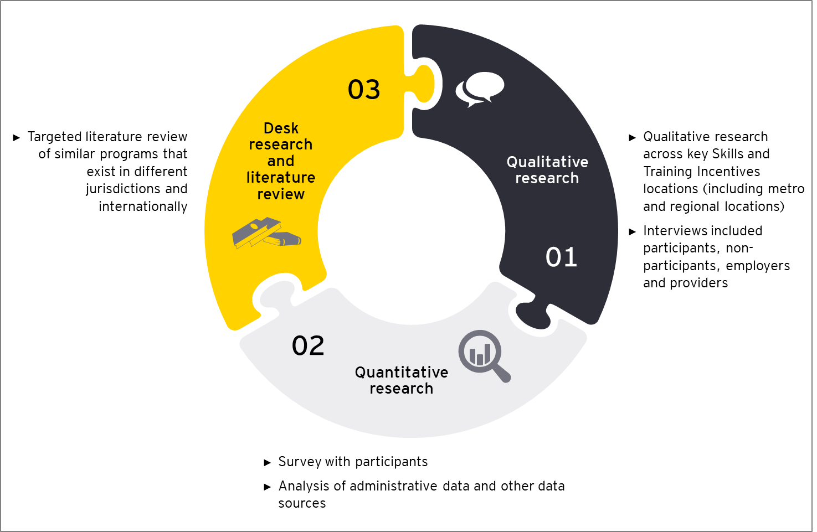

Qualitative research
The qualitative phase sought feedback on experiences with the Incentive; participants’ motivations for accessing the Incentive; and its delivery, service quality, impacts and effectiveness. In addition, those who accessed the Skills Checkpoint program but didn’t access the Incentive were also interviewed to understand the barriers to taking up the Incentive.
Specifically, the qualitative research included interviews with:
- Skills and Training Incentive participants
- Skills Checkpoint participants who did not receive the Incentive
- Skills Checkpoint provider delivery and administrative staff
- employers who provided the co-contribution for employees to access the Incentive.
This research was undertaken throughout Australia, including regional and metropolitan areas. Skills Checkpoint and Incentive participants were aged between 45 and 64 years old at the time of interview. Further information around age and location can be seen in Table 2.
Table 2: Participant sample
State | Skills and Training Incentive participants |  | Skills Checkpoint
 | Male | Female | Male | Female
Victoria | 1 | 1 | 1 | 1
Tasmania | 1 | 1 | 1 | –
New South Wales | 1 | 2 | 1 | –
ACT | 1 | – | – | 1
Queensland | 1 | 2 | 2 | 2
South Australia | – | 1 | 1 | 3
Western Australia | 1 | 1 | 1 | 2
Total | 6 | 7 | 7 | 9
Employers from a range of locations, including NSW, VIC, SA and WA, as well as organisations that operate Australia-wide, were included in the research. Employers represented a range of industries, including:
- Health
- Not for Profit
- Education and Training
- Community Services
- Engineering
- Tourism
- Transport
- Manufacturing
- Wholesale
- Government.
In light of the COVID-19 pandemic and the restrictions it imposed, consultations were conducted via telephone.
Table 3: Employer and Checkpoint provider sample
Qualitative sample structure | Number
Skills Checkpoint provider representatives (including central office and site office staff) and a mix of VERTO and Busy At Work | 11
Employers | 13
Total interviews | 54

Quantitative research
The quantitative phase was informed by the qualitative phase, which facilitated the development of the questionnaire (questions and the code frames). A survey was then administered for participants who accessed the Incentive and those who accessed the Skills Checkpoint Program but not the Incentive. Analysis of administrative data was also captured in this stage.

Participant survey
A survey was used to investigate the experiences, outcomes, activities and views of Incentive and Skills Checkpoint program participants. While data was primarily collected via the online survey, where respondents were unable to complete the online survey, they were able to complete the survey via a Computer Assisted Telephone Interview. This helped to ensure those who otherwise had challenges completing the survey were also represented in the analysis. The survey included questions to gauge:
- motivations and experiences when accessing the Incentive
- experiences undertaking the training funded by the Incentive
- satisfaction with the Incentive and perceptions of the Incentive’s usefulness/impact
- the employment situation and any changes (e.g. retaining or finding new employment) following the receipt of the Incentive
- the influence of the Incentive on individuals and workplaces in changing behaviours.
A census approach was taken, with the survey sent to all participants. To ensure the best possible opportunity for obtaining a representative sample of respondents with respect to location, gender, age, cultural and linguistic diversity, and employment background, the following criteria were monitored throughout fieldwork, with final achieved completed interviews as noted in Table 4:
Table 4: Qualitative sample structure
Cohort | – | Received Incentive | Only accessed Skills Checkpoint | Total
Gender | Male | 318 | 141 | 459
Gender | Female | 508 | 153 | 661
Gender | Prefer not to say | 3 | 3 | 6
Age | 45–49 years | 208 | 47 | 255
Age | 50–59 years | 434 | 162 | 596
Age | 60+ years | 186 | 88 | 274
Age | Prefer not to say | 1 | 0 | 1
State | NSW/ACT | 283 | 53 | 336
State | VIC | 158 | 35 | 193
State | WA | 113 | 44 | 157
State | TAS | 9 | 16 | 25
State | QLD | 195 | 108 | 303
State | SA/NT | 71 | 41 | 112
Culturally and linguistically diverse/ Aboriginal or Torres Strait Islander audiences | Aboriginal or Torres Strait Islander | 8 | 7 | 15
 | Culturally and linguistically diverse (excluding Aboriginal or Torres Strait Islander) | 135 | 48 | 183
Disability or medical condition | Disability or medical condition impacting work and training | 82 | 32 | 114
Contribution | Employer | 115 | - | 115
Contribution | Personal | 710 | - | 710
Contribution | Both employer and personal contributions | 4 | - | 4
Total interviews |  | 829 | 297 | 1,126
Table 5 compares the overall sample structure with the national incidence for 45 to 70 year olds with respect to gender, age and location. The overall sample structure consists of all survey respondents: the 829 individuals who received the Incentive and the 297 individuals who only accessed Skills Checkpoint.
Seventy-four per cent of the survey sample received the Incentive, resulting in this group having a strong impact on the overall distribution across each demographic category. A higher level of participation by individuals who had received the Incentive was anticipated, as they would likely be more engaged with the program compared to those who only accessed Skills Checkpoint.
Table 5: Qualitative sample structure compared to national incidence of target age group
Cohort | –– | Overall survey sample  (Incentive participants and Skills Checkpoint only respondents)  % | National incidence (45 to 70  years of age)  %
Gender | Male | 41% | 49%
Gender | Female | 59% | 51%
Age | 45–49 years | 22% | 22%
Age | 50–59 years | 53% | 41%
Age | 60+ years | 24% | 37%
Age | Prefer not to say | <1% | n/a
State | NSW/ACT | 30% | 33%
State | VIC | 17% | 25%
State | WA | 14% | 10%
State | TAS | 2% | 2%
State | QLD | 27% | 20%
State | SA/NT | 10% | 8%

Administrative data analysis
Administrative data collected through the delivery of the Skills Checkpoint Program and the Skills and Training Incentive was also used. This data included demographic information on participants’ age, location, employment history, interest in the program, training course enrolment and reimbursement amount.
Analysis of the administrative data included basic observations (participant demographics, funding provided, timing of accessing the Incentive, types of training created by program stage, etc.) and investigated potential relationships between the variables and outcomes collected by the participant survey. Consent to link this data with survey responses was obtained as part of the consent for the participant survey.

Desk-based research and literature review of similar programs
A rapid literature review was conducted to determine whether programs similar or complementary to the Incentive are available in other jurisdictions, as well as the extent to which they are effective. The literature review was particularly focused on publications on government subsidies for job-related training opportunities targeted at mature age cohorts using co-contribution funding models. The review was not intended to be exhaustive or systematic, but to provide a limited overview of relevant programs.
Parameters for the review included:
- Academic, industry, government and peak body publications which were published both within Australia and internationally
- A focus, where possible, on publications based on programs in comparable jurisdictions such as other Commonwealth and OECD countries
- Publications spanning the past 5 years. Where literature was unavailable in the last 5 years, this search parameter was extended.

Limitations
This section outlines all the main factors that may have acted as methodological limitations of the evaluation, largely related to scope limitations, as well as the validity and reliability of the Skills and Training Incentive evaluation. These factors are:
- Data quality issues: Missing or poorly recorded data may have limited the measurement of the effectiveness of the Skills and Training Incentive (for example, where reasons for choosing not to take on the Skills and Training Incentive are not recorded or are insufficiently detailed to adequately inform the evaluation).
- Limited employer interviews: The scope of the evaluation and lack of data for potential recruitment did not allow for interviews with employers who declined to access the Incentive, which would have provided valuable information on the factors limiting employer support for the Incentive.
- Impact of COVID-19: The evaluation was initiated prior to the onset of the COVID-19 pandemic. Aside from COVID-19 impacting the uptake of the Incentive, this means that the way some of the evaluation questions were addressed evolved as we adapted the analysis of the evaluation to factor in the impact of the pandemic.

Section 3: Context and background



Literature review summary
Prior to conducting primary research for the evaluation, a rapid literature review was undertaken to determine whether programs similar to the Skills and Training Incentive are available in other jurisdictions. The review sought to investigate programs which provide funding for mature age workers to undertake job-related training opportunities, as well as the extent to which they are effective. In line with the approach of the Skills and Training Incentive, the review focused on government-subsidised training programs available to workers or employers, including those involving a co-contribution funding model. The complete review is included at Appendix 1 with a summary of key findings provided in this section.
The review found that government-subsidised programs offering training opportunities for mature age workers which use a co-contribution funding model appear to be limited. The most similarly structured program was found to be the German government WeGebAU program which co-funds training opportunities for mature age (45+) cohorts. An evaluation of this program reported some promising findings, including increasing participants’ job stability and duration in the labour market. Further, these effects were pronounced for those over 55, those working part time and those who completed longer duration courses. A second German government-subsidised program using a co-contribution funding model also found that the subsidy led to increased employer funding of worker training opportunities (Dauth & Toomet, 2016).
A government-subsidised training program offered by the Netherlands government, though not specifically targeted at mature age workers or using a co-contribution model, found that job-related training for mature age workers improves their employability (Picchio & Van Ours, 2013). Further, programs which are most effective at increasing worker employability and employment duration are targeted to specific cohorts (Messer & Wolton, 2009; Schwerdt et al., 2012). This includes relevant subgroups within the mature age cohort, such as those who are over 55 years of age (Dauth & Toomet, 2016). Such targeted programs have been found to maximise the investment in training provided by the subsidy by targeting workers whose employability benefits from training, but who are less likely to undertake needed training in the absence of financial assistance to support them.
It was also found that several countries including Austria, Estonia, Denmark, Finland, Ireland, Norway and Korea offer other forms of subsidies to employed adults for job-related learning, including fully subsidised training courses or small co-contributions to support training. While these programs provide subsidies for employed adults, they differ in structure and scope to the Skills and Training Incentive as they do not specifically target mature age workers or target very specific categories of adult workers, such as low-skilled or low-income workers. Details of these programs are provided in Appendix 1.
Overall, these findings indicate that there is a strong need, as well as considerable scope and promise, for subsidised job-related training for mature age workers (Dauth & Toomet, 2016; OECD, 2018; OECD, 2019). They particularly suggest that effective programs focus on subgroups within this cohort who would most benefit from training but who are least likely to access it. To target such individuals, programs need to be carefully designed to reach and motivate the employers and workers who would most benefit from subsidies. The review also indicates that courses of longer duration may be particularly beneficial in increasing skillsets and knowledge base, highlighting the need to promote the importance of in-depth courses in some instances (Dauth & Toomet, 2016; Schwerdt et al., 2012).
While further research and evaluations are required to reach a more conclusive position on the effectiveness of government-subsidised training programs, existing findings indicate that co-contribution models targeted at mature age workers through businesses or directly to individuals show good prospects in increasing mature age people’s employability and their length of time in the workforce.

Skills and Training Incentive context

Overview
By targeting the over-45s with training opportunities, the Incentive has been able to successfully support a new and important cohort in undertaking training opportunities. Many of those included in the qualitative interviews commented on the fact that they hadn’t had access to support previously and that, as a result of ageing, there was a sense that they needed to work much harder to remain relevant in the workplace. The support through the Incentive is perceived by the mature age worker as a representation of their value. As many had felt discriminated against in employment applications, interviews or opportunities for progression, they saw this as validation that their age group had relevance in the workforce in the longer term.
For older workers, it [training] adds to their level of confidence in their own capability because you can often feel, particularly with younger staff members, you can often feel you’re viewed as irrelevant… therefore a lot of older workers can feel overlooked … Education can help you get over that and to feel like you’re valuable.
Skills Checkpoint participant, female

Linkages with the Skills Checkpoint program
Although outside of the scope of this evaluation, the Skills Checkpoint program is the access point to the Incentive and provides context for how the Incentive itself has been received. Overall, participants tended to view the Skills Checkpoint program and the Skills and Training Incentive as one and the same. In fact, for the majority, access to funding was a key motivation to take part in the Skills Checkpoint program (see Figure 3).
The Skills Checkpoint program was considered helpful for participants who are uncertain of their career direction and training options. The interviews revealed that some wanted to access career guidance, and specifically wanted to upskill in future-focused careers, but lacked the knowledge to be able to find this information on their own.
It sounded really interesting. I thought, I would really enjoy [the training]. I was told that more and more people would be doing this in the future, that it would go out into the private sector too, not just in government. It wasn’t something that had ever been on my radar, but I thought about it when he proposed [the training].
Incentive participant, QLD
Figure 3: The extent to which funding was the motivation to take part in the Skills Checkpoint Program
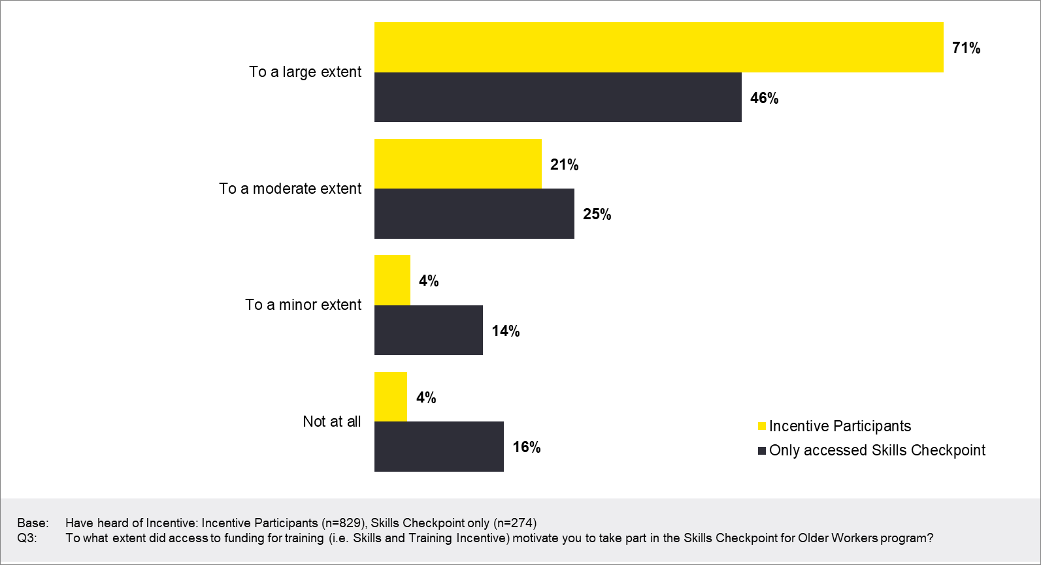
Although some participants reported that they needed the guidance of the Skills Checkpoint program, others did not, and the extent to which the Skills Checkpoint was considered valuable was dependent on:
- the quality and skillset of the provider’s frontline staff, and their ability to effectively connect the participant to training courses and employment opportunities that met the needs of the participant and were considered future relevant
- the degree to which the participant needed career guidance.
While access to the Incentive was a key driver for participating in the Skills Checkpoint program, ultimately, participants want to futureproof their careers, and the advice and guidance that is available on this is fundamental. However, it is critical that the guidance offered through the Skills Checkpoint program is relevant, in terms of both the industry and the roles of the future, and in line with the skills, abilities and interests of the recipient.

Reasons for participation in the program
Reasons for participation in the Skills Checkpoint and, subsequently, utilising the Incentive were varied. Seventy-three per cent of participants who received the Incentive had been employed at the time of accessing the Skills Checkpoint program, with 4 in 10 (40%) having been employed full time. A small proportion of this cohort specified that they were stood down and/or were on JobKeeper due to COVID-19. A quarter (26%) of Incentive participants were unemployed when accessing the program, with half of this group (52%) having been made redundant.
Whilst the borders are shut we’re not carrying any international passengers and we’re doing some ad-hoc flying. I haven’t started yet but we’re doing some government work to bring urgent medical supplies and things into the country to ensure we’re stocked up in the country with medical supplies. I’ll be doing that. I haven’t touched the aeroplane since March.
Participant, QLD
For many of those who had been made redundant this had occurred relatively recently, with half (54%) having their redundancy take place less than 3 months before accessing Skills Checkpoint. However, this leaves 46% of Incentive participants who had been made redundant and had been unemployed for 3 months or longer. This would have likely increased their risk of entering the income support system. Six per cent of all Incentive participants surveyed who accessed Skills Checkpoint in 2018 or 2019 had been made redundant in the 3 months prior. This finding should be interpreted with care due to the base size being low (n=19).
One in 10 (10%) of all Incentive participants surveyed who accessed Skills Checkpoint in 2020 or 2021 had been made redundant in the 9 months prior.
Figure 4: Employment and study status at time of accessing Skills Checkpoint (multiple responses allowed)
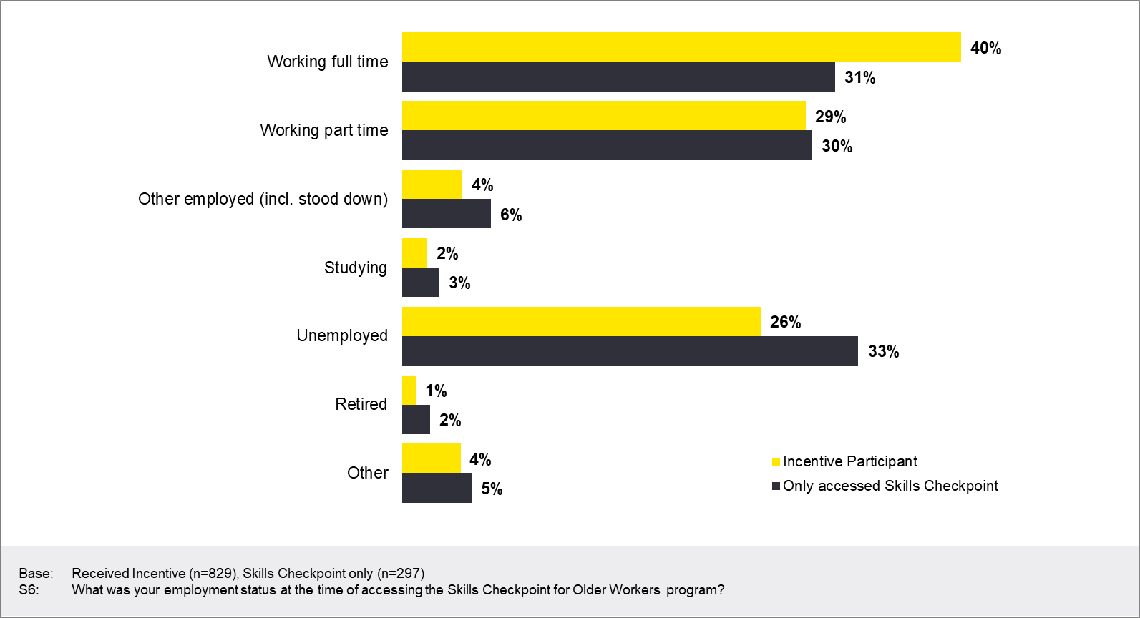

Older workers are looking to ‘futureproof’ their employment prospects
The interviews with older workers highlighted that they recognise their potential longevity in the workforce, and the importance of staying relevant for future success.
I’m always thinking about where the industry is going, like what’s next. Because if you work in tech, you’re always thinking ahead about what’s going on in the industry, how do my skills translate to what’s coming. And so, I think eventually systems, especially if I want to stay in IT, they’re going to get better and better. They’re going to be more consumer grade, intuitive. So, we’ll still need some change stuff done, but I don’t think it’s as effective as putting in a big ERP, SAP system. So, I thought where is this going, and I think it’s around how to design more user friendly experiences for people.
Incentive participant, QLD
Survey responses cited a variety of reasons for Skills Checkpoint participation. While improving job opportunities was the most cited reason for Incentive participants (65%), 1 in 3 (33%) cited reasons for participation related specifically to the risk or fear of job loss, specifically ‘increasing job security’ (23%), ‘to assist me if I’m made redundant’ (14%), or ‘fear of losing my job’ (10%). Twelve per cent stated that their participation was influenced by having already lost their job due to COVID-19. Among Incentive participants who were unemployed at the time of participation, 29% indicated they had lost their job during COVID-19.
Figure 5: Reasons for participation in the Skills Checkpoint program among Incentive participants (multiple responses allowed)
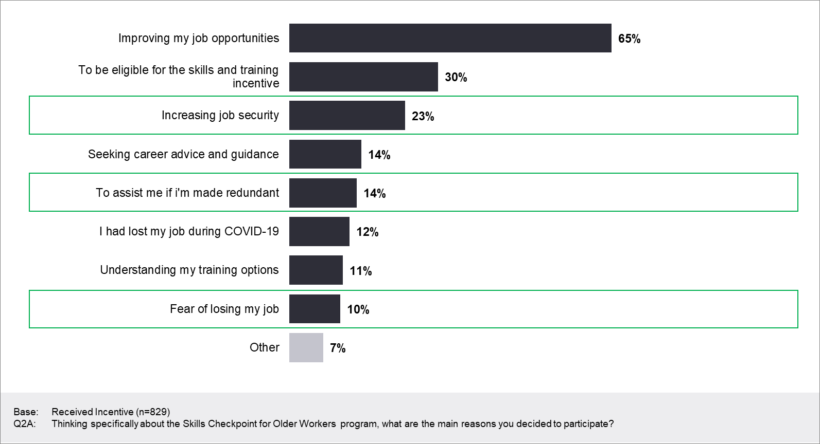

Recipients are looking for new opportunities
Participants use the Incentive to fund training opportunities for current and future roles, involving either retraining for a new role or upskilling their existing skillset. Figure 6 indicates that 40% of participants accessed training to retrain for a new role or career with a new employer. The qualitative interviews revealed that for some participants, the training was an opportunity to upskill in roles or industries that have greater longevity.
Unless you have an upgraded qualification, many won’t even look at you.
Incentive participant, female, regional VIC
The need to retrain was driven by:
- industry shifts and challenges (i.e. automation, changed manufacturing processes)
- industry shutdowns due to COVID-19 (e.g. tourism and hospitality)
- physically demanding roles no longer being viable (e.g. manual labour becoming increasingly difficult with age)
- burnout in certain professions (e.g. frontline healthcare workers, executives in corporate roles)
- returning to the workplace after extended leave (e.g. parental or sick leave).
In addition, participants cited a range of reasons for upskilling, including the following:
- to increase job security
- to gain a formal qualification for an existing skillset which they had actively been performing throughout their career. In some cases, formal qualifications were not available when these individuals first commenced their career and/or the role is now subject to regulations
- to increase employment shifts for casual workers. Some participants reported that their hours had been reduced due to COVID. They believed that undertaking training would increase the likelihood of being considered for additional work.
Figure 6: Main reason to use funding to access training
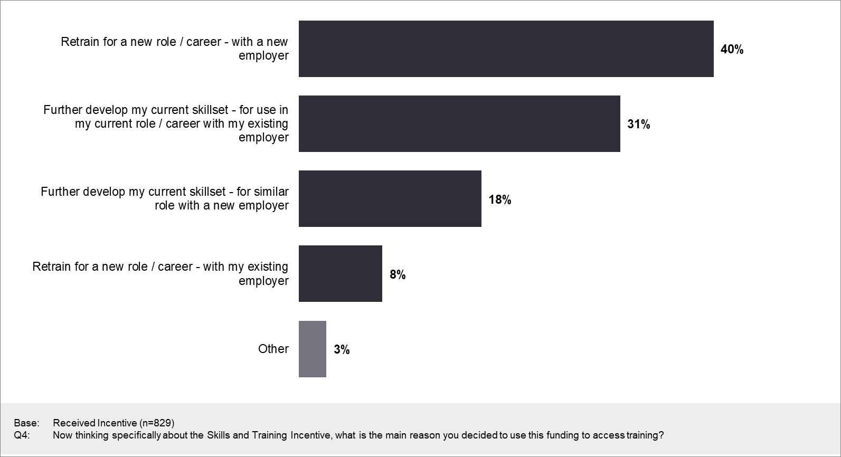

Section 4: Reach, uptake and applicant profile


Key findings
The Skills and Training Incentive has reached a new and relatively diverse audience, and one where providers and participants highlighted there can be a real need to ensure skills are updated to increase longevity in the workforce.
The survey found that 1 in 4 participants were unemployed at the time of accessing the Incentive, with around half of those having been made redundant – some for more than 9 months, suggesting that a small number are potentially at risk of entering the support system.
However, there was also a sizable proportion employed either full or part time, who were looking to prevent themselves from having to access government support. The qualitative findings highlighted that the cohort that SATI caters to is largely proactive and engaged with the workforce and therefore seeking to futureproof their career.
Interestingly, the real estate and property sector appears to have benefited from use of the Incentive, which could be a result of the change in registration requirements within the sector.

Box 1: Evaluation questions addressed
The evaluation questions addressed in this section relate to the relevance, appropriateness and effectiveness of the co-contribution model and include:
- How many mature age individuals have or are currently engaging in the Skills and Training Incentive?
- How many mature age individuals who have or are currently engaging in the Skills and Training Incentive were employed and/or identified as being at risk of entering the income support system?
- How many mature age individuals engaging in the Skills and Training Incentive are recently unemployed?*
- What are the backgrounds (age, gender, cultural identification, industries, etc) of the people who are accessing the Skills and Training Incentive program?
- How many employers have or are currently engaging in the Skills and Training Incentive?
- How many training organisations have or are currently engaging in the Skills and Training Incentive?
- How could the reach of the Skills and Training Incentive program be improved?
*It is important to note that the time period for which recently unemployed individuals were eligible for the Skills and Training Incentive was changed on 31 July, 2020. Prior to 31 July, 2020, the amount of time an applicant could have been unemployed was 3 months. After 31 July, 2020, this was extended to 9 months.

Source of awareness for the Skills Checkpoint and Skills and Training Incentive programs
The most common source of awareness for both Skills Checkpoint and the Incentive was training organisations, with a third of Incentive participants surveyed noting they were made aware by their training organisation (both 33%). This suggests that a relatively high proportion of participants are already engaged with or interested in further training. Fifteen per cent heard about the Incentive through their Skills Checkpoint provider. During the qualitative interviews participants highlighted that they often found out about the program through chance. Raising awareness among potential participants who are not currently engaged in training may prove beneficial in expanding the program’s reach.
I’ve found him in the week I was made redundant in [Launceston]. There was another guy, who was like a consultant for another department and we met for coffee down here and we talking … He gave me [provider staff member’s] number. I rang [provider staff member’s] and he said this is the program, I looked it up, I rang [provider staff member], [provider staff member] rang back, and we just went from there. So it was from another guy who was in the employment sector, I can’t think of his name or what department he’s in but I found him on Google and so I looked at it and read it and I thought yes, I’ll give him a call, and it was you know a positive step forward but other than that, I wouldn’t have known about the Skills Checkpoint.
Participant, TAS
When looking at other information and awareness channels, online sources are common including social media, search engines, the department’s website and other online information. Digital literacy among the target population should be considered though, and participants to date may represent a relatively digitally capable cohort of the target population.
Figure 7: First source of awareness for Skills Checkpoint and Incentive among Incentive participants
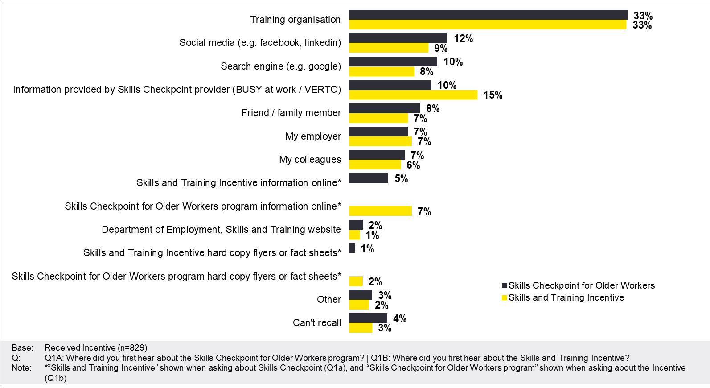

Reach of the Skills and Training Incentive

Participants
As of 17 March 2021, when fieldwork for the evaluation was completed, 5,195 mature age individuals were identified as having engaged or currently engaging in the Incentive. This count is composed of the following sources, with relevant limitations noted in Appendix 4.

Employers
As of 31 December 2020, the administrative data highlighted that 351 employers were engaged in the Incentive program. This comprised:
- employers from across 132 different industries, as defined in the administrative data
- a comparatively higher representation of employers from the real estate industry versus other industries, with 26% of employer participants being from the real estate sector.
The findings of comparatively higher participation from employers in the real estate industry may be related to several factors, including the registration and training requirements needed to work in the sector and a relatively higher awareness of the availability of the Incentive among employers or employees in the sector.

Training providers
There were 677 training providers identified as having engaged with participants undertaking the Incentive.

Profile of Incentive participants
When considering the profile of those accessing the Incentive, the quantitative data suggests the Incentive was accessed by a range of mature age workers who were conscious of the impact of their age on their future employability. Further, when engaging with this cohort during the qualitative research, it was clear that this audience generally has not had much access to government support previously because of a strong workforce history, suggesting the Incentive is catering to an important demographic.
However, as providers were responding to demand, rather than being proactive, employer participation was skewed towards certain industries – particularly real estate and property.
Figure 8: Demographic profile of survey respondents: demographics
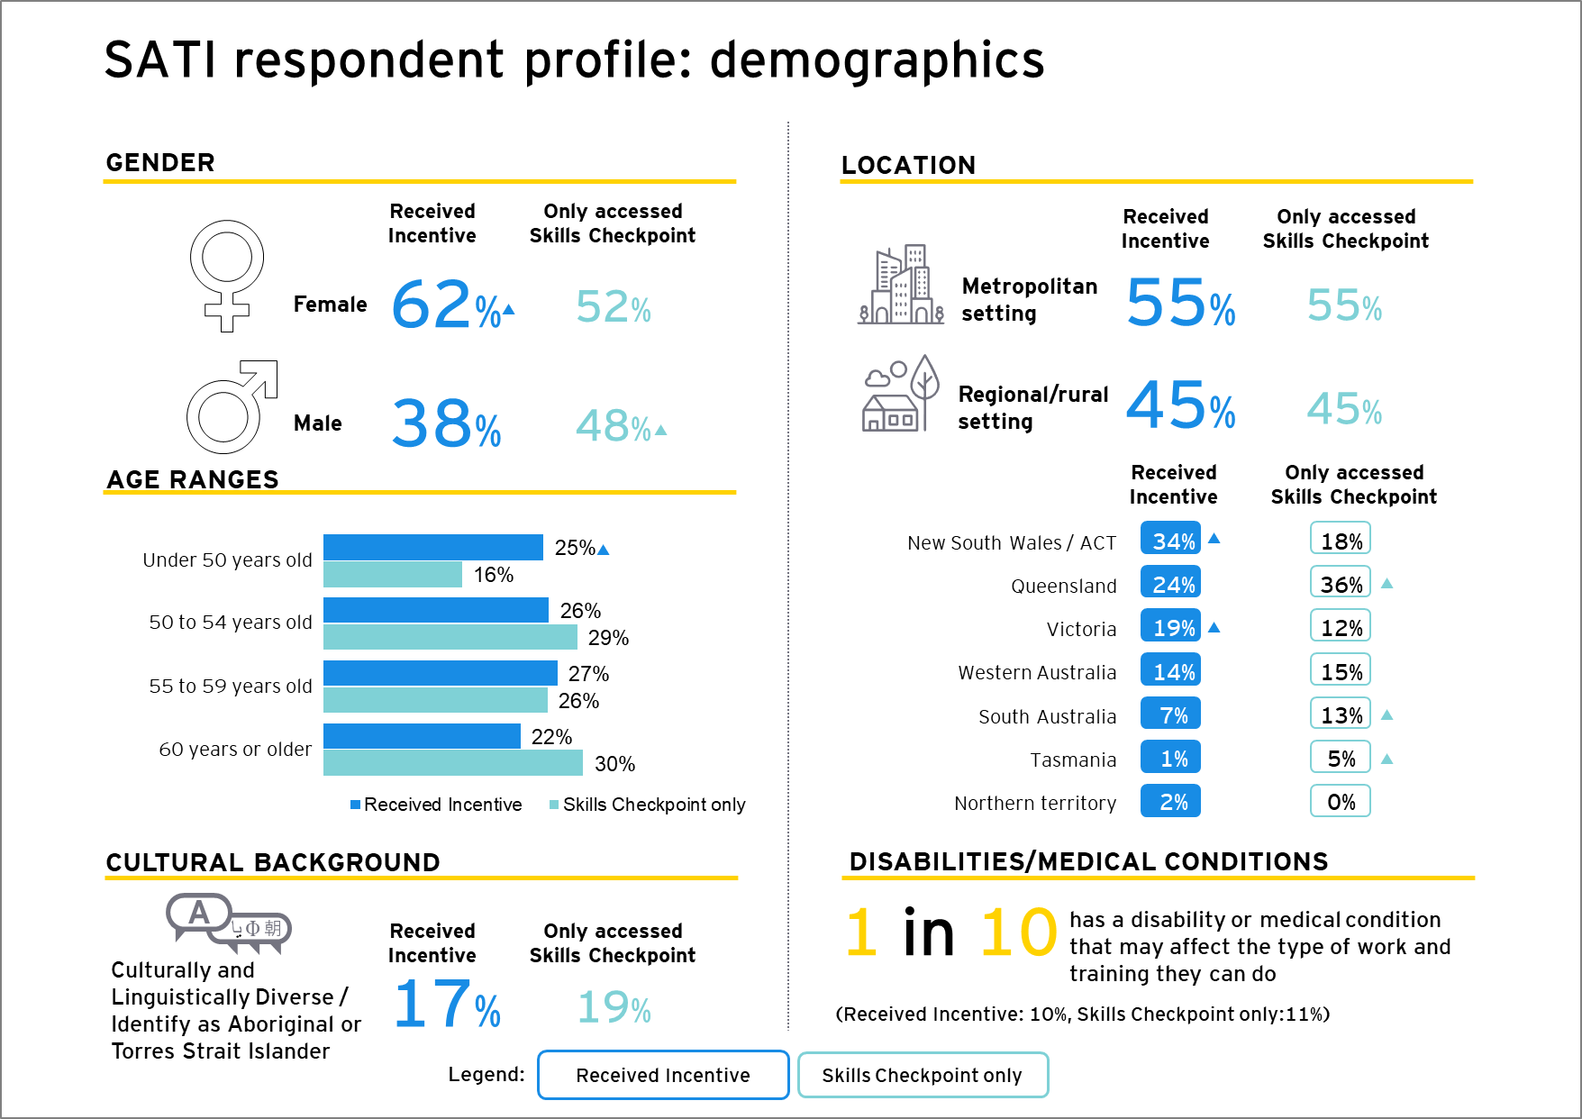

Age
The age distribution of Incentive participants is relatively even across the defined age group, as shown in Figure 8. In contrast, those who participated in the Skills Checkpoint program but did not receive the Incentive skewed slightly older, with fewer in the ‘under 50 years old’ bracket.

Gender
Sixty-two per cent of Incentive participants surveyed were female, and 38% were male. In contrast, those who only accessed the Skills Checkpoint were more evenly spread between women (52%) and men (48%).

Cultural identification
Seventeen per cent of Incentive participants identified as culturally and linguistically diverse or Aboriginal/Torres Strait Islander (6% of Incentive participants identifying as ‘culturally and linguistically diverse or Aboriginal/Torres Strait Islander’ stated that they identified as Aboriginal or Torres Strait Islander).
More broadly, 32% of Incentive participants were born in a country other than Australia, with England (8%), New Zealand (3%) and South Africa (3%) being the most common countries.

Location
The Incentive participants surveyed are largely located on the eastern seaboard of Australia, with 34% living in New South Wales/ACT, 24% living in Queensland, and 19% living in Victoria.
Incentive participants were from a mix of both metropolitan (55%) and regional/rural locations (45%). Those in Victoria and Western Australia were more likely than other participants to be living in a metropolitan setting (VIC: 66%, WA: 78%). In contrast, those from New South Wales/ACT and Queensland were more likely to be living in a regional or rural setting (NSW/ACT: 52%, QLD: 58%).
Figure 9: Demographic profile of survey respondents – employment status when accessing Skills Checkpoint
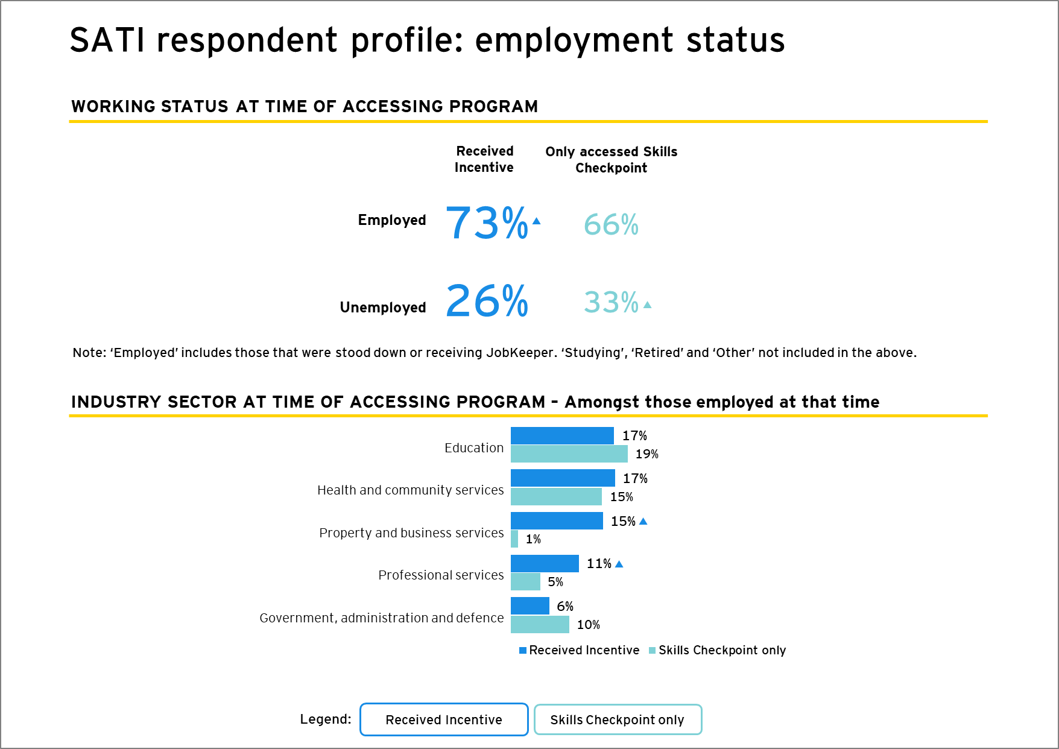

Industries
The most common industries worked in across all employed participants who received the Incentive (whether funded by the employer or the individual) were Education (17%), Health and Community Services (17%), Property and Business Services (15%) and Professional Services (11%).
Employed participants were more likely to have been working in the Property and Business industry compared with those who were employed and only accessed the Skills Checkpoint (15% and 1% respectively). Three-quarters (76%) of the Incentive participants employed in the Property and business industry were from New South Wales/ACT. This may be related to real estate and property industry reforms in New South Wales, which involved a change in qualification requirements for in-scope professionals.
Similarly, although there was considerable diversity in terms of industry participation in the Incentive, 26% of sampled employers who co-funded training were from the property and real estate services industry, as outlined above. The small disparity between individuals receiving the Incentive and employers co-contributing may indicate that a larger number of property and real estate services employers are encouraging employees through the program, with each employer providing a relatively small number of employees. Other high-contributing industries such as education and health and community services may be seeing employees coming from a more concentrated pool of employer organisations.
This highlights a potential need to monitor industry, to ensure that a range of industries have access to the Incentive.

Employers have a positive attitude towards upskilling employees
Although the employers who had supported staff to receive the Incentive were smaller in number, there was clear appreciation of the benefit of ongoing staff training, and the associated business benefits:
- Providing training opportunities to mature age staff members was considered important to ensure staff skills were current, relevant and continued to deliver value to the business.
Where we probably do struggle a little bit with is the new automation equipment, to get people skilled knowing this. And that’s because not a lot of companies have this automation, or at least this level of automation in the business. So yeah, we probably do struggle a little bit in that respect.
Employer, VIC
- Mature age workers are recognised by employers as an important cohort, bringing diversity and experience to a team. Investing in this cohort is considered a demonstration of value, which can help with staff retention.
- There were clear benefits associated with training and upskilling, ensuring that as industry evolves, so do the skills of those working within organisations.
- For some employers, where there had been past or expected redundancies, ensuring that those at risk of redundancy were suitably skilled to find new employment was important. Although there was limited benefit to the business, there was a feeling of ‘duty of care’ to those who were facing redundancy.
Ultimately, for any training to be relevant to an employer, there had to be a strong business case for them to consider contributing financially. Those who co-funded their employees’ training using the Incentive were able to match up the organisational skills needs with the recommendations of the Skills Checkpoint provider. Although not included in this evaluation research, we would assume that employers who were unable to see the business benefit in a particular training program would be hesitant to co-fund training.

Section 5: Implementation and delivery

This section presents findings in relation to the extent to which the program was implemented and delivered as intended. It highlights participants’ and providers’ experiences with program implementation and delivery and presents some challenges both cohorts encountered. The evaluation questions addressed in this section are presented in Box 2.

Key findings
Overall, the program was generally implemented and delivered as intended, with participants reporting high satisfaction with the application process. However, the evaluation identified some delivery challenges leading to some delays in accessing the Incentive or eligible applicants being turned away. These challenges indicate there is room for improvement in the delivery of the Incentive, with respondents highlighting the following challenges:
- Invoicing issues increasing administrative burden and delaying training commencement (13%)
- Misinformation about the Incentive eligibility criteria (11%)
- Inefficient administration delaying the application process (11%).
While not related to the SATI program or its delivery, an additional challenge faced by participants and employers was delay in finding or organising suitable training (15%).

Box 2: Evaluation questions addressed
Evaluation questions addressed in this section include:
- To what extent was the Skills and Training Incentive implemented as intended? (the high-level roll out, i.e. governance, deeds, guidelines)
- To what extent is the Skills and Training Incentive being delivered as intended? (the operational delivery of the program)

The program was generally implemented as intended
Despite some initial challenges with delivery, the Skills and Training Incentive was largely implemented as intended. Initial challenges included limited understanding of the Incentive and its eligibility criteria from provider staff. Ongoing challenges included administrative bottlenecks related to invoicing, and participants being provided with misinformation about the Incentive. These findings indicate there is some room for improvement in relation to the Incentive’s delivery.
While not related to the program itself, a related challenge cited by participants and employers was delay or difficulty finding, organising or accessing suitable training.

Very high levels of satisfaction from participants
At an overall level, participants were highly satisfied with the Incentive (90% total satisfied; see Figure 10). The qualitative interviews confirmed this, as recipients highlighted how they felt the program promoted mature age workers as valuable. Many had limited experience with accessing support in the past, and as a result were particularly grateful for any funding available to help them with their future employment.
Figure 10: Overall satisfaction with the Skills and Training Incentive
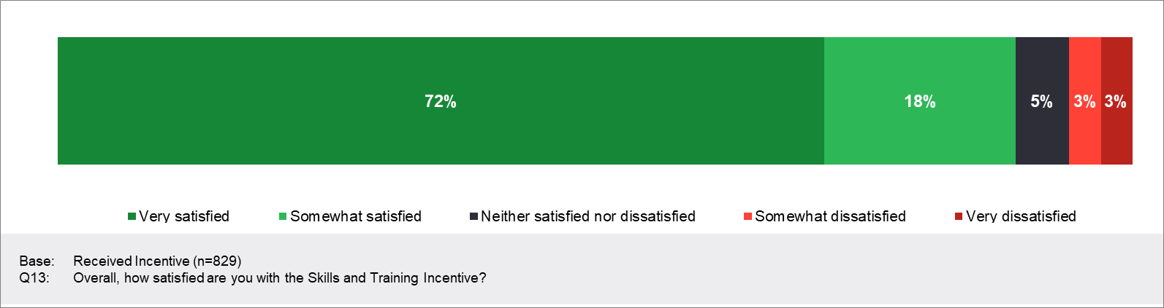
Although there was some evidence of misinformation from providers around eligibility criteria, sometimes resulting in potential participants being turned away, this appears to have been largely contained to the program’s earlier phases. Participants were largely satisfied with the application process and recommended training options, with findings indicating:
- an easy application process: Overall, satisfaction with the ease of applying for the Incentive was high, with 79% of Incentive participants surveyed ‘very’ or ‘somewhat’ satisfied, as shown in Figure 11. Notably, culturally and linguistically diverse/Aboriginal and Torres Strait Islander respondents were more satisfied with the ease of application, with 87% very or somewhat satisfied
- high satisfaction with availability of recommended training options: Satisfaction with the availability of recommended training options was also strong, with 82% ‘very’ or ‘somewhat’ satisfied, as presented in Figure 11.
Figure 11: Satisfaction with ease of applying for the Incentive and availability of training options
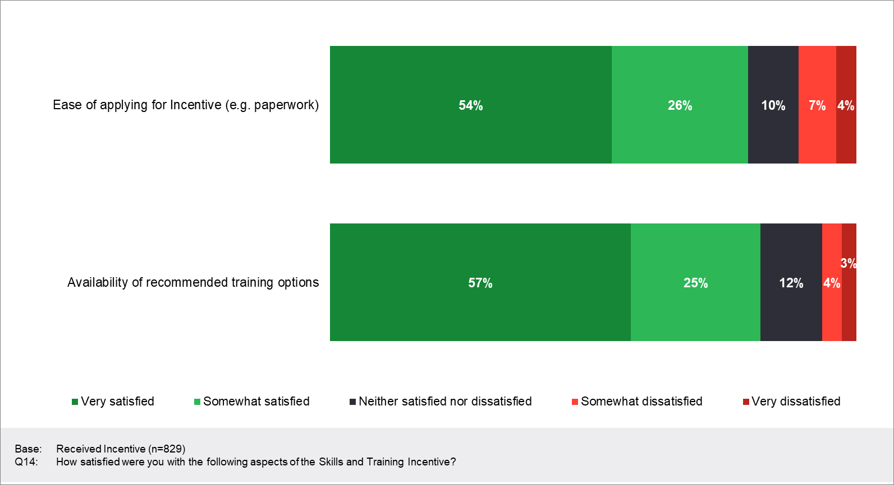

Section 6: The co-contribution model

This section presents findings relating to the relevance and appropriateness of the co-contribution funding model, as well as its effectiveness in motivating individuals and employers to co-fund training. It also explores the extent to which employers and providers supported the program and the extent to which the program influenced organisational approaches to learning. The evaluation questions addressed in this section are presented in Box 3.

Key findings
The co-contribution model was found to be largely relevant and appropriate, with key findings including:
- The co-contribution model makes training more affordable, with 87% of Incentive participants satisfied with the amount funded by the government.
- The co-contribution model did not provide sufficient financial assistance for those experiencing financial hardship to access training.
- The co-contribution model did not increase the financial viability of training for a smaller proportion of those who completed the Skills Checkpoint, including individuals experiencing health-related challenges and some living in metropolitan areas.
- The co-contribution model strongly motivates individuals to fund training opportunities, with 46% stating that they had co-funded training which they would have otherwise been unlikely to do.
- Employers who recognised the value of training were more likely to co-fund training opportunities as a result of being able to use the Incentive.
One in 2 (49%) Incentive participants accessed training to develop their existing skillset for use in their current role or with a new employer and 40% accessed training to retrain for a new role or career with a new employer.

Box 3: Evaluation questions addressed
The evaluation questions addressed in this section include:
- To what extent did Skills and Training Incentive participants perceive the co-contribution model as relevant and appropriate?
- To what extent did employers perceive the co-contribution model as relevant and appropriate?
- To what extent did Skills Checkpoint providers perceive the co-contribution model as relevant and appropriate?
- To what extent did the Skills and Training Incentive motivate individuals to fund training opportunities linked to their current job (e.g. upgrading skills)?
- To what extent did the Skills and Training Incentive motivate individuals to fund training opportunities linked to a future job opportunity?
- To what extent did the Skills and Training Incentive motivate employers to contribute their staff’s training?
- To what extent did the co-contribution encourage employers to support training opportunities for their mature aged workforce?
- To what extent did the co-contribution model lead to Skills Checkpoint participants not accessing the Skills and Training Incentive?

Challenges related to misinformation, organising training and invoicing
Forty-seven per cent of Incentive participants surveyed encountered no specific challenges in accessing the Incentive, as highlighted in Figure 12. Nevertheless, participants did face some challenges, often as a result of lengthy processes and issues with invoicing (see Figure 12). For 5% of those who only accessed Skills Checkpoint, the lengthy process prevented them from accessing the Incentive altogether.
Figure 12: Challenges in accessing the Incentive
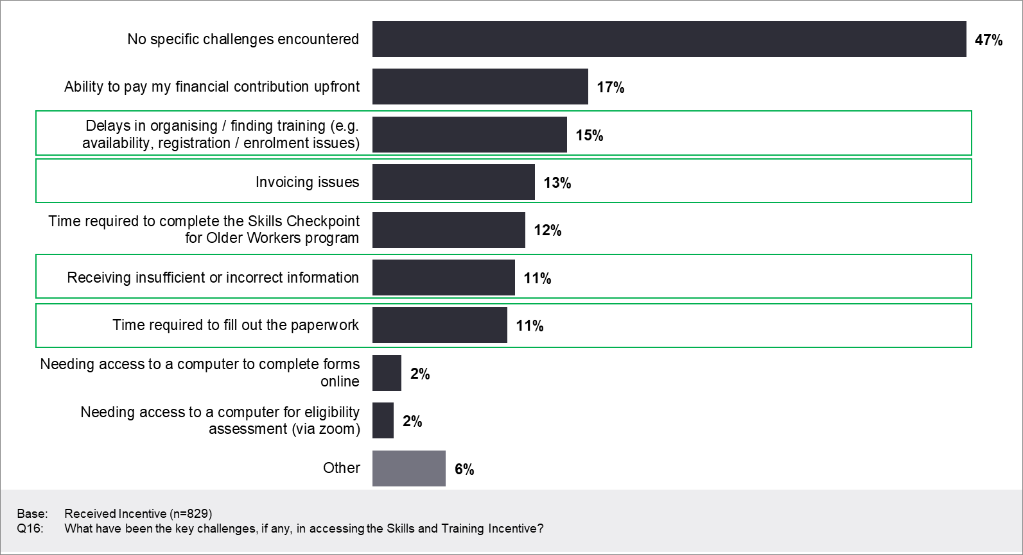
- Securing suitable training can be challenging: Some participants reported experiencing delays in relation to finding or organising suitable training (15%), suggesting there may be opportunities to streamline the application and enrolment process. This is particularly important, given that delays in securing training can result in individuals choosing not to undertake training.
- Invoicing issues were a challenge for some: Survey respondents also cited invoicing issues (13%). This was supported by qualitative findings, which revealed training organisations would not initially invoice providers, creating administrative inefficiencies in relation to accessing the training and lengthy delays in commencing training. This led to increased administrative burden for provider staff members, who often had to spend time persuading training organisations to reissue the invoice and led to some applications being delayed (in some instances, up to 6 weeks).
- The qualitative interviews highlighted that invoicing issues were contained to certain training organisations – typically TAFEs or universities – who would not issue invoices to the provider (as is required by the Incentive) and instead preferred to issue the Incentive to individuals or employers directly. Some participants reported they had to wait up to 6 weeks to have their application processed, sometimes having to postpone the start date of their training to a later session. Typically, they had to spend time locating the relevant staff member of the training organisation responsible for the administration of invoices, inform them of the process required for the Incentive and persuade them to issue the invoice in the provider’s name. One interviewee noted:
It took a while to get the agreements together… The RTO invoice had to be made out to the provider … and that was challenging as they were often online enrolments and there wasn’t the possibility to make out the invoices to anyone other than an individual or employee.
Employer, SA regional
- Digital literacy challenges: During the COVID-19 pandemic when face-to-face consultations with providers could not proceed, the necessary paperwork had to be completed by participants remotely and digitally. Providers reported that some participants struggled to complete the necessary paperwork online due to limited digital literacy skills or access to a computer.
- Misinformation from provider staff: 11% of Incentive participants surveyed reported receiving misinformation about the Incentive. This included misinformation about the program’s eligibility criteria and sometimes led to eligible participants being turned away and/or missing out on receiving the Incentive. Examples included:
- misinformation about the unemployment timeframe
- not being informed about the Incentive after completion of the Skills Checkpoint
- lack of clarity on eligibility criteria
- lack of clarity on eligible training courses.
While this largely occurred in the program’s early phases and appears to have been rectified, qualitative evidence continued to emerge of provider confusion in relation to the eligibility criterion surrounding applicants’ JobSeeker status, with some provider staff believing that receipt of JobSeeker rendered applicants ineligible for the Incentive. Given that this audience is one that may not be particularly familiar with support, any confusion could mean the difference between someone taking on training or not. This finding also highlights there is room for improvement in relation to providers’ understanding of the program’s eligibility criteria to ensure the right information is communicated.

The co-contribution model is relevant and appropriate
The co-contribution model was relevant and appropriate to the majority of participants who required financial assistance to undertake training. The qualitative interviews revealed that this model of incentivisation provided funding to a cohort that felt they didn’t often get access to government support. In addition, making a financial contribution towards training meant they took greater ownership of the training than they may have if it had been fully supported. It fostered a sense of value in that they were recognised as important members of the future workforce.
Some 14% of participants in the survey highlighted that their employer co-funded their training. It is important to note that some employers invest in training regardless (i.e. if there is an industry requirement, e.g. in manufacturing or real estate); however, the Incentive also encouraged funding of employee training opportunities that may have been less likely to fund otherwise. One employer noted:
Yeah, probably less likely [that we would have been able to fund training]. Naturally that would double the cost, and again the fact that this is such a moving piece as to who would end up where. And it would be hard to say that we definitely would [fund this training]. We didn’t look into that until it was [possible through the Incentive] as a thought process this way. So, it’s less likely.
Employer, National

The co-contribution model assists most individuals to fund training opportunities
While it was highly valued by those who accessed it, there was also a population for whom it was less suitable. The model was less appropriate for individuals facing financial stress or hardship, and for some of those living in metropolitan areas, as it did not provide them with sufficient financial assistance to co-fund training opportunities. A one-off financial outlay is not always feasible for individuals facing financial hardship. For some, uncertainty in the job market and limited available funds meant that even with a co-contribution, the financial outlay was still too much. Additionally, the Incentive was less suitable for those with health-related challenges; however, it is important to note that it was not designed to specifically address the training challenges which may be experienced by this cohort.
Findings highlighted the relevance and appropriateness of the co-contribution model to individual participants’ needs and circumstances, with the following key considerations influencing participation:
- Training can be considered expensive: Interviews revealed that participants typically associate the cost of training as a relatively significant financial outlay, particularly when there is limited ability to pay in instalments. Not being able to afford the 50% training cost contribution (14%) was the third most common reason for not accessing the Incentive among those who had accessed Skills Checkpoint. Even though training is considered valuable and necessary for future employment, having to co-contribute can limit their capacity to undertake training.
It was a big financial commitment on my part, but this certainly helped.
Incentive Participant, QLD
First of all I didn’t have the cashflow at the time to be able to initiate some of the courses I was interested in ...
Checkpoint Participant, NSW
- Life costs reduce the priority of training: Interviews highlighted that costs such as household expenses, mortgage payments and raising a family place a high financial demand on individuals and are often prioritised above training. Given the added uncertainty around job security, it can lead to greater scrutiny as to whether the financial outlay for training is feasible in the absence of financial assistance.
- COVID-19 and job market uncertainty increased the need for funding assistance: Industry shutdowns and subsequent job losses caused by the COVID-19 pandemic led to financial stress and hardship. This had forced some participants to find work in new industries for which they needed new skillsets and support to finance relevant training opportunities. As presented in Figure 13, COVID-19 contributed to approximately 6 in 10 Incentive participants taking part in both the Skills Checkpoint (63%) and the Incentive (62%) in 2020 or 2021, with the impact ranging from ‘just a little’ to a ‘very large extent’. This finding was supported by qualitative observations, with general uncertainty in the job market also a key contributing factor, as well as taking an opportunistic approach to training for some who wanted to make the most of the lockdowns and upskill while they had the opportunity.
Figure 13: The effect of COVID-19 on motivation to participate in the Skills Checkpoint and Incentive
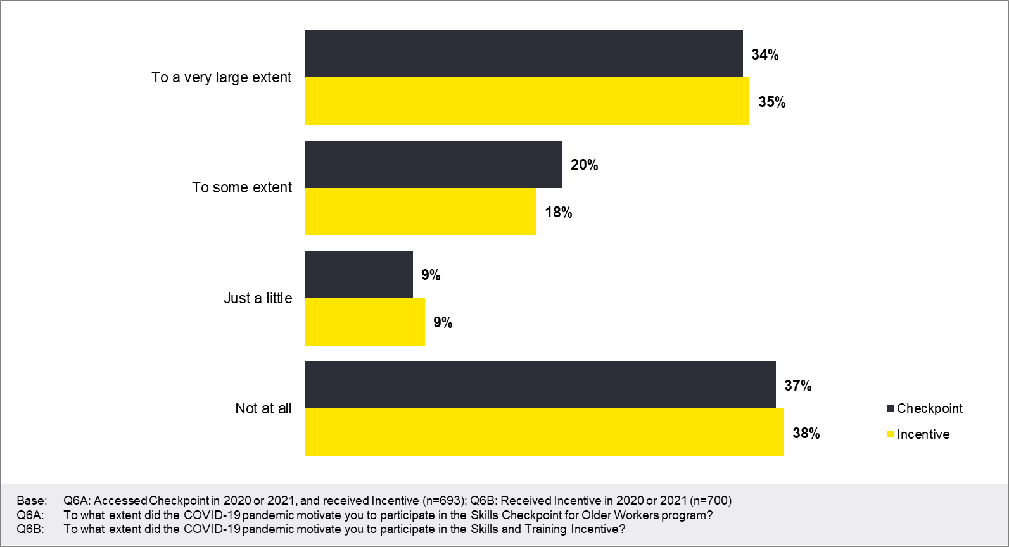
- The co-contribution model can make training attainable and viable: Although training was still an expense, qualitative data found that the cost of training, when supplemented by the co-contribution model, was more viable for participants. The survey found that 82% of Incentive participants were somewhat or very satisfied with the co-contribution model, and 87% were satisfied with the amount funded by the Government, as presented in Figure 14.
If I didn’t have this Incentive, I couldn’t have completed this course … because my organisation could only offer up to $2000, and because of my family circumstances – at the time we had just bought a house. So, I had to be careful with my spending.
Participant, female, WA metro
Figure 14: Satisfaction with funding and co-contribution approach

The co-contribution model does not meet the need of some sub-groups
While overall the co-contribution model has been valuable support for recipients, there are sub-groups for whom it was found to be less appropriate, including:
- individuals facing financial stress: The value covered by the co-contribution model was not sufficient for 14% of individuals surveyed who had only accessed the Skills Checkpoint, as presented in Figure 15. These individuals accessed the Skills Checkpoint but could not afford to co-fund the training that was recommended. Qualitative interviews revealed that this was typically due to experiences of financial stress or hardship, including job loss and redundancy (sometimes due to COVID-19), as well as financial hardship related to a range of life circumstances or the high costs of living and/or having a family. Financial stress was compounded when combined with redundancy, unemployment or an uncertain unemployment future.
Some people have said that they can’t afford the 50% and have asked for a repayment plan, and they can’t go ahead … Reasons they can’t afford the 50% are they’re about to lose a job, have lost a job, and some are forced to go onto Centrelink and then they are taken out of the Skills Checkpoint/Incentive program.
Provider
- those living in metropolitan areas: Those living in a metropolitan setting (e.g. capital city) were more likely to cite the contribution as a barrier, at 20%, compared with those living in a regional (9%) or rural setting (3%). This appears to be driven by a higher rate of unemployment in metropolitan areas amongst those who didn’t access the Incentive: 38% in metropolitan areas reported being unemployed at the time of accessing the Skills Checkpoint, compared to 28% and 24% in regional and rural settings respectively.
Outside the limited number of Incentives, which was a barrier for 18% of those who did not access the Incentive, some other factors that either slowed down access to the training once the Incentive had been approved or prevented participants from applying for the Incentive at all were highlighted in the qualitative interviews as:
- challenges accessing the desired training course: While not related to the Incentive itself, 15% of those who did not access the Incentive identified not being able to find a relevant training option as the reason. Qualitatively, it was indicated that individuals and employers – particularly in regional areas – had difficulty accessing the training they wanted to complete due to a lack of available training organisations in their area. The distance needed to travel to complete the desired course made it prohibitive to undertake the training. Such courses often involved a heavy practical component and couldn’t be done online.
- confidence in digital literacy skills: Some mature age individuals reported having poor digital literacy skills that they believed would have prevented them from successfully undertaking and completing a training course. These individuals opted not to pursue training for this reason
- lack of confidence to undertake study generally: During interviews, some mature age individuals stated that they lacked the confidence to undertake training due to perceived personal limitations related to their age, their capability and their level of motivation. This barrier prevented them applying for training.
Figure 15: Reasons for not accessing the Incentive
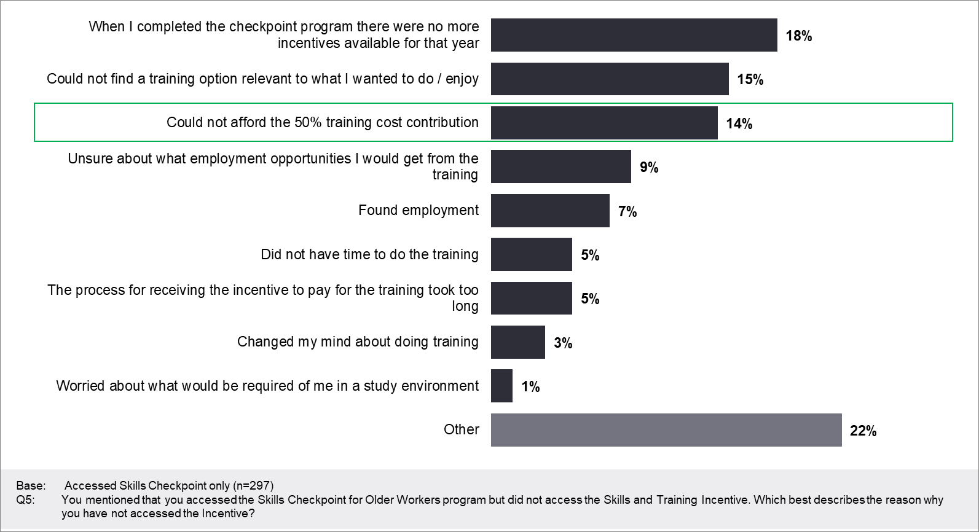

Employers and providers consider the co-contribution appropriate
The co-contribution model was considered appropriate by employers who recognised business value in upskilling and/or retraining their staff. In the absence of alternative funding options for training and with finite training budgets, some employers deprioritised or limited funding for employee training due to ongoing financial pressures (although there was still a proportion who continued to invest in training, largely as a result of industry requirements). Some stated they would have been unlikely to co-fund employee training, would have reduced the number of employees to be trained, or would have delayed training until a time when they could include it in their annual budget. Interviews with providers also highlighted that the financial assistance provided by the co-contribution model substantially increased the accessibility and financial viability of training for individuals and employers – making the decision to take on training easier.
[the Incentive] really helped more people than what we could ever really realise. People come back after they’ve completed their course to tell us their good news stories and how much they’ve loved it. It really has helped a lot of people.
Provider
They (participants) were over the moon about the funding. Older workers won’t waste their money. Older workers need to make an informed decision as they feel they are parting with their hard-earned money. Especially if they have kids and mortgages to pay so they are more careful … young people are more carefree with money.
Provider
It is important to note that interviews were only conducted with employers who took up the co-funding model to put their employees through training. A more comprehensive indication of relevance and appropriateness requires data collection with employers who did not access the Incentive, but this was not possible within the available resources for the evaluation.

Co-contribution strongly motivates individuals to fund training
The co-contribution model was found to motivate individuals to co-fund training opportunities linked to their current job or to a future job opportunity.
I think if you contribute yourself, we are more motivated than something being given to us … if we all bring a bit to the party, we’re more invested.
Female, regional VIC, Incentive participant
For the majority of those who received the Incentive, the government contribution facilitated the decision to undertake training, making the financial decision easier, as highlighted in Figure 16. Among those who had completed their training, 42% reported that the Incentive encouraged them to undertake training when they otherwise would have been less likely to do so (see Figure 17). Forty-six per cent indicated they would have been somewhat or very likely to have completed the training without the Incentive, suggesting this proportion of the individuals completing training were already highly motivated to do so.
Figure 16: Impact of government contribution on decision to undertake training

Figure 17: Likelihood to undertake training without incentive
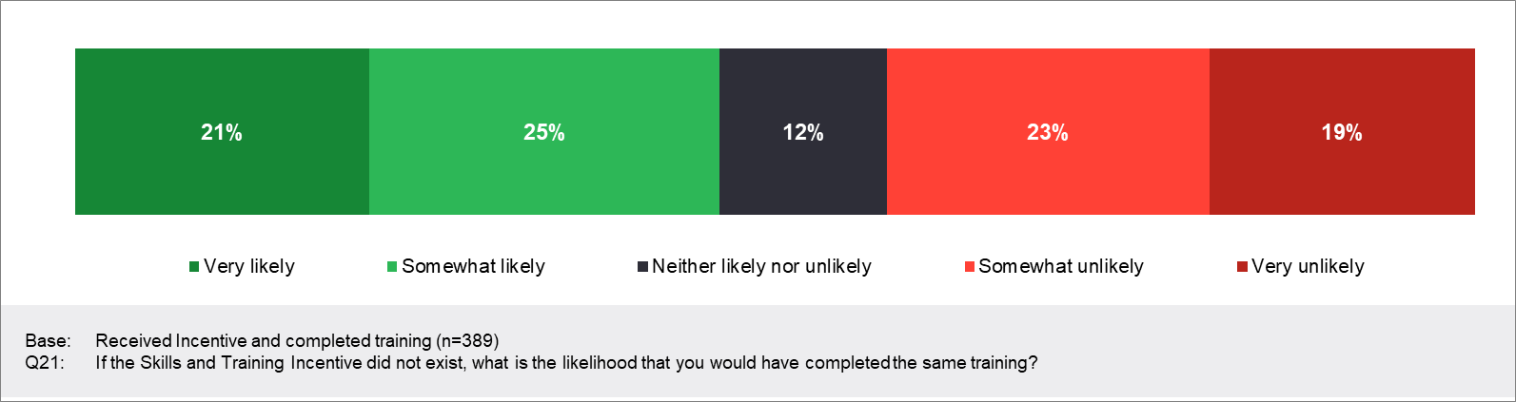

The co-contribution model eases the financial burden for employers
Interviews with employers who co-funded employee training revealed that the Incentive made it easier for them to contribute to employee training. This was particularly well received in light of the COVID-19 pandemic.
Fourteen per cent of Incentive participants had their employer financially contributing to their training costs, as shown in Figure 18. Of those who did have this additional financial support, 81% believed that the government’s contribution to costs influenced their employer’s decision to support their training, with 55% believing that it had a large impact on the decision (see Figure 19).
Figure 18: Participants approaching employers about training costs

Figure 19: Perceived impact of the government’s contribution to training costs on the employer’s decision to support training
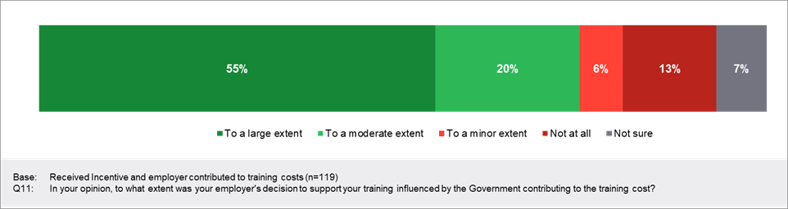

Section 7: Impact on learning and training

This section presents findings in relation to the impact of the Skills and Training Incentive on participants’ attitudes towards learning and training, as well the development of their skills. It also explores the extent to which the program influenced organisational approaches to learning. The evaluation questions addressed in this section are presented in Box 4.

Key findings
The Incentive ultimately meant that the decision to undertake training was much easier for participants. However, there was already recognition of the importance of professional development and training generally (amongst employers and participants), and a proportion of participants would have sought to upskill regardless.
Nevertheless, the co-contribution model meant that those co-funding personally were investing in themselves and, as a result, there was a greater level of responsibility towards completion of the learning.

Box 4: Evaluation questions addressed
The evaluation questions addressed in this section relate to the impact of the program on learning and training, as well as the extent to which it was supported by employers. They include:
- To what extent has the Skills and Training Incentive influenced individuals’ attitudes and willingness to undertake further training?
- To what extent did the Skills and Training Incentive motivate individuals to complete the training they started?
- To what extent were Skills and Training Incentive participants motivated by the program to learn new skills?
- To what extent did the Skills and Training Incentive program influence the culture of an organisation with respect to training?

The Incentive increases willingness to undertake and complete training
Participants believed the training was highly valuable and would increase their employment opportunities, though this belief was typically held independently of the Skills and Training Incentive. The program, however, had an influence on participants’ willingness to commence and complete training. Specifically, the financial incentive encouraged individuals to apply to undertake training via the Incentive and the co-contribution model encouraged them to complete the training.
Survey results of individuals who personally contributed to training costs indicate that the co-contribution model motivated 69% to complete their training to a large or moderate extent, as presented in Figure 20. Interviews confirmed this finding, with participants stating that having to contribute their own funds to the cost of training was a strong motivator to ensure that they completed the training. Participants stated that this was because they had to use their own funding to support the training and wanted to realise the maximum benefit from this personal investment, with both providers and participants using language akin to having ‘skin in the game’ to describe the way in which the model increased their commitment to the training and its outcomes.
Figure 20: Extent to which financially contributing to costs motivated participants to complete training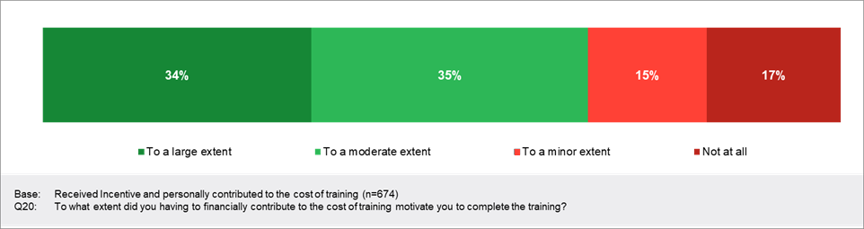
Interviews revealed that participants believed training was important to ensure their skills remained current and relevant, as well as to increase their attractiveness to employers. These beliefs were often held prior to being exposed to the Incentive.
When considering their employer’s contribution, a large majority (86%) indicated that their employer’s contribution had at least some impact on their decision to undertake training; 57% indicated that it had a large impact.
Figure 21: Employer financial contribution and impact on desire to undertake training
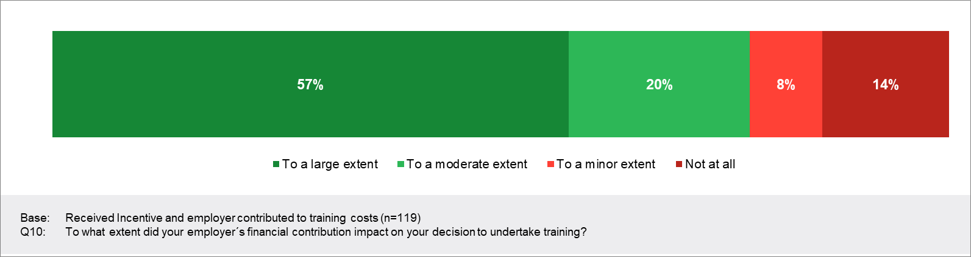

Participants believe the Incentive improves employment outcomes
The Incentive increased participants’ commitment to learn new skills, with participants also stating it increased their employment opportunities. Seventy-seven per cent of Incentive participants who had completed their training stated that it had increased their employment opportunities, as presented in Figure 22. This was supported by findings from the participant interviews, with some stating that they either gained employment due to the training, had their contract extended or received a greater salary in a new role due to the training.
Figure 22: Perceptions of improvements to employment opportunities
Current employment status appeared to influence perceptions of how the training improved their employment opportunities. Those who were unemployed when accessing the program were more likely to indicate that they saw no improvement to their opportunity to find work (18% stated ‘no, made no improvement’), highlighting a greater uncertainty among this cohort (see Figure 23).
Those who accessed the Incentive more recently were more likely to highlight a positive outcome. In 2019, 62% stated that it had increased their employment opportunities, increasing to 82% in 2020–21.
Figure 23: Perceptions of improvements to employment opportunities, by employment status at time of accessing Skills Checkpoint

The program has low impact on organisational learning culture
The program was used by organisations with an existing learning culture. Interviews with employers who engaged with the program revealed it had limited impact on their organisational learning culture. Instead, employers who engaged with the program either:
- already recognised the value of supporting an organisation-wide learning culture
- were approached by an employee (typically just one employee) with a request to co-fund their training, usually supported by a business case, with the Incentive having little impact on the organisation’s approach to learning.
Further, although the mature age workforce is valued, there wasn’t evidence of a specific training plan or pathway for this cohort. Rather, training was viewed holistically, and from the perspective of the benefit to the organisation.

Section 8: Employer and provider engagement and support

This section outlines the extent to which employers and providers were engaged with and supportive of the Skills and Training Incentive. It also explores the extent to which employers recommended the program to other employers. The evaluation questions addressed in this section are presented in Box 5.

Key findings
Employers were generally appreciative and supportive of the Incentive where the training undertaken had a tangible business benefit. Those engaged with the research either felt that they had influenced the training selected or felt that they had managed to find common ground between what was recommended and what was required internally. The data highlighted a stronger representation from the real estate industry, an industry that requires employees to hold a real estate license. Their reliance on formalised training suggests it is an industry that may have invested regardless – however, the opportunity to upskill older workers in the sector may also have been a driving factor.
Providers were particularly positive about the Incentive as filling an important gap in the market. They highlighted that much of their effort had gone towards filling the demand from participants and that employers were less engaged with the Incentive.

Box 5: Evaluation questions addressed
The evaluation questions addressed in this section relate to the extent to which employers and providers supported the program. They include:
- To what extent are employers supporting the program (including through co-contribution)?
- To what extent would employers recommend other employers to participate in the Skills and Training Incentive program?
- To what extent are providers supporting the program?

Lower engagement from employers
Employers were less engaged with the program, as outlined in Section 6. This limited engagement led to a smaller proportion of participating employees receiving co-funding support from their employer. During interviews, providers indicated that while it was their intention to raise awareness of the program in their employer networks, the program was so enthusiastically embraced by individuals that provider staff were often overwhelmed in trying to keep up and process this high demand. This led them to focus on individual participants and spend minimal or negligible time marketing the program to employers. Some providers believed that this was a key reason for low employer engagement with the program.
Those employers who contributed towards the training for their employees ensured that the training accessed was relevant to the organisation. For them to contribute financially, there had to be a business benefit and a tangible outcome from the training for the organisation. Some employers had already identified training solutions for their employees, and although their employees had gone through the Skills Checkpoint program with the provider, employers felt that they’d been able to influence the final approval of the training selected for their employees.
Those who were able to co-fund the training for their employees therefore felt that they had been successful in ensuring that the training recommended was relevant. Where this differed was among employers who had made, or were going to make, employees redundant. This group sought to help those at risk of redundancy increase their employability elsewhere.
Given employers’ capacity to fund training is limited, it is not surprising that the majority of those co-contributing to the training are the employees themselves.
Employers with a dedicated HR function cited the importance of continuous upskilling to the business, and therefore sought to keep abreast of relevant funding opportunities that allowed them to facilitate this within restricted budgets. Examples include an organisation with an HR department that wanted to retrain a substantial number of longstanding mature age employees to work in other areas of the business due to the business pivoting to provide new services or because the mature age employees were no longer suited to work involving heavy manual labour. The Incentive facilitated the redeployment of impacted staff.
Despite some employers trying to stay up to date with funding opportunities, their knowledge of the Incentive is limited. Interviews revealed that employers who co-funded training had limited knowledge of the Incentive, aside from its being a financial co-contribution to mature age employees’ training costs. Employers appeared to be engaged to the extent that they signed paperwork to provide and authorise the co-contribution payment.

Providers are highly supportive of the program
Providers were particularly supportive of the Incentive, highlighting that it fills a vital gap in the market in assisting mature age people to undertake much-needed training to maintain and increase the relevance and currency of their skillset.
The program I feel is really quite unique in the fact that it targets a group [who think] ‘I don’t feel like you can help me’, ‘I feel overlooked’, ‘all the monetary incentive goes to employers who have taken on younger people’, ‘I feel undervalued’, ‘I feel invisible’. So, the benefit of the program itself really allows it to focus on people to have aspirations.
Provider
A number of factors fed into the provider support of the Skills Checkpoint and Incentive programs:
- Providers see the challenges that mature age people face – such as ageism, gradual reduction of currency of their skillsets, and challenges with digital and technological literacy. Providers highlighted that a highly effective way to address these challenges was via access to training opportunities.
- Training support targeting mature age people has been negligible. Prior to the introduction of the Incentive, support available for mature age people to access training opportunities to upskill or reskill was lacking. They believed that while there had been significant assistance provided for other cohorts, such as apprenticeships (which were perceived as being more relevant for younger people), their relevance for mature age individuals had not been clear.
- Program demand means heavy workloads. Some providers highlighted that the extensive demand for the Incentive had resulted in significant work to manage the needs of the applicants, as well as the paperwork.
Whoever can get their documents back to us, get their testing done, whoever is eligible for the program – we obviously have to ensure people are qualified people. Things like that, and those things take time. Not everyone who applies is eligible, some people are on a jobactive payment, some people are on a debts payment, and they’re not eligible, so they have to be referred back to their jobactive provider. Some people aren’t Australian citizens or permanent residents. Some people have been unemployed for more than 9 months. They fit the category, but they’ve been unemployed for 12 months, they don’t fit the category. So not every single lead that we get turns around and is approved and qualified. But in saying that, we might have 40 or 50 people a month per consultant. We’ve got KPIs we need to meet for budget and to use the spots in the program, but sometimes we go over that, and that’s when you have to go okay we’ll hold off and pop you in next month. We don’t just use all the spots because then we’ve got nothing left for everyone else. So, it’s not about saying no to people, we can’t provide you support, it’s about how can we get them to a free course this month, maybe we could use your funding next month.
Provider
- The Incentive addresses a gap in the market. Providers stated that the Incentive addressed a gap in support for training and facilitated mature age individuals to access training opportunities that they may otherwise be challenged or unmotivated to fund.
This niche little pocket of people, people who have worked all their lives who haven’t been on Centrelink before, who are in a position where they’ve been good, they’ve been in employment for most of their lives and had a good run, but now they’re like ‘hold on a second, I can’t keep working on a machine all day, I can’t be hairdressing for the rest of my life, I need up retrain, upskill, reskill’. And these people, without this program, there’s isn’t anything for them, there is nothing. And so that’s why I’m so passionate and I advocate so much for the business development I do.
Provider
- The Incentive provides assistance and motivation to undertake training. Providers unanimously believed that both the Incentive and the Skills Checkpoint program were effective at encouraging mature age people to access training opportunities to upskill or reskill to maintain or regain employment. As a result, they were highly supportive of the program and recommended it to all relevant mature age candidates – limited by the fact that the allocated available positions available were often exhausted early.
- Providers used the same language as participants, highlighting buy-in from those they service. Providers and recipients alike discussed ‘investing in the self’ as key to the success of this program, and the uptake and completion of relevant training.
- They want access to data to help them manage participants better. Providers wished to have access to data or greater follow-up on the outcomes of training on participants’ employment. Despite limited access to this information, providers reported having some follow-up on individuals’ cases in which participants had reported that training had significantly helped them achieve their employment goals.
- Some frontline staff accessed the Incentive. Some provider staff reported that they, or other staff from their organisation, had accessed the Incentive to complete training and were highly satisfied with it.

Section 9: Conclusions and suggestions


Conclusions
The Incentive overall is considered effective at providing needed training support to a cohort that does not often receive or access government support. In this instance the co-contribution approach increased commitment to undertake and complete training from participants, due to their having to invest some of their own funds into the training and wanting to realise the return from this investment.
The COVID-19 pandemic had a strong impact on the uptake and access of the Incentive, as industries across Australia faced uncertainty about their future direction. As a result, individuals used the opportunity to upskill, or reskill in a chosen area, in an attempt to safeguard their employability and futureproof their opportunities.
The consequence of this has been the way in which the Incentive has been accessed. Providers highlighted that they struggled to keep pace with the demand, making marketing and proactive engagement with industries as intended difficult. Although a diverse range of industries have benefited from training using the Incentive, this has meant there has been an over-representation of those using the Incentive in the real estate industry. As a broad range of industries facing challenges would benefit from utilising the Incentive, actively marketing the Incentive to a wider range of industries may be valuable, particularly those facing the greatest labour market challenges.
The Incentive is considered by participants to be a tangible demonstration of the value of older workers in the workforce, and as a result they were particularly grateful for the support.

KEQ 1: Was the design of the Incentive relevant and effective in engaging mature aged people to take up the training identified?
The design is highly relevant and appropriate, as it’s targeted to a cohort with a significant need for work-related training that has not been addressed through existing programs and supports. There is some concern and vulnerability about being a mature age person in the workforce due to ageism, and participants are therefore grateful for assistance to access training opportunities to increase their employability.
There is recognition of the benefits of training to employment, job satisfaction and confidence both as a result of accessing the Incentive and independently of it, and there remains a proportion of people who would have undertaken training regardless. However, as 2020 increased uncertainty, the financial assistance has made the decision to access training much easier for many people.
Most participants considered the amount funded by the Incentive sufficient and were grateful for the assistance. However, the Incentive does not provide adequate support for those experiencing financial hardship who cannot afford upfront payment of the co-contribution towards training.

KEQ 2: Did the co-contribution model act as an incentive for training participants to undertake the training?
The co-contribution model is effective at engaging participants to commit to and complete training, because committing their own funds to training makes them invested in completing it.
There is a cohort that would have undertaken the training regardless.

KEQ 3: To what extent did the design of the Incentives program encourage employers to make a co-contribution to a staff member’s training?
Due to the multiple options for paying the co-contribution, a smaller proportion of employers participated in the Incentive, which providers highlighted as being a result of less targeted engagement with this cohort.
As only employers who co-funded employee training were interviewed as part of the evaluation, this question can only be answered from their perspective and cannot be answered completely.
For employers who paid the co-contribution, the model made it easier for some to co-fund employee training opportunities, with smaller businesses indicating they would have been unlikely to do so in the absence of the Incentive. It was also recognised as something that catered to a new audience, allowing them to upskill their older workers.
Nevertheless, the higher representation of those in the real estate industry (and the associated licensing requirements in that space), highlights that a proportion of employers would have likely funded training regardless of the Incentive. There was limited reach in terms of the number and type of employers engaged with the Incentive, but the positive response from those who did participate indicates this model may be successful at engaging employers more broadly – particularly if the Incentive were promoted to more industries and employers.
However, for employers to invest in training, there must be a tangible business benefit, meaning employers are unlikely to invest in training that doesn’t align with business needs.

KEQ 4: What is the reach (e.g., number and diversity of participants) of the Skills and Training Incentive?
The Skills and Training Incentive has reached a new and relatively diverse audience, and one that can benefit greatly from training and upskilling to increase their longevity in the workforce. This cohort was found to be engaged in training and upskilling generally, and to be proactive about managing their future employability.
However, responding to the demand, particularly during the COVID-19 pandemic, meant engagement from providers was mostly reactive rather than proactive. Providers highlighted the difficulties they faced in keeping up with the demand for the Incentive, highlighting the appetite from the market for this funding. This has resulted in a skew towards certain sectors that may have funded and accessed training regardless.
Moving forward, monitoring industry spread to ensure greater diversity of industry and/or actively targeting other important industries could help to ensure that uptake is more even across industries and the Incentive doesn’t contribute to over-saturation of employees in particular sectors.

Suggestions to improve the Incentive
Although the Incentive has been positively received and is clearly catering to a new audience who require ongoing training to help them stay competitive, there are a number of considerations that could improve the Incentive moving forward.
- Proactive monitoring of industries: Greater targeting of the Incentive towards industries and individuals who really need it and would benefit from it, yet who are unlikely to undertake training without it, may result in less utilisation of the Incentive by those who would have completed training without it. This could be achieved by monitoring the industries that are accessing the Incentive (from both an employee and an employer perspective) and proactively promoting the Skills Checkpoint and the Incentive to industries in need.
- Greater assistance to those in financial hardship: Options include developing an income scale to assess the amount of funds available to individuals or the amount individuals are required to pay. Further, offering a payment plan to assist those who can’t afford to make an upfront payment, and increasing the co-funding amount to targeted sub-groups who need it most, could also improve accessibility for those facing hardship. Consider introducing relevant eligibility criteria or increased allocations to those who need it most – for example:
- Income levels – allowing for means testing (based on data generated by this evaluation)
- Working for a small or medium sized company which is less likely to fund training opportunities (based on findings of the literature review)
- Being 55+ (based on findings of the literature review).
- Reallocation of funds: Exhausted allocations before year end indicates that either more allocations could be made available or the allocation of funding could be maximised so that it becomes a pool of money that’s accessible, rather than individual allocations. For example, when $2,200 isn’t provided per individual, the remaining money per allocation could be put towards additional allocations.
Administrative issues were highlighted as some of the key challenges associated with the Incentive. Suggestions to address these are:
- Minimise misinformation: Ensure provider staff are providing correct information by introducing quality control measures which involve ongoing assessments of provider staff knowledge and information provision.
- Streamline administration: Consider making the application process mobile friendly, allowing participants to complete and sign forms digitally to increase access, particularly during periods involving increased remote working such as the COVID-19 pandemic.
- Address invoicing issues: Address invoicing bottlenecks due to some educational institutions needing to invoice individuals or employers rather than the provider. This might involve enabling greater flexibility in invoicing practices to remove the requirement to solely invoice the provider.
- Conduct ongoing review: Conduct ongoing formative evaluations to continue to refine the program, analyse effectiveness at reaching sub-groups and engaging them in training, and conduct cost-benefit analyses to determine efficiency.

Appendix 1: Literature review
Prior to conducting primary research for the evaluation, a rapid literature review was undertaken to determine whether programs similar to the Skills and Training Incentive are available in other jurisdictions. The review specifically aimed to investigate programs which provide funding for mature age workers to undertake job-related training opportunities, as well as the extent to which they are effective. In line with the approach of the Skills and Training Incentive, the review focused on government-subsidised training programs available to workers or employers, including those involving a co-contribution funding model.
As outlined in the Methodology section, it is important to note when reviewing the findings of the literature review that the review was not intended to be exhaustive or systematic, but to provide a limited overview of relevant programs. A more extensive review would be likely to reveal further publications and information of relevance regarding similar or complementary programs.

Context for training
Mature age workers face increased challenges in the labour market which lead to reduced employability, limit their time in the workforce and, in some instances, lead to an early retirement. These challenges include a reduced tendency to undertake training to refresh skillsets, combined with some employers being reluctant to hire and retain mature age workers due to ageism. These outcomes have impacts at multiple levels, leading to increased financial stress for individuals, increased financial burden, debt at the public level and potentially challenges with labour market supply (Dauth & Toomet, 2016; Picchio & Ours, 2013).
Increasing or refreshing the skillsets of mature age workers has been recognised as one strategy to address these challenges. The governments of some countries, including Austria, Denmark, Estonia, Finland, Ireland and Norway, have adopted the approach of assisting adults more generally to participate in subsidised job-related training opportunities, including mature age cohorts, to increase their employability and length of time in the workforce (Dauth & Toomet, 2016; Gorlitz, 2010; OECD, 2019; Picchio & Ours, 2013). Some of these subsidised training programs are outlined below in the section titled ‘Other government-subsidised training programs’.

Relevant programs
This review found that there was limited available literature on government-subsidised training programs which were specifically targeted at mature age workers and/or which used a co-contribution funding model, a finding also supported by some literature (Dauth & Toomet, 2016; Schwerdt et al., 2012). While the literature on fully or partly government-subsidised training programs for adults is broader than the literature on subsidised training programs targeted at mature age workers, it is still limited overall.
Further, while most OECD countries have active labour market policies and while there is widespread recognition that mature age cohorts face significant challenges in the labour market, based on the findings of this rapid review, there appears to be limited literature in which training programs for employed adults are connected to jobs or job-seeking activities. Like the Skills Checkpoint program, however, one Korean program was found to assess the training needs, skills shortages and career aspirations of participants prior to providing them with approval to undertake subsidised training (OECD, 2018; OECD, 2019). A brief overview of this program is provided in the section titled ‘Other government-subsidised training programs’.
While still limited, a greater range of literature is available on training programs targeted at employed workers (Abramovsky et al., 2011; Heinrich et al., 2013; Hildago et al., 2014; Picchio & van Ours, 2013). While the literature presents mixed outcomes on the outcomes and efficacy of these programs, it has been found that employed workers who receive training can experience employment-related benefits (Picchio & van Ours, 2013). Some of these benefits include increased employment stability, length of time in the workforce (Lechner et al., 2008) and job satisfaction (Dearden et al., 2006). The bulk of literature on subsidised training programs, however, focuses on programs for the unemployed, overall concluding it does deliver benefits to this cohort in the long run (Dauth, 2020). The review identified 2 programs which provide government-subsidised training employing a co-contribution model with a similar proportion of training funded. These include the following programs:
- WeGebAU (Germany): Targeted to employed mature age (45+) workers and to low-skilled workers
- Bildungsscheck (Germany): Targeted to individuals of all ages with a range of employment statuses.
Similar to the Skills and Training Incentive, both of these programs allowed workers and employers to co-fund training opportunities. These programs have been the focus of limited evaluations; an overview of their structure and outcomes is presented below.

WeGebAU

Program overview
The WeGebAU program offers government training subsidies for both mature age (45+) and low-skilled employees using a co-contribution model. Only core facts about this program are readily accessible, however, and an evaluation of its effectiveness has also been conducted by Dauth and Toomet (2016).
The WeGebAU program was introduced in 2007 by the German Federal Employment Agency (FEA) as a countermeasure to address the country’s ageing population coupled with its high levels of public debt. The program recognises that older workers are at increased risk of skill depreciation and that leaving the workforce for this cohort can increase their likelihood of longer term unemployment or even lead to early retirement. It aims to provide mature age workers with increased access and incentive to undertake training opportunities to improve their employability and reduce their likelihood of leaving the workforce (Dauth & Toomet, 2016).

Eligibility
Similar to the Skills and Training Incentive, the WeGebAU program offers subsidies to mature age workers and their employers to participate in a wide range of training courses. It does not, however, offer subsidies to recently unemployed workers. The program’s eligibility criteria are:
- Applicants must be 45+ or classified as low-skilled workers
- Applicants must be employed
- Applicants must be working for organisations with no more than 250 employees (Dauth & Toomet, 2016; European Centre for the Development of Vocational Training [ECDVT], 2021).
The program targets workers employed by firms with no more than 250 employees as it recognises that these firms are the least likely to invest in employee training, while simultaneously facing the greatest challenges with skills shortages. While both employers and employees can apply for the subsidy, Dauth and Toomet (2016) report that, at least in its earlier years of operation, local agencies were the primary channel through which awareness of the program was raised. Case workers for these agencies were responsible for contacting eligible organisations and filing applicants’ paperwork. These agencies targeted small firms in industries which faced skills shortages, with approximately 80% of participants employed by firms with under 100 employees and approximately two-thirds of participating organisations only training one worker (Dauth & Toomet, 2016).

Co-funding amount
The ECDVT (2021) states that mature age workers are eligible for up to 75% of training costs to be subsidised, with the balance to be co-funded by the employer or employee. Costs related to training, such as transport and child care are also eligible for subsidies (Dauth & Toomet, 2016; ECDVT, 2021), though the proportion of these costs which are subsidised does not appear to be available. The literature indicates that the proportion of training covered by the subsidy may have changed throughout the years of the program’s operation. Other stipulations of the program include:
- Employers must pay the employee’s salary while they are completing the training
- The training does not have to be specific or related to the employing organisation’s operations, field of expertise or service offering.
- The available literature does not state the proportion of employers and workers who co-funded training opportunities.
Unlike the Skills and Training Incentive, the WeGebAU program also targets low-skilled workers, with Dauth and Toomet (2016) reporting that the majority of participants are low-skilled workers. From April 2012, the program was also extended to workers under 45 years of age but only if their employer co-funded 50% of the costs of training.

Training courses subsidised
The program subsidises a wide range of training courses of varying durations, but the available literature does not state what or whether there are any funding limits to the government’s co-contribution. An example of a short-duration course is a 24-hour forklift training course, with long-duration courses including those covering commercial languages, metal construction, mechanical and automotive engineering and information and communications technology (ICT), among others (Dauth & Toomet, 2016). Dauth and Toomet (2016) report that the sample they observed completed training, which was completed, on average, over a time period of 115 days.

Program outcomes
Dauth and Toomet (2016) found the program has positive impacts on mature age participants’ employment outcomes. They conducted an analysis of its effectiveness for participants taking part between July 2007 and December 2008. Comparing the participating sample to a sample of matched individuals who did not participate in training, the authors found the program improves job stability and extends the time participants remain in employment. The authors’ analyses indicate that this is due to participants extending the amount of time they spend in the workforce prior to retirement (Dauth & Toomet, 2016).
Key findings include:
- Increased time in employment for several subgroups: The program was associated with a substantial reduction in the rate at which mature age workers leave paid employment, with the largest effect noted for those aged over 55 and part-time workers
- Courses of longer duration have a greater impact: Participants who completed courses which spanned more than 60 days were more likely to stay in employment longer
- Increased job stability: The program was found to lead to improved job stability and survival in employment, as well as the declining likelihood to leave paid employment. The authors surmise this may be related to increased job satisfaction and performing new and more fulfilling tasks
- Increased earnings: The program was found to have a small but positive impact on participants’ earnings, though this appears to be due to participants staying in employment for longer than they would have in the absence of completing the training (Dauth & Toomet, 2016).
Critically, the authors’ statistical analyses with matched samples of individuals who did not participate in training indicate that the program engaged and motivated workers who would not have otherwise opted to undertake work-related training. This suggests the program’s effectiveness lies in its capacity to recruit individuals to training who would not otherwise have participated in it. The authors cite 2 key reasons for participation among this cohort: first, the training enables organisations to subsidise training that would otherwise not be able to afford it; and, second, older workers show a below-average rate of participating in training. Thus, investing in this particular cohort of mature age workers is worthwhile and avoids deadweight economic losses (Dauth & Toomet, 2016).
The authors conducted rudimentary cost-benefit analyses which are not supported by comprehensive data. They indicated the program may provide social gains, but further data on expenditure is required to determine whether the program provides financial gains.

Bildungsscheck program
The German Bildungsscheck offers government subsidies for vocational training courses to both workers and employers. The subsidy was implemented to increase participation in training among small and medium sized businesses. It is available to those in the state of North Rhine-Westphalia and provides 50% of course fees, up to a maximum of 500 euros, a figure which appears to have been reduced over time (Gorlitz, 2010).
The Bildungsscheck was implemented in 2006 and is funded by the Ministry of Labor, Integration and Social Affairs (MAIS) and the European Social Fund (ESF) of the European Union (Go Academy, 2021) The voucher is issued via organisations promoting economic development, such as chambers of commerce or industry groups who are also responsible for verifying eligibility criteria and requirements (Ministry of Labour, Health and Social Affairs of the State of North Rhine-Westphalia [MLHSA], 2021).

Eligibility criteria
For individual workers, the program is open to all those who are currently employed and those returning to work, as well as the self-employed. It is particularly targeted to those who are currently employed. For workers and individuals, eligibility criteria include:
- Residence: Applicants must reside in the state of North Rhine-Westphalia.
- Number: Applicants can take advantage of one educational training voucher per calendar year.
- Income parameters: Applicants’ taxable income must be above 20,000 euros, but not more than 40,000 euros for a single / individually assessed spouse. For married applicants, combined income must be more than 40,000 euros, but not more than 80,000 euros.
- Type of training: Training must be work related.
- Previous training: Applicants could not have participated in training in the previous or current year.
- Working status: Individuals receiving unemployment benefits, those working for the public service or apprentices cannot receive the subsidy (MLHSA, 2021).
For businesses, the subsidy is aimed at small to medium sized employers and eligibility criteria include:
- Place of work: The organisation’s head office and/or place of work must be in the state of North Rhine-Westphalia.
- Business size: The organisation must have less than 250 employees (full-time equivalents).
- Numbers: An organisation can receive up to 10 subsidies for its employees in a single calendar year.
- Business type: Public sector organisations are not eligible (MLHSA, 2021).

Program outcomes
While there appears to be a range of articles published on the program in German, those published in English are very limited. Gorlitz (2010) evaluated some of the impacts of the program, with a focus on whether the program stimulated increased business investment in employee training.
Gorlitz (2010) found that take-up of the subsidy was considerable, with more than 140,000 subsidies provided in its first 1½ years. Over 60% of these subsidies were provided to businesses, with medium-sized businesses most likely to invest in training.
It was also found that the program increased businesses’ likelihood of investing in ongoing training by, on average, by 5% in the state of North Rhine-Westphalia. Gorlitz (2010), however, reports there is insufficient data to determine whether the subsidy motivated businesses which would not have invested in training otherwise to do so. Further, data limitations led to the author being unable to determine whether this increase in training was due to businesses investing in training more frequently or due to businesses which had not previously supported training being motivated to do so by the subsidy.

Other government-subsidised training programs
Several countries offer other forms of subsidies to employed adults for job-related learning, including fully subsidised training courses or small co-contributions to support training. These programs provide subsidies for employed adults, but differ in structure and scope to the Incentive as they do not specifically target mature age workers. Details of these programs, including the countries offering them, include:
- Austria: offers co-funded training for employed and unemployed workers with below tertiary education up to the value of 300 euros or up to 2,000 euros for low income earners. The co-funding amount provided ranges from 30% to 50% (OECD, 2019).
- Denmark: has developed an adult and continuing training education fund (VEU) that offers adults, including employed adults, opportunities to upgrade their qualifications related to their current role or sector or for a change of career. For employed adults, it appears that employers subsidise on average 15% of the training fee, with the government subsidising the remainder (OECD, 2019; Ministry of Children and Education, 2021).
- Estonia: offers training vouchers to a range of workers who meet particular criteria. There appears to be limited information available in English on the amounts provided or the criteria required; however, the OECD (2019) indicates that for older workers earning a low wage, the training must be related to ICT skills or skills identified by the Estonian Qualifications Authority as being in short supply (OECD, 2019; Republic of Estonia, 2021).
- Finland: offers an Adult Education Allowance for employed adults who participate in study-related vocational training. To qualify, the applicant must take leave of at least 43 days from their employment to participate in the study. The allowance provided is determined based on participants’ income levels, with 15 months being the maximum period for which an allowance is provided (European Commission, 2021A).
- Ireland: offers free or subsidised training to employed adults, including:
- The Skills for Work program: provides free training to employed adults to upskill or retrain. Programs are 35 hours in duration (Department of Further and Higher Education, Research, Innovation and Science, 2021).
- The Springboard+ program: participants are required to contribute 10% of the cost of training and are eligible if they receive one of a range of social security benefits (Citizens Information, 2021).
- Korea: offers what is known as Individual Training Accounts to a range of adults, including employees of small to medium sized businesses and self-employed workers. In line with the Skills Checkpoint, the voucher is available only after the applicant has completed a screening process to assess their needs and career goals. Participants can select from a range of approved courses capped at a particular figure which is not specified. If they complete 80% of the training, they receive the funding and are required to pay 30–50% of training fees. Those from low-income households are exempted from any upfront payment (OECD, 2018).
- Norway: offers loans and grants for a range of training – including vocational training – for individuals up to the age of 65 through the National Education Loan Fund. Initially, the funding is provided as a loan with up to 40% reimbursed if the individual passes exams, lives away from their parents and earns income below a certain limit. The amount of financial support provided is reduced for individuals who study part time (European Commission, 2021B).

Findings from evaluations of adult training programs
While not focused on training opportunities for mature age and/or employed workers, a range of studies explore the effectiveness of subsidised training programs with findings relevant to the current review. Key insights include:
- Business-subsidised training improves employability: In a sample from the Netherlands, Picchio and van Ours (2013) found that employer-sponsored training for older workers (classified as those 26 to 64, with an average age of 43 sampled), significantly improved employees’ future employability by leading to an increased duration of employee retainment. They conclude that subsidised training may help reduce the burden of the ageing population on the pension system in the Netherlands.
- Untargeted subsidies are less effective: Schwerdt et al. (2012) evaluated the effectiveness of government-subsidised training offered through a voucher system in Switzerland. The funding amount provided ranged from 200 to 1,500 Swiss francs and did not involve co-contribution from participants. The program was targeted at adults aged 20 to 60, with no eligibility limitations related to employment status and no restrictions on the type of course undertaken. It was found that 39.7% of participants used the funding for courses that were directly related to their work, with the majority of courses undertaken overall considered relevant to the labour market.
The authors found that the program had no effects on employment or earnings after one year of completing the training. The widespread and untargeted availability of the funding was also found to lead to reduced business funding of employee training opportunities. Further, of the sample of 2,437 applicants examined by the authors, only 18.4% actually redeemed the vouchers they received.
The authors state that their findings ‘cast doubt that voucher programs that are neither targeted at specific groups nor restricted to specific approved uses are effective in improving labour market outcomes’. The findings of this study indicate that programs targeted to specific cohorts within approved parameters are more likely to have an impact on employment outcomes, particularly for subgroups who would most benefit from training but who are also least likely to undertake it, such as older and low-skilled workers (Schwerdt et al., 2012).
- Targeted subsidies increase maximise public investment: The findings of Schwerdt et al. (2012) follow a study conducted by Messer and Wolton (2009) on the training voucher subsidy offered in Switzerland. Messer and Wolton (2009) report similar findings to those of Schwerdt et al. (2012), with results showing that while the subsidy increased participation in training (compared to a control group), those who needed it least – those with higher educational attainment – were more likely to access the greater amount of funding. These findings suggest that subsidised training is more financially beneficial to the public purse when targeted at particular subgroups who would benefit from it most.
- Age-specific training subsidies are recommended: Picchio and van Ours (2013, p.3) recommend that subsidised worker training, especially targeted at older workers, ‘can be influenced by government policy, for example by providing employers with age-specific subsidies to stimulate firm-provided training’. They also recommend an age-related firing tax to incentivise employers to train older workers, thereby increasing their employability.

References
Abramovsky, L., Battistin, E., Fitzsimons, E., Goodman, A., & Simpson, H. (2011). Providing employers with incentives to train low-skilled workers: Evidence from the UK Employer Training Pilots. Journal of Labor Economics, 29(1), 153-193.
Citizens Information. (2021). Springboard+. Retrieved from https://www.citizensinformation.ie/en/education/third_level_education/applying_to_college/third_level_places_for_unemployed_people.html
Dauth, C. (2020). Regional discontinuities and the effectiveness of further training subsidies for low-skilled employees. ILR Review, 73(5), 1147–1184.
Dauth, C., & Toomet, O. (2016). On Government‐Subsidized Training Programs for Older Workers. Labour, 30(4), 371-392.
Dearden L., Reed H., & Van Reenen J. 2006. The impact of training on productivity and wages: Evidence from British panel data. Oxford Bulletin of Economics and Statistics, 68, 397–421.
Department of Further and Higher Education, Research, Innovation and Science. (2021). Learn new skills or retrain. Retrieved from https://www.gov.ie/en/publication/89b3c-learn-new-skills-or-retrain/#skills-to-advance-if-your-job-is-changing-or-you-want-to-learn-new-skills
European Centre for the Development of Vocational Training. (2021). Financing Adult Learning Database. Retrieved from https://www.cedefop.europa.eu/en/publications-and-resources/tools/financing-adult-learning-db/search/further-training-low-skilled-and-older-employees-companies
European Commission. (2021A). Finland: Adult education and training funding. Retrieved from https://eacea.ec.europa.eu/national-policies/eurydice/content/adult-education-and-training-funding-25_en
European Commission. (2021B). Norway: Adult education and training funding. Retrieved from https://eacea.ec.europa.eu/national-policies/eurydice/norway/adult-education-and-training-funding_en
Go Academy. (2021). Bildungsscheck – Education Check. Retrieved from https://goacademy.de/en/support/bildungsscheck
Görlitz, K. (2010). The effect of subsidizing continuous training investments – evidence from German establishment data. Labour Economics, 17(5), 789–798.
Heinrich, C. J., Mueser, P. R., Troske, K. R., Jeon, K. S., & Kahvecioglu, D. C. (2013). Do public employment and training programs work?. IZA Journal of Labor Economics, 2(1), 1–23.
Hidalgo, D., Oosterbeek, H., & Webbink, D. (2014). The impact of training vouchers on low-skilled workers. Labour Economics, 31, 117–128.
Lechner M., Miquel R., & Wunsh C. 2008. The curse and blessing of training the unemployed in a changing economy: The case of East Germany after unification. German Economic Review, 8, 468–509.
Messer, D. & Wolter, S. C. (2009). Money matters: evidence from a large-scale randomized field experiment with vouchers for adult training. Retrieved from http://ftp.iza.org/dp4017.pdf
Ministry of Children and Education. (2021). Adult vocational training. Retrieved from https://eng.uvm.dk/adult-education-and-continuing-training/adult-vocational-training
Ministry of Labour, Health and Social Affairs of the State of North Rhine-Westphalia [MLHSA]. 2021. Bildungsscheck. Retrieved from https://translate.google.com/translate?hl=en&sl=de&u=https://www.weiterbildungsberatung.nrw/finanzierung/bildungsscheck&prev=search&pto=aue
OECD. (2018). Working better with age: Korea. OECD Publishing, Paris.
OECD. (2019). Getting skills right: Future ready adult learning systems. OECD Publishing, Paris.
Picchio, M., & Van Ours, J. C. (2013). Retaining through training even for older workers. Economics of Education Review, 32, 29–48.
Republic of Estonia: Ministry of Education and Research. (2021). Adult education. Retrieved from https://www.hm.ee/en/activities/adult-education
Schwerdt, G., Messer, D., Woessmann, L., & Wolter, S. C. (2012). The impact of an adult education voucher program: Evidence from a randomized field experiment. Journal of Public Economics, 96(7–8), 569–583.

Appendix 2: Fieldwork instruments

Department of Education, Skills and Employment

Evaluation of the Skills and Training Incentive

Participant discussion guide

Liability limited by a scheme approved under Professional Standards Legislation
EY Sweeney is accredited under the International Standard, ISO 20252.
All aspects of this study will be completed in accordance with the requirements of that scheme.

The research objectives
The overall aim of the research is…
To understand the effectiveness of the design of Skills and Training Incentive and its co-funding approach in engaging mature aged people to take up training opportunities.

The specific objectives are…
Program fidelity | - Was the design of the incentive relevant and effective in engaging mature aged people to take up the training identified?
Program appropriateness and relevance | - Did the co-contribution model act as an incentive for training participants to complete the training?
Program effectiveness | - To what extent did the design of the incentives program encourage employers to make a co-contribution to a staff member’s training?
Program reach | - What is the reach (e,g. number and diversity of participants) of the Skills and Training Incentive?

Logistics
- 60 minute in-depth interviews

Discussion overview
The following discussion guide provides an overview of the areas that will be covered in this study. It is not intended to be a prescriptive list of questions. The sessions will be free-flowing, and the interviewer will pursue issues/ reactions/thoughts as they arise, while ensuring all of the key areas are covered off.
The broad flow of the interviews can be summarised as follows…
1. Introduction | 5 minutes
2. Understanding the interviewees | 10 minutes
3. Attitudes towards the program | 25 minutes
4. Attitudes towards the co-funding approach | 15 minutes
5. Conclusion and final comments | 5 minutes

Discussion guide

 | Introduction | (5 mins)
  HEADER AND SECTION BOXES NOT EXPLORED WITH RESPONDENTS
  Purpose: To build rapport between the moderator and participant and cover administrative requirements prior to starting the core interview.
- Topic... The purpose of the interviews is to gain an insight into mature aged people’s perceptions of and experiences with the Skills and Training Incentive Trial, the Skills and Training Checkpoint for Older Workers, as well as any challenges or barriers which impacted on their participation in the program.
- Confidentiality and industry code of conduct
- Reminder that the research is being done on behalf of the department and the interview is being recorded and the recording and transcript will be provided to the department and confirm agreement to do this (if consent previously obtained)
- Brief interviewer introduction
- Respondent introduction... Before we start, could you tell me a little about yourself?
- Just briefly, can you tell me a little bit about the work you do/did? How long have you been doing this?
- Any long term plans you might have?

 | 2. Understanding the interviewees and an overview of current/recent employment and career aspirations | (10 mins)
  HEADER AND SECTION BOXES NOT EXPLORED WITH RESPONDENTS
  Purpose: To understand current/recent work roles, as well as future career aspirations and attitudes towards work-related training experiences
Moderator note: Adjust tense depending on whether participant is currently employed
- Can you tell me about your current / most recent role at work?
- How long have you been in/ were you in that role?
- What type of work did this involve?
- What did you like most about the role?
- What kind of work would you like to do in the future?
- What appeals to you about this type of work?
- How similar is this to the type of work you do now / did most recently?
- IF DIFFERENT TO EXISTING/MOST RECENT WORK: What is it about this new work that attracts you to it?
- What impact, if any, has the COVID-19 pandemic had on your current role / future work aspirations?
- Have any work opportunities or aspirations been affected? If so, in what way?
- IF YES: What do you plan to do about this?
- What are your thoughts on doing work-related training to improve your existing skills or to learn new skills?
- How important do you think it is to take part in this kind of training? Why/why not?
- How relevant do you think it is to your current circumstances? Why/why not?
- How interested have you been in doing work-related training in the past?
- Why is that?
- ASK IF EMPLOYED: How important do you think it is to your current employer that you take part in work-related training?
- Why is that?
- How important do you think it is for mature aged workers to participate in work-related training?
- Why is that?
- To what extent do you think it might increase employment opportunities?
- What do you think are some of the reasons why mature aged people might not participate in work-related training?
- Are there any specific barriers or hurdles that need to be overcome?
- Are there any specific reasons why people might not want to get involved in training? (PROBE: employer / trainer biases, lack of suitable options, difficulty fitting into life, etc.)
- How can these barriers and hurdles be overcome?
- Have you at any time been treated less favorably than other people in a similar situation because of your age or because of assumptions made about older people?
- PROBE: Ability to learn, outdated skills, pressure to retire, access to a promotion, opportunity to interview, cultural fit, employment status, access to training, derogatory behavior
- In what ways?

 | 3. Attitudes towards the program | (25 mins)
  HEADER AND SECTION BOXES NOT EXPLORED WITH RESPONDENTS
  Purpose: Explores participants’ attitudes towards the program and its relevance to their training needs, as well as any deterrents, challenges or barriers to participation
- Have you heard of the Skills Checkpoint for Older Workers or the Skills and Training Incentive (SATI)? Tell me what you know about them?

Provide participants with a brief explanation of the program to confirm we discuss the right program:
The Skills Checkpoint for Older Workers provides those aged 45 to 70 who are employed or recently unemployed with advice and guidance looking for new roles within their current industry or a new career, including any relevant education and training options.
The Skills and Training Incentive provides up to 50% of the cost of a training course identified through the Skills Checkpoint Program (up to the value of $2,200.) The funding can be used for accredited or non-accredited training and the contribution must be matched by the participant or their employer.
Moderator note: All participants should have completed the Skills Checkpoint for Older Workers. If they haven’t heard of it and if the description is unfamiliar to them, please ask them if they participated in the Checkpoint. If they did not, terminate the interview.
MODERATOR TO UNDERSTAND TOP OF MIND THOUGHTS ABOUT THE PROGRAMS
- How did you first hear about this / these program(s)?
- When did you first hear about it / them?
- Was it / were they relevant for you? Why/why not?
- What were your initial impressions of the Incentive?

SKILLS CHECKPOINT
Thinking back to when you first heard about the Skills Checkpoint for Older Workers Program, what were the main reasons you wanted to participate?
- PROBE: Pathway to retraining, finding or maintaining work, etc.
- What was it that appealed to you about the Skills Checkpoint program?
- How did you expect this program to benefit you?
- Was there anything that didn’t appeal to you or that you were unsure about?
- Can you tell me about this? (Probe fully)
- To what extent did the availability of the Skills and Training Incentive motivate you to take part in the Skills Checkpoint for Older Workers program?
- How relevant did you think the Incentive was to you and your circumstances?
- What was it that made it relevant / not relevant?
- IF NOT RELEVANT: What would have made it more relevant to you?

SKILLS AND TRAINING INCENTIVE
FOR PARTICIPANTS WHO RECEIVED THE SKILLS AND TRAINING INCENTIVE
- What were the main reasons you decided to use the Incentive?
- What was it that appealed to you about the Incentive?
- How did you expect the Incentive to benefit you?
- Was there anything that didn’t appeal to you or that you were unsure about?
- Can you tell me about this? (Probe fully)
- To what extent did the Incentive motivate you to take part in some training?
- What would you have done differently without the Incentive?
- To what extent did you think training would assist you to build skills related to your current work or to access future job opportunities?
- Why is that?
- Can you tell me a little bit about the training recommended to you?
- Was this training that you had considered undertaking in the past?
- What considerations did you make when choosing whether to do this training? (probe: content, accreditations, costs, time, location of training, etc.)
- In what ways is/was the training relevant to you and your circumstances?
- What stage are you at in your training?
- In what ways did the training relate to your future skill development and job aspirations?
- To what extent did you think that it would assist you to build skills related to your current or to future job opportunities?
- Why is that?
- How helpful has it been in building your skills / employability for your current / future job?
- IF HELPFUL: In what ways has it been helpful?
- IF NOT HELPFUL: Why is this the case?
- To what extent did you think participating in the training might increase employment opportunities for you in general?
- Why is that?
- Have you completed the training?
- IF NO: Why not?
- What could be changed to encourage you to complete the training?

FOR NON-RECIPIENTS OF THE INCENTIVE
- What were the main reasons you didn’t undertake the recommended training and seek the Skills and Training Incentive?
- PROBE: cost, time, relevance, found work, NOT RECOMMENDED?, etc.
- What prevented you from taking part?
IF RECOMMENDED TRAINING:
- Would any changes to the Incentive have encouraged you to apply and take part in training?
- Were there any aspects of participating in training that appealed to you?
- What aspects seemed appealing?
- What didn’t you like?
- Are you interested in participating in training opportunities that are not accessed via the Incentive?
- Why is that?
IF NOT RECOMMENDED TRAINING
- Are you interested in participating in training opportunities that are not accessed via the Incentive?
- Why is that?

ASK ALL INTERVIEWEES
- Have you taken up any other training opportunities since completing the Skills Checkpoint without the Skills and Training Incentive?
- IF YES: Why did you choose to do this training without the Skills and Training Incentive?
- IF NO: what are your thoughts about taking part in training in the future?
- PROBE: What would encourage you to take part in training?
- What kinds of assistance would you need to facilitate this?
- What suggestions do you have for how mature aged people can be encouraged to participate in training opportunities?

 | 4. Attitudes towards the co-funding approach | (10 mins)
  HEADER AND SECTION BOXES NOT EXPLORED WITH RESPONDENTS
  Purpose: Explores participants’ attitudes towards the program’s co-funding approach, including their perception of its effectiveness at engaging mature aged audiences and any perceived limitations
- The Skills and Training Incentive involves the Government funding half the cost of training (up to $2200), with the other half paid by you or your employer. What were your first impressions of this approach to encouraging mature age people to participate in training?
- What did you like/dislike about this?
- To what extent did the amount of money you could access through the Skills and Training Incentive influence your decision to apply / not to apply for the Incentive / training?

ASK INTERVIEWEES WHOSE EMPLOYER CO-FUNDED THEIR TRAINING
- To what extent did your employer paying half the cost increase your interest in taking part in training?
- Why was this?
- To what extent did having the course fully funded by contributions from your employer and the Government contribute to you taking part in training?
- What was your experience of having your employer co-fund the course?
- What were the positive aspects of this?
- Were there any challenges associated with this?
- What could be done differently?

ASK ALL EXCEPT THOSE WHOSE EMPLOYERS FUNDED THEIR TRAINING
- To what extent did the Government paying half the cost impact on your decision to take part in training?
- Why was this?
- How affordable was the 50% payment contribution for you?
- IF NO: Could anything have been done to make it easier for you to manage the co-contribution? What would that have been?
- Would your decision have been different if you didn’t have to contribute as much yourself?
- Would your decision have been different if the government contribution was higher than 50%?
- Would your decision have been different if the Incentive was more than $2,200? (probe why/how much)

ASK ALL
- What are the limitations to this co-funding approach to training?
- How can these be addressed?
- Are there any aspects of the funding approach that you think can be improved?

 | Conclusion and final comments | (5 mins)
  HEADER AND SECTION BOXES NOT EXPLORED WITH RESPONDENTS
  Purpose: To close the discussion and ensure there are no further comments
- Considering everything we have discussed today, in what ways would you improve the Incentive to better support mature aged people who want to access training opportunities?
- Is there anything else you would like to add in relation to the trial or to accessing training opportunities?

Thank and close

Department of Education, Skills and Employment

Evaluation of the Skills and Training Incentive

Employer discussion guide

Liability limited by a scheme approved under Professional Standards Legislation
EY Sweeney is accredited under the International Standard, ISO 20252.
All aspects of this study will be completed in accordance with the requirements of that scheme.

The research objectives
The overall aim of the research is…
To understand the effectiveness of the design of Skills and Training Incentive and its co-funding approach in engaging mature aged people to take up training opportunities.

The specific objectives are…
Program fidelity | - Was the design of the incentive relevant and effective in engaging mature aged people to take up the training identified?
Program appropriateness and relevance | - Did the co-contribution model act as an incentive for training participants to complete the training?
Program effectiveness | - To what extent did the design of the incentives program encourage employers to make a co-contribution to a staff member’s training?
Program reach | - What is the reach (e,g. number and diversity of participants) of the Skills and Training Incentive?

Logistics
- 60 minute in-depth interviews

Discussion overview
The following discussion guide provides an overview of the areas that will be covered in this study. It is not intended to be a prescriptive list of questions. The sessions will be free-flowing, and the interviewer will pursue issues/reactions/thoughts as they arise, while ensuring all of the key areas are covered off.
The broad flow of the interviews can be summarised as follows…
1. Introduction | 5 minutes
2. Understanding the employer | 5 minutes
3. Attitudes towards training for older workers | 10 mins
4. Attitudes towards the program | 15 minutes
5. Attitudes towards the co-funding approach | 15 minutes
6. Attitudes towards the training | 5 minutes
7. Conclusion and final comments | 5 minutes

Discussion guide
 | 1. Introduction | (5 mins)
  HEADER AND SECTION BOXES NOT EXPLORED WITH RESPONDENTS
  Purpose: To build rapport between the moderator and participant and cover administrative requirements prior to starting the core interview.
- Topic... The purpose of the interviews is to gain an insight into employers’ perceptions of and experiences with the Skills and Training Incentive trial , as well as any challenges or barriers which impacted on their participation in the program.
- Confidentiality and industry code of conduct.
- Reminder that the research is being done on behalf of the department and about the interview being recorded and the recording and transcript being provided to the department. Confirm agreement to do this (if consent previously obtained).
- Brief Interviewer introduction.
- Respondent introduction... Before we start, could you tell me a little about the organisation you work at, and your role within the organisation, how long you have been there?

 | 2. Understanding the employer | (5 mins)
  HEADER AND SECTION BOXES NOT EXPLORED WITH RESPONDENTS
  Purpose: To understand more about the employer, the composition of the organisation’s workforce
- Can you tell me about your organisation? What do you do?
- How long has the organisation been in operation for?
- How many people are employed within the organisation?
- What is the age composition of the organisation’s workforce?
- What proportion of the workforce are 45 and over? What roles are they in?
- What skills or experience is required for the roles? [probe on the range of skills required for different roles]
- How easy/difficult is it to find suitably skilled workers? Why?
- How has this changed over the years? What new skills/experience is required now in comparison to the past?
- What challenges do you face in ensuring that your workforce is suitably skilled?
- What kind of training does your organization typically invest in for employees?
- Is there any training specifically targeted to mature workers? Why/why not?

 | 3. Understanding attitudes towards training for older workers | (10 mins)
  HEADER AND SECTION BOXES NOT EXPLORED WITH RESPONDENTS
  Purpose: To understand attitude and approach towards training for older workers
- How does your organisation approach ongoing training for employees?
- How important is it that employees take part in work-related training?
- How does it benefit them?
- How does it benefit your organisation?
- Does your organisation see a difference in how mature age workers approach work-related training?
- How does this compare to younger cohorts?
- What impact does training have on your employee/s’ ability to maintain ongoing employment with your organisation?
- Are there any particular groups of mature aged workers who would most benefit from training?
- Who are they? Why is that?
- To what extent does your organisation see a need to specifically encourage mature aged employees to participate in work-related training?
- Why is that?
- Are there specific types of training that are encouraged?
- What are some of the reasons an organisation may not invest in or support training for mature aged employees?
- How can these barriers be overcome by an employer?
- PROBE: Strategies for / with Mature age people, employers, trainers, operational needs, others
- What impact, if any, has the COVID-19 pandemic had on your organisation’s approach to training employees?
- Have training opportunities been affected? If so, in what way?
- In what ways, if any, has this affected older employees?
- IF TRAINING APPROACH HAS BEEN AFFECTED: What does your organisation plan to do about this?

 | 4. Attitudes towards the program | (15 mins)
  HEADER AND SECTION BOXES NOT EXPLORED WITH RESPONDENTS
  Purpose: Explore how employers’ first learned about the programs, as well as their impressions of the programs, their relevance to helping to meet the organisation’s training needs and the outcomes they were hoping to achieve
- Have you heard of the Skills Checkpoint for Older Workers or the Skills and Training Incentive Trial? Tell me what you know about them?

Provide participants with a brief explanation to confirm we are discussing the right program:
The Skills Checkpoint for Older Workers provides those aged 45 to 70 who are employed or recently unemployed with advice and guidance on looking for new roles within their current industry or a new career, including any relevant education and training options.
The Skills and Training Incentive provides up to 50% of the cost of training identified through the Skills Checkpoint Program (up to the value of $2,200.) The funding can be used for accredited or non-accredited training and the contribution must be matched by the participant or their employer.
Moderator note: All training participants’ employers should have made a co-contribution to fund part of the cost of training for one or more of their employees through the Skills and Training Incentive. If they haven’t heard of the Incentive program and if the description is unfamiliar to them, please ask them if they did contribute a part payment through the program for an employee’s training. If they did not, terminate the interview.
- How did you first hear about this / these programs?
- IF RELEVANT: Did you recommend the Skills Checkpoint to your employee(s)? Why is that?
- IF RELEVANT: Did your employee tell you about the Skills Checkpoint?
- When did you first hear about it / them?
- How was it / were they relevant to your organisation?

ASK IF EMPLOYERS HAVE HEARD ABOUT THE SKILLS CHECKPOINT FOR OLDER WORKERS
Thinking back to when you first heard about the Skills Checkpoint for Older Workers, what were your impressions of it?
- PROBE: Pathway to retraining, helping mature workers to upskill in your organisation, etc.
- In what ways, if any, did it benefit your employee(s)?
- In what ways, if any, did it benefit your organisation?
- What did you think of the training recommended for your employee(s) by the Skills Checkpoint?
- Did you think it was appropriate? In what ways?
- Was it appropriate for the needs of your organisation? In what ways?
- Would you have preferred your employee(s) was /were recommended other training that wasn’t recommended? Why?
- How would this have benefited the employee? The organisation?
- IF PREFERRED DIFFERENT TRAINING: What motivated you to support your employee(s) to undertake the recommended training in light of this?
- Was there anything about the Skills Checkpoint that didn’t appeal to you or that you were unsure about?
- IF YES: Can you tell me about this? (Probe fully)

ASK ALL EMPLOYERS
- Thinking back to when you first heard about the Skills and Training Incentive, what were your initial impressions of it?
- Can you tell me about the training your employee(s) was recommended?
- Do you know why was this particular training selected? [note, incentive only used for training recommended by Checkpoint provider]
- What were the main reasons your employee gave you for wanting to undertake this training?
- What were the main reasons you supported your older employees to take part in the recommended training?
- PROBE: Retraining or upskilling of employees, supporting employees, meeting skills gaps etc.
- What were the key outcomes you were hoping to achieve by supporting this training?
- How were hoping it might benefit your employee(s)?
- How did you think it might benefit your organisation?

 | 5. Attitudes towards the co-funding approach | (15 mins)
  HEADER AND SECTION BOXES NOT EXPLORED WITH RESPONDENTS
  Purpose: Explores attitudes towards the program’s co-funding approach, including perceptions of its effectiveness at engaging employers and mature aged people, as well as any perceived limitations or barriers to participation
- What were your first impressions of the co-funding approach to encouraging work-related training?
- What was appealing about the Incentive?
- Was there anything that didn’t appeal to you or that you were unsure about?
- Can you tell me about this? (Probe fully)
- How many employees did you support to undertake training using the Incentive?
- How many did you want to support?
- Was this less suitable for certain employees? Why?
- Why did you support this / these particular employee(s) by paying the co-contribution?
- PROBE: Upskilling, retraining, to maintain relevant skills, to maintain employment, etc.
- To what extent did the availability of the Incentive influence your decision to support your employee(s) to undertake training?
- Would your organisation have done anything differently if the Incentive didn’t provide funding for this training?
- What considerations did you make when deciding to contribute funding to this training?
- PROBE: content, relevance to organisation, requirement for role, retaining an employee, etc.
- To what extent did the amount of money provided by the Government through the Incentive program influence your organisation’s decision to partly fund your employees to take part in training? Why?
- If the Government didn’t fund half the cost of the training, how likely would your organisation have been to fund your employees’ training? Why?
- How affordable was the 50% payment contribution for your organisation?
- IF CHALLENGING:
  - Could anything further have been done to make it more affordable for your organisation?
  - What would that have been?
- How effective do you think the co-funding approach is at encouraging older workers to participate in training?
- Why is that?
- How effective do you think it is at encouraging employers to co-fund older workers to upskill or reskill?
- Why is that?
- Has the availability of the incentive changed how you approach training for older workers?
- Would you want to co-fund other employees to undertake training through the Incentive?
- Why/Why not?
- IF NO: What would motivate you to co-fund other older employees to undertake training via Incentive?
- What kinds of assistance would you need to facilitate this?
- Are you aware of any of your older employees taking up training opportunities that you haven’t co-funded through the Incentive program?
- IF YES: Do you know why this training was undertaken without the Incentive?
- Do you think it makes sense to provide the Incentive for older workers only?
- Why/why not?
- Are there any limitations to this co-funding approach to training?
- How can they be addressed?
- Are there any aspects of the funding approach that you think can be improved?

 | 6. Attitudes towards the training | (5 mins)
  HEADER AND SECTION BOXES NOT EXPLORED WITH RESPONDENTS
  Purpose: Explores attitudes towards the training and its impacts on employees and the organisation
- Has / Have your employee(s) completed the training?
- Do you know what stage they are at in the training?
- IF COMPLETED:
  - Has the training benefited your employee(s)? If so, In what ways?
  - Has it benefited your organisation? If so, In what ways?
- What (if any) impact has the training had on your employee(s)’ skills?
- In what ways?
- Has it enhanced their existing skills and capabilities?
  - To what extent? In what ways?
- Has it helped them build new skills?
  - To what extent? In what ways?
- What (if any) impact has the training had on your organisation?
- Has it had any benefits on your organisation?
  - To what extent? In what ways?
- Do the benefits of the training justify the investment made by your organisation?
- Why?
- What could have been done differently to improve the benefits of the training for your organisation?
- Would you consider having your other employees undertake this type of training?
- Why/Why not?

 | 7. Conclusion and final comments | (5 mins)
  HEADER AND SECTION BOXES NOT EXPLORED WITH RESPONDENTS
  Purpose: To close the discussion and ensure there are no further comments
- Considering everything we have discussed today, in what ways would you improve the Incentive to better support mature aged people who want to access training opportunities?
- Would you recommend the Incentive to other employers?
- IF NO:
  - Why is this?
  - What would need to change for you to recommend it to them?
- Is there anything else you would like to add in relation to the Incentive or to accessing training opportunities?

Thank and close

Department of Education, Skills and Employment

Evaluation of the Skills and Training Incentive

Provider discussion guide

Liability limited by a scheme approved under Professional Standards Legislation
EY Sweeney is accredited under the International Standard, ISO 20252.
All aspects of this study will be completed in accordance with the requirements of that scheme.

The research objectives
The overall aim of the research is…
To understand the effectiveness of the design of Skills and Training Incentive (the Incentive) and its co-funding approach in engaging mature age people to take up training opportunities.

The specific objectives are…
Program fidelity | - Was the design of the Incentive relevant and effective in engaging mature age people to take up the training identified?
Program appropriateness and relevance | - Did the co-contribution model act as an incentive for training participants to complete the training?
Program effectiveness | - To what extent did the design of the Incentive program encourage employers to make a co-contribution to a staff member’s training?
Program reach | - What is the reach (e,g. number and diversity of participants) of the Skills and Training Incentive?

Logistics
- 60 minute in-depth interviews

Discussion overview
The following discussion guide provides an overview of the areas that will be covered in this study. It is not intended to be a prescriptive list of questions. The sessions will be free-flowing, and the interviewer will pursue issues/reactions/thoughts as they arise, while ensuring all of the key areas are covered off.
The broad flow of the interviews can be summarised as follows…
1. Introduction | 10 minutes
2. Attitudes towards the Skills and Training Incentive | 20 minutes
3. Attitudes towards the co-funding approach | 15 minutes
4. Conclusion and final comments | 5 minutes

Discussion guide
 | 1. Introduction | (10 mins)
  HEADER AND SECTION BOXES NOT EXPLORED WITH RESPONDENTS
  Purpose: To build rapport between the moderator and participant and cover administrative requirements prior to starting the core interview.
- The purpose of the interviews is to gain an insight into employment and training providers’ perceptions of and experiences with the Skills and Training Incentive Trial, as well as any challenges or barriers which impacted on their participation in, and delivery of the Incentive.
- Confidentiality and industry code of conduct.
- Reminder that the research is being done on behalf of the department and about the interview being recorded and the recording and transcript being provided to the department. Confirm agreement to do this (if consent previously obtained).
- Brief Interviewer introduction.
- Respondent introduction... Before we start, could you tell me a little about:
- Your organisation (Busy At Work/VERTO) and how long you have been with the organisation
- Your role within the organisation and involvement with the Skills Checkpoint and Skills and Training Incentive programs.

 | 2. Attitudes towards the Skills and Training Incentive | (20 mins)
  HEADER AND SECTION BOXES NOT EXPLORED WITH RESPONDENTS
  Purpose: Explore provider impressions of the programs, relevance to helping to meet training needs and the outcomes they hoped the programs would achieve
- Central / frontline Staff*: Firstly, can you tell us what the employment landscape is like in your current area? How has COVID-19 impacted employment opportunities?
- How has the local population responded?
- What opportunities are there for training/upskilling in the local area?

* INTERVIEWER NOTE: Central Staff – overall program manager; Frontline Staff – Responsible for delivering the program to participants in the relevant state or territory.

THE SKILLS CHECKPOINT FOR OLDER WORKERS
Focusing on the Skills Checkpoint for Older Workers:
- What do you think about this program?
- How does it compare to other programs your organisation offers?
- Frontline Staff: How well do you think it meets the needs of people in your area?

- Are there certain types of people/organisations that this is more relevant for? Why?
- How do you/does your organisation determine who should/shouldn’t access this program?
- Do people apply for this program who don’t meet the eligibility criteria? What are their reasons for wanting to participate in the program?
- What impact do you think it has had for older workers/employers?
- Front line staff: What reasons do people give for wanting to complete the Skills Checkpoint Program? PROBE: Maintaining or gaining employment, pathway to retraining, helping mature workers to upskill in their organisation, etc.
- How has this changed since COVID-19?
- Front line staff: What are some of the characteristics that Skills Checkpoint participants might have? (e.g. growth mindset, disciplined, motivated etc.)
- Front line staff: When is training considered a good solution?
- When is it not? In what circumstances would you not recommend training?
- What are the key outcomes you hope to achieve by recommending this training?

- Central office/management: Tell me a bit about your marketing efforts, how has your organisation approached the delivery of this program?
- What has been the impact of COVID-19 on the frequency of marketing and promotion of this program?
- Probe - Was the marketing plan submitted to the department delivered as intended? What made this possible? / What challenges did you face?

- How has the program been received by those you work with?
- Frontline staff: probe - mature age people? Employers?
- Central office/management staff: probe – by the frontline staff?
- What concerns or questions do they have?
- How well does the Skills Checkpoint process identify the training needs of mature age people? Can you tell me about this? (Probe fully)

THE SKILLS AND TRAINING INCENTIVE
- What do you think of the Skills and Training Incentive?
- What role does the Incentive play in helping people access training recommended through the Skills Checkpoint Program?
- What is it about the Incentive that works well?
- Are there things about the Incentive that don’t work well? If so, what are they?

IMPLEMENTATION AND DELIVERY OF THE PROGRAM
- Central office/management: How has your organisation approached the delivery of the Incentive?
- How does this differ from how you approach the delivery of the Skills Checkpoint Program?
- Central office/management: How would you describe the department’s support in implementing the Incentive?
- What level of contact have you had with the department?
- How responsive is the department when issues are raised about the Incentive?
- How satisfied are you with the level of communication with the department?
- How well do you think the administrative requirements are working? PROBE: Set up of administrative processes? (record keeping, guidelines, IT systems)
- What works well?
- What can be improved?
- Can you tell me about a time when you’ve had to deal with competing demands in relation to delivering the Incentive?
- How did you manage this?
- What could have been improved?

MANAGING AND ADMINISTERING THE PAYMENT OF THE INCENTIVE
READ TO ALL:
The provider is responsible for managing and administering the payment of the Incentive. This involves making a single payment to the training organisation, which includes the co-contribution and government contribution. The provider pays the government contribution out of its own funds and seeks reimbursement from the department.
- What has been your/your organisation’s experience with how the Incentive is managed and administrated?
- What are the key benefits?
- What are the key challenges?
- What can be improved?
- How does the number of Incentives that are available each year (3600 per year), affect how your organisation delivers the program?
- Was your experience in meeting this target impacted by Covid-19? How so?
- How do you/does your organisation determine which Skills Checkpoint participants are offered an Incentive (noting up to 5,000 people a year can have a Checkpoint assessment)?
- Is it actively recommended? How is this approached?
- Are there certain types of people/organisations that the Incentive is more relevant for? Why?
- Has there been organisations that had a significant number of employees access the Incentive? Why do you think this was?
- What are the main reasons mature age people/employers want to undertake training using the Incentive? PROBE: Retraining or upskilling, supporting employees, meeting skills gaps, financial, opportunity, employment status etc.
- What prevents mature age people from taking up the incentive?
- What prevents employers from taking up the Incentive?

 | 3. Attitudes towards the co-funding approach | (15 mins)
  HEADER AND SECTION BOXES NOT EXPLORED WITH RESPONDENTS
  Purpose: Explores attitudes towards the program’s co-funding approach, including perceptions of its effectiveness at engaging employers and mature aged people, as well as any perceived limitations or barriers to participation
- Central office/management: what feedback have you heard from your staff about the co-funding approach?
- In relation to employers? Mature age people?
- What challenges/barriers do they face?
- Frontline staff: What feedback have you received from employers about the co-funding approach to encourage work-related training?
- How effective is this at encouraging mature age people to participate in training?
- Is there anything that isn’t effective about this approach? Probe fully.
- In your experience, how willing do you think employers are to co-fund the training?
- Have you noticed any differences across industries? Why do you think that is?
- What (if any) resistance have you experienced from employers when it comes to co-funding? Why do you think that is?
- What can be done to overcome these barriers?
- Frontline staff: What feedback do participants provide regarding the co-funding approach?
- How is this different from what you’re hearing from employers?
- Does this feedback change depending on the individual?
  - Currently employed mature age people? Why?
  - Recently unemployed mature age people? Why?
  - Employers? Why?
- How do the people you deal with respond to the co-funding approach?
- Can you tell me about this? (Probe fully – including any differences between employers and individuals)
- What challenges do they face?
- How influential has the value of the Incentive been at encouraging people to partly fund their own training? Why?
- Would they have undertaken training without it? Why/why not?
- Probe specifically on mature age people and employers’ perspectives
- How affordable do you think the 50% payment contribution was for… Probe fully
- Mature age people? And why?
- Employers? And why?
- IF CHALLENGING:
  - Could anything further have been done to make it more affordable?
  - What would that have been?
- Are there any other approaches that would motivate mature age people to undertake training?
- What about employers?
- Are you aware of any mature age people who were recommended training through the Skills Checkpoint program, but didn’t take up the training?
- Do you know the reasons for this?
- Are you aware of any mature age people who were recommended training through the Skills Checkpoint program but did training through other channels? Why is that?
- Do you think it makes sense to provide the Incentive specifically for mature age workers?
- Why/why not?
- Are there any limitations to this co-funding approach to training?
- How can they be addressed?
- Are there any aspects of the funding approach that you think can be improved?

 | 4. Conclusion and final comments | (5 mins)
  HEADER AND SECTION BOXES NOT EXPLORED WITH RESPONDENTS
  Purpose: To close the discussion and ensure there are no further comments
- Considering everything we have discussed today, in what ways would you improve the Incentive to better support mature age people who want to access training opportunities?
- In what ways could the Skills and Training Incentive be improved to support the:
- affordability of training opportunities for mature age people?
- participation in training by mature age people?
- take-up of co-contribution by employers for their mature age employees?
- The SATI program has been extended to 30 June 2022, knowing this, do you think you/your organisation will continue to recommend the Incentive to employers and mature aged people?
- IF NO:
  - Why is this?
  - What would need to change for you to recommend it to them?
- Is there anything else you would like to add in relation to the Incentive or to accessing training opportunities for mature age people?

Thank and close

Appendix 3: Evaluation matrix
Evaluation Question | Sub-questions | Information requirements | Data source
1. Was the design of the Incentive relevant and effective in engaging mature aged people to take up the training identified? (Fidelity) | 1.1 To what extent was the Skills and Training Incentive implemented as intended? (the high-level roll out, i.e. governance, deeds, guidelines) | Skills and Training Incentive departmental staff (feedback)  Skills Checkpoint departmental staff (feedback)  Skills and Training Incentive participant insights (perceptions of Incentive)  Skills and Training Incentive providers (what’s working, what’s not) | Skills and Training Incentive staff interviews  Skills Checkpoint staff interviews  Skills and Training Incentive participant interviews and online survey  Skills and Training Incentive provider interviews  Program Deed and Guidelines
– | 1.2 To what extent is the Skills and Training Incentive being delivered as intended? (the operational delivery of the program) | Skills and Training Incentive departmental staff (feedback)  Skills Checkpoint departmental staff (feedback)  Skills and Training Incentive participant insights (perceptions of Incentive)  Skills Checkpoint participants (feedback)  Skills Checkpoint providers (what’s working, what’s not) | Skills and Training Incentive departmental staff interviews  Skills Checkpoint departmental staff interviews  Skills and Training Incentive participant interviews and online survey  Skills Checkpoint participant interviews  Skills and Training Incentive provider interviews
– | 1.3 To what extent are employers supporting the program (including through co-contribution)? | Skills Checkpoint departmental staff (feedback)  Skills and Training Incentive participant insights (feedback)  Skills Checkpoint providers (feedback)  Employers’ observations and feedback | Skills Checkpoint departmental staff interviews  Skills and Training Incentive participant interviews and online survey  Skills Checkpoint provider interviews  Employer interviews  Program administrative data
– | 1.4 To what extent are providers supporting the program? | Skills and Training Incentive staff (feedback)  Skills Checkpoint staff (feedback)  Skills and Training Incentive participant insights (feedback)  Skills Checkpoint participants (feedback)  Skills Checkpoint providers (what’s working, what’s not) | Skills and Training Incentive departmental staff interviews  Skills Checkpoint departmental staff interviews  Skills and Training Incentive participant interviews and online survey  Skills Checkpoint participant interviews  Skills Checkpoint provider interviews  Program Deed and Guidelines
– | 1.5 To what extent are Skills and Training Incentive participants motivated by the program to learn new skills. | Skills Checkpoint departmental staff (feedback)  Skills and Training Incentive participant insights (experience)  Skills Checkpoint providers (what’s working, what’s not)  Employer observations and feedback | Skills Checkpoint departmental staff interviews  Skills and Training Incentive participant interviews and online survey  Skills and Training Incentive provider interviews  Employer interviews
2. Did the co-contribution model act as an incentive for training participants to undertake the training? (Appropriateness and relevance) | 2.1 To what extent did Skills and Training Incentive participants perceive the co-contribution model as relevant and appropriate? | Skills and Training Incentive participant insights (perceived satisfaction, relevance, appropriateness)  Skills Checkpoint providers (perceived appropriateness and effectiveness) | Skills and Training Incentive participant interviews and online survey  Skills Checkpoint provider interviews
– | 2.2 To what extent did employers perceive the co-contribution model as relevant and appropriate? | Employer insights (relevance and usefulness of content and structure)  Skills and Training Incentive participant insights (perceived appropriateness and effectiveness) | Employer interviews  Skills and Training Incentive participant interviews and online survey
– | 2.3 To what extent did Skills Checkpoint providers perceive the co-contribution model as relevant and appropriate? | Skills Checkpoint Provider insights (relevance and usefulness of content and structure) | Skills Checkpoint provider interviews
– | 2.4 To what extent did the Skills and Training Incentive motivate individuals to fund training opportunities linked to their current job (e.g. upgrading skills)? | Skills and Training Incentive participant insights (motivation, availability)  Skills Checkpoint provider insights | Skills and Training Incentive participant interviews and online survey  Skills Checkpoint provider interviews
– | 2.5 To what extent did the Skills and Training Incentive motivate individuals to fund training opportunities linked to a future job opportunity? | Skills and Training Incentive participant insights (motivation, availability)  Skills Checkpoint provider insights | Skills and Training Incentive participant interviews and online survey  Skills and Training Incentive provider interviews
– | 2.6 To what extent did the Skills and Training Incentive motivate employers to contribute their staff’s training? | Employer insights (relevance and usefulness of the incentive and possible blockers)  Skills and Training Incentive participant insights (perceived motivators and barriers)  Skills Checkpoint provider insights (perceived motivators and barriers) | Employer interviews  Skills and Training Incentive participant interviews and online survey  Skills Checkpoint provider interviews
– | 2.7 To what extent did the co-contribution model lead to Skills Checkpoint participants not accessing the Skills and Training Incentive? | Skills Checkpoint providers (feedback)  Skills Checkpoint participants (feedback) | Skills Checkpoint provider interviews  Skills Checkpoint participant interviews and online survey
– | 2.8 To what extent did the Skills and Training Incentive motivate individuals to complete the training they started? | Skills and Training Incentive participant insights (influence of co-contribution, usefulness of the incentive and possible barriers/challenges) | Skills and Training Incentive participant interviews and online survey  Skills Checkpoint provider interviews  Employer interviews
3. To what extent did the design of the incentives program encourage employers to make a co-contribution to a staff member’s training? (Effectiveness) | 3.1 To what extent did the Skills and Training Incentive program influence the culture of an organisation with respect to training? | Employer insights  Skills and Training Incentive participant insights | Employer interviews  Skills and Training Incentive participant interviews and online survey
– | 3.2 To what extent has the Skills and Training Incentive influenced individuals’ attitudes and willingness to undertake further training? | Employers’ observations and feedback  Skills Checkpoint providers (what’s working what’s not)  Skills and Training Incentive participant insights (attitudes and perceptions) | Employer interviews  Skills Checkpoint provider interviews  Skills and Training Incentive participant interviews and online surveys
– | 3.3 To what extent did the co-contribution encouraged employers to support training opportunities for their mature aged workforce? | Employer insights  Skills and Training Incentive participant insights  Skills Checkpoint insights | Employer interviews  Skills and Training Incentive participant interviews and online survey  Skills Checkpoint provider interviews
– | 3.4 To what extent would employers recommend other employers to participate in the Skills and Training Incentive program? | Employer insights  Skills Checkpoint insights | Employer interviews  Skills Checkpoint provider interviews
4. What is the reach (e.g., number and diversity of participants) of the Skills and Training Incentive? (Reach) | 4.1 How many mature age individuals have or are currently engaging in the Skills and Training Incentive? | Department database (number of registered individuals) | Department database
– | 4.2 How many mature age individuals that have or are currently engaging in the Skills and Training Incentive were employed and/or identified as being at risk of entering the income support system? | Skills and Training Incentive participant insights | Skills and Training Incentive Participant online survey
– | 4.3 How may mature age individuals have or are currently engaging in the Skills and Training Incentive were recently unemployed (prior to 31 July 2020 within 3 months, and 9 months after 31 July 2020)? | Department database (number of registered individuals) | Department database
– | 4.4 What are the backgrounds (age, gender, cultural identification, industries, etc) of the people who are accessing the Skills and Training Incentive program? | Department database (number of registered individuals) | Department database  Skills and Training Incentive Participant online survey
– | 4.5 How many employers have or are currently engaging in the Skills and Training Incentive? | Department database (number of registered individuals) | Department database
– | 4.6 How many training organisations have or are currently engaging in the Skills and Training Incentive? | Department database (number of registered individuals) | Department database
– | 4.7 How could the reach of the Skills and Training Incentive program be improved? | Skills and Training Incentive departmental staff (feedback)  Skills Checkpoint departmental staff (feedback)  Skills and Training Incentive participant insights (perceptions and insights)  Skills Checkpoint participants (perceptions of Incentive)  Skills Checkpoint providers (what’s working what’s not)  Employers (observations and feedback) | Skills and Training Incentive staff interviews  Skills Checkpoint staff interviews  Skills and Training Incentive Participant interviews and online survey  Skills Checkpoint participant interviews  Skills and Training Incentive provider interviews  Employer interviews
– | 4.8 What barriers prevent Skills Checkpoint participants from accessing the Skills and Training Incentive? | Skills Checkpoint providers (feedback)  Skills Checkpoint participants (feedback) | Skills Checkpoint provider interviews  Skills Checkpoint participant interviews and online survey

Appendix 4: Limitations around counting Incentive participants
Of the 5,195 mature age individuals who were identified as having engaged or currently engaging in the Skills and Training Incentive, a number of limitations were identified:
- The Department of Education, Skills and Employment (DESE) identified 5,119 individuals as having received the Incentive, as per data provided to EY Sweeney on 10 February 2021. This count was obtained by de-duplicating full names (first name and last name) in the data. Ideally age or date of birth would be included to avoid potential ‘double-counting’ of individuals with the same name; however, incomplete data makes this approach impractical.
- There were 76 individuals who indicated they had received the Incentive in the survey but had been identified as having accessed the Skills Checkpoint but not the Incentive in the data provided by DESE. These individuals have been included on the assumption they received the Incentive in the intervening period between EY Sweeney receiving the relevant data from DESE and the individual completing the survey.
- This count also includes 124 individuals who indicated they had not received the Incentive in the survey but were identified as having received the Incentive in the data provided by DESE. Given data was available for these individuals around training providers and funding amounts, these individuals have been included on the assumption that they received the Incentive but were unaware of receiving the Incentive due to individual circumstances, such as another party (e.g. employer) managing the application process.

Human Rights Commission (2016) Willing to Work: National Inquiry into Employment Discrimination Against Older Australians and Australians with Disability 2016, available at: https://www.humanrights.gov.au/sites/default/files/document/publication/WTW_2016_Full_Report_AHRC_ac.pdf
Employers’ experiences and attitudes to hiring mature age workers (2019) Department of Education, Skills and Employment, https://lmip.gov.au/default.aspx?LMIP/GainInsights/EmployersRecruitmentInsights
Source: Australian Bureau of Statistics (https://www.abs.gov.au/)
For the purposes of this study, a culturally and linguistically diverse person is someone who was born in a predominantly non-English-speaking country and has been in Australia for less than 15 years and/or someone who speaks a language other than English at home.
NSW Fair Trading – Recent property reforms (https://www.fairtrading.nsw.gov.au/housing-and-property/property-professionals/recent-law-reforms).
WeGebAU is an abbreviation of Forderung der Weiterbildung Geringqualifizierter und beschaftigter alterer Arbeitnehmer iin Unternehmen (Promotion of further training for low-skilled and employed older people in companies)
Information was obtained from this source using Google’s translate function.

