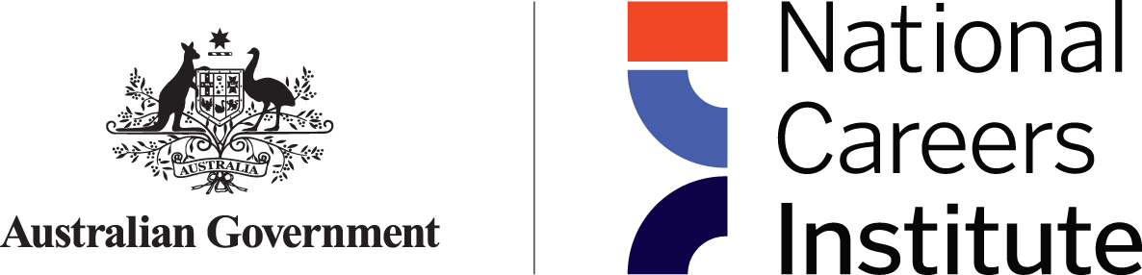

National Careers Institute **Advisory Board** Communiqué

The National Careers Institute (NCI) Advisory Board meeting was held virtually on Thursday 24 August 2023. Discussion centred around the Advisory Board Forward Workplan and included a deep dive discussion on challenges and opportunities arising from Australia’s transition to a net zero economy and approaches to promoting careers in current and emerging clean energy occupations.

At the meeting:

* The Board received briefing from the NCI Deputy Executive Director on work underway in the NCI including update on enhancements to Your Career website, key research milestones, the Partnership Grants Program evaluation, preparations for the Australian Training Awards presentation in Hobart in November 2023, the passing of Jobs and Skills Australia Amended Bill 2023 and the House of Representatives Inquiry into the Perceptions and Status of VET.
* Department of Employment and Workplace Relations officers gave a presentation on the department’s role in supporting the Australian Government’s commitment to the transition to a net zero economy by 2050 as well as an overview of careers opportunities in clean energy. The presentation included a snapshot of regions impacted by the transition to net zero, an outline of areas of future employment growth, and opportunities for the NCI to support the transition and to provide leadership in the promotion of careers in clean energy. Members agreed there was a clear role for the NCI in delivering quality information on careers in clean energy as well as supporting workers and their communities impacted by the decarbonisation of the energy sector with information to help them make informed decisions about their careers beyond the transition. The Board undertook to provide further feedback as the work of the department in both of these areas progresses.
* The Board discussed the NCI’s annual update draft and received a status update on the evaluation of the NCI currently underway.

The NCI Advisory Board is next scheduled to meet in person in Canberra on Thursday 23 November 2023.